  Component One: Student Journal (learning log) 750 words +/- 10%  Contribution to Overall Module Assessment: 25% | Student No: | 2226188
 | Module Title: | Hotel Administration & Front Office Operations
 | Module Code: | BMIH4004
 | Lecturer: | Natalie Brailsford
In reflection on my experiences in the hotel front office, I have gained lots of valuable experiences in my life. Various kinds of skills are necessary to work in this industry.
Using Gibbs Model of reflection, I identify the key skills based on my own experience, skills and theoretical principles.
First of all, perhaps, the most essential of all, is the multiple language skill, the ability to speak more languages. In the hotel front desk, the front desk agents can meet guests from different countries, so it is required if someone wants to work in the hotel front office (Hcareers, 2021).
Personally, I can speak more languages, including Hungarian, which is my mother tongue and English as well. I think English is a world language, so I can communicate with almost everyone. On the other hand, misunderstandings might occur in communication, so it is important to increase language skills.
Secondly, initiative and problem- solving abilities are also important (Half, 2023). It is a valuable skill because the reason for the problem has to be recognised and solved. In order to find the best solution, analysing the situation, clear communication, and quick decision-making are necessary (Indeed Editorial Team ,2023). During my work, I encountered lots of problems at the front desk.
One day a Chinese guest complained about the hotel service. He claimed that there were not enough towels that he needed. I felt frustrated and annoyed because I had to make a decision quickly and solve his problem in order that the hotel would not get a bad review. I agreed with the guest’s complaint, so I took more towels into his room. Later, I was ashamed because I made a mistake, I did not discuss the problem with others. In the future, I will try my best to solve the problem using my previous experience and knowledge.
Furthermore, a good receptionist is supposed to work properly under pressure. For instance, during his or her work, he/she has to answer the phone, or a new guest may arrive and ask for information about the place. The front desk agents are often interrupted by other guests requests or complaints (Jill, 2023).
Punctuality and reliability are essential skills because being late for work is not allowed. The reception desk cannot be left empty, and calls must be answered as well. Moreover, it is important that the receptionist is able to work independently (Jill, 2023).
In addition, a receptionist job requires technological skills such as knowledge of the software system, using printers, and computers. This skill is one of the most vital of all because from reservation to cancelling, a lot of things are controlled by machines (Half, 2022).
Finally, it is essential to mention the ability to work independently. It is very common in the hotel industry that the hotel front office worker has to solve a problem alone (Half, 2022).
The aforementioned skills are primary in the hotel front office based on certain principals.
The first principle includes a warm welcome, answering the phones and emails in a friendly manner. It is not allowed that the phone rings more that three times because it means very rude behaviour. The first impression determines the guest’s opinion about the service (Borba, 2020). Reflecting my own experience, I used to have a colleague in the front desk who replied for an email two days later. I warmed her more times, but in vain, I felt so embarrassed. That email contained an important change in a guest’s booking. Finally, the guest did not arrived, cancelled his reservation. Seeing this situation, I learnt the importance of answering emails and calls as soon as possible to avoid misunderstanding and problems. As a result, my former colleague was sent to a training in order to learn the importance of answering to an email and how to handle overstressed situations.
The second principle is taking care of the guests’ needs in order to make the hotel service better. For instance, offering a room on the ground floor for elderly people (Borba, 2020).
The next principle is also very essential to know the guests’ cultural differences in respect to their personal space. Because of the same thing, gestures can be different for people from different countries. For example shaking hands, talking about salary, etc (Borba, 2020).
To sum up, considering all the skills are equally important based on principles if somebody chooses this sector to work.

word count: 736

Component Two
Contribution to Overall Module Assessment: 25%
Trip Advisor Review Response 150 words +/-10%
Dear Mary,

Thank you very much for reviewing our hotel. We are glad to read positive feedback from our guests. We appreciate every review in order to make more improvements in order that our customers will be more satisfied and feel comfortable during their stay. We are thrilled to hear that your stay met your expectations and you had a great time in our hotel. Our staff always tries to provide the best experience and service for our guests. We pay attention to our customers’ requests and needs to be satisfied. Our hotel is located in the city centre close to various sightseeings and shopping facilities, in order to provide even more experience and more convenient stay for our customers.
We hope that you will choose our hotel next time and meet again.

Yours sincerely,

Renata
Customer Experience Team

word count:139

Screen shot of referenced Trip Advisor review used:
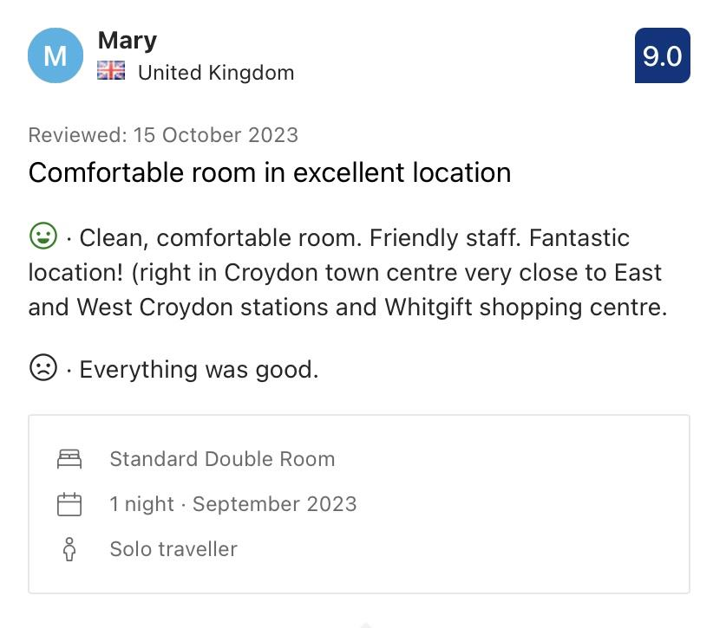

Letter of complaint response 500 words +/- 1-%
29th October,2023

Dear Mr. Ronald Federick,

Thank you for writing to us and sharing your complaint with us. We are sorry to hear that you are dissatisfied and your stay did not meet your expectations in our hotel.
We agree that the usual high standards of our service were not met.

In your letter, you mentioned the problems during your stay. First of all, you stated that the standard of the room was not what you had expected. Secondly, you are not satisfied with the quality of the breakfast on Sunday morning; in addition, you made a complaint about the served food, which was cold and tasteless. Furthermore, you stated that a baby was crying in the next hotel room, and that is why you could not sleep. Finally, you mentioned other problem with the tidiness of room 205. Moreover, you stated that the toilet was very dirty, and you recognised hair in the bath. We are very sorry to have inconvenienced you during your visit to our hotel.
Please, accept our sincere apologies about these problems.
We investigated our records, and it looks as if there was no another vacant room available at that time when you had booked your stay. We apologise for the noise, we are terribly sorry that you could not sleep and crying made you annoyed. We respect all our guests, and everyone’s need is equally important for us, however, we cannot ignore booking of customers with little children, they have an equal right to visit our hotel.
Your complaint motivated us to retrain the chambermaids and chefs in order to improve the quality of our service and avoid similar problems in the future. We checked your complaint, and you are completely right, poor service is never acceptable. Unfortunately, during that period you were staying in our hotel, more chambermaids were on sick leave, and the rest of them had just begun their work for a few days. They were overstressed and too busy to do all their duties on time. Apparently, the problem was the result of an unclean room.
We also investigated your complaint about food, and we found that there was not another complaint about Sunday breakfast or the taste of served food. Certainly, we accept your remark, and we want to prevent the re-occurrences, therefore, our chefs try to improve the quality and flavour of dishes.
We appreciate all negative feedback from guests; it can help us know what improvements are necessary to develop.
We would like to ask you to inform us next time before leaving the hotel if you have any problems or questions to discuss about the service. We all try to find the best solution for every kind of matter as soon as possible.
As a compensation, we would like to offer you a voucher for your next visit. Using this voucher, you will get 20% discount on your next booking and consumption of drinks and food. We hope, you accept our offer and see you soon.

Yours sincerely,

Renata Kapus
Hotel Manager

word count: 504

Component Three:
Contribution to Overall Module Assessment: 50% (1000 words +/- 10%)
Writing in essay format

Element 1 – Pre-Arrival

Pre- Arrival means booking; the customer selects the lodging and schedules the stay. A great number of factors can influence the choice, like experience, recommendation, prices, and so on (Kumar, 2023).
This phase of the visitor cycle typically begins with a guest's engagement and correspondence with the hotel before the guest even sets foot there. As a result, during the pre-arrival activity phase, reservations are quite important (Hotelier Life, 2021).
The reservation department is in charge of reserving the guest's accommodation, and the staff's promptness and skill in addressing the request leaves the guest with a positive first impression of the hotel. The reservation staff creates and changes a reservation on the hotel administration software as soon as the reservation is accepted (Hotelier Life, 2021).
This initiates the cycle of guests staying at the motel. To enable the hotel to provide each visitor with individualized service during their stay, the reservation department gathers the guest's information and makes note of any special requests or arrangements that need to be made for their booking (Hotelier Life, 2021).

The primary objective and goal of making a reservation is to guarantee that a room will be available when the guest arrives at the hotel, even though the reservation information helps to provide anticipatory service (Hotelier Life, 2021).
Making any necessary special arrangements or requests for the guest, including updating the guest folio if they pay in advance and assigning the room according to the reservation (Hotelier Life, 2021).
An example of pre-arrival is emailing or delivering a welcome note to clients a few days prior to their arrival (Travel Pedia, 2023).

Element 2 – Arrival

The registration and room assignment procedures are part of the visitor cycle's arrival stage.
Upon arrival, the visitor forges a business connection with the hotel via the front desk. The front desk employees are responsible for answering any questions the guest may have, particularly those about the specifics of the package or room rate they are reserved for (Kumar, 2023). Front desk staff members can also benefit from business from walk-ins, or guests who arrive without a reservation. (Kumar, 2023).
When a guest checks in, they print and fill out a registration card, often known as a Reg. card, which helps the front desk gather important data. Billing instructions, reservation details, the number of people and children occupying the space, location, passport and visa information for foreign nationals, full address, personal information, and credit card information should all be included on the registration card (Augustine, 2023).
It is essential to obtain the guest's signature on the registration card, as both the hotel and the guest receive specific legal advantages. Once the guest's departure date and payment method have been verified and formally signed, the registration process is finished (Augustine, 2023).
An example of arrival is when the customer arrives at the hotel, then the bell boy accompanies the guest to registration desk. The guest is welcomed by the front office desk workers, they ask the customer to fill the registration form and give the room key to him or her ( Deepan,2020).

Element 3 – Duration of stay

The visitor has an up-close look at the amenities and services the hotel has to offer at this phase. In terms of a guest's entire hotel experience, these amenities and services are the most significant (Gurnule, 2023). This is the length of time a visitor stays in their lodging (Q4Launch, 2022).
Everything ought to revolve around the visitor experience. The only thing you can guarantee is that your customers will return for a second or third visit—your service. While on the premises, guests will be more responsive to cross-selling and upsell suggestions. Anything you can do to improve your visitors' experience is really worthwhile. In order to utilize concierge services, this step also initiates communication with personnel (Q4Launch, 2022).

In front office guest cycles, this is the most crucial phase. Since this stage saw the greatest amount of engagement amongst all departments (Gurnule, 2023).
Consequently, it needs to work closely with other departments in order to guarantee that guests receive facilities and services that run well. for the hotel's recurring patronage (Gurnule, 2023).
An example of duration of stay is if the guest asks about the monuments or attractions nearby or asks for some items which he or she forgot to bring such as toothpaste, and so on (Habas,2020).

Element 4 – Departure

As visitors are ready to pay, check out, and go, hoteliers should take this opportunity to express gratitude for their business, solicit feedback, and extend an invitation for future visits. Once more, using an online check-out option will expedite the process (Alemar,2022).
Similar to all other phases, it must be smooth and optimized to ensure that guests do not become frustrated. This is usually the time to gather visitor input and apply it to enhance operations. The guest's excellent experience will be rounded out with no unexpected paperwork or hidden surcharges (Q4Launch, 2022).
Examples of departure are airport pickup and drop-off, airport transfers, bill payment, and key return upon checkout are all frequently viewed by guests as stressful events. (Javier,2022).
Departure-related requests for information and service contracts include the appearance of virtual assistants, chatbots, concierge robots, or even interactive kiosks that provide access to flight information, departure details, and other relevant services. Offering helpful information and automatically suggesting services like a chauffeur or luggage transfer to the airport is a great way to take advantage of this amazing chance for upselling through proactive customer assistance (Javier,2022).
Maintaining a devoted clientele is more profitable than continuously looking for new ones (Nicky, 2023).
Asking visitors for comments can help the hotel improve customer service and make the necessary adjustments. Rather than wait too long, when customers can get side tracked by everyday life, post-stay surveys can be provided when the experience is still fresh in their minds (Nicky, 2023).
Feedback from previous visitors may be highly enlightening because this information can help the hotel what to improve (Nicky, 2023).
Utilizing guest loyalty programs and exclusive incentives is one tried-and-true method of promoting repeat reservations (Nicky, 2023).

word count:1004

References

Alemar, S. (2022) ’ The Hotel Guest Cycle & Why It Matters’, Canary Technologies, 12 April. Available at: https://www.canarytechnologies.com/post/the-hotel-guest-cycle-why-it-matters (Acessed:30 October 2023).
Augustine (2023) ’Guest Cycle’, Setup my Hotel. Available at: https://setupmyhotel.com/train-my-hotel-staff/front-office-training/131-the-guest-cycle-in-hotel.html (Acessed:01 November 2023).
Booking (2023) Leonardo Hotel London Croydon - formerly Jurys Inn. Available at: https://www.booking.com/hotel/gb/leonardo-hotel-london-croydon.en-gb.html#tab-reviews (Acessed:28 October 2023).
Borba, L. (2020) ‘The Five Principles of Exceptional Service’, Entrepreneur’s Handbook, 10 December. Available at: https://entrepreneurshandbook.co/the-five-principles-of-exceptional-service-b972517db1e4 (Acessed:28 October 2023).
Deepan (2020) ’The Guest Cycle’, Easy Hotel Management, 03 June. Available at: The Guest Cycle (easyhotelmanagement.com) (Acessed:30 October 2023).
Gurnule,M. (2023) ’ 5 Stages of Guest Cycle in Front office’, Everything about Hospitality. Available at: https://everythingabouthospitality.in/5-stages-of-guest-cycle-in-front-office/#3_Occupancy (Accessed: 01 November 2023).
Habas,C. (2020) ’ Front Office Operations & Its Relation With the Guest Cycle’, Small Business, 22 October. Available at: https://smallbusiness.chron.com/front-office-operations-its-relation-guest-cycle-14378.html (Accessed: 01 November 2023).
Half, R. (2023) ‘Make your Resume Pop with these 8 Receptionist Skills’, Indeed, 15 June. Available at: https://www.indeed.com/career-advice/resumes-cover-letters/front-desk-resume-skills (Accessed: 16 October 2023).
Half, R. (2022) ‘7 must-have receptionist skills that top employers want’, Robert Half, 28 March. Available at: https://www.roberthalf.co.uk/advice/career-development/7-receptionist-skills-can-impact-entire-company (Acessed:28 October 2023).
Hcareers (2021) 12 Necessary And Essential Skills Of Front Desk Professionals. Available at: https://www.hcareers.com/article/career-advice/12-necessary-and-essential-skills-of-front-desk-professionals#multiple-languages (Accessed: 16 October 2023).
Hong Kong Polytechnic University (no date) How to Reply to Complaints. Available at: http://www2.elc.polyu.edu.hk/CILL/eiw/adjustmentletters.htm (Accessed: 29 October 2023).
Hospitality Learning Online (2023) How to respond to an unhappy guest email/survey. Available at: https://www.hospitalitylearningonline.com/how-to-respond-to-an-unhappy-guest- (Accessed: 29 October 2023).
Hotelier Life (2021) The Guest cycle in the hotel. Available at: https://www.hotelierlife.com/the-guest-cycle-in-the-hotel/ (Accessed: 29 October 2023).
Indeed Editorial Team (2023) ‘Front Desk Resume Skills: Definitions and Examples’, Indeed, 11 March. Available at: https://www.indeed.com/career-advice/resumes-cover-letters/front-desk-resume-skills (Accessed: 17 October 2023).
Javier, F. (2022) ’ Automation and The Hotel Guests Cycle: Departure’, Linkedin, 25 January. Available at: https://www.linkedin.com/pulse/automation-hotel-guests-cycle-departure-francisco-javier-martin-romo/ (Accessed: 02 November 2023).
Jill (2023) ‘The top 10 receptionist skills’, Vizito, 24 July. Available at: https://vizito.eu/blog/the-top-10-skills-that-every-receptionist-needs/#resistance-to-stress (Accessed: 17 October 2023).
Kumar,P. (2023) ’Introduction to guest cycle’, HmHub, 7 July. Available at: https://hmhub.in/introduction-to-guest-cycle/ (Accessed: 30 October 2023).
McQuerrey, L. (2021) ’How to Answer a Guest Complaint Letter’, Bizfluent, 1 January. Available at: https://bizfluent.com/how-to-answer-a-guest-complaint-letter.html (Accessed: 29 October 2023).
Nicky,M. (2023) ’Optimize the Hotel Guest Experience Journey: 5 Key Stages’, Roomraccoon, 14 September. Available at: https://roomraccoon.com/blog/hotel-guest-experience/ (Accessed: 02 November 2023).
Q4Launch (2022) What is the Guest Life Cycle in Hotels? Available at: https://q4launch.com/blog/guest-life-cycle/ (Accessed: 01 November 2023).
Travel Pedia (2023) ’ How to write a complaint letter to a hotel for bad service?’, Love the Maldives, 4 October. Available at: https://lovethemaldives.com/faq/how-to-write-a-complaint-letter-to-a-hotel-for-bad-service (Accessed: 29 October 2023).
Travel Pedia (2023) ’What is an example of pre arrival?’, Love the Maldives, 5 October. Available at: https://lovethemaldives.com/faq/what-is-an-example-of-pre-arrival (Accessed: 30 October 2023).

