UNIVERSITY OF WALES TRINITY SAINT DAVID
NAME: Mohammed Abdul Rahim
STUDENT ID: 2210095
SUBJECT CODE: LCMB7012

A Study on Banking Financial Management and Financial Markets

Executive summary
When the housing bubble in the United States broke in 2008, it resulted in a collapse of the global financial system. To avoid a repeat of this catastrophe, the governments of the UK, US, as well as EU have implemented a number of changes. The Dodd-Frank Wall Street Improvement and Consumer Defense Act of 2010 was accepted in the United States, increasing regulatory monitoring and starting new controlling organisations with the Consumer Financial Defense Bureau. In order to stabilise the banking industry, the US government also created the Troubled Asset Relief Programme (TARP). In order to enhance consumer protection and guarantee financial stability, the UK formed a new regulatory organisation, the Financial Conduct Authority, in 2013. Separating trade banking from venture banking was another way the government reorganised the banking industry. New laws, such as the Capital Requirements Directive IV, that required banks to keep more capital to protect against losses, were enacted in the EU, giving the European Central Bank greater control over the financial sector. The Global Financial Crisis (GFC) of 2008 is remembered as one of the most significant financial cataclysms of modern times. Its ramifications were felt across the globe, exposing the vulnerabilities inherent in the international financial system. Financial markets witnessed unprecedented collapses, massive meltdown of banking entities, and a deterioration of financial stability. As a result, regulatory authorities and governments across the world took drastic measures to confront the crisis and introduced sweeping financial reforms. Some of these measures include the Dodd-Frank Wall Street Reform and the Consumer Protection Act in the United States, and Basel III regulations by the Basel Committee on Banking Supervision.
Table of Contents
1. Introduction 4
2. Discussion and Analysis 4
2.1. Key laws, regulations and contracts that were enacted post-2008 crises 4
2.2. Contribution of reforms towards stabilising the economy 9
2.3. Impact of reforms on the Bank Natwest’s business model and their level of compliance/non-compliance 11
3. Conclusion 14
References 16

1. Introduction
Managing a bank's financial resources to increase earnings and reduce risks is known as banking financial management. Financial analysis, asset and liability management, investment management, and risk management are some of the tasks performed by the managers. The term "financial markets" describes the locations where buyers and sellers transact with respect to financial assets including stocks, bonds, currencies, and commodities (Caroleo et al., 2020). These marketplaces contribute to price discovery and the flow of capital between lenders as well as investors. They are essential to the operation of the world economy and play a significant part in distributing money to useful uses. Thus, it is very important for the investors, policy makers and other financial institutions to have adequate knowledge of the financial institutions (Andreoni, 2020).
The Great Recession, also known as the Worldwide Financial Crisis of 2008, was a disastrous financial And economical crash, started in the United States that cost many ordinary people their jobs , homes and assets. The Recession spread quickly throughout the globe. The financial markets showed signs of a crisis due to increase in government spending as well as reduced interest rates as a result a few investors suspected that the global financial system was about to collapse by the worst economical crisis. It was brought on by the U.S. housing market collapse, that was made possible by the overabundance of subprime mortgages and inadequate regulatory conditions. Lenders that were ready to extend loans to borrowers that did not fulfil conventional credit standards often with adjustable rates that initially began off low but eventually rose significantly were responsible for the subprime mortgage crisis (Chen, Ting and Wang, 2020). The objective of this was to boost the conditions of the economy by making money accessible to businesses as well as consumers at low rates. This resulted as an increase in home prices as borrowers took advantage of low mortgage rates. As borrowers fell behind on their payments increasingly, the housing market became more vulnerable, sending repercussions across the whole global financial system (Behn and Schramm, 2021).
According to a 2011 report, The financial crisis inquiry commission (FCIC) came to a conclusion that the financial crisis was avoidable. There were several Signs that led to one of the largest financial and economical global crisis
THE WARNING SIGNS BEFORE THE CRISIS
Early 2006 : House prices fell
Early 2007 : Subprime lenders started filing for bankruptcy
June 2007 : weighed down by investments in subprime loans, 2 major hedge funds failed
Aug 2007 : The global lending system froze due the panic caused by the losses in subprime loan investments
September 2008 : The biggest U.S Bankruptcy ever , The collapse of the Lehman Brothers
When the housing bubble eventually burst in 2007, it exposed the fragility of the financial system, triggering a chain of events that culminated in the collapse of major financial institutions such as Bear Stearns, Lehman Brothers, and Northern Rock.
The collapse of these institutions, in turn, resulted in a severe liquidity shortage throughout the global financial system, which led to a plummeting of stock markets and the freezing of credit markets worldwide. In response to the crisis, central banks and governments across nations scrambled to adopt measures aimed at containing the financial meltdown and preventing a complete collapse of the global economic system.
Many financial firms failed or came dangerously close to failing as a result of the crisis, that also caused a liquidity crisis that compelled governments all over the world to step in and offer bailouts to stop further collapse (Christensen and Hearson, 2019). The crisis had a noteworthy effect on the world economy, ensuing in job losses, house foreclosures, and an extended period of severe recession. The financial industry was also subject to more regulation as a result of the crisis (Berman and Snegovaya, 2019).

2. Discussion and Analysis

2.1. Key laws, guidelines and contracts that were passed post-2008 crises
By The UK authorities
The UK's financial system was significantly impacted by the worldwide monetary crisis of 2008, that prompted the adoption of several laws, rules, and agreements. Some of the enactments made were:
The Financial services act
The Financial Services Act 2010 was passed in order to improve the UK's financial regulatory framework. In order to control and oversee financial institutions in the UK, it established the Financial Conduct Authority (FCA) and the Prudential Regulation Authority (PRA) (Brem, Nylund and Viardot, 2020).
Basel III
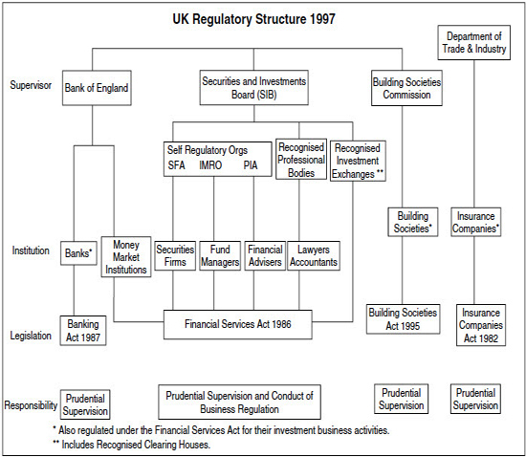
Figure 1: The Banking regulatory structure for Base III
Source: (Sahasrabuddhe, 2019)
The Basel III framework was created to increase the banking industry's flexibility. It attempted to lower the danger of systemic collapse by introducing additional capital and liquidity requirements for banks (Fingerman, Huo and Birditt, 2020).
The Bank of England and The Financial Services Act of 2016
This legislation constricted the regulatory system even further. It also established the Payment Systems Regulator as well as granted the Bank of England’s new authority to preserve financial stability (Burdekin and Tao, 2021).
Senior managers and certification regime
Review of Fair and Effective Markets (FEMR) In reaction to the manipulation of important financial benchmarks like LIBOR, the FEMR was established. It made suggestions to increase regulation and raise standards of behaviour in the financial industry (Chen, Ting and Wang, 2020).
The European market infrastructure regulation
The European Market Infrastructure Regulation (EMIR) was established to improve the competence and openness of the byproduct markets. It mandates the central clearing and trade repository reporting of specific derivatives (Caroleo et al., 2020).
By The US authorities
The United States was at the epicentre of the GFC, so it came as no surprise that some of the most comprehensive reforms emerged from the country. The Dodd-Frank Act of 2010 is one such landmark legislation that aimed to rectify the deficiencies of the financial systemThe Dodd-Frank Consumer Protection and Wall Street Reform Act
The Dodd-Frank Act, that was passed into law in 2010, aimed to put controls on banks, credit rating companies, and other financial organisations in order to stop future financial disasters. The Customer Financial Defence Bureau was founded under the Act with the responsibility of defending customers from unfair, dishonest, as well as abusive practises by financial institutions (Christensen and Hearson, 2019).
The Volcker Rule
The Volcker Rule, that was a component of the Dodd-Frank Act, was designed to stop banks from using their own funds to engage in hazardous trading operations. The rule prohibited banks from engaging in certain kinds of investments, including trading proprietary products and funding privet funds (Andreoni, 2020).
Basel III
New international rules on bank capital competence and fluidity were approved by the Basel Commission on Banking Supervision in the Basel III Accord. Making banks more resistant to economic shocks and preventing another global financial disaster in the future (Fingerman, Huo and Birditt, 2020).
BCBS, or the Basel Commission on Banking Supervision
A global opportunity for banking managerial bodies, the BCBS seeks to create and advance international regulatory standards. The Basel III Accord, that set new rules on bank capital capability and liquidity, was developed by the Group (Franklin, Rostom and Thwaites, 2019).
The Basel Committee on Banking Supervision (BCBS) introduced the Basel III framework, an extension of the existing Basel I and Basel II regulations, which focuses on improving the banking sector's resilience to economic shocks. The primary objectives of Basel III include:

1. Enhancing the quality and quantity of capital that banks must hold, by raising the minimum Tier 1 capital ratio and introducing a minimum common equity capital ratio.
2. Implementation of a counter-cyclical capital buffer to ensure that banks accumulate sufficient capital during periods of economic buoyancy.
3. Introducing a new liquidity coverage ratio (LCR) and net stable funding ratio (NSFR) to improve banks' short-term and long-term liquidity risk management.
4. Ensuring transparency and disclosure of banks' risk-related information to support market discipline.
Troubled Asset Relief Programme (TARP)
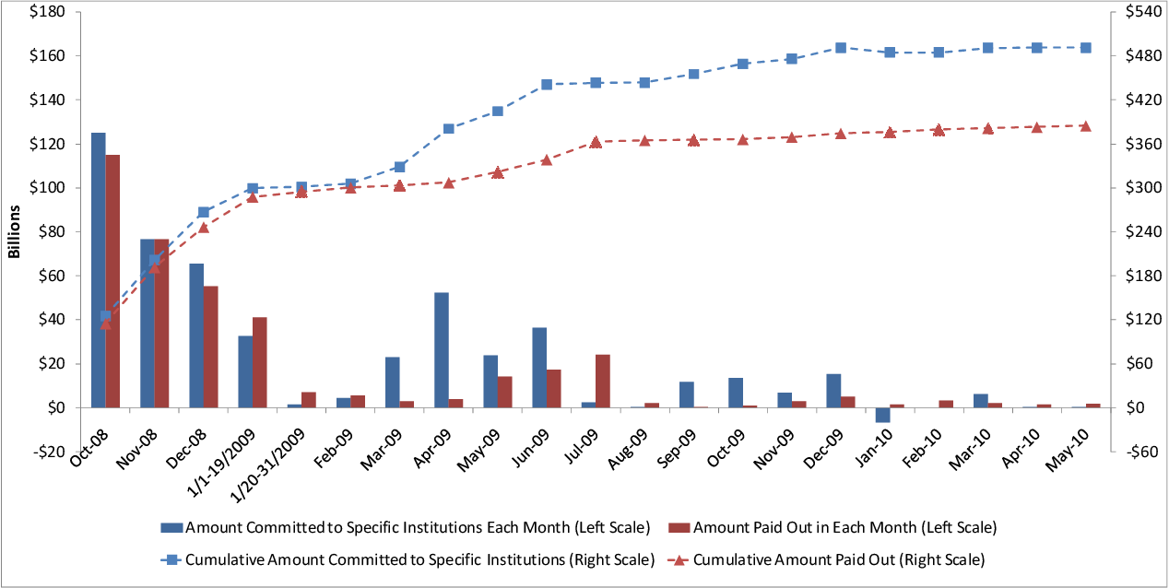
Figure 2: TARP graph
Source: (Tulumello, Cotella and Othengrafen, 2019)
In order to assist banks and other financial institutions, the TARP was established in 2008 with the goal of stabilising the financial system. It was also observed that it bailed out the same institutions that triggered the crisis and the programme proved disruptive (Behn and Schramm, 2021).
By EU authorities
The European stability mechanism
ESM, or the European Stability Instrument The ESM, that was recognised in 2012, is a perpetual crisis-resolution device that offers financial support to EU member states experiencing extreme economic hardships (Burdekin and Tao, 2021).
Single Supervisory Mechanism
The SSM, or Single Supervisory Device The SSM, that was established in 2014, gives the European Central Bank (ECB) the power to monitor and control the eurozone financial sector (Brem, Nylund and Viardot, 2020).
Single resolution mechanism
The Single Resolution Mechanism (SRM), that was established in 2014, enables the eurozone's failing banks and other monetary organisations to be resolved in an orderly fashion (Saghir, 2021).
Capital Requirements Instruction IV (CRD IV) and the Capital Requirements Guideline (CRR)
These regulations, that went into effect in 2013, require banks to tighten their risk management procedures and maintain adequate capital buffers to withstand any losses (de la Porte and Jensen, 2021).
The Markets in financial instruments derivative II
The MiFID II, or Markets in Monetary Instruments Directive MiFID II, that was introduced in 2018, tightens up the management of financial markets by mandating more transparency, protecting investors, and monitoring high-frequency trading (Christensen and Hearson, 2019).
Anti-Money Laundering Derivative
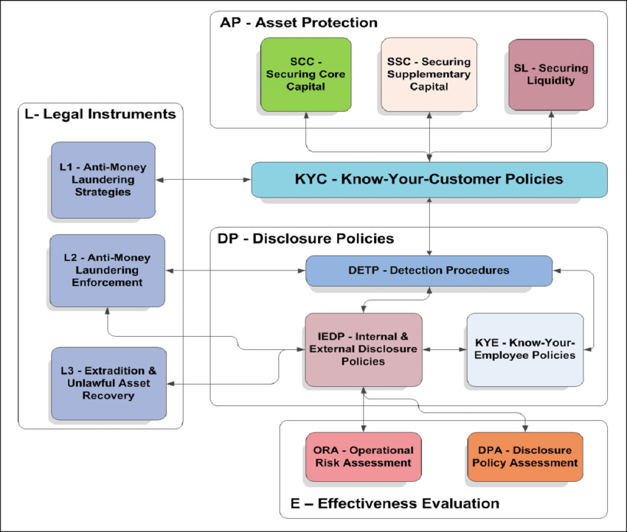
Figure 3: Anti-money laundering derivative framework
Source: (van Gent and Hochstenbach, 2019)
The AMLD, or the Anti-Money Laundering Directive The 2018 update to the AMLD improves counter-money laundering and counter-terrorist financing measures, including stronger customer due diligence standards and more EU member state collaboration (de la Porte and Jensen, 2021).

2.2. Contribution of reforms towards stabilising the economy
One of the biggest worldwide economic recessions since the Great Depression was the financial crisis of 2008. A number of things, including careless lending practices, insufficient regulatory monitoring, and a highly integrated global financial system, contributed to the crisis. Authorities in the UK, US, and EU undertook a number of measures in reaction to the crisis with the goal of strengthening the financial system and preventing another one in the future (Chen, Ting and Wang, 2020). The extent to these that have helped create a more stable financial system and banking institutions can be critically examined as:
UK Reforms
To monitor the constancy of the monetary system and control the banking sector, the UK government formed the Financial Stability Board (FSB) and the Prudential Regulation Authority (PRA) (Fingerman, Huo and Birditt, 2020). While the PRA was in charge of overseeing the UK's banking sector, the FSB was entrusted with keeping an eye on the world financial system. The Financial Services Act 2012 was also introduced by the government with the goal of strengthening financial institution regulation and enhancing consumer protection. All these measures helped the government in strengthening the economy of the country (Franklin, Rostom and Thwaites, 2019).
The isolation of trade banking operations from speculation banking activities was one of the most significant measures implemented by the UK government. The purpose of this policy was to shield the deposits of retail banking clients from the dangers posed by investment banking operations (Ravenscroft and Williams, 2021). However, some attackers contend that the isolating methods fall short in addressing the crisis's roots. It may not prove to be an effective measure taken by the UK government (Giebel and Kraft, 2020).
US Reforms
Following the crisis, the US administration passed the Dodd-Frank Wall Street Improvement and Consumer Protection Act in an effort to stop the recurrence of the same type of situation (Franklin, Rostom and Thwaites, 2019). The legislation required banks to maintain greater capital ratios and conduct stress tests, established a number of regulatory organisations, including the Consumer Financial Protection Bureau and the Financial Stability Oversight Council. The government also encouraged flow of currency in the economy in order to strengthen the financial backbone of the country (Behn and Schramm, 2021).
The Volcker Rule, that prohibits banks from participating in exclusive trading and places limitations on their involvement in hedgerow funds and private equity firms, was one of the most significant reforms implemented by US regulators (Giebel and Kraft, 2020). The goal of the regulation was to lessen the risks involved in speculative trading activities and restrict the activities of banks that risk the constancy of the financial system. It was important in order to avoid any such crises in the upcoming and revive the economy (Andreoni, 2020).
EU Reforms
In reply to the crisis, the EU implemented a number of reforms aimed at enhancing financial system stability and regulating the banking sector. The European Banking Authority (EBA) was created to monitor the stability of the financial sector, and the European System of Financial Supervision (ESFS) was formed to govern the EU's investment sector (Saghir, 2021).
The Capital Requirements Directive (CRD), that obliges banks to maintain greater capital ratios to lower their exposure to hazards, was also established by the EU (Nikkinen, Piljak and Rothovius, 2019). The EU authority also established the Single Resolution Mechanism (SRM), that aims to make it easier for deteriorating banks to be resolved in an orderly manner and avoid the need for government bailouts (de la Porte and Jensen, 2021).
Analysis
Although the UK, US, and EU authorities' reforms have made significant steps towards creating a more stable financial system and banking institutions, there are still a number of issues that need to be resolved. First, according to some critics, the changes do not go far enough in tackling the crisis' root causes, that include tax regulatory monitoring and risky lending practises. Second, the changes have made it more expensive for financial institutions to comply, that may limit their capacity to lend to both companies and individuals. Long-term economic growth and financial stability may suffer as a result of this (Gudgeon et al., 2020). Thirdly, some critics contend that the reforms may have unforeseen repercussions, such as motivating banks to take up riskier ventures in an effort to lessen the impact of the increasing regulatory burden. The changes implemented by the governments of the UK, US, and EU have advanced efforts to create a more stable financial sector and banking institutions. However, there are possibilities that the measures may have unexpected repercussions and don't go far enough in tracing the crisis's root causes. The overall effectiveness of these changes can only be determined on the basis of balance level these are able to achieve (Ravenscroft and Williams, 2021).
While these reforms have undeniably contributed to the stabilisation of the financial system post-GFC, they are not without their limitations and unintended consequences. For instance, the increased capital and liquidity requirements of Basel III may have stifled lending, indirectly impeding economic growth. Furthermore, the stringent compliance requirements imposed by the Dodd-Frank Act may have disproportionally affected smaller financial institutions, consolidating the financial system and reducing competition.
2.3. Impact of reforms on the Bank Natwest’s business model and their level of compliance/non-compliance
A significant financial organisation with a presence in the UK called NatWest Group offers both retail and business banking services. Numerous regulatory agencies in the UK, US, and EU have implemented a number of changes over the past few years with the goal of enhancing the stability, accountability, and transparency of the financial industry (Giebel and Kraft, 2020). The effects of these reforms had significant impact on NatWest Group's business strategy and the bank's compliance or non-compliance level with these reforms:
The Effect of Regulatory Reforms on the NatWest Group
Basel III
Basel III is a collection of international banking rules designed to strengthen banks' ability to withstand times of economic hardship. According to the laws, banks must maintain a certain amount of capital, liquidity, and leverage ratio (Hinrichs, 2021). NatWest Group's business model has been significantly impacted by Basel III regulations, that have boosted the bank's capital needs and made it maintain more liquid assets. Due to having to redirect money away from higher-risk, higher-reward operations like investment banking and trading, the bank's income has decreased as a result of implementation of these reforms (Nikkinen, Piljak and Rothovius, 2019).
Act of Dodd-Frank
A US law known as the Dodd-Frank Act brought about a number of changes aimed at enhancing the constancy of the monetary system. In order to make sure that banks can survive economic shocks, the legislation mandates that they undertake periodical stress testing. The Volcker Rule, that forbids banks from participating in proprietary trading, was also introduced (Kim, Batten and Ryu, 2020). NatWest Group's business model has been significantly impacted by the Dodd-Frank Act since the bank was compelled to sell its non-core divisions, such its US retail banking operations, in order to fulfil with the legislation. For the bank to meet the criteria of the stress tests, technology and risk management systems have to be purchased (Mason, 2020).
MFIR II
The EU laws known as MiFID II are intended at improving the competence and transparency of the financial markets. According to the laws, banks must guarantee that their customers obtain the greatest execution on their trades and give better disclosure of their fees and levies. The MiFID II laws significantly altered the NatWest Group's business strategy by requiring the bank to enhance its disclosure and transparency procedures (Marques and Hoerisch, 2019). To be able to give customers accurate and timely information about their trades, the bank had to make investments in technology and infrastructure (Kim, Batten and Ryu, 2020).
NatWest Group's Compliance/Non-Compliance with Regulatory ReformsBasel III The NatWest Group has complied with the Basel III rules and taken a number of actions to raise its capital adequacy and liquidity ratios (Mason, 2020). The bank has improved its liquidity coverage ratio, decreased its risk-weighted assets, and raised its common equity Tier 1 capital ratio. The bank has come under fire for not going far enough with the laws' implementation and for relying excessively on risk-weighted assets to gauge its capital sufficiency (Marques and Hoerisch, 2019).
Act of Dodd-Frank
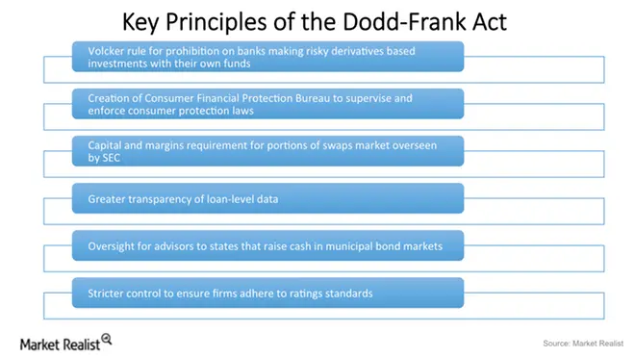
Figure 4: Dodd-Frank prnciples
Source: (Zubair, Kabir and Huang, 2020)
The Dodd-Frank Act and the Volcker Rule have both been mostly complied with by NatWest Group, that has also sold its non-core assets in the US. The bank has come under fire, meanwhile, for not going far enough in the execution of the stress testing standards and for failing to sufficiently plan for the effects of Brexit on its US operations (Kim, Batten and Ryu, 2020).
MiFID II
NatWest Group has made investments in technology and processes to enhance its transparency and disclosure practises, and has substantially complied with the MiFID II standards. However, the bank has come under fire for not going far enough with the legislation' implementation and for failing to sufficiently inform customers of its fees and charges (Hinrichs, 2021).
Overall analysis of the impact of reforms on Natwest banks
NatWest has had to keep more capital due to higher capital and liquidity requirements, stress testing, and the need to guarantee liquidity. Additionally, rules on behaviour and culture have been put in place to stop careless behaviour that may lead to another disaster (Gudgeon et al., 2020).
NatWest has had its trading and investing operations subject to more scrutiny and oversight. New regulations, including the Volcker Rule in the US, that forbids banks from engaging in certain speculative activities, have forced the bank to adapt. Overall, the regulatory changes have improved the stability, accountability, and transparency of the financial sector (Nikkinen, Piljak and Rothovius, 2019). For NatWest and other banks, they have raised compliance expenses as well, albeit this might have an effect on profits. In order to comply with these rules and yet compete in the market, NatWest had to modify its business strategy (Franklin, Rostom and Thwaites, 2019).
Policies Adopted by Central Banks and Governments in Responding to the GREAT RECESSION

1. Expansionary Monetary Policy: Central banks around the world turned towards unconventional monetary policy tools to combat the crisis. The United States Federal Reserve embarked on a series of quantitative easing (QE) programmes, involving large-scale purchases of government bonds and mortgage-backed securities, which helped to inject liquidity into the financial system and stabilise asset prices. The Bank of England and the European Central Bank also embarked on similar programmes to provide additional liquidity.

2. Fiscal Stimulus: Many governments adopted expansionary fiscal policies to boost domestic demand and cushion the impact of the crisis on their economies. In the United States, the Troubled Assets Relief Program (TARP) was initiated, amounting to nearly $700 billion in funds to shore up banks and other financial institutions. Moreover, the American Recovery and Reinvestment Act provided additional stimulus to the US economy, while other nations likewise enacted significant public spending programmes to stave off recession.

3. Financial Regulation: Governments and regulatory authorities recognised the need for stronger financial regulation and oversight to prevent the recurrence of such a crisis. In the United States, the Dodd-Frank Wall Street Reform and Consumer Protection Act was enacted to enhance regulatory supervision, impose stricter capital requirements, and establish the Consumer Financial Protection Bureau. Similar regulations were also implemented in Europe, with increased oversight on financial institutions and the establishment of the European Systemic Risk Board.

3. Conclusion
The economy of the United Kingdom, United States, and the European Union were all suggestively impacted by the world-wide financial crisis of 2008. The authorities in these areas adopted a number of measures in reaction to the crisis to address its underlying causes and stop it from happening again. The Financial Services Act 2012 was implemented in the UK in order to tighten regulations on financial institutions and safeguard customers. The Financial Conduct Authority was established under the legislation, that also reinforced the Prudential Regulation Authority. The Dodd-Frank Wall Street Reform and Consumer Protection Act of 2010 was presented in the US in order to tighten regulation of the financial industry. The act tightened rules on financial institutions in an effort to promote transparency, lower systemic risk, and safeguard customers.
The European System of Financial oversight was developed in the European Union in 2011 with the goals of enhancing financial institution oversight and averting further crises. The EU also passed laws to improve financial sector transparency and guarantee that financial institutions have sufficient capital and liquidity reserves. The UK, US, and EU authorities' reforms tried to remedy the flaws in the financial industry that contributed to the 2008 crisis. While some detractors claim that the changes did not go far enough, they have still contributed to the stabilisation of the financial system and the prevention of future occurrences of the same kind of incidents.
The end of the GFC did not come about through any one measure or policy but was instead the cumulative result of the combination of the measures adopted by central banks and governments worldwide. The restoration of confidence in the financial system, improved liquidity, and the stabilisation of asset prices gradually led to the end of the GFC towards the latter part of 2009.

However, the crisis left many lasting impacts on the global economy. One significant outcome was the shift towards a more conservative stance on financial regulation and supervision, culminating in the introduction of tighter regulations on financial sector risk-taking, such as Basel III and higher capital requirements for banks. It was a complex and intricate process involving the concerted efforts of governments and central banks worldwide. The combination of unconventional monetary policies, fiscal stimulus measures, and stronger financial regulations resulted in the eventual restoration of confidence in the financial system and the normalisation of economic activity. Furthermore, the GFC provided important lessons on the need for enhanced financial regulation, the importance of international coordination, and the need for multilateral cooperation to foster a more resilient global financial system. In the years that followed, much progress has been made to address the shortcomings exposed by the GFC, but the continued pursuit of global economic stability remains a work in progress.
Although the reforms have also faced criticism for inhibiting growth and fostering consolidation, the overall impact of these changes has been favourable to the stability and resilience of the financial system. Nevertheless, additional complementary and ongoing measures may be required to address existing gaps and safeguard against future crises.

References
Andreoni, V. (2020). The energy metabolism of countries: Energy efficiency and use in the period that followed the global financial crisis. Energy Policy, 139(6), p.111304. doi:https://doi.org/10.1016/j.enpol.2020.111304.
Behn, M. and Schramm, A. (2021). The impact of G-SIB identification on bank lending: Evidence from syndicated loans. Journal of Financial Stability, 57(9), p.100930. doi:https://doi.org/10.1016/j.jfs.2021.100930.
Berman, S. and Snegovaya, M. (2019). Populism and the Decline of Social Democracy. Journal of Democracy, [online] 30(3), pp.5–19. doi:https://doi.org/10.1353/jod.2019.0038.
Brem, A., Nylund, P. and Viardot, E. (2020). The impact of the 2008 financial crisis on innovation: A dominant design perspective. Journal of Business Research, 110(7), pp.360–369. doi:https://doi.org/10.1016/j.jbusres.2020.01.048.
Burdekin, R.C.K. and Tao, R. (2021). The golden hedge: From global financial crisis to global pandemic. Economic Modelling, 95(5), pp.170–180. doi:https://doi.org/10.1016/j.econmod.2020.12.009.
Caroleo, F.E., Rocca, A., Mazzocchi, P. and Quintano, C. (2020). Being NEET in Europe Before and After the Economic Crisis: An Analysis of the Micro and Macro Determinants. Social Indicators Research, 79(6). doi:https://doi.org/10.1007/s11205-020-02270-6.
Chen, Y.-L., Ting, H.-I. and Wang, M.-C. (2020). Government support and bank performance during the 2007–2008 financial crisis. The North American Journal of Economics and Finance, [online] 34(9), p.101301. doi:https://doi.org/10.1016/j.najef.2020.101301.
Christensen, R.C. and Hearson, M. (2019). The new politics of global tax governance: taking stock a decade after the financial crisis. Review of International Political Economy, 26(5), pp.1068–1088. doi:https://doi.org/10.1080/09692290.2019.1625802.
de la Porte, C. and Jensen, M.D. (2021). The next generation EU : An analysis of the dimensions of conflict behind the deal. Social Policy & Administration, 55(2), pp.388–402. doi:https://doi.org/10.1111/spol.12709.
Fingerman, K.L., Huo, M. and Birditt, K.S. (2020). A Decade of Research on Intergenerational Ties: Technological, Economic, Political, and Demographic Changes. Journal of Marriage and Family, 82(1), pp.383–403. doi:https://doi.org/10.1111/jomf.12604.
Franklin, J., Rostom, M. and Thwaites, G. (2019). The Banks that Said No: the Impact of Credit Supply on Productivity and Wages. Journal of Financial Services Research, 57(2), pp.149–179. doi:https://doi.org/10.1007/s10693-019-00306-8.
Giebel, M. and Kraft, K. (2020). Bank credit supply and firm innovation behavior in the financial crisis. Journal of Banking & Finance, 121(8), p.105961. doi:https://doi.org/10.1016/j.jbankfin.2020.105961.
Gudgeon, L., Perez, D., Harz, D., Livshits, B. and Gervais, A. (2020). The Decentralized Financial Crisis. [online] IEEE Xplore. doi:https://doi.org/10.1109/CVCBT50464.2020.00005.
Hinrichs, K. (2021). Recent pension reforms in Europe: More challenges, new directions. An overview. Social Policy & Administration, 55(3). doi:https://doi.org/10.1111/spol.12712.
Kim, H., Batten, J.A. and Ryu, D. (2020). Financial crisis, bank diversification, and financial stability: OECD countries. International Review of Economics & Finance, 65(4), pp.94–104. doi:https://doi.org/10.1016/j.iref.2019.08.009.
Marques, P. and Hoerisch, F. (2019). Promoting workplace‐based training to fight youth unemployment in three EU countries: Different strategies, different results? International Journal of Social Welfare, 28(4), pp.380–393. doi:https://doi.org/10.1111/ijsw.12381.
Mason, R. (2020). The Transformation of International Tax. American Journal of International Law, [online] 114(3), pp.353–402. doi:https://doi.org/10.1017/ajil.2020.33.
Nikkinen, J., Piljak, V. and Rothovius, T. (2019). Impact of the 2008–2009 financial crisis on the external and internal linkages of European frontier stock markets. Global Finance Journal, 39(9), p.100481. doi:https://doi.org/10.1016/j.gfj.2019.100481.
Ravenscroft, S. and Williams, P.F. (2021). Sustaining discreditable accounting research through ignorance: The mainstream elite’s response to the 2008 financial crisis. Accounting, Organizations and Society, 95(9), p.101280. doi:https://doi.org/10.1016/j.aos.2021.101280.
Saghir, W. (2021). The Online Age: The Shift From Traditional Banking to Online Banking in the UK and Its Effect on Applied Regulations. Financial Law Review, 89(23 (3)), pp.63–76. doi:https://doi.org/10.4467/22996834flr.21.021.14441.
Sahasrabuddhe, A. (2019). Drawing the line: the politics of federal currency swaps in the global financial crisis. Review of International Political Economy, 26(3), pp.461–489. doi:https://doi.org/10.1080/09692290.2019.1572639.
Tulumello, S., Cotella, G. and Othengrafen, F. (2019). Spatial planning and territorial governance in Southern Europe between economic crisis and austerity policies. International Planning Studies, 25(1), pp.72–87. doi:https://doi.org/10.1080/13563475.2019.1701422.
van Gent, W. and Hochstenbach, C. (2019). The neo-liberal politics and socio-spatial implications of Dutch post-crisis social housing policies. International Journal of Housing Policy, 35(7), pp.1–17. doi:https://doi.org/10.1080/19491247.2019.1682234.
Zubair, S., Kabir, R. and Huang, X. (2020). Does the financial crisis change the effect of financing on investment? Evidence from private SMEs. Journal of Business Research, [online] 110(7), pp.456–463. doi:https://doi.org/10.1016/j.jbusres.2020.01.063.

