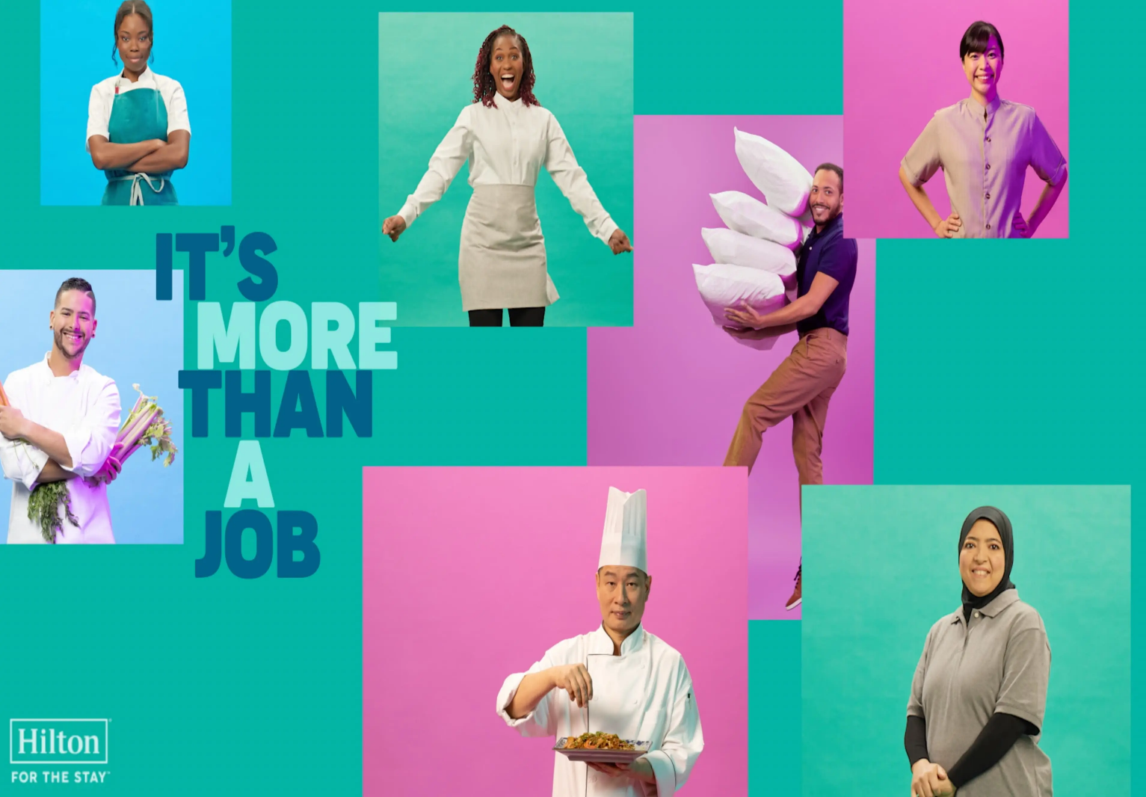

Student name: Anat Dranciuc Gergescu
Student number: 2125394
Module title and module code: Personnel Resourcing & Development (BMIH5005)
Lecture’s name: Deborah Lloyd
Word count: 2005

Hilton (2023)

How to engage employees (Generation Y’s or Generation Z’s) throughout the employee lifecycle?

In this essay, the main key points that will be presented are, Human resources and the interaction between the Hilton hotel chain and the recruitment of Gen Z and Gen Y, Gen Z’s and Gen Y’s lifestyle, Gen Z’s, and Gen Y’s job-hunting techniques and what they are looking for in a job, engaging with the team from both generations and its benefits, The employee lifecycle: attraction, recruitment, and development.
Mullins and McLean (p.390,2019) point out that Human Resources and recognition of people as the most important asset of the company are imperative. Recognizing that there is a massive difference between people as an asset and finances or technology assets massively improves the work environment and shifts the mindset of a company.
Having a focus on people's necessities, and strong dialogues across the company gives the business a huge success as well as its employees. Treating everyone as an equal and accepting everyone's ideas boosts the company's success.
Nawrat (2023) explains a different type of HR: named ERG which stands for employee resources group, it aims to have a closer approach between employees and senior leaders. Having honest and open discussions about any problems or new ideas benefits the company, allowing a gender-neutral dress code, supporting all employees equally and accepting all feedback boosts the company's productivity.
On another note, (Half, 2023) identifies five challenges that HR deals with daily:” Identifying and hiring candidates for open jobs”, managing remote and hybrid work, managing benefits and perks programs, and ensuring pay equity, staffing HR roles within the organization”.
All these small details need to be carefully analysed to meet the future employees' needs and reassure the company that they found the best candidates for the right jobs.
Now when it comes to Hilton’s HR, Shumway (2023) discusses the new changes implemented by Hilton’s HR and leadership worldwide after the COVID-19 pandemic. Launching same-day hiring fairs where jobseekers would get a job straight away, offering second chance hiring programs, hiring refugees, reintegrating retired workers back in the field of work, and hiring youth no matter the background and all this was based on the same program that HR used for the war veterans. By implementing a 24/7 partner at work, Hilton employees can learn the ropes and culture of the company, on another note Hilton University and the “Guild Education” program are supporting employees worldwide to either learn new skills, finish certain courses, get a high school diploma or higher education diploma all this being free for their employees to access.
From an HR point of view, these programs help all Hilton’s employees in different ways to achieve maximum success for work and personal goals.

When it comes to Gen Z (Fernandez, Landis, and Lee, 2023, Pappas, 2023) all identified the following aspects: Generation Z, born roughly between 1995 and 2010, is the most racially and ethnically diverse generation in history. This generation has also been influenced and is influencing macro-social movements and systemic issues that have shaped who they are and what they stand for in the workplace and society. They have played a crucial role in movements to combat racism and discrimination, sexual harassment, gun violence and worsening climate change, as growing income disparities make the possibility of social mobility more unrealistic than ever. To build trust and a stronger bond with this generation, companies need to prioritize transparency and change their management and communication style.
Access to information will alleviate Gen Z's anxieties and allow them to process and feel in control, giving them space for autonomy to keep them motivated companies need to make their management style flexible and give them more space and autonomy to explore and discover improvements in work processes. Create opportunities for these workers to build on their strengths, such as their use of technology, and social media, and their desire to connect.
Various ways to make Gen Z employees feel engaged within the company would be, opportunities for growth and development, the company should provide them with training programs to help them keep up with the latest trends in their field and give them the chance to familiarize themselves with new technologies that will make their working lives easier. Also, consider mentoring programs that will help younger employees seek advice from their more experienced colleagues.
Flexibility Remote work opportunities are extremely important for Gen Z employees, as they often prefer jobs that offer flexibility. In addition to flexible work arrangements, offering them wellness programs, such as gym memberships or mental health resources.
Recognition and reward programs, the company needs to recognize employees' efforts and dedication by offering them performance-based bonuses and other reward programs, all valued by Gen Z employees.
Companies should use social media platforms to share updates, news, and posts about employee achievements to attract a dynamic Gen Z audience. Younger employees are usually more active on social media and can use these platforms to communicate with their peers, promote the brand’s company, or even share feedback and opinions. They can even share company posts on their profiles or show followers some of their work, which is a great way to attract potential job candidates to their social networks.
In conclusion, Generation Z has high standards when it comes to hiring them and they don't settle for less. After all, they will represent most of the company's employees in the future, so it is special for the company to understand their unique needs and address them.
When discussing Gen Y, (Insync, 2019, Tivian, 2022, Indeed Editorial Team, 2022) point out the following aspects: millennials, were born between 1981 and 1994/6. They are currently between 25 and 40 years old.
Millennials have unique preferences that have led to changes in consumer behaviour, education, and workplace relationships, they can be an integral part of any workforce because of their open-minded approach, exposure to technology as they grow, and their effort to make their work environment diverse and culturally enjoyable. As a human resources (HR) employee, it can be helpful to know the skills and traits millennials possess and the factors that can attract them to their careers. Working remotely may require certain technological changes to ensure that team members can access home systems and complete their tasks successfully.
This software can include mailboxes and phone lines. While this may initially be a financial outcome for the business, being able to retain millennial team members in the long run is likely to outweigh those costs.
Creating flexible working hours can mean allowing employees to choose their working hours. This can help promote a positive company culture and instil trust in its employees to meet their deadlines. A flexible work schedule can also mean they can complete their work at the right time.
Companies that allow employees to take extra leave, allow them to celebrate holidays in their culture, in addition to the days they already have off for national holidays is a boost not only for the employee but for the company as well since it gives a more cultural acceptance in the company.
Scheduling regular meetings with the employees to seek feedback on how they are progressing in their work and opening the lines of communication makes for a better company. Managers and leaders who are considering scheduling more formal annual and quarterly meetings as an opportunity to document the goals and targets of the company will have more success.
Having associated new employees with someone who has worked in the company for a long time boosts the confidence of the new employee. This can be very useful for effective integration and training, can help bring new and old employees together and allow open communication to encourage creativity and new ideas, creating an environment where employees feel they can share their ideas and talk openly with managers and other team members is important.
As an HR manager or team leader, allowing team members to approach leaders without scheduling a meeting can be a great way to build trust and relationships within the company.
As for the employee’s life cycle HR University (2022), and Hrone (2022) describe the employee's life cycle as an HR framework or the theory that helps in supporting and encouraging jobseekers through their journey within a company. From reading the job advertisement to accepting the job and having the first training, all the way to retirement if applicable.
To ensure companies' HR successfully succeed in the previous discussion, Singh (2023) suggests keeping records, having constant free communication between employees and managers, and allowing employees to answer surveys with honest and free answers.
As for Hilton’s recruitment tactics (Castle,2014, Hilton,2022) points out that, Hilton’s vision is not just to make money, but to make life better for people in the countries where they operate.
Hilton puts its money where its mission statement is by funding internal training, running a Hilton University, and providing employment opportunities to people who have little or no education.
Hilton works closely with schools and training colleges to run work experience programs.
With 152 different positions within the Hilton business, there are plenty of jobs and positions that the company offers.
After a survey made by Hilton across Europe, the Middle East and Africa where the company has several hotels and resorts Gen Y and Gen Z agreed that flexibility while working, travel perks, contributing towards their workplace, social interaction and mental health well-being would be the most important factors towards a successful job.
To support its employees, Hilton launched a program named Thrive@Hilton which offers mental health and wellness support, an app for team members, and support for leaders to help them and their teams achieve both personal and professional goals.
When it comes to attracting and recruiting new employees Sales Operations, UK and Ireland (2022), Hilton Careers UK&I(2023), and Hilton (2023) suggest why Hilton Hotels and Resorts are the choices for most jobseekers with all the travelling perks, flexible working hours, lots of courses and job positions, opportunities to travel world-wide and so much more.
As for employee engagement, (Rai p.1,2 2012) points out that employee engagement is, helping companies understand the power of engaging their employees towards delivering high-quality performance and services. Engaged employees offer more to the workplace, its clients, and the company. On the other hand, companies need to identify this behaviour and prize it. Engagement from both parties, employer and employees must be honest and constant for it to succeed.
When it comes to motivation theories and applying them by companies (Osemeke, Ph.D and Adegboyega 2017, Ching 2015, and Burchard 2023) discuss that, by understanding Maslow’s pyramid of needs and McClelland’s needs theory, companies can successfully motivate their employees.
Maslow’s pyramid has the following principles: physiological needs, compensation and comfortable conditions, safety needs, social needs, esteem needs and self-actualization needs. In other words, paid breaks, a clean and safe work environment, good communication between staff and management, recognition of a hard worker employee, equal opportunity promotions or courses.
On the other side, McClelland’s needs theory has the following steps: achievement, affiliation, and power and these could be applied to any individual depending on their skills and abilities. Managers must recognise high performance within their team of employees and need to prize them and challenge and support them threw their growth. Having the ability to identify affiliation employees throughout the team will help the managers build strong teamwork with them and solve different projects or problems with their help since these employees work brilliantly within a team-based company. Employees who are driven by power in the workplace can be motivated by managers who provide them with access to leadership roles or promotions within the company, recognising their expertise and talent and rewarding it.
To effectively implement these theories, managers need to consider assessing employees' individual needs, tailor motivation strategies based on individual needs, create a supportive work environment, and finally provide continuous development opportunities.
In conclusion, after all, Gen Z and Gen Y are looking for almost the same aspects in a job, cultural understanding and acceptance, free communication with managers and leads, fair pay and promotion.

Reference list:

Bhavna Singh (2022) Only 4 Employee Experience Lifecycle Stages That Matter [+ways to measure & optimise].[Online] Available at: https://hrone.cloud/employee-lifecycle-stages/ (Accessed: 23 October 2023).
HROne (2022) Employee Experience Lifecycle Stages That Matters | HROne – YouTube. [Online] Available at: https://www.youtube.com/watch?v=UNtMPV4ZPgU (Accessed: 23 October 2023).
HR University (2022) What is the Employee Life Cycle? - YouTube. [Online] Available at: https://www.youtube.com/watch?v=q6tYsyFF-yM (Accessed: 23 October 2023).
Hilton Careers UK&I(2023) Hilton Recruitment - Chefs - YouTube. [Online] Available at: https://www.youtube.com/shorts/OJYXB_wHrl8 (Accessed: 23 October 2023).
Hilton (2023) Hilton. For the Stay. | Every Job Makes The Stay - YouTube. [Online] Available at: https://www.youtube.com/watch?v=B_lASitcM_c (Accessed: 23 October 2023).
Sales Operations, UK and Ireland(2022) Hilton's of London Recruitment - YouTube. Available at: https://www.youtube.com/watch?v=kRLaN8TpD6I (Accessed: 23 October 2023).
Monday Osemeke, Ph.D and Samuel Adegboyega (2017) Critical Review and Comparism between Maslow, Herzberg and
McClelland's Theory of Needs. [Online] Available at: https://www.fujabf.org/wp-content/uploads/2018/01/Critical-Review-and-Comparism-between-Maslow-Herzberg-and-McClellands-Theory-of-Needs.pdf (Accessed: 23 October 2023).
Brandon Ching (2015) Literature Review on Theories of Motivation. [Online] Available at: https://www.linkedin.com/pulse/literature-review-theories-motivation-brandon-ching-phd (Accessed: 23 October 2023).
Oskar Burchard (2023) Motivating Hotel Employees: Insights from Maslow's Pyramid of Needs and McClelland's Needs Theory. [Online] Available at: https://www.linkedin.com/pulse/motivating-hotel-employees-insights-from-maslows-pyramid-burchard (Accessed: 22 October 2023).
Soumi Rai (2012). International Conference on Emerging Economies - Prospects and Challenges/ Engaging Young Employees (Gen Y) in a Social Media Dominated World – Review and Retrospection. [Online] Available at: https://www.sciencedirect.com/science/article/pii/S1877042812007719
Emma Castle (2014) Gen Y and Z employment: Hilton's vision for 'millennials'. [Online] Available at: https://www.spicenews.com.au/hotel-venue-news/gen-y-z-employment-hiltons-vision-millennials / (Accessed: 11 October 2023).
Hilton (2022) The Workplace of The Future: Millennials and Gen Zs Call for Social Interaction, Travel Perks, Flexible Working Hours and Purpose‑Driven Work across Europe, Middle East & Africa. [Online] Available at: https://stories.hilton.com/emea/releases/future-workplace-millennials-gen-z (Accessed: 11 October 2023).
Insync (2019) Four steps to inspire Gen Y employees. [Online] Available at: https://insync.com.au/insights/four-steps-to-inspire-gen-y-employees/ (Accessed: 11 October 2023).
Tivian (2022) MILLENNIALS IN THE WORKPLACE: HOW TO MANAGE GEN Y SUCCESSFULLY. Available at: https://www.tivian.com/us/generation-y / (Accessed: 11 October 2023).
Indeed Editorial Team (2022) How to Attract and Retain Millennial Employees (A Guide). [ Online] Available at: https://au.indeed.com/career-advice/career-development/how-to-attract-and-retain-millennial-employees (Accessed: 11 October 2023).
Jenny Fernandez, Kathryn Landis, and Julie Lee ( 2023) Helping Gen Z Employees Find Their Place at Work. [ Online] Available at: https://hbr.org/2023/01/helping-gen-z-employees-find-their-place-at-work (Accessed: 11 October 2023).
Christopher Pappas (2023) How To Make Gen Z Employees Feel More Connected. [Online] Available at: https://elearningindustry.com/how-to-make-gen-z-employees-feel-more-connected (Accessed: 11 October 2023).Accessed: 11 October 202
Hilton job opportunities (2023) Careers at Hilton |. [ Online] Available at: https://jobs.hilton.com/emea/en (Accessed: 18 October 2023).
Mullins, L, & McLean, JE 2019, Mullins: Organisational Behaviour in the Workplace, Pearson Education, Limited, Harlow. [Online] Available at: https://ebookcentral.proquest.com/lib/trinity/reader.action?docID=5830196# [18 October 2023].
Allie Nawrat (2023) Ethics must be top of mind with HR & AI. [Online] Available at: https://www.unleash.ai/unleashworld/hr-tech/netcompany-cpo-ethics-must-be-top-of-mind-with-hr-ai/ (Accessed: 19 October 2023).
Emilie Shumway (2023). Hilton’s CHRO on how purpose drives the company’s HR strategy | HR Dive. [Online] Available at: https://www.hrdive.com/news/hiltons-chro-how-purpose-drives-hr-strategy/638449/ (Accessed: 19 October 2023).

