Operating Systems
Module Name: Computer Architecture & OS
Module Code: ACCA 4022
Student Name: Fatema Bandali
Student ID:2514792
Lecturer Name: Md Shantanu Islam

Submission date:

Contents
Introduction 4
Key functions of general Operating Systems 4
Task Management: 4
Application/Program Management: 4
File/Directory Management: 5
Device Management: 5
Security Management: 6
Use of Windows OS CLI commands 7
Example 1: 7
Example 2: 7
Example 3: 8
Example 4: 8
Example 5: 8
Example 6: 9
Example 7: 9
Example 8: 10
Example 9: 10
Example 10: 11
Use of Linux OS CLI commands 11
Example 1: 11
Example 2: 12
Example 3: 12
Example 4: 13
Example 5: 13
Example 6: 14
Example 7: 14
Example 8: 15
Example 9: 15
Example 10: 16
Use of Windows OS scripts 16
Example 1: 16
Example 2: 17
Use of Linux OS scripts 18
Example 1: 18
Example 2: 19
Conclusion 20
References 20
Appendices 21

Introduction
Write a brief description of this coursework. Describe what this report contain. (100 words)

Key functions of general Operating Systems
Write an introduction about windows operating system when it came, importance, functions. Use 1-2 references (50 words)

Task Management:
Task management shows you all apps that are currently open in your background,it shows you the history and usage of applications and allows you to manage the app tht automatically open when signing in to windows and what current sessions are loggedin.It shows you apps that logged in, it allows you to check memory and End task to force close a programme that is giving issues. [1] Use 1 reference minimum (100 words)
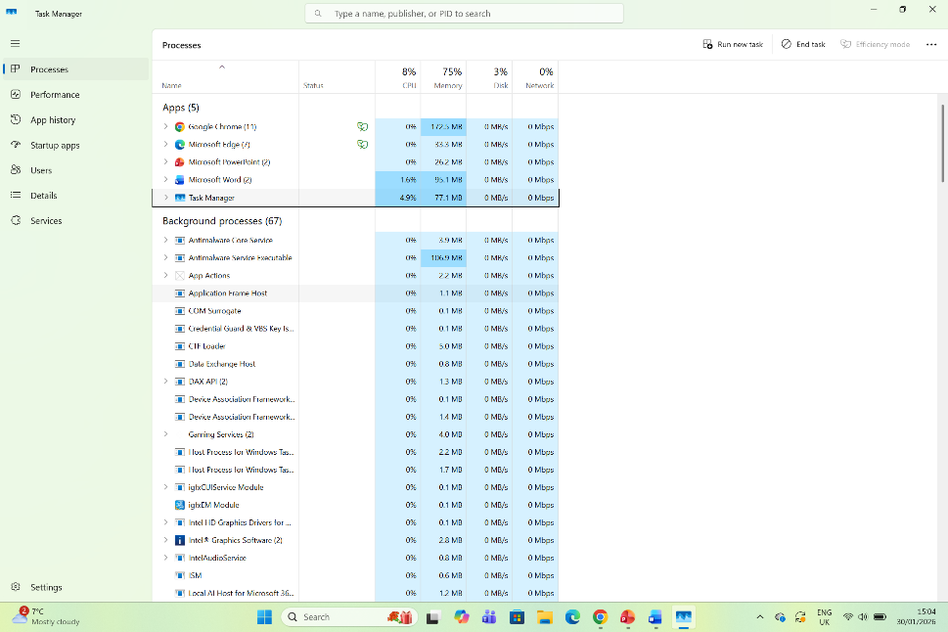
Figure 1: Task Manager

Application/Program Management:
Write about Application/Program management in windows. Use 1 reference minimum (100 words)
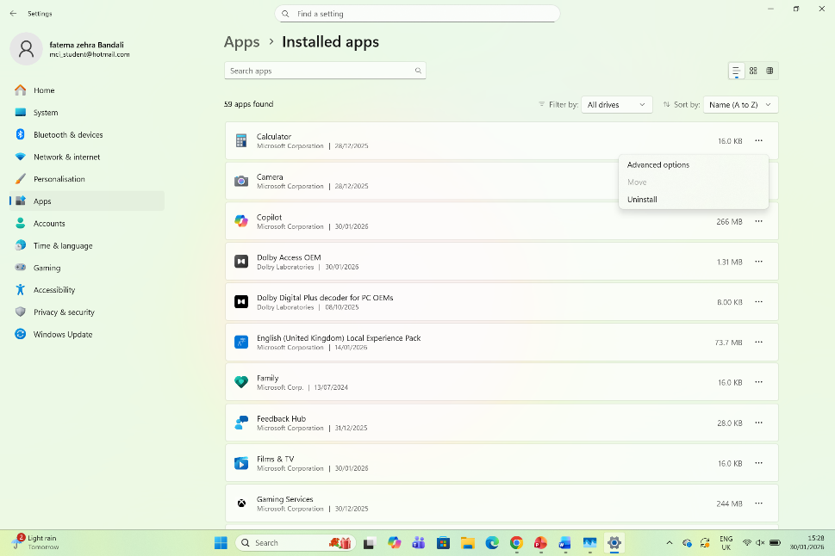
Figure 2: Programme manager

File/Directory Management:
File management helps in organizing folders and where you would like to save your documents. It also helps you to create sub folders in which you can Edit, delate /rename file/folders and can sort according to size and date. It also lets you view the folders in different ways such as Icons, lists or details.You can also view where you iles are saved and under what document name which can be moved accordingly. [2]

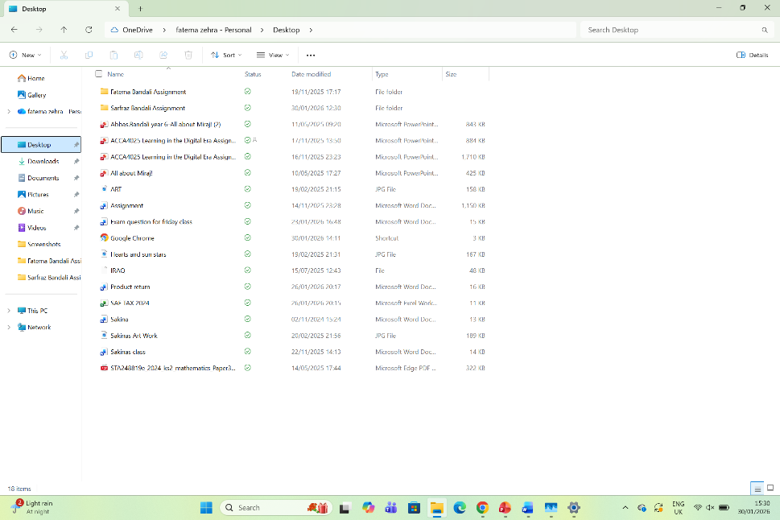
Figure 3: Windows Explorer

Device Management:
Device management shows the hardware which you can install, update and troubleshoot a device.If a device is working properly or not.It also helps to configure devices remotely for security purposes. It increases efficiency and reduced administrative time. For example you want to check the camera/webcam is functioning properly. It can be found if you type device management in the search bar.[3]
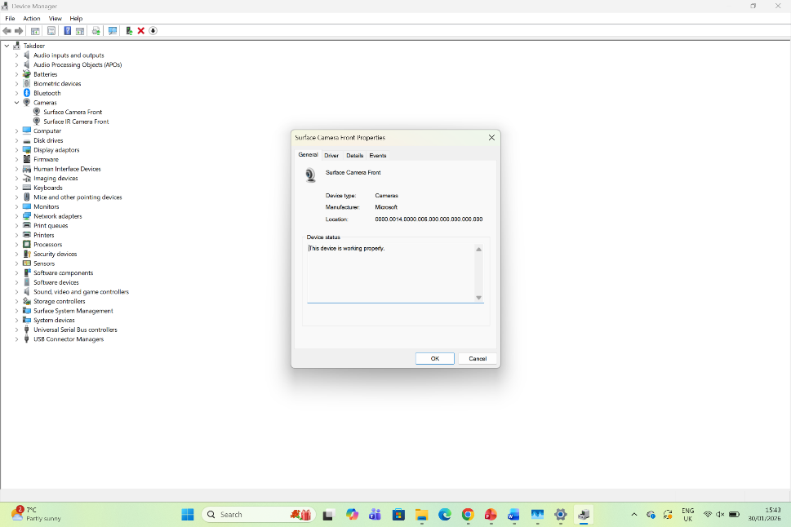
Figure 4: Device Manager

Security Management:
Security management helps with keeping up and checking with the device security.Y ou can check the account protection, network and virus. It also show your device performance and protection history

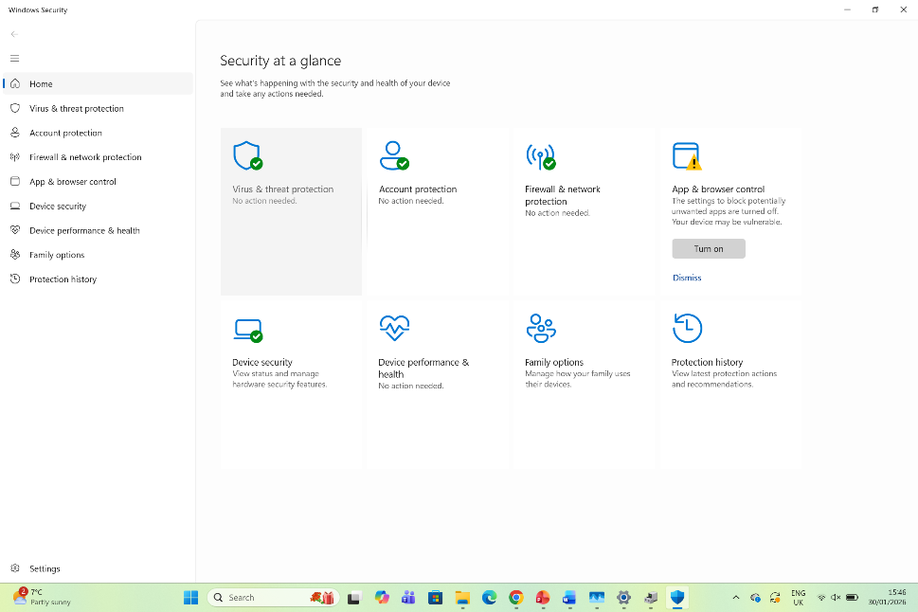

Figure 5: Security Manager

Use of Windows OS CLI commands
Write about windows CLI functions and applications. Use 1-2 references. (40 words)
CLI Windows shows you the information of the system and configuration one the device. It’s where you input your commands that communicate with the computer system.

Example 1:
Explain the command and output. (30 words)
Dir-mostly all commands are in small letters
cd-change directory to change location-cd d than tab
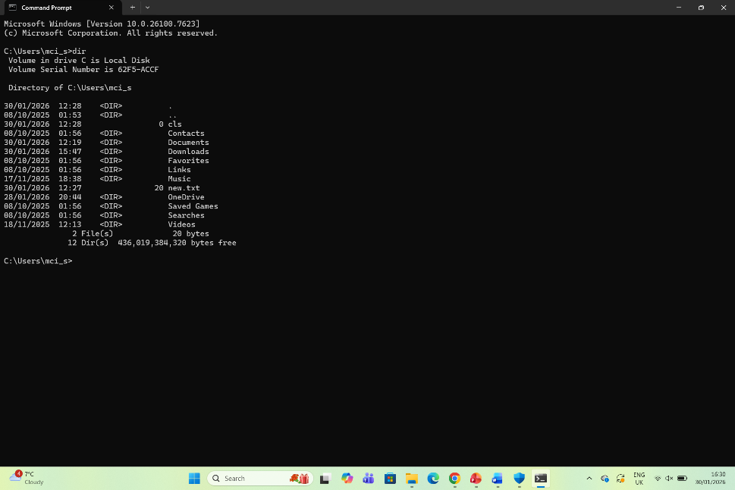
Figure 6: DIR

Example 2:
The cd helps to chamge between directories in Linux.
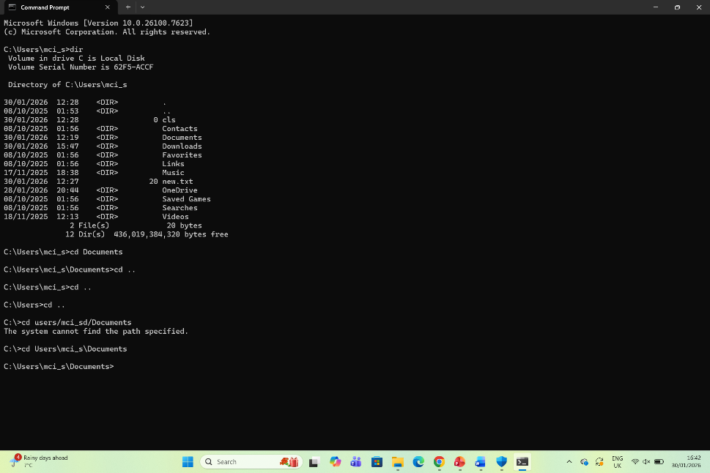
Figure 7: CD

Example 3:
Mkdir creates a new system in the system.
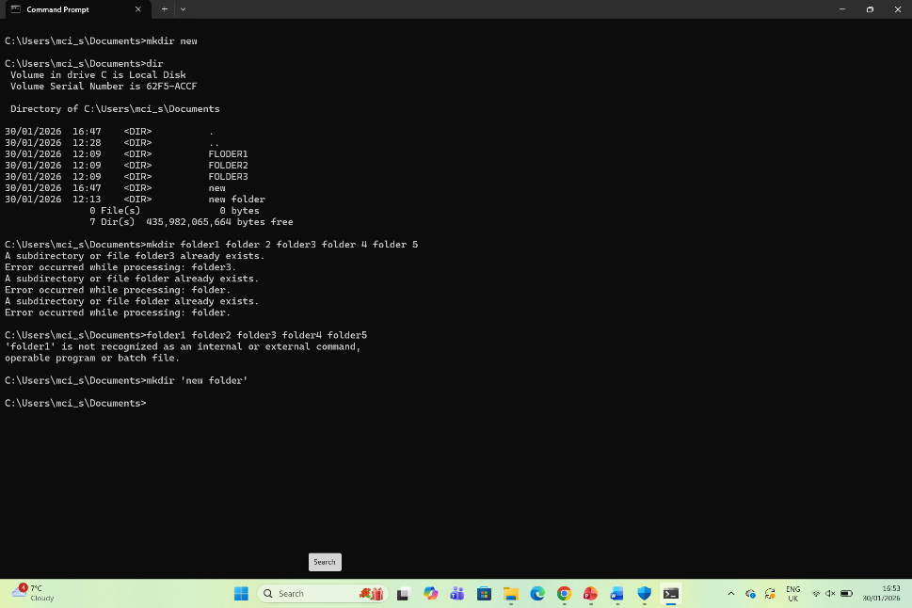
Figure 8: MKDIR

Example 4:
I used cd to go to documents-can also do space and ..
To clear the screen press cls-center
New folder mkdir new
Rmdir-remove directory
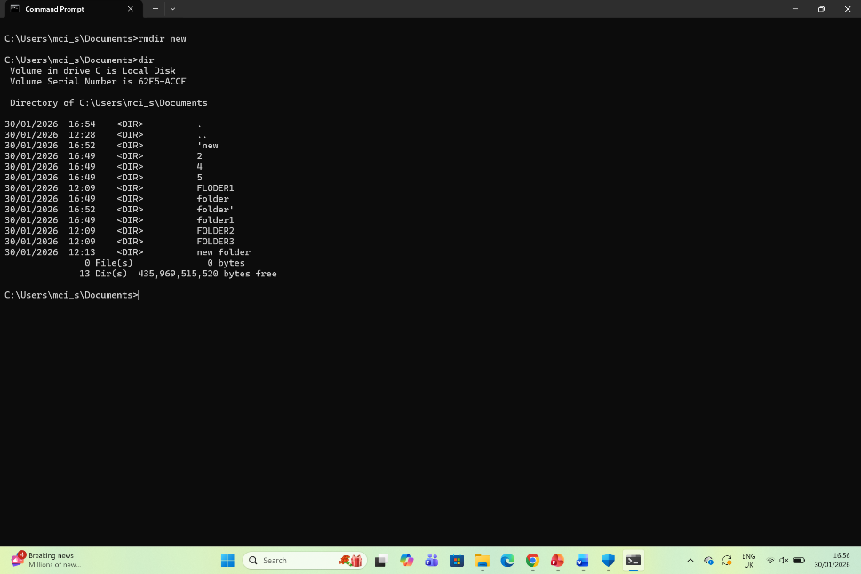
Figure 9: RMDIR

Example 5:
command is echo-after echo you can write the message you want,
Arrow is the location and then the name of the file-file.txt

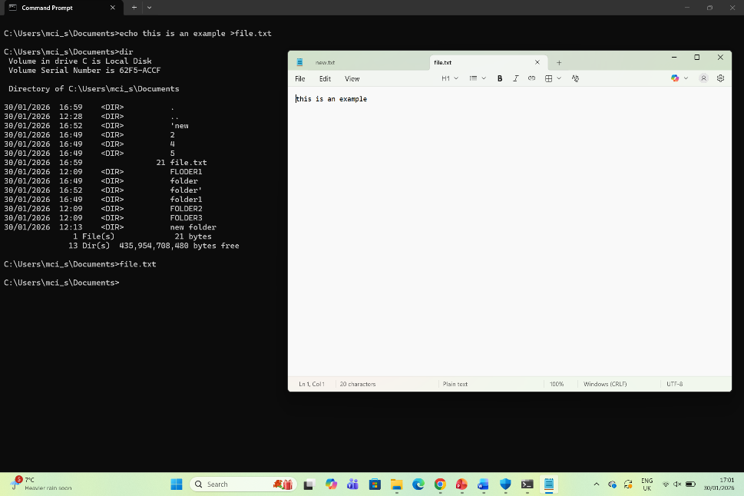
Figure 10: ECHO

Example 6:
Typed task list and it brought it all 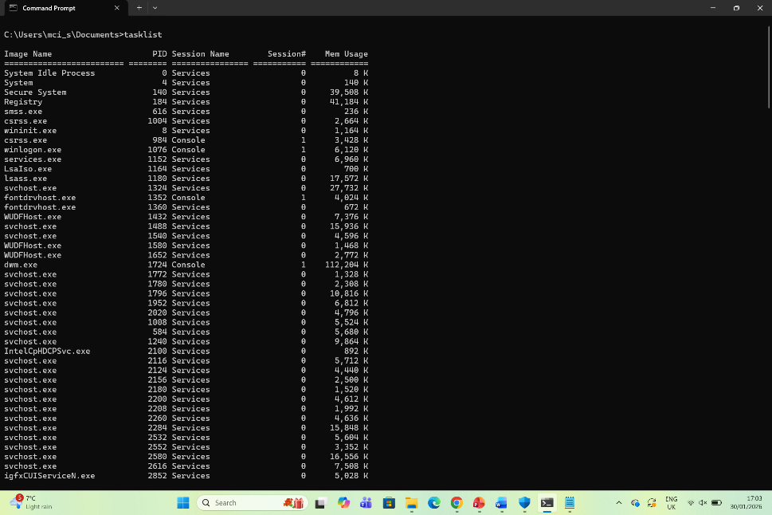
Figure 11: Task list

Example 7:
Type system info and all opens with the information
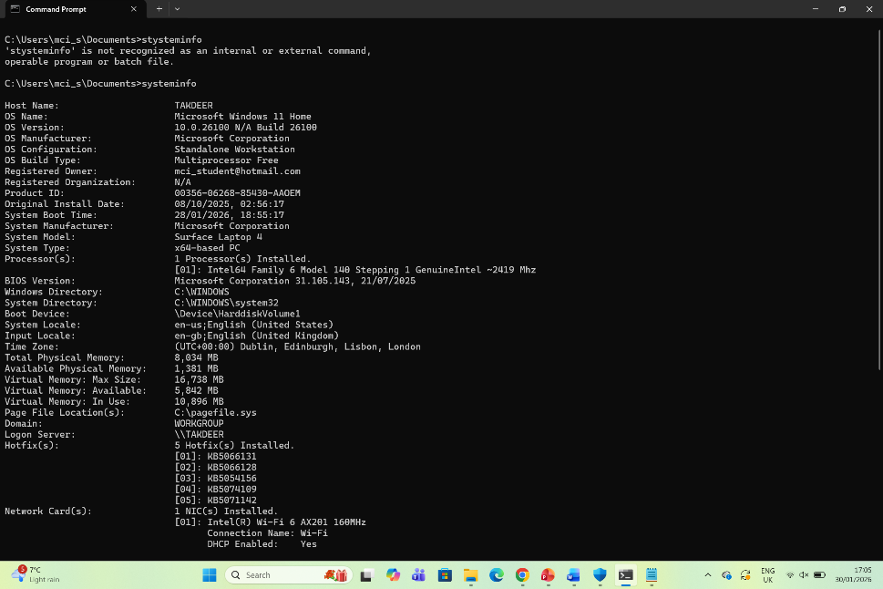
Figure 12: System Info

Example 8:
Typed ipconfig /all

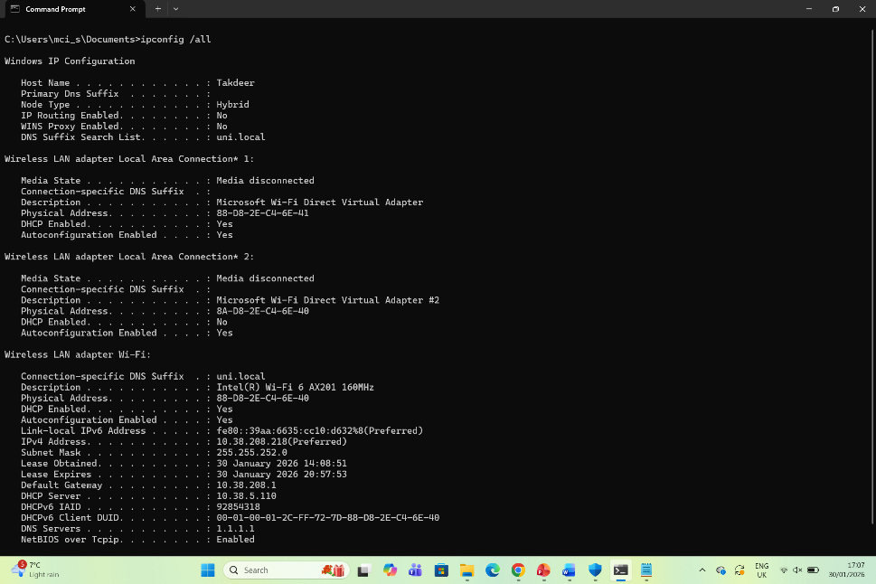
Figure 13: IPCONFIG

Example 9:
ping www.google.com-to check internet connection
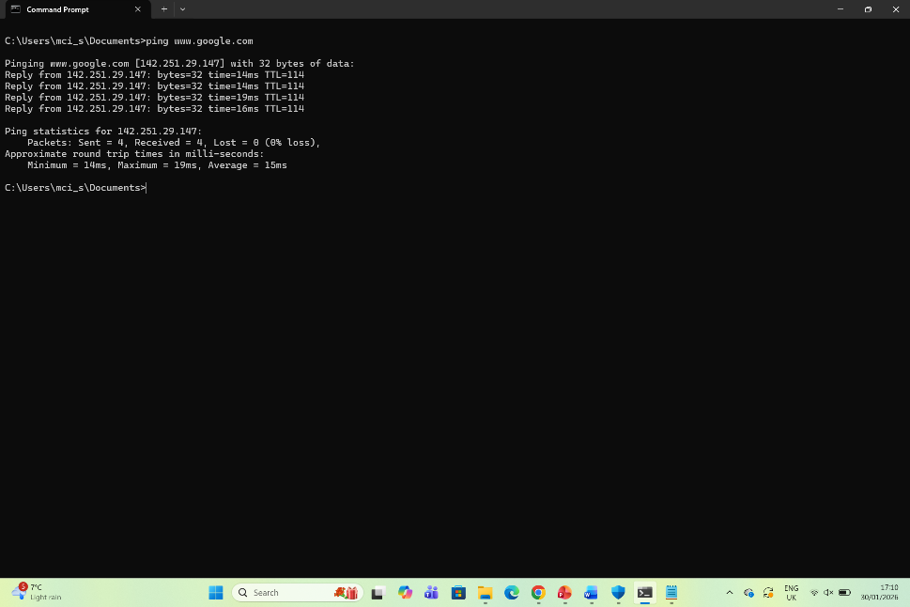
Figure 14: PING

Example 10:
Typed netsat to check network
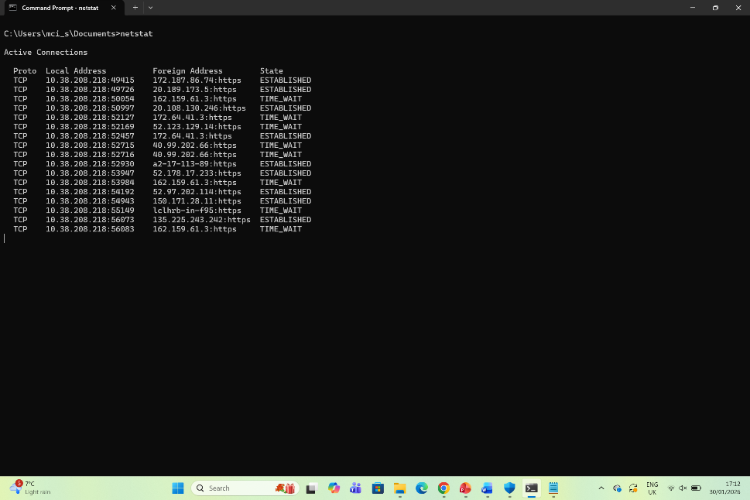
Figure 15: NETSTAT

Use of Linux OS CLI commands
The Linux interacts with system by using text commands and enables efficient task exicution.Use [4]

Example 1:
The su command is to switch user.
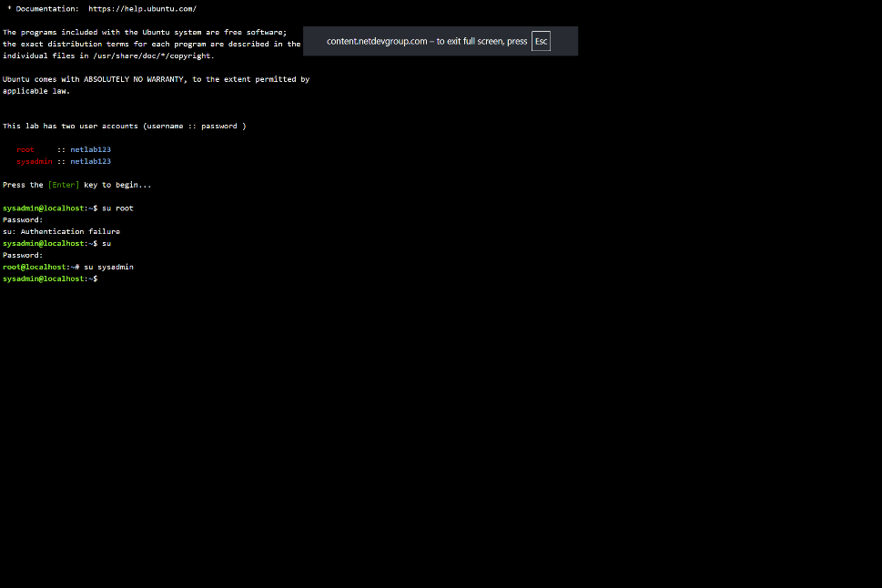
Figure 16: su

Example 2:
Thw pwd shows the location you are in.
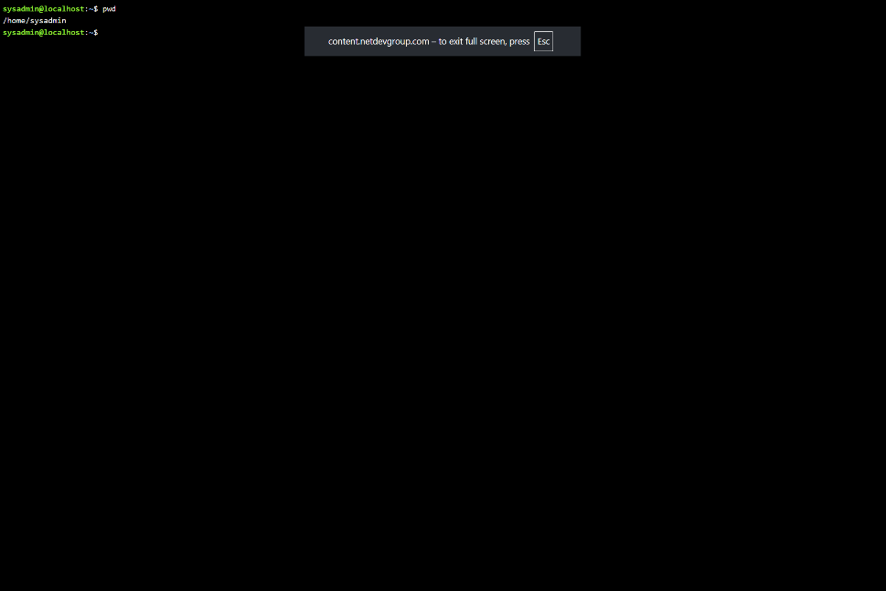
Figure 17: pwd

Example 3:
The is command shows current list of folders with names,sizes and dates.
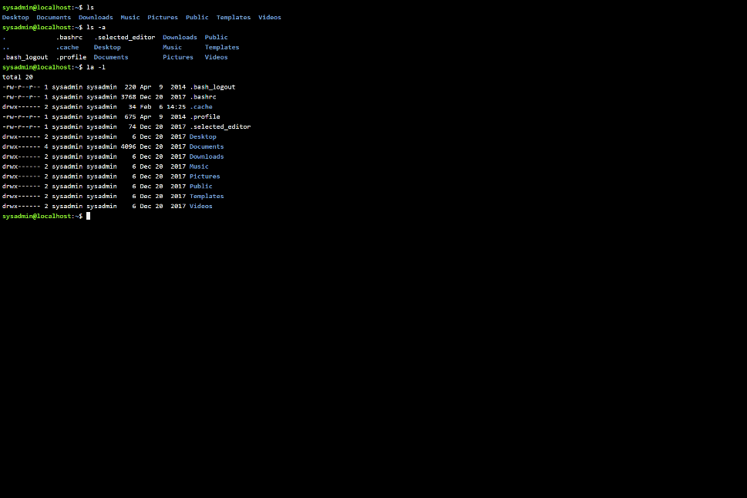
Figure 18: ls

Example 4:
The cd command chamges the current folder name

Figure 19: cd

Example 5:
The mkdir creates a new folder, and produces no out put if created successfully.
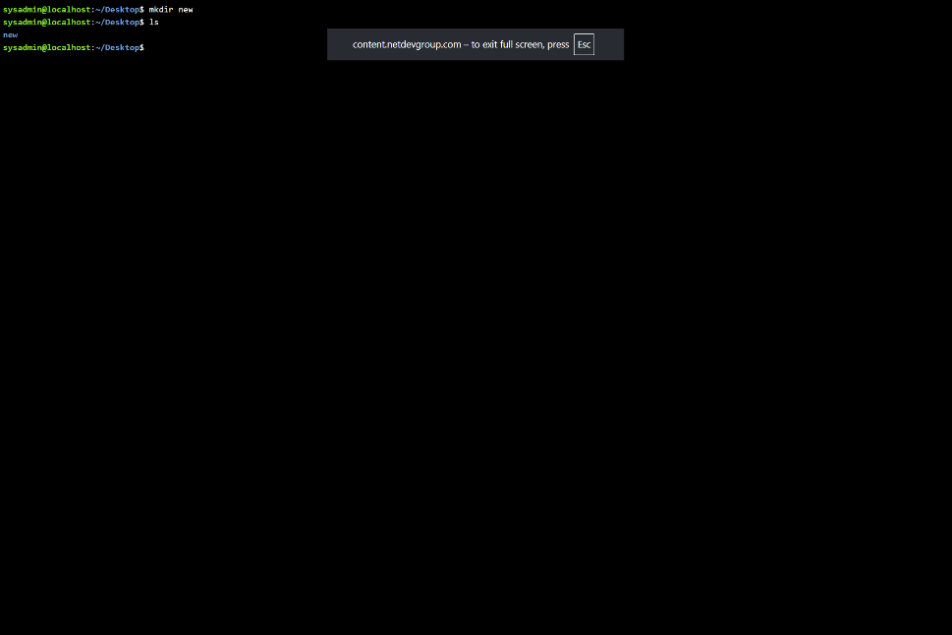
Figure 20: mkdir

Example 6:
The rmdir command takes out empt directory, if tit doesn’t exists it shows an error and has no putput.
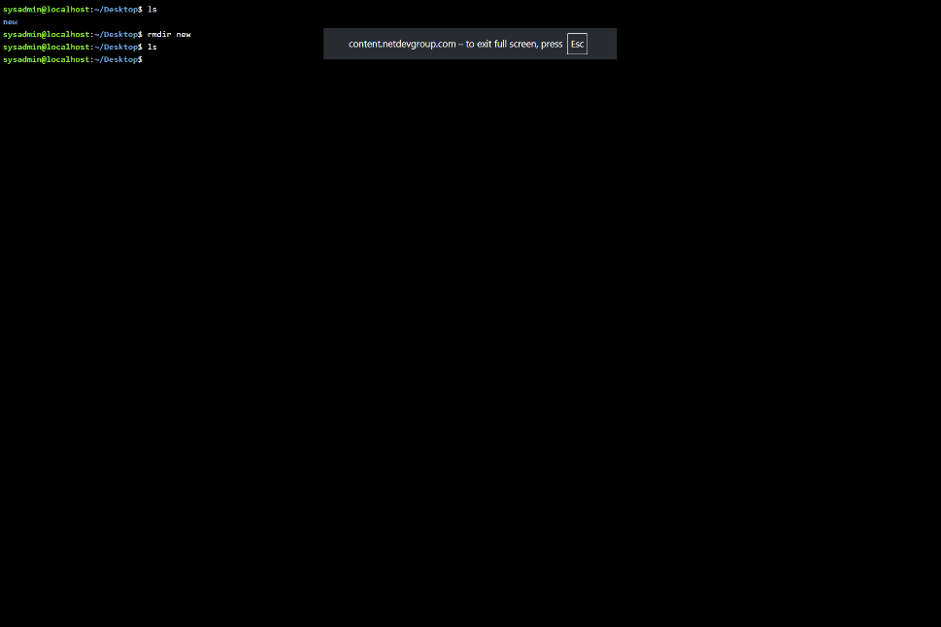
Figure 21: rmdir

Example 7:
Touch created a new file, doesn’t produce any visible out pus but can change when file was last modified.
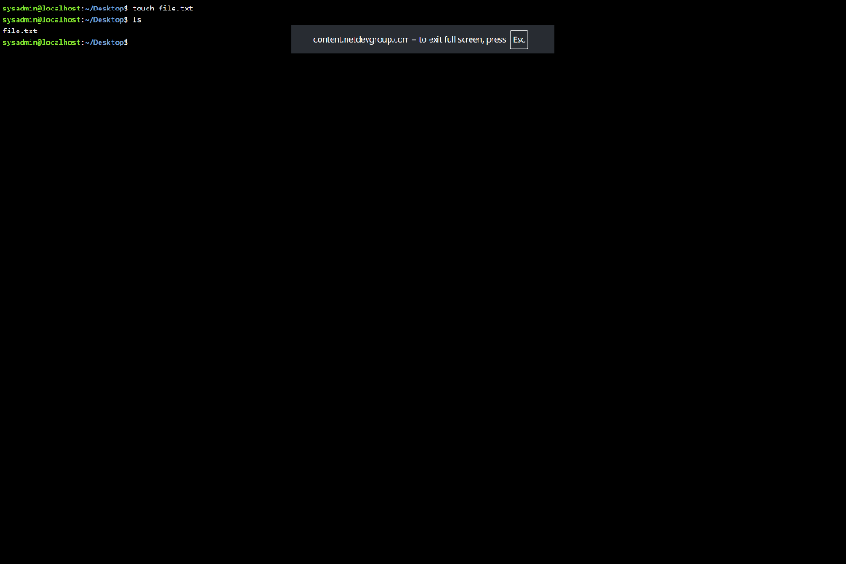
Figure 22: touch

Example 8:
Th echo commands display the text, the cat shows what is in the file while rm command deletes the files. Output is printed text and the content display.
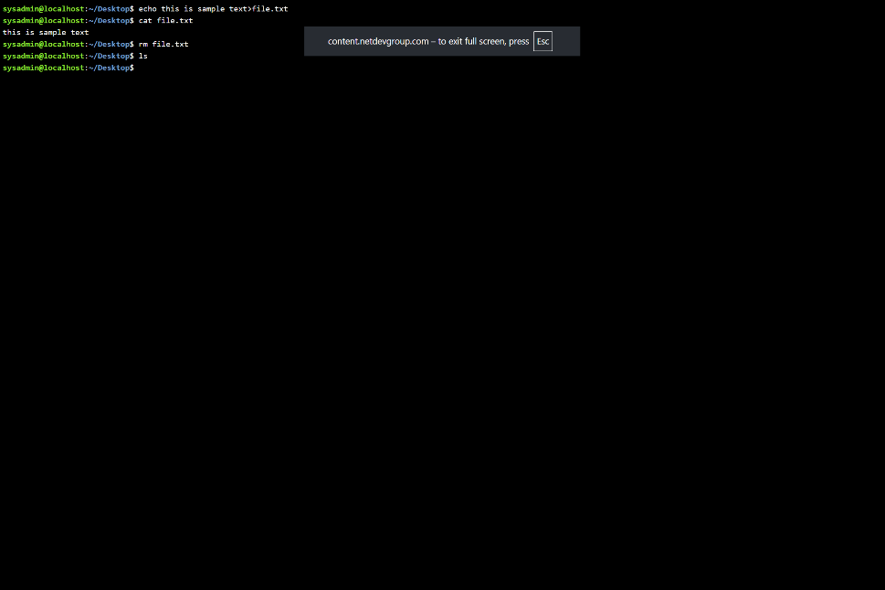
Figure 23: echo, car,rm

Example 9:
The if config shows the network details, IP address and reived data.
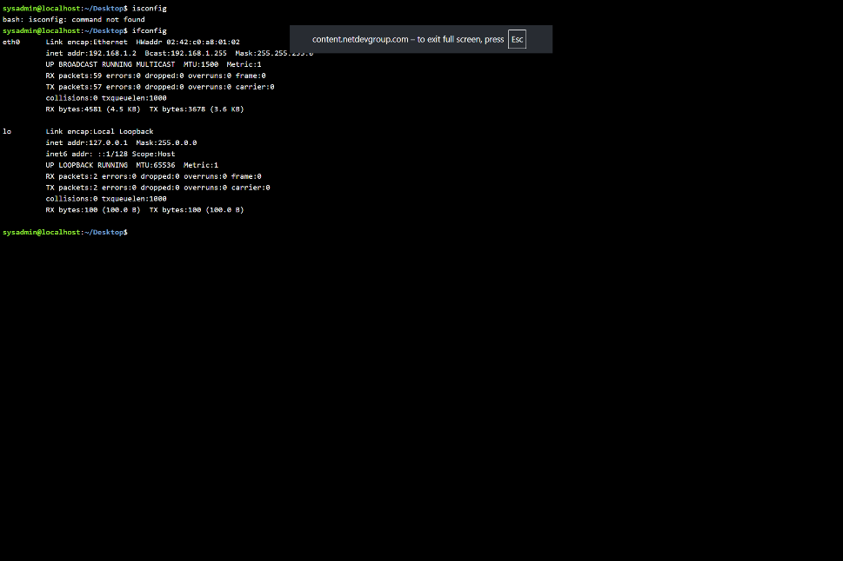
Figure 24: ifconfig

Example 10:
The who am I command shows the user who is currently logged in and the date cte shows the current date and time.

Figure 25: who am I,date

Use of Windows OS scripts
Batch scripting Is used to automate tasks that need to be repeated on windows system. It has a series of commands hat help you automate repeated tasks.[5]
It helps with Common applications such as file backups, file management and configuration. It also has the common applications such as installation and scheduling Maintenance.
[6]

Example 1:
This script shows 2numbers added by the user, echo off hides execution of commands. Set p is used twice for Num 1 and then Num 2 and are sorted as variables .The numb1 and numb2 form an addition ad than stores results as total. Pause stope the window from closing immediately.
If user adds NUMB 2 and NUMB 3 ,Output would be 5.

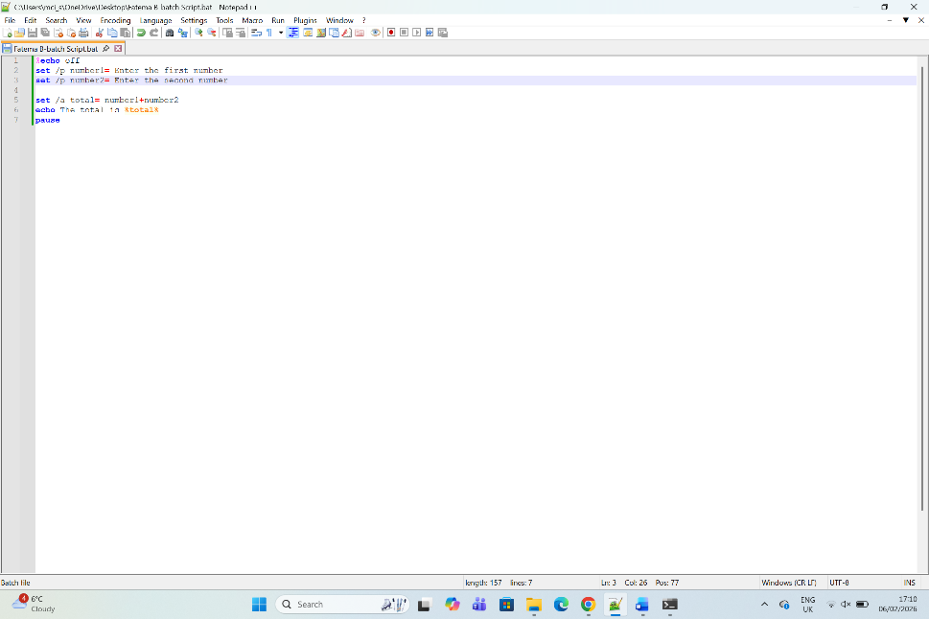
Figure 26: Adding two numbers
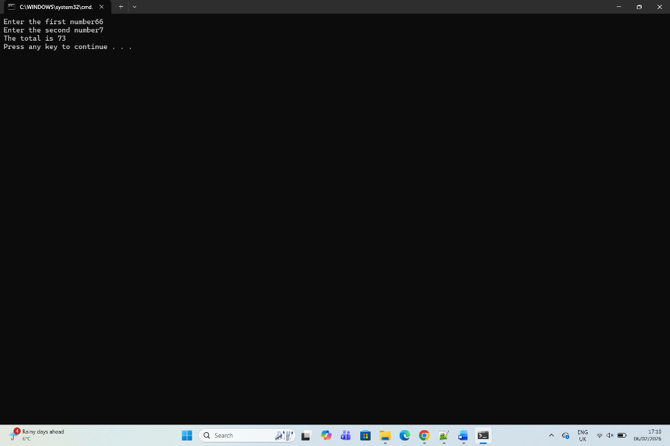
Figure 27: Adding the two numbers

Example 2:
Explain the script and output. (150 words)
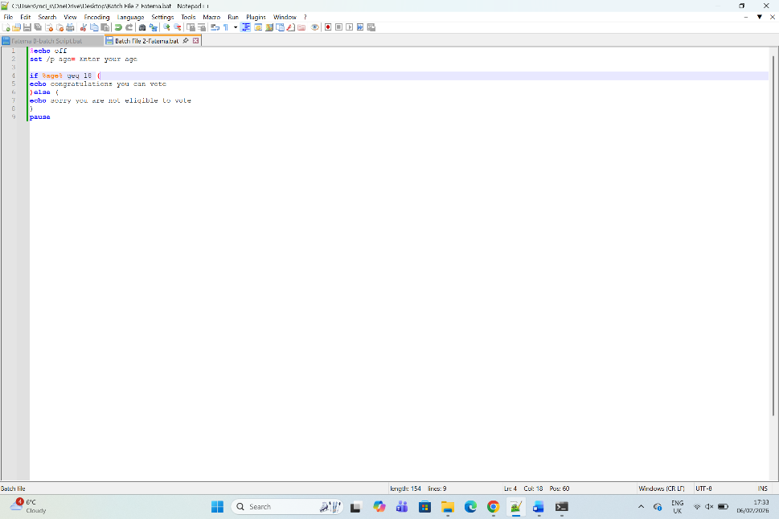
Figure 28: Description
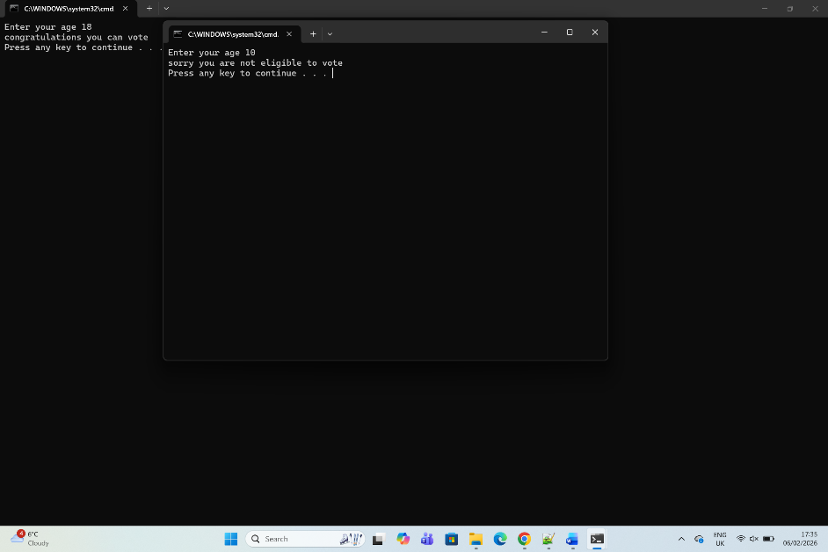
Figure 29: Description

Use of Linux OS scripts
BASH scripting is writing the sequence for commands, so it can perform the task automatically, BASH allows you to run it in a single step rather than running it one by one which saves time.[7]

Example 1:
BASH Scripts are a series of commands and have two outputs which are called standard and error. The arithmetic addition displays the value of variable sume
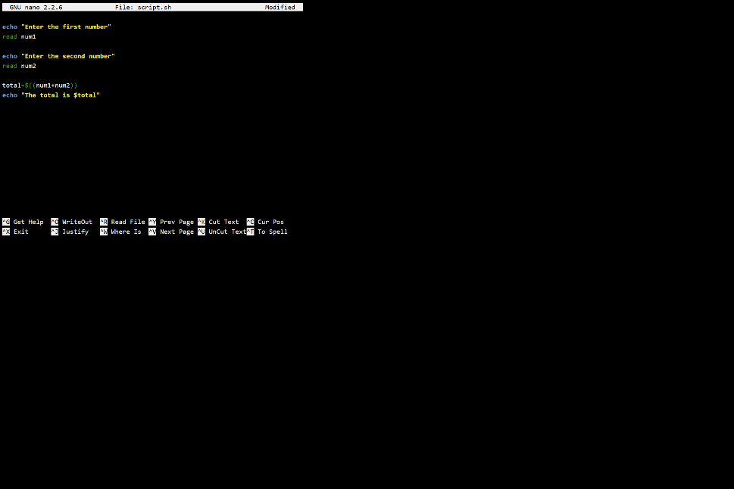
Figure 30: Bash script to add two numbers
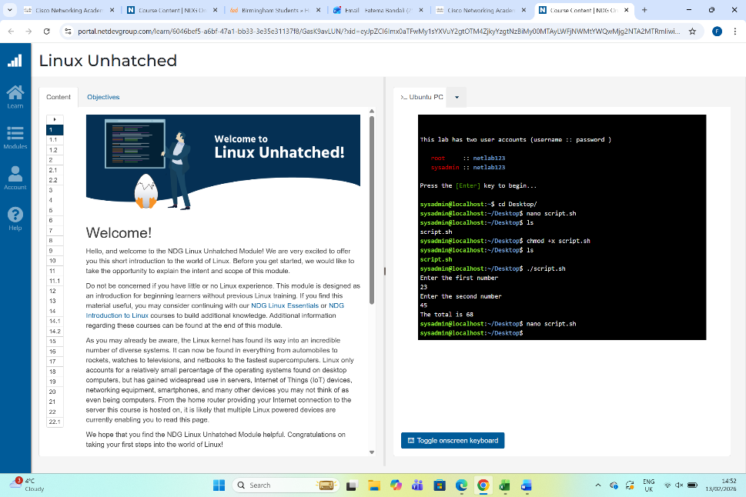
Figure 31: Out of script in figure 30

Example 2:
Loop works with number, fil and words. The for keyword is followed by a variable name a range of values and a keyword that marks the start of a loop block. (150 words)
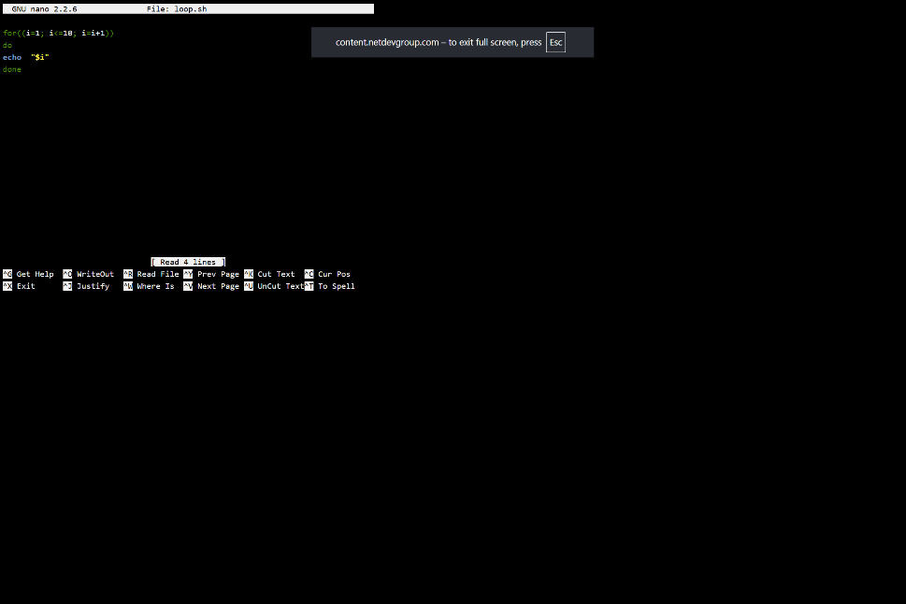
Figure 32:example of fol loop
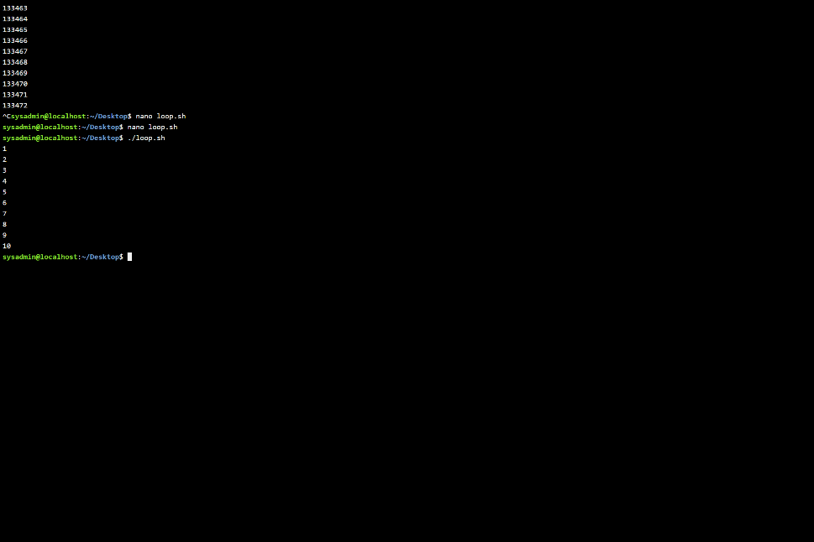
Figure 33: output of fol loop

Conclusion
This assignment teaches us general keyboard operating functions, and how the Linux operating function works,teaches you how to pertate

References
[7]

Appendices
Online Course name:
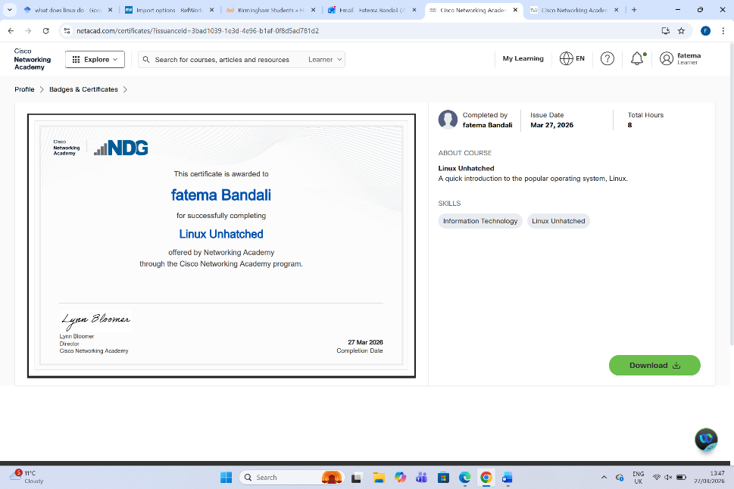
Figure 34: Certificate of completion

