Name: Chris Morris
Student number: P149915
Module title: Project Management
Assignment number: 1
Module code: M5X00615
Lecturer: Sue Maw
Contents
Abstract 1
Introduction 2
Content 3
Risk matrix 3
Completed project 4
Project plan 4
Sustainability and ethical/legal issues 5
Quality of service 5
Conclusion 7
References 8

Abstract

A network for a local charity was constructed by a trio including the author. The documents created along the way included a project plan and a risk analysis matrix, alongside the completed simulation. Meanwhile, the consequences of the task were given consideration, such as how it would be sustainable. At the end, the positives and drawbacks were considered, including the author’s view on their contributions.

Introduction
The objective is to construct a device based on a client need, as part of a project worked on by a group consisting of three people. It was decided that a network would be created for a local charity. To help achieve this, a project plan and initiation document should be created to manage and track progress. Other documents such as a risk matrix must also be formed to help analyse the most important potential drawbacks. As well as these, issues such as sustainability are required to be taken into consideration. Once complete, an evaluation should be carried out, including areas that were performed sufficiently and targets for improvement in future projects.

Content

Risk matrix
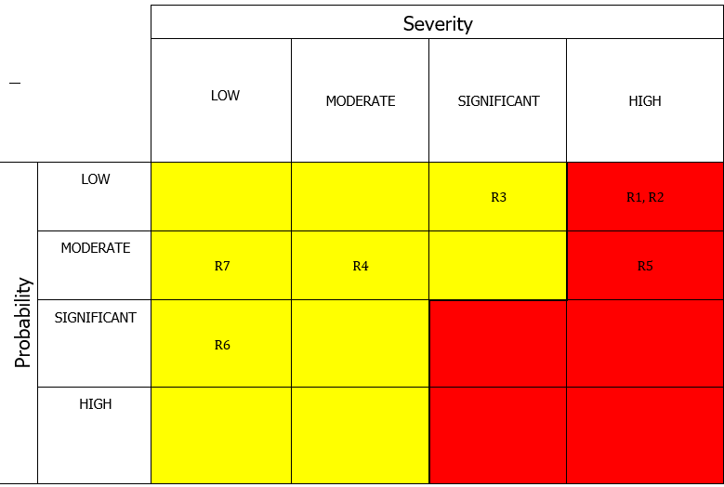
Figure 1: Risk matrix diagram
To help manage potential drawbacks to the project, a risk assessment matrix was created. This helped identify which issues could damage the project the most and consider even low risks. There are seven risks that the group identified and decided its significance if caused;
- The network components malfunctioning. This was decided as an unlikely risk, as the group aims to stick to knowledge we are familiar, but high-impact, as a replacement would be required immediately if it did occur. To be safe, the team will discuss what to select as a replacement if a component does malfunction.
- The client suddenly deciding to shut down. The chances of this are small, as can be seen by the client’s desire on their website to stay in Swansea, but if it did happen, it could cause a huge impact, forcing the group to choose another client. To minimise the risk, the group agreed to regularly communicate with the charity.
- A network hack. This is a significant risk and would require many changes but was deemed unlikely to occur. The group is familiar with this factor and can make changes to keep the network safe. Protection measures against this include the use of an anti-virus program and relaying safety information such as passwords and how to connect safely to the client.
- The client switching address. This was deemed an average-sized risk overall, one that has an impact but can hopefully be easily fixed. If necessary, the project can plan for expansion to cover a wider area.
- A network failure. This is something that is unlikely provided the group sticks to our current knowledge but can cause a big impact without care. In the case that we fall stuck, we plan to ask a member of staff for assistance, provided we cannot research the problem first.
- The network failing to connect. This is the author’s highest concern, that the network will encounter bugs along the way and require more time to fix. Again, the group can ask for assistance in the matter, or perhaps allot time away from studies to ensure that the network is running as efficiently as possible.
- The Internet Service Provider (ISP) being changed. This was deemed the risk that could cause the lowest amount of damage, but still worth consideration. The group will keep updated for any adjustments of the ISP and plan a substitute in the case of any changes.

Completed project
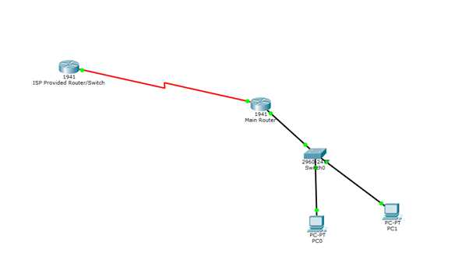
Figure 2: Network screenshot
The group initially decided to manually configure network using the network labs provided by the university, but instead chose to stick to a simulated network in Cisco Packet Tracer. This ensured that changes could easily be made, and the layout is as clear as possible to the client. The group’s familiarity with Packet Tracer was also a factor. The network encompassed multiple features such as VLAN and manual passwords to ensure it remained as secure as possible. The charity PC’s will link to a switch to allow for any configuration, which then connects to a router and provides a gateway to the ISP.

Project plan
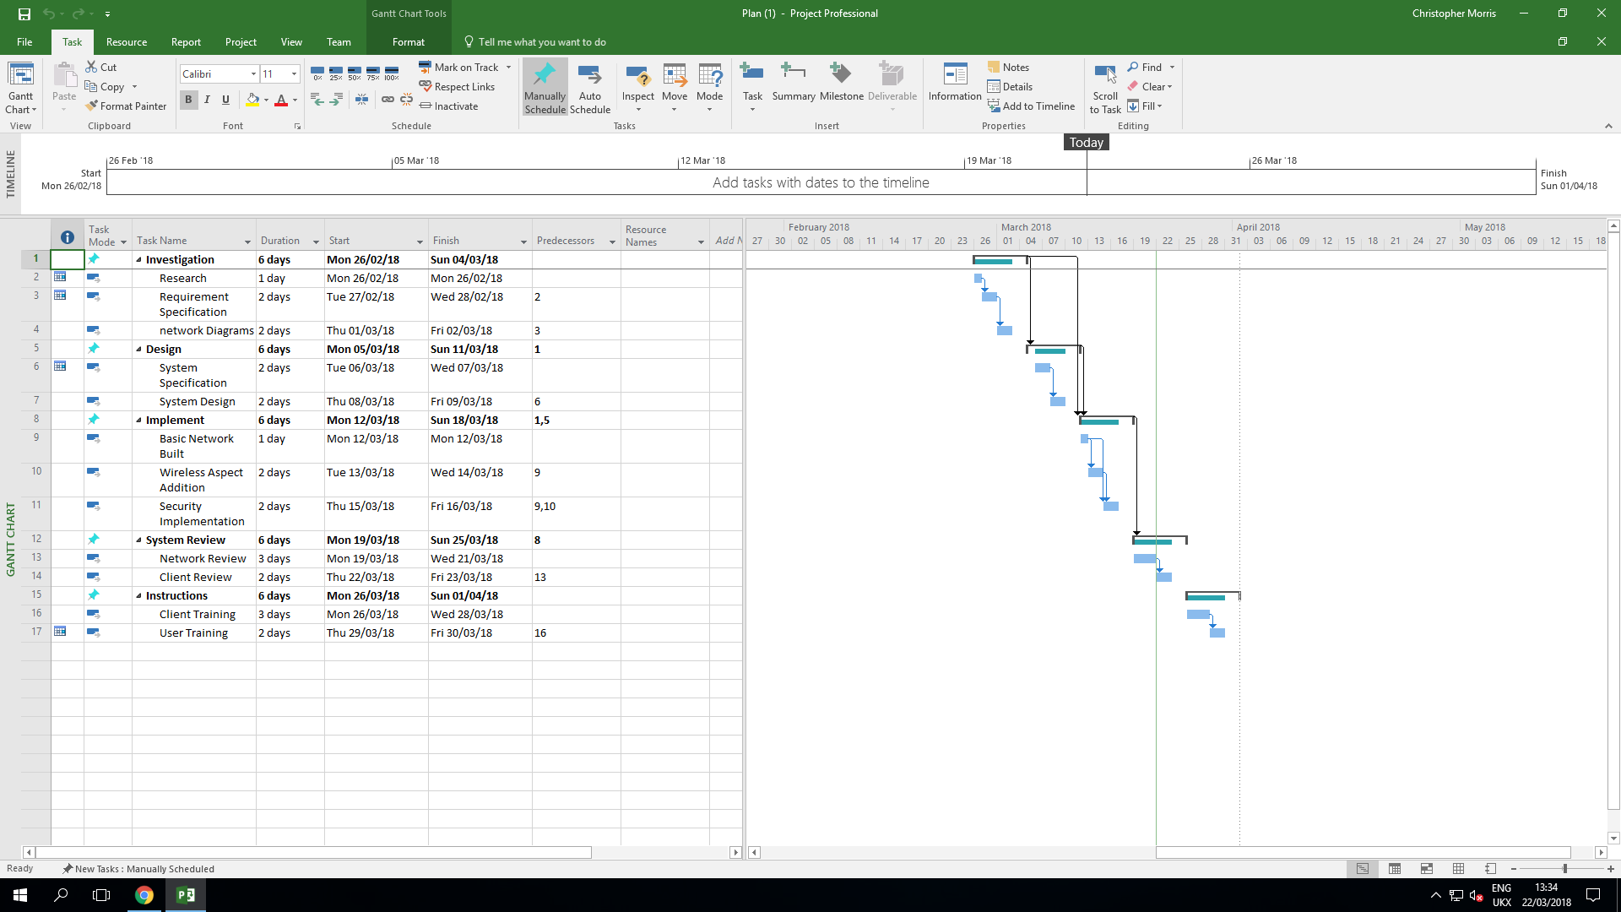
Figure 3: Project timetable
Above is a screenshot detailing the time estimates of the project. The project began at the end of February and was split into five sections. Each project area was given a week to complete, a period that was deemed challenged but not too lenient to work with.
The project began near the end of February in 2018. The group planned to do some research to discover inspiration from other projects and determine whether there was any information that had not been considered. However, it was decided to begin the project early, since the group felt confident enough to start the design phase, discover any issues, and fix them as early as possible.
This early finish allowed for further consideration of the clients’ needs, and more time for the team to concentrate on network security. This was the part where we were checking that the client’s needs were carried out. The network was built in Packet Tracer. This section was again finished early, as we decided on our design early on and instead focused on how we would make the network secure.
The implementation of the project was the longest section. The group decided to change plans after concluding that the original security was too complex for the knowledge base of the group. It was decided to produce a product of a good standard with less complicated processes and ensure the deadline was met. These changes ensured there was time to undergo a system review.
The system review was primarily discussion-based, where the team revisited the project and ensured that it was as simple and secure as possible. This is where we added the protective layers such as passwords, that would be made available to the client. This was finished within the deadline date.

Sustainability and ethical/legal issues
Thought was given as to how the task would be sustainable, and the consequences it would bring once completed. A first order impact would include the network, as an online resource, being able to save paper and as a result becoming sustainable. A second-order impact would include people being able to bring their own device and easily connect to the network. This lastly results in a third-order impact of the network providing the charity a balanced structure, providing a greater overall sense of control.
There were some ethical and legal issues that needed to be considered when building a network, such as the storage of confidential data [1] and following the terms and guidelines provided by the university, ensuring that if the return of University property if necessary. The Data Protection Act would also need to have been followed throughout the project. What also required attention was sticking to the Code of Conduct of the Institute of Electrical and Electronics Engineers (IEEE) [2], the format used throughout the project, as well as the code for the British Computer Society (BCS) [3], the dominant IT organisation in the UK.

Quality of service
There are several factors to bear in mind when deciding the overall quality of a project. Among those factors is usability (the project’s simplicity). The opinion is that the project is easy to use. Simplicity was a key factor in the group changing to a simulation. This allows the client more accessibility in coming to grips with the project. As usability increases, so does the potential for expansion, and perhaps future adjustments such as the network becoming configured manually through cabling.
The belief is that the project does fulfil the brief requirements, as it is a software resource that can hopefully benefit the third party (client). While it will likely take them time to get used to using a software like Packet Tracer, the group has aimed to keep it as simple but secure as possible with the aim of helping them learn quicker. Meanwhile, the project’s portability (ability to become accessible elsewhere) is, in the author’s opinion, is a big advantage for it. Network commands can, as previously mentioned, be implemented outside the software if need be.
While the project can help provide the charity greater control, it will require updating, especially if there plans for it to expand later. The passwords that are provided will require changing on regular occasions for security reasons, and the software will update as Cisco provides improvements for Packet Tracer and maintains reliability. However, the author believes that the area of growth is beneficial, and the network can run consistently provided these concerns are made clear to the client.
In terms of the project dates, it is considered a disadvantage that the project was not started at an earlier date. The group started it when we felt we had acquired enough knowledge to cover the client brief, but the author’s belief is that it should have started earlier to allow for more time to fix any issues and avoid potentially missing deadlines. In this sense, time is a factor of consideration for improvement in future projects on part of the author.
Achievability, however, is one of the personal positives to take away from the task. While we initially planned to make the network larger and include more features, we decided that simplicity would benefit the client more. This ensured that we kept the task on time and did not make the network too difficult to use. It also made our project realistic to complete and hopefully provides a large potential for growth and a small but significant learning curve for the client.
Each team member’s contribution to the project was laid out as early as possible to increase our productivity. To reach these, we broke the tasks into sub-tasks, as shown in the project plan. This helped us measure the progress of the task and each member to advise the others on each task, even the ones they were not chiefly working on. Breaking the tasks down also resulted in more objectives being made, and we therefore became more specific in what we wanted to achieve. [4]

Conclusion
In conclusion, it is considered that the project was completed to a satisfactory standard. While there are issues that could be improved in the future, such as earlier planning and therefore an earlier start date, the team collaborated well, and all the tasks were completed within the timeframe, some even earlier. The teamwork throughout the project was deemed to have been a decent standard, as we regular met up and ensured that the task was achievable but also realistic.
The author’s contribution to the project was updating the project plan, listing suggestions for the simulation, and listing how it is sustainable. This ensured that the deadlines were stuck to and sustainability was not forgotten, which was a pleasing result. The project has increased confidence and knowledge, particularly in making a task timely but also measurable and specific. Previously it was considered that a hands-on role would be a weak area or expertise, however, it is now considered a challenging task that could be willingly undertaken in future projects.

References
[1] P. Swatman, “Ethical Issues in Social Networking,” Ethics in Social Media Research, no. October, pp. 0–10, 2012.

[2] IEEE board, “IEEE Code of Conduct,” no. June, pp. 3–4, 2014.
[3] R. Alves and A. Souza, “Code of Conduct for Bcs,” Igarss 2014, no. 1, pp. 1–5, 2014.

[4] Charted Management Institute, “Checklist 231 Setting SMART Objectives,” pp. 1–4, 2012.

