University of Wales Trinity St David

School of Engineering

Analysis and Simulation of a Centrifugal Clutch

Stress Analysis and Dynamics

ACMA5010

Kielder Francis

1907778

Task A

Contents

1 Introduction 3

2 About centrifugal clutches 4

2.1 How do centrifugal clutches work? 4

2.2 A further discussion of centrifugal clutches 4

3 The development of centrifugal clutches 4

3.1 Industries and materials 4

3.2 Other types of clutches 5

4 Advantages and disadvantages 6

4.1 Advantages 6

4.2 Disadvantages 7

5 Electromagnetic clutches 7

6 Conclusion 7

7 References 8

1 Introduction

Centrifugal clutches have been around for over a century now, helping motors and engines to start up by giving them a slow start. This ensures that the axel is not damaged when starting, otherwise the jerking motion could cause damage. First patented in 1898 by Walter A. Crowdus for the design of an automobile (U.S.A Patent No. 598314, 1989), and then another inventor called Thomas Fogarty was credited for the invention of it during his adolescence in the 1940s, (Sarvestani, 2014).
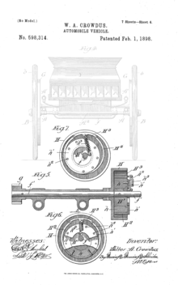
Figure 1 shows the patent by Walter A. Crowdus for one of the first centrifugal clutches, (U.S.A Patent No. 598314, 1989)

2 About centrifugal clutches

2.1 How do centrifugal clutches work?

The centrifugal friction clutch works by spinning an axel (called the driving shaft) on the inside of a drum (sometimes called the cover plate or driven shaft). There are weights (called shoes) attached to springs that are attached to the centre of the driving shaft, and are held in place by rods coupled to the driving shaft (called a spider, as there are 8 rods). As the shaft accelerates, the centripetal force overcomes that of the springs, and so the shoes proceed to move outwards. When the shaft reaches a certain speed, the shoes touch the drum, and it starts to spin due to friction on the shoes. This velocity is called the engagement speed, or speed of engagement, (Eitel, 2017).
The friction can be changed by the type of friction materials the shoes are lined with (sometimes called the Ferodo lining), which controls how much angular speed is converted to the drum. Slowing the speed down results in the outer drum stopping as the springs pull the shoes back in, preventing them from transmitting any more power across, (Lync, 2020).

2.2 A further discussion of centrifugal clutches

There are many different possibilities that can affect the outcome of how it works. This could include, but may not be limited to the:
-Mass of shoes
-Spring constant
-Radius of inner shaft
-Angular velocity
-Friction coefficient of shoes and drum

3 The development of centrifugal clutches

3.1 Industries and materials

Such clutches have many uses, even today. They currently powers things such as Go karts, chainsaws, lawnmowers, mopeds, and smaller boats, (Global, 2019).
The materials used in the clutch are essential to making the whole component work, otherwise certain parts will fail. The clutch faces a lot of friction, which is needed to create the smooth start and prevent any further damage from any jerking movements. With the existence of friction comes the conversion of kinetic energy to thermal energy, or in other words, heat. The clutch will face high temperatures, so the lining of the clutch must have a high melting point, and must not be flammable. A suitable material usually used is asbestos, small heat-resistant fibres used to capture the friction against the drum, although recent laws prohibit its existence within modern machinery due to the fact that the residual dust can be fatal if inhaled, (Health and Safety Executive, 2021).
Other materials used in clutches are copper, steel, iron, and aramid fibres, and others, (Clutch Materials).

3.2 Other types of clutches

There are different variations of centrifugal clutches, although they all still use the idea of using centrifugal force to apply an automatic connection. The one given in this report has 4 shoes held in place by a spider. There are other versions that do not have a spider. For example, there is another version that has arms that are held on by pivot points. As the shaft accelerates, the arms reach outwards, applying a frictional force when reaching engagement speed, (Global, 2019).

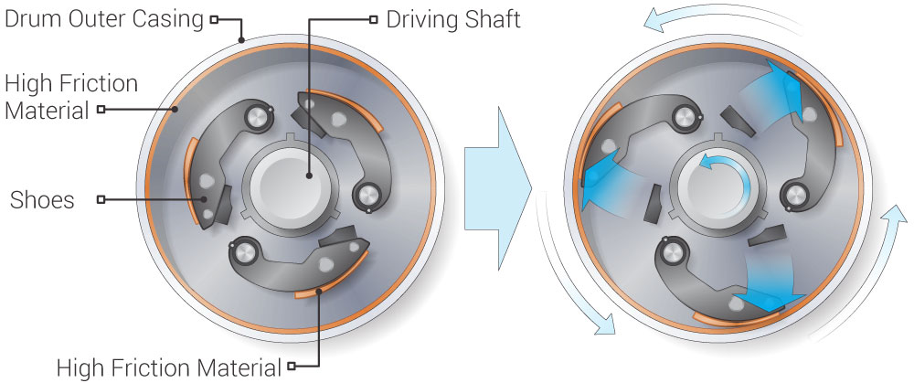
Figure 2 shows a different variation of a centrifugal clutch, (Toulas, 2018)

Figure 2 shows a type of centrifugal clutch that shows 3 shoes, each attached to different pivot points, allowing the shoes to move under the influence of centripetal force.

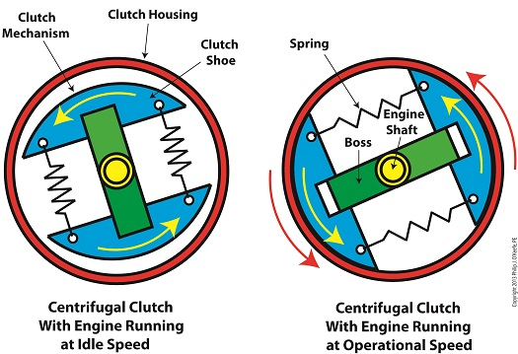
Figure 3 shows another design of a centrifugal clutch, (O'Keefe, 2013)
Another example is a version where there are only 2 shoes that are connected together by springs. This example has two semicircle shoes instead of the 4 smaller ones. Having 2 larder shoes ensures a tighter grip, although if one of them fails, they both fail due to the fact that they are interlocked, and rely on each other to work properly. The above diagram shows yet another means of applying angular motion to a cover plate, this time with only 2 semi-circular shoes attached to each other via springs. To stop the shoes from touching and collapsing in on themselves, a rod is inserted in, called a boss, to prevent this when the shaft has stopped moving. When moving fast enough, the springs will overcome the force brought upon themselves.

4 Advantages and disadvantages of centrifugal clutches

4.1 Advantages

In the case of centrifugal clutches, there are many advantages, and less disadvantages. Firstly, it is completely automatic, so nothing is needed to turn it on or off and to control it much. The only thing needed to be controlled is the speed of the inner shaft, (Global, 2019). The clutch is a simple and elegant machine, so it is easy to assemble, or disassemble when needed to replace a part. This ease means there is less maintenance required, and as a result it is also more affordable. It also gives a smooth start if slowly accelerated, (Team, 2019).

4.2 Disadvantages

However, it relies on friction, which can sometimes slip, which leads to a greater power loss. Friction also wears down the pads of the shoes, so they need to be replaced after so many uses. Friction is also its biggest enemy as well as it can cause the drum and the shoes to overheat, mainly due to major slippage problems, (Global, 2019).

5 Electromagnetic clutches

Electromagnetic clutches play a huge role in modern industry, by helping modern machinery to be controlled electronically. They are in many industries, including but not limited to automotive, medical, robotic and many other sectors. They can also help out in other machines like lawn mowers and office equipment such as printers. They usually show up where there needs to be a transfer of rotary motion. Although not fully automated, they can still work when there is an electrical current running through them, commanding them when to active and deactivate. When a current does pass through it, it goes through the coils (typically made of copper, as it is a good conductor of electricity,) and induces an electromagnetic force. This force temporarily attracts the nearby but not previously attached rotor, and so the rotary motion is allowed to pass through to the next shaft. The shafts are typically made of steel, and there is usually a frictional pad in between the rotor and the rotating electromagnet to create a better response time and reduce wear and tear, (oguraindustrial, 2016).
They can be seen as superior to centrifugal clutches as they can be turned on at any time, regardless of speed. Although they may be more complex and harder to assemble than their predecessors, they still convert motion the same way.

6 Conclusion

There are many types of centrifugal clutches, but each working the same way by transmitting circular motion to a rod or shaft. They are a relatively simple concept to understand and recreate, but modern technology has surpassed the majority of them for an electrical option.

7 References
Clutch Materials. (n.d.). Retrieved from Friction materials: https://www.frictionmaterials.com/clutch-material/#read
Crowdus, W. A. (1989). U.S.A Patent No. 598314.
Eitel, L. (2017, August 15). What are common modes of industrial clutch and brake engagement? Retrieved from Motion Control Tips: https://www.motioncontroltips.com/common-modes-industrial-clutch-brake-engagement/
Global, T. A. (2019, May 26). How Centrifugal clutch Works? Retrieved from Youtube: https://www.youtube.com/watch?v=HrmWNBwHBQ0
Health and Safety Executive. (2021, February 1). Asbestos. Retrieved from Health and Safety Executive: https://www.hse.gov.uk/mvr/mechanical-repair/asbestos.htm
Lync, S. (2020, July 1). How does a Centrifugal Clutch work? | Skill-Lync. Retrieved from Youtube: https://www.youtube.com/watch?v=p_BbHxCpJiM
oguraindustrial. (2016, April 11). Electromagnetic Clutches - How they work. Retrieved from Youtube: https://www.youtube.com/watch?v=5SuqyE_bXqo
O'Keefe, P. J. (2013, December 16). centrifugal clutch. Retrieved from Engineering Expert Witness Blog: http://www.engineeringexpert.net/Engineering-Expert-Witness-Blog/tag/centrifugal-clutch
Sarvestani, A. (2014, March 21). The making of an icon | Dr. Tom Fogarty's obsession with innovation. Retrieved from Mass Device: https://www.massdevice.com/making-icon-dr-tom-fogartys-obsession-with-innovation/
Team, T. B. (2019, August 27). Advantages and Disadvantages of Centrigugal Clutches. Retrieved from BLM: https://www.blm-cm.com/blog/advantages-disadvantages-centrifugal-clutches/
Toulas, B. (2018, September 23). How does a Centrifugal Clutch work? What are the pros and cons? Retrieved from engineering clicks: https://www.engineeringclicks.com/centrifugal-clutch/

Part B

Q1)

r=95mm=0.095m
x=9mm=0.009m
l=4mm=0.004m
$$∅=2r$$
Inner diameter of drum = 2(0.095+0.009) = 0.208m
Outer diameter of drum = 2(0.095+0.009+0.004) = 2(0.004) + 0.208 = 0.216m

Q2)
$$F=kx$$
x=0.009m
k=7.5kN/m
$$F=\left(7.5*{10}^{3}\right)\left(9*{10}^{-3}\right)=67.5N$$

$$F_{c}=\frac{mv^{2}}{r}$$
m=275g=0.275kg
r=0.095+0.009=0.104m
$$v=\sqrt{\frac{F_{c}r}{m}}$$
$$v=\sqrt{\frac{67.5*0.104}{0.275}}=5.052m/s$$

$$C=π∅$$

$$C=0.208π=0.6534m$$

$$ω_{rps}=\frac{v}{C}=\left(\frac{5.052}{0.6534}\right)=7.7312rps$$

$$ω_{rpm}=60rps=60*7.7312=463.9169rpm$$

Q3)
ω=550rpm
$$ω_{rpm}=550rpm=\frac{550}{60}rps=9.1667rps$$

$$v=ω_{rps}C=9.1667*0.6534=5.98997m/s$$

$$F_{c}=\frac{0.275*\left(5.98997^{2}\right)}{0.104}=94.8743N$$

Q4)
$$94.8743-67.5=27.3743N=R$$
μ=0.35
$$F_{r}=μR=0.35*27.3743=9.581N$$

$$F_{max}=ΣF_{r}=4F_{r}=38.324N$$

r=0.108

$$τ=F_{r}r=38.324*0.108=4.139Nm$$

Q5)
Table 1 shows the data values for velocity in both rpm and m/s, centrifugal force, normal force, friction and torque at the different velocities. Credit for the screenshot goes to the author
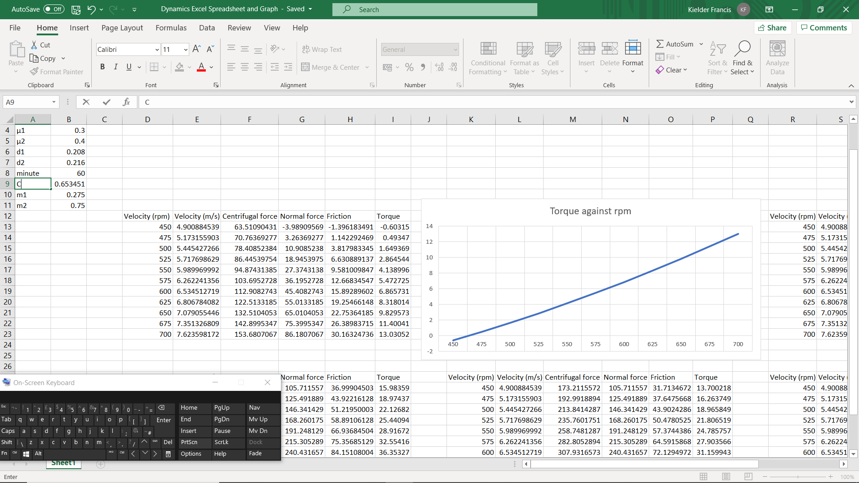

Figure 4 shows a graph of torque against velocity in rpm. credit for this screenshot goes to the author

Q6)
Table 2 shows the same data values, but the coefficient of friction changes from 0.35 to 0.3. credit for this screenshot goes to the author
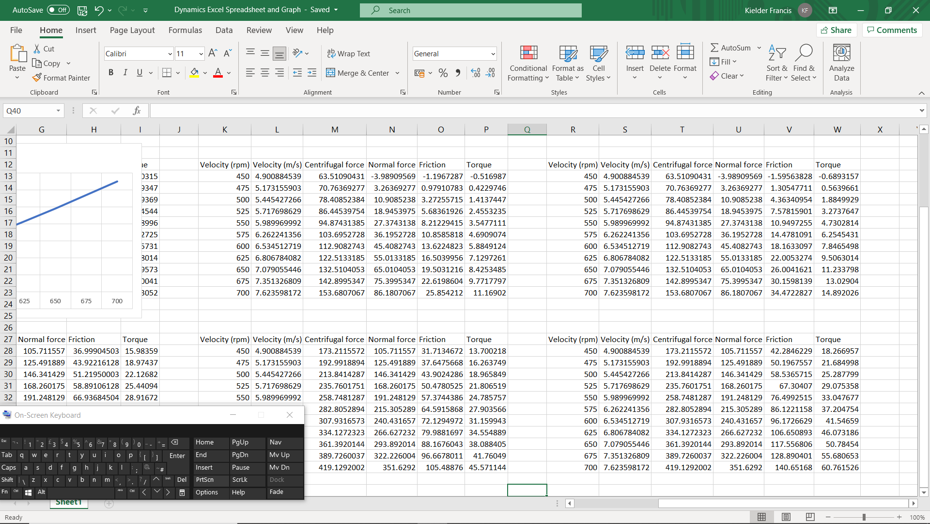

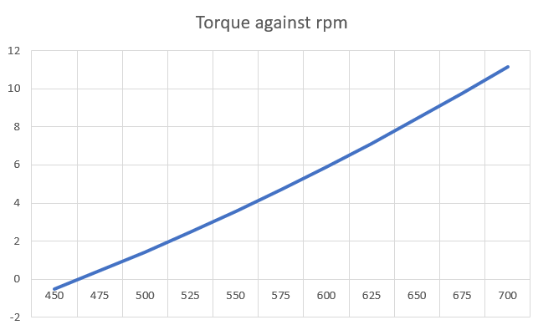
Figure 5 shows a graph of torque against velocity in rpm, with the same values as before but the friction coefficient has been changed from 0.35 to 0.3. credit for this screenshot goes to the author

Table 3 shows the same data values, but the coefficient of friction has been changed from 0.35 to 0.4. credit for this screenshot goes to the author

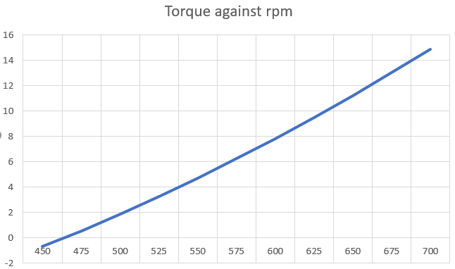
Figure 6 shows a graph with the same values, but the friction coefficient has changed from 0.35 to 0.4. credit for this screenshot goes to the author

The effect of decreasing the coefficient of friction decreases the overall torque, due to the fact that there is less force acting upon the drum. Increasing the coefficient does the opposite, it increases the torque as there is an increases force there. Increasing the mass also has the same effect, as there will be more of a force there.

Q7)
Table 4 shows the same values where the mass has increased from 0.275kg to 0.75kg, but the coefficient of friction has stayed the same. credit for this screenshot goes to the author
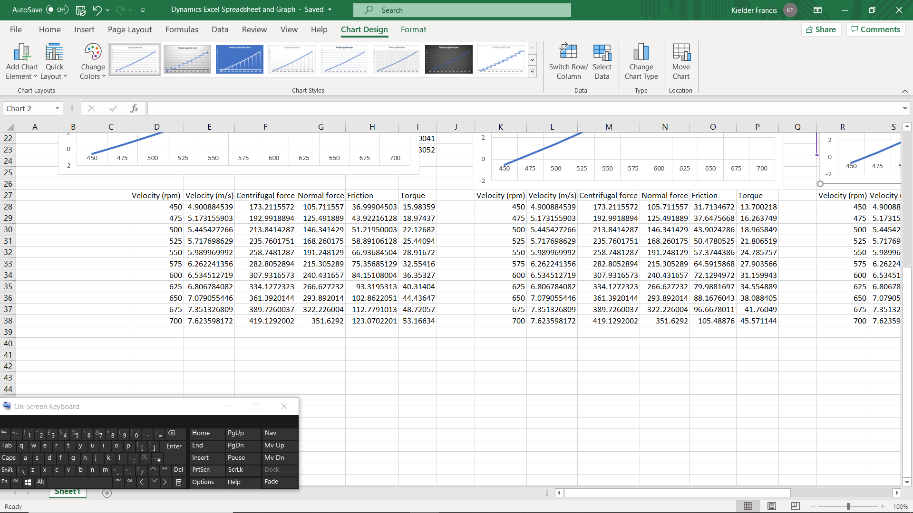

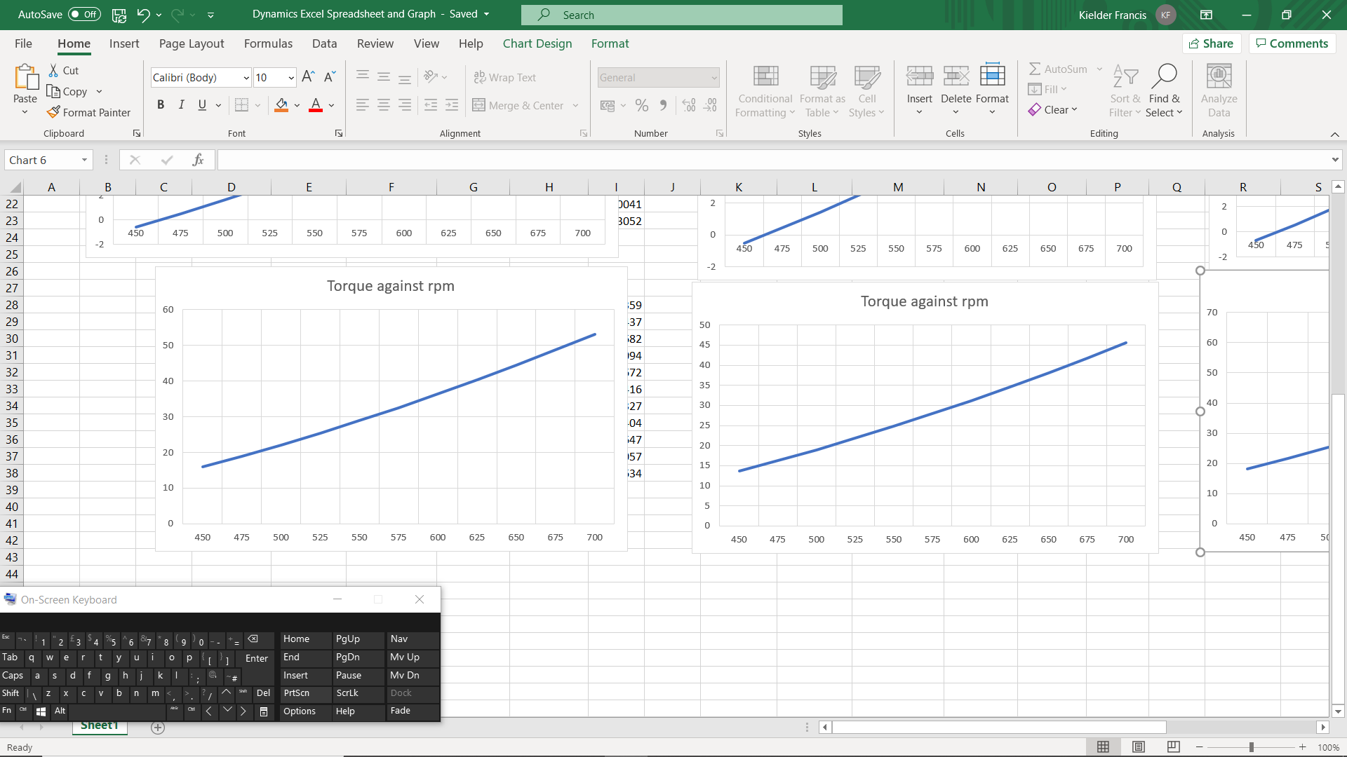
Figure 7 shows the graph of torque against rpm, where the mass has been increased to 0.75kg, and the friction coefficient has stayed constant. credit for this screenshot goes to the author

Table 5 shows data values for an increased mass of 0.75kg, and a decreased friction coefficient of 0.3. credit for this screenshot goes to the author

Figure 8 shows the graph of torque against rpm, where the mass has increased to 0.75kg, but the friction coefficient has been decreased to 0.3. credit for this screenshot goes to the author

Table 6 shows the values for an increased mass of 0.75kg, and an increased friction coefficient of 0.4. credit goes to the author for this screenshot
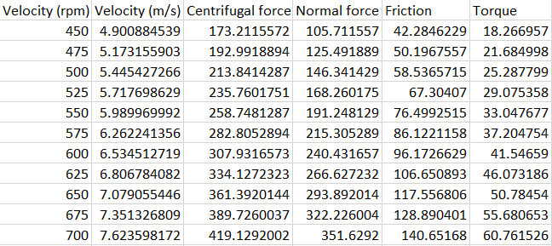

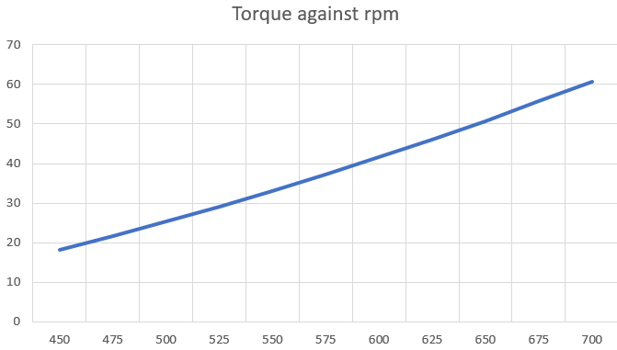
Figure 9 shows the last graph of torque against rpm, where both the mass and the coefficient of friction have increased to 0.75kg and to 0.4. credit for this screenshot goes to the author

m=0.75kg
$$τ=Ια$$
$$κ^{2}=\frac{d^{2}}{8}=\frac{0.216^{2}}{8}=5.832*10^{-3}$$
$$Ι=mκ^{2}=0.75*5.832*10^{-3}=4.374*10^{-3}$$
$$α=\frac{τ}{Ι}=\frac{14.8902}{\left(4.374*10^{-3}\right)}=\frac{3404.252rad}{s^{2}}$$

