Construction Technology Assignment
Rhys Mathias
Student Number: 1701347

The Ground Floor.

1.0 Suspended Timber Ground Floor
The type of ground floor selected to be built for the domestic dwelling is a suspended timber ground floor. A suspended timber floor is a ground floor in which the actual floor appears to be floating above a void beneath the floor. (Thermohouse, 2016)
The ground floor of the property is supported within this void with permanent sleeper walls along with the internal block wall.
Visual drawing of the suspended timber ground floor showcasing all the following components available in part 1 of the appendix.

1.1 Sleeper Wall
The sleeper walls consist of bricks placed in a honeycomb formation. Above these bricks sits the damp proof course and a wall plate. The function of the wall plate is to form a greater bond between the sleeper wall and the floor joists and helps to transmit the loads of the timber floor joists and flooring. Visual drawing of the honeycomb formation of the sleeper wall brick work and how they support the floor joists available in part 2 of the appendix.

1.2 Ventilation
The void beneath the ground floor along with the honeycomb brickwork style allows for the space to be easily ventilated. (Thermohouse, 2016). The presence of natural ventilation is essential in terms of stopping dry rot and mould from occurring over the damp ground. It also stops the moisture content of the timber from rising above 20% which is seen as an unacceptable level for timber as it could lead to a fungal attack. The damp proof course is also in place to stop the rise of moisture.
However, the ventilation beneath the floor can lead to droughts and cold air entering the house which is why insulation is required. (Greeno and Greeno, 2018)

1.3 Insulation
The floor insulation is placed between each floor joist. The insulation board needs to be cut to the correct size in order for it to fit snugly between each floor joist. The insulation needs to be supported on a minimum of 25mm x 25mm softwood timber battens as stated in part A of the building regulations and these battens should be placed at a height so they meet the insulation in order to support it and so the insulation lays flush with the top surface of the floor joists. (How to insulate under a suspended timber floor – a practical guide, 2016)

1.4 Building Regulations
In order to comply with Approved Document A the TRADA tables were used to calculate the floor joist sizes for the entire ground floor of the property. The calculations were based on the spans between load bearing walls and the overall load on the floor being between 0.25 - 0.50 Kn/m2. The following timber joist sizes were selected to be used in the construction of the ground floor: (All joists have a spacing of 450mm for the ground floor).

- For the lounge with a span of 3.915 metres a timber class C16 38mm x 220mm joist was calculated which can reach spans of up to 3.932 metres.
- For the hall and study with a span of 2.4 metres a timber class C16 with partition 38mm x 145mm joist was calculated which can reach spans of up to 2.437 metres.
- For the kitchen and dining room with a span of 3.915 metres the same joist that was calculated for the lounge will be used due to the rooms having identical spans and both with no partitions.
For the utility room with a span of 2.665 a timber class C16 with partition 38mm x 170mm joist was calculated which can reach spans of up to 2.788 metres. (Eurocode 5, 2020)

The suspended timber ground floor also complies with approved Document F with the fact that air bricks have been used on the external block wall to form a flue which allows for the void beneath the suspended floor to be effectively ventilated.

The First Floor

2.0 Traditional Solid Timber Floor
To construct the first floor the method of using a traditional solid timber floor was chosen. A traditional timber floor consists of timber floor joists reaching across the spans between load bearing walls. These timber joists are then supported with herringbone strutting and sit on metal joist hangers which are fixed to the solid block wall. The tongue and groove flooring will then be laid over the top of the floor joists.

2.1 Herringbone Strutting
Herringbone strutting is a form of bracing. They are fixed between parallel rows of floor joists to keep them in place and to stop joists from twisting overtime. In order to comply with part A of the building regulations the timber herringbone strutting should be at least 38mm x 38mm and can only be used where the spacing of the joists is less than 3 times the depth of the joists. The strutting is needed when joists exceed a 2.5 metre span and as all spans in the property are less than 4.5 metres then only one row and now two of herringbone strutting will be needed. (Herringbone strut, 2018)

2.2 Joist Hangers
Joist hangers are the metal components that fix to the block and wall and to the timber and hold and support the timber joist. Joist hangers are fixed into the 10mm mortar joint within the blockwork and are fixed to the block wall during the construction of the external and internal block walls. Herringbone strutting and joist hanger detail shown in part 3 of the appendix. (Strukta UK, 2020)

3.0 Openings (NHBC, No date)

Window opening detail shown in Part 4 of the appendix.

3.1 Thermal Bridging
The opening design must consider thermal bridging to comply with the building regulation approved document c. Underneath the cill of the window where the opening begins in the cavity wall the decision to incorporate a insulated cavity closer which will reduce thermal bridging effects. If not installed it will create a cold spot in the wall which can lead to future moisture ingress issues in the wall and window. (Kingspan, 2015)

3.2 Cill Detail

The external cill will be installed set to a slight fall to allow any rainwater to travel away from the building. The internal cill will be made good with a UPVC cill to cover the plasterboard joint to the opening that will return into the internal jams. Mastic seals will be added in the necessary areas of the window and sill opening to eliminate risk of moisture penetration.

3.3 Lintel Detail

A steel lintel will be used to transfer the loadings of the intermediate floor and roof structures safely to the foundations. This detail will be required to be installed correctly to the manufacturer’s specification.

3.4 Cavity Tray

The cavity tray will be installed above the lintel and will serve a similar purpose as the damp proof course which will be installed at the mortar joint above the window at a fall leaning towards the external skin of the cavity wall.

3.5 Window and Glazing
The client has specified to have a double-glazed window which will achieve a u-value of (AD L1A). This will reduce the transfer of sound and thermal loss of the building as the glazing panels within the window will contain a noble gas that will act as insulation

4.0 Eaves
The roof structure will have closed eaves. Eaves have an aesthetic role when it comes to the design of the house as well as them providing shade and protection from rain and snow by projecting away from the facade of the building.
Due to the vapour control barrier present in the roof construction the eaves do not need ventilation meaning a closed eaves design can be used compared to an open eaves.

4.1 Soffit
It’s important to have a soffit as part of the roof construction as they act as passive ventilation for attic spaces. They keep warm moisture in the air from entering the attic air and condensing and creating mould. (Thompson Creek, 2018)

4.2 Double lapping tiles
The house will have natural slate tiles as the roof covering. These tiles will be laid in a way in which they have a double lap. Double lap refers to the way in which the roof tiles overlap each other twice compared to single lap where they overlap once. As slate tiles have no side interlocks it means that water can enter the gaps between the tiles. To allow this water to drain away safely there needs to be another tile below each joint therefore making the tiles double lapped. (Weinerberger, No date)

4.3 Heap Lap and Tile Size
The main roof of the dwelling will have a 40-degree pitch. The building regulation state that a roof with a 40-degree pitch needs to have a heap lap of 80mm. Heap lap refers to how much the tiles overlap each other by. The heap lap is calculated based on the type of slate chosen and its size. I decided to use marchioness slates which are 22 inches x 11 inches in size which equates to approximately 600mm x 300mm. With this tile size along with average rainfall in Wales I calculated that an 80mm heap lap is needed from the heap lap table in the building regulations. Full eaves detail showcasing the closed eaves construction with soffit and double lapping slate tiles shown in part 5 of the appendix. (Weinerberger, No date & UWTSD presentation)

4.4 Battens
In order to comply with Document A of the building regulations the battens that the roof tiles sit on need to be sized appropriately for the spacing of the roof rafters. I calculated that the roof rafter for this dwelling to be placed at 600mm centres. To cover this span there needs to be battens with a width of 50mm and a depth of 25mm. (Approved Document A, 2017)

5.0 Main Roof Structure
For the main roof structure, the method of using a timber attic truss design was chosen in order to allow open space in the roof for the storage areas shown on the floor plans. Attic truss roof detail is shown in part 6 of the appendix.

5.1 Function of a roof
The main function of a roof is to provide protection from the elements for inhabitants as well functioning as a form of security, privacy and insulation for the building. (Designing Buildings, 2019)

5.2 Insulation - Warm roof
I decided to insulate the roof, so it has continuous insulation across the top of the rafters. This makes it a warm roof compared to a cold roof which only has insulation between the rafters. The benefit of a warm roof is that it's breathable and allows moisture to escape which prevents damp and mould from occurring. (Helifix, What is a Warm Roof?, 2012). Warm roofs also have a vapour control barrier which sits beneath the insulation to stop any warm moist air from the interior of the house entering the insulation and condensing back into water forming condensation in the roof structure. (What is a vapour control layer (VCL)? - Celotex Blog, 2015)

5.3 Rafter Sizing Building regulations
In order to comply with Part A of the building regulations the roof rafters needed to be sized appropriately to the span of the roof. For the main central roof which has a total span of 7.5 metres I calculated that an appropriate rafter size for this span would be 47mm x 195mm using the C16 strength timber with each rafter placed at 600 centres. (Europspan 5, TRADA, Approved Document A).

Appendix
Floor finish covering

- Suspended Timber Ground Floor

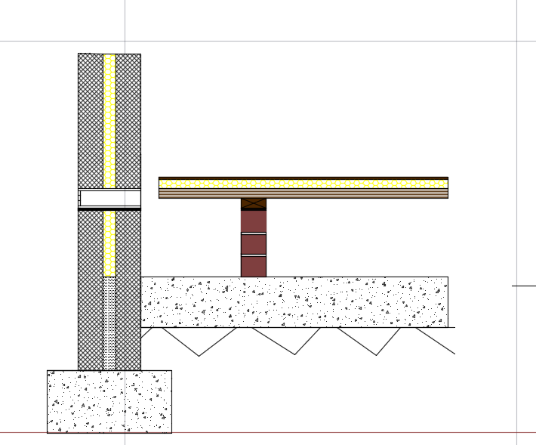
Insulation placed between floor joists

Floor joist
Airbricks and flue to allow for ventilation

Honey comb wall and wall plate to support floor joists

Void underneath floor joists to allow for
ventilation from the airbricks

Bricks in honeycomb formation with half brick spacing to allow for ventilation.

Floor joist
Insulation between floor joists

Floor covering

Floor plate

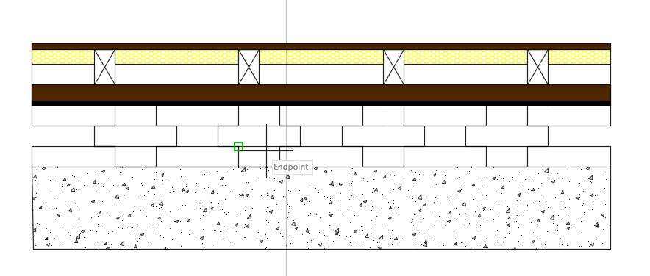
2. Honeycomb brick wall that supports the suspended ground floor.

Damp proof course

3.Traditional Timber First Floor

Flooring finish

Floor joists

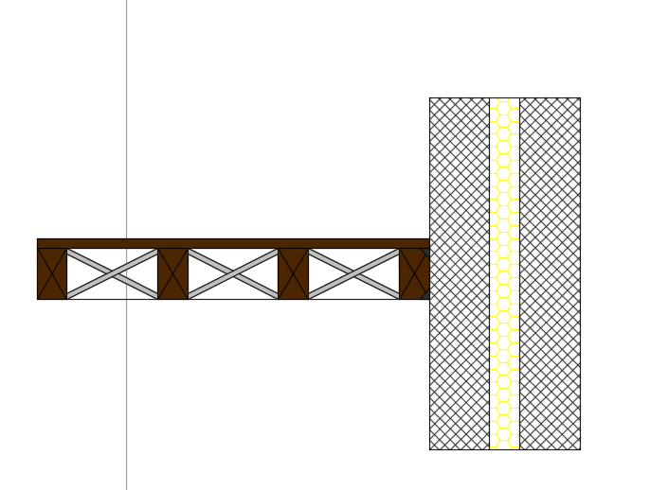
Herringbones strutting to support floor joists.

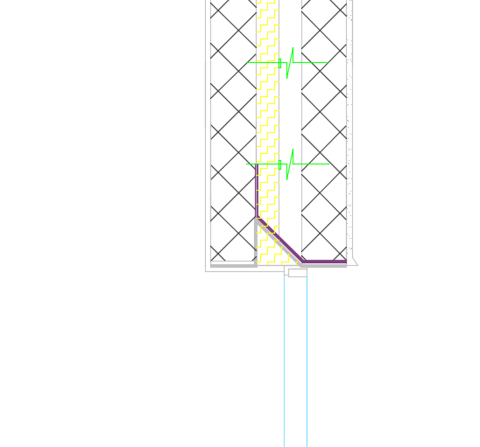
4. Window Opening
Lintel
Wall tie

Insulation
Plasterboard

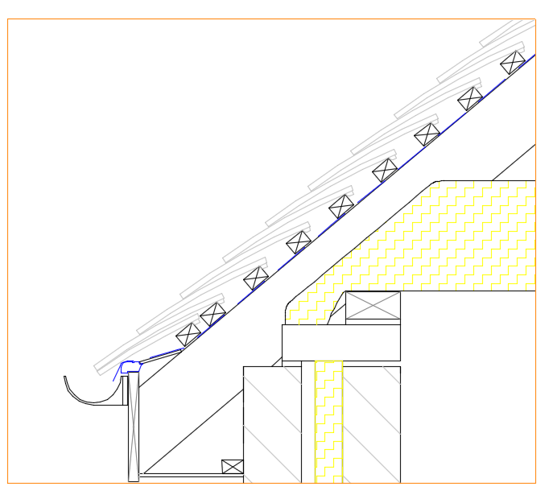
5. Closed Eaves Detail
Double lap natural slate tiles.
Soffit
Guttering

Tile battens
Roof rafter

6. Attic Truss Roof with Storage Space

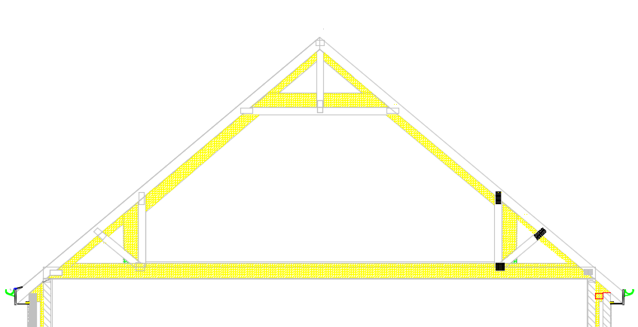
Insulation
Attic truss roof rafter.

Free
open space available for storage

Bibliography

ThermoHouse. 2016. Suspended Floors - All You Need To Know - Thermohouse. [online] Available at: <https://thermohouse.co.uk/blog/suspended-floors/> [Accessed 15 April 2020].

Greeno, C. and Greeno, R., 2018. Building Construction Handbook. 8th ed.

Kingspan | Great Britain. 2016. How To Insulate Under A Suspended Timber Floor – A Practical Guide. [online] Available at: <https://www.kingspan.com/gb/en-gb/products/insulation/kingspan-insight/articles-and-advice/how-to-insulate-under-a-suspended-timber-floor-a> [Accessed 16 April 2020].

2020. [online] Available at: <https://bookshop.trada.co.uk/bookshop/view/EA646D16-D0EB-44CE-9270-B9427728ACE4/Eurocode_5_Span_Tables_4th_edition_for_solid_timber_members_in_floors_ceilings_and_roofs_for_dwellings> [Accessed 16 April 2020].

Designingbuildings.co.uk. 2018. Herringbone Strut. [online] Available at: <https://www.designingbuildings.co.uk/wiki/Herringbone_strut> [Accessed 28 April 2020].

Strukta.co.uk. 2020. Joist Hangers | Joist Products Supplier | Strukta UK. [online] Available at: <https://www.strukta.co.uk/building-materials-41/joist-products/joist-hangers> [Accessed 18 April 2020].

Kingspan | Ireland. 2015. How To Prevent Thermal Bridging At Openings?. [online] Available at: <https://www.kingspan.com/irl/en-ie/product-groups/insulation-boards/blog/how-to-prevent-thermal-bridging-at-openings> [Accessed 24 April 2020].

Thompson Creek. 2018. What Is Soffit And Why Does My Home Need It? - Thompson Creek. [online] Available at: <https://www.thompsoncreek.com/blog/what-is-soffit-and-why-does-my-home-need-it/> [Accessed 28 April 2020].

Wienerberger.co.uk. n.d. [online] Available at: <https://www.wienerberger.co.uk/content/dam/wienerberger/united-kingdom/marketing/documents-magazines/technical/UK_MKT_DOC_TEC_ROF_SAN_Dr_John_notes_Double__single__001.pdf> [Accessed 25 April 2020].

Building Regulations. 2017. Approved Document A [Accessed 26th April 2020]

Designingbuildings.co.uk. 2019. Types Of Roof. [online] Available at: <https://www.designingbuildings.co.uk/wiki/Types_of_roof> [Accessed 26 April 2020].

Helifix.co.uk. 2012. What Is A Warm Roof? | Helifix. [online] Available at: <https://www.helifix.co.uk/blog/warm-roof> [Accessed 27 April 2020].

Celotex Blog. 2015. What Is A Vapour Control Layer (VCL)? - Celotex Blog. [online] Available at: <https://blog.celotex.co.uk/technical/vapour-control-layer-vcl-celotex/> [Accessed 26 April 2020].

