NAME: LENISHA MUNIANDY
ID: 2226099
MODULE: TAXATION
TOPIC: NEW BUSINESS CHOICE – SELF EMPLOYED OR LIMITED COMPANY?

TABLE OF CONTENT
- SELF EMPLOYMENT ………………………………………………………………….;
- LIMITED COMPANY ……………………………………………………………………
- COMPARISON BETWEEN SELF-EMPLOYMENT AND LIMITED COMPANY........
  - Advantages of being self-employed vs a limited company
  - Disadvantage of being self-employed vs a limited company
  - Advantage of being limited company vs a self employed
- CONCLUSION

1.0 SELF-EMPLOYMENT
In today’s era, the most common question that arises among start-up entrepreneurs is “being self-employed or running a limited company is a better option.” These are two popular choices for individuals who have been looking to start their businesses in the United Kingdom. Both options have their advantage as well as their disadvantages. An individual has to consider the factors among the options to ensure the best option is decided for their business. In the report, the benefits and drawbacks of a self-employed and limited company will be discussed further.
Self-employment is defined as the simplest way on starting a business. An ordinary self-employed nutrition coach in the United Kingdom has an average salary of £ 26,797. The idea of self-employment narrows to the form of business ownership where all the individuals often work for themselves and does not have any employees working for them. Some self-employed individuals can be classified as freelancers, independent contractors, or sole traders. Self-employed individuals often earn their income by contracting with the business directly. For self-employment, the annual self-assessment tax return should be filed by the business owner. The tax return will be filed once a year and the tax year is between the 6th of April and the 5th of April (Acca Taxation, 2019).
According to the Labour Market Statistics (2023) states that there were approximately 4.3 million self-employed workers in the United Kingdom.
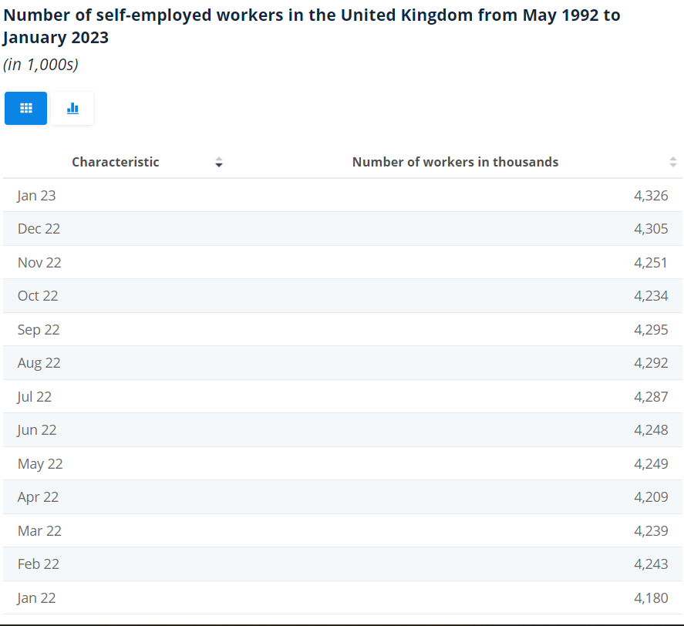
Table 1 shows the number of self-employed workers in the United Kingdom from May 1992 to January
The statistics above show the percentage of self-employed workers which increases from 1992 to the year 2023. It can be preferably admitted that most individuals prefer opening their self-employed business. To register on self-employed business, an online application can be sent to HM Revenue & Customs (HMRC).
There are numerous advantages for self-employed individuals. One of the pros is the flexible lifestyle. Most individuals are concerned with having balanced life with their work life and personal life. Therefore, no restrictions are essentially done on the individuals who would want to take holiday and use their time for other activities. It brings us back to the choice of an individual to decide their work time as well as their time off. Besides that, being self-employed could provide creative freedom. Owning a business by own defined that the processes of the company are also directed by the owner. The business owner has the liberty to decide on all business decisions, exploring new opportunities and constantly innovating to develop their business. If it is a limited company, the range of power will be limited, so, it does not provide freedom and full access to ownership during the process. Self-employed often provides more potential to the earnings as the business owner has control over the progression. Most business often has limitation in achieving their targeted sales due to internal factors within the employers. The concept of self-employment allows the business to have a flexible lifestyle and gain more experience. It is also proven that self-employment will be more motivation than having fixed wages (Nat, 2022).
Considering the pros of self-employment, the report will further outline the cons of having self-employment. Having own business will not provide employment benefits to the business owner. The benefits such as pension contribution, annual leave allowance, private medical cover, and others will be not covered in self-employment. These benefits often depend on the company but some of the mutual benefits are such as having at least 28 days of paid annual leave including bank holidays. Most of the benefits that are obtained by individuals are important to ensure that the future is stable. The major disadvantage of self-employment is financial uncertainty. For most start-up businesses, the income is not much as expected. If the demand for the service is not as expected, the income gained by the business owner could result in a loss (Nat, 2022).

2.0 LIMITED COMPANY
A limited company (LC) is defined as any incorporation that has limits on the amount of liability which are undertaken by the company’s shareholders. Most of the limited company structure refers to the shareholders’ limit to their stake by investments and commitments. In the term of the legal sense, a limited company is defined as a person. The assets and debts of the company are often separated from the shareholders. There is general naming that is used for the corporate structure in the United Kingdom such as Ltd. Any company name which is followed by the abbreviation “Ltd” could be recognized as a limited company. A company’s year often runs from the date where it was established and ends at the end of the month. It will be different from the first year of the company but it will end at month end every subsequent year. The file of accounts should be included with the Companies House and the Corporation Tax returning to HMRC.
The ownership in the limited company could be transferred easily and passed through by generations. It is unlikely the public company allows anyone to acquire shares, the limited company has a membership that is only governed by company rules and regulations. A limited company could be adjusted by the limited by shares or limited by guarantee. It has differed as limited by shares when an organization has one or more shareholders and is managed by one director. As for the limited guarantee process, the organization is owned by multiple guarantors and managed by a director.
The limited company could be codified in multiple ways in many nations. This is due to the changes in government regulations. For instance, there are two types of limited companies in the United Kingdom such as private limited companies and public limited companies. Most private limited companies don’t permit their offer of shares to the public. Most commonly, the type of companies could be structured for small businesses. Public limited companies (PLCs) often offer shares to the public to raise capital. Most of the public limited companies are large companies that have a stock exchange of at least GBP 50,000. Table 1.2 shows the United Kingdom's total and effective register sizes from the year 2012/13 to 2022/23.
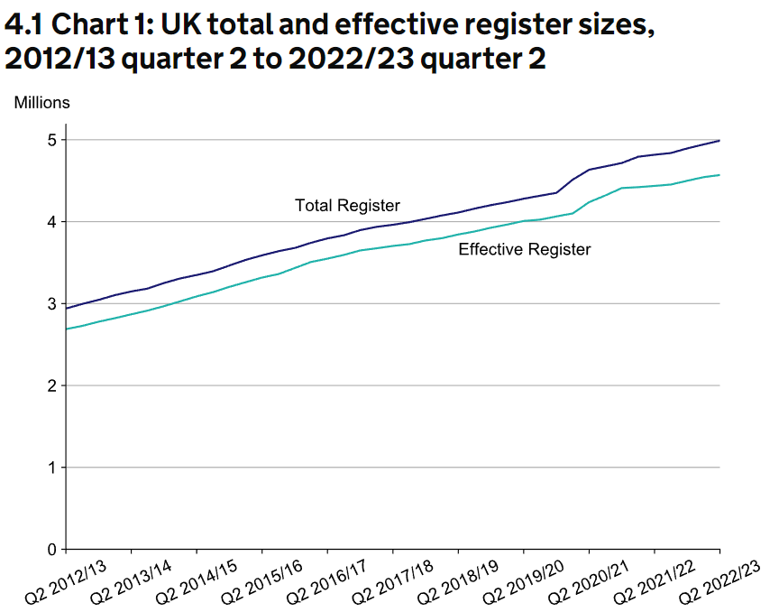
Table 1.2 shows the United Kingdom's total and effective register sizes from the year 2012/13 to 2022/23.
The statistics show the increment of incorporated companies in the United Kingdom from the year 2012 to 2023. It is said that the growth of incorporations increased along with a decreased number of dissolutions. The limited company could be registered by a UK non-resident as well. The tax benefits of a UK-based limited company can be benefitted by non-resident individuals as well. The only requirement to switch to a limited company is by earning profits over GBP 50,000.
There are numerous advantages to forming a limited company. One of the major advantages is that the liabilities are dependent on the shareholder's amount of investment in the company. In the future, if the business encounters loss or is sued, the shareholders and director would not be accountable personally for the debts. Therefore, the personal assets of the company are guaranteed to be safe. As a company director and shareholder, a sum of salary will be paid to avoid PAYE and NIC tax on the payroll. The dividends are often paid including the salary. To differentiate between loans and dividends, the official board members should have a fixed sum to be agreed upon (Bondarenko, 2022). Once the sum is finalized, the sums could be allocated upon the share ownership structure. The second advantage is that a limited company could be incredibly tax efficient if tax planning is properly planned. The company needs to hire an experienced accountant who can contribute to identifying tax savings and growth opportunities. This will ensure that the owners could minimize their taxes. Unlike the sole trader, the limited company could claim tax deductions and allowances which are only given to limited companies. For instance, a limited company could set up a pension scheme and ensure that contribution payments which are done by the scheme are more tax efficient compared to a private pension. The third advantage is the professional image of trading in a limited company. Compared to other business structures, a limited company is said to have a certain level of trust due to its professional image. This will provide a high advantage to the competitors. Most of the suppliers often deal with limited companies better compared to sole traders. The company has to ensure that it produces all types of legal documents and sets of accounts to ensure the transparency of clients or suppliers.
Setting up a limited company could also have its drawbacks. The most common drawback is the higher cost to set up a limited company business compared to a sole trader or partnership. This is due to the legal fees and accounting fees being charged higher for the limited company. Besides that, the limited company often has a larger operation which complicates the entity. The complication often results in more paperwork and financial documents such as sets of accounts, confirmation statements, and Company Tax returns. The director of the company has to file a personal tax return to HMRC. In most cases, limited companies will have issues in registering their company employers as well as setting up the payroll. When the company starts paying its staff, HMRC has to report in real time (Bondarenko, 2022). Most of the limited companies will have a tough time turning the company structure to the sole trader if the business is unsuccessful. Due to extra-legal obligations and administration involved, changing the company structure will seem to be complicated.
3.0 COMPARISON BETWEEN SELF-EMPLOYMENT AND LIMITED COMPANY
3.1 Advantages of being self-employed vs a limited company
Most business has to consider financial advice upon choosing a self-employed and limited company. A new business often has more demands and high motivation by the business owner to expand it further. Therefore, it is often advised to register on a self-employed basis which could encourage the business owner to start trading swiftly. If the profits are under GBP 50000, it is suggested that the business owner opt-out for self-employed. This is because the total profit that is computed has to be declared to HMRC in the self-assessment tax return. The main advantage is that once the taxes and VAT are deducted, the profits are entitled wholly to the business owner. If the profit is more than GBP 50 000, a limited company will be the best option for the business owners as the percentage of tax will be higher when the profits are more than GBP 50,000. Therefore, it is advised that the business owner make proper planning on their budget and allocation as switching to a limited company is easy but not vice-versa.
Besides that, the limited company requires to pay tax each time when the profits are made. The differences are often measured by the scale of tax and how is it assigned. It can be argued that self-employment often pays more tax compared to a limited company. This is including the Income Tax and National Insurance contributions (class 2 and class 4) but not the Corporation Tax as it is for the limited company. At the same time, self-employed grants greater freedom to extract profits from the business without any immediate taxable impact. Unlikely, the limited company often has issues where the strict framework on dividends and benefits should be divided before extracting the profits. Considering the control over the monetary, self-employment is said to be the best option compared to a limited company.
3.2 Disadvantage of self-employed vs a limited company
Self-employment often holds different risks compared to a limited company. Mostly self-employment is dependent on business activities. If the business activities are at their peak, the business will be considered a potentially funded company. If the business activities are resulting a loss, the business will have a negative impact. HMRC and the financial world often view financial affairs as a whole. Therefore, the risk is higher on assets which include individual cars and individual homes. The failure to pay the debts of the business could result in higher risk on the assets. The risk for the limited company is often considered a limited liability. Personal finance and the company’s finance are treated separately. Therefore, the business owner should be knowledgeable on the nature of the business by understanding their business model further. By ensuring the needs of their business sustainability, the business owner gets to decide on the adoption ((Sole trader vs limited company: Which is better for you?, 2022).
Most financial institutions and investors prefer working with a limited company compared to a self-employed business. This compares to the efforts to raise the finance for self-employment is higher. After all, the business needs to purchase equipment, stocks, vehicles, or tools to start trading. At that point, a limited company has more potential to attain loans from the bank compared to self-employment. This is due to the risk of credibility. The tax rates imposed on the self-employed business have been punitive compared to owners of limited companies. However, the gap has been lessened significantly due to the dividend tax relief being slashed in the past 5 years. The self-employed business owner pays 20%-45% of the income tax rate whereas a limited company pays 19% of the corporation tax.

3.3 Advantages of being a limited company vs self-employed
The company director will be able to control the income as a limited company director. The tax bill can be also reduced by splitting up the wages and dividends. This will benefit the director as the dividend is taxed at a lower rate of income and the first GBP 2000 is free of tax. Unlike the self-employed, the tax will be assessed on the profits. Therefore, there is no possibility of getting away without paying the tax.
4.0 CONCLUSION
Considering all the disadvantages and advantages of self-employment and limited company choices, I would personally prefer the limited company choice compared to self-employed. This is due to the motive of generating higher income for the business. The shareholder and the investors will contribute in increasing the profits of the company over some time.
At the same time, the business owner should consider the business nature of their company by depending on their business activities. Besides that, they should also consider their client’s preferences. If the number of clients gradually increases day by day, the business owner should consider being a limited company to improve tax efficiency. If the number of clients remains constant throughout the year, the business needs to be self-employed as it reduces the risk of failure. In making the proper choice, the business owners could also consult their accountants. The professional accountant could often analyze the financial state and external risks that are implied in the business. Their transparency on the work will provide simpler methods to maximize profits over the years. Most of the time, the self-employed will decide to change their business nature after starting the business for some time. This is due to the tax which is paid lesser in time and also to become more attractive to attract potential clients and investors. The higher the capacity of the business to generate profit, the higher the interest of the investors to make investments in the business and profit from the returns. Last but not least, every business has its circumstances which may cause changes in their decisions.

REFERENCES
Acca Taxation (TX-UK) FA19 (F6) (2019). Wokingham, Berkshire: Kaplan Publishing.
Admin (2022) Sole trader vs limited company: Which is better for you?, 1Accounts. Available at: https://1accountsonline.co.uk/2022/05/17/sole-trader-vs-limited-company-which-is-better-for-you/ (Accessed: March 30, 2023).
Bondarenko, S. (2022) Guide to self-employment versus limited company, Prestige Business Management. Available at: https://www.prestigebm.co.uk/self-employed-vs-limited-company-status-what-you-need-to-know/ (Accessed: March 30, 2023).
Hayes, A. (2022) Limited company (LC): Definition, meaning, and variations, Investopedia. Investopedia. Available at: https://www.investopedia.com/terms/l/limited_company.asp (Accessed: March 30, 2023).
Nat (2022) Limited company advantages and disadvantages (2022), JMC Accountants. Available at: https://jmcaccountants.co.uk/blog/limited-company-advantages-and-disadvantages/ (Accessed: March 30, 2023).
Taxation (2017). New York?: Thomson Reuters.
Taxation study manual: For exams until March 2017 (2016). London: InterActive World Wide Limited.

