Population Health and Digital Health Promotion
Blog and poster Design

Name : Harsh Sathvara
Student ID:

Table of Contents
TASK 1: Blogs 3
Blog 1: - Critically discuss the impact of an existing digital technology currently used for a digital health promotion intervention 3
Blog 2- Critically discuss the impact of a digital technology you designed for a digital health promotion intervention 5
TASK 2- Poster design 8
1. Background 8
2. Health promotion values and principles (300 words) 9
3. Behaviour change theory 10
4. Expected outcome 11
5. Conclusion 12
Reference 13

TASK 1: Blogs

Blog 1: - Critically discuss the impact of an existing digital technology currently used for a digital health promotion intervention
Addressing COPD
The crucial effect that “Chronic Obstructive Pulmonary Disease” COPD has on world health and its increasing prevalence makes it an urgent public health problem. The “World Health Organization” projects that by 2030, COPD will rank third globally in terms of cause of mortality. According to the “Global Burden of Disease Study,” 3.23 million deaths were expected to be related to COPD in 2017, highlighting the increasing levels of morbidity and mortality (Saeid Safiri et al 2022). The substantial financial cost of COPD, along with its correlation with cigarettes and ecological variables, highlights the need for focused treatments and public health campaigns to lessen the disease's effects on people and healthcare systems throughout the world.
Telehealth Monitoring System in COPD
Technologies in telehealth monitoring systems are essential for managing COPD and promoting health. To improve care, these systems make use of virtual consults and remote patient monitoring equipment. Gadgets such as pulse oximeters and spirometers can be used by COPD patients at residence to record and send data in real-time to medical professionals. Regular virtual check-ins made possible via telehealth allow for prompt action in the event of an aggravation. Patients gain knowledge about managing their COPD on their own, adhering to their drug regimen, and changing their lifestyle through customized instructional modules. Telehealth monitoring solutions enable people with COPD to take an active role in their health by providing easily available remote support. This leads to improved health outcomes and less load on medical facilities.
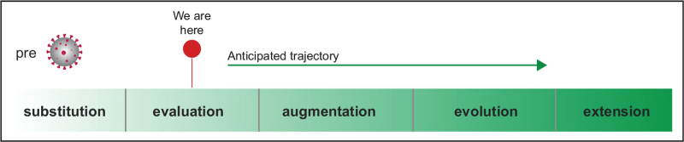
Figure 1: Telehealth Monitoring Timeline in COPD
(Source: Sculley et al. 2021)
Literature Review on Telehealth Promoting Health
A wider range of research demonstrates how effective telehealth monitoring systems are in improving healthcare, particularly in the case of chronic illnesses like COPD. According to the comprehensive study that was released in the “Journal of Medical Internet Research,” telehealth treatments greatly improved the quality of life and hospital admissions associated with COPD. A research published in the “International Journal of Chronic Obstructive Pulmonary Disease” found that hospitalized linked to COPD were reduced by 44% as a result of telehealth monitoring (Russell, 2023). These results highlight the beneficial impact of digital technology on health promotion and offer evidence of the efficiency of telehealth in controlling and enhancing the quality of life for those with COPD.
Impact of Telehealth Monitoring System
Significant advancement has been achieved in health promotion with telehealth monitoring systems, especially in controlling illnesses like COPD. The benefits are clear in the enhanced accessibility that enables quick interventions, tailored treatments, and remote vital signs surveillance. Patients become more empowered as a result of taking an active role in their health, which enhances managing oneself and lowers the need for hospital stays. But problems still exist.
According to ‌Amorim et al. 2021, Healthcare disparities may worsen as a result of differences in digital literacy and technological access. Furthermore, privacy and data security issues might prevent wider use. The effectiveness of telehealth depends on a patient's readiness to accept digital solutions, which may exclude some populations. Several studies confirm that telehealth improves communication between patients and providers and offers a proactive method of managing chronic illnesses.
Addressing the Short Falls
Policymakers should place a high priority on infrastructural improvement to provide universal broadband access to overcome the lack of telehealth uptake. Initiatives to promote digital literacy can enable a variety of demographics to make good use of telehealth. Strong data security laws and regulations should also be put in place to boost technological confidence and allay privacy worries.

Reference
- Saeid Safiri, Carson‐Chahhoud, K., Noori, M., Seyed Aria Nejadghaderi, Mark, Javad Ahmadian Heris, Khalil Ansarin, Mohammad Alì Mansournia, Collins, G.S., Ali‐Asghar Kolahi and Kaufman, J.S. (2022). Burden of chronic obstructive pulmonary disease and its attributable risk factors in 204 countries and territories, 1990-2019: results from the Global Burden of Disease Study 2019. BMJ, [online] pp.e069679–e069679. doi:https://doi.org/10.1136/bmj-2021-069679.
- Russell, D.R.E. (2023). International Journal of Chronic Obstructive Pulmonary Disease. [online] Dovepress.com. Available at: https://www.dovepress.com/international-journal-of-chronic-obstructive-pulmonary-disease-journal [Accessed 10 Nov. 2023].
- ‌Amorim, P., Brito, D., Castelo-Branco, M., Fàbrega, C., Gomes da Costa, F., Martins, H., Gonçalves, L., Gonçalves, L.M., Martin, V., Milner, J. and Nêveda, R., 2021. Telehealth opportunities in the COVID-19 pandemic early days: what happened, did not happen, should have happened, and must happen in the near future?. Telemedicine and e-Health, 27(10), pp.1194-1199. 10.1089/tmj.2020.0386
- Sculley, J.A., Musick, H. and Krishnan, J.A. (2021). Telehealth in chronic obstructive pulmonary disease: before, during, and after the coronavirus disease 2019 pandemic. Current Opinion in Pulmonary Medicine, [online] 28(2), pp.93–98. doi:https://doi.org/10.1097/mcp.0000000000000851.

Blog 2- Critically discuss the impact of a digital technology you designed for a digital health promotion intervention
Addressing Arthritis
Arthritis is a serious public health problem that affects people's everyday lives and is widely prevalent, especially in the elderly person. The Centers for Disease Control and Prevention “CDC” estimates that around 54 million persons in the US have arthritis, making it the most common cause of disability. According to the “Global Burden of Disease ”Study, from 1990 to 2017, the frequency of osteoarthritis rose by 75% worldwide (Long et al. 2022). Because arthritis is a chronic condition, it requires long-term management measures and places a considerable financial strain on healthcare infrastructures. To deal with the increasing prevalence and enhance the standard of life for individuals afflicted, effective public health interventions are essential.
Describing New Designed Technology
The AI-driven Smart Joint Assistant is a state-of-the-art piece of digital technology that will completely change how arthritis is managed. With the help of cutting-edge sensors and artificial intelligence, this creative instrument allows for real-time joint condition surveillance (Syngle et al. 2019). It provides individualized fitness plans and dietary advice in addition to anticipating and controlling pain occurrences. User involvement is improved with online rehabilitation programs and a helpful community network.
Smart Joint Assistant in Arthritis
With Real-time surveillance and AI algorithms, The Smart Joint Assistant is at the cutting edge of promoting the health of people with Arthritis. Recent research indicates that these technologies engage users with proactive pain treatment, dietary counseling, and customized exercise regimens. The incorporation of telerehabilitation sessions promotes participation, and the community support elements correspond with the author's results. This all-encompassing strategy tackles the issue of arthritis in public health by encouraging proactive self-management, minimizing pain episodes, and building a helpful digital environment that improves general well-being (Sivakumar et al. 2023).
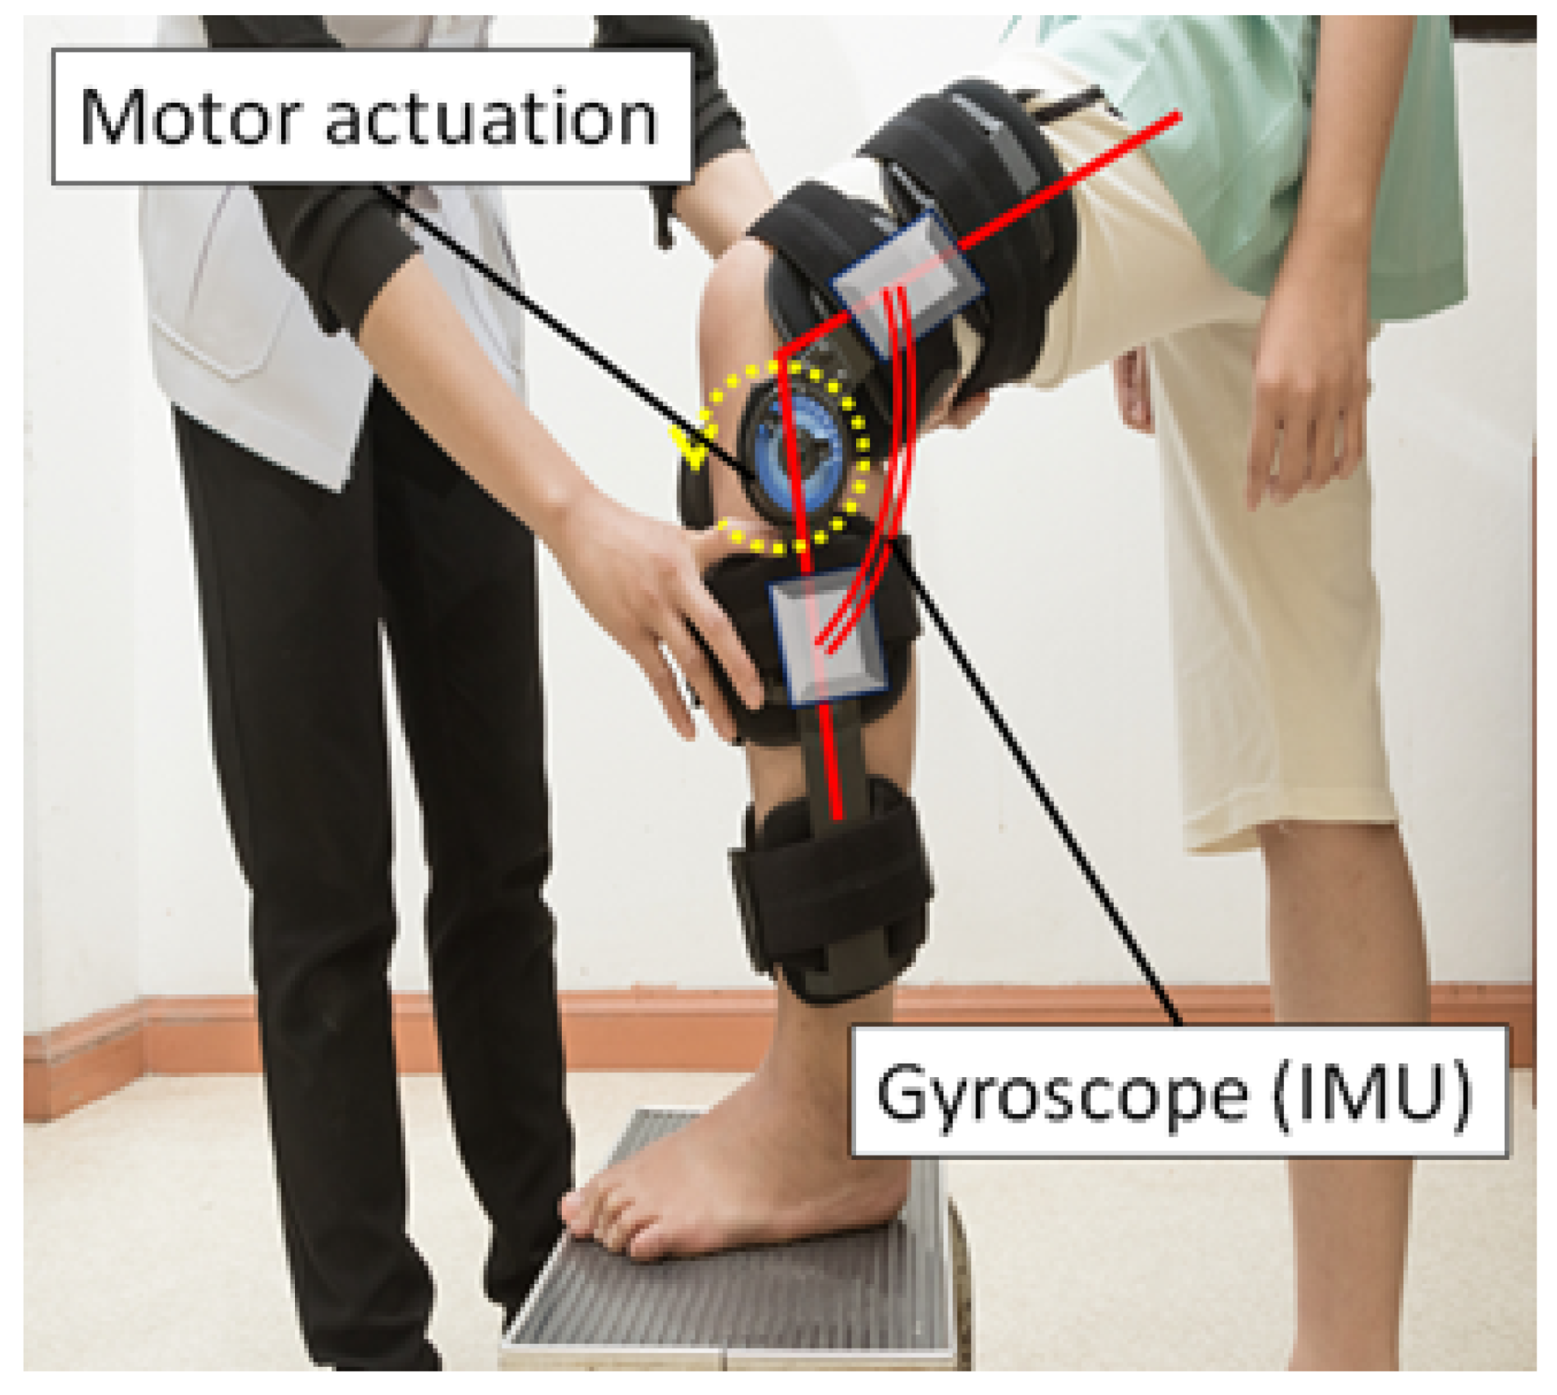
Figure 2: Smart Joint Assistant
(Source: ‌Nagano et al. 2021)

By providing important data, the smart joint assistant helps researchers comprehend arthritis and advanced study into the illness. Through the integration of innovative technology and health promotion tactics, this digital tool presents a revolutionary approach to reducing the negative effects of arthritis on Public health.
Impact of Smart Joint Assistant in Health Promotion
In terms of promoting Arthritis Wellness, the AI-powered smart joint Assustnar represents a paradigm change. Benefits include individualized therapies, continuous evaluation, and a network of support that encourages active participation. However, issues with data protection, digital literacy requirements, and technological accessibility might be shortcomings (Long et al. 2022). To fully realize the possibilities of the Smart Joint Assistant, guarantee its inclusiveness, and optimize its beneficial effects on managing arthritis and public health in general, it is imperative to strike a balance by tackling these issues.
Addressing the Short Falls
Focused educational programs can improve users' comprehension to solve accessibility and technological proficiency challenges. Establishing clear standards and strict data protection regulations will foster confidence. Working together with neighborhood groups may guarantee outreach to a variety of demographics, fostering equal accessibility for the Smart Joint Assistant.

Reference
- Long, H., Liu, Q., Yin, H., Wang, K., Diao, N., Zhang, Y., Lin, J. and Ai, G. (2022). Prevalence Trends of Site‐Specific Osteoarthritis From 1990 to 2019: Findings From the Global Burden of Disease Study 2019. Arthritis & Rheumatology, [online] 74(7), pp.1172–1183. doi:https://doi.org/10.1002/art.42089.
- Syngle, A., Garg, N., Rana, R. and Sherawat, S., 2019. AB0281 UTILIZATION OF SMART PHONE APPLICATION TO ASSESS THE DISEASE OUTCOMES IN RHEUMATOID ARTHRITIS: SMART-RA STUDY. 10.1136/annrheumdis-2019-eular.3720
- Sivakumar Chinnadurai, Mahadevan, S., Balakrishnan Navaneethakrishnan and Mahabaleshwar Mamadapur (2023). Decoding Applications of Artificial Intelligence in Rheumatology. Cureus. [online] doi:https://doi.org/10.7759/cureus.46164.
- ‌Nagano, H., Sparrow, W.A. and Begg, R. (2021). Developments in Smart Multi-Function Gait Assistive Devices for the Prevention and Treatment of Knee Osteoarthritis—A Literature Review. Applied sciences, [online] 11(22), pp.10947–10947. doi:https://doi.org/10.3390/app112210947.
- ‌Nakatsu, K., Rahman, R., Morita, K., Fujita, D. and Kobashi, S., 2022. Automatic Carpal Site Detection Method for Evaluation of Rheumatoid Arthritis Using Deep Learning. Journal of Advanced Computational Intelligence and Intelligent Informatics, 26(1), pp.42-50. https://doi.org/10.20965/jaciii.2022.p0042


