Speciesism and the global meat trade

In this essay I shall look at speciesism, whether it is justified and how it applies to the global meat production industry. Also looking at the most notable people that are involved in this discussion, such as Peter Singer.
Firstly, speciesism is, plainly, the belief that humanity is superior to all other living beings. A more detailed explanation would be that speciesism is the philosophical belief in animal rights. It is a practice where treating members of one species as morally more superior and important in regard to all other species, whilst also believing that said practice is justified. The belief is determined by terms of the interest, rights and the personal identity of humans and animals as well as the moral relevance of said species. The term was first introduced in the 1970s by an English philosopher Richard Ryder and then popularised by Peter singer, an Australian philosopher. Singer, Ryder and other philosophers claim it is akin to racism, sexism and other forms of discrimination.
An important argument that goes against speciesism, mainly accredited to Singer, is what has been dubbed the principle of equal consideration of interests (PEC). This is the principle that when looking at moral decision making, equal weight to all those affected by one’s actions. Singer states that the idea of PEC is what people now know as human equality. This shows that one should not favour someone based on sex, race and sexual orientation.
Singer believed that if PEC was accepted then the principle would have to be applied to animals as well as humans. Animals have interests, yet they do not always share the same interests as humans. For interests are based on the capability of the species. For example, humans may have an interest in procuring money whilst animals don’t; however, both animals and humans can feel pain, so they have a shared interest in not feeling pain. If PEC was only applied to humanity, then that implies that members of the homo Sapiens race are also morally superior. Furthermore, if animals and human both share the interest of not feeling pain, then why is it seen as more important for a human to avoid pain rather than an animal? This proves that PEC can apply for animals which also shows that speciesism, like other discrimination, is immoral.
However, even with this influential argument, there are defenders for speciesism such as Michael A. Fox. He responded to singers argument by claiming that species is a morally relevant characteristic for the reason that it is uniquely tied with multiple capabilities that are themselves morally relevant ( not all defenders of speciesism agree with this term) Such capabilities includes autonomy, the ability to act freely and purposefully on the basis on moral principles/values) The point of this defence is that for PEC to be applied a certain amount of intelligence is needed; according to a speciests, humans have the capability for autonomy whilst animals are incapable of this.
Of course, this argument can fall short, on problem is down to the idea that capability determines how a being should be favoured. The main problem however is that for each capability, it is believed that all humans share this ability. For example, some animals just as intelligent as humans (infants/ toddlers) This brings the predicament that a spesiesist must face: either the interests of humans are as important than the shared interests of animals, or the interests of some animals are just as important as the like interest as humans. In response to this argument some speciesists claim that it is down to the potential of being, those with a greater potential take president when speaking about morality. However, this counterargument contradicts the previous argument the speciesists used; for it narrows the idea of an all-important being. Critics, including Singer, objected that such claims are fallacious.

There are other arguments that speciesism can be justified, one argument can be found in religion. When looking at the bible there are multiple passages that reinforce the idea of speciesism. For example genesis 1:26-28 states “Then God said, “Let us make man in our image, after our likeness. And let them have dominion over the fish of the sea and over the birds of the heavens and over the livestock and over all the earth and over every creeping thing that creeps on the earth.” So God created man in his own image, in the image of God he created him; male and female he created them. And God blessed them. And God said to them, “Be fruitful and multiply and fill the earth and subdue it, and have dominion over the fish of the sea and over the birds of the heavens and over every living thing that moves on the earth.” This passage shows in multiple ways that speciesism can be seen as a divine right. Firstly, God saying “Let us make man in our image, after our likeness” shows that humanity is the closest depiction to God, of course if you are a Christian this is proof that you are greater than all other species. Secondly, God carries on to state “And let them have dominion over the fish of the sea and over the birds of the heavens and over the livestock and over all the earth and over every creeping thing that creeps on the earth.” This is fairly clear cut, it seems as a God-given right to treat animals however one pleases.
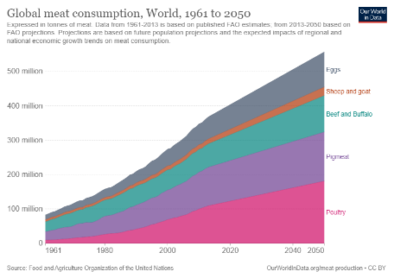
Of course, such is the way with the bible, there are contradictions. In Mathew 6:26 it states “Look at the birds of the air: they neither sow nor reap nor gather into barns, and yet your heavenly Father feeds them. Are you not of more value than they?” this passage shows that the dominion of animals is questioned. The idea behind it is that all living beings are provided for by God, so how can one be more important than another. Another bible passage that advocates for animal equality is Isiah 32:20 “Happy are you who sow beside all waters, who let the feet of the ox and the donkey range free.” Once again, this contradicts Genesis 1:26-28 as it shows that happiness can be found through the treatment as animals, not a tyrannical control.

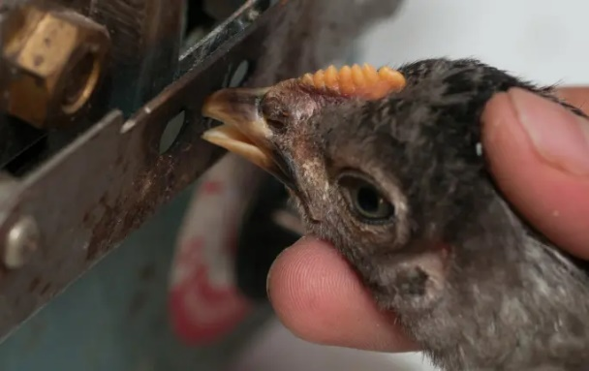
Looking away from the justifications and counter arguments of speciesism, I shall now look at how the ideology of speciesism have affected the global meat production industry. Over the years the meat industry has expanded dramatically, the global average of yearly consumed meat has also risen, From 23kg/capita in 1961 to 43kg/capita in 2013. The image above gives a predicted consumption of meat up to 2050. And with anything, a greater demand leads to a greater supply. However, the notable difference being that the product is a living, breathing thing. To match the rising population and higher demand of meat, factory farming has become more and more prevalent. Factory farming, or concentrated animal feeding operations (CAFOs), are a modern industrial method of raising farmed animals. It is an intensive agriculture process to maximise profits using as little effort and cost as possible. This means that a large number of animals will be kept indoors for most of their lives in incredibly confining spaces. The harsh living conditions are also coupled with incredibly cruel treatment of the animals. For example, chickens are debeaked, seen in the image to the right. The beak is an incredibly important part for the chicken, it is how they explore and interact with the world, like how humans use their hands. When chickens are confined in an overcrowded space they can’t use their beak to explore, so the chicken uses its beak to peck at its surrounding chickens, which can lead to injury, cannibalism and death. Rather than giving chickens more space to avoid this problem, many companies debeak the chickens instead.
Just by a shallow look at factory farming, it is obvious that animals undergo horrendous living conditions and treatment. It of course seems inexcusable, however because of speciesism, this process can be seen as justifiable for humanity is simply superior. This ideology enables companies to not take responsibility for it is simply the natural way of things and there is no need to improve conditions for the animals.
In conclusion, Speciesism is not justified as arguments for it have been counter argued and have their problems pointed out, be that on morality, physiology or religiously. The global meat industry uses speciesism to avoid responsibility and improve profits. However, even though it is not justified, it will continue simply because the demand from the growing population enables the negligent treatment of the animals.

https://www.britannica.com/topic/speciesism https://thehumaneleague.org/article/what-is-factory-farming https://link.springer.com/article/10.1007/s10460-018-09902-1 https://www.openbible.info/topics/animal_rights

