

Assessment 2

Student name:​ Rosemond Y Asante
Student ID: ​
Module name: Mental Disorders and Psychopathology​
Module code: BMHP6006
Lecturer name: Bianca Sanfilippo ​
Date:

Contents

Introduction - 3

General anxiety disorder – 3

Introduction
Mental diseases, often known as mental illnesses, are problems that affect people's emotions, behaviour, feelings, and thoughts. Mental illnesses may have an impact on how people interact with others and how well they do their everyday tasks. According to Minkoff and Covell (2021), mental illnesses are caused by a variety of factors, including chemical imbalances in the brain, previous experiences such as stress or abuse, exposure to microorganisms such as bacteria and viruses in pregnant women, substance and drug abuse, health problems such as cancer, loneliness, and traumatizing brain injury, to name a few. These illnesses include, among others, General Anxiety Disorder, Schizophrenia, Autism, depression, dementia, and Bipolar Disorder. However, this study will critically explore the categorization of the first three illnesses as well as how to diagnose, treat, and assess rehabilitation.

1.0 General Anxiety Disorder (GAD) (1000 words for general anxiety disorder)
A general anxiety disorder is a condition that causes a person to feel anxious, panic, and have excessive fear that interferes with their daily activities (Mayo Clinic, 2018). Furthermore, the illness has an impact on one's well-being as well as mental and physical health. In most circumstances, the individual in this condition will be excessively concerned or anxious, and they will be aware that there is no guarantee since even simple tasks like doing daily chores cause anxiety in persons with GAD symptoms.

1.1 Classification of GAD within ICD-10
According to (ICD.WHO.int 2016), GAD is grouped under the conditions related to stress, illnesses of somatoform, and Neurotic of the range F40 to that of F48, and under section F41.1. It is estimated that about 5% of the population of the UK is affected by this disorder, where female are more vulnerable than male, and it is most common for people between the age 40 and 60 (MHFA England, 2020). GAD is a frequently occurring condition, approximated to affect up to 8% of the UK population; thus, intervention seems to greatly concern people with GAD and other mental disorders.

1.2 Causes of anxiety (Aetiology)
The first cause is genetic factors. An individual's genes play an important role in determining whether or not a person will have GAD. In this sense, a person is predisposed to developing the signs and symptoms of the condition genetically, just like some other medical health-related conditions. Individuals can get the condition when some genes which are vulnerable to the condition are passed on to them by their relatives, making them also vulnerable. By combining both this vulnerability and other factors in the environment, the person starts showing the disorder's symptoms.
Secondly, we have the structure of the brain. This effect mainly happens through a part of the limbic system called the amygdala. This symptom is the part that deals with the response to fear and emotional as well as memory integration. According to the many types of research that have been done, it has been revealed that most people with GAD show similarities of increased activities in this part. These make researchers believe that they are responsible for patients' social behaviour interpretations being inaccurate. Life experiences cannot be left out on the long list of the cause of the GAD mental illness. Whenever a person experiences trauma during childhood, there are more chances of developing the condition. Factors such as a person being divorced, abandoned, and isolated, being abused mentally and losing a loved one contribute much to the development of the illness.
Lifestyle factors such as stress in the workplace, use of caffeine, and relationships can cause this condition. Substances with a high quantity of caffeine like tea and energy drinks make a significant number of people anxious or sometimes feel restlessness when they consume them in high quantities. On the other hand, relations may either cause pain or comfort. In women, past humiliation by their current or former lovers makes many women anxious.

1.4 Signs and Symptoms
The common signs and symptoms include difficulties in sleeping; the mouth is dry, the tension of muscles, being exhausted often and fatigued, exaggerating situations, concentration difficulties, feeling it is hard to let a worry, diarrhea, palms sweating, stomachaches now and then, irritation, excess thinking, being nervous, relaxation difficulties, being weak, and numbness for adults. Children lack self-esteem, are anxious about how to fit in with their friends, lack confidence, are worried about stomach aches, social situations avoidance, and are worried over approval from those in authority, like teachers.

1.5 When anxiety can be diagnosed
Diagnosis is conducted by a doctor screening the mental health of an individual. They are asked questions about the signs and symptoms they have and for what period they have persisted. After that, they decide whether you require medication or should be referred to a psychiatrist or psychologist. On top of that, medical tests can be done the determination whether there is an illness or drug abuse. Whenever it has been suspected that the GAD is caused by drug usage or it is an illness, then the following tests are done: To check the condition of the heart X-Ray test is done, hormone levels that cause disorders of the thyroid are tested using blood tests, checking substance abuse professionals use urine test while the condition of the gut they test using reflex tests of the gut by doing an X-Ray of the digestive system.

1.6 Current treatment
The main two ways of treating are medication and Cognitive Behavioural Therapy (CBT). The latter involves the patient meeting regularly with the health specialist to convince them to change their behaviours and thoughts. Changes in decreased signs and symptoms are seen after one year of treatment. In the one-on-one session, they are taught recognition and management of GAD and calming themselves during increased thoughts time. On the side of medication, both long-term (antidepressants) and short-term schedules (anti-anxiety medications) of medication are created. The short-term one entails relaxation of biological tissues like stomach ache and tension of muscles. These short-period treatments include medications, i.e., Xanax, Lorazepam, and Klonopin. However, these medications are taken only for a very short time since their dependence and abuse are high risks. Some commonly used long-term medications include sertraline, sertraline, duloxetine, duloxetine, Luvox, Pristiq, and Pristiq. In terms of duration, these medicines start working after some weeks. Their side effects include diarrhoea, having a dry mouth, and feeling nauseated, making many stop the medication. During the first days of using antidepressants, the cases of suicidal thoughts are minimal. It is advised that the patients remain close to their specialists and report any changes in thoughts and mood. In some cases, the medications may be taken together if advised, but the first ones are used for a few weeks as they wait for the others to start working.

1.7 Measurements of rehabilitation
From the data collected between 2002and 2013, The Mood and Anxiety Symptoms Questionnaire (MASQ) responded more than the Brief Symptom Inventory (BSI). However, measures for specific disorders equalled the two parameters, and if there were statistically significant differences, there were small effective sizes (ES). According to NICE (2016), GAD's most common care principle is psychotropic medication, including antidepressants and stimulants.

1.8 Recommendations for improvement of anxiety
Support groups would be a good recommendation for people with GAD, especially adults. This way, people with GAD get the chance to meet in comfort and safety and give and receive all kinds of support, such as education and learning about anxiety and how to develop social links amongst each other. An additional dietary recommendation would be to adequate intake of vitamin B and Calcium that help relax tissue muscles. Specific foods include leafy greens, wholegrain cereals, and low-fat dairy products.

1.9 Principles of care for people with generalised anxiety disorder (GAD)
(NICE)
According to NICE (2016), GAD's most common care principle is psychotropic medication, including antidepressants and stimulants.
Useful link: National charity helping people with Anxiety - Anxiety UK

2.0 Schizophrenia
According to World Health Organization (2019), schizophrenia is a mental illness that affects a person’s decision-making process, behaviour, perception, thoughts, and language ability. The mental disorder always makes it difficult for people at work/school to perform their duties as assigned. Schizophrenia causes psychosis related to socio-cultural norms such as family matters, career life, education, and personal life. People with schizophrenia also fall victim to discrimination, stigma, and violation of their human rights.
  - classification (Schizophrenia within the ICD –10 is classified as schizotypal and delusional disorders
  - (F20-F29),
  - Causes (Aetiology)
  - Signs/Symptoms
  - diagnosis,
  - Current treatments
  - measurements of rehabilitation,
With this condition, we can only measure the quality of care and treatments provided to effectively control and manage the condition and avoid complications, such as self-harm and suicide, substance misuse, neglect and self-neglect, lack of dignity and violation of human rights.
We can measure the quality of life with the indicators that are used for long-term mental disorders.
‘Quality Indicator for Rehabilitative Care(QuIRC-SA)’ (SEE APPENDIX B). This tool includes specific indicators that show that quality of care and effective are provided to manage the condition (see appendix b). https://quirc.eu/quirc-sa/. Schizophrenia is a long-term condition and in this case it is important to support the service users to have a good quality of life. We can measure this by using indicators for rehabilitative care which apply to all long-term mental health conditions.
  - Guidance and principle of care NICE
  - Recommendations for improvement of Schizophrenia

- Autism - 1000 words for autism
- Definition
- Classification (F80-F89 Disorders of psychological development, ICD, 2010)
- Provide data related to percentage of children people with autism in the world and UK and other data, e.g. if there is prevalence by gender….
- Causes (Aetiology)
- Signs /symptoms
- diagnosis,
If you or your child have signs of autism, the next step is to talk to someone about it.
You could speak to:
a GP a health visitor (for children under 5)
any other health professional you or your child see, such as another doctor or therapist
special educational needs (SENCO) staff at your child's school
Ask them if they think it's a good idea to refer you for an autism assessment.

An assessment is done by autism specialists. It's the only way to find out if you or your child are autistic.
autism assessment
An autism assessment is where a team of autism specialists check if you or your child are autistic.
An assessment team may:
ask about any problems you or your child are having watch how you or your child interact with other people speak to people who know you or your child well, such as family, friends, your GP or your child's teachers.
What happens during an autism assessment
You may have 1 or more appointments with a team of different professionals.

For children
The assessment team may:

ask you about your child's development, such as when they started talking
watch how you and your child interact, and how your child plays
read any reports sent by the GP and the nursery or school
A member of the team may also visit your child's school to watch them in class and at break time.
At the end of the assessment, you'll be given a report saying if you or your child are autistic.
SOURCE NHS https://www.nhs.uk/conditions/autism/getting-diagnosed/how-to-get-diagnosed/
Diagnostic measures include The Autism Diagnostic Interview- Revised (ADI-R).

- Current treatments

- measurements of rehabilitation: ‘Childhood Autism Rating Scale (CARS)’ (SEE APPENDIX C) and observation, called ADOS - ‘Autism Diagnostic Observation Schedule’.
- Recommendations for improvement of AUTISM (you can write about complementary therapies , such as yoga in autism as many studies have demonstrated the effectiveness of yoga in the behaviour of children with autism.
- Guidance and principle of care - NICE
- National Autistic Society (USEFUL WEBSITE)
- Conclusion
Show understanding of importance of person-centred approach, based on Human Rights Act non-discriminatory practice based on Equality Act 2010.

References

Within your report you must include a minimum of 12 references in your reference list, to include - literature, legislation, or case studies.

NHS (2021) Anxiety and panic attacks (Online). Available at: Anxiety and panic attacks - NHS (www.nhs.uk) (Accessed: 05 November 2021).

World Health Organisation, WHO (2010) ICD-10 VERSION (Online). Available at: https://icd.who.int/browse10/2010/en#/F30-F39 (Accessed: 16 December 2021).

Appendix A: Generalised Anxiety Disorder Questionnaire GAD –7.

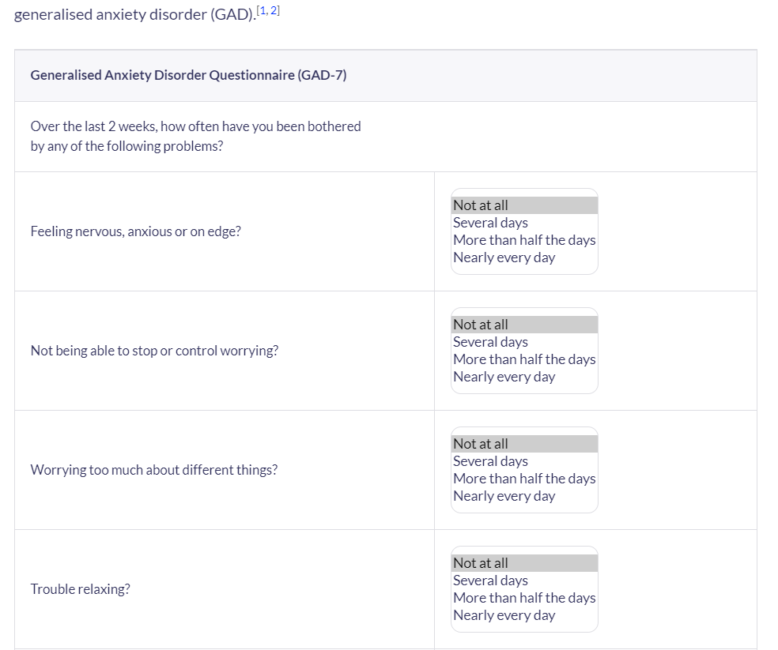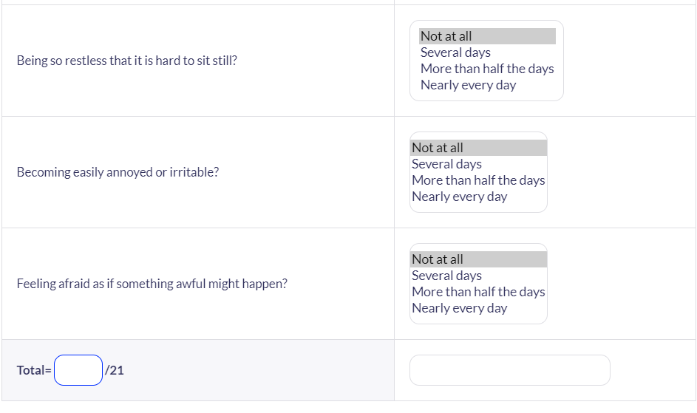

Appendix B: Indicators for rehabilitative care:

‘Quality Indicator for Rehabilitative Care (QuIRC-SA)’
The indicators to be considered are the these:
‘Living Environment’,
‘Therapeutic Environment’,
Treatments and Interventions,
Self-Management and Autonomy,
Social Interface,
Human Rights
Recovery Based Practice.



