

Strategic Management Analysis of Tesco PLC in the UK Grocery Retail Market

Programme: Master of Business Administration
Module: Strategic Management
Module Code: LCMB7003

Lecturer Name: Balendran Kandasamy

Student Name: Shariara Mahmud Rafat
Student ID: 2521546

Word Count: 5393
Submission Date: 12th August 2026

Table of Contents
1. Introduction 1
2. Organisational Context and Overview 1
2.1 Company Background and Historical Perspective 1
2.2 Mission, Vision and Business Model 1
2.3 Industry, Competitors and Market Position 2
3. External and Internal Strategic Analysis 3
3.1 PESTEL Analysis of Tesco’s UK Grocery Market 3
3.2 Porter’s Five Forces 7
3.3 VRIO Analysis 8
3.4 SWOT Analysis 10
4. CSR Strategy and Balanced Scorecard 12
4.1 Tesco’s CSR Strategy and Alignment with Business Objectives 12
4.2 Balanced Scorecard 14
5. Strategic Choices, Evaluation and Implementation 15
5.1 Current Business-Level Strategy 15
5.2 Alternative Strategic Choices 15
5.3 Recommended Strategy 16
5.4 SAFE Evaluation 16
5.5 Financial Performance and Organisational Effectiveness 17
5.6 Gap Analysis 17
5.7 McKinsey 7S Framework 18
5.8 Implementation Challenges and Solutions 19
6. Reflection Using Gibbs’ Reflective Cycle 19
7. Conclusion 22
8. References 23

1. Introduction
This report critically analyses the strategic position of Tesco PLC in the Grocery retail sector in the United Kingdom as a strategic management consultant. The UK market is chosen as it is Tesco's primary operating market and it offers a strong foundation to analyse competitive pressures, customer value and strategic capability. Tesco has been around for over 50 years, and they have given enough financial, operational and strategic information publicly to carry out in-depth analysis of their business (Tesco PLC, 2025). The report uses PESTEL, Porter's Five Forces analysis, VRIO & SWOT analysis to identify the external environment and internal resources of Tesco and CSR & Balanced Scorecard analysis to assess it. Strategic alternatives are analysed by SAFE, Gap Analysis and the framework of the Seven S of McKinley. The frameworks enable the linkage of theoretical knowledge and practical strategic decision making (Hanelt et al., 2021). In addition, a reflective evaluation is provided to show how learning is being assessed as well as analytical judgement and professional development.

2. Organisational Context and Overview

2.1 Company Background and Historical Perspective
Tesco PLC is one of the biggest grocery stores in the UK and has a rich history in the retail sector. It was established in 1919 by Jack Cohen, who started out as a small market-stall company, and expanded into a large supermarket chain, with convenience stores and online grocery delivery services that cater to millions of customers. The main business activities of Tesco are food retailing, household products, own brand products, online food delivery and customer loyalty services. It is significant in the UK retail market as it is large, has coverage across the country and is the market leader in grocery market share (Tesco PLC, 2021; Tesco PLC, 2025).

2.2 Mission, Vision and Business Model
Tesco's strategic intent is to better serve customers, communities and the planet day-by-day, which underpins its business model, which is focused on value, convenience and responsible retailing (Tesco PLC, 2024). It sells through a range of supermarkets, Express convenience stores, online groceries, supplier partnerships, Clubcard loyalty offers and private label product ranges. Clubcard is also vital in terms of its value in terms of strengthening customer retention and helping to support personal pricing. Throughout the period 2021-2025, Tesco maintained its impressive scale, with its group sales (excluding fuel) growing from around £53.4 billion in FY2021 to £63.4 billion in FY2025, and adjusted operating profit from round £1.82 billion to £3.10 billion (Tesco PLC, 2021, 2025).

2.3 Industry, Competitors and Market Position
Tesco faces a very competitive grocery market in the UK with Sainsbury's, Asda, Morrisons, Aldi, Lidl, Waitrose and Ocado. It's well-positioned as a result of large scale, brand trust, a wide store network, and online grocery and Clubcard loyalty. Aldi and Lidl on the other hand are constantly putting pressure on prices, especially in the cost of living period, leading to a significant strategic question: what value do they perceive. Tesco's market share is estimated to be 27-28% of the UK grocery market during 2021-2025, confirming it as a market leader, but also highlighting a need to defend market share against discounters (Kantar, 2024; Kantar, 2025).
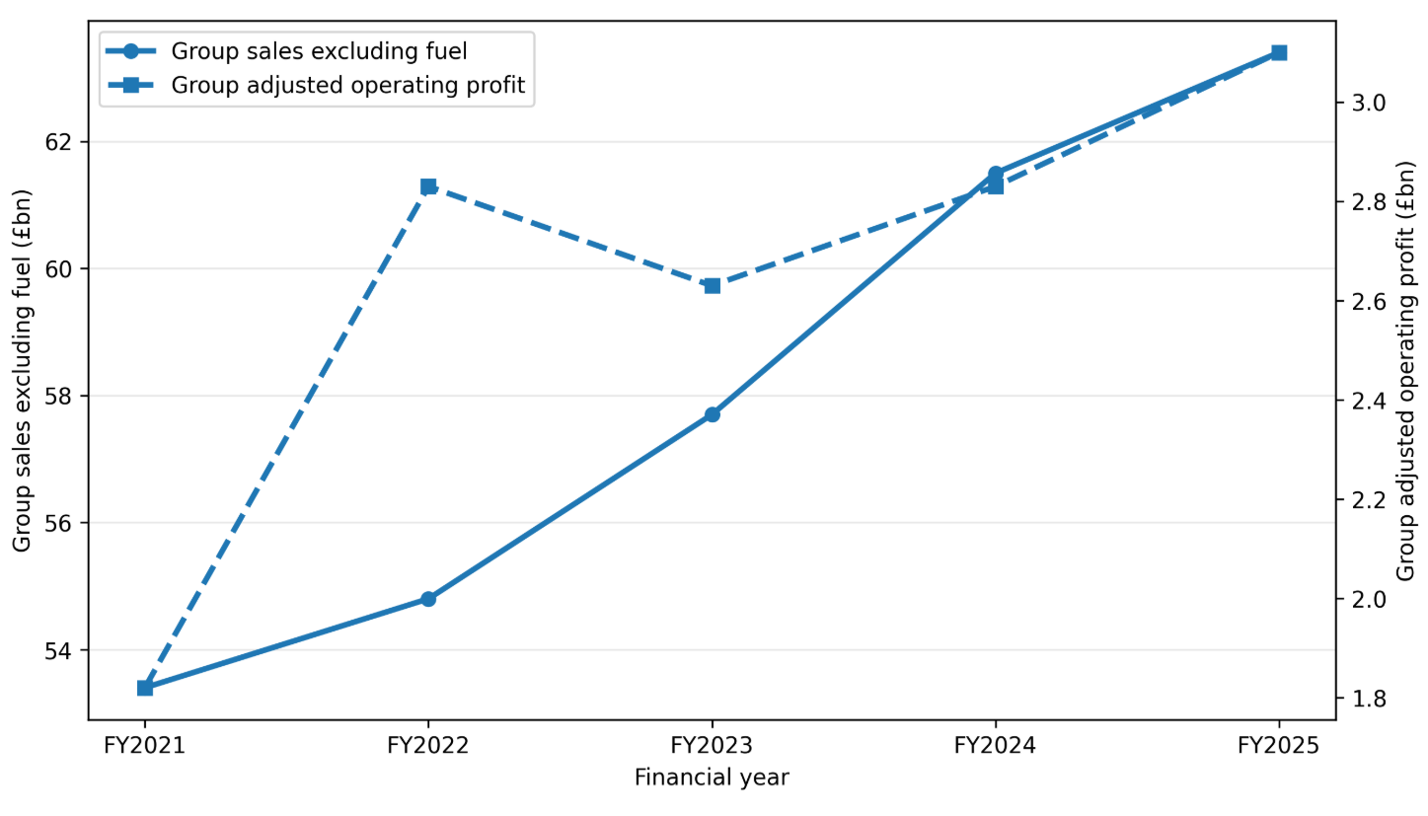
Figure 1: Tesco PLC sales and adjusted operating profit trend, FY2021–FY2025.
Source: (Tesco PLC, 2021, 2022, 2023, 2024, 2025).
As seen in figure 1, Tesco's sales increased consistently during the period of FY2021 to FY2025, whereas the adjusted operating profit has seen an increase in value during FY2023 and bounced back in FY2025. This indicated Tesco's revenue growth was enhanced but the focus on margin protection remained very significant.

3. External and Internal Strategic Analysis

3.1 PESTEL Analysis of Tesco’s UK Grocery Market
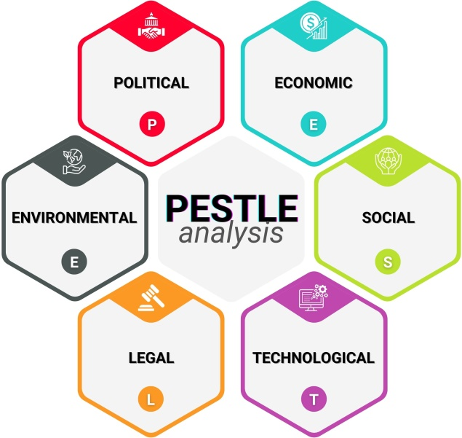
Figure 2: PESTEL Analysis (Iqbal, 2025)
Political Factors
Food policy and the complexity of supply chains as a result of Brexit and regulation on consumer affordability are all having an impact on Tesco's grocery business in the UK. Brexit created operational difficulties on imports and availability of labour, coordination of suppliers as well, which is key for Tesco, a high volume, and low margin business. The grocery unit pricing review by the Competition and Markets Authority also indicates that supermarkets are facing growing regulatory and reputational challenges due to a lack of pricing transparency (Competition and Markets Authority, 2023). So, Tesco needs to ensure that there is a difference between the value ranges of Clubcard Prices and promotions and the own label value ranges, which is commercially effective and publicly defensible.

Economic Factors
The greatest pressure that the economy brought to Tesco was in the years 2021-2025. UK food and non-alcoholic beverage inflation rose to 19.2% in March 2023, leading to an increase in consumer sentiment about the price of food and non-durable goods (Office for National Statistics, 2023), which ultimately raised the demand for cheaper food and non-durable goods. Meanwhile, Tesco was experiencing increased supplier, logistics, energy and labour expenses. Tesco's resilience, however, is evident as the group sales excluding fuel jumped from around £53.4 billion in FY 2021 to £63.4 billion in FY 2025, as its adjusted operating profit grew from about £1.82 billion to £3.10 billion (Tesco PLC, 2021; Tesco PLC, 2025). The key question is whether Tesco can maintain profits with the price pressures being put on them by the discounters.
Social Factors
The price conscious, convenience seeking and tech-savvy consumers of UK grocery brands have now become even more so, especially since cost-of-living pressures have led to higher frequency of comparison shopping and lower levels of automatic brand loyalty. This challenge and opportunity is a problem for Tesco. Aldi and Lidl are still firmly in the fight for Price Value, whereas Tesco has the opportunity to leverage its Clubcard customer base to provide personalised promotions, targeted discounts and more relevant customer offers. In a mature grocery market, the ability to gain a competitive edge becomes more and more dependent on the total grocery shopping experience, the convenience and perceived value of the product or service. Hence, in order to increase the retention rates and maintain their market competitiveness, Tesco needs to strike a balance between affordability and personalised engagement (Kantar, 2025; Tesco PLC, 2025).
Technological Factors
Technologies play a key role in Tesco's competitive position as online grocery, loyalty analytics, automation, self-checkout and supply-chain technologies have a direct impact on customers' experience and operational efficiency. Clubcard gives Tesco a strong digital competency by allowing them to run personalised promotions and use the data to guide pricing decisions. But technological investment has strategic significance only when it is used in an integrated manner and not separately in the context of the organisation's processes and decision making. Tesco should thus ramp up its application of analytics to better manage stock availability, online fulfilment, demand forecasting and reducing waste and enhance more profitable customer baskets. For digital transformation to be effective, the technology must complement organisational processes, skills, and goals (Hanelt et al., 2021; McKinsey & Company, 2024).
Environmental Factors
Tesco will be impacted by carbon reduction, food waste, packaging and responsible sourcing as a result of environmental pressures. Waste reduction, reducing emissions and supplier standards initiatives are reported in the case of Tesco PLC (2024). Such activities can help build brand legitimacy but at the same time can also put pressure on the price due to the fact that customers are not only price sensitive but also want sustainable retailing. According to the British Retail Consortium (2024), retailers in the UK are under a double burden from a need to invest in sustainability and to manage operating costs. Tesco's environmental policy should thus be aimed at improvement in efficiency as a result of waste reduction, improved logistics and close cooperation with suppliers.
Legal Factors
Employment law, food safety regulation, competition law and data protection are legal forces which impact Tesco. Labour regulation is particularly relevant since the National Living Wage is moving from £8.91 in 2021 to £12.21 in 2025, increasing the store and distribution costs (GOV.UK, 2025). GDPR is also very important in terms of strategy as Tesco's Clubcard is based on customers' data. Compliance is therefore linked to trust, and brings with it increased complexities and costs.
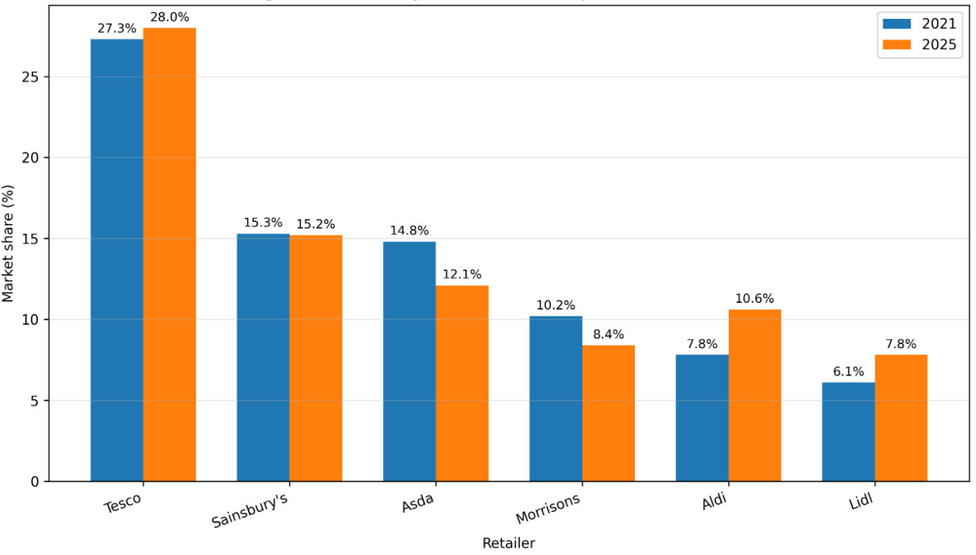
Figure 3: UK grocery market share comparison, 2021 vs 2025
Source: (Kantar, 2021; Kantar, 2025).
In the UK grocery market, Tesco has been the market leader, with a slight growth from 27.3% in 2021 to 28.0% in 2025 as shown in Figure 2. However, Aldi rose from 7.8% to 10.6% and Lidl from 6.1% to 7.8%, while Asda declined from 14.8% to 12.1% and Morrisons from 10.2% to 8.4%. This reveals that Tesco's biggest external challenge is not a threat to their top position, it's a threat to the perception of their product and brand, customer loyalty and profit margin as a result of discount pressure (Kantar, 2021; Kantar, 2025).

3.2 Porter’s Five Forces
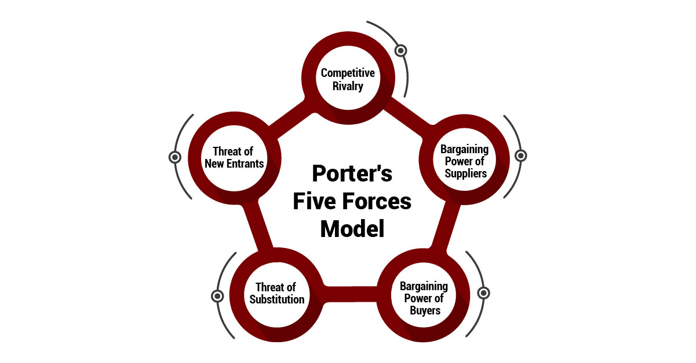
Figure 4: Porter’s Five Forces (The Strategy Institute, 2024)
Competitive Rivalry
Tesco has a high level of competitive rivalry in the UK grocery market, with it competing with full-range supermarkets including Sainsbury's, Asda and Morrisons, and being pressured by Aldi and Lidl. But, as Porter (2008) asserts, the rivalry is more intense when firms compete on price, promotions and service improvements. In the UK grocery market, for instance, Tesco's share of the market has stayed at around 27-28% from 2021 to 2025, while that of Aldi has risen from around 7.8% to 10.6%, and Lidl's has risen from around 6.1% to 7.8% (Kantar, 2021; Kantar, 2025).
Buyer and Supplier Power
There is a high degree of buyer power as consumers have the ability to easily shop around. This was more important as UK food and non-alcoholic beverage inflation rose to 19.2% in March 2023, raising the sensitivity of customers to the price of their basket (Office for National Statistics, 2023). Supplier power is of moderate strength. Although it is a reflection of Tesco's scale that it has some purchasing power, it also exposes suppliers to the impact of energy prices, commodity inflation, labour shortage and weather disruption, which means that it does not have full control over cost pressure (British Retail Consortium, 2024).

Substitutes and New Entrants
Moderate to high threat of substitutes because other options to supermarkets are meal kits, delivery services, convenience stores and the discount retailers can replace some items in the supermarket basket. But it's low to moderate competition due to grocery retailing being a high ticket item, supplier networks, logistics systems, and brand trust (Grant, 2022). The whole point of Tesco's problem is not that survival is a question, but that they need to defend their market share and margins in the face of customers who are going for lower prices and better convenience. It has been resilient in terms of sales performance, which increased from £53.4 billion in FY2021 to £63.4 billion in FY2025, but it needs to control margin pressure from competitors to continue to be an advantage (Tesco PLC, 2021; Tesco PLC, 2025).

3.3 VRIO Analysis
Competitive advantage is derived from the interaction of the resources within the internal environment of Tesco as opposed to any one resource. According to the resource-based view, sustainable competitive advantage is granted to companies that have resources that are valuable, rare, hard to imitate and organized (Barney, 1991). Tesco's major assets are its own label products, its supply chain, Clubcard data, online grocery offering and brand image, with its scale of stores being its biggest asset.
While it is true that the brand name Tesco has value, it is only a little less rare than Sainsbury's, Asda and Morrisons as the UK is also well acquainted with these brands. Its store network is more operationally significant as it has a much wider geographical reach which enables Tesco to offer convenience, fulfilment and local access. But besides the costs of physical size is the cost of rent, labor, energy and maintenance.
One of the very best VRIO resources that Tesco has is Clubcard. It is valuable because it facilitates personalised pricing and retention; rare because few UK competitors have the same level of scale to their loyalty data; difficult to imitate as customer data builds over many years and is used by Tesco directly, e.g. in the Clubcard Prices and promotional targeting; and organised because Tesco leverages it directly, e.g. in Clubcard Prices and promotional targeting. Grant (2022) sees the power of resources when they are part of the capabilities of the organisation, as can be seen in Tesco using data to link pricing, promotions and customer behaviour.
Tesco's supply chain scale is useful in helping to achieve availability and cost efficiency in inflation. The value products aspect is also relevant as it will give Tesco a chance to compete with Aldi and Lidl, while still maintaining standard and premium products in its product range, all under its own brand. Online grocery is useful but not so widespread as there are other players in the online grocery space, such as Ocado and Sainsbury's Fresh. Thus, the value that can be obtained from the Clubcard, stores, supply chain and online fulfilment is greatest when all three work in harmony within a single organization as a whole, as is the case with Tesco.
Table 1: Compact VRIO Analysis of Tesco PLC
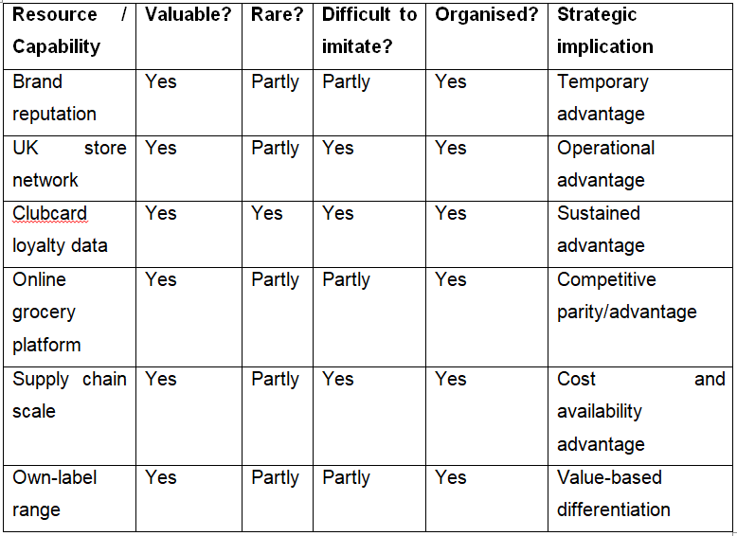
Source: (Grant, 2022; Tesco PLC; Tesco PLC ,2022; Tesco PLC ,2023, Tesco PLC,2024).
As table 1 reveals, Clubcard loyalty data is the largest opportunity for sustainable competitive advantage, bolstered by store scale and supply chain ability and flexibility of own labels. The table also indicates that certain resources (e.g., brand and online grocery) must be continually invested, as they can be copied by competitors in obvious ways in the retail space.

3.4 SWOT Analysis
Tesco's SWOT position indicates the strategic strength at a time of stress. It has good attributes including brand trust, Club card, online grocery and supplier scale and its own label ranges. These are coupled well with external opportunities like personalized loyalty pricing, omnichannel growth and private label expansion. Tesco's alignment is significant as it will enable it to act on the customer behaviour in response to inflation, based on their own internal data and product architecture.
But the weaknesses of Tesco diminish strategic choices. Its size and nature of operations exposes it to wage, energy and logistical inflation. It also relies on UK grocery, thus placing direct pressure on performance as a result of domestic consumer pressure. Sales grew from 2021-2025 but the company is still under pressure on margins due to discount competition, which means that they are unable to raise the prices due to competition (Tesco PLC, 2021; Tesco PLC, 2025).

Table 2: SWOT Matrix of Tesco PLC in the UK Grocery Retail Market
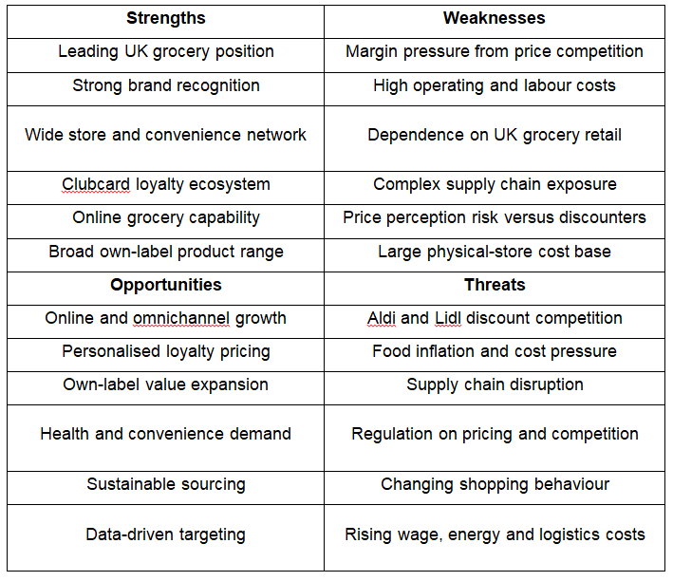
Source: (Competition and Markets Authority, 2023; IGD, 2024; Mintel, 2024; Statista, 2024).
Table 2 shows that the most favourable prospects for Tesco are those where there is a match of strengths. Personalised loyalty pricing is driven by Clubcard, online growth is driven by digital and store fulfilment and own label expansion drives value competition. The key takeaway is, that Tesco should not go with pure cost leadership and instead should go with value differentiation, which is based on data, with their competitive pricing, insight into loyalty, own brand innovation, convenience of online shopping and efficient supply chain.

4. CSR Strategy and Balanced Scorecard

4.1 Tesco’s CSR Strategy and Alignment with Business Objectives
Due to Tesco's business goals, which rely on the trust and value placed in Tesco by its consumers, responsible sourcing and efficient operations, the CSR strategy is tightly linked to its business goals. It has a number of priorities to minimize food waste, reduce carbon, make responsible sourcing, improve packaging, make healthier product decisions, support people in the community with food, look at supplier ethics and employee welfare. These spaces offer Tesco its value proposition as customers have come to expect large supermarkets to offer an affordable food, as well as reduce social and environmental damage. WRAP (2024) recognises that minimising food waste is one of the primary challenges for retailers in the UK as it helps to improve food retailers' resource efficiency and environmental impact.
One of the best examples of CSR helping to improve business performance is to reduce food waste. The amount of food waste in FY2021, across Tesco's large store and distribution network is around 45,000 tonnes (Tesco PLC, 2021), thus demonstrating the challenge of food waste management. This has dropped to approximately 43,000 tonnes in FY2022, indicating that there are efforts to generate surpluses and have waste control measures at the store level (Tesco PLC, 2022). Food waste has also been reduced to some 41,000 tonnes in FY2023, despite the inflationary pressures and pressures in the supply chain (Tesco PLC, 2023). The number of tonnes dropped to around 39,000 by FY2024, reflecting improved waste management, particularly embedding it in business processes (Tesco PLC, 2024). The estimated amount of food waste is around 37,000 tonnes, which is an estimated 18% less than it was 5 years ago (Tesco PLC, 2025).
Reducing carbon is also a long-term strategy as all the storage, refrigeration, distribution and logistics are energy intensive processes. The operational Scope 1 and 2 emissions for Tesco can be reported as reducing from around 1.05 million tCO₂e in FY2021 to c0.78 million tCO₂e in FY2025 which is a reduction of approximately 26%. Additionally, packaging reduction contributes to environmental performance as the removal of unnecessary plastic is achieved or “recyclable” packaging is enhanced. The principles of the circular economy have been outlined as a way to generate greater value for business through the reduction of packaging, which must be part of the product design and supply-chain process (Ellen MacArthur Foundation, 2022).
Community food redistribution helps ensure food security for households in need of help while responsible sourcing helps mitigate risks to reputability associated with animal welfare, traceability and deforestation, as well as labour standards. Tesco's employee welfare is also crucial as they have over 300,000 employees, which means wellbeing, retention and training has an impact on the productivity and service levels they provide (Tesco PLC, 2025; CIPD, 2023). Hence, Tesco's CSR can be considered as contributing to its competitive advantage to build trust among stakeholders, minimize waste and build trust among people. But it needs to be viewed in a critical manner as sustainability investment can lead to higher costs in periods of high competition in pricing.
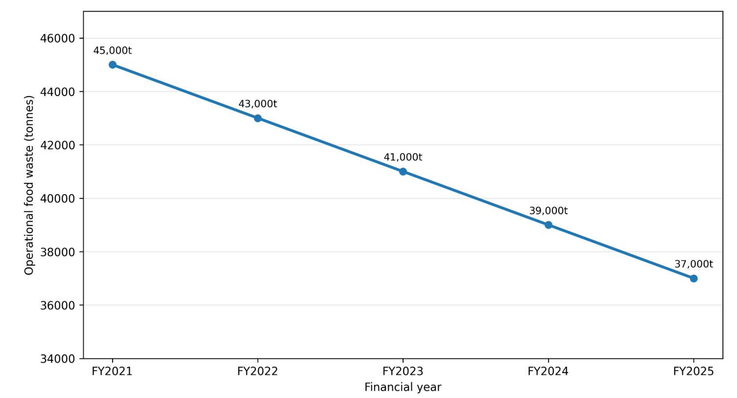
Figure 5: Tesco operational food-waste trend, FY2021–FY2025
Source: (Tesco PLC, 2021; Tesco PLC, 2022; Tesco PLC, 2023; Tesco PLC, 2024; Tesco PLC, 2025)
Figure 3 shows Tesco’s operational food-waste trend from 45,000 tonnes in FY2021, 43,000 tonnes in FY2022, 41,000 tonnes in FY2023, 39,000 tonnes in FY2024 and 37,000 tonnes in FY2025. A reduction of 8,000 tonnes is indicative of the fact that there is strength in linking environmental responsibilities with cost efficiency and impact on the community to Tesco's CSR strategy.

4.2 Balanced Scorecard
The Balanced Scorecard is suitable for Tesco as it links financial and non-financial with strategies. Kaplan and Norton (1992) have stated that a good performance measurement system should consist of four components: financial results, customer value, internal processes and learning and growth. This is appropriate for Tesco as their strategy is based on making it affordable, being loyal, convenient, their operational efficiency and their employees.
Financial Perspective
Tesco's financial goal should be to be profitable and maintain margins. Group sales (excluding fuel) estimated to be around £53.4bn in FY2021 (Tesco PLC, 2021). Sales increased to about £54.8 billion in FY2022 (Tesco PLC, 2022). Around £57.7 billion (inflated) was sold in FY2023, but sales were under pressure from inflation (Tesco PLC, 2023). This saw sales rise to around £61.5 billion in FY2024 (Tesco PLC, 2024). In FY2025, sales were approximately £63.4 billion with the adjusted operating profit of £3.10 billion (Tesco PLC, 2025). The aim is stable growth with margin security based on cost efficient, private label growth and optimisation of supply chain.
Customer Perspective
The Tesco's customer goal should be to create more loyalty and feel of value by customers. Mandated it to lead the UK grocery market with a 27.3% share of the market in 2021, while in 2025 the market share rose to 28.0% indicating a leadership position but also a need to offer better protection to customers against Aldi and Lidl (Kantar, 2021; Kantar, 2025). Market share, Clubcard engagement, customer satisfaction as well as online grocery usage should be part of the KPIs.
Internal Business Process Perspective
Improve efficiencies, availability and minimise waste that's the aim of Tesco's internal aims. Every year, it is estimated that food waste will be reduced from 45,000 tonnes to 37,000 tonnes, which helps to enhance the efficiency of the operation and CSR performance (WRAP, 2024). Some KPIs should be stock availability, the accuracy of deliveries, cost of the supply chain, reduction of waste and packaging advancement.
Effective learning and growth Perspective
Tesco's desired learning goal should be to strengthen the capability of their employees and digital. Digital transformation is only of value when technology is part of the organisation's processes and the skills of employees (Verhoef et al, 2021). Training, retention, engagement, productivity and digital skills should be included in the set of the KPIs.

5. Strategic Choices, Evaluation and Implementation

5.1 Current Business-Level Strategy
Tesco's current business-level strategy is a hybrid one, it has a competitive approach to pricing and an approach to differentiation via Clubcard, own-label products, online grocery, convenience formats and scale as part of the supply chain. This has helped Tesco to maintain its market dominance with UK grocery market share rising from 27.3% in 2021 to 28.0% in 2025, whilst Aldi’s market share grew from 7.8% to 10.6% and Lidl saw market share rise from 6.1% to 7.8% (Kantar, 2021; Kantar, 2025). In March 2023, however, the rate of inflation for food and non-alcoholic beverages hit 19.2%, driving up customer price sensitivity (Office for National Statistics, 2023). Hence, Tesco's business plan is still viable but over betting on the price competition measures may reduce the margins.

5.2 Alternative Strategic Choices
There are three fundamental strategies that can be adopted: cost leadership, differentiation and focus. Pure cost leadership isn't very appealing as Aldi and Lidl have a relatively lean discount operating model, while Tesco has to bear the costs of having a larger store network, online fulfilment and a much broader service offer. Differentiation is more appropriate as Clubcard information, own label innovations, convenience and brand trust can provide unique customer value and premiums would clash with price sensitivity. A focus strategy would also be less suitable as Tesco is targeting an extensive national market, rather than a small target customer segment. Data-driven value differentiation is, therefore, the strategic fit that is most suitable, as it is the most affordable with personalisation, convenience and product choice (IGD, 2024; Verhoef et al., 2021).

5.3 Recommended Strategy
Tesco needs to implement Data-Driven Value Differentiation, with more Clubcard data available for targeted offers, increased value and premium own-label product ranges, better online fulfilment, waste and stock-out reduction using analytics and better supplier relationships. This is more stable than simply a cost leader as Tesco doesn't have to adopt the discount strategy of Aldi and Lidl and more achievable than a pure differentiator in a cost conscious market. The recommendation is also based on a theory of dynamic capability which is concerned with how firms maintain their competitiveness by continually reconfiguring their resources as market conditions evolve (Teece, 2021).

5.4 SAFE Evaluation
Suitability: The proposed strategy is highly appropriate as it will cater to the inflationary pressure, discount competition, omnichannel demand, sustainability, and leverage the strengths of the Clubcard, stores, own-label products and supply-chain capabilities of Tesco.
Acceptability: It is medium-high because it provides personalised value and convenience to the customers and potential shareholder benefits are in the form of improved retention and margin protection. However, there are concerns about privacy, costs of the technology, and over discounting that must be managed.
Feasibility: Its level of feasibility is high as Tesco already has most of the resources available such as Clubcard data, a store network across the country and the ability to sell groceries online or has scale of their supply chains. Implementation then needs to be done with a greater degree of integration of existing capabilities, rather than the development of an entirely new business model (Tesco PLC, 2024; Tesco PLC, 2025; Whittington et al., 2023).

5.5 Financial Performance and Organisational Effectiveness
The value of Tesco's group sales, excluding fuel, grew from about £53.4 billion in FY2021 to £63.4 billion in FY2025 and its adjusted operating profit increased from around £1.82 billion to £3.10 billion (Tesco PLC, 2021; Tesco PLC, 2025). Indiscriminate discounting may be minimised through data-driven promotions, own-label development can help boost margins and supply-chain analytics can help cut down on waste and stock-outs. Organizingly, there needs to be better synchronization between marketing, digital, stores and supply-chain roles and a quicker time to make evidence-based decisions (McKinsey & Company, 2024).

5.6 Gap Analysis
The key chicken is not the lack of resources, but the lack of integration of the resources that are available. Tesco has a lot of Club card data but a need for even more predictive personalisation; competitive price with more margin sensitive targeting; extensive supply chain with more powerful forecast, waste reduction and fulfilment integration. Likewise, there is still a lack of capacity in the areas of data literacy, digital decision-making and supplier information sharing. Filling these gaps would lead to the creation of a more coherent system of competitive advantage from individual strengths (Hanelt et al., 2021; Verhoef et al., 2021).

5.7 McKinsey 7S Framework
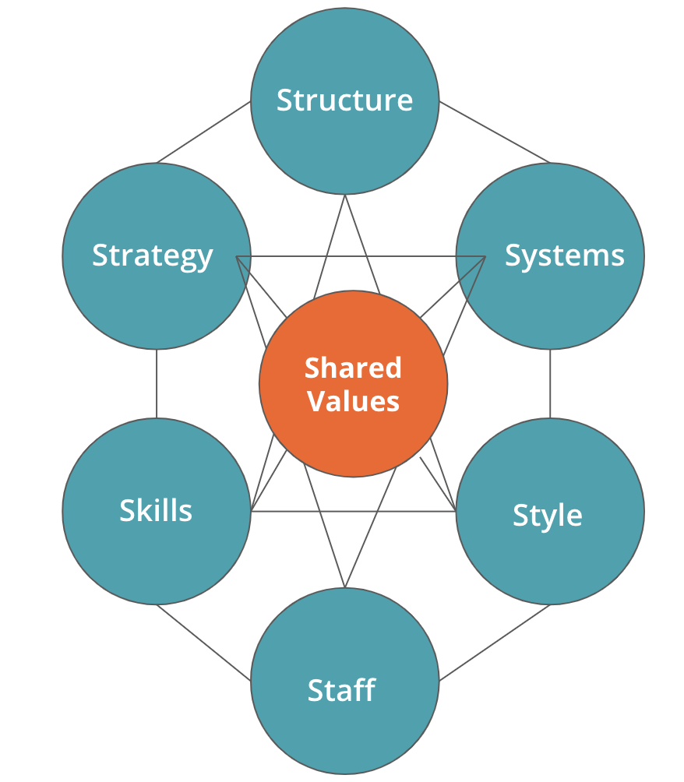
Figure 6: McKinsey 7S Framework (CFI, 2022)
Structure: The digital, marketing, stores and supply-chain functions need to be better coordinated to eliminate organisational silos.
Systems: There is a need for better integration between clubcard analytics, pricing, forecasting systems as well as inventory and online-fulfilment systems (Verhoef et al., 2021).
Skills: Employers require employees to have improved data analytics skills, digital retail and change management skills (Hanelt et al., 2021).
Staff: The targeted digital training will enhance the uptake of new systems by frontline and managers.
Style: Leadership must be collaborative, evidence-based and customer focus (McKinsey & Company, 2024).
Shared Values: Affordability, Trust, Responsible retailing and sustainability should continue to be at the heart. In general, there is a need for alignment throughout all seven elements as otherwise, technological investment doesn't provide an advantage unless supported by a combination of the other factors.

5.8 Implementation Challenges and Solutions
Some of the implementation challenges to deal with are: margin erosion, data-privacy issues, employee capability gaps, supplier resistance, technology costs and competitor reactions. Tesco should invest in technology incrementally based on impact and should focus on targeted promotions instead of blanket deals, build tighter data governance and gradually replace employee training, build closer ties with suppliers and introduce data governance. The progress achieved should be monitored by operating margin, market share, Clubcard engagement, fulfilment accuracy, reduction in food-waste and capability of the workforce, which directly correlates to the Balanced Scorecard (BSC) (Tesco PLC, 2025; McKinsey & Company, 2024).

6. Reflection Using Gibbs’ Reflective Cycle
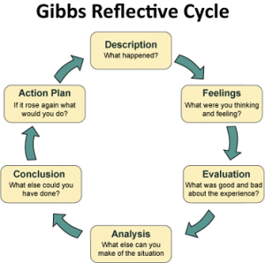
Figure 7: Gibbs’ Reflective Cycle (Crowe Associates, 2019)
Description
This is a strategic management report on the development of a strategy for Tesco PLC, specifically on their operations in the UK grocery retailing market. I collected data on the financial performance of Tesco, its market share, competitors, customer behaviour, digital strategy, CSR activities and conditions in the industry. The analysis used was PESTEL, Porter's Five Forces, VRIO and SWOT followed by CSR and Balanced Scorecard analysis. I then evaluated strategic options and made a recommendation for a value differentiation strategy based on the data. The suitability of the recommendation and the changes in the organisation that were necessary to implement the recommendation were then evaluated using SAFE evaluation, Gap Analysis and the McKinsey 7S framework. Gibbs' Reflective Cycle allowed me to critically reflect on what I had learnt in a systematic way instead of just describing the activities that were carried out (Gibbs, 1988).
Feelings
At first I was feeling confident when I chose Tesco as it is a large and well established organisation with a lot of information made public. I did become more careful, however, when put together a theory with the evidence. I knew that if I'm going to use strategic models then I need to have clear judgment and recommendations to match. Assessing suitability, acceptability and feasibility was especially difficult since there were various risks and benefits associated with each strategic alternative. As the report went on, I felt more certain in making strategic decisions and comparing evidence to arrive at conclusions. The reflective practice is a mechanism to acknowledge uncertainty and make experience into professional learning, as described by Bassot (2023).
Evaluation
There were a number of things that were useful in the process. PESTEL was used to understand external factors like inflation, regulation, technology and sustainability, and Porter's Five Forces was used to understand competitive intensity and customer bargaining power. VRIO proved to be particularly helpful in analysing the internal resources of Tesco, such as Clubcard data, coverage of stores, own label products and supply chain. The Balanced Scorecard enabled the alignment of financial results to the customer results, processes and human resource development. Further, Gap Analysis and McKinsey 7S proved helpful in analyzing the implementation and demonstrated that valuable resources need to be aligned across the systems, people and organisational capabilities. One of the main difficulties was limiting the description of the company, and choosing the most pertinent evidence from various sources. This underscored the need for appropriate source selection, and science-based evidence use in the process of academic analysis (Donthu et al., 2021).
Analysis
This is the most significant lesson from this assignment: There is a strong link between external pressures and internal capabilities, and strategic success is dependent upon this link. Tesco has some key strengths to navigate its way, including Clubcard, online grocery and ability, ranges of its own labelling and scale of its supply chain, but is also under pressure from discount rivals, price-sensitive consumers, cost and digital transformation. This was helpful for me to understand why it is less appropriate to use a pure Cost Leadership approach than using a Data-driven Value Differentiation approach. Gap Analysis revealed that the issue for Tesco is not only one of resource, but also about the need to combine and re-organize existing resources. McKinsey 7S has also shown the importance of supporting strategy with structure, systems, staff, skills and leadership and shared values if there is to be sustainable advantage in technological investment. Digital transformation then has only a strategic value when it is integrated into organisational routines and decisions (Hanelt et al., 2021).
Conclusion
Overall, this assignment helped to reinforce my grasp of the theory of strategic management and its application to real challenges of organisations. I learned that analysis is essential to be effective and it should be based on evidence, comparison, critical judgement and there needed to be a clear connection between strategic diagnosis, recommendation and implementation. A more in-depth competitor benchmarking and robust triangulation of company, industry and academic evidence would enhance future work. The methodological precision and transparent selection of evidence are crucial to create sound analysis (Aguinis, Ramani and Alabduljader, 2023).
Action Plan
I will gather and categorize evidence at the beginning of the strategic report, use fewer frameworks more critically and focus more on implementation and measurable outcomes in future strategic reports. I will also make enhancements to the competitor comparison, evaluation of the sources and the link between theory and recommendations for practice. Sadly, it is evident that the process of planning, evaluating and developing a coherent argument will be essential to enhancing my postgraduate academic practice (Saunders, Lewis and Thornhill, 2023).

7. Conclusion
Tesco has a very strong position in the United Kingdom grocery market, and is currently focusing on its size, Clubcard benefits, private label brand, e-commerce, and supply chain. But, with competitive discounting, price-sensitive consumers, increasing costs, regulatory pressures and technology change, it is necessary to adapt strategically on an ongoing basis. A data-driven value differentiated strategy, rather than a pure cost-leader strategy is supported by the analysis. Customer data, pricing, digital services and operational capability are combined, organisational systems and skills are aligned and Tesco will be able to enhance the loyalty, maintain margins, be more efficient and maintain competitive advantage over the long term.

8. References
Aguinis, H., Ramani, R.S. and Alabduljader, N. (2023) ‘Best-practice recommendations for producers, evaluators, and users of methodological literature reviews’, Organizational Research Methods, 26(1), pp. 46–76.
Barney, J. (1991) ‘Firm resources and sustained competitive advantage’, Journal of Management, 17(1), pp. 99–120.
Bassot, B. (2023) The Reflective Practice Guide: An Interdisciplinary Approach to Critical Reflection. 2nd edn. Abingdon: Routledge.
British Retail Consortium (2024) Retail statistics and insight. Available at: https://brc.org.uk/ (Accessed: 2 July 2026).
CFI (2022). McKinsey 7s model. [online] Corporate Finance Institute. Available at: https://corporatefinanceinstitute.com/resources/management/mckinsey-7s-model/ [Accessed 10 Aug. 2026].
CIPD (2023) Health and wellbeing at work 2023. London: Chartered Institute of Personnel and Development. Available at: https://www.cipd.org/uk/knowledge/reports/health-well-being-work/ (Accessed: 3 July 2026).
Competition and Markets Authority (2023) Grocery unit pricing: final report. London: Competition and Markets Authority. Available at: https://www.gov.uk/government/publications/grocery-unit-pricing-final-report (Accessed: 2 July 2026).
Crowe Associates (2019). Gibbs reflective cycle | Crowe Associates. [online] Crowe Associates. Available at: https://www.crowe-associates.co.uk/coaching-tools/gibbs-reflective-cycle/ [Accessed 10 Aug. 2026].
Donthu, N., Kumar, S., Mukherjee, D., Pandey, N. and Lim, W.M. (2021) ‘How to conduct a bibliometric analysis: An overview and guidelines’, Journal of Business Research, 133, pp. 285–296.
Ellen MacArthur Foundation (2022) Circular economy introduction. Available at: https://www.ellenmacarthurfoundation.org/topics/circular-economy-introduction/overview (Accessed: 13 July 2026).
Gibbs, G. (1988) Learning by doing: A guide to teaching and learning methods. Oxford: Oxford Polytechnic.
GOV.UK (2025) National Minimum Wage and National Living Wage rates. Available at: https://www.gov.uk/national-minimum-wage-rates (Accessed: 22 July 2026).
Grant, R.M. (2022) Contemporary strategy analysis. 11th edn. Hoboken: Wiley.
Hanelt, A., Bohnsack, R., Marz, D. and Antunes Marante, C. (2021) ‘A systematic review of the literature on digital transformation: Insights and implications for strategy and organizational change’, Journal of Management Studies, 58(5), pp. 1159–1197.
IGD (2024) UK grocery market outlook. Available at: https://www.igd.com/ (Accessed: 18 July 2026).
Iqbal, A. (2025). PESTLE analysis: The CEO’s guide to future-proofing a business. [online] Medium. Techno-Preneurship. Available at: https://medium.com/techno-preneurship/pestle-analysis-the-ceos-guide-to-future-proofing-a-business-877e6c4e20ea [Accessed 10 Aug. 2026].
Kantar (2021) Grocery market share: Great Britain. Available at: https://www.kantar.com/uki/inspiration/fmcg/grocery-market-share/great-britain (Accessed: 18 July 2026).
Kantar (2025) Grocery market share: Great Britain. Available at: https://www.kantar.com/uki/inspiration/fmcg/grocery-market-share/great-britain (Accessed: 20 July 2026).
Kaplan, R.S. and Norton, D.P. (1992) ‘The balanced scorecard: Measures that drive performance’, Harvard Business Review, 70(1), pp. 71–79.
McKinsey & Company (2024) Transformation with impact: How to deliver successful business change. Available at: https://www.mckinsey.com/capabilities/transformation/our-insights (Accessed: 10 July 2026).
Mintel (2024) Supermarkets: UK market report. London: Mintel Group Ltd. Available at: https://www.mintel.com/ (Accessed: 22 July 2026).
Office for National Statistics (2023) Consumer price inflation, UK: March 2023. Available at: https://www.ons.gov.uk/economy/inflationandpriceindices/bulletins/consumerpriceinflation/march2023 (Accessed: 22 July 2026).
Porter, M.E. (2008) ‘The five competitive forces that shape strategy’, Harvard Business Review, 86(1), pp. 78–93.
Saunders, M.N.K., Lewis, P. and Thornhill, A. (2023) Research methods for business students. 9th edn. Harlow: Pearson.
Statista (2024) Grocery retail in the United Kingdom. Available at: https://www.statista.com/ (Accessed: 25 July 2026).
Teece, D.J. (2021) ‘Dynamic capabilities and strategic management: Organizing for innovation and growth’, Oxford Research Encyclopedia of Business and Management. Available at: https://oxfordre.com/business/ (Accessed: 25 July 2026).
Tesco PLC (2021) Annual report and financial statements 2021. Available at: https://www.tescoplc.com/investors/reports-results-and-presentations/annual-report-2021/ (Accessed: 25 July 2026).
Tesco PLC (2022) Annual report and financial statements 2022. Available at: https://www.tescoplc.com/investors/reports-results-and-presentations/annual-report-2022/ (Accessed: 2 July 2026).
Tesco PLC (2023) Annual report and financial statements 2023. Available at: https://www.tescoplc.com/investors/reports-results-and-presentations/annual-report-2023/ (Accessed: 2 July 2026).
Tesco PLC (2024) Annual report and financial statements 2024. Available at: https://www.tescoplc.com/investors/reports-results-and-presentations/annual-report-2024/ (Accessed: 2 July 2026).
Tesco PLC (2025) Annual report and financial statements 2025. Available at: https://www.tescoplc.com/investors/reports-results-and-presentations/annual-report-2025/ (Accessed: 2 July 2026).
The Strategy Institute (2024). Porter’s five forces: The ultimate competitive strategy blueprint. [online] www.thestrategyinstitute.org. Available at: https://www.thestrategyinstitute.org/insights/porters-five-forces-the-ultimate-competitive-strategy-blueprint [Accessed 10 Aug. 2026].
Verhoef, P.C., Broekhuizen, T., Bart, Y., Bhattacharya, A., Dong, J.Q., Fabian, N. and Haenlein, M. (2021) ‘Digital transformation: A multidisciplinary reflection and research agenda’, Journal of Business Research, 122, pp. 889–901.
Whittington, R., Regnér, P., Angwin, D., Johnson, G. and Scholes, K. (2023) Exploring strategy: Text and cases. 13th edn. Harlow: Pearson.
WRAP (2024) Food waste reduction roadmap. Available at: https://wrap.org.uk/taking-action/food-drink/initiatives/food-waste-reduction-roadmap (Accessed: 17 July 2026).

