
BMSW6104_LON
Strategic Development and Implementation for SMEs

MIHAITA GHEORGHE
2120440
LECTURER: Dr TOYIN ADISA

Table of Contents
Introduction 3
Current strategic direction of Robinsons Caravans Limited 4
Analysis of the company using business environmental tools 5
PESTEL analysis (External environment) 5
SWOT analysis (Internal evnvironement) 9
Strategic Growth Choices for SME’s 11
Ansoff Matrix 11
Porter's Generic Strategies 12
Stakeholder analysis 13
Key strategic recommendations 14
Conclusion 16
References 17

Introduction
Robinsons Caravans Limited, a British company, engages in the sale and maintenance of recreational vehicles. The enterprise, with a history spanning little over five decades, has experienced significant growth and emerged as a prominent participant in the caravan industry. Robinsons Caravans Limited requires a robust plan to enter promising new markets successfully. This analysis encompasses stakeholders, both internal and external environments, as well as the firm's future growth aspirations. This report explores the obstacles encountered by small and medium-sized enterprises (SMEs) while attempting to enter new markets. This study aims to clarify the internal workings of small and medium-sized enterprises (SMEs) by examining the operational structure of Robinsons Caravans Limited and considering suggestions from stakeholders. By thoroughly evaluating all possible benefits and drawbacks, this study provides an elaborate plan for the company's future expansion.

Current strategic direction of Robinsons Caravans Limited
Forecasts indicate that the UK apparel sector will reach £68.516 million in sales by 2024, representing a CAGR (compound annual growth rate) of 6.3% from 2020 to 2024. This trend is beneficial for the sector because the garment industry in the UK is both established and growing rapidly. Online clothing marketplaces have grown substantially in recent years. From £28.1 billion in 2020 to £46.3 billion in 2025, that is the predicted increase in UK online sales of clothing and footwear (Pegden, 2022).
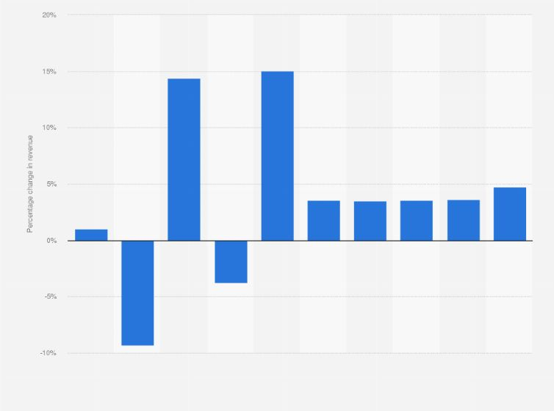
Figure 1: UK apparel revenue growth 2019-2028(Pegden, 2022)
Robinsons Caravans Limited and other organisations have put a lot of focus on digital accessibility and e-commerce capabilities because of the COVID-19 outbreak and the quick shift to online purchasing. The company's ability to successfully navigate market dynamics is demonstrated by its deep industry knowledge and its successful development beyond the UK. The importance of high-quality things and the accessibility of technology are two of the many factors that affect demand. Decisions at Robinsons Caravans Limited are frequently based on extensive analyses and studies of the market.
Robinsons Caravans Limited does need assessments to find out what startups need before they offer personalised clothing services. Before beginning mass production, businesses must ensure they have a thorough grasp of customer needs (Todorov and Smallbone, 2014). Companies that aggressively seek out new customers, according to them, research the market and its needs extensively before deciding how to break in. Take, for example, how a respectable company could use its knowledge of the market and customer tastes to go where no one has gone before. Having these two qualities shows that the organisation is dedicated to being fair while dealing with clients. Since its inception, Robinsons Caravan has grown its operations across the UK, gaining a wealth of market data in the process. On top of that, the identified demand drivers greatly impact the way the company makes decisions. The key to Robinsons Caravan Limited's success, as a well-established business, is satisfying customers with items that go above and beyond their expectations. Furthermore, the company makes good use of technology to meet the needs of consumers all over the world.
The value of using effective ways to interact with customers. For example, consider the importance of developing great client relationships in today's intensely competitive business environment (Srivastava and Śubhā Varmā, 2013). The company is always looking for new ways to improve its communication strategies to encourage stronger client interaction. A specific area of the business's website allows customers to ask questions and get quick responses. Market trends, customer needs, and industry research inform the company's strategic decisions, which impact the production process.

Analysis of the company using business environmental tools

PESTEL analysis (External environment)
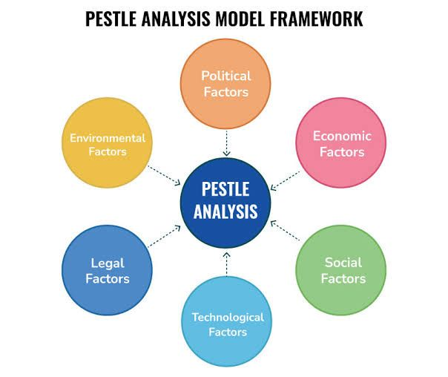
Figure 2: PESTEL analysis(Rothaermel, 2021)
Political factors
Businesses must consider all political factors, including laws and regulations enacted by the government. Those who are well-versed in political variables, the complex dynamics of both politics and corporate operations and the complicated interaction between the two can shape future endeavours. The emphasis shifts to operations, sustainability, and profitability in the face of politically unpredictable conditions. Politics, according to both writers, has a major role in shaping business practices. Their comparisons diverge, however, about how much political influence factors into the decision-making process. Companies felt the effects of the political turmoil in the UK both before and after Brexit. Just like any other company, Robinsons Caravan Limited is subject to the whims of British politics. Businesses in the UK have had to rethink their strategies considering the new Brexit uncertainties (Rothaermel, 2019). Since interests impact policymaking, organisations need to get better at predicting the political atmosphere. Among the most dynamic fields that undergo regular alterations in regulatory frameworks are regulations dealing with occupational health and safety, environmental safeguards, taxes, and trade agreements. In this respect, organisations may face challenges. to its extensive background in the industry, Robinsons Caravan Limited has honed a keen ability to foresee upcoming legislative actions and possible roadblocks to its business strategy. Based on its knowledge of the political climate, the corporation can adjust its strategy accordingly. The unpredictable nature of politics makes it difficult for businesses to remain viable. When political unrest occurs, Robinsons Caravan Limited can feel its effects. Transportation of finished goods and raw materials will be more difficult to arrange in the case of political or civil unrest. Now more than ever, businesses must achieve their sales goals. The political philosophy of Robinsons Caravan Limited is based on the notion of nonviolence. Businesses in the UK now have the tools they need to face whatever the future brings to the market's relatively painless regime shifts (Rothaermel, 2021). Government decisions regarding infrastructure development can improve the efficiency and growth of businesses. Investments in transportation networks by the government might be beneficial for companies looking to grow. Given the current political calm in Britain, Robinsons Caravan Limited may show less worry about how reasonable measures could affect its supply chain. The current political atmosphere has affected the UK's tax and tariff policies. The company has no trouble sourcing raw materials or shipping finished goods because there is no political turmoil on a global scale. To have a better understanding, it is necessary to examine all how post-Brexit rules may affect current operations.
Economical factors
Companies think about the current economic situation as they plan. The industrial goods and services market is dynamic and very competitive, which Robinsons Caravans Limited must navigate. Numerous macro and microeconomic variables provide difficulties for businesses functioning in the highly competitive industrial and service sectors. When discussing macroeconomic issues, the list factors such as interest rates, savings, investment, currency exchange rates, business cycles, and inflation (Wheelen et al., 2017). Predictive analysis, in which companies use trends instead of conventional criteria, is, however, gaining traction among economics professors. As a result of inflation and other macroeconomic issues, Robinsons Caravan Limited faces a volatile operating environment. Robinsons Caravan Limited anticipates that rising inflation will affect its manufacturing expenses and profit margin. The corporation has been forthright about the difficulties it has had since the COVID-19 outbreak began regarding its struggles to control operational expenses. The effect of current economic conditions on the company's financial situation is another factor to think about. The organisation must carefully monitor the economic cycle and adjust its actions appropriately to maintain financial stability and take advantage of possibilities. By taking macroeconomic factors and market shifts into account, Robinson Caravans Limited's study backs up these assertions. Microeconomic variables, such as rules, market dynamics, and competitive pressures, may also affect the company's performance (Pegden, 2022). Robinsons Caravan Limited notes in their most recent financial report that the number of competitors is on the rise, with a concentration on those companies targeting the UK market. Now that it has taken care of this part, the company may focus on developing a strategy that considers the economic aspects influencing its operations. In a highly competitive market where economic conditions are inherently unpredictable; the corporation must take advantage of advantageous situations while minimising risks.
Social factors
Societal influences such as public emotion, ideals, and habits have the potential to have an impact on corporate practices. When selecting a market to enter, social factors are given priority over economic factors. Consider the increasing prevalence of corporations researching the importance of worker ideology, perspective, and value considerations in the process of decision-making. The marketing prompt has been customised to align with the social and cultural norms of the target market, as the organisation possesses a comprehensive understanding of these factors. Robinsons Caravan Limited possesses extensive expertise in the British market, accumulated over a significant period. The extent to which a firm can adjust to the changing demands of its consumers is strongly correlated with the strength of its community connections. For firms seeking to grow into new regions, it is imperative to analyse the demographics of those locations and formulate strategies to attract diverse economic segments (Mehdi Khosrow-Pour, 2021). Robinsons Caravan Limited is distinguished among a multitude of firms that have demonstrated resilience in the face of fierce competition. The organisation has become proficient in researching customer habits and opinions beyond the borders of the United Kingdom, intending to expand into new areas and meet consumer demand. The increasing demand for environmentally sensitive items inside the European Union serves as evidence of a notable shift in consumer thinking towards sustainability. There is a lack of enough attention being given by companies to social problems inside their supply networks (Wiley, 2016). Perhaps how Robinsons Caravan Limited is being compared may not be appropriate. The correlation between the frequency of public consumption and the influence on consumers' social norms of Robinson's products is evident. Societal challenges can also have an impact on organisational structures. Performance can be influenced by several social factors such as aspirations, goals, and values. Robinsons Caravan Limited's success can be attributed to its profound concern for the personal lives of its employees beyond their professional commitments. To effectively appeal to both employees and consumers, companies must consider social considerations while making decisions and creating marketing.
Technology factors
Technology is reshaping business as know it by making it simpler to automate tasks that formerly necessitated substantial human intervention. From advertising and logistics to market research and consumer segmentation, technology is essential to many different businesses. to technological advancements, Robinsons Caravan Limited has significantly improved its operational abilities. To broaden its consumer base and increase sales, the company started a digital marketing campaign (Matt, Modrák and Zsifkovits, 2021). Using social media to disseminate their message is essential for progressive organisations. Many channels, including digital publications, social media, and email subscriptions, are utilised by Robinson Caravan Limited to ensure that their clients are always informed of all the most recent advancements. Companies should be careful when determining how to integrate ubiquitous technology into their operational frameworks. Prospective clients may continue to prefer more traditional approaches to data analysis if this line of thinking is followed. Customers who are very tech-savvy and in the middle of their families are Robinsons Caravan Limited's ideal clients. The details of a company's products, updates, and reports are easier to access through digital media. Robinsons Caravan Limited uses both traditional and modern advertising methods to cater to its diverse consumer base. The effectiveness of a business's usage of the web and social media for customer relationship management is proportional to that effectiveness. Businesses' efforts to engage with customers through digital marketing methods, especially social media platforms, have seen a clear surge. By utilising the most recent platforms, marketing team can remain ahead of the competition and adapt to the always-evolving technology landscape (Martyn Pitt and Koufopoulos, 2017). The usage of numerous channels to acquire and retain clients is one of Robinsons Caravan Limited's strategic decisions.
Environmental factors
The profitability of a corporation operating in numerous markets can be influenced by various external factors. The variability of environmental norms and laws across different markets has a significant impact on businesses and supply chain activities. Businesses must comply with the environmental rules mandated by the respective countries in which they conduct their operations. To sustain its foreign commercial operations, Robinsons Caravan Limited must adhere to the environmental regulations of other countries. Before entering a new market or expanding its market presence, Robinsons Caravan Limited must undertake a thorough examination of the respective local rules and environmental standards. However, laws alone are insufficient to ensure a smooth entry into a new market. It is imperative to thoroughly evaluate the environmental ramifications of the company's operations. Upon completion of their Environmental Impact Assessment (EIA), Robinsons Caravan Limited plans to adopt more environmentally friendly policies and processes.
Legal factors
A company's success depends on its ability to effectively handle legal concerns, particularly when expanding into new areas. The nature and supply chain are defined by the organisational legal systems of different jurisdictions. Businesses that are interested in expanding into new areas should start by requesting the necessary permits. However, regulations concerning taxes, health, safety, and labour provide a treasure trove of information regarding the inner workings of companies (Konstantinos Biginas et al., 2022). It is well-known that businesses cannot expand unless they adhere to the regulations imposed by the government. Robinsons Caravan Limited adheres to stringent regulations on human resources and salary changes. A thorough familiarity with the intricate web of tax regulations that could lead to penalties and other legal issues is also possessed by the organisation. All company executives must have a thorough understanding of anti-discrimination, health and safety, and consumer protection laws.

SWOT analysis (Internal evnvironement)
Strength
A company's strength determines its ability to capitalize in a competitive and populated market. Strength often encompasses what a company does well, including resources that position it at the helm of the hierarchy. Strengths are characteristics that give a company a competitive advantage over others. Robinsons Caravan Limited stands out with a strong brand image and reputation in the UK industry. The UK market has several players. However, the company has capitalized on its reputation to cement its position as an industry leader. The company's reputation is built on diversifying a wide range of products, such as new and used caravans, awnings, and other accessories. The importance of the brains behind the product cycle of a company's product. For instance, his mention of experience and a knowledgeable team resonates with the company's investment in an all-rounded team capable of taking its products to the next level. However, there is a need to assess the extent to which a knowledgeable team can work independently without external influences. A company must incorporate other factors to make the team efficient. Failure of which, any brilliant team may only partially achieve its mandate (Karami, 2016). Robinsons Caravans Limited inspires its team by creating a challenging work environment that pushes everyone to their limit. That way, the team has become a formidable resource and asset in meeting its objectives. The company's e-commerce platform is another major pillar that defines its success. Companies capitalizing on digital platforms to promote their products and increase visibility have an edge over their counterparts.
Weakness
Organisations working in industries with high levels of risk must prioritise the ability to recover quickly. The most valuable assets of a company are usually its main competencies and other resources. One definition of a company's strengths is its ability to set itself apart from rivals. A sizeable portion of the British public holds Robinsons Caravan Limited in the highest regard, mostly because of the company's stellar reputation. The level of competition in the UK market is quite strong. The corporation has solidified its position as the market leader by emphasising its spotless past. A wide selection of new and used caravans, awnings, and accessories are what give this company its outstanding reputation. The total amount of money a company makes from its IP throughout a product's entire lifecycle. Following his comments about the importance of teamwork, the company is determined to hire a diverse team that can enhance its services. The key to a successful team is knowing how each member excels and where they may use improvement. The team needs further backing from the company to win. To keep its employees motivated, Robinsons Caravans Limited creates challenging work conditions. The organisation has become an unstoppable force capable of achieving its objectives by sticking rigidly to its strategy. The organisation's e-commerce platform has been instrumental in its growth. Companies have a clear edge in the competitive market when they promote their products and increase brand awareness using digital channels.
Opportunities
Possibilities enable the expansion of the market reach and economic potential. The presence of individuals engaging in the purchase of products and services ensures the existence of demand within the market (Kafel and Ziębicki, 2021). Several factors determine the applicability of the comparison, one of which is the nature of the relevant industry. On the other hand, the operational environment refers to the external elements that influence an organisation's response. Robinsons Caravans Limited has demonstrated a prudent approach in managing their website thus far. Customers are provided with the opportunity to subscribe to the company's newsletter and receive information regarding upcoming product improvements. Ensuring prompt and convenient communication with clients is crucial for maintaining their satisfaction. Implementing a subscription panel facilitates enhanced customer engagement, hence boosting website traffic and maybe driving sales.
Threats
Businesses have numerous obstacles when they function in high-stress, rapidly changing situations. Every business enterprise inherently involves a degree of uncertainty. Organisations have implemented several procedures to facilitate the identification and mitigation of such dangers (Hisrich and Veland Ramadani, 2017). Nevertheless, it will necessitate a certain amount of time to address or mitigate these hazards. Robinsons Caravans Limited should be concerned about the possibility of a more competitive market. Multiple rivals can be found on this planet. Subsequently, he asserts that the corporation must devise remedies to avert the recurrence of these problems, as they are bound to happen. One potential course of action entails exploring the operations of Robinsons Caravans Limited. Despite their proficiency in identifying warning indicators, the team cannot exert control over all of them. Robinsons Caravans Limited can mitigate the effects of competition by effectively preserving its competitive advantage (Hill, Jones and Schilling, 2019). Company executives may choose to invest in technology advancements to meet the increasing demands of their clientele, cater to their preferences, and provide them with an exceptional experience. Supply chain disruptions, such as Brexit, can result in extensive and enduring repercussions.

Strategic Growth Choices for SME’s

Ansoff Matrix
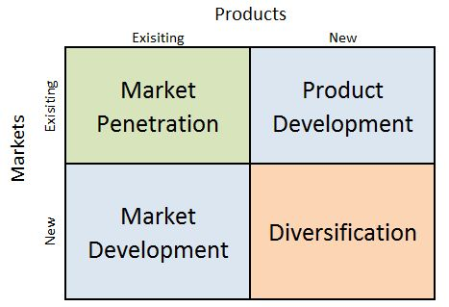
Figure 3: Ansoff Matrix(Evans, 2020)
Market Penetration
Market penetration is a strategic approach implemented by organisations to augment their sales and enhance brand recognition within an established market. The objective of a well planned market penetration strategy is to augment a company's market share. To successfully penetrate a market, it is imperative to employ multiple strategies. The primary objective of this research is to investigate the effectiveness of advertising and brand recognition in the expansion of market share. The recommendations put out by the writers align effectively with the digital advertising initiatives implemented by Robinsons Caravans Limited. To enhance sales on its e-commerce platform in the United Kingdom, the corporation must effectively promote and advertise it. To enhance company visibility, Robinsons Caravans Limited should reassess its digital marketing approach and give priority to sponsored promotions and customised adverts. An effective approach to broaden distribution channels is enhancing consumer accessibility. The presence of strong rivals poses a constant risk to customers. Organisations should perform thorough market research before developing partnerships or launching new distribution channels.
Product Development
Product development refers to a strategic approach that focuses on creating and marketing novel products and services to meet the needs of consumers. One of the various aspects highlighted during the phase of new product development involves the implementation of market surveys to determine customer preferences (Fernandez, Powell and Gill Ten Hoor, 2023). Robinsons Caravans Limited consistently incorporates client feedback while creating new products. Consumer products companies must be mindful of the dynamic nature of customers' tastes and preferences. The expeditious introduction of products into the market poses a significant risk of rapid obsolescence. This parallel is applicable in the contemporary corporate landscape due to the rapid pace at which technology is transforming consumer preferences. Once the product development team has defined it, the ability to comprehend the broader perspective becomes crucial. One of the potential unfavourable consequences of the treatment is its relatively high cost. The unsatisfactory performance of the product is further exacerbated by the lack of emphasis on conducting thorough market research.
Market Development
Another possible way for Robinsons Caravan Limited to grow is by utilising market expansion tactics. They should investigate other nations that might have markets for recreational vehicles To achieve this objective, they might need to modify their products and marketing approaches to cater to specific customer demands (Evans, 2020) Extensive market research is required due to a number of issues, such as cultural variations, statutory limits, and practical challenges.
Diversification
It is important to break into new areas with unique solutions as part of any diversification plan. Robinsons Caravan Limited should think about expanding into related industries or giving services that go well with what they already do if they want to broaden their business. One way to go is to look for work in the outdoor leisure industry, like selling camping gear or adventure trip packages. Due to the possible risks of diversity, it is important to plan ahead and keep market conditions in mind.

Porter's Generic Strategies
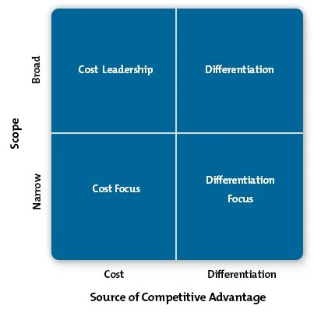
Figure 4: Porter’s Generic Strategic (Cokins, 2017)
Cost Leadership
Maximising revenue while cutting costs is the goal of a cost leadership strategy. By making the most of available opportunities and reducing delivery costs, SMEs can increase their profitability (Dobson, Starkey and Richards, 2019). Using the average market price, SMEs can increase their profits to their fullest potential. For Robinsons Caravans Limited to succeed in this highly competitive industry, they must increase their market share and reduce production costs. The primary objectives are to decrease expenditures and augment income. The company has already solidified its supremacy in the UK sector, which is strengthening its achievements.
Differentiation Strategy
Distinguishing goods and services from competitors can be achieved by emphasising their unique qualities. The three fundamental pillars of a comprehensive differentiation strategy encompass research innovation, the production of high-quality products, and the development of a meticulously planned marketing and sales strategy (Cokins, 2017). Differentiating their products is considered the most effective approach for small and medium-sized firms (SMEs) to experiment with novel concepts and ascertain client preferences. Robinsons Caravan Limited, with its vast expertise and experience, can experiment with various things to ascertain their popularity. Differentiation is the pivotal factor for a prosperous product and the focal point of the company's efforts.
Focus Strategy
Companies employing a focus strategy typically concentrate on specific segments of the market. To create tailored items for the extensive market, businesses need to understand the intricacies of their industry and the preferences of their customers. Irrespective of the atypical nature of their belongings, individuals will invariably experience sympathy towards them (Butler, 2012). He contends that for SMEs to maintain their customer base, they must embrace a more all-encompassing approach. Robinsons Caravan Limited places a high premium on identifying its optimal consumer base. However, the organisation must surpass expectations to provide an outstanding client experience and foster brand loyalty. As corporations strive for market supremacy, they often find themselves occupying less desirable market segments.

Stakeholder analysis
Stakeholder assessments are often conducted by businesses to gain insight into the needs of various interest groups. This allows them to identify and evaluate the different stakeholders involved. Organisations have the responsibility of understanding and addressing the individual needs of stakeholders. They should also have a comprehensive engagement plan to effectively guide their involvement throughout the engagement process (Barney and Hesterly, 2020).
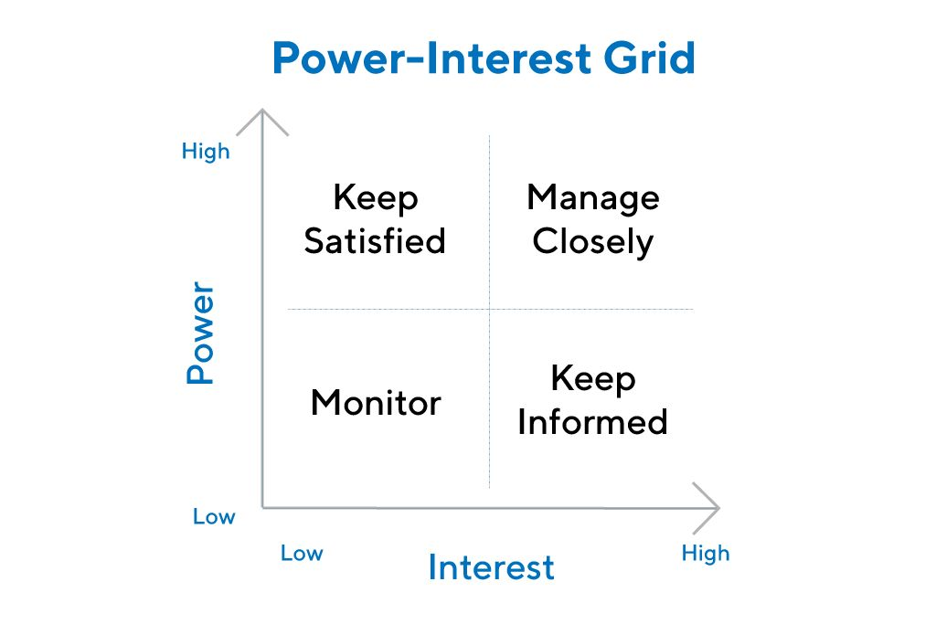
Figure 5: Stakeholder analysis (Alick Mhizha, 2015)
Thoroughly contemplating the distinct demands of all parties involved during the process of generating viable solutions is crucial. Robinsons Caravan Limited places a high priority on ensuring the satisfaction and well-being of its customers. Businesses rely on clients to generate revenue. Many consumers have expressed concerns about the availability and quality of products. Customers can explore and compare the pricing and services provided by different companies. Customers' opinions have a significant impact on their purchasing power, although their influence on the company's final decision-making process is relatively limited. Ensuring client satisfaction is a top priority for the organisation. The organisation's personnel also play a crucial role. The belief that workers are the most valuable resource of an organisation is held by many. The individual is looking for a competitive wage, job security, and chances for growth and advancement. The mobilisation of employees is a powerful phenomenon that Robinsons Caravan Limited should carefully consider (Alkis Thrassou et al., 2020). As a result, the strategic decision should give priority to the needs of employees by offering benefits like a supportive work environment and chances for professional growth. Suppliers are crucial for maintaining the smooth functioning of the organisation. Suppliers possess the capacity to participate in product sharing with other businesses. The firm's operational dynamics are not significantly impacted by their influence. When suppliers are not constrained, a company's activities can operate smoothly and without any obstacles. Robinsons Caravans Limited prioritises supplier satisfaction by maintaining open lines of communication, ensuring prompt payment, and actively participating in product development.

Key strategic recommendations
Small and medium-sized enterprises (SMEs), such as Robinsons Caravans Limited, commonly encounter similar obstacles in their pursuit of long-term objectives. To expand their business's reach, individuals are advised to concentrate on accessing unexplored areas in the United States and Europe. An organisation that has easily accessible products is typically associated with a lower level of risk (Alick Mhizha, 2015). By focusing on its core competencies, the corporation increases its chances of expanding into new markets. In addition, Robinsons Caravans Limited can improve their online presence. Many organisations in the modern era place a great deal of importance on using digital media to advertise products and increase brand awareness. One must consider the significant impact of the COVID-19 pandemic on businesses. It has forced them to adopt digital transformation strategies to avoid losing customers.
To ensure continued success in the future, Robinsons Caravan Limited must immediately broaden its business activities outside the borders of the UK. Another strategy that could work is to break into unexplored markets in countries that have a strong predilection for RVs. To break into new markets and achieve long-term growth, in-depth research is required. Cultural differences, regulatory constraints, and logistical challenges are all factors that must be considered.

Conclusion
The remarkable ability of Robinsons Caravan Limited to adapt and expand in response to customer requests has brought it great praise as a leading SME. As it strives to keep up with new rivals offering items that are on par with or better than its own, the company faces fierce market competition Robinsons Caravans Limited places a premium on carefully considering the creation of a comprehensive company plan to enable market expansion and foster growth. All relevant factors, including those of a legal, social, economic, political, and ecological nature, must be considered in light of the subject's activities The outstanding reputation, devoted customers, and solid infrastructure of Robinsons Caravans Limited set it apart. Using a well-thought-out strategy, the company improves its chances of being competitive and capitalising on growth opportunities in its industry.

References
Alick Mhizha (2015). Strategic Management Practices and Challenges. The Case of Small and Medium Scale Enterprises in Harare. GRIN Verlag.
Alkis Thrassou, Demetris Vrontis, Yaakov Weber, S M Riad Shams, Evangelos Tsoukatos and Springerlink (Online Service (2020). The Changing Role of SMEs in Global Business : Volume I: Paradigms of Opportunities and Challenges. Cham: Springer International Publishing.
Barney, J.B. and Hesterly, W.S. (2020). Strategic Management and Competitive Advantage: Concepts. Harlow, United Kingdom: Pearson Education Limited.
Butler, D. (2012). Business Development: A Guide to Small Business Strategy. Routledge.
Cokins, G. (2017). Strategic business management : from planning to performance. Hoboken, New Jersey: John Wiley & Sons, Inc.
Dobson, P.W., Starkey, K. and Richards, J. (2019). Strategic Management : Issues and Cases. Hoboken: John Wiley & Sons, Ltd.
Evans, N. (2020). Strategic management for tourism, hospitality and events. New York: Routledge.
Fernandez, M.E., Powell, B.J. and Gill Ten Hoor (2023). Implementation mapping for selecting, adapting and developing implementation strategies. Frontiers Media SA.
Hill, C.W.L., Jones, G.R. and Schilling, M.A. (2019). Strategic management : an integrated approach : theory et cases. 13th ed. Boston, Ma Cengage Learning.
Hisrich, R.D. and Veland Ramadani (2017). Effective entrepreneurial management : strategy, planning, risk management and organization. Cham: Springer International Publishing.
Kafel, T. and ZiębickiB. (2021). The evolution of strategic management challenges in theory and business practice. Nowy Targ, Poland: ‘Cognitione’ Foundation for the Dissemination of Knowledge and Science.
Karami, A. (2016). Strategy Formulation in Entrepreneurial Firms. Routledge.
Konstantinos Biginas, Stavros Sindakis, Koumproglou, A., Vlasios Sarantinos and Wyer, P. (2022). Small Business Management and Control of the Uncertain External Environment. Emerald Group Publishing.
Martyn Pitt and Koufopoulos, D.N. (2017). Essentials of strategic management. London ; Los Angeles: Sage.
Matt, D.T., ModrákVladimír. and Zsifkovits, H. (2021). Implementing Industry 4.0 in SMEs : Concepts, Examples and Applications. Cham: Springer International Publishing : Imprint: Palgrave Macmillan.
Mehdi Khosrow-Pour (2021). Handbook of research on modern educational technologies, applications, and management. Hershey, Pennsylvania: Information Science Reference.
Pegden, T. (2022). Caravans chain reports record revenues during pandemic. [online] Business Live. Available at: https://www.business-live.co.uk/retail-consumer/robinsons-caravans-reports-record-revenues-22881915.
Rothaermel, F. (2021). Strategic management. 6th ed. New York, New York: Mcgraw-Hill Education.
Rothaermel, F.T. (2019). Strategic management. New York: Mcgraw-Hill Education.
Srivastava, R.M. and Śubhā Varmā (2013). Strategic management : concepts, skills and practices. New Delhi: Phi Learning.
Todorov, K. and Smallbone, D. (2014). Handbook of research on strategic management in small and medium enterprises. Hershey, PA: Business Science Reference.
Wheelen, T.L., Hunger, D.J., Hoffman, A.N. and Bamford, C.E. (2017). Strategic Management and Business Policy : globalization, Innovation and Sustainability. 15th ed. Harlow, England Pearson.
Wiley (2016). Great by Design How to deliver accelerated and sustained business growth. New York John Wiley & Sons Ann Arbor, Michigan Proquest.

