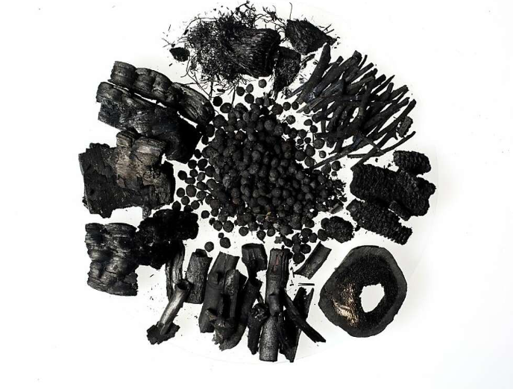
Reducing net CO2 emissions in steelmaking using Biochar
Jamie Waters
Jamie Waters (1551425) | 7/29/22 | Lean & Agile Operations

Abstract

Declaration
This thesis is the result of the author’s personal research and conducted work. It has been composed by the author with all relevant research cited and has not been previously submitted for examination for the award of an honour’s degree. Confirmation of work:
Signed:
Date:



Acknowledgements
Table of Contents
Abstract 1
Declaration 2
Acknowledgements 3
Table of Figures 6
Glossary 8
Introduction 11
Background 11
Research aim 15
Objectives 15
Theory 16
Biomass 16
Raw Biomass structure 16
The problem with Raw Biomass 18
Biomass Pre-treatment 19
Biomass utilisation in the iron and steel industry 22
Injection of Biomass into blast furnaces 22
Potential for biomass in metallurgical coke making. 24
Potential for biomass in the sintering process 26
Biomass supply and availability 28
Analysis 31
Biochar characterisation 31
Proximate analysis 31
Ultimate analysis 34
Calorific value 35
Major Elemental Analysis 35
Minor elemental analysis 36
Particle size distribution 36
Assessing biochar substitution in pulverised coal injection (PCI) 37
Drop tube furnace. 37
Assessing biochar substitution in coke making 39
Pilot scale coke oven 39
1/5th Micum – Mechanical Strength 42
Coke strength after reaction and Coke reactivity index (CSR/CRI) 43
Assessing biochar substitution in sinter making 45
Sinter pot 45
Determination of low-temperature reduction disintegration indices 47
Tumble and Abrasion indices 48
Quality Control 49
Results 50
Biochar substitution for pulverised coal injection 50
Properties of charcoal and PCI coal 51
Chemical Composition 52
Combustibility 54
Biochar substitution into coke making. 56
Chemical properties of coking coal and biochar 57
Coke Mechanical strength 59
Hot mechanical strength and reactivity 61
Coke chemistry Analysis 62
Photographs of the Biocoke produced in the Pilot oven 63
Biochar substitution in Sinter making. 67
Coke breeze and biochar chemical analysis 67
Characteristics of Sintering with Biocoke 68
Sinter quality indices 75
Photographs of the sinter produced on the sinter pot. 77
Biochar comparison 81
Carbon Dioxide emission mitigation potential using Biochar at Port Talbot Steelworks 81
Conclusion 84
Limitations 85
Recommendations 87
Reference list 88
Appendix 89

Table of Figures
Figure 1 The response of some climate variables to global warming (Arias et al. 2021). 9
Figure 2 World Steel Production 1950 - 2021 (Worldsteel. 2021) 10
Figure 3 - CO₂ emissions in an integrated steelworks (BF - BOS route) showing carbon-bearing material input (Gray boxes), CO2 emissions, expressed in volume (kg/t of hot rolled coil) and concentration in the flue gas (volume %)in the blue box (Birat 2010). 11
Figure 4 Major constituents of a woody biomass (Basu 2013) 14
Figure 5 Structure of primary cell wall of plant cell (Nhuchhen et al. 2014). 15
Figure 6 Van Krevelen diagram of products from woody biomass. Raw biomass (non-filled symbols), torrefied biomass (red symbols), HTC biomass (blue symbols), and charcoal (black symbols) (Suopajärvi and Fabritius 2013). 16
Figure 7 Biomass upgrading technologies according to product type (Mousa et al. 2016). 17
Figure 8 Influence of pre-treatment temperature on key variables (Liu and Shen 2021) 19
Figure 9 Opportunities for Biomass in iron & steelmaking (Mandova et al. 2018) 20
Figure 10 An illustration of a blast furnace (Geerdes et al. 2009) 21
Figure 11 A blast furnace tuyere diagram (Geerdes et al. 2009).. 22
Figure 12 Diagram of a typical by-product coke plant (Hilding 2005) 23
Figure 13 Diagram of a sintering machine (Chen et al. 2016). 25
Figure 14 Sinter quality indices after biochar addition (Mousa et al. 2015). 26
Figure 15 a) The distribution of woody biomass and waste in the EU b) Comparison of the woody-biomass supply and the existing woody-biomass demand, per country) (Mandova et al. 2018). 27
Figure 16 The cost of charcoal production (Suopajärvi and Fabritius 2013) 28
Figure 17 Calculated VUI's for BF fuels and subsequent CO2 emissions from the BF (Mathieson et al. 2011) 28
Figure 18 Rotary kiln pilot-scale pyrolysis unit used to make biochar 1 (Mašek et al. 2018) 29
Figure 19 The components of coal (Backus 2022) 30
Figure 20 Illustrating x-ray fluorescence (Blondel 2020) 33
Figure 21 Excitation of an atom by a plasma (Thermo Fisher Scientific 2022) 34
Figure 22 Particle size distribution by sieves (Particle Technology Labs 2022) 35
Figure 23 A picture and schematic (Steer et al. 2021) of the drop tube furnace. 36
Figure 24 The Pilot scale coke oven at Tatasteel 37
Figure 25 An illustration of the 25Kg pilot scale coke oven at Port Talbot, made by the author. 38
Figure 26 Preparing the coal charge 39
Figure 27 The coal density calculation 40
Figure 28 The motion of coke in a micum test (Geerdes et al. 2009). 41
Figure 29 Diagram of the CSR/CRI test 42
Figure 30 A photograph (author) and a schematic diagram of the sinter pot (Zandi et al. 2010) 43
Figure 31 RDI test equipment apparatus (British Standards Institute 2015b) 45
Figure 32 The drum specifications for the tumble and abrasion test (British Standards Institute 2015a) 46
Figure 33 The lower zone of the BF (Ahmed 2018). 52
Figure 34 Graph showing the burnout efficiency of T-coal and biochar 53
Figure 35 Results from the coke cold strength tests 57
Figure 36 Coke strength and reactivity results 59
Figure 37 Reference coke - 100% Riverside coal 61
Figure 38 Pictures of the Biocoke. A – 3% biochar 1 substitution, B – 5% biochar 1 substitution, C – 7.5% biochar 1 substitution. 62
Figure 39 Pictures of the Biocoke. A – 3% biochar 2 substitution, B – 5% biochar 2 substitution, C – 7.5% biochar 2 substitution. 63
Figure 40 Factors affecting coke strength after reaction (Dı́ez et al. 2002) 64
Figure 41 The effect on the temperature profile of combustion rate (Kawaguchi and Hara 2013). 66
Figure 42 Time - temperature profiles of the biochar 1 sinter pot tests. 67
Figure 43 Cold and hot permeability graphs – Biochar 1 69
Figure 44 Time - temperature profiles of the biochar 2 sinter pot tests. 70
Figure 45 Cold and hot permeability graphs – Biochar 2 72
Figure 46 The Sinter quality indices for biochar 1 73
Figure 47 Biochar 2 sinter quality indices 74
Figure 48 Examples of sinter cake produced in the sinter pot. On the left a whole sinter cake, on the right an example of channelling in a sinter cake. 75
Figure 49 Base blend sinter. 76
Figure 50 25%addition biochar 1(left) and biochar 2 (right). 76
Figure 51 50% addition biochar 1 (left) and biochar 2 (right) 77
Figure 52 75% addition biochar 1 (left) and biochar 2 (right) 78

Glossary
GHG – Greenhouse gases
ISI – Iron and steel industry
COP – Conference of parties
CO₂ – Carbon dioxide
EUETS – European union emissions trading system
UK – United Kingdom
BF – Blast furnace
BOS – Basic oxygen steelmaking
EAF – Electric arc steelmaking
C – Carbon
H – Hydrogen
O – Oxygen
N – Nitrogen
Na – Sodium
K – Potassium
Ca - Calcium
S – Sulphur
Zn – Zinc
Fe - Iron
CO – Carbon monoxide
CV – Calorific value
NCV – Net calorific value
LHV – Lower heating value
HTC – Hydrothermal carbonisation
PCI – Pulverised coal injection
Kg/tHM – Kilogram per ton of hot metal
TGT – Top gas temperature
RAFT -
CSR – Coke strength after reaction
CRI – Coke reactivity index
PSD – Particle size determination
LCA – Life cycle assessment
EU – European union
VM – Volatile matter
Kg – Kilogram
g – Gram
Kt – Kiloton
mm – Millimetre
μm – Micron
ms - milisecond
XRF – X-ray fluorescence
ICPOES - Inductively coupled plasma optical emission spectrometer
DTF – Drop tube furnace
M₄₀ – Fracture index
M₁₀ – Abrasion index
RDI – Reduction disintegration index
Ti – Tumble index
Ai – Abrasion index
UKAS – United Kingdom accreditation services
CRM – Certified reference materials
ISO – International standards organisation
RR – Replacement ratio
Ti – Ignition temperature
Tm – temperature of the maximum weight loss rate
Tb – burnout temperature
TGA – Thermogravimetric analysis
wt – Weight
db – Dry basis
AI – Alkalinity index
FFS – Flame front speed

Introduction

Background
Climate change is a problem the world cannot ignore, shifting weather patterns threaten food production and rising sea levels threaten catastrophic flooding. Climate change has been directly linked to the concentration of greenhouse gases (GHG) in the earth’s atmosphere and the influence of human activities on climate change is undisputed. The choices made today will have a significant effect on the climate that future generations will experience. Reducing emissions rapidly will limit further changes but if current trends continue then some climate changes could persist for thousands of years, figure 1 illustrates the possible long term effects of climate change (Arias et al. 2021).
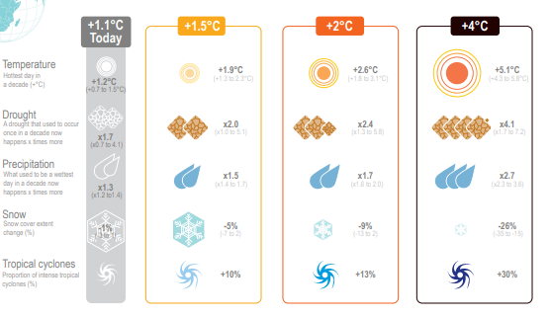
Figure 1 The response of some climate variables to global warming (Arias et al. 2021).
According to (Holappa 2020) GHG emissions have doubled since 1970 and Carbon Dioxide (CO₂) the most important GHG has increased from 300ppm to 410 ppm (atmospheric content) since 1950. At the conference of parties Paris (COP21) in 2015 an agreement to prevent a global rise in temperature of over 2 ◦C was achieved, this target was later reduced to 1.5 ◦C at the COP 24 meeting in 2018. To meet the 2 ◦C target a 50% reduction in emissions by 2050 is required and an 80% reduction is required to meet the 1.5 ◦C target respectively.
The Iron and steel industry (ISI) is one of the world’s most important manufacturing sectors with a significant impact on the global economy. Steel is a highly cost-effective material which can be recycled endlessly and has a vast array of applications, steel is going to be crucial for the low carbon transition as it is required in in the manufacture of solar panels, wind turbines, dams, and electric vehicles. Recent steel demand and production has increased sharply (Figure 2), there are predictions of growth range from 3000 MT by 2050 to a more conservative prediction of 2500 MT (Holappa 2020).
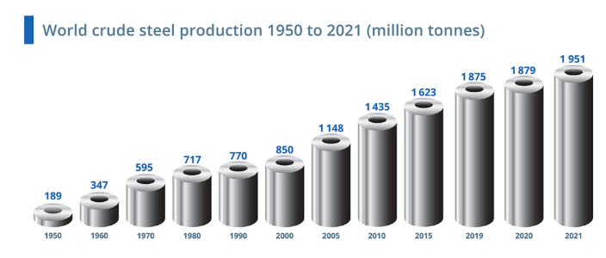
Figure 2 World Steel Production 1950 - 2021 (Worldsteel. 2021)
The ISI is the 2nd biggest energy user in the world consuming approximately 22% of industrial energy and ~ 8% of total worldwide energy. The ISI is also the 2nd largest emitter of CO₂ and it accounts for ~25% of industrial CO₂ emissions and ~9% total CO₂ emissions producing 3.2 GT CO₂ in 2019 (IEA.org 2020). For every tonne of steel produced there is 1.89 tonne of CO₂ emitted (WorldSteel. 2021).
The Kyoto protocol 1997 persuaded the worlds industrialised countries to adopt policies that would limit and reduce GHG’s to agreed targets (UNFCCC 2022). As a result, a Carbon trading market was created, the European Union Emissions trading system (EUETS) being the first and largest, the UK has since created its own trading system. Carbon trading allows governments and countries to trade permits and credits to emit CO₂ into the atmosphere. It is designed to punish those who over pollute and reward those who reduce their emissions. The “cap and trade” is the most widely used scheme, governments set a legal limit on emissions over a specific time period and companies are allocated allowances. The UK has set a legal minimum price of £22 a ton of CO₂. A company that has used all its credits but is still emitting CO₂ would need to buy carbon credits from a company that has emitted less pollution and has credits saved (Carbonaro 2021).
The UK government has set a target for a 68% reduction in greenhouse gases by 2030 when compared to levels in 1990, with further targets of 78% reduction by 2035 and net zero GHG emissions by 2050 (Gov.UK. 2021). In order to meet these targets , the ISI needs to decrease its CO₂ usage by 1.9% year on year until 2030 (de Souza and Pacca 2021).
The ISI has strived to reduce its energy consumption and has decreased its GHG emissions by 60% in the last 50 years, with many new ways of further reducing emissions under research. Some of these improvements can be implemented immediately but in order to meet the targets set for 2050 there needs to be changes in the technologies used to produce steel (WorldSteel, 2021).
An integrated steelworks consists of coke making, sintering, iron making (blast furnace), basic oxygen steelmaking (BOS), hot and cold rolling. Figure 3 shows the CO₂ concentration in flue gas from each process in an integrated steel works.
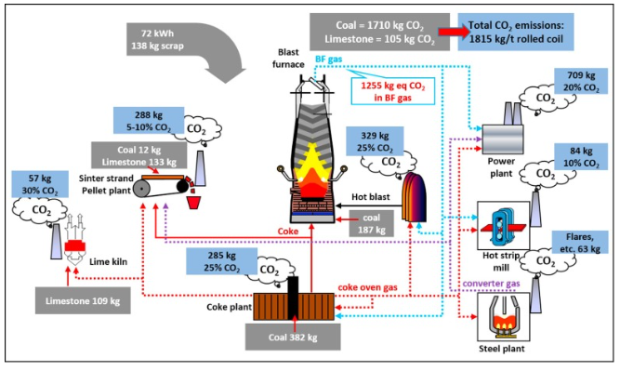
Figure 3 - CO₂ emissions in an integrated steelworks (BF - BOS route) showing carbon-bearing material input (Gray boxes), CO2 emissions, expressed in volume (kg/t of hot rolled coil) and concentration in the flue gas (volume %)in the blue box (Birat 2010).
There are many pathways towards meeting these targets and the ISI must take them all collectively. In the medium to long term new technologies such as carbon capture, and a fuel shift away from fossil fuels towards hydrogen, natural gas and renewable energy and an increase in the utilisation of electric arc furnace (EAF) steel production capacity, will yield the greatest results. In the short-term, significant improvements in process reliability, steel demand reduction through material efficiency and minimising waste through energy efficiency are mitigations that need to be actioned immediately (Aaskov 2022).
A biofuel is renewable biomass that is used as an energy source. Biomass such as trees and plants absorb CO₂ from the atmosphere as they grow. The biomass is then burned as a fuel and the CO₂ is returned to atmosphere. New trees are planted to form a continuous cycle that meets zero net CO_{2.} Using biomass can be considered a transitional strategy for the reduction of CO₂ emissions from the ISI over the next 30 – 40 years, until new net zero emission iron and steelmaking processes can be developed and adopted, with potential for up to 50% net emission reductions (Mathieson et al. 2011). The dominant route for Iron production is through the blast furnace (BF) and it accounts for 70% of world crude steel production. The energy source of the BF comes from coal and coke.
The technological feasibility of using biomass in BF has been studied by several authors (Suopajärvi et al. 2013; Fick et al. 2014; Mousa et al. 2016; Ye et al. 2019). According to these studies, there is true potential to utilise renewable biomass in the BF processes in significant quantities, thereby offsetting net CO₂ emissions in the industry. These studies have mainly concentrated on the use of charcoal although torrefied wood pellet has also been considered. Despite the few studies where biomass has been introduced in ironmaking, there is a need for more detailed considerations of material and energy balances, CO2 reduction potential and environmental burden.
There are limitations to using biomass in iron and steelmaking, biomass in its raw form is not suitable for the ironmaking processes because of its high moisture and oxygen content and low calorific value (Strezov 2006; Montiano et al. 2014b). Pre-treatment processes such as torrefaction, pyrolysis, gasification, liquefaction, and hydrogenation can enhance the properties of biomass for use in industry. Slow pyrolysis of biomass results in charcoal, the properties of charcoal are comparable to the bituminous coals used in ironmaking although at reduced yields due to a lower bulk density.
(Conte et al. 2021) defines biochar as:
“Biochar is a porous, carbonaceous material that is produced by pyrolysis of plant biomasses and is applied in such a way that the contained carbon remains stored as a long-term C sink or replaces fossil carbon in industrial manufacturing. It is not made to be burnt for energy generation”.
Biochar represents an opportunity to enable the ISI industry to reduce its net CO₂ output and help the UK meet the GHG reduction targets set out by the government. The most suitable type of biomass for use in the ISI is biochar produced from woody feedstocks (Wei et al. 2017).
Research on the effect of biomass in the ISI is limited and sometimes conflicting. Each steel plant uses different sources for its raw materials and uses them in various concentrations and therefore the effect of biochar on each individual steel plant could vary.

Research aim
The aim of this report is to assess the suitability of two types of biochar, wood industry waste hardwood biochar and a pelletised softwood biochar, for use in three ironmaking processes at Port Talbot steelworks. The biochar will be assessed as partial replacement for the coal used in coke and iron making and coke breeze used in sinter making. The report aims to understand the near optimum amount of biochar that can be used without having a detrimental impact on product quality. The biochar will be assessed using:
- A lab scale pilot coke oven and the quality tests associated with coke.
- A sinter make simulation called the sinter pot. Including the quality tests associated with sinter.
- Several tests required for assessing potential fuel replacement in the blast furnace.
Another aim of this project is to understand the potential CO₂ savings from using biochar in the three aforementioned processes.

Objectives
- Analyse the biochar samples using the same techniques that would be used to assess the fuels for coke making, sinter making, and iron making.
- Evaluate the biochar analysis against typical fuel analysis for each process.
- Compare the combustion characteristics of biochar with pulverised coal to determine the suitability of biochar as partial replacement of the coal, using a drop tube furnace and thermogravimetric analyser.
- Use a lab scale pilot oven to produce biocoke with varying biochar/coal replacement concentrations.
- Assess the biocoke against blast furnace coke quality measures.
- Produce sinter using a sinter pot at varying different biochar/coke breeze replacement concentrations.
- Assess the bio-sinter using blast furnace sinter quality measures.
- Identify the near optimum biochar/fuel replacement percentage.
- Calculate the potential CO₂ savings that could be realised by using biochar in these processes.

Theory

Biomass
Biomass refers to organic materials produced by plants, animals, and microorganisms. It can be split into four categories:
- Wood and forestry residues – Sawdust, woodchip, bark, lump wood etc.
- Agriculture residues – Straw, corn stalks, bagasse, willow, and nut hulls.
- Organic industry waste – Papermill sludge and food processing wastes.
- Urban wastes – Sewage, common waste manure and compost.
(Mousa et al. 2016)
These products all have very different origins, and their physical and chemical properties will therefore differ significantly. The coal, sinter and iron making processes are complex and their raw materials have specific requirements. Therefore, not all the biomass fuels listed above would be considered suitable for use in these processes, there is also usually some form of thermal pre-treatment required (Fick et al. 2014).

Raw Biomass structure
The structure of biomass can be lignocellulosic or non-lignocellulosic. The lignocellulosic material is the fibrous part of the plant that consists of cellulose, hemicellulose, and lignin (figure 4). The non-lignocellulosic material is non-cellulosic organic material which is used for nutritional purposes such as Sugar, protein, fat and starch. Lignocellulosic material can be described as woody and is not easily digestible by humans (Basu 2013). In a thorough assessment of many different types of biomass (Tao et al. 2012) found that woody materials were considered a higher quality for use in a BF, while herbaceous biomass such as straw and fruit residues were considered low quality fuels. The reasons the wood-based biomasses are favourable is because they have low ash and sulphur content and the level of harmful elements such as sodium (Na) and potassium (K) found in wood ash, are at acceptable levels.
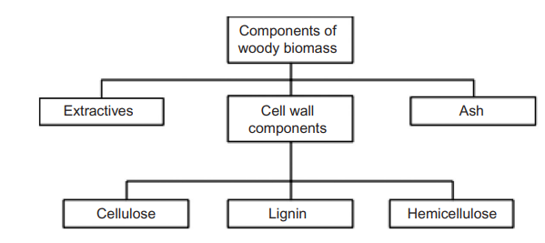
Figure 4 Major constituents of a woody biomass (Basu 2013)
Cellulose (C₆H₁₀O₅)_{n} is the most common organic compound on earth and is the primary structural component of cell walls in biomass. Cellulose is a long chain polymer; its crystalline structure gives it a high strength and forms most biomass skeletal structure. It is the largest component of wood, making up to 44% of dry weight (Basu 2013). Cellulose is hygroscopic and is responsible for the hygroscopic behaviour of biomass (Nhuchhen et al. 2014). Hemicellulose (C₅H₈O₄)_{n} is also a constituent of the biomass cell wall although unlike cellulose it has an amorphous structure with little strength. The composition and structure vary significantly among different biomasses. It constitutes approx. 20-30% of the dry weight of most wood (Basu 2013). Hemicellulose groups release CO₂ & CO upon low temperature thermal treatment and has a significant effect on the mass yield in a thermal pre-treatment process (Nhuchhen et al. 2014). Lignin is an integral part of the secondary cell wall of plants, it acts as the cementing agent for cellulose fibres, holding adjacent cells together. It is one of the most abundant organic polymers on earth (exceeded only by cellulose). It accounts for between 18 – 35% of the dry weight of wood (Basu 2013). Lignin is thermally stable over a wide range of temperatures, thus in the thermal pre-treatment process, lignin remains less modified and a biomass with higher lignin content yields a more solid product (Nhuchhen et al. 2014). Figure 5 illustrates these components in a typical plant cell wall.
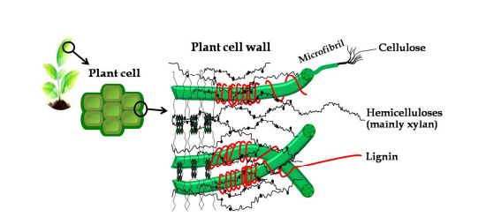
Figure 5 Structure of primary cell wall of plant cell (Nhuchhen et al. 2014).
Biomass mainly comprises of carbon (C), hydrogen (H), oxygen(O), nitrogen (N) and sulphur (S). The O:C and H:C ratios for various fuels are illustrated in the Van Krevelen diagram, fig 6. Anthracite coal has the lowest O:C and H:C ratios and is of the highest rank. When compared to fossil fuels, biomass has the highest O:C and H:C ratios. The calorific value (CV) of the fuel is reduced due to the high proportion of oxygen and hydrogen in comparison with carbon, this is because of the lower energy bonds between the C-O and C-H molecules when compared with the C-C bond (van der Stelt et al. 2011).
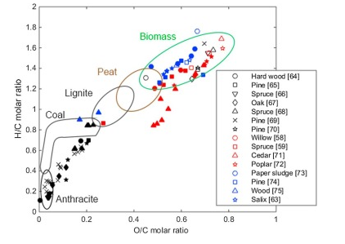
Figure 6 Van Krevelen diagram of products from woody biomass. Raw biomass (non-filled symbols), torrefied biomass (red symbols), HTC biomass (blue symbols), and charcoal (black symbols) (Suopajärvi and Fabritius 2013).

The problem with Raw Biomass
Biomass in its raw form is not suitable for an energy source in industry as compared with fuels such as coal. Biomass compared with coal as a fuel:
- Higher oxygen content – reduces the heating value, results in a higher volume of flue gas during combustion.
- Lower carbon content – Required as a fuel and reducing agent.
- Low bulk density – High transportation and storage costs, also influences process conversion efficiency.
- Higher moisture content 45 – 60% - Higher thermal energy is required to combust, higher tar formation, lower density, greater tendency to decompose.
- Low net calorific value (NCV) – Low product yields, more biomass required to compensate.
- Low heating value (LHV)
- Hygroscopic – Can draw moisture in, even after drying.
- Fibrous – The fibrous nature of biomass increases the difficulty in pulverising it into a powder ready for processing. Thus, increased processing costs.
- Higher organic volatile mater – Burnt off in BF processes, lower product yields, can interfere with processes.
- Higher concentration of Alkali metals (Na, K, Zn) – Can foul BF refractory, increase coke consumption, and can be released into atmosphere upon combustion.
(Tumuluru et al. 2012; Suopajärvi et al. 2013)

Biomass Pre-treatment
Biomass pre-treatment methods can be classified into five categories:
- Chemical – Removes the lignin and hemicellulose improving biodegradability of cellulose. Includes Steam explosion, acid, alkaline, ammonia and freeze explosion treatments.
- Mechanical – Only brings about a physical change. The main methods are grinding, milling and extrusion.
- Biological – Microorganisms modify the chemical composition and structure of lignocellulose to make it suitable for enzymatic digestion. Environmentally friendly and consumes less energy than other treatments but requires a large, controlled environment and is costly and slow.
- Thermal – Modifies the physical, structural, and chemical properties of biomass. Volatiles are driven off producing a more brittle and less fibrous product.
- Hydrothermal – A thermochemical conversion process in which biomass and water is subjected to high pressure at moderate temperatures. Can be used for wet biomass such as animal manures, human waste, and sewage. Produces an energy dense product.
Figure 7 illustrates some of the available biomass upgrading technologies.
(Nhuchhen et al. 2014)
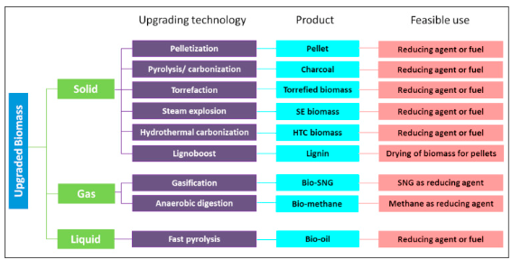
Figure 7 Biomass upgrading technologies according to product type (Mousa et al. 2016).
Biomass must be dried before any thermochemical conversion processes. The moisture content needs to be reduced from 50 – 60% to 10% to avoid thermal ballast and affecting the yield of the charcoal. The most common technology used for biomass are rotary dryers although there are several other technologies available.
Thermal pre-treatments include torrefaction, carbonisation, fast pyrolysis, hydrothermal carbonisation, and gasification, they are classified based on their operating conditions, mainly temperature and reaction time and they produce heat, syngas (H₂+CO), or bio-oil and char. However, the solid product from some of these processes is not regarded as suitable for use in the ISI. (Suopajärvi et al. 2018) provides a summary of the available pre-treatments as follows (product yields from (Kambo and Dutta 2015):
Slow Pyrolysis – Slow heated to 300 - 600⁰C without air, residence time can vary from 15 – 30 min to several hours. Produces a highly carbonated solid residue (50 – 95% fixed carbon) called charcoal or Biochar with a large particle size. Gas and bio-oil produced as by-products. The product yields for carbonisation are 20 -30% liquid, 25 - 35% char and 25 - 35% gas.
Torrefaction – Temperature range is 200 - 300⁰C in the absence of air with 15 – 30 min residence time. Produces carbonised solid residue 14 – 48% fixed carbon. The product yields for torrefaction are 60 - 80% char and 20 - 40% gas.
Hydrothermal Carbonisation (HTC) – Mixed with saturated water-steam at 150 – 250⁰C form a few minutes to a few hours. Produces a slightly carbonated solid residue called HTC biomass with similar properties to torrefied biomass. Suitable for wet biomass. Eliminates the need for pre-drying. The product yields for HTC are 45 – 70% char, 5 – 25% liquid, and 2 – 5% gas.
Fast Pyrolysis - Heated to 400 - 600⁰C for a few seconds without the presence of air. Produces bio-oil. The product yields for fast pyrolysis are 75% liquid, 12% char and 13% gas.
Gasification – Operating conditions are 600 – 1400 ⁰C, mixed with 30 – 50% oxygen or air. Syngas is produced. The product yields of gasification are 5% liquid, 10% char and 85% gas.
Some char is produced as a by-product in both fast pyrolysis and gasification but is not considered biochar does not have the required properties.
The most suitable biomass state for use in industry as a source of energy is solid biomass, followed by biogas. The solid biofuels are represented by charcoal and torrefied wood pellets, and these are the most appropriate fuels for industrial use as an energy source. Biochar has the highest fixed carbon and calorific value and the lowest volatile matter among the bio products (Suopajärvi et al. 2018). Figure 8 illustrates that during thermal pre-treatment the carbon mass increases relative to the oxygen and hydrogen content, as a result the heating value and CV increases by about 9 – 12%.

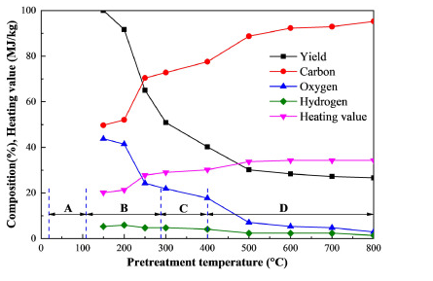
Figure 8 Influence of pre-treatment temperature on key variables (Liu and Shen 2021)

Biomass utilisation in the iron and steel industry
The BF – BOS steelmaking process accounts for 70% of global steel production. The BF process involves charging agglomerated iron ore and /or sinter into the BF at 1600 -2000⁰C. Metallurgical coke is the primary source of energy and the reducing agent. Fluxes such as limestone and dolomite are added to remove impurities such as sulphur. Pulverised coal injection (PCI) and oxygen are injected into the furnace to increase productivity and reduce coke demand (Geerdes et al. 2009).
The three processes with most potential for CO₂ savings in the ISI, displayed in figure 9, are:
- As a replacement for coal in PCI at the BF tuyeres.
- Partial replacement of coal in the coke making process for charging into the BF.
- Biomass in iron ore sintering for charging into BF.
(Liu and Shen 2021b)
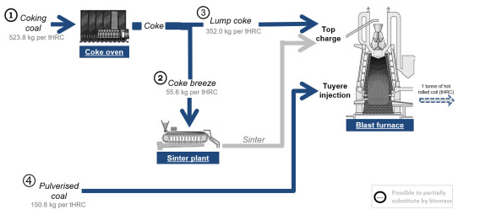
Figure 9 Opportunities for Biomass in iron & steelmaking (Mandova et al. 2018)
Other potential options for CO₂ savings in the ISI include:
- Biomass briquette charged directly into the BF (partial coke replacement).
- Iron ore pellets produced using biomass.
- BF nut coke replacement.
This report will focus on the first three options.

Injection of Biomass into blast furnaces
The raw materials are charged into the BF through the top of the furnace. Iron bearing materials are charged in alternating layers along with the coke. The BF is heated by injecting preheated air (blast) and coal through tuyeres (water cooled pipes) at the bottom of the furnace. The hot blast reacts with the material in the furnace creating a high temperature flame of 2100⁰C – 2300⁰C. The coke and coal are gasified and the hot gases ascend the furnace, melting and reducing the iron ore. The voids created allow the burden to descend through the furnace (Geerdes et al. 2009).
The blast furnace is illustrated in figure 10. As the temperature at the throat of the furnace reaches 500⁰C – 600⁰C the iron ore in the form of Hematite (Fe₂O₃) starts to reduce to Magnetite (Fe₃O₄). Further down the furnace as temperatures raise to 700⁰C – 900⁰C the Magnetite reduces to Wustite (FeO). Further down at an area called the cohesive zone at 1100⁰C – 1400⁰C the Wustite is reduced to metallic iron, here the iron starts to soften and melt. Below the cohesive zone temperatures reach 1500⁰C and coke is now the only solid material. The iron continues to descend the furnace through the active zone, this is a semi fluidised region where liquid iron drips through the coke voids. The final stage of reduction is completed at the dead man, a stable region of coke in the middle of the raceway. The fully melted iron and slag collects at the hearth where it is cast via a tap hole (Haapakangas 2016),
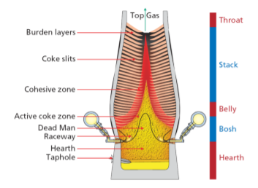
Figure 10 An illustration of a blast furnace (Geerdes et al. 2009)
(Mathieson et al. 2011) reports that the use of biomass in the blast furnace could reduce 22 - 32% of CO₂ emissions. Biomass can be injected into the BF in three forms; Biochar, bio-oils and bio syngas (Suopajärvi et al. 2013) although most studies have focused on biochar, as it has comparable properties to the coals used in PCI (Matsumura et al. 2008; Babich et al. 2010; Mathieson et al. 2011; Suopajärvi et al. 2013; Bazaluk et al. 2022). Coke is irreplaceable as the fuel in the BF and cannot be directly replaced by biochar due to its insufficient strength (Mathieson et al. 2011). PCI is used worldwide as a method to enhance BF profitability and efficiency. The injection of coal into the BF (illustrated in figure 11) has various economic and operation benefits including a) lower consumption of coke (which is significantly more expensive that coal) b) Coke oven life extension c) higher BF productivity d) improved hot metal quality e) BF operation flexibility f) lower CO₂ emission.
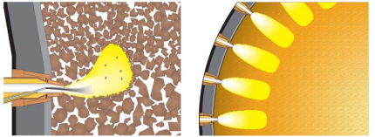
Figure 11 A blast furnace tuyere diagram (Geerdes et al. 2009)..
(Matsumura et al. 2008) state that the most important characteristics for PCI are combustion, devolatisation and gasification. They demonstrated that, when compared to PCI, biomass has higher reactivity and combustion levels. (Wang et al. 2014; Wang et al. 2015a) investigated various types of biomasses for replacement of coal in PCI, they found that 155 kg/tHM (Kg per tonne of hot metal) of pulverised coal (PC) could be replaced by 166.7 kg/tHM of biochar, This equates to an 22.8% replacement rate of PC with biochar, they found that increasing the biochar injection rate any further required further oxygen enrichment and might lead to a decrease in the RAFT temperature and an increase in the top gas temperature (TGT), which is undesirable. (Mousa et al. 2022) observed that CO₂ emissions could be reduced by 34% by full replacement of PC with biochar in the BF. They state that 100% PC - biochar replacement is achievable without negatively affecting RAFT and TGT. (Babich et al. 2010; Mathieson et al. 2011; Mousa et al. 2022) conclude that a good quality charcoal out preforms PC, the low ash and high basicity (CaO content) of the charcoal results in a decrease in slag volume and blast volume which results in a reduced coke rate and improvement in BF productivity. The drawbacks of charcoals include poor grindability, achieving the correct particle size may be problematic, that and the low density of charcoal means high injection rates may be difficult to realise without modifications to the PCI plant. (Ng et al. 2018) add that the production of biochar’s with low O/C ratios (high CV) may result in the increase of phosphorus and alkali metals which would lead to BF operational challenges.

Potential for biomass in metallurgical coke making.
Coke performs many functions inside the blast furnace: it supports the burden as it descends the furnace, provides gas permeability, permits the decent of the liquid iron, acts as reducing agent, carburising of the hot metal and a fuel source. Coke is the only material capable of carrying out all these functions making it irreplaceable for BF operation. Coke is made by heating a blend of coals of specific rank to 1000 - 1100⁰C in the absence of air (pyrolysis) (Dı́ez et al. 2002). An example of a typical by-product coke oven is shown in figure 12. High quality coke allows the BF to achieve low coke consumption and high PCI rate and therefore high productivity. Metallurgical coke needs to be of a certain size, resistant to degradation, abrasion and chemical attack, have a certain chemical composition and mechanical strength (Geerdes et al. 2009).
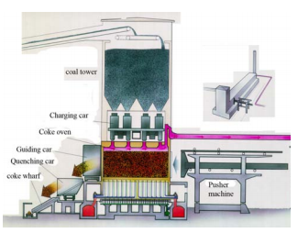
Figure 12 Diagram of a typical by-product coke plant (Hilding 2005)
Coking coal goes through several chemical and physical changes during the coking process, in order these are softening, swelling, contraction, evolution of volatile matter and then re-solidification. The thermoplastic properties of the coals are critical to the quality of the final coke (Loison et al. 1989).
Studies have shown that biomass can be added into the blend in several forms, raw biomasses, torrefied biomasses and pyrolyzed biomass. The addition of any of these seems to have a negative effect on the fluidity of the coal blend (MacPhee et al. 2009). (Diez et al. 2012) added untreated saw dust to the coal blend, they found that the inert nature of the sawdust negatively affected fluidity development, it does not soften and melt and does not bind the components of the plasticised coal. (Solar et al. 2021) added charcoal to the coking blend and found that it reduced the thermoplastic properties, an effect which increased as more char was added.
The mechanical strength and reactivity of coke are important parameters when measuring coke quality. These can be measured using ISO standard 1889-4 : CSR (coke strength after reaction) / CRI (coke reactivity index), the CSR and CRI measures are inversely proportional, when the CSR measure is high the CRI measure will be low (Dı́ez et al. 2002).
The particle size of the biochar can have a significant effect on the CSR/CRI values (MacPhee et al. 2009; Ng et al. 2011; Suopajärvi et al. 2017; Ng et al. 2018) biochar was introduced into the coal blend at 2 – 5% (Ng et al. 2011; Ng et al. 2018), 2 – 10 (MacPhee et al. 2009), 3 - 8% (Flores et al. 2017), and 5 – 25% (Yustanti et al. 2021). They found that coke reactivity (CRI) increased with the addition of biochar, the CRI increase is more pronounced when the charcoal is fine, this is due to the dispersion of calcium oxide (CaO) within the blend, which acts as a catalyst, promoting the carbon and CO₂ reaction. This reaction is less defined as the particle size of charcoal used increased. Reactive coke is favourable in the BF, as it improves the combustion process in the BF raceway and can equal or improve on the performance of coal (Babich et al. 2010; Mathieson et al. 2011), however, too high reactivity can mean a decrease in the CSR, this can lead to the generation of fines, which can result in BF permeability issues. The addition of course charcoal also led to the impairment of the biocoke’s cold mechanical strength, this measure relates to the behaviour of the coke during handling on its way to and during charging into the BF. Low cold strength could lead to fracture of the coke and the creation of fines. Course biochar affected the cold strength considerably, while the effect was far less pronounced when fine biochar was added (MacPhee et al. 2009; Ng et al. 2011; Flores et al. 2017; Suopajärvi et al. 2017). According to (Nomura and Kato 2006) the lower limit of biomass size was found to be 3 – 10mm.
Due to the negative effects of biomass addition into the coking coal blend, the amount that can be added is limited to 5% wt., while still maintaining acceptable coke quality (MacPhee et al. 2009). (Montiano et al. 2014a) found that by briquetting biomass that additions of 10 – 15% can be included in coking blends.

Potential for biomass in the sintering process
The materials available for the ferrous input into a blast furnace are pelletised iron ore, iron ore lump or sinter. Iron ore pellets are formed by agglomerating iron ore fines, that are not suitable for direct charge into the BF. A good blast furnace burden consists of sinter and/or pellets. Lump ores are becoming increasingly scarce and their properties are generally poorer than the alternatives, and so are mainly only used as a cheap replacement for pellets (Geerdes et al. 2009).
Iron ore sintering is the process of heating iron ore fines, coke fines and other materials to produce a semi molten mass that solidifies into a porous piece of sinter. Sinter must be of a certain size and strength to be suitable for use in the BF. The main steps in the sintering process are proportioning, mixing and sintering. Raw materials such as iron ore fines, reverts - iron and steelmaking by-products that contain iron and fluxes are added together to form what is called a raw mix. The raw mix is mixed with water to form granules. The granules are then fed onto a moving grate to form the sintering bed. The bed is ignited by gas burners near the ignition hood at the face of the bed. As the coke in the bed burns it creates a high temperature combustion zone at temperatures 1200⁰ – 1400⁰C. Air is drawn through the bed creating a narrow self-propagating flame front, further promoting combustion. Some of the materials melt and as the flame front moves the material cools and resolidifies. This partial melting and diffusion within the materials forms an agglomerated porous sinter cake, this is illustrated in figure 13. The process produces sinter with the required chemical composition, permeability and strength for use in the BF (Chen et al. 2016).
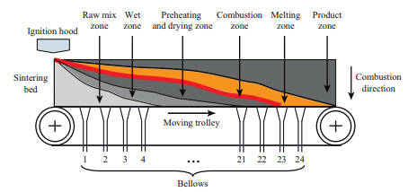
Figure 13 Diagram of a sintering machine (Chen et al. 2016).
The best fuel for use in the sintering process is coke breeze, undersized coke screened from the coke produced at the coke ovens. The sintering process contributes up to 12% of the CO₂ emissions produced at a typical integrated steel plant. The CO₂ in this case is mainly generated from the combustion of the coke breeze and decomposition of flux additives. The combustion of coke breeze in the sintering process is also responsible for the emission of various types of GHG such as sulphur dioxide (SO₂), nitrogen oxides (NO_{x}), carbon monoxide (CO), methane (CH₄), dioxins and fine dust. The concentration of these emissions is correlated with operational conditions, quality of the fuel and raw materials used (Abreu et al. 2015).
Biochar can be used as an alternative fuel instead of coke breeze, the primary differences between coke breeze and biochar that affect the sintering process and sinter quality is higher reactivity (Gan et al. 2015) due to higher surface area and porosity (Lovel et al. 2009). (Lu et al. 2013) found that partial replacement of coke breeze with biochar resulted in higher concentration of CO_{x} but lower concentrations of SO_{x} and NO_{x} in the off gas. (Abreu et al. 2015) conclude that a 50% biochar/coke breeze blend fuel mix was operationally feasible and that a 50% reduction in GHG emissions was observed, however, dust concentration and methane concentrations (although lower in comparison) rose significantly. (Mathieson et al. 2011) states that partially replacing coke breeze with biochar can reduce net CO₂ emission by 5 – 15%. They also found that as charcoal is highly porous, sinter granulation is negatively affected. The moisture saturation of charcoal is 48% compared to 25% for coke breeze. Therefore a higher percentage of water needs to be added to the sinter mixture (~8.5%) while coke breeze requires (~7.1%). (Mousa et al. 2015) studied biochar substitution for coke breeze at 0 - 100%, they found that that the lower crushing strength of biochar when compared to coke breeze resulted in its destruction during mixing, as a result the bed permeability is negatively affected, and the vertical sintering speed is decreased. Sinter yield was unaffected, but sinter quality (measured by the tumbler index) and product yield sharply decreased when the biochar substitution for coke breeze surpassed 25%. (Lovel et al. 2007; Kawaguchi and Hara 2013; Wei et al. 2017) demonstrated that biomass addition to sinter making has a negative effect on the sinters yield and ability to resist impact and friction (measured by the tumble index) while at this point fuel consumption increases as illustrated in figure 14. Although (Kawaguchi and Hara 2013) found that by using biochar with high fixed carbon (>90%) and larger particle size (1-5mm), the sinter yield and product yield was comparable to that of coke breeze and by adjusting the sintering process, sinter produced from biomass can meet BF requirements.
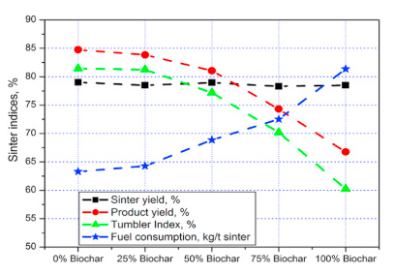
Figure 14 Sinter quality indices after biochar addition (Mousa et al. 2015).
(Ooi et al. 2011) suggest that up to 20% of coke breeze can be replaced with charcoal, they discovered that both sinter yield and productivity was improved. (Gan et al. 2014; Gan et al. 2015) report that up to 40% biochar replacement could be reached. As the substitution rate increased, the combustion efficiency deteriorated due to variation in the flame front speed and heat front speed. They found if the PSD in the 1 - 5mm range is increased the sinter quality indices improved. The parameters that need to be considered and controlled when optimising the substitution rate of biochar, include chemical composition, reactivity, particle size, and strength of the biomass products.

Biomass supply and availability
There are barriers to implementing biochar in the ISI. At present there are no supply chains in place for the supply of biochar to the ISI (Suopajärvi et al. 2018). The UK also currently lacks the facilities to produce the amount of biochar that would be required for the ISI (Lamers et al. 2016). For biochar to be sustainable as a green technology there is a need to ensure that the feedstocks are sourced from sustainably managed lands. Biochar needs to be both environmentally and economically viable (Jahanshahi et al. 2014). Charcoal production technology needs to be developed that can produce charcoal at a significantly lower cost (Norgate et al. 2012)
Life cycle assessments (LCA) assess the potential environmental impacts associated with a product, or process during its entire life cycle, from extraction of raw materials through to the production and use of the end product. LCA’s on biochar carried out by (Norgate and Langberg 2009; Norgate et al. 2012; Feliciano-Bruzual and Mathews 2013; Suopajärvi and Fabritius 2013; Fick et al. 2014) found that net CO₂ and GHG levels were reduced between 3.4 to 12.9 CO₂/MJ or 31 – 57% CO₂ emission reduction when assessing biochar usage.
Approximately 800Kt of charcoal is consumed yearly in Europe, mostly by the barbecue market, 70% of which is imported from Africa. Substituting 5% of the fossil fuels used by a small European size steelmaking plant BOS – BF with a production output of 3 million tonnes of crude steel per annum would require roughly 120kt of charcoal. The question needs to be asked whether the countries such as the UK has the resources to meet the demand. (Mandova et al. 2018) demonstrated that forestry growth in the EU is 36% bigger than EU sourced wood consumption (see figure 15 b) and sufficient biomass resources exist to meet demand by all steel plants in Europe, however counties such as Great Britain, Germany, Italy, Spain, Belgium, and the Netherlands would be highly reliant on cross border trading, as shown in figure 15 a). Similar resource studies were also carried out for Finland (Suopajärvi and Fabritius 2013), Sweden (Wang et al. 2015a) and France (Fick et al. 2014) indicating that these nations natural resources are capable of supplying biomass to their iron and steel plants.
a)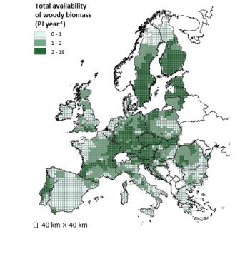 b)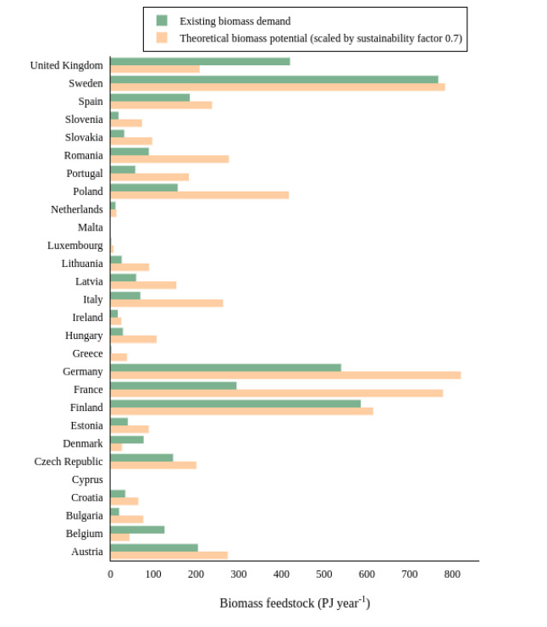
Figure 15 a) The distribution of woody biomass and waste in the EU b) Comparison of the woody-biomass supply and the existing woody-biomass demand, per country) (Mandova et al. 2018).
Biomass raw materials are low in energy density and require treatment in order to make them suitable for use in iron making processes. A significant amount of energy costs are associated with cultivating, transporting and pre-treating and handing them, as illustrated in figure 16. As such biochar productions costs are significantly in excess of the fossil fuels they are meant to replace. Charcoal cannot compete with fossil fuels on price without the introduction of high carbon taxes (Mousa et al. 2016).
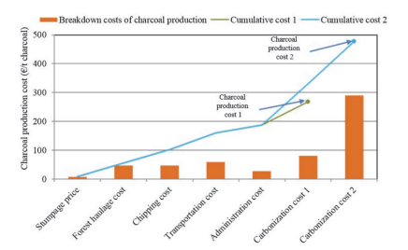
Figure 16 The cost of charcoal production (Suopajärvi and Fabritius 2013)
Charcoal production costs range from €268/t to €478/t, for logging residues. Raw material costs account for between 54% - 65.4% and transportation costs make up 21% - 34%. Investment in Charcoal production plants near to the steel plants would help to reduce costs significantly (Suopajärvi 2014). (Mandova et al. 2018) found that maximising CO₂ reduction using biomass would increase steel production costs by 50%. This would therefore require that the EUETS CO₂ price should be set at 124 £/t to encourage the use of biomass. They found that the carbon tax would severely impact upon cost of steelmaking in Europe and that other measures such as subsidies or tax relief should be considered.
(Mathieson et al. 2011) showed the value in use (VUI) of various charcoal examples compared with different coals for BF tuyere injection at 140kg/t-HM shown in figure 17. Three charcoal samples had calculated values 50% greater than the reference bituminous coal. The reason for this is the predicted lower BF coke rates and improved hot metal composition.
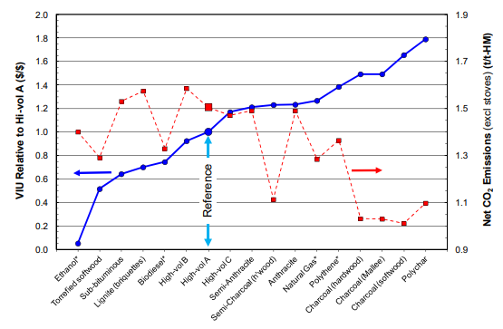
Figure 17 Calculated VUI's for BF fuels and subsequent CO2 emissions from the BF (Mathieson et al. 2011)

Analysis
Two biochar samples were considered for assessment. The first sample (biochar 1) is a softwood pellet biochar that has been pyrolysed at 650⁰c in a rotary kiln (Mašek et al. 2018) shown below in figure 18.
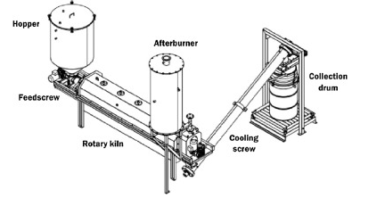
Figure 18 Rotary kiln pilot-scale pyrolysis unit used to make biochar 1 (Mašek et al. 2018)
The second sample (biochar 2) is a mixed hardwood sample sourced from industry waste. For which the process parameters and specifications were unavailable.
Before these materials can be assessed for use in the iron making processes it is necessary to fully understand their chemical and physical properties to ensure they are suitable for the processes they are being assessed in. These can then be compared with the fossil fuels they are replacing.

Biochar characterisation

Proximate analysis
Proximate analysis is widely accepted as the basis for coal characterisation in connection with the utilisation of coal. Proximate analysis is a means of determining the products obtained when a coal sample is heated under specific conditions. The proximate analysis of coal separates these products into four groups (Speight 2015), see figure 19.
- Moisture - Water content.
- Volatile matter – the gases and vapours driven off during pyrolysis.
- Ash – The inorganic residue remaining after combustion.
- Fixed carbon – The non-volatile fraction of coal.
- Free swell index – The swelling properties of the coal.
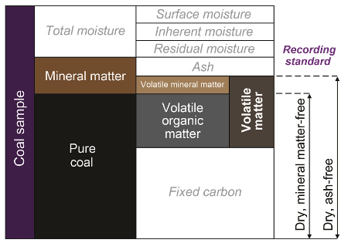
Figure 19 The components of coal (Backus 2022)

Moisture
There are several types of moisture values reported for coal. The surface moisture is water adhering to the outside of the coal sample or particle, inherent moisture is held by capillary action in the microscopic structure of the coal, residual moisture is water that remains in the coal after air drying and/or minor heating to 10 -15⁰C. The moisture value that will be used in this report is the total moisture – All moisture in and on a coal sample that can be removed through heating (Backus 2015).
The method used to determine moisture is taken from the British standard BS 1016-1: 1973, 1 Kg of sample is heated in an air oven at 105⁰to 100⁰C for approx. 4 – 5 hours, the sample and container is then weighed and returned to the oven. This is repeated until a constant mass is achieved. The Moisture is calculated from the loss in mass of the sample.
If m1 = Mass of container plus sample as received (g),
m2 = Mass of empty tray (g),
m3 = Mass of tray plus sample after heating (g),
m4 = Mass of dry empty container (g),
M = Percentage of moisture in the sample analysed,
then $M=\frac{\left(m_{1}- m_{4}\right)-(m_{3}- m_{2)}}{\left( m_{1}- m_{4}\right)}*100$
(BS 1016-1: 1973)

Volatile matter
Volatile matter (VM) refers to the components of coal, excluding moisture, that are released at high temperature in the absence of air. Coals are ranked by the amount of carbon present in them and therefore their energy content. Measuring VM is an important parameter used to help identify a coals rank. VM decreases as the coal rank increases see table 1 (Speight 2015). Most VM comes from the organic components in coal, but some elements from minerals combine to form volatile oxides. The most common VM in coal is water, carbon dioxide, and sulphur dioxide (Backus 2015).
Table 1 Decrease of VM in bituminous coals in response to increasing coal rank (Osbourne 2013)
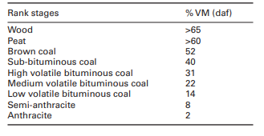
VM is determined by measuring 1g of sample into a lidded silica crucible (preventing air ingress), the crucible is placed in a furnace at 900⁰C for 7 minutes. VM is calculated from the loss in mass of the sample after adjusting for moisture.
VM is given by $V=\frac{100\left(m_{2}-m_{3}\right)}{m_{2}-m_{1}}- ω_{H_{2}O}$
Where: m1 is the mass (g) of the empty crucible and lid.
m2 is the mass (g) of the crucible and lid and test portion before heating.
m3 is the mass (g) of the crucible and lid and contents after heating.
^{ω}H₂O (%) is the moisture
(BS ISO 562: 2010)

Ash
Ash is the non-combustible residue left after coal is burned and represents the bulk mineral matter after carbon, sulphur and water has been driven off during combustion. The ash is composed primarily of oxides and sulphides and can be considered to be an approximation for the mineral content but does not equal the original mineral content as some of the mineral phases are altered when the coal is combusted e.g., CO₂ is removed from carbonates and SO₃ is removed from the sulphides (Speight 2015). Ash is determined by measuring 1g of sample into a silica dish, the dish is placed into a furnace at 815⁰C for 60 minutes. The ash is calculated as the mass remaining in the dish as a fraction of the original sample weight.
The ash is expressed as a percentage mass fraction:
$$A=\frac{m_{3}- m_{1}}{m_{2}- m_{1} } ×100$$
where: m1 is the mass (g) of the empty dish.
m2 is the mass (g) of dish plus test portion.
m3 is the mass (g) of dish plus ash.
(BS ISO 1171: 2010)

Fixed carbon
Fixed carbon is the solid combustible residue remaining after removal of moisture, ash and volatile materials. Fixed carbon is calculated by subtracting the percentage moisture, ash and VM from 100%.
$$FC=100-\left(M+A+V\right)$$
where: M = Moisture content (%)
A = Ash content (%)
V= Volatile matter content (%)
(Loison et al. 1989)

Ultimate analysis
The organic components of coal are composed of carbon, hydrogen, nitrogen, oxygen and sulphur, these components make up 99% of the organic portion of coal. Analysis performed using an instrument called an ultimate analyser, carbon, hydrogen, and nitrogen are determined by combusting the sample, the elements carbon, hydrogen and nitrogen are converted into CO₂, H₂0, N₂ and NO_{X}. Carbon and hydrogen content are determined by passing the gasses through an infrared cell, a thermal conductivity cell is used to determine nitrogen. The raw hydrogen analysis result is moisture corrected. The total oxygen is calculated from the other values (Osbourne 2013).
Total oxygen weight % = 100 – (total carbon weight % + total hydrogen weight % + total nitrogen weight % + total sulphur weight % + total ash weight%).
Sulphur can be determined using a combustion analyser, a sample is placed in the sulphur analyser. The sample is combusted at a temperature of 1,370°C in an oxygen atmosphere. The oxygen reacts with sulphur to form sulphur dioxide gas. An infrared detector then measures the sulphur concentration (Backus 2015).

Calorific value
The calorific value is a measure of the energy content of the coal. It is the amount of energy produced when a known quantity of sample is combusted in oxygen. The instrument used to measure this is called a bomb calorimeter. The sample is combusted in a steel container placed in water. The change in water temperature is used to determine the calorific value of the sample. Calorific value is measured in kilojoules/kg or megajoules/kg (Backus 2015).

Major Elemental Analysis
Coals can contain a variety of elements, major elements make up more than 1%, they are determined by X-ray fluorescence (XRF), the coal is combusted, and the remaining ash is fused with a flux material before being analysed on the XRF. The XRF works as follows: Photons from the x-ray tube strike the sample with enough energy to expel the electrons out of the element’s innermost orbital, the atoms become unstable. To regain stability electrons in the outer orbitals, move into the newly vacant inner orbitals. When an electron transitions from an outer orbital to an inner orbital it emits energy known as x-ray fluorescence, each element has a specific energy signature which is picked up by the detector, see figure 20 below (Blondel 2020).
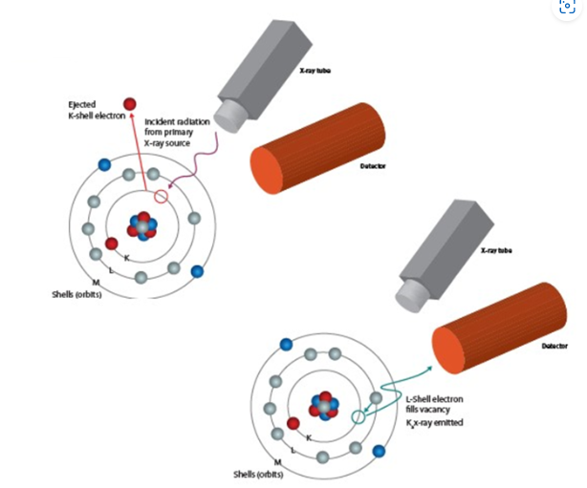
Figure 20 Illustrating x-ray fluorescence (Blondel 2020)
Results are presented on an oxides basis, such as SiO₂, Al₂O₃, Fe₂O₃, CaO, MgO, Na₂O, K₂O, TiO₂, Mn₃O₄, SO₃, P₂O₅.

Minor elemental analysis
Minor elements make up less than 1% of the sample by weight. They are determined by using an inductively coupled plasma optical emission spectrometer (ICP-OES). A plasma is formed by applying a high frequency electric current to argon gas. The electromagnetic field created by the current ionises the argon gas and a plasma is created. The analyte in the form of atoms is introduced to the plasma which then becomes ionised. When an atom or ion is excited within the plasma, its electrons move from a lower energy level to a higher energy level (see figure 21). When the electrons then return to their initial state, energy is emitted in the form of photons which a picked up by a detector. These photons possess wavelengths that are unique to their respective elements (Thermo Fisher Scientific 2022).
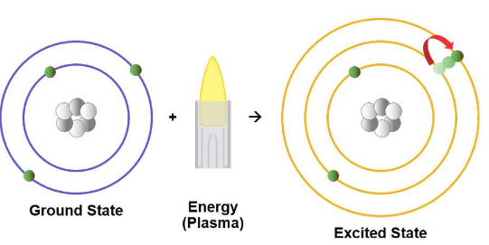
Figure 21 Excitation of an atom by a plasma (Thermo Fisher Scientific 2022)

Particle size distribution
The particle size distribution (PSD) of a material can be of critical importance to the performance of the material in its use. A PSD indicates the percentages of particles of certain size fractions of a granular material. It is determined by allowing a representative sample of the material to pass through a series of sieves (typically woven wire or punched plate for larger particle sizes) of decreasing opening size (see figure 22). The sieves are placed on a mechanical shaker which shakes them for a set period to allow the material to fall through the sieve openings. PSD results are reported as the weight percent retained on each sieve as well as the cumulative weight percent less than the sieve size.
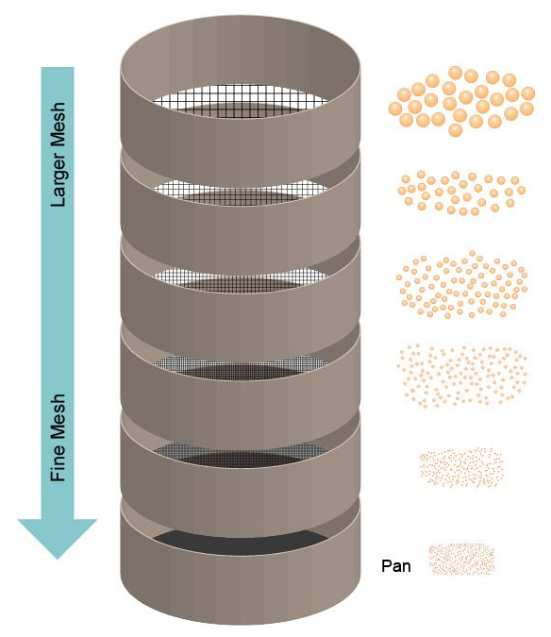
Figure 22 Particle size distribution by sieves (Particle Technology Labs 2022)

Assessing biochar substitution in pulverised coal injection (PCI)

Drop tube furnace.
A drop tube furnace (DTF) is designed to study the high temperature combustion and devolatilasation of materials such as pulverised coal. The DTF is designed to achieve rapid particle heating rates (up to 1450⁰C) using different gas compositions (inert or oxidising) and residence times ranging from 30ms to 700ms. The DTF can replicate conditions similar to those found in the BF raceway.
The DTF (shown in figure 23) consists of a vertically mounted alumina work tube which is heated by four main and two trim silicon carbide heating elements. The temperature is monitored by three thermocouples spaced evenly along the length of the tube. The gas has a laminar flow, such that particles delivered into the DTF drop at a constant velocity, enabling accurate residence times. Samples are fed through a water-cooled stainless-steel tube at the top of the DTF. A water-cooled stainless steel collection probe is positioned within the lower half of the work tube. The residence time is varied by adjusting the length of the probe inside the tube.
The biochar samples were dried to a constant mass and then crushed in a hammermill. 15g of each sample, sieved to 100% < 1mm and 50% < 200μm, were fed via a vibrating hopper at a rate of 15g/hour into the DTF, this sample particle size is representative of the coal that would be injected into the BF after being crushed and processed through the PCI plant at Port Talbot. The sample travels through the work tube in the main gas stream and the residue is collected in a cyclone trap. The residence time of the samples can be controlled by adjusting the length of the collection probe. Coals injected into the furnace have residency times of approx. 35ms, therefore the biochar samples were tested at this residency time to assess burnout characteristics, as the DTF has a lower temperature, a longer residency time of 700ms was also assessed.
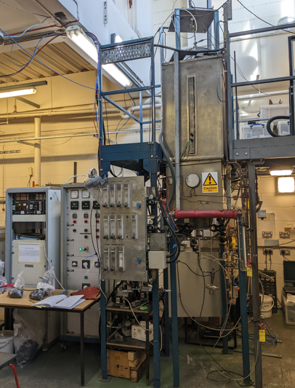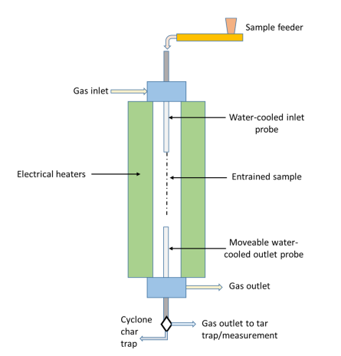
Figure 23 A picture and schematic (Steer et al. 2021) of the drop tube furnace.

The ash tracer method was used to calculate the burnout of the coals, also referred to as the combustion efficiency. The burnout (%) is calculated using the initial weight of the ash (A₀) and its final weight (A₁) after leaving the DTF.
$$Burnout \%= \frac{{10}^{4}(A_{1}-A_{0})}{A_{1}(100- A_{0})}$$
(Steer et al. 2021)
The biochar samples will be compared with a coal often used at Port Talbot for PCI called T-coal.

Assessing biochar substitution in coke making

Pilot scale coke oven
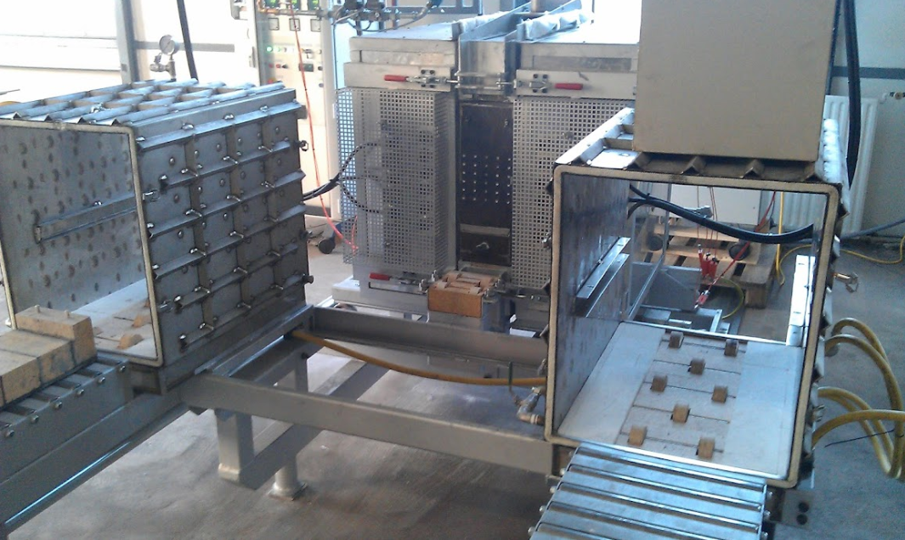
Figure 24 The Pilot scale coke oven at Tatasteel
Pilot scale coke ovens (PSCO’s) are widely used to produce coke samples for characterisation and to assess the coking behaviour of coal blend. This allows the business to optimise the value in use of the coals available to them. The purpose of pilot scale testing is to determine the suitability of the produced coke for use in the blast furnace and to assess the pressure generated at the oven walls during coking. The 25Kg PSCO at Tata steel is pictured above in figure 24.
The oven uses a silicon carbide plate in the refractory walls to heat the oven. The electrical heating elements are situated inside the refractory wall and behind the silicon carbide plate. The walls of the oven can both move horizontally. A refractory C-section sits in the middle. An illustration of the PSCO is shown in figure 25. The 25 Kg packed coal bed is charged into the furnace in a rectangular cardboard box which sits inside a refractory cassette. The cassette is charged through the front of the furnace via movable cooling jackets. The walls are then closed, a stainless-steel gasket keeps the oven sealed. The furnace is charged at 900⁰C and left for 3 hours to allow the furnace to stabilise, the temperature is then ramped up to 1000⁰C and held at temperature for 5 hours before ramping back down. The ramp ensures full carbonisation of the coke by driving off any excess volatiles. All exhaust gases are vented into a local exhaust ventilation system. The charge stays in the furnace for 18 hours, once the coal is fully coked, the cassette is placed into a water-cooled jacket and left to cool.
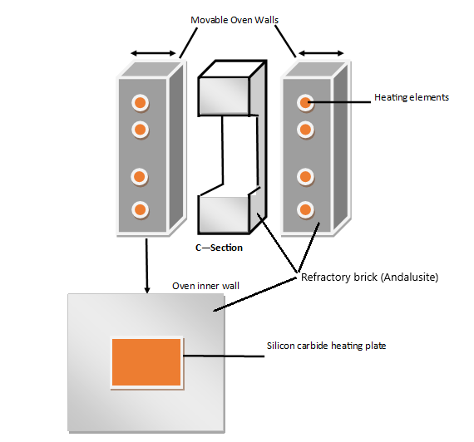
Figure 25 An illustration of the 25Kg pilot scale coke oven at Port Talbot, made by the author.
The biochar will be assessed against a coal used at Port Talbot steelworks called Riverside. Riverside is a high-quality Australian coking coal. Each biochar will be blended with Riverside in increments of 3%, 5% and 7.5% addition.
Riverside coal was sampled from a stockpile, 50 shovel loads of material were collected from around the stockpile at evenly spaced points (5 meters). The heights of the sample points were varied to avoid material size bias. Auto sampling is preferred by the ISO standard however there are no coal autosamplers or belt sampling points onsite. Manual sampling is permitted, however.
To mimic the coal charged into the Morfa coke ovens at Port Talbot, the Riverside coal and the biochar samples will be passed through a hammer mill, set to crush the materials to 80% > 3.175mm and 40% > 0.5mm and the bulk density will be 750 Kg/m³ dry.
The Riverside coal and Biochar blends were tested in duplicate 2x 25Kg charges, to calculate the biochar additions the total blend weight the following calculation was applied.
$$Biochar addition=Tw*(\frac{B\%}{100})$$
Where: Tw is the total weight of the duplicate charge = 50Kg
B% is the biochar addition in Kg.
An example would be for a biochar addition of $x= 50*(\frac{3}{100})$ which equals 1.5Kg of Biochar. The blend would consist of 48.5 Kg of Riverside coal and 1.5 Kg of biochar.
The moisture of the charges will be set at 9.5%, this is to reduce variation across tests. Adding water to the coal to increase moisture content is a lot less labour intensive than drying the coal to reduce moisture content. The figure 9.5% was chosen as the majority of coal sampled is less than 9.5%. In all cases for this project the moisture was measured >9.5 %, meaning water needed to be added to the charge. The calculation used to assess the required water addition was:
$$Wa=\left(\frac{9.5-M\%}{100}\right)*Tw$$
Where: Wa is the water addition required in Litres
M5 is the measured moisture percentage.
Tw is the total charge weight in Kg
An example would be for a charge measuring 8.4% moisture = $Wa=\left(\frac{9.5-8.4}{100}\right)*50 Kg$ which equals 0.55 L of water addition to the charge.
The riverside coal is weighed out and charged into a cement mixer, the biochar is then weighed out and added, while the materials are mixing the water is sprayed onto the material in the cement mixer.
A cardboard box placed inside the refractory cassette to contain the coal. Lines are drawn inside the cardboard box using a template, see figure 26. A known mass of coal is then compacted into the known volume of space inside the box which results in the required coal density (figure 27).
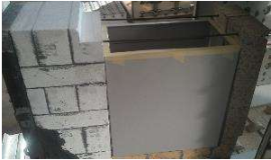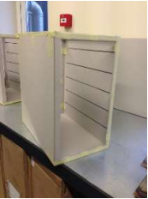
Figure 26 Preparing the coal charge
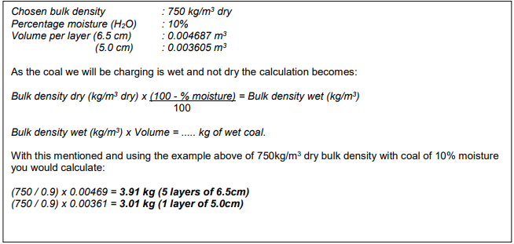
Figure 27 The coal density calculation
The cassette is then charged into the PO and left for 18 hours. After which the cassette is discharged into a steel water-cooled jacket and left to cool.
The coke produced in the PSCO was then assessed for its quality using the tests described below.

1/5th Micum – Mechanical Strength
During its transportation from the coke ovens to the BF, the coke will be handled several times, through conveyors, stockpiles and bunkers before finally being charged through the top of the BF. This handling will result in some degradation due to abrasion and shock. The resistance to this degradation is measured using a test called the micum test.
The coke sample is screened, and a composite sample is made up of the representative size distribution of coke +40 mm. This composite sample is then subjected to 100 revolutions inside a drum at 25 rpm, containing paddle lifters, as shown in figure 28. The coke is essentially subjected to a 100 m drop. The coke is then rescreened and the percentage of coke left over 40 mm is called the M₄₀ fracture index and the percentage of coke under 10 mm is called the M₁₀ abrasion index (Geerdes et al. 2009).
As the coke produced in a PSCO weighs only ~15Kg the ISO 556-2020 standard does not apply, the standard states a full micum sample weight of 50 Kg or a half micum weight of 25Kg. For the purposes of the PSCO, a 1/5 micum has been adapted from the standard. For this test, the sample weight is ratioed at 10Kg and the drum width is 1m x 1m to 1m x 0.2m. All other specifications remain the same in both tests.
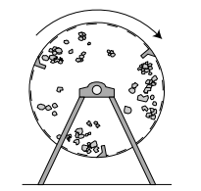
Figure 28 The motion of coke in a micum test (Geerdes et al. 2009).
The M₁₀ is calculated as follows:
$$M_{10}=\frac{\left(m_{1}+m_{2}\right)}{m_{3}}x100$$
Where: m₁= is the mass of coke (-10mm) after 100 drum rotations
m₂= is the mass of material lost during determination
m₃= is the mass of the test portion
The M₄₀ is calculated as follows:
$$M_{40}= \frac{m_{4}}{m_{3}} x 100$$
Where: m₃= is the mass of the test portion
m₄= Is the cumulative mass of coke (=/> 40mm) after 100 drum rotations
(ISO 556 - 2020)

Coke strength after reaction and Coke reactivity index (CSR/CRI)
The CSR/CRI test replicates some of the conditions metallurgical coke is exposed to in a blast furnace. A high CSR is believed to indicate that the coke will resist breaking down, improve the permeability of gas and liquid iron, increase productivity and reduce coke consumption in the BF (Li et al. 2014). A good quality coke should have a low CRI and high CSR. The CRI measures the solution loss reaction of coke by CO₂ at 1100⁰C for 2 hours under standardised gas flow rate conditions. For the CSR, the coke is tumbled post reaction and re-screened to calculate the strength index, see figure 29 (Dı́ez et al. 2002).
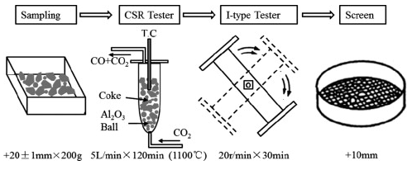
Figure 29 Diagram of the CSR/CRI test
The CRI is given by the formula.
$$CRI=100× \frac{m₀-m₁}{m₀}$$
Where: m₀ is the mass (g) of the sample before reaction
m₁ is the mass (g) of the sample after reaction.
The CSR is given by the formula.
$$CSR=100×\frac{m₂}{m₁}$$
Where: m₁ is the mass (g) of the sample after reaction
m₂ is the mass (g) of the fraction of the sample >9,5 mm after tumbling.
(BS ISO 18894: 2018)

Assessing biochar substitution in sinter making

Sinter pot
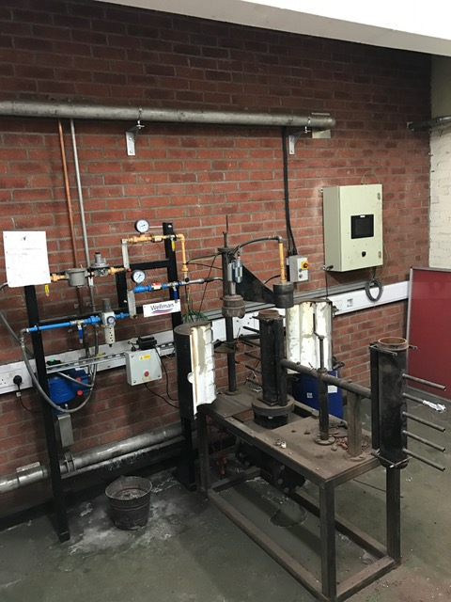
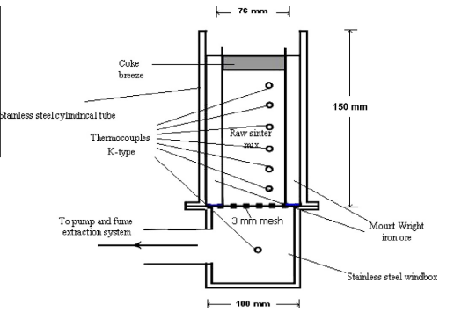
Figure 30 A photograph (author) and a schematic diagram of the sinter pot (Zandi et al. 2010)
The sinter pot is a laboratory scale sintering furnace. It is capable of producing iron ore sinter in 10kg batches. The furnace is filled iron ores, coke breeze and limestone. The top is ignited, and air is then drawn through the bottom of the furnace, drawing the flame front downwards. This allows combustion to occur throughout the mixture, finishing the agglomeration process. The sinter pot is connected to a computer system, where the process parameters can be monitored via flowmeters, thermocouples, and pressure gauges. The sinter pot and computer system are connected to a butterfly valve where the user can adjust the pressure drop accordingly. Overall, the sinter pot essentially mimics the process conditions of the sinter plant at a laboratory scale in order to investigate and optimize the process (Mousa et al. 2015). The sinter pot is demonstrated in figure 30.
The Biochar will be assessed against a base sinter blend, made up of a blend of iron ores fluxes and fuel, similar to that used at the Port Talbot steelworks sinter plant. A blend model excel sheet was used to calculate a base blend with the required chemistry to give a strong sinter with high quality characteristics, see table 2. The base blend can then be used to assess the impact of biochar addition on sinter quality.

Table 2 Sinter blend components
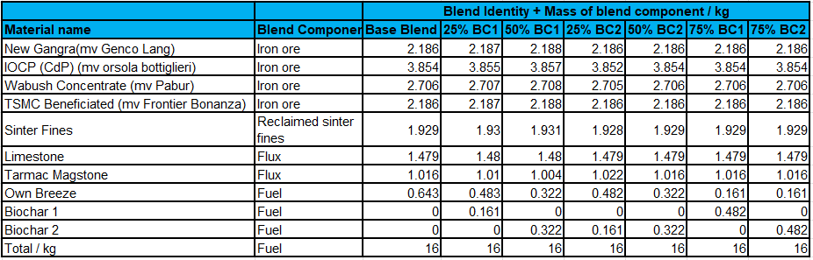
The calculated fuel percentage in this blend was 5% coke breeze. The coke breeze will be replaced by biochar in increments of 25%, 50% and 75%. The resulting sinter will be assessed using the quality measures discussed below. The emissions during these tests will also be monitored for their GHG concentration.
The iron ore samples are collected during discharge of the vessel, the ore is loaded onto a conveyor belt and transported to the stockyard. An iron ore stacker discharges the iron ore from the conveyor belt into large stockpiles. Every 5000 Kt the stacker, diverts the material away from the main stockpile and creates a small pile for sampling. The practice of sampling from the main stockpile has been discontinued at Port Talbot for safety reasons, large stockpiles of iron ore fines have been known to slip, rainfall can cause the fines to liquefy, large amounts of the ore can slip away from the stockpile. The ISO recommended sampling method is to use an autosampler, which is not available at Port Talbot, the next best recommendation is to stop the conveyor belt and take cuts from across the belt. This practice has also been stopped as it caused operational issues when discharging iron ore, the weight of the ore on the belt can strain the conveyor belt when it has been stopped, discharging of the vessel is slowed down which incurs a cost, and discharge chutes can become blocked. The small sample stockpiles method was developed at Port Talbot laboratories to try obtain as representative sample as possible given the constraints put in place. 50 increments are taken from around the small pile and bagged up to create 25Kg samples for every 5000Kt. These samples are mixed and spilt down into more manageable sample sizes. A composite was then created to obtain a representative sample of the vessel cargo. As it is not to ISO standard some bias may exist in this sampling method. The fluxes and coke breeze were sampled from conveyor belts as they discharge into the process. They are sampled using ISO standard methods.
The materials were then dried in an oven at 105⁰C until constant mass was achieved. The ores were screened through a 5mm sieve, any oversize was discarded. This was done to mimic plant conditions, a uniform particle size ensures air flow uniformity (Cheng et al. 2016). Fuels are sieved to <3mm.
The Materials were weighed out according to the weights shown in table 2. The blend was thoroughly mixed together in a cement mixer before being charged into a granulation drum and mixed with 6.5% water to form micro pellets, granulation helps create a porous and permeable mixture and the moisture helps the particles adhere to one another. Next the furnace is filled with a layer of sinter 10-15mm called the hearth layer, this layer ensures good permeability and protects the base from thermal attack. The granulated raw mix is now added to the furnace and thermocouples fixed into place.
A flowmeter is fixed above the furnace, air is drawn through the furnace to measure the raw mixture permeability. To ignite the mixture a burner is placed above the furnace and left for 1 minute, the flow meter is returned to the top of the furnace and the furnace is left to sinter.

Determination of low-temperature reduction disintegration indices
Inside the BF, sinter material is degraded due to mechanical wear and reduction. The reduction wear mechanism results from the crystal structure change from hematite (Fe₂O₃) to magnetite (Fe₃O₄). This structural change occurs in the low temperature region of the furnace and therefore is known as low temperature degradation. This degradation is measured by the reduction disintegration index (RDI) (Jiao et al. 2021). Figure 31 illustrates the RDI equipment requirements.
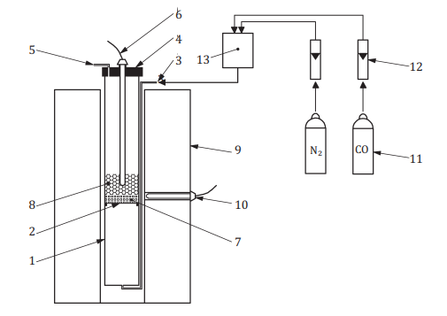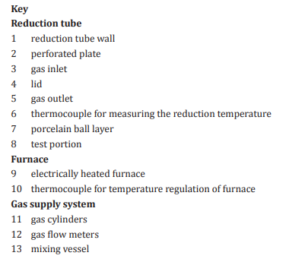
Figure 31 RDI test equipment apparatus (British Standards Institute 2015b)
The test portion (500g of sinter 16 mm - 20 mm) is reduced by heated to 550⁰C and a reducing gas consisting of a 70/30 % mix of N₂ and CO is passed through the sample for 30 minutes. The reduced sample portion is then tumbled in a small drum for 900 revolutions before being sieved through a 2.8mm sieve. The RDI is calculated as the mass percentage of material less than 2.8mm.
$${RDI}_{-2.8mm} = 100- \frac{m_{1}}{m_{0}}* 100$$
Where: m₀ is the mass (g) of the test portion after reduction and before tumbling.
m₁ is the mass (g) retained on the 2,8 mm sieve.
(BS ISO 4696-2: 2015)
The sinter pot produces approx. 10 Kg of sinter and each biochar addition was carried out in duplicate. A PSD was carried out on the sinter and the material between 16mm – 20 mm kept from one of the tests for RDI testing the other was used for the tumble and abrasion testing. The weight of this material would not be enough to meet the ISO std of 500g and so the RDI test was carried out using whatever material was left of the required size fraction.

Tumble and Abrasion indices
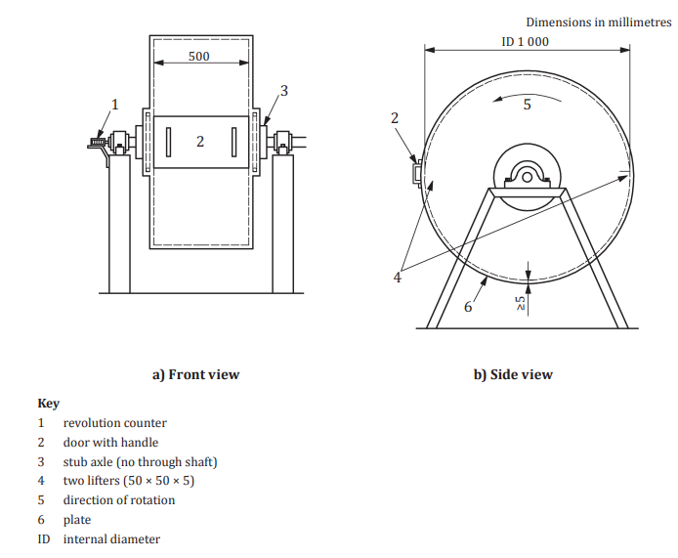
Figure 32 The drum specifications for the tumble and abrasion test (British Standards Institute 2015a)
It is very important for the BF to reduce the quantity of fines within it as much as possible. Fines produced during charging of the burden can accumulate at the point of impact on the burden surface. A high concentration of fines will impede gas flow and result in operational instability. Cold strength is characterised by the tumbler test (Geerdes et al. 2009).
The sinter sample is sieved through 25mm, 16mm and 10mm sieves, normally a 15Kg sample is made up from proportionate amount of material from each of these size fractions. As the sinter pot only produces a 10 Kg sample, a modified version of this test will be carried out using 5Kg of the sinter pot produced sinter, sieved to 10mm, 16mm, 25mm.
The ISO std states that the sample should be tumbled in a drum for 200 revolutions at 25 rpm and then sieved again over 6.3mm and 500μm sieves. Due to the smaller sample size only 50 revolutions were carried out. The drum requirements are displayed in figure 32.
The tumble index (TI) is calculated by:
$$Ti= \frac{m_{1}}{m_{0}}*100$$
The abrasion index (AI) is calculated by:
$$Ai= \frac{m_{0-( m_{1}* m_{2})}}{m_{0}}*100$$
Where: m₀ is the mass (Kg) of the test portion placed in the tumble drum.
m₁ is the mass (Kg) of the tumbled test portion (+6.3mm);
m₂ is the mass (Kg) of the tumbled test portion (-6.3mm - 500 μm).
(ISO 556-2020)

Quality Control
All the analysis in the report was carried out at the Port Talbot steelworks laboratories apart from the CV, ultimate and drop tube testing, as the laboratories lacked the facilities to provide this analysis. For CV and ultimate analysis, the samples were sent to Socotec laboratories which has United Kingdom accredited services (UKAS) accreditation (Solid Biofuels. [no date]). The drop tube tests were carried out by the author at Cardiff university engineering department under the supervision of Dr J. Steer.
In line with the laboratory standard ISO 17025, all the equipment used in these tests such as drying ovens, furnaces, thermocouples, XRF’s and ICP’s are calibrated, serviced, and certified annually by independent and accredited companies. Quality checks are also carried out and recorded daily. Equipment such as the XRF and ICP require that certified reference materials (CRM’s) are run and meet control limits before any analysis can be carried out. The CSR/CRI & RDI equipment has a weekly standard made up of internally validated bulk coke material.
All analysis has been carried out in duplicate and meets the repeatability control limits set out in the relevant ISO standard.

Results

Biochar substitution for pulverised coal injection
PCI is a well establish technique used to reduce coke consumption in the BF. Pulverised coal is pneumatically injected into the BF tuyeres through a lance. The tuyeres a direct hot blast of air into the BF forming a balloon like void called the raceway. PCI can replace up to 50% of the required coke, many furnaces achieve PCI rates of 200 kg/t hot metal. Variations in the process, such as temperature and pressure can cause issues such as localised hot/cold spots which can cause damage to the lining of the furnace or result in over consumption of raw materials. BF process stability is very important to ensure consistent iron production and to prolong the life of the furnace (Steer et al. 2021).
(Liu and Shen 2021) advise that when assessing biochar as a BF fuel, there are several criteria you should consider, namely:
- Calorific value (CV)
- Chemical composition
- Combustion characteristics
- Carbon gasification reactivity
- Grinding characteristics and fluidisation properties
- Softening and melting characteristics of the ash
Of these six characteristics the first three have been tested on two biochar samples and a PCI coal, for this report. The facilities for testing the others were not available for this report.

Properties of charcoal and PCI coal

Replacement ratio
The Ultimate analysis and proximate analysis results for the PCI coal and two biochar’s can be found below in table 3.
Table 3 The properties of pulverised coal and biochar (Proximate in blue and Ultimate analysis in grey).
(%) db. | T - Coal | Biochar 1 | Biochar 2
C | 83.2 | 90.2 | 83
H | 3.2 | 1.83 | 2.02
N | 1.84 | 0.09 | 0.47
S | 0.34 | <0.02 | 0.005
O | 2 | 6.02 | 7.33
Vm | 12.3 | 6.7 | 15.6
Ash | 9.4 | 1.89 | 6

According to (Geerdes et al. 2009) the most important property of a fuel injected into the BF is the replacement ratio (RR) of coke. The coke RR is defined as the mass, in kilograms, of coke replaced per kilogram of coal. The composition and moisture content of the fuel determines the amount of coke that can be replaced by the fuel. To determine the RR, the carbon percentage, hydrogen percentage, ash content, moisture content and the heat required to crack the coal chemical structure have to be considered. The formular for the RR (for coke with 87.5% carbon) is:
$$RR ≈ 2xC\% + 2.5xH\% -2xH2Oinj - 86 + 0.9xash\%$$
The moisture figure used was 1.5% as this is the moisture that PCI coals are dried to for injection at Port Talbot steelwork.
Table 4 The replacement ratios for T-coal and two biochar’s are compared.
% | T - Coal | Biochar 1 | Biochar 2
RR | 93.86 | 97.676 | 87.45

The aim is for a high RR without affecting furnace productivity and hot metal quality. The RR aim of PCI coals should be 85% (Geerdes et al. 2009). The RR is correlated with the calorific value and volatile matter of the fuel. RR increases with CV value. The CV values of T-coal and the biochar can be seen in table 5. Typical RR values for PCI coals range from 70% for high VM coals to 99% for low VM coal such as anthracite (Carpenter 2010). The carbon content is also correlated with the CV value, high values for both are desirable.
Table 5 The Calorific values of potential PCI fuels
MJ/Kg | T - Coal | Biochar 1 | Biochar 2
CV (Gross) | 31.06 | 33.26 | 28.07
CV (Net) | 30.89 | 32.80 | 27.54

T-coal is used in PCI at Port Talbot BFs on its own and in a blend, its RR is 93.86 T-coal has a reasonably high carbon content and CV.
Biochar 2 has lower carbon, hydrogen, and ash that the T-coal and so the RR is lower, however it is still above the aim.
Biochar 1 has a high RR, carbon content and CV. It could replace more coke and it would provide more energy into the furnace if used. Biochar with similar properties could outperform PCI coals using these measures.

Volatile Matter
During coal pyrolysis combustible gases are released, such as H₂, CH₄ and CO, incombustible gases (steam and CO₂) and tar. The high volume of gas generated when coal is injected into the raceway, this can increase the depth of the raceway and increase blast momentum. The volatile content of the coal can affect the formation of char and coke fines in the raceway. Low volatile coals have higher RR values and therefore lower coke rates and they have less of a cooling effect on the furnace. They produce less off gas with a lower CV, less H₂ (for Iron ore reduction). They have a higher RAFT and lower combustion efficiency than high volatile coals. High volatile coals produce more reactive chars, they also have a higher combustion performance and a lower ignition temperature. They also contribute more hydrogen. The higher gas volume can lead to back pressure issues at the tuyere. BF operators often use mid volatile coals as a solution or a blend of low and high coals (Carpenter 2010).
Low volatile coals - <14%, medium volatile coals – 14% – 31%, high volatile coals >31%.
T-coal and biochar 2 would be considered low volatile while biochar 1 is has a very low volatile, comparable with anthracite.

Chemical Composition

Ash content
The coal components can influence BF operation and the quality of the iron. An ash content of < 10% is preferred. Low ash results in lower slag volumes and therefore less flux requirements. High levels of ash can block the PCI lances. There needs to be a limit of undesirable constituents as they can negatively influence BF performance (Carpenter 2010).
The most significant elements affecting BF process defined by (Suopajärvi et al. 2018) are:
Zinc (Zn) – Attacks the BF lining and negatively impacts coke CSR/CRI.
Potassium (K) & sodium (Na) – Alkalis metals reduce coke and iron ore pellet strength and can promote scaffold formation.
Phosphorus (P) – Phos content in iron hot metal should be kept to a minimum as it undesirable in steelmaking.
Sulphur (S) – Sulphur is detrimental to steel properties. Removal from the hot metal is an expensive process.
Table 6 The chemical compositions of T-coal and biochar ash
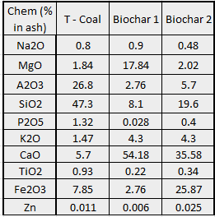
At 1.89% biochar 1 has a low ash content which would be beneficial for PCI use. Biochar 2 has an ash content well within 10% and is lower than the T-coal, both the biochar’s are significantly lower in sulphur content (table 3) when compared with the T-coal.
The T-coal has a high SiO₂ and Al₂O₃ content, this would indicate an acidic character of the coal ash. The biochar 1 & 2 both have a high CaO level which would indicate a basic ash character. Using biochar would mean less lime would be needed to adjust the basicity in the BF which in turn would reduce the slag generation rate (Wang et al. 2015b).
Table 7 shows the chemical composition by weight. The sodium and phosphorus levels are lower in the biochar. There is higher potassium content in the biochar 2 ash but not overly so and this amount would not be a concern. There is also less sulphur in the biochar than in the coal.
The chemical analysis of the biochar demonstrates that there would be no significant increase in harmful elements introduced into the BF as a result of using these two biochar as a fuel injectant.
Table 7 - T-coal and biochar chemical composition by weight %
Chem (wt. %) | T - Coal | Biochar 1 | Biochar 2
Na2O | 0.08 | 0.02 | 0.03
MgO | 0.17 | 0.34 | 0.12
A2O3 | 2.52 | 0.05 | 0.34
SiO2 | 4.45 | 0.15 | 1.18
P2O5 | 0.12 | 0.001 | 0.02
K2O | 0.14 | 0.08 | 0.26
CaO | 0.54 | 1.02 | 2.37
TiO2 | 0.09 | 0.00 | 0.02
Fe2O3 | 0.74 | 0.20 | 1.55
Zn | 0.0010 | 0.0001 | 0.0015

Combustibility
To ensure efficient BF operation it is crucial that all the PCI is gasified as soon as possible. The residence time of the coal particles in the raceway is only approx. 20 – 30 ms, this short residence time can mean that the pulverised coal is not completely combusted in the raceway and a considerable amount of char (unburnt coal) can escape from the raceway region into the active coke zone as shown in figure 33. This fine char can block coke bed voidage and consequently result in reduced gas flow, a drop in BF pressure, reduced permeability, and decreased furnace productivity (Ahmed 2018).
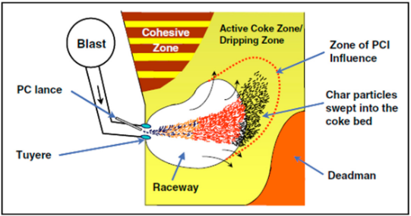
Figure 33 The lower zone of the BF (Ahmed 2018).
The DTF can be used to characterise burnout behaviour of fuel injected into the BF as the environment in the DTF closely resembles the BF raceway (Steer et al. 2015). The burnout or combustion efficiency for the biochar samples and T-coal are:
Table 8 The burnout efficiency of T-coal and the biochar
Burnout (%) | T - Coal | Biochar 1 | Biochar 2
35ms | 13.3 | 46.09 | 71.97
700ms | 58.7 | 86.01 | 91.47

Figure 34 Graph showing the burnout efficiency of T-coal and biochar
It can be seen from table 8 and figure 34 that the burnout efficiency of the biochar is higher than that of the T-coal. This would mean less char would escape the raceway into the active coke zone and benefit BF productivity. (Babich et al. 2010; Ng et al. 2011) propose that this may be due to the higher specific surface areas of charcoals compared with PCI coals.
However, it is inevitable that when using PCI, that some char will escape from the raceway into the coke active zone, because of the short residence time and high injection rates.
The char reactions in the raceway are A) devolatisation and B) char combustion which can be written as:
- Biochar→^{Rr}VM+Char
- Char+O2→^{Rr}CO+CO2
- Char+CO2→2CO
The char in the active zone is reactive, more so for biochar, see the reverse Boudouard reaction (solution loss reaction) C) shown above. The BF contains a large amount of C0₂, which reacts with the coke in the furnace, reducing its strength, which can weaken the coke scaffold function. Under high PCI injection rates, any unburnt carbon powder (char) with high reactivity will react with the CO₂ in preference with coke, this sacrificial reaction can protect the coke leaving it strong, which is beneficial for the operation of the furnace (Ning et al. 2022). However (Steer et al. 2021) states that the reverse Boudouard reaction is endothermic, meaning that the reaction between coke and reactive chars could have a cooling effect on the BF, reducing its thermal reserve temperature. Localised char retention could result in BF instability.
Table 9 T-coal and biochar reactivity
Reactivity | T - Coal | Biochar 1 | Biochar 2
Ti ⁰C | 492 | 368 | 380
Tm 0^{C}(Er/Kj/mol) | 636 | 515 | 512
Tb ⁰C | 816 | 537 | 581

Ti – Ignition temperature, Tm – temperature of the maximum weight loss rate, Tb – burnout temperature
Table 9 contains the TGA analysis, blast furnace heating rates are in the order of 10⁴ – 10⁵ ⁰C/s, the heating rates of a TGA (10 ⁰C/min) are considerably lower, with small sample masses ~20mg. However the technique is fast and reliable (Steer et al. 2015).
These results show that the biochar’s ignite at lower temperatures, reach maximum rate of combustion at lower temperatures and burnout at lower temperatures when compared with the T-coal.
When considering chemistry, combustibility and burnout then the biochar samples have the potential to at least partially replace coal in PCI, plant trials would be required to see how much of it could be substituted in. A trial at 10% to begin with is recommended, while gradually increasing increments until an optimum level of biochar addition is settled upon.

Biochar substitution into coke making.
Metallurgical coke plays are role in the BF that no other known material can replicate, that being a permeable support of the BF burden. The BF environment is harsh, and the coke is subjected to long periods under mechanical, thermal, and chemical stress. The performance of the coke inside the furnace is correlated with the BF operational stability. As such the quality of the coke is critical. Metallurgical coke should have high mechanical strength, high CSR, and low CRI. Impurities such as VM, ash, sulphur and phosphorus and alkali metal content need to be kept as low as possible. (Dı́ez et al. 2002).

Chemical properties of coking coal and biochar

Table 10 Chemical properties of coking coal and biochar
(%) dry basis | Riverside | Biochar 1 | Biochar 2
C | 80.5 | 90.2 | 83
H | 4.48 | 1.83 | 2.02
N | 1.75 | 0.09 | 0.47
S | 0.54 | <0.02 | 0.005
O | 2.73 | 6.02 | 7.33
Vm | 21.6 | 6.7 | 15.6
Ash | 10 | 1.89 | 6

The general coking coal parameters for BF addition aim for ash levels less than 10 wt% db with Sulphur concentration less than 0.7 wt% db. Both the biochar has significantly lower sulphur levels and meet the specification for ash level see table 10. Both Biochar’s have high carbon levels which are similar to that of coal.

Table 11 The ash composition of Riverside and biochar
Chem as (% in ash) | Riverside | Biochar 1 | Biochar 2
Na₂O | 0.4 | 0.9 | 0.48
MgO | 0.47 | 17.84 | 2.02
A₂O₃ | 28.5 | 2.76 | 5.7
SiO₂ | 62.6 | 8.1 | 19.6
P₂O₅ | 0.2 | 0.028 | 0.4
K₂O | 0.96 | 4.3 | 4.3
CaO | 0.41 | 54.18 | 39.58
TiO₂ | 1.63 | 0.22 | 0.34
Fe₂O₃ | 3.88 | 10.76 | 25.87
Zn | 0.016 | 0.006 | 0.025

The composition of the ash in the coke blend is of major importance, the coking coals have high levels of Silica and Alumina, which is typical. The Biochar’s have high levels of calcium oxide, and elevated levels of potassium oxide, these oxides would be of a concern if carried over into the coke, as increased levels of these oxides in the BF would be problematic (MacPhee et al. 2009). The zinc oxide levels are low in the biochar, so would be of little concern.
(Montiano et al. 2014a) describes the alkalinity index (AI) as a ratio that can be used to predict CSR. It was found that the AI is linearly correlated with CSR with a correlation coefficient of r = 0.893.
$$AI=Ash. (\frac{{Fe}_{2}O^{3}+CaO+{Na}_{2}O+K_{2}O+MgO}{{Al}_{2}O+SiO_{2}})$$
The AI of coal blends with biochar addition increase in line with the biochar concentration. The CSR would be expected to decrease proportionally.

Coke Mechanical strength

Figure 35 Results from the coke cold strength tests
The M₄₀ is a measure of the cokes resistance to size degradation, the 100% coking coal Riverside had a M₄₀ result of 77.75% which is typical of a high-quality coking coal. After 3% addition of biochar 1 the result drops slightly to 76.2% and at 5% it rises marginally to 76.76%. There is only a small drop off in the M₄₀ up to 5% Biochar 1 addition. At 7.5% biochar 1 addition there is a significant drop off with a 72.6% result. At 3% Biochar 2 addition the M₄₀ raises a little to 78.18% but at 5% biochar 2 addition the M₄₀ drops to 73.1% and at 7.5% biochar 2 addition the M₄₀ falls significantly to 61.8%.
The M₁₀ is a measure of the coke fines created during transportation and handling of the coke on its way to the BF. Abrasion resistant coke is desired. The 100% Riverside coke had an M₁₀of 7%. The 3% and 5% addition of biochar 1 has little effect on the M₁₀ until the 7.5% biochar 1 addition when the M₁₀ rises to 8.34. The AI for Biochar 2 at 3% increases a little to 7.28% but then climbs to 8.64% at 5% before sharply escalating to 19.99% at 7.5% biochar 2 substitution.
It can be seen from the cold strength tests that there is a correlation between the M₄₀ and M₁₀ results, it seems they are inversely proportional as the M₄₀ decreases then the M₁₀ increases. This is intuitive as you would expect there to be more coke fines as the coke gets weaker.
Both biochar’s performed well at 3% substitution for cold strength quality, and biochar 1 only saw a slight M₄₀ drop at 5% substitution. Biochar 2 saw a 5% drop in cold strength quality at 5% substitution and a considerable drop off at 7.5% substitution.
It would be predicted that the cold strength test results would be linear, the 5% biochar 1 result and the 3% biochar 2 M₄₀ results did not conform to these estimations. This is likely due to variation such as preparation of the coal blend and testing of the coke. There could have been operator error. The repeatability of the test is 3%.
When considering cold strength, both biochar’s could be used at 3% substitution into the coal blend with minimal effect on cold coke strength quality, biochar 1 could be used up to 5% with little impact on cold strength quality.

Hot mechanical strength and reactivity

Figure 36 Coke strength and reactivity results
The CSR is considered the most important coke quality measurement when maintaining BF operational stability. The CSR and CRI are inversely proportional.
The CSR result for the 100% Riverside coal is 62.2% and the CRI was 29.1%. When Biochar 1 is added at 3% and 5%, the CSR result drops slightly each time to 60.5% and then 59.1%. At 7.5% the CSR falls sharply to 41.2%. The CSR remains consistent at 3% biochar 2 substitution but then decreases significantly to 39.1% and 41.2% at 5% and 7.5% respectively.
The coke gets more reactive as more biochar is added, at 100% the CRI is 29.1%. At 3% biochar 1 addition it is 30.2% and up to 32.5% at 5% addition. At 7% addition it increases to 39.9%. Biochar 2 has a CRI of 29.9% at 3% addition not far off the 100% Riverside result but then climbs at 5% addition to 39.8% before sharply rising to a high result of 19.99% at 7.5% addition.
The prediction for the CSR tests would be a fairy linear line decreasing as the biochar addition increases. The biochar 1 conforms to this prediction but in the biochar 2 tests, the 3% CSR result is marginally higher than the 100% Riverside test when you would expect a drop. Similarly, the 7.5% result is higher than the 5% result. There are many variables present during the preparation of the PO blend and the coke testing and these results are possibly a consequence of a variable such as operator error. Although the repeatability of the test is between 2.5 – 3.5 depending on the CSR result. The standard deviation of the test is high due to the number of variables inherent in the testing. Demonstrating that the CSR/CRI measure is not precise.
Both biochar’s could be used at 3% substitution when considering the quality measure CSR and CRI. Biochar 1 could be used at 5% despite there being a 3% drop in the CSR but this small drop could be managed by adjusting the coal blend with high quality coal to compensate.

Coke chemistry Analysis
Table 12 Riverside and Biochar coke analysis
db % | Riverside 100% | Biochar 1 3% | Biochar 2 3% | Biochar 1 5% | Biochar 2 5% | Biochar 1 7.5% | Biochar 2 7.5%
VM | 1.73 | 1.64 | 1.12 | 1.42 | 1.26 | 1.07 | 1.44
Ash | 13.4 | 13 | 13.4 | 13.6 | 14.6 | 13.3 | 14
SiO₂ | 55.73 | 56.65 | 55.22 | 54.38 | 54.09 | 53.51 | 50.23
Al₂O₃ | 28.14 | 23.22 | 27.35 | 22.37 | 25.46 | 21.38 | 21.22
TiO2 | 1.42 | 1.47 | 1.37 | 1.42 | 1.41 | 1.37 | 1.43
CaO | 0.99 | 1.45 | 1.75 | 1.82 | 2.74 | 2.26 | 3.11
MgO | 0.36 | 0.41 | 0.35 | 0.61 | 0.38 | 0.42 | 0.58
Fe₂O₃ | 4.55 | 5.34 | 4.73 | 6.01 | 10.05 | 9.56 | 10.58
P₂O₅ | 0.018 | 0.021 | 0.019 | 0.021 | 0.021 | 0.021 | 0.03
Na₂O | 0.453 | 0.477 | 0.453 | 0.446 | 0.383 | 0.427 | 0.409
K₂O | 0.726 | 0.793 | 0.853 | 0.848 | 0.856 | 0.892 | 1.175
Zn | 0.014 | 0.012 | 0.011 | 0.014 | 0.012 | 0.013 | 0.019
CU | 0.015 | 0.016 | 0.014 | 0.015 | 0.015 | 0.015 | 0.017

There is an increase in the alkali metal oxide, potassium, an increase in the alkaline metals, calcium and magnesium and higher levels of iron with increasing amount of biochar. All these metals contribute to a higher reactivity in the coke. The increase in reactive metal concentration can explain the behaviour of the coke in the CSR/CRI tests, as demonstrated in the previous section.
The amount of acidic metal oxides also decreases, there are lower amounts of SiO₂ and Al₂O₃ in the coke as the percentage of biochar increases. Added to the BF, coke containing biochar will reduce the acidity of the burden, thereby reducing the need for lime addition as mentioned earlier.

Photographs of the Biocoke produced in the Pilot oven
The following photographs were taken of coke produced in the pilot oven, crushed, and sieved to 19 mm – 22.4mm for the CSR/CRI test.
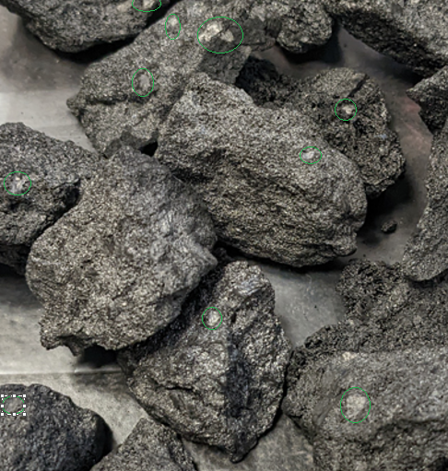
Figure 37 Reference coke - 100% Riverside coal
Metallurgical coke has a very complex structure with a variety of pore and wall sizes. The coke walls have diverse microscopic properties. Microscopically, coke consists of amorphous anisotropic (different strength properties in different directions) areas and crystalline isotropic (uniform in all directions) areas. Coke that contains high concentrations of anisotropic areas demonstrate high CSR and low CRI values, while coke with high concentrations of isotropic areas are mechanically weaker and generally more reactive with CO₂ which increases the CRI value. Although isotropic areas are also more resistant to alkali attack. The concentration of each type is dependent on the rank and types of coal used (Sarna 2013).
The photo in figure 38 of the reference coke made with 100% Riverside coal. This coke has a mostly amorphous anisotropic structure with some isotropic area dispersed throughout (circled in green). These isotropic inclusions are caused by inert materials in the coal.
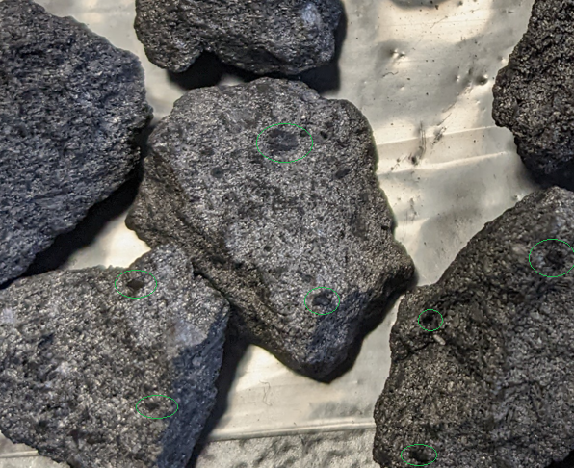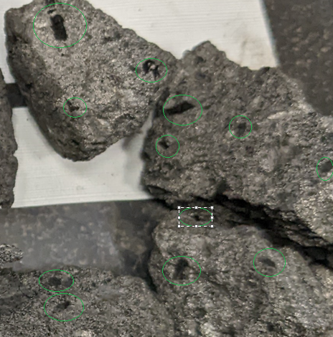
B
A
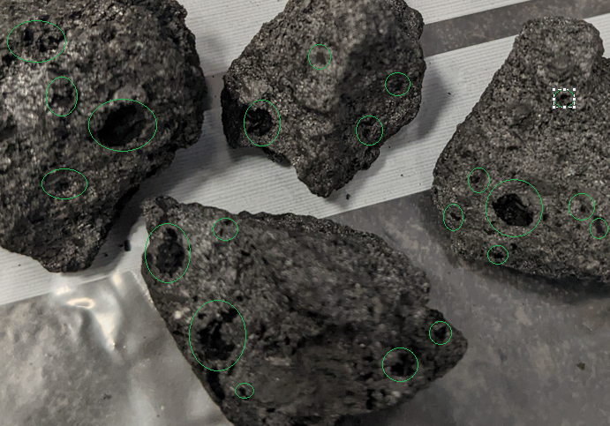
C
Figure 38 Pictures of the Biocoke. A – 3% biochar 1 substitution, B – 5% biochar 1 substitution, C – 7.5% biochar 1 substitution.
The pictures above in figure 39 are of the biocoke produced with biochar 1. The biochar can be seen as black inclusions (circled in green) dispersed throughout the samples. At 3% there are not many biochar inclusions, the size of inclusions in this sample are small and the majority of the coke seems unchanged. At 5% substitution the number of inclusions has increased for biochar 1, shown above as (B) in figure 39. A few bigger inclusions can be seen. The number of inclusions has increased notably in the coke made with 7.5% biochar (C) there are also more large inclusions in this sample.

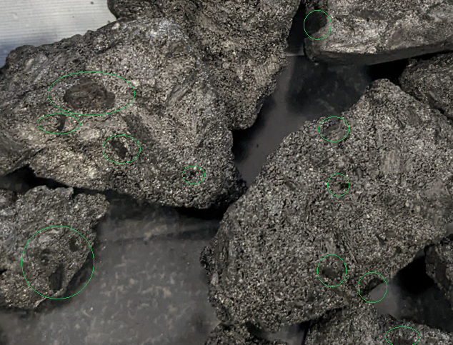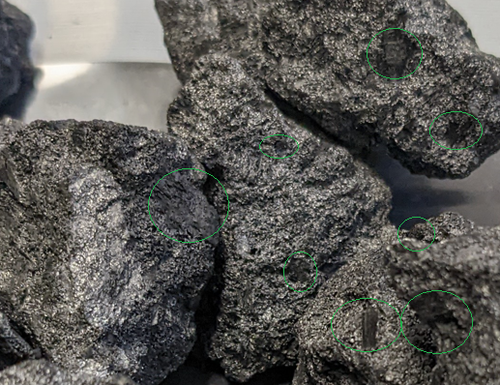
B
A
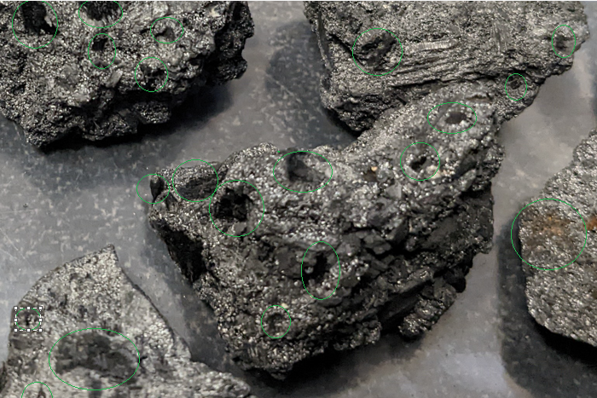
C
Figure 39 Pictures of the Biocoke. A – 3% biochar 2 substitution, B – 5% biochar 2 substitution, C – 7.5% biochar 2 substitution.
The biochar 2 at 3% substitution is shown above in figure 40, the biochar inclusions are moderately dispersed throughout the coke structure, the size of the inclusions in this sample are larger than the biochar 1 sample. The remaining coke seems to be unchanged.
The main factors affecting CSR are outlined in figure 40, all these variables are kept constant for the test carried out in this report other than the coal composition and therefore any variation from the original analysis can be attributed to the addition of the biochar.
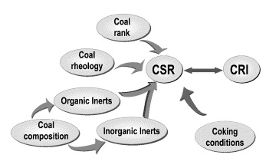
Figure 40 Factors affecting coke strength after reaction (Dı́ez et al. 2002)
(Guerrero et al. 2015) studied the influence of charcoal fines on the coking of coal and found that the presence of charcoal increased the softening temperature of the coal during its plastic phase and reduced its fluidity. Increased quantity of inert material in the coal forms inclusions within the coke, from which fissures can propagate, reducing mechanical strength. Coal dilation is also affected which may lead to voids in the coke acting as weak points.
(Diez et al. 2012) describe charcoal as a porous material with a much higher surface area than coal, during coke making the biochar absorbs the decomposition products from coal, increasing the softening temperature and inhibiting fluidity development. Resulting in a lower quality coke.
The results of the coke quality tests show that it would be possible to replace at least 3% of coal with biochar for coke making. Biochar 1 could be used at 5% with minimal impact upon coke quality. At 7.5% biochar substitution the quality of the coke decreases significantly.
The addition of biochar to coking coal increases its reactivity and decreases its hot and cold mechanical strength. When kept to 5% addition and below these effects are low enough to be tolerable and as previously mentioned a more reactive coke may increase the efficiency of the BF.
Further work could be carried out to research the effects of biochar PSD, feedstock, and pyrolysis conditions on coke quality.

Biochar substitution in Sinter making.
Sinter is the most commonly used BF burden material. The sinter plant agglomerates iron ore, iron rich revert materials and fluxes into a suitable feedstock for the BF. The process is a complex, energy intensive one and a considerable amount of CO2 is produced, up to 12 % of the steel plant. Coke breeze is the most conventional fuel used to provide the heat for the process, the coke breeze is screened from the coke that is to be used in the BF, however in many steel plants the total amount required for sintering falls short and needs to be outsourced or alternative fuels used total (Zandi et al. 2010).

Coke breeze and biochar chemical analysis
The comparison of coke breeze and biochar chemistry is shown below in table 13.
Table 13 Coke breeze and biochar analysis compared.
Parameter db% | Coke Breeze | Biochar 1 | Biochar 2
Fixed Carbon | 86.1 | 90.2 | 83
VM | 1.9 | 6.7 | 15.6
Ash | 12.3 | 1.89 | 6
Sulphur | 0.6 | <0.02 | 0.005
Fe2O3 | 9.61 | 10.76 | 25.87
SiO2 | 48.64 | 8.1 | 19.6
Al2O2 | 26.13 | 2.76 | 5.7
CaO | 3.51 | 54.18 | 39.58
MgO | 0.79 | 17.84 | 2.02
TiO2 | 1.34 | 0.22 | 0.34
Na2O3 | 0.35 | 0.9 | 0.48
K2O | 1.02 | 4.3 | 4.3
P | 0.042 | 0.028 | 0.4
S | 0.64 | <0.02 | 0.005

The biochar has a higher VM when compared to coke breeze. Sinter plants control particulate matter in exhaust gases by using electrostatic precipitators. The use of filter bags to clean the off gas is an essential method to achieve low dust emissions, high VM in the fuel can lead to operational safety issues, therefore care should be taken when using materials that increase the VM% of the sinter (Abreu et al. 2015).
The biochar’s also have significantly higher ash, which is has a more basic nature due to increased levels of CaO and MgO and decreased levels of SiO₂ and Al₂O₂.
The coke breeze and biochar 2 have similar fixed carbon and CV results (table 14), while biochar 1 has a higher fixed carbon and CV value. Meaning biochar 1 will provide more energy into the sinter reaction.
Table 14 Coke breeze and biochar calorific values
MJ/Kg | Coke breeze | Biochar 1 | Biochar 2
CV (Gross) | 28.15 | 33.26 | 28.07
CV (Net) | 27.64 | 32.80 | 27.54

Characteristics of Sintering with Biocoke
The quality of the sinter is related to the temperature conditions of the sintering bed (Cheng et al. 2016). The sintering characteristics that are evaluated are peak temperature, sintering time, flame front speed and hot and cold permeability, some of these can be derived from the time - temperature profiles (Biochar 1) shown in figure 41 below. Thermocouple 1 is located near the top of the sinter pot and they are evenly distributed through the pot to thermocouple 5 near the bottom, there are also 2 thermocouples measuring the off-gas temperature underneath the pot, the sintering time ending is concluded once the off gas temperature drops back down to the baseline.
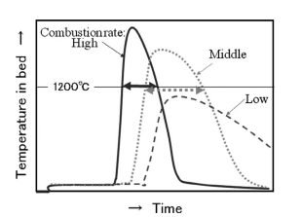
Figure 41 The effect on the temperature profile of combustion rate (Kawaguchi and Hara 2013).
Authors such as (Kawaguchi and Hara 2013; Gan et al. 2014; Cheng et al. 2016; Liu et al. 2020) found that biochar has a faster combustion rate than coke. As the combustion rate increases, heat generation is increased, and the maximum temperature is higher as shown in figure 41. A high combustion rate results in a reduction in the holding time at high temperature, a lower maximum temperature and lower combustion efficiency. When the combustion rate is too high there is a reduction in the sinter yield as the sinter does not have time to agglomerate. Conversely sinter productivity increases as a result.
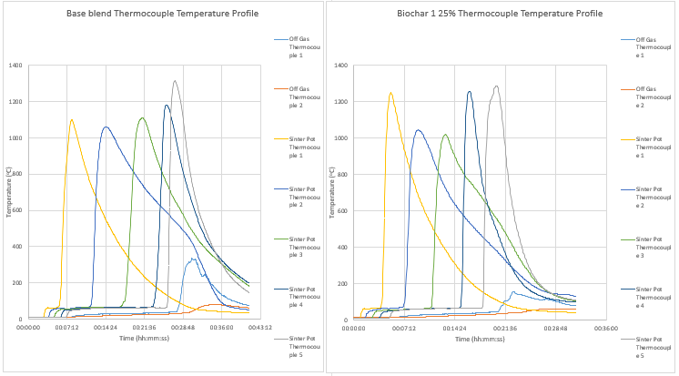
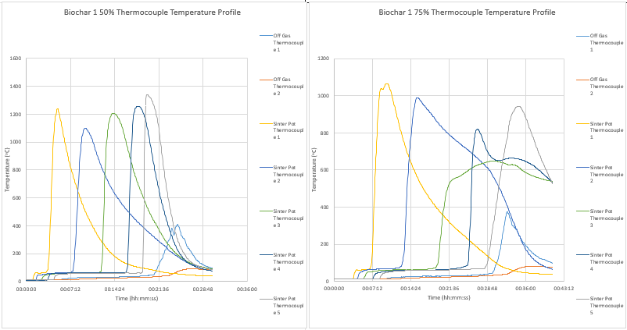
Figure 42 Time - temperature profiles of the biochar 1 sinter pot tests.
The temperature profiles of the biochar 1 results are shown above in figure 42. Each test has been carried out in duplicate and the most consistent graph has been demonstrated for each test. The material produced was then composited for the quality test.
The temperature profiles are reasonably consistent in the first three tests, they all have tall narrow curves which mostly peak consistently, there are some peaks which are lower (peaks 2 + 3 in the biochar 25% test), some of these could be explained by operator error when setting the thermocouples Some of the peaks are wider than others, these peaks have slower cooldown rates which is related to the permeability of the sinter. In the 75% biochar test there were some issues with channelling, when a hot spot forms along a narrow channel through the sinter pot. Channelling will be discussed later in the report. As a result, this graph has distorted profiles displaying middle to low combustion rates.
Table 15 Sintering process characteristics Biochar 1
 | Coke breeze 100% | Biochar 1 (25%) | Biochar 1 (50%) | Biochar 1 (75%)
Max Sintering Temperature (ºC) | 1313.05 | 1286.02 | 1342.16 | 1064.92
Average max sintering temp (ºC) | 1152.76 | 1170.97 | 1229.52 | 892.63
Average time above 1000⁰C (mm:s) | 02:25:00 | 01:43:00 | 02:31:00 | 00:29:00
Sintering Time (mm:ss) | 00:27:25 | 00:21:55 | 00:23:35 | 00:28:50
Flame Front Speed Average (mm/s) | 0.33 | 0.31 | 0.41 | 0.26
Fraction of sinter >5mm (%) | 51.19 | 42.79 | 53.29 | 38.64

(Lu et al. 2012) explains that sinter melt starts to form at ~1100⁰C the sinter continues to react with nucleus particles nearby until the reaction zone temperature falls below 1100⁰C at which point the sinter melt solidifies. The time at which the reaction zone is maintained above 1100⁰C is important, more time above this temperature leads to a better sinter structure.
The sinter pot software package at port talbot displays the time above 1000⁰C so this measure is used instead.
Table 15 contains the sintering characteristics for the biochar 1 tests. Although the base blend had the highest peak temperature at 1313.05⁰C, this only occurred at one thermocouple, the average peak temperature was 1152.76⁰C, the 25% biochar 1 blend had a slightly lower max temperature and slightly higher average. Biochar 1 (50%) had the highest peak temperature and highest average temperature. Biochar 1 (75%) had significantly lower results in both the maximum and average temperatures. The average time above 1000⁰C seems to be trending downwards as more biochar is added, however biochar 1 50% has the longest time above 1000⁰C and does not follow the trend.
The sintering time for biochar addition 25% and 50% are lower than the base blend but the 75% biochar addition took longer. The flame front speed (FFS) is calculated by dividing the bed height (mm) by the time taken for waste gas temperature to peak, indicating burn through. FFS is influenced by factors including bed permeability, permeability of the reaction zone and fuel combustion rate (Lovel et al. 2009). The FFS was 0.33 mm/s for the base blend and was lower for the 25% and 75% blends. Again the 50% blend had a higher result.
Sinter yield is calculated by measuring the sinter above 5mm after screening (Ooi et al. 2011). The sintering tests show a general decrease in yield as the amount of biochar decreases, with the 50% biochar an exception.
The literature predictions of decreased peak temperature, shorter time held at temperatures above 1000⁰C, increased flame front speed and decreased yield are mostly followed, with the exception of the 50% biochar results.
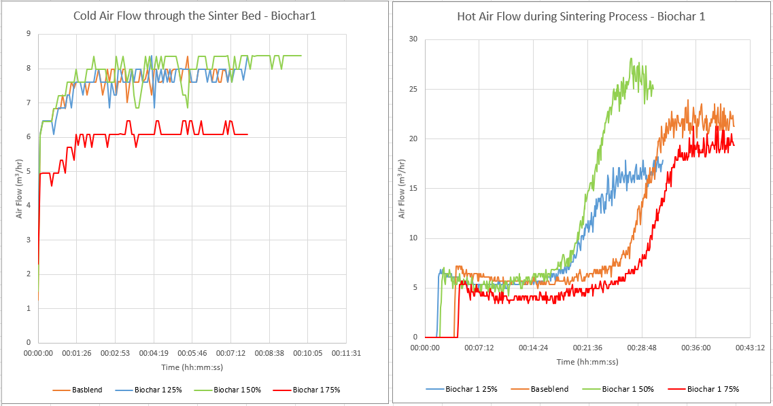
Figure 43 Cold and hot permeability graphs – Biochar 1
Table 16 Sintering air flows– Biochar 1
Process Parameters | Coke breeze 100% | Biochar 1 (25%) | Biochar 1 (50%) | Biochar 1 (75%)
Hot Flow Average (m³/hr) | 5.76 | 5.41 | 5.47 | 4.08
Cold Flow Average (m³/hr) | 7.79 | 7.79 | 8.09 | 6.14
Sintered Air Flow (m³/hr) | 23.92 | 18.23 | 28.09 | 21.26

An explanation for the 50% biochar 1 having stronger process characteristics than the base blend could be partly explained by the permeability results shown above in figure 43 and table 16. The base blend has the highest permeability of all the tests. The cold permeability test was carried out on the raw sinter mix, the 50% biochar 1 test has the highest result. The hot flow is taken during the sintering process, again the 50% blend came out on top. The sintered air flow is taken after sintering has finished and again the 50% blend had the highest result. The expectation on this test would be for the base blend to have the highest permeability which would then decrease as the biochar addition increased. The reason for this is that charcoal is very porous and so has a much higher moisture saturation value than coke breeze. This is likely to have had an effect on the sinter granulation which in turn affects the sinter density (Lu et al. 2013). The base blend had the second highest of the results across all permeability measures which otherwise did decrease as the biochar addition increased.
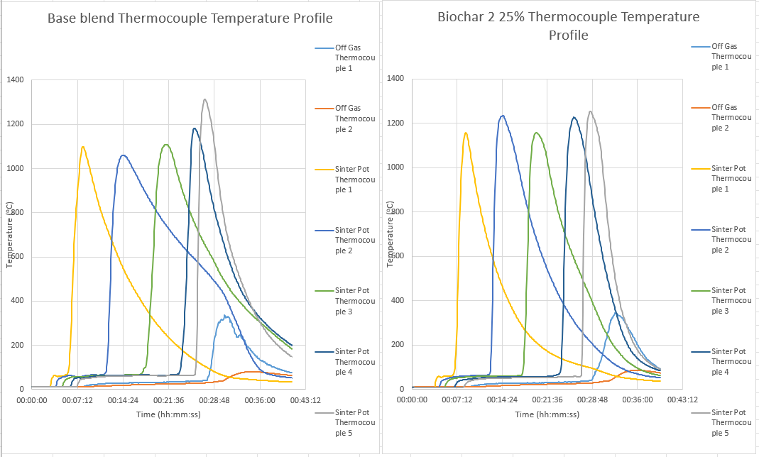
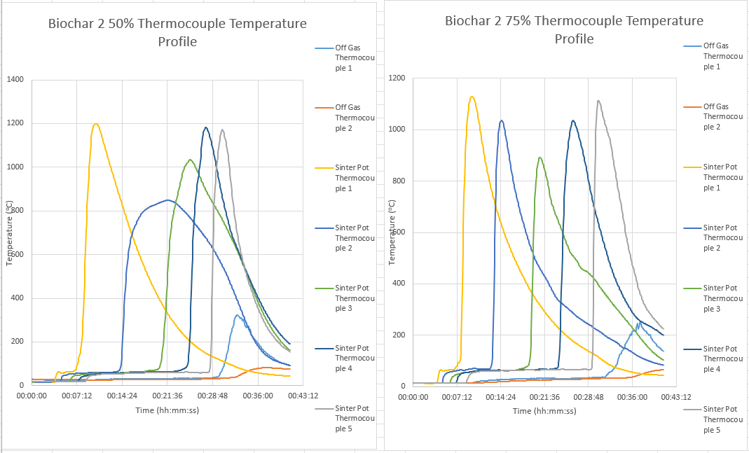
Figure 44 Time - temperature profiles of the biochar 2 sinter pot tests.
The time – temperature graphs for biochar 2 are displayed above in figure 44, the graph peaks largely have a shape that demonstrates a high combustion rate (see figure 41). The base blend has some wider profiles at the middle to base of the profile this represents a slower cool down time.
The base blend has an average max peak temp of 1152.76⁰C (see table 17 for process characteristics biochar 2) with the final thermocouple peaking at 1313.03, this profile is inconsistent with the others and may be because of variation in density while packing the sinter pot. In the biochar 2 25% graph the profile peaks are at a consistent level around the average 1206⁰C, and the max peak is not much higher at 1254⁰C. The biochar 2 50% graph has two profiles indicating medium to slow combustion rates that do not match the rest of the thermocouple profiles in that graph, this may be due to channelling or operator error when fixing the thermocouples. The three remaining profiles in this graph peak at around 1200⁰C. Biochar 75% has consistently lower profile peaks, with a max peak temperature of 1129⁰C, the average max peak temperature is 1041⁰C, although this is distorted by the middle thermocouple profile.
The average time above 1000⁰C is 2mins 20 secs for the base blend, the 25% biochar 2 blend is slightly higher at 2 mins 54 secs, the following two blends are lower than the base blend at 1 min 58 secs and 1 min 12 secs respectively. The FFS and yield decrease linearly with the exception of the 50% blend.
Table 17 Sintering process characteristics Biochar 2
 | Coke breeze 100% | Biochar 2 (25%) | Biochar 2 (50%) | Biochar 2 (75%)
Max Sintering Temperature (ºC) | 1313.05 | 1254.13 | 1198.54 | 1129.27
Average max sintering temp (ºC) | 1152.76 | 1206.26 | 1087.38 | 1041.73
Average time above 1000⁰C (mm:s) | 02:20:00 | 02:54:00 | 01:58:00 | 01:12:00
Sintering Time (mm:ss) | 00:27:25 | 00:28:45 | 00:28:55 | 00:31:25
Flame Front Speed Average (mm/s) | 0.33 | 0.26 | 0.34 | 0.23
Fraction of sinter >5mm (%) | 51.19 | 54.41 | 45.43 | 25.56

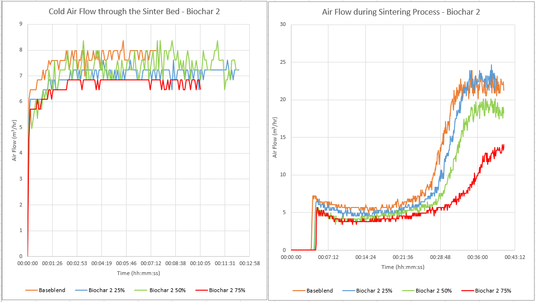
Figure 45 Cold and hot permeability graphs – Biochar 2
The permeability results shown in the figure 45 above and table 18 below show that the base blend has the highest hot permeability followed linearly by the 25%, 50%, and the 75% blends. The base blend also has the highest cold permeability, but the closest result is the 50% blend, the 25% and 75% blends then follow in order. For the finished sinter permeability, the 25% blend has the highest result, with the base blend close behind. The 50% blend and 75% follow with lower results.
Table 18 Sintering air flows– Biochar 2
Process Parameters | Coke breeze 100% | Biochar 2 (25%) | Biochar 2 (50%) | Biochar 2 (75%)
Hot Flow Average (m³/hr) | 5.76 | 5.03 | 4.22 | 3.98
Cold Flow Average (m³/hr) | 7.79 | 7.12 | 7.42 | 6.78
Sintered Air Flow (m³/hr) | 23.92 | 24.64 | 20.12 | 15.19

Sinter quality indices
A major requirement for BF raw materials is to limit the quantity of fines introduced or created as much as possible. To support this, all sinter material >5mm is screened out before being charged. The remaining sinter material needs to be resistant to fracture and abrasion (have cold strength) and have good reduction – disintegration properties. These properties are measured by the tumble and abrasion indices and the RDI indices (Geerdes et al. 2009).

Figure 46 The Sinter quality indices for biochar 1
The sinter quality indices for the biochar 1 tests are displayed above in figure 46. For the cold strength indices, the resistance to fracture, the tumble index shows a general trend downwards, the base blend starts at 44.4% and the 25% blend then drops to 41.8%, the 50% is slightly stronger than the base blend at 44.7% then the 75% blend drops to 37.1%, a drop of 7.3% from the base blend. The 50% biochar result supports the results gained from the process characteristics. The abrasion index represents the resistance to fines generation. The biochar 1 AI results show an upward trend as more fines are created as the sinter gets weaker. The 50% blend sinter being the exception with a marginally lower result than the base blend.
The RDI is a indicates how the sinter may disintegrate in the upper region of the BF. Sinter with a high RDI would generate fines at the top of the furnace which would decrease permeability in that region. The RDI index results for biochar 1 are illustrated in figure 46, it shows that as the concentration of biochar increases, the amount of material -2.8mm increases. Again the 50% blend is an exception with the least amount of material -2.8mm generated.

Figure 47 Biochar 2 sinter quality indices
The tumble index for biochar 2 presented above shows that the sinter gets weaker as the biochar concentration increases. A tumble test could not be completed on the 75% blend as 74.5% of the material was less than 5mm when screened. There was not enough material from the 25mm, 16mm and 10mm fractions to make up the test portion. This reaffirms the theory that the sinter gets weaker as the biochar addition increases. The AI is 5.68% for the base blend then falls slightly for the 25% blend before increasing significantly for the 50% blend. The prediction would be for the AI to increase as the biochar addition increases if the sinter is becoming weaker.
The RDI results show that the material less than 2.8mm increases as the biochar concentration increases excluding the 25% blend which is marginally lower.
The results displayed above for the sintering tests do not all conform to the results gathered in similar research carried out by authors such as (Kawaguchi and Hara 2013; Gan et al. 2014; Cheng et al. 2016; Liu et al. 2020). The general trends are shown but there are a few exceptions. This could be due to operator error, the author had limited access to the sinter pot which is used a plant process quality measurement and research and development tool. The author was trained and assessed as competent in using the equipment but has a lack in experience in what is a complicated process. The author also changed roles during this time, further reducing access to the equipment. There are many variables when preparing and testing sinter, more testing would have been beneficial to get more consistent results.
The 50% biochar 1 blend and the 25% biochar 2 blend performed better in the quality tests than the base blend, as discussed above this could be due to operator error or some form of variation. Alternatively, these conditions could make stronger sinter. According to previous studies carried out in literature, the former is more likely.

Photographs of the sinter produced on the sinter pot.
The pictures below in figure 48 display examples of sinter cake produced on the sinter pot. The picture on the right is of a fully formed sinter cake, the fact that it came out whole indicates that the sinter is reasonably strong. A weak sinter would crumble and fall apart when extracted. The picture on the right is an example of a sinter cake that exhibits channelling. Channelling occurs down the side of the sinter pot where the thermocouples are inserted. The areas between the thermocouple entry points become weak and partially collapse creating a more permeable area, through which the air passes more quickly. As a result, the channel stays hotter for longer and reacts for longer than the rest of the cake. Examples can be seen in figures 42 and 44 for Biochar 1 75% and biochar 2 50%.
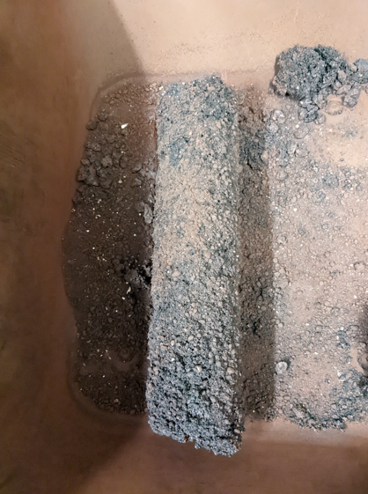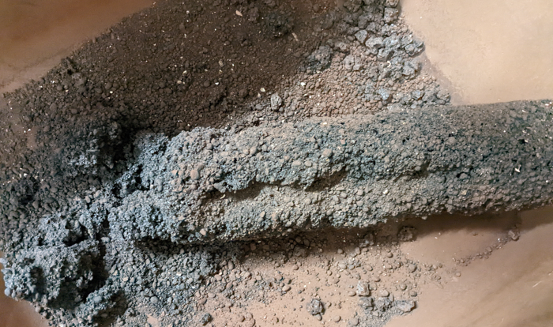
Figure 48 Examples of sinter cake produced in the sinter pot. On the left a whole sinter cake, on the right an example of channelling in a sinter cake.
For the following photographs the sinter cake was broken at approx. 50mm from the bottom of the cake and a picture taken of the cross section. This location was chosen as the bottom of the cake should have the best quality sinter because the sintering conditions will be stable and at an optimum at this point.
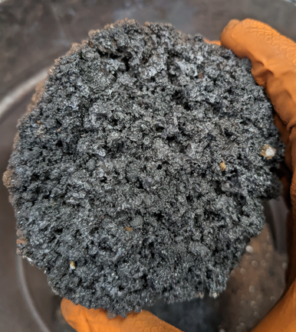
Figure 49 Base blend sinter.
Figure 49 is a photograph of a cross section of the base blend. There are some areas where good agglomeration can be seen, the sinter granules have bonded together. Some of these areas are highlighted in red. The cake looks porous with many holes observed. The quality across the cross section is consistent.
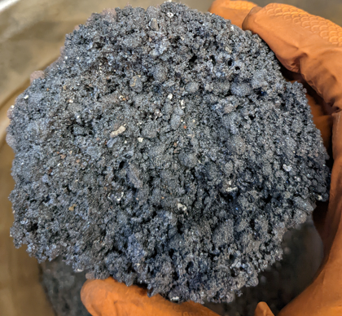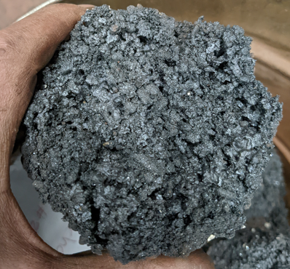
Figure 50 25%addition biochar 1(left) and biochar 2 (right).
The photograph on the left above in figure 50 is of the 25% biochar 1 blend. There is noticeably less evidence of agglomeration when compared to the base blend. Un-sintered raw mix granules can be observed (shown in yellow circles). The cake seems dense, less porosity can be observed. Visually, the quality of this sinter cake is somewhat poor.
The 25% biochar 2 blend shown on the right in figure 50 has evidence in some areas of good agglomeration (shown in red circles). There is a large crack running through the cross section shown in a yellow circle. There are areas that seem dense, while other areas do exhibit some porosity. There is a mix of good quality and poor-quality sintering across this cross section.
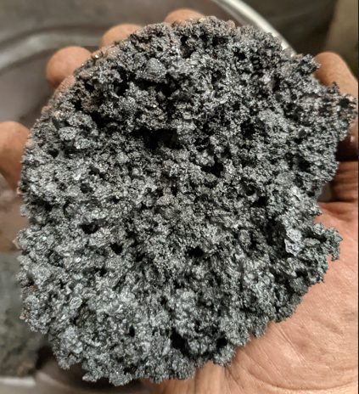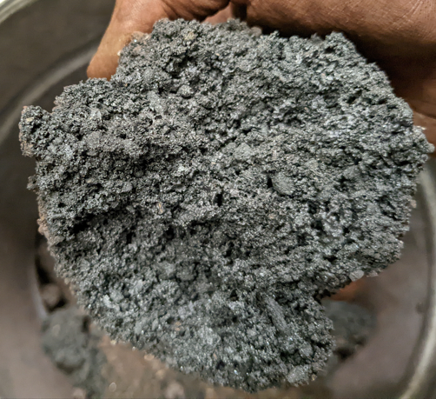
Figure 51 50% addition biochar 1 (left) and biochar 2 (right)
The 50% biochar 1 blend is presented in figure 51. This cross section demonstrates a good level of agglomeration (red circles) and porosity. The quality of sintering, across the cross section is consistent.
The 50% biochar 2 blend on the right is far denser than the 50% biochar 1 with a significant difference in porosity. There is fair amount of agglomeration, however there not much evidence of porosity. The area circled in yellow shows where some channelling has taken place.
The 75% biochar 1 sinter cake is shown below on the left in figure 52, a large channel can be seen on the right side marked with a yellow circle. There is evidence of some agglomeration, and the cross section is very porous, some of the holes are large. The cross section is also misshapen and has a relatively smaller diameter.
The photograph on the right-hand side is of the 75% biochar 2 sinter cake. There is little evidence of agglomeration and the un-sintered raw mix granules can be clearly seen throughout. There is a lack of porosity, and the cross section seems dense. The cross section has a red discolouration on it. The diameter is also smaller than the other samples.
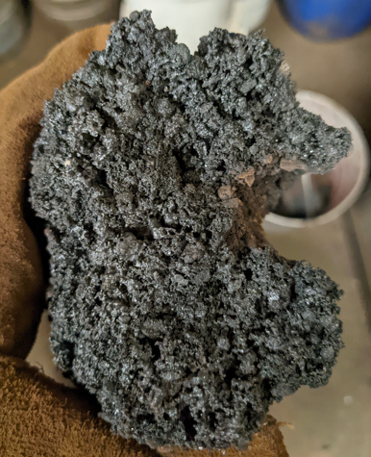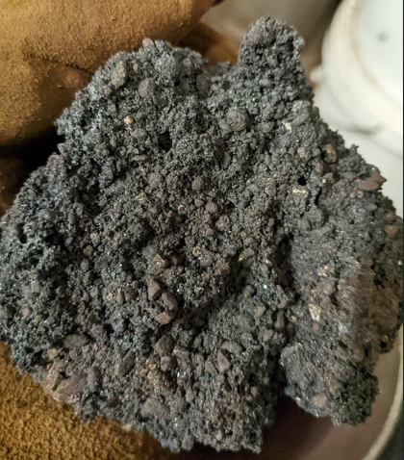
Figure 52 75% addition biochar 1 (left) and biochar 2 (right)
The sinter quality analysis carried out on biochar 1 & 2 demonstrates the potential for using biochar as a partial replacement for coke breeze as a fuel in the sinter making process. Using these results, up to 50% of biochar 1 and 25% of biochar 2 could be substituted for coke breeze before overly affecting quality results. In general biochar addition had the effect of decreasing maximum temperature and the length of time the sinter temperature is held over 1000⁰C, decreased sinter yield. The tumble and abrasion and RDI indices also dropped as the level of substitution increased. Further tests would be required as there were some inconsistencies in these results. The 50% biochar1 for example, produced the strongest sinter.
In hindsight, more fuel could have been added to the raw mix to better aid sinter agglomeration. A 4% fuel addition was tried on the base blend, which turned out to be too low, as the quality of sinter produced was very poor. The fuel addition was then raised to 5% for these tests. A 6% fuel addition may have been more beneficial.
The moisture level was set at 6% for all tests. According to (Kawaguchi and Hara 2013), due to the porous nature of biomass, a higher moisture addition is required to ensure appropriate granulation of the sinter mix. A 7% - 8% moisture level for the biochar blends may have been more suitable.
More tests will have also given the author more practice using the equipment and aid in achieving more consistent results. Further trials could examine the effect of biochar PSD, feedstock, and pyrolysis conditions on sintering performance.
Due to the safety implications of increased volatile matter in the fuel, plant scale trial would be required.

Biochar comparison
The results indicate that biochar 1 has superior properties for use in steelmaking processes when compared with biochar 2. Biochar 1 outperformed biochar 2 in every aspect of each process.
(Ning et al. 2022) state that the most important factor affecting biochar properties is pyrolysis temperature, this determines the yield, microstructure and chemical properties of the biochar produced. As pyrolysis temperature increases the biochar VM and yield decreases while carbonisation and CV increases, as previously demonstrated in figure 8. The optimum value was found to be 500⁰C.
The process parameters used to produce biochar 1 are known while not all the process parameters for biochar 2 were disclosed. Although due to biochar 2’s lower carbon content and higher VM it can be assumed that the pyrolysis temperature and or residence time were lower than biochar 1.

Carbon Dioxide emission mitigation potential using Biochar at Port Talbot Steelworks
In 2021 Port Talbot steelworks produced:
Approx. 3.5 Mt of Iron, using 630 kt of PCI coal and 1.12 Mt of coke - at the BF.
Approx. 900 kt of coke using 1.3 Mt of coal – at the coke ovens.
Approx. 3.6 Mt of sinter using 150 kt of fuel – at the sinter plant.
6,643,838 t of CO₂ emitted at Port Talbot.
The plant product tonnages were sourced from the area technical managers. The CO₂ figure was from the results reported to for the EUETS report and sourced from the environmental department. Please see appendix.
(Birat 2010) explains that CO₂ emission figures are mostly attributed to the stacks they are released from. The figures often do not take into account the area of steel plant that they were created. There is no comprehensive registry of CO₂ emissions published for the steel sector. Table 19 below uses figures calculated from emission factors.

Table 19 CO₂ emissions by area in a steel plant (Birat 2010).
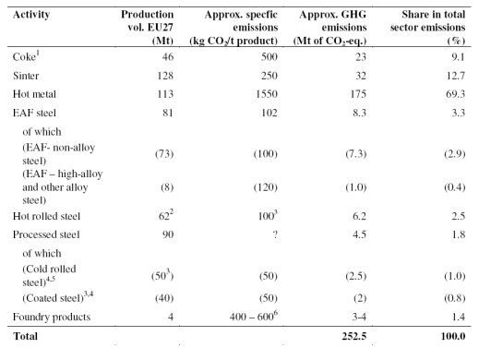
(Pardo and Moya 2013) employ estimated emission factors for direct CO₂ emissions per tonne of product for the different steelmaking processes. The figures they reported were:
Blast furnace – 1.219 (tCO2) per ton of iron.
Coke plant – 0.794 (tCO2) per ton of coke.
Sinter plant – 0.200 (tCO2) per ton of sinter.
Using the figure quoted by (Pardo and Moya 2013) and the product tonnage figures figure from Port Talbot in 2021 approximate CO₂ emissions can be calculated.
Blast furnace: $BFe=1.219*$3,500,000, which equates to 4,266,500t of CO₂ emissions. 64.22% of the annual plant total emissions.
Morfa coke ovens: $COe=0794*900,00$, equals 714,600t of CO₂ emissions. 10.76% of the annual plant total emissions.
Sinter plant: $SPe=0.200*3,600,00$, returning 720,000t of CO₂ emissions. 10.83% of the plant’s total emissions annually. These emission percentages are close to those presented by (Birat 2010) in table 19.
(Babich et al. 2010) reports that approximately 41% of BF emissions can be accounted to PCI. At Port Talbot this would equal 1,749,265t CO₂ (41% of 4,266,500t). If biochar was substituted for PCI at a conservative 25%, then there is potential to reduce 437,316t of CO₂ annually at the BF. 6.58% of total CO₂ emissions. A 50% biochar substitution would save 874,632.5t CO₂, 13.16% of total CO₂ emissions. A 75% substitution would save 1,311,948.8t CO₂, 19.75% of total CO₂ emissions.
This report has found that there is potential to replace 5% coal with biochar for coke making. This would reduce CO₂ emissions in this process by 35,730t annually. Which equates to 0.54% of the total CO2 emissions.
In the sinter tests it was found that there is potential to replace up to 50% of the sinter fuel with biochar. This could save 360,000t of CO₂ annually. 5.42% of the total CO2 emissions.
In three scenarios, the total potential CO₂ savings annually from substituting biochar into iron, sinter and coke making at Port Talbot could be:
at 25% PCI substitution – 833,046t – a 12.5% saving in total CO₂ emissions.
at 50% PCI substitution – 1,270,362t – a 19.1% saving in total CO₂ emissions.
at 75% PCI substitution – 1,707,679t – a 25.7% saving in total CO₂ emissions.

Conclusion
The purpose of this report was to investigate whether the fossil fuels used in steelmaking process could be partially replaced with biochar produced from sustainably sourced biomass, without adversely impacting product quality. Replacing these fossil fuels with biochar would potentially allow the steel industry to significantly reduce its CO₂ footprint.
Three steelmaking process were replicated at a lab scale and the impact of partially replacing the current fuel with biochar on product quality was assessed for each process. Two biochar feedstocks were chosen, a pyrolised softwood and a pyrolised waste hardwood.
Biochar was compared to pulverised coal by simulating blast furnace conditions, a drop tube furnace was used to produce blast furnace char which was tested for its chemical, combustion, and burnout properties. The biochar had a comparable chemical properties to pulverised coal. It was established that although the biochar does contain higher concentrations of harmful alkali elements, the concentrations of these elements in the two biochar’s’ tested was reasonably low. The biochar was more reactive than the pulverised coal meaning any blast furnace char it produced would ignite at lower temperature and burnout more quickly than pulverised coal which could result in improved blast furnace performance. It was determined that based on combustion and burnout characteristics, measures used to assess pulverised coal, it would be possible to replace a substantive amount of pulverised coal with biochar at the blast furnace. In 2021 Port Talbots blast furnaces consumed approximately 1.05 - 1.12 Mt of coke and 0.63 – 0.70 Mt of coal producing approximately 3.5 Mt of Iron while emitting approximately 4.27Mt of C0₂. If between 25% - 75% of the coal was substituted with biochar, then 6.6% to 19.8% C0₂ annual savings could be achieved at Port Talbots blast furnaces alone.
Coal was partially replaced with biochar in a lab scale pilot oven to produce biocoke, which was quality assessed. It was found that the addition of biochar to coking coal adversely affects the quality of the biocoke produced. Drops in the quality measures, hot and cold coke strength were observed. The nature of biochar leaves inert inclusions in the biocoke, acting as focal points for stress from which fissuring can occur. Biocoke has higher concentrations of alkali metals making it more reactive in the blast furnace. These characteristics severely limit the amount of biochar that can be used for coke making.
It would be possible to use 5% of a biochar with the properties of biochar 1 without overly impacting coke quality. In 2021 the coke ovens at Port Talbot produced approximately 0.9 Mt of coke using 1.3Mt of coal while emitting approximately 0.71 Mt of CO₂. Substituting 5% biochar into the coal blend could save 35kt of CO₂ annually, 0.54% of the total emissions.
Bio-sinter was produced using the sinter pot, a lab scale replication of the sinter making process. Biochar was used to partially replace coke breeze as the fuel in the process. The tests found that as the amount of biochar increased then the quality of sinter was decreased. The maximum sintering temperature dropped, and the time spent above 1000⁰C reduced, permeability decreased, and the yield was lower. The quality measures, cold strength and reducibility were negatively affected. The quality drops were not significant however until over 50% biochar substitution.
The results were not perfectly linear as the tests for both biochar 1 and biochar 2 contained an outlier. The tests for biochar 1 at 50% substitution all showed an improvement in results from the base test. Similarly for the 25% substitution test results on the biochar 2. The results do though show the potential for biochar to be used in sinter making with a coke breeze replacement rate up to 50%.
Of the two biochar types tested, biochar 1 yielded the better results. It can be concluded that a single biochar source could be used in all three of the processes investigated in this report. The total potential CO₂ savings at Port Talbot between 0.83Mt (25% biochar substitution in PCI) and 1.7Mt (75% biochar substitution in PCI). Which equates to savings of between 12.5% - 25.7% of total CO₂ emissions at Port Talbot.

Limitations
Several biochar and charcoal companies were sent communications requesting samples for use in this report. Many did not reply and those that did were only interested in supplying large quantities of charcoal. Edinburgh University Biochar research centre supplied Biochar 1 and the data for its processing parameters. Biochar 2 was purchased from a supplier of charcoal used for gardening purposes. Several requests to the supplier for the processing parameters used to make the charcoal were ignored. This information would have been beneficial when comparing and analysing the biochar’s.
Access to the drop tube furnace at Cardiff university was limited, there were several students that were using the facility for their own projects, supervision using the equipment was also required. The materials lecturer (Dr Steer) was very generous with their time, but he had other responsibilities and could only offer so much of his time. More tests with coal/ biochar blends would have provided valuable information and given a better understanding of how much biochar could be substituted for PCI in the blast furnace.
There were plans to analyse the waste gases from the sinter pot tests but the author required training on the equipment. The availability of the training did not align with the availability of the sinter pot. This testing therefore had to be abandoned as time ran short. It was hoped that the tests would demonstrate that biochar addition would reduce GHG emissions during sinter making.
Other tests that were not completed were dilation and fluidity of the coal and coal/biochar blends. These tests would have demonstrated the effect of biochar on vital coking characteristics. Again, the author required training on the instruments. The availability of the training and the time taken to carry out the tests would have made this tests difficult to complete within a sensible time frame. It was felt that possibly too many tests would have been included in the report.
To ensure that these results are adequately repeatable, more tests would have been preferable. However, the process of making blast furnace char with a drop tube, making coke with a pilot oven and sinter with a sinter pot are time consuming activities. One sample through the drop tube took 3 hours. A sinter pot test took 3 hours to run produce 1 sinter cake. One pilot oven test takes 24 hours to produce 1 coke batch. These activities also had to be planned around the regular use of the equipment.
Some tests were completed by laboratory staff at Port Talbot laboratories, some level of variation will have been introduced by this fact. Dependent on the level of training, competency and experience of the technician.
The author’s level of training, competency and experience using some of the equipment may have also introduced variation to the results. Although trained and signed off as competent using the equipment. For some of the tests it was the authors first time using the pilot oven and sinter pot alone and unsupervised following training.

Recommendations

Reference list

Appendix
Supporting documentation

