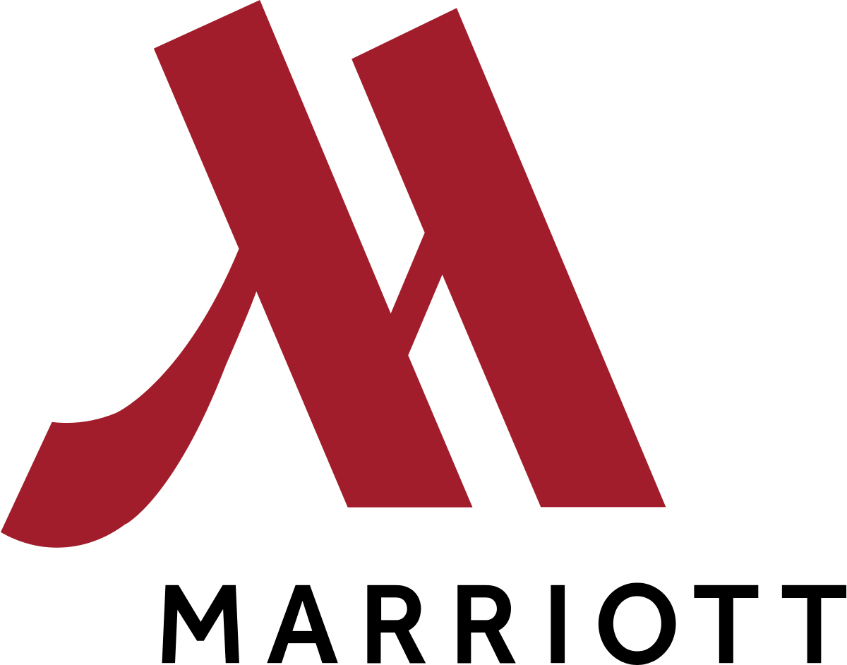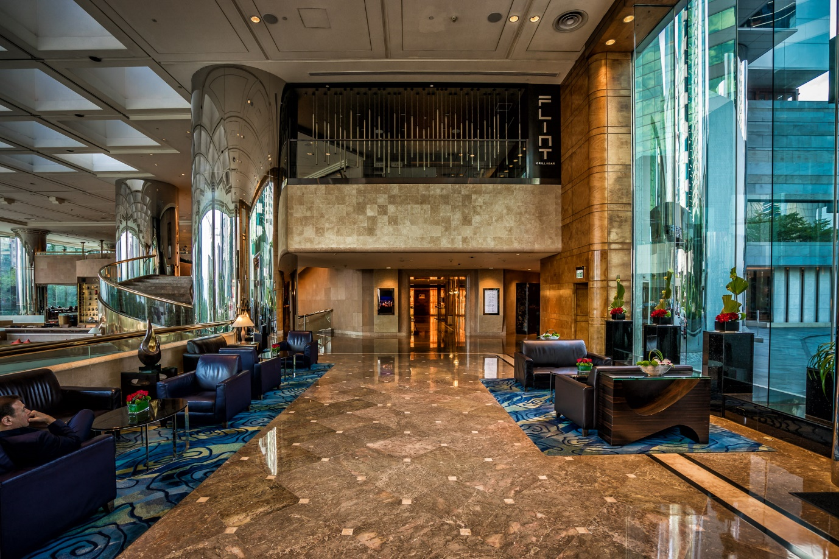

Placement Assessment 28th November
Student Stefan Ilie 1815223
Project coordinator Muhammad Cassamo
Dean John Howell

Part 1
Leading a review after somebody remains at your lodging or guesthouse is a genuinely normal marketing tool.

These are questions you can use to see where you can exceed expectations or where you can improve a hotel business.

Your notoriety relies upon what individuals are stating about you, and on the off chance that you don\'t know how they truly feel, you don't have anything to put together your upgrades with respect to. This is the reason a visitor assessment study is so critical to the accommodation field.

Think about what you truly need to know before choosing the sort of inquiry.

# 1: For what reason did you decide to remain at this hotel?

By posing this inquiry, you will have an ideal picture of whether it was an online hunt, value, word, surveys, rehash client or something different.

Give your clients alternatives and let them check the amount they might want on the grounds that there could be numerous reasons.

# 2: Tell us about the staff at the front desk

The front desk staff will give the early introduction to your visitors and set the pace for the whole remain.

Enable visitors to rate the staff at the front work area. On the off chance that the appropriate response was negative, pose another inquiry, with the goal that he can say why.

# 3: How was the registration procedure?

This inquiry is reasonable for an underlying finished inquiry.

You may ask the respondents how fulfilled they were in the registration procedure with decisions, for example, exceptionally fulfilled, fulfilled, nonpartisan, disappointed and extremely disappointed.

Be that as it may, you can utilize contingent rationale to assemble more data as an open inquiry.

For instance, on the off chance that they replied with fulfilment or fulfilled, you would send them an inquiry, inquiring as to why.

On the off chance that they addressed the far edge, you unquestionably need to recognize what occurred, so you\'ll request subtleties.

# 4: Was your room clean on appearance?

This is a basic inquiry and typically, a yes or no answer is okay.

Be that as it may, once more, you need to utilize the restrictive rationale if the review respondents answer without an answer.

Go ahead to discover what wasn\'t on par. This encourages you better train your housekeeping staff to address the issues of your visitors.

As to tidy up rooms, it is significant this is one of the most significant components for lodging visitors with regards to picking facilities.

# 5: How did the housekeeping staff handle your remain?

With this inquiry, you would utilize a rating scale.

For instance, your inquiry may resemble this:

The housekeeping staff worked superbly tidying up my room.

o Solid understanding

o Concur

o Impartial/Not certain

o I don't concur

o I emphatically oppose this idea

In the event that they state they dissent, ask them another inquiry so you can get some answers concerning the issues they are encountering.

# 6: Did you utilize any of the offices? In the event that truly, which one?

This is a significant inquiry since you truly need to know whether they have utilized your business focus, pool, whirlpool, practice room, eatery, and so forth.

So, the most ideal approach to pose this inquiry is to give a rundown of every one of your offices with the goal that you can tick the crates of everybody who applies.

You can pursue this inquiry with a \"Why not utilize X layout\" in the event that you need to discover how significant individual ones are for your lodging visitors.

# 7: Was your bed agreeable?

This is another significant component for your lodging visitors. While it may not be what drives them to make the underlying reservation, you can wager it is a deciding variable when choosing the accompanying:

Regardless of whether you come back to your property or not

What sort of online audit will they compose?

In the event that you prescribe it to other people.

Along these lines, pose this inquiry. At that point investigate your outcomes over a couple of months. In the event that the appropriate response is regularly no, at that point you need to chip away at new beds in your next spending plan.

# 8: Did you like breakfast?

In the event that you serve breakfast, this is a significant inquiry to pose, as it is fundamental to the general impression visitors have of your property.

In spite of the fact that this might be a yes or no inquiry, you absolutely need to tail it with restrictive rationale.

A definitive objective is to discover what they preferred about breakfast. You may not find that nobody likes oats, so you can expel it from your offers.

You likewise need to comprehend what they like to ensure it remains on your menu.

# 9: How was the registration procedure
Much the same as the inquiry you posed about the registration procedure, you need to think about the registration procedure.

This incorporates things like:

Was your bill exact?

Did you look at on the web?

Did you go to the front work area to look at?

How was the front work area staff?

Were there enough baggage racks for you?

Did you discover the leaving sufficient for simplicity of getting your luggage to the vehicle?

#10: How Likely Would you say you are to Prescribe Our hotel to Other people?

At long last, this is a definitive inquiry on your rundown. This is the meat of your visitor assessment.

Why? Since when all is said and done, you need to know whether you are prevailing with regards to making your visitor's stay so magnificent that they will prescribe you to other people.

This inquiry is the thing that makes up your Net Promotor Score. It's what gives you a chance to measure the dependability of your client.

Did you go far enough to assemble an extraordinary relationship?

On the off chance that the response to this inquiry is not exactly acceptable, you have an issue on your hands and one that must be comprehended rapidly.
The accommodation business depends on notoriety, advanced surveys and even verbal.

To ensure that your hotel is getting a five-star rating and notoriety on the web, you need to comprehend what your visitors think. The most ideal approach to do this is through a visitor assessment overview.

Part 2

Operations

Preparing and displaying an F&B item

This includes the preparation of various new foods and beverages. Kitchens prepare different foods, and bartenders prepare cold refreshments, for example, models and mixed drinks. I also make the food generally satisfying, organizing the food on a platter and beautifying it in an appealing way. In addition, beverages are enriched by using organic product cuts, finishing glasses, drinks, and shakers.
I can say that I was and am attracted by the complexity of this department and can speak of the experience that I have accumulated for example in the restaurant Zest.
I was taught how to prepare and how to present two types of coffee in particular Cappuccino and Caffe Macchiato in the purest way that a true Barista can present. and ending with decorating the cup of coffee in such a way as to give the client visually and taste satisfaction.

Part 3

5 interview questions for one of the following 3 positions:
• Household Manager
• Conference and event manager
• The administrator in front of the house

For this topic, I decided that the following 5 questions cover the entire area of ​​interest in the deeper knowledge of the candidate.

These five questions are as follows:

~ what style of management suits you?
~ How long are you willing to fail at this job before you succeed? ...
~ What would your boss, who you didn't get along with, tell me about you? ...
~ Tell me what you felt was unfair in your last position. ...
~ What are you most proud of in your career?

