Name: Zara Westlake
Student Number: 2515974
CIPD Number: 919556
Course Module: Professional behaviours and valuing people
Course Code: 5CO03
Course Lecturer: James Moore
Task 1
Q1 (AC 1.1)
In preparation for the first management meeting, I would explain that a ‘People Professional’ is expected to be principles-led, evidence-based and outcomes driven, role modelling the core behaviours which are in the CIPD Profession Map (For example ethical practice, working inclusively, valuing people, professional courage and influence) to create value for people and the organisation. The behaviours are universal and consistent even in challenging or new situations.
In the context of Nexobyte’s rapid growth, the informal structures, and inconsistent practices between the teams. The new role of HR/L&D advisor should begin with restoring fairness, clarity and consistency across people and processes including recruitment, performance, working arrangements and access to L&D. The profession map stresses that working inclusively listening to diverse voices, collaboration, and building trust in relationships. With this in mind I would introduce transparent criteria and standards to reduce the variation between the teams and ensure equal opportunities.
A second priority would be building capability. The team leaders hadn’t had formal training, which links to inconsistent decision making, Using the maps behaviours (Professional courage and influence, passion for learning) I would provide coaching, toolkits and bite size training for fair decision making, feedback skills, and inclusive leadership, practical steps that help manager to lead consistently and confidently.
Ethics is a third pillar. CIPDs ethical practice highlights the need to embed principled decision making and build cultures of transparency and trust, particularly relevant where there has previously been favouritism in L&D and misuse of company equipment. I would set out clear expectations and evidencing the rationale, I would therefore introduce simple people metrics and feedback loops to inform actions and measure impact and improvements.
Finally, I would connect people practice to strategic outcomes. An inclusive fair environment is associated with better engagement, retention and performance. CIPD’s EDI guidance explains effective EDI is vital to business and not just compliance. For Nexobyte, moving on from ad-hoc practices to scalable ethical and inclusive systems will support growth, reduce risk and improve employee experience.
To summarise, the people professional contribution is to set standards, develop managers, embed ethics and use evidence aligning people practices to business goals while ensuring colleagues feel included valued and are treated fairly.

Q2 (AC 1.2)
At the start of my new role at Nexxobyte, the two personal and ethical values I think would significantly support my success as a people professional are integrity and fairness. These values align with the CIPD Profession Map, which positions ethical practice and inclusivity as being core behaviours which are essential for building trust and shaping positive organisational cultures. Applying these values consistently will be important in an environment like Nexxobyte, where inconsistent management practices and previous unethical behaviour have contributed to employee dissatisfaction and staff attrition.
Integrity is a fundamental part of ethical people practice. Ethical practice according to the CIPD is “building trust by role-modelling ethical behaviour and applying principles and values consistently in decision-making” (CIPD, 2024). In the case of Nexxobyte, where team leaders have been operating independently and without formal guidance, integrity will be essential in establishing credibility and ensuring that people management decisions are transparent, evidence-based and aligned with organisational values. Demonstrating integrity will mean being honest in my communication with Aisha, Kit and the team leaders, even when the messages may be challenging. It also involves ensuring that policies, processes and recommendations are based on fairness and legal compliance rather than personal preference or convenience. By modelling integrity, I can help rebuild trust and contribute to a culture where ethical behaviour is expected and reinforced.
Fairness is another value that will strongly guide my practice. The CIPD emphasises that effective equality, diversity and inclusion (EDI) strategies stretch beyond legalities and compliance and focus on creating environments where people feel valued and able to achieve their full potential (CIPD, 2024). At Nexxobyte, inconsistent access to training, differing working arrangements and informal decision making have created perceptions of inequity. Applying fairness in a consistent manner will guide my development of transparent and inclusive policies that ensure equal access to opportunities such as learning and development, flexible working and progression. It will also support me in challenging biased or inconsistent practices and helping managers understand the impact of their decisions on employee morale, engagement and retention.
Together, fairness and integrity will influence my approach to people practice at Nexxobyte. These values combined will help me to build trust, promote ethical behaviour and support the development of consistent, inclusive and transparent systems while addressing many of the issues that have contributed to complaints and staff attrition. By embedding these values into my daily practice, I can contribute to creating a more positive, ethical and equitable working environment.

Q3 (AC 1.3)
Clear, informed and confident communication is a fundamental requirement of effective people practice, particularly for an organisation like Nexxobyte where the approach to management was informal and inconsistent practices have contributed to employee complaints and staff attrition. Aisha’s expectation that I am “a firm voice for people practice” mirrors the CIPD’s view that people professionals must be able to influence others through credible, evidence-based communication (CIPD, 2024). Communicating in this way is essential for establishing professional authority, shaping decision-making and ensuring that people management practices support not only organisational performance but also employee wellbeing.
Communicating using an informed approach will ensure that my recommendations are supported by evidence, legal requirements and professional standards. The CIPD emphasises that people professionals must use data, insight and research to guide organisational decisions (CIPD, 2025). At Nexxobyte, where the managers have had little formal training, informed communication will help them understand why changes are necessary and how structured, fair and ethical people practices can address the issues the organisation is facing. Without this, managers may continue to rely on personal preference or habit, reinforcing inconsistency and inequity.
Clarity is equally important, communicating clearly will reduce ambiguity, ensure shared understanding and support consistent implementation of policies and procedures. Given that Nexxobyte’s managers currently operate independently, clarity will help align expectations and create a more considered approach to people management. Research on organisational communication highlights that unclear messages can lead to confusion, resistance and errors in implementation (Tourish, 2020), all of which could undermine the efforts intended to improve practice.
Confidence also plays a critical role, confident communication demonstrates competence and helps build trust, making it more likely that managers and directors will take my advice seriously. The CIPD notes that courage and influence are important behaviours for people professionals, enabling them to challenge poor practice and advocate for ethical and inclusive approaches (CIPD, 2024). In a growing organisation like Nexxobyte, confidence will be vital in encouraging leaders to adopt new ways of working.
If I am fail to communicate in this manner, there are consequences for myself and the company. For me, a lack of confidence or clarity could undermine my credibility, making it harder to influence decisions or gain the respect of managers. For Nexxobyte, ineffective communication could result in continued inconsistency, further employee dissatisfaction and potential legal or ethical risks. Ultimately, the organisation may struggle to develop the structured, fair and inclusive practices needed to support sustainable growth.

Q4 (AC 1.4)
Had I been working at Nexxobyte during the period when unethical and unlawful behaviours occurred, the correct approach would have been to address these issues promptly, professionally and in line with legal obligations and the ethical standards expected of people professionals. The CIPD places emphasis that ethical practice entails “building trust by role-modelling ethical behaviour and applying principles and values consistently in decision-making” (CIPD, 2024). This means that people professionals must not only recognise unethical conduct but also take appropriate action to challenge and report it.
In the first issue, where a manager approved costly training for favoured team members while consistently declining similar opportunities to others the behaviour represents clear favouritism and a breach of fairness and equality principles. It also contradicts the CIPD’s expectations around inclusivity and equitable access to development (CIPD, 2024). My approach to this would be I would firstly gather relevant evidence, such as training records, budget allocations and employee feedback, to ensure that any concerns raised were based on facts rather than hear say. I would then arrange a confidential conversation with the manager to explore the reasons behind their decisions, affording them with an opportunity to clarify any misunderstandings. If the behaviour was confirmed as unfair or discriminatory, I would escalate the issue to Aisha and Kit, recommending corrective action such as clearer L&D criteria, manager training and a transparent approval process. Addressing this issue early would help prevent further inequity and help to rebuild trust among employees.
The second situation, where an employee was using company time and equipment to run a personal business would constitute misconduct and potentially fraud. In this case, my response would need to be more formal. I would document the relevant evidence, including system logs or witness statements, and follow Nexxobyte’s disciplinary procedures, or if none existed, apply ACAS guidance on fair disciplinary processes. The CIPD stresses that people professionals must act with courage and integrity when faced with wrongdoing, even when doing so may be uncomfortable (CIPD, 2024). I would therefore raise the issue with senior leadership immediately, ensuring that the investigation was conducted fairly, confidentially and in line with legal requirements.
In both scenarios, my actions would be guided by ethical principles, organisational policies and the need to protect both employees and the business. By addressing such issues promptly helps foster a culture of accountability, fairness and trust which are essential foundations for Nexxobyte’s future growth.

Q5 (AC 2.1)
The manager’s remark that “people work much harder when they are not protected by a load of feel-good policies and procedures” reflects a narrow and archaic view of motivation and organisational performance. Research shows that when people feel included, valued and are fairly treated, both the individuals and organisations benefit considerably. These principles are central to modern people practice and are strongly supported by CIPD evidence and wider organisational behaviour theory.
From a human point of view, feeling valued and included is fundamental to psychological wellbeing. The CIPD highlights that inclusive cultures enable individuals to feel a sense of belonging and empowerment, which in turn supports confidence, engagement and personal growth (CIPD, 2024). When employees believe they are treated fairly and have equal access to opportunities, they are far more likely to feel job satisfaction and lower levels of stress. This is especially relevant at Nexxobyte, where inconsistent management practices have led to complaints and talented staff have left. Ensuring fairness and inclusion is incorporated would help rebuild trust and create a healthier working environment.
From a business point of view, the benefits are equally compelling. Research on organisational performance shows that inclusive workplaces experience higher levels of employee engagement, which is strongly linked to productivity, innovation and discretionary effort (Harter et al., 2020). When employees feel respected and valued, they are more forthcoming with ideas, collaborate effectively and go beyond minimum expectations. Fair treatment also reduces conflict, grievances and turnover. These are all issues that have already affected Nexxobyte’s stability and growth. Replacing skilled software engineers is costly and retaining talent through fair and inclusive practices is far more efficient.
Equity and inclusion also support better decision-making. Diverse teams that feel psychologically safe are more likely to challenge assumptions, identify risks and generate creative solutions (Edmondson, 2019). In a rapidly growing software development company, this kind of innovation is essential for maintaining competitive advantage. Conversely, environments where employees feel undervalued or unfairly treated often experience disengagement, reduced performance and increased absenteeism.
Finally, fairness and inclusion contribute to organisational reputation. The CIPD notes that ethical and inclusive people practices strengthen employer brand and support long-term sustainability (CIPD, 2024). For a young company like Nexxobyte, building a reputation as a fair and supportive employer will be crucial for attracting high-quality talent in a competitive market.
In summary, the evidence clearly demonstrates that inclusion, feeling valued and fair treatment are not “feel-good” extras but essential components of wellbeing and business success. Embedding these principles at Nexxobyte will support both organisational performance and a positive employee experience.

Q6 (AC 2.2)
Creating a fair and inclusive Learning and Development (L&D) policy for Nexxobyte requires a structured, evidence-based approach that ensures all staff members have the same access to development opportunities. Given the previous inconsistencies in training allocation where some employees received preferential treatment establishing transparent and inclusive processes is essential for rebuilding trust and supporting organisational growth. The CIPD emphasises that effective L&D strategies must be inclusive, accessible and aligned with organisational needs, ensuring that all employees can develop their talents and contribute meaningfully (CIPD, 2024).
The first part of designing the initiative would be to undergo a needs analysis across all teams. This would involve gathering data via surveys, interviews and performance discussions to understand current skill gaps, employee aspirations and organisational priorities. Engaging employees in this process supports inclusivity by ensuring diverse voices are heard and considered. I would also review training records to identify patterns of inequity and ensure that the new policy addresses these gaps. The CIPD highlights the importance of evidence-based practice in designing fair people initiatives, ensuring decisions are grounded in data rather than assumptions (CIPD, 2025).
Next, I would develop clear and transparent criteria for training access, including approved paid time for development, training budgets and appropriate learning activities. These criteria would be communicated openly to all staff to ensure understanding and consistency. To further support inclusivity, the policy would offer a selection of learning methods, such as, mentoring, peer learning, online courses as well as formal training whilst recognising that individuals have different learning preferences and needs. Ensuring accessibility for employees with disabilities or caring responsibilities would also be a priority, reflecting the CIPD’s emphasis on inclusive workplace practices (CIPD, 2024).
To assess if initiative is inclusive after three months, I would introduce a structured review process. This would include analysing participation data to identify whether all groups are accessing training equitably, reviewing feedback from employees and managers, and assessing whether the policy has reduced complaints or perceptions of unfairness. Surveys and focus groups would provide qualitative insight into employee experiences, helping to identify any unintended barriers. If disparities were identified, for example, if certain teams or demographic groups were under-represented I would adjust the policy accordingly. Continuous monitoring via KPI’s ensures that the initiative remains fair, relevant and aligned with organisational values.
In summary, designing and evaluating an inclusive L&D policy requires a combination of data-driven decision-making, transparent processes and ongoing review. This approach will help Nexxobyte create a fairer, more supportive learning culture that benefits both employees and the organisation.

Q7 (A.C 2.3)
Table 1
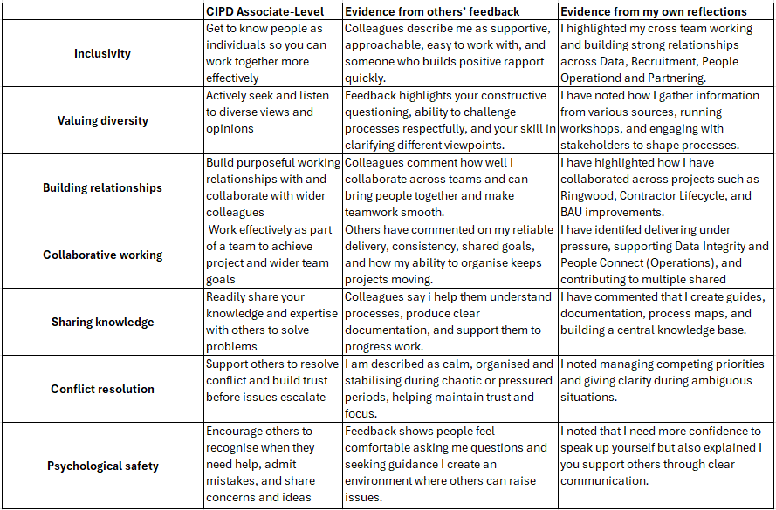

In completing this review, I drew on two sources (Appendix 1 and 2): my own reflections from my annual appraisal and detailed feedback from colleagues I have worked with across People Services. This included colleagues involved in key projects such as Ringwood (a major internal reward project), the Contractor Lifecycle project, documentation improvements, and BAU activities. Their feedback was collected through our LMS portal, where 360‑degree reviews are gathered continuously throughout the year. Combining these perspectives enabled me to assess my behaviours against the CIPD Associate‑level standards for Working Inclusively.
The feedback strongly demonstrates that I meet, and in places exceed Associate‑level standards. Colleagues noted that I “get to know people as individuals” and work effectively with a wide range of stakeholders, which aligns with Inclusivity at Associate level. I consistently build purposeful working relationships, collaborating with wider colleagues across functions such as DI, Recruitment, People Connect and project teams directly reflecting the building relationships expectations.
Feedback also shows that I actively seek and listen to diverse views, particularly through my questioning style, structured communication, and ability to simplify complex issues. This is well aligned to Valuing diversity at Associate level. Colleagues also highlighted my willingness to share knowledge, provide clarity, and guide others through complex processes which reflects the standard of readily sharing knowledge and expertise to solve problems.
I also demonstrate Associate‑level Collaborative working, with strong evidence that I help teams achieve shared goals and enable smooth delivery across interconnected workstreams. My calm, organised approach during pressured periods shows that I support others to resolve issues and maintain trust, linking to the Conflict resolution standard. Additionally, colleagues appreciated my supportive and approachable style, which contributes to encouraging others to share concerns or ask for help, aligning to psychological safety at Associate level.
Overall, by combining my reflections with multi‑source colleague feedback, my experience aligns strongly with Associate‑level expectations and contributes positively to an inclusive and collaborative working environment.

Q8 (AC 3.1)
The role of the people practitioner is evolving rapidly in response to changes in technology, workforce expectations and organisational priorities. Two significant developments shaping the profession today are the increasing shift towards evidence‑based, data‑driven HR practice and the growing emphasis on employee experience (EX) and wellbeing as strategic drivers of organisational performance. Both developments have important implications for my ongoing professional development.
The first major shift is the profession’s move towards evidence‑based practice and the use of people analytics. The CIPD highlights that modern people professionals are expected to draw on data, organisational insights and external research to inform decisions and demonstrate the impact of people initiatives (CIPD, 2025). This reflects a broader trend in HR towards analytical capability, where practitioners must interpret workforce data, identify patterns and use insights to influence strategic decisions. As organisations increasingly rely on data to drive performance, people professionals must be able to translate complex information into meaningful recommendations. For my own development, this means strengthening my analytical skills, deepening my understanding of HR metrics and becoming more confident in using data visualisation and reporting tools. Developing these skills will enable me to contribute more effectively to evidence‑based decision‑making and enhance my credibility when advising senior stakeholders.
The second key development is the growing focus on employee experience and wellbeing as central components of organisational success. The CIPD notes that organisations are increasingly recognising the importance of creating positive, inclusive and supportive working environments that enable people to thrive (CIPD, 2024). This shift reflects changing employee expectations, greater awareness of mental health and the need for organisations to attract and retain talent in competitive labour markets. As a result, people practitioners are expected to design people practices that prioritise fairness, inclusion, wellbeing and meaningful work. For my professional development, this means continuing to build my knowledge of wellbeing frameworks, inclusive design principles and approaches that enhance engagement and psychological safety. It also requires developing stronger skills in stakeholder engagement, communication and change management to ensure that employee‑centred initiatives are effectively implemented.
In summary, the evolution of the people profession towards data‑driven practice and employee‑centred organisational design requires practitioners to develop a broader skillset that combines analytical capability with a deep understanding of human behaviour and workplace culture. Strengthening these areas will enable me to remain effective, credible and aligned with the future direction of the profession.

Q9 (AC 3.2)
Table 2
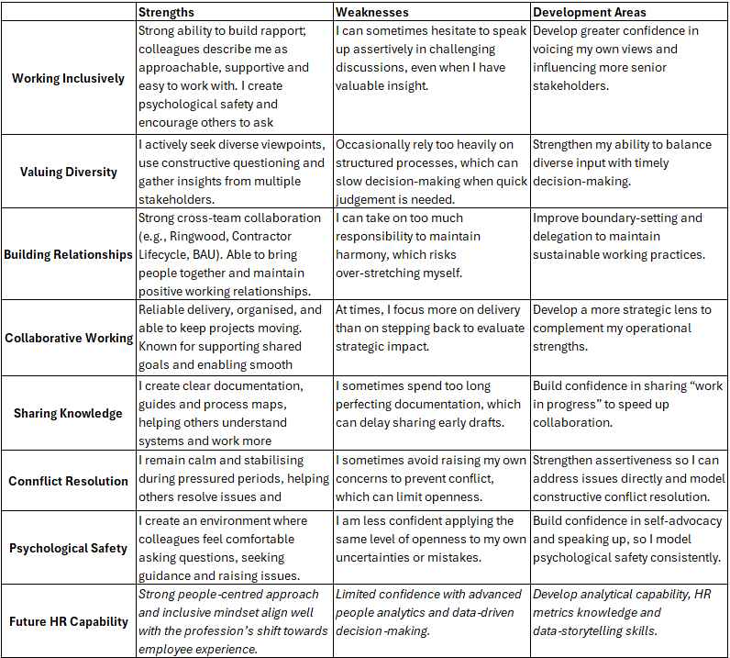

Q10 (AC 3.3)
1. Completing a People Analytics Course
One of my development needs is to build greater confidence and capability in using people data to inform decisions. As the profession increasingly moves towards evidence-based practice, developing stronger analytical skills will help me interpret workforce trends, evaluate the impact of people initiatives and present insights more effectively to stakeholders. To address this, I will complete a course in people data analytics. This will give me practical skills in understanding dashboards, analysing data and using data storytelling techniques. I have chosen this because it directly supports the future direction of the profession and will enable me to contribute more strategically to organisational discussions.
2. Participating in Assertiveness or Influencing Skills Training
My self-assessment highlighted that while I support others confidently, I sometimes hesitate to speak up assertively in challenging situations. To strengthen my professional presence and influence, I will undertake assertiveness or influencing skills training. This activity will help me develop techniques for communicating my views clearly, managing difficult conversations and contributing more confidently in meetings. I have chosen this because it will support my ability to influence decisions, represent people insights effectively and model the psychological safety I encourage in others.
These two development activities will help me build both the analytical capability and interpersonal confidence required to meet the evolving expectations of the people profession and support my continued growth over the next six months.

Q11 (AC 3.4)
Figure 1
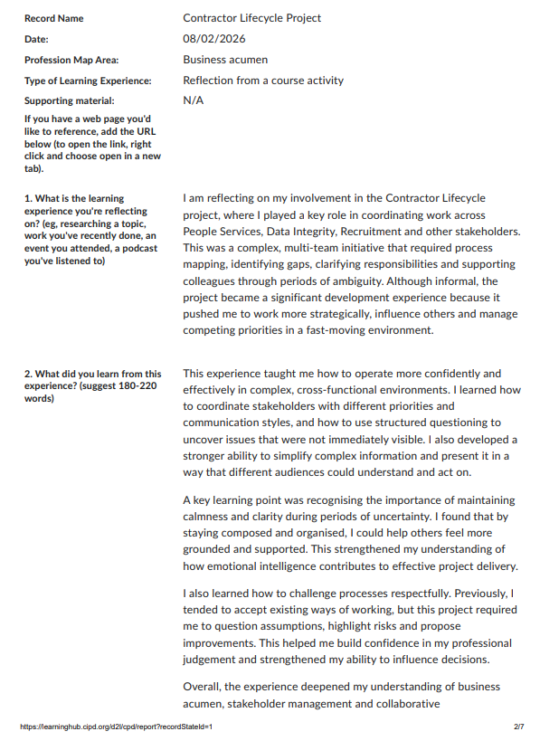
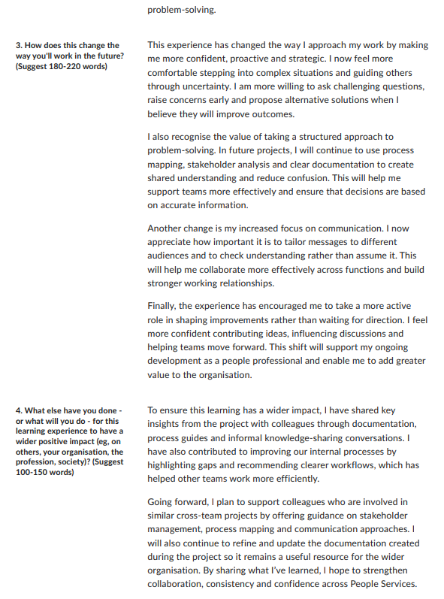

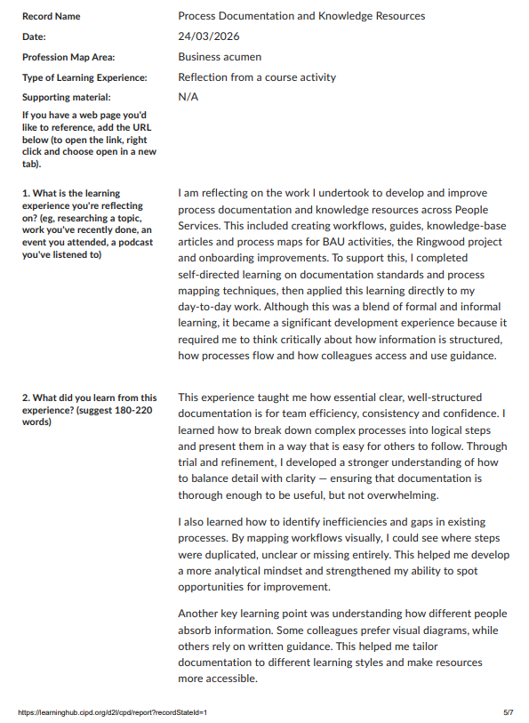

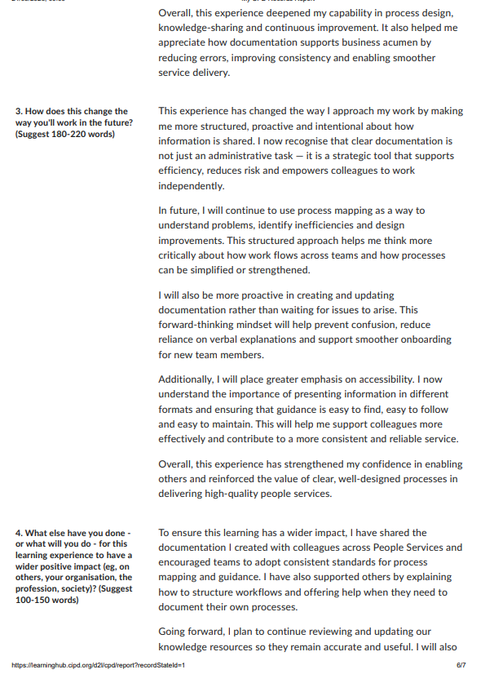
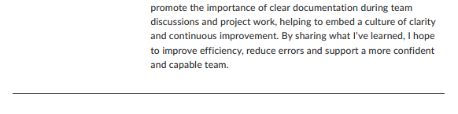

Appendices
Appendix 1 – 360 Feedback Summary


Appendix 2 – Appraisal Reflection
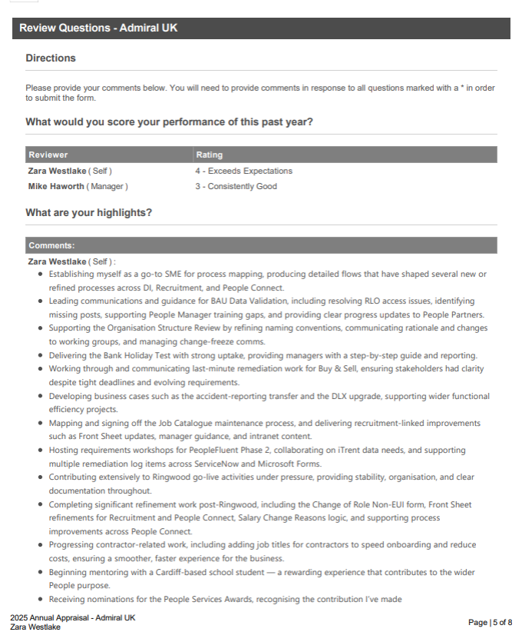

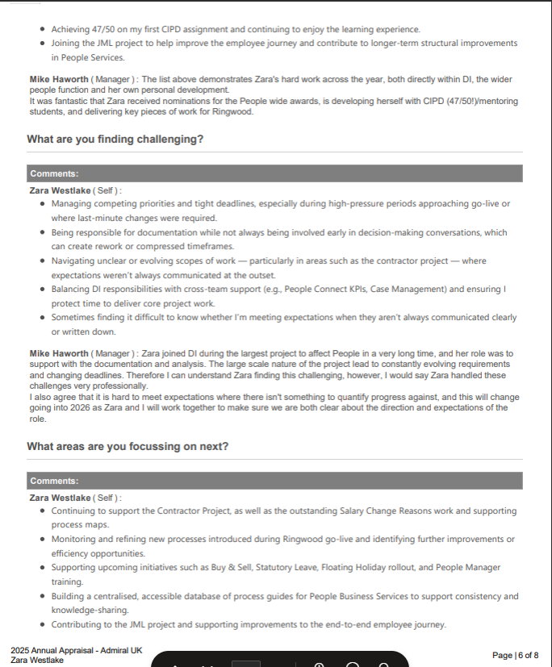

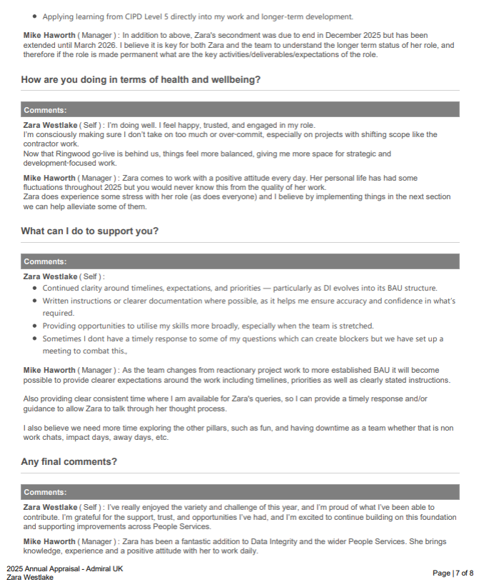
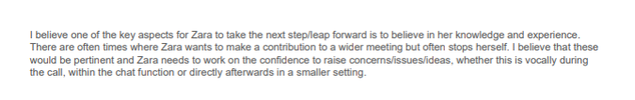

References
Barends, E., Rousseau, D. and Briner, R. (2014) Evidence-Based Management: The Basic Principles. Amsterdam: Center for Evidence-Based Management.
CIPD (2020) Building Inclusive Cultures. Available at: https://www.cipd.org (Accessed: 7 February 2024).
CIPD (2020) Principles-Led, Evidence-Based, Outcomes-Driven: The CIPD Approach. Available at: https://www.cipd.org (Accessed: 18 February 2024).
CIPD (2021) Developing Management Capability. Available at: https://www.cipd.org (Accessed: 3 February 2024).
CIPD (2021) The People Profession 2030: A Collective View of Future Trends. Available at: https://www.cipd.org (Accessed: 22 February 2024).
CIPD (2022) Diversity and Inclusion in the Workplace. Available at: https://www.cipd.org (Accessed: 14 February 2024).
CIPD (2022) Ethical Practice and the Role of People Professionals. Available at: https://www.cipd.org (Accessed: 27 February 2024).
CIPD (2022) Good Work Index. Available at: https://www.cipd.org (Accessed: 9 February 2024).
CIPD (2025) The CIPD Profession Map: Full Standards. Available at: https://www.cipd.org/globalassets/media/comms/the-people-profession/profession-map-pdfs/full-standards-download-a4-updaterefreshnov2025.pdf (Accessed: 16 February 2024).
Treviño, L. and Nelson, K. (2021) Managing Business Ethics: Straight Talk About How to Do It Right. 8th edn. Hoboken: Wiley.

