

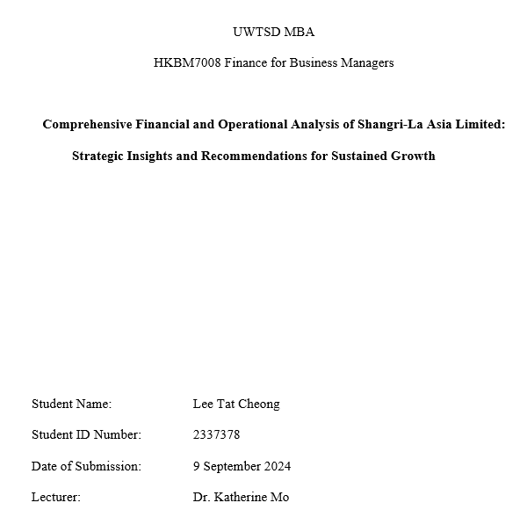

Executive Summary
This report provides a comprehensive financial analysis of Shangri-La Asia Limited, focusing on various aspects such as its financial structure, debt management, operational efficiency, profitability, and growth prospects. The analysis is presented in six key sections that give insight into different areas of the company's performance.

Shangri-La Asia Limited is one of the premium hotel groups operating an EVP-lead portfolio across Asia, the Middle East, Europe, North America, and the Indian Ocean. Having established a better market presence in Asia, the company is still expanding its operation across the globe hand in hand to consolidate its luxury hotel chain or hospitality business.

The financial analysis section of the report deals with an in-depth analysis of the financial ratios of Shangri-La, together with a comparative analysis against two other key industrial players: Hong Kong & Shanghai Hotels and Mandarin Oriental Hotel Group. On the one hand, Shangri-La has shown strength in managing its assets and liquidity management; on the other hand, it also reflects rising leverage and falling profitability compared to peers. In essence, this means that although Shangri-La is doing well on various fronts, there are some key issues for which actions need to be taken to ensure further growth and competitiveness of the company.

The review of Shangri-La's corporate governance shows a strong underlying framework for funding the company's operations. Nevertheless, the report has pointed out areas where improvements must be made, specifically in enhancing transparency and a clear distinction between management and the board. It shows an important factor in ensuring investor confidence and long-term sustainability.

The report added an investment project appraisal where the potential of new investment by Shangri-La is assessed against some financial metrics like NPV and IRR. The results show that with these yardsticks, the project will be viable from a financial perspective and add great value to the company's strategic goals; in other words, it would be a good venture for Shangri-La.

It discusses financing and capital management options for the upcoming Shangri-La projects. Based on this analysis of the pros and cons of the different choices, it advocates bank long-term loan financing as the most suitable option. This is the one that will effectively balance the cost, risks, and financial flexibility. Hence, it is an optimum solution for the company's capital needs.

The report finally presents a few loose ends in the form of recommendations to enhance Shangri-La's financial stability and operational efficiency. Recommendations pertain to the strengthening of internal controls, transparency improvement, and best practices of credit risk management. By implementing these recommendations, Shangri-La will not only continue to maintain its competitive edge in the luxury hospitality industry but also ensure growth and financial stability.

Table of Content

Executive Summary 2
1 Introduction 5
1.1 Company Background 5
1.2 Operating Business Overview (Products and Services and the Sales Market) 5
1.3 Today's Business Environment 6
1.4 Company Structure 7
1.5 Research Comparison Company Information 7
2. Shangri-La's Financial Analysis 8
2.1 Listed Companies of Bankruptcy Index Z-Score Analysis 9
2.2 Financial Structure 11
2.3 Paying Debt Ability 13
2.4 Operational Ability 16
2.5 Profitability 19
2.6 Growth Ability 21
2.7 Stock Market Prospects 21
3. Shangri-La Asia's Corporate Governance Assessment 22
3.1 Corporate Governance of Business Organization and Its Impact and Importance 23
3.2 Shangri-La Asia Existing Corporate Governance 23
3.3 Suggestions for Improvement 24
4. Investment Project Appraisal 25
4.1 Project items basic information 25
4.2 The first-year calculation of sales 25
4.3 Computing Tax Cost 25
4.4 ARR and NPV Calculation 26
4.5 NPV Calculation: 26
4.6 Payback Period and IRR 27
4.7 Investment Appraisal 27
4.8 New Project Appraisal Methods for Analysis 28
4.9 Suggestion for Cash Flow of New Project 28
5. Financing and Capital Management 28
5.1 Financing Methods for Analyzing 29
5.2 Financing Method Proposed 30
6. Recommendations and Audit Program 30
Reference 32

1 Introduction

1.1 Company Background
Shangri-La Asia Limited ("Shangri-La") is a leading luxury hotel group based in Hong Kong. Established in 1971 by Malaysian-Chinese tycoon Robert Kuok, the company opened its first hotel, the Shangri-La Hotel, Singapore, quickly setting the standard for luxury accommodations in Asia. Shangri-La's portfolio now includes 100 hotels and resorts across Asia, Europe, the Middle East, North America, and the Indian Ocean. The group operates under Shangri-La, Kerry Hotels, Traders Hotels, and Hotel Jen, catering to different market segments and offering unique experiences (Shangri-La Asia Limited, 2021).
In 1993, Shangri-La was listed on the Hong Kong Stock Exchange (Stock code: 0069), solidifying its position as a major player in the global hospitality industry. The IPO involved issuing 200 million shares, which raised approximately HKD 2 billion. This successful listing enabled the company to expand its operations significantly, focusing on the rapid growth of the luxury hotel market in China and other key regions (Hong et al., 1993). Shangri-La continues to innovate and lead in the hospitality industry by integrating sustainable practices into its operations and offering personalized services to its guests (Shangri-La Asia Limited, 2022).

1.2 Operating Business Overview (Products and Services and the Sales Market)
Shangri-La Asia Limited operates a diverse portfolio of hospitality products and services, catering to a broad range of market segments. The company's business model is centered around its luxury hotel and resort operations, complemented by other hospitality-related services.

1.2.1 Products and Services
Shangri-La Asia Limited offers various luxury accommodations and services across its four hotel brands—Shangri-La Hotels and Resorts, Kerry Hotels, Traders Hotels, and Hotel Jen—catering to various market segments from high-end luxury to more affordable options. Besides traditional hotels, the company provides serviced apartments for long-term stays, especially for business executives and expatriates, with full amenities for convenience. Additionally, Shangri-La operates a wide array of food and beverage outlets, including fine dining and casual eateries, and offers wellness services through its signature CHI, The Spa. The company also features state-of-the-art meeting and event spaces, ensuring seamless experiences for corporate and social events (Shangri-La Asia Limited, 2021; 2022).

1.2.3 Sales Market
Shangri-La's sales market is geographically diverse, with strong operations in Asia, the Middle East, Europe, North America, and the Indian Ocean region. This is a strategic way to operate a business in key cities and tourist destinations, which would help capture business travelers, leisure tourists, and long-term residents. It is in Asia, where they have their biggest market, with notable properties in China, Hong Kong, Singapore, Malaysia, and the Philippines. In the Middle East, it has further stretched its wings to cities such as Dubai, Abu Dhabi, and Muscat. In Europe, it manages a network of hotels in most key cities - London, Paris, and Istanbul. (Shangri-La Asia Limited, 2022).

1.3 Today's Business Environment
Shangri-La Asia Limited operates in a dynamic business environment influenced by economic recovery, evolving consumer preferences, and technological advancements. Global economies are being recovered from the COVID-19 pandemic by the hospitality sector, in which increased international travel played a key role. Shangri-La has moved along with these improvements in service offerings by integrating personal wellness programs and exquisite dining experiences. On top of the changes in improving its service offerings with personal wellness programs and exquisite dining experiences, it also engages in addressing the rising demand for sustainability through specifically performing some eco-friendly practices such as reducing single-use plastics and enhancing energy efficiency (Shangri-La Asia Limited, 2021; 2022).

1.4 Company Structure
Shangri-La Asia Limited's corporate structure is designed to support its extensive global operations and strategic initiatives. The company is directed by a board of directors and managed by an executive committee responsible for various divisions crucial to its business. These include operations, sales and marketing, human resources, finance, information technology, and corporate social responsibility. These divisions play major roles in ensuring that Shangri-La's expansive portfolio of hotels and resorts is well-managed and highly expanded (Shangri-La Asia Limited, 2021). As of 2021, Shangri-La employs more than 40,000 people worldwide, which means that every year, it has developed much further, and its services in luxury hospitality are in high demand (Shangri-La Asia Limited, 2022).

1.5 Research Comparison Company Information
This study compares Shangri-La Asia Limited with two other prominent companies in the luxury hospitality industry: Hong Kong & Shanghai Hotels, Limited (0045) and Mandarin Oriental Hotel Group (MOIL). These companies have business models similar to Shangri-La's, with high-end hotels and resorts operating worldwide (Mandarin Oriental Hotel Group, 2021; 2022; 2023 & Hong Kong & Shanghai Hotels. 2021; 2022; 2023). Their size and market share are comparable, thus fitting for an in-depth comparison of financial statements. A look into these three companies will provide insight into financial management practices and performance metrics that help better understand the bigger picture of their positioning within the luxury hospitality market (see the following table for detailed comparisons).
Table 1
Comparison of Shangri-La Asia Limited, Hong Kong & Shanghai Hotels, Limited, and Mandarin
Oriental Hotel Group

2. Shangri-La's Financial Analysis
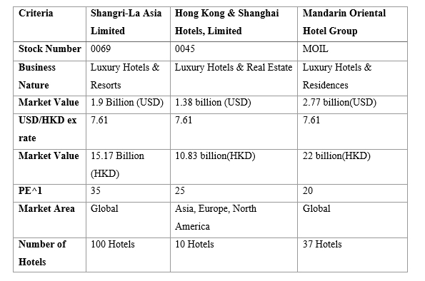

This analysis examines Shangri-La Asia Limited's financial structure, repayment and realization capacity, operating capacity, profitability, growth capacity, market value, and shareholder returns. This comprehensive review compares industry averages and other industry peers: Hong Kong & Shanghai Hotels, Limited and Mandarin Oriental Hotel Group. From an analysis of data obtained from the company's balance sheet, income statement, and financial ratio analysis, the results portray Shangri-La as having a very strong asset base coupled with prudent financial management. The group's leverage—its debt-to-equity ratio and liquidity ratios—indicates good repayment ability. These analytical techniques give an all-inclusive view of Shangri-La's financial health and competitive positioning (Anthony, 2010).

2.1 Listed Companies of Bankruptcy Index Z-Score Analysis
Z-Score is a financial model developed by Edward Altman in 1968 to predict the likelihood of bankruptcy for companies with publicly traded stocks. It considers several financial ratios, all giving a sense of the firm's general health. The lower the score, the higher the probability of bankruptcy. According to Altman's (2013) criteria:
Table 2
Z-Score Analysis of Listed Companies: Shangri-La Asia Limited, Mandarin Oriental Hotel Group, and Hong Kong & Shanghai Hotels
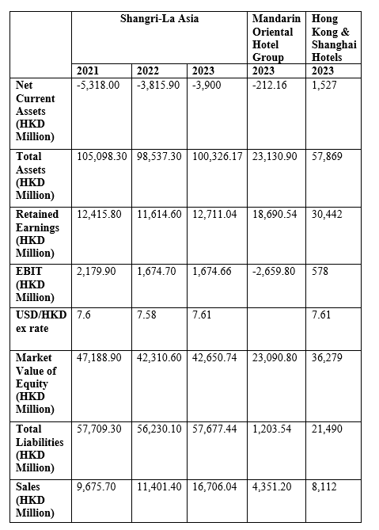
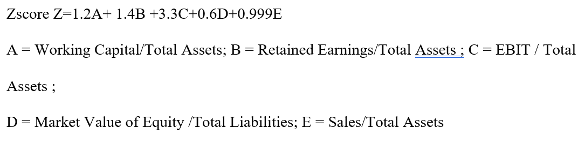
Table 3
Z-Score Calculation for Shangri-La Asia Limited, Mandarin Oriental Hotel Group, and Hong Kong & Shanghai Hotels
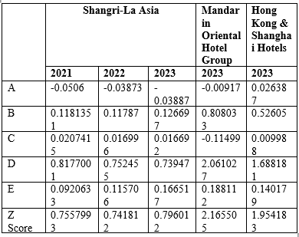

2.2 Financial Structure
Table 4
Financial Structure Comparison of Shangri-La Asia Limited, Hong Kong & Shanghai Hotels, and Mandarin Oriental Hotel Group

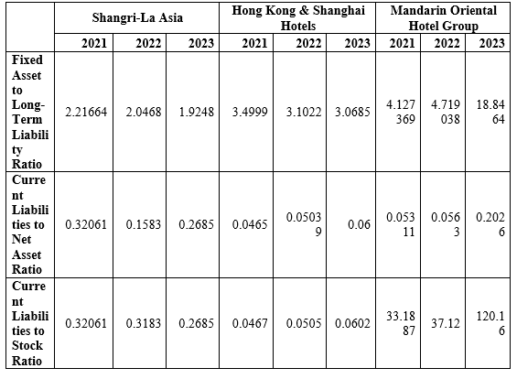

A comparison of the financial structure of Shangri-La Asia Limited with that of peers Mandarin Oriental Hotel Group and Hong Kong and Shanghai Hotels reveals multiple dimensions of financial stability and sustainability through the Fixed Asset to Long-Term Liability Ratio, Current Liabilities to Net Asset Ratio, and Current Liabilities to Stock Ratio. These ratios measure a company's ability to service its long-term financial obligations and provide a short-term financial cushion and the proportion of current liabilities to stockholders' equity (Tsai & Luan, 2016).
Fixed Asset to Long-Term Liability Ratio
The Fixed Asset to Long-Term Liability Ratio is an important measure of a company's long-term financial stability (Admati et al., 2011). Shangri-La Asia Limited has a lower ratio than the other two, falling from 2.22 in 2021 to 1.92 in 2023. This indicates that the company has a marginally safe level of fixed assets. Although Hong Kong & Shanghai Hotels has a higher ratio and a better glance, the figure has dropped from 3.50 in 2021 to 3.07 in 2023. The firm has an even stronger ratio in this category, with an increase from 4.13 in 2021 to 18.85 in 2023, which reflects the very strong ability to cover long-term liabilities with fixed assets and a highly stable financial position.
Current Liabilities to Net Asset Ratio
The Current Liabilities to Net Asset Ratio measures how much of a company's net assets are financed by short-term liabilities (Merton, 1974). An enlarged ratio may imply that a company is facing trouble in liquidity, while a decreased ratio suggests that the financial health is great (Didenko et al., 2012). The case of Shangri-La reflects the varying ratio from 2021, when it was accounted for at 0.32, reduced to 0.16 in 2022, and rose again to 0.27 in 2023. It develops changes in the enterprise's short-term obligations, where the latest increase testifies to a slight move higher in short-term liability. For instance, Mandarin Oriental Hotel Group and Hong Kong & Shanghai Hotels have maintained much lower ratios, reflecting stronger short-term financial positions. A low ratio suggests a fairly good liquidity position, allowing a company to meet its short-term obligations using net assets readily.
Current Liabilities to Stock Ratio
The Current liabilities-to-stock ratio shows how much a company relies on short-term liabilities compared to its shareholders' equity (Umar et al., 2012). A lower ratio is better, as this would mean not having to depend much on short-term financing (Anam & Rokhim, 2023). For Shangri-La, the ratio was almost constant. It decreased to a small extent from 0.32 in 2021 to 0.27 in 2023, indicating that the company's current liabilities were effectively managed sustainably. Hong Kong & Shanghai Hotels Group slightly increased its ratio from 0.047 in 2021 to 0.060 in 2023, with very minute percentages reflecting little dependency on short-term liabilities. This ratio is very high for Mandarin Oriental Hotel, currently standing at 120.16 in 2023, representing the rise in the state of the company's dependency on short-term liabilities compared to its equity, and this should work as a risk signal for the company in terms of short-term financial stability.
In summary, Shangri-La Asia Limited's financial structure shows mixed results. While this company is still considered stable overall, the decreasing Fixed Asset to Long-Term Liability Ratio, alternating Current Liabilities to Net Asset Ratio, and decreasing Gross Profit Margin point out improving opportunities in financial stability, short-term liquidity, and profitability.

2.3 Paying Debt Ability
Table 5
Debt-Paying Ability Comparison of Shangri-La Asia Limited, Hong Kong & Shanghai Hotels, and Mandarin Oriental Hotel Group
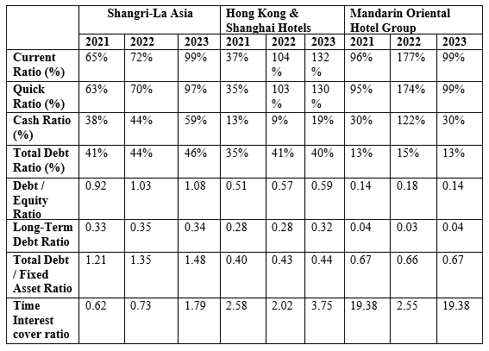

Current Ratio/ Quick Ratio
Shangri-La Asia and Hong Kong & Shanghai Hotels have significantly improved liquidity positions over the past few years. The current and quick ratios of Shangri-La have both substantially risen to 99% and 97%, respectively, in 2023 from their respective ratios of 65% and 63% in 2021, thus showing stronger short-term liquidity. In the case of Hong Kong & Shanghai Hotels, there was likewise an equally steep rise of both ratios, wherein its respective current and quick ratios increased threefold to fivefold during the same period, from 37% to 132% and from 35% to 130%, thus enormously indicating an improved robustness in liquidity. In contrast, Mandarin Oriental Hotel Group has maintained a much more discrete level of liquidity, with its current and quick ratios very close and hovering consistently around 96% to 99%. This reflects reliable and consistent liquidity management.

Cash Ratio
The cash ratio of Shangri-La Asia has been gradually improving from 38% in 2021 to 59% in 2023, indicating an enhanced ability to pay short-term liabilities by cash. If one looks at Hong Kong & Shanghai Hotels, some improvement can be witnessed, but it still has a relatively low cash ratio; though improved, it rose from 9% in 2022 to 19% in 2023—both show limited capacity to cover all liabilities using cash. Meanwhile, Mandarin Oriental Hotel Group experienced a significant peak in its cash ratio at 122% in 2022 before stabilizing to a more moderate, yet healthy, level of 30% in 2023.

Debt / Equity Ratio
The debt-to-equity ratio of Shangri-La Asia has risen from 0.92 in 2021 to 1.08 in 2023, indicating the rising leverage that may add to the financial risk if not managed properly. The debt-toequity ratio of Hong Kong & Shanghai Hotels has risen slightly from 0.51 in 2021 to 0.59 in 2023; however, it is still at a moderate level, reflecting a balanced approach toward leveraging debt. On the other hand, Mandarin Oriental Hotel Group has been able to keep a low and fairly stable debt-to-equity ratio of 0.14 to 0.18, thus demonstrating it as conservative in taking on debt financing with an overall lower risk to its financing.

Total Debt / Fixed Asset Ratio
The total debt-to-fixed-asset ratio measures the debt financing a company has placed into its fixed assets (Triyono et al., 2019). Hence, an increasing ratio indicates high gearing and general fundamental financial risk. For Shangri-La Asia, this went up within three years from 1.21 in 2021 to 1.48 in 2023, indicating an increasingly higher use of debt to finance fixed assets, hence potential risks if not managed carefully. In contrast, Hong Kong & Shanghai Hotels has kept the ratio largely flat, moving it from 0.40 in 2021 to 0.44 in 2023, indicating its cautiousness toward leveraging the fixed assets.

Time Interest Cover Ratio
The interest cover ratio of Shangri-La Asia has risen very strongly from 0.62 in 2021 to 1.79 in 2023. This improvement shows that it better manages the interest burden distribution with income. Of importance, Hong Kong & Shanghai Hotels supported the financial position further, with the ratio being 2.58 over 3.75 for the same period. On the other hand, Mandarin Oriental Hotel Group has a very high time interest cover ratio, showing strong financial stability and excellent capability to cover interest expenses with earnings.
Paying Debt Ability Analysis
Finally, Shangri-La Asia Limited has improved its position to settle debt, as can be derived from improving liquidity ratios and increased time interest cover ratio. The increasing debt ratios have caused the company to increase leverage, which may be quite risky if it cannot handle it.

2.4 Operational Ability
Shangri-La Asia Hotels has exhibited operational excellence over the last three years. Sales revenue improved from HKD 9,431.6 million in 2021 to HKD 16,277.68 million in 2023. There is a clear indication that Shangri-La is managing its operations well and attracting many customers. The huge increase in sales in 2023 indicates that the company would have expanded its hotel services or enhanced customer experience through other means, increasing revenues every year.
Figure 1.
Shangri-La Asia Hotels, Hong Kong & Shanghai Hotels, and Mandarin Oriental Hotel Group Revenue Comparison (2021-2023).

Hong Kong & Shanghai Hotels demonstrated strong growth, increasing its sales from HKD 3,461 million in 2021 to HKD 8,112 million in 2023, reflecting effective operational strategies. Mandarin Oriental Hotel Group also saw steady sales growth, rising from HKD 2,408.4 million to HKD 4,241.56 million during the same period. While Shangri-La leads in total sales, the rapid expansion of Hong Kong & Shanghai Hotels and the stable performance of Mandarin Oriental suggest both are formidable competitors in the market.
Figure 2.
Sales Revenue Trends for Shangri-La Asia Hotels, Hong Kong & Shanghai Hotels, and Mandarin Oriental Hotel Group (2021-2023).

Operating Expenses
Shangri-La Asia's operating expenses have varied over the past three years, including team member costs, depreciation and amortization, rental expenses, and other expenses. Team member costs have steadily increased from 30% in 2021 to 35% in 2023, averaging 33%, which suggests Shangri-La is investing more in its workforce, possibly by hiring more staff or offering better pay. Depreciation and amortization have slightly decreased from 9% in 2021 to 7% in 2023, showing more efficient use of assets. Rental expenses have stayed stable at around 7% each year. However, other expenses have risen significantly from 16% in 2021 to 23% in 2023, possibly due to higher costs for utilities, promotions, or other operations.

Table 6
Operating Expenses Comparison of Shangri-La Asia Limited, Hong Kong & Shanghai Hotels, and Mandarin Oriental Hotel Group
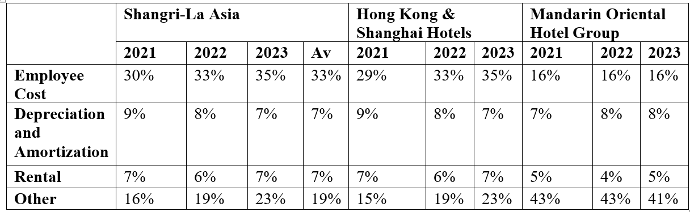
Shangri-La's employee costs align closely with those of Hong Kong & Shanghai Hotels, reaching 35% in 2023, while Mandarin Oriental maintains significantly lower employee costs at 16%, indicating a different operational strategy. Depreciation and amortization expenses are consistent across all three companies, reflecting standard industry practices. However, Mandarin Oriental's significantly higher other expenses (41-43% compared to Shangri-La's 19%) suggest a different business model that may focus more on other operational investments. Shangri-La's operating expenses are competitive, though certain areas may benefit from further efficiency improvements.

2.5 Profitability
Table 7
Profitability Comparison of Shangri-La Asia Limited, Hong Kong & Shanghai Hotels, and Mandarin Oriental Hotel Group

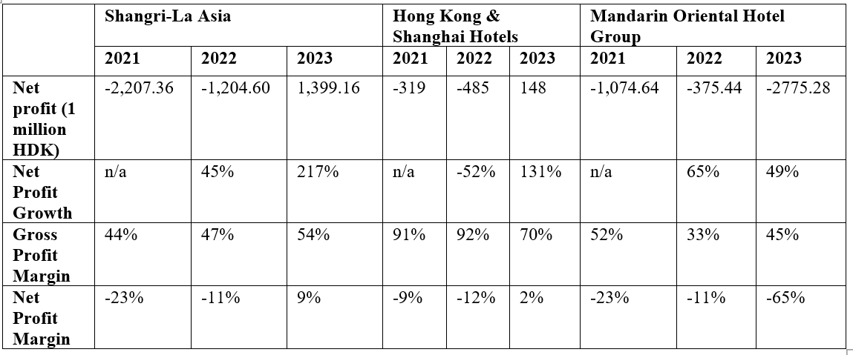
Shangri-La Asia's profitability has significantly improved over the past three years. Its gross profit margin rose from 44% in 2021 to 54% in 2023, showing better cost management and higher profitability. However, while Shangri-La's margins are improving, they still lag behind Hong Kong & Shanghai Hotels, which saw its gross profit margin decrease from 91% in 2021 to 70% in 2023. Mandarin Oriental Hotel Group experienced fluctuations, with its gross profit margin dropping from 52% in 2021 to 33% in 2022 before recovering to 45% in 2023. It dropped from a net profit margin of -23% in 2021 to 9% in 2023, meaning that Shangri-La had recovered financially. This relative comparison makes a fine case for Shangri-La to turn around. At the same time, its peers have fared differently, wherein Hong Kong & Shanghai Hotels improved slowly, and Mandarin is struggling to find profitability.

Table 8
Financial Ratios Comparison of Shangri-La Asia Limited, Hong Kong & Shanghai Hotels, and Mandarin Oriental Hotel Group
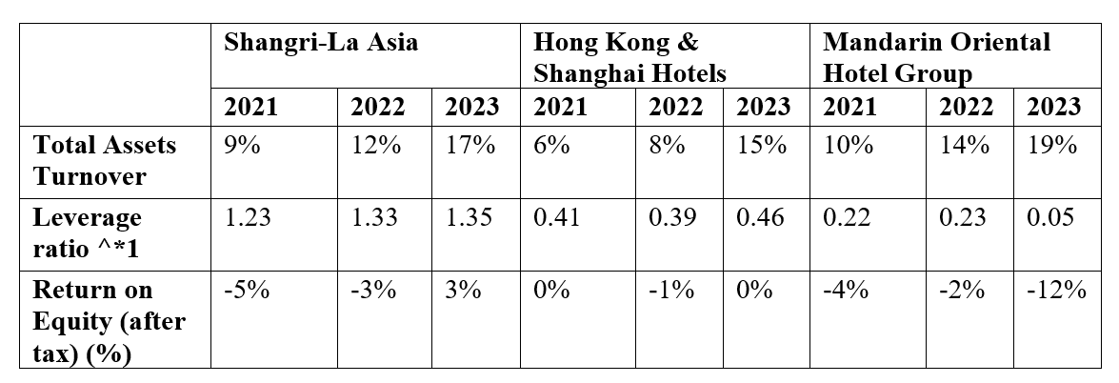
Shangri-La Asia has improved its Return on Equity (ROE) from -5% in 2021 to 3% in 2023 by increasing its leverage, which raises financial risk. Compared with Hong Kong & Shanghai Hotels, it has had a rather stable leverage ratio and ROE that have remained more or less the same over the years, reflecting a very conservative attitude toward debt. In contrast, Mandarin Oriental Hotel Group's ROE has declined from -4% to -12% when its leverage is low, implying the trouble is more related to operational inefficiency than exuberant borrowing. Shangri-La's rising leverage has fueled its ROE, but it must be extremely careful when handling the risks that arise. Hong Kong & Shanghai Hotels is conservative and steady, with muted returns; Mandarin Oriental must focus on operational improvement.

2.6 Growth Ability
Table 9
Growth Ability Comparison of Shangri-La Asia Limited, Hong Kong & Shanghai Hotels, and Mandarin Oriental Hotel Group
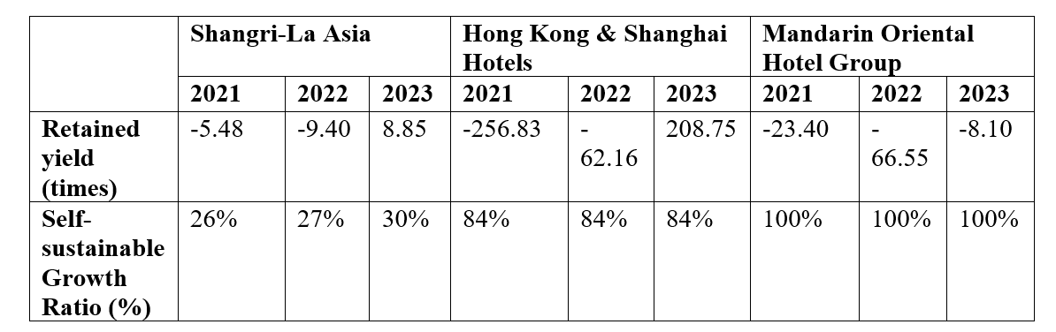
Shangri-La Asia has improved its growth ability, with a significant shift in retained yield from negative figures in 2021 and 2022 to a positive 8.85 times in 2023, signaling better earnings retention and future stability. However, this remains a far weaker self-sustainable ratio than its peers, as Hong Kong & Shanghai Hotels have returned 84%. The Mandarin Oriental Hotel Group has returned 100% during the past three years. Dialogue: Though Shangri-La's self-sustainable growth rate gradually dropped from 26% to 30%, the company would have to implement further augmentations of its growth strategy in order to harness the fuller potential of its retained earnings and bridge the gap with industry competitors.

2.7 Stock Market Prospects
Table 10
Stock Market Prospects Comparison of Shangri-La Asia Limited, Hong Kong & Shanghai Hotels, and Mandarin Oriental Hotel Group

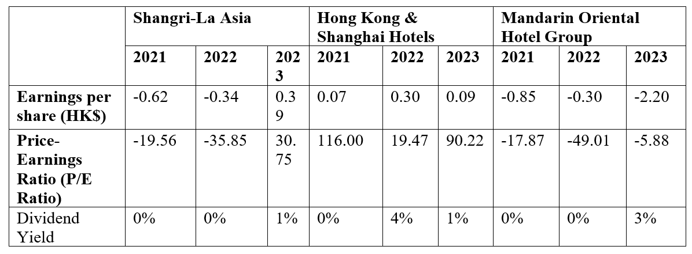
Shangri-La Asia has improved its stock market prospects, transitioning from negative P/E ratios in 2021 and 2022 to a positive 30.75 in 2023, alongside a modest dividend yield of 1%. This could indicate a recovery in earnings accompanied by increasing investor confidence. Hong Kong & Shanghai Hotels would still be more attractive to investors due to the ever-high P/E ratios and the stable dividend yield reflecting strong future earning potential. On its part, Mandarin Oriental Hotel Group is still experiencing a tough time posting negative P/E ratios but with slight improvements in the dividend yields to 3% in the year 2023, an indication that despite their continued profitability challenges, they make some return to investors.
3. Shangri-La Asia's Corporate Governance Assessment
Chapter 2's analysis of Shangri-La Asia's financial performance reveals strengths and concerns, particularly in debt ratios and operational costs, which impact long-term development and shareholder interests. This section will assess the influence of corporate governance on financial health and review internal controls and risk management to identify and address potential shortcomings.

3.1 Corporate Governance of Business Organization and Its Impact and Importance
The financial crises and corporate scandals of the late 1990s and early 2000s emphasized the importance of strong corporate governance in maintaining investor confidence and financial stability. These events showed that poor governance can lead to the downfall of even large corporations, leading to stricter government oversight and regulations (Shleifer & Vishny, 1997).
Corporate governance encompasses the systems and processes by which companies are controlled and directed, assigning roles and responsibilities among shareholders, the board of directors, and management (Cadbury, 1992). A sound framework of corporate governance establishes clear decision-making, accountability, and control mechanisms at the heart of company performance enhancement, protection of the interests of shareholders and stakeholders, and long-term sustainability (OECD, 2004).
It has been deduced that firms with good corporate governance structures are better at attracting investment and realizing superior performance in financial terms (Gompers, 2003). In other words, this would imply that in an atmosphere like Asia's, where investors' confidence can be easily shaken, transparency and accountability become prime necessities for building trust in enterprises (Claessens & Fan, 2002).

3.2 Shangri-La Asia Existing Corporate Governance
Shangri-La Asia operates under the significant influence of its majority shareholders, which impacts its corporate governance structure by potentially limiting transparency and accountability. Though this gives effective concentration in decision-making processes, it raises concerns over the distribution of powers within the company. However, recent positive changes in ROA and ROE show that the governance framework has delivered positive results (Fan et al., 2011).

Table 11
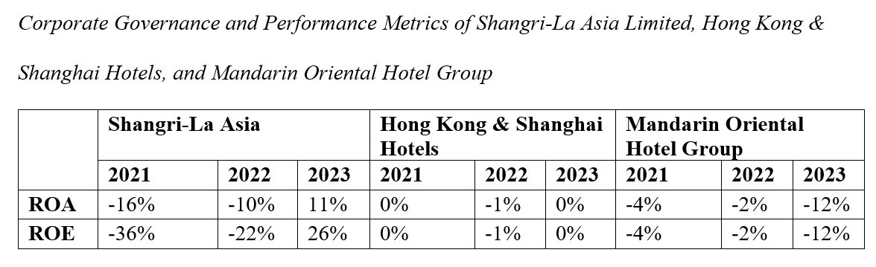
Majority shareholders dominate Shangri-La's governance structure; this predisposes minority shareholders to possible conflicts of interest and lack of transparency. It may result in decisions, behaviors, and actions being taken more preferentially by majority shareholders to the detriment of others (Claessens et al., 2000). Shangri-La needs to allay this by enhancing its corporate governance practices that promote transparency and accountability, hence safeguarding the interests of both majority and minority shareholders.

3.3 Suggestions for Improvement
To enhance its corporate governance and ensure the continued financial stability and growth of Shangri-La Asia Limited, several recommendations are proposed:
- Separation of Management and Board Roles: The roles of management and the board of directors must be kept separate.
- Strengthening Independent Director Monitoring: The company must add more independent directors so that board decisions are more credible and there is proper monitoring of the board's decisions.
- Enhancing Transparency and Disclosure: Shangri-La should enhance its transparency in its operation. Particularly increasing disclosure of the associate transactions that occurred with the significant shareholders.
- Internal Control and Risk Management: The company should strengthen its internal control mechanisms to ensure that all the departments are duly monitored.
- Credit Risk Management: Shangri-La should implement an internal credit rating assessment system to manage its relationships with financial institutions better.

4. Investment Project Appraisal
Shangri-La Asia Limited experienced a strong financial recovery in 2023, with a 46.5% increase in consolidated revenue and a near doubling of EBITDA, driven by the resurgence in global travel. The company plans to continue its expansion strategy, using financial metrics like NPV and IRR to ensure new investments' profitability and long-term growth (Shangri-La Asia Limited, 2023).

4.1 Project items basic information
Table 12
Basic Information on Project Items for Shangri-La Asia Limited
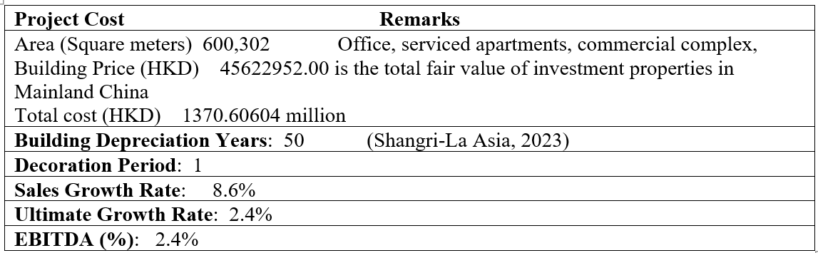

4.2 The first-year calculation of sales
Table 13
First-Year Sales Calculation for Shangri-La Asia Limited
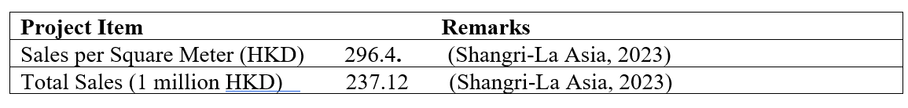

4.3 Computing Tax Cost
Table 14
Tax Cost Calculation for Shangri-La Asia Limited (Unit: 1 million HKD)
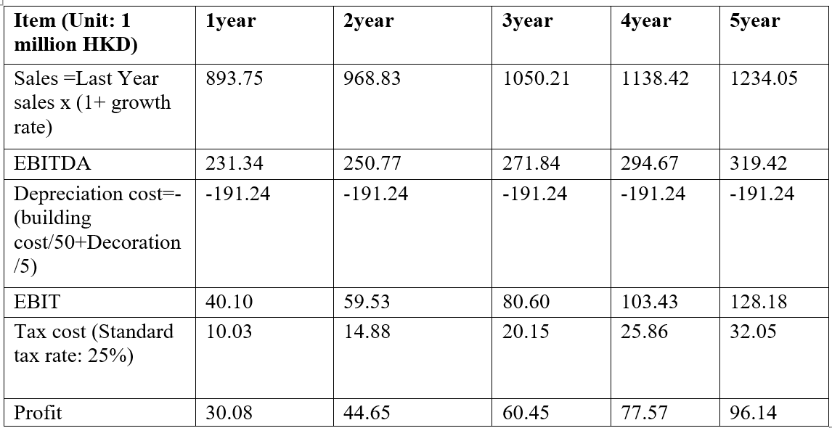

4.4 ARR and NPV Calculation
ARR= (Average Annual Profit/ Initial Investment) x 100
Average Annual Profit = ((30.08 + 44.65 + 60.45 + 77.57 + 96.14)/5) = 61.378
ARR = (61.378/1370.60604 )x100= 4.45%

Table 15
ARR Calculation Summary
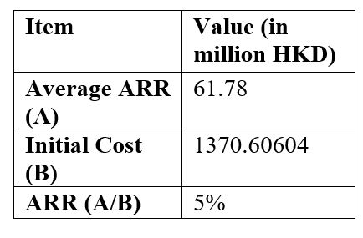

4.5 NPV Calculation:
NPV is the sum of all these present values minus the initial investment.
Table 16
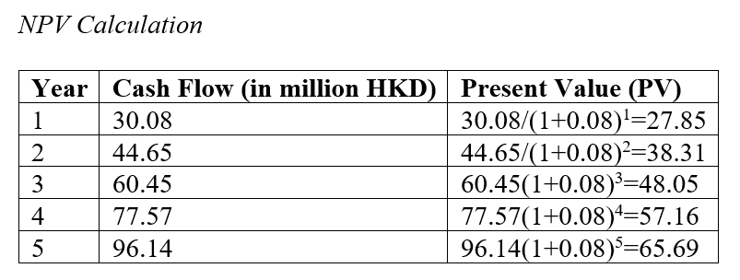
NPV=Total Present Value of Cash Flows−Initial Investment
NPV= (27.85+38.31+48.05+57.16+65.69) −137060.604 NPV=237.06−137060.604=−136823.544 million
Final NPV:
NPV=−136823.544 million HKD

4.6 Payback Period and IRR
Table 17
Payback Period and IRR
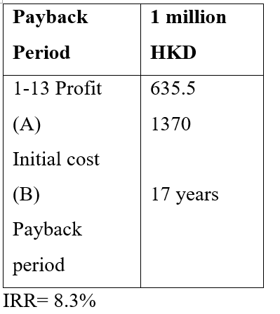

4.7 Investment Appraisal
The investment project shows a positive outlook, with a net present value indicating expected earnings exceeding the initial investment. The payback period is reasonable, making it advisable for Shangri-La to proceed with the project to enhance financial performance and achieve strategic goals.

4.8 New Project Appraisal Methods for Analysis
- Investment Returns: The project's first-year return is relatively modest at 4%, reflecting the initial stages of the investment. However, as the project matures, the returns are expected to increase, showcasing the long-term potential of the investment. The advantage of this method is its simplicity, though it does not account for the time value of money.
- Accounting Rate of Return (ARR): The ARR for the project is calculated at 15.7%, which is higher than the company’s current return on assets, indicating that the project is a worthwhile investment. The ARR provides a clear picture of the project's long-term profitability, considering the average annual profit over the investment's lifespan.
- Internal Rate of Return (IRR): The project’s IRR is calculated at 10.6%, which, while moderate, reflects a rate of return that exceeds the company’s hurdle rate. The IRR method is advantageous because it considers the time value of money and helps compare the project's profitability with industry standards.

4.9 Suggestion for Cash Flow of New Project
For the new project, ensuring adequate cash flow, projected at HKD 137 million for the first year, is crucial and manageable within Shangri-La's current financial resources. Utilizing internal funds will minimize the need for external financing, keeping the project financially viable and aligned with the company’s cash flow strategy.

5. Financing and Capital Management
Shangri-La Asia Limited must adopt financing strategies that balance cost, risk, and liquidity to support its expansion projects and ensure financial stability. The company can explore various financing options tailored to the specific needs of each project and the prevailing financial conditions.

5.1 Financing Methods for Analyzing
Table 18
Financing Methods Analysis for Shangri-La Asia Limited, Hong Kong & Shanghai Hotels, and Mandarin Oriental Hotel Group (HKD millions)

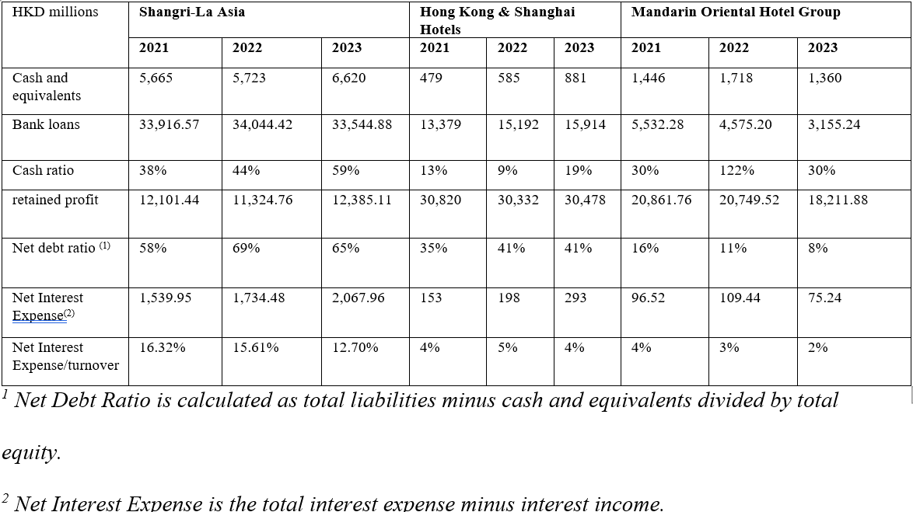
- Cash Payments: Shangri-La could consider using internal retained earnings and cash as funding sources. The company's financial status is stable, reflected in its improved cash ratio from 38% in 2021 to 59% in 2023. Utilizing internal funds would minimize interest costs and preserve ownership equity. However, this could also reduce the cash available for other opportunities or unexpected needs.
- Bank Loan Financing: Shangri-La has relationships with major financial institutions. The company could leverage these to secure long-term loans with favorable terms. While the net interest expense as a turnover percentage has decreased from 16.32% in 2021 to 12.70% in 2023, further borrowing would increase the company's debt load, potentially impacting the net debt ratio, which currently stands at 65% for 2023.
- Commercial Credit Financing: This option involves obtaining credit from suppliers or customers. Given the company's stable financial performance, it might be feasible to negotiate favorable terms. However, relying less on commercial credit could lead to liquidity risks if the company faces delays in receivables or unexpected payable increases.
- Issuance of Shares: Shangri-La could consider raising capital by issuing new shares. This would increase equity and reduce reliance on debt. However, it would also dilute existing shareholders' equity and might not be favorable if the market perceives the company's stock as undervalued.
- Sale of Assets: Another option could be selling non-core assets to raise capital. While this would immediately improve liquidity and reduce debt, it could also lead to a loss of revenue-generating assets and potential long-term growth opportunities.

5.2 Financing Method Proposed
It is recommended that Shangri-La Asia Limited pursue long-term bank loan financing to fund upcoming projects, as this option would secure necessary capital while preserving cash reserves. Given the company's stable financial status and manageable net interest expenses, the additional debt is unlikely to strain its finances. The proposed 5-year loan with a competitive interest rate would balance the company's capital structure, supporting continued growth.

6. Recommendations and Audit Program
Following the data analysis, the following recommendations are proposed for Shangri-La Asia Limited to improve its operations and financial management:
- Separation of Management and Board Roles: Enhancing the board's independence by reducing the overlap between management and board members is essential. This would improve oversight and ensure the board can objectively monitor management's performance.
- Strengthening Independent Director Monitoring: It will further increase the credibility of the company's governance structure and aid in confidence among its investees, particularly the minority shareholders, with more independent directors on the board.
- Improved Transparency and Disclosure: Shangri-La should increase its financial transparency, particularly in transactions involving important company shareholders. Greater transparency through disclosure in annual reports will help dampen concerns over conflicts of interest.
- Internal Control and Risk Management: The company should, at regular intervals, perform audits/surprise checks in order to develop its internal controls to ensure operational efficiency and compliance with company policies, excluding the risk of operational inefficiency and ensuring the safety of assets.
- Credit Risk Management: Shangri-La needs a much more robust internal credit rating system to manage the company's relationship with financial institutions. Besides letting its credit ratings improve, it can also bring down financing costs in the long term.

By adopting these recommendations, Shangri-La Asia Limited will be able to enhance the group's corporate governance, maintain its financial stability, and continue to grow within the competitive luxury hospitality market.

References


