

Module : Strategic Development and Implementation for SMEs
Module code: BMSW6104
Student : Md. Abdul Q Chowdhury
Student ID : 2119999
Lecturer : Mr . Toyin Adisa

Table of Contents
Executive Summary
1.0 Introduction 1
1.1 Company Overview 1
2.0 Strategic Statement 2
2.1 Mission 2
2.2 Vision 2
2.3 Objective 2
2.4 Strategy 2
3.0 Environmental Analysis 4
3.1 SWOT Analysis 4
3.2 PESTEL Analysis 5
5.0 Strategic Growth 7
5.1 Porter’s Generic Strategy Model 7
5.2 Ansoff Matrix Model 10
5.3 Recommended Strategy for Sustainable Growth 12
6.0 Stakeholder Analysis 14
6.1 Company/ Owner and Staff Stakeholder Analysis 14
6.2 Supplier and Customer Stakeholder Analysis 14
7.0 Strategic Recommendations 16
8.0 Conclusion 18
References 20

Executive Summary
This report comprises with secondary data and depicts a detailed strategic analysis of the London-based SME, Plus Samples, a fashion company that became known in the industry for its high-quality, sustainable fashion samples. The techniques used to assess Plus Samples’ potential include the SWOT analysis that unpacks its strengths, including its sustainable operation and strategic location, and weaknesses like economic fluctuations and intense competition. PESTEL analysis that reveals the external impacting the growth of the company. Strategical recommendations involve improving digital presence, implementing smart technologies, and expanding market access. This report provides the key points that support Plus Samples' market position, the next part (Growth opportunities and strategies) will focus on long-term success in evolving the fashioning industry.
1.0 Introduction
Strategy is a roadmap for a company that navigates through a competitive landscape. A company commences with certain strengths, and opportunities therefore, it faces threats and difficulties while functioning and expanding its horizon ( Dahalin, 2020). Then, the strategy comes up to the role. It helps to recognize the challenges and combat them using strengths and foresight. Strategy also assists in taking advantage of opportunities and achieving bigger goals (Svechin and Lee, 2004). There are internal and external pressures on a company that prevents it from obtaining core competencies and competitive advantage. However, with a comprehensive plan and set of actions for long-term and sustainable goals and objectives, a company can succeed in this direction.
Strategic management, which involves the implementation of the actions of the company for the achievement of the desired goals, is a continuous process that implies the monitoring of the company's performance in comparison with the plan and ensuring that the company acts accordingly (Rothaermel, 2021). It is about maintaining a well-managed work speed and tracking the elective expenses simultaneously to fix things when it is the need of the hour.

1.1 Company Overview
Plus Samples on their apparent website show that the company is a Small and Medium-sized Enterprise (SME) that concentrates on the areas of the fashion industry and is provided with good quality clothing samples. The company was a one-woman in-house operation and was founded by Nailya Belkacemi. It is a London-based company that started its journey in 2003 (Plus Samples, 2024). With the urge to develop the fashion industry, the company functioned with a dedicated team and expanded its range of services. The operation was expanded by the time and the team kept growing with dedicated and experienced individuals. Their team consists of 11 sample mechanists, 1 studio manager and 2 garment cutters and patterns cutters. The company focuses on CMT (Cut, Make, Trim) of clothes and designs for both male and female customers (Plus Samples, 2024).

2.0 Strategic Statement

2.1 Mission
The mission of Plus Samples is to revolutionize the fashion industry with wearable clothing samples that are unique, creative and sustainable to meet the rapidly increasing demand and set a benchmark (Plus Samples, 2024).

2.2 Vision
The company aims to be a leading clothing designing partner and cooperative with their professional craftsmen, and sustainable practices (Plus Samples, 2024).

2.3 Objective
The company wants to expand its horizon by offering services to a greater number of clients and engaging with top-end fashion houses improving their work while eliminating any incompetencies in expertise (Plus Samples, 2024).

2.4 Strategy
Plus Samples Ltd. has a strong tendency to produce a high level of garment manufacturing and collaborate with well-end fashion designers and retailers, their current market strategy surely cherishes tailor-made production and craftsmanship. They go hand-in-hand with both flourishing start-ups as well as renowned brands which shows the rather flexible nature of market requirements. The fact that their ‘no minimum order’ ethos caters to sophisticated small, and one-on-one relationships, attracts start-up businesses, while their capacity for CMT production suggests a wide range of services that is preferable by everyone. With this approach, they have secured a dominant position in the premium level of the fashion production field, placing an emphasis on quality, adaptability, and a collaborative approach (Plus Samples, 2024).
Plus Samples is trying really hard to picture itself as a leading creative and cooperative partner which provides detailed and quality work. They go for it from a simple scribble to the catwalk working as a functioning growing company of custom clothing in London. For the clients meeting the highest standards of fashion, they offer specialized services on the sampling and production of the clothing. It is a design studio operating its first production line or a well-established fashion house that seeks the friendly and productive cooperation of a factory – all situations they have dealt with they understand the enormous commitment needed in the industry. They understand that the main principle behind the most important design sketch and the highest quality of each stitch should be satisfied. By specializing in providing CMT services such as samples as well as projects from various needs, operates sampling, production and grading services with no MOQ (Maximum Order Quantity). They can process orders of 150 pieces at a maximum per style to be able to carry out the production process. The cutting of patterns and sampling are developed through drawings and inspirational pictures. While for production orders, a complete tech pack is an absolute necessity to raise the discussions, on the other hand, for marketing purposes, a small part of the tech pack is sufficient to market the product (Plus Samples, 2024).

3.0 Environmental Analysis

3.1 SWOT Analysis
By conducting a SWOT analysis, the stakeholders will get a complete picture of internal and external factors that have an immense impact on a company. Where on one side, the company’s inside advantages and disadvantages will come to light, on the other side, measurements to grab the opportunities and deal with threats will be taken (Lubis, Marhayanie and Hasibuan, 2019). So, reflection and action both can be obtained through this tool. SWOT analysis of Plus Samples is elaborated below:
SWOT Analysis of Plus Samples
Strengths:  - There are many sample companies scattered around the nook and corner of London. But what makes Plus Sample is its core focus on quality, creativity and uniqueness which is an asset for the company.  - The company particularly specializes in CMT (Cutting, making, trimming) as they have a strong control over designing patterns and producing them.  - Their location is a hub of fashion where giant fashion companies make millions of euros. Thus, Plus Sample has a strategic advantage. | Weaknesses:  - As they operate on an order-per-minimum basis, it would be difficult for them to handle larger batches.  - As Plus Samples is a high-end fashion industry cantered, they would be at a great loss if the industry faced any downturns.  - In order to keep up with the increasing demand, their sustainability ethos can be compromised as fast fashion is on trend.
Opportunities:  - There is an enormous number of environment-conscious people who seek sustainable items of clothing. Meeting their requirement will bring diverse collaboration and growth.  - Digital exposure and online marketing will assist in taking advantage of global markets. The boundary of the company will not be limited to the U.K. solely. | Threats:  - Competition is a great threat for Plus Sample. Many players in the garment sector are offering inexpensive options.  - Fashion trends are dynamic. To predict the direction of trends is very risky. So, the economic falloff and changes in the direction of the trends may cost a fortune.
Table 1 SWOT Analysis of Plus Samples

3.2 PESTEL Analysis
PESTEL analysis covers six external factors that threaten the expansion, efficiency and sustainability of a company. Political, environmental, social, technological, economic and legal factors are assessed to measure the outer impedance (Kampanje, 2020). As Plus Samples is an SME and has the potential to outgrow its competition, it needs to evaluate the external forces carefully. Below is the PESTEL analysis of Plus Samples :
PESTEL Analysis of Plus Samples
Political Forces | - Trade policies have an impact on the industry, via setting up tariffs and taxes that affect the import of materials and finished products, which go a long way to determine production costs and prices.  - Labor Laws which define practices on employment and the cost structures, hold a significant bearing on global competition and operating efficiency, mostly where workers’ protection has the strictest regulations.  - Brexit has added uncertainties as far as trade between the UK and EU is concerned, thus creating possible new costs and supply-chain disruptions for fashion industry players for raw materials and European sales, resulting in decision-making for procurement and distribution strategy.
Economic Forces | - Economic conditions are related in a way that disposable income always reacts to economic shifts and recessions. In the fashion industry where budgeting is discretionary, changes in the economy affect consumer spending.  - Large consumer spending is characterised by times of economic growth thus boosting the demand for fashion. Cases such as low consumer confidence and high inflation rates are some of the major causes of the decline in fashion spending. Non-essential items may not be the first options to spend on. This will then require brands to reconsider pricing, strategies, and product offerings.  - The overall dynamics of the economy, too, are the determinant of the inflows into new designs and technologies as well as influence the sector’s innovation process and growth agenda.
Social Forces | - Sustainable fashion as well as ethical fashion brings about a notable change in the sphere of fashion triggering the brands to have their priority on eco-friendly materials and transparent supply chains.  - This era is at the forefront of innovation in sustainable practices, which potentially increases costs but at the same time, opens up various market segments.  Eco-friendly brands that adjust to these expectations can create a positive brand reputation and consumer loyalty which makes ecologic-minded shoppers demand responsible fashion.
Technological Forces | - Using updated manufacturing technologies, like automated cutting and sewing machines and digital fashion design tools, profoundly increases efficiency and quality in the fashion industry.  - These innovations simplify production, eliminate waste and provide accurate construction which enable brands to respond quickly to the dynamic market trends.  - Having this technological advantage enables the company to produce better quality apparel with faster and less costly processes, and therefore a significant competitive edge in a very dynamic market.
Environmental Forces | - Along with sustainable production, investing in importing green materials and green processes leaves a more sustainable footprint.  - Environment-friendly manufacturing process that has lesser impact on the environment enriches the brand reputation.  - Abiding by environmental compliance offers a competitive advantage and attracts eco-conscious customers.  - These strategies could be expensive in the primary stage of a company however shortcut success does not stay long.
Legal Forces | - Legal frameworks of the fashion industry including health and safety, employment laws, and intellectual property rights - these are the rules that largely determine and direct the central features of the operations.  - Compliance prevents worker safety issues and any unlawful treatment, often leading to lower costs by including a higher percentage of payments to employees and safety measures.  - Intellectual property laws constitute the shield for design innovation, an essential demand by the owners for preserving what unique and competitive edge belongs to them.  - Achievement of this legislation's goals can be either an additional burden or a competitive advantage for a brand. Nevertheless, somehow companies have to find a way to compatibilized their legal compliance needs with their operational efficiency imperatives.
Table 2 PESTEL Analysis of Plus Samples

5.0 Strategic Growth

5.1 Porter’s Generic Strategy Model
- Cost Leadership Strategy: If Plus Samples followed a cost leadership strategy, it would negate its mission to display sustainable and superior quality product samples. Its main offer on the market is reflected by its samples of green clothing, which are probably made up of higher standards of processing, materials and employment- two essential key factors costly. Cost Leadership could influence the brand perception among the target consumers of Plus Samples, the high-end brand owners and designers who desire to have a simplifying service at a premium level (Polo and Weber, 2010). Such clients might be inclined to connect lower costs to lower quality, resulting in lessening your brand reputation centred on producing artisanal products and recyclable materials.
- Differentiation Strategy: Plus Samples puts forward its distinguishing unique selling propositions such as the provision of the best type of fashion samples that are nicely designed and sustainable to differentiate itself from other market participants. The current green business model comprises the CMT (Cut, Make, Trim) service which is a response to the growing market of customers with the desire to have individually unique and environmentally friendly fashion items (Grundy, 2021). Through the emphasis on a specialization that covers its ability to collaborate with high fashion designers as well as top retailers in the industry, Plus Samples creates a clear positioning through the quality aspect of the product and the innovations that it could demonstrate.
- Focus Strategy: Together with the strategy of differentiation Plus Samples deals with the focus strategy by narrowing the niche of the fashion industry down within which designers, brands and companies want prototypes or a collection of the first samples before the full manufacturing. This specialization has given Plus Samples an advantage in addressing the individual needs and preferences of clients. It has, as the case may be, supplemented their lack of the customized services that some of the bigger competitors offer. With the concept of the "no minimum order" approach that the company has chosen to focus on, it can be seen that they specifically target the requirements of startup businesses and designers who demand flexibility and specific attention (Grundy, 2021).
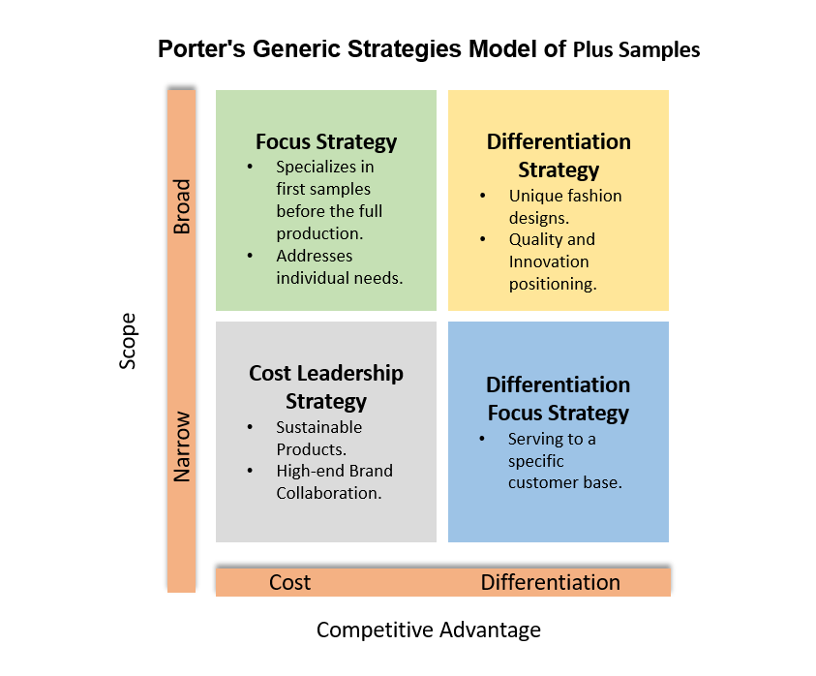
Figure 1 Strategy growth analysis of Plus Samples using Porter's Generic Strategy Model
Regardless of whether businesses, including those smaller ones like Plus Samples, manage costs well; it is very unlikely that referring to cost leadership as the main strategic approach is going to spell much commitment to the business’s mission and the value comparisons it offers (Chintalapati, 2020). Instead Plus Samples can work much better to achieve this aim with its differentiation and focus strategies that will keep its competitive advantage in the market related to a particular niche. Nevertheless, whilst it is critical to realize that employing cost control measures can be complementary to fight against the market pressures of strong competition, ensuring the quality, and sustainability of the service, this does not mean that the aim of the company should be Cost Leadership (Brammer, Hoejmose and Marchant, 2011).
The strategy of differentiation and focus combined gives the Plus Samples a long-term stand among the rivals in the constantly changing market. To grow and strengthen its position, Plus Samples has to be creative in its designs, and sustainable practices besides keeping the products unique and leadership in the target market. Besides, it can extend its digital appearance and use online marketing so that it can gain more global engagement and clients which enables its objectives to grow and be the best in services (. Dahalin, 2020). Also, given Plus Samples ' vision, future concerns moving beyond economic conditions, technology advancements, and adjustments towards green fashion will be of great importance. Those growth strategies must be aligned with the constantly changing trends and challenges to be sure of resistance, competition, and sustainability in the international fashion industry (Lubis, Marhayanie and Hasibuan, 2019).

Ansoff Matrix Model
- Market Penetration: It is worth remarking that Plus Samples has already successfully positioned itself within its current market segment offering high-quality and eco-conscious materials for designers and brands. The study provides evidence about the existence of remarkable capabilities of companies which can be utilized to improve the market share and loyalty of the consumers (Chintalapati, 2020). Sales data analysis and customer feedback further help the company to spot weaknesses in its products and to make activities that are geared towards the specific tastes and requirements of the average consumer (Brammer, Hoejmose and Marchant, 2011). Besides competitor's analysis allows for gaining perspective on the strategic moves made by competitors and sparks an idea of untapped appealing differentiation options for samples to Plus Samples.
- Market Development: Going international or serving new societies might become an opportunity for an extension beyond the current market especially if the current market is limited to decision-makers or certain client segments. Performing market research to be able to choose the areas or the demographic groups where there is a high need for environmentally friendly fashion samples will be a fundamental aspect of strategic expansion decisions. Mitigating risks of market entry by conducting the regulatory analysis, as well as environmental, cultural, and competitive analysis is important in developing the strategy for market entrance (Chintalapati, 2020). Cooperating with local distributors or with influencers in new markets can be a great way to enter into the new market, and can also lead to the brand being more visible.
- Product Development: Innovation within the product assortment will be key for long-term survival in responding to changing customer trends. Data collection regarding trends in the market, customers’ inclinations, and technology evolution may help to direct product creation (Brammer, Hoejmose and Marchant, 2011). Plus Samples could go further to its green knowledge base and develop a new product line oriented at environmental sustainability or partner with other designers to invent exciting designs. Customer feedback considering and market testing become the two fundamental parts of making sure that new products are made according to customer needs and preferences.
- Diversification: Exploring additional markets or providing additional products contributes to the process of diversification and revenue growth for the company. Conducting a deep analysis of diversification opportunities including market potential, competitive landscape and resource requirements are the prerequisite (Chintalapati, 2020). Performing synergies and risk analysis for the diversification initiatives can assist Plus Samples in making proper decisions and preventing potential downsides. Strategic partnerships or acquisitions could be another alternative to accelerating the diversification process and benefit from the existing expertise or resources in new fields.
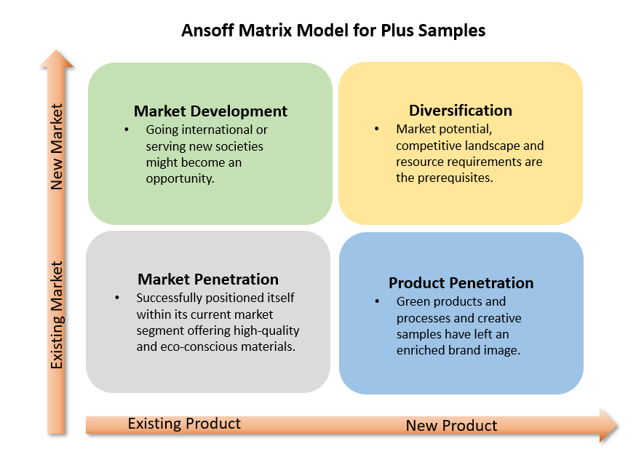
Figure 2 Strategy growth analysis of Plus Samples using the Ansoff Matrix Model.

5.3 Recommended Strategy for Sustainable Growth
Embracing Porter’s Five Forces Strategies, Samples Plus can aim to fight the tough challenges that await the fashion industry. The company strives to be unique and to create lasting bonds with its customers. This approach ensures it gains a competitive edge in the market (Missonier, 2020). Establishing fruitful relationships with suppliers helps reduce costs and boost supply chain efficiencies, both of which are just as important as product quality when trying to stay competitive while controlling prices (Grundy, 2021). Consequently, continuous innovation and production standards at the highest level allow Plus Samples to increase market share, therefore, neutralization of threats from new entrants and substitutes can be carried out. This approach allows the Team to stay in the pole position as designers and houses.
- Competitive Rivalry
High Competition: The markets in the London area for clothes and fashion have always been machinated by strong competition amongst the garment and fashion business.
Strategic Response: Besides that, Plus Samples' samples are always of high quality and remarkable value, so, it is possible to stand firm against competitors. To achieve the real distinction, firms better focus on handmade products, customization and delivery speed.

- Supplier Power
Moderate to High Supplier Power: Vendors who offer only rare kinds of fabrics and ecological materials may come to dominate because they produce products with no counterparts on the market.
Strategic Response: Create long-lasting relationships with suppliers through long-term agreements, collaborative planning, and common goals for a green environment and sustainable development. This will to a great extent reduce the risk and give Plus Samples the ability to procure at better prices and also enjoy priority services.

- Buyer Power
Significant Buyer Power: The public, being very discerning and selective shoppers, may have to convince many who also have the choice to replace them.
Strategic Response: Ensure superiority in catering to customers, offer specific services and retain touch interactions, which are the major determinants of customer retention. Also, the feedback loop should be designed so that quick shortening of mistreatment to customer needs makes Plus Samples less and less vulnerable to buyer power.

- Threat of Substitution
Moderate Threat of Substitution: The difficulty of imitating provided services in the fashion samples market is related to the level of their quality and the scope of their offer.
Strategic Response: Address the materials and the design aspects of the technology as well. Plus Samples should invest heavily in research and development to ensure brands value-addition and remain difficult to replace. By emphasising on eco-friendly and ethical methods of production, will help the company to sidestep the threat of substitution.

- Threat of New Entrants
Moderate to High Threat: The fashion and garment industry presents low barriers to entry which makes it possible for new market players to come in.
Strategic Response: Improve the brand and customer loyalty by maintaining quality, reliability, and innovations. Choosing a niche market, for instance, eco-friendly and high-tech fabric samples would be a good way to create a high barrier to entry for the new competitors.

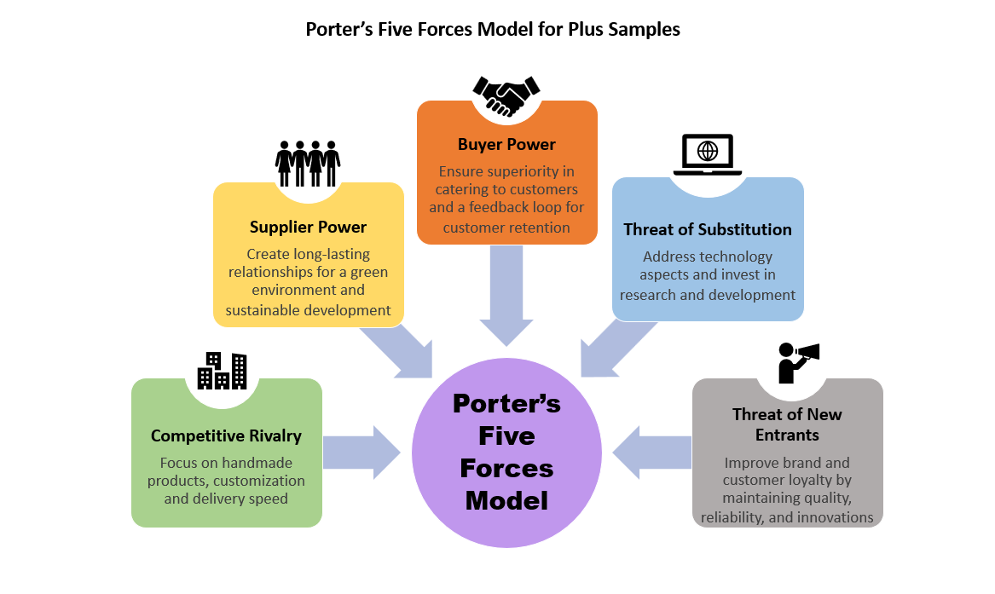
Figure 3 Suggested Strategy growth analysis of Plus Samples using Porter’s Five Forces Model.

6.0 Stakeholder Analysis

6.1 Company/ Owner and Staff Stakeholder Analysis
Company/Owner: Since the owner is the main stakeholder, their interests are related to the company's profitability, growth, and sustainability in the future (Missonier, 2020). Owners are interested in getting the highest yields on investment and in keeping the power of authority over strategic decisions. Their visions and leadership substantially influence the enterprise's direction and results.
Staff: The staff comprising designers, tailors, and administrative workers are the paramount stakeholders in Plus Samples. They render an important role in the company's operations and success by offering their own innovation and effort. Their happiness, morale, and career growth are necessary for the required productivity, quality of the output and positive work environment (Missonier, 2020).

Analysis:
Strengths: The most important feature of the owners‘ business profitability is that it is the main factor which guides the owners in the process of developing their marketing strategy. Staff that is awake and indeed willing to take up new responsibilities and challenges related to service delivery can lead to improved productivity and perhaps innovation too.
Weaknesses: The owner might intend to go in a different direction in comparison with shareholders and then they may feel uneasy and drift away. If communication is not enough and the decision-making process is not democratic, the morale of the team members will be depressed hence the team will be less efficient.

6.2 Supplier and Customer Stakeholder Analysis
Supplier: The suppliers, to begin with, are responsible for supplying the necessary resources like raw materials and machinery which the plant requires daily. They are the partners that are with the company on a long-term basis and, as such, play an important role in the achievement and maintenance of the company's target financial profits. The practices which enable prompt payments, clear communication and fair attribution of responsibilities are the principles for successful interactions with suppliers (Missonier, 2020).
Customer: Customers such as wholesale buyers, fashion brands, designers and retailers are core stakeholders for Plus Samples. The feedback of the clients on the quality, promptness and value for money of the business services determines the service quality of the company. Strictly speaking, the capacity of the enterprise to keep a good name, do repeat business and achieve success as a whole is at stake here. Identifying customer requirements tries to assess and address their preferences and feedback is an important aspect of being competitive while maintaining relationships in the long term (Missonier, 2020).

Analysis:
Strengths: Strong and tried relationships with the suppliers who can provide high-quality materials and services without which production expenses may rise and efficiency decrease. Customers who feel good about the product or the service can become loyal customers and can create positive word of mouth which can ultimately lead to business growth and profitability.
Weaknesses: Bracing dependence on selected suppliers may constitute vulnerabilities in the supply chain in the case of any unexpected cause. Falling behind customer expectations related to product quality, delivery timing and any kind of customer service can be a dangerous thing and cause lost business and damage the reputation of the company.

7.0 Strategic Recommendations
In the view of the small and medium-sized businesses (SMBs) like Plus Samples that are struggling with strategic development, the following six strategic recommendations are proposed below.
- Enhance Digital Presence and E-commerce Capabilities: Plus Samples can build a powerful digital space that includes a simple website with an e-commerce feature that encompasses online ordering as well as facilitating customer management efficiently. Through using social media platforms and search engine optimization (SEO) the website visibility will grow to represent clients from around the globe, and with these strategies, the market of the product will be broadened and the dependency on the local market will be reduced.
- Focus on Sustainable and Ethical Practices: The firm needs to widen its sustainability collection by selecting environmentally friendly materials and grading sustainability markings. Developing technologies ensuring zero waste and energy consumption will attract consumers with similar attitudes to the environment and set the company up for future legislation requirements.
- Adopt Advanced Manufacturing Technologies: To boost production efficiency, lessen the manufacturing costs, and maintain quality levels future acquisition of technical sewing and cutting machines are visioned, plus integration of 3D design software will be brought into the labour process. These technologies cover the sphere of staying competitive in the high-tech industry and also solve the matters of labour cost, which is relevant for SMEs.
- Strengthen Supplier Relationships: Plus Samples should strive to obtain regular contracts with their suppliers for continual protection from fluctuating material prices and shortage of supply. Collaborating with vendors on new materials and product innovations can help preserve the uniqueness and value of not only their business but also their customers.
- Expand into New Markets: With geographic and demographic reach over into high-potential markets or Asian countries, together with exploring new segments like children's wear or athletic wear, will diversify Plus Samples' customer base and decrease market concentration risk.
- Cultivate a Skilled Workforce: Continuous training and growth programs are indispensable in enlarging employees' skills and maintaining the neck on industry progress. Compensation at a competitive level and keeping a good working environment will be the tools to recruit and retain the best professionals, contributing with innovation and maintaining quality as the main objectives.

8.0 Conclusion
An evident picture of the situation shines through as the competition and fashion industry are shown to be very tough, and always changing. The enterprise has demonstrated over the years compliance with the two principles, quality, and sustainability, which is more than a reason to appeal to the current market trends and also a foundation for future growth and development. To sum up, Plus Samples is suggested to keep focusing on its key strengths in manufacturing high-standard and ecologically clean garments and give more thought to the digitalization of the company and internet marketing. Strategic partnerships and channel expansion into new regions, as well as segments of the customers, are the contributing factors to the market entry strategy that will allow the company to create a competitive advantage and identify market opportunities. Compassionate corporation occupies a leader status in ethical practices and sustainability, which is not only an advantage to its brand, but also goes against the environment-unfriendly fashions that are widely spread over the globe.
Endole.co.uk. (2023). Plus Samples Ltd - Company Profile - Endole. [online] Available at: https://suite.endole.co.uk/insight/company/07364302-plus-samples-ltd. In-text citation: (Endole.co.uk, 2023)

References
- A Svechin and Lee, K.D. (2004). Strategy. Minneapolis, Minn.: East View Publications.
- Brammer, S., Hoejmose, S. and Marchant, K. (2011). Environmental Management in SMEs in the UK: Practices, Pressures and Perceived Benefits. Business Strategy and the Environment, 21(7), pp.423–434. doi:https://doi.org/10.1002/bse.717.
- Chintalapati, S. (2020). BankBuddy.ai—Business Expansion and Marketing Dilemma: A Case Study to Discuss the Ansoff Growth Matrix Concepts Combined with Business Expansion Strategies for Expanding into Emerging Markets. Emerging Economies Cases Journal, 2(1), p.251660422092999. doi:https://doi.org/10.1177/2516604220929994.
- Grundy, T. (2021). Rethinking and Reinventing Michael Porter’s Five Forces Model. Strategic Change, [online] 15(5), pp.213–229. doi:https://doi.org/10.1002/jsc.764.
- Kampanje, B.P. (2020). Pestel Analysis. SSRN Electronic Journal, 3(2).
- Lubis, A., Marhayanie, M. and Hasibuan, B. (2019). Developing Strategies Based on Swot Analysis for SMEs. Proceedings of the Proceedings of the 1st International Conference on Economics, Management, Accounting and Business, ICEMAB 2018, 8-9 October 2018, Medan, North Sumatra, Indonesia. doi:https://doi.org/10.4108/eai.8-10-2018.2289250.
- Md. Dahalin, Z. (2020). Strategic Application Portfolio in SMEs*. Malaysian Management Journal. doi:https://doi.org/10.32890/mmj.6.1-2.2002.8592.
- Missonier, S. (2020). Stakeholder analysis and engagement in projects: From stakeholder relational perspective to stakeholder relational ontology. International Journal of Project Management, 32(7), pp.1108–1122.
- Plus Samples. (2024). Plus Samples / About Us. [online] Available at: https://plussamples.co.uk/who-we-are/ [Accessed 10 Apr. 2024].
- Polo, E.F. and Weber, W. (2010). Competitive Generic Strategies Evolution and the Importance of Michael E. Porter. Revista de Gestão, 17(1), pp.99–117. doi:https://doi.org/10.5700/rege389.
- Rothaermel, F. (2021). Strategic management. 6th ed. New York, New York: Mcgraw-Hill Education.

