

Programme : BA Business Management
Module : Strategic Management & Sustainability
Module code : LCBB6004
Assignment Title : Written Report
Lecturer : Dr . Jaya Gopalkrishnan
Student Name : Daniela Ivanova Krasteva
Student No : 2124368


Table of Contents
- Executive Summary ………………………………………………………………………….03
- Introduction …………………………………………………………………………………03
- Strategic Analysis …………………………………………………………….…………03 - 06
a) External Context: Summary of PESTEL and Five Forces Analysis
b) Internal Context: Summary of SWOT Analysis
c) Resource and Capability Analysis
- Corporate and Business Strategies …………………………………………….07 - 08
a) Diversification and Internationalization
b) Cost Leadership and Differentiation
- Strategy Implementation and Success Evaluation …………………………………. 09
a) Corporate Strategies
b) Business Strategies
- Strategic Sustainability and Environmental Considerations …………….…10 - 11
a) Tesco's Sustainability Practices
b) Impact on Competitiveness
- Future Strategic Directions ………………………………………………….……….11 - 14
a) Strategic Choices for the Future
b) Recommendations for Enhancing Sustainability and Competitive Advantage
- Conclusion …………………………………………………………………………………….….14
- References …………………………………………………………………………………15 - 17
- Appendix ……………………………………………………………………………………17 - 21
a) PESTEL Analysis
b) SWOT Analysis

Executive Summary
Strategy is the long-term direction of an organisation, formed by choices and actions about its resources and scope, in order to create advantageous positions relative to competitors and peers in changing environmental and stakeholder context (Whittington et al,2020). This research offers a comprehensive evaluation of Tesco Plc's corporate and business strategies, specifically examining the strategic decisions made and how they were put into action. The research utilizes strategic analytical methodologies such as PESTEL, Porter's Five Forces, and SWOT to identify and emphasize the crucial external and internal elements that impact Tesco's plans. The examination focuses on Tesco's strategic actions, namely in the domains of diversification, globalization, cost leadership, and distinction. Moreover, the paper assesses the efficacy of Tesco's strategy implementation and its sustainability initiatives, providing suggestions for future strategic pathways to improve competitiveness.
Introduction
Tesco Plc is a prominent global retailer that strives to provide its customers with reasonably priced wholesome, and environmentally friendly food daily, thereby enhancing their standard of living and facilitating a simpler lifestyle (Tesco,2022). Tesco works in a highly competitive and ever-changing environment, which requires well designed corporate and commercial strategy. The purpose of this research is to analyse Tesco's strategic decisions and evaluate the effectiveness of its strategy execution. Every company needs to meet the strategic business direction, and they have challenges for meet their business activities (Bakken, 2012). The text examines how the organization has strategically integrated its resources and competencies to achieve its goals, while also considering the influence of sustainability measures on its competitiveness. The utilization of strategic analysis methodologies such as PESTEL, Porter's Five Forces, and SWOT aids in gaining a more comprehensive comprehension of the aspects that influence Tesco’s strategy.

Strategic Analysis
a) External Context: Summary of PESTEL and Five Forces Analysis

Tesco operates inside a strategic environment that is influenced by external influences. These elements are analysed and summarized using the PESTEL and Porter's Five Forces frameworks. More information may be found in the Appendix. Notable discoveries consist of:
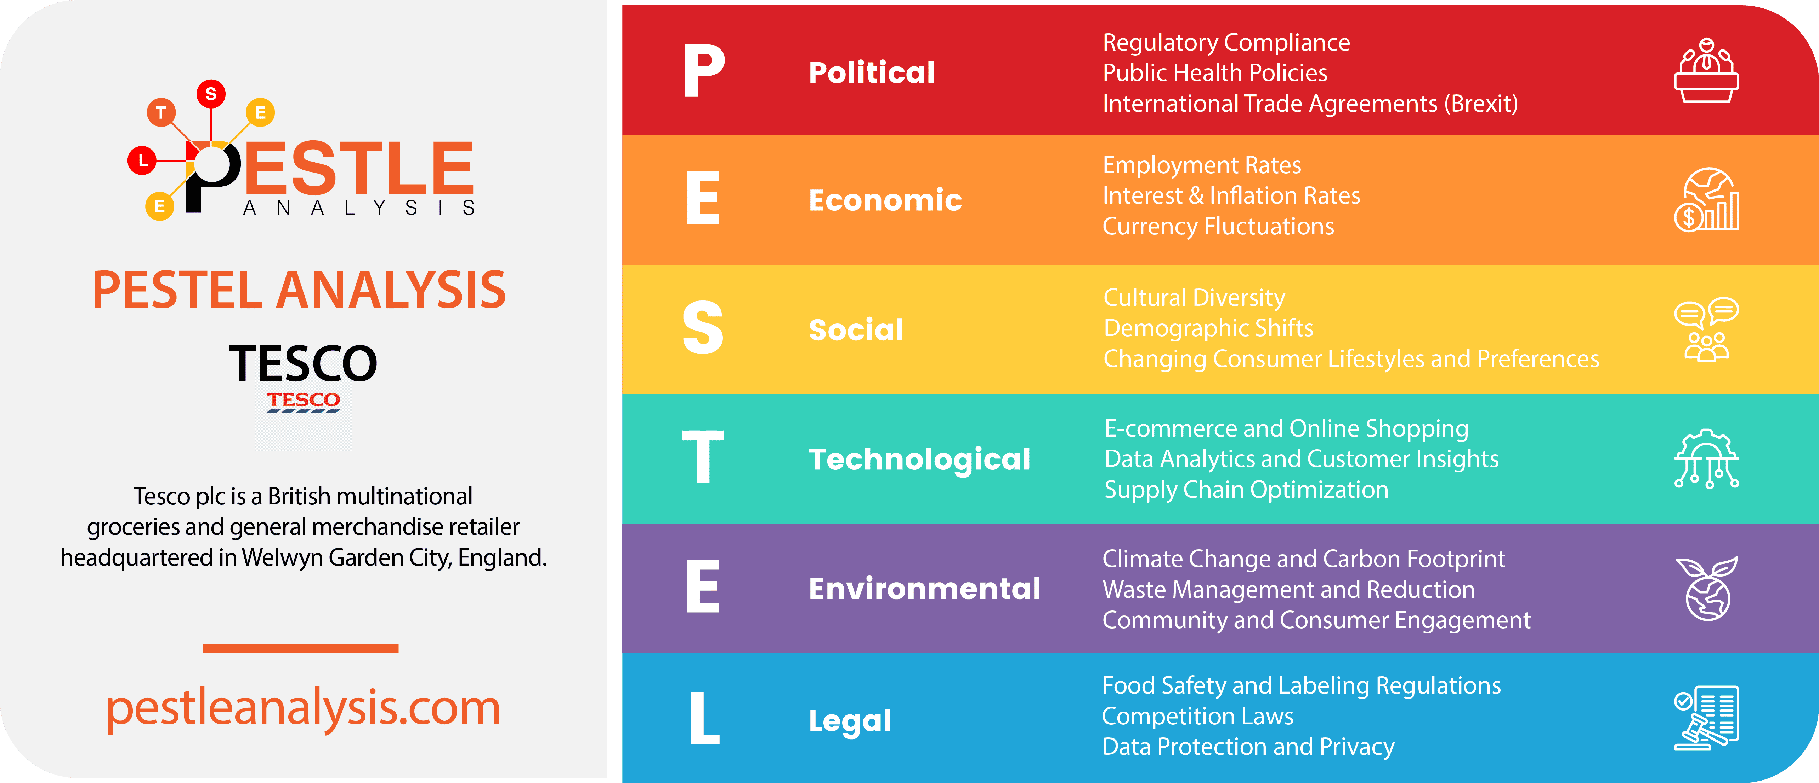

PESTEL Analysis
The presence of political uncertainties, such as those arising from Brexit, along with economic concerns like inflation and variable consumer spending, give rise to both potential hazards and possibilities. The shift in consumer behaviour towards online shopping and the increasing importance of sustainability need businesses to strategically adapt. At the same time, technical improvements, particularly in e-commerce and artificial intelligence, provide opportunities for gaining a competitive edge.
Tesco is being compelled to prioritize sustainability due to environmental challenges. Tesco is under increasing pressure to address its environmental impact and adopt eco-friendly practices as one of the biggest retailers in the world. (Pereira, 2023). In order to sustain its operations, Tesco must also ensure strict adherence to regulatory compliance, as legal factors play a crucial role. Tesco has implemented various sustainability initiatives, including reducing food waste, minimizing plastic usage, and sourcing products ethically. It aims to become a zero-carbon business by 2050 (The strategy Story.com, 2024).
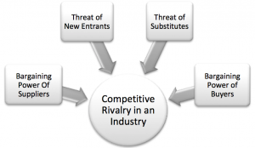
Source: Porters Five Forces Framework (theunitutor.com,2014)
Porter’s Five Forces is a framework that helps analysing the level of competition within a certain industry (DE Bruin, 2016). Strong competition especially from rivals like Sainsbury's, Asda, Aldi, and Lidl defines the retail sector. the presence of such well-known brands in the sector increases competition amongst them in terms of business practices. (Adamkasi, 2021)
Tesco must constantly innovate and cut costs given the mild danger of new competitors and replacements as well as consumer high negotiating power. Given Tesco's size and market position, suppliers still have little negotiating strength.

b) Summary of SWOT Analysis
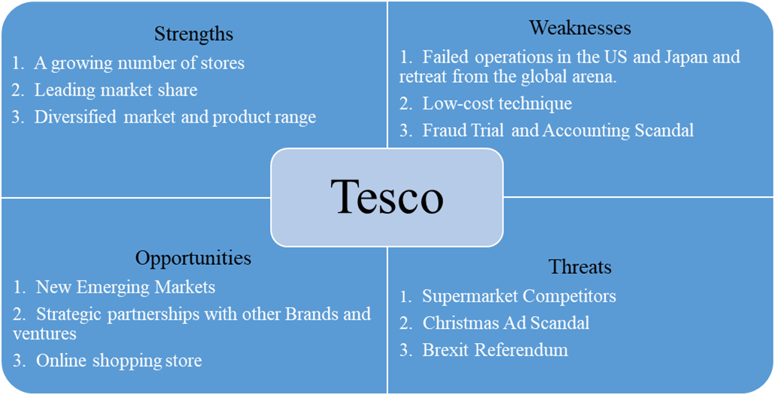
Source: (Study Corgi,2023)
The internal environment of Tesco is examined through the use of a SWOT analysis, which uncovers significant strengths, weaknesses, opportunities, and threats. Tesco regularly performs SWOT assessments to assess business possibilities (growth into new areas), threats (regulatory constraints), vulnerabilities (possible pricing wars affecting profit margins), and strengths (brand awareness and economies of scale). Through the identification of external elements that impact corporate performance, this analytical framework aids in the process of making strategic decisions. Further information may be found in the Appendix.
- Strengths Tesco’s dominant position in the market, well-established brand reputation, and wide-reaching distribution network are crucial assets. The Clubcard loyalty program and wide selection of products enhance its competitive edge.
- Weaknesses:
Prior instances of reputational issues, such as accounting scandals, and difficulties encountered in overseas marketplaces serve to underscore specific areas of susceptibility. Tesco's significant reliance on the UK market also poses a potential problem to overcome this weakness, Tesco should explore opportunities for growth in emerging markets, diversify its product offerings, and invest in digital capabilities to enhance its online presence ( Pereira, 2023)
- Opportunities:
The proliferation of online commercial transactions and the penetration into developing economies present substantial opportunities for growth. Tesco can capitalize on the growing consumer demand for sustainability to improve its product range and brand image
- Threats:
Tesco's market position and profitability could be significantly affected by intense rivalry, economic uncertainties, and regulatory risks, which are major threats.
Resource and Capability Analysis:
Tesco's success is mostly attributed to its adeptness in harnessing and exploiting its available resources and talents. The company's wide-reaching distribution network, advanced technological infrastructure, and strong financial resources are crucial factors that support its strategies. Tesco's investment in digital platforms and data analytics has enhanced its ability to lead in terms of cost and differentiate itself from competitors. This has enabled the corporation to provide competitive pricing and individualized. Tesco's robust financial resources allow it to actively explore strategic acquisitions, such as the Booker Group, in order to broaden its market presence and diversify its business portfolio.

Corporate and Business Strategies
a) Diversification and Internationalization

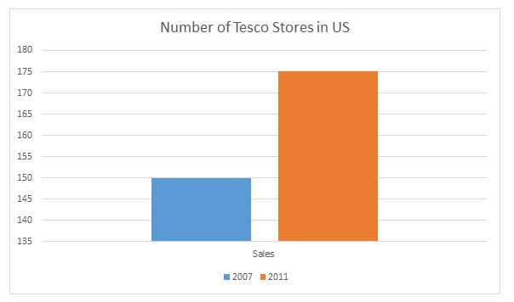

Implementation Of Tesco International Business Strategy In USA. Source: (total assignment.com, n.d)
Tesco's corporate strategy is distinguished by its pursuit of diversification and global expansion. Tesco's diversification efforts, exemplified by the acquisition of Booker Group, have facilitated its entry into new areas and bolstered its presence in the wholesale sector. Tesco's strategic approach has not only expanded its range of products but also served as a safeguard against market volatility in its main retail sector. Nevertheless, the process of internationalization has produced outcomes that are both positive and negative. Tesco's withdrawal from the U.S. market demonstrates the difficulties of expanding globally, despite its strong position in Central Europe and Asia. The corporation needs to optimize its international strategy to guarantee success in varied and intricate marketplaces.
b) Cost Leadership and Differentiation
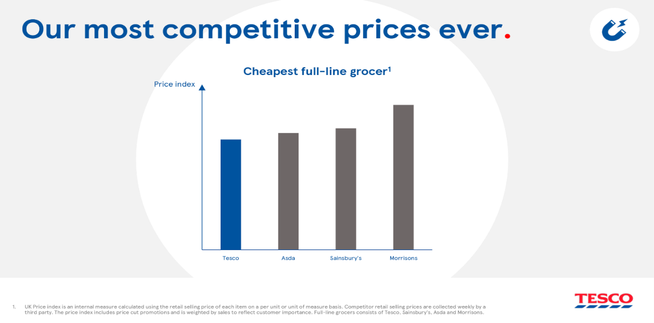
Source: (Ada Insights,2023)

Tesco utilizes a hybrid business strategy that combines cost leadership with differentiation. The company's capacity to attain cost leadership is derived from its large scale, operational efficiency, and effective supply chain management. Tesco may utilize these capabilities to provide competitive pricing, which is crucial for retaining and gaining customers who are sensitive to price. Tesco sets itself apart by offering high-quality products, such as the Tesco Finest collection, and customer-focused programs like the Clubcard reward program.
These endeavours assist Tesco in distinguishing itself in a saturated market and cultivating robust client allegiance, so reinforcing its position as a Market leader. For example, Tesco uses a cost leadership approach in India with the goal of luring volume customers in with low costs. This strategy should pay off handsomely because of India's sizable population and expanding retail industry, as the country's percentage of modern retailers is anticipated to increase significantly.
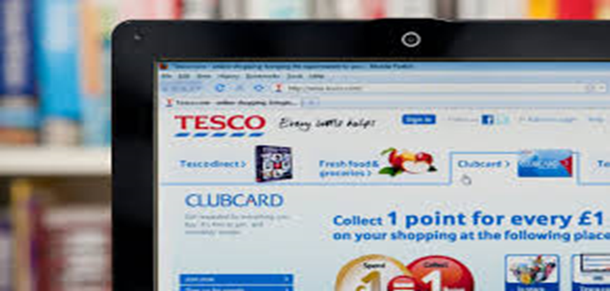
Source: (the Drum ,2021)
Strategy Implementation and Success Evaluation
a) Corporate Strategies
Tesco's effective execution of company strategy is clearly demonstrated by its robust market position and broad portfolio. Tesco's diversification strategy has been proven beneficial with the integration of Booker Group, which has not only enlarged its consumer base but also enhanced its product offers. Nevertheless, Tesco's approach to expanding globally has been somewhat erratic. The corporation has had triumph in specific markets but has also encountered obstacles, such as its departure from the U.S. market. These experiences emphasize the necessity of implementing a more customized strategy for expanding internationally, considering the specific conditions of the local market and the preferences of consumers.
b) Business Strategies
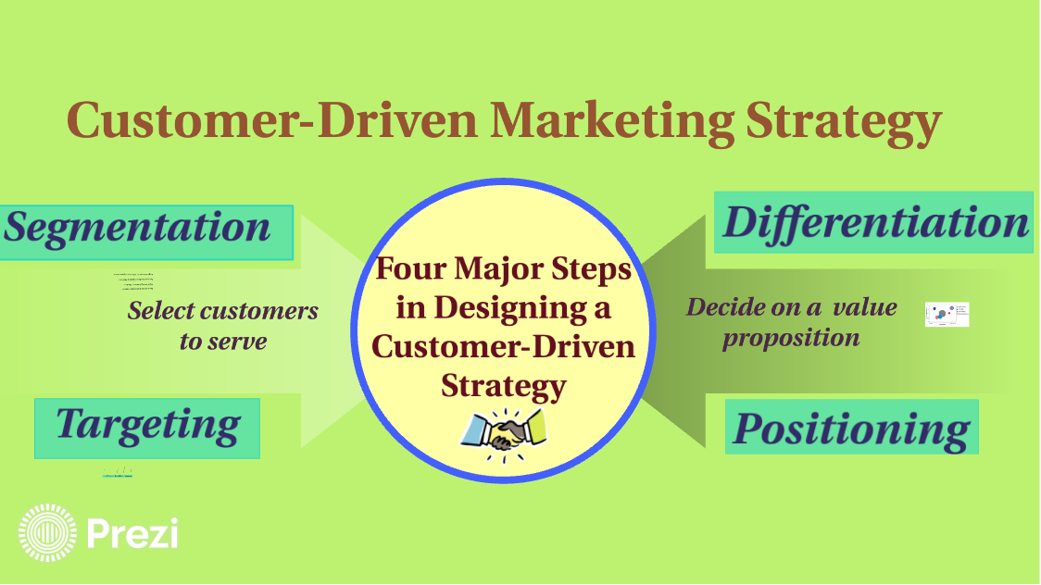 :
(Prezi, Source no date)
Tesco has successfully implemented its business goals, with a particular emphasis on cost leadership and distinctiveness. The company's allocation of resources towards enhancing supply chain efficiency and implementing advanced technology has allowed it to sustain competitive pricing. Additionally, the company's initiatives to distinguish itself, such as the creation of high-quality product lines and the implementation of customer loyalty programs, have been well-received by customers. These methods have played a vital role in assisting
Tesco in navigating the fiercely competitive retail environment, maintaining its market share, and attaining sustainable development.
Strategic Sustainability and Environmental Considerations
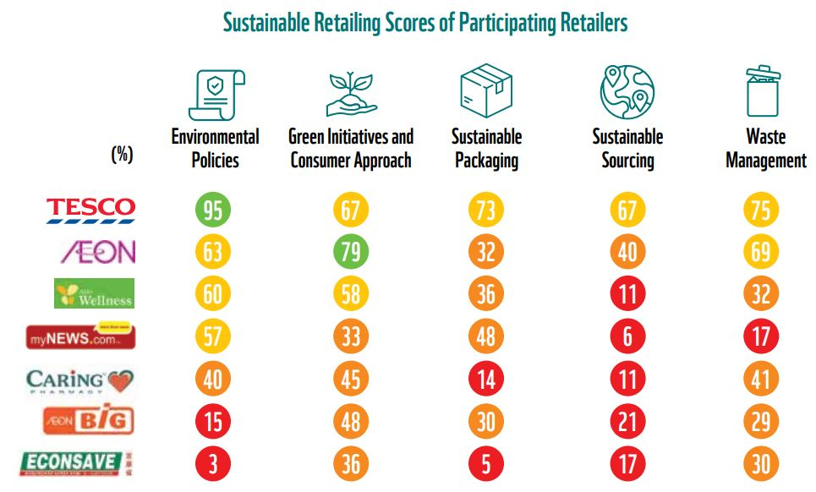
WWF: Tesco ranked most sustainable retailer. Source:( Marketing-Interactive,2020)
a) Tesco's Sustainability Practices
Tesco's corporate strategy places a strong emphasis on sustainability. Tesco has achieved great progress toward sustainability by emphasizing the mitigation of its environmental effect and the promotion of moral behaviour across its whole business. The corporation has established ambitious objectives, including achieving carbon neutrality by the year 2050( Tesco,2023). Tesco's sustainability endeavours encompass the reduction of plastic consumption, the procurement of sustainable goods, and the allocation of resources towards renewable energy. “We're also encouraging our customers to try more plant-based diets that are kinder on the planet” (Tesco Plc, 2023). Tesco's endeavours not only demonstrate their dedication to corporate social responsibility but also correspond with the increasing consumer desire for eco-friendly items.
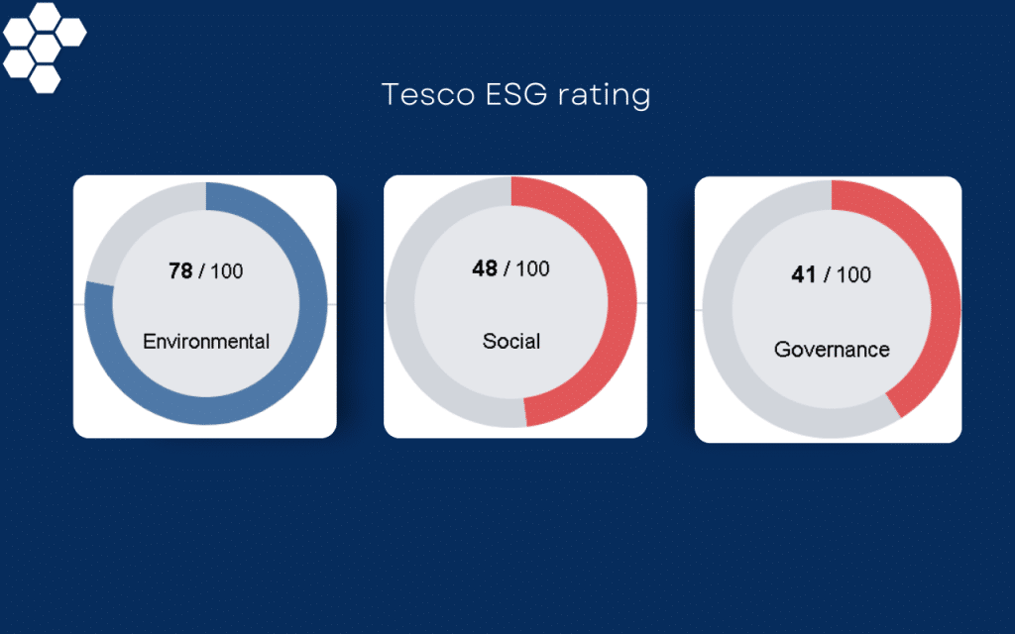
Source: permutable.ai
b) Impact on Competitiveness
Tesco's emphasis on sustainability has bolstered its competitiveness by improving its brand image and addressing consumer demands. Nevertheless, these endeavours also pose difficulties, especially in regard to achieving a harmonious equilibrium between sustainability and cost effectiveness. In order to keep its competitive edge, Tesco must persist in implementing innovative sustainability practices while efficiently managing the accompanying expenses.
Future Strategic Directions

Source: www.jupiteram.com,2023
a) Strategic Choices for the Future
In the future, Tesco will have to make various strategic decisions. These initiatives encompass the expansion of its internet presence, exploration of new international markets, and strengthening of its commitment to sustainability. Tesco must strike a balance between expanding its business and improving its operational efficiency while still being environmentally responsible in order to achieve long-term success. The company's capacity to adjust to evolving market conditions and consumer tastes will be crucial in sustaining its global dominance.
b) Recommendations for Enhancing Sustainability and Competitive Advantage
In order to maintain a strong position in the market and enhance its long-term competitive advantage, Tesco should consider the following strategic suggestions:

Strengthen Online Capabilities
It is crucial for Tesco to prioritize the improvement of its internet presence. The corporation should persist in allocating resources towards modern e-commerce technologies, such as artificial intelligence (AI) and machine learning, in order to individualize the purchasing experience. This entails enhancing the website and mobile app to ensure ease of use for users and streamlining logistics to expedite delivery with more efficiency. Tesco can satisfy the increasing need for convenience in today's fast-paced world by enhancing its click-and-collect choices and same-day delivery services. Moreover, by combining digital platforms with in-store experiences, Tesco could create a smooth omni channel shopping experience, which would assist in maintaining its existing client base and enticing new ones.
Tesco is also exploring innovative solutions to address sustainability challenges (Tesco, 2023). Tesco should persist in allocating resources to enhance e-commerce technology and infrastructure in order to exploit the burgeoning phenomenon of online buying. To increase its market share in the fast-developing online shopping sector, Tesco should focus on improving the online shopping experience and broadening its range of delivery alternatives.

Explore Green Innovation
Given the growing importance of sustainability to consumers, Tesco should take advantage of this trend by introducing a greater range of environmentally friendly items and minimizing the environmental consequences of its operations. This encompasses advancing its efforts to decrease plastic consumption and improve the energy efficiency of its stores and supply systems. In addition, Tesco can pursue green innovation by allocating resources towards the advancement of sustainable packaging solutions and expanding its assortment of plant-based and organic items.
Tesco's strategic positioning as a sustainability leader not only fulfils consumer expectations but also sets it apart from competitors, potentially creating opportunities for additional sources of revenue and attracting new customer segments.
A key component of Tesco’s forward-looking strategy is to become as sustainable and environmentally friendly as possible (Strategy study,2022). Tesco may enhance its distinctiveness by creating environmentally friendly product ranges and introducing packaging advancements. These endeavours will not only improve Tesco's sustainability reputation but also attract environmentally aware consumers.

Global Market Expansion
Tesco's variable performance in international markets indicates the necessity for a more sophisticated and strategic method for expanding globally. In order to ensure the success of future overseas initiatives, it is essential to conduct comprehensive market research and develop a profound comprehension of local consumer preferences. Tesco should prioritize targeting areas that exhibit strong development prospects, especially in places where the middle class is expanding and consumer purchasing power is on the rise.
Tesco has the opportunity to implement a differentiated approach in these emerging regions by customizing its product offers and marketing strategies to cater to local preferences and cultural subtleties. Establishing strategic partnerships with local counterparts can assist in reducing risks and expediting market penetration. Tesco ought to contemplate re-engaging in global markets by using an improved approach that prioritizes locations with robust development prospects. To achieve success in new areas, it is essential to have a focused and strategic strategy, backed by comprehensive market research.

Enhance Supply Chain Resilience
Given the current interruptions in the global supply chain, it is advisable for Tesco to focus on enhancing the resilience of its supply chain. One can accomplish this by expanding the range of suppliers, allocating resources to local sourcing in order to decrease reliance on global supply chains, and utilizing technology to anticipate and handle hazards. Tesco can enhance its resilience to economic shocks and guarantee a steady supply of products by developing a stronger and more adaptable supply chain. This is essential for preserving customer confidence and loyalty.
Focus on Data Analytics for Personalized Marketing
Tesco's extensive customer base and loyalty programs, such as Clubcard, offer a substantial amount of data that can be effectively utilized to improve tailored marketing initiatives. Tesco may enhance its understanding of customer behaviour and preferences by employing sophisticated data analytics. This would allow them to implement more precise promotional strategies and provide tailored product recommendations. Utilizing a data-driven methodology can effectively enhance customer happiness, stimulate sales, and enhance retention rates.

Strengthen Corporate Social Responsibility (CSR) Initiatives
Given the growing preference of consumers for companies that demonstrate great corporate social responsibility (CSR), it is advisable for Tesco to enhance its initiatives in the areas of social and environmental responsibility. This encompasses not only the aspect of environmental sustainability but also encompasses endeavours that promote community development, such as efforts aimed at assisting local farmers and educational programs. Tesco can strengthen its community connections and cultivate a more devoted consumer following by improving its corporate social responsibility initiatives, all while making a good impact on society.

Conclusion

Tesco Plc has shown impressive strategic skill in successfully navigating the intricate and fiercely competitive retail industry. Tesco has maintained a strong market position and made considerable triumphs by utilizing its advantages in market leadership, technological innovation, and sustainability. Nevertheless, the retail landscape is always changing, and Tesco must maintain its ability to adapt quickly and look ahead in order to maintain its competitive edge.
The measures specified - improving online capabilities, investigating green innovation, pursuing strategic worldwide expansion, reinforcing supply chain resilience, using data analytics, and expanding CSR initiatives - are essential for Tesco's future expansion. By implementing these tactics, Tesco can not only sustain but also strengthen its dominance in the market, guaranteeing long-term prosperity in a swiftly evolving environment.
Tesco is a testament to the importance of innovation, adaptability, and sustainability. Its ability to anticipate and respond to market changes while staying true to its values will determine its competitiveness and worldwide impact. Tesco Plc has achieved substantial success in numerous areas by effectively implementing its corporate and business goals. Tesco must adapt and plan forward, especially in terms of online expansion and sustainability, as the retail business develops. By bringing new ideas and adapting to market trends, Tesco can stay competitive.

References
2021) Porter’s Five Forces of Tesco

Kasi, A. (2021). Porter’s Five Forces of Tesco. Porter Analysis. Available at: https://www.porteranalysis.com/porters-five-forces-of-tesco/.

The Strategy Story (2023). Tesco PESTEL Analysis. The Strategy Story. Available at: https://thestrategystory.com/blog/tesco-pestel-analysis/.
‌Cascade.app. (2022). Strategy Study: How Tesco Became The Biggest Retailer In The UK. Available at: https://www.cascade.app/studies/tesco-strategy-study#The-Clubcard-Loyalty-Program/.
Bakken, D.G. (2012). Are you sure the price is right? (pricing and business strategy). Strategic Direction, 29(1). doi:https://doi.org/10.1108/sd.2013.05629aaa.005.
‌ BBC (2020). Tesco demands supplier cuts in discount battle. BBC News. [online] 3 Jul. Available at: https://www.bbc.co.uk/news/business-53284788.
‌ Cartwright, S., Liu, H., and Davies, I.A. (2022) ‘Influencer marketing within business-to-business organisations’, Industrial Marketing Management, 106, pp. 338–350. :10.1016/j.indmarman.2022.09.007(Accessed 19 th August 2024).
Chan, W. (2024, April 23). Sustainability matters: Tesco ESG score analysis and implications for the future - Permutable. Permutable Technologies Limited. https://permutable.ai/sustainability-matters-tesco-esg-score-analysis-and-and-implications-for-the-future/
De Bruin, L. (2024, January 9). Porter’s Five Forces. B2U - Business-to-you.com. https://www.business-to-you.com/porters-five-forces/ (accessed 19 th 2024)
diego.bercacula@digitalhefestos.com.br. (2024, August 1). The Business Model Analyst - Business Model Canvas Examples and AnalysisThe Business Model Analyst. Business Model Analyst. https://businessmodelanalyst.com/wp-content/uploads/2023/06/Tesco-SWOT-Weakenesses (Accessed 19 th August 2024)
Hayu Agustini, M., Suciarto Athanasius, S. and Bekti Retnawati, B. (2019) ‘Identification of green marketing strategies: Perspective of a developing country’, Innovative Marketing, 15(4), pp. 42–56. doi:10.21511/im.15(4).2019.04.
Implementation of Tesco International Business Strategy in USA | Total Assignment help. (n.d.). TotalAssignment. https://www.totalassignment.com/free-sample/implementation-of-tesco-international-business-strategy-in-usa
Johnson, G., Whittington., Regner, p., Angwin, D., Scholes. K. (2020). Exploring Strategy, Text and Cases, 12th edition (12th ed., Vols. 978-292-28245–9). Pearson education Limited UK.
Karim. A. (2023) Engagement summary: Tesco Q2 2022.UK | EN | Professional. https://www.jupiteram.com/uk/en/professional/engagement-summary-tesco-q2-2022/
Kivilahti, A. (2023, October 5). Tesco: improving profitability while growing with online — Ada Insights. Ada Insights. https://adainsights.com/blog/tesco-improving-profitability-while-growing-with-online
Rahman, M. (2023, January 27). Porter’s five forces analysis of Tesco. www.howandwhat.net. https://www.howandwhat.net/porters-five-forces-analysis tesco/1

Pereira, D. (2023, October 19). Tesco PESTLE Analysis (2024). Business Model Analyst. https://businessmodelanalyst.com/tesco-pestle-analysis/ (Accessed 23rd August 2024)D. (2023)PESTLE Analysis (2024)
Prezi, K.K.O. (no date) Customer-Driven Marketing Strategy. https://prezi.com/6ok3_8mt5hkr/customer-driven-marketing-strategy/.(Accessed: 20th August 2024).

Tesco (2022) Annual report. Available at:https://www.tescoplc.com/investors/reports-results-and-presentations/annual-report-2022/
Tesco (2023) Tesco’s International Business Development Strategy. Available at :https://itchy brain scentral .com /example-essays/tesco-business-strategy (Accessed: 10 April 2024).
Tesco Group’s Strategic (SWOT) Analysis | Free essay example. (2023, June). StudyCorgi. https://studycorgi.com/tesco-groups-strategic-swot-analysis/
Theoharakis, V., Zheng, Y. and Zhang, L. (2024) ‘Dynamic Strategic Marketing Planning: The paradox of concurrently reconfiguring and implementing strategic marketing planning’, Journal of Business Research, 174, p. 114525. doi:10.1016/j.jbusres.2024.114525.
The Uni Tutor. (2014). Strategic International Business Management : Tesco Future International Expansion Strategy. https://www.theunitutor.com/strategic-international-business-management-tesco-future-international-expansion-strategy/ (Accessed 22nd August 2024)
WWF: Tesco ranked most sustainable retailer in MY, local firms lag behind. (2020, February 21). Marketing-Interactive. https://www.marketing-interactive.com/wwf-tesco-ranked-most-sustainable-retailer-in-my,-local-firms-lag-behind

Appendix :
a) PESTEL Analysis

Economic:

Tesco's pricing tactics and profit margins have been directly affected by economic factors such as volatile exchange rates, inflation, and shifts in customer buying patterns. The issues have been worsened by the worldwide economic instability that has resulted from the COVID-19 epidemic.
Social:

Tesco has improved its e-commerce infrastructure and expanded its selection of healthy and organic items in response to the growing popularity of online shopping and the increasing need for health-conscious consumer choices. The socioeconomic changes have a crucial role in influencing Tesco's strategic decisions.
Technological:

The emergence of digital technologies, such as e-commerce, artificial intelligence (AI), and big data, has fundamentally changed the retail industry. Tesco's allocation of resources to these technologies has been essential in preserving its advantage in the market.

Environmental:

Tesco has been compelled to implement more environmentally friendly practices, including lowering plastic consumption and enhancing energy efficiency in its stores and supply chains, due to the growing emphasis on environmental awareness and sustainability.
Legal:

Tesco's operations rely on strict adherence to a wide range of rules, encompassing food safety, environmental legislation, and data protection such as GDPR. Failure to comply with legal requirements may lead to significant fines and harm Tesco's brand image.

b) Porter’s Five Forces Analysis

Industry Rivalry:
The retail industry is characterized by intense competition, with prominent rivals such as Sainsbury's, Asda, Aldi, and Lidl. This fierce competition impacts pricing strategies and market share. Though Tesco is the market leader in the UK, the pressure from the nearest rivals is intense (how and what.net, 2023).

Threat of New Entrants:
The obstacles preventing new businesses from entering the retail industry, such as the advantages gained from large-scale operations and the strong attachment customers have to established brands, are of a moderate level. Nevertheless, the emergence of e-commerce retailers who operate only online presents a possible danger.

Bargaining Power of Suppliers:
Due of Tesco's substantial market dominance, suppliers have comparatively limited negotiation strength. Tesco is able to secure advantageous conditions with its large scale and substantial buying influence. According to BBC (2020) Tesco has reportedly asked many suppliers to agree price cuts as it is increasing the intensity of battle with budget supermarkets.

Bargaining Power of Buyers:
Consumers possess significant negotiating power as a result of the abundance of other options, such as rival grocery stores and e-commerce platforms. This power exerts an impact on the pricing and product options of Tesco.

Threat of Substitutes:
The level of danger posed by substitutes is moderate, primarily due to the expansion of cheap stores and internet merchants that provide convenience and competitive pricing.

c) SWOT Analysis
Strengths
Market Leadership:
Tesco holds the dominant position in the UK's grocery retail industry, boasting a robust brand and a substantial portion of the market.

Diverse Product Range:
Tesco provides a diverse selection of merchandise, encompassing food and electronics, to accommodate the diverse demands and preferences of its customers.

Strong Distribution Network:
Tesco's wide and effective distribution network facilitates its extensive operations and guarantees prompt product accessibility.

Clubcard Loyalty Program:
The Clubcard program has played a crucial role in maintaining customer loyalty and gathering data, enabling Tesco to tailor their marketing strategies.
Weaknesses
Past Scandals:
Tesco has experienced reputational harm as a result of previous accounting scandals, which have had an impact on investor trust.

Dependence on the UK Market:
Tesco relies heavily on the UK market for a substantial amount of its sales, which exposes it to economic volatility inside the country.

International Failures:
Tesco has encountered difficulties in certain overseas countries, such as the U.S., where it was compelled to withdraw due to subpar performance, highlighting the obstacles it has in expanding globally.
Opportunities
Expansion into Emerging Markets:
Emerging markets with expanding middle classes offer opportunity for expansion by providing new client bases.

Growth in Online Retail:
Tesco can leverage the growth of e-commerce to enhance its online grocery offerings and gain a larger portion of the market.

Sustainability and Ethical Sourcing:
Tesco has the opportunity to improve its product options and brand image due to the growing consumer demand for sustainable and ethically sourced items.
Threats

Intense Competition:
The retail market in the UK is characterized by intense competition, since companies such as Sainsbury's, Asda, Aldi, and Lidl present substantial challenges.
Economic uncertainty:
Characterized by periods of economic downturns, inflation, and currency changes, has the potential to adversely affect Tesco's profitability.
Regulatory Risks:
Alterations in regulations, specifically pertaining to environmental practices and labour laws, may escalate operational expenses and provide difficulties in meeting compliance requirements.

