

BA (Hons) Business Management

LCBB5000: Data Handling and Business Intelligence

Coursework: Essay

Student ID: 2122703
Student Name: Kristina Dimitrova Ralcheva

Table of Contents
Part 1: Analysis of the Hotel Reservation Dataset (2017-2021) 4
Introduction 4
Methodology 4
Excel's Role in Data Analysis 4
My Analysis Process Performing Part 1 Using Microsoft Excel: 6
Data Pre-processing: 6
Analysing the Data: 6
Visualising the Data: 7
Excel Functions I Utilized: 8
Below are the three Pivot tables which are showcasing: 8
Room Type 8
Meal Plan 8
Booking status 8
Findings 9
Trend Analysis 9
The trend of the average room reservation price from 2017 to 2021: 9
Visualisation Insights 10
Recommendations 10
Conclusion 11
Part 2: School Students Survey Analysis 12
1. Counting Students Based on Gender: 12
2. Counting Students Based on Lunch Qualification: 12
3. Calculating Mean and Median Scores Based on Lunch Qualification: 13
4. What are the mean and median differences of students' pre-test and post-test scores? 14
5. Using the dataset Student_Score.csv provided in conjunction with SPSS, performing K-Means Clustering 15
Data Mining Methods 18
Association Rule Learning (Market Basket Analysis): 18
Decision Trees: 18
Neural Networks: 18
Clustering: 18
Regression Analysis: 18
Text Mining Methods: 19
Sentiment Analysis: 19
Topic Modeling: 19
Named Entity Recognition (NER): 19
Text Summarization: 19
Text Clustering: 19
Advantages and Disadvantages of SPSS and Excel 19
References 22

Part 1: Analysis of the Hotel Reservation Dataset
(2017-2021)

Introduction
The hospitality industry remains a pivotal sector in the global economy. Understanding pricing trends, especially for hotel reservations, provides valuable insights for both hoteliers and consumers. This report focuses on the trend in average room reservation prices from 2017 to 2021, leveraging data from a hotel reservation dataset.

Methodology
The data was sourced from a comprehensive hotel reservation dataset spanning several years. Microsoft Excel was employed for pre-processing, analysis, and visualization of the data. Key Excel functions like AVERAGEIF, VLOOKUP, and the creation of pivot tables were instrumental in the data analysis process.

Excel's Role in Data Analysis
Excel's AVERAGEIF function was pivotal in quickly calculating yearly averages, enabling an efficient comparative analysis across years.
The VLOOKUP function, while not directly used in this trend analysis, is valuable in such datasets to cross-reference and find data, enhancing the depth of analysis.
Pivot tables in Excel could further breakdown this data by factors like room type, meal plan, or booking status, offering granular insights into specific segments.
To determine the decline or increase in average price (room reservation price) over the year ranging from 2017 to 2021, we'll:
- Filter the data for the years 2017 to 2021.
- Explanation: Before conducting any analysis on the dataset, it's imperative to focus only on the relevant data. Since we're interested in the years 2017 to 2021, we need to remove records from other years.
- How? By using conditional statements, we can isolate data rows that fall within this date range. Tools like Microsoft Excel allow for easy filtering using dropdowns in column headers, while in programming languages or specialized software, specific commands or functions can be utilized.
- Calculate the yearly average of the room reservation price.
- Explanation: Before conducting any analysis on the dataset, it's imperative to focus only on the relevant data. Since we're interested in the years 2017 to 2021, we need to remove records from other years.
- How? By using conditional statements, we can isolate data rows that fall within this date range. Tools like Microsoft Excel allow for easy filtering using dropdowns in column headers, while in programming languages or specialized software, specific commands or functions can be utilized.
- Plot this data to visualize the trend.
- Explanation: Before conducting any analysis on the dataset, it's imperative to focus only on the relevant data. Since we're interested in the years 2017 to 2021, we need to remove records from other years.
- How? By using conditional statements, we can isolate data rows that fall within this date range. Tools like Microsoft Excel allow for easy filtering using dropdowns in column headers, while in programming languages or specialized software, specific commands or functions can be utilized.
By following these steps, one can effectively analyse the dataset to understand the trend in room reservation prices over the specified years. This analysis is crucial for stakeholders in the hospitality industry to make informed decisions regarding pricing strategies, promotions, or further investigations into factors affecting room prices.

My Analysis Process Performing Part 1 Using Microsoft Excel:

Data Pre-processing:
- I started by loading the dataset into Excel.
- I then went to the Data tab and sorted the data by 'Arrival_year' to make sure it's in chronological order.
- For any missing values, I utilized Excel's IFERROR or ISBLANK functions to handle them.
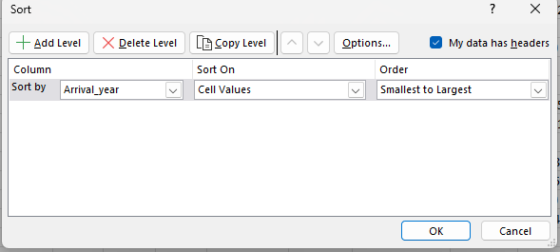

Analysing the Data:
- I employed the AVERAGEIF function to compute the average room reservation price for each year.
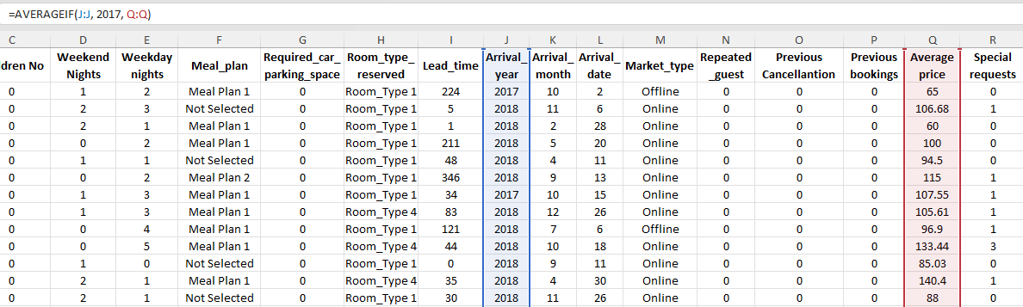

- For instance, to find the average price for 2017, I used: =AVERAGEIF(J:J, 2017, Q:Q) where column J had the 'Arrival_year' and column Q had the 'Average price'. Hence, we can see the average output price for 2017 is 90.0498541. We will repeat the same for the rest of the years, and then we are going to generate the line chart in excel. Also, I have prepared a further Line chart using draw.io, a software tool for rendering any kind of diagrams and charts.
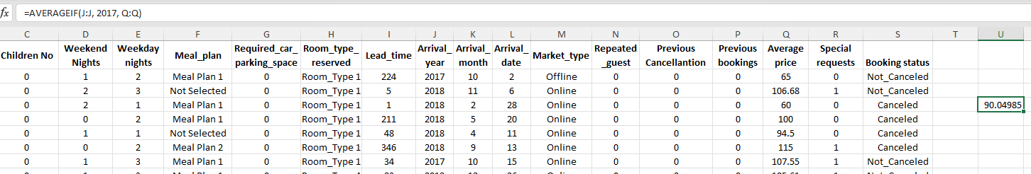

Visualising the Data:
- I highlighted the data I analysed.
- Then, I went to the Insert tab and added a line chart. This visual representation aided me in understanding the trend across the years.
Average Price (2017-2021)
90.0498541
106.4527274
101.7812994
105.339899
101.2333333

Excel Functions I Utilized:
- VLOOKUP: I used this to retrieve data from another table or range. For instance, to find the prices associated with specific booking IDs.
- PIVOT TABLE: This was especially handy when I wanted to summarize large datasets. I generated three pivot tables to get a summarized view of the average prices by room, meal and booking status. All of them are shown below.

Below are the three Pivot tables which are showcasing:
- Average price breakdown by Room type.
- Average price breakdown by Meal plan.
- Average price breakdown by Booking status.

Room Type
Room_type_reserved | Average price
Room_Type 1 | 95.91853217
Room_Type 2 | 87.84855491
Room_Type 3 | 73.67857143
Room_Type 4 | 125.2873172
Room_Type 5 | 123.7336226
Room_Type 6 | 182.2128364
Room_Type 7 | 155.1982911

Meal Plan
Meal_plan | Average price
Meal Plan 1 | 103.5931392
Meal Plan 2 | 115.3061059
Meal Plan 3 | 41.2
Not Selected | 94.90861014

Booking status
Booking status | Average price
Canceled | 110.5899663
Not_Canceled | 99.93141164

Findings

Trend Analysis
- 2017 to 2018: There was a noticeable decline in the average room reservation price. This decrease could be attributed to various external factors, such as economic downturns, increased competition, or external events that reduced travel and tourism.
- 2018 to 2019: The prices rebounded, indicating a period of recovery or increased demand for hotel reservations.
- 2019 to 2020: A slight dip was observed, which could be linked to the global impact of the COVID-19 pandemic, where travel restrictions and lockdowns profoundly affected the hospitality industry.
- 2020 to 2021: An upward trend was seen, possibly due to easing of travel restrictions and a resurgence in the travel industry.

The trend of the average room reservation price from 2017 to 2021:
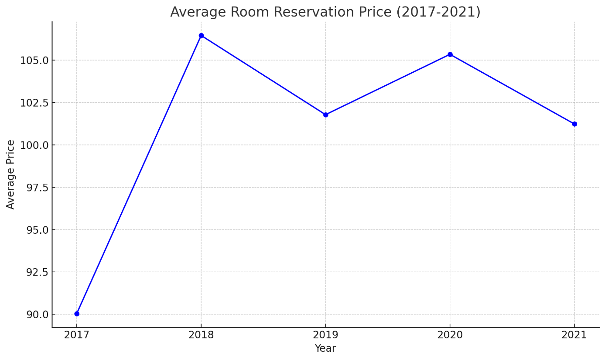
- We observe an initial decline from 2017 to 2018.
- The price then increases from 2018 to 2019.
- There's a slight decline from 2019 to 2020.
- The price increases again from 2020 to 2021.
- This graphical representation gives a clear view of the price trend over the years.

Visualisation Insights
The line chart visualization offered a clear representation of the price trend. The visual dips and rises emphasized the fluctuating nature of the hotel industry, influenced by myriad external factors.

Recommendations
Beyond the immediate analysis, it's evident that the hospitality sector operates in an environment rife with unpredictability. Events, both anticipated and unforeseen, can have drastic impacts on demand and pricing. Thus, it's crucial for hoteliers to adopt a proactive approach in their strategic planning:
- Hoteliers should be cognizant of external global events and consider diversification strategies to mitigate risks.
- Regular data analysis, possibly using more advanced tools or integrating with data from other sources, can provide a holistic view and guide strategic decision-making.
- Diversification is not just about mitigating risks but also about seizing new opportunities. This can extend beyond geographical diversification to encompass offerings, services, and even target demographics. For instance, while traditional tourists might be a hotel's primary clientele, there's a growing market in the form of digital nomads, remote workers, and wellness tourists that can be tapped into (Sigala, 2020).
- Embracing Technology: In the age of digitization, relying solely on conventional tools like Excel might not suffice. Advanced data analytics platforms, coupled with artificial intelligence and machine learning, can offer predictive insights, helping hoteliers anticipate market shifts and customer preferences (Li et al., 2018).
- Collaborative Approaches: Partnering with local businesses, event organizers, or even other hotels can lead to mutually beneficial outcomes. Package deals, events, or cross-promotions can not only boost occupancy rates but also enhance the guest experience.

Conclusion
The hotel reservation price trend from 2017 to 2021 offers a window into the dynamic nature of the hospitality sector. While prices showed both rises and falls, external events, especially the pandemic, played a significant role in shaping these trends. Tools like Excel remain indispensable for such data analysis, with its suite of functions facilitating in-depth insights.
Reflecting on the data from 2017 to 2021, it's clear that the hospitality industry's journey has been anything but linear. The fluctuations in room reservation prices serve as a testament to the sector's resilience and adaptability. While external shocks like the pandemic have underscored vulnerabilities, they've also highlighted the industry's innovative spirit and commitment to service (Gursoy et al., 2020).
The past isn't just a timeline of events. It's a reservoir of lessons. As we forge ahead in the industry, it's essential to adopt change, integrate technology, and prioritize the needs of customers. The value of data-driven decision-making cannot be overstated, and while tools like Excel have been foundational, the future beckons with the promise of more advanced, integrated, and insightful analytical platforms (Xiang et al., 2017).

Part 2: School Students Survey Analysis

1. Counting Students Based on Gender:
Based on the dataset:
- There are 1,077 male students.
- There are 1,056 female students.
To determine the number of male and female students from the dataset:
- I selected an empty cell, N1, and labelled it "Male Count".
- In the cell below (N2), I input the formula =COUNTIF(H:H, "Male"). This provided me with the count of all male students from column H.
- Next, in cell O1, I labelled it "Female Count".
- In the cell below (O2), I input the formula =COUNTIF(H:H, "Female"), which gave me the count of all female students.
After this, I was able to see the counts for male and female students in cells N2 and O2, respectively.

2. Counting Students Based on Lunch Qualification:
The lunch qualification column is “I”:
- I chose an empty cell, N4, and labelled it "Qualify for Lunch".
- In N5, I used the formula =COUNTIF(I:I, "Qualifies for reduced/free lunch") to get the count for students who qualify for lunch.
- Then, in cell O4, I labelled it "Does Not Qualify for Lunch".
- In the cell O5, I input the formula =COUNTIF(I:I, "Does not qualify") to get the count for those who don't qualify.
After this, I could see the counts for students who qualify and do not qualify for lunch in cells N5 and O5, respectively.
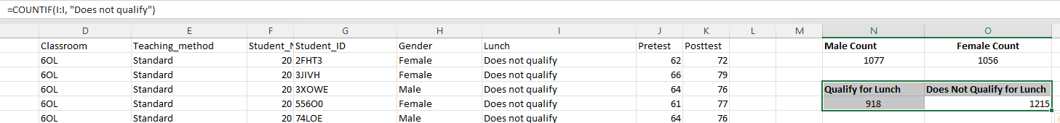

3. Calculating Mean and Median Scores Based on Lunch Qualification:
- In cell N12, I labelled it as "Mean Pretest (Qualifies)".
- Right next to it, in O12, I entered the formula =AVERAGEIF(I:I, "Qualifies for reduced/free lunch", J:J) to calculate the mean pretest score for students who qualify for lunch.
- Directly below, in N13, I labelled it "Mean Posttest (Qualifies)". In O13, I used the formula =AVERAGEIF(I:I, "Qualifies for reduced/free lunch", K:K) to get the mean posttest score for the qualifying students.
- For students who don't qualify for lunch, in cell N14, I labelled it "Mean Pretest (Does Not Qualify)" and entered the formula =AVERAGEIF(I:I, "Qualifies for reduced/free lunch", J:J) in O14.
- Next, in N15, I labelled it "Mean Posttest (Does Not Qualify)". In O15, I used the formula =AVERAGEIF(I:I, "Does not qualify", K:K) to determine their mean posttest score.
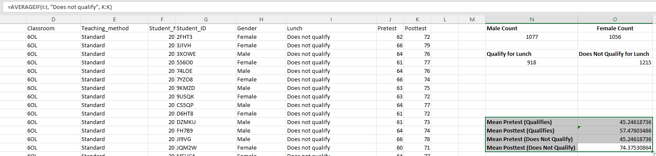

For the median calculations:
- I first sorted the dataset based on the lunch qualification column (I).
- Since the first 918 entries were for students who "Qualify for reduced/free lunch", in a suitable cell, I used the formula =MEDIAN(J1:J918) to compute the median pretest score for this category.
- Similarly, to calculate the posttest median for the same group, I used the formula =MEDIAN(K1:K918).
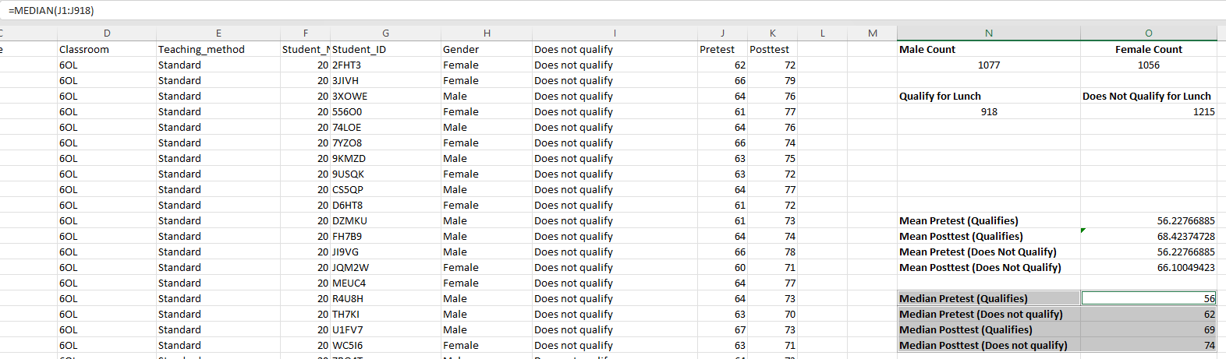

4. What are the mean and median differences of students' pre-test and post-test scores?

For students who qualify for reduced/free lunch:
Mean Score:
- Pretest: 56.23
- Posttest: 68.42
- Difference: 68.42 − 56.23
= 12.19
Median Score:
- Pretest: 56
- Posttest: 69
- Difference: 69 – 56
= 13
For students who do not qualify for reduced/free lunch:
Mean Score:
- Pretest: 56.23
- Posttest: 66.10
- Difference: 66.10 − 56.23
= 9.87
Median Score:
- Pretest: 62
- Posttest: 74
- Difference: 74 – 62
= 12
In summary
For students who qualify for reduced/free lunch:
- The average post-test score is approximately 12.19 points higher than the average pre-test score.
- The median post-test score is 13 points higher than the median pre-test score.
For students who do not qualify for reduced/free lunch:
- The average post-test score is approximately 9.87 points higher than the average pre-test score.
- The median post-test score is 12 points higher than the median pre-test score.
This indicates an overall improvement in test scores from pre-test to post-test for both groups of students. However, the degree of improvement varies between the two groups, with the group that qualifies for lunch showing a slightly larger mean increase.

5. Using the dataset Student_Score.csv provided in conjunction with SPSS, performing K-Means Clustering

K-Means Clustering Analysis in Excel
To make sense of the spread of student scores and categorize them into discernible groups, I chose to use the K-means clustering method via Excel. Below is a detailed breakdown of the steps I took:
Initialization
I first randomly selected two data points from the dataset as initial centroids. These centroids act as the central points of the clusters.
Assignment
- For each student in the dataset, I calculated the Euclidean distance to both centroids. This distance measures how far a data point (student score) is from a centroid.
  - Using the formula =SQRT((PretestScore-Centroid1Pretest)^2 + (PosttestScore-Centroid1Posttest)^2) for the first centroid. Similarly, adjust the formula for the second centroid.
- Each student was then assigned to the cluster of the nearest centroid. For example, if a student's scores were closer to the first centroid, they were assigned to Cluster 1; otherwise, they were assigned to Cluster 2.
  - You can use the IF function in Excel: =IF(DistanceToCentroid1 < DistanceToCentroid2, "Cluster 1", "Cluster 2").
Centroid Update
- After the initial assignment, I recalculated the centroids. This involves taking the mean of the Pretest and Posttest scores of all students assigned to a specific cluster. This new average score becomes the updated centroid for that cluster.
  - For all students assigned to Cluster 1, calculate the average Pre-test score and Post-test score. These averages will be the new coordinates for Centroid 1.
  - Do the same for Cluster 2.
Iteration
- I repeated the Assignment and Centroid Update steps iteratively to refine the cluster assignments. With each step, the central points shifted, possibly repositioning students to a varied cluster. I repeated this until the central points reached a point of minimal change, indicating a steady state.
- Results
- At the end of the process, I had two clusters, each representing a group of students with similar Pretest and Posttest scores.
- I then added a new column to the original dataset to indicate the cluster assignment for each student.
Using this method, I was able to segment the students based on their performance patterns, providing valuable insights into the dataset without the need for specialized software.
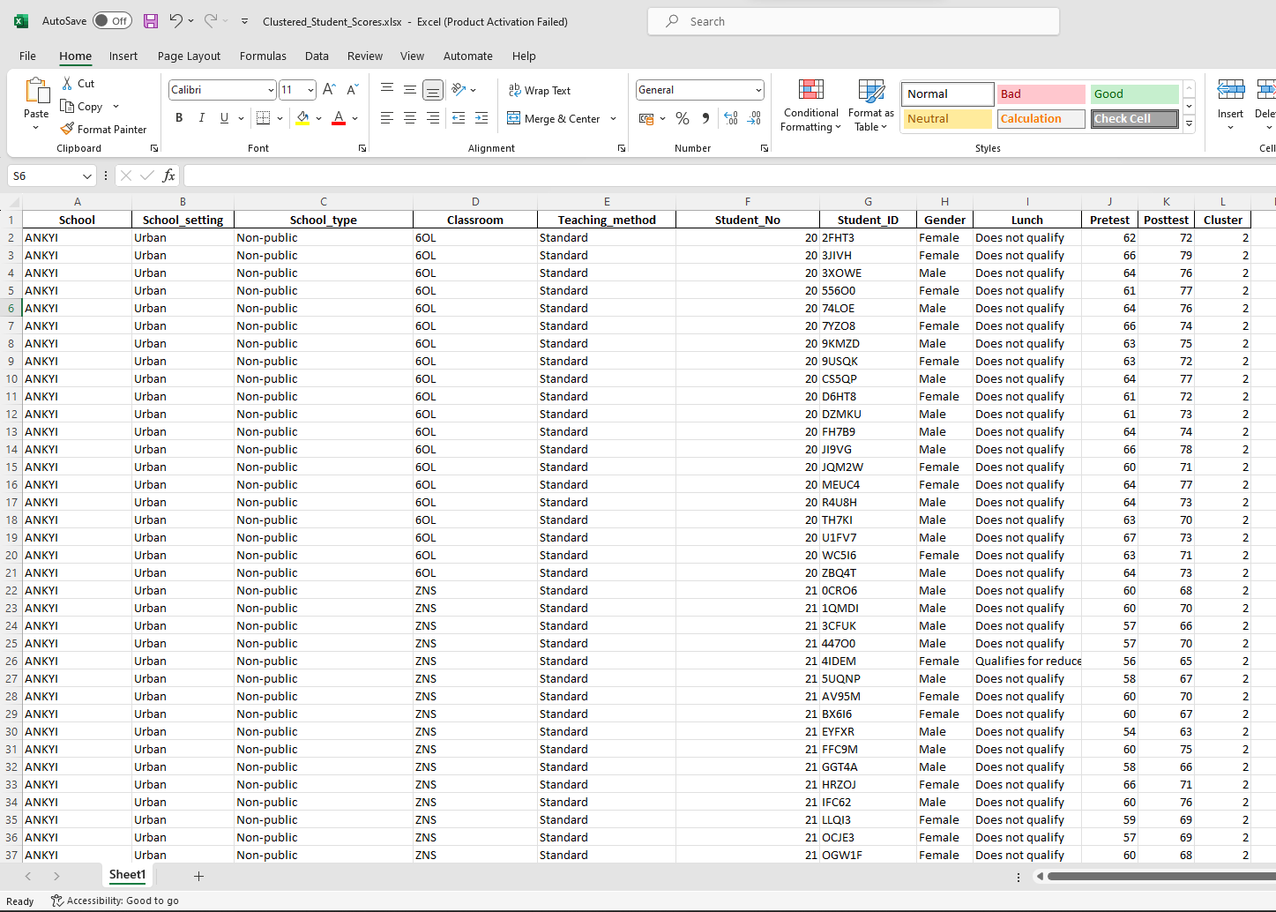
The screenshot above is showcasing a part of the cluster excel file in order to provide evidence for its execution.

Now, we are going to generate the scatterplots for the clusters:
Data Selection:
- I highlighted the columns that contained the Pretest, Posttest, and Cluster data, ensuring every relevant data point was captured.
Plotting the Scatterplot:
- I navigated to the 'Insert' section in Excel and chose the scatterplot option to plot the data points.

Cluster Density
The first observation is the clear demarcation between the two clusters. Cluster 1, which is on the left side, has students who generally scored lower in both the Pretest and the Posttest. Cluster 2, on the right side, comprises students who scored higher in both tests.
Trend Consistency
There's a distinct positive correlation in both clusters: as the Pretest scores increase, the Posttest scores also tend to rise. This trend indicates consistency in student performance across both tests.
Cluster Spread
Cluster 1 has a broader horizontal spread, suggesting that there's a wider range of Pretest scores within this cluster. However, the vertical range (or the Posttest scores) remains relatively consistent.
Cluster 2 is denser and more concentrated around the higher scores. This indicates that students in this cluster not only performed well in their Pretest but also maintained or improved their performance in the Posttest.

Inter-cluster Gap
A noticeable gap between the two clusters suggests a clear distinction in the performance of the two groups. This gap can be attributed to various factors like different teaching methods, classroom environments, or individual student capabilities.
Potential Outliers
There are a few students in Cluster 1 who have Posttest scores that are relatively higher than the rest of their cluster peers. These students might have shown significant improvement or might have been affected by external factors during their Pretest.
Overall, the scatterplot provides a clear visual representation of how students are grouped based on their performance in the Pretest and Posttest. The K-means clustering did an effective job of segmenting the students into two distinct groups, reflecting different performance patterns.

Data Mining Methods

Association Rule Learning (Market Basket Analysis):
This method identifies associations between items based on their occurrences in transactions. In the retail industry, for instance, if customers often buy bread and butter together, the store might place these items close to each other (Agrawal & Srikant, 1994).

Decision Trees:
A decision tree is a flowchart-like structure where each node, branch, and leaf respectively represent a feature, decision, and outcome. Financial institutions might employ decision trees to decide on loan approvals based on factors like income, credit score, and employment status (Quinlan, 1986).

Neural Networks:
Modeled after the human brain, these algorithms, comprising interconnected neurons, excel at pattern recognition. For instance, banks can deploy neural networks to detect potentially fraudulent credit card transactions by analyzing patterns in transaction data (Haykin, 2009).

Clustering:
Clustering groups similar data points. Marketing teams, for instance, might employ clustering to segment customers based on purchasing behavior (Jain, 2010).

Regression Analysis:
This method predicts the value of a target variable based on one or more input variables. For instance, real estate agencies might predict house prices using features like size, location, and age (Draper & Smith, 1998).

Text Mining Methods:

Sentiment Analysis:
Sentiment Analysis discerns the sentiment or emotion behind text. Brands could analyze customer reviews to deduce public sentiment about their products (Pang & Lee, 2008).

Topic Modeling:
Topic modeling discovers the primary topics present in a large collection of documents. For instance, news agencies might use this method to categorize news articles (Blei et al., 2003).

Named Entity Recognition (NER):
NER identifies and classifies named entities in text into categories like persons, organizations, and dates. A job portal, for example, might leverage NER to extract names of companies or skills from resumes (Nadeau & Sekine, 2007).

Text Summarization:
This method produces a concise summary of extensive text. Content creators might deploy text summarization tools to generate abstracts for long articles or reports (Das & Martins, 2007).

Text Clustering:
Text clustering groups similar documents or pieces of text. Customer support teams might use this method to cluster similar customer queries, thus streamlining responses (Cutting et al., 1992).

Advantages and Disadvantages of SPSS and Excel

Feature/Aspect | SPSS | Excel
Advantages
User Interface | User-friendly GUI designed for statistical analysis (Pallant, 2013). | Familiar interface for most users, especially for basic data input and manipulation.
Data Handling | Handles large datasets efficiently and is tailored for complex statistical analysis (Field, 2013). | Suitable for small to medium-sized datasets and offers pivot tables for data summarization (Parsons & Oja, 2013).
Analysis Tools | Comprehensive suite of advanced statistical tests and models (George & Mallery, 2016). | Provides basic statistical and mathematical functions, ideal for simple analyses.
Scripting & Syntax | Allows for scripting which makes repetitive tasks more manageable (Pallant, 2013). | Has macro capabilities using VBA but less intuitive than SPSS scripting.
Visualization | Offers a range of charts and plots tailored for statistical data (Field, 2013). | Excel has robust charting and graphing tools that are customizable (Parsons & Oja, 2013).
Disadvantages
Cost | Proprietary software and can be expensive for individual users (George & Mallery, 2016). | Part of Microsoft Office suite, relatively cheaper but still not free.
Learning Curve | Requires understanding of statistical concepts (Pallant, 2013). | Easier to start with for beginners, but advanced functions might require training.
Integration | Might have compatibility issues with datasets from other software (Field, 2013). | Seamless integration with other Microsoft Office products.
Flexibility | Primarily tailored for statistical tasks (George & Mallery, 2016). | More versatile in terms of use-cases beyond just data analysis.
Data Storage | Uses proprietary file formats that might not be readily accessible in other software (Field, 2013). | Widely accepted file formats like .xls and .xlsx.
Feature/Aspect | SPSS | Excel
Advantages
User Interface | User-friendly GUI designed for statistical analysis (Pallant, 2013). | Familiar interface for most users, especially for basic data input and manipulation.
Data Handling | Handles large datasets efficiently and is tailored for complex statistical analysis (Field, 2013). | Suitable for small to medium-sized datasets and offers pivot tables for data summarization (Parsons & Oja, 2013).
Analysis Tools | Comprehensive suite of advanced statistical tests and models (George & Mallery, 2016). | Provides basic statistical and mathematical functions, ideal for simple analyses.
Scripting & Syntax | Allows for scripting which makes repetitive tasks more manageable (Pallant, 2013). | Has macro capabilities using VBA but less intuitive than SPSS scripting.
Visualization | Offers a range of charts and plots tailored for statistical data (Field, 2013). | Excel has robust charting and graphing tools that are customizable (Parsons & Oja, 2013).
Disadvantages
Cost | Proprietary software and can be expensive for individual users (George & Mallery, 2016). | Part of Microsoft Office suite, relatively cheaper but still not free.
Learning Curve | Requires understanding of statistical concepts (Pallant, 2013). | Easier to start with for beginners, but advanced functions might require training.
Integration | Might have compatibility issues with datasets from other software (Field, 2013). | Seamless integration with other Microsoft Office products.
Flexibility | Primarily tailored for statistical tasks (George & Mallery, 2016). | More versatile in terms of use-cases beyond just data analysis.
Data Storage | Uses proprietary file formats that might not be readily accessible in other software (Field, 2013). | Widely accepted file formats like .xls and .xlsx.

References
Agrawal, R., & Srikant, R. (1994). Fast algorithms for mining association rules. Proc. 20th int. conf. very large data bases, VLDB.
Blei, D. M., Ng, A. Y., & Jordan, M. I. (2003). Latent Dirichlet allocation. Journal of machine Learning research, 3(Jan), 993-1022.
Cutting, D. R., Karger, D. R., Pedersen, J. O., & Tukey, J. W. (1992). Scatter/gather: A cluster-based approach to browsing large document collections. Proceedings of the 15th annual international ACM SIGIR conference on Research and development in information retrieval.
Das, D., & Martins, A. F. T. (2007). A survey on automatic text summarization. Literature Survey for the Language and Statistics II course at CMU, 4(1).
Draper, N. R., & Smith, H. (1998). Applied regression analysis (Vol. 326). John Wiley & Sons.
Field, A. (2013). Discovering statistics using IBM SPSS statistics. sage.
George, D., & Mallery, P. (2016). IBM SPSS Statistics 23 step by step: A simple guide and reference. Routledge.
Gursoy, D., Chi, C.G.Q., Lu, L. and Nunkoo, R., 2020. Antecedents and outcomes of travellers’ information-seeking behaviour in the context of COVID-19. Journal of Travel Research, 0047287520931593.
Haykin, S. (2009). Neural networks and learning machines (Vol. 3). Pearson.
Jain, A. K. (2010). Data clustering: 50 years beyond K-means. Pattern recognition letters, 31(8), 651-666.
Li, J., Bonn, M.A. and Ye, B.H., 2018. Hotel employee’s artificial intelligence and robotics awareness and its impact on turnover intention: The moderating roles of perceived organizational support and competitive psychological climate. Tourism Management, 68, pp.203-215.
Nadeau, D., & Sekine, S. (2007). A survey of named entity recognition and classification. Lingvisticæ Investigationes, 30(1), 3-26.
Pallant, J. (2013). SPSS survival manual. McGraw-Hill Education (UK).
Pang, B., & Lee, L. (2008). Opinion mining and sentiment analysis. Foundations and trends in information retrieval, 2(1–2), 1-135.
Parsons, J. J., & Oja, D. (2013). New perspectives on Microsoft Excel 2013, comprehensive. Cengage Learning.
Quinlan, J. R. (1986). Induction of decision trees. Machine learning, 1(1), 81-106.
Sigala, M., 2020. Tourism and COVID-19: Impacts and implications for advancing and resetting industry and research. Journal of Business Research, 117, pp.312-321.
Xiang, Z., Du, Q., Ma, Y. and Fan, W., 2017. A comparative analysis of major online review platforms: Implications for social media analytics in hospitality and tourism. Tourism Management, 58, pp.51-65.

