Maddie Howes
University of Wales Trinity St David | law and policing ba
A critical analysis on whether UK legislation is affording sufficient protection to victims of domestic abuse
Dissertation (BMPS6012)

Table of Contents
Abstract 4
Acknowledgements 5
Declarations 6
Chapter One – Introduction 7
1.1. Introduction 7
1.2. Objectives 7
1.3. Research focus 8
1.4. Methods and timescale 9
1.5. Challenges 9
1.6. Conclusion 10
Chapter Two – Literature Review 11
2.1. Introduction 11
2.2. The prevalence of domestic abuse in England and Wales 11
2.3. Reasons victims do not report domestic abuse 12
2.4. Legislation that protects victims of domestic abuse 13
2.5. Conclusion 18
Chapter Three – Methodology 19
3.1. Introduction 19
3.2. The Research Onion 19
3.2.1. Philosophy 20
3.2.2. Approach 20
3.2.3. Strategy 21
3.2.4. Choice 21
3.2.5. Time 21
3.2.6. The Centre 22
3.2.7. Reliability and Validity 22
3.2.8. Limitations 22
3.3. Conclusion 23
Chapter four – Analysis 24
4.1. Introduction 24
4.2. Research data analysis 24
4.2.1. What is your age range? 24
4.2.2. What is your gender? 25
4.2.3. What do you think the definition of domestic abuse is in England and Wales? 25
4.2.4. What percentage of the population in England and Wales (59,642,000 people) do you think reported cases of domestic abuse in 2022? 27
4.2.5. If you were in charge of creating laws to protect victims of domestic abuse. In what order would you prioritise these laws. 1 being the most important and 6 being the least. 28
4.2.6. There is a lack of legislation (laws) to protect victims of domestic abuse, why do you think this is? 29
4.2.7. Do you think there should be any exemptions or exceptions to allow people to commit actions of domestic abuse? 30
4.2.8. A protection order is a legal way you can prevent a person from causing you harm or annoyance. An example of this is a non-molestation order. How much do you think the court fee is for applying for this order? 30
4.2.9. How much do you think protection orders involving children cost? 31
4.2.10. What percentage of women in 2015 that applied for legal aid for domestic abuse do you think were rejected because they did not fit the criteria? 31
4.2.11. How much money do you think the government allocated to the tackling domestic abuse plan in 2023? 31
4.2.12. Other than the police could you identify any other support agencies that aim to support victims of domestic abuse? 32
4.3. Conclusion 33
Chapter Five - Conclusion 34
5.1. Introduction 34
5.2. Objective One 34
5.3. Objective two 35
5.4. Objective three 35
5.5. Limitations 36
5.6. Conclusion 36
References 37
Case Law 37
Legislation 37
References 39
Appendix 1 60

Abstract

This research found that legislation is currently affording sufficient protection methods to some victims. However, this does not apply to all victim's such as migrant women. This research investigates the prevalence of domestic abuse in the UK and the needs of the victims. The research found this was due to underreporting and not a lack of cases. Reasons for lack of reporting include the victim's fear of an abuser's actions and the attitudes of the police. It critically analyses legislation that aims to protect victims of domestic abuse. Despite legislation providing protection they are not common knowledge to the public and therefore rendered ineffective if the public are not aware they exist. Primary research was used to gather the public's perception on the protection methods currently afforded to victims of domestic abuse and any reforms they may offer. The primary research found that the public have a good understanding of the meaning domestic abuse. However, the public had an extreme overestimate of the prevalence of domestic abuse. The public showed strong views as to why current legislation does not offer sufficient protection for victims of domestic abuse. However, upon analysis the public did not understand the cost of protection methods or their existence.

Acknowledgements

I would like to thank Laura Knight for her support and guidance on this dissertation. I would also like to thank my family for supporting me through my journey at university.

Declarations
This work has not previously been accepted in substance for any degree and is not being concurrently submitted in candidature for any degree.

STATEMENT 1

This dissertation is being submitted in partial fulfilment of the requirements for the degree of BA/BSc.

STATEMENT 2

This dissertation is the result of my own independent work/investigation, except where otherwise stated.

Other sources are acknowledged in the Reference Section.
STATEMENT 3

I hereby give consent for my dissertation, if accepted, to be available for photocopying and for interlibrary loan, and for the title and summary to be made available to outside organisations.

STATEMENT 4

I hereby give consent for my dissertation, if accepted, to be available on the university’s IT system to those who have consent to use the system.

Student’s Name: Madeline Howes

Signed:

Date: 22/04/2024

Chapter One – Introduction

1.1. Introduction
The aim of this dissertation is to critically analyse whether UK legislation is affording sufficient protection to victims of domestic abuse. This topic has been chosen because domestic abuse is prevalent in the UK with the Office for National Statistics (2022a) calculating that 59,642,000 cases of domestic abuse were reported in England and Wales, which equates to 5% of the adult population. According to the Home Office (2022), only one in five cases of domestic abuse is reported to the police. From this statistic it can be evaluated that there are many victims in the UK that are not receiving the protection they need. There are many reasons why domestic abuse is unreported, an example of this is an abuser using coercive and controlling behaviour towards a victim (Birchall and Choudhry, 2022). The literature review will analyse the problems with current legislation that currently aims to protect victims of domestic abuse. The research will be beneficial as it will identify possible reforms to current legislation to further protect victims.

1.2. Objectives
This project will be focused on three main objectives.
- Objective one: Identify the prevalence of domestic abuse in England and Wales and the needs of victims.
This was chosen as it will show the relevance of this dissertation’s topic. It will also consider if statistics are a true representation of victims.
- Objective two: Assess current legislation that aims to protect victims from domestic abuse.
This is necessary to allow a critical evaluation of legislation currently available to victims whilst highlighting any gaps in literature.
- Objective three: Evaluate public perception on the protection currently afforded to victims of domestic abuse by UK legislation and the reforms they offer.
The third objective will be carried out using primary research to find correlations between the public’s opinions and a victim’s thought process. The Home Office (2022) offers the contact information of support groups to victims of domestic abuse to encourage early intervention. However, as it is only for early intervention and does not support those who have reached full crisis, it might not offer enough protection for all victims. The third objective will also show what is required from the law makers for reform.

1.3. Research focus
This research will be investigating current legislation as well as the evolution of UK legislation throughout history regarding domestic abuse. The Centre for Women’s Justice (2023) shows a timeline of the slow evolution of legislation as well as the limited reforms to create protection for victims of domestic abuse. The timeline shows the first piece of legislation dedicated to combat domestic abuse -the Domestic Violence and Matrimonial Act 1976, to the last piece of legislation - the Domestic Abuse Act 2021. Upon evaluation, progression of legislation has been slow it terms of protection to victims. McPhee et al (2021) reports the significant gaps found between the newest and oldest legislation for domestic abuse. Rapid progression in legislation is imperative to protect victims of domestic abuse as current legislation does not protect all victims equally. Some victims must wait for future legislation, unpredictable circumstances can arise such as the global pandemic. The pandemic forced victims and abusers to be trapped together (Gulati and Kelly, 2020). Another example is before January 2022, abusers were legally allowed to contact associated children of the victim. CPS (2022) write that due to the reform of section 3 of the Domestic Abuse Act 2021, associated children under the age of eighteen will be treated as primary victims and are no longer required to have contact with the abuser. This reform to legislation was imperative as Katz, Nikupeteri and Laitinen (2020) conducted a study that found fathers would use coercive and threatening control over their children once the mothers had separated from the abuser. If this reform had not taken place, the rights of an abusive parent would have continued to affect many children and their primary care giver.

Obstacles such as housing arrangements, childcare and reduced finances are additional challenges that victims are faced with (Hunter, Barnett and Kagnas, 2018). Legislation found in the Family Law Act 1996 such as occupation orders can be put in place, thus allowing victims the right to their home (Bates and Hester, 2020). An occupation order is only available to those who can access the relevant information independently or can afford legal representation to do on their behalf (Richardson and Speed, 2023). According to Blakely (2024), legal aid is not often awarded to those who are facing financial hardship; therefore, legislation that is in place to protect, is not affordable to all victims equally. Garton (2016) reveals that 39% of women who applied for legal aid do not have the evidence to qualify for it.

1.4. Methods and timescale
The research for this dissertation will consist of secondary research that will analyse the current literature regarding the protection legislation currently afforded to victims of domestic abuse. It will also consist of primary research to collate the public’s perception of protection methods that are currently afforded to victims of domestic abuse by a questionnaire to the public (Newby, 2014). A mixed methodology would be used for the primary data in this project. This is because quantitative questions will focus the aim of the survey but will be followed by qualitative questions to address the participants true thoughts and feelings on each matter (Einola and Alvesson, 2021). This dissertation will be written over the course of eight months and will be split into monthly deadlines to keep a consistent flow of writing. The primary research will consist of probabilistic sampling from a random group of participants (University of Bath, 2023). Participants over the age of 18 and of different genders, ethnicities and backgrounds will be used to create an unbiased sample (Mitani et al, 2021). This will show an unbiased overview on the public’s perception on whether sufficient protection is currently afforded to victims of domestic abuse by UK legislation.

1.5. Challenges
According to Taylor (2023) the problems that may occur within primary research are cost, time, feasibility, and lack of knowledge. However, certain measures such as using a free questionnaire site with simplistic features, will ensure these problems will be tackled. The results from the primary research could reveal that the public do not have a good understanding of the term ‘domestic abuse’ or the prevalence of it in the UK. A correlation may be found between public perception and a lack of sufficient protection for victims of domestic abuse.

1.6. Conclusion
This research is important because it could highlight current gaps in literature that in turn could be detrimental to a victim of domestic abuse. Gaps such as the many convoluted steps it takes to prevent or stop contact with an abuser. Harassment orders and occupation orders can only offer protection once complete, however victims require protection prior to, and during the protection order process (Gordon, 2020). Furthermore, there is no guidance or support to victims about the facts and steps to completing these orders (Vidu, Tomas and Flecha, 2022).

Chapter Two – Literature Review

2.1. Introduction
Domestic abuse has been a relevant topic dating back to the 15th century when the Catholic Church would encourage men to be the punishers of their wives to keep them submissive (Swisher, 1994). Unfortunately, it is only within the past few decades that abusers have been held accountable for their actions. This was made possible by the Domestic Violence and Matrimonial Proceedings Act 1976, the first piece of legislation dedicated to combat domestic abuse. This act sought to bring equal justice into each marital home by the threat of arrest. It was suggested by Maidment (1983) that this legislation did not reduce violence to battered women or others that suffered from domestic abuse, as it was observed to be too difficult to change the publics deep seated attitudes towards domestic abuse. However, the Domestic Violence and Matrimonial Proceedings Act 1976 was the first necessary step towards eradicating domestic abuse. It was in the late 1900’s when English law started to take domestic abuse seriously as shown in the case of R v Ahluwwalia (Kiranjit) (1992). This case concluded that the conviction for murder was quashed and a retrial for manslaughter was called for. The defendant pleaded that her actions lead to his death by a direct result of the provocation of her husband’s abusive behaviour towards her.

2.2. The prevalence of domestic abuse in England and Wales
Domestic abuse is prevalent in England and Wales, with the Office for National Statistics (2022a) reporting that there were an estimated 2.4 million victims of domestic abuse, and only 1.5 million cases reported to the police (Office for National Statistics, 2022b). There was no significant change for the following year as the Office for National Statistics (2023) shows that 2.1 million victims had experienced domestic abuse that year as well as only 889,918 of the 2.1 million cases were reported to the police. This is a significant difference between the estimated number of victims and reported victims. Gracia (2004) explains the analogy that reported cases of domestic abuse are compared to the tip of an iceberg because we can only create laws about the surface that we see. The unreported cases are below the water line, which is a large and undiscovered territory, therefore no intervention or lawful progression can be made to help the unreported victims.

2.3. Reasons victims do not report domestic abuse
There are many reasons that victims do not report to the police. Aldridge (2015) proposed the idea that victims do not report their experience of domestic abuse because they are bonded by the trauma they have endured during the abuse and do not want to break the connection they have. For example, some victims will not remove themselves from their abusers because they blame the actions of the abuser on themselves (Cravens and Whiting and Aamar, 2015). Victim Support (2018) is an independent charity that has worked with over 35,000 survivors of domestic abuse. The charity commissioned a survey to investigate the reasons why victims may not report their case of domestic abuse to the police. The main outcome of the survey was the victims felt there was a lack of empathy and in some cases intimidation from male police officers, making female victims feel inadequate or uncomfortable to discuss their situation. Victim Support (2022), report that 48% of black and ethnic minorities felt that they were not taken seriously by the police because of the colour of their skin. Prejudice’s such as this could be a factor as why legislation takes a long time to evolve. The survey also showed that some victims felt that they were not believed and dealt with in a robust and unsympathetic manner, leaving victims feeling infuriated that the police could not conceive the level of danger they were in. An additional factor for not reporting a case of domestic abuse is the fear of repercussions from an abuser if intervention or a conviction is not made (Gurm and Marchbank, 2020). The Crown Prosecution Service (2022a) provide that the police charge rate for domestic abuse is 77.2%. Although this may appear to be a high percentage, 22.8 % risk of failure may be too high for some victims to come forward. The Office for National Statistics (2023) stated that only 39,198 offenders were convicted in 2023. The case of R v Curtis (2010) highlighted the difficulty of proving harassment in a court of law that would conclude in a conviction. Some victims may not realise that what they are experiencing is abuse, it can be a common misconception that domestic abuse is solely physical (Sweetnam, 2013). However, Cox (2022) explained that the Domestic Abuse Act 2021 defined domestic abuse as behaviour that was physical, sexual, violent, threatening, controlling or coercive. As well as economical, psychological, or emotional abuse.

It was found by Birdsall and Boulton (2022) that victims are concerned with the process of reporting domestic abuse and the limited support the police can offer. The Metropolitan Police (2023) advise that in the first instance a victim should call 999 for physical intervention by the police. The police are duty bound to update the victim who reported abuse within 24 hours of the report being made. A helpline telephone number is given to the victim to follow up on the progress of their report. In 1987, EVA Woman’s Aid (2019), was launched as the first national domestic violence hotline to support victims. Following the initial report of the abuse the victim can apply for an injunction or protection order which Durfee (2011) explains is a way a victim can prevent or restrict contact between themselves and their abuser. There are many independent actions that the victim must follow to proceed with a claim of domestic abuse with little support from the police, this could be a contributory factor as to why more cases of domestic abuse are not reported as victims may not feel protected by law enforcement. However, Citizens Advice (2023) offer additional advice on the steps that a victim of domestic abuse should take once an allegation of abuse has been reported, such as housing arrangements.

2.4. Legislation that protects victims of domestic abuse
Victims can use legislation to apply for injunctions to distance themselves from the situation and the abuser. Domestic abuse protection notices/orders can be put in place to create immediate and long-term interventions to create a safety net from their abuser (UK Government, 2024a). However, a drawback is the cost of legal representation. Whilst this is not necessary, they could provide extensive knowledge and guidance (Women’s Aid, 2023). Many victims do not have the financial capability for legal support. Reasons for this could be financial dependency on their abuser or their abuser has control over a victim’s resources (Johnson et al, 2022) and cannot afford legal representation. Therefore, a victim could apply for legal aid. Whiting (2023) defines legal aid as a government funded scheme that pay the legal fees for those who cannot afford it. Legal aid could afford a victim to leave the domestic abuse, or if rejected subject them to further suffering (The Law Society, 2023). Sentencing and Punishment of Offenders Act 2012 was found to be restricting as it has a five-year time limit to provide evidence of domestic abuse to apply for legal aid. This could be hard as it is not easy gathering sufficient evidence for the police. It is shown in Garton (2016) that 39% of women who applied for legal aid do not have sufficient evidence to receive it. To prove domestic abuse, a victim will need to gather verbal testimonies from witnesses, medical reports of injuries, and ensure that police reports are compiled to show a repetitive case of domestic abuse (National Domestic Violence Hotline, 2021). The time limit was abolished in the civil legal aid (procedure) (amendment) (no. 2) 2017 regulations so victims did not have to feel under pressure from a time constraint. Citizens Advice (2023) offer a free tool to help victims independently apply for non-molestation orders or occupation orders. They also give guidance on how to apply for legal aid. UK Government (2023a) state that non-molestation orders and occupation orders are free to apply for but if the victim does not know of the sufficient protection methods they will not be used. Some victims experience coercion from their abuser and might not have access to facilities for research (Speed and Richardson, 2022). Victims then may feel obligated to stay with their abuser for financial reasons (Postmus, Plummer and Stylianou, 2016).

Although the Office for National Statistics (2023) suggest a decrease in domestic abuse reports, the accuracy of these statistics as a true representation is questionable (Sainani, 2017). One of the main dangers with statistics that suggest reporting domestic abuse incidents are decreasing is the lack of demand for change to existing policy and legislation (Bunce et al, 2024). Maslen and Paine (2024) suggest a further implication could be the allocation of resources to other crimes are deemed a priority. According to HM Government (2023) over £140 million was invested into the tackling domestic abuse plan for two years. However, this is miniscule compared to the £2.2 billion that is spent annually to tackle fraud (UK Parliament, 2011). The £140 million for the domestic abuse plan is split up into smaller divisions. Although it seems like a large budget, each division is not specifically for victims of domestic abuse. An example of this is that money from the budget is allocated to general housing instead of housing for victims of domestic abuse. UK Government (2023b) specify that £10 million is given to organisations providing support to children suffering from domestic abuse, such as counselling with 1:1 support. However, the £10 million is also split over different organisations such as Welsh Woman’s aid, The Children’s Society, SafeLives, and more, meaning that each organisation is receiving around £1 million or under. This might not be sufficient for each community to create the best resources and protection for the victims. SafeLives (2023b) state that they are primarily funded by charities, meaning funding is crucial. Support and protection are vital to help victims of domestic abuse as the charity SafeLives (2023a) reveal that they have helped over 50,000 victims and 70,000 children. Mahapatro, Prasad and Singh (2021) report that 60% of victims afforded sufficient protection found the abuse stopped when receiving the correct advice and protection methods provided by these support communities.

Current legislation does give the opportunity for victims to gain protection from domestic abuse, however, the evolution of legislation has been extremely slow. Only within recent years domestic violence was changed to domestic abuse by the Domestic Abuse Act 2021, as violence did not have the connotations of all that a victim could experience (Aldridge, 2021). It is because of this slow evolution that so many perpetrators were able to and are still able to commit acts of domestic abuse. The first piece of legislation to combat domestic abuse was the Domestic Violence and Matrimonial Proceedings Act 1976. It gave the police the power of arrest if domestic violence had occurred. Slow evolution of legislation is dangerous because a portion of the public still have the perception that domestic abuse is acceptable (Martin-Fernandez, Gracia and Lila, 2022). An example is that it was only made a law in 1991 that marital rape was a crime, a decision which was made in R v R (1991). The next legislation to protect victims of domestic abuse was introduced 21 years later, this was the Housing Act 1996. A large gap in legislation would have caused victims to suffer during this period due to lack of legal support (Sivarajasingam et al, 2022). The Housing Act 1996 act recognised that primary care givers and children were at risk of homelessness when leaving homes of domestic abuse. The victims and children were considered ‘homeless’ and would be put through the housing process. Although this legislation was not created specifically for victims of domestic abuse, it provided sufficient protection for them.

The Protection from Harassment Act 1997 and the Family Law Act 1996 are crucial pieces of legislation for protecting victims of domestic abuse. The Protection from Harassment Act 1997 was first put in place to criminalise harassment and protect victims from a variety of abuse and inappropriate behaviours displayed by perpetrator’s (Strickland, 2017). Daily abuse causes a mental strain on a victim, gaining a successful protection order can provide an ease for the victim (Kaur and Garg, 2008). The Crown Prosecution Service (2022b) claim that restraining orders can be applied for any criminal offence. Sentencing Council (2023) explain that if a protection order is breached, a prison sentence of up to 5 years can be implemented.

The Family Law Act 1996 introduced occupation orders and non-molestation orders. An occupation order has the power to legally allocate who can occupy the family home. It could allow victim’s and children of domestic abuse to remain in their family home, whilst removing the abuser (Shelter, 2021). Certain criteria, such as both parties must have lived in the property together as a family home or intended to in the future and must be associated persons; another deciding factor is relevant children. In the case of Re L (Children) (2012), it was decided that the children were affected by the parents quarrelling and it was in their best interest to remove the father from the home. Under section 33 (3) of the Family Law Act 1996, it is the courts digression to decide who remains in the property or part of the property. Non-molestation orders can be used to protect a victim from harassment by diminishing an abuser’s actions, such as visiting the home or threatening physical abuse (College of Policing, 2022). Non-molestation orders can only be applied for associated people such as marriage or civil partnerships (National Centre for Domestic Violence, 2020). Most legislation available to protect victims have specific criteria and many blockades for a victim who may need a protection order. An example is non-molestation orders can only be made for deliberate harassment and the victim must prove the harassment (Bates and Hester, 2020). In C v C (1998) the publication of a newspaper article was not seen as a molestation despite fears of a tarnished reputation. However, there are gaps regarding this current legislation because there are remedies available for abusers to reduce or clear charges against them. It is reported by Judiciary (2007) that physical and emotional factors including mental illness, such as post-traumatic stress disorder (PTSD) can impact the sentencing of an abuser. This was demonstrated in the cases of Bratty v Attorney General for Northern Ireland (1963) where PTSD was used as a defence. However, the defence of PTSD was not always accepted by judges due to fear of flooding the courts with this defence for all crimes (Savla, 1999). Abusers who suffer or claim to suffer from mental illness can also prevent victims from using the law to protect themselves from domestic abuse. This was demonstrated in the case of Banks v Banks (1999) where a spouse was refused a non-molestation order because his wife’s actions were excused by mental illness.

The next piece of legislation was the Domestic Violence, Crime and Victims Act 2004. The government implied it was the biggest change to law regarding domestic violence within the past 30 years. Hester, Pearce and Williamson (2008) wrote in a Ministry of Justice report that this claim was an exaggeration because it had a limited impact to victims of domestic abuse. They reported that in their opinion the most effective change was that common assault was made an arrestable offence in England and Wales under the Police and Criminal Evidence Act 1984. This proves that the slow evolution of legislation was not affording sufficient protection to victims, and it takes years for each legislation to be published. The next act to have an impact on domestic abuse was the Crime and Security Act 2010. The act enabled victims to attain a Domestic Violence Protection Notice if they had received threatening violence towards them. An emergency non-molestation order can be implemented by the police in serious incidents (UK Government, 2022).

It was a further 5 years until the Violence Against Women, Domestic Abuse and Sexual Violence Act (Wales) 2015 was introduced, with the main aim to stop gender-based violence/abuse. Policy and Strategy (2022) reported the Welsh government wanted to change public perception on violence towards women by holding offenders accountable.

The latest legislation dedicated to the protection of victims from domestic abuse is the Domestic Abuse Act 2021. This act defined that domestic abuse is not just physical violence. This is the first act to make non-fatal strangulation and sharing private sexual images a criminal offence (UK Government (2024b). Legislation has not been sufficient at affording protection to victims of domestic abuse until 2021 as laws such as the two previously mentioned should have been implemented in prior legislation. This act was first announced to be drafted in the Queen’s speech in 2017 and to be implemented between 2018-2020, however it was not introduced until 2021 (End Violence Against Women, 2017). The bill was proposed in the House of Commons and sat through 12 sittings (House of Commons Library, 2021) taking a long time to become law (UK Parliament (2023). This gap in legislation can be fatal to some victims as previous legislation may not apply to them and will have to wait longer for legislation that will protect them from domestic abuse. For example, according to the Middle Eastern Women & Society Organisation (2023), the Domestic Abuse Act 2021 does not offer protection for migrant women that suffer domestic abuse or the power to punish their abuser. The charity reports 92% of immigrant domestic abuse victims are threatened with deportation by their abusers. The Domestic Abuse Commissioner (2023) reported that the police made 537 referrals of cases involving domestic abuse victims who were immigrants to Homeland security as they were prioritised as criminals instead of victims.

2.5. Conclusion
The literature review analysed that not all current legislation is sufficient at affording protection to victims of domestic abuse. It found that not every method is affective or accessible to victims with drawbacks such as, negative perceptions of the police which made victims feel uncomfortable involving them. This is a critical perception because the police are one of the only effective ways to start the process of intervention in cases of domestic abuse (Davies, Barlow and Fish, 2023). Legislation should investigate other correction methods other than imprisonment such as rehabilitation so that there is not a dependency on new legislation. Hackett and Small (2023) have conducted that prison officers that encourage a supportive environment and encourage rehabilitation have higher success and lower reoffending rates. The UK government promote the Community Domestic Violence Programme (Ministry of Justice, 2016) which aims to diminish abusive thinking in males and to convert aggressive behaviour. National Offender Management Service (2015) report that the results from this programme was effective and slightly reduced the rate of reoffending.

Chapter Three – Methodology

3.1. Introduction
Primary research gives first-hand perspective into the research in the literature review. It is paramount to identify the public’s perception of the objectives.
- Objective one– Identify the prevalence of domestic abuse in England and Wales and the needs of victims.
The literature review investigated the second objective in depth. However, the primary research will give an insight into the public opinions and knowledge of current legislation.
- Objective Two- Assess current legislation that aims to protect victims from domestic abuse.
The literature review showed gaps in current literature such as there is no current legislation to protect migrant women from domestic abuse (Middle Eastern Women & Society Organisation, 2023).
The third objective will aim to perceive the public’s perception on the gaps that were found in the literature review.
- Objective Three - Evaluate public perception on the protection currently afforded to victims of domestic abuse by UK legislation and the reforms they offer.
Other gaps found in legislation are the remedies available for abusers to reduce or clear their charges. Remedies such as mental health can influence an abuser’s sentence (Judiciary, 2007).

3.2. The Research Onion
The Research Onion will be applied to the research methodology. The Research Onion was created by Saunders et al (2007) to allow a researcher to methodically describe actions and decisions. It is used to examine the relevance of research, as well as analysing findings to provide validity and reliability. This will be achieved by using all the layers of the research onion (Melnikovas, 2018).
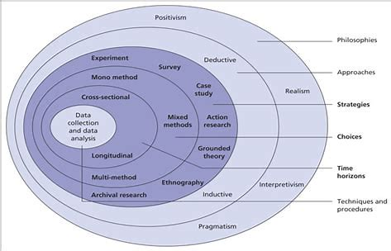

(Saunders et al, 2007)

3.2.1. Philosophy
The first layer is the philosophy of the project. It describes the reasoning and purpose of the research. There are different types of research philosophy however, Saunders only refers to three, positivism, interpretivism and pragmatism (Ryan, 2018). This research will use interpretivism to review social phenomena’s whilst considering cultural factors in the participants environment. This method gives an insight to the public’s perception on legislation and if it provides sufficient protection to victims of domestic abuse (Saunders, Tosey, 2013). The researcher can summarise a collection of the publics thoughts to remain subjective and factual.

3.2.2. Approach
An inductive approach will be applied to generate a theory from the results of the research rather than adopt a pre-existing theory (Naeem et al, 2023). The aim is to analyse the perceptions from the public and review if they hold UK legislation in high regard or have a pessimistic view. Makri and Neeley (2021) suggest that the data will be collected and analysed for patterns and formulate a conclusion. An inductive approach consists mainly of qualitative data to receive the public’s input with specific reasoning to their opinions. This raw data will be condensed into a clear evaluation (Thomas, 2006).

3.2.3. Strategy
The next layer in the research onion is strategy. This will focus on how the research will be conducted. The strategy will consist of identifying the facts and describe its findings with justification (Rasheed et al, 2019). A survey with open and closed questions will be used to conduct the primary research to gather qualitative and quantitative data. The research will be motivated by descriptive research to offer depth and acutely analyse all data to create a hypothesis (Bccampus, 2023).

3.2.4. Choice
The fourth layer of Saunders research onion is choice. This layer defines what type of data will be used. In this research a mixed method is used to ask quantitative and qualitative questions (Baran, 2020). Quantitative questions will focus on statistics and high volumes of information (NIHR, 2023). It is used to gather statistical data so conclusions can be drawn by the researcher. Asking participants quantitative questions will present an average of the answers which will be compared to the research from the literature review. Busetto, Wick, Gumbinger (2020) write that qualitative research focuses on words rather than numbers, primarily targets the why behind participants opinions. Pathak, Jena and Kalra (2013) convey that the main point of qualitative research is to have an in depth understanding from a humanistic view. This will could show a correlation between the thoughts of participants and victims of domestic abuse.

3.2.5. Time
Marhaben et al (2012) stated that creating a timeline will structure the process of conducting research by giving small goals to make the project manageable. Working on small aims allows a researcher to gather quality content consistently, until the end of the research. A cross sectional time horizon is used during this research. Research with long time horizon goals and short-term horizons will keep the research on track by breaking up goals to increase motivation (Rolison, Hanoch and Wood, 2017).

3.2.6. The Centre
Saunders et al (2015) report the centre of the onion is the techniques for data collection, the processes and analysis of research. The techniques for data collection will be a questionnaire with qualitative and quantitative questions. The benefits of a questionnaire are it can intake a large population to gain as many statistics as possible (Jones, Baxter and Khanduja, 2013). The findings will guide the research of the project by revealing the public’s view on protection methods available to victims of domestic abuse (Wasti et al, 2022). Using a questionnaire is beneficial according to Cleave (2023) due to no cost and gives flexibility for the participants to complete the questionnaire. Appropriate wording that will not confuse the respondents will be used to ensure easy completion (Choi and Pak, 2005). Thematic analysis will be used to find correlations and patterns in the data that will be analysed (Braun and Clarke, 2012). The use of primary research will give validity to the literature review (Driscoll, 2011).

3.2.7. Reliability and Validity
These are important factors to prove that the research is reliable and would ensure the same results if repeated. Random sampling ensures a large sample is formed. Andrade (2020) conveys that this method allows accurate and concise results. The questionnaire will be made on google forms and shared via social media to gain a large range of participants over the age of 18 with varied ethnicities and genders for unbiased results (Delbosc, 2023). Snowball sampling will be used to quickly spread the questionnaire by participants passing it along to others. A limitation to this is that the participants may come from one geographical area (Emerson, 2015).

3.2.8. Limitations
The limitations could include participants rushing the questionnaire or answer based on what they think the answers should be and not their perception. This would collect false facts and would not be beneficial (Murdoc et al, 2014). Confidentiality and informed consent are the main ethical issues in primary research. However, the participants personal information will not be collected and only answers to the questions will be included and evaluated. All respondents must give full consent and have the right to withdraw at any stage prior to submission of the questionnaire by closing the page (Kelley et al, 2003). This research will follow UWTSD research integrity and ethics (2024) code by maintaining integrity and high standards throughout the research and remain professional. This research will also meet the conditions of the Data Protections Act 2018 and the General Data Protection Regulation 2018.

3.3. Conclusion
The methodology proposes that the questionnaire will identify the public’s perception on the gaps in legislation found in the literature review and evaluate any gaps proposed by the respondents. The questionnaire will be distributed and evaluated to find patterns and trends to draw conclusions surrounding the gaps in literature.

Chapter four – Analysis

4.1. Introduction
This chapter will be analysing the answers from the primary research to gain the public’s perception of domestic abuse and provide primary evidence to support the literature review. This research consisted of a questionnaire that was released to the public online because it is a reliable way to gather and store participants answers (Scharf, 2014). The analysis chapter aims to answer all the objectives of the dissertation.

- Objective 1 – Identify the prevalence of domestic abuse in England and Wales and the needs of victims.
- Objective 2 – Assess current legislation that aims to protect victims from domestic abuse.
- Objective 3 – Evaluate public perception on the protection currently afforded to victims of domestic abuse by UK legislation and the reforms they offer.

The results from the questionnaire will answer the research question by using quantitative analysis testing the hypothesis to determine whether UK legislation is affording sufficient protection to victims of domestic abuse in England and Wales. This will be executed by using thematic analysis, to identify themes and patterns in the answers (Terry et al, 2017). The questionnaire is made up of quantitative and qualitative questions for validity. Quantitative analysis will be used because O’Leary (2023a) explains that it will magnify any relationships and patterns formed from the participants answers. Qualitative analysis will draw conclusions from the participants answers by coding them into different occurring themes (O’Leary, 2023b).

4.2. Research data analysis

4.2.1. What is your age range?
Using snowball sampling (Emerson, 2015) the questionnaire reached a broad age range, between 18 to 65 years +. Having opinions from a wide variety of ages assists in engaging the overall opinions of the public regarding domestic abuse as anyone can be subject to it (Betz et al, 2023). Whilst the questionnaire was completed by a wide age range, 50% of the respondents were aged between 18 and 25, limiting the research due to a lack of representation.
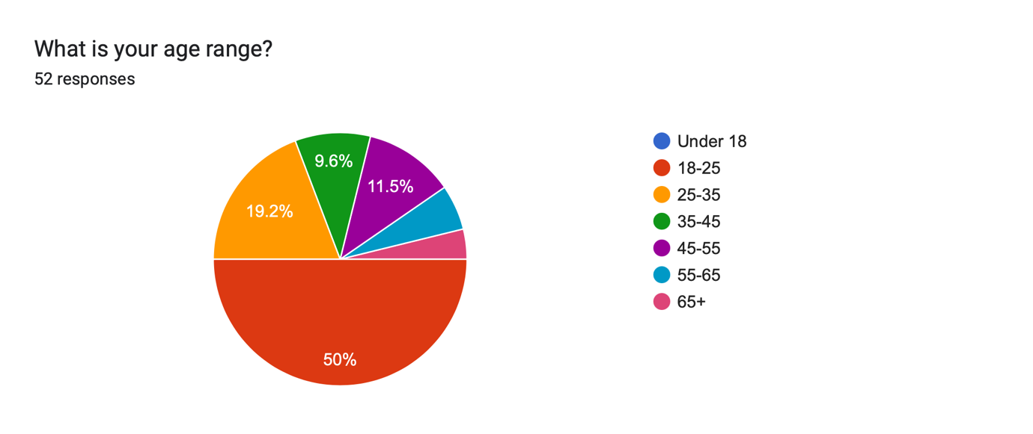

4.2.2. What is your gender?
According to Monteiro et al (2024) women are more likely to do an online survey than men, this was confirmed by the questionnaire with 80.4% were female, 17.3% male and 2.3% non-binary. This could also limit the research with a lack of representation.
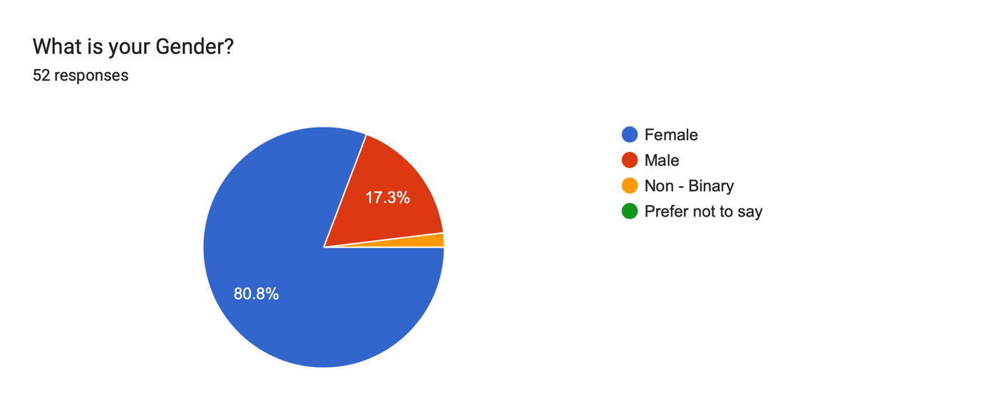

4.2.3. What do you think the definition of domestic abuse is in England and Wales?
All the respondents referred to violent or abusive behaviour that may harm another within a household. According to the Ministry of Defence (2024) 84% of domestic abuse victims experience non-physical abuse, however 39 of the respondents referred to physical abuse. This shows that the public may believe that emotional abuse is not considered to be as harmful as physical abuse (Women’s Aid, 2022). The literature review echoes this stating that some victims do not report domestic abuse because they do not realise they are experiencing it (Sweetnam, 2013). However, Cox (2022) defined that domestic abuse could range from physical, sexual, violent, threatening, controlling or coercive behaviour. As well as economic, psychological, or emotional abuse. Respondents stated that domestic abuse involves coercion over an individual’s finances or their mental state. Examples of the respondent’s definitions include “Any incident or pattern of incidents of violent/ threatening/ controlling/ sexual abuse. Another respondent quoted “Physical, mental, financial or emotional abuse (among others) between partners, family members, or those who live under the same roof”. None of the participants specified a gender, showing that there is an understanding that abuse is not gender specific. The public may have a good understanding of domestic abuse because of victims who share their experiences. Ucko (2010) found Storieswork, a non-profit organisation that supports domestic abuse victims and provides a safe space to share their experiences.

4.2.4. What percentage of the population in England and Wales (59,642,000 people) do you think reported cases of domestic abuse in 2022?
This question answered the first objective as the literature review found that 1,500,369 of the domestic abuse cases were reported to the police (Office for National Statistics, 2022a).
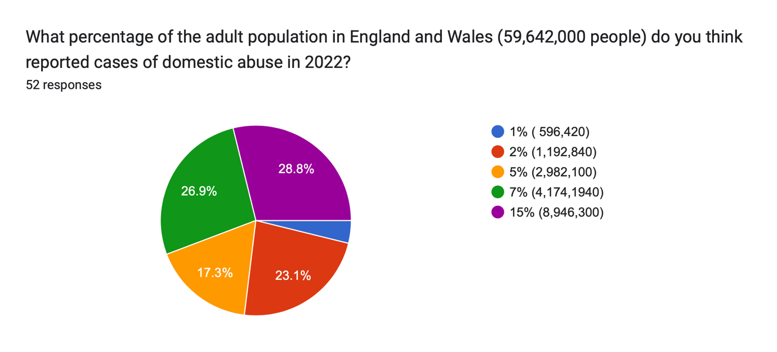
The questionnaire found 28.8% of the participants voted the highest option of 8,946,300 cases reported, showing the public do not have an accurate prevalence of domestic abuse in the UK. A public perception is potentially that domestic abuse is a current issue. The minority may have thought that domestic abuse is not prevalent or that there are more cases of domestic abuse that are un-reported than reported. The literature review revealed that out of 2.4 million occurrences of domestic abuse, only 1.5 million cases made a police report (Office for National Statistics, 2022a).

4.2.5. If you were in charge of creating laws to protect victims of domestic abuse. In what order would you prioritise these laws. 1 being the most important and 6 being the least.
This question focused on the second objective assessing current legislation. It found the public’s focus was to prioritise rehoming children where domestic abuse is present. Cox (2024) indicates that 2.4 million women in the UK are primary caregivers and given that 80% of the respondents were female, they may have felt an obligation to make children a priority, however it was not stated that the children were in danger. It could be presumed that adults would rather any form of abuse were aimed at them rather than children (Landgren, 2005).

The second priority was to permanently separate the victim and the abuser, this was selected higher than rehoming a victim. This could be because rehoming a victim does not ensure permanent separation from their abuser and could make the situation worse if they return (Basilio, Guglielmucci and Livanou, 2022). Victims may stay in an abusive relationship for the protection of children or for financial security (Cheverton, 2023). Incarcerating an abuser gave a varied response ranging from the top two or the bottom two of the participants priority list. This may be because the protection and attention needed to be aimed at the victim who remained without a voice until intervention (Patra et al, 2018).

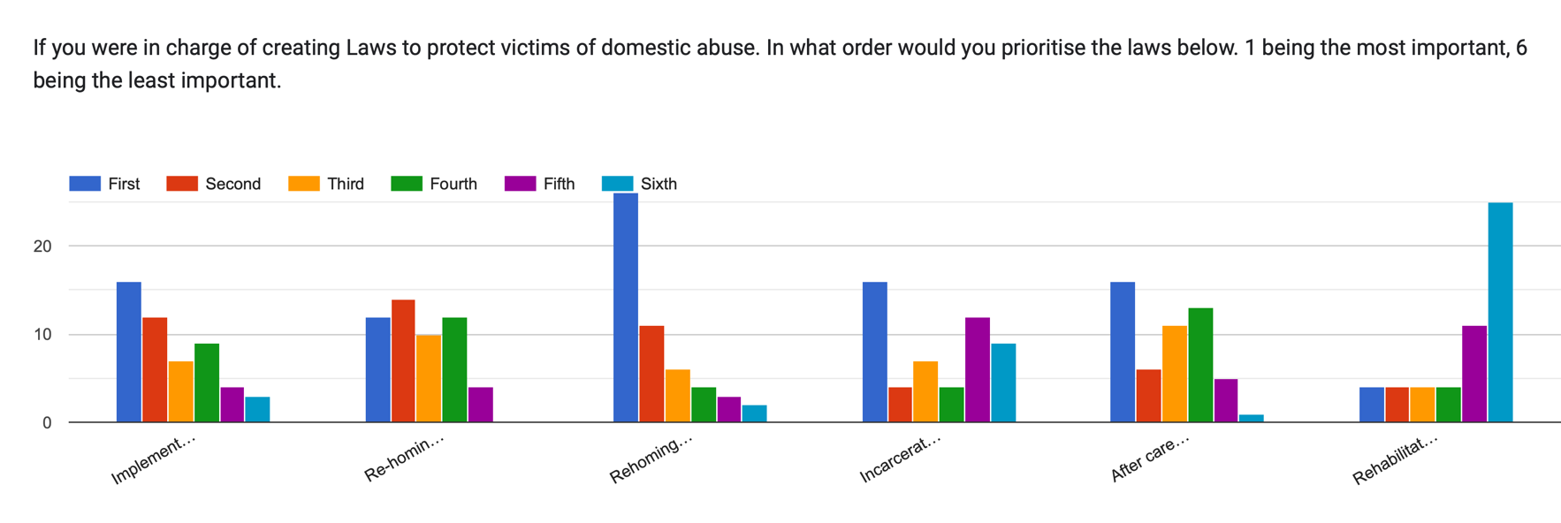
The least prioritised option was rehabilitation, implying the participants would not help the abuser to re-educate themselves. If most of the public and the law makers have this perception, then re-offending rates will not decrease. It was reported by Mills, Grauwiler and Pezold (2006) that female victims were advocates for male abusers to attend rehabilitation sessions rather than incarceration. This suggests the public may need educating on the importance of rehabilitation. The literature review provides that prison officers who provide supportive environments to encourage rehabilitation had low reoffending rates (Hackett and Small, 2023). Rehabilitation is a critical tool to prevent perpetrators from reoffending whilst continuing their sentence. It is reported by Cullen, Jonson and Nagin (2009) that prison is not always the most effective method to stop criminals from reoffending. However, there were four participants that placed rehabilitation first, and this may be for the same reason.

4.2.6. There is a lack of legislation (laws) to protect victims of domestic abuse, why do you think this is?
This statement was made to the respondents to see if there was any dispute or reasoning for supporting it. This was undisputed and lead to strong views targeting the legal system and the government. One respondent said, “lack of understanding from misogynistic systems & women being the most likely victim of the harm”. A common response was the government prioritises visible crimes. Abuse can be hidden and therefore discarded as the government may view it an invasion of privacy to the public (Paine, 2015). Domestic abuse is notoriously hard to prove. One participant responded that it is due to “lack of evidence and victims being too afraid to come forward, also from a societal perspective, there is still a great deal of stigmatism on what is seen as ‘acceptable’ behaviour within families”. The National Domestic Violence Hotline (2021) stated in the literature review that a victim needs a portfolio of evidence including: witness statements, medical reports, evidence of injuries and police reports to show a pattern of abuse; potentially overwhelming the victim. Participants also raised that many victims do not report their situation. The literature review evaluated many reasons why victims do not report their cases of domestic abuse. One example being a trauma bond with their abuser and refusal to leave the abuser (Aldridge, 2015). Showing that the number of reported cases does not reflect the true level of domestic abuse in England and Wales, subsequently there is not an urgency for new laws to be created. This is supported by the analogy made by Gracia (2004) in the literature review that compared reported cases of domestic abuse are the tip of an iceberg because we can only create laws about the surface that can be seen and the unreported cases, under the water line, which are undiscovered so no lawful progression can be made. However, the literature revealed that the lack of legislation is not a cause of ignorance but a cause of prejudice, the Middle Eastern Women & Society Organisation (2023) conveys the Domestic Abuse Act 2021 does not offer protection for migrant women that suffer domestic abuse but will imprison them.

4.2.7. Do you think there should be any exemptions or exceptions to allow people to commit actions of domestic abuse?
It was a unanimous vote that there should not be exemptions to domestic abuse. On the contrary a minority of respondents conveyed that mental health should be taken into consideration. An example given was perpetrators that suffers from ‘PTSD’ with appropriate evidence should receive a different sentence such as mandatory rehabilitation. PTSD can be used as a defence, demonstrated in the case of Bratty v Attorney General for Northern Ireland (1963). A respondent stated that exemptions could create loopholes to avoid reprimands which could prevent future victims from reporting domestic abuse. The defence of PTSD could be seen as one of those loopholes.

4.2.8. A protection order is a legal way you can prevent a person from causing you harm or annoyance. An example of this is a non-molestation order. How much do you think the court fee is for applying for this order?
Protection orders are free (UK Government, 2023a) but only 5.8% of the participants answered £0, the rest estimated between £60 - £400,000. This shows not all respondents have prior knowledge of the cost of protective legislation, meaning victims may not either due to limited resources or control from an abuser (Speed and Richardson, 2022). The literature review refers to reasons why victims do not seek help from the police or the law to escape domestic abuse. Reasons being some victims may have the assumption that any methods will be an expense they cannot afford (Johnson et al, 2022).

4.2.9. How much do you think protection orders involving children cost?
Participants suggested a higher price for protection orders involving children. This could be because they assumed protecting multiple people cost more than an individual. If victims had this viewpoint, they may not apply for a protection order and stay with an abuser for financial reasons (Cheverton, 2023).

4.2.10. What percentage of women in 2015 that applied for legal aid for domestic abuse do you think were rejected because they did not fit the criteria?
The questionnaire revealed that 34.6% of the respondents voted 60%. Stated in the literature review, 39% of applicants for legal aid are rejected for not fitting the criteria (Garton, 2016). If victims had a similar thought process, they might think there is a high chance of rejection for legal aid and a lower risk staying in an abusive relationship.
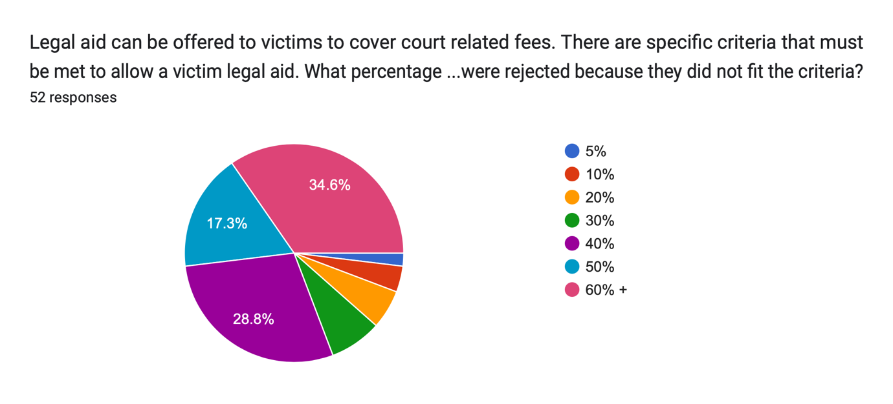

4.2.11. How much money do you think the government allocated to the tackling domestic abuse plan in 2023?
£2.2 billion is spent on fraud prevention annually (UK Government, 2011) with this guidance the public were asked how much funding the tackling domestic abuse plan received. 82.4% of participants guessed lower than the real budget, which was £140 million (HM Government, 2023), and 51% guessed half the real budget. This shows that even though the government allocate a significant amount towards this sector it does not reflect in the progress if the public are not seeing results.
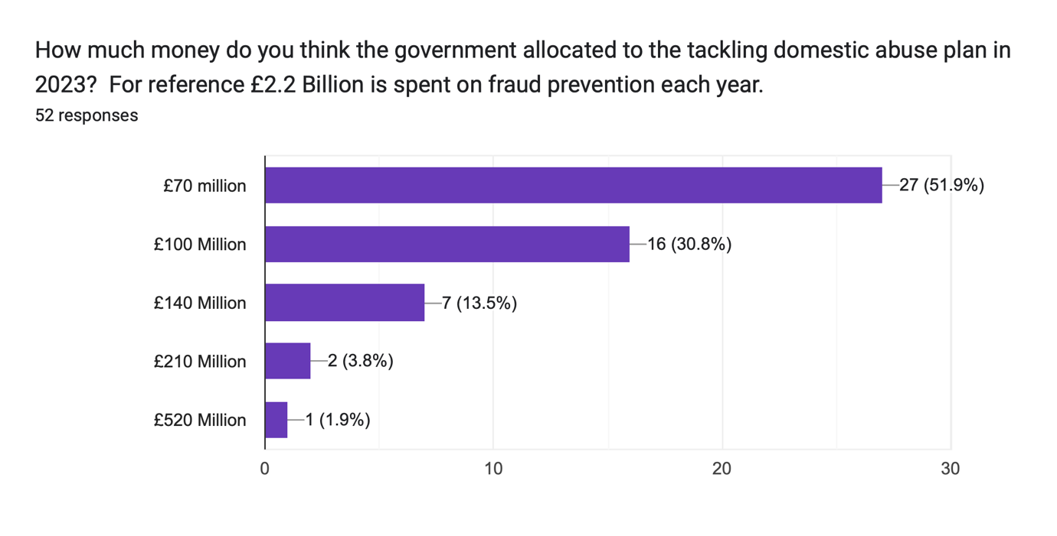

4.2.12. Other than the police could you identify any other support agencies that aim to support victims of domestic abuse?
Whilst most respondents thought that there might be charities to help domestic abuse victims, they were unable to name any organisations. This shows that victims not wanting police intervention might not know of alternative forms of support. One participant suggested reading Monckton-Smith (2019) as she proposes eight stages in an abusive relationship that can lead to homicide. Even though this is an extreme case, reading this article could help victims identify the dangerous situation they could be in.

4.3. Conclusion
The respondents displayed good knowledge of the definition of domestic abuse however they had an over-estimation of the prevalence in society. The respondent’s answer’s highlighted gaps in legislation such as the lack of knowledge to existing protection methods. There is no need for new legislation if the public do not know of existing ones.

Chapter Five - Conclusion

5.1. Introduction
The dissertation aimed to critically analyse whether UK legislation is currently affording sufficient protection to victims of domestic abuse. Current legislation aims to protects victims that have prior knowledge of the legal system and legislation. This was found by investigating the three objectives, these are:

- Objective 1 – Identify the prevalence of domestic abuse in England and Wales and the needs of victims.
- Objective 2 – Assess current legislation that aims to protect victims from domestic abuse.
- Objective 3 – Evaluate public perception on the protection currently afforded to victims of domestic abuse by UK legislation and the reforms they offer.

5.2. Objective One
The investigation found domestic abuse is highly prevalent in the UK with an estimated 2.1 million victims. However, the research shows that the true prevalence is difficult to estimate as only 889,918 of those victims made a police report (Office for National Statistics, 2023). Research found the needs of the victims, including greater support from the police due to current victims feeling no empathy from the police (Victim Support, 2018) and not supported if an abuser does not receive a conviction (Gurm and Marchbank, 2020). It was found that female victims were advocates for male abusers completing rehabilitation programmes instead of incarceration (Mills, Grauwiler and Pezold, 2006). A recommendation is that rehabilitation should be mandatory in an abuser’s sentence to prevent re-offending (Hackett and Small, 2023). The research highlighted the needs of the victims such as support in creating a portfolio of evidence to prove domestic abuse (The National Domestic Violence Hotline, 2021). It was discovered that once a report is made, it is left to the victim’s discretion to take further action with no guidance from the police (The Metropolitan Police, 2023). A recommendation would be a specialised team to guide victims with legislation to protect them. Therefore, if victims feel they can trust the capabilities of the police, more victims may report domestic abuse.

5.3. Objective two
The research found that there are sufficient protection methods available for victims of domestic abuse such as the Domestic Abuse Act 2021 which defined domestic abuse to emphasise it is not solely physical (Cox, 2022). However, the Domestic Abuse Act 2021 does not protect all victims such as migrant women (Middle Eastern Women & Society Organisation) showing the need for further reform. The primary research found a gap in legislation, the public did not have prior knowledge that non-molestation orders have no cost, therefore showing a lack of knowledge of protection orders. The primary evidence also highlighted gaps in legislation such as remedies available for abusers. An example, mental health disorders can excuse an abuser’s actions or prevent victims from receiving sufficient protection methods, seen in Banks v Banks (1999). Oversights such as this could persuade a victim to stay with an abuser out of fear. Other reasons why victims stay with abusers are for financial stability (Cheverton, 2023). Victims may not be able to afford legal representation and Garton (2016) found that 39% of women who applied for legal aid were rejected. Safelives (2023) communicated that 60% of victims that used the correct protection methods were permanently removed from the abuse. A recommendation for the exposure of current legislation would be to create an information pack for victims containing relevant legislation that serve to protect victims. It would include the Housing Act 1996 to inform victim’s that they will be considered homeless and prioritised on housing lists. Another recommendation is to enforce the urgency of police using an emergency non-molestation order when a victim displays signs of harm it should be implemented immediately whilst the case is under investigation (UK Government, 2022).

5.4. Objective three
The primary research suggests the public have a good understanding of the meaning of domestic abuse however, a large proportion of the public associate domestic abuse with just physical violence where in fact it includes many other factors (Cox, 2022). The primary research highlighted that the public overestimated the prevalence of domestic abuse in the UK. However, this conclusion is based on the estimated statistics provided by the Office for National Statistics (2023) which as previously discussed are likely to be significantly affected by underreporting. It was found that the public struggled to name other support services other than the police which could allude to victims not knowing other support methods too. The questionnaire highlighted that the public are not aware of the cost or existence of protection orders such as non-molestation and occupation orders which could correlate to victims. This shows there is no point of having sufficient protection available for victims if they do not know it exists or are free. A recommendation is to implement education programmes into schools and the police to create awareness of the accessibility of these methods.

5.5. Limitations
The primary research had limitations due to 50 % of the respondents were aged between 18 and 25, this could have limited the research due to a lack of representation. Another limitation was 80.4% were female, 17.3% male and 2.3% non-binary. This may not be a fair representation of male and non-binary perceptions of domestic abuse. If the primary research was to be carried out again, another method would be used to spread the questionnaire to ensure a varied response from all backgrounds.

5.6. Conclusion
This research is important as it highlights key gaps in legislation that need to be addressed. Reform is needed to raise awareness of the sufficient protection methods available and to make them more accessible. Legislation should be put in place for schools and prisons to teach and communicate the facts of domestic abuse and the protection afforded by legislation. Legislation does not currently protect all victims of domestic abuse such as migrant women (Middle Eastern Women & Society Organisation). Reform is detrimental to the safety of victims and “everyone has the right to the preservation of human dignity, personal honour, reputation and the protection of good name” (Charter of Fundamental Rights of the European Union, 2007).

References

Case Law
- Banks v Banks [1999] 1 FLR 726 H

- Bratty v Attorney General for Northern Ireland [1963] AC 386

- C v C (Non-molestation Order: Jurisdiction) [1998] 1 FLR 554

- R v Ahluwwalia (Kiranjit) (1992) EaCA

- Re L (Children) [2012] EWCA Civ

- R v Curtis (2010) EWCA crim 123

- R v R (1991) UKHL 12

Legislation
- Crime and Security Act 2010 (c. 17). Available at: https://www.legislation.gov.uk/ukpga/2010/17/contents. (Accessed: 17th February 2024)

- Data Protection Act 2018 (c. 12). Available at: https://www.legislation.gov.uk/ukpga/2018/12/schedule/2/paragraph/20. (Accessed: 14th March 2024)

- Domestic Abuse Act 2021 (c. 17). Available at: https://www.legislation.gov.uk/ukpga/2021/17#:~:text=An%20Act%20to%20make%20provision,participate%20in%20civil%20proceedings%3B%20to. (Accessed: 23rd April 2024)

- Domestic Violence and Matrimonial Proceedings Act 1976 (c. 50). Available at: https://www.legislation.gov.uk/ukpga/1976/50/enacted#:~:text=An%20Act%20to%20amend%20the,the%20same%20rights%20in%20the. (Accessed: 15th December 2023)

- Domestic Violence, Crime and Victims Act 2004 (c. 28). Available at: https://www.legislation.gov.uk/ukpga/2004/28/section/12. (Accessed: 15th December 2023)

- General Data Protection Regulation 2018. (c. 12). Available at: https://www.legislation.gov.uk/ukpga/2018/12/section/13. (Accessed: 23rd October 2023)

- Legal Aid, Sentencing and Punishment of Offenders Act 2012 (c. 10). Available at: https://www.legislation.gov.uk/ukpga/2012/10/contents/enacted. (Accessed: 17th February 2024)

- Police and Criminal Evidence Act 1984. (c. 60). Available at: https://www.legislation.gov.uk/ukpga/1984/60/contents. (Accessed: 21st April 2024)

- Protection From Harassment Act 1997. (c. 40). Available at: https://www.legislation.gov.uk/ukpga/1997/40/contents. (Accessed: 29th February 2024)

- The civil legal aid (procedure) (amendment) (no. 2) regulations 2017. (N0. 1237). Available at: https://www.legislation.gov.uk/uksi/2017/1237/made. (Accessed:20th April 2024)

- The Family Law Act 1996. (c. 27). Available at: https://www.legislation.gov.uk/ukpga/1996/27/contents. (Accessed: 9th November 2023)

- The Housing Act 1996. (c. 52). Available at: https://www.legislation.gov.uk/ukpga/1996/52/contents. (Accessed: 13th April 2024)

- Violence Against Women, Domestic Abuse and Sexual Violence Act (Wales) 2015. (anaw. 3). Available at: https://www.legislation.gov.uk/anaw/2015/3/contents/enacted. (Accessed: 6th March 2024)

References

- Aldridge, J. (2015) Participatory research: Working with vulnerable groups in research and practice. 1st edn. Policy Press. Available at: https://doi.org/10.2307/j.ctt1t8933q. (Accessed 29th February 2024)

- Aldridge, J. (2021) “‘Not an Either/or Situation’: The Minimization of Violence Against Women in United Kingdom ‘Domestic Abuse’ Policy,”’ Violence against women, 27(11), pp. 1823–1839. Available at: https://doi.org/10.1177/1077801220927079. (Accessed: 21st April 2024)

- Andrade, C. (2020) ‘Sample Size and its Importance in Research’, Indian journal of psychological medicine, 42(1), pp. 102–103. Available at: https://doi.org/10.4103/IJPSYM.IJPSYM_504_19. (Accessed: 17th October 2023).

- Baran, M. (2020) Applied social science approaches to mixed methods research. Edited by M. Baran and J.E. Jones. Hershey, Pennsylvania: IGI Global. Available at: https://doi.org/10.4018/978-1-7998-1025-4. (Accessed: 4th February 2024)

- Basilio, D. Guglielmucci, F. and Livanou, M. (2022) ‘Conceptualising the separation from an abusive partner as a multifactorial, non-linear, dynamic process: A parallel with Newton’s laws of motion’, Frontiers in psychology, 13. Available at: https://doi.org/10.3389/fpsyg.2022.919943. (Accessed: 20th April 2024)

- Bates, L., & Hester, M. (2020). ‘No longer a civil matter? The design and use of protection orders for domestic violence in England and Wales’. Journal of Social Welfare and Family Law, 42(2), 133-153. Advance online publication. https://doi.org/10.1080/09649069.2020.1751943. (Accessed: 21st April 2024)

- Betz, L.T. et al. (2023) ‘Disentangling heterogeneity of psychosis expression in the general population: sex-specific moderation effects of environmental risk factors on symptom networks’, Psychological medicine, 53(5), pp. 1860–1869. Available at: https://doi.org/10.1017/S0033291721003470. (Accessed: 10th April 2024)

- Bccampus (2023) ‘3.2 Exploration, Description, Explanation’ Research methods for the social sciences: An introduction. Available at: https://pressbooks.bccampus.ca/jibcresearchmethods/chapter/3-2-exploration-description-explanation/#:~:text=Market%20researchers%20rely%20on%20descriptive,is%20what%20you%20are%20doing. (Accessed: 7th February 2024).

- Birchall, J. and Choudhry, S. (2022) ‘“I was punished for telling the truth”: how allegations of parental alienation are used to silence, sideline and disempower survivors of domestic abuse in family law proceedings’, Journal of Gender-Based Violence, 6(1), pp. 115–131. Available at: https://doi.org/10.1332/239868021X16287966471815 (Accessed: 14th October 2023)

- Birdsall, N. and Boulton, L. (2022) ‘Theorising victim decision making in the police response to domestic abuse’, International review of victimology, 28(3), pp. 330–344. Available at: https://doi.org/10.1177/02697580211063658. (Accessed: 21st April 2024)

- Blakey, R. (2024) ‘Assessing the availability of legal support through the ‘Help with family Mediation’ legal aid scheme’, The Journal of social welfare & family law, 46(1), pp. 82–103. Available at: https://doi.org/10.1080/09649069.2024.2304977. (Accessed: 26th April 2024)

- Braun, V. and Clarke, V. (2012) 'Thematic analysis' Washington, DC, US: American Psychological Association, pp. 57-71. Available: https://doi.org/10.1037/13620-004 (Accessed: 6th February 2024).

- Bunce, A. Smith, K. Carlisle, S and Capelas, B.E. (2024) ‘Challenges of using specialist domestic and sexual violence and abuse service data to inform policy and practice on violence reduction in the UK’. Journal of Gender-Based Violence. Available at: https://doi.org/10.1332/23986808Y2024D000000024> (Accessed: 5th May 2024)

- Busetto, L., Wick, W. & Gumbinger, C. (2020) ‘How to use and assess qualitative research methods’. Neurological Research and Practice 2, 14, Available at: https://doi.org/10.1186/s42466-020-00059-z (Accessed: 7th February 2024).

- Centre for women's justice (2022) Timeline of key legal developments. Available at: https://www.centreforwomensjustice.org.uk/timeline (Accessed: 9th November 2023).

- Cheverton (2023) Domestic abuse and the cost-of-living crisis. Available at: https://www.aurorand.org.uk/news/domestic-abuse-and-the-cost-of-living-crisis/#:~:text=Women%20are%20feeling%20trapped%20within%20their%20abusive%20relationship&text=Many%20cannot%20afford%20to%20leave,there%20is%20no%20other%20option. (Accessed: 20th April 2024)

- Choi, B. C., & Pak, A. W. (2005). ‘A catalog of biases in questionnaires’. Preventing chronic disease, 2(1), A13. Available: https://www.ncbi.nlm.nih.gov/pmc/articles/PMC1323316/. (Accessed: 6th February 2024)

- Charter of Fundamental Rights of the European Union (2007) ‘Human Dignity’ Official Journal of the European Union C, 3030/17. Available at: https://fra.europa.eu/en/eu-charter/article/1-human-dignity#:~:text=Article%2019(1)%20Everyone%20has,the%20protection%20of%20good%20name. (Accessed: 4th May 2024)

- Citizens Advice (2023) Domestic Abuse. Available at: https://www.citizensadvice.org.uk/family/gender-violence/domestic-violence-and-abuse/ (Accessed: 28th November 2023).

- Cleave, P. (2023) Advantages of Questionnaires in Online Research. Available at: https://www.smartsurvey.co.uk/blog/advantages-of-questionnaires-in-online-research (Accessed: 31st October 2023).

- College of Policing (2022) Non-molestation orders – effective practise published. Available at: https://www.college.police.uk/article/non-molestation-orders-effective-practice-published. (Accessed: 21st April 2024)

- Cox, J. (2022) ‘“I’ll try violence” :Patterns of Domestic Abuse in Charlotte Brontë’s Jane Eyre (1847)’, Women’s Writing, 29(3), pp. 323–345. doi: 10.1080/09699082.2021.1883236. (Accessed: 15th April 2024)

- Cox (2024) How many single mothers are there in the UK?. Available at: https://www.singlemotheredit.com/parenting/how-many-single-mothers-are-there-uk#:~:text=More%20and%20more%20women%20are,for%2084%25%20of%20the%20total. (Accessed: 20th April 2024)

- CPS (2022) Legal Guidance Domestic Abuse. Available at: https://www.cps.gov.uk/legal-guidance/domestic-abuse (Accessed: 19th October 2023).

- Cravens, J.D., Whiting, J.B. and Aamar, R.O. (2015) ‘Why I Stayed/Left: An Analysis of Voices of Intimate Partner Violence on Social Media’, Contemporary family therapy, 37(4), pp. 372–385. Available at: https://doi.org/10.1007/s10591-015-9360-8. (Accessed: 13th April 2024)

- Crown Prosecution Service (2022a) CPS data summary Quarter 1 2022-2023. Available at: https://www.cps.gov.uk/publication/cps-data-summary-quarter-1-2022-2023 (Accessed:6th December 2023).

- Crown Prosecution Service (2022b) Restraining Orders. Available at: https://www.cps.gov.uk/legal-guidance/restraining-orders (Accessed: 5th December 2023).

- Cullen, F.T. and Jonson, C.L. Nagin, D.S., (2009) ‘Imprisonment and Reoffending’, Crime and justice (Chicago, Ill.), 38(1), pp. 115–200. Available at: https://doi.org/10.1086/599202. (Accessed: 13th April 2024)

- Dana Lynn Driscoll (2011) 'Introduction to primary research: observations, surveys, and interviews ', Writing spaces: Readings on writing, 2, pp. 153-174. available at: https://wac.colostate.edu/docs/books/writingspaces2/driscoll--introduction-to-primary-research.pdf. (Accessed: 7th February 2024).

- Davies, P., Barlow, C. and Fish, R. (2023) ‘The hard and complex work of implementing new multi-agency risk assessment approaches to policing domestic abuse’, Crime prevention and community safety, 25(2), pp. 148–165. Available at: https://doi.org/10.1057/s41300-023-00175-3. (Accessed: 21st April 2024)

- Delbosc, A. (2023) 'There is no such thing as unbiased research – is there anything we can do about that?', Transport Reviews, 43(2), pp. 155-158. available at: https://doi.org/10.1080/01441647.2022.2146939 (Accessed: 7th February 2024).

- Domestic Abuse Commissioner (2023) Police report victims of domestic abuse to immigration Enforcement, “empowering abusers”. Available at: https://domesticabusecommissioner.uk/police-report-victims-of-domestic-abuse-to-immigration-enforcement-empowering-abusers/ (Accessed: 9th January 2024).

- Durfee, A. (2011) ‘“I’M NOT A VICTIM, SHE’S AN ABUSER’: Masculinity, Victimization, and Protection Orders”’, Gender & society, 25(3), pp. 316–334. Available at: https://doi.org/10.1177/0891243211404889. (Accessed: 26th April 2024)

- Einola, K. and Alvesson, M. (2021) ‘Behind the Numbers: Questioning Questionnaires’, Journal of management inquiry, 30(1), pp. 102–114. Available at: https://doi.org/10.1177/1056492620938139. (Accessed: 26th April 2024)

- Emerson, R.W. (2015) ‘Convenience Sampling, Random Sampling, and Snowball Sampling: How Does Sampling Affect the Validity of Research?’, Journal of visual impairment & blindness, 109(2), pp. 164–168. Available at: https://doi.org/10.1177/0145482X1510900215. (Accessed: 10th April 2024)

- End Violence Against Women (2017) Domestic violence and abuse legislation announced in Queen's speech. Available at: https://www.endviolenceagainstwomen.org.uk/domestic-violence-and-abuse-legislation-announced-in-queens-speech/ (Accessed: 7th December 2023).

- EVA Woman’s Aid (2019) About us. Available at: https://evawomensaid.org.uk/home/about/ (Accessed: 4th December 2023).

- Garton, G. (2016) Legal aid for victims of domestic abuse (House of Commons Library briefing paper 05839). Available at: https://researchbriefings.files.parliament.uk/documents/SN05839/SN05839.pdf (Accessed: 31st October 2023).

- Gordon B. G. (2020). ‘Vulnerability in Research: Basic Ethical Concepts and General Approach to Review’. Ochsner journal, 20(1), 34–38. Available at: https://doi.org/10.31486/toj.19.0079. (Accessed: 26th April 2024)

- Gracia, E. (2004) ‘Unreported cases of domestic violence against women: towards an epidemiology of social silence, tolerance, and inhibition’, Journal of epidemiology and community health (1979), 58(7), pp. 536–537. Available at: https://doi.org/10.1136/jech.2003.019604. (Accessed: 14th April 2024)

- Gulati, G. and Kelly, B.D. (2020) ‘Domestic violence against women and the COVID-19 pandemic: What is the role of psychiatry?’, International journal of law and psychiatry, 71, pp. 101594–101594. Available at: https://doi.org/10.1016/j.ijlp.2020.101594. (Accessed: 26th April 2024)

- Gurm, B. and Marchbank, J. (2020) Making sense of a global pandemic: Relationship violence & working towards a violent free society. Kwantlen Polytechnic University: Surrey, BC. ISBN 978-1-989864-14-2. (Accessed: 21st April 2024)

- Hackett, P. and Small, M. (2023). Offender Rehabilitation Programmes: The Role of the Prison Officer (1st ed.). Routledge. https://doi.org/10.4324/9781003274858. (Accessed: 14th April 2024)

- Hester, M. Westmarland, N. Pearce, J. Williamson, E. (2008) Early evaluation of the Domestic Violence, Crime and Victims Act 2004. Available at: http://nicolewestmarland.pbworks.com/f/Early+evaluation+of+the+DVCV+Act.pdf (Accessed: 7th December 2023)

- HM Government (2023). Domestic Abuse Commissioner's Report: 'A Patchwork of Provision: how to meet the needs of victims and survivors across England and Wales" . Available at: https://assets.publishing.service.gov.uk/government/uploads/system/uploads/attachment_data/file/1140159/FINAL_Annex_A_-_DAC_Mapping_Report_Government_Response__clean_.pdf (Accessed: 30th November 2023).

- Home Office (2022) Domestic Abuse Statutory Guidance. London: Available at: https://www.gov.uk/government/consultations/domestic- abuse-act-statutory-guidance. (Accessed:19th October 2023).

- Houses of Common Library (2021) Domestic Abuse Bill 2019-21: progress of the bill. Available at: https://commonslibrary.parliament.uk/research-briefings/cbp-8959/#:~:text=The%20Domestic%20Abuse%20Bill%202019%2D21%20was%20introduced%20to%20the,are%20available%20on%20Gov.uk. (Accessed: 7th December 2023).

- Hunter, R., Barnett, A. and Kaganas, F. (2018) ‘Introduction: contact and domestic abuse’, The Journal of social welfare & family law, 40(4), pp. 401–425. Available at: https://doi.org/10.1080/09649069.2018.1519155. (Accessed: 26th April 2024)

- Johnson, L. Chen, Y. Stylianou, A. and Arnold, A. (2022) ‘Examining the impact of economic abuse on survivors of intimate partner violence: a scoping review’, BMC public health, 22(1), pp. 1014–1014. Available at: https://doi.org/10.1186/s12889-022-13297-4. (Accessed: 21st April 2024)

- Jones, T.L., Baxter, M.A.J. and Khanduja, V. (2013) ‘A quick guide to survey research’, Annals of the Royal College of Surgeons of England, 95(1), pp. 5–7. Available at: https://doi.org/10.1308/003588413X13511609956372. (Accessed: 6th February 2024).

- Judiciary (2007) Domestic Violence A Guide to Civil Remedies and Criminal Sanctions.Available: https://www.judiciary.uk/wpcontent/uploads/JCO/Documents/FJC/domestic-violence-guide-march07.pdf (Accessed: 8th February 2024).

- Katz, E., Nikupeteri, A. and Laitinen, M. (2020) ‘When Coercive Control Continues to Harm Children: Post‐Separation Fathering, Stalking and Domestic Violence’, Child abuse review (Chichester, England : 1992), 29(4), pp. 310–324. Available at: https://doi.org/10.1002/car.2611. (Accessed: 26th April 2024)

- Kaur, R. Garg, S. (2008) 'Addressing Domestic Violence Against Women: An Unfinished Agenda', Indian Journal of Community Medicine, volume 33(2): 73-76.

- Kelley, K. Clark, B., Brown, V., Sitzia, A. (2003) 'Good practice in the conduct and reporting of survey research', International Journal for Quality in Health Care, 15(3), pp. 261-266 Available at: https://doi.org/https://doi.org/10.1093/intqhc/mzg031. (Accessed: 12th October 2023).

- Landgren, K. (2005) 'The Protective Environment: Development Support for Child Protection', Human Rights Quarterly, 27(1), pp. 214-248 Available at: http://www.jstor.org.ezproxy.uwtsd.ac.uk/stable/20069784. (Accessed: 11th April 2024)

- Levin, K.A. (2006) ‘Study design III: Cross-sectional studies’, Evidence-based dentistry, 7(1), pp. 24–25. Available at: https://doi.org/10.1038/sj.ebd.6400375. (Accessed 6th February 2024)

- Mahapatro, M., Prasad, M.M. and Singh, S.P. (2021) ‘Role of Social Support in Women facing Domestic Violence during Lockdown of Covid-19 while Cohabiting with the Abusers: Analysis of Cases Registered with the Family Counselling Centre, Alwar, India’, Journal of family issues, 42(11), pp. 2609–2624. Available at: https://doi.org/10.1177/0192513X20984496. (Accessed: 21st April 2024)

- Maidment, S. (1983). ‘Domestic Violence and the Law: The 1976 Act and its Aftermath’. The Sociological Review, 31, 4-25. Available at: https://doi-org.ezproxy.uwtsd.ac.uk/10.1111/j.1467-954X.1983.tb00093.x (Accessed: 7th December 2023)

- Makri, C. and Neely, A. (2021) ‘Grounded Theory: A Guide for Exploratory Studies in Management Research’, International journal of qualitative methods, 20, pp. 160940692110136-. Available at: https://doi.org/10.1177/16094069211013654. (Accessed: 22nd April 2024)

- Marhaban, S. et al. (2021) ‘Strategies employed by EFL doctoral candidates in dissertation writing completion’, Studies in English language and education, 8(2), pp. 546–560. Available at: https://doi.org/10.24815/siele.v8i2.17694. (Accessed: 12th October 2023)

- Maslen, H. and Paine, C. (2024) ‘Ethical Resource Allocation in Policing: Why Policing Requires a Different Approach from Healthcare’, Criminal Justice Ethics, pp.1-36. Available at: https://doi.org/10.1080/0731129X.2024.2327819. (Accessed: 5th May 2024)

- McPhee, D., Hester, M., Bates, L., Lilley-Walker, S.J. and Patsios, D. (2022) 'Criminal justice responses to domestic violence and abuse in England: an analysis of case attrition and inequalities using police data', Policing and Society, 32(8), pp. 963-980 Available at: https://doi.org/10.1080/10439463.2021.2003358. (Accessed: 26th April 2024)

- Melnikovas, A. (2018) 'Towards an Explicit Research Methodology: Adapting Research Onion Model for Futures Studies', Journal of Future Studies, 23(2), 29-44. Available at: https://doi.org/10.6531/JFS.201812_23(2).0003. (Accessed: 7th February 2024)

- Metropolitan Police (2023) How to report domestic abuse. Available at: https://www.met.police.uk/advice/advice-and-information/daa/domestic-abuse/how-to-report-domestic-abuse/ (Accessed: 30th November 2023).

- MEWSO (2023) Step up migrant women. Available at: https://www.mewso.org/migrant-women (Accessed: 3rd February 2024).

- Mills, L.G., Grauwiler, P. and Pezold, N. (2006) ‘Enhancing Safety and Rehabilitation in Intimate Violence Treatments: New Perspectives’, Public health reports (1974), 121(4), pp. 363–368. Available at: https://doi.org/10.1177/003335490612100404. (Accessed: 18th April 2024)

- Ministry of Defence (2024) No Defence for Abuse. Available at: https://assets.publishing.service.gov.uk/media/65ba6fffc75d300012ca100c/14.354_MOD_DA_Action_Plan_v8.pdf. (Accessed 21st April 2024)

- Ministry of Justice (2016) Glossary of Programmes. Available at: https://assets.publishing.service.gov.uk/media/5a7ce48eed915d7c849ade01/glossary-programmes.pdf. (Accessed: 14th April 2014).

- Mitani, A.A. Mercaldo, N.D. Haneuse, S. and Schildcrout, J. (2021) ‘Survey design and analysis considerations when utilizing misclassified sampling strata’, BMC medical research methodology, 21(1), pp. 1–145. Available at: https://doi.org/10.1186/s12874-021-01332-8. (Accessed: 26th April 2024)

- Monckton-Smith, J (2019). ‘Intimate Partner Femicide: Using Foucauldian Analysisto Track an Eight Stage Progression to Homicide’. Violence Against Women. 26:11, pp. 1267-85. Available at: doi: 10.1177/1077801219863876. (Accessed: 15th April 2024)

- Monteiro, J.S. Nakano, E. Zandonadi, R. Botelho, R and Arujo, W. (2024) ‘How Do Brazilian Consumers Understand Food Groups in the Food-based Dietary Guidelines?’, Foods, 13(2), pp. 338-. Available at: https://doi.org/10.3390/foods13020338. (Accessed: 19th April 2024)

- Murdoch, M. et al. (2014) ‘Impact of different privacy conditions and incentives on survey response rate, participant representativeness, and disclosure of sensitive information: a randomized controlled trial’, BMC medical research methodology, 14(1), pp. 90–90. Available at: https://doi.org/10.1186/1471-2288-14-90. (Accessed: 7th February 2024).

- Naeem, M. Ozuem, W. Howell, K. and Ranfagni, S. (2023) ‘A Step-by-Step Process of Thematic Analysis to Develop a Conceptual Model in Qualitative Research’, International journal of qualitative methods, 22. Available at: https://doi.org/10.1177/16094069231205789. (Accessed: 22nd April 2024)

- National Centre for Domestic Violence (2020) Non-molestation Orders. Available at: https://www.ncdv.org.uk/non-molestation-order/ (Accessed: 7th December 2023).

- National Domestic Violence Hotline (2021) Building your case: How to document abuse. Available at: https://www.thehotline.org/resources/building-your-case-how-to-document-abuse/ (Accessed:2nd December).

- National Offender Management Service (2015) Analytical Summary. Available at: https://assets.publishing.service.gov.uk/media/5a74969f40f0b616bcb17b3d/outcome-evaluation-idap-cdvp.pdf. (Accessed: 14th April 2024).

- Newby, P. (2014) Research methods for education. Second edition. Abingdon, Oxon; Routledge. Available at: https://doi.org/10.4324/9781315758763. (Accessed: 7th February 2024)

- NIHR (2023) Quantitative Research. Available at: https://rds-nenc.nihr.ac.uk/how-we-can-help/quantitative-study-design/ (Accessed:7th February 2024).

- Pathak, V., Jena, B. and Kalra, S. (2013) ‘Qualitative research’, Perspectives in clinical research, 4(3), pp. 192–192. Available at: https://doi.org/10.4103/2229-3485.115389. (Accessed” 7th February 2024).

- Office for National Statistics (2022a) Domestic abuse in England and Wales review: November 2022. Statistical bulletin. Available at: https://www.ons.gov.uk/peoplepopulationandcommunity/crimeandjustice/bulletins/domesticabuseinenglandandwalesoverview/november2022 (Accessed: 7^{h} December 2023).

- Office for National Statistics (2022b) Domestic abuse prevalence and trends, England and Wales: year ending March 2022. Available at: https://www.ons.gov.uk/peoplepopulationandcommunity/crimeandjustice/articles/domesticabuseprevalenceandtrendsenglandandwales/yearendingmarch2022#:~:text=5.-,Police%20recorded%20crime,previous%20year%20%5Bnote%202%5D . (Accessed: 6th December 2023).

- Office for National Statistics (2023) Domestic abuse prevalence and trends, England and Wales: year ending March 2022. Available at: https://www.ons.gov.uk/peoplepopulationandcommunity/crimeandjustice/articles/domesticabuseprevalenceandtrendsenglandandwales/yearendingmarch2023. (Accessed: 6th December 2023).

- O’Leary (2023a) The Essential Guide to Doing Your Research Project: Steps in Quantitative Analysis. Available at: https://study.sagepub.com/oleary3e/student-resources/analysing-data/steps-in-quantitative-analysis (Accessed: 20th March 2023)

- O’Leary (2023b) The Essential Guide to Doing Your Research Project: Steps in Qualitative Analysis. Available at: https://study.sagepub.com/oleary3e/student-resources/analysing-data/steps-in-quantitative-analysis (Accessed: 20th March 2023)

- Paine, P. (2015) ‘“Public records in private devices: how public employees’ Article I, section 7 privacy rights create a dilemma for state and local government”’, Washington law review, 90(1), pp. 545.

- Patra, P. Prakash, J. and Khanna, P. (2018) “’ntimate partner violence: Wounds are deeper’, Indian journal of psychiatry, 60(4), pp. 494–498. Available at: https://doi.org/10.4103/psychiatry.IndianJPsychiatry_74_17. (Accessed: 22nd April 2024)

- Policy and Strategy (2022) Violence against women, domestic abuse and sexual violence: strategy 2022 to 2026. Available at: https://www.gov.wales/sites/default/files/pdf-versions/2022/5/2/1653392517/violence-against-women-domestic-abuse-and-sexual-violence-strategy-2022-2026.pdf (Accessed:7th December 2023).

- Postmus, J.L., Plummer, S.-B. and Stylianou, A.M. (2016) ‘Measuring Economic Abuse in the Lives of Survivors: Revising the Scale of Economic Abuse’, Violence against women, 22(6), pp. 692–703. Available at: https://doi.org/10.1177/1077801215610012. (Accessed: 15th April 2024)

- Rashid, Y. Rashid, AS. Warraich, A. Sabir, S and Waseem, A. (2019) ‘Case Study Method: A Step-by-Step Guide for Business Researchers’, International journal of qualitative methods, 18, pp. 160940691986242-. Available at: https://doi.org/10.1177/1609406919862424. (Accessed: 22nd April 2024)

- Richardson, K. and Speed, A.K. (2023) ‘Smoke and mirrors? Regulation 12 and access to legal aid for victims of domestic abuse’, The Journal of social welfare & family law, 45(3), pp. 249–264. Available at: https://doi.org/10.1080/09649069.2023.2243148. (Accessed: 26th April 2024)

- Rolison, J.J., Hanoch, Y. and Wood, S. (2017) 'Saving for the future: Dynamic effects of time horizon', Journal of Behavioral and Experimental Economics, 70, pp. 47-54. Available at: https://doi.org/10.1016/j.socec.2017.07.006 (Accessed 7th February 2024)

- Ryan, G. (2018). ‘Introduction to positivism, interpretivism and critical theory’, Nurse Researcher, 25(4), 14–20. Available: https://doi.org/10.7748/nr.2018.e1466. (Accessed: 9th January 2024)

- Sainani, K.L. (2017) ‘Reliability Statistics’, PM&R, 9(6), pp. 662-628. Available at: https://doi.org/10.1016/j.pmrj.2017.05.001. (Accessed: 5th May 2024)

- SafeLives (2023a) Getting it right first time. Available at: https://safelives.org.uk/sites/default/files/resources/Getting%20it%20right%20first%20time%20-%20complete%20report.pdf (Accessed: 6th December 2023).

- SafeLives (2023b) How we are run and funded. Available at: https://safelives.org.uk/about-us/how-we-are-run-and-funded. (Accessed: 21st April 2024)

- Saunders, M. & Tosey, P. (2013) ‘The Layers of Research Design’, Rapport. (Winter), 58–59. Available from: https://d1wqtxts1xzle7.cloudfront.net/32495174/Research_30_-_Research_Onion_Layers_58-libre.pdf?1391223129=&response-content-disposition=inline%3B+filename%3DThe_Layers_of_Research_Design.pdf&Expires=1707498803&Signature=fVkeFWNTgJNo9tEgiIJG3UDVLQFvTuJwMWNowtAWMhOwmund3hEQD0OWZCEdhpEk8S8nuglj9mM1ZDoQ3KAgz-qZerKIlpIW6JGLQWtDthHbpp8~AwolwweVuhaod0cHbZPKMZZL8KhXjBpkRnNzY7br2HX44XkKnF2m~siIKvZ7cKD81YBPFm-k2hc~2LZnMHDA7YxlnBN9oV65BAlRz7GFEUUj07qd-7Q186h~pLoy0gcexn9z37HNpkjnnDDowqsEMSg2~m7~iLqWvPfYuQnzcsjUcMtAKEfGx1IjG6IVhJ4h9UXYtletYzUxkcqkEaTa4mwGLY~OL6ZIDIFPUQ__&Key-Pair-Id=APKAJLOHF5GGSLRBV4ZA (Accessed: 7th February 2024)

- Saunders, M.; Lewis, P; Thornhill, A and Bristow, A (2015). ‘Understanding research philosophy and approaches to theory development. In: Saunders, Mark N. K.; Lewis, Philip and Thornhill, Adrian eds’ .Research Methods for Business Students. Harlow: Pearson Education, pp. 122 161. Available at: http://catalogue.pearsoned.co.uk/educator/product/... (Accessed: 6th February 2024)

- Savla, Sandeep (1999) Criminal Law – Post-traumatic stress disorder: the legal view. (18). Amicus Curiae. pp. 13-15

- Scharf, D.M., Breslau, J., Hackbarth, N.S., Kusuke, D., Staplefoote, B.L. and Pincus, H.A. (2014) 'Surveys', An Examination of New York State’s Integrated Primary and Mental Health Care Services for Adults with Serious Mental Illness RAND Corporation, pp. 34-58. Available at: http://www.jstor.org/stable/10.7249/j.ctt14bs28b.12 (Accessed: 21st March 2024)

- Sentencing council (2023) Breach of a protective order (restraining and non- molestation orders). Available at: https://www.sentencingcouncil.org.uk/offences/magistrates-court/item/breach-of-a-protective-order-restraining-and-non-molestation-orders/ (Accessed: 7th December 2023).

- Shelter (2021) Occupation orders for sole owners and their married or civil partners. Available at: https://england.shelter.org.uk/professional_resources/legal/relationship_breakdown/housing_rights_of_married_sole_homeowners/occupation_orders_for_sole_owners_and_their_married_or_civil_partners (Accessed: 7th December 2023).

- Sivarajasingam, V. Webber, I. Riboli-Sasco, A. and El-Osta, A. (2022) ‘Investigating public awareness, prevailing attitudes and perceptions towards domestic violence and abuse in the United Kingdom: a qualitative study’, BMC public health, 22(1), pp. 1–2042. Available at: https://doi.org/10.1186/s12889-022-14426-9. (Accessed: 21st April 2024)

- Speed, A. and Richardson, K. (2022) “‘Should I Stay or Should I Go Now? If I Go There will be Trouble and if I Stay it will be Double”: An Examination into the Present and Future of Protective Orders Regulating the Family Home in England and Wales’, Journal of criminal law (Hertford), 86(3), pp. 179–205. Available at: https://doi.org/10.1177/00220183211073639. (Accessed: 14th April 2024)

- Strickland, P. (2017) The Protection from Harassment Act 1997 (6648). Available at: https://researchbriefings.files.parliament.uk/documents/SN06648/SN06648.pdf (Accessed: 4th December 2023).

- Swisher, K. et al. (1994) Violence against women. San Diego: Greenhaven Press.

- Sweetnam, S. (2013) ‘Where Do You Think Domestic Abuse Hurts Most?’, Violence against women, 19(1), pp. 133–138. Available at: https://doi.org/10.1177/1077801212475340. (Accessed: 15th April 2024)

- Taylor, E. (2023) Disadvantages of Primary Research. Available at: https://www.ivoryresearch.com/library/dissertation-articles/disadvantages-of-primary-research/ (Accessed: 9th November 2023).

- Terry, G., Hayfield, N., Clarke, V. and Braun, V. (2017). ‘Thematic Analysis’, The SAGE Handbook of Qualitative Research in Psychology. 55 City Road, London: SAGE Publications Ltd. pp. 17-36 Available at: <https://doi.org/10.4135/9781526405555> [Accessed 21 Mar 2024].

- The Law Society (2023) LASPO Act. Available at: https://www.lawsociety.org.uk/topics/legal-aid/laspo-act (Accessed: 1st December 2023).

- Thomas, D.R. (2006) ‘A General Inductive Approach for Analyzing Qualitative Evaluation Data’, The American journal of evaluation, 27(2), pp. 237–246. Available at: https://doi.org/10.1177/1098214005283748. (Accessed: 5th February 2024).

- Ucko, L (2010) ‘StoriesWork: Interactive Storytelling and Domestic Abuse’. Storytelling, self, society, 6(2), pp.94-106. Available at: https://Doi.org/10.1080/15505341003684426. (Accessed: 11th April 2024)

- UK Government (2022) Domestic Violence Protection Notices (DVPN) and Domestic Violence Protection Orders (DVPO'S) guidance. Available at:https://www.gov.uk/government/publications/domestic-violence-protection-orders/domestic-violence-protection-notices-dvpns-and-domestic-violence-protection-orders-dvpos-guidance-sections-24-33-crime-and-security-act-2010 (Accessed:7th December 2023).

- UK Government (2023a) Apply for a non-molestation or occupation order: form FL401. Available at: https://www.gov.uk/government/publications/apply-for-a-non-molestation-or-occupation-order-fl401#:~:text=There%20are%20no%20court%20fees,both%2C%20depending%20on%20your%20situation. (Accessed: 28th November 2023).

- UK Government (2023b) New funding to support child victims of abuse. Available at: https://www.gov.uk/government/news/new-funding-to-support-child-victims-of-abuse (Accessed: 30th November 2023).

- UK Parliament (2023) Bills. Available at: https://www.parliament.uk/about/faqs/house-of-lords-faqs/lords-bills/ (Accessed: 7th December 2023).

- UK Government (2024a) Domestic Abuse Protection Notices/Orders factsheet. Available at: https://www.gov.uk/government/publications/domestic-abuse-bill-2020-factsheets/domestic-abuse-protection-notices-orders-factsheet. (Accessed: 29th February 2024)

- UK Government (2024b) Domestic Abuse Act 2021: overarching fact sheet. Available at: https://www.gov.uk/government/publications/domestic-abuse-bill-2020-factsheets/domestic-abuse-bill-2020-overarching-factsheet#:~:text=The%20act%20will%3A,the%20Commissioner's%20functions%20and%20powers. (Accessed: 21st April 2024)

- UK Parliament (2011) The Local Government Fraud Strategy. Available at: https://assets.publishing.service.gov.uk/government/uploads/system/uploads/attachment_data/file/118508/strategy-document.pdf. (Accessed: 21st April 2024)

- University of Bath (2023) Sampling in research. Available at: https://www.bath.ac.uk/guides/sampling-in-research/ (Accessed: 17th October 2023).

- UWTSD, (2024). Research integrity and ethics. Available at: https://www.uwtsd.ac.uk/research/research-integrity-and-ethics#:~:text=The%20University%20recognises%20its%20obligations,practices%20of%20conduct%20and%20governance. (Accessed: 5th February 2024)

- Victim Support (2018) How victims and survivors of domestic abuse experience the criminal justice system. Available at: https://www.victimsupport.org.uk/wp-content/uploads/documents/files/How%20victims%20and%20survivors%20of%20DA%20experience%20the%20criminal%20justice%20system.pdf (Accessed: 6th December 2023).

- Victim Support (2022). New research shows police failing to act on domestic abuse report – ethnic minority victims worst affected. Available at: https://www.victimsupport.org.uk/new-research-shows-police-failing-to-act-on-domestic-abuse-reports-ethnic-minority-victims-worst-affected/. (Accessed: 14th April 2024)

- Wasti, S. P., Simkhada, P., van Teijlingen, E., Sathian, B. and Banerjee, I. (2022) ‘The Growing Importance of Mixed-Methods Research in Health’, Nepal Journal of Epidemiology, 12(1), pp. 1175–1178. doi: 10.3126/nje.v12i1.43633. (Accessed: 31st October 2023)

- Women’s Aid (2022) Women’s Aid releases new research on how UK public attitudes ‘tolerate’ domestic abuse. Available at: https://www.womensaid.org.uk/womens-aid-releases-new-research-on-how-uk-public-attitudes-tolerate-domestic-abuse/. (Accessed: 18th April 2024)

- Women's Aid (2023) I need ongoing support. Available at: https://www.womensaid.org.uk/information-support/the-survivors-handbook/i-need-ongoing-support/#:~:text=You%20can%20apply%20for%20an,to%20understand%20all%20the%20issues. (Accessed: 4th December 2023).

- Whiting, G. (2023) What does legal aid mean?. Available at: https://www.lexisnexis.co.uk/legal/glossary/legal-aid (Accessed: 1st December 2023).

- Zefeiti, S.M.B.A. and Mohamad, N.A. (2015) ‘Methodological Considerations in Studying Transformational Leadership and its Outcomes’, International Journal of Engineering Business Management, 7. pp. 10. Available at: https://doi.org/10.5772/60429. (Accessed: 7th February 2024).

Appendix 1

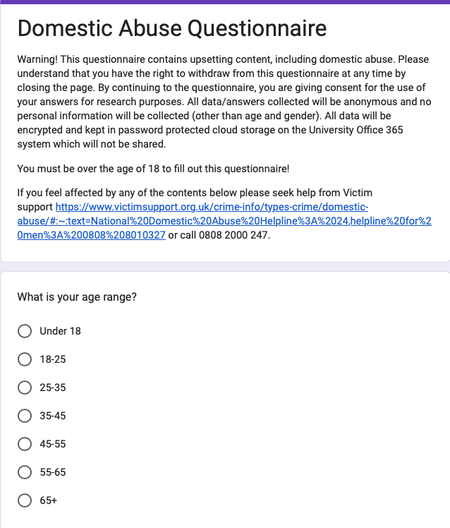
Dissertation Questionnaire



