Data Security, Governance and Compliance (ACCA7028)

By Connor Michael Anthony Wilson (2011592@student.uwtsd.ac.uk)

University of Wales Trinity Saint David



Table of Contents
1.0 Introduction 4
2.0 The importance of information technology security for businesses in the modern age 4
• Compliance (Laws and Ethics) 5
• Governance and Strategic Planning for Security 5
• Security Policies 5
• Risk Management 5
• Security Management Models and Practices 5
• Contingencies Planning 5
• Protection Mechanisms 5
• Service Level Agreement 5
3.0 Who are NatureGarden 5
4.0 NatureGardens Business needs and requirements overview 6
5.0 Research Section 6
5.1 Contingency Planning and risk management 6
5.1.1 Designing the framework 7
5.1.2 Risk Assessment 8
5.1.3 Risk Identification 8
5.1.4 Risk Analysis 9
5.1.4 Risk Evaluation 9
5.1.5 Risk Treatment 10
5.1.6 Monitoring, Review and Treatment 10
5.1.7 Context Establishment 11
5.2 Compliance (Laws and Ethics) 11
5.2.1 General Data Protection Act (GDPA) 12
5.2.1.1 Scope and applicability 12
5.2.1.2 Data Subject rights 12
5.2.1.3 Data protection officer (DPO) 12
5.2.1.4 Data Breach Notifications 13
5.2.1.5 Data Transfer 13
5.2.1.6 Accountability 13
5.2.1.7 Fine and Regulations 13
5.2.2 HIPPA (Health Insurance Portability and Accountability) 14
6 Security Management Models and Practices 16
6.1 Frameworks 16
6.1.1 ISO 27001 16
6.1.2 ISO 27001 Business Benefits 17
6.1.3 ISO 27001 International Standards for management systems (ISMS) 17
7 Designing an Information Security Approach for NatureGarden 18
7.1 Purpose 18
7.2 Scope 18
7.3 Responsibilities 18
7.4 Governance and Leadership 19
7.4.2 Compliance (Laws and Ethics) 19
7.4.3 Data Protection Officer 19
7.4.4 Clean Desk Policy 21
7.4.5 Training 22
8 Conclusion 23
9 References 24

Introduction
In this Assignment, the author will have been tasked with designing a security framework model to meet NatureGardens (NG) information security needs, making use of various framework models and best practices to offer the company a well-rounded approach to their information security structure.

The importance of information technology security for businesses in the modern age

It is important in an ever-expanding world of technology to make sure that companies are making use of robust information technology security infrastructure to be sure that they are at reduced risk of threat factors to the company, which can include cybersecurity threats such as phishing, Malware attacks and data breaches.

In 2023 alone, it was reported in the “Cyber security breaches survey 2023” that Approximately 32% of companies and 24% of non-profit organizations remember experiencing any security breaches or attacks in the past year. These figures significantly rise for medium-sized companies (59%), large corporations (69%), and charities with an annual income of £500,000 or more (56%) based on BEIS Business population estimate of around 1447900 businesses based within the UK. [1]

A further takeaway from the survey is that a total of 9% of businesses and 5% of charities report adhering to ISO 27001. This is again higher among large businesses (27%) [2].

I will go into further detail later in the assignment to explain what the “ISO 27001” framework entails.

In larger organisations as well as smaller ones adopting best industry practices for cybersecurity are not cultural normalised which is problematic for the protection of an organisation. It was more normalised for larger businesses but still 27% seems very low considering the following: The average (mean) annual cost of cybercrime for businesses is estimated at approximately £15,300 per victim. The sample sizes do not allow this cost calculation for charities. [3]

Depending on the previously stated statistic, the cost to an organisation can be severe, even especially for smaller businesses. Where they could be looking at large costs if a cybercrime is committed against an organisation, with these costs likely being associated with legal costs and fines related to data protection governess laws such as “The Data Protection Act 2018” and “General Data Protect Regulation” which will be elaborated on in my research section.

This will be achieved initial by the author researching a variety of security frameworks and models. Being contracted and compared to find the most appropriate combination of solutions for NG business needs.

After the research portion of the assignment, the author will be using their acquired knowledge to form a comprehensive solution for NG and will take into consideration the following:

• Compliance (Laws and Ethics)

• Governance and Strategic Planning for Security

• Security Policies

• Risk Management

• Security Management Models and Practices

• Contingencies Planning

• Protection Mechanisms

• Service Level Agreement

The author will discuss each of the above bullet points and consider the requirements for the organisation.

Who are NatureGarden

NatureGarden (NG) is a globally recognized brand specializing in products contributing to a healthy lifestyle. With a widespread presence internationally, NG relies on cloud services for the efficient delivery of IT services to both its staff and clients. Approximately 95% of the company's network operates on a wireless basis. Furthermore, NG has a significant online and social media presence to boost its promotional activities.

Given its extensive workforce and international clientele, NG faces considerable pressure to permit the use of personal devices by both employees as well as customers to access the company's network and resources.

The paramount concern for NG is ensuring the security of staff and client data safeguarding intellectual properties valued at billions. Despite the critical importance of information security to the company, there is currently a lack of an established policy addressing these security needs, resulting in disarray.

NatureGardens Business needs and requirements overview

Based on case scenario provided around NG I will be discussing some of their business requirements considering the different business areas. NG is service provider which delivers its services via Cloud services to employees and customers alike.
This means that any confidential data such as customers and employee’s personal details will need to have an appropriate security solution to make sure that data is safeguarded appropriately.

The company would need to follow data security laws as it does not state where the company is based nor what regions it provides its services within. I will assume that it provides these services international so I will have to cover a variety of data protection laws were relevant for this section and the author will make consideration to look at various laws and approach’s during the research to make sure this properly addressed.

Research Section

In this research section I will be discussing about all the categories mentioned in my introduction that will need to be addressed when designing the information security approach for NG.

Contingency Planning and risk management

It is the utmost importance that an organisation makes use of a contingence plan. Contingency planning allows organisations to help reduce the severity of risks that will inevitability occur with an organisation rather a business’s operations being halted or effected.

An Organisation would want to make use of Risk Assement and Contingency planning as it allows them to focus on other beneficials practices within their organisation.

Proper structuring of the asset management process is crucial for focusing on key assets and optimizing investments. This strategic approach enhances financial performance, facilitates informed investment decisions, and manages risks effectively. It also boosts service quality and output, underscores social responsibility, ensures compliance, and elevates the organization's reputation. Furthermore, it contributes to organizational sustainability and enhances overall efficiency and effectiveness, leading to significant benefits and gains. [4]

The first step that will need to be completed is a risk assessment to identify potential risk factors that could occur within an organisation in the future. Completing the risk assessment would be informed by the ISO 31000 Framework. The organisation would want to use the ISO 31000 Framework for their risk assessment as this allows for standardised approach for the process the risk assessment.

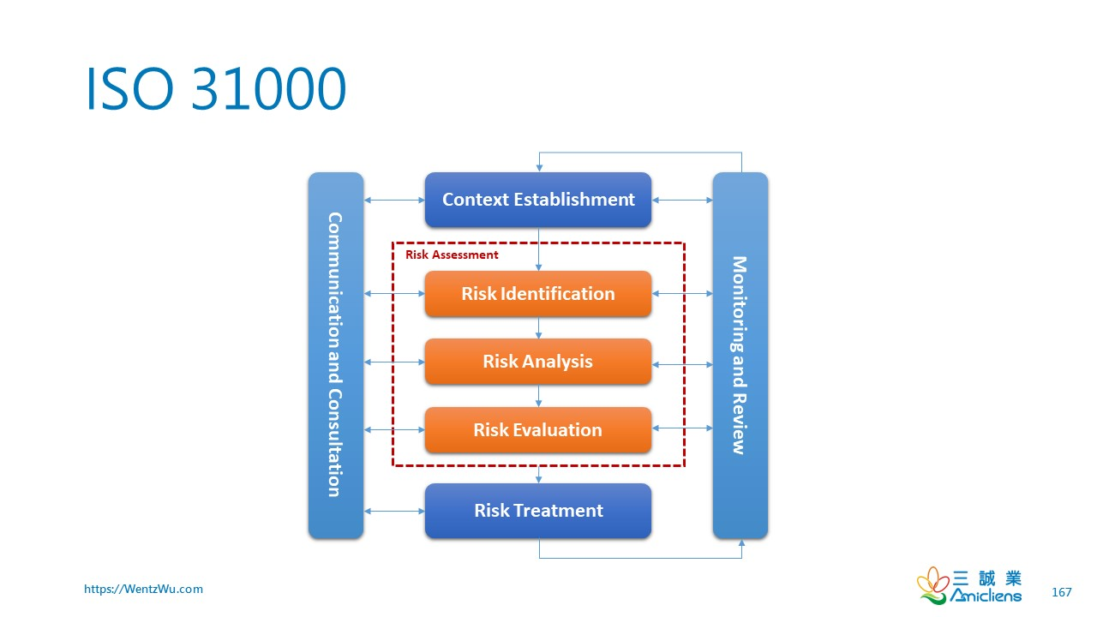
Figure 1 ISO 30001 workflow process x§[4]

Outlined in the graph above the steps associated with process of the ISO 31000 framework.
The author will be providing an overview of the steps below:

5.1.1 Designing the framework

When designing a framework for an organisation, the internal and external context of the organisation should be considered.

— the social, cultural, political, legal, regulatory, financial, technological, economic and environmental factors, whether international, national, regional or local.
— key drivers and trends affecting the objectives of the organization.
— external stakeholders’ relationships, perceptions, values, needs and expectations.
— contractual relationships and commitments.
— the complexity of networks and dependencies. [5]

Articulating risk management commitment:
Within an organisation a continual commitment to risk management should be established via a policy. This would be a statement that clearly conveys an organization’s objectives and commitment to risk management. This can include the following:
— the organization’s purpose for managing risk and links to its objectives and other policies.
— reinforcing the need to integrate risk management into the overall culture of the organization.
— leading the integration of risk management into core business activities and decision-making.
— authorities, responsibilities and accountabilities.
— making the necessary resources available.
— the way in which conflicting objectives are dealt with.
— measurement and reporting within the organization’s performance indicators [6]

Assigning organization roles, authorities, responsibilities and accountabilities:
Senior management and governing bodies, when applicable, must make sure that the authorities, duties, and obligations related to risk management roles are properly designated and communicated throughout the entire organization, and they should:

— emphasize that risk management is a core responsibility.
— identify individuals who have the accountability and authority to manage risk (risk owners [7].

5.1.2 Risk Assessment

General:

Risk assessment is a crucial process that encompasses the identification, analysis, and evaluation of risks to help organizations achieve their objectives. This process should be systematic, iterative, and collaborative, leveraging the knowledge and perspectives of stakeholders and utilizing the best available information, with additional inquiries as needed.

5.1.3 Risk Identification

During risk identification, organizations aim to recognize risks that could impact their objectives, employing various techniques to uncover uncertainties. Factors such as tangible and intangible risk sources, causes, events, opportunities, vulnerabilities, changes in external and internal contexts, emerging risks, asset values, consequences, knowledge limitations, and stakeholder biases should be considered. It's important to identify risks regardless of their control over the sources, acknowledging that outcomes can vary and have diverse impacts.

— tangible and intangible sources of risk;
— causes and events;
— threats and opportunities;
— vulnerabilities and capabilities;
— changes in the external and internal context;
— indicators of emerging risks;
— the nature and value of assets and resources;
— consequences and their impact on objectives;
— limitations of knowledge and reliability of information;
— time-related factors;
— biases, assumptions and beliefs of those involved [8]

5.1.4 Risk Analysis

Risk analysis delves into understanding the nature, characteristics, and levels of risk, examining uncertainties, sources, consequences, likelihoods, scenarios, and control effectiveness. This analysis can be qualitative, quantitative, or a mix, tailored to the analysis's purpose, information reliability, and available resources. It factors in event likelihoods, consequence magnitudes, complexity, time-related aspects, control effectiveness, and confidence levels, considering divergent opinions and biases. The aim is to provide insights for decision-making, where options involve different risk levels.
This can consider the factors:

— the likelihood of events and consequences;
— the nature and magnitude of consequences;
— complexity and connectivity;
— time-related factors and volatility;
— the effectiveness of existing controls;
— sensitivity and confidence level [9]

5.1.4 Risk Evaluation

Risk evaluation supports decision-making by comparing risk analysis results with risk criteria to determine if further action is needed. This could include additional analysis, risk treatment, maintaining controls, or reconsidering objectives, always considering stakeholder impacts and the wider context. The outcomes should be documented, communicated, and validated.

— do nothing further;
— consider risk treatment options;
— undertake further analysis to better understand the risk;
— maintain existing controls;
— reconsider objectives. [10]

5.1.5 Risk Treatment

Risk treatment involves selecting and implementing strategies to address risks, considering the benefits, costs, and potential stakeholder impacts. Options include avoiding, accepting, reducing, sharing, or transferring risks, with the choice reflecting the organization's objectives, resources, and stakeholder views. Monitoring and review ensure treatment effectiveness and manage any new risks introduced.

Some of the following options may be considered for risk treatment:
avoiding the risk by deciding not to start or continue with the activity that gives rise to the risk;
— taking or increasing the risk in order to pursue an opportunity;
— removing the risk source;
— changing the likelihood;
— changing the consequences;
— sharing the risk (e.g. through contracts, buying insurance);
— retaining the risk by informed decision [11]

5.1.6 Monitoring, Review and Treatment

Finally, the risk management process, including monitoring, review, and treatment outcomes, should be documented, and reported to facilitate communication, decision-making, and stakeholder engagement. Reporting should consider stakeholders' needs, the cost and timing of reports, and the relevance of information to organizational goals. This comprehensive approach to risk management supports informed decision-making and organizational resilience.

The information provided in the treatment plan should include:
— the rationale for selection of the treatment options, including the expected benefits to be gained.
— those who are accountable and responsible for approving and implementing the plan;
— the proposed actions;
— the resources required, including contingencies;
— the performance measures;
— the constraints;
— the required reporting and monitoring;
— when actions are expected to be undertaken and completed [12]

Recording and reporting aims to:
— communicate risk management activities and outcomes across the organization;
— provide information for decision-making;
— improve risk management activities;
— assist interaction with stakeholders, including those with responsibility and accountability for risk management activities. [13]

5.1.7 Context Establishment

Firstly, there is the context establishment –
This covers the scope for the risk assement process going forward within an organisation. It will outline the main areas that will need to be considered during the risk assessment process. It forms a basis before more in-depth analysis.

When planning the approach, considerations include:
— objectives and decisions that need to be made;
— outcomes expected from the steps to be taken in the process;
— time, location, specific inclusions and exclusions;
— appropriate risk assessment tools and techniques;
— resources required, responsibilities and records to be kept;
— relationships with other projects, processes and activities [7]

External and internal Context:

This will consider the environment in which the company operates and should reflect the activities that the organisation conducts to which the risk management process should be applied.

5.2 Compliance (Laws and Ethics)

Considering the law and ethics within a company is important to make appropriate considerations for a culture within a workplace or organisation and make sure that employees and customers are safe.

As the company has not stated that it operates in a specific region or country it can be assumed that the company operates on an international scale. Keeping this in mind is important as the company needs to consider the plethora of data protection of laws international. I will be going into detail around these laws.

Before conducting research on individual laws within I will outfling definitions that may be repeated for each of different laws being analysed.

- Personal Data
information (typically held electronically) about a particular person, especially sensitive information regarding their finances, medical history, etc. [4]

can be identified or who are identifiable, directly from the information in question; or
who can be indirectly identified from that information in combination with other information. [5]

5.2.1 General Data Protection Act (GDPA)

5.2.1.1 Scope and applicability

GDPR applies to the processing of personal data of individuals in the European Union which is not dependant on location of origin of the organisation. This law would essentially cover any customers within Europe that are under the European union.

5.2.1.2 Data Subject rights

GDPR grants rights including the right for individual to request for data to be accessible, amended, erased, restrict processing and data portability.

The individual rights are:

the right to be informed.
the right of access.
the right to rectification.
the right to erasure or restrict processing; and
the right not to be subject to automated decision-making. [6]

5.2.1.3 Data protection officer (DPO)

In organisations there is normally an appointed Data Protection Officer. They are responsible for ensuring that a company is compliant with GDPR.

The main responsibility of the data protection officer (DPO) is to oversee their organization's processing of personal data, whether it pertains to employees, clients, suppliers, or other persons (also known as data subjects), making sure it adheres to relevant data protection regulations. [7]

5.2.1.4 Data Breach Notifications

Organizations are required to report a data breach within 72-hour period of becoming aware. This will be reported by the DPO normally to the ‘Information Commissions Office”.

By law, you've got to report a personal data breach to the ICO without undue delay (if it meets the threshold for reporting) and within 72 hours. [8]

5.2.1.5 Data Transfer

Any transfers utside of the EU are subject specific requirements to ensure an adequate level of data protection.

These interpretations create a compelling force for EU institutions to prioritize the safeguarding of the data of EU residents when engaging in data transfer agreements with third countries or permitting foreign entities to conduct business activities within the EU market. [10]

5.2.1.6 Accountability

Organisations are required to demonstrate compliance with GDPR principles and be able to provide evidence of their data protection measures.

You must have appropriate measures and records in place to be able to demonstrate your compliance. [9]

5.2.1.7 Fine and Regulations

GDPR imposes substantial fines for non-compliance from organisations. This can see a 4% of global annual turnover for organisations or 20 million euros whichever is higher for the organisation.

In a white paper written by Ruohonen and Hjerppe it found that of 294 decisions made available via third party that on average they would see a median fine amount of 9 million euros.

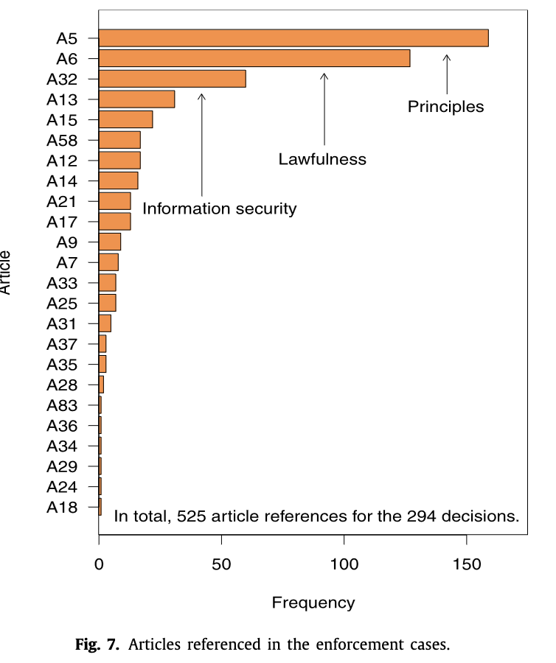
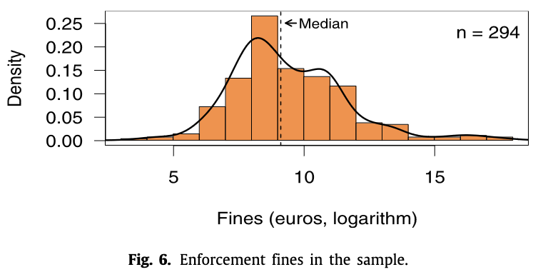
Figure 2 Enforced Case Graph [11]
Figure 3 Fine amounts graph via GDPR enforcement [11]

5.2.2 HIPPA (Health Insurance Portability and Accountability)

HIPPA was enacted in 1996, safeguarding health information privacy and security in the United States. It comprises Title I, ensuring continuity of health insurance for individuals changing jobs, and Title II, establishing national standards for electronic health transactions and penalties for offenses.

The Health Insurance Portability and Accountability Act of 1996 (HIPAA) is a federal statute that mandated the establishment of national guidelines to safeguard confidential patient health information, preventing its disclosure without the patient's permission or awareness. [12]

The Privacy Rule governs the use and disclosure of health information, granting patient’s rights and regulating entities subject to it.

This rule allows for significant applications of such information, while maintaining the confidentiality of those who are pursuing medical treatment and recovery. [13]

The Security Rule mandates safeguards for electronic protected health information (e-PHI), covering administrative, physical, and technical aspects.

To comply with the HIPAA Security Rule, all covered entities must:

- Ensure the confidentiality, integrity, and availability of all e-PHI
- Detect and safeguard against anticipated threats to the security of the information.
- Protect against anticipated impermissible uses or disclosures that are not allowed by the rule.
- Certify compliance by their workforce. [14]

The Enforcement Rule outlines investigation procedures and penalties. The Breach Notification Rule requires reporting breaches of unsecured protected health information.

- PHI may be disclosed to law enforcement officials if it is believed to help prevent or mitigate a serious and immediate threat to someone's health or public safety.
- If a covered entity suspects that a crime has occurred on its premises, it is permitted to report PHI as evidence of this crime.
- PHI can be used to inform law enforcement about a death that might be due to criminal actions.
- In case of a medical emergency off-site, PHI can be disclosed to law enforcement if it relates to criminal activities.
- PHI should be reported to law enforcement if legally required, such as in cases involving gunshot or stab wounds. [15]

The Omnibus Rule, enacted in 2013, expanded requirements to business associates.

HIPAA compliance is obligatory for covered entities and their associates, with violations incurring fines and potential criminal charges. The law reflects ongoing efforts to protect patient data amid evolving medical system and infrastructure.

The importance of HIPPA can be witnessed via press release by the “United States Attorney’s Office”. In a case where Methodist Hospital employees had leaked details of patients which resulted in fines being issued with each violation containing a potential of up to one year in prison.

6 Security Management Models and Practices

6.1 Frameworks

6.1.1 ISO 27001

ISO 27001, officially named ISO/IEC 27001, is an international standard for information security management systems (ISMS). It's part of the ISO/IEC 27000 family of standards, which are designed to help organizations keep information assets secure.

Covered below in the diagram are the 8 main sections of the ISO 27001 framework.

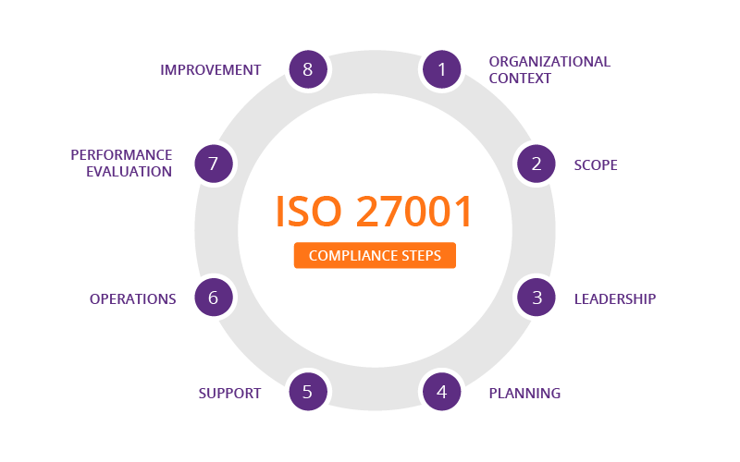
Figure 4 ISO 27001 8 steps for compliance [18]

According to the ISO 27001 standard, the primary objective of an Information Security Management System is to safeguard three key facets of information:

Confidentiality: Information can only be accessed by individuals who have been granted authorization.
Integrity: Modifications to the information are restricted to those who have the necessary authorization.
Availability: Authorized individuals should have access to the information whenever required.

information security involves safeguarding information against diverse threats. This is essential for maintaining continuous business operations, minimizing business risks, and enhancing both return on investment and business opportunities [19]

6.1.2 ISO 27001 Business Benefits

Legal Compliance: ISO 27001 provides a comprehensive framework to meet the increasing legal, regulatory, and contractual requirements related to information security. It aids in creating security policies aligned with regulations like the EU GDPR.

Competitive Advantage: Attaining ISO 27001 certification can give your company a competitive edge, especially when competitors lack this certification. This distinction appeals to customers concerned about safeguarding their information.

Cost Savings: ISO 27001's focus on preventing security incidents translates to substantial cost savings. Investing in ISO 27001 is significantly smaller than the financial impact of security incidents, making it a cost-effective choice.

Enhanced Organization: Implementing an ISO 27001-compliant Information Security Management System promotes better organizational structure. It encourages companies to document processes, enhancing clarity, reducing lost time, and preserving critical knowledge, crucial for fast-growing companies.

6.1.3 ISO 27001 International Standards for management systems (ISMS)

A framework is defined in ISO 27001 as ISMS as a model for use with an organisation for setting up and operating a management system.
An Information Security Management System (ISMS) is a comprehensive framework used by an organization to protect its information assets. This system, involving policies, procedures, and activities, is designed to systematically manage information security. [20]

7 Designing an Information Security Approach for NatureGarden

In this next section, I will be outlining how the needs of NG information security approach will be meet. Each subsection will outline specifics.

7.1 Purpose
Defining information security approach for NatureGarden, the company mainly operates using cloud services for most of their workforce as well as online services such as social media. This security approach should offer a solution informed by the authors understanding of laws and ethics, Policy, governance, risk management, security architecture and controls, incident response and recovery, Training and Awareness, Vendor and Third-Party management, monitoring, auditing, and reporting, continuous improvement. The security approach will enable the organisation to stay protected in all aspects of their operation and will have considerable scope of the business.

7.2 Scope
In the scope, the author will be outing the information, assets, and departments covered by the security approach. As the brief for the organisations does not go into specifics on the organisation’s requirements, I will be making some generalisations and assumptions when considering the scope of the organisation.

It is stated that “Approximately 95% of the company’s network operates on a wireless basis” with this information it can be assumed that the company will take advantage of working remotely which will be leveraged with cloud technology as well as work from home practices which will be governed B.Y.O.D (Bring your own device) policy for safety and protection, technology for security will need to be leveraged such as making sure that RSA, VPN, Firewall technology will be utilized.

It’s important staff are educated on the security training to maintain data security and cybersecurity safety especially if working from public locations.

The author will still be considering elements of physical security in the design as well as the entirety of the business is not operated online which will be covered by a clean desk policy, security training, etc.

7.3 Responsibilities

The main responsibilities of security within the organisation would be Head of Compliance and the CISO (Chief information Security Officer). There responsibilities will be in the creation of security policy for the organisation which will be guided by the various frameworks previously mentioned e.g. ISO 27001 and ISO 31000 and Head of compliance to make sure that the security procedures are being mandated throughout the organisation and that organisation is in-line with laws and regulations of laws such as the (data protection act, HIPPA, ISO 27001.)

7.4 Governance and Leadership

7.4.1 Information Security Policy
Leveraging various frameworks which cover different aspects of security within the organisation such as ISO 27001, ISO 30001.

As stated earlier in the research section that those that are not in compliance with ISO certification more likely at risk of attacks which can lead to finical loss through fines or damage to reputation.
Utilizing a professional standard will help to build trust within customers and shareholders as well as any other companies the organisation may wish to collaborate with.

7.4.2 Compliance (Laws and Ethics)

It is important that NG is compliance with the different laws accredited to protect employees and staff. I will be addressing how the author hopes to achieve this within the organisation.

7.4.3 Data Protection Officer

Firstly, A DPO will need to be employed within the company due to the gross revenue of the company being valued at over 3 billion it is fair to assume that there will not be budgetary issues when it comes to acquire new staff and technology solutions to enhance the organisations current security offerings.

The total revenue for the organisation being so high it would be likely that there may a need for multiple DPO’s to be based around various international locations within the company.

On investigation it seems that the average yearly salary for a data protection officer is around £42,500 from sample size 79. This is just based in the UK however and will vary based on different regional economies.

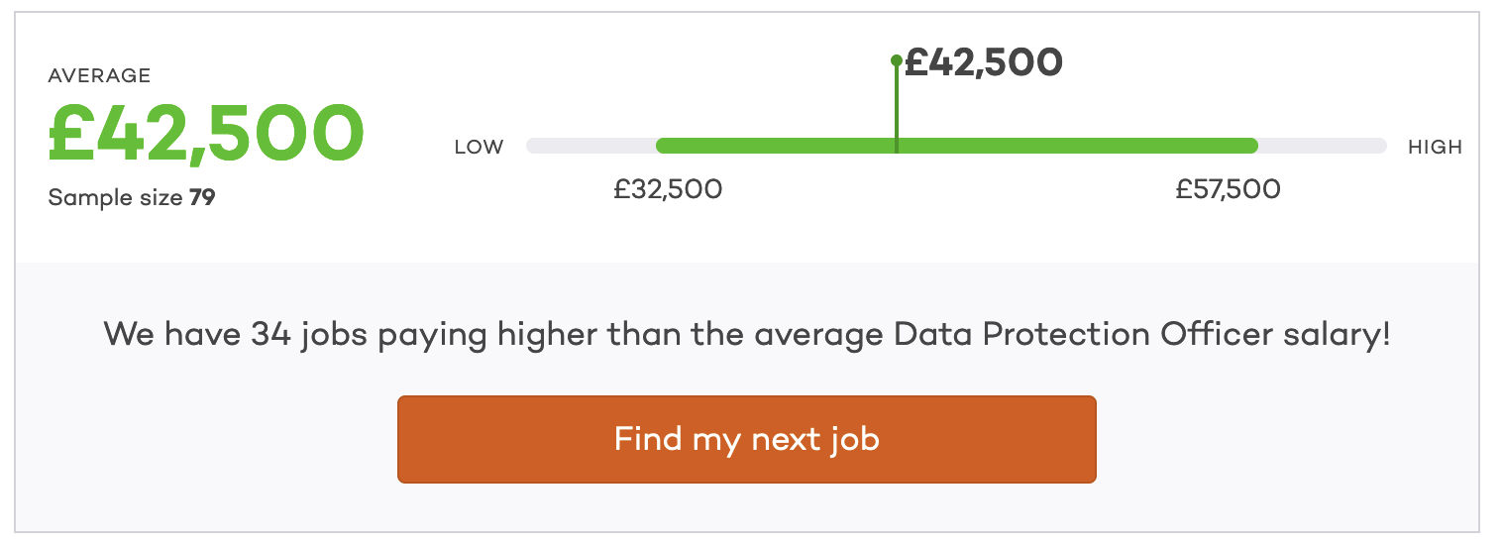
Figure 5 Average salary for Data Protection Officer UK [16]
The DPO will be responsible for making sure that the company is compliant with GDPR as well as the “Data Protection Act 2018” which is the United Kingdom’s implementation post Brexit. The laws are very comparable, however.

Implementing a variety of policies within the company will help with compliance with GDPR and other related laws such as the previously mentioned DPA as well as laws like HIPPA which could potentially be relevant as the company does offer lifestyle-based services which could include medical details which would be covered under HIPPA.

Their role will involve cultivating a culture around data security within an organisation by implementing, adapting, and training on data security policy. I will elaborate further one what the different policies will involve.

7.4.4 Clean Desk Policy

Making use of a “Clean Desk Policy would be a form of documentation that would detail the how employee should conduct themselves within a work environment and out of work when working with work equipment in the act of consistent security and awareness within a organisations culture.

In implementing this policy within NG, the author will try to take considerations on blend.

This would include making use of Kennington locks on desk to physically secure laptops or desktop machines to the desk so that when employees are away from their desks their equipment is at a vastly reduced risk of being stolen.

Not storing any passwords or confidential information digitally or physical via a written note. There may be a large host of login information for employees to potentially retain which encourages practices such as writing down confidential information in the first place. Adopting a password manager creates an ease of use within an organisation making it more efficient for employees to access their different accounts but also helps to reduce the need for any notetaking of account information. It would also allow for employees to use more complex via password generators within password managers which are completely randomised normally around user’s parameters, but they will normally implement numbers, letters (upper and lower case), Symbols, in a random combination.

Any physical notes should be disposed of when no longer required.
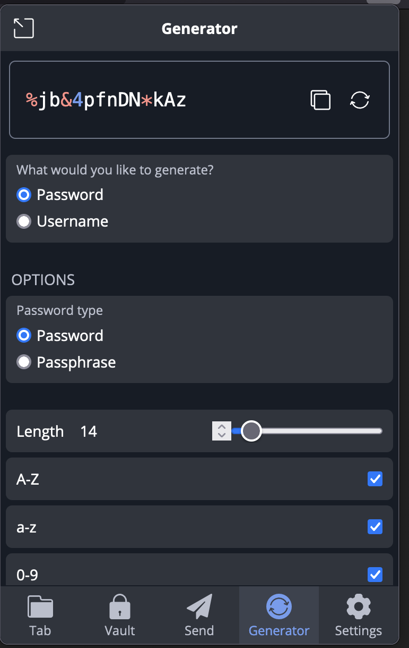
Figure 6Example of the password generator within Bitwarden Password Manager [17]

Making use of a secure locked waste point within the office space where paper waste can be disposed without the risk of paper materials being accessible by any potential intruders that may access the office space.

The waste can then be taken away by a professional third party to be disposed of confidentially and shredded so that none of the information is recoverable.

Any storage such as file cabinets or personal storage at employees’ desks should always remain locked when the employee is away from their desk.

With all the above in consideration this will help to reduce the chance of breaches though this will need to be reiterated on during training sessions to remain relevant within the cultural of the workplace.

7.4.5 Training

Creating regular training interval will help to keep employees familiar with the best security practices to follow when conducting work within an organisation.

Training employees on the “Clean Desk Policy” during enrolment will create a well-established for their practices of security within the workspace. Reiterating on this training via meetings or retraining can be conducted throughout the year say ever 2-3 months. It seems like a good balance between practicality in its application and being non disruptive to staff.

Email reminders can be sent out regularly throughout the year around every other week to help refresh employees with the training provided and help with this knowledge retention.

This can be further reminders provided by email reiterating on initial training points and can also test the staff’s knowledge via mandatory small tests so that if employees score below a certain threshold, they can be scheduled for another training session immediately.

Internal fake phishing campaigns can be launched to establish employee’s suitability to phishing emails also as these are one of the most common forms of cybercrime and almost anyone can become a victim to a phishing attack.

Any employee that clicks the link within the email can be flagged for training exercise online or in person so that they are more aware of the risk of these emails.

Training will become more in-depth depending on the role of the employee of the organisation for instance cyber security analysts within the organisation maybe required to take additional qualifications (CISSP, Security+ or CISA) or refresh their knowledge on qualifications as techniques change as well as the trending threats within cybersecurity overtime.

8 Conclusion

To conclude,

The author is pleased with the final solution that has been conducted with the creation of the information security design. The coverage of solution touches on many of the relevant areas for security within a modern-day organisation such training, policy, best practices within an organisation by leveraging industry standard frameworks such as ISO 31000 for risk management and contingency planning,

Taking into consideration the limited word count of this assignment the author was not able to go into signification depth during their research section due to the open-ended nature of brief for the assignment there was vast variety of laws, ethics, and other considerations that due to the international platform that Nature Gardens operates in. this made it challenging to into significate detail regarding each of that researched. Given a larger word count this could be more extensive and with better depth.

The need for information security cannot be overstated, as highlighted by the alarming statistics on cyber breaches and their financial impacts. By adhering to established frameworks and best practices. NG can significantly mitigate the risk of security incidents. The proposed security framework addresses essential elements such as compliance with laws and ethics, risk management, security policies and contingency planning. This holistic approach ensures that NG not only protects its information assets but also maintains the trust and confidence of its stake holders.

The emphasis on training and awareness programs, as well as the integration of security policies like the Clean Desk Policy and the employment of Data Protection Officers (DPOs), underscores the commitment to fostering a culture of security within the organization. By continuously monitoring, reviewing, and updating its security practices, NG can stay ahead of potential threats and ensure the resilience of its operations.

Ultimately, the tailored security framework designed for NG provides a strategic roadmap for achieving and maintaining high standards of information security. It empowers the company to navigate the complexities of the modern digital environment while safeguarding its intellectual property, client data, and overall business integrity. Through diligent implementation and ongoing evaluation, NG can achieve its goal of a secure, compliant, and efficient information security posture.

9 References

[1][2][3] Cyber security breaches survey 2023 - GOV.UK. (n.d.). Retrieved January 9, 2024, from https://www.gov.uk/government/statistics/cyber-security-breaches-survey-2023/cyber-security-breaches-survey-2023

[4] Risk Management Summary by Wentz Wu, CISSP/ISSMP/ISSAP/ISSEP,CCSP,CSSLP,CISM,PMP,CBAPWentz Wu. (n.d.). Retrieved January 31, 2024, from https://wentzwu.com/2022/01/29/risk-management-summary/

[4] Khaliq, S. A., Mahmood, M. N., & Das, N. (2016). Towards a best practice asset management framework for electrical power distribution organisations. Asia-Pacific Power and Energy Engineering Conference, APPEEC, 2016-January. https://doi.org/10.1109/APPEEC.2015.7381065

[5] Iso. (2018). Risk management-Guidelines INTERNATIONAL STANDARD ISO 31000 ISO 31000:2018(E) ii COPYRIGHT PROTECTED DOCUMENT Published in Switzerland.

[4] Oxford Languages and Google - English | Oxford Languages. (n.d.). Retrieved January 9, 2024, from https://languages.oup.com/google-dictionary-en/

[5][6]Iso. (2018). Risk management-Guidelines INTERNATIONAL STANDARD ISO 31000 ISO 31000:2018(E) ii COPYRIGHT PROTECTED DOCUMENT Published in Switzerland.

[5] What is personal information: a guide | ICO. (n.d.). Retrieved January 9, 2024, from https://ico.org.uk/for-organisations/uk-gdpr-guidance-and-resources/personal-information-what-is-it/what-is-personal-information-a-guide/

[6] The rights of individuals | ICO. (n.d.). Retrieved January 9, 2024, from https://ico.org.uk/for-organisations/uk-gdpr-guidance-and-resources/data-sharing/data-sharing-a-code-of-practice/the-rights-of-individuals/#

[7] Data Protection Officer (DPO) | European Data Protection Supervisor. (n.d.). Retrieved January 9, 2024, from https://edps.europa.eu/data-protection/data-protection/reference-library/data-protection-officer-dpo_en

[8] 72 hours - how to respond to a personal data breach | ICO. (n.d.). Retrieved January 9, 2024, from https://ico.org.uk/for-organisations/advice-for-small-organisations/72-hours-how-to-respond-to-a-personal-data-breach/

[9] Accountability principle | ICO. (n.d.). Retrieved January 9, 2024, from https://ico.org.uk/for-organisations/uk-gdpr-guidance-and-resources/data-protection-principles/a-guide-to-the-data-protection-principles/the-principles/accountability-principle/

[10] Ryngaert, C., & Taylor, M. (2019). SYMPOSIUM ON THE GDPR AND INTERNATIONAL LAW THE GDPR AS GLOBAL DATA PROTECTION REGULATION? https://doi.org/10.1017/aju.2019.80

[11] Ruohonen, J., & Hjerppe, K. (2022). The GDPR enforcement fines at glance. Information Systems, 106. https://doi.org/10.1016/J.IS.2021.101876

[12] [13] [14] Health Insurance Portability and Accountability Act of 1996 (HIPAA) | CDC. (n.d.). Retrieved January 9, 2024, from https://www.cdc.gov/phlp/publications/topic/hipaa.html

[15] Office of Civil Rights, H. (n.d.). Health Insurance Portability and Accountability Act (HIPAA) Privacy Rule: A Guide for Law Enforcement. Retrieved January 9, 2024, from http://www.hhs.gov/ocr/privacy.

[16] Check average Data Protection Officer salary | Data Protection Officer salary information on totaljobs.com. (n.d.). Retrieved January 9, 2024, from https://www.totaljobs.com/salary-checker/average-data-protection-officer-salary

[17] Free Password Generator | Create Strong Passwords | Bitwarden. (n.d.). Retrieved January 9, 2024, from https://bitwarden.com/password-generator/

[18] What is ISO/IEC 27001 Standard | Security Certification for Information Management Systems | Imperva. (n.d.). Retrieved January 9, 2024, from https://www.imperva.com/learn/data-security/iso-27001/

[19] Taherdoost, H., Chaeikar, S., Jafari, M., & Shojae Chaei Kar, N. (2013). Definitions and Criteria of CIA Security Triangle in Electronic Voting System. https://papers.ssrn.com/abstract=2372782

[20] Iso. (2018). Information technology-Security techniques-Information security management systems-Overview and vocabulary ISO/IEC 27000:2018(E) ii COPYRIGHT PROTECTED DOCUMENT. www.iso.org

