Designing a kiteboard: Fluid
flow assessment
by Kieran Cassidy



Table of Contents
Table of Contents 1
Table of Figures 2
Introduction 3
Reynolds Number 3
The Importance of Reynolds Number 4
Influence of Reynolds number to the Kitesurf board 4
Estimation of Reynolds Number 5
Boundary Layer 6
Separation and Turbulence 7
Design Considerations 8
Material Selection: Carbon Fibre Reinforced Plastic 8
Performance Capabilities 8
Developments of the Kitesurf Board 9
Low-cost: fiberglass reinforced Polyethylene boards. 9
Medium-Cost: Epoxy Resin with fiberglass and wooden cored boards. 9
High–Cost: Carbon Fibre Reinforced Plastic Boards. 9
Modelling Techniques 9
Estimation of Forces 11
Stagnation Point Pressure 11
Pressure at Pressure Side 12
Pressure at Suction Side 12
Lift Force 12
Drag Force 13
Prototype 13
Data collection in relation to Simulation 13
Conclusion 13
Bibliography 14

Table of Figures
Figure 1 Representation of Laminar and Turbulent Flow 3
Figure 2 Visualisation of Aerodynamic Drag. 4
Figure 3 Table Justifying Figures Used in Equation 5
Figure 4 Stagnation Point and Boundary Layer Height. 6
Figure 5 Diagram Showing Transition from Laminar to Turbulent Flow in the Boundary Layer. 7
Figure 6 A Model of a Kitesurf Board 8
Figure 7 CFD simulation Stages Breakdown. 10
Figure 8 Diagram of the Process of CFD. 10

Introduction
Reynolds number is fundamental to turbulent and laminar flow. This has many implications for the boundary layer, design and computerized fluid dynamics (CFD) results. The implementation of CFD in conjunction with experimental fluid dynamics analysis has improved the design and performance of many applications and products. Understanding fluid dynamics is crucial to the design process and influence on the kitesurf board’s performance. Several factors such as material, shape and surface finish will influence the Reynolds number and boundary layer, and in turn influence the turbulent and laminar flow, affecting performance. The collaboration of CFD and experimental fluid dynamic analysis will excel the performance of components.

Reynolds Number
Reynolds number defines when we see laminar and turbulent flow of a fluid. A Reynolds (RE) number under 1x10⁵ is considered to be laminar flow. An RE number over 5x10⁵ is considered to be in turbulent flow. Between these values is referred to as the transitional region. Laminar flow is organised particle movement in the same direction. Perfect laminar streamlines represent this. Particles will not merge vertically, but rather in a horizontal motion to the streamlines. In contrast, turbulent flow consists of particles moving in a disorganised motion, merging vertically and with no organised flow. Figure one shows laminar and turbulent flow being represented by streamlines.

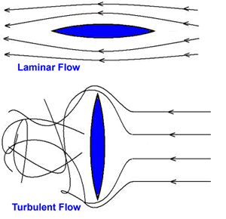
Figure 1 Representation of Laminar and Turbulent Flow

To identify the Reynolds number the below equation is used.
$$Re=\frac{ρuL}{μ}$$
Re = Reynolds number.
$ρ$ = Density of the fluid.
u = Velocity of the fluid.
L = Characteristic length.
$μ$ = Viscosity of the fluid.

To summarise, the density of the fluid multiplied by the velocity and characteristic length divided by the viscosity of the fluid produces the Reynolds number. The Reynolds number will determine if the fluid is in laminar, transitional or turbulent flow. Viscosity is an important factor in determining the Reynolds number affecting the fluid’s ability to change shape. Extremely viscous fluids are resistant to change while less viscous fluids are less resistant. Therefore, the viscous forces are the internal forces resisting change.

The Importance of Reynolds Number
Reynolds number is important because it distinguishes the flow regime, helping to determine laminar and turbulent flow. Understanding flow behaviour is crucial to understanding the efficiency and performance of the fluid. Laminar and turbulent flows can heavily impact efficiency and performance. For example, heat transfer and mixing rates are enhanced by turbulent flow. However, turbulent flow also results in higher energy losses as a result of increased friction. Understanding the flow regime is crucial to design considerations (Besagni et al., 2018). Understanding flow regime can provide insight into potential risks and design considerations.

Drag reduction and stall prediction are two concepts that are heavily influenced by Reynolds number. Drag is a force acting opposite to the direction of motion and friction. Pressure difference between the object and surrounding air causes this. Reynolds number influences the drag experienced and understanding the flow regime allows designers to implement streamlined concepts reducing the drag in turbulent flow conditions. Designers also take Reynolds number as reference when optimizing wing profiles to prevent flow separation and stall conditions. (Rojratsirikul et al., 2011).
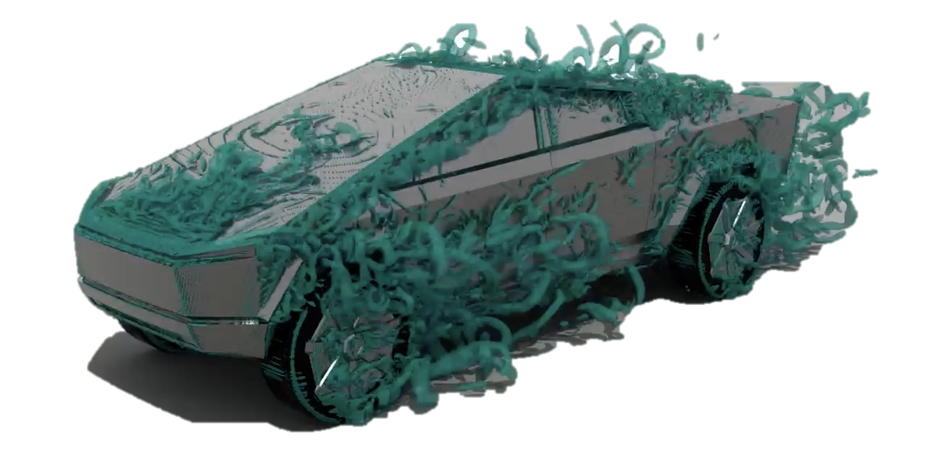
Figure 2 Visualisation of Aerodynamic Drag.

Influence of Reynolds number to the Kitesurf board
Reynolds number can significantly influence a Kitesurf board’s performance in the water and should be considered during the design stages. Identifying laminar and turbulent flow regions of the Kitesurf board is crucial to performance. Laminar flow regions will create smooth and organised streamlines. The benefit of laminar flow is lower frictional drag (Nick & Sato, 2020), allowing the board to glide through the water more efficiently. Laminar flow has flaws as it is vulnerable to flow separation. This is where the smooth flow breaks away from the surface creating a turbulent region increasing drag and reducing lift. Turbulent flows disorganised chaotic flow will have a higher frictional drag but will be less prone to separation. This is interesting as it could potentially lead to more stable and controlled movement, which for Kitesurf boards can be crucial for use. Another aspect of the Kitesurf board Reynolds number is the drag. Turbulent flow can result in less drag as a result of delayed flow separation (Hsu et al., 2021). Lift is influenced by a higher Reynolds number. Lift and stability are heavily influenced by the design of the board Schmidt et al. (2020). To summarise, Reynolds number is crucial to the Kitesurf board’s performance and design considerations.

Estimation of Reynolds Number
To identify the Reynolds number for the fluid flowing around the Kitesurf board the below equation will be used.
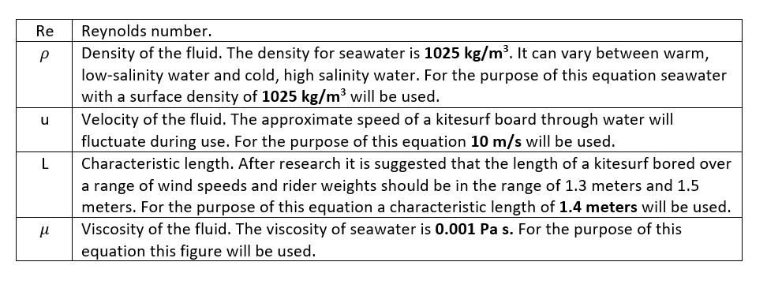
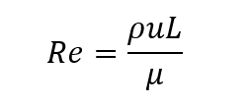
Figure 3 Table Justifying Figures Used in Equation

$$ρ=1025 kg/m^{3}$$
$$u=10 m/s$$
$$L=1.4 meters$$
$$μ=0.001 Pa s$$
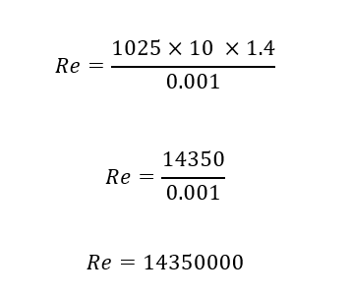

The high Reynolds number shows that the fluid flow around the kitesurf board is turbulent. This will affect the performance of the board. Designers can minimise negative performance on the board such as increased drag and stability by implementing corrective design features and altering material selection.

Boundary Layer
A boundary layer is a thin layer around the object. In this region the fluid velocity changes from zero to free stream. The velocity is zero at the surface as this is the point the fluid encounters the object and there is a no-slip condition. The fluid velocity increases as you move from the surface. Bernoulli’s equation clearly defines this relationship between velocity and pressure to be a direct correlation. If there is high pressure then there will be low velocity and vice versa. As Bernoulli’s equation bellow shows, if the velocity increases, then the pressure must decrease to keep total energy at a constant. Many behaviours of fluid flow can be defined by Bernoulli’s equation.

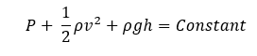
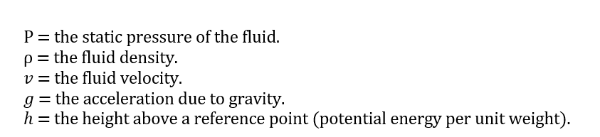
The stagnation point is the start of the boundary layer. The thickness of the boundary layer is between the plate where velocity is zero and freestream velocity outside the boundary layer as seen in figure 3. This is dictated by factors such as the characteristic length and viscosity / velocity of the fluid. The higher the viscosity the greater resistance to flow meaning a thicker boundary layer and determines how quickly the velocity increases from zero at the surface to the free stream. As the boundary layer increases in distance from the stagnation point, it grows in thickness as a result of more fluid particles interacting with the surface in a sheering interaction and increasing the velocity gradient. Higher free stream velocity leads to a sharper velocity gradient and thinner boundary layer. The increased kinetic energy allows particles to overcome viscous forces.

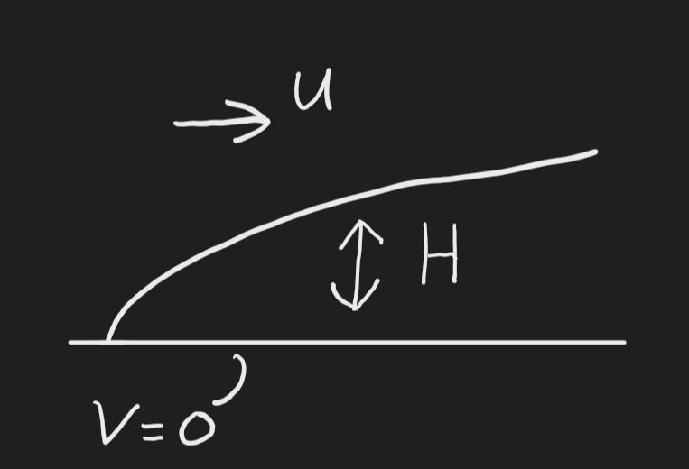
Figure 4 Stagnation Point and Boundary Layer Height.

To summarise, the boundary layer fluid strikes the object at the stagnation point where the velocity of the fluid at the surface is zero and the pressure is at its highest. The thickness of the boundary layer is then determined by the viscosity of the fluid. The higher the viscous forces the higher the increase in height. The distance from the stagnation point, the increase in sheering interaction increases the height of the boundary layer. Finally, the higher the free stream velocity the thinner the boundary layer.

Separation and Turbulence
As the boundary layer Reynolds number increases owing to several factors including the distance from the stagnation point and the flow of the particle’s transitions from laminar flow to transitional region to turbulent flow. The state of the boundary layer is linked to the separation of the boundary layer, it is influenced by laminar, transitional and turbulent flow. Attached flow consists of the boundary layer being connected to the object while in separated flow the layer has detached from the object.

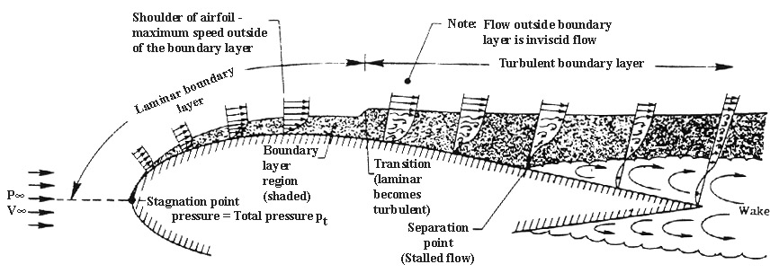
Figure 5 Diagram Showing Transition from Laminar to Turbulent Flow in the Boundary Layer.

Figure 5 shows the transition of the boundary layer. At the initial region close to the leading edge the flow will be laminar, meaning a smooth organised motion. The laminar flow boundary layer grows in thickness as the length increases. The laminar flow moves to the transitional region as a result of small disturbances and turbulent spots within the laminar boundary layer begin to show. The boundary layer then becomes turbulent flow, disorganised and chaotic enhancing mixing and increasing momentum.

Boundary layer attached flow is assisted by a favourable pressure with the pressure flowing in the same direction. The separation point is a result of an adverse pressure gradient. This is where the pressure is flowing in a opposite direction to the fluid. This means that not only the viscosity of the fluid but also the adverse pressure gradient is slowing down the velocity of the fluid. When the velocity reaches zero separation begins to occur. Beyond the separation point is referred to as the wake. This is a low-pressure region where there is a backflow of turbulent fluid. The size of the wake is directly linked to the amount of drag, a larger wake causing an increase in drag and reduction in lift. Delaying the separation point would reverse this increasing lift and reducing drag. To implement this, you would need to increase velocity in the boundary layer by introducing turbulence creating attached flow.

Design Considerations
Figure 6 shows the design of the board, a flat board with grooves at either end. There are many design considerations that would influence performance, efficiency and cost. The surface roughness and texture would influence the performance of the board. A smooth surface would minimise drag while a controlled roughness could help maintain the turbulent flow in the boundary layer (Flack et al. 2005). The edges of the board are rounded to transition more smoothly and increase stability. The front contour provides guidance to the water flow. This manages the boundary layer and reduces separation. Design considerations such as size, shape and length all influence the Reynolds number, meaning the Reynolds number can be manipulated using these parameters to increase performance. An example of this is longer Kitesurf boards being more stable at higher speeds, a higher Reynolds number can be linked to an increase in length leading to more turbulent flow characteristics and a performance change Bohorquez et al. (2011).

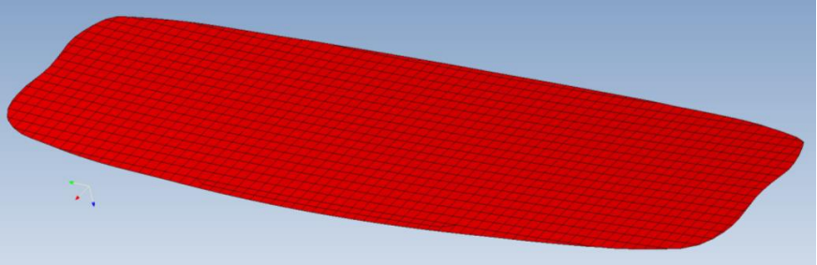
Figure 6 A Model of a Kitesurf Board

Material Selection: Carbon Fibre Reinforced Plastic
Carbon fibre reinforced plastic is a composite material used in a wide range of high-performance applications and is known for its great mechanical properties. Carbon fibre is the reinforcement to the matrix plastic material. The plastic matrix binds the carbon fibres together, while also improving the composite properties. Plastic will protect carbon fibres from environmental impacts such as moisture, chemical and UV radiation. It will also improve toughness and flexibility helping the composite to absorb impact (Adeniran et al., 2022).

Carbon fibre adds many benefits as a reinforcement to the composite material. Carbon fibre is extremely light weight helping to reduce the weight of the overall composite. Light weight joined with exceptional strength and stiffness enhances the mechanical properties and creates an improved strength to weight ratio (Ning et al., 2016).

Performance Capabilities
Carbon fibre reinforced plastic uses the beneficial properties of plastic and carbon fibre to create a composite that works in unity. The unity of these materials creates significant performance capabilities which the kitesurf board will benefit from. The major benefit of the composite material for the kitesurf board is the strength to weight ratio. This increases the performance of the board as it provides strength without increasing the weight (Alam et al., 2019). A high fatigue resistance increases the board performance under cyclic load (Machado et al., 2019). The lifespan of the composite material is enhanced as the structural integrity and appearance is prolonged (Rajak et al., 2019). Carbon fibre reinforced plastic offers many advantages when considering the surface roughness of the board. The surface roughness is important because it directly effects the flow in the boundary layer. The smooth finish of the material reduces friction drag resulting in better flow of water around the board (Shin & Song 2014). The surface finish of carbon fibre reinforced plastic can also be linked to durability as the properties ensure the finish remains constant over time, enhancing the longevity of the board.

Developments of the Kitesurf Board
Cost is a major factor in determining the performance, manufacturability and materials each board is made from. There is a trend between high cost and better performance, due to the manufacturability of high-performance boards.

Low-cost: fiberglass reinforced Polyethylene boards.
The advantages of low-cost boards are the availability and affordability. Beginners will find adequate performance. Due to the low cost, the board will be heavier and therefore less responsive with lower performance. Low-cost boards genuinely tend to be injection moulded for high production volumes. This leads to less durable shorter lifespan board. Also, low-cost boards typically have rougher surfaces, increasing frictional drag. The turbulent flow at the boundary layer will have a negative effect on the performance of the board. Related research shows significant role of surface characteristics influencing performance outcomes (Ali et al., 2022).

Medium-Cost: Epoxy Resin with fiberglass and wooden cored boards.
Medium cost boards offer better strength to weight ratio, enhanced flexibility and are more durable compared to lower cost boards. Performance may not meet advanced levels but should be sufficient for intermediate users. The enhanced shock absorption abilities and increased rigidity of fiberglass (Wada et al., 2018) allows for intermediate manoeuvrers. Advanced manufacturing techniques such as vacuum bagging ensures better quality control but increases the cost.

High–Cost: Carbon Fibre Reinforced Plastic Boards.
High-cost carbon fibre reinforced plastic boards have exceptional strength to weight ratio (Zhang & Tani, 2017), are highly responsive and flexible, especially for advanced manoeuvrers. Advanced techniques such as resin fusion and the use of high-quality materials ensure precision engineered boards. The smooth finish to the board is optimal for efficiency and manoeuvrability and ensures laminar flow around the boundary layer, useful for advanced manoeuvrers.

Modelling Techniques
There are three main types of fluid dynamic analysis: theoretical, experimental and computational. Theoretical fluid dynamics relies on mathematical models and analytical methods. However, this comes with limitations. The complexity of equations cannot accurately capture real-world scenarios. As a result, specific conditions are assumed (Schweizer & Saltzman, 2003). Concepts such as the Navier-Stokes equations are fundamental to theoretical fluid analysis, as they allow fluid behaviour to be modelled in various conditions (Foias et al., 2016).

Experimental fluid dynamic analysis is a hugely beneficial tool, allowing theoretical conclusions to be validated and confidence to be gained in computational fluid dynamic simulations. Case studies often implement this approach to gain confidence in CFD simulations (Kasmaee et al., 2019). Facilities such as wind tunnels are used to study aerodynamics and apply validation to manufactured models. Experimental fluid dynamics is beneficial because it provides data on real-world validation and is capable of capturing complex fluid behaviours (Zhang, 2023). There are limitational factors such as high cost and time-consuming aspects. There are also physical constrains of the experimental setup limiting the analysis results (Treeratanaphitak, 2021).

Computerized fluid dynamics (CFD) uses numerical methods and algorithms to solve fluid dynamic equations simultaneously on a specified problem. The important aspects to CFD are discretization, numerical solvers and boundary conditions. Discretization converts all the elements in the fluid domain into discrete cells, implemented through meshing techniques. This can heavily influence the results from the analysis (Menaa et al., 2019). Numerical solvers, equate Navier-Stokes equations throughout the mesh validating the results of the analysis. Boundary conditions ensure realistic simulations and define the boundary used in the analysis (Jiang et al., 2017). The benefits of CFD are the complex shapes and fluid behaviours it can handle (Gao, 2023). However, CFD does require substantial computational resource to get accurate results including a quality mesh and substantial boundary conditions.
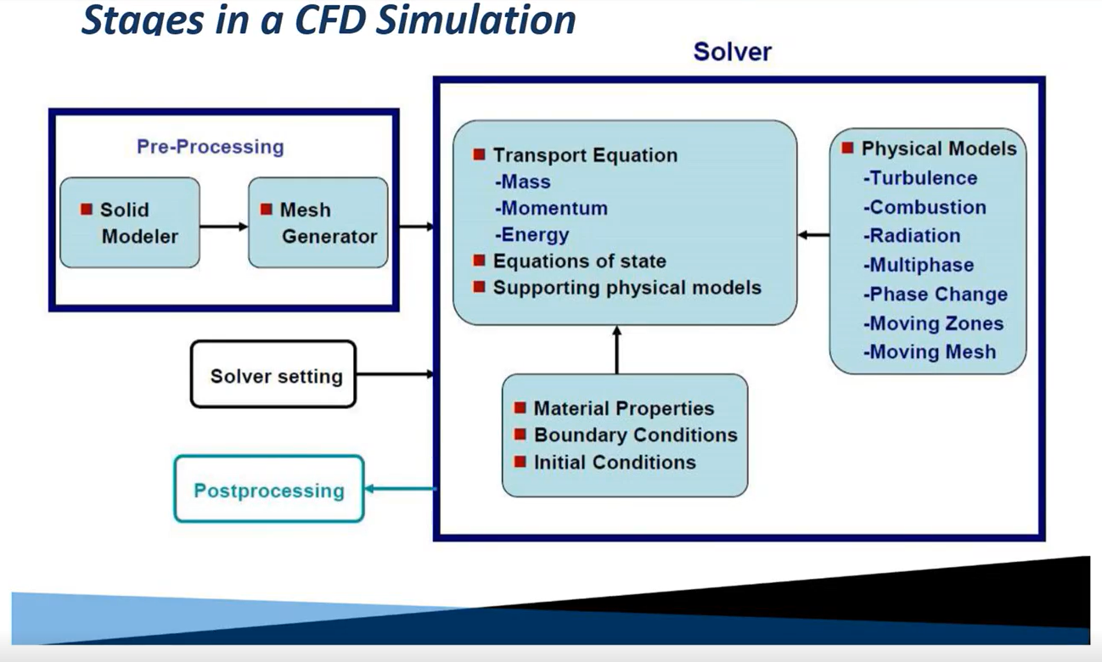
Figure 7 CFD simulation Stages Breakdown.

Figure 7 shows the physical stages of CFD including the factors implemented to create an accurate simulation. Figure 8 shows the process of CFD. This represents constant improvement and collaboration of CFD with experimental fluid dynamic analysis. This is crucial to a representative CFD simulation, ensuring confidence that the results reflect those of reality Park et al. (2022)

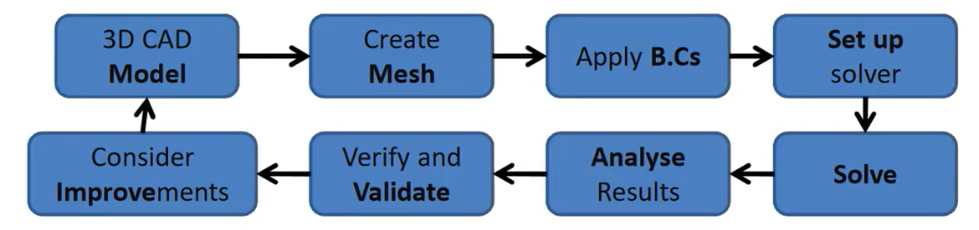
Figure 8 Diagram of the Process of CFD.

Estimation of Forces
Using Bernoulli’s equation the stagnation point, pressure at the low velocity region (Pressure side) and pressure at the high velocity region (Suction side) can be calculated. To do this, the assumptions below will be made.
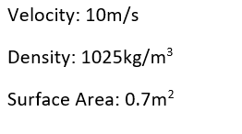

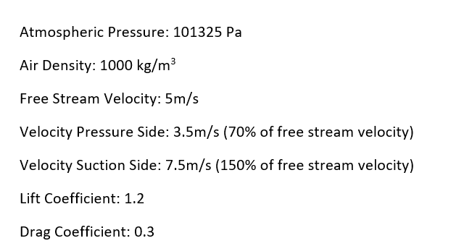

Stagnation Point Pressure
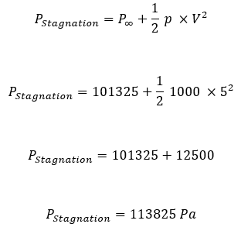

Pressure at Pressure Side
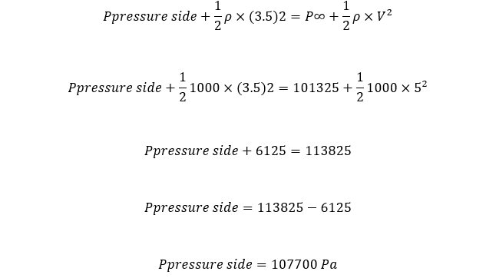

Pressure at Suction Side
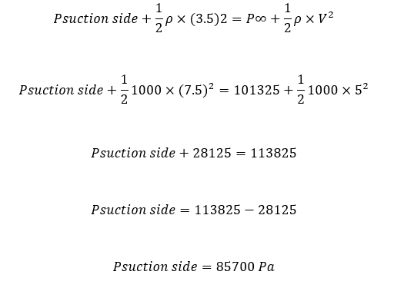

Lift Force
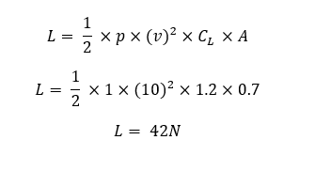

Drag Force
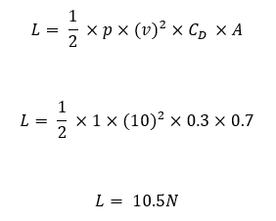

Prototype
Protypes serve as a bridge between CFD analysis and experimental analysis, and consolidates the simulation results (Mathias et al., 2018). The implementation of prototypes allows the results to be analysed and reflection on the CFD analysis. Experimental analysis gives a better insight into boundary conditions and material properties (Kajero et al. 2016). The collaboration of CFD and prototyping can be cost effective as it allows for accurate design iterations. Multiple designs can be tested and then refined. Identifying design flaws during the design phase can have tremendous benefits to the manufacturing stage of the project. This is particularly important when considering a mass-produced component like an injection moulded Kitesurf board. During the design phase it would be crucial to gain confidence in the design before implementing mas production tooling. This is often done through silicone or aluminium low volume tooling (Ferguson et al. 2022).

Data collection in relation to Simulation
There are three main stages to the data collection process: designing the experiment, acquiring accurate data and affectively compiling the data. When designing, the experiment objectives need to be outlined, and should consider how the kitesurf board can be further improved. Considering this the objectives should be to assess the performance of the board in different environments, validating the results by comparing it to the CFD and identifying how the design can be further improved.

Test environments such as a wave tank and multiple field tests can be used to simulate real world conditions and is crucial to ensure their accuracy and reliability (Allen et al., 2010). To accurately acquire data, instruments should be used such as force sensors, to measure the forces acting on the board, GPS / speed sensors to track the speed and position of the board, pressure sensors to monitor the distribution of pressure at the boards surface, accelerators and gyroscopes to measure the angular velocity and acceleration and Pitot tubes to measure the wind speed and direction (Isoda et al., 2009). From this, data can be acquired and compared with figures obtained in the CFD. The results of the real-world prototype experiments will indicate the accuracy of the CFD simulation. Some parameters of the simulation may need to be adjusted. To improve the design, this process can be repeated multiple times, using the results to influence features implemented into the design of the board (Climent et al., 2019).

Conclusion
Fluid dynamic analysis is fundamental to understanding the fluid flow and being able to monopolise design considerations to benefit the performance. Reynolds number can provide insight to the location of turbulent and laminar flow, helping to identify characteristics of the kitesurf board. The boundary layer is crucial to how the kitesurf board moves through the seawater and the performance ability. The Reynolds number of 14350000 indicates turbulent flow around the board. This can increase drag and have a negative impact on the performance. However it can also introduce attached flow and prolong separation flow in the boundary layer. Implementing CFD and experimental fluid analysis into the design of the kitesurf board has many benefits, creating advanced insights into the performance of the kitesurf board and allowing a more robust design. The advancements in kitesurf board production will be expedited by the use of CFD and prototype collaboration throughout the design phase.

Bibliography
Adeniran, O., Cong, W. and Oluwabunmi, Kayode Emmanuel (2022). Thermoplastic Matrix Material Influences on the Mechanical Performance of Additively Manufactured CarbonFiberReinforced Plastic Composites. Journal of Composite Materials, 56(9), p.13911405. doi:https://doi.org/10.1177/00219983221077345.

Alam, P., Mamalis, D., Robert, C., Floreani, C. and Brádaigh, Conchúr M. Ó (2019). The Fatigue of Carbon Fibre Reinforced Plastics: A Review. Composites Part B Engineering, 166, p.555579. doi:https://doi.org/10.1016/j.compositesb.2019.02.016.

Ali, S., Kurniawan, R., Xu, M., Ahmed, F., Danish, M. and Aslantaş, K. (2022). Effect of MicroDimple Geometry on the Tribological Characteristics of Textured Surfaces. Lubricants, 10(12), p.328. doi:https://doi.org/10.3390/lubricants10120328.

Allen, R.B., Park, G. and Cook, M.L. (2010). Simulator Fidelity and Validity in a TransferofTraining Context. Transportation Research Record Journal of the Transportation Research Board, 2185(1), p.4047. doi:https://doi.org/10.3141/218506.

AlonsoMontemayor, F.J., Tarrés, Q., OliverOrtega, H., Espinach, Francesc X, NarroCéspedes, R.I., CastañedaFacio, Adali O and DelgadoAguilar, M. (2020). Enhancing the Mechanical Performance of Bleached Hemp Fibers Reinforced Polyamide 6 Composites: A Competitive Alternative to Commodity Composites. Polymers, 12(5), p.1041. doi:https://doi.org/10.3390/polym12051041.

Besagni, G., Inzoli, F. and Ziegenhein, T. (2018). TwoPhase Bubble Columns: A Comprehensive Review. Chemengineering, 2(2), p.13. doi:https://doi.org/10.3390/chemengineering2020013.

Bohorquez, P., Sanmiguel‐Rojas, E., Sevilla, A., JiménezGonzález, J.I. and Martı́nezBazánC. (2011). Stability and Dynamics of the Laminar Wake Past a Slender BluntBased Axisymmetric Body. Journal of Fluid Mechanics, 676, p.110144. doi:https://doi.org/10.1017/jfm.2011.35.

Climent, J., Martínez‐Cuenca, R., Carratalà, P., GonzálezOrtega, M.J., Abellan, M., Monrós, G. and Chiva, S. (2019). A Comprehensive Hydrodynamic Analysis of a FullScale Oxidation Ditch Using Population Balance Modelling in CFD Simulation. Chemical Engineering Journal, 374, p.760775. doi:https://doi.org/10.1016/j.cej.2019.05.195.

Ferguson, S., Lai, K., Chen, J., Faidi, S.E., Leonardo, K. and Olechowski, A. (2022). ‘Why Couldn’t We Do This More Often?’: Exploring the Feasibility of Virtual and Distributed Work in Product Design Engineering. Research in Engineering Design, 33(4), p.413436. doi:https://doi.org/10.1007/s00163022003912.

Flack, K.A., Schultz, M.P. and Shapiro, T.M. (2005). Experimental Support for Townsend’s Reynolds Number Similarity Hypothesis on Rough Walls. Physics of Fluids, 17(3). doi:https://doi.org/10.1063/1.1843135.

Foiaş, C., Tian, J. and Zhang, B. (2016). On the Emergence of the NavierStokesα Model for Turbulent Channel Flows. Journal of Mathematical Physics, 57(8). doi:https://doi.org/10.1063/1.4960750.
Gao, Y. (2023). CFD Based Aerodynamic Optimization Design. Theoretical and Natural Science, 18(1), p.8390. doi:https://doi.org/10.54254/27538818/18/20230343.

Isoda, H., Ohkura, Y., Kosugi, T., Hirano, M., Alley, M.T., Bammer, R., Pelc, N.J., Namba, H. and Sakahara, H. (2009). Comparison of Hemodynamics of Intracranial Aneurysms Between MR Fluid Dynamics Using 3D Cine PhaseContrast MRI and MRbased Computational Fluid Dynamics. Neuroradiology, 52(10), p.913920. doi:https://doi.org/10.1007/s0023400906344.

Jiang, C., Soh, Y.C., Li, H., Masood, M.K., Wei, Z., Zhou, X. and Zhai, D. (2017). CFD Results Calibration From Sparse Sensor Observations With a Case Study for Indoor Thermal Map. Building and Environment, 117, p.166177. doi:https://doi.org/10.1016/j.buildenv.2017.02.007.

Kasmaee, M., Varaminian, F., Khadiv‐Parsi, P. and Saien, J. (2019). Study of Parameters Affecting the Coalescence of Dimethyl Disulfide Drops in a Merox Unit. Brazilian Journal of Chemical Engineering, 36(4), p.14531462. doi:https://doi.org/10.1590/01046632.20190364s20180569.

Machado, J.J.M., Marques, E.A.S., Barbosa, A.Q. and Lucas, S. (2019). Fatigue Performance of Single Lap Joints With CFRP and Aluminium Substrates Prior and After Hygrothermal Aging. Fatigue & Fracture of Engineering Materials & Structures, 42(10), p.23252339. doi:https://doi.org/10.1111/ffe.13067.

Mathias, D., Hicks, B., Snider, C. and Ranscombe, C. (2018a). Characterising the Affordances and Limitations of Common Prototyping Techniques to Support the Early Stages of Product Development. doi:https://doi.org/10.21278/idc.2018.0445.

Mathias, D., Hicks, B., Snider, C. and Ranscombe, C. (2018b). Characterising the Affordances and Limitations of Common Prototyping Techniques to Support the Early Stages of Product Development. doi:https://doi.org/10.21278/idc.2018.0445.

Menaa, A., Lounici, Mohand Said, Amrouche, F., Loubar, K. and Kessal, M. (2019). CFD Analysis of Hydrogen Injection Pressure and Valve Profile Law Effects on Backfire and PreIgnition Phenomena in HydrogenDiesel Dual Fuel Engine. International Journal of Hydrogen Energy, 44(18), p.94089422. doi:https://doi.org/10.1016/j.ijhydene.2019.02.123.

Nick, N. and Sato, Y. (2020). Computational Fluid Dynamics Simulation of Hyperloop Pod Predicting Laminar–turbulent Transition. Railway Engineering Science, 28(1), p.97111. doi:https://doi.org/10.1007/s4053402000204z.

Ning, F., Cong, W., Hu, Y. and Wang, H. (2016). Additive Manufacturing of Carbon FiberReinforced Plastic Composites Using Fused Deposition Modeling: Effects of Process Parameters on Tensile Properties. Journal of Composite Materials, 51(4), p.451462. doi:https://doi.org/10.1177/0021998316646169.

Rajak, Dipen Kumar, Pagar, Durgesh D, Menezes, P.L. and Linul, E. (2019). FiberReinforced Polymer Composites: Manufacturing, Properties, and Applications. Polymers, 11(10), p.1667. doi:https://doi.org/10.3390/polym11101667.

Rojratsirikul, P., Genç, Mustafa Serdar, Wang, Z. and Gursul, I. (2011). FlowInduced Vibrations of Low Aspect Ratio Rectangular Membrane Wings. Journal of Fluids and Structures, 27(8), p.12961309. doi:https://doi.org/10.1016/j.jfluidstructs.2011.06.007.

Schmidt, J., Fleischmann, M., Ehemann, C., Kaufmann, J. and Cebulla, H. (2020). Parametric Shape and Manufacturing Optimization of Customized Kitesurf Hydrofoils. doi:https://doi.org/10.3390/proceedings2020049126.
Schweizer, K.S. and Saltzman, E.J. (2003). Entropic Barriers, Activated Hopping, and the Glass Transition in Colloidal Suspensions. The Journal of Chemical Physics, 119(2), p.11811196. doi:https://doi.org/10.1063/1.1578632.

Shin, J. and Song, S.J. (2014). Pressure Gradient Effects on SmoothAnd RoughSurface Turbulent Boundary Layers—Part II: Adverse Pressure Gradient. Journal of Fluids Engineering, 137(1). doi:https://doi.org/10.1115/1.4027475.

Treeratanaphitak, T. and Abukhdeir, Nasser Mohieddin (2021). PhaseBounded Finite Element Method for TwoFluid Incompressible Flow Systems. doi:https://doi.org/10.48550/arxiv.2101.05734.

Wada, T., Churei, H., Takayanagi, H., Iwasaki, N., Ueno, T., Takahashi, H. and Uo, M. (2018). Improvement of the Shock Absorption Ability of a Face Guard by Incorporating a GlassFiberReinforced Thermoplastic and Buffering Space. Biomed Research International, 2018, p.18. doi:https://doi.org/10.1155/2018/6503568.

Y, H.X., Miau, J., Ku, T., J, C.J., Yuan, W., H, L.Y., R, C.Y., J, C.Y., Tseng, C., H, C.C., Jan, S., S, C.Y., Chen, Y. and Chiu, C. (2021). A Study of Drag Reduction With Textile Roughness on a Cyclist Model. Journal of the Textile Institute, 113(6), p.12061230. doi:https://doi.org/10.1080/00405000.2021.1950978.

Zhang, X., Li, M., Wang, B. and Li, Z. (2023). A Parameter Correction Method of CFD Based on the Approximate Bayesian Computation Technique. Journal of Physics Conference Series, 2569(1), p.012076. doi:https://doi.org/10.1088/17426596/2569/1/012076.

Zhang, Y. and Tani, Y. (2017). Cutting Characteristics of CFRP Boards Using Electroplated Diamond Wire Tools. Journal of Mechanics Engineering and Automation, 7(7). doi:https://doi.org/10.17265/21595275/2017.07.001.

Zhang, yongjie, wang, songyuan and guo, yazhou (2023). Review of LowVelocity Impact Analysis Methods for Composite Structures. doi:https://doi.org/10.1117/12.3007194.

