
____________________

With, not for.
Own the Outcome.
Never Stop Learning.

Ground Investigation Report

Document Number:
GI-001

Trinity Group Ltd

Trinity Group – Ground investigation report

Contents
EXECUTIVE SUMMARY 1
1. INTRODUCTION AND SCOPE 3
1.1 Purpose of the Report 3
1.2 Scope of Assessment 4
2. SITE DESCRIPTION AND CONTEXT 5
2.1 Location and Setting 5
2.2 Proposed Development 6
2.3 Historical Land Use 6
3. DESK TOP STUDY AND BACKGROUND REVIEW 7
3.1 Methodology 7
3.2 Regional Geological Setting 8
3.3 Dockland Stratigraphy and Ground Conditions 9
3.4 Hydrogeological Context 10
3.5 Environmental and Contamination Context 10
3.6 Existing statutory services 11
4. CONCEPTUAL GROUND MODEL (CGM) 11
4.1 Purpose of the Conceptual Ground Model 11
4.2 Anticipated Stratigraphy 12
4.3 Engineering Significance of Stratigraphy 12
5. PRELIMINARY GROUND INVESTIGATION METHODOLOGY (SIMULATED) 13
5.1 Rationale for Simulated Investigation 13
5.2 Representative Borehole Locations 13
6. BOREHOLE LOGS AND INTERPRETATION 14
6.1 Overview 14
6.2 Borehole Logs 14
6.3 Engineering Interpretation of Boreholes 17
7. GEOTECHNICAL PARAMETER ASSESSMENT 17
7.1 Adopted Design Parameters 18
7.2 Engineering Significance 19
8. ENGINEERING ASSESSMENT – STRUCTURAL LOADING AND GROUND RESPONSE 20
8.1 Structural Loading from a Two-Storey Steel Frame 20
8.2 Bearing Capacity of Near-Surface Soils 20
8.3 Settlement Mechanisms 21
9. FOUNDATION OPTIONS APPRAISAL (CRITICAL COMPARISON) 22
9.1 Shallow Foundations 22
9.2 Raft Foundations 23
9.3 Piled Foundations 24
10. PILED FOUNDATION DESIGN RATIONALE 25
10.1 Pile Type Selection 25
10.2 Load Transfer Mechanisms 25
10.3 Negative Skin Friction 26
10.4 Pile Group Behaviour 26
11. CONTAMINATION AND GROUND GAS ASSESSMENT 27
11.1 Potential Contaminants 27
11.2 Conceptual Site Model (CSM) 28
11.3 Ground Gas Risk 28
12. CONSTRUCTION CONSIDERATIONS 29
13. LIMITATIONS AND UNCERTAINTY 29
14. CONCLUSIONS AND RECOMMENDATIONS 30
15. REFERENCES 30

Figures
Figure 1 – Location of development – Plan view (Google, 2025) 8
Figure 2 - Location of development . View from adjacent building. (Morris N, 2026) 8
Figure 3 - Bedrock geology (British Geological Society, 2026) 11
Figure 4 - Superficial geology (British Geological Society, 2026) 12
Figure 5 - Combined Geology (British Geological Society, 2026) 12
Figure 6 - CGM model (OpenAi, 2026) 15
Figure 7- Scottish and Southern Electricity plan 41
Figure 8 - Wales and West utility plan 42
Figure 9 - National Grid Electricity plan 43
Figure 10 - Welsh water Utility plan 44
Figure 11 - Google Earth current site plan (Google, 2025) 45
Figure 12 - Historical Ordnance Survey Map (1991) (Google, 2025) 46
Figure 13 - Historical Ordnance Survey Map (1945) (Google, 2025) 47

Executive Summary
This report presents the findings of a ground investigation study undertaken to inform the proposed development of a two‑storey Construction Training Centre and associated car park at the SA1 waterfront development, Swansea. The proposed development comprises of a 1410 m² steel‑framed building with car park. The site forms part of the SA1 Waterfront regeneration area located adjacent to the River Tawe and Swansea Bay and close to the Swansea UWTSD Campus. Historic dockland activity, industrial land use and land reclamation have resulted in complex ground conditions including made ground, soft alluvial deposits and potentially contaminated soils.
Desk top study information and representative borehole data indicate that the site is likely to consist of heterogeneous made ground overlying compressible alluvial and estuarine deposits, underlain by granular strata and Carboniferous sandstone bedrock at depth (British Geological Society, 2026). The near‑surface soils are expected to have low shear strength and high compressibility, making them unsuitable for shallow foundations.
Piled foundations are therefore considered the most appropriate solution for the proposed development, allowing structural loads to be transferred to competent strata at depth while reducing settlement risks.
The historical industrial use of Swansea docks means that contamination from hydrocarbons, heavy metals and industrial waste materials may be present. Furthermore, due to wartime bombing of Swansea during the Second World War, a potential unexploded ordnance (UXO) risk cannot be entirely discounted, and appropriate additional surveys must be undertaken.
The proximity of the site to the River Tawe introduces hydrogeological considerations including shallow groundwater levels and possible tidal influence. Construction works therefore require appropriate groundwater management and pollution prevention measures to avoid contamination of nearby watercourses. The accompanying Environmental report will pick up these considerations and can be viewed separately and is referenced as Document number ENV-001.
Construction activities may also generate community impacts due to heavy construction traffic and piling works. Previous developments within the SA1 area have resulted in congestion along Kings Road and surrounding access routes. Appropriate traffic management, delivery scheduling and stakeholder communication will therefore be required during construction and is covered in the accompanying traffic management plan TMP-001.
Key risks associated with the development include variable made ground, compressible alluvial deposits, groundwater inflow during excavation, potential contamination, UXO presence, buried dock structures and community disruption during construction.
A detailed intrusive site investigation including boreholes, in‑situ testing, groundwater monitoring and contamination testing is recommended prior to final foundation design.

1. Introduction and Scope

1.1 Purpose of the Report

The purpose of this report is to provide a geotechnical interpretation of the SA1 Waterfront site to support the preliminary design of the proposed Construction Training Centre and associated car park. The report aims to:

- Characterise anticipated ground conditions beneath the site.
- Identify geotechnical and environmental risks associated with development.
- Assess the suitability of potential foundation solutions.
- Provide engineering recommendations for foundation design and further investigation.
- Demonstrate critical evaluation of geotechnical uncertainty in a brownfield redevelopment context.

Ground investigation is a fundamental component of civil engineering design, as subsurface conditions cannot be directly observed and must be inferred from limited data. Eurocode 7 emphasises that geotechnical design should be based on an appropriate level of site investigation commensurate with project complexity and risk (Eurocode 7, 1997). BS 5930 further highlights the importance of integrating desk study, intrusive investigation, and laboratory testing to develop a reliable understanding of ground conditions (BSI, 2026).

1.2 Scope of Assessment

The scope of this assessment includes:

- Review of geological, historical, and environmental information relevant to the site.
- Development of a conceptual ground model based on desk study and simulated intrusive data.
- Interpretation of representative borehole profiles.
- Identification of preliminary geotechnical parameters for key soil and rock units.
- Consideration of hydrogeological conditions and groundwater behaviour.
- Identification of potential contamination and ground gas risks.
- Preliminary assessment of foundation options with reference to a two-storey steel-framed structure.

This report is based on desk top study information and simulated borehole data and is intended for preliminary design and academic purposes only. It should not be relied upon for construction without a detailed intrusive site investigation.

2. Site Description

2.1 Location and Setting
The site is located within the SA1 Waterfront regeneration area in Swansea, South Wales, adjacent to Island Road and the River Tawe. The SA1 area represents one of the largest waterfront regeneration projects in Wales, comprising mixed-use development including residential, commercial, educational, and leisure facilities.
The site is generally flat, reflecting its origin as reclaimed dockland land. The surrounding environment includes modern buildings, infrastructure, and public spaces, which impose constraints on construction activities and influence foundation design considerations, particularly in relation to vibration, noise, and ground movement.
Current land use consists of regenerated brownfield land with areas of hardstanding and reclaimed dockland fill.
Boundaries: Island Road (north), mixed-use commercial buildings (west), waterfront access areas (south), and River Tawe development corridor (east).
The site covers approximately 4145 m² within the SA1 Waterfront regeneration area.
Approximate Site Coordinates: 51.6186° N, 3.9269° W
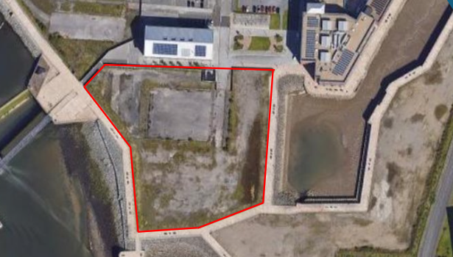
Figure 1 – Location of development – Plan view (Google, 2025)
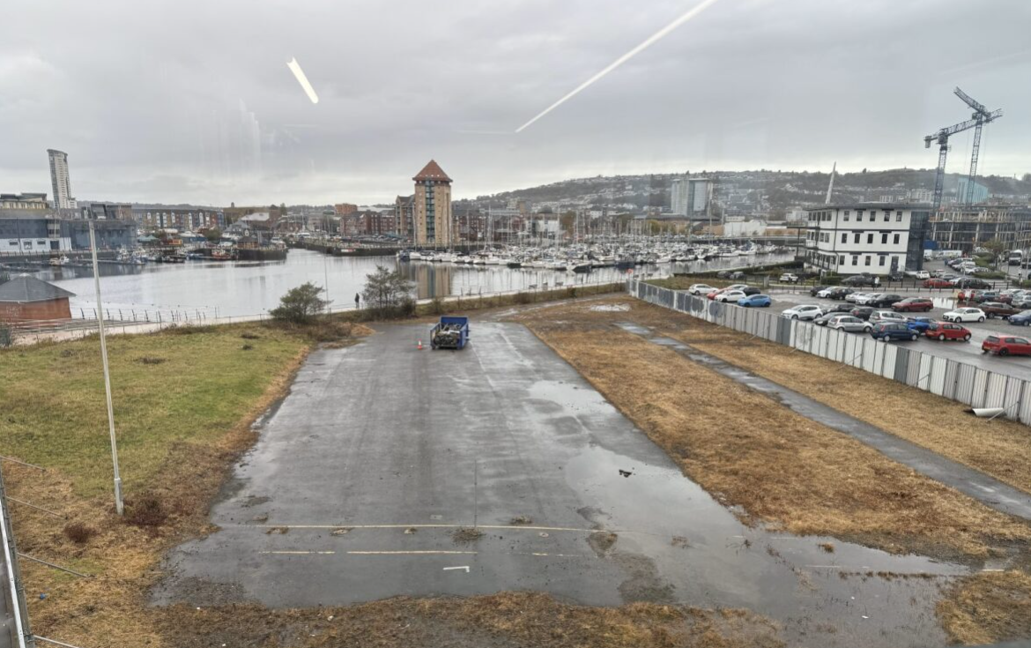
Figure 2 - Location of development. View from adjacent building. (Morris N, 2026)

2.2 Proposed Development

The proposed development consists of a two-storey steel-framed Construction Training Centre with an approximate gross floor area of 1410 m², together with an associated car park and total land of approx. 4145 m². Structural loads are assumed to be transmitted through steel columns to foundations. The two-storey nature of the building significantly influences foundation design, as it imposes higher vertical loads and increases sensitivity to differential settlement compared with single-storey structures.

From a geotechnical perspective, the proposed development can be classified as a medium-complexity structure in accordance with BS 590 (BSI, 2026), requiring a robust understanding of ground conditions and careful consideration of serviceability limit state (SLS) performance.

2.3 Historical Land Use
As Swansea docks were an industrial target during WWII, a low to moderate unexploded ordnance (UXO) risk may exist and should be considered prior to intrusive groundworks.
Due to this history, heterogeneous made ground and possible contamination are anticipated.
Following industrial decline in the late 20th century, dock infrastructure was removed and regeneration works created the present SA1 development zone.
Large areas of land reclamation occurred through the placement of industrial fill materials including ash, slag and demolition rubble.
Historical mapping shows dock basins, rail sidings, warehouses and industrial yards across the wider site area.
The SA1 Waterfront area historically formed part of Swansea Docks developed in the 19th century to support coal export and copper smelting industries.
Historically, the SA1 area was occupied by docks, warehouses, rail infrastructure, and industrial facilities associated with Swansea’s maritime and metallurgical industries. Swansea was a major centre for copper smelting and coal export during the nineteenth and early twentieth centuries, earning the nickname “Copperopolis” (Swansea Museum, 2026)
Land reclamation, dock construction, and industrial activity have significantly altered natural ground conditions across the SA1 area. Large volumes of fill material were placed to create usable land, resulting in heterogeneous made ground with variable composition and engineering properties. Brownfield redevelopment sites of this nature commonly present complex geotechnical and environmental challenges, including variable stratigraphy, compressible soils, and legacy contamination (Hammond, et al., 2021).

3. Desk Top Study

3.1 Methodology

The desk top study involved the review of:

- British Geological Survey (BGS) geological mapping and publications.
- Historical mapping and land use records as well as Borehole logs.
- Published literature on dockland redevelopment and geotechnical behaviour of reclaimed land.
- UK standards and guidance, including BS 5930.
- Information relating to the SA1 regeneration scheme.

The desk top study provides a preliminary understanding of site conditions and forms the basis for the conceptual ground model developed in this report.

3.2 Regional Geological Setting

The regional geology of Swansea is dominated by Carboniferous formations associated with the South Wales Coalfield. The bedrock geology comprises Pennant Sandstone and Coal Measures, consisting of interbedded sandstones, mudstones, and coal seams (British Geological Society, 2026). These formations generally provide competent bedrock at depth, although weathering and fracturing may reduce rock strength in the upper zones.

Overlying the bedrock are Quaternary superficial deposits, including alluvium, estuarine clays, sands, gravels, and anthropogenic made ground. These deposits were formed through a combination of fluvial, marine, and anthropogenic processes and exhibit variable geotechnical properties.
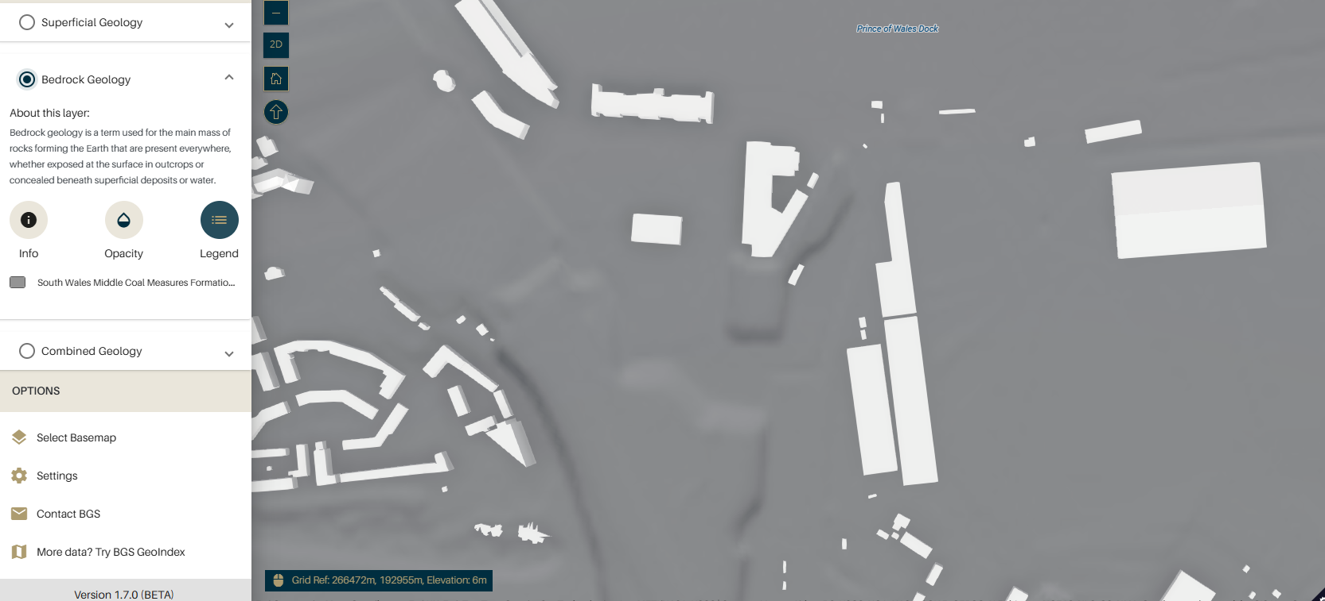
Figure 3 - Bedrock geology (British Geological Society, 2026)
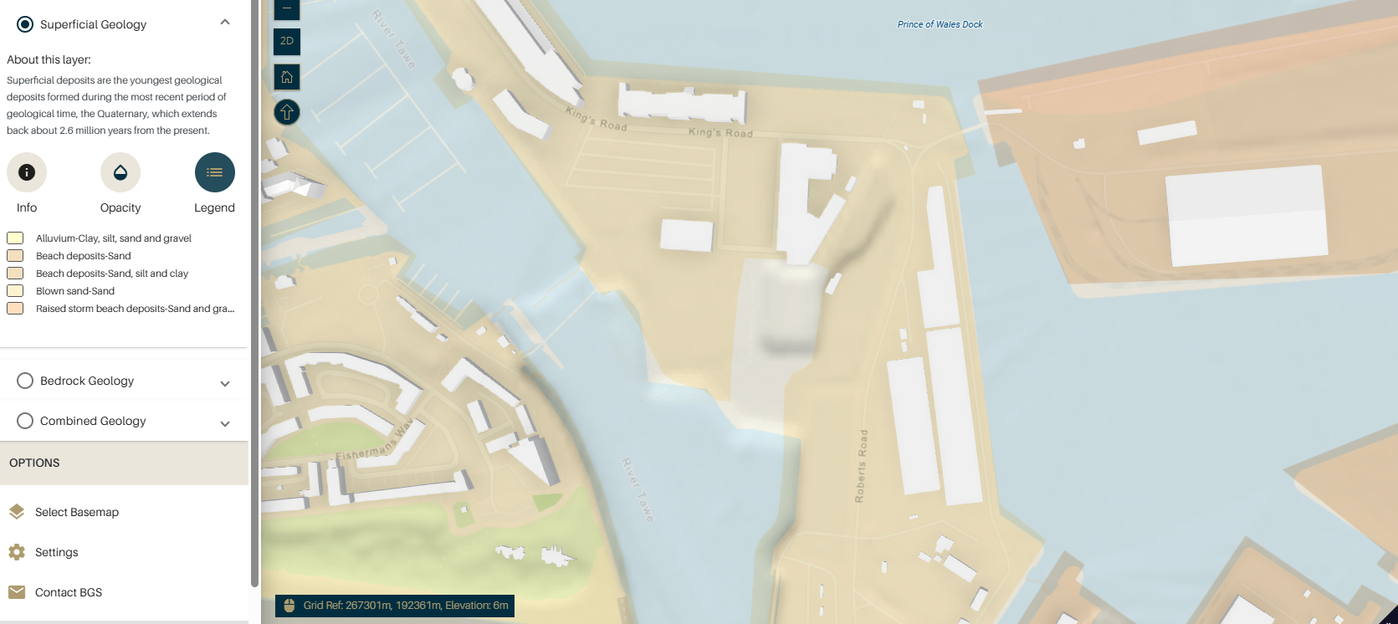
Figure 4 - Superficial geology (British Geological Society, 2026)
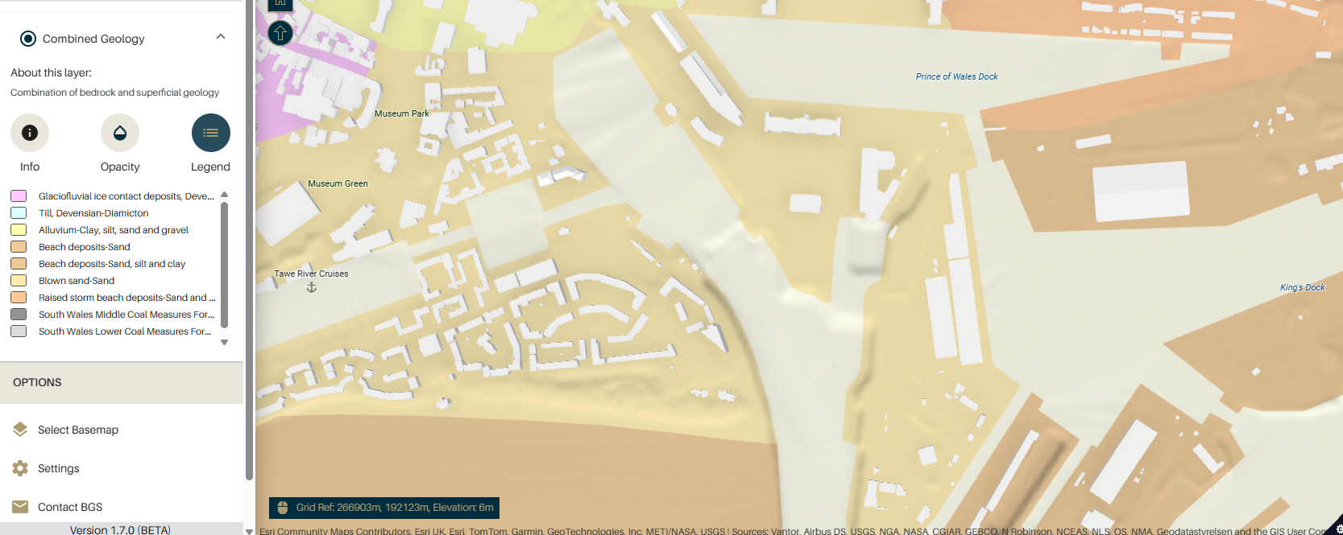
Figure 5 - Combined Geology (British Geological Society, 2026)

3.3 Dockland Stratigraphy and Ground Conditions

Dockland environments are typically characterised by complex stratigraphy resulting from historical reclamation and industrial activity. In the SA1 area, superficial deposits are expected to comprise layers of made ground overlying soft alluvial clays and silts, with underlying granular deposits and bedrock (British Geological Society, 2026).

Such stratigraphic sequences are associated with significant spatial variability in soil properties. This variability represents a key geotechnical risk, as foundation performance may differ across relatively short distances. Consequently, dockland redevelopment projects typically require deep foundations to bypass weak superficial deposits and mobilise resistance in competent strata.

3.4 Hydrogeological Context

The site is located adjacent to the River Tawe and near Swansea Bay. This geographical setting suggests a shallow groundwater table influenced by tidal and seasonal fluctuations. Granular deposits such as sands and gravels are expected to exhibit relatively high permeability, while cohesive clay layers may act as aquitards.

Groundwater conditions have important implications for:

- excavation stability,
- pile installation,
- effective stress and bearing capacity,
- long-term durability of foundations.

Shallow groundwater levels may also necessitate temporary dewatering during construction and influence the selection of pile type and construction methodology.

3.5 Environmental and Contamination Context
Nearby estuarine habitats may contain protected species, and ecological checks should be undertaken prior to vegetation clearance. This along with the below issues will be covered separately and in more detail within the accompanying Environmental Impact Assessment report (ENV-001). These are simply identified to make the reader aware that they are important to a typical GI study and will be looked at in additional reports.
Construction activities may generate dust and noise impacts which should be managed through environmental control measures.
Groundwater is likely shallow due to proximity to the River Tawe and Swansea Bay and may fluctuate with tidal influence.
Common contaminants in such environments may include heavy metals, hydrocarbons, PAHs and sulphates.
Potential contamination sources include historic dockland fill, fuel storage residues and metallurgical waste.

Historic dockland and industrial activity at SA1 may have resulted in contamination of soils and groundwater. Potential contaminants include:

- heavy metals (e.g. lead, copper, arsenic),
- hydrocarbons and petroleum products,
- polycyclic aromatic hydrocarbons (PAHs),
- sulphates,
- asbestos.

These contaminants may pose risks to construction workers, future occupants, groundwater, and surface water bodies. The Environment Agency’s Land Contamination Risk Management framework provides a structured approach to identifying and managing such risks (Environment Agency, 2025). And it is essential a full contaminants survey is undertaken; more detail on the environmental impacts will be covered in full in the accompanying Environmental report ENV-001.

3.6 Existing statutory services
There are currently all essential services available within the area, with adequate capacity for water and sewerage and no restrictions with gas or electricity. The plans for these services can be found in the appendix of this report along with the contact details of all utility providers.

4. Conceptual Ground Model (CGM)
A CGM report is a structured summary of the key risks and a visualisation of this can be found in figure 6, with a brief description below.
Key risks include differential settlement, contamination exposure, groundwater ingress and potential ground gas accumulation.
Receptors: construction workers, future occupants, nearby watercourses, underground services and building structures.
Pathways: soil ingestion, dust inhalation, groundwater migration and gas migration through permeable strata.
Potential Sources: made ground, industrial fill materials, hydrocarbons, heavy metals and ground gases.
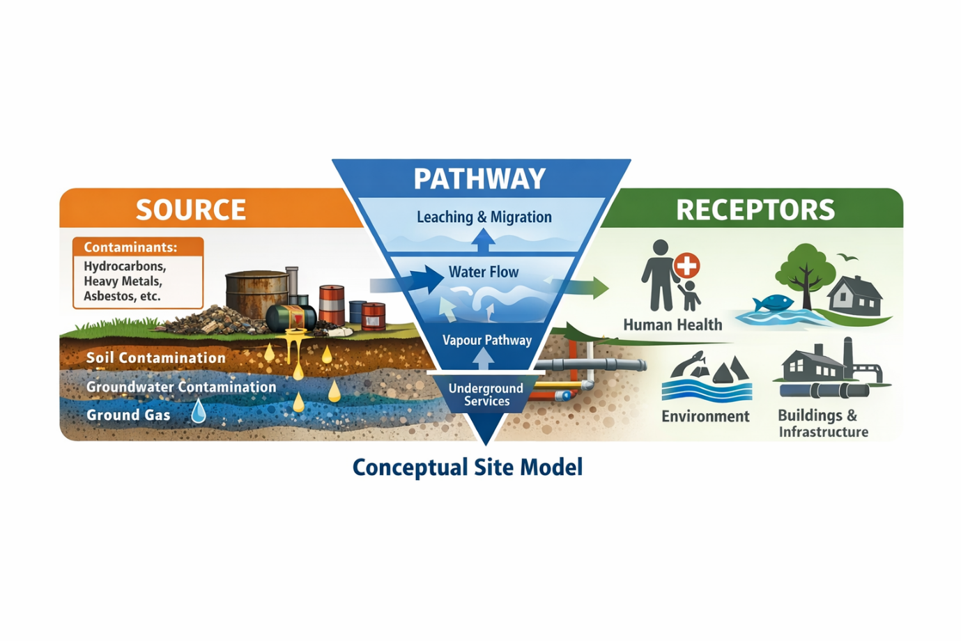
Figure 6 - CGM model (OpenAi, 2026)

4.1 Purpose of the Conceptual Ground Model

A conceptual ground model is a simplified representation of subsurface conditions developed from desk study and investigation data (AGS, 2024). It provides a framework for geotechnical interpretation and supports engineering decision-making. In accordance with BS 5930, the CGM should be updated as new information becomes available and should reflect both geological and anthropogenic influences on ground conditions (BSI, 2026).

4.2 Anticipated Stratigraphy

Based on the desk top study and nearby borehole logs as well as representative dockland conditions, the anticipated stratigraphic sequence beneath the site is as follows:

- Topsoil (approximately 0.2–0.5 m thick): silty clay with organic matter.
- Made Ground (approximately 1–3 m thick): heterogeneous fill comprising ash, slag, rubble, demolition waste, and sandy clay.
- Alluvial and Estuarine Deposits (approximately 2–6 m thick): soft to firm clays and silts with occasional sand lenses.
- Sands and Gravels (approximately 1–4 m thick): medium dense to dense granular soils.
- Carboniferous Sandstone Bedrock: moderately strong to strong rock.

This stratigraphic profile is consistent with typical conditions encountered in dockland redevelopment sites across the UK (British Geological Survey, 2026).

4.3 Engineering Significance of Stratigraphy

From a geotechnical perspective, the near-surface made ground and alluvial clays are considered unsuitable for shallow foundations due to their low shear strength, high compressibility, and variable composition. These materials are likely to exhibit significant settlement under structural loading and may lead to differential movement across the site.

In contrast, the underlying sands, gravels, and sandstone bedrock provide significantly higher strength and stiffness and are therefore suitable target strata for piled foundations. The depth to competent strata and the thickness of compressible layers are key factors influencing pile length and design.

5. Preliminary Ground Investigation Model

5.1 Rationale for Simulated Investigation

Borehole data from nearby logs have been developed to represent realistic dockland ground conditions at the site. The simulated investigation reflects the type of intrusive work typically undertaken during the preliminary phase of a geotechnical investigation.

In practice, a more comprehensive site investigation would include:

- rotary boreholes to bedrock,
- trial pits in areas of shallow ground disturbance,
- in-situ testing such as Standard Penetration Tests (SPT) and Cone Penetration Tests (CPT),
- laboratory testing of soil and groundwater samples,
- groundwater monitoring.

5.2 Representative Borehole Locations

Three representative boreholes (BH1, BH2, and BH3) have been assumed across the site to capture potential spatial variability in ground conditions. The boreholes are positioned to represent areas of differing historical land use and structural loading. These boreholes were derived from near bye samples taken from the BGS website (British Geological Survey, 2026) for this location and can be viewed in the appendix to this report.

6. Borehole Logs and Interpretation

6.1 Overview

Three representative boreholes (BH1, BH2, and BH3) were developed to reflect likely ground conditions across the site. The boreholes were assumed to extend to depths sufficient to encounter competent strata suitable for piled foundations.

The interpretation of borehole data focuses not only on soil description but also on engineering behaviour, variability, and implications for foundation design.

6.2 Borehole Logs

Borehole BH1

Depth: 12.0 m
- 0.0 – 0.4 m: Topsoil
- Silty clay with organic matter
- Low strength and high compressibility

- 0.4 – 2.1 m: Made Ground
- Sandy clay with ash, brick fragments, slag, and rubble
- SPT N = 8–12
- Highly variable composition

- 2.1 – 5.6 m: Alluvial Clay
- Soft grey clay with silt
- SPT N = 4–7
- High moisture content and compressibility

- 5.6 – 9.2 m: Sands and Gravels
- Medium dense to dense sand with gravel
- SPT N = 25–35

- 9.2 m+: Sandstone Bedrock
- Weathered Carboniferous sandstone

Borehole BH2

Depth: 13.0 m

- 0.0 – 0.3 m: Topsoil
- 0.3 – 1.7 m: Made Ground
- Clayey sand with rubble and industrial fill
- SPT N = 6–10

- 1.7 – 6.4 m: Alluvial Clay
- Soft to firm clay with silt
- SPT N = 5–9

- 6.4 – 10.5 m: Sands and Gravels
- Dense granular soils
- SPT N = 22–30

- 10.5 m+: Sandstone Bedrock

Borehole BH3

Depth: 14.0 m

1. – 0.5 m: Topsoil
2. 0.5 – 2.6 m: Made Ground
- Ash, slag, sandy clay, demolition debris
- SPT N = 7–14

- 2.6 – 7.1 m: Alluvial Clay and Silt
- Soft cohesive soils
- SPT N = 3–6

- 7.1 – 11.5 m: Sands and Gravels

- Dense granular layer
- SPT N = 28–40

- 11.5 m+: Sandstone Bedrock

6.3 Engineering Interpretation of Boreholes

The boreholes demonstrate a consistent stratigraphic pattern across the site:

1. Heterogeneous made ground at shallow depth.
2. Thick layers of compressible alluvial clay.
3. Competent granular strata and bedrock at depth.

From an engineering perspective:

- The made ground is unsuitable for shallow foundations due to variability and low strength.
- The alluvial clay presents a high risk of consolidation settlement.
- The sands, gravels, and bedrock provide suitable bearing strata for piles.

The variation in thickness of clay and granular layers across boreholes indicates potential differential settlement risk if shallow foundations were adopted.

7. Geotechnical Parameter Assessment

7.1 Adopted Design Parameters

Indicative geotechnical parameters were derived from typical UK dockland soil behaviour and published guidance (Eurocode 7, 1997).

Made Ground
Parameter | Symbol | Typical Value
Unit weight | γ | 17–20 kN/m³
Undrained shear strength | cu | 20–50 kPa
Young’s modulus | E | 5–20 MPa
Permeability | k | 10⁻⁵–10⁻⁷ m/s

Alluvial Clay
Parameter | Symbol | Typical Value
Unit weight | γ | 16–18 kN/m³
Undrained shear strength | cu | 10–30 kPa
Compression index | Cc | 0.2–0.4
Young’s modulus | E | 3–10 MPa
Permeability | k | 10⁻⁷–10⁻⁹ m/s

Sands and Gravels
Parameter | Symbol | Typical Value
Unit weight | γ | 18–21 kN/m³
Friction angle | φ | 30–36°
Young’s modulus | E | 30–80 MPa
Permeability k | k | 10⁻³–10⁻⁵ m/s

Sandstone Bedrock
Parameter | Typical Value
UCS | > 5 MPa
Young’s modulus | > 1000 MPa

7.2 Engineering Significance

The stark contrast between the stiffness of alluvial clays and granular strata explains why shallow foundations would perform poorly. The low stiffness and strength of clays would result in excessive deformation under structural loading, whereas piles can mobilise resistance in deeper competent materials.

8. Engineering Assessment – Structural Loading

8.1 Structural Loading from a Two-Storey Steel Frame
A two-storey steel-framed building imposes moderate to high column loads compared with single-storey structures. Typical column loads for such a building may range from:

- 800–2,000 kN per column (order-of-magnitude estimate).

These loads must be safely transferred through weak superficial soils to competent strata (ICE, 2022).

8.2 Bearing Capacity of Near-Surface Soils

The ultimate bearing capacity of alluvial clay is low due to:

- low undrained shear strength,
- high moisture content,
- compressibility.

Qualitatively, shallow foundations founded in these soils would be prone to:

- excessive total settlement,
- differential settlement,
- long-term consolidation.

This makes shallow foundations technically inappropriate for the proposed development.

8.3 Settlement Mechanisms

Three principal settlement mechanisms are anticipated:

- Immediate (elastic) settlement in made ground.
- Primary consolidation of alluvial clay.
- Secondary compression (creep) of cohesive soils.

Even modest differential settlement (e.g. 20–40 mm) could adversely affect a steel-framed structure, causing:

- distortion of frames,
- cracking of cladding and partitions,
- serviceability issues.

9. Foundations Option Assessment

9.1 Shallow Foundations
Advantages:

- Lower initial cost.
- Simpler construction.

Disadvantages:

- High settlement risk.
- Unreliable performance in heterogeneous fill.
- Unsuitable for two-storey structural loading.
Conclusion:
Technically unacceptable due to serviceability risk.

9.2 Raft Foundations
Advantages:
- Improved load distribution.
- Reduced differential settlement compared with pads.
Disadvantages:
- Still sensitive to consolidation of alluvial clay.
- Performance uncertain due to variable ground conditions.
Conclusion:
Potentially feasible but not optimal in dockland conditions.

9.3 Piled Foundations

Advantages:
- Transfer loads to competent strata.
- Reduced settlement risk.
- Suitable for heterogeneous ground.

Disadvantages:
- Higher cost.
- More complex construction.

Conclusion:
Most technically appropriate solution.

10. Piled Foundations Rationale

10.1 Pile Type Selection

Continuous Flight Auger (CFA) piles are considered suitable due to:

- Low vibration (important in urban SA1 environment),
- Ability to penetrate variable fill,
- Suitability for cohesive and granular soils.

Typical assumed pile characteristics:

- Diameter: 450–600 mm
- Length: 8–14 m
- Spacing: 2.5–3.5 m

10.2 Load Transfer Mechanisms

Pile capacity is derived from:

- Shaft friction in sands and gravels,
- End bearing on dense granular strata or bedrock.

10.3 Negative Skin Friction

Negative skin friction may occur where:

- Alluvial clay consolidates relative to piles,
- Downward drag forces increase pile load.

This phenomenon is particularly relevant in dockland environments and must be considered in detailed design.

10.4 Pile Group Behaviour

In pile groups:

- interaction effects may reduce efficiency,
- settlement is influenced by group stiffness,
- pile caps distribute loads across multiple piles.
This further supports the selection of piles for structural reliability; a full detailed design will be undertaken separately.

11. Contamination assessment

Consultation with local archaeological planning authorities may be required prior to intrusive works.
Excavations may encounter buried dock walls, timber piles or historical foundation structures.
Given the maritime industrial history of the area there is potential for buried archaeological remains associated with historic dock structures, rail infrastructure and industrial foundations.

11.1 Potential Contaminants

Likely contaminants include:

- heavy metals,
- hydrocarbons,
- PAHs,
- sulphates,
- asbestos.

11.2 Ground Gas Risk

Methane and carbon dioxide may be generated from made ground.
Appropriate gas protection measures may be required depending on risk classification.

12. Construction Considerations

Key issues include:

- Variable made ground and obstructions,
- Groundwater inflow during piling,
- Handling of contaminated soils,
- Noise and vibration control,
- Health and safety risks.

13. Limitations

This report is based on simulated data and desk study information.
Actual ground conditions may differ.
Geotechnical engineering inherently involves uncertainty, and conservative design approaches are recommended.

14. Conclusions and Recommendations

Further intrusive site investigation including boreholes, in‑situ testing and laboratory analysis is recommended prior to detailed design.
Piled foundations are considered the most appropriate solution to transfer structural loads to competent granular strata or bedrock.
The principal risks for the proposed development include variable made ground, compressible alluvial clays, shallow groundwater conditions and potential contamination.

15. Additional information
In conjunction to this Ground investigation report the Environmental impact assessment (ENV 001) which will cover areas such as flood risk, SSSi’s, contamination and detailed Radon gas risk should be viewed separately. The traffic management plan (TMP 001) should also be viewed as this cover’s issues surrounding access and egress as well as community impacts during construction of this building and the associated risks such as heavy plant, deliveries etc.

Site Summary– Key Risks

The SA1 site exhibits complex dockland ground conditions.
Near-surface soils are unsuitable for shallow foundations due to low strength and high compressibility.
Piled foundations are technically justified for the proposed two-storey steel-framed building, providing improved structural reliability and settlement control.

It is recommended that:

- A detailed intrusive site investigation be undertaken,
- Pile design be refined using site-specific data,
- Contamination and groundwater risks be managed through appropriate mitigation measures.

15. REFERENCES

AGS, 2024. Assosciation Of Geotechnical & Geoenvironmntal Specialists. [Online]
Available at: https://www.ags.org.uk/2024/01/bitesize-guide-geotechnical-unit-ground-models-and-geotechnical-design-models-what-are-these-what-do-they-cover-and-who-is-responsible/
[Accessed 01 05 2026].
British Geological Society, 2026. BGS Geology Viewer. [Online]
Available at: https://www.bgs.ac.uk/map-viewers/bgs-geology-viewer/
[Accessed 5 January 2026].
British Geological Survey, 2026. BGS - Borehole records. [Online]
Available at: https://www.bgs.ac.uk/information-hub/borehole-records/
[Accessed 5 May 2026].
BSI, 2026. Code of Practice for ground investigations. [Online]
Available at: https://knowledge.bsigroup.com/products/code-of-practice-for-ground-investigations
[Accessed 28 04 2026].
Digdat, 2026. Digdat Utilities. [Online]
Available at: https://utilities.digdat.co.uk/
[Accessed 11 02 2026].
Environment Agency, 2025. Land contamination risk management, Bristol: Environment Agency.
Eurocode 7, 1997. Geotechnical design. [Online]
Available at: https://eurocodes.jrc.ec.europa.eu/EN-Eurocodes/eurocode-7-geotechnical-design
[Accessed 05 05 2026].
Google, 2025. Gogle earth. [Online]
Available at: https://www.google.com/maps/@51.6504793,-3.4177677,3a,75y,81.33h,51.25t/data=!3m8!1e1!3m6!1sAF1QipNNFnBqEatnyS3_TUrrWb90IT3Ma_yeZ5ELTJug!2e10!3e11!6shttps:%2F%2Flh5.googleusercontent.com%2Fp%2FAF1QipNNFnBqEatnyS3_TUrrWb90IT3Ma_yeZ5ELTJug%3Dw900-h600-k-no-
[Accessed 20 November 2025].
Hammond, E. et al., 2021. A Critical Review Of Decision Support Systems For Brownfiled Development. Science Of Total Environment, 785(1), pp. 132-147.
ICE, 2022. Structural Load Paths. [Online]
Available at: https://knowledgehub.ice.org.uk/cpd/delivery-exc/structural-load-paths/
[Accessed 05 05 2026].
Morris N, 2026. Photo from CwIC Laboratory. Swansea: s.n.
OpenAi, 2026. Chat GPT. [Online]
Available at: https:/www.chatgpt.com
[Accessed 8 January 2026].
Swansea Museum, 2026. Swansea Museum - Industrial Revolution. [Online]
Available at: http://www.swanseamuseum.co.uk/swansea-and-the-industrial-revolution/
[Accessed 05 05 2026].

Appendix

Appendix 1 – Borehole Log – BGSID 370201 (British Geological Survey, 2026)

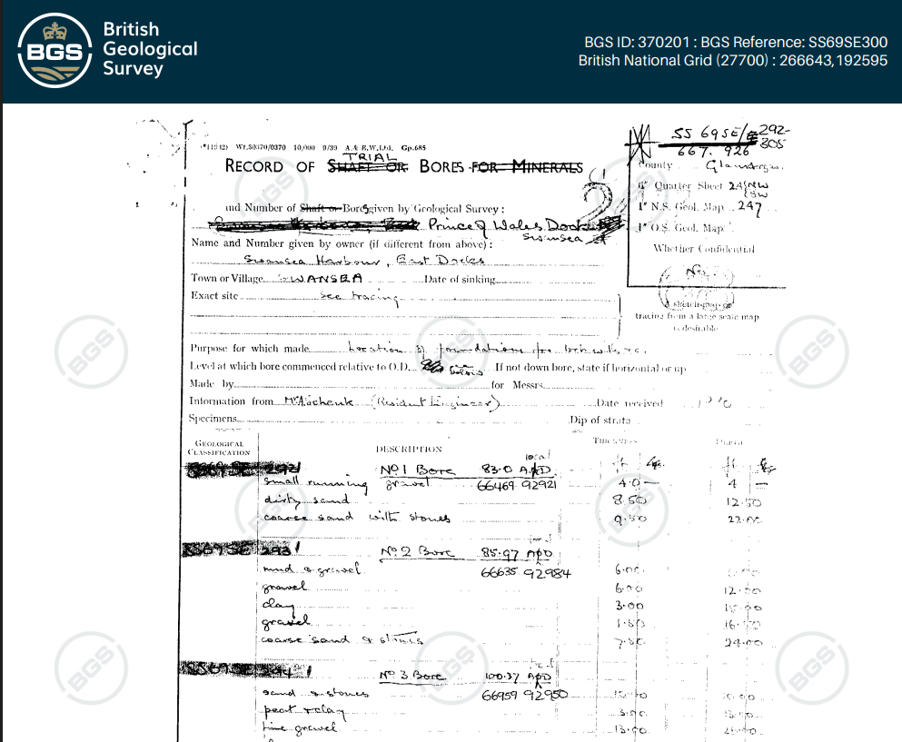
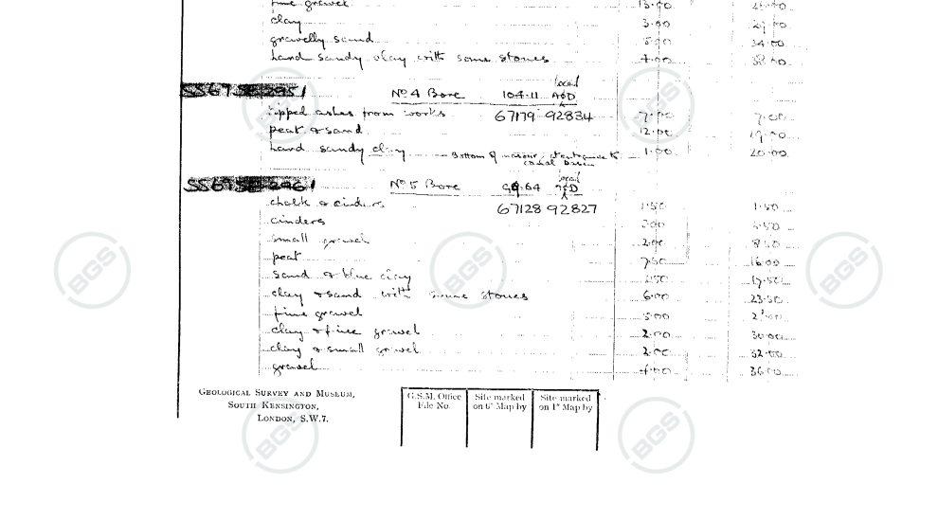
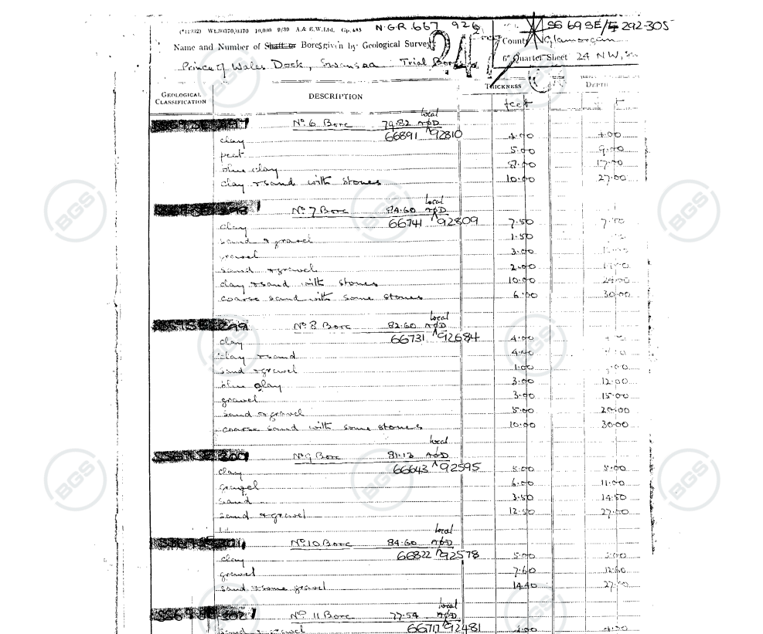
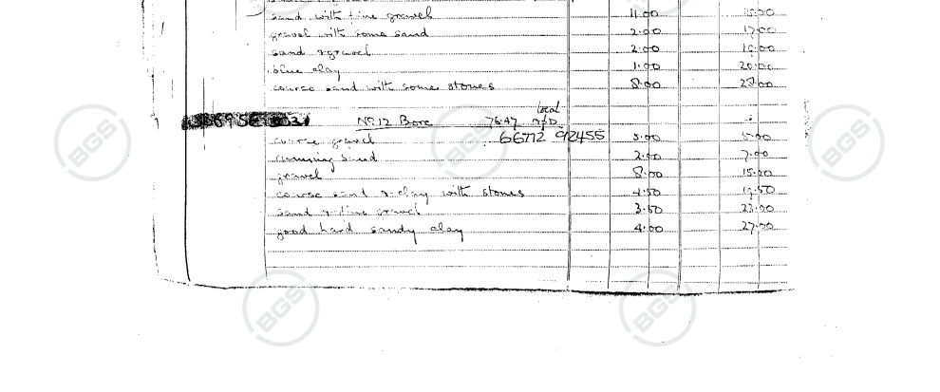
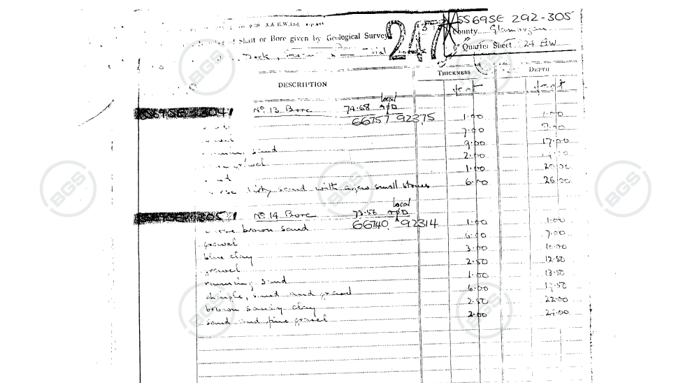

Appendix 2 – Borehole Log – BGSID 370316 (British Geological Survey, 2026)

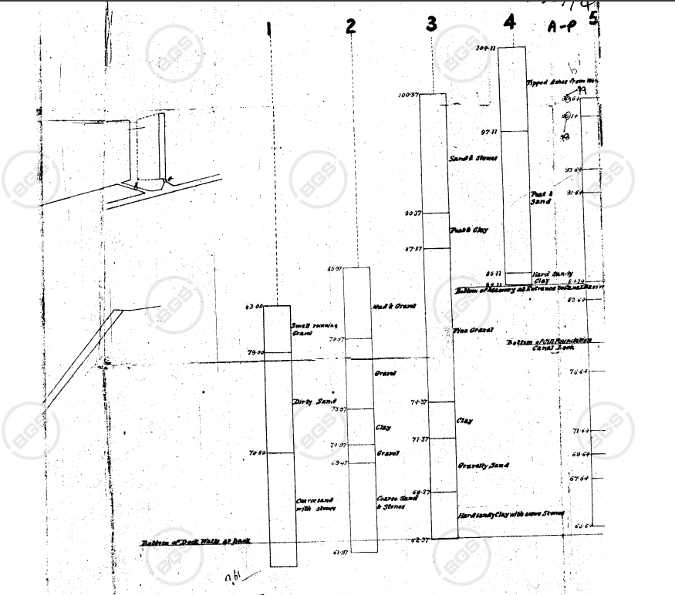
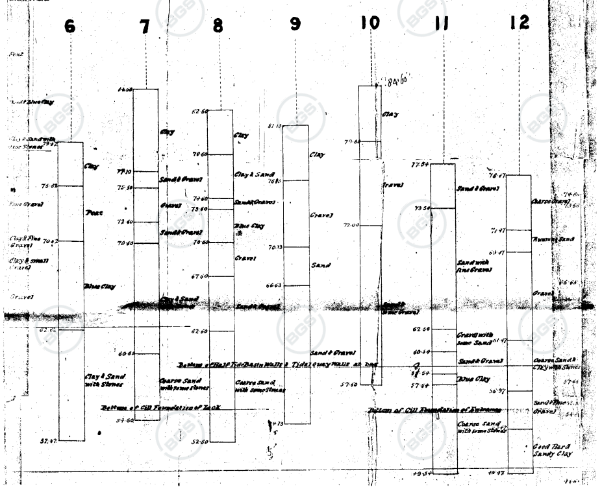
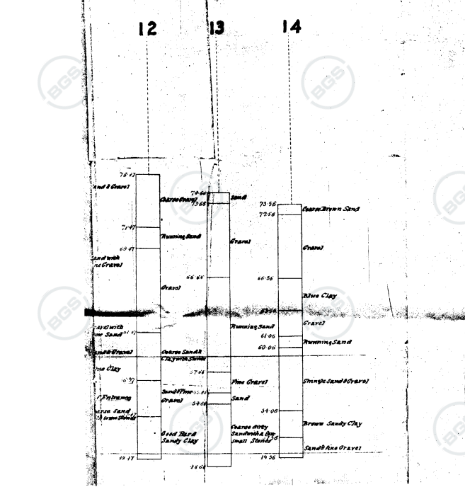

Appendix 3 – Borehole Log – BGSID 370203 (British Geological Survey, 2026)

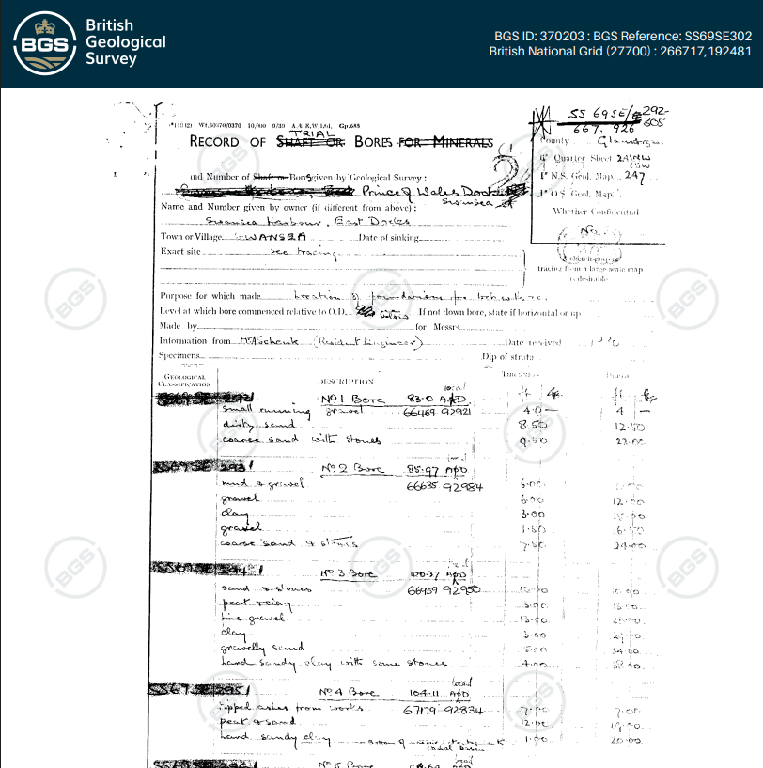
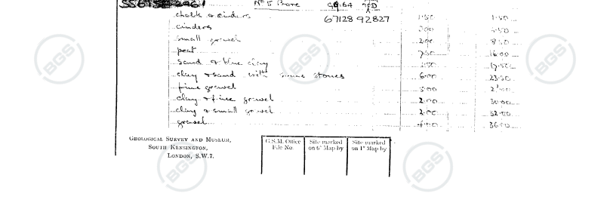
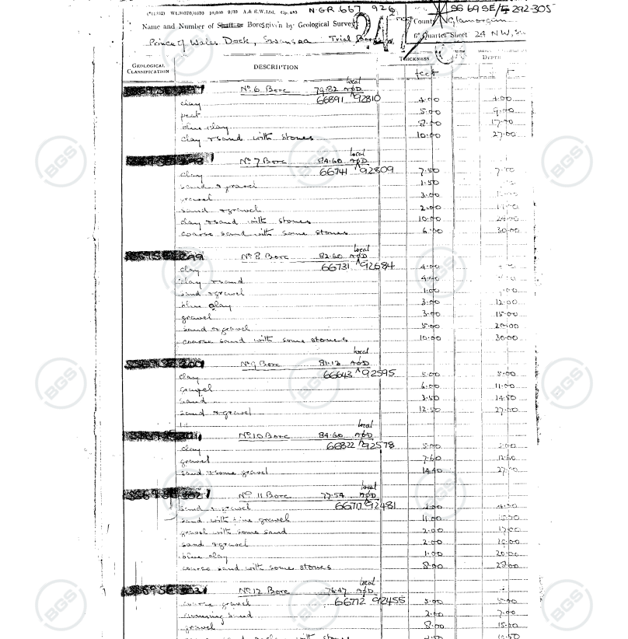

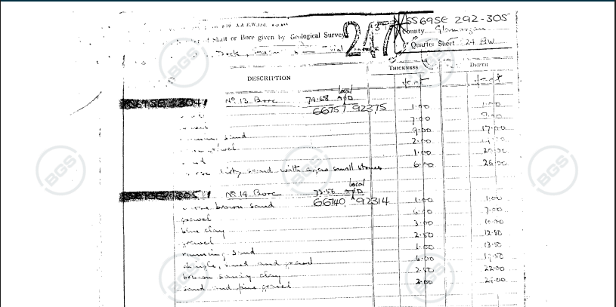

Appendix 4 - Utility plans

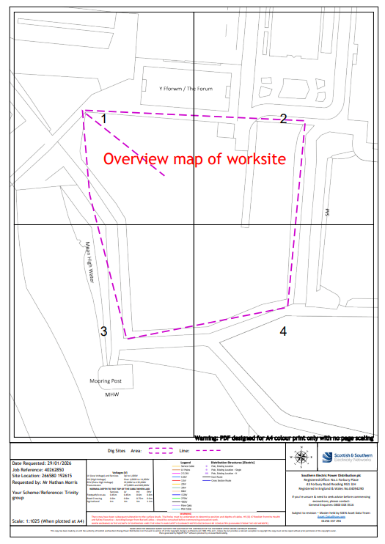
Figure 7- Scottish and Southern Electricity plan (Digdat, 2026)
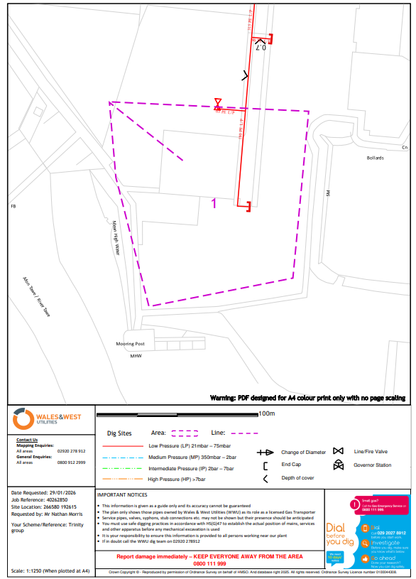
Figure 8 - Wales and West utility plan (Digdat, 2026)

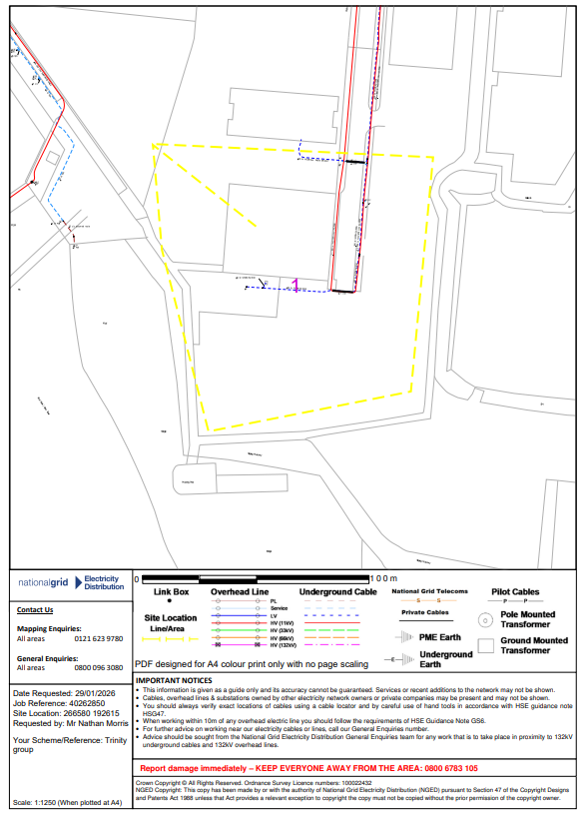
Figure 9 - National Grid Electricity plan (Digdat, 2026)

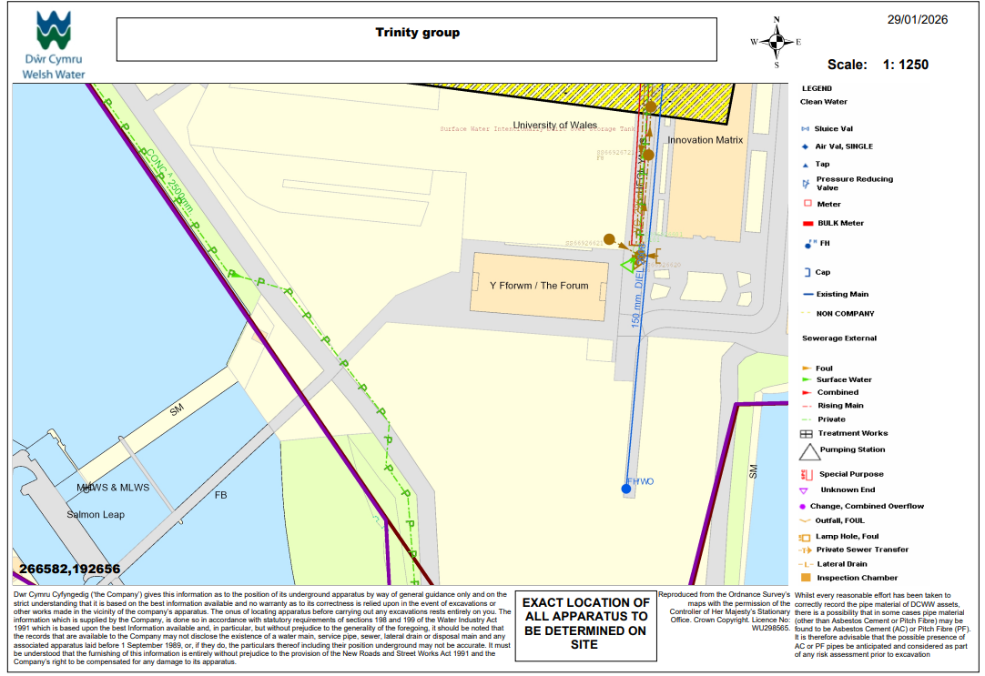
Figure 10 - Welsh water Utility plan (Digdat, 2026)

Historical Land use Mapping
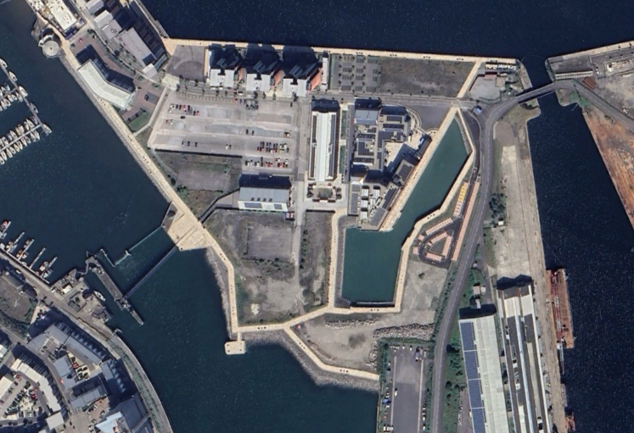
Figure 11 - Google Earth current site plan (Google, 2025)
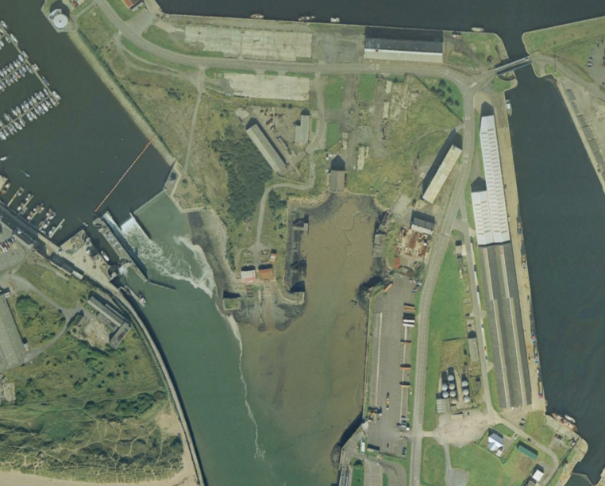
Figure 12 - Historical Ordnance Survey Map (1991) (Google, 2025)

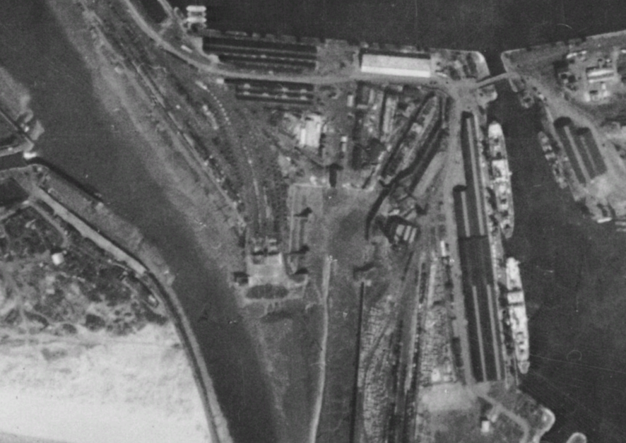
Figure 13 - Historical Ordnance Survey Map (1945) (Google, 2025)

