University of Wales Trinity St David

Effective Team Work and Communication

BMSW4002

Dr Navami

Student’s ID: 1818266

Linda Adeyeye

Student’s Id 1818266

Table of Contents
- Introduction

- Communication

- Theories and models of communication

- Communication at my work place

- Support strategies

- Barriers to communication

- Conclusion

- Referencing

- Appendix

Introduction
In this assignment on Effective team work and communications I will endeavour to analyse different theories and methods of communication that I have learnt in my course work, and those practices at my workplace. The various theories and methods of communication, its relevance and application to health and social care in my work place.
For the purpose of this assignment I will endeavour to demonstrate my understanding of communication skills, methods and models discussed in class and the application in my work place. Communication according to Keith Davis is defined as giving and receiving information as a fundamental part off our daily activity. There are many types of communication models and approaches. I will also analyse communication in my work place, the support strategies and the process of dealing with the barrier in communication with my clients. Davis, (2013)

Communication
Communication can be divided into two categories, which are verbal and non-verbal. The verbal communication method includes words while the Non-verbal involves eye contact, signs, use of symbols or pictures, writing, using objects, torch, physical gestures, body language, emotion and lip reading. As a health and Care practitioner, I try to understand and make myself aware of the individual recipient’s needs, wishes, beliefs, value and culture as these variables provide people with ways of thinking, seeing, hearing and interpreting the world. The same words can mean different things to people from different cultures. Listening is an important aspect of effective communication; I listen carefully, attentively and allow enough time to respond to what people say. I concentrate, show understanding and maintain an open mind, I choose appropriate place to avoid distraction. The tone and body language of the sender is important in getting massage across. There are sometimes when we say one thing, yet our body language reveals something different. This non-verbal language will affect how we react to others and how they react to us. I always ensure that my tone of voice is clear, firm and full of exuberance to build confidence in the mind of the recipients. I maintain eye contact, relax my body and avoid facing the recipient full on and invading the recipient’s space. I also make use of expressions and gestures when speaking; I speak simply and ask questions to establish good understanding and feedback, l avoid jargons, use humour, and tell stories where appropriate. In my role when writing to clients I make use of correct sentences and punctuations. I avoid the use of vocabulary that is not easy to understand, hence could be ambiguous. I my communication with people from different background such as culture, value and beliefs am very careful to avoid misinterpretation; as it could be misconstrued hence creating challenges in future communication. It is important to consider the beliefs, values and culture of service user as these provide them with the way of thinking, seeing, hearing and interpreting the world. The same words can mean different things to people from different cultures though they speak the same language. In some culture some body gesture, eye contact, facial expression and torch are not allowed and considered inappropriate.
On meeting an individual for the first time, it is important to find out how both of you would like to communicate with each other and how to be addressed; either formally or informally. It is very important to ask direct questions in simple words and consider individual responses as this could make or break a working relationship with clients of complex needs. Other important factor to consider are communication aids for individuals who requires assistance; aids for clients with hearing loss, impaired vision, mobility problems, speech impairment which can affect effective communication with them. The environment is another important factor to take into consideration for effective interpersonal communication. Lack of privacy can cause interference, distraction and lack of interest in communicating. Issues such as lights, noise and crowded areas must be considered particularly for complex needs service user. For example, clients with hearing impairment may not grasp the spoken conversation if there is significant background interference and noise.
Theories and Models of Communication
I will be referring to some communication models that we have discussed in class. The Shannon Weaver Model 1949, Berol’s Model of Communication, and the Schramm’s Model of Communication 1954. The communication cycle can be divided into six steps, the communication begins with the sender, the originator of the message putting thoughts into feelings, the contents could be verbal, or nonverbal referred to as encoding. The message the receiver processes referred to as decoding; make meaning of the message. The last processes are feedback, which is done by the receiver of the message. Shannon Weaver’s model likens communication to three parts, sender, channel and the receiver. Shannon Weaver considered interference in decoding which could be likened to interruption for example echoing in a telephone conversation or the channel could be the noise source in decoding the message. Berol’s model is like the Shannon Weaver, but it puts into consideration other variables such as communication skills, attitude, knowledge, culture and social systems to mention a few. KEYS communication strategies can also be considered effective nonverbal communication skills, Keys stand for know yourself, evaluate yourself look out for the nonverbal cues you display for example eye contact, winking smiles or signs you unconsciously display during communication with others. Evaluate yourself be conscious of nonverbal communications you display in the work place, make sure they are appropriate and acceptable in the work place. Your interaction with others, how your colleagues take your nonverbal communication and how you perceive your colleagues’ nonverbal communications to you. Finally step back and reflect, this allows you after the communication to reflect on your nonverbal communication to assess if you made the impression that was intended and appropriate in the communicating with the person. Communication methods can be divided into two categories verbal and nonverbal. Verbal communication methods include words while nonverbal includes eye contacts, signs, use of symbols, pictures, writing, signing, objects, touch, physical gestures, body language, emotion and lip reading. As a good health and social care practitioner, I try to understand I shall also be demonstrating how I use my communication skills within my work setting.
Communication at my work place.
I will attempt to do my analysis based on the support l give in my place of work, which is support of clients with Complex Needs. Rogers, (1951) emphasises empathy, which is the individual needs and it is a person-centred approach. The approach requires health and social care professionals to listen to client, respect them and try to understand their emotions. For example, a client that suffers from Anorexia may feel that food can make him fat, obese and look horrible. Although we know this is untrue, we must respect his thought in order to be able to empathise with him. In my role as a health and social care practitioner l support clients by showing empathy and actively listen to what the client is saying. Reflecting on what is been said and adopting a person-centred approach; clients are given opportunity to examine their thoughts and freely express themselves without having to worry about what people think of them.
In my role as a Health and social care practitioner working with client with Complex needs. Empathy and understanding are very important, progress and achievements are recorded in little steps; hence, a lot of support and understanding is required. Complex needs are not easily defined, it depends on the individual and their situation, and are often referred to as 'multiple unmet needs'. Drugs, alcohol or co-existing drug and alcohol and mental health and cognitive impairment or involvement in the criminal justice system is defined as complex. High-need individuals have clinically complex needs, functional limitations, and/or behavioural health conditions. This is a diverse population, ranging from frail older adults to younger people with behavioural health and social needs. As a health and care practitioner, when writing to clients I make use of correct sentences and punctuations. I avoid the use of vocabulary that is not easy to understand. I avoid words that could be ambiguous. Types of communication we adapt in my work place with clients are Key work sessions which happened every two to four weeks depending on client’s needs. It is a session whereby you give the client an opportunity to offload to you their challenges and you both work out a strategy to solve the problems. We communicate by emails, letters, house meetings where clients take lead roles.

Support Strategies.
There are various ways and strategies to support users of health and social care with complex health needs to communicate effectively. The strategies are through good interpersonal communication, reassurance, empathy and confidence building. Assertive technology such as the use of hearing aids, text phones, loop system for users who have hearing impairment. Sign language is also available for clients with hearing impairment. The blind service user can also use Braille. All these can be received through a referral by the GP, individual’s family, friends, social worker, specialist nurse, advocate and support groups. Translation of various languages in variety of formats e.g. through interpreting service, sign language for deaf clients, and cultural language barrier are readily available. Service users can have leaflets converted to other languages that is formal or informal.
The advocacy service is also available to support service users who are unable to speak up for themselves. This service will identify needs, wishes and preferences of individuals and will argue on their behalf. A health and social service worker may as part their role to advocate for a service user. A support worker may also be asked to be a lead advocate for the organisation and act as representative for the service users. Lawyers, members of the public, family member, peers and the concerned individuals can also act as advocates, assist in changing individual’s situation, and protect their rights.
Social Care Organisations have charters, professional code of conduct and good practice that must be followed by health care workers in order to communicate effectively and work efficiently with service users. Staff are aware and trained on the relevant law of confidentiality, Data Protection Act and Code of Practice. Computer system has revolutionized the Health and Care Setting. In my work place which is Hestia Housing and Support, information about service users are stored on PSOCC within client records. Any supporting information (either written or electronically generated, such as email) are scanned and saved to an individually named sub-folder within the team folder and then added to PSOCC as a file. Passwords are used to access the system and password must not be shared between members of staff under any circumstances.
Barriers in Communications.
The following could be barriers to effective communication in my work place. As we have a diver’s client group, people with different languages, culture and backgrounds. Culture is the pattern of taken-for-granted assumptions about how a given collection of people should think, act, and feel as they go about their daily affairs” -Joynt & Warner, (1996). Cultural differences, hearing challenges, bad eyesight, speech impediments, language differences, confidence issues and mental health issues. Sometimes there are issues with poor or malfunction equipment for example poor earring aids. Lack of eye contact, poor body language. To avoid communication barrier, we need to communicate effectively and be willing to ask questions in making ourselves understood. Communicate only what is necessary; be aware of your environment, avoid noise, distractions, communication overload, jargon and slangs. Be aware of cultural differences and be willing to explain yourself severally if need be.

Solutions or strategies for effective communication.
As we know solutions and strategies to effective communications, it helps the organisation to build strong relationships with the clients and stakeholders. Employ an open-door policy never be one-way communication. The organisation will also be able to measure its goal against its success rate. If employees are directly communicating with management and staff with clients all involved will feel connected and a part of the bigger picture hence there will be self-worth and satisfaction. The following should be considered listening skills, active listening considering other languages and cultures

Conclusion.
In this essay I have endeavoured to analyse and demonstrate my understanding of communication skills and theories discussed in class and in my work place. I discussed theories and methods of communication. I described communication in my work place and the strategic support we give our clients.

Referencing.
www.//Hestia.Org.uk; Confidentiality and Data Protection policy 2014. Accessed August 5, 2019
https://www.projectguru.in/publications/the-communication-process/ K.Davis 2013
https://www.businesstopia.net/communication/shannon-and-weaver-model-communication
First published: July 1951 https://doi.org/10.1002/1097-4679(195107)7:3<294::AID-JCLP2270070325>3.0.CO;2-O Carl Rogers
https://www.england.nhs.uk/ourwork/patients/accessibleinfo/
https://www.voiceability.org/about-advocacy/care-and-support-advocacy
https://www.businesstopia.net/communication/cultural-barriers-communication Joynt & Warner 1996
https://businnesstopia.net/communications/shannon-and-weaver model of communication January 6, 2018

Appendix

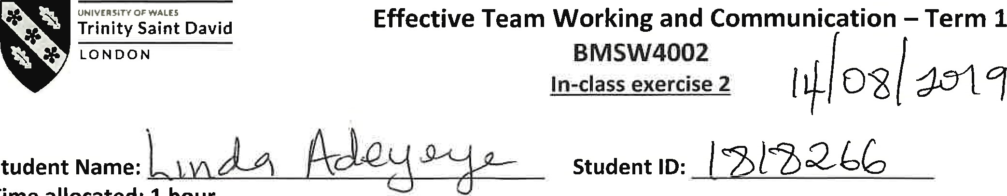
Student
Time
allocated:
1
hour.
Please return your paper to the lecturer upon completion. It will be returned to you at the next session. You will need to include a scanned copy of this exercise in the form of an appendix together with your Task 1 (part of the Assignment for this module).
Ex.l. Read the following passage and answer the questions on the next page.

Case Study: A Day With The Chief
Mark is a top-performing salesperson at a pharmaceutical supply company. As a reward for his performance, he is treated to a trip to the corporate office in California to meet the chief executive officer, Ms. Mills. Ms. Mills is known around the office as the "Wicked Witch of the West" because of her short and sometimes abrasive demeanour.
Mark's co-workers share "horror stories" of their encounters with her, stating that she rarely makes eye contact, never smiles, and dislikes being approached unless she initiates the conversation.
Although he is excited to travel, he is also nervous about what he and Ms. Mills might talk about. He prepares by thinking about how he can share his sales strategies and techniques. On the day of the meeting, he waits patiently for Ms. Mills' assistant to call him into her office. When he is escorted in to meet her, he is shocked to see a petite woman behind the large desk smiling back at him with kind eyes. He approaches, shakes her hand, and waits for her permission to sit.
Ms. Mills is nothing like the horrible person they made her out to be. Ms. Mills asks Mark several thoughtful questions about why he is successful, ways the staff can be supported, and how the company fits in with his professional goals. Mark feels more and more comfortable as she leans forward to listen intently to what he is saying. Mark loosens his tie, crosses his legs, and begins sharing stories of how he feels his immediate supervisor has dropped the ball on more than one occasion and that the team would be better if more money were allocated to incentives and bonuses. Mark immediately sees Ms. Mills' eyes begin to squint and her brow furrow. She stands up abruptly and says in a gruff voice that their time is up and that her assistant will show him out.
Lecturer's signature:  Date: 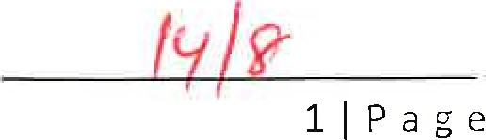 2
- Given the professional context, what would you have done the same and/or differently if you were in Mark's position?
- Do you think Mark accurately evaluated the context? Why or why not?
- What communication factors led to the change in the chief executive officer's disposition?
- How could Mark improve his communication skills?
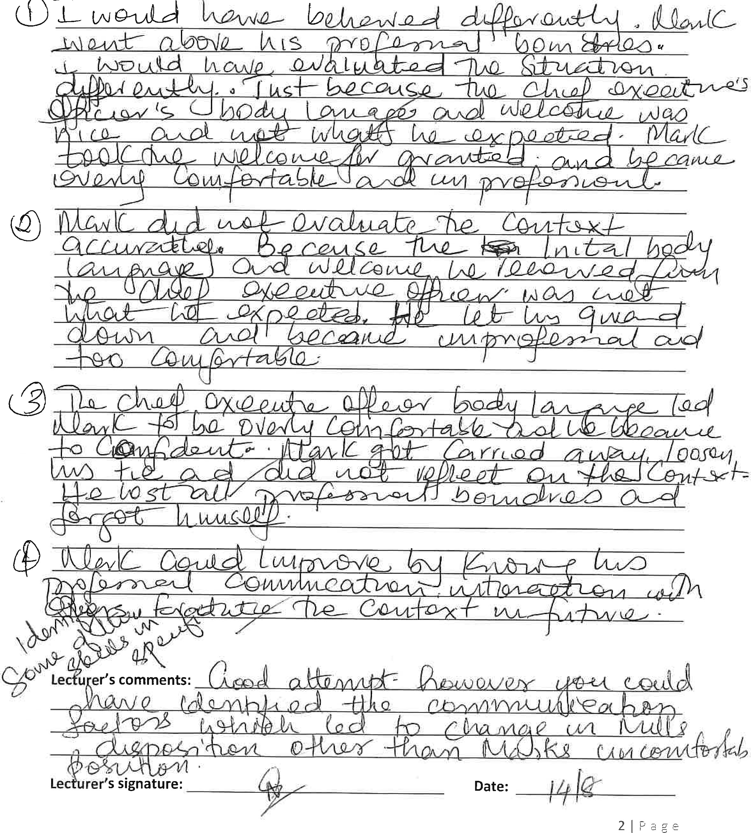
QD
 1
Time allocated: 1 hour. Please return your paper to the lecturer upon completion. It will be returned to you at the next session. You will need to include a scanned copy of this exercise in the form of an appendix together with you Task 1 (part of the Assignment for this module).
Student Name: 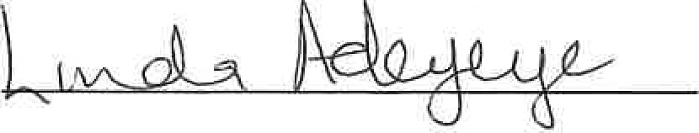 Student ID: (
Ex.l. Read the following passage and answer the questions.

The Drofessor and the village people
A Professor of English at a well-known Welsh University lived in a large house not far from a little village. He never went into the village, bur shopped in the town near the University because he had nothing in common with the village people, who were largely uneducated and did manual jobs. One night, the professor felt asleep while smoking his pipe and the pipe fell onto the carpet and started a fire.
When the professor awoke and saw the house on fire, he rushed into the village, screaming:
'The edifice is being consumed by a great conflagration!'
'The edifice is being consumed by a great conflagration!'
The village people looked at him and continued doing what they were doing.
'Don't you understand?' He said. "The edifice is being consumed by a great conflagration!' They ignored him.
When the Professor returned home, he saw that his house had been completely destroyed. He sat down on the ground and wept. The next day, he went into the village crying. 'Why, oh why didn't you help me? My home has been destroyed by the fire. I came and begged you last night.' He wept.
'But Professor, why didn't you say that your house was on fire? We would have helped.'
QI: Why didn't the village people help the Professor?
Q2: What should he have done to get them to help him?
Q3: Whose model of communication do you think can explain this situation?
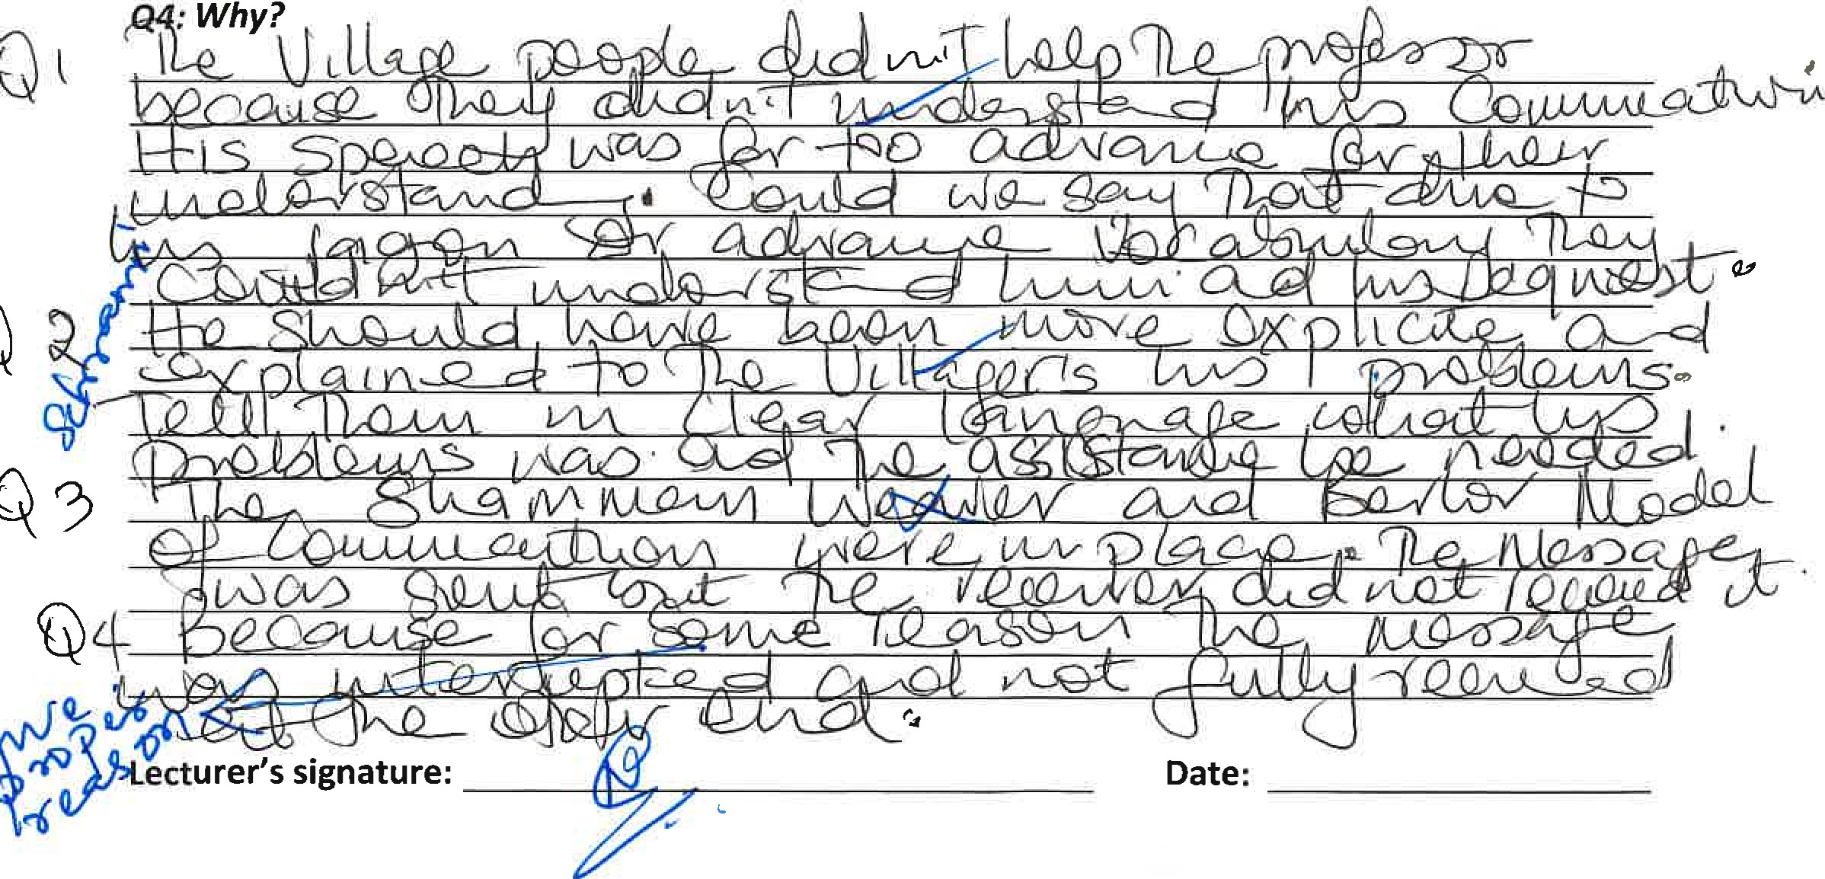
 1
Ex.2. Read the following brief and write a business email according to the instructions.
You are Director of Communications at your company and you would like an employee, Jack Daniels, to join your Communications Training team.
- Tell JD why you are writing
- Say what you have observed and like about his communication skills
- Tell him why you think he would be an asset to the team


