Name: Hussein Atalla Mohamed

Student number:2423786

Lecturer: Rexon nting

Assignment 1 project management

Project Management Plan: Central Transport Hub Redevelopment

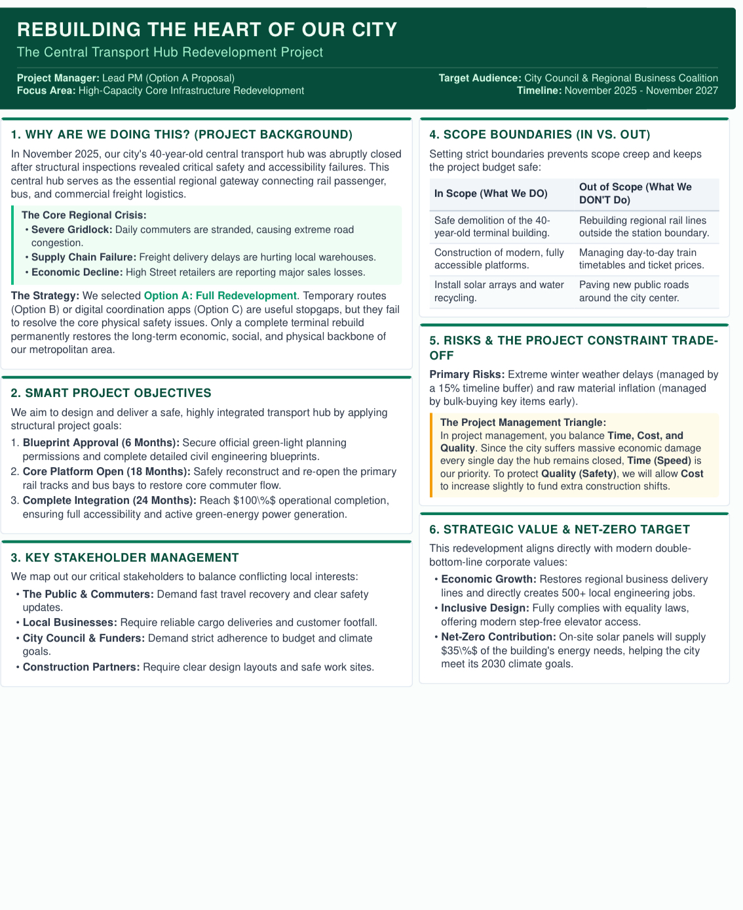
Part A

Part B: Critical Reflection on Tutor and Peer Feedback
The feedback received from the tutor and peers has been useful in improving the overall quality and direction of the proposed project. The initial proposal had a clear focus on the redevelopment of the central transport hub, but the feedback highlighted the need to make the project more realistic, better structured and more closely connected to project management theory. The feedback has therefore influenced several changes to the final project management plan, particularly in relation to scope, stakeholders, risk, resources and project controls.
One of the main strengths of the initial proposal was the choice of project. The redevelopment of the central transport hub provides a direct response to the closure of an important piece of transport infrastructure. The project is also significant because the closure affects several groups at the same time. Commuters experience longer journeys, freight operators face logistical difficulties, businesses lose passing trade and the local authority faces pressure to restore transport capacity. The proposed redevelopment therefore has a clear practical purpose rather than being a project based only on improving an existing facility.
The feedback also recognised the strength of incorporating sustainability and digital technology into the redevelopment. Rather than treating the project simply as a construction programme, the proposal considers how the new hub could support longer-term environmental and operational objectives. This has been retained in the final plan. Renewable energy, energy-efficient systems, sustainable materials and improved public transport integration are included alongside digital passenger-information and logistics systems. This approach reflects Silvius and Schipper’s (2014) argument that sustainability should be considered throughout project management rather than added at the end of a project.
However, one important area for improvement was the definition of the project scope. The original proposal included several ambitious outcomes, but the boundaries between project deliverables and wider benefits were not sufficiently clear. The final plan addresses this by identifying exactly what the project will deliver. These deliverables include the new transport hub, accessible passenger facilities, digital infrastructure, sustainable building systems, public-realm improvements and operational readiness. Wider outcomes, such as increased local employment and economic regeneration, are recognised as benefits rather than direct project deliverables. This distinction should make the project easier to control and reduce the possibility of scope creep.
Stakeholder management was another area identified for improvement. The initial proposal acknowledged that many stakeholders would be affected, but it did not explain sufficiently how their different interests would be managed. The final plan therefore applies a power-interest approach to stakeholder analysis. The city authority, transport operators, funding bodies and regulatory organisations require close management because they have significant influence over the project. Residents, passengers, businesses and accessibility groups also require meaningful engagement because they are directly affected by the project. This reflects Freeman’s (1984) stakeholder theory and the importance of considering the interests of groups affected by organisational decisions.
The feedback also showed that the risk section needed to be more practical. The final plan therefore identifies specific risks, assesses their probability and impact, and assigns responsibility for managing them. Major risks include construction delays, cost inflation, safety incidents, planning delays, supply-chain disruption, technical problems and stakeholder opposition. The revised approach is more useful because it moves beyond simply listing risks and explains what will be done to reduce their potential effects.
Another improvement concerns the relationship between the different project-management tools. The revised plan links the WBS to the schedule, resources and risk-management approach. This provides a clearer picture of how the project will actually be delivered. The Gantt chart identifies the major phases and dependencies, while the WBS breaks the project into manageable packages. Resources are then allocated according to these work packages.
Overall, the feedback has helped move the proposal from a general redevelopment idea towards a more realistic project management plan. The final version has clearer boundaries, stronger stakeholder arrangements, more structured risk management and better integration between scope, schedule and resources. These changes should make the proposed project more achievable and provide stakeholders with greater confidence that the redevelopment can be controlled throughout its lifecycle.

Part C: Project Management Plan

1. Introduction
The closure of a major central transport hub creates an immediate problem for a metropolitan UK city. The hub acts as an important interchange for rail, bus and freight services, meaning that its closure affects much more than passenger journeys. Local businesses may experience reduced customer numbers, freight operators may face additional costs and commuters may have to use longer or less convenient routes. The situation also creates pressure on the local authority to provide a solution that is safe, affordable and capable of meeting future transport needs.
The proposed response is the Central Transport Hub Redevelopment Project. The project will replace or substantially redevelop the existing facility and provide modern transport infrastructure that is safer, more accessible and better equipped for future demand. Digital technology and sustainable design will be incorporated into the redevelopment rather than being treated as separate projects.
The project is expected to take approximately 36 months from mobilisation to final handover. A structured project management approach will be used to manage scope, time, cost, quality, resources, stakeholders and risk. Project management literature emphasises that successful projects require the integration of these areas rather than managing each one independently (Turner, 2009; Kerzner, 2022).
The purpose of this Project Management Plan (PMP) is to provide stakeholders with a practical framework for delivering the redevelopment. It explains what the project will deliver, how the work will be organised, when key activities will take place, who will be involved, what resources are required and how major risks will be managed.

2. Project Description
The project involves the redevelopment of the city’s central transport hub following its closure because of structural and safety concerns. The existing facility is more than 40 years old and does not adequately meet modern expectations for safety, accessibility, digital connectivity and environmental performance.
The redevelopment will create a modern multimodal interchange capable of supporting rail, bus and freight operations. Passenger facilities will be redesigned to make movement through the hub easier and safer. Step-free routes, lifts, accessible toilets, improved signage and suitable waiting areas will be provided.
Digital infrastructure will also form an important part of the project. Real-time passenger information, digital wayfinding, passenger-flow monitoring and freight coordination systems will help the new hub operate more efficiently. These systems can also provide useful information to transport operators, allowing them to respond more quickly to congestion or disruption.
Sustainability is another central element of the project. The new facility will incorporate energy-efficient lighting and building systems, renewable energy generation where feasible, sustainable materials, waste reduction and improved connections between different forms of public transport. The intention is to reduce the environmental impact of the facility while encouraging greater use of public transport.
The project has four main objectives:
- Restore safe transport capacity following the closure of the existing hub.
- Improve accessibility and inclusion for passengers with different mobility and access needs.
- Introduce digital systems that improve passenger movement and freight coordination.
- Improve environmental performance and contribute towards wider net-zero transport objectives.
A hybrid project management approach is proposed. Traditional predictive planning will be used for construction, procurement and regulatory activities because these require clearly defined deliverables, specifications and dependencies. Agile principles will be used for the digital components because passenger-information and logistics systems can benefit from testing and user feedback before full implementation. A hybrid approach therefore provides control where certainty is required while allowing flexibility where requirements may develop.

3. Scope

3.1 In-scope activities
The project will include:
- structural and site investigations;
- architectural and engineering design;
- planning and regulatory approvals;
- demolition or remediation of unsafe structures;
- construction of the new transport hub;
- passenger and interchange facilities;
- rail and bus integration;
- freight and logistics facilities;
- pedestrian routes and public-realm improvements;
- lifts, ramps and accessible facilities;
- mechanical, electrical and fire-safety systems;
- renewable-energy installations where feasible;
- energy-efficient building systems;
- digital passenger-information systems;
- passenger-flow monitoring;
- freight coordination technology;
- testing and commissioning;
- staff training;
- operational-readiness activities; and
- final handover.

3.2 Out-of-scope activities
The project will not include unrelated city-centre developments, major road schemes outside the hub area or private commercial developments that are not necessary for transport-hub operation. These activities may support wider regeneration but will be treated as separate programmes.
This distinction is important because uncontrolled additions to project scope can increase both cost and duration. Any proposed change to the approved scope will therefore be assessed through formal change control.

3.3 Constraints
The project faces several important constraints. The first is the need to maintain essential transport connections while construction takes place. Temporary arrangements may therefore be required.
The second constraint is the limited space available within a busy urban environment. Construction activity will need to be carefully coordinated to reduce disruption to pedestrians, businesses and nearby residents.
Cost is another constraint. Construction inflation and changes in material prices could put pressure on the approved budget. Early procurement and appropriate contingency allowances will therefore be required.
Finally, the project must meet relevant planning, building, transport, environmental and health-and-safety requirements.

4. Work Breakdown Structure
A Work Breakdown Structure (WBS) divides the project into smaller and more manageable areas of work. This makes it easier to assign responsibilities, estimate resources and monitor progress. Haugan (2002) identifies the WBS as an important tool for organising project work and establishing a clear relationship between deliverables and activities.
Figure 1. Work Breakdown Structure
Central Transport Hub Redevelopment
│
├── 1. Project Management
│ ├── Governance
│ ├── Project controls
│ ├── Cost management
│ ├── Risk management
│ └── Stakeholder management
│
├── 2. Surveys and Design
│ ├── Structural surveys
│ ├── Site investigations
│ ├── Architectural design
│ ├── Engineering design
│ └── Sustainability design
│
├── 3. Approvals and Procurement
│ ├── Planning approval
│ ├── Regulatory approval
│ ├── Tendering
│ ├── Contractor selection
│ └── Contract award
│
├── 4. Enabling Works
│ ├── Site preparation
│ ├── Temporary transport
│ ├── Utility diversions
│ └── Demolition/remediation
│
├── 5. Main Construction
│ ├── Foundations
│ ├── Structural works
│ ├── Platforms/interchange
│ ├── Passenger facilities
│ └── Public realm
│
├── 6. Digital Infrastructure
│ ├── Passenger information
│ ├── Digital wayfinding
│ ├── Passenger-flow monitoring
│ └── Freight coordination
│
├── 7. Sustainable Infrastructure
│ ├── Renewable energy
│ ├── Energy-efficient systems
│ ├── Sustainable materials
│ └── Sustainable drainage
│
└── 8. Testing and Handover
├── Systems testing
├── Safety certification
├── Staff training
├── Operational readiness
└── Final handover
The WBS provides the foundation for the project schedule and resource plan. Each work package will have a responsible manager, defined outputs and agreed completion criteria.

5. Quad Chart
The Quad Chart provides senior stakeholders with a concise overview of the project. Table 1 summarises the project’s objectives, deliverables, resources and major risks.
Table 1. Project Quad Chart
Objectives and outcomes | Main deliverables
Restore safe transport capacity | Modern multimodal transport hub
Improve accessibility | Step-free routes, lifts and accessible facilities
Support economic recovery | Improved passenger and freight connectivity
Reduce environmental impact | Renewable and energy-efficient systems
Improve operational efficiency | Digital passenger and logistics systems

Schedule and resources | Key risks and controls
36-month programme | Construction delay – schedule contingency
Public/project funding | Cost inflation – contingency and monitoring
Professional project team | Safety incident – safety management
Main contractor and specialists | Stakeholder opposition – engagement
Digital and sustainability specialists | Technology failure – staged testing
The Quad Chart is particularly useful at project-board level because senior stakeholders can quickly understand what the project is trying to achieve, what will be delivered and where the main challenges lie.

6. Gantt Chart
The project is planned over 36 months. The schedule is based on logical dependencies between design, approvals, procurement, construction, digital installation and commissioning.
Table 2. High-Level Gantt Chart
Activity | M1–6 | M7–12 | M13–18 | M19–24 | M25–30 | M31–36
Project mobilisation | ███
Surveys and investigations | ███
Detailed design | ███ | ███
Planning and approvals | ███ | ███
Procurement |  | ███
Enabling works |  | ███ | ███
Main construction |  |  | ███ | ███ | ███
Digital systems |  |  |  | ███ | ███
Sustainability works |  |  | ███ | ███ | ███
Testing and commissioning |  |  |  |  | ███ | ███
Training |  |  |  |  |  | ███
Handover |  |  |  |  |  | ███
The critical path is expected to run through design, approvals, procurement, enabling works, main construction, systems installation, testing and commissioning. Delays to these activities could directly affect the final completion date.
Progress will be reviewed monthly against the approved baseline. The project controls team will compare planned progress with actual progress and identify corrective action where performance begins to fall behind. Earned-value principles can be used to compare planned value, earned value and actual cost, providing early warning of cost and schedule problems (PMI, 2021).

7. Stakeholder Involvement
The project has a wide range of stakeholders. Their interests are different, meaning that a single communication approach would not be appropriate. Stakeholder management is therefore treated as an ongoing project activity rather than a one-off consultation exercise.
Freeman (1984) argues that organisations need to consider the interests of groups that can affect or are affected by their activities. This is particularly relevant to infrastructure projects because decisions can have long-term consequences for communities.
Table 3. Stakeholder Analysis
Stakeholder | Influence | Interest | Engagement approach
City authority/project sponsor | High | High | Project board and monthly reporting
Transport operators | High | High | Joint planning and workshops
Funding bodies | High | High | Formal financial and progress reports
Planning authorities | High | High | Early consultation and compliance reviews
Main contractor | High | High | Weekly coordination meetings
Local residents | Medium | High | Public meetings and regular updates
Local businesses | Medium | High | Business forums and disruption updates
Freight operators | Medium | High | Logistics planning meetings
Accessibility groups | Medium | High | Design reviews and user testing
Passengers | Low individually | High collectively | Surveys and digital engagement
Emergency services | High | Medium | Safety and emergency-planning meetings
Stakeholders with high power and high interest will be managed closely. The project board will meet monthly to review progress, risks, costs and major decisions. Transport operators will be involved in operational planning because the new facility must work effectively with existing transport networks.
Accessibility groups will be involved during design and testing. Their involvement is particularly important because accessibility should be built into the design from the beginning rather than treated as a compliance issue at the end.
Local residents and businesses will receive regular information about construction activities, temporary access arrangements and expected disruption. A complaints and feedback process will also be established. Issues will be recorded, assigned to responsible individuals and tracked until they are resolved.
This approach should improve transparency and help build public confidence in the redevelopment.

8. Allocation of Resources
The project requires a combination of financial, human, technical and physical resources. Effective resource planning is important because having the correct resources available at the wrong time can still create delays.
Table 4. Resource Allocation
Resource | Responsibility | Main period
Project manager | Overall delivery | M1–36
Project controls team | Cost, schedule and reporting | M1–36
Architects and engineers | Design and technical assurance | M1–18
Planning specialists | Approvals | M1–12
Procurement team | Tendering and contracts | M7–12
Main contractor | Construction | M13–30
Digital specialists | Digital infrastructure | M19–30
Sustainability specialists | Environmental measures | M13–30
Health and safety team | Construction safety | M13–30
Commissioning team | Testing and handover | M25–36
The project manager will have overall responsibility for coordinating these resources. Work-package managers will be responsible for managing resources within their areas and reporting performance to the project manager.
Financial resources will be managed against an approved cost baseline. A contingency allowance will be maintained for identified risks. However, contingency will not be used to finance uncontrolled changes in scope.
Procurement decisions will consider whole-life value rather than simply selecting the lowest initial price. For example, an energy-efficient system may have a higher initial cost but provide lower operating costs over the life of the facility. This approach is consistent with the broader principles of sustainable project management.
The human-resource structure will also change during the project lifecycle. More design specialists will be required during the early stages, while construction labour and technical specialists will increase during the main works. Digital and commissioning specialists will become particularly important towards project completion.

9. Risk Analysis
Risk is unavoidable in a project of this scale. The objective is therefore not to eliminate every risk but to understand uncertainty and take reasonable action to reduce its likelihood or impact. Chapman and Ward (2003) emphasise the importance of managing uncertainty systematically rather than relying on reactive responses.
A probability-impact assessment will be used to prioritise risks. High risks will be reviewed at project-board meetings, while work-package managers will monitor risks within their areas.
Table 5. Project Risk Register
Risk | Probability | Impact | Rating | Mitigation | Owner
Construction delay | High | High | High | Detailed programme and contingency | Project Manager
Construction cost inflation | High | High | High | Early procurement and cost monitoring | Commercial Manager
Major safety incident | Medium | Very High | High | Safety plans, audits and training | H&S Manager
Planning delay | Medium | High | High | Early authority engagement | Planning Lead
Supply-chain disruption | Medium | High | High | Alternative suppliers and early ordering | Procurement Lead
Unknown site conditions | Medium | High | High | Early surveys and contingency | Engineering Lead
Digital-system failure | Medium | High | High | Prototypes, integration testing and backup systems | Digital Lead
Stakeholder opposition | Medium | Medium | Medium | Consultation and transparent communication | Stakeholder Manager
Environmental non-compliance | Low | High | Medium | Environmental monitoring and audits | Sustainability Lead
Passenger disruption | High | Medium | High | Temporary transport arrangements | Operations Lead
The most significant risks are construction delay, cost escalation, safety incidents and unknown site conditions. These risks could have a direct effect on the project’s completion date and budget.
Construction delay will be controlled through detailed programming, regular contractor reviews and contingency within the schedule. Cost risk will be managed through monthly cost reporting and early procurement of materials with significant price volatility.
Safety will be treated as a non-negotiable priority. Appropriate construction health-and-safety arrangements will be established, with regular inspections, training and reporting. Any serious safety issue will be escalated immediately.
Digital risks will be managed differently from construction risks. The digital systems will be developed and tested progressively rather than being installed for the first time immediately before opening. User testing will allow problems to be identified early.

10. Project Governance, Monitoring and Control
Strong governance is necessary to ensure that the project remains aligned with its objectives. The project will operate under a clear reporting structure.
The Project Board will provide strategic direction and approve major changes. The Project Manager will have responsibility for day-to-day delivery. Work-package managers will manage individual areas such as construction, digital infrastructure and sustainability.
Project performance will be monitored through a monthly dashboard covering:
- overall schedule performance;
- budget and forecast final cost;
- major risks;
- health and safety;
- quality performance;
- stakeholder issues;
- procurement progress;
- sustainability performance; and
- achievement of key milestones.
A formal change-control process will be used. A proposed change will be assessed in terms of cost, time, quality, risk and benefits before approval. Changes with significant effects will require Project Board approval.
Quality will be controlled through design reviews, inspections, testing and commissioning. Quality should not be left until the final stage because defects discovered late in construction can be expensive and disruptive to correct.
The project will also use stage reviews. Progression from design to procurement and from construction to commissioning will depend on agreed readiness criteria being met. This provides senior stakeholders with opportunities to intervene before problems become more difficult to correct.

11. Conclusion
The Central Transport Hub Redevelopment Project provides a practical response to the closure of critical transport infrastructure. The project addresses the immediate need to restore transport capacity while also responding to longer-term requirements for safety, accessibility, sustainability and digital connectivity.
The project management plan provides a structured approach to achieving these objectives. The scope establishes clear boundaries, while the WBS breaks the project into manageable work packages. The Gantt chart provides a high-level delivery programme, and the Quad Chart gives senior stakeholders a concise overview of the project’s objectives, resources and risks.
Stakeholder involvement is particularly important because the redevelopment affects passengers, residents, businesses, transport operators and public authorities. Regular communication and meaningful consultation should help reduce opposition and ensure that the final facility responds to real user needs.
Risk management, resource allocation and project controls provide further protection against cost overruns, delays and quality problems. The proposed hybrid approach also provides an appropriate balance between the structured control required for construction and the flexibility needed for digital development.
Ultimately, the success of the project should not be judged solely by whether a new building is completed. A successful project will restore reliable transport services, provide an inclusive environment for passengers, support local economic activity, improve operational efficiency and contribute to environmental objectives. The proposed Project Management Plan provides the framework needed to achieve these outcomes in a controlled and accountable manner.

References
Aaltonen, K. and Kujala, J. (2010) ‘A project lifecycle perspective on stakeholder influence strategies in global projects’, Scandinavian Journal of Management, 26(4), pp. 381–397.
Chapman, C. and Ward, S. (2003) Project Risk Management: Processes, Techniques and Insights. 2nd edn. Chichester: John Wiley & Sons.
Freeman, R.E. (1984) Strategic Management: A Stakeholder Approach. Boston: Pitman.
Haugan, G.T. (2002) Effective Work Breakdown Structures. Vienna, VA: Management Concepts.
Kerzner, H. (2022) Project Management: A Systems Approach to Planning, Scheduling, and Controlling. 13th edn. Hoboken, NJ: Wiley.
Müller, R. and Turner, J.R. (2007) ‘The influence of project managers on project success criteria and project success by type of project’, European Management Journal, 25(4), pp. 298–309.
Project Management Institute (PMI) (2021) A Guide to the Project Management Body of Knowledge (PMBOK Guide). 7th edn. Newtown Square, PA: Project Management Institute.
Silvius, A.J.G. and Schipper, R. (2014) ‘Sustainability in project management: A literature review and impact analysis’, Social Business, 4(1), pp. 63–96.
Too, E.G. and Weaver, P. (2014) ‘The management of project management: A conceptual framework for project governance’, International Journal of Project Management, 32(8), pp. 1382–1394.
Turner, J.R. (2009) The Handbook of Project-Based Management. 3rd edn. New York: McGraw-Hill.
Winch, G.M. (2010) Managing Construction Projects. 2nd edn. Chichester: Wiley-Blackwell.
Zwikael, O. and Ahn, M. (2011) ‘The effectiveness of risk management: An analysis of project risk planning across industries and countries’, Risk Analysis, 31(1), pp. 25–37.

