The use of technology in talent management in the hospitality sector
Charlotte Joyner (1650411)
Presentation link:
https://uowtsd-my.sharepoint.com/:v:/g/personal/c_joyner_uwtsd_ac_uk/EYdP7Y6EDAdCrJT8ouSnJ8YBcqn-ahDvn41RbNDqQY23QA

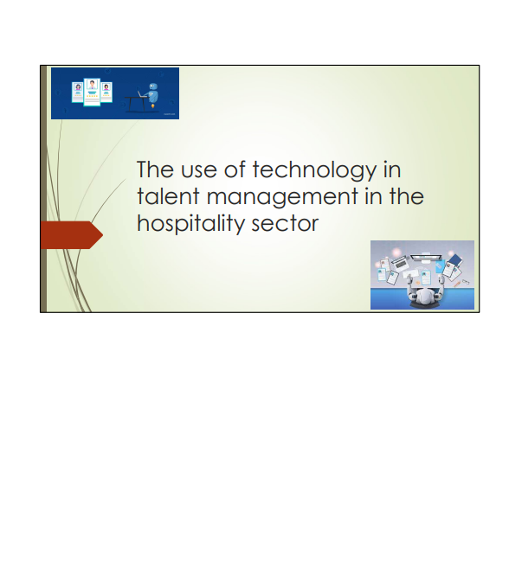

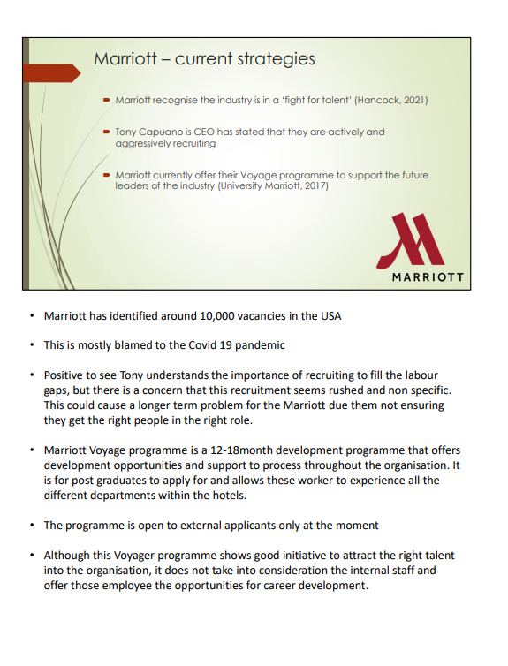

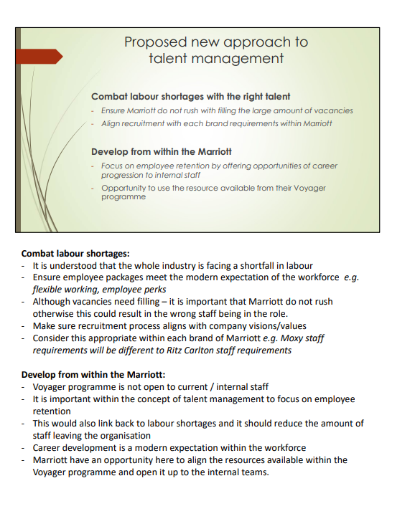

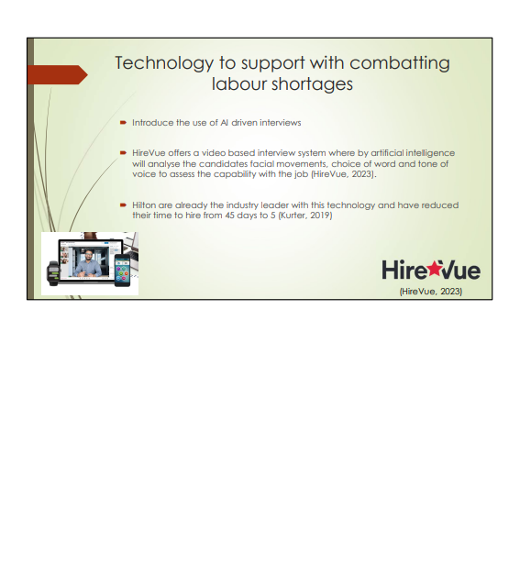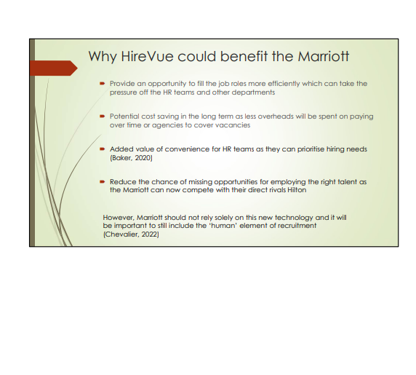

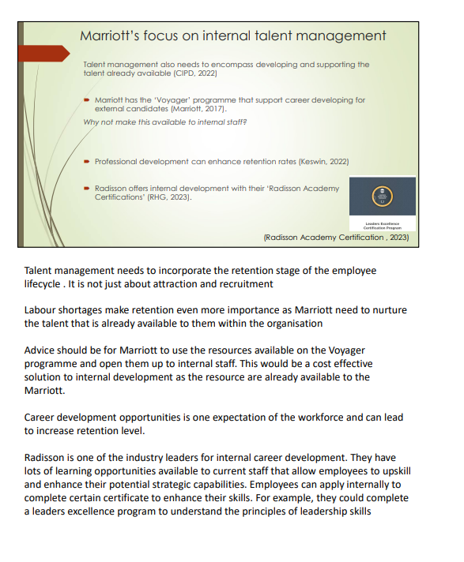

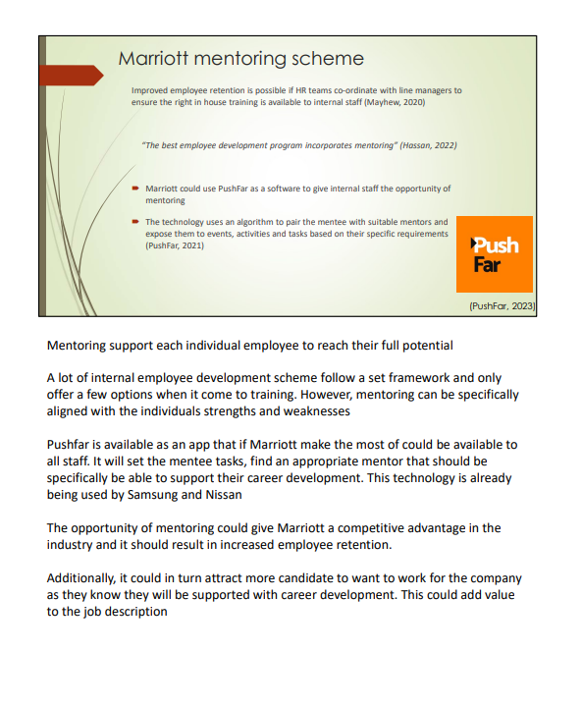

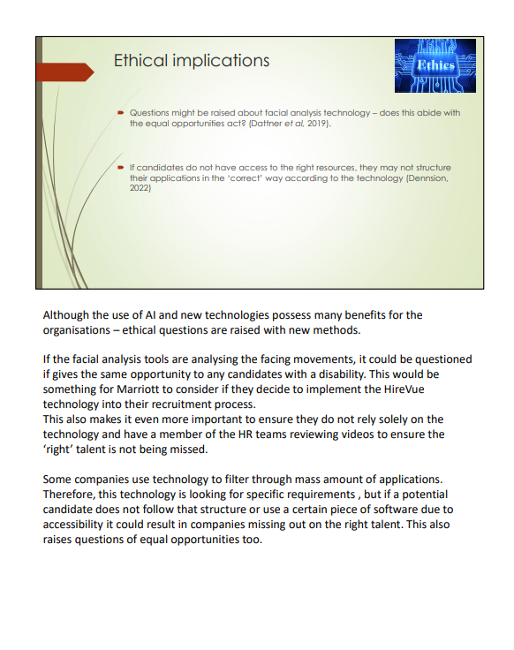

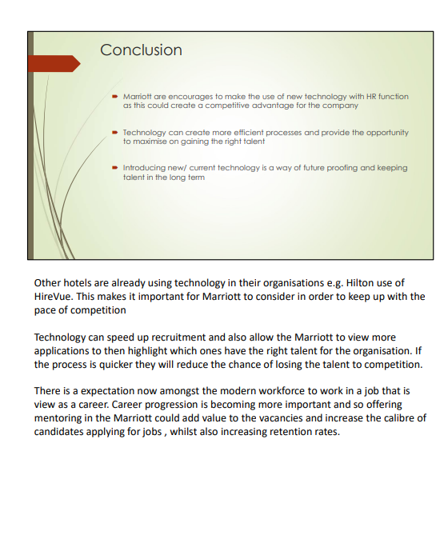

Reference list :
Baker, M. (2020) AI Shows value and gains traction in HR. Available from: https://www.gartner.com/smarterwithgartner/ai-shows-value-and-gains-traction-in-hr#:~:text=As%20AI%20continues%20to%20improve,51%25%20will%20maintain%20their%20investments. [Accessed 27 March 2023]
Chevalier, F. (2022) AI in HR: How is it really used and what are the risks? Available from: https://www.hec.edu/en/knowledge/articles/ai-hr-how-it-really-used-and-what-are-risks [Accessed 26 March 2023]
CIPD (2022) Talent Management. Available from : Talent Management | Factsheets | CIPD [Accessed 27 March 2023]
Dattner, B., Chamorro-premuzic, T., Buchban, R. and Schettler, L. (2019) The Legal and Ethical Implications of Using Ai in Hiring. Harvard Business Review., pp. 2-7.
Dennison, K. (2022) Are AI recruitment tools ethical and efficient? The pros and cons of ATS. Available from: https://www.forbes.com/sites/karadennison/2022/06/27/are-ai-recruitment-tools-ethical-and-efficient-the-pros-and-cons-of-ats/?sh=28feb5582e4f [Accessed 27 March 2023]
Ellery, M. (2021) Is the UK ready for AI in coaching and mentoring? Available from: https://www.hrmagazine.co.uk/content/comment/is-the-uk-ready-for-ai-in-coaching-and-mentoring [Accessed 26 March 2023]
Galer, S. (2019) AI Based career mentoring for the masses: When people talk, innovations happens. Available from: https://www.forbes.com/sites/sap/2019/06/25/ai-based-career-mentoring-for-the-masses-when-people-talk-innovation-happens/?sh=136966f776d1 [Accessed 27 March 2023]
Gulliford, F. and Parker, A. (2019) AI: the HR revolution. Strategic HR Review. 18 (2), pp. 52-55
Hancock, A. (2021) Marriott warns of ‘fight for talent’ as hotels struggle to find staff. The financial times [online]. Available from: https://www.ft.com/content/8acbe8d0-f1d0-4cb9-a15b-518a817455a4 [Accessed 26 March 2023]
Harwell, D. (2019) A face-scanning algorithm increasingly decides whether you deserve the job. The Washington Post [online] Available from: https://www.washingtonpost.com/technology/2019/10/22/ai-hiring-face-scanning-algorithm-increasingly-decides-whether-you-deserve-job/ [Accessed 26 March 2023]
Hassan, S. (2022) 5 Ways mentorship can revamp your employee development program. Available from: https://www.togetherplatform.com/blog/how-mentoring-boosts-employee-development [Accessed 27 March 2023]
HireVue (2023) Why HireVue? Available from: https://www.hirevue.com/why-hirevue [Accessed 26 March 2023]
Hospitality On (2022) Radisson Academy – The umbrella for all training and development initiative within RHG. Available from: https://hospitality-on.com/en/hospitality-schools/radisson-academy-umbrella-all-training-and-development-initiatives-within-rhg [ Accessed 27 March 2023]
Kurter, H.L. (2019) How Hilton reduced their time to hire from 43 days down to 5. Available from: https://www.forbes.com/sites/heidilynnekurter/2019/09/19/how-hilton-reduced-their-time-to-hire-from-43-days-down-to-5/?sh=40a41ebd6759 [Accessed 26 March 2023]
Marriott (2017) Voyage , Global leadership development program. Available from: Marriott Voyage: Leadership Development Program | Marriott University Programs -Marriott Voyage [Accessed 26 March 2023]
Maskey, S. (2022) How AI is primed to disrupt HR and recruiting. Available from: How AI Is Primed To Disrupt HR And Recruiting (forbes.com) [Accessed 26 March 2023]
Maurer, R. (2022) HR must be vigilant about the ethical use of AI technology. Available from: https://www.shrm.org/resourcesandtools/hr-topics/technology/pages/hr-must-be-vigilant-about-the-ethical-use-of-ai.aspx#:~:text=Another%20major%20ethical%20issue%20that,for%20biased%20tech%20is%20there. [Accessed 27 March 2023]
Mayhew, R. (2020) The components of employee retention & career development processes. Available from: https://smallbusiness.chron.com/components-employee-retention-career-development-processes-12191.html [Accessed 26 March 2023]
PushFar (2021) The 5 mobile mentoring apps you need for your mentoring program in 2021. Available from: https://www.pushfar.com/article/the-5-mobile-mentoring-apps-you-need-for-your-mentoring-program-in-2021/ [Accessed 27 March 2023]
PushFar (2023) The world’s leading mentoring platform. People power, unleashed. Available from: https://www.pushfar.com/?gclid=EAIaIQobChMI8YHY66_8_QIVHertCh19IgIUEAAYASAAEgLExfD_BwE [Accessed 27 March 2023]
Radisson Hotel Group (2023) Radisson Academy Certifications. Available from: https://www.radissonhotels.com/en-us/corporate/careers/radisson-academy-certifications [Accessed 27 March 2023]

