Student name: Lubna Begum
Student ID: 1707901
MODULE CODE: BMSK4004
MODULE TITLE: Problem Solving and Decision Making
Teacher name : molly jack
Table of Contents
1 A problem in the workplace; its scope and impact: 4
1.1: Description of the problem 4
1.2: The nature of the problem 4
1.3: The scope of the problem 4
1.4: Impact of the problem 4
2. Analysis of Information: 5
3 A range of alternative solutions to the problem 10
3.1: Alternative 1: Adding Canadian and Mexican foods: 10
3.2: Alternative 2: Adding Japanese, Chinese, Bengali and Thai Foods: 10
3.3: Alternative 3: Addition of Chinese, Japanese and Mexican foods: 10
4. Decision making: 11
5 A plan for implementing the solution 12
5.1 Aims and Objective of the plan 12
5.2 Situation or Business Environmental Analysis 12
5.2.1 PESTLE Analysis 12
5.2.2 Industry Analysis 14
5.2.3 SWOT Analysis 16
5.3 Action Plan for Implementation 17
5.3.1 Work Breakdown Structure 17
5.3.2 Comprehensive Project Schedule 18
5.3.3 Gantt Chart 19
5.3.4 Budget 20
5.3.5 Risk Matrix 21
6. Stakeholders communication plan 21
7. Monitoring and reviewing techniques to ensure successful implementation of the solution 24
7.1 Survey Questionnaire 24
7.2 Benchmark or KPI 25
7.2 360 Feedbacks 25
References: 27

1 A problem in the workplace; its scope and impact:

1.1: Description of the problem
There are different kind of challenges a business may face in terms of its operation, resources, opportunities, objectives etc. of which some problems are really complex to address and to solve it properly (Adair, 2011). The managers of Prezzo Restaurant UK have faced some problems in creating a new menu for the restaurant. Currently, the company serves different Italian dishes to its customers. The managers of the restaurant have identified several dishes which could be introduced such as Mexican food, Japanese food, Thai food, Chinese, Bengali foods, Pakistani etc. (Prezzorestaurants.co.uk, 2018).

1.2: The nature of the problem
Creating a new menu by the restaurant may face a range of threats and challenges. The nature of the problem of Prezzo Restaurant UK can be multifarious. The introduction of the new menu of the restaurant can be affected by the aims and objectives of the company, expansion strategy of the company, economic and political condition of the country, taste pattern and demands of the customers etc.

1.3: The scope of the problem
Prezzo Restaurant UK has different options to choose the right menu for its business such as Mexican food, Japanese food, Thai food etc. The restaurant can introduce the new menu throughout all the branches or some of the selected branches. The restaurant has to analyse the plausible opportunities and threats before introducing the new menu. In order to continue to attract the new customers, the restaurant should exploit some opportunities successfully.

1.4: Impact of the problem
This problem has an impact on the different areas of the business such as operation and administration, marketing, finance, production etc. In order to address this problem, the restaurant must have proper resources such as management expertise and necessary personnel to accomplish the objective of creating the new menu for the customers, sufficient fund to assist in the operation etc. Then, the company also have to define its marketing strategies and to implement them to solve the problem of the company (Russo and Duci, 2016).

2. Analysis of Information:
The problem with this case is to add some new food items with the current menu of Prezzo Restaurant which a restaurant in the UK is presently serving Indian foods mainly. The restaurant is situated in London which is one of the largest and famous cities of the world. The city is the living place of the people from many parts of the world and for this, different types of foods are served in the restaurants of London. London is also a city of tourists and historical interest. Many tourists visit London each year and many of these tourists come from Asian and American countries.
According to the census of 2011, the total population of London was 8,173,941. Among those, the number of Indian-born residents was 542,857 which is around 6.6% of the total population of the city, the number of Chinese-born was 124,250 which is around 1.5% of the total population, the other Asian-born except the sub-continent was 398,515 which was 4.9% of the city’s population.
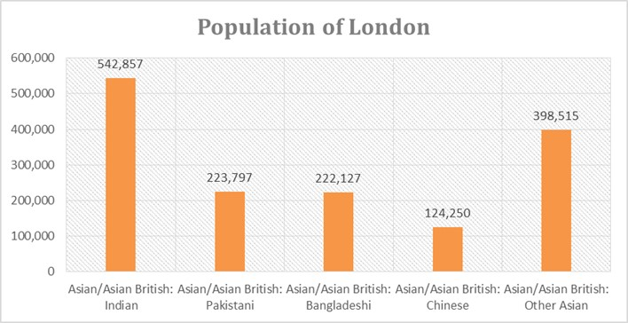
Figure 1: Population of London; Source: (VisitBritain, 2018)
The number of population of from these countries can also be presented on the percentage of the total population of London. Here is the percentage of the population from these countries in terms of the total population of London city:
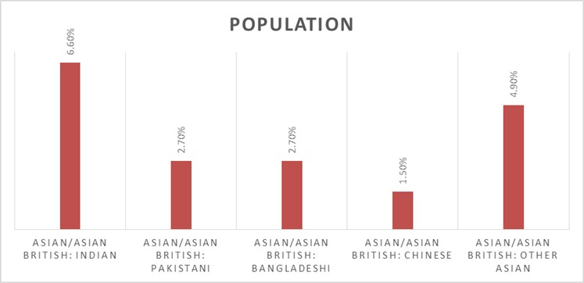
Figure 2: Population of London
Among all the population of London, more than 18% are from the Asian countries and the Prezzo Restaurant is serving only Indian foods. So, the restaurant has access of only 6.6% of 18.4% of the population of London. To grab the other Asian-born UK customers, Prezzo Restaurant should offer other Asian foods as well as some other tasty and healthy foods which have the demand to the customers. Mexican foods can be a good option for the hotel as Mexican foods are well-known among the visitors and these foods are considered as healthy also.
Many visitors from the Asian countries come to the UK every year. The following graph presents the number of Chinese visitors’ trends from 2002 to 2017.
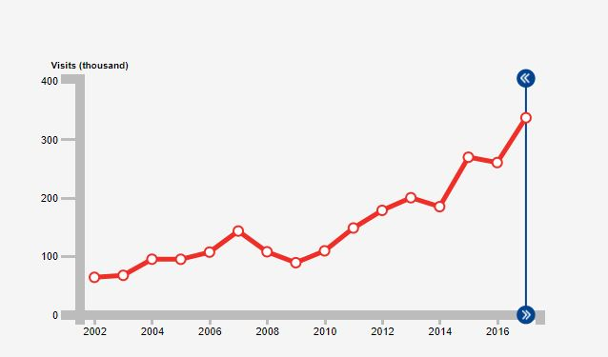
Figure 3: Chinese visitor trend in the UK: Source: (VisitBritain, 2018)
In 2017, the number of Chinese visitors visit to the UK was 337,127 which is 29.45% more from that of the previous year. The visitors spent more than £694.04 million in the UK which was 35.16% more than the spending of the Chinese visitors in 2016.
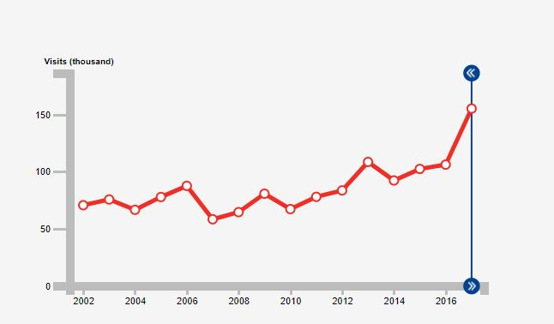
Figure 4: Mexican visitor trend in the UK; Source: (VisitBritain, 2018)
The above-presented graph shows the trend of the Mexican visitors in the UK from 2002 to 2017. In 2017, the number of Mexican visitors to the UK was 155,347 who spent more than £101.07 million on that year. The increase in the number of visitors in 2017 from that of 2016 was 46.14% and the spending of the visitors was 57.17%.
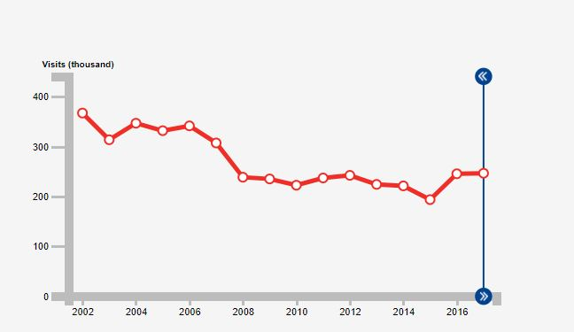
Figure 5: Japanese visitor trend to the UK; Source: (VisitBritain, 2018)
In the last year, 246,857 Japanese tourists visited the UK which is 0.42% more than that of the previous year and the spending of these visitors were £249.67 million which was 15.94% more than the previous year. Though the increase in the number of visitors from Japan is low, the increase in their spending in high and for this the Japanese tourists should also be considered by Prezzo Restaurant.
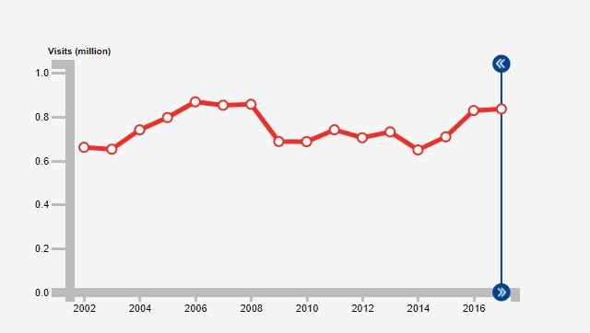
Figure 6: Canadian tourist trend to the UK; Source: (VisitBritain, 2018)
835,243 Canadians visited the UK in 2017 and it is 0.88% more than the number of visitors of the previous years. The amount of spending of these tourists is £604.41 million and a portion of these spending was for foods.

From these data, it is clear that the number of Asian and Mexican visitors are increasing and it is an opportunity for the Prezzo Restaurant to serve those visitors with the foods they want. To do this, the restaurant will have to add new food items like Mexican foods, Bengali foods, Thai foods, Chinese foods, Pakistani foods etc. with the existing menu.

3 A range of alternative solutions to the problem
A problem has to be solved by developing more than one solutions for that problem (Barton, 2014). The solutions used for solve the problem is called alternatives. If the alternatives are built properly by analysing the problem and the available data for solving the problem, then the problem can be solved easily. For this, the development of alternatives is significant for the manager of the Prezzo Restaurant. The manager is facing a problem about adding dishes into the existing product line and is a little bit confused about adding dishes. The following alternatives can be developed by the manager to solve the problem:

3.1: Alternative 1: Adding Canadian and Mexican foods:
The 1st alternative of solving the dishes problem of Prezzo Restaurant is to add Canadian and Mexican foods into the existing food menu of the restaurant. If the restaurant adds those foods into its existing dishes, it will be good for the Canadian and the Mexican visitors as they will find their country’s food in a restaurant in London.

3.2: Alternative 2: Adding Japanese, Chinese, Bengali and Thai Foods:
The second alternative for solving the food dishes related problem of Prezzo Restaurant is adding Japanese, Chinese, Bengali and Thai foods with the existing menu of the restaurant. The number of Asian tourists in the UK is increasing and the Asian-born English are not small in number. So, the addition of Asian food items with the menu of the Prezzo restaurant can be a good solution for solving the problem.

3.3: Alternative 3: Addition of Chinese, Japanese and Mexican foods:
The third alternative for the Prezzo restaurant is to add both Asian and American food items in the restaurant as both of the foods have great demand among the customers of London. Canadian, Mexican and Japanese food items are not popular and thus a few numbers of restaurants are serving those to the customers. This can be another alternative solution to solve the problem.

4. Decision making:
In the decision making the stage of the problem solving, all the developed alternatives have to be analysed and the best alternative should be chosen as the ultimate solution. For the problem of Prezzo Restaurant problem of adding dishes, all the 3 developed alternatives will be analysed.
All the three alternative is about adding new food items to the existing dishes of the restaurant. The first alternative is about adding non-Asian foods, the second alternative is about adding Asian food and the third alternative is about adding both Asian and non-Asian foods. If only the non-Asian foods are added on the menu of the restaurant, then the non-Asian visitors and the non-Asian-born people will be benefited as they will be offered with their local foods. But, the number of Asian visitors and the Asian-born British are many in number. So, the Prezzo Restaurant will lose those customers if it will follow alternative 1. The second alternative is about adding Asian foods like Chinese foods, Japanese foods, Thai Foods and Bengali foods. It will be a good decision to add Asian foods in the menu of the restaurant. But, the number of Mexican visitors are increasing and the Mexican foods are popular with many of the visitors from different part of the world. The non-Mexican travellers also like Mexican foods and thus Mexican foods are a good option for Prezzo Restaurant (Tourism in Britain. 2018). But the Mexican food isn't considered in the alternative 2. The third alternative is about adding both the Asian and some non-Asian foods to the existing menu of the Prezzo Restaurant. By adding both the Asian and no-Asian foods, the restaurant will be able to grab both the Asian and non-Asian customers. The number of non-Asian visitors in the UK is more than 80% of the total visitors and many of them like Mexican foods. For this, adding Chinese, Thai, Japanese, Bengali and Mexican foods is the best alternative to follow for the Prezzo Restaurant. Canadian foods are not a good option because of the decreasing trend of the Canadian visitors in the UK. The Canadian-born British is rare in London and thus Canadian foods are not a good option. For this, Canadian foods are not considered in choosing the best alternative for solving the problem, Prezzo Restaurant is facing now.
After considering all the alternatives developed in the previous part of the report, it is seen that the third alternative will give the best result to the Prezzo Restaurant. So, the manager should solve the selecting new dishes problem by following the third alternative which is about adding Asian and Mexican foods with the existing food menu of the restaurant.

5 A plan for implementing the solution
After evaluating three alternatives the Prezzo restaurant has decided that they will launch Chinese, Japanese and Mexican foods that means the restaurant will include both Asian and American food menu with their existing offerings. Launching both of these menus will require adequate human resources and appropriate raw material sourcing hence implementation will not be easy for the restaurant. They will require a structured plan for that which is below:

5.1 Aims and Objective of the plan
The aim of the plan is to help Prezzo restaurant to successfully launch the Chinese, Japanese and Mexican dishes with their existing offerings to attract more customers successfully.
The SMART objectives include:
- To increase the existing sales revenue by at least 25% within the first 6 months of new menu launching
- To help the restaurant to source the right human resources and to source proper raw material sources at the same time as well
- To allow the restaurant to increase the new customer acquisition by 75% within the first year of operation
- To help the company in keeping customer satisfaction above 85% by enabling a variety of the foods items
- To ensure the company extends at least 3 branches within the first year of operation

5.2 Situation or Business Environmental Analysis
For successfully launch the products the restaurant will need to understand and assess the factors that can arise from both macro and microenvironment and need to delineate strategies accordingly to properly launch the proposed menus (Fitzgerald, 2012). The situational analysis in the context of Prezzo is below:

5.2.1 PESTLE Analysis
The macro environmental factors create a significant impact on the operations of the business and the management needs to adjust their strategies accordingly for perfectly launching the proposed menus. The PESTLE analysis for Prezzo is highlighted below:
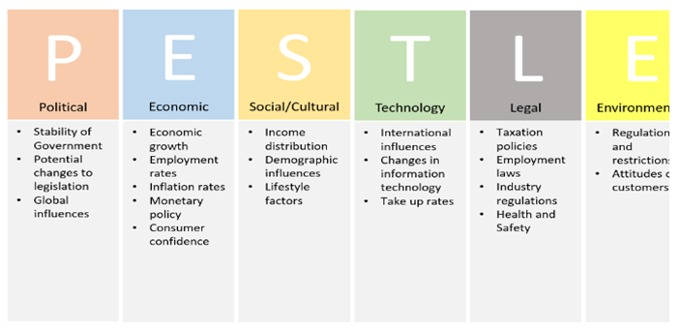
Figure 7: PESTLE Framework
Source: (Kashi, and Franek, 2014).
Political factors
Almost all of the businesses are affected by the shift of the political environment and restaurant business is no exception to this. The political stability matters a lot as it determines the visitors flow inside the country and as the restaurant is going to launch the foreign menus hence visitors flow will be important for their business growth. Moreover, tax policies and the shift in labour laws are going to affect the business as well (Tsalikis, and Peralta, 2016). Brexit will make it difficult to source the raw materials as it can increase the cost and make it difficult to source the raw materials because of restrictions.
Economic factors
People tend to eat outside if their income flow is stable and upward moving hence the GDP growth rate, employment rate, availability of finance, interest rate movement and also people’s saving pattern can affect the operations of Prezzo. The restaurant will need fund for launching new menus and for extending their branches and so interest rate movement will affect the cost of capital and the profit margin as well (Baker, 2011). The inflation rise will make it difficult for the business to keep the prices lower.
Social factors:
The eating habits of the people are largely connected with the social factors movement. Presently, the UK people are opting to try outside food and there are growing trends regarding the takeaway foods and trying out foods from other countries and cultures. All these positive social vibes are going to benefit the business and will fetch more customers for them when they will launch their Asian and Mexican food items. The demand for their new menus will increase in the future if this trend continues.
Technological factors:
Technology makes the life easier and has transformed the business world significantly. Prezzo will have to comply with the technological changes happening around their business. For example, the company will have to install an automated transaction processing system, inventory management system and also accountancy software in their operations (Battersby, and Shuchman, 2013). Along with it, they need to implement digital and online marketing to handle their operations smoothly and comply with the trend shifting relating to technologies.
Legal factors:
Businesses can't but comply with the legal laws and regulations. For Prezzo, the food and safety law of 1990 and also the food regulations act of 2004 will be mandatory to follow and accordingly, they will need to maintain the food and hygiene codes in their operations to serve the customers safe and quality foods (Gilligan, et al, 2013). The restaurant will have to abide by the UK Labour law of 2004 and also will need to ensure their workplace is aligned according to the workplace safety and security law of 2006 as well. Not respecting these laws will adversely affect the operations of the business.
Environmental factors:
The activities of Prezzo will not create any direct adverse impact on the environment. However, the business will need to be careful in handling their wastages and for earning positive image from their customers they will need to participate in the environmentally friendly programs by sponsoring green initiatives and so on. For ensuring sustainability these things will be needed to be taken care of.

5.2.2 Industry Analysis
For determining the demands for the newly proposed menus of Prezzo restaurant the management will need to understand the industry dynamics and for understanding that application of Porter's five forces model is appropriate. The application of the five forces model in the context of Prezzo is below:
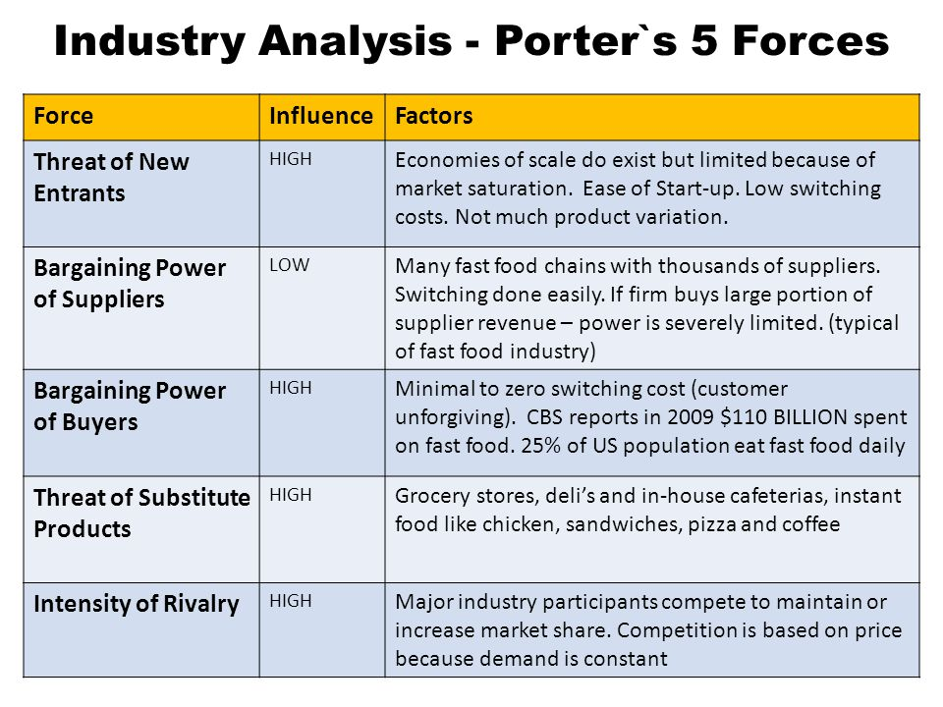
Figure 8: Porter’s five forces
Source: (Gilligan, et al, 2013).
New entrant’s threats: High
There around 83635 restaurants operating around the UK and the number is expected to increase further because the industry growth is close to 9%. Moreover, with fewer investment and good cooking skills, anybody can opt to establish a restaurant. Above all the UK people are trying on new cuisines on a constant basis (Black, 2016). All these factors have made the entry barriers low and threats of the new entry higher.
Threats from the Substitutes: Higher
There are ample substitute products available for the firms and also there are enough alternatives to replace the choice with. The grocery stores, frozen foods, in-house cafes, instant cooking foods, sandwiches and many other alternatives have made the substitutes threats very higher for Prezzo. The business will need to maintain strict quality to sustain their business.
Bargaining Power of the Buyers: High
The buyers bargaining power is connected with the switching costs, availability of the substitutes and also the availability of the same quality alternatives. All these factors are present in the restaurant industry of the UK and these have made the buyer's bargaining power very much higher because there are no switching costs involved and there are ample same quality alternatives (Ferrell, et al, 2015).
Bargaining Power of the Suppliers: Low
The suppliers bargaining power will be lower for the company because there is an ample number of suppliers available for the Prezzo and the switching costs are also lower. Moreover, in most cases, the restaurant employees make the important ingredients on their own. The supplier's sources are also abundant and these have made the bargaining ability of the suppliers lower.
The rivalry among the existing competitors: High
Though the UK restaurant business is highly growing and moving too fast the industry is already concentrated. There are rising numbers of foreign restaurants opening in the UK hence the new menus of Prezzo will face tough competition while launching new menus for the customers. moreover, there are many existing specialist restaurants serving these menus so it won’t be easier for the company to launch the menus successfully.

5.2.3 SWOT Analysis
The SWOT analysis provides an insight of the business that helps the management of the business to take the best decisions incorporating the company’s key resources and capabilities (Henriques, 2016). Prezzo is already an established Italian chain restaurant. The SWOT analysis for the business is below:
 | Helpful  to achieving the objective | Harmful  to achieving the objective
Internal origin  (attributes of the system) | Strengths  - Established brand recognition  - The experienced human resource team  - Capital strength for launching new products  - Loyal sets of customers  - Positive social trends | Weaknesses  - Being branded as only Italian food supplier  - Less strict control over the branches  - The inconsistent supply chain in some locations
External origin  (attributes of the environment) | Opportunities  - Positive social trends of the UK residents regarding consuming foreign dishes  - Increased number of visitors  - Diversification opportunity | Threats  - Threats regarding labour law changes  - Inflation rate changes setting raw materials price higher  - Rising competition and growth of the substitute products

5.3 Action Plan for Implementation
To successfully launch the proposed two new menus among the three selected alternatives the company will have to be very precise in designing and fixing the plans that they require to complete the launching plan successfully (Kimmel, et al, 2016). The management team needs to be sure regarding the details activities and need to ensure the proper breakdown to ensure the proper allocation of responsibilities. The plan for implementation is below:

5.3.1 Work Breakdown Structure
With the help of producing WBS, the restaurant's management will be able to break down the core tasks into subtasks and allocate them effectively to the team members associated with it. The WBS is below:

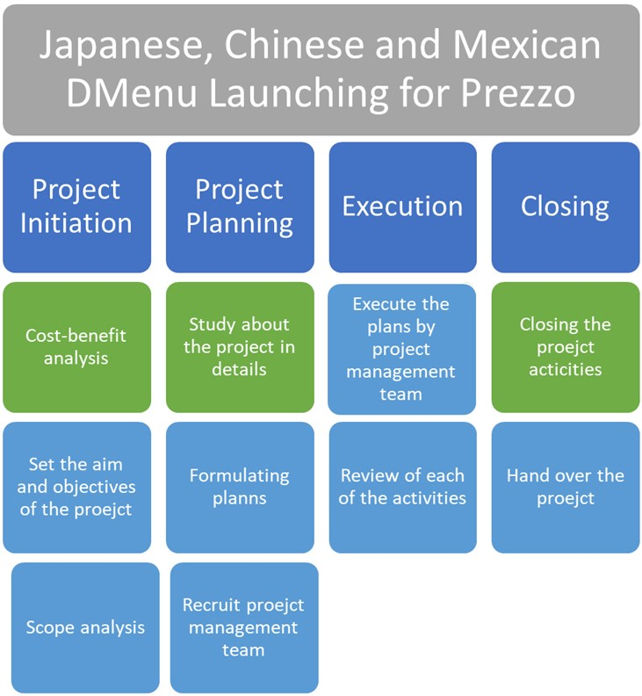
Figure 9: WBS
Source: Author

5.3.2 Comprehensive Project Schedule
The project scheduling highlighting the duration, start date and end date and also the list of the responsible persons are demonstrated in the below table:
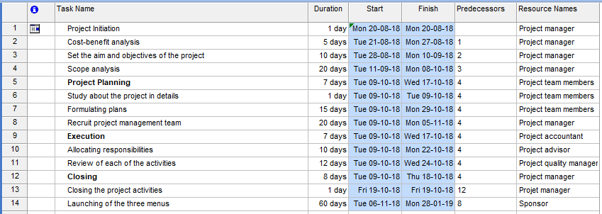
Figure 10: Schedule
Source: Author

5.3.3 Gantt Chart
The details timeframe for the project is demonstrated below with the help of the Gantt chart because it helps the project related personnel to understand the project’s time schedule appropriately. The Gantt chart is below:
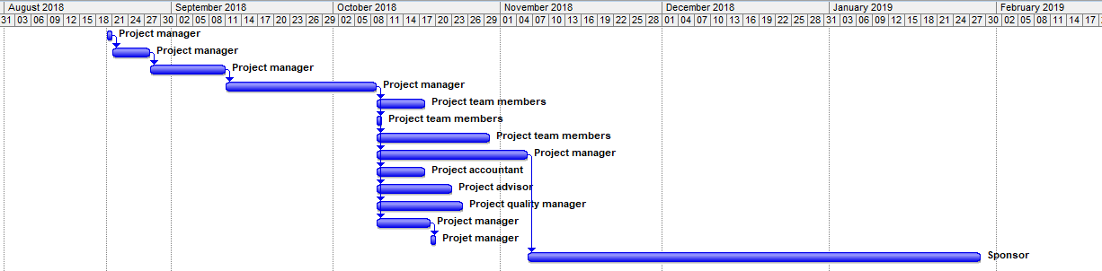
Figure 11: Network
Source: Author
The network diagram showing the relationship between the tasks related to the project's implementation is below:
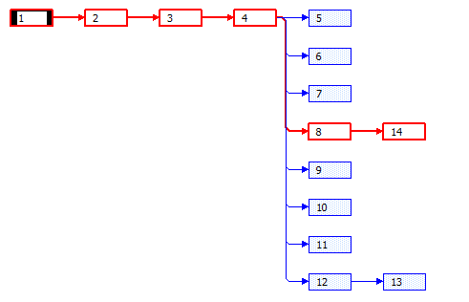
Figure 12: Network Diagram
Source: Author
The network chart shows the relationship between the tasks involved in the project. From the above diagram, it can be seen that the critical tasks are the activities number 1, 2, 3,4, 8 and 14 and so the total expected duration for the project's launching is 1+5+10+20+20+60=116 days.

5.3.4 Budget
There needs to be a specific budget to complete the launching of the new menus within the agreed costs. The budget for the new menus launching the project of Prezzo is below:
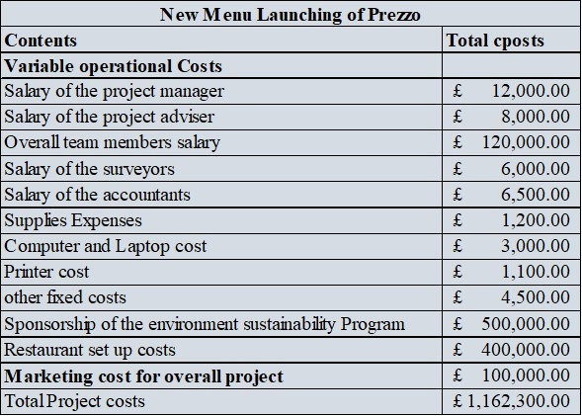
Figure 13: Budget
The project authority is expected to complete is the project within this cost plan.

5.3.5 Risk Matrix
Launching new menus will always be challenging for Prezzo. To overcome the challenges, the restaurant authority will need to conduct risk analysis appropriately. The risk analysis for the proposed three new menus launching project is below:
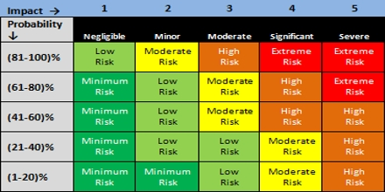
Figure 14: Risk Matrix
Source: (Kourdi, 2013).
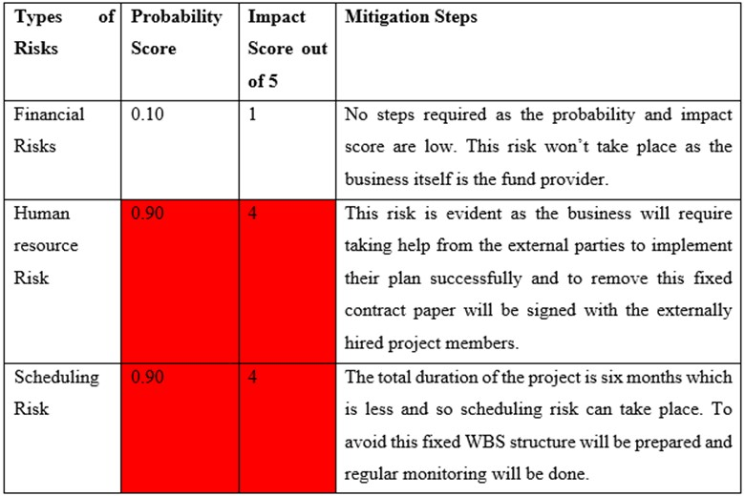

6. Stakeholders communication plan
The stakeholders are the interested parties who have the stake in the project. The new menus launching plans will involve the sponsor which is the Prezzo restaurant, the customers, employees and outside investors and these all are important stakeholders who will be needed to be updated regarding the project's progress. The stakeholder's communication plan for this project will be done following the below chart:
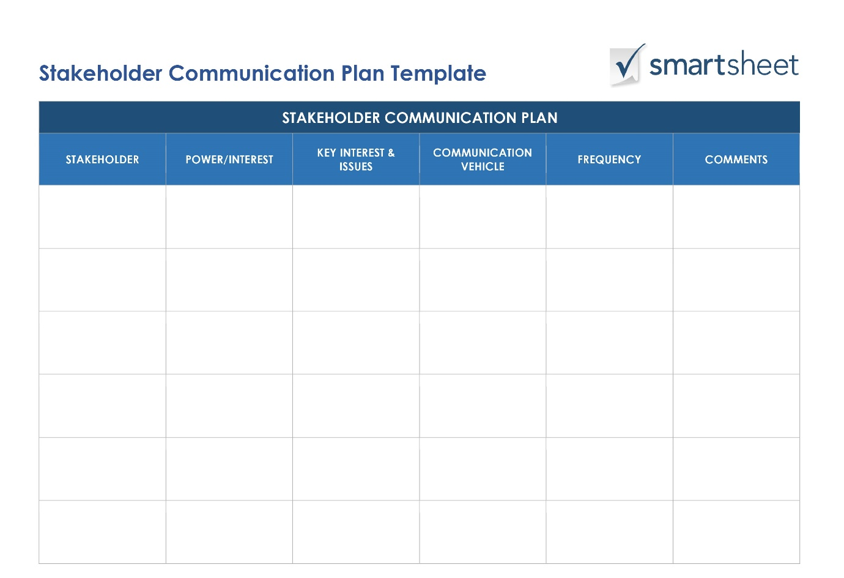
Figure 15: Stakeholder communication example
Source: (Piccirillo, and Noro, 2014).
For stakeholder communication, the focus will be given to both formal and informal ways of communication. The list of tools to be used are highlighted below:

Figure 16: Communication tools lists
Source: (Tsalikis, and Peralta, 2014).
The project manager is going to arrange regular formal meetings and workshops and discussion sessions for formal communicational purposes. For informal communication, the project manager is going to use texts, Facebook messages, phone calls and informal gossips to allow the team members communicate freely and to instantly update the mentioned stakeholders regarding the project's progress. The stakeholder's matrix will be applied to assess the power and interest of each stakeholder and their needs.

7. Monitoring and reviewing techniques to ensure successful implementation of the solution
To check whether the recommended alternative has helped the Prezzo restaurant to achieve the business targets or not the management should need to establish a proper review and control loop and for that different quantitative and qualitative tools can be applied. The monitoring and review techniques are below:
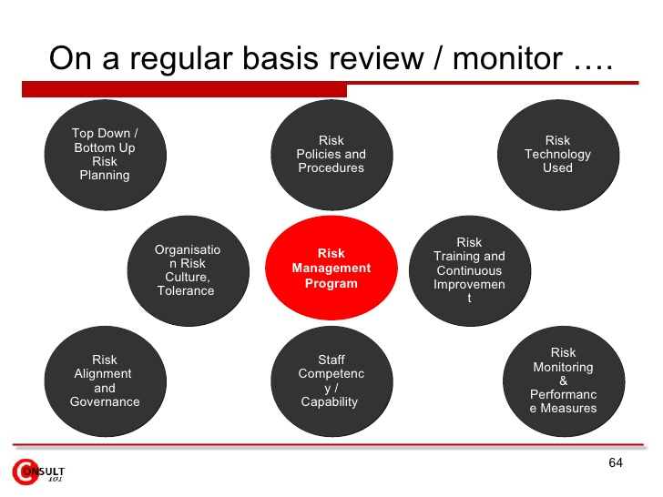
Figure 17: monitoring and reviewing techniques
Source: (Tsalikis, and Peralta, 2014).

7.1 Survey Questionnaire
The survey will help to ensure that the real responses of the project related persons are achieved. The evaluation team can design close-ended questions and collect the responses of the related people within quick time to check the success of the proposed project. An example of the close-ended survey is below:
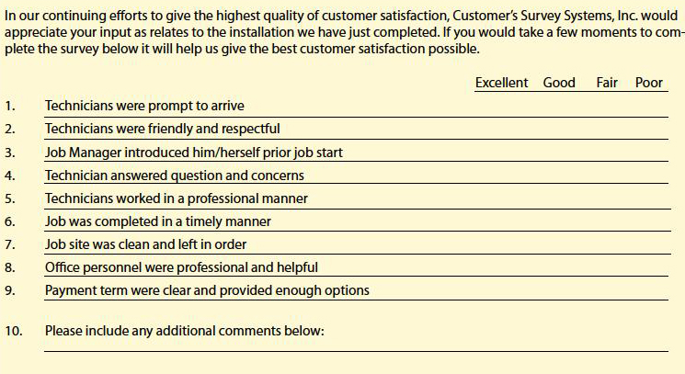
Figure 18: Close-ended survey exampleSource: Author

7.2 Benchmark or KPI
Through the benchmark or KPI, the management can judge the outcome of the project against some specified criteria's. The KPI for this project is below:
Indicators | 1st quarter | 2nd quarter | 3rd quarter | 4th quarter
New sales growth | 10% | 15% | 18% | 25%
Acquisition of new customers | 75% | 80% | 94% | 97%
Market Share | 10% | 12% | 14% | 118%
If the launching of the new menus can help the business attaining these targets the business will be termed as successful.

7.2 360 Feedbacks
Through the close-ended survey, the restaurant authority will only be able to collect responses from specific groups of people but through 360 feedbacks the company will be able to collect the responses of every related person from all ranges (Henriques, 2016). The 360 feedbacks will help to remove the inconsistencies in the most planned way.
Prezzo has structured and established operations in the UK. the addition of the newly proposed menus will ensure the company gets access to increased customers, increased revenues and rising amount of market share in the long run if they can overcome the identified problems successfully.

References:
Adair, J. (2011). Decision making and problem-solving.
Baker, A. (2011). Business decision making. New York: St. Martin's Press.
Barton, S. (2014). Travel and tourism in Britain, 1700-1914. London: Pickering et Chatto.
Battersby, A. and Shuchman, A. (2013). Scientific Decision Making in Business. OR, 16(1), p.118.
Black, K. (2016). Business statistics. Hoboken, NJ: Wiley.
Ferrell, O., Fraedrich, J. and Ferrell, L. (2015). Business ethics. Boston: Houghton Mifflin Co.
Fitzgerald, S. (2012). Decision making. 1st ed. Oxford, U.K.: Capstone Pub.
Gilligan, C., Neale, B. and Murray, D. (2013). Business decision making. Deddington, Oxford: P. Allan.
Henriques, A. (2016). Good decision? bad business?. International Journal of Management and Decision Making, 6(3/4), p.273.
Kashi, K. and Franek, J. (2014). Applying Group Decision Making and Multiple Attribute Decision Making Methods in Business Processes. Applied Mechanics and Materials, 693, pp.237-242.
Kimmel, P., Weygandt, J. and Kieso, D. (2016). Financial accounting. Hoboken, NJ: John Wiley.
Kourdi, J. (2013). Business strategy. London: Profile.
Piccirillo, E., and Noro, M. (2014). Guidebook for supporting decision making under uncertainties. Hackensack, NJ: World Scientific.
Prezzorestaurants.co.uk. (2018). Prezzo Restaurants. [online] Available at: https://www.prezzorestaurants.co.uk/about-prezzo/prezzo-news/ [Accessed 29 Jun. 2018].
Russo, D. and Duci, S. (2016). Supporting Decision Making and Requirements Evaluation with Knowledge Search and Problem Solving. Procedia CIRP, 39, pp.132-137.
Tourism in Britain. (2018). London: Reference Services, Central Office of Information.
Tsalikis, J. and Peralta, A. (2014). Priming effects on business ethical decision making. Priming effects on business ethical decision making, 01(01).
Tsalikis, J. and Peralta, A. (2016). Priming effects on business ethical decision making. Priming effects on business ethical decision making, 01(01).
VisitBritain. (2018). Home. [online] Available at: https://www.visitbritain.org/ [Accessed 20 Aug. 2018].

