

The impact of Virtual Learning Environment (VLE, as an example Moodle of our university) on the learning experience of the students at UWTSD London campus.

Student Name | Bianca Ioana Terza
Student Number | 2009067
Module Number | BMSW4003_LON
Module Title | Digital Skills and Research Methods
Lecturer Name | Koushik Modak
Date on submission | 6th of January 2021

Table of Contents:

- Introduction page 3
- Rational page 3
- Research Objectives page 3
- Literature Review page 4
- Research Methodology page 4
- Findings, analysis, and discussion page 5
- Conclusions and Recommendation page 11
- References page 12
- Appendices page 14

1.Introduction
This report will focus on the impact that VLE has on the students at the University of Wales Trinity Saint David (UWTSD). Jonsons (2019) claims that “the Virtual Learning Environment is an online system that allows education materials to be transmitted through the internet to transfer knowledge from organization to employee or teacher to student”

The research will make use of both primary and secondary data. The primary data will be collected via an online survey, due to the happening pandemic, and the results will be transposed into graphs and analysed, while multiple online sources will be consulted to gather the secondary data. The study will also include a recommendation for the future use of VLE.

2.Rational
This research will focus on the students’ interest and satisfaction levels in the Moodle platform, made available by the University to support pupils’ learning during the online activities and classes.

3.Research Objective
This research aims to understand the role that Moodle plays in the academic development of the students and consider future suggestions to maximize the learning assistance.

4.Literature Review
Woodwark (2012) in her research analyses the experience of the students with VLE for Ofsted, the results originate from a survey submitted to 600 learners from different courses, showing that most of the students are positive about VLE, considering the experience essential for the studies, easy to use and thanks to the material available, satisfying even though a third of the students confessed that they used it only because instructed to do so. In her research Miller (2020) compares the VLE with the face-to-face lessons by organizing the same 4 weeks period course with the only difference of delivery. At the end of it, the feedback got gathered, the VLE experience was more enjoyable due to its easy access, the possibility to stay at home, and the opportunity to create a multicultural community. This is recalled in her outcomes as a chance to have highly dispersed subjects gathering for one class.
Ryan and Poole in their article (2019) were inquiring about the attitude the students have towards the study, the sample has been divided and two identical sessions with different delivery were then submitted, concluding then with a knowledge questionnaire. VLE students had a higher score showing satisfaction and feeling encouraged using it. Chowdhry S., Sieler K, and Alwis L. investigated in 2014 on the relation between the students’ academic results and the teaching system, asking the students of different courses to follow the lectures virtually and analysing the final marks, comparing them with the ones received during face-to-face classes. The same research was made by the University of Kuala Lumpur (Mohd Yusop M. Y., Mansor M. N., Ramli M. K., Abd Samad F. I., Mat Saad K. A., Abdul Hamid S. E., Mukhtar Z. Z.) in 2018. In the first study, we can notice that VLE promotes the students’ discussion and interaction with the module contents, considered better than traditional ones, the VLE also provides the opportunity to become an “active learner” (Walker, 2003; Mijatovic, Cudanov, Jednak, and Kodijevich, 2013) by taking the responsibility for the studies. In the second investigation, we can see that the non-technical departments had a better improvement since the introduction of VLE compared to the others and the lecturers declare that they have sufficient time and resources to improve the teaching.

In this research I will be focusing on the students at UWTSD, I will analyse the data collected from the survey to understand the satisfaction and the advantages that the platform Moodle brings to the pupils of this University.

5.Research Methodology
As reported by “The Research Excellence Framework” in 2014, Research is "a process of investigation leading to new insights, effectively shared.” (Parveen, H. and Showkat, N.,2017), while Methodology is defined by the author Brown as the “philosophical framework within which the research is conducted or the foundations upon which the research is based”, in 2006 (BRM, n.d.). Via this research we collect Data which is a “factual information used as a basis for reasoning, discussion or calculation”, described by Gleason Jr (n.d.) as plentiful and easily available (Merriam-Webster, n.d.). There are different types of data, Secrist (n.d.) mentions that the “data which are gathered originally for a certain purpose are known as Primary data”, more reliable yet time wasting, while Blair (n.d.) says that “the data which are used in an investigation, but which have been gathered originally by someone else for some other purpose are known as Secondary data”, (Mehta, n.d.); by doing that, we are going through a Data Collection Process. The approach to this process can be Qualitative a definition given by Denzin and Lincoln (1994) describe it as “focused on the interpretation of phenomena in their natural settings to make sense in terms of the meanings people bring to these settings”. (Relacion, n.d.), the Quantitative approach, according to Matthews & Ross (2010) is “basically applied to the collection of data that is structured and which could be represented numerically” (UKEssays, 2018) or Combined. In order to do this we consider a Population defined by Polit and Hungler (1999) as an “aggregate or totality of all the objects, subjects or members that conform to a set of specifications” (Megaiab, M., Wijana, D. and Munandar, A., 2019) which we can simplify by considering a Sample “a subset of a population selected to participate in the study” (Brink 1996, Polit & Hungler 1999) and a Sample size which “most typically refers to the number of units that were chosen from which data were gathered” (Lavrakas P., 2008) During the process we need to consider the Ethics, “the application of moral rules and professional codes of conduct to the collection, analysis, reporting, and publication of information about research subjects” (Oxford University press, 2020) to respect the other’s research.

In this report, I will use both Qualitative and Quantitative data arising from a questionnaire created for the topic and an analysis of existing research studies which took into consideration different aspects of VLE. The population in this report will be the students of UWTSD, which includes over 11.000 pupils (Wikipedia, 2020). Due to the pandemic, the study has been conducted online, submitting a questionnaire to the students of the group I was part of, receiving an answer from 21 colleagues.

6.Findings, analysis, and discussion
In the following paragraph, I will expose the results obtained from the survey I have conducted, analysing the graphs created with the data collected.

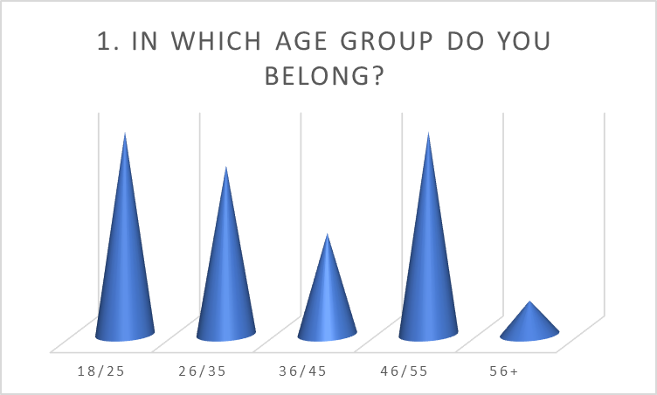
In the first graph we notice that 29% of the students are either younger than 25 or between 46 and 55, 24% have an age that goes from 24 to 35, 14% are 36 to 45 years old and 5% are older than 56, which shows that the community created by the institutions is shaping a dynamic environment including not only different cultures, but also different age groups.

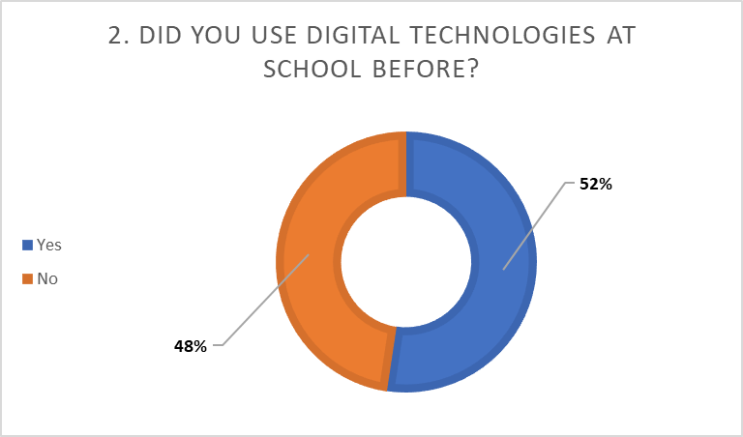
In this graph, we understand that 52% of the students had already used digital technologies before this course having more experience than the 48% whose answer was negative. We can, then, predict some difficulties during the lessons’ delivery due to the new environment presented to the learners. Those who are using these technologies for the first time are most likely to have complications with the software than those who have worked already with them.

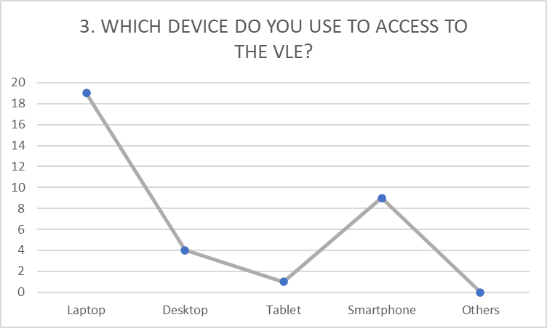
This was a multiple-choice question to understand which device is more used to access VLE.
Despite the different technologies the laptop keeps being preferred by the students due to the facility to access different platforms simultaneously without inconveniences. The smartphone results more suitable for those who attend classes while dealing with other duties. A desktop computer is used by 4 people even though it offers the laptop’s resources, it appears uncomfortable to the majority and only 1 person is using a tablet to access VLE. None of the interviewees is using alternative technologies.

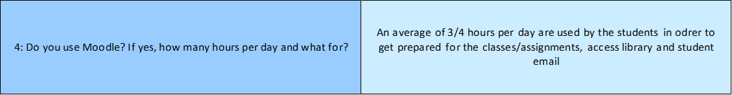
The following question was an open one in which I asked about the time each person is dedicating to Moodle and what for. In general, the students are using the platform for about three/four hours per day, to access the information available for the lessons and assignments or read documents in the library. Not all the students are using Moodle for so many hours, even so, all of them are employing at least thirty minutes to check the emails.

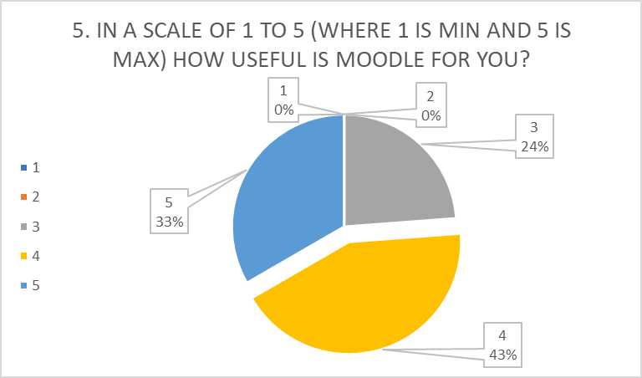
From this chart we can understand that 76% (43% gave the platform a 4/5 and 33% a 5/5) of the students are satisfied, they consider Moodle a platform plentiful of information that supports their studies, the remaining 24% indicate a lower level of interest, resulting neutral. None of the respondents is unsatisfied, the platform results informational, educative, and rich in material but has room for improvement.

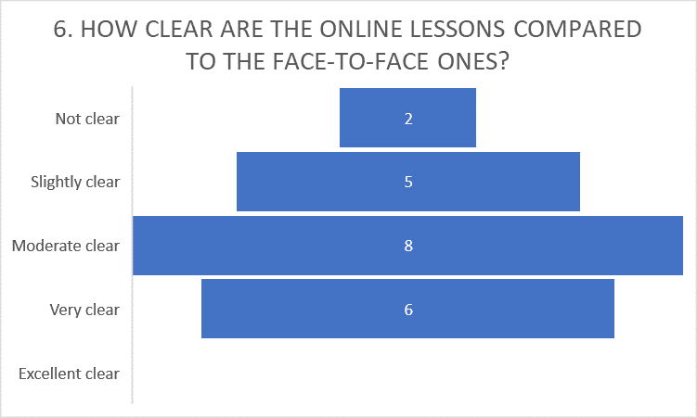
From the results obtained from question 6, we can confirm that 34% (10% replied ‘not clear’ and 24% ‘slightly clear’) of the students prefers the traditional lessons while 38% remains neutral, only 29% considered the online lessons clear. That shows that the majority prefers the face-to-face classes or would prefer a “blended learning” defined by Oliver and Trigwell (2005: 17) as “the integrated combination of traditional learning with web-based on-line approaches” (Sharma, 2010).

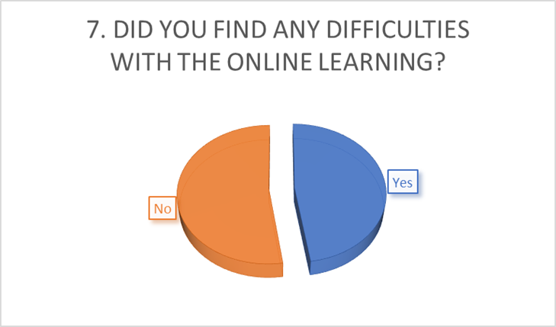
In this graph, 48% of the students confirm that they have some difficulties with on-screen learning while the remaining 52% is denying it. From a general point of view, most of the students have no difficulties with the online lessons but the percentage that confirms the issues remains high.

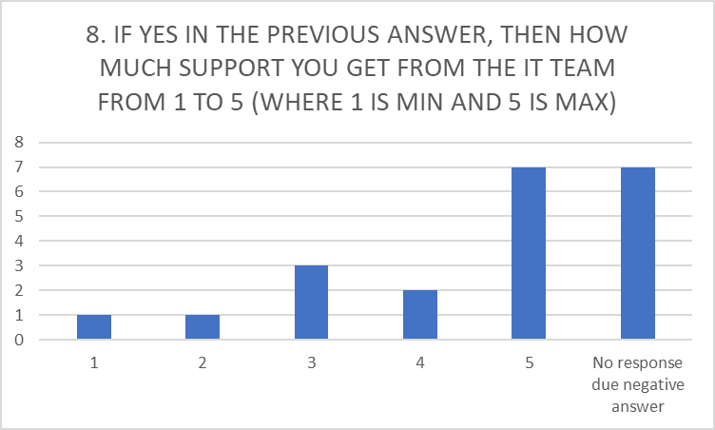
This question was about the support that the students have received from the IT team when in difficulty during the term.
5% considered it minimum and another 5% thought of it as slightly helpful. 14% remain neutral, 10% are satisfied with the help received and 33% considered the help excellent. There are 33% of the students who did not reply due to a negative response in the previous question.
These results have been changed because most of the students replied even if they hadn’t got the urge to contact the IT service. For this reason, I had to consult the questionnaires to understand how useful IT was which brought to the creation of the next graph.
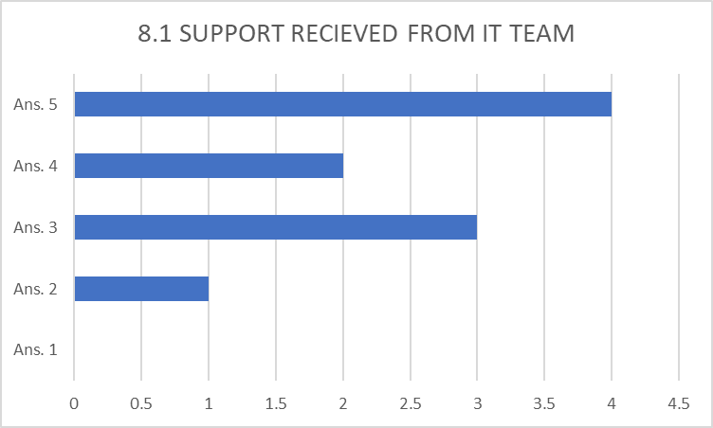
We can conclude with 60% (20% answered 4/5 and 40% 5/5) are satisfied with the support received during the term and 30% remain neutral while only 10% consider the support insufficient for their learning.

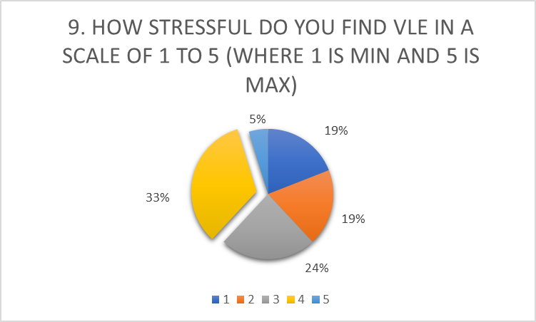
This chart was analysing the stress that the students are experimenting during the VLE. 19% report a minimum level of stress and the same percentage comes up from those who reported it as a slightly stressful environment. 24% remain neutral, 33% report a high level of stress and 5% confirms that the environment is really stressful. This data confirms that the tension created by VLE is high. The students are under pressure due to the difficulties produced by the environment they must attend to. Technical issues and the struggle to maintain attention are the main causes reported.

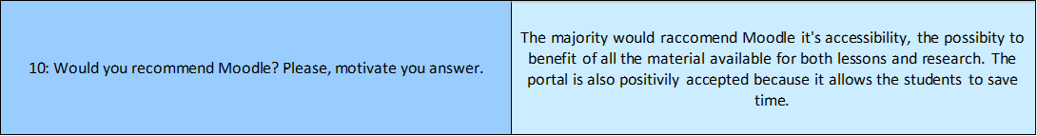
This was the last open question where the students were asked if they would recommend Moodle and the reason behind this choice. Most of them appreciate the accessibility of the portal and the opportunity to access a variety of material from a personal platform optimizing their time but also the possibility of receiving updates directly from the University is welcomed among the interviewees.

We can summarize the information gathered from the analysis of the graphs confirming that the UWTSD is a University that incorporates different cultures and age groups, creating a lively society.
The gap between the students that were familiar with online learning and those who weren't is minimum, even so, all the pupils are accessing Moodle for almost three hours per day to analyse the material available and go through the updates provided by the University.
More than 70% of the students are pleased with the platform but still, more than 30% of them prefer the traditional classes over the on-screen ones or they would appreciate alternative options such as "blended learning"; more than 35% remains neutral and less than 30% prefers the online learning, leaving enough room for improvement.
The percentage regarding the difficulties that the students came across during the course has a similar value. The IT team could be further enhanced yet thanks to the numerous participations that the group made in class to support the learning environment, was wildly appreciated among the learners.
Despite all the efforts, VLE is confirmed as stressful by over 35% of the students and the main causes reported are from the difficulty to concentrate in a familiar environment like the own home or the workplace, and the technical issues reported by them.

7.Conclusion and Recommendations
In 1999 Sitters affirms that “[…] learning can be defined as a process by which long-lasting changes in behaviour are acquired by experience”, while in 2008 Rudy simply defines it as the process of acquiring information. As the definition of learning changed through time, it’s delivery did as well. In 2007, Bloxham states that VLE can offer more flexibility to the students by mixing personal learning with the web 2.0 method like Twitter, blogs, and mobile learning would make the study more interactive and less rigid (Rollins, 2015). Thanks to this research we can confirm that VLE is an integral part of today’s schooling, it still needs revision and further development to meet all the students’ necessities and requests, but the platforms are well appreciated and popular among the learners.

8.References
- Barron, A. B., Hebets, E. A., Cleland, T. A., Fitzpatrick, C. L., Hauber, M. E., and Stevens, J. R., (2015), Embracing multiple definitions of learning, available at: https://digitalcommons.unl.edu/cgi/viewcontent.cgi?article=1058&context=bioscihebets [Accessed on 29.12.2020]
- Business Research Methodology, (n.d.), Methodology, available at: https://research-methodology.net/research-methodology/ [Accessed on 27.12.2020]
- Chowdhry, S., Sieler, K., and Alwis, L. (2014), A Study of the Impact of Technology-Enhanced Learning on Student Academic Performance, available at: https://www.napier.ac.uk/~/media/worktribe/output-175414/vlejpaappdf.pdf [Accessed on 28.12.2020]
- DOCPLAYER, (n.d.), CHAPTER 3. Research design, research method and population, available at: https://docplayer.net/23265557-Chapter-3-research-design-research-method-and-population.html [Accessed on 27.12.2020]
- Johnson, S. (2019), The Advantages and Disadvantages of a Virtual Learning Environment, available at: https://www.knowledgeanywhere.com/resources/article-detail/the-advantages-and-disadvantages-of-a-virtual-learning-environment [Accessed on 28.12.2020]
- Lavrakas P., (2008), Sample Size, available at: https://methods.sagepub.com/reference/encyclopedia-of-survey-research-methods/n507.xml [Accessed on 27.12.2020]
- Megaiab, M., Wijana, D., and Munadar, A. (2019), Politeness Strategies of Request Used between Libyan Students and their Lecturers Using English as a Foreign Language, available at: https://files.eric.ed.gov/fulltext/ED597381.pdf [Accessed on 27.12.2020]
- Mehta, P., (n.d.), Primary Data and Secondary Data, available at: https://www.economicsdiscussion.net/statistics/primary-data-and-secondary-data/2329 [Accessed on 27.12.2020]
- Merriam-Webster, (n.d.), Data, available at: https://www.merriam-webster.com/dictionary/data [Accessed on 27.12.2020]
- Miller, J., (2020), VIRTUAL LEARNING VS FACE TO FACE: A CASE STUDY, available at: https://www.management-dynamics.com/blog/virtual-learning-vs-face-to-face-a-case-study [Accessed on 28.12.2020]
- Mohd Yusop, M. Y., Mansor, M. N., Ramli M. K., Abd Samad, F. I., Mat Saad, K. A., Abdul Hamid, S. E., and Mukhtar, Z. Z., (2018), Impact of Virtual Learning Environment (VLE): A Case Study on Students’ Academic Performance by Subject, available at: https://journalined.uitm.edu.my/images/Vol91/Journal_eLearning_Vol_9_June_2017_Final.pdf#page=5 [Accessed on 28.12.2020]
- Oxford University Press, (2020), Research Ethics, available at: https://www.encyclopedia.com/social-sciences/dictionaries-thesauruses-pictures-and-press-releases/research-ethics [Accessed on 27.12.2020]
- Parveen, H. and Showkat, N. (2017), Research Ethics, available at: https://www.researchgate.net/publication/318912804_Research_Ethics [Accessed on 27.12.2020]
- Relacion, P., (n.d.), Qualitative Research Methods DEFINITION OF QUALITATIVE RESEARCH, available at: https://www.academia.edu/37017373/Qualitative_Research_Methods_DEFINITION_OF_QUALITATIVE_RESEARCH [Accessed on 27.12.2020]
- Ryan, E., and Poole, C., (2019), Impact of Virtual Learning Environment on Students' Satisfaction, Engagement, Recall, and Retention, available at: https://pubmed.ncbi.nlm.nih.gov/31229502/#:~:text=Results%3A%20Virtual%20learning%20seemed%20to%20significantly%20improve%20students%27,didactic%20group%3B%20however%2C%20this%20was%20not%20statistically%20significant [Accessed on 28.12.2020]
- Rollins, M. (2015), The Future of the Virtual Learning Environment, available at: https://mjrlearning.co.uk/the-future-of-the-virtual-learning-environment/ [Accessed on 29.12.2020]
- Sharma, P. (2010), Blended learning, available at: https://academic.oup.com/eltj/article/64/4/456/390082 [Accessed on 29.12.2020]
- Wikipedia, (2020), University of Wales Trinity Saint David, available at: https://en.wikipedia.org/wiki/University_of_Wales_Trinity_Saint_David#:~:text=The%20University%20of%20Wales%20Trinity%20Saint%20David%20%28,learning%20centres%20in%20Cardiff%2C%20Wales%2C%20and%20Birmingham%2C%20England [Accessed on 29.12.2020]
- Woodwark,E., (2012), Report for Ofsted: Virtual Learning Environment Survey, available at: https://assets.publishing.service.gov.uk/government/uploads/system/uploads/attachment_data/file/383959/VLE_portfolio_-_Youth_Sight_report_-_summary.pdf [Accessed on 28.12.2020]
- UKEssays, (2018), Definitions available for quantitative research given by different authors, available at: https://www.ukessays.com/essays/psychology/definitions-available-for-quantitative-research-given-by-different-authors-psychology-essay.php [Accessed on 27.12.2020]

9.Appendices
Class Activity 1: Questionnaire Design
Question 1: In which age group do you belong to?
- 18/25
- 26/35
- 36/45
- 46/55
- 56+

Question 2: Did you use digital technologies at school before?
- Yes
- No

Question 3: Which device do you use to access to virtual learning?
- Laptop
- Desktop
- Tablet
- Smartphone
- Others

Question 4: Do you use Moodle? If yes, how many hours per day and what for

Question 5: In a scale from 1 to 5 (where 1 is not useful and 5 is really useful) how useful is the Moodle portal for you?
- 1
- 2
- 3
- 4
- 5
Question 6: How clear are the online lessons compared to the face-to-face ones?
- Not clear
- Slightly clear
- Moderate clear
- Very clear
- Excellent clear

Question 7: Did you find any difficulties with the online learning?
- Yes
- No

Question 8: If you checked yes in the previous question, how much support do you get from the University IT team in a scale from 1 to 5 (where 1 is no support and 5 is excellent support)?
- 1
- 2
- 3
- 4
- 5

Question 9: How stressful do you find the virtual learning in a scale from 1 to 5 (where 1 is not stressful and 5 is really stressful)?
- 1
- 2
- 3
- 4
- 5

Question 10: Would you recommend Moodle? Please, motivate you answer.
- Yes, because ___________________________________________________ ______________________________________________________________
- No, because____________________________________________________ ______________________________________________________________

Class activity 2: Data Analysis
Questionnaire Answers; total answers |  |  | 21
1: In which age group do you belong? |  |  | 18/25 |  |  | 26/35 |  |  | 36/45 |  |  | 46/55 |  |  | 56+
 |  |  | 6 |  |  | 5 |  |  | 3 |  |  | 6 |  |  | 1 |  |  | 21
Percentage |  |  | 29% |  |  | 24% |  |  | 14% |  |  | 29% |  |  | 5% |  |  | 100%
2: Did you use digital technologies at school before? |  |  | Yes |  |  | No
 |  |  | 11 |  |  | 10 |  |  | 21
Percentage |  |  | 52% |  |  | 48% |  |  | 100%
 |  |  |  |  |  |  |  |  |  |  |  |  |  |  |  |  |  | multiple choice answer, no percentage needed
3: Which device do you use to access to the virtual learning environment? |  |  | Laptop |  |  | Desktop |  |  | Tablet |  |  | Smartphone |  |  | Others
 |  |  | 19 |  |  | 4 |  |  | 1 |  |  | 9 |  |  | 0
4: Do you use Moodle? If yes, how many hours per day and what for?
 |  |  |  |  |  |  |  |  |  |  |  |  |  |  | An average of 3/4 hours per day are used by the students in order to get prepared for the classes/assignments, access library and student email
5: In a scale from 1 to 5 how useful is the Moodle portal for you? |  |  | 1 |  |  | 2 |  |  | 3 |  |  | 4 |  |  | 5
(1 being not useful and 5 really useful) |  |  | 0 |  |  | 0 |  |  | 5 |  |  | 9 |  |  | 7 |  |  | 21
Percentage |  |  | 0% |  |  | 0% |  |  | 24% |  |  | 43% |  |  | 33% |  |  | 100%
6: How clear are the online lessons compared to the face-to-face ones? |  | Not clear |  |  | Slightly clear |  |  | Moderate clear |  |  | Very clear |  |  | Excellent clear
 |  | 2 |  |  | 5 |  |  | 8 |  |  | 6 |  |  | 0 |  |  | 21
Percentage |  | 10% |  |  | 24% |  |  | 38% |  |  | 29% |  |  | 0% |  |  | 100%
7: Did you find any difficulties with the online learning? |  | Yes |  |  | No
 |  | 10 |  |  | 11 |  |  | 21
Percentage |  | 48% |  |  | 52% |  |  | 100%
8: If yes, how much support did you get from the IT team from 1 to 5? |  | 1 |  |  | 2 |  |  | 3 |  |  | 4 |  |  | 5 |  |  | Negative answer
(1 being no support and 5 is excellent support) |  | 1 |  |  | 1 |  |  | 3 |  |  | 2 |  |  | 7 |  |  | 7 |  | 21
Percentage |  | 5% |  |  | 5% |  |  | 14% |  |  | 10% |  |  | 33% |  |  | 33% |  | 100%
9: How stressful do you find the virtual learning in a scale from 1 to 5? |  | 1 |  |  | 2 |  |  | 3 |  |  | 4 |  |  | 5
(1 being not stressful and 5 is really stressful) |  | 4 |  |  | 4 |  |  | 5 |  |  | 7 |  |  | 1 |  |  | 21
Percentage |  | 19% |  |  | 19% |  |  | 24% |  |  | 33% |  |  | 5% |  |  | 100%
The majority would recommend Moodle it is accessibility, the possibility to benefit of all the material available for both lessons and research. The portal is also positively accepted because it allows the students to save time.
10: Would you recommend Moodle? Please, motivate you answer.

8.1. Support received from IT team | Ans. 1 |  |  | Ans. 2 |  |  | Ans. 3 |  |  | Ans. 4 |  |  | Ans. 5
(1 being no support and 5 is excellent support) | 0 |  |  | 1 |  |  | 3 |  |  | 2 |  |  | 4 |  |  | 10
Percentage | 0% |  |  | 10% |  |  | 30% |  |  | 20% |  |  | 40% |  |  | 100%

