Steven Shears
2204133
Design Crafts
ADAD4018 Ways of Thinking

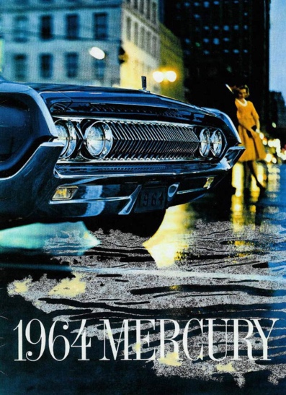

The advertisement, encompassing the 1964 built Mercury automobile contains a lot more than initially meets the eye. Through the inclusion of subliminal messages ,the advertisement packs in a lot more information than just the car itself.
To begin with the colour which appears the most dominant is noticeably blue. “Blue calls to mind feelings of calmness and serenity” (Colour and Meaning, John Gage). This portrayal of calmness is key to the advertisements goals to show the masses that driving this vehicle is a calming occasion. Also the feeling of calm portrayed can signify what a life with this automobile can be like. No worrying about how to get anywhere as by owning the car, as your life will be made easy as you journey around in its comfortable atmosphere. Altogether the usage of the colour blue in the advertisement clearly tells the viewer a lot about what their life can be like with owning the vehicle.
Furthermore the presence of the main contrasting colour plays a dominant part of the overall scene. This is the yellow dress worn by the young blonde woman in the background. Although she is very much pushed into he background in the advertisement, her role is very much of importance. To begin with, “Its enthusiasm, and enlightenment and yellow is – in practical terms the opposite of dark and dull”. (The symbolism of Color, Ellen Conroy). This quote suggests that the young man would harbour a great degree of enthusiasm. Not only to get in the car and enjoy it personally, but to get the woman also whom he would be trying to impress by using the car to lure her into becoming his girl. The colour yellow would also help to get the viewer enthusiastic about owning the vehicle also.
On another note, the colour yellow is used to grab attention. This is clearly used by the advertisement, not only to grab the viewers attention towards the car, but to grab the attention to what is an otherwise dark scene. The inclusion of the young, attractive, blonde woman wearing this attention grabbing colour also is used to lure the cars dominant clientele, young men, to want to obtain this car for themselves. The woman is key for this role as they have been used to advertise various things for many decades before this advertisement was conceived.
Regarding women of the era of the advertisement, the way the man is looming over her is suggesting that he needs to look after her. Women of the era were still seen as very much second rate citizens in comparison to their male counterparts. “women are nothing but mere machines for producing children “(Napoleon Bonaparte, Cutting Remarks, Maria Leach). Although this quote is from many years before the advertisement, the simplistic and very old fashioned views on which men have had on women have in many senses stayed the same over the years, and women’s role within society was not great during the 1960s. Linking back to the advertisement, it is clearly the man dominating the woman ,not the other way round. This shows that the man is in charge. This suggests that the man would purchase the car and that women were not allowed to do so.
Lastly women of the era would not be allowed to drive. Again this is men’s downgrading attitude’s towards women. By the inclusion of both sexes in the advertisement it showcases the car to them both appropriately. The man wants the car for himself, plus to gain popularity with women, whereas women want their men to obtain the said car for them to enjoy.
To conclude, the advertisement is very much of its time. The way it’s catering for both sexes, plus the way it is advertised towards them both respectively. What’s clear is that it’s a very clever add that would greatly succeed to selling the automobile to the public.

Bibliography And References

Gage John , Color and meaning: art, science and symbolism, Thames & Hudson, 2013.
Conroy Ellen, The symbolism of Color, Newcastle pub. 1996.
Leach Maria, Cutting Remarks: a miscellany of quotations from life and literature, Michael O’Mara, 2003.

