

Assignment Title: Accounting Fundamentals

Module Code: LCBB4001
Module Lecturer: Dr. Emad Elkhashen
Student name: Milena Valentinova Ilieva
Student ID: 2231625

Table of Contents
Introduction 3
Question 1 4
b) financial position balanced 5
Question 2 7
a) Ratio analysis of Sweets Plc 7
b) Financial Performance of Sweet Plc 9
Conclusion 14
Reference 15

Introduction
The financial statements of a corporation are a crucial resource for investors, creditors, analysts, and other parties interested in the firm's future (Al Karaawy and Al Baaj, 2018). The existing assignment specification necessitates that this report be broken down into two distinct sections. The first section focuses on the depiction of a company's financial situation via the use of income statements and balance sheets of Wales plc. In the report's second section, financial performance review and ratio analysis for businesses are shown as having major applications.

Question 1
a) The purpose of a company's financial statement is to describe the company's financial situation at the end of the accounting period covered by the statement. GAAP and IFRS provide forth the foundation for how such financial statements should be kept and reported (Karaawy and Baaj, 2018).
Financial statements for Wales PLC, as required by law, have been calculated in line with the data in the balance sheet as of the 31st of December, 2022.
Wales Plc
Income Statement
For the year ended 31st Dec 2022
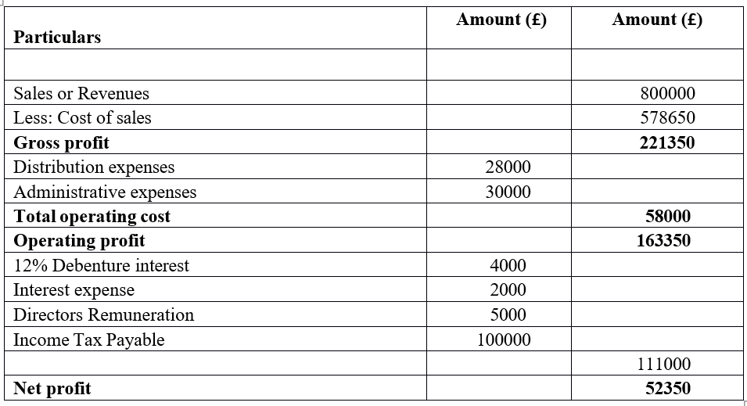
Wales PLC
Balance sheet
For the period ended 31-12-22
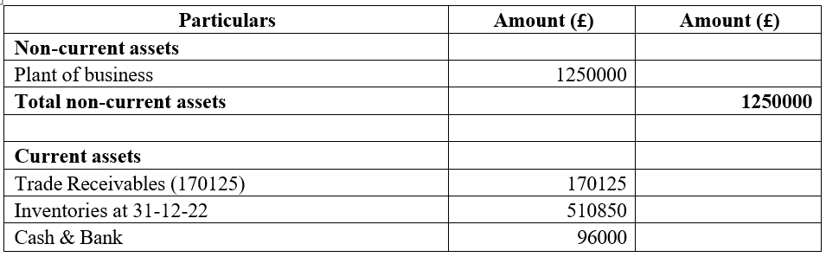
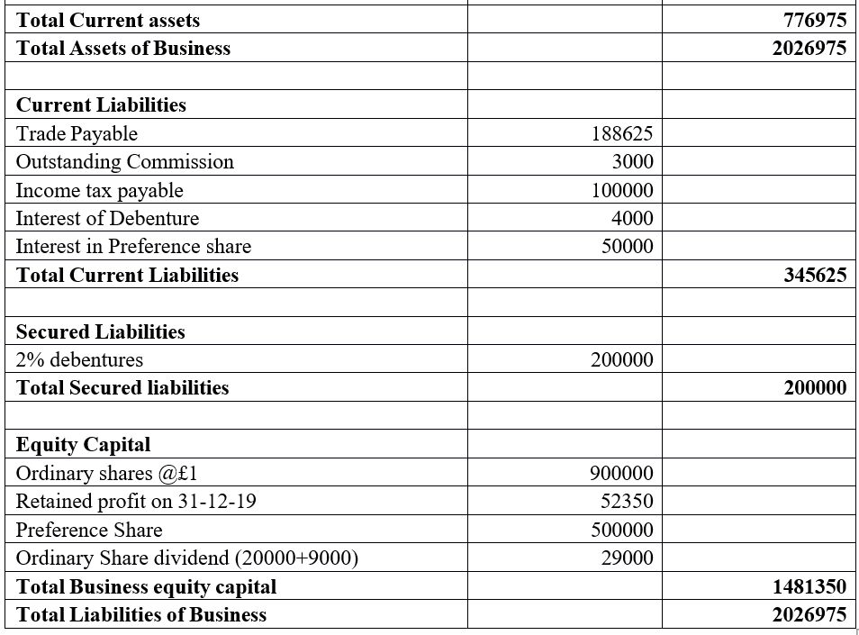

b) financial position balanced
The balance sheet, or statement of financial position, is a key financial report that gives an overall picture of a company's financial health as of a certain date (Bionda and Mahdar, 2017). The notion of double-entry accounting is important to the balance sheet since it guarantees that the statement balances when all assets, liabilities, and equity are equal.
Assets = Liabilities + Equity is the fundamental accounting equation that underlies the balance sheet. A company's assets are funded by its obligations and owner equity, as shown by this equation. The entire amount of debits must always match the total value of credits whenever a business makes a financial transaction (Drake et al., 2017). This is how the formula works:
Assets: Cash, accounts receivable, inventory, property, and equipment are all examples of what a firm "owns" or "controls." The left side of the equation (assets) becomes larger as the value of those assets grows.
Liabilities: Accounts payable, loans and accrued costs are all examples of the company's liabilities. The right side of the equation (the liabilities) grows as a result of the growth in obligations.
Equity: Owners' equity, or net worth, is the amount of a company's assets left over after all obligations have been paid. It consists of the owner's investments and any retained profits. When equity rises, it moves to the right side of the equation (Drake et al., 2017).
There is always a left-hand (debit) and right-hand (credit) entry in a financial transaction. If a business borrows money from a bank, it will have a rise in both its cash on hand (an asset) and its loan payable (a liability) as a result of the transaction. Sales revenue is recorded as a credit to equity (retained profits) and a debit to the company's assets (cash or accounts receivable).
Meticulous record-keeping, precise posting of transactions, and persistent application of the double-entry concept produce a balanced balance sheet. Accountants and finance experts check that the books are balanced before releasing financial statements. In the event of any discrepancies or omissions in the books, this balance may be used as a quick and easy error check (Bionda and Mahdar, 2017). Every monetary transaction must have equal and opposite effects on at least two accounts, according to the fundamental concept of double-entry bookkeeping, which ensures that the balance sheet always balances. In addition to ensuring reliable financial reporting, this equilibrium gives useful information about a company's resources, liabilities, and cash flow.

Question 2

a) Ratio analysis of Sweets Plc
- ROCE

 | 2021 | 2020
Profit before interest and tax | 805 | 699
Equity + long-term loans | 3088+4137 = 7225S | 2912+ 4129 = 7041
Ratio | 11.14% | 9.93%

- Return on equity
 | 2021 | 2020
Net profit after tax | 431 | 366
Equity Capital | 3088 | 2912
Ratio | 13.96% | 12.57%

- EPS
 | 2021 | 2020
Net profit after tax | 431 | 366
Equity Capital | 600 | 600
Ratio | 71.83% | 61%

- Net profit margin

 | 2021 | 2020
Net profit | 431 | 366
Revenues | 6,738 | 6,441
Ratio | 6.40% | 5.68%

- Assets Turnover ratio

 | 2021 | 2020
Revenues | 6,738 | 6,441
Total assets | 9736 | 10087
Ratio | 0.69 | 0.64

- Stock holding period
 | 2021 | 2020
Inventories | 708 | 659
Cost of sales | 6,738 | 6,441
Ratio | 38 days | 37 days

- Debtor collection period
 | 2021 | 2020
Trade receivables | 1,249 | 1,287
Revenues | 6,738 | 6,441
Ratio | 67 days | 73 days

- Current ratio
 | 2021 | 2020
Current assets | 2303 | 2355
Current Liabilities | 2511 | 3046
Ratio | 0.92 | 0.77

- Gearing ratio
 | 2021 | 2020
Fixed interest-bearing funds | 4137 | 4129
Equity capital of business | 3088 | 2912
Ratio | 133.97% | 141.79%

- Interest cover ratio
 | 2021 | 2020
Profit before interest and tax | 805 | 699
Financial cost | 226 | 186
Ratio | 3.56 | 3.76

b) Financial Performance of Sweet Plc
ROCE
The Return on Capital Employed (ROCE) for Sweet Plc is a crucial financial indicator used to evaluate the efficacy and profitability of the firm's use of its capital resources (Evana et al., 2019). Sweet plc’s ROCE was 9.93% in 2020 and in 2021 it was 11.14%. This growth indicates that the firm is doing a better job of converting its capital into profit. It suggests that with better management, cost controls, or strategic choices, operational performance may improve, or that resources may be allocated more effectively.
As the Return on Capital Employed (ROCE) increases, it shows that the firm is doing well financially. But things like liquidity, solvency, and overall profitability should also be taken into account when evaluating a company's financial health (Karaawy and Baaj, 2018). Sweet Plc's competitive position and its potential to produce wealth for its shareholders may be better understood by analysing patterns over time and comparing the return on capital employed (ROCE) to industry standards.
Return On Equity
The Return on Equity (ROE) for Sweet Plc is an essential profitability number as it displays how much profit a business generates in comparison to the amount of equity its shareholders have invested (Karaömer and Özbirecikli, 2019). This ratio indicates the efficiency with which a corporation returns capital to its shareholders.
Sweet Plc's Return on Equity (ROE) in 2021 was 13.96%, up from 12.57% in 2020. The capacity to create bigger profits from shareholders' equity has increased, as shown by this increase. Increases in return on equity (ROE) often indicate improved efficiency in the use of capital. Rising return on equity is indicative of a strong financial position and proof that the business can sustainably deliver value to its investors. It is important to consider other financial metrics, such as debt levels, liquidity, and market circumstances, in addition to ROE when assessing Sweet Plc's financial health and performance (Evana et al., 2019). Sweet Plc's competitive position and its capacity to build sustainable shareholder value may be gauged by looking at trends and comparing the return on equity to that of competitors in the same sector.
EPS
Earnings per share (EPS) for Sweet Plc is an important financial indicator since it shows how much of the company's earnings are distributed to each share of ordinary stock (Karaawy and Baaj, 2018). Increased per-share profitability is shown in an EPS growth from 61% in 2020 to 71.83% in 2021. This expansion could result from improved profitability, better control of expenses, or even just more money coming through the door.
Increases in profits per share (EPS) are indicative of a healthy financial situation, as they show that shareholders are seeing a better return on their investment. However, the market, debt, and overall profitability should all be part of any thorough examination (Karaömer and Özbirecikli, 2019). Sweet Plc's financial performance and its potential to produce value for shareholders may be better understood by examining EPS trend lines over time and comparing them to industry rivals.
Net profit Margin
The Net Profit Margin for Sweet Plc is a key financial number because it indicates the proportion of revenue that is kept as profit after subtracting all costs. A rise in the net profit margin from 2020's 5.68% to 2021's 6.40% is indicative of better profitability and cost management (McEnroe and Mindak, 2020). This expansion could come from leaner processes, smarter pricing, or lower overhead costs.
A higher net profit margin is indicative of a stronger financial situation since it shows that a greater proportion of revenues is being turned into profits. However, aspects like liquidity, leverage, and market dynamics should be taken into account for a thorough assessment (Munir, 2018). The financial health of Sweet Plc and its ability to create stable profits may be evaluated by looking at the company's net profit margin in comparison to industry averages over time.
Asset Turnover
The Asset Turnover ratio for Sweet Plc provides insight into how well the firm turns its assets into cash. Asset Turnover is expected to rise from 0.64 in 2020 to 0.69 in 2021, indicating enhanced effectiveness in transforming assets into revenue (ÖZEVİN, 2020). Better inventory management, more sales, or smarter use of resources are all possible causes of this improvement.
Increases in revenue per used unit of assets (as measured by Asset Turnover) point to improving financial health. However, other financial factors like profitability and market circumstances should be taken into account for a more in-depth examination (McEnroe and Mindak, 2020). One may get a sense of Sweet Plc's operational efficiency and its ability to optimise asset utilisation for sustainable revenue development by looking at the trajectory of its Asset Turnover over time and comparing it to similar companies in its sector.
Stock Holding Period
The Stock Holding Period for Sweet Plc, sometimes referred to as Inventory Turnover, is the time it takes to sell all of the company's inventory and buy new stock (Munir, 2018). In 2021, the average time it takes to sell inventory is projected to be 38 days, up from 37 in 2020. Reasons for this may include shifts in demand, disturbances in the supply chain, or changes to inventory management strategies.
Stock Holding Periods that are longer than the industry average may reflect a conservative stance towards inventory management (ÖZEVİN, 2020). While this may reduce working capital, avoiding the dangers of having too much inventory on hand may indicate a more conservative financial position.
Debtors Collection period
Debtors Collection Period, or Days Sales Outstanding (DSO), is a metric used to evaluate how long it typically takes Sweet Plc to be paid by its customers after a transaction (Öztürk and Karabulut, 2018). The improvement in accounts receivable collection times is seen in the reduction from 73 days in 2020 to 67 days in 2021.
This decline may be attributable to better credit management, more efficient billing and payment processes, or a higher quality clientele. Shortening the time it takes to collect payments has a beneficial effect on Sweet Plc's finances since it increases the company's cash flow and the efficiency with which it uses its working capital (Pinto, 2020). To get a full picture of the company's financial health and its capacity to handle receivables, this ratio should be evaluated with other liquidity and operational indicators.
Current Ratio
The Current Ratio for Sweet Plc is a measure of the company's ability to meet its short-term obligations using its most liquid assets (Pinto, 2020). The strengthening in the company's short-term liquidity situation is shown by the rise in the Current Ratio from 0.77 in 2020 to 0.92 in 2021.
Sweet Plc has a considerably superior ability to satisfy its short-term commitments, as measured by the Current Ratio. However, if the ratio is less than 1, it suggests that the corporation still has some trouble meeting its short-term obligations with its current assets (Öztürk and Karabulut, 2018).
While this improvement is encouraging, the Current Ratio should be considered in combination with other measures of liquidity and financial health. Sweet Plc's overall financial status and its capacity to handle short-term financial obligations might be better understood with the help of a thorough investigation.
Gearing Ratio
The Gearing Ratio of Sweet Plc (sometimes denoted as the Debt-to-Equity Ratio) indicates the extent to which debt financing has been used concerning total capital (Robinson, 2020). Relying less on debt to fund operations is shown by a decline in the Gearing Ratio from 141.79% in 2020 to 133.97% in 2021.
A lower Gearing Ratio is indicative of a more secure financial situation. A lower level of debt suggests that Sweet Plc is more financially secure and better able to withstand economic storms (Sunjoko and ARILYN, 2016).
Interest Coverage Ratio
To what degree may interest costs be covered by earnings before interest and taxes (EBIT) at Sweet Plc is shown by calculating the Interest Coverage Ratio. Although still comfortably able to cover its interest obligations, the company's Interest Coverage Ratio will decrease from 3.76 in 2020 to 3.56 in 2021 (Robinson, 2020). A minor decline may be attributable to greater interest expenses or decreased EBIT, but the ratio is still over 1, indicating that the company is producing enough money to pay its interest.

Conclusion
The financial statements of a firm may provide light on its strengths and shortcomings, which can help with strategic planning, risk management, and decision-making in general (Yudawisastra et al., 2018). The income statement, financial condition, and balance sheet of Wales Plc have all been calculated and explained in this report. An in-depth look into Sweet Plc's financial ratios reveals the company's robustness and potential for expansion. Prudent financial management is shown by the decrease in Gearing and Debtors Collection Period.

Reference
Al Karaawy, N.A.A. and Al Baaj, Q.M.A., 2018. The Impact of International Taxation Systems Variations on the Application of Financial Accounting Principles. Academy of Accounting and Financial Studies Journal, 22(2), pp.1-11.
Bionda, A.R. and Mahdar, N.M., 2017. Pengaruh gross profit margin, net profit margin, return on asset, dan return on equity terhadap pertumbuhan laba pada perusahaan manufaktur di bursa efek indonesia. Kalbisocio Jurnal Bisnis dan Komunikasi, 4(1).
Drake, M.S., Quinn, P.J. and Thornock, J.R., 2017. Who uses financial statements? A demographic analysis of financial statement downloads from EDGAR. Accounting Horizons, 31(3), pp.55-68.
Evana, E., Metalia, M. and Mirfazli, E., 2019. Business Ethics in Providing Financial Statements: The Testing of Fraud Pentagon Theory on the Manufacturing Sector in Indonesia. Business Ethics and Leadership, 3(3), pp.68-77.
Karaawy, N.A.A.A. and Baaj, Q.M.A.A., 2018. The impact of international taxation systems variations on the application of financial accounting principles. Academy of Accounting and Financial Studies Journal, 22(2), p.1z.
Karaömer, Y. and Özbirecikli, M., 2019. Effects Of Financial Reporting Differences In Between BOBI FRS And MSUGT On Financial Statement Analysis: An Investigation On Financial Structure Ratios. Muhasebe ve Vergi Uygulamalari Dergisi (MUVU)/Journal of Accounting & Taxation Studies (JATS).
McEnroe, J.E. and Mindak, M., 2020. An empirical analysis of an application of an alternative measurement model on international accounting standard 33, earnings per share. Accounting Research Journal.
Munir, M.H., 2018. Holding period, Stock market illiquidity and Disposition effect in Karachi Meezan Index (KMI) (Doctoral dissertation, CAPITAL UNIVERSITY).
ÖZEVİN, O., 2020. A Model Recommendation On Determination Of Manipulation Risk In Financial Statements: BIST Application. Journal of Accounting & Finance, (87).
Öztürk, H. and Karabulut, T.A., 2018. The relationship between earnings-to-price, current ratio, profit margin and return: an empirical analysis on Istanbul stock exchange. Accounting and Finance Research, 7(1), pp.109-115.
Pinto, J.E., 2020. Equity asset valuation. John Wiley & Sons.
Robinson, T.R., 2020. International financial statement analysis. John Wiley & Sons.
Sunjoko, M.I. and ARILYN, E.J., 2016. Effects of inventory turnover, total asset turnover, fixed asset turnover, current ratio and average collection period on profitability. Jurnal Bisnis dan Akuntansi, 18(1), pp.79-83.
Yudawisastra, H.G., Manurung, D.T. and Husnatarina, F., 2018. Relationship between value added capital employed, value added human capital, structural capital value added and financial performance. Investment management and financial innovations, (15, Iss. 2), pp.222-231.

