EXAMINATION SOLUTIONS
(to accompany the examination paper sent to the external examiner
but NOT to be seen by students)

Programme: | BSc Cloud Computing | Level: | 5
Module: | Local Area Networks (ACCC5002)
Author: | Arya Sedigh | Sem: | February 16 Term

Q 1 |  | Marks
a  b | 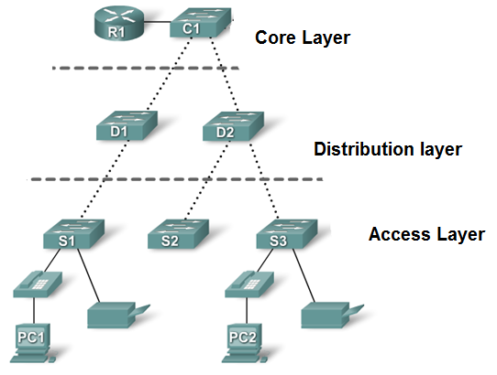  Core layer:  The core layer of the hierarchical design is the high-speed backbone of the internetwork. The core layer is critical for interconnectivity between distribution layer devices, so it is important for the core to be highly available and redundant. The core area can also connect to Internet resources. The core aggregates the traffic from all the distribution layer devices, so it must be capable of forwarding large amounts of data quickly.  Distribution layer:  The distribution layer aggregates the data received from the access layer switches before it is transmitted to the core layer for routing to its final destination. The distribution layer controls the flow of network traffic using policies and delineates broadcast domains by performing routing functions between virtual LANs (VLANs) defined at the access layer.  Access layer:  The access layer interfaces with end devices, such as PCs, printers, and IP phones, to provide access to the rest of the network. The main purpose of the access layer is to provide a means of connecting devices to the network and controlling which devices are allowed to communicate on the network.  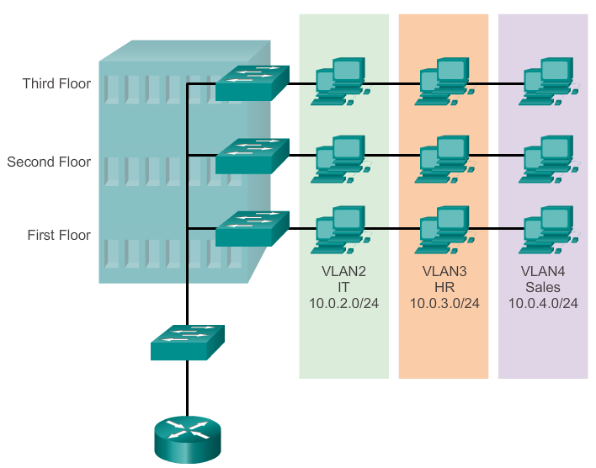  VLAN Definition:  - Logical partition of a layer 2 network.  - Each VLAN is a broadcast domain, usually with its own IP address.  Benefits:  - Security  - Cost Reduction  - Higher performance  - Broadcast storm mitigation  - Improved IT staff efficiency  - Simpler project or application management | 3  4  4  4  3  2  5

Q 2 |  | Marks
a  b | - Cisco developed PVST+ so that a network can run an STP instance for each VLAN in the network.  - With PVST+, more than one trunk can block for a VLAN and load sharing can be implemented.  - However, implementing PVST+ means that all switches in the network are engaged in converging the network, and the switch ports have to accommodate the additional bandwidth used for each PVST+ instance to send its own BPDUs.  - A network can run an independent IEEE 802.1D STP instance for each VLAN in the network.  - Optimum load balancing can result.  - One spanning-tree instance for each VLAN maintained can mean a considerable waste of CPU cycles for all the switches in the network. In addition to the bandwidth that is used for each instance to send its own BPDU.  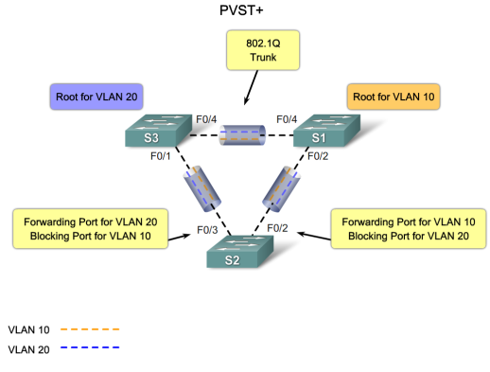  1. VTP Domain - Consists of one or more interconnected switches. All switches in a domain share VLAN configuration details using VTP advertisements. A router or Layer 3 switch defines the boundary of each domain.  2. VTP Server - VTP servers advertise the VTP domain VLAN information to other VTP-enabled switches in the same VTP domain. VTP servers store the VLAN information for the entire domain in NVRAM. The server is where VLANs can be created, deleted, or renamed for the domain.  3. VTP Client - VTP clients function the same way as VTP servers, but you cannot create, change, or delete VLANs on a VTP client. A VTP client only stores the VLAN information for the entire domain while the switch is on. A switch reset deletes the VLAN information. You must configure VTP client mode on a switch.  4. VTP Transparent - Transparent switches forward VTP advertisements to VTP clients and VTP servers. Transparent switches do not participate in VTP. VLANs that are created, renamed, or deleted on transparent switches are local to that switch only.  5. VTP Pruning - VTP pruning increases network available bandwidth by restricting flooded traffic to those trunk links that the traffic must use to reach the destination devices. Without VTP pruning, a switch floods broadcast, multicast, and unknown unicast traffic across all trunk links within a VTP domain even though receiving switches might discard them. | 2  2  2  2  2  2  3  2  2  2  2  2
Q 3 |  | Marks
a  b | Traditional Inter-VLAN routing:  Traditionally, LAN routing has used routers with multiple physical interfaces. Each interface needed to be connected to a separate network and configured for a different subnet.  In a traditional network that uses multiple VLANs to segment the network traffic into logical broadcast domains, routing is performed by connecting different physical router interfaces to different physical switch ports  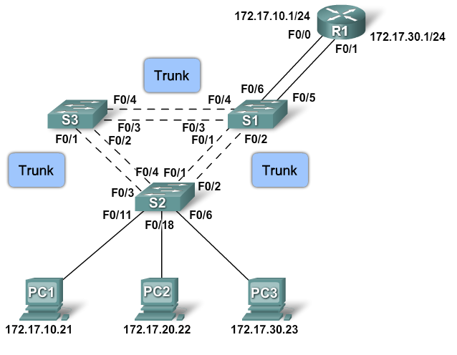  ‘Router-on-a-Stick’ Inter-VLAN routing  "Router-on-a-stick" is a type of router configuration in which a single physical interface routes traffic between multiple VLANs on a network.  The router interface is configured to operate as a trunk link and is connected to a switch port configured in trunk mode.  The router performs the inter-VLAN routing by accepting VLAN tagged traffic on the trunk interface coming from the adjacent switch and internally routing between the VLANs using subinterfaces.  The router then forwards the routed traffic-VLAN tagged for the destination VLAN-out the same physical interface  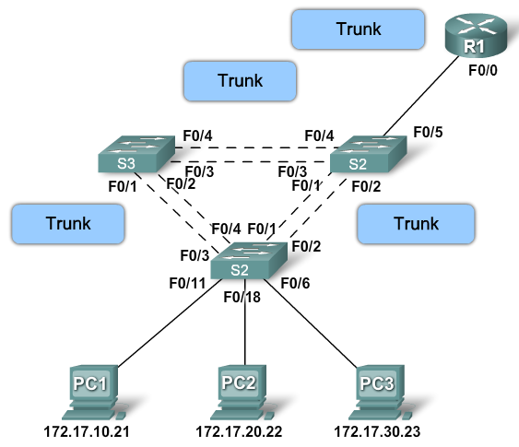  Switch-based Inter-VLAN routing  Some switches can perform Layer 3 functions, replacing the need for dedicated routers to perform basic routing on a network. Multilayer switches are capable of performing inter-VLAN routing  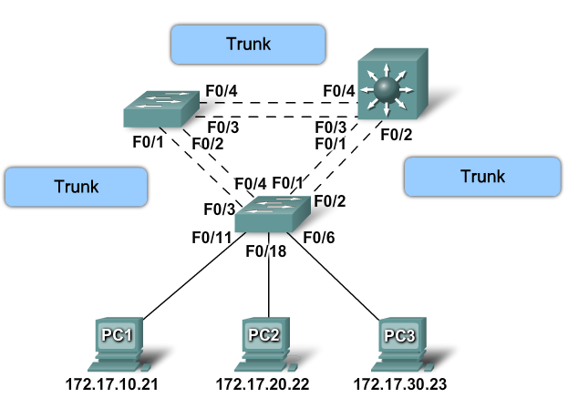  - EtherChannel must be supported.  - Speed and duplex must match.  - VLAN match – All interfaces are in the same VLAN.  - Range of VLAN – Same range on all interfaces.  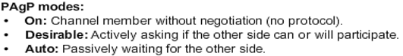 | 3  2  2  3  2  3  4  6
Q 4 |  | Marks
a  b  c | 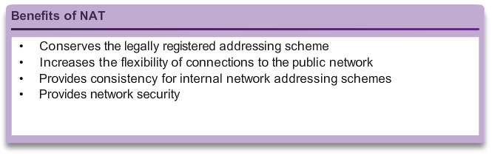  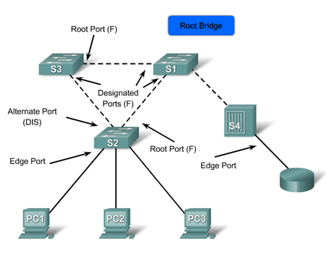  Root ports do not use the link type parameter. Root ports are able to make a rapid transition to the forwarding state as soon as the port is in sync.  Alternate and backup ports do not use the link type parameter in most cases.  Designated ports make the most use of the link type parameter. Rapid transition to the forwarding state for the designated port occurs only if the link type parameter indicates a point-to-point link.  A RSTP edge port is a switch port that is never intended to be connected to another switch device. It immediately transitions to the forwarding state when enabled.  DHCP requests are failing, because the DHCP server is on a different network than Host1.  To resolve this issue, the Gateway router should be configured as a DHCP relay, using the ip helper command, to forward the DHCP requests of Host1 to the DHCP server. | 4  6  2  2  2  2  1  6
 |  | 100

