
Sam Tucker
Student number -2018390

Assignment one
lecturer- Deborah Hughes
Modern and traditional construction
Module -ACBA 5000

Table of Contents
1.0 Executive Summary 2
2.0 Procedure 2
3.0 Findings 2
3.1 Primary structure introduction 2
3.1.1 Foundation choice 3
3.1.2 Structural steel frame and structural elements 4
3.1.2.1 Columns, beams, walls, floor and roof 5
3.1.3 Structural steel fireproofing 7
3.1.4 Structural steel Connections 7
3.1.5 Strategy towards wind loading 9
3.2 System of enclosure 9
3.2.1 Introduction to system enclosures 9
3.2.2 Infill walling 10
3.2.3 Timber effect rainproof cladding 11
3.2.3 The roof deck 11
References 13
Appendix 14
Appendix A – Location of Foundation piles in case study (One floor only) 14
Appendix B – Location of steel elements in case study (One floor only) 15
Appendix C- Wind calculations for Case study to BS 6399: Part 2:1997 16
Appendix D – Minimum U-value Values from Approved Document L1A 17

Executive Summary

This report is split into two parts. Main objective of part one is to briefly describe a system of primary structure I consider appropriate for the case study provided, to which will also include my choice of foundation type, structural elements and an appropriate strategy towards the accommodation of wind loads. Main objective of part two is to describe a system of enclosure I consider appropriate, conducive to the primary structural chosen. Drawings, details and plan annotations aid the text throughout the essay.

2.0 Procedure

This assignment has been derived from background reading, online resource lists given, books, revision of corresponding course lecture notes and content uploaded onto Microsoft Teams.

3.0 Findings

3.1 Primary structure introduction

A primary structure can be briefly defined as all of the structural components in a building, necessary in order to keep the structure standing and to support a load. Erection of primary structures falls under the building regulations Approved Document A for structure and states “The building shall be constructed so that the combined dead, imposed and wind loads are sustained and transmitted by it to the ground , safely and without causing such deflection or deformation of any part of the building, or have such movement of the ground , as will impair the stability of any part of another building” (Government, 2010). My recommendation for the Case study primary structure would be that of structural steel.

3.1.1 Foundation choice

A foundation of a structure can be classified as shallow or deep foundations, defined as “That part of the structure in direct contact with the ground and which transmits the load of the structure to the ground” (Tomlinson, 2001).Irrelevant on size of structure, foundations need to be designed. The main objectives of foundation design are to ensure the total loads, both dead or imposed are calculated and how the bearing characteristics of the ground, economic effects or constraints, along with the total loads may affect the choice of foundation choice. Based on the information obtained within the bore hole logs provided within the assignment brief, the recommended foundation detail for the case study would be that of frictional piling with a pile cap under each structural column, due to the depth of suitable end bearing ground at too far of a depth to practically bore to. I recommended due to the location of the site being adjacent to buildings that a replacement method is used instead of displacement as to not cause vibrations, thus the possibility to cause ground movements affecting surrounding utility services or foundations. As the ground is mostly made ground to a depth of 5 meters, use of a supporting casing would minimalize falling strata. All works should comply with Approved Document C, Site preparation and resistance to contaminants and moisture 2010 Edition with 2013 Amendments where it states the preparation of the site will depend on the findings of the site investigation. The site investigation is relevant to Sections 1, 2 and 3 of this Approved Document and also to the requirements of Approved Document A with respect to foundations “ (Government, 2010, p. 18). See Figure 1 for foundation detail including column fixing detail and Appendix A for foundation locations annotated on Case study plans provided.

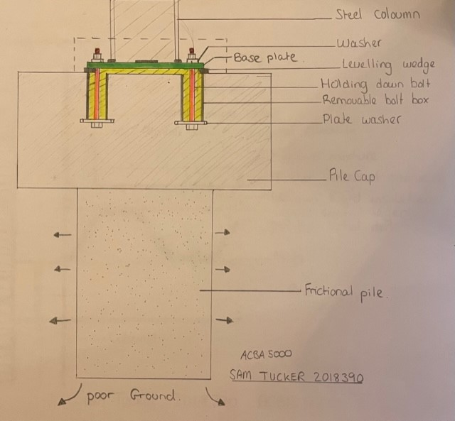
Figure 1

3.1.2 Structural steel frame and structural elements

Structural steel framed buildings are typically referenced by a “grid system that uniquely identifies each steel column and beam section” (R.Chudley, 2011, p. 52). This design means the steel can be easily set out accurately and more efficiently. Unlike Concrete Framing, more accuracy is needed during the erection of Steel frames due to them cast and cut to lengths offsite, although offsite construction in a controlled environment should give the higher accuracy needed compared to on site formwork. This accuracy is highlighted by the tolerance for steelwork connections to the Pad foundations being as minimal as allowing plus or minus 3mm (Cotgrave, 2021). There are many steel sections that collectively, Form the primary structure. These are hot rolled columns, Universal beams, Joists and channels. More specified beams include Open web, Perforated, Litzka and castellated beams, the later providing open areas of the beams that services can be run through. Although The steel making process has a poor impact on the environment a research by Timothy Werner Johnson determined “ based on three targeted environmental impacts , the study concludes that steel is better and a more sustainable building material in the pre-use phase building development” (Johnson, 2006, p. 113) The primary reference documents to follow for steel framing are the Code of Practice for Erection multi-storey Buildings , Handbook of Structural steelwork both of which has been produced by the British Constructional Steelwork Association and endorsed by the HSE and the Eurocode 3: Design of steel structures BS EN 1993. See figure for structural frame and structural element locations annotated on Case study plans provided.

3.1.2.1 Columns, beams, walls, floor and roof

In relation to the case study, all concerned elements would be made in structural steel and their locations shown in Appendix B The columns, members rolled with parallel flanges stand vertically and carries its primary load in compression or tension parallel to its axis. Beams commonly transfer loads from the structure floors and roof to the columns. Steel beam members can span up to eighteen meters, but the most usual range of steel beam spans range between three and nine meters in length (Gary.S.Berman, N.D).The main floors used for steel framed buildings are pre cast concrete or composite steel deck with in-situ concrete screed. For the case study a deep corrugated steel decking is connected to the lower flange of the supporting beam by shot fired fixings and “galvanised on both sides to protect from corrosion” (Cotgrave, 2021, p. 294), topped with concrete poured in -situ with integrated mesh for additional reinforcement. See Figure 2 for detailed section drawing. The advantages of such a steel deck system are the speed of construction along with the safer alternative as the decking acts as a safe working platform, thus abiding by the CDM regulations 2015 for safer approaches to work. Also ease of attachment for services and duct runs (R.Chudley, 2011) can be connected to the underside of the deck allowing easier adaption and dismantlement over the whole life cycle of the building and encouraging sustainability. All internal wall plasterboard lining to stud framed walls satisfies the Building Regulations approved document B “as a material of limited combustibility with a class 0 rating for surface spread of flame. The plasterboard dry walling should completely protect any combustible timber components such as sole plates” (Grenno, 2020, p. 597)To comply with Approved Document E for Resistance to passage of sound, additional soundproofing measures like robust detail or sound resistance boards can be used (Government, 2010).The roof structure provides support to the roof and transmits the dead and applied loads through the main structure for the case study the roof structure will be steel deck, where the roof is formed by a framework of supporting beams. Durability and ability to construct without need for secondary support being the advantages. The roof covering will be covered in further detail in part B of this assignment.

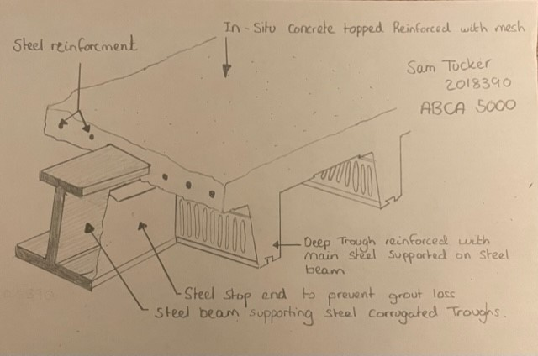
Figure 2

(R.Chudley, 2011, p. 530)

3.1.3 Structural steel fireproofing

All elements of the structure need to comply with fire resistance periods and the regulations set out in Approved document B for the “Resistance to collapse (loadbearing capacity), which applies to loadbearing elements only, denoted R in the European classification of the resistance to fire performance” (Governement, 2010 amended to 2020). Although Steel as a material is non-combustible, if in close contact with fire the steel will lose its strength. The International Building Code and the BRE Report 128 ‘Guidelines for the Construction of Fire Resisting Structural Elements, gives acceptable methods of compliance (Grenno, 2020), determines how structural frames need be protected from fire in a way that preserves the stability of the building based on their connection to all essential elements of the structure. Encasing steal in concrete is a common way of Fire proofing due to the excellent fire proofing quality’s it holds, but can be costly and add time due to the formwork needed and unwanted live loads to the structure. However, Fireproofing the bolted connections to the pad foundation would be practicable and also provide greater strength and moisture resistance. For the case study, to maintain sustainability principles, my method of fire proofing the primary structure would be to cover the steel with 20mm thick vermiculite spray giving up to four hours protection, a much cheaper, quicker and sustainable option (R.Chudley, 2011).

3.1.4 Structural steel Connections

Structural connections can be classed as “shop connections or site connections and can be made using bolts, rivets or welding” (Cotgrave, 2021, p. 196).There are three bolt grades, these being 4.6, 8.8 and 10.9, all to BS EN ISO 4034. The first number represents tensile strength in N/mm2 and the second ratio between yield stress and tensile stress. The basic methods of welding include oxyacetylene and electric arc. Welds are classified as Fillet or butt welds. (R.Chudley, 2011).The design of steelwork elements and their connections is the province of the structural engineer, to whom the selection of connection type, number of bolts or size and length of weld due to desired connection strength is trusted with. Connections can be described as simple connections, semi- rigid connections, Rigid connections, Beam to beam connection, Top beam bearing connections, column to column connection and beam to column connection. In regards to the case study, Beam to beam connections would be used. This method depends on the depth of beams used, the main beam receives the secondary beam via web cleats and shop connections as shown in Figure 3. Connection to the Base pad foundation is completed by holding down bolts for the frame being concreted into the pad cap. A base plate is then required and fixed through the holes in the base plate and tightened to form the column to foundation connection as shown in Figure. 1 previously. Accuracy is paramount, although if the setting out is incorrect, epoxy resin can be used, but “some structural engineers will not allow this as the joint between bolt and the concrete is not as strong” (Cotgrave, 2021, p. 199)

Figure 3

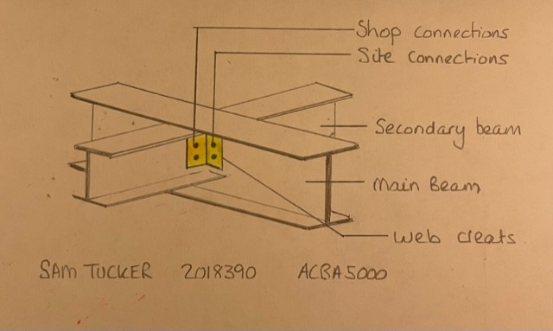
(R.Chudley, 2011)

3.1.5 Strategy towards wind loading

When designing large structures, wind loads are particularly important within design process. The wind velocity to be considered in the design of a structure depends on its geographical location. Wind load Calculations to BS 6399: Part 2:1997 can be obtained by calculation and Generic figures calculated by the use of GPS coordinates to aid the design process. See Appendix C for case study location detailing relevant calculations for roof and external walls. A braced structure as per the case study is a strong structural system commonly used in buildings subject to lateral wind loads. Members in a braced frame made of structural steel, which can work effectively both in tension and compression give the structure additional stability and rigidity. The beams and columns that form the frame carry vertical loads, and the bracing system carries the lateral loads. (Cotgrave, 2021) Due to the Case study having a large number of external windows, the bracing would be fitted internally as to not obstruct openings, with the envelope of the structure transferring the loads to the internal members to transmit the load to the supporting elements and thus to the ground through the columns.

3.2 System of enclosure

3.2.1 Introduction to system enclosures

System enclosures or also knows as the building envelope is the term given to parts of a building structure that physically separates the external environment from the interior environment. The physical components of the enclosure include, The roof, windows, doors, the above and below grade wall systems and the case floor to the building. The enclosure design is often dictated by the built environment and the aesthetic appearance and cost allowance, but must also follow the main principles, thus must be able to incorporate the control of air and heat flow both in and out if the building, be rigid and have strength, control of the water vapour flow and movement, and be resistant from fire. In addition to these main principles, considerations relating to the natural occurring phenomena, and the functions required to satisfy the users needs. Some of the environmental phenomena found to impact on enclosures include the weather, climate, wind or snow loadings, topography, seismic or noise pollutants, aerobic life forms or natural gases such as radon. Generally, enclosures are classed as being monolithic or composite assemblies where Monolithic enclosures, a single material composition, thus becoming the structure and then also external cladding and interior finishes, such as load-bearing masonry. Alternatively composite assemblies, a combination of differing materials with critical control functions, such as control of air ventilation, heat transfer and air leakage. (buildings, 2022). In relation to the case study and the building being situated in close proximity to the ocean and in an open area subject to winds, a timber effect rain proof wall cladding would be my recommended enclosure due to composite material being more durable in the environment, although not the most sustainable material to be used, in the whole life cycle of the structure, less maintenance would be needed, thus longevity of the material being my main reason for material choice.

3.2.2 Infill walling

Infill walls, a type of non -loadbearing cladding along side curtain walling and cladding. The infill wall, most commonly used in medium to high rise buildings act only to exclude weather and loads transferred to the main structure. The material choice for the infill walling can be concrete cladding panels, structural glazing, brick panels, lightweight steel or timber, The wall section is secured to the primary structure, but must also remain stable and solid in its own right and allow slight differential movement due to its dissimilar materials. This can be done by specific movement accommodation fittings and details. Each material has its unique fixing detail. For the case study, my choice of cladding is that of lightweight infill steel frame with a rainscreen cladding. The main advantages of infill walling are the speed of construction, dry construction process, no shrinkage and waste almost completely eradicated by use of cut to length C sections (www.steelconstruction.info, N.D) See Figure 4 and 5.
Figure 4 Figure 5
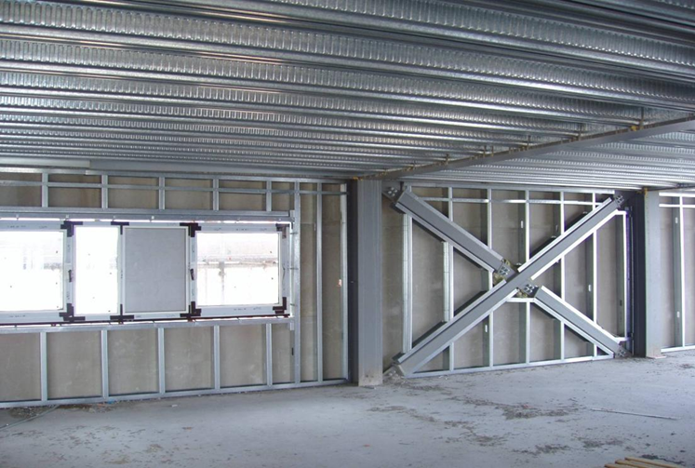
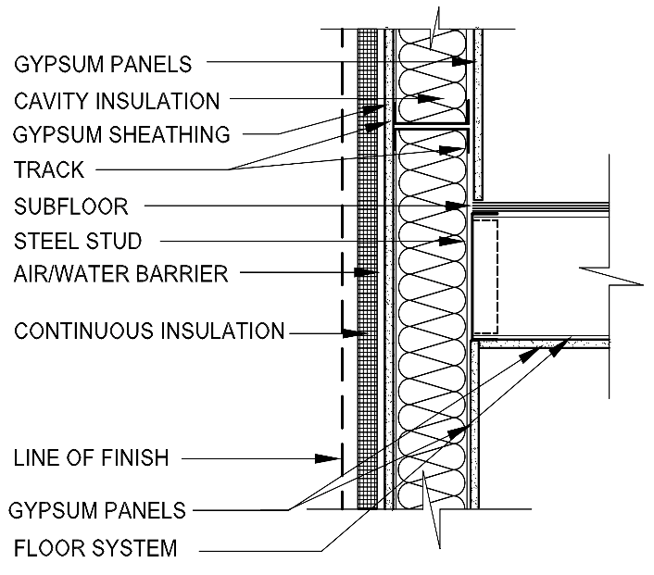
(www.steelconstruction.info, N.D) (BuildSteel, 2022)

3.2.3 Timber effect rainproof cladding

This construction technique is produced by over cladding the external walls. This concept gives the contractor and client an inexpensive loose fit weather resistant layer. The outer layer is attached to the infill walling or structural wall. This is achievable by the lightweight nature of the cladding. The cladding is vented behind to allow air flow, but also to allow any penetrated moisture to be drained without bridging the wall. The simplicity of the cladding ensures sustainability objectives are met by reuse and refurbishment with simple and economic ease of replacement and existing buildings can be extended or adapted easily.
See Figure 6 for cladding detail.

3.2.3 The roof deck

The roof deck provides a surface which the impervious roof covering is laid. In flat roof construction the “weather resistance is provided by a continuous, impervious covering” (Cotgrave, 2021, p. 342). To comply with building regulations Approved Document L1A: Conservation of fuel and power in new dwellings, where it states “In order to demonstrate compliance with regulation 25C (b), the fabric performance values must be as good as or better than the worst acceptable values set” (Government, 2016) See Appendix D for Table. It is also vital that the minimum U-value is met during the roof covering. This will be a warm deck roof. The advantage of this, “this form of construction allows the deck to be insulated against external temperature variation and the dimensional changes that can results in defects arising in the roof are more readily avoided (Cotgrave, 2021, p. 353)done in the case study by adding 110mm ridged insulation board between the profiled sheet deck, 18mm ply board and waterproofing membrane topped with asphalt roofing. Additional gravel and stone will complete the roof to harmonise with the built environment. The fall of the roof will be designed with focus points with numerous shallow channels leading to rainwater outlets. See Figure 6 for roof deck detail, adapted to suit case study from Construction handbook.

Figure 6
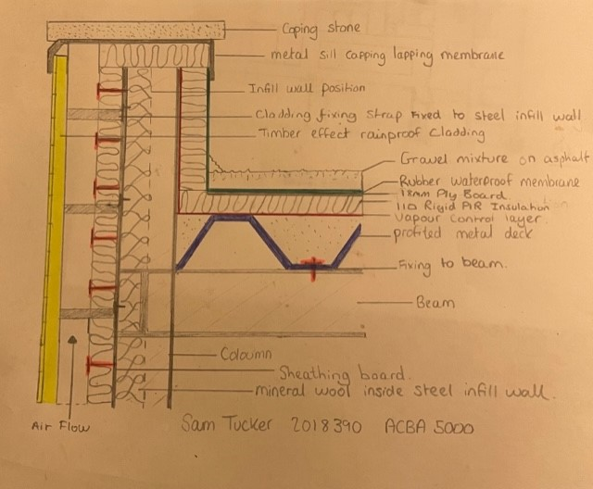
(Grenno, 2020)

References
buildings, D., 2022. Primary structure. [Online]
Available at: https://www.designingbuildings.co.uk/wiki/Primary_structure
[Accessed 22 February 2022].
buildings, d., 2022. system of enclosures. [Online]
Available at: https://www.designingbuildings.co.uk/wiki/Principles_of_enclosure
[Accessed 5 March 2022].
BuildSteel, 2022. Basic Steel Framing Details for Mid-Rise Construction. [Online]
Available at: https://buildsteel.org/technical/codes-and-standards/basic-framing-details/
[Accessed 7 March 2022].
Cotgrave, R. a., 2021. Constuction Technology 2: Industrial & commercial building. Third ed. Dublin: Bloomsbury Academic.
Gary.S.Berman, N.D. Structural steel design and construction. [Online]
Available at: https://www.wermac.org/pdf/steel2.pdf
[Accessed 25 February 2022].
Governement, W., 2010 amended to 2020. Approved Document B. [Online]
Available at: https://gov.wales/sites/default/files/publications/2021-12/building-regulations-guidance-part-b-fire-safety-volume-2-buildings-other-than-dwellinghouses.pdf
[Accessed 24 February 2022].
Government, W., 2010. Approved Document A : Structure. [Online]
Available at: https://gov.wales/sites/default/files/publications/2019-04/170403building-regs-approved-document-a-structure-en.pdf
[Accessed 18 February 2022].
Government, W., 2010. Approved Document C. [Online]
Available at: https://gov.wales/sites/default/files/publications/2019-05/building-regulations-guidance-part-c-resistance-to-contaminants-and-moisture.pdf
[Accessed 21 February 2022].
Government, W., 2010. Approved Document E. [Online]
Available at: https://gov.wales/sites/default/files/publications/2021-07/building-regulations-guidance-part-e-resistance-to-the-passage-of-sound.pdf
[Accessed 4 March 2022].
Government, W., 2016. The Building Regulations 2010. [Online]
Available at: www.labc.co.uk/sites/default/files/EXT.Approved-Document-L-2014-Conservation-of-Fuel-%26-Power-L1A-New-Dwellings.JMCN_.v1.030417.pdf
[Accessed 2 March 2022].
Grenno, C. a., 2020. Building construction handbook. Twelfth ed. London : Routledge.
Johnson, T. W., 2006. Comparison of Environmental Impacts of Steel and Concrete asBuilding Materials Using the Life Cycle Assessment method, s.l.: Timothy Werner Johnson.
R.Chudley, R., 2011. Construction technology. fith ed. London: Pearson Education.
Roofconsult, N.D. Roofconsult. [Online]
Available at: https://www.roofconsult.co.uk/calculations/wind/flatresults.asp
[Accessed 16 February 2022].
Tomlinson, M., 2001. Foundation design and construction. seventh ed. essex: Pearson Education.
www.steelconstruction.info, N.D. SteelConstruction.info. [Online]
Available at: https://www.steelconstruction.info/The_Steel_Construction_Information_System
[Accessed 6 March 2022].

Appendix

Appendix A – Location of Foundation piles in case study (One floor only)

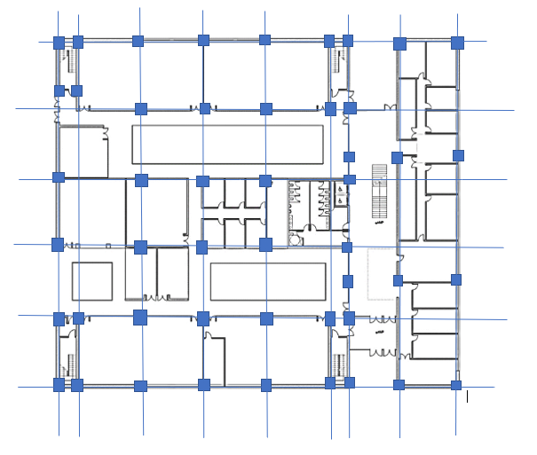
Key- Foundation pile

Appendix B – Location of steel elements in case study (One floor only)

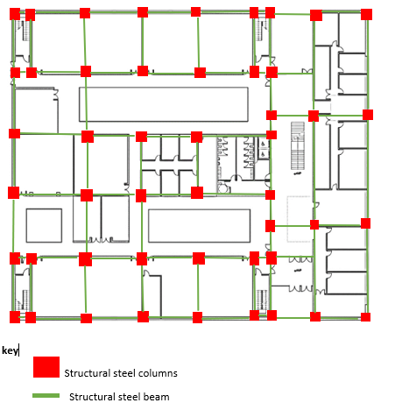

Appendix C- Wind calculations for Case study to BS 6399: Part 2:1997

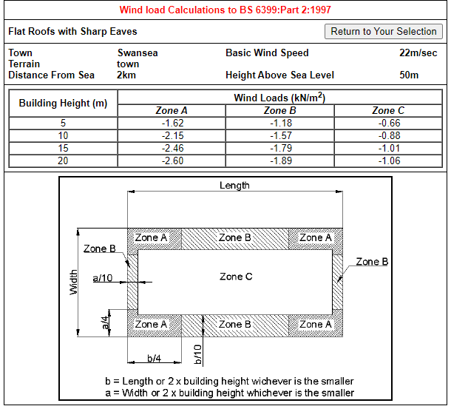
(Roofconsult, N.D)

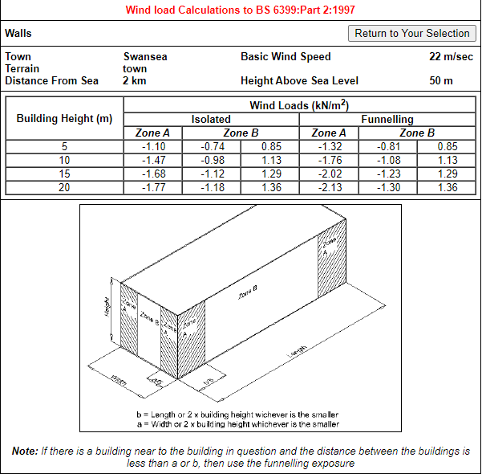
(Roofconsult, N.D)

Appendix D – Minimum U-value Values from Approved Document L1A

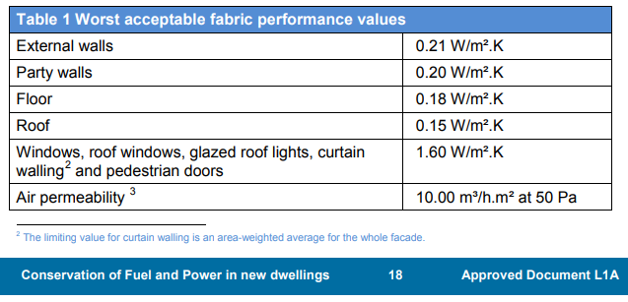

(Government, 2016)

