Task 1:
Compare the skills and knowledge listed in the two adverts:
The two job advertisements outline the essential skills and knowledge for leadership roles in customer-focused environments.
The first advertisement emphasises a strong customer care experience, including several years in a commercial setting and at least 2 years in a leadership role. Rajhi and Aljuhmani (2026) believe that effective leadership depends on clear communication, which enhances team performance, trust, and collaboration.
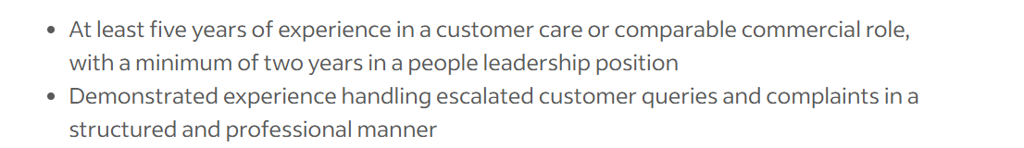
The second advertisement emphasises leadership and team development through coaching, mentoring, and performance management. It highlights the importance of achieving key performance indicators, using data for decision-making, and generating statistical reports. The role also requires strong stakeholder management skills and the ability to contribute to continuous improvement initiatives.
Identify the common skills:
Both advertisements highlight key skills such as leadership, people management, and effective communication, particularly in addressing customer escalations. While the specific responsibilities differ, both roles require candidates who can inspire teams and maintain service standards. A strong commitment to leadership and exceptional customer service is essential, along with the ability to resolve conflicts and prioritise tasks in a cross-functional environment.
Choose one shared skill and explain why that skill is important:
Effective communication is a crucial leadership skill. It allows managers to set clear expectations, provide constructive feedback, and build positive relationships within their teams. In customer environments, leaders must communicate professionally and empathetically when addressing client concerns, particularly during disputes. According to Zulkeifli et al. (2023), effective communication between managers and employees reduces misunderstandings and aligns individual efforts with organisational goals. Clear communication reduces misunderstandings, enhances operational efficiency, and promotes collaboration across departments, driving employee engagement and customer satisfaction.
I have learned that effective communication in the workplace is crucial for clarity, especially when reordering items, managing stock, and engaging with customers. Clear communication during calls, face-to-face interactions, and emails ensures that information is conveyed accurately and professionally. By speaking politely, I can provide precise information, resolve issues quickly, and leave a positive impression of the organisation. Additionally, well-structured emails help prevent misunderstandings and ensure important records are maintained. Overall, clear communication reduces errors, builds trust, improves efficiency, and enables me to manage tasks and customer interactions confidently.
To minimise errors, leaders must prioritise clear communication and confirm understanding. Using the Shannon–Weaver model (1949), team leaders can reduce communication noise by using straightforward language, providing clear explanations, and allowing for questions. Encouraging feedback helps reinforce understanding, ensuring messages are accurately received.
Effective communication is vital for team performance and customer satisfaction. For customer service leaders, mastering this skill is essential, as it enables clear communication with both staff and clients. Additionally, it furthers employee engagement and enhances customer satisfaction, making it a key strategic skill for organisational success in customer service leadership.

Task 2:
Self-Assessment SWOT Analysis:
Self-assessment is crucial for understanding my capabilities and areas for growth. Using a SWOT analysis, I can reflect on my strengths, weaknesses, opportunities, and threats regarding my employability and career development. Pluchevskaya, Varlacheva and Andrienko (2017) argue that SWOT analysis can be adapted as a tool to support personal goal achievement and well-being. This helps me strategically plan and set actionable goals to achieve my career aspirations.
Strengths
One of my key strengths lies in my Defender personality type. According to Myers and Briggs (1980), defender personality types are responsible, dependable, and detail oriented. I take pride in my ability to complete tasks accurately and consistently, and I am deeply committed to meeting deadlines. My natural empathy enables me to collaborate effectively within teams and cultivate positive relationships with colleagues and peers.
Strength | Evidence | Impact on Employability
Defender Personality | The personality test identified me as a Defender, a type known for its responsibility and dependability. | Employers value dependable employees who consistently meet deadlines and maintain steady performance.
Auditory Learner | The learning style test indicated that I learn best through listening and verbal instruction. | It helps me follow instructions accurately and communicate effectively within teams.
77% Money Motivated | Career Motivation Test result | Financial incentives promote a strong work ethic, enhance productivity, and facilitate career advancement.
Teamwork and cooperation | Experience with group work and positive feedback from peers. | Collaboration and effective workplace relationships are essential.
Academic commitment | Consistently completing assignments and attending classes. | Shows discipline, responsibility, and the ability to achieve goals.

Employers highly value traits like reliability, teamwork, and accountability. In group projects, I consistently complete tasks on time and to a high standard, highlighting my organisational skills and commitment to the team's success. Yorke (2006) believes that these behaviours reflect essential employability skills, such as time management and collaboration, which are vital for workplace success and career prospects.
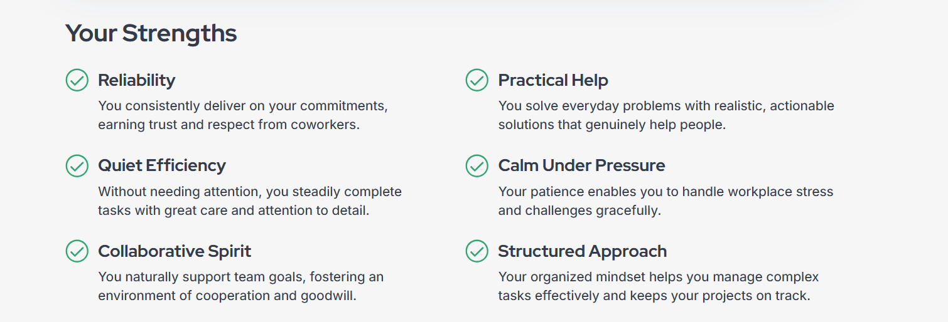
I have a strong financial motivation, as evidenced by my 77% drive for financial incentives on the Career Motivation Test. This desire for financial stability enhances my ambition, productivity, and work ethic, pushing me to seek growth opportunities and perform at a high level. Herzberg (1959) suggests that salary influences performance and purposeful behaviour, which aligns with my aspiration to advance into higher responsibility roles while also pursuing long-term job satisfaction.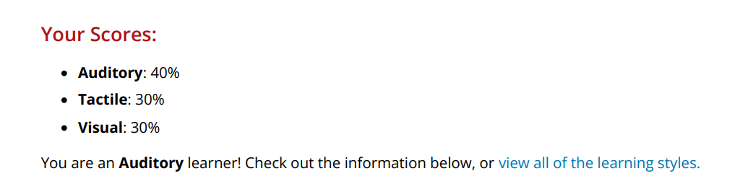
My Learning Style Test identifies me as an auditory learner, meaning I absorb information best through listening and discussions. This strength improves my participation in lectures and meetings, enhancing my communication and listening skills, which are vital for employability.
Weaknesses
As a Defender personality type, I occasionally struggle with overcommitment. My desire to assist others and ensure tasks are completed correctly often leads me to take on too much responsibility, which can result in stress and challenges with delegating work. Northouse (2019) believes that Effective managers delegate tasks to boost team performance and develop future leaders. Without improving this skill, I may struggle in future supervisory roles.
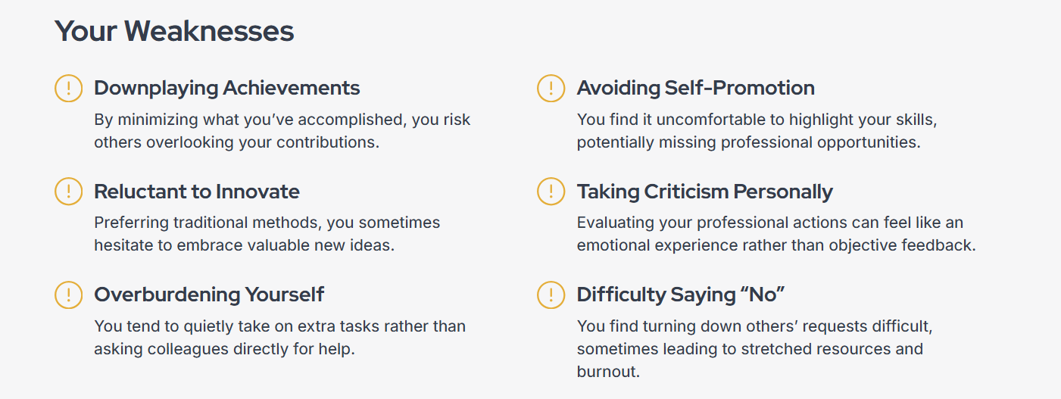
Another area of weakness is my high motivation for financial incentives, which is 77%. While financial stability is important, an overemphasis on monetary rewards can overshadow passion and job satisfaction. It is essential to balance financial ambition with personal fulfilment and meaningful career growth.
As an auditory learner, I struggle to absorb information from purely visual or written materials without discussion. Therefore, I need to adapt my study strategies and expand my learning methods.
Weakness | Evidence | Impact on Employability
A lack of confidence in unfamiliar environments. | Personal reflection and feedback. | It can impact performance in interviews and professional settings.
Overcommitment and difficulty saying no | Defender personality tendency. | It can lead to stress and reduced productivity.
Downplaying achievements | Tendency to minimise personal accomplishments in feedback or self-assessment. | It may hinder recognition of skills and contributions, limiting career advancement and visibility to potential employers.

Opportunities
I have numerous opportunities for personal and professional growth. My sense of responsibility and reliability make me well-suited for leadership roles that require trust and accountability. Pursuing employment and volunteering will help me gain practical experience, while my financial motivation drives me to seek career paths with clear advancement and rewards. By setting measurable goals, I can focus this motivation on my career progression. Additionally, recognising my auditory learning style enables me to enhance my knowledge through workshops and group discussions.
Opportunities | Evidence | Impact on Employability
University careers services | Access to CV support, workshops, and career advice | Helps improve employability skills and job readiness.
Online courses and professional training | Access to learning platforms | Helps develop new skills and improve qualifications.
Networking opportunities | Career fairs and LinkedIn | Helps build professional connections and job opportunities.

Threats
Potential threats include competitive job markets and economic uncertainty. My focus on financial rewards makes me aware that limited salary growth in some industries may affect my job satisfaction. I must continuously develop my skills while being cautious of burnout from overcommitment; unmanaged stress can diminish performance (Maslach & Leiter, 2016). Additionally, I should be wary of the risks associated with overworking and taking on extra responsibilities. Achieving a healthy work-life balance is essential for long-term success.
Weakness | Evidence | Impact on Employability
High competition in the job market | Many graduates are applying for similar roles. | Makes it harder to secure employment.
Risk of burnout due to overcommitment | Defender personality tendency to overwork. | It can affect performance and well being.
Economic uncertainty | Changing job market conditions. | May reduce the availability of job opportunities.

Conclusion
Through self-reflection, I have found that my Defender personality type, strong financial motivation, and auditory learning style shape my approach to work and study. My reliability and empathy form a solid foundation for employability. By managing my tendency to overcommit and balancing financial success with personal fulfilment, I can continue to grow both professionally and personally.

Evidence of readiness
My academic achievements reflect my discipline and commitment, demonstrating my reliability, an essential trait of my Defender personality. I have been able to attain high grades in my first semester.
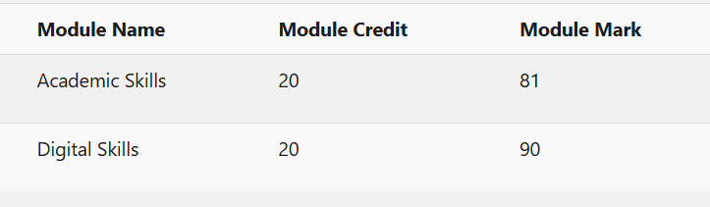
In group projects, I demonstrated teamwork, communication, and critical thinking by actively participating in discussions and contributing ideas. As the group leader in our teamwork module, I organised our team effectively, allowing us to finish ahead of schedule and have ample time to prepare for our presentation.
My work experience and volunteering have given me insights into workplace expectations, especially regarding punctuality and professionalism, which are valued in employability. Additionally, I have helped grow my current job's business and successfully launched my own online venture, achieving profitability for the first time.
After taking Tasha Eurich's quiz, I have strong self-awareness both internally and externally. To confirm this, I was advised to have someone close to me take the quiz about me. Eurich (2018) states that self-awareness is understanding one’s values and emotions while recognising how others perceive us, which enhances personal growth and relationships. My analysis indicates that I reflect on my thoughts and behaviours and am open to feedback, supporting my personal development and relationship effectiveness.
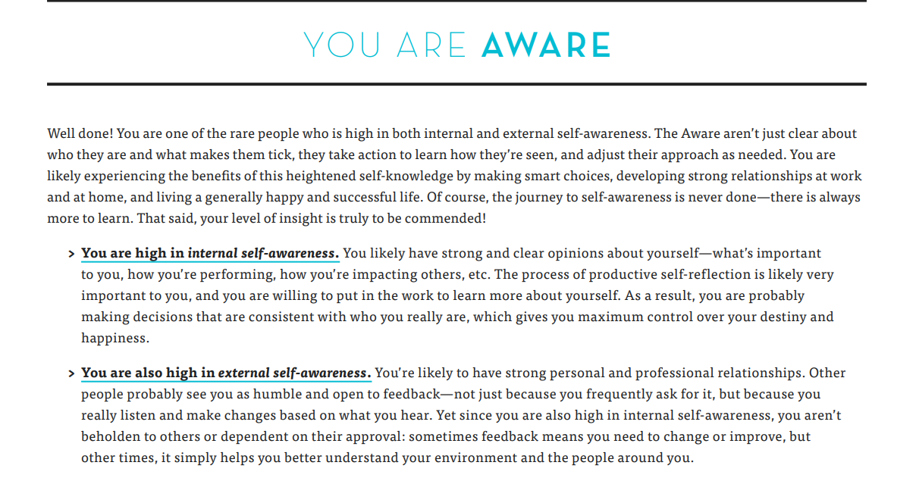

Task 3:
Employment Goals:
My SWOT analysis identifies key weaknesses affecting my employability, including a lack of confidence in unfamiliar environments, difficulty saying no due to overcommitment, and downplaying my achievements. My short-term goal is to prepare for job interviews by building confidence, effectively communicating my accomplishments, and enhancing my self-presentation skills. As highlighted by Robbins and Judge (2017), confidence is essential in professional settings, influencing both performance and adaptability. By strengthening my confidence, I will be better prepared for interviews and better able to showcase my skills.
My short-term goal is to manage overcommitment by prioritising responsibilities and setting realistic limits. While my dependability is a strength, taking on too much can lower productivity and increase stress. Locke and Latham (2002) suggest that clear goals enhance focus and performance. By effectively managing my workload, I can improve my reliability and reduce the risk of burnout.

My long-term goal is to secure a junior accountant position in the accounting and finance sector and eventually become a fully qualified accountant. This path requires attention to detail, confidence in presenting financial information, effective communication with clients and colleagues, and the ability to meet deadlines. As noted by the CBI (2021), employers value candidates who can articulate their contributions effectively. By addressing my weaknesses now, I aim to enhance my readiness for the accounting profession and support my long-term career and financial stability.

Personal Development Plan:
Objectives | Time | Activates | Success Criteria | Resources
Communicate at least 3 key achievements confidently when applying for Junior Accountant roles. | Within 6 months | - Maintain a weekly record of my accomplishments in a self-reflection journal.  - Practise explaining these using the STAR method once per week. | Clearly explain 3 relevant achievements confidently and professionally in interviews for Junior Accountant roles. | Self-reflection journal, interview preparation.
Reduce overcommitment to maintain accuracy in accounting tasks | Within 3 months | - Use a weekly priority planner urgent/important matrix.  - Review workload every Friday before accepting new tasks.  - Limit task acceptance when the workload exceeds the planned capacity.  - Conduct monthly workload review. | Meet 100% of deadlines over 8 consecutive weeks without errors caused by rushing. | Planner, Digital calendar
Improve ability to say no professionally in a finance work environment. | Within 3 months | - Apply assertive communication in real situations.  - Reflect monthly on outcomes.  - Practice declining tasks with a family member. | Successfully decline or renegotiate at least 2 tasks appropriately without stress or conflict | Communication skills resources, feedback from supervisor
Strengthen deadline management skills for financial reporting and reconciliation tasks. | Within 4 months | - Complete one timed accounting task weekly, such as budgeting, reconciliation.  - Track completion time and accuracy.  - Review performance monthly and identify improvements.  - Adjust time management strategies where needed. | Complete 90% of tasks accurately within the allocated time for 6 consecutive weeks. | Accounting practice materials, spreadsheet software, timer.

Reference List:
CBI (2021). Employability skills: An employer perspective. London: Confederation of British Industry.
Herzberg, F., 1959. The motivation to work. New York: John Wiley & Sons.
Locke, E.A. and Latham, G.P. (2002) ‘Building a practically useful theory of goal setting and task motivation’, American Psychologist, 57(9), pp. 705–717.
Maslach, C. and Leiter, M.P., 2016. Burnout. Hoboken, NJ: John Wiley & Sons.
Myers, I.B. and Briggs, K.C., 1980. Gifts differing: Understanding personality type. Palo Alto, CA: Consulting Psychologists Press.
Pluchevskaya, E., Varlacheva, N. and Andrienko, O. (2017) ‘SWOT-Analysis as a Tool to Achieve a State of Personal Well-Being’, The European Proceedings of Social & Behavioural Sciences (EpSBS), 19, pp. 548–553. doi:10.15405/epsbs.2017.01.74.
Rajhi, M. and Aljuhmani, H. Y. (2026). Fostering sustainable innovation through communication quality: the sequential role of trust in leadership and organizational commitment in team-based enterprises. Sustainability, 18(2), p.554. doi: 10.3390/su18020554.
Robbins, S.P. and Judge, T.A. (2017). Organisational behaviour. 17th edition. Harlow: Pearson.
Shannon, C.E. and Weaver, W. (1949). The mathematical theory of communication. Urbana, IL: University of Illinois Press.
Eurich, T. (2018). What self-awareness really is (and how to cultivate it). Harvard Business Review, 4 January. Available at: https://hbr.org (Accessed: 26th February 2026).
Yorke, M., 2006. Employability in higher education: What it is – what it is not. York: Higher Education Academy.
Zulkeifli, N.Y., Jamri, M.H., Ridzuan, A.R., Ismail, N., Khairuddin, K., Abdul Rani, N.S.A., Ab Hadi, S.N.I. and Ibrahim, N.A.N. (2023). Communication as a strategy in enhancing an organisation's performance. International Journal of Academic Research in Business and Social Sciences, 13(10). doi:10.6007/IJARBSS/v13-i10/19123.

