
BMIH6004
Hotel Placement- Managing Hotel Administration
Level 6

Student Name: Simina Maria Suciu
Student ID: 2131600
Module Lead: Giulia Chifari

Contents
Introduction 1
Reflection on Experience and Personal Development 2
Analysis of Work-Based Skills and Technical Knowledge 3
Reflection on Organisational Issues 4
Conclusion 6
Action Plan 7
References 8

Introduction
Coldra Court Hotel being a reputable company in the hotel business sector provides a broad variety of administrative services crucial for the proper functioning of the company. The functions which are under the administration department comprise many functions such as front-desk functions, back functions, selling and marketing, human resource management, accounting functions and revenue management among others. During my placement within the administrative department at Coldra Court, I aimed to achieve the following objectives:
- To develop practical skills in different areas of administrative work Including record-keeping, data entry, and report preparation.
- To acquire experience in the efficient operation of a hotel that relies on the HMS.
- To identify relationships of different departments within the hotel organisation and their effect on the total performance.
- To learn the identification and management of administrative issues.

Reflection on Experience and Personal Development
When I was working at Coldra Court, I was lucky enough to observe a particular supervisor at the front office. This experience was very helpful to understand how it works to have a team, discuss how to improve guest service, and much more. Watching the work process of the supervisor, I came to know about work-based competencies and the technical know-how necessary for a supervisor. I became aware of organisational communication, conflict-solving, and decision-making as tools that keep an organisation efficient. I was able to learn how my supervisor manages guest complaints, how he or she deals with booking-related problems and how the supervisor encourages employees.
Experience: When I entered my organisation for placement, I ensured that I followed the supervisor around in my first few weeks. For instance, during my practice, I saw a guest who was very angry because he was accommodated in the wrong type of room. The supervisor sincerely heard the guest, said sorry for the inconvenience, and he provided a free upgrade of the room and a free meal voucher in the hotel’s restaurant. Once the guest was happy, the supervisor made other housekeeping members understand why such an incident happened in the first place to avoid a repeat in future. This particular situation made an emphasis on the problem-solving and guest recovery procedures.
Personal Development: The knowledge and experience that I have gained in the field of communication and teamwork during my previous work experience in the industry and my academic sessions have been quite helpful. Some of the learning includes detailing communication skills both oral and written as well as conflict resolution in handling guests' issues. In a setting such as a hotel, where things happen relatively fast, one learns how to cooperate with others to achieve the intended objectives.

Analysis of Work-Based Skills and Technical Knowledge
Work experience plays the most crucial role in hotel administration; therefore, appropriate work-based skills are inevitable. While shadowing I applied and noted the importance of communication, problem solving, and time management skills. Gentle and precise language is required in the process of communication with guests, coworkers and superiors (Shen, Qian and Chen, 2020). Administrators can therefore know how to solve problems in the right manner and come up with the best solutions. Time management is key in order-flow scheduling, deadlines and workload distribution.
Work-Based Skills: It is thus important that hotel employees acquire certain work-based skills as they seek to join the hotel industry. Mutual goal and problem-solving skills are important regarding contingencies handling and performance of guest complaints (Waqanimaravu and Arasanmi, 2020). In critical thinking and analysis, a person must be able at least to some extent to assess a given context and come up with unique options and strategies (Bardi, 2010). Flexibility is a core element in an organisation, especially in areas such as a hotel. Front office staff should manage to balance the shifting priorities, emergencies and changing customers’ needs. Also, a good communicator has organisational skills, detail-oriented person, and can work effectively among several tasks for an organizational operation to occur efficiently (Shen, Qian and Chen, 2020).
Technical Knowledge: Front office employees need to have comprehensive knowledge of several technologies (Tewan, 2009). This entails the mastery of Property Management Systems (PMS) that is used to perform the following; reservations, check-in, check-out and guest list (Vallen and Vallen, 2014). It is acknowledged that Channel Management Systems (CMS) play an important role in the management of online distribution channels and in increasing occupancy rates (Waqanimaravu and Arasanmi, 2020). Furthermore, previous experience with point-of-sale equipment for processing payments and billing is required (Bardi, 2010). First of all, the shadowing allowed me to work on the HMS of the selected hotel using the system, entering data, and preparing reports. Technical knowledge I will be using in my future work as a hotel administrator.

Reflection on Organisational Issues
While at Coldra Court, I saw a problem related to the training and development policy of the organisation. Kolb’s Experiential Learning Cycle was mainly employed by me in my reflective writing. This cycle possesses 4 aspects.
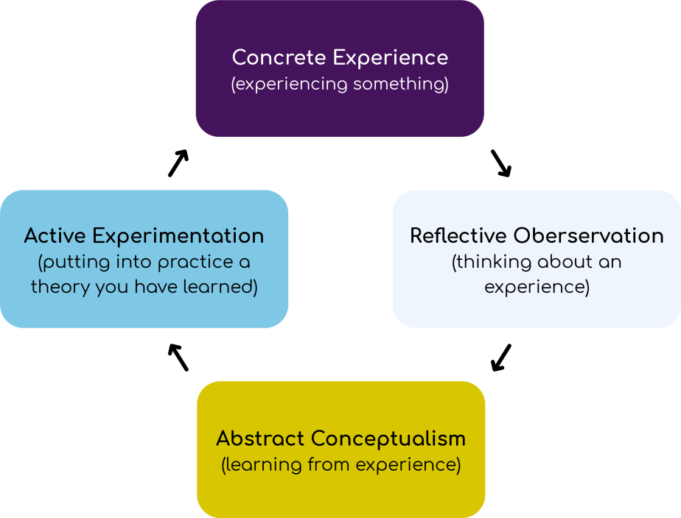
Figure 1: Kolb’s Experiential Learning Cycle (Wijnen-Meijer et al., 2022)
- Concrete Experience: Direct observations of new employee interactions include observed employee tasks which revealed that new hires were experiencing problems and consequently, check-in/check-out times and guest requests were slower. The consequence meant that there were changes in the quality of the services delivered by the department, low productivity and possible unsatisfied guests in regard to the services offered to them.
- Reflective Observation: I examined the sources of this problem, including lack of training resources, absence of training guidelines and inappropriate coordination among team members. Since new staff members were not trained, the new staff was not efficient in fulfilling their tasks resulting in delays and mistakes. Also, some of the interpersonal skills are required to be built to develop a healthy relationship between employees.
- Abstract Conceptualisation: In order to solve this problem, more extensive staff training can be provided, where the agenda for the training will comprise theoretical and practical parts. All clerical and related aspects of the hospitality industry such as the operations of a hotel should be included in this program. Besides, employees' knowledge levels should be reconsidered by providing refresher courses and regular training throughout the reporting period.
- Active Experimentation: Staff development is a common method through which the hotel can upgrade the morale of the staff, the quality of services and seeking ways of executing improvements continually.

Figure 2: Action steps for Coldra Court (Author, 2024)

Conclusion
In short, I can say that through practising at Coldra Court I was able to gather substantial administrative experience working in a hotel. The shadowing allowed me to better grasp the basic vocational competencies including interpersonal and practical ones together with technical competencies including the management of hotel operational software and understanding of basic human resource management concepts necessary to perform successfully in this industry. Knowledge about communication, teamwork and hospitality services has been greatly enhanced by this experience obtained in the hospitality industry. This essay allowed me to discover how important training and adjustment are for evaluating one’s self and career progress in a highly competitive field, such as hospitality.

Action Plan
Every problem met and every achievement made throughout my placement has mounded my future career endeavour of achieving the best in hotel management. To further enhance my skill set, I will focus on the following areas:
Skill | Action Steps | Timeline
Technical Skills | Complete online courses on advanced hotel management systems and financial analysis (Hagg, 2013). | 3 months
Soft Skills | Enroll in a communication and interpersonal skills workshop. | 2 months
Leadership Skills | Seek opportunities to lead small projects within the workplace or volunteer organisations. | 6 months
Industry Knowledge | Attend industry conferences and webinars, and network with hospitality professionals (Wood, 2013). | Ongoing

Figure 3: Action Plan for Personal Development (Author, 2024)

References
Bardi, J. (2010). Hotel Front Office Management. London: Wiley.
Hagg, E. (2013). Internship Guide: Work Placements Step by Step. 5th Ed. The Hague: Eleven International Publishing.
Gannon, J., Clayton, D. and Klenert, A. (2021). Mentoring Initiatives as Talent Management Innovations. Talent Management Innovations in the International Hospitality Industry, (5), pp.99–125. doi https://doi.org/10.1108/978-1-80071-306-220211006.
HYASAT, A.S., AL-WESHAH, G.A. and KAKEESH, D.F. (2022). TRAINING NEEDS ASSESSMENT FOR SMALL BUSINESSES: THE CASE OF THE HOSPITALITY INDUSTRY IN JORDAN. GeoJournal of Tourism and Geosites, 40(1), pp.20–29. doi:https://doi.org/10.30892/gtg.40102-798.
Radhakrishnan, U., Koumaditis, K. and Chinello, F. (2021). A systematic review of immersive virtual reality for industrial skills training. Behaviour & Information Technology, 40(12), pp.1–30. doi https://doi.org/10.1080/0144929x.2021.1954693.
Sakas, D.P., Reklitis, D.P., Terzi, M.C. and Vassilakis, C. (2022). Multichannel Digital Marketing Optimisations through Big Data Analytics in the Tourism and Hospitality Industry. Journal of Theoretical and Applied Electronic Commerce Research, [online] 17(4), pp.1383–1408. doi:https://doi.org/10.3390/jtaer17040070.
Shen, L., Qian, J. and Chen, S.C. (2020). Effective Communication Strategies of Sustainable Hospitality: A Qualitative Exploration. Sustainability, 12(17), p.6920.
Tewan, J. (2009). Hotel Front Office: Operations and Management. Oxford: Higher Education Press.
Vallen, G.K. & Vallen, J.J. (2014). Check-In Check-Out: Managing Hotel Operations. 9th Ed. Harlow: Pearson Education Limited.
Waqanimaravu, M. and Arasanmi, C.N. (2020). Employee training and service quality in the hospitality industry. Journal of Foodservice Business Research, [online] 23(3), pp.216–227. doi https://doi.org/10.1080/15378020.2020.1724850.
Wijnen-Meijer, M., Brandhuber, T., Schneider, A. and Berberat, P.O. (2022). Implementing Kolb´s Experiential Learning Cycle by Linking Real Experience, Case-Based Discussion and Simulation. Journal of Medical Education and Curricular Development, 9(2), pp.1–5.
Wood, R.C. (2013). Key Concepts in Hospitality Management. London: SAGE Publications Ltd.

