Student Name: Dumitru Alin Popa
Student ID: 2132755
Module: International Meetings Management for the Hotel Industry
Module code: BMIH6007
Lecture: Jemma Smith

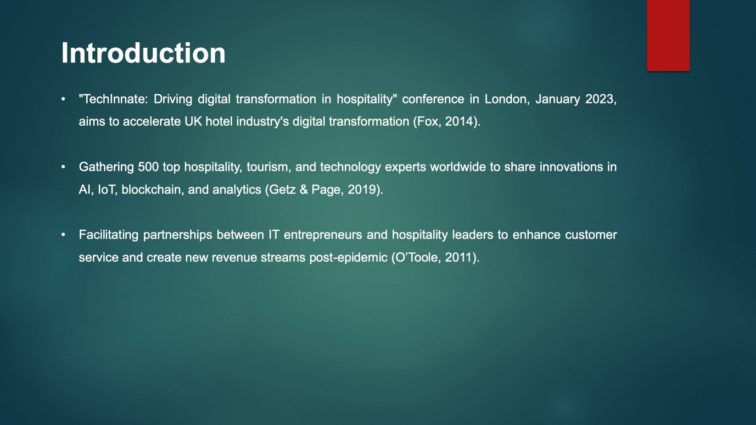

Introduction
UK hospitality relies on technology and innovation. Digital technology has improved customer experiences and back-office processes in hotels, restaurants, and event spaces (Fox, 2014). Industry adoption of developing technology can be increased. This is the focus of the international conference "TechInnate: Driving digital transformation in hospitality". In January 2023, 500 global hospitality, tourism, and technology specialists will meet in London for three days. The conference will discuss global AI, IoT, blockchain, and analytics breakthroughs (Getz & Page, 2019). Partners between IT entrepreneurs and hospitality leaders are also formed. Thought leaders, end-users, and developers are invited to drive the UK hotel industry's digital transformation. Technology and teamwork can unlock customer service and income possibilities as firms recover from the pandemic (O'Toole, 2011).
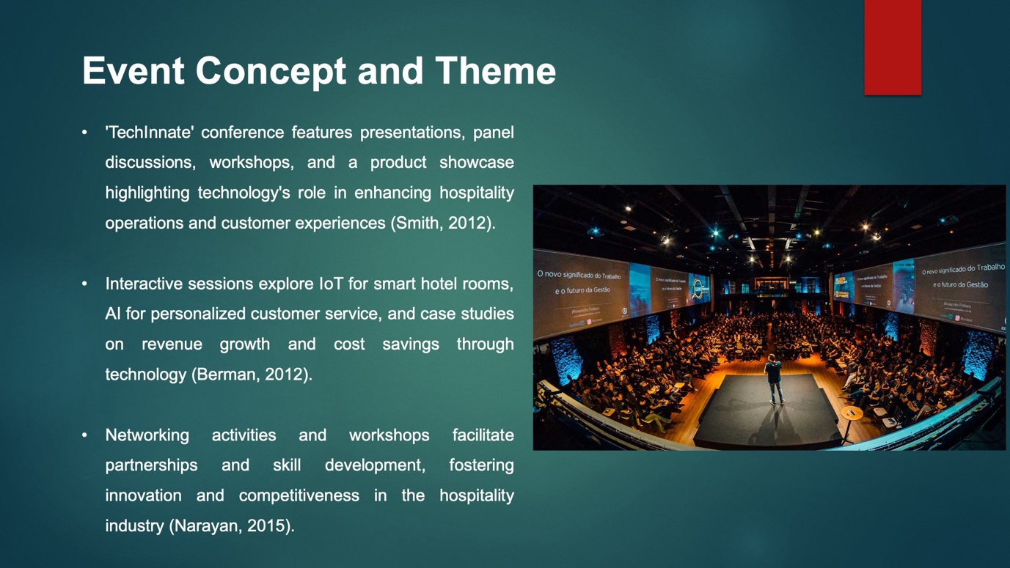

Event Concept and Theme
The proposed concept for the 'TechInnate conference involves hosting a variety of informative presentations, panel discussions, workshops and a product showcase across the three days. The overarching theme aims to demonstrate tangible ways in which technology is enhancing operations, customer experiences and workforce capabilities within hospitality (Smith, 2012). Interactive sessions would explore areas such as building smart hotel rooms through IoT, leveraging location data for targeted offers, and deploying AI for personalised customer service. Industry leaders would share case studies highlighting technologies enabling revenue growth, cost savings and environmental efficiencies (Berman, 2012). The product showcase provides a platform for startups to pitch novel solutions involving virtual reality, mobile apps, robotics and more. Workshops allow participants to learn new skills like coding intuitive interfaces and leveraging analytics. Networking activities including sponsored lunches and evening receptions provide opportunities to foster partnerships that can pilot emerging technologies (Narayan, 2015). The conference hopes participants are inspired and equipped to drive further innovation back home by illuminating ongoing digital evolution through multiple engaging formats. Both large multinational chains and smaller regional establishments would benefit from the focus on strategies, tools and technologies being applied across various sectors within hospitality worldwide to gain a competitive advantage in the experience economy (Bayless & Neelakantan, 2012).
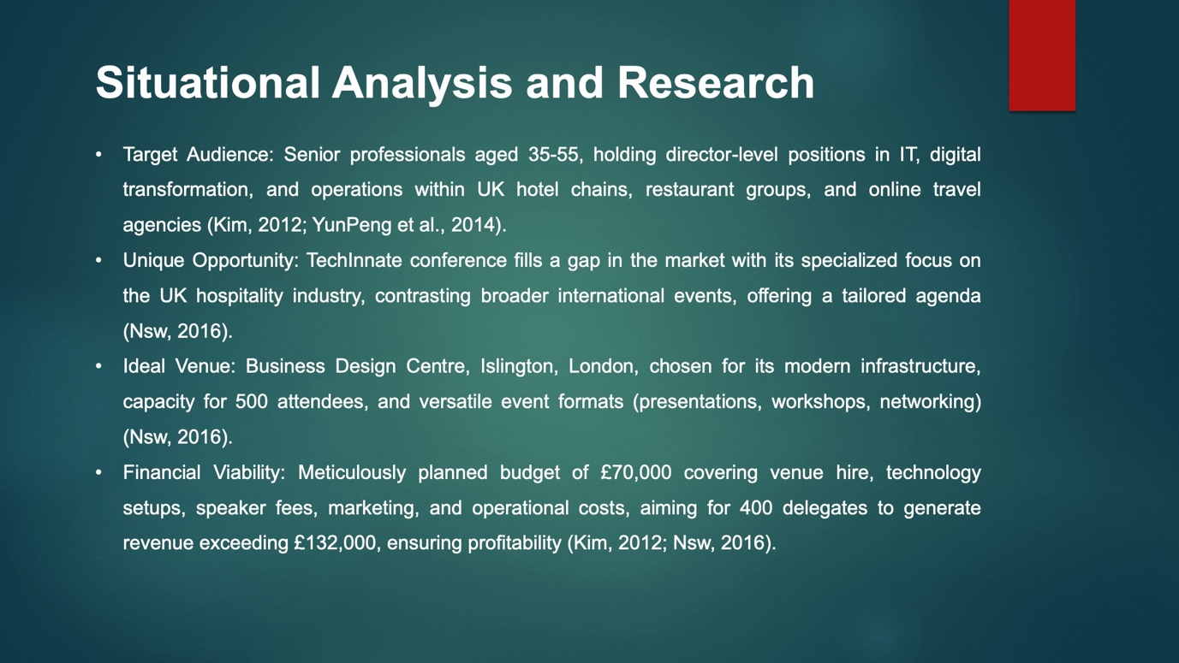

Situational Analysis and Research
The "TechInnate" conference is designed to cater to senior professionals between the ages of 35 and 55, holding director-level positions in IT, digital transformation, and operations within the UK's hotel chains, restaurant groups, and online travel agencies. This target market is recognized for its technological savviness and interest in career advancement, with substantial investments being made in IT by over 500 independent hotels, indicating a large potential audience (Kim, 2012; YunPeng, et al., 2014). Although there are similar events in Europe, they generally target a broader, international audience and lack a focused agenda, highlighting a unique opportunity for this specialized UK-based event (Nsw, 2016).The chosen venue, the Business Design Centre in Islington, London, offers modern technological infrastructure and is capable of accommodating 500 attendees, making it ideal for various event formats including presentations, workshops, and networking. It is available for the proposed dates in January 2023 and is equipped with necessary facilities such as catering services, lighting, seating, and parking, ensuring a seamless experience for participants. The event staff will require skills in IT, audiovisual systems, and customer service to manage the conference effectively. Financially, the event is meticulously planned with a budget that includes costs for venue hire at £25,000, technological setups at £15,000, and speaker fees at £5,000. Additional expenditures include marketing at £10,000 and operational costs at £7,000, alongside catering and contingencies, bringing the total projected expenditure to around £70,000. Revenue will be generated through sponsorships, exhibitor fees, and tiered ticket sales, aiming for a minimum of 400 delegates to ensure financial viability. With an estimated total revenue of £132,000, the event is expected to cover all costs and yield a profit, thus securing its financial success (Kim, 2012; Nsw, 2016).
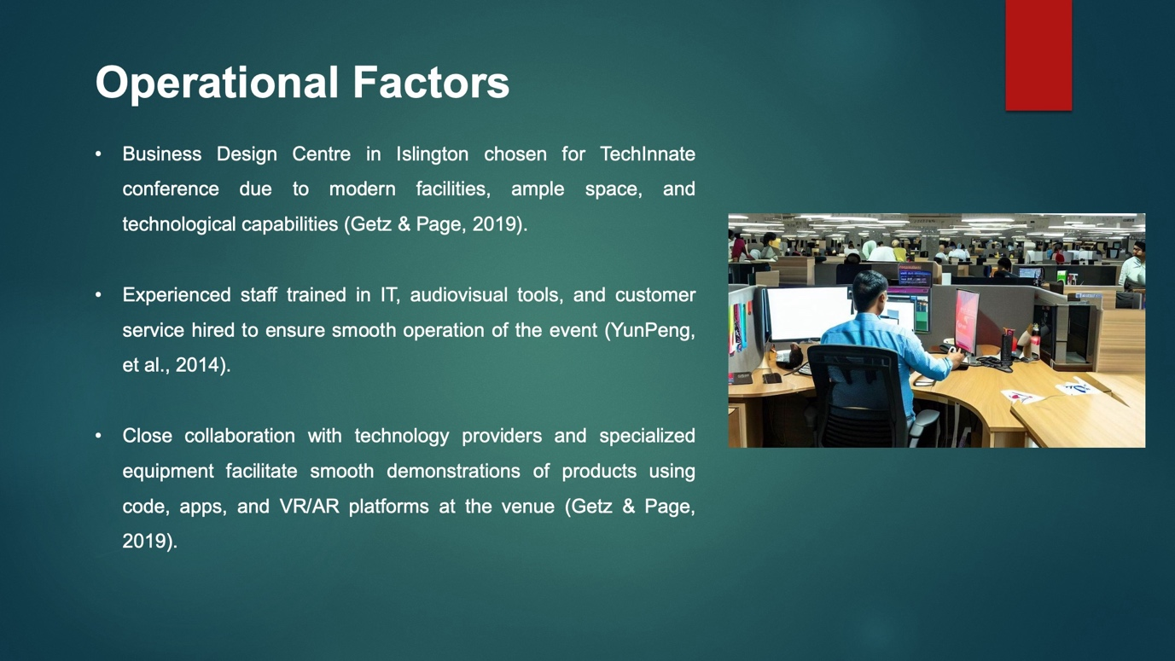

Operational Factors
In order to choose a venue, study was done on central London venues that could hold 500 people over three days and also met technological needs. The Business Design Centre in Islington was chosen because it has modern facilities and a mix of studio, theatre, and exhibition areas (Getz & Page, 2019). The rooms are big enough for presentations, and there are also places for food service and networking in the foyers. The venue is free on the weekends in January which works for the suggested event dates. To help the speakers, staff and volunteers will need to know how to use IT, audiovisual tools, and digital support services, and have experience running successful conferences (YunPeng, et al., 2014). People who work at the front desk need to be good at customer service to make sure that delegates have a good time. A company with a lot of experience in event management will be hired to make sure there are enough resources. Under the catering deal, three lunches will be served and guests and speakers will be given drinks every day (Berman, 2012). The lighting and seating will be set up so that each type of event, from talks to workshops, works best. To show off products that use code, apps, and VR/AR platforms, special gear like multiple big screens, computers, projectors, and Internet access is needed (Getz & Page, 2019). The venue works closely with many technology providers to make sure that the demonstrations go easily. Because it is in the middle of everything, there are close places to stay and park that make getting there easier for registrants.
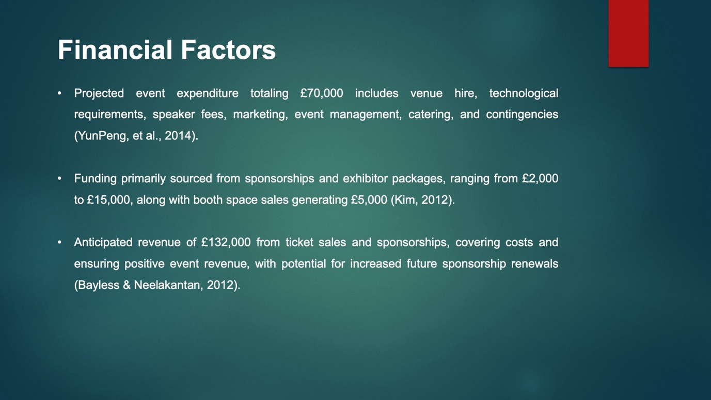

Financial Factors
A detailed budget was compiled to ascertain the event's financial viability. Major costs include venue hire at £25,000 for three days, including facilities and on-site support. Technological requirements such as AV equipment, Internet infrastructure and presentation computers are estimated at £15,000 based on supplier quotations (YunPeng, et al., 2014). Attracting high-profile speakers necessitates budgeting £5,000 per featured keynote towards travel expenses and agreed fees. Marketing efforts such as a website, mailers and targeted digital campaigns will require £10,000. Additional outlays cover event management (£7,000), catering (£8,000) and contingencies. The total projected expenditure is £70,000. Primary sources of funding and revenue will be sought from sponsorships and exhibitor packages (Kim, 2012). Various tiers are offered ranging from £2,000 for basic branding to £15,000 as a platinum partner sponsoring select sessions or networking activities. Booth spaces in the product showcase area will generate £5,000 from ten confirmed startups. Ticket sales present another key stream, differentiated as early bird (£200), standard (£250) and on-site (£300) rates (Nsw, 2016). Meeting the 500-delegate target would yield £100,000 at average prices. Surveys suggest over 75% of the target market is willing to attend. Should sponsorships, exhibitors and 80% capacity registration be achieved, total income will reach £132,000, covering costs and ensuring the event revenue is positive. Impactful showcasing of opportunities also has potential to increase future sponsorship renewals (Bayless & Neelakantan, 2012).
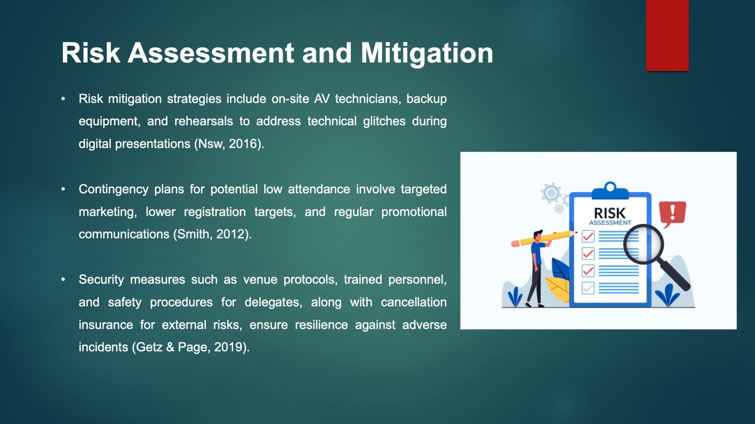

Risk Assessment and Management
Despite the best efforts in planning and organisation, certain risks must be managed. One concern relates to technical glitches disrupting sessions relying on digital demonstrations or presentations (Nsw, 2016). To address this, specialist audio-visual technicians will be on-site throughout with backup equipment. Multiple rehearsals are scheduled ahead of keynotes to test compatibility. Failure to achieve expected attendance numbers could negatively impact revenues. Contingencies include launching a marketing push four months out, regular promotional communications in the final weeks, and setting a lower registration target of 400 delegates (Smith, 2012). Security risks involve potential adverse incidents at the venue. However, the Business Design Centre maintains strict protocols with trained personnel on patrol. Delegates will be informed of safety procedures during check-in. External risks like natural disasters are largely unpreventable, so cancellation insurance has been purchased. Buy-in from major sponsors six months out enhances resilience against economic downturns deterring support (Getz & Page, 2019). Developing alternative partnerships also helps diversify reliance. With careful planning embedded in logistics, use of experienced suppliers and flexibility built into finances, this event aims to smoothly overcome challenges and deliver value for all participants (Berman, 2012).
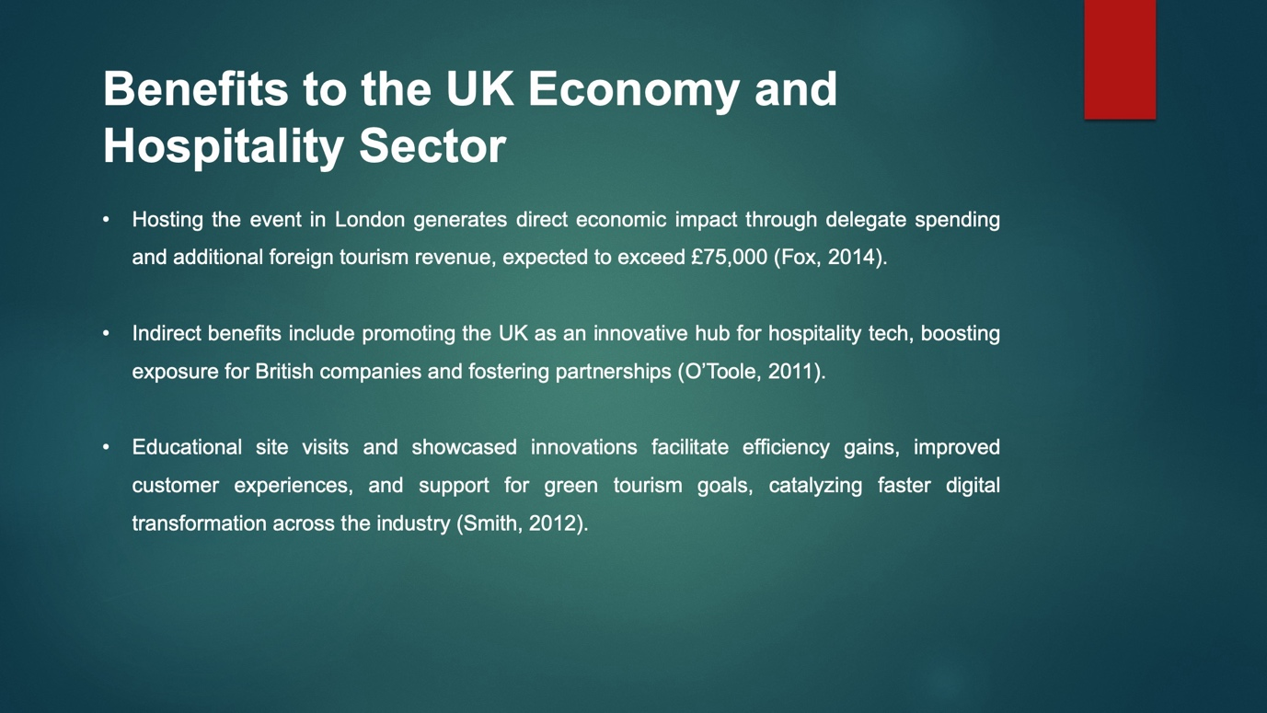

Benefits to the UK Economy and Hospitality Sector
By hosting the event in London, the direct economic impact will result from the expenditure of delegates on accommodation, food and transportation within the city. With international attendees comprising over 30% of registrations, additional foreign tourism revenue is expected to exceed £75,000 (Fox, 2014). Indirect benefits include promotion of the UK as an innovative hub for hospitality tech globally. Speakers from British companies gain exposure boosting future partnerships and investment (O’Toole, 2011). Through educational site visits organized for delegates, local F&B businesses will connect with potential B2B clients and showcase opportunities. By assessing the latest solutions, UK hospitality enterprises stand to enhance competitiveness through efficiency gains and improved customer experiences. Innovation showcased can inspire homegrown development and adoption of advanced technologies supporting green tourism goals as well (Smith, 2012). Inspired by success stories shared, event outcomes may catalyze cultural changes facilitating faster digital transformation across the industry. UK plc is thus positioned to capture more value from hospitality’s rising contribution as a key export sector.
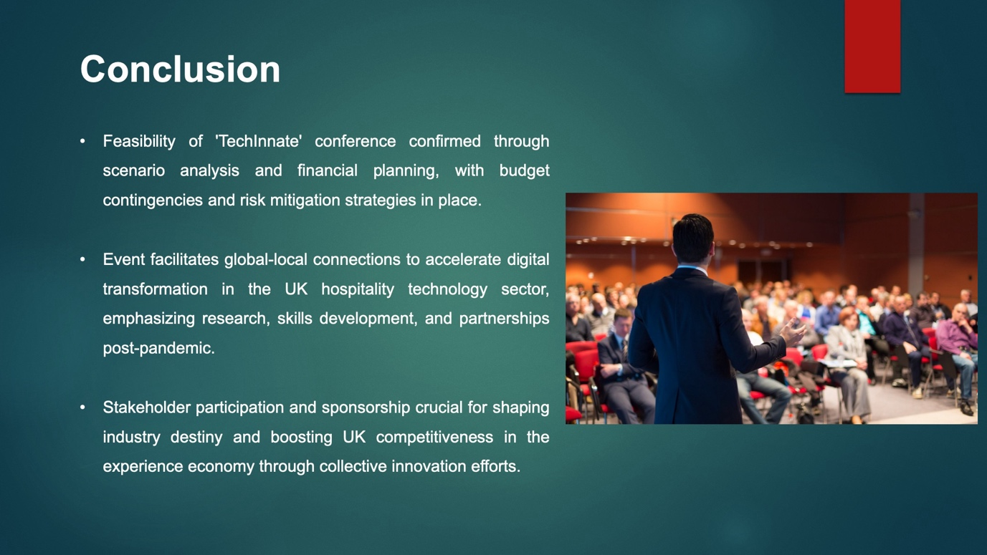

Conclusion
In conclusion, extensive scenario analysis and operational and financial planning show the 'TechInnate' conference concept is feasible. Budget contingencies and risk mitigation techniques reassure. The UK hospitality technology environment will benefit from the event. It connects global innovators with local adopters to accelerate sector-wide digital transformation. Research, skills development, and partnerships around developing technologies are important after pandemics. Participation and sponsorship allow stakeholders to shape their industry's destiny. The event organisers urge technological, hospitality, and academic organisations to encourage innovation for long-term success. TechInnate can boost the UK experience economic competitiveness with collective effort.

References
Bayless, S. H. & Neelakantan, R., 2012. Smart Parking and the Connected Consumer: Opportunities for Facility Operators and Municipalities. [Online]
Available at: https://fortunedotcom.files.wordpress.com/2014/07/smart_parking_and_the_connected_consumer_its_america_bayless_2012.pdf
[Accessed 21 4 2024].
Berman, S. J., 2012. Digital transformation: opportunities to create new business models. Strategy & Leadership, , 40(2), pp. 16-24.
Fox, D., 2014. Doing events research: from theory to practice.. s.l.:Routledge: Oxford.
Getz, D. & Page, S., 2019. Event studies: theory, research and policy for planned events.. 3rd ed. s.l.:Routledge: Oxford.
Kim, K. H., 2012. Smartphone application effecting potential increase of hotel business revenue and guest satisfaction. [Online]
Available at: http://digitalscholarship.unlv.edu/cgi/viewcontent.cgi?article=2354&context=thesesdissertations
[Accessed 21 4 2024].
Narayan, S., 2015. Agile IT Organization Design: For Digital Transformation and Continuous Delivery. [Online]
Available at: https://amazon.com/agile-organization-design-transformation-continuous/dp/0133903354
[Accessed 21 4 2024].
Nsw, T. S., 2016. Smart and Skilled. [Online]
Available at: https://training.nsw.gov.au/smartandskilled/index.html
[Accessed 21 4 2024].
O’Toole, W., 2011. Events feasibility and development: from strategy to operations.. s.l.:Elsevier: Oxford.
Smith, A., 2012. Events and urban regeneration: the strategic use of events to revitalise cities.. s.l.:Routledge: Oxford.
YunPeng, L., Hu, C., Chao, H. & LiQiong, D., 2014. The Concept of Smart Tourism under the Context of Tourism Information Service. Tourism Tribune, , 29(5), pp. 106-115.

