

Program Name | MBA IB
Module Name | International Marketing: Principles and Practices
Module Code | LCMB7026
Assessment Title | Individual Report
Report Title | BMW’s marketing strategies Analysis in USA & INDIA
Student Name | Masum Patel Harishbhai
Student ID | 2430264
Lecturer | Dr Muhammad Tariq
Date of Submission | 19 Dec 2025
Word Count | 5080

TABLE OF CONTENTS
Introduction 1
1. Brand overview 2
2. Comparison Of Socio-Cultural Context: USA Vs India 3
2.1 Political Environment Comparison 3
2.2 Economic Environment Comparison 4
2.3 Social Environment Comparison 6
2.4 Technological Environment Comparison 8
2.5 Legal Environment Comparison 9
2.6 Environmental Context Comparison 9
3. Comparison of Brand’s STP strategies in Country A and Country B 12
3.1 Segmentation Strategy Comparison 12
3.2 Targeting Strategy Comparison 13
3.3 Positioning Strategy Comparison 14
4. Comparison Of Marketing Mix (7Ps) Strategies: USA Vs India 16
4.1 Product Strategy Comparison 16
4.2 Price Strategy Comparison 17
4.3 Place (Distribution) Strategy Comparison 19
4.4 Promotion Strategy Comparison 20
4.5 People Strategy Comparison 21
4.6 Process Strategy Comparison 22
4.7 Physical Evidence Strategy Comparison 23
5. Evaluation Of The Performance Of Marketing Strategies 26
5.1 BMW USA - Performance Evaluation 26
5.2 BMW India - Performance Evaluation 27
6. Evaluation Of Marketing Ethics Practice 30
6.1 Ethical Issues in BMW USA Marketing 30
7. Recommendation & Conclusion 32
7.1 Strategic Recommendations for BMW's International Marketing 32
7.2 Conclusion 32
Reference List 33

Introduction
The globalisation of markets has strategically transformed how automotive manufacturers approach international market expansion, determining sophisticated strategies which balance standardisation with locations. In contemporary business marketing, luxury automobile brands face the critical challenge of maintaining consistent brand equity while adapting to the diverse cultural, economic and regulatory environments across the different geographic markets. This report undertakes a detailed, comprehensive evaluation of BMW’s marketing strategies in the two distinctly different markets, the United States and India, demonstrating the contrasting stages of economic development and cultural values in the automotive market aspects.
The United States market demonstrates a mature, highly competitive luxury automotive market with robust infrastructure and changing consumer preferences. On the other hand, India articulates rapidly emerging consumer aspirations and substantial growth projections despite the lack of infrastructure.
The report systematically evaluates BMW’s macro-microenvironmental context through PESTLE, compares STP strategies and critically examines the 7Ps of marketing mix implementation with the ethical marketing practices and leveraging recommendations for BMW’s continued international marketing success in both the markets of the United States and India.

1. Brand overview
BMW, founded in 1916, has evolved from aircraft engines to a global premium mobility group spanning BMW, MINI, Rolls-Royce, and Motorrad. The group reports stable global performance, delivering 1,795,734 vehicles (+2.4%). Growth was driven by Europe and the Americas market, while China lagged.
In the context of the United States market, BMW demonstrates strong momentum with deliveries up to 9.5% and +24.9% growth in Q3 of FY 25 by outperforming the overall U.S. auto market. The broader Americas regions saw a 9.8% YTD (Bmwgroup.com, 2025). However, profitability faces the contextual pressures from the new U.S.-EU tariffs and slower-than-expected U.S BEV market uptake.
While in the Indian market context, BMW Group strategically delivered its highest-ever annual sales in 2024, selling 15,721 cars. Luxury car models reached 2,507 units, while EVs demonstrated strong growth with 1,249 units sold, servicing BMW’s position in India’s top luxury brand list.

2. Comparison Of Socio-Cultural Context: USA Vs India

2.1 Political Environment Comparison
USA
US political shifts have created acute uncertainty for automotive organisations, with a 25% tariff on imported vehicles raising the cost of parts and cars. Insurance may rise over $300 in 2025 as 60% of replacement parts are imported, while new-car inventories fell from 91 to 70 days, and sales jumped 5.3% as buyers rushed purchases. A Centre for Automotive Research study estimates tariffs could add $108 billion industry-wide in 2025, about $42 billion for Ford, GM and Stellantis — implying roughly $4,900–$8,600 per vehicle (Nbcnews.com, 2025). With 70% of new cars assembled abroad and 60% of replacement parts imported, tariffs disrupt production, inflate premiums, and trigger halted imports and plant adjustments, reshaping automakers’ strategic decisions.
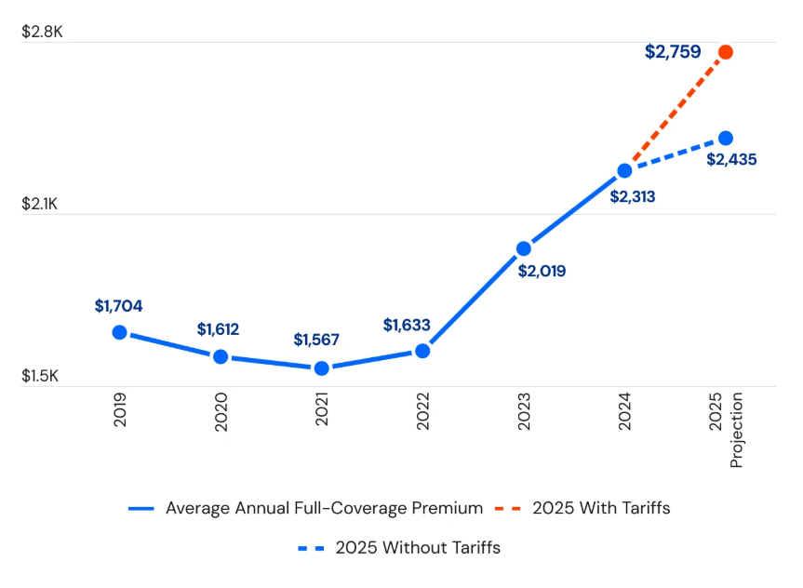
Figure 1: Tariff impact on automakers
(Source: Nbcnews.com, 2025)

India
India’s political environment has become most favoured for the foreign automotive manufacturers under the Make in India initiative, with the encouragement of local manufacturing and foreign investment. India’s protectionist policy—~106% car tariffs and only $700 million imports in 2023–24—compels BMW to localise; the EU’s proposed 10% cut could reshape incentives, affect investment and pricing (Statista.com, 2025). The government's push for electric mobility with the FAME scheme creates contextual opportunities and challenges.
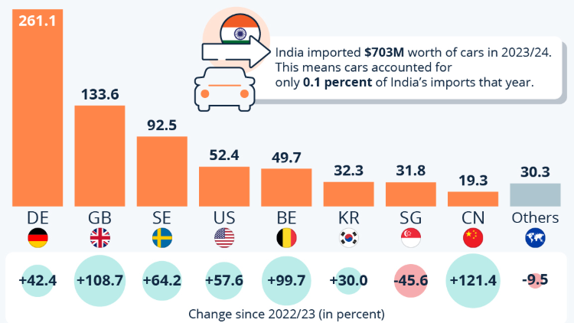
Figure 2: Consumers of USA preference of car
(Source: Statista.com, 2025)

2.2 Economic Environment Comparison
USA
According to the report of (2025), the United States remains the world’s largest economy with a GDP estimated at around US$29–30 trillion in 2024. The global prominence of its currency reinforces its economic dominance. The US dollar is the leading international reserve currency used in roughly 58% of global reserves and involved in about 80% of foreign-exchange transactions globally. Economic stability strategically provides consistency in the luxury automobile demand (Statista.com, 2025). Growing demand for automobiles, flexible owned models, and robust financing availability are driving growth in the US car loan and leasing business, which is valued at USD 185 billion. Lease now makes up 24.7% of new agreements, while captive lenders hold the largest market share at 29.8%.
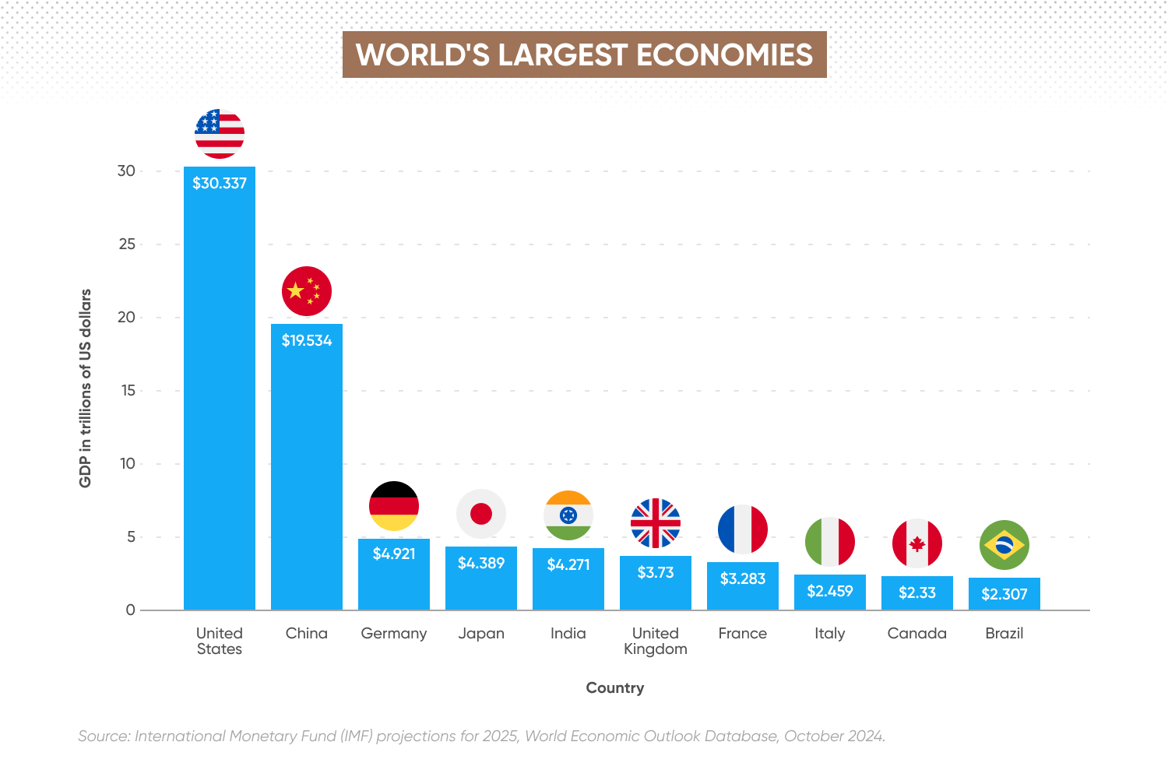
Figure 3: USA economic growth
(Source: Statista.com, 2025)
India
India presents a rapidly growing economy, with the economy growing above 6% for three consecutive years and over 8% during 2021-2024, now controlling about 17% of global GDP growth and holding 8.3% of global GDP (PP) (Econofact.org, 2025). Though challenges include the low capital stock, declining FDI and rising AI-driven labour risks. The luxury automotive market, though smaller in absolute size, shows double-digit growth rates (Cavusgil et al. 2016). Economic liberalisation and growing entrepreneurial wealth create expanding target demographics for BMW.
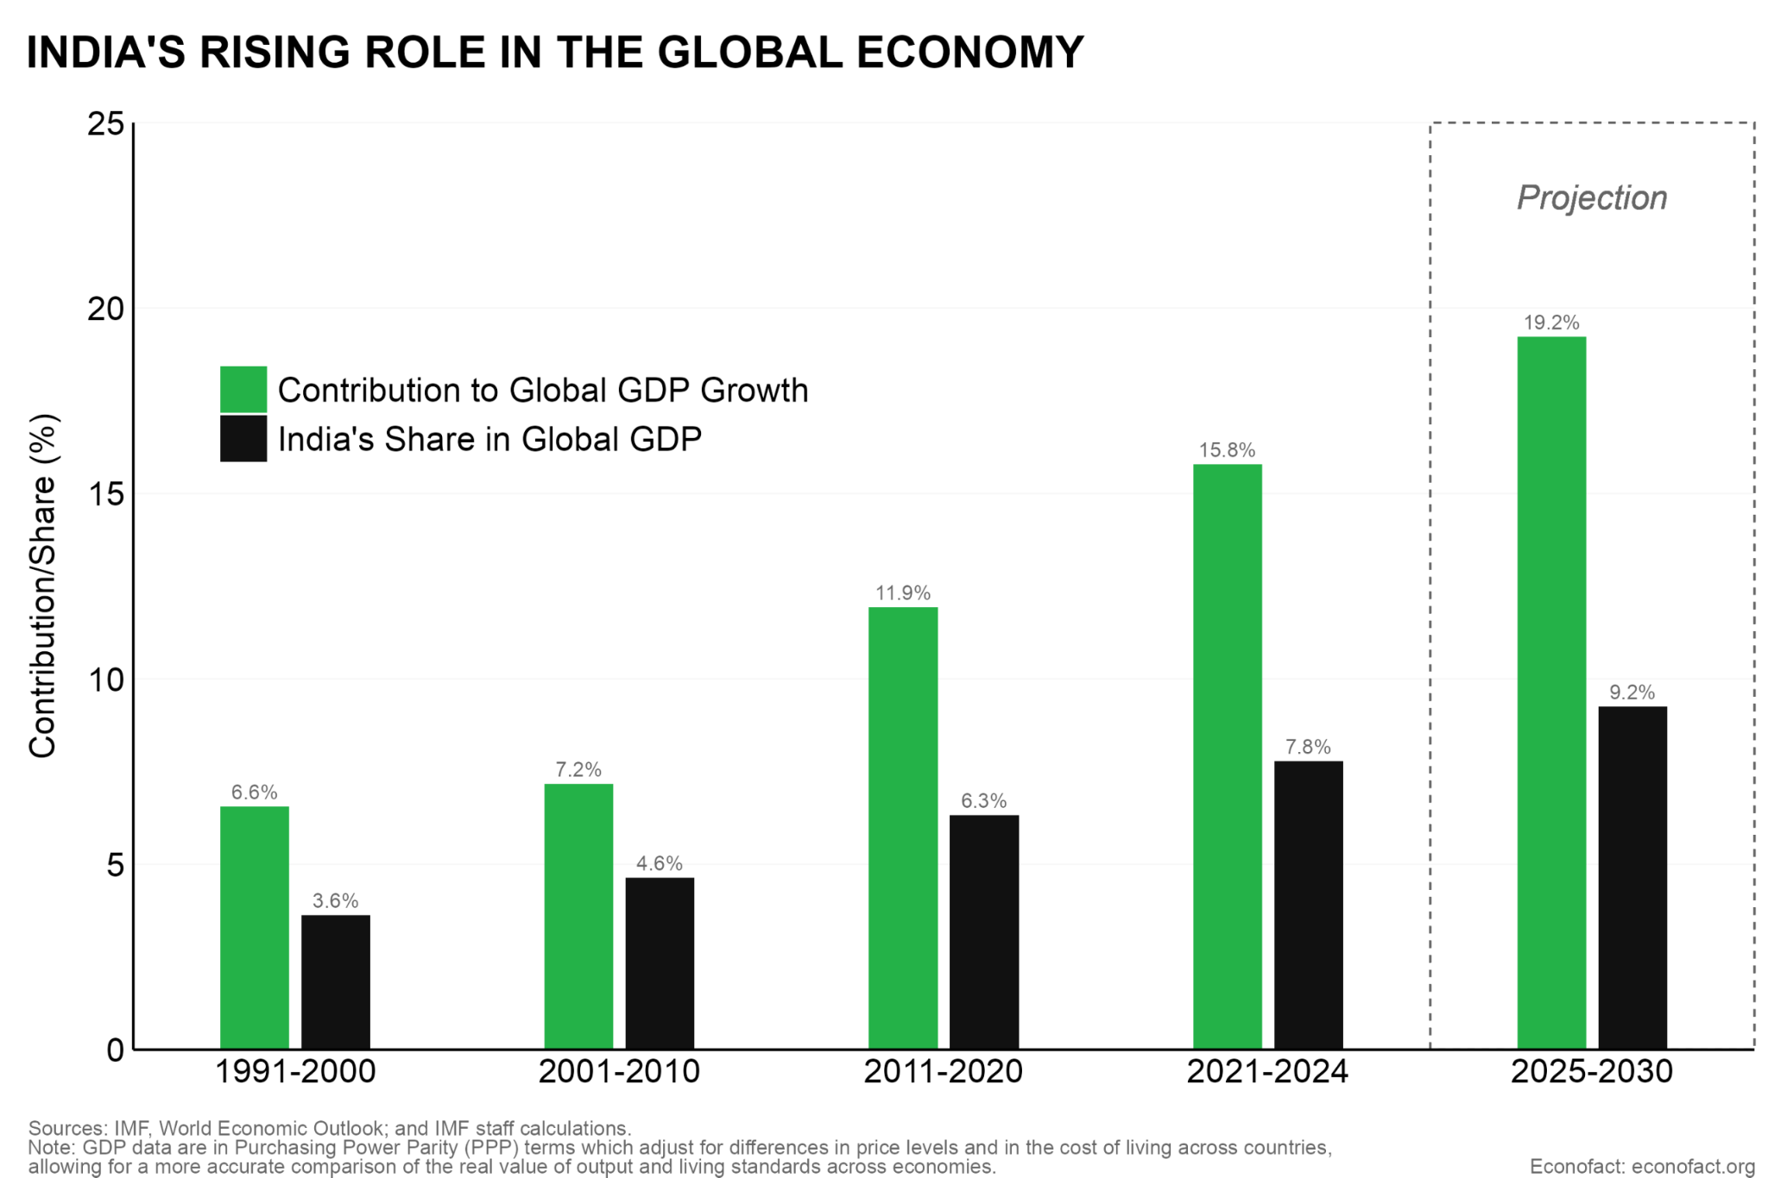
Figure 4: India’s growth
(Source: Econofact.org, 2025)

2.3 Social Environment Comparison
USA
According to the report of Statista (2025), younger generations show declining interest in U.S car ownership; only 54% of Gen Z consider owning a car important, compared to 625 of the millennials. Overall, 62% of 10,000+ respondents value ownership. Growing federal investment in rail projects signals shifting mobility preferences amid high urban congestion (Statista.com, 2025). Further, U.S car ownership remains high, with 283.4 million registered vehicles in 2022 and 91.7% of households owning at least one car. This trend demonstrates the representative value for BMW in different segments targeting the younger consumers.

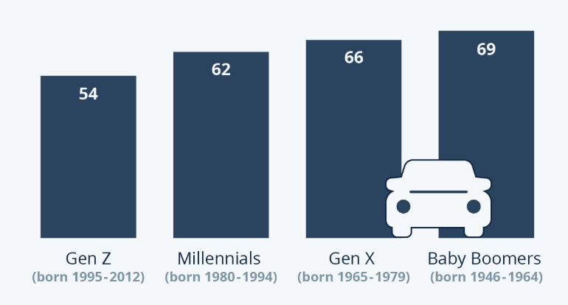
Figure 5: Young consumer preference for car
(Source: Statista.com, 2025)

India
Indian society is experiencing a rapid social transformation with the urbanisation and rising aspirational consumption among the new affluent class. According to the report of Mordor Intelligence (2025), India’s luxury car market is expanding due to powerful social drivers: rising affluence (affluent households growing 10–26 million by 2025), younger aspirational buyers in Tier-II cities, and financing penetration (Mordorintelligence.com, 2025). Urban congestion and challenging driving conditions influence the vehicle choices as regards compact sedans and SUVs for BMW in the Indian market landscape.
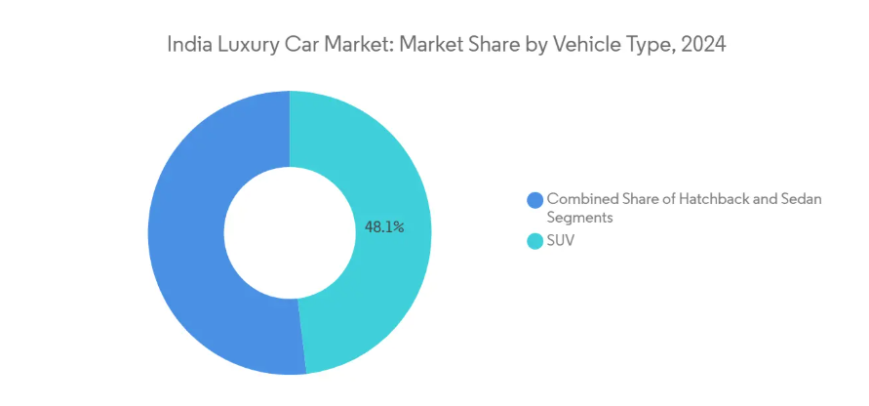
Figure 6: India luxury car markets
(Source: Mordorintelligence.com, 2025)

2.4 Technological Environment Comparison
USA
The United States leads the contextual automotive technology integration with the digital infrastructure supported by the connected vehicles, autonomous driving research and electric vehicle charging facility. According to the report of PwC (2025), the U.S EV charging market is set to witness explosive growth driven by the federal incentives and soaring EV adoption. The fastest-growing categories are multi-unit housing and business expenses, which will each reach 17% by 2030 (Pwc.com, 2025). Due to this change, businesses and developers must modify old locations and incorporate EV charging into new construction. BMW can strategically leverage American consumers, technology enthusiasts, as regards integrating advanced features and electric models.
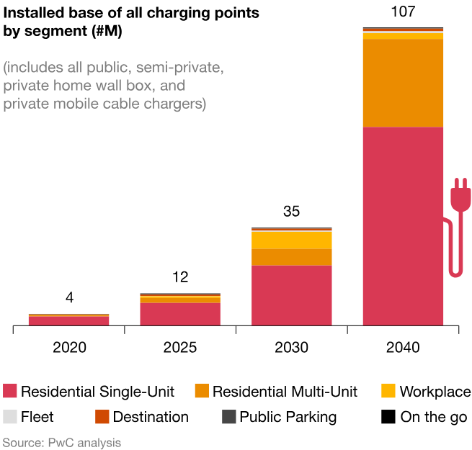
Figure 7: Charging points of USA
(Source: Pwc.com, 2025)
India
India’s technological environment is contextually evolving but remains uneven. Urban centres show higher smartphone penetration and digital literacy among the affluent segments, creating opportunities for connected car features and digital marketing (Palazzo and Micozzi, 2024). According to the report of Orfonline (2025), with 1.75M FY2024 sales expanding 40% YoY, India's EV market reached US$8.49B in 2024, with 2Ws and 3Ws leading the way (94%) (Orfonline.org, 2025). However, only 8% of FY2024 sales were EVs, and India requires 1.32M chargers compared to about 29,000 now, creating a dire 1:235 EV-to-charger imbalance that jeopardises future adoption. The growing IT industry creates a tech-savvy consumer segment interested in BMW's technological sophistication.

2.5 Legal Environment Comparison
USA
The United States presents a well-developed legal framework for the automotive business with clear intellectual property protections, established consumer protection laws, and transparent regulatory processes. The National Highway Traffic Safety Administration (NHTSA) has strict and well-defined safety requirements. States have different emissions laws, with California's CARB (California Air Resources Board) establishing the most stringent guidelines (Mcgregor, 2014). Robust systems for compliance are necessary due to strict liability rules and recalling restrictions. Dealership franchise laws protect the dealer networks, influencing the distribution strategies. The legal environment is predictable and stable, though litigation risks require careful quality management.
India
India’s legal environment is developing with the improving but still complex regulatory frameworks. India’s Automotive Industry Standards (AIS), governed by MoRTH and aligned with UNECE norms, ensure safety and emissions compliance and EV readiness (Teichmann, 2022). Drafted by AISC, these regulate crash protection, BS VI emissions, battery safety and performance. Mandatory AIS certification through ARAI/ ICAT enforces global-grade compliance, with the support of clearance, safety, mobility and international harmonisation.

2.6 Environmental Context Comparison
USA
According to the report of McKinsey (2025), products with ESG claims drove 56% of industry growth, achieving 28% cumulative growth versus 20% for non-ESG products and a 1.7 point CAGR advantage (Mckinsey.com, 2025). Environmental awareness among consumers is higher and increasingly influential in the purchasing decisions of young consumers. The survey demonstrates that 60% of Americans would pay more for sustainable packaging, and 78% value the sustainable lifestyle. Further, the climate change concerts drive the growth in demand for EVs and hybrids. BMW’s environmental credentials and electric vehicle portfolio are significant marketing assets.
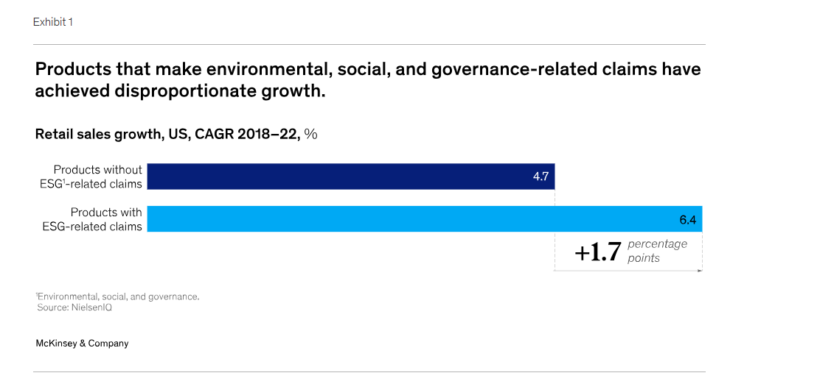
Figure 8: ESG preference of consumers in USA
(Source: Mckinsey.com, 2025)
India
The rising awareness among the affluent urban Indians is increasing, though it remains secondary to economic considerations for most consumers. According to the report of Pv-magazine-india (2025), by switching to entirely renewable energy sources, using 56% hydrogen-based green steel, and increasing the utilisation of scrap steel to 48%, India's car industry may reduce emission levels from production by 87% by 2050. However, EV infrastructure remains limited by constraining electric vehicle adoption (Pv-magazine-india.com, 2025). Sustainability messaging resonates with educated segments but lacks the broader consumer urgency. The government's FAME scheme provides policy support for EVs, but implementation challenges persist.
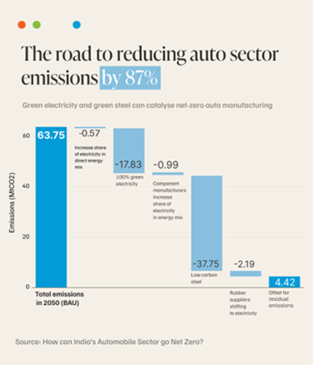
Figure 9: USA car emission target
(Source: Pv-magazine-india.com, 2025)

3. Comparison of Brand’s STP strategies in Country A and Country B

3.1 Segmentation Strategy Comparison
BMW USA - Segmentation Approach
BMW strategically employs the multi-variable segmentation in the mature American market with the combined demographic, psychographic, and behavioural dimensions (Walsh, 2018). Demographically, the primary segment consists of affluent professionals aged 35-55 with household incomes exceeding $100,000 annually through the specific models targeting different age cohorts. BMW Group's expansion in America is driven by the USA: deliveries from January to September 2025 were 364,320, with 298,365 units coming from the USA. America's 126,348 (+24.4%) and the USA's 104,539 saw an acceleration in Q3 (Bmwgroup.com, 2025). Capacity expansion is supported by major expenditures (the first US pressed factory and the Spartanburg plant). Psychologically, BMW segments based on lifestyle and values (Myers, 1996). The technology adopter segment prioritises innovation, connected features and cutting-edge technology, including electric powertrains. As regards the geographical context, BMW identifies the affluent coastal regions such as California and Northeast corridor. Whereas the behavioural aspect, BMW segments the usage patterns and purchase motivations.
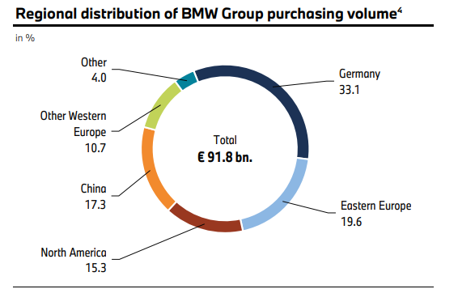
Figure 10: Regional distribution of BMW
(Source: Bmwgroup.com, 2025)

BMW India - Segmentation Approach
In the context of the Indian luxury market, BMW employs a more concentrated segmentation focusing on the limited but rapidly growing affluent class (Dawson, 2014). Demographically, the target segment is narrowed with the included successful business owners, corporate executives and entrepreneurs aged between 30-50 (Mordorintelligence.com, 2025). This segment is concentrated on the major metropolitan areas such as Mumbai, Delhi, Bangalore and Chennai, where wealth creation is centred. Psychologically, BMW segments the Indian consumers differently than Americans. The younger entrepreneur segment effectively represents newly wealthy individuals from technology and start-up sectors, valuing both status and driving dynamics. As regards behavioural aspects, Indian consumers prefer vehicle purchases, not leases, indicating long-term ownership intentions.

3.2 Targeting Strategy Comparison
BMW USA - Targeting Approach
BMW’s multi-brand, multi-technology strategy is delivering clear commercial resilience and targeted consumer reach in the Americas (Kotler et al. 2015). Diverse pricing tiers are captured by brand division: BMW core (+8.6%), MINI (+23.7%), and Rolls-Royce (4,100 units; +3.3%)—and drivetrain variation helps adapt to changing preferences: PHEVs increased by 30.2% (146,754 units), MINI BEVs accounted for 35.6% of MINI sales, and 26.2% of deliveries were electrified. But in China and the USA, BEV adoption fell short of expectations, leveling the all-electric fraction and creating a more cautious outlook (Bmwgroup.com, 2025). Furthermore, the BEV uptake underperformed in the USA, flattening all-electric share and promoting a tempered outlook. Operationally, tariff pressures trimmed Automotive EBIT by 1.5-1.75 percentage points, articulating downside risk from trade costs. Overall, BMW’s differentiated approach mitigates market volatility with the balanced ICE, PHEV and BEV portfolios, which requires sharper demand activation in key markets and continued local production and pricing strategies.
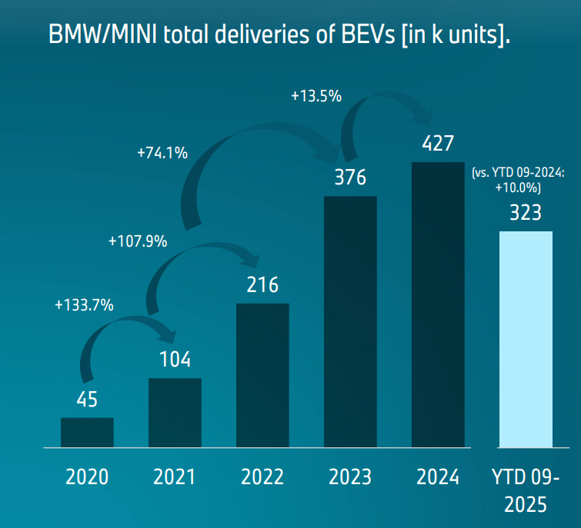
Figure 11: BMW MINI deliveries
(Source: Bmwgroup.com, 2025)
BMW India - Targeting Approach
BMW further employs the more concentrated targeting strategy in India, focusing on the resource on the core affluent urban segment with selective expansion (Johnson, 2013). BMW effectively concentrates on the established and emerging urban professionals, apart from attempting to serve all possible segments who are aspirational achievement symbols. BMW targets affluent Indian EV buyers—plans for 25% of India sales by 2025; sold 1,474 EVs (10% of its India sales) in 2023, while national EV share is 2.3% (Economictimes.indiatimes.com, 2025). Geographical targeting is highly concentrated in tier-1 metropolitan areas, where dealership networks and target customer density support operations with selective expansion into tier-2 cities, showering wealth growth.

3.3 Positioning Strategy Comparison
BMW USA - Positioning Approach
In the American market, BMW positions itself through the long-standing tagline of “The Ultimate Driving Machine”, which frames the brand around performance rather than traditional luxury. The performance-centric deity further reinforced the motorsport success and consistently creative messaging effectively differentiates BMW from the competitors and justifies the premium pricing (David, 2011). This approach proved to be effective for the American market as deliveries reached 364,320 (Jan–Sept 2025) with the U.S, showing sustained demand. BMW’s multi-brand portfolio. Further, the diversified drivetrain mix, such as ICE, PHEV, and BEV, extends this positioning across segments while managing electrification transition risks (Cargroup.org, 2025). Key positioning themes include the masculine values around achievement and competition, low power distance through individual merit emphasis, and driving pleasure focus.
BMW India - Positioning Approach
In India, BMW strategically adjusts its positioning and brand consistency, emphasising prestige and achievement-based positioning alongside performance (Leisch et al. 2018). By cutting expenses and increasing supplies, BMW India's localisation approach strengthens its premium positioning. 1,500+ reservations were made for the Chennai-assembled iX1 Long Wheelbase (₹49 lakh, ~531 km), while BMW produces 10 cars locally to increase availability and cost (Bmwgroup.com, 2025). Sports action automobiles accounted for 55% of sales (2,079 units) in Q1 2025, with deliveries up 7% YoY to 3,914 units, with EV deliveries up 206% (646 units) and long-wheelbase variants up 187% YoY. In CY2024, the luxury market in India grew by 6% to over 51,200 units. Thus, localisation facilitates viable EV options and quicker market reaction; yet, connectivity and price sensitivity continue to be obstacles (Scienceagri.com, 2025).
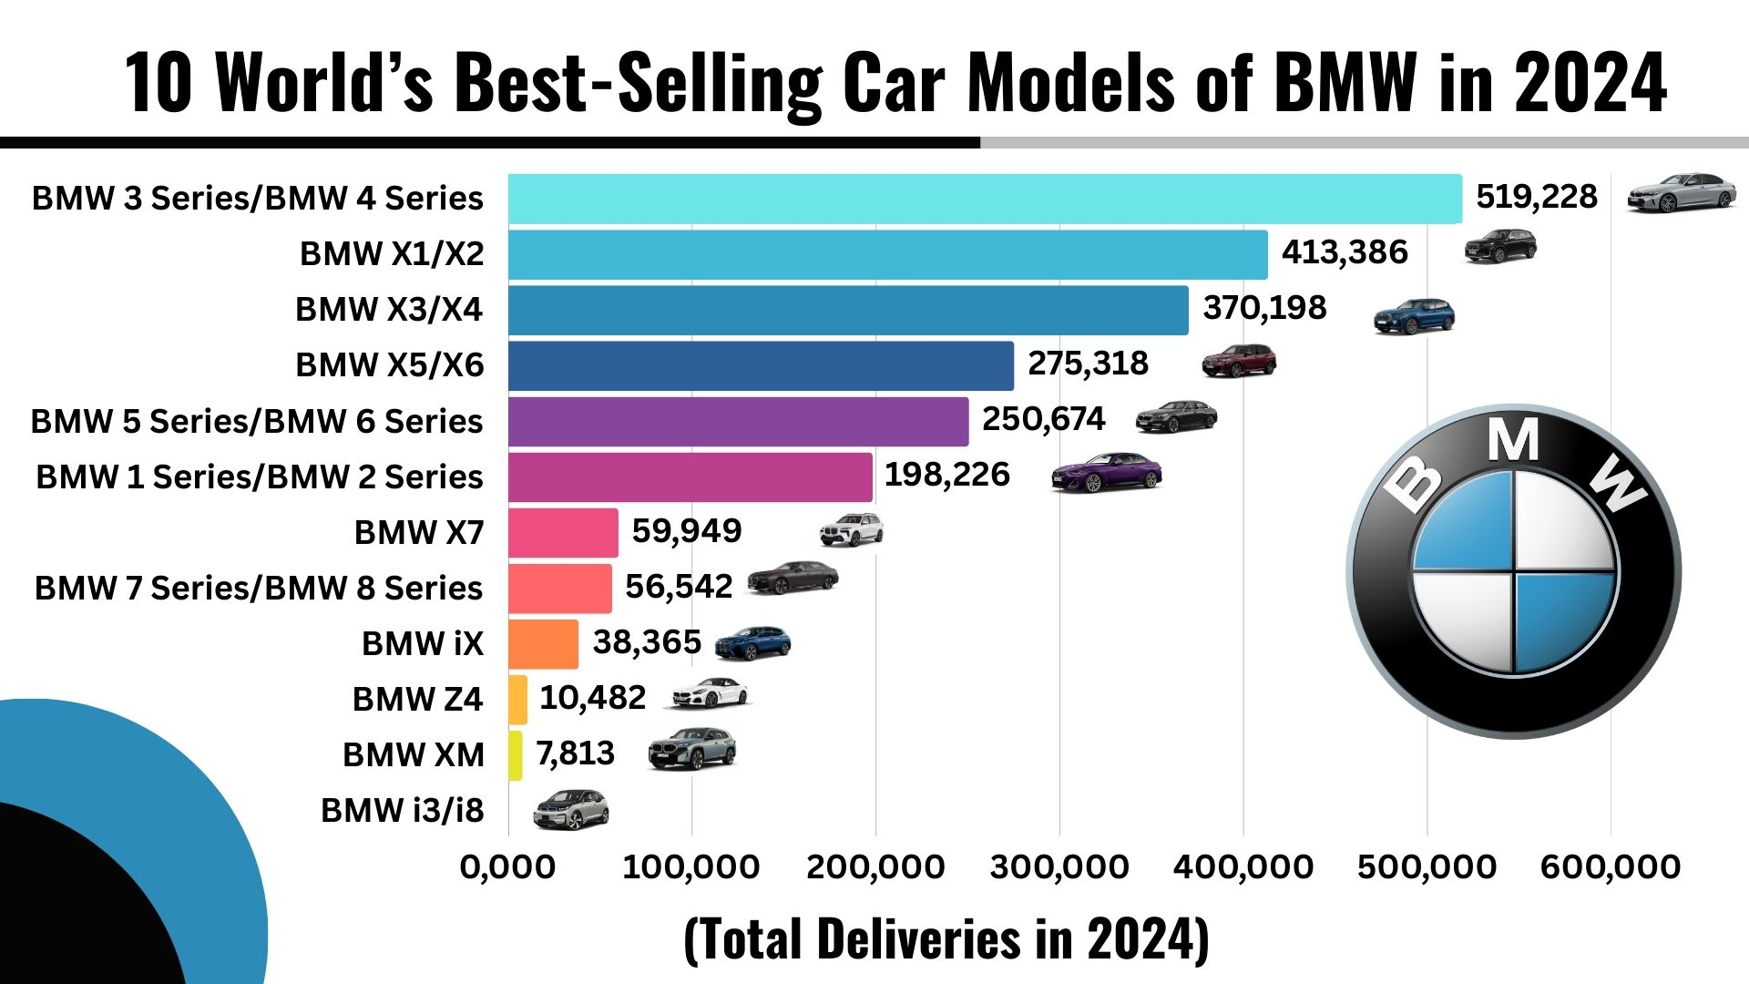
Figure 12: BMW sales in car models
(Source: Scienceagri.com, 2025)

4. Comparison Of Marketing Mix (7Ps) Strategies: USA Vs India

4.1 Product Strategy Comparison
BMW USA - Product Portfolio and Adaptation
BMW’s U.S market product portfolio is structured to maximise the convergence across the luxury, performance, and electrification segments with the support of premium positioning. The X-Series SUVs dominate the lineup from entry-level X1 to the ultra-high performance XM in aligning with America’s SUV heart market (Dibb and Simkin, 2008) BMW's reputation as The Ultimate Driving Machine is reinforced by its sedans, which range in price from the 2 Series ($39,600) to the flagship 7 Series ($99,300) and performance M versions. With models including the iX, i4, i5, and i7 (beginning at $57,900–$105,700), electrification is incorporated across segments. Enthusiasts are further targeted with coupes, convertibles, M models, and the Z4 roadster, resulting in a wide, diverse portfolio catered to American consumer desire for SUVs, premium quality, and growing adoption of electric cars.
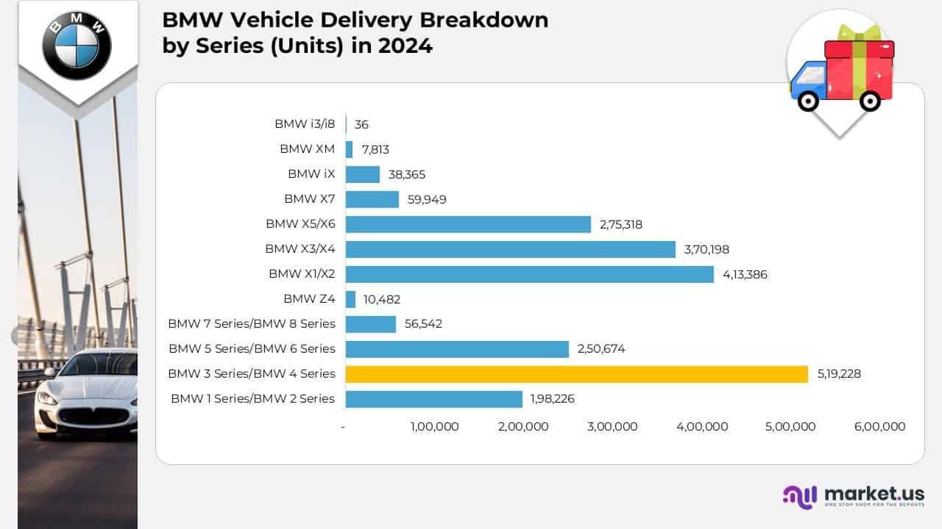
Figure 13: BMW’s USA market cars
(Source: Market.us, 2025)
BMW India - Product Portfolio and Adaptation
BMW India offers a more selective product portfolio focused on the proven models with strong prestige appeal (Jain et al. 2022). The product lineup spans 4 full EVs, 2 plug-in hybrids, 13 petrol and 6 diesel models priced. SUV focus and BMW M variants strategically target the locally assembled iX 1 LWB with 1500+ bookings to accelerate the electrification.

4.2 Price Strategy Comparison
BMW USA - Pricing Approach
BMW strategically employs the premium pricing strategy in the USA market with a position above mainstream brands but competitively within the luxury segment. Promotional pricing is limited by maintaining the brand's prestige, though BMW offers end-of-year incentives, competitive lease rates for volume models such as the 3 Series and X3, providing accessible entry to BMW ownership (Myers, 1996). The pricing anchor is set by MSRPs from $42,800 (X1) to $159,600 (XM) to capture distinct value tiers. Captive finance, leasing, and subscription programs (BMW Financial Services) enhance accessibility and residual values. American pricing maintains brand prestige while remaining competitive, with average transaction prices around $60,000-65,000 reflecting a strong SUV mix and options packages.
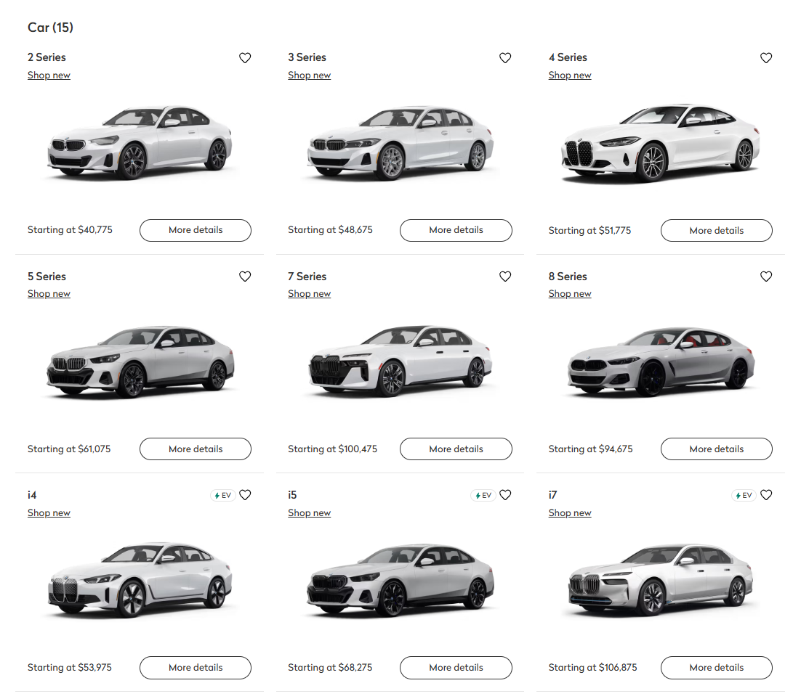
Figure 14: BMW USA pricing
(Source: Truecar, 2025)
BMW India - Pricing Approach
BMW, in targeting the Indian market, employs the prestige premium pricing positioned at the apex of the luxury segment (Ecodigest.in, 2025). Pricing is significantly higher than the USA market in absolute terms, relative to local purchasing power, considering the import duties, taxes, and market positioning. The portfolio spans ₹4.53M–₹25.8M, while the locally assembled iX1 LWB launched at ₹4.9M, showing demand for competitively priced EV luxury. Further, the heavy optioning and financing or leasing programs present margins and accessibility, but price sensitivity remains an adaptation risk.

4.3 Place (Distribution) Strategy Comparison
BMW USA - Distribution Approach
BMW USA distribution relies on the dense, quality-focused dealer network. With 350 BMW centres (plus 144 motorcycles, 105 MINI, 38 Rolls-Royce dealers) demonstrating the key national convergence and premium service. The supply is mostly operated and relies on Plant Spartanburg, with a significant number of 1500 vehicles per day, up to 450000 per year and 7 million built since 1994. Even the BMW Financial Services and digital tools contribute towards accessibility and financing (Santoso et al. 2024). This extensive network defines the distribution approach with the integrated production, finance, and experience-led retailing.
BMW India - Distribution Approach
BMW India strategically employs a highly selective, exclusive distribution strategy with authorised dealerships concentrated on the major urban centres, demonstrating the landscape of the Indian luxury market. The mostly linked to local production with market access to optimize price, availability and after-sales (Incss.org, 2025). Plant Chennai assembles 10 models, achieves 50% localisation, capable of rolling out 17500 units per single shift, enabling the rapid dealer fuel and competitive pricing for locally made EVs such as the iX LWB.
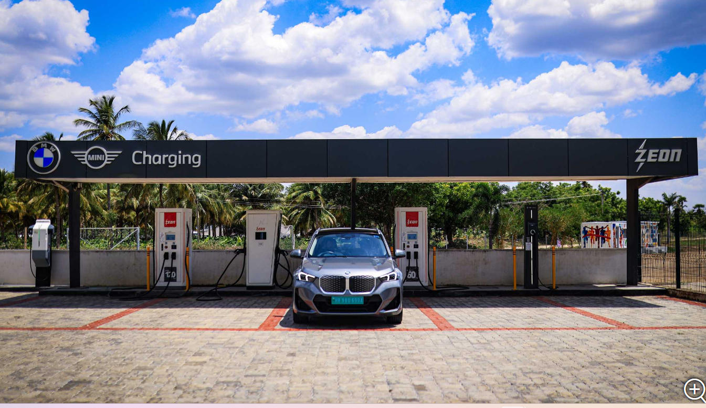
Figure 15: India charging network of BMW
(Source: Bmwgroup.com, 2025)

4.4 Promotion Strategy Comparison
BMW USA - Promotional Mix
BMW USA’s promotion mix is integrated with the blending of high-reach advertising, digital performance and dealer activation and experimental events for defending premium positioning and driving EV adoption. Social media platforms such as Instagram, Facebook and YouTube define the key approach of promotion through displaying advertising targeting the affluent demographics and influence partnerships with automotive journalists and lifestyle influencers (Mintz et al. 2021). Its slogan, “The Ultimate Driving Machine”, is one of the most recognisable in the automotive industry, anchors campaigns that emphasise engineering excellence and emotional appeal. PR efforts—including sponsorship of the BMW PGA Championship and participation in Formula E—signal leadership in performance and sustainability.
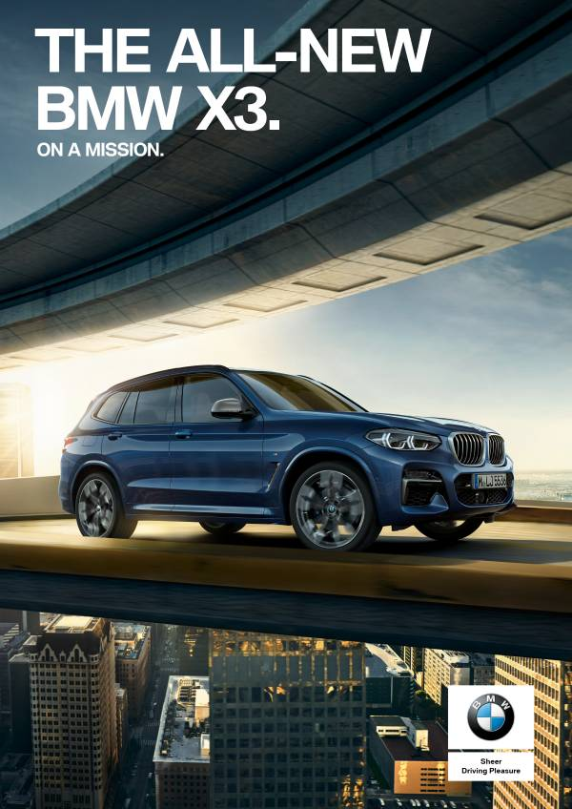
Figure 16: BMW USA promotional campaign
(Source: Bmwgroup.com, 2025)
BMW India - Promotional Mix
BMW strategically employs a multilayered marketing strategy which blends data-driven personalisation, a digital-first approach and luxury branding for engine and retaining customers in the Indian market. It collects customer and vehicle data for tailoring communication through email, in-app, SMS and calls for offering promotions and service reminders (Econofact.org, 2025). BMW India also maintains the luxury-level dealership showrooms across the major metros, ensuring the premium consumer experience, boosting brand loyalty. Experience luxury is used by BMW India's Excellence Club to bolster premium positioning. It increases affluent owners' loyalty through special events, customised travel, carefully chosen lifestyle benefits, and access to elite sports.

4.5 People Strategy Comparison
BMW USA - People and Service
Technical competency is the focus of BMW's personnel strategy, which includes a $56 million program that increases training capacity by 50% with new facilities in Spartanburg (35,000 square feet; $10 million) and Atlanta (53,000 square feet; $17 million). Since 1997, STEP's 16-week program has produced almost 5,200 graduates, 95% of whom received job offers (Wibawa et al. 2023). With the implementation of EV FastTrack programs on all UTI campuses, the number of Scholars apprentices increased to 200, assisting about 348 BMW dealers in the United States and providing future-proofing services for electrified vehicles.
BMW India - People and Service
BMW in the Indian market context attributes a value-driven culture of responsibility, appreciation, transparency and openness with service excellence (Bhada and Dasani, 2021). Proactive care outreach through the My BMW app, dedicated three-step case resolution, and extended warranty offerings. Social impact is further enhanced through the BMW India Foundation by skilling and an inclusion approach, reinforcing the brand trust and loyalty.
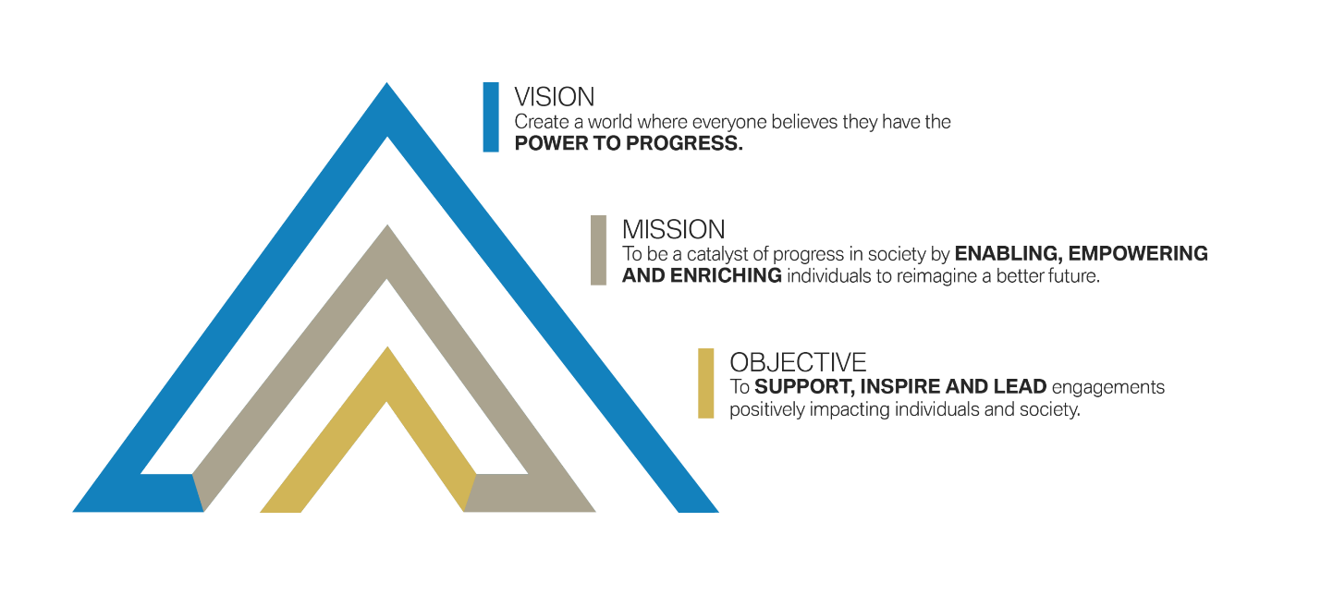
Figure 17: BMW India Foundation - Vision and mission
(Source: Bmwgroup.com, 2025)

4.6 Process Strategy Comparison
BMW USA - Process Design
BMW in the USA market strategically emphasises efficiency in the overall process through transparency and digital integration. The purchase process is effectively streamlined within online research and configuration preceding dealership visit, transparent pricing and financing options and quick purchase completion (Anand, 2022). BMW’s USA purchase process blends digital convenience with premium in-store service, offering online personalised dealership and extensive customisation through the program of “Build Your Own”
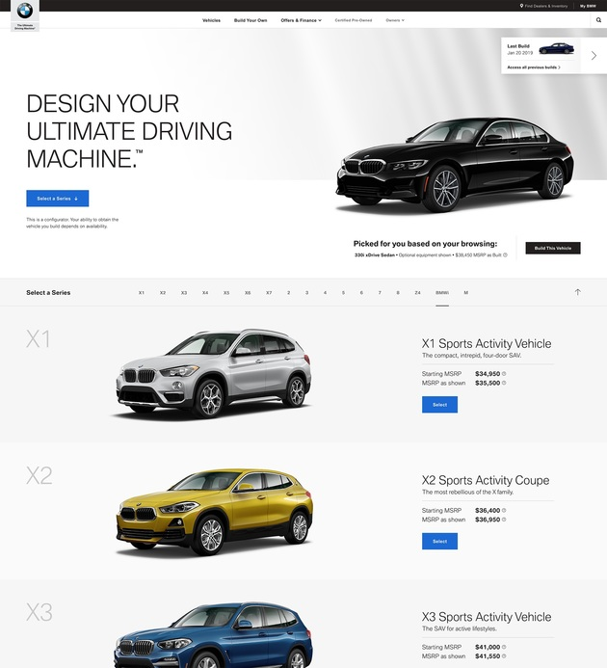
Figure 18: BMW Build Your Own process
(Source: Agencyspotter, 2025)
BMW India - Process Design
BMW India is strategically redesigning processes through its Retail. NEXT concept with the unified facilities and customer-centric layouts. A ₹365.6-crore investment, expanding across 33 cities, demonstrates the strategic commitment. Further, the improved process design is contextually enhancing customer satisfaction and brand preference.

4.7 Physical Evidence Strategy Comparison
BMW USA - Physical Evidence
BMW’s American market physical evidence maintains the global luxury standard with significant standards, including modern, architecturally distinctive dealership buildings and premium showroom environments with dedicated service facilities (Wuori, 2023). Physical evidence articulates the aspects of technological sophistication with the digital displays and interactive configurations, and modern aesthetic illustrating German design philosophy. Locally profitable dealerships and steady new-vehicle retail (≈90/month) sustain buyer demand despite global headwinds.
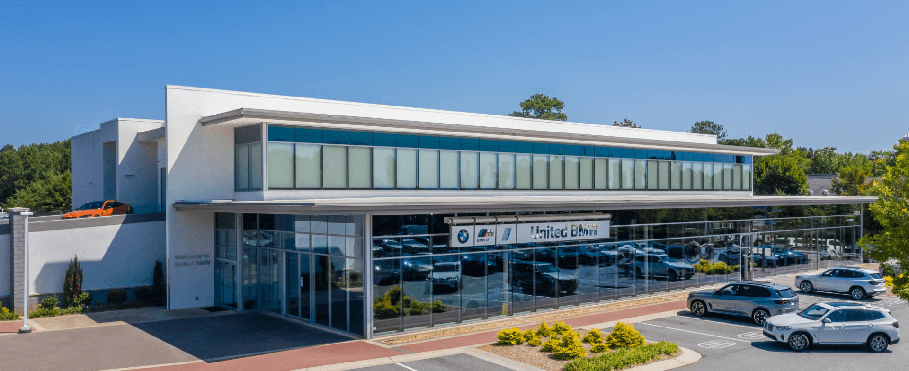
Figure 19: United BMW centres
(Source: Unitedbmw, 2025)
BMW India - Physical Evidence
The physical evidence of BMW in the Indian market emphasises the prestige, luxury, and exclusivity. By growing its retail, BMW is bolstering its physical presence in India. Deutsche Motoren and Infinity Cars are implementing the NEXT idea in Delhi NCR (Hong, 2024). The new shops highlight luxury, digital engagement, and customer-focused design, demonstrating BMW's dedication to contemporary retail, high-end visitor experiences.
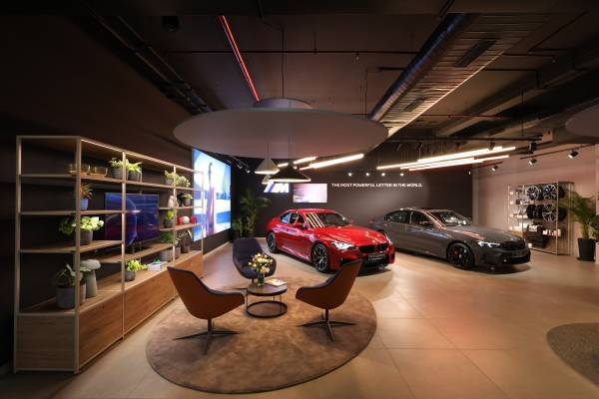
Figure 20: Retail.NEXT in Delhi NCR
(Source: Bmwgroup, 2025)

5. Evaluation Of the Performance of Marketing Strategies

5.1 BMW USA - Performance Evaluation
Sales and Market Share Performance
BMW’s Americas performance is proven to be strong with the present sales. In FY 2025, the deliveries hit 465,000 units, which is 20% of the global volume. Electrification in the U.S is further accelerating as BEVs = 12.4%, xEVs = 18.6% of sales, while strategic moves underpin the future growth potential. Passenger cars rose 19.1% and SUVs/light trucks surged 28.1%, driven by X-series demand. Although Q3 volume fell 2.8% to 16,096 units (compared to 16,557 in 2024), BMW's U.S. electrified vehicles hit over 20% of sales YTD 2025. Due to its updated electrified lineup, MINI demonstrated remarkable momentum, with Q3 sales increasing 37.6% to 7,270 units and YTD sales rising 24.6% to 21,862. The multi-OEM JV targets 30000 high-power chargers across North America, and BMW is adding a Gen6 high-voltage battery facility in Woodruff and Spartanburg under its ‘local for local' initiatives (Zhang and Thomson, 2025). Even the digitalisation of OTA upgrades and ADAS leadership enhance the product value and differentiation.
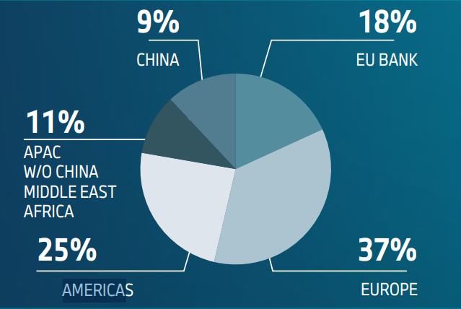
Figure 21: USA revenue share
(Source: Bmwgroup.com, 2025)
Brand Metrics Performance
According to the report of Bloomberg (2025), BMW strategically positions its crown in the luxury car segment in the United States market by outperforming the competitors, such as Lexus and Mercedes, marking its second consecutive year in a top position (Bloomberg.com, 2025). BMW’s U.S brand strength is reinforced through the premium positioning, higher customer retention rates and sustained leadership approach. Its South Carolina plant, BMW’s largest globally, boosts "American-made’ credibility, supporting trust, local jobs and strong market dominance across the premium segments.
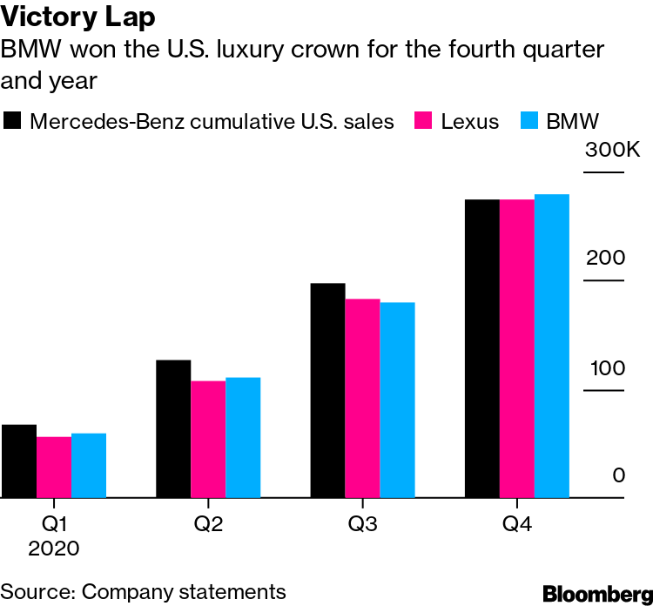
Figure 22: BMW USA luxury market share
(Source: Bloomberg.com, 2025)
Digital and Social Performance
BMW’s digital and social performance in the U.S demonstrates the strong gains driven by the creator-led advertising and reels-optimised content (Consumeraffairs.com, 2025). The Meta case study demonstrates that adding creator-built video ads boosted unique reach by 36%, with reduced creative similarity by 37% and improved cost-per-action efficiency by 20% for the key website actions (El Ebrashi, 2024).BMW even partnered with the specialised creators for highlighting the X5 and X6 models in the native, social-first formats, increasing relevance among luxury shoppers. The campaign ran across Facebook and Instagram Reels, Stories, and Feed, supported by multi-cell brand-lift studies

5.2 BMW India - Performance Evaluation
Sales and Market Share Performance
According to the report of Rushlane (2025), BMW Group India recorded a run through 2025 with 11,978 cars (BMW 11,510; MINI 468) and 3,976 motorcycles sold YTD, driven by its strongest quarterly performance with 4205 cars in Q3. BMW brand sales were 4,033 (+21.4%), MINI 171 (+25.7%). With 2,509 EVs sold so far (a 246% YoY increase), BMW India is the top luxury EV brand thanks to electric driving, which supports a superior status (Rushlane.com, 2025). Festive demand, GST-linked costs, long-length vehicles (+169%), and SUVs (+19%) all contributed to growth. The X1, 3 Series, and 7 Series were among the greatest finishers (Thehindubusinessline.com, 2025).
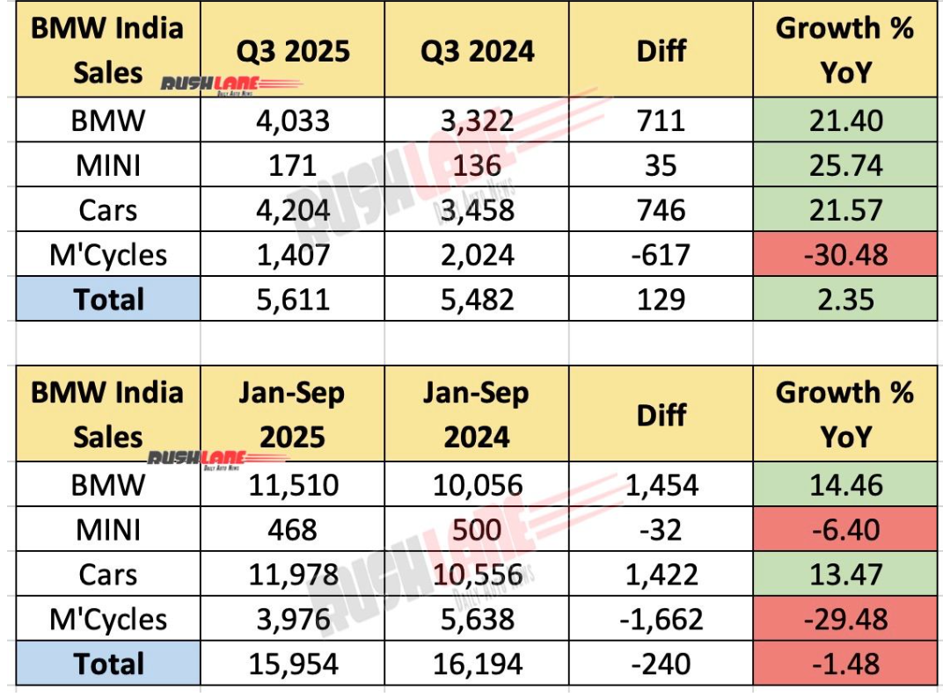
Figure 23: BMW India market share
(Source: Rushlane.com, 2025)
Brand Metrics Performance
BMW brand metrics in India demonstrate the strong market leadership and sustained momentum. It remains the top luxury EV brand for three years, recording over 200% EV growth in 2025, underscoring its dominance in premium electrification (Fadhil and Shen, 2025). Product strength is evidenced in its long-wheel-based model, aligning with the Indian consumer’s preference for rear seat comfort. Further festive demand and GST-linked price revisions significantly amplified the sales performance, reinforcing BMW’s premium positioning and deepening customer satisfaction across segments.
Digital and Social Performance
BMW’s India market presence is influenced by its digital and social performance, reflecting the strong digital-first, data-driven strategy. With heavy investments in SEO, AI-powered personalisation and influencer collaborations, BMW strategically boosted its visibility and engagement across platforms (Mary, 2024). BMW's premium electric car image was strengthened by an EV-focused narrative, which concentrated on the Neue Klasse foundation and premier EVs like the i4 and iX. This boosted interest among savvy luxury consumers.

6. Evaluation Of Marketing Ethics Practice

6.1 Ethical Issues in BMW USA Marketing
Environmental and Sustainability Claims
BMW’s sustainability messaging is backed by its targets of including a net-zero pledge by 2050, major Scope 1 and 3 emission reductions and a plan for 50% fully electric deliveries by 2030, with the supported verifiable ESG disclosures and CDP reporting (Grieco et al. 2024). The organisation, in the context of the USA market, attributes on Redwood Materials' recycling partnerships and Spartanburg plant sustainability projects for reinventing the green mobility prospects.
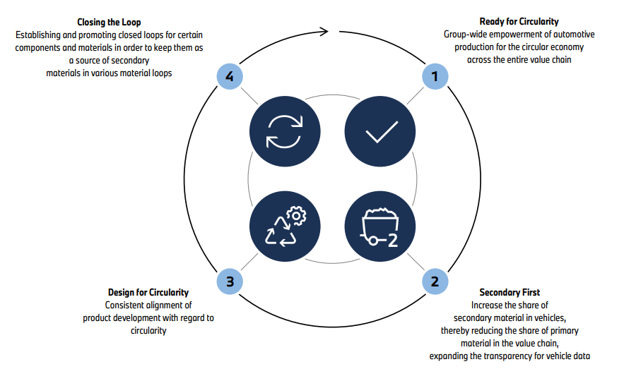
Figure 24: Key elements to a circular economy
(Source: Bmwgroup.com, 2025)
Advertising Standards and Consumer Protection
BMW’s USA marketing and consumer projection landscape demonstrates the stronger brand credibility along with the significant ethical risks. Consumer Reports ranked BMW the No. Luxury brand and No. 2 overall in 2024, articulating the strong perception of quality and safety aspects. However, ethical concerns arise from the delivery stops linked to the defective integrated brake system components and broader safety-related risks. In 2024, BMW conducted recalls affecting 12.2 million vehicles globally (Madić et al. 2021). While NHTSA-related airbag litigation in the U.S. poses financial and reputational exposure. Even the data ethics remain significant as BMW’s CarData platform (CCPA-aligned) enhances transparency.
Social Responsibility Practices
BMW strategically demonstrates structured social responsibility in the U.S through resource management and transparent political engagement. BMW's global goal is to reduce the amount of drinkable water used per vehicle by 25% by 2030 (compared to 2016) by recovery and other sourcing, as its Spartanburg factory runs in a region with severe water stress and Oxnard confronts exceptionally high strain (Micus et al. 2025).
Labour and Supply Chain Ethics
To enforce ethical and environmental norms, the corporation has a multistage due diligence approach that includes on-site supplier audits (Chou et al. 2022). However, hazards like forced labour, unfavourable employment circumstances, or tensions in US-China commerce could lead to supply shortages or damage to one's brand.
Potential Ethical Concerns
BMW USA faces legal liabilities from product liability lawsuits, highly stressful water business processes, increased cybersecurity concerns under the CCPA, and protectionist trade conflicts that may impair commodity supplies and competitiveness moving forward.

7. Recommendation & Conclusion

7.1 Strategic Recommendations for BMW's International Marketing
- Product Strategy Recommendations: BMW should expand its United States lineup to compete with Tesla while leveraging Spartanburg production for a stronger local appeal. In India, by widening the entry-luxury options and scaling premium EVs can contextually capture growing demand.
- Positioning and Communication Recommendations: BMW should modernise its U.S brand by effectively blending performance with sustainability and expanding the digital-first ownership models (Zhang and Thomson, 2025). In India, it should strengthen its prestige through tech-forward storytelling and experimental marketing.
- Distribution and Accessibility Recommendations: BMW should refine the U.S omnichannel journey with the unified digital and dealership experiences. In India, selectively expanding into tier 2 cities would strengthen service infrastructure for building trust, loyalty and sustainable growth.
- Sustainability and Ethical Marketing Recommendations: BMW should advance authentic sustainability in both markets through transparent reporting and strict supply-chain standards, and clear EV milestones (Kukkamalla et al. 2021).

7.2 Conclusion
This comprehensive comparative analysis demonstrates BMW’s sophisticated international marketing approach with the balanced global brand consistency and essential local market adaptations across the different continents of the United States and the Indian market. The USA market articulates the mature, high-volume profitability characterised by the luxury automotive culture and intense competition and consumers valuing technological innovation. On the other hand, the Indian market embodies dynamic growth opportunities with the emerging affluent economy, where luxury vehicles serve as the key status symbols and professional achievement markers. Performance evaluation evaluates the strategic approach with BMW, achieving market leadership through culturally adapted, contextually appropriate strategies in both markets, valuing profitability and innovation leadership.

Reference List
Agencyspotter (2025). BMW Shop new BMW models. Available at: https://www.agencyspotter.com/agency_projects/bmw-build-your-own [Accessed on: 26.11.2025]
Anand, A., (2022). MNC's Affiliation and Their Exports Performance: A Case of the Indian Motor Vehicle Industry. In Innovation Systems, Economic Development and Public Policy (pp. 189-217). Routledge India.
Bhada, M.B.A. and Dasani, M.K., (2021). The Financial Benefits of Sustainable Business Practices.
Bloomberg.com (20255). Available at: https://www.bloomberg.com/news/articles/2021-01-08/bmw-beats-lexus-mercedes-benz-for-2020-u-s-luxury-sales-crown [Accessed on: 26.11.2025]
Bmwgroup.com (2025).BMW GROUP REPORT 2024 Available at: https://www.bmwgroup.com/content/dam/grpw/websites/bmwgroup_com/ir/downloads/en/2025/bericht/BMW-Group-Report-2024-en.pdf [Accessed on: 26.11.2025]
Capital.com (2025).Largest economies in the world Available at: https://capital.com/en-int/analysis/largest-economies-in-the-world [Accessed on: 26.11.2025]
Cargroup.org (2025).The U.S. Automotive Market and Industry in 2025 Available at: https://www.cargroup.org/wp-content/uploads/2017/02/The-US-Automotive-Market-and-Industry-in-2025.pdf [Accessed on: 26.11.2025]
Cavusgil, S.T., Knight, G.A., Riesenberger, J.R., Rammal, H.G. and Rose, E.L. (2016). International business : the new realities. Frenchs Forest, N.S.W.: Pearson Australia.
Chou, H.C., Hung, S.W. and Lu, W.M., (2022). Exploring competition efficiency of automobile brands: An extensional data envelopment analysis‐metafrontier framework. Managerial and Decision Economics, 43(1), pp.206-218.
Consumeraffairs.com (2025). How many cars are in the U.S.? 2025Available at: https://www.consumeraffairs.com/automotive/how-many-cars-are-in-the-us.html [Accessed on: 26.11.2025]
David, F.R., (2011). Strategic management concepts and cases. Prentice hall.
Dawson, J., (2014). The marketing environment (RLE marketing). Routledge.
Dibb, S. and Simkin, L., (2008). Market segmentation success: Making it happen!. Routledge.
Ecodigest.in (2025). BMW Beats Lexus, Mercedes-Benz for 2020 U.S. L Available at: https://ecodigest.in/bmw-india-surpasses-20-ev-sales/ [Accessed on: 26.11.2025]
Econofact.org (2025). India’s Path To Becoming One of the World’s Largest Economieshttps://econofact.org/indias-path-to-becoming-one-of-the-worlds-largest-economies [Accessed on: 26.11.2025]
Economictimes.indiatimes.com (2025).
El Ebrashi, R., (2024). Political strategies of emerging and developed markets' multinationals in developing markets. Available at SSRN 5045338.
Fadhil, I. and Shen, C., (2025). Global electric vehicle market monitor for light-duty vehicles in key markets, 2024.
Grieco, P.L., Murry, C. and Yurukoglu, A., (2024). The evolution of market power in the us automobile industry. The Quarterly Journal of Economics, 139(2), pp.1201-1253.
Hong, J., (2024). Competitive Strategies and Market Positions of Global Automotive Giants: Toyota, Tesla, and BMW. In International Conference on Educational Information Technology (Vol. 6, No. 2).
https://brandequity.economictimes.indiatimes.com/news/business-of-brands/bmw-targets-affluent-customers-in-indias-emerging-ev-market/107384535 Available at: https://brandequity.economictimes.indiatimes.com/news/business-of-brands/bmw-targets-affluent-customers-in-indias-emerging-ev-market/107384535 [Accessed on: 26.11.2025]
Incss.org (2025). BMW Group India Records Highest-Ever Q3 Car SalesAvailable at: https://www.incss.org/bmw-group-india-records-highest-ever/ [Accessed on: 26.11.2025]
Jain, R., Jain, S. and Jain, S., (2022). Analyzing and exploring the effectiveness of each element of 7Ps of marketing mix. International Journal of All Research Education and Scientific Methods (IJARESM), 10(1), pp.2455-6211.
Johnson, W.H., (2013). Project Strategy and Strategic Portfolio Management: A Primer. Business Expert Press.
Kotler, P., Burton, S., Deans, K., Brown, L. and Armstrong, G., (2015). Marketing. Pearson Higher Education AU.
Kukkamalla, P.K., Bikfalvi, A. and Arbussa, A., (2021). The new BMW: business model innovation transforms an automotive leader. Journal of Business Strategy, 42(4), pp.268-277.
Leisch, F., Dolnicar, S. and Grün, B., (2018). Market segmentation analysis: Understanding it, doing it, and making it useful.
Madić, V., Marković, D. and Mijušković, V., (2021). Competitive strategies in premium automotive segment. Teme, pp.639-659.
Market.us (2025). BMW AG Statistics and Facts. Available at: https://market.us/statistics/automotive-companies/bmw-ag/ [Accessed on: 26.11.2025]
Mary, M., (2024). A Case Study On Performance Evaluation Of Capital Market Efficiency In Selected Automobile Industries In India. Special Issue on, p.122.
Mcgregor, H. (2014). Globalisation. London: Wayland.
Mckinsey.com (2025).Consumers care about sustainability—and back it up with their wallets Available at: https://www.mckinsey.com/industries/consumer-packaged-goods/our-insights/consumers-care-about-sustainability-and-back-it-up-with-their-wallets [Accessed on: 26.11.2025]
Micus, C., Homola, D., Prommegger, B., Thaetz, J. and Krcmar, H., (2025). Leveraging Bmw Fleet Data for Customer Integration in Product Development. Results in Engineering, p.105498.
Mintz, O., Gilbride, T.J., Lenk, P. and Currim, I.S., (2021). The right metrics for marketing-mix decisions. International Journal of Research in Marketing, 38(1), pp.32-49.
Mordorintelligence.com (2025).India Luxury Car Market Analysis | Industry Report, Size & Growth Insights, 2030 - 2025 - Intelligence Available at: https://www.mordorintelligence.com/industry-reports/india-luxury-car-market [Accessed on: 26.11.2025]
Myers, J.H., (1996). Segmentation and positioning for strategic marketing decisions. (No Title).
Nbcnews.com (2025).Even drivers who aren’t buying cars will pay for tariffs soon Available at: https://www.nbcnews.com/data-graphics/trump-tariffs-car-insurance-bill-price-auto-repair-cost-rcna201392 [Accessed on: 26.11.2025]
Orfonline.org (2025). Charging Infrastructure: The Missing Link in India’s EVs Transition. Available at: https://www.orfonline.org/research/charging-infrastructure-the-missing-link-in-india-s-evs-transition#_ednref38 [Accessed on: 26.11.2025]
Palazzo, M. and Micozzi, A., (2024). Decision-Making Strategies and Tools: State-of-the-Art and Advancement. In Rethinking Decision-Making Strategies and Tools: Emerging Research and Opportunities (pp. 11-32). Emerald Publishing Limited.
Pv-magazine-india.com (2025).India’s auto industry can cut emissions by 87% through green electricity, low-carbon steel: CEEW Available at: https://www.pv-magazine-india.com/2025/07/23/indias-auto-industry-can-cut-emissions-by-87-through-green-electricity-low-carbon-steel-ceew/ [Accessed on: 26.11.2025]
Pwc.com (2025). The US electric vehicle charging market could grow nearly tenfold by 2030: How will we get there?. Available at: https://www.pwc.com/us/en/industries/industrial-products/library/electric-vehicle-charging-market-growth.html [Accessed on: 26.11.2025]
Read more at:
Rushlane.com (2025).BMW India reports highest ever sales - Q3 2025, Jan to Sep 2025 - 2025 - Patel, Patel Available at: https://www.rushlane.com/bmw-india-reports-highest-ever-sales-q3-2025-jan-to-sep-2025-12531881.html [Accessed on: 26.11.2025]
Santoso, R.P., Ningsih, L.S.R. and Irawati, W., (2024). Implementation Of Segmenting Targeting And Positioning Strategies In Improving Marketing Performance. BIMA: Journal of Business and Innovation Management, 6(2), pp.280-292.
Scienceagri.com (2025).The 10 World’s Best-selling BMW models - 2025 - Santosa Available at:. https://www.scienceagri.com/2024/06/the-10-worlds-best-selling-bmw-models.html [Accessed on: 26.11.2025]
Statista.com (2025). Owning a Car Is Less Important To Younger Generations . Available at: https://www.statista.com/chart/33097/importance-of-owning-a-car-for-us-residents-by-generation/?srsltid=AfmBOooCtb7hXCWOwmz3vmsriny6JDeROk3oiVfiW5Yko0HCcZtLkhZ3 [Accessed on: 26.11.2025]
Statista.com (2025).India Barely Imports Cars To Protect Its Own Industry Available at: https://www.statista.com/chart/34269/indias-car-imports/?srsltid=AfmBOoqqOb1bVN_ln48_O-sHPx9QnmrOSI7nLCpD0KeFNr9RL9aLfsgD [Accessed on: 26.11.2025]
Teichmann, I. (2022). Globalisation. London: Watts.
Thehindubusinessline.com (2025). Localisation strategy helping sales growth in IndiaAvailable at: https://www.thehindubusinessline.com/news/localisation-strategy-helping-sales-grow-in-india-bmws-vikram-pawah/article69408789.ece [Accessed on: 26.11.2025]
Truecar (2025). Available at: https://www.truecar.com/overview/bmw/ [Accessed on: 26.11.2025]
Unitedbmw (2025). Service Center . Available at: https://www.unitedbmw.com/service/ [Accessed on: 26.11.2025]
Walsh, L. (2018). International marketing. 1st ed. London: Financial Times Management.
Wibawa, E.D., Ratu Roy, E.R., Sentosa, G.A. and Riza, I.W., (2023). Success Indicators of International Corporate Research Cooperation: Case Study of Collaboration between BMW Group and Toyota Motor Corporation 2011. Global Journal of Business Social Sciences Review (GATR-GJBSSR), 11(3).
Wuori, P.E.M., (2023). Analysing the Differences Between Luxury and Premium in Marketing–Case Study: BMW and Rolls-Royce.
Zhang, Z., Ye, N. and Thomson, M., (2025). BMW is powerful, beemer is not: nickname branding impairs brand performance. Journal of Marketing, 89(1), pp.135-152.
Zhang, Z., Ye, N. and Thomson, M., (2025). BMW is powerful, beemer is not: nickname branding impairs brand performance. Journal of Marketing, 89(1), pp.135-152.

