

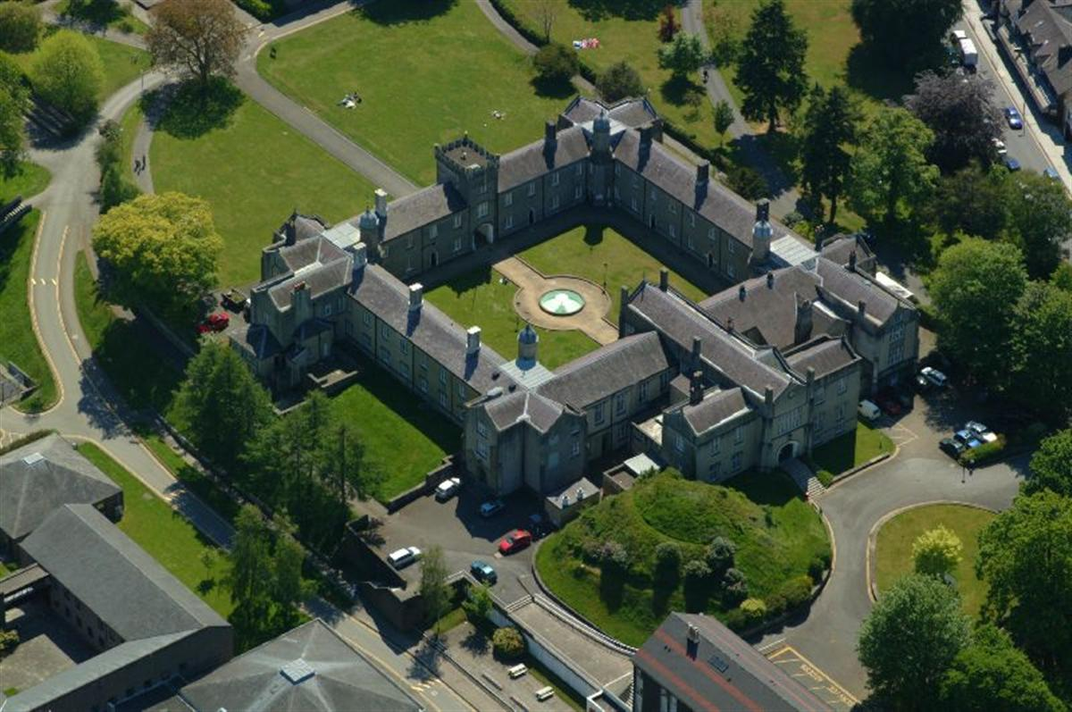

Lampeter University Campus - Listed Building Grade II

windows refurbishment

Case Study for Building Sustainability Upgrade

Sandra p143636 | Bsc Architectural Technology | March 9th, 2018
Table of Contents

1. Introduction 3
2. Listed Buildings Classification 3,4
3. Windows History 4,5,6,7,8
3.1 General principles of windows 9,10,11
4. Report 12,13
4.1 Surveying report 14,15,16,17,18
5.Propose 19
6. Conclusion 20,21
References 22,23
Appendix 1 24,25,26
Appendix 2 27

- Introduction
This report was developed based on the surveying carried out in December 2017 in the UWTSD building (University of Wales Trinity St. David's in Lampeter) which works as student accommodation and is listed as Grade II. This visit and surveying was carried out by third year students of the Architectural Technology course at the University of Wales Trinity St. David's in Swansea, with the interest of submitting proposals for the restoration of the building by converting it to a sustainable building without any alteration of structure and its external design. The report developed in this assignment specifically addresses the windows of the building, the recovery and conservation of existing material and the adaptation of new proposals for the recovery.
- Listed Buildings Classification
In the United Kingdom a listed building is a building that is registered in the Statutory list, these are special considerations of architectural and historical interest. They are protected against demolition or alteration. If repairs, maintenance or minor alterations are required, they must have the approval of the local planning authorities. If they are religious buildings, they are exempt, and the own organization operates its own permitting procedure. The historic and emblematic buildings to be listed must have the requisites for this purpose. such as being built by the man's hand with a sturdy structure and surviving in something at least approaching its original state. Most buildings listed are historic and architectural landmarks, and bridges, monuments, sculptures, and memoirs of war, landmarks and miles are also listed. Buildings built before 1700 and surviving mostly are listed, as well as between 1700 and 1840. After the Second Great War all buildings over 30 years old can also be listed if they are exceptionally important.

England and Wales / 3 grades of classification:
Grade I: Buildings with special historical and architectural interest, sometimes of international importance
Grade II *: Important buildings, especially architectural styles
Grade II: They are distinct buildings, of National interest and of special interest, in most of them private buildings and residential housing and others.
The owners of these buildings have the responsibility of keeping the building in full condition, without being able to make alterations without the approval of the local council. If alterations or repairs are made without planning submition, the owner can be judged for not complying with all the required process. These buildings may have changes if it is in the interest of the owner, but the owner has to request the removal of his building from the listing, which is not very common in the United Kingdom.

- Windows History
The Window is defined as an architectural design adornment applied to buildings with the function of allowing the entrance of light, air and allowing a more pleasant interior environment at the level of thermal and acoustic comfort, as well as the visualization of the exterior giving the pleasure of observation (fig. 1). According to history, the window did not always fill these requirements simultaneously. It was only possible to establish these properties at a more advanced level of window design, namely with the appearance of the guillotine or sash window in the mid-Gregorian era until the mid-1950s. The windows in conjunction with the doors were considered by many protections for the occupants. Initially the ventilation was the main concern in the conception of the window in the places of habitation but was its potential for the lighting that provided its architectural design.
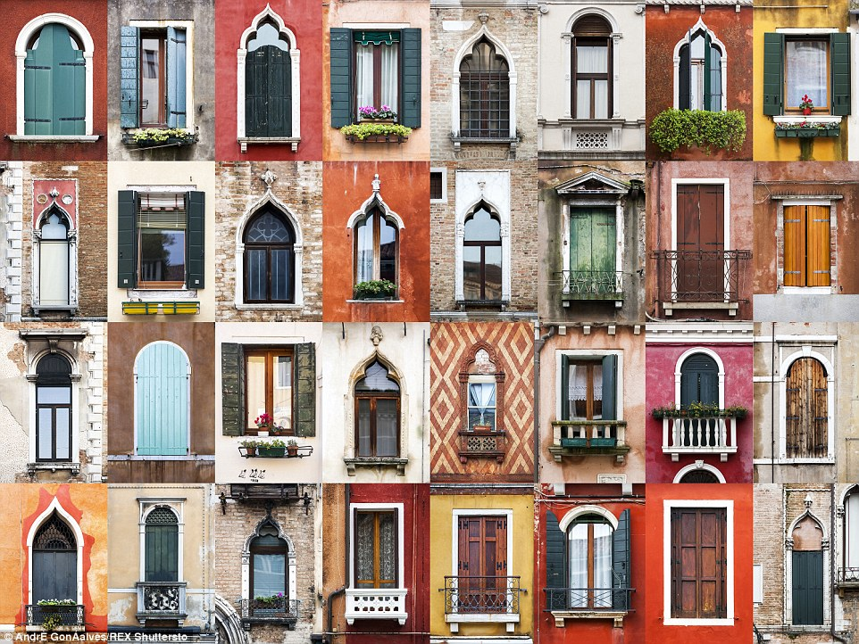
Fig. 1 example of many assorted designs of windows

The windows entirely made of unglazed wood, were the houses of the poor, who had to keep them open for light and ventilation, while the rich had windows and the number of windows was more than a sign wealth. During the Renaissance period (fig.2) for the need of light, the windows had a lush decor, of great dimensions and with vivid colors to show the owners' wealth. In the middle of the 18th century there was a need to construct a more efficient window for a post-medieval world and the design was the guillotine or sash window (fig. 3), this was considered a modern and effective instrument. Traditionally the window gave the building its character and style of the time. The classical windows (fig.2) were the Renaissance windows, which presented concepts of symmetry, harmony, proportion and decoration. Its dimensions were adapted to each country, depending on its design and size, consonant with the different climatic conditions.
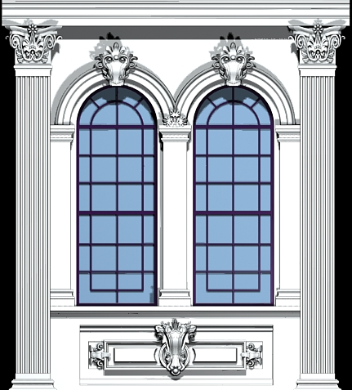
Fig. 2 Renaissance Window, XIII Century
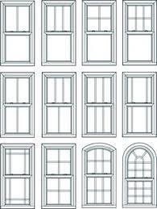 Fig. 3 Sash window style, XV Century

The Gothic, the Baroque and the Oriental window (fig. 4), were 3 identical styles because they had common artistic qualities. The variety, the symmetry, the movement and the exaggerated spontaneity of adornments that were fundamental points of agreement between them. It can be said that these styles were the opposite of the ideals of the classic style. In the modernist period, it was necessary to transform the window into a standardized device to admit controlled amounts of light and air. With the influence of the time there is a greater expectation of creating a window that provides a healthy environment and offers a greater amount of interior light, which developed the study to design windows with more functional features.
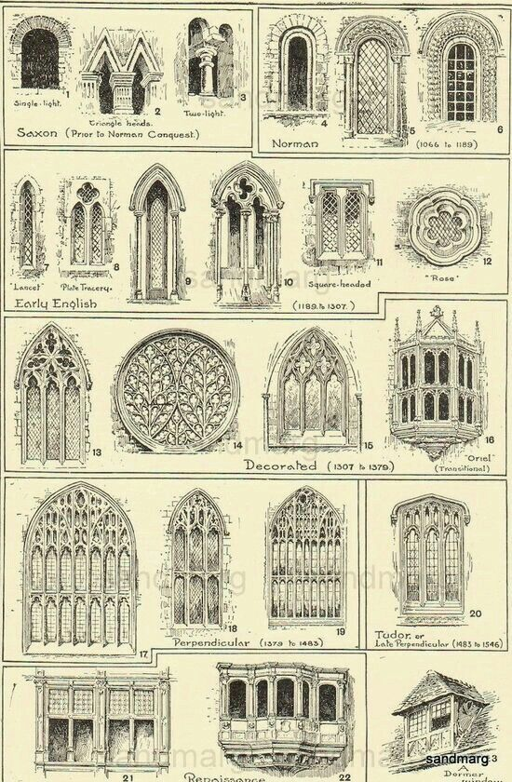
Fig. 4 Baroque style
The shape of the window has undergone changes over time. Initially there were only fixed windows, but later, with the needs of ventilating the interior space, windows were created to open. The Venetian (fig. 5) window persists for several centuries to the present times. However, windows appeared in other ways, to captivate more consumers.
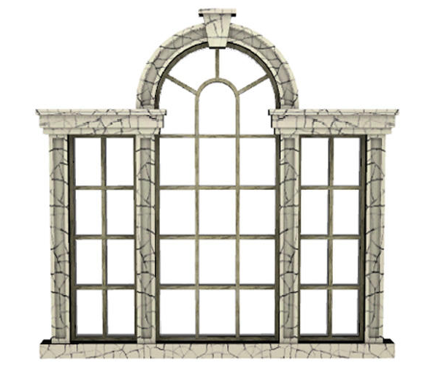
Fig. 5 Venetian Window, XV Century

  - General principles of windows
The need for ventilation inside the dwellings was the basic need in the design of the window. Although light and air can be treated individually, they must be associated for stability and safety reasons. The slash window, at the time of its invention, is essentially characterized by its counterbalancing device. Its acceptance was a little time-consuming, largely because of the sash windows, which were very much rooted in the culture of the people.
The windows of rotation on a vertical axis, were also very used, due to their good ventilation behavior, in rainy conditions. Its shapes were regular, in circular, rectangular or oval shape, and of fine thickness. Throughout history, it was necessary to obtain a window that was equipped with mechanical systems, which solved the problems related to the opening and closing of the same. Responding imaginatively to material circumstance, and exploiting relevant technological advances, a rich heritage of window shapes was conditioning its future development. This process was not only affected by functional concerns. Social and aesthetic preferences played significant roles in determining the result of the type of solution that, during the was largely conditioned by historical precedents. In stylistic terms, too, there is no infinite range of forms available: the external shape of a window achieves a delicate balance between functional requirements, decorative taste and material ability (conditions that are perennial). The layout of the exterior windows on the façade of a building also fulfilled these requirements, forming recognizable patterns associated with the architectural language of a period or school of thought. The origin of the Serlian window which is also called Venetian blinds or Palladian (fig.5), originated in Rome. It was reinvented by the Italian Renaissance, as a window that includes a vast central arch flanked by straight spans and columns and decorated according to classical orders.
In the 17th century, Inigo Jones used Venetian windows in several of his buildings, but after his death, in addition to the work of his follower, John Webb, the sheer format of the Italian Venetian window fell into disuse.
Later, in the second decade of the eighteenth century, when Italian influence became dominant, the Serlian style was resumed and followed by Palladian and Baroque schools. According to contemporary writers, the Venetian window was popularized due to three basic factors: its visualization, lighting and potentiality in the decoration of buildings. These windows were considered windows of very high quality and extreme elegance. The most significant development in this type of windows was its elaboration according to an arch and the balcony window. The Venetian window designed in a hemicycle, or in a segment of a smaller circle, becomes what is commonly called a bow window.
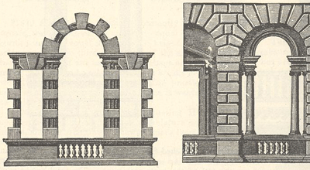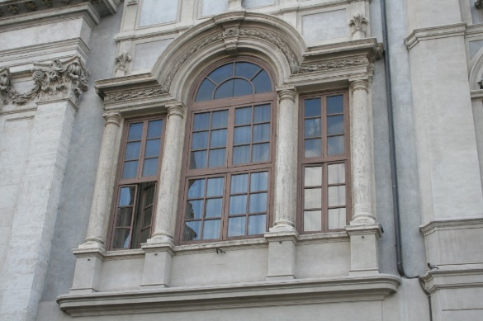
Fig. 5 Serlian or Palladian window

The Gothic style was poorly implemented at the time, but the triumph of the picturesque movement at the turn of the century, with the search for transparency and contact with nature, guaranteed the Venetian window (fig.6) a place in the early nineteenth century. Until the early nineteenth century, Venetian windows were the only option to be used in buildings, which led to its enormous popularity.
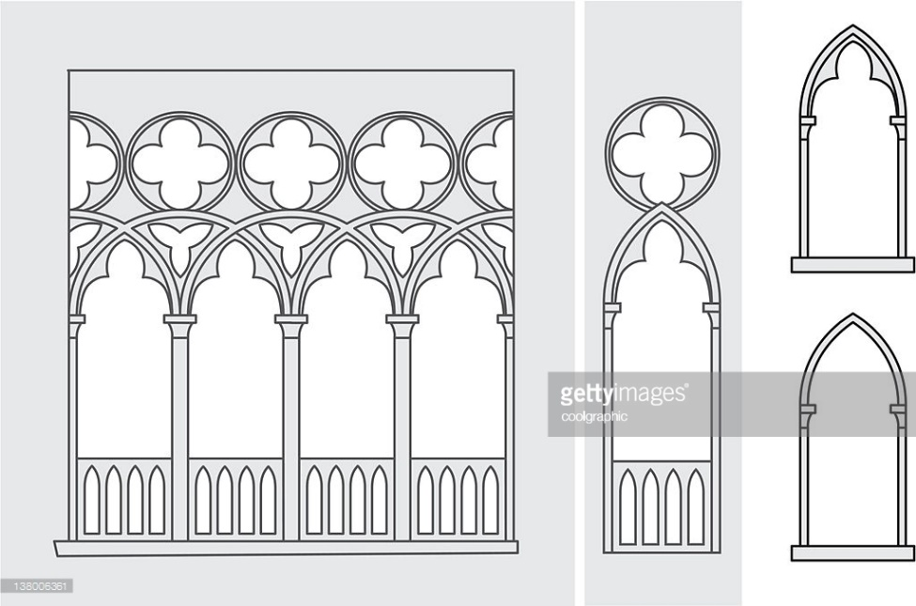
Fig. 6 Venetian window (Gothic arch design influence)

- Report
This work is based in surveying made in 12th of December 2017 in Lampeter University of Wales Trinity St. Davis with a group of Bsc. Architectural Technology students from UWTSD Swansea. (fig. 7)
The surveying was made to the listed building on site, and this report is a propose for sustainable windows, conservation and sustainable refurbishment for this building.
Listed on grade II: Gates and boundary wall to St. David’s University College, Lampeter, Ceredigion (along da SW of station terrace and the E side of College Street).
Listed date: 10 February 2012
Last emended: 10 February 2012
Grade: II
Source: Cadw
Source ID: 87646
Building Class: Education
Location: Along th SW of station terrace and the E side of College Street
County: Ceredigion
Town: Lampeter
Community: Lampeter (Llanbedr Pont Steffan)
Built-up Area: Lampeter
Traditional County: Cardiganshire
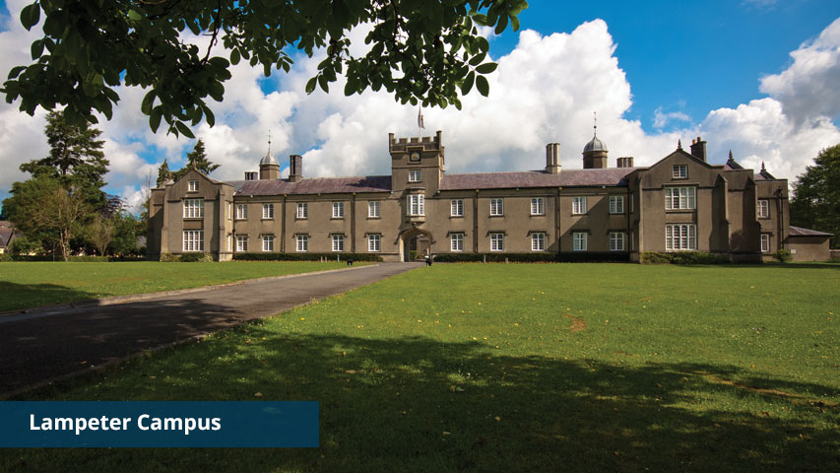
Figure 7

History of the Building
The Boundary walls and gateways are possibly contemporary with the original early 19th Century construction of the college but may belong to the later 19th Century phase of college additions. The gates are probably later replacements. (www.britishlistedbuildings.co.uk/wales)

Exterior

Rubble stone boundary wall of varying heights, the Station Terrace section is higher to the E and has been reduced and capped to the West and around into College Street where it increases in height again. Two gateways oblique Station Terrace, to the E wide vehicular entrance and to the W on the corner with College Street a narrow low pedestrian gateway with piers and pyramid capping, the wall ramped up to meet the piers. Wrought iron gate.

(www.britishlistedbuildings.co.uk/wales)

Part way down College Street a wider vehicular gateway with similar but taller piers with pyramid covering and double shaped iron gate. A further similar gateway at the S end adjacent to the lodge. (www.britishlistedbuildings.co.uk/wales)
Reasons for Listing
Included for their special architectural interest as a largely intact set of boundary walls and gateways of clever design quality which define the University College site. Group value with the Lodge and the University College buildings.
The report presents "Windows with Planning Guidance for a Listed Building Grade II." The guidance is intended to ensure that planning requests are informed, competent and in accordance with the policy. It will also ensure that the Council makes consistent decisions in line with national policy and best practice.
The guidance is in accordance with the national policy and guidelines published by the Historic Environment of Wales and incorporates the best conservation practices for the management of old windows in Buildings and Conservation Areas.
(www.britishlistedbuildings.co.uk/wales)
4.1 Surveying report
The first step is to carry out a thorough surveying, to detect all the work to be done in the restoration of all old windows (fig. 8,9), to point out possible scenarios in the integration and fixation of secondary windows, and thicknesses of profiles that can be used in a way that does not alter the visualization of the design of the building being viewed from outside the building. The second step was to consult the electronic documents of the local council and to know which Grade this building was named in the listings of the local Listed buildings.
With this surveying it was recorded by observation and notes, measurements, water infiltration measurements and the different temperature scales captured by a laser scan, as can be observed in the figures (fig.10,11,12), which is possible to detect that the windows do not require the objectives for a sustainable building, the energy losses are visible by the color of the negative temperatures that are obtained in this building with this type of window with single glass and cracks that promote the loss of energy, as the lack of isolation acoustic. It has also been found that the south facing windows have a greater wear and deterioration because they have a greater exposure to the sun, which causes a significant difference in temperature from day to night and the material tends to break and crack. and the jugs of the inner courtyard and side facing west, have signs of deterioration and the need to be treated, but do not require so much conservation work, which significantly reduces costs. As for the method and restoration, it must be initiated by the current windows, and so that when the interior secondary windows are fixed the old materials are prepared for their fixation without additional costs or risks. All work should begin and be prepared in advance so that all work is most successful without loss and risk of materials and workers. Large windows can hamper work and create risks, to avoid.
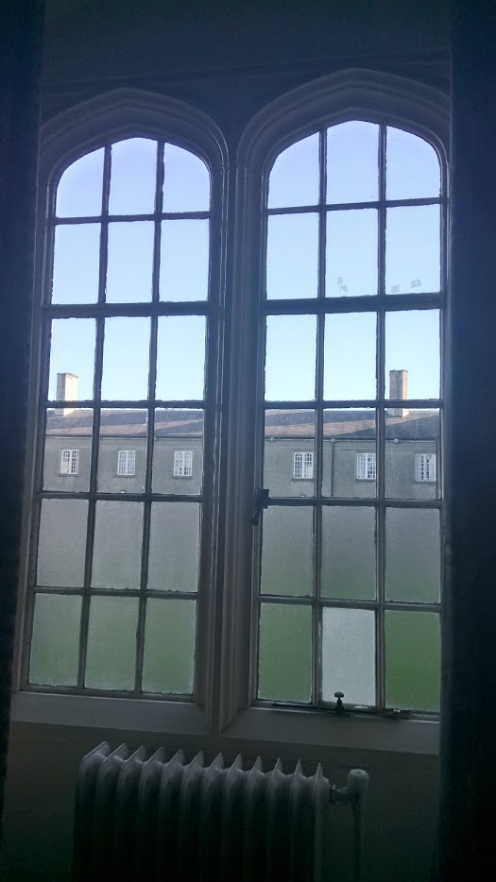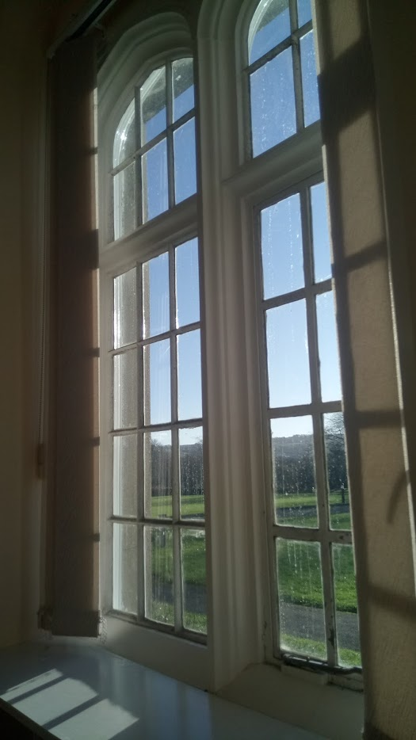 Fig. 8 and 9
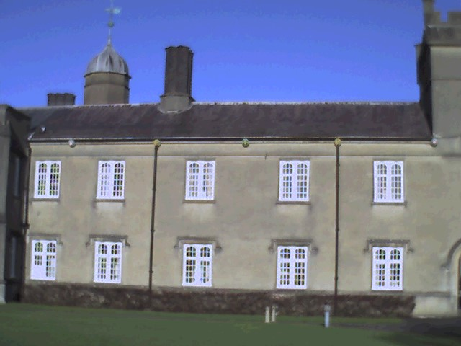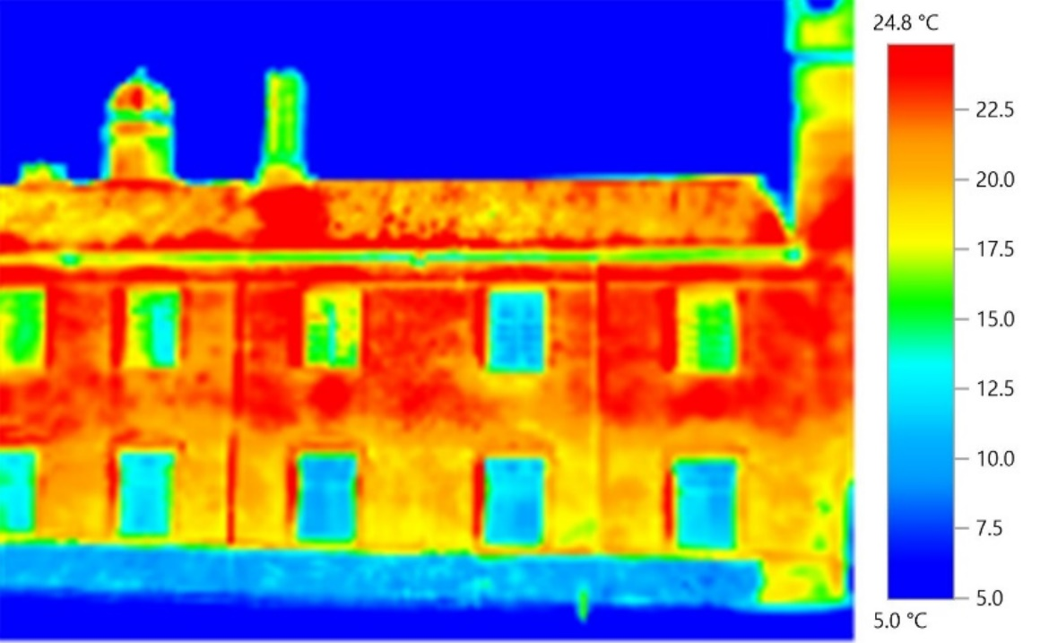
Fig. 10 - South Facade
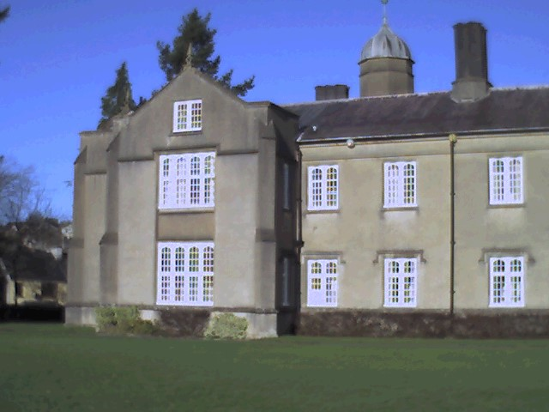
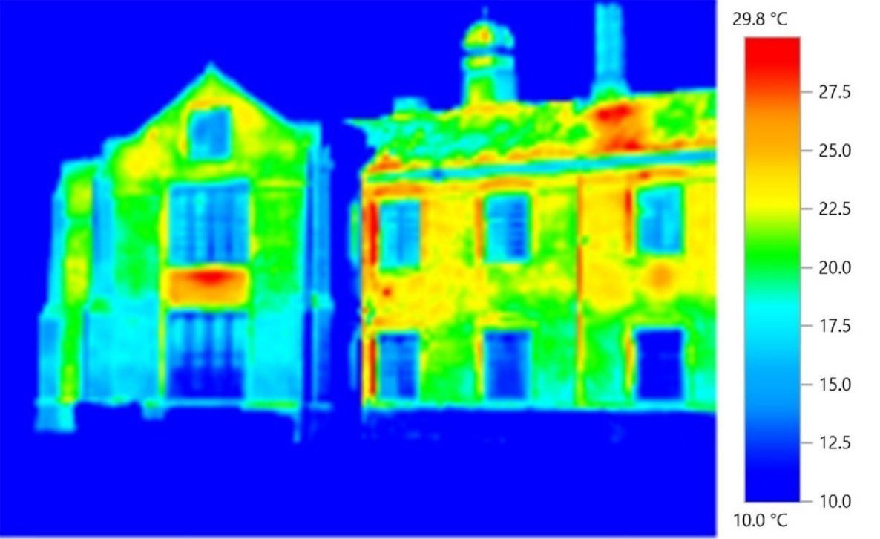
Fig. 11 - South left corner to west facade

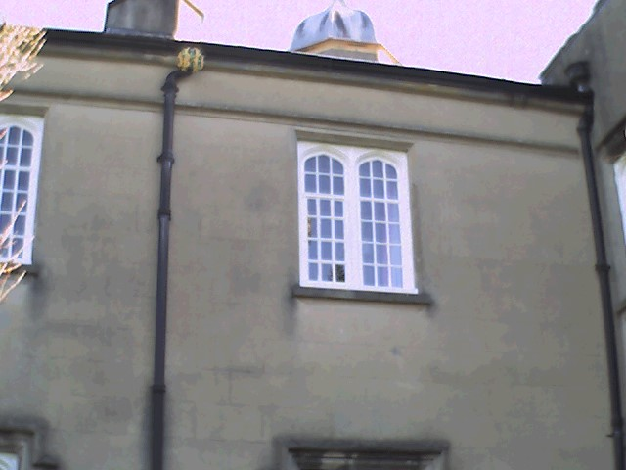
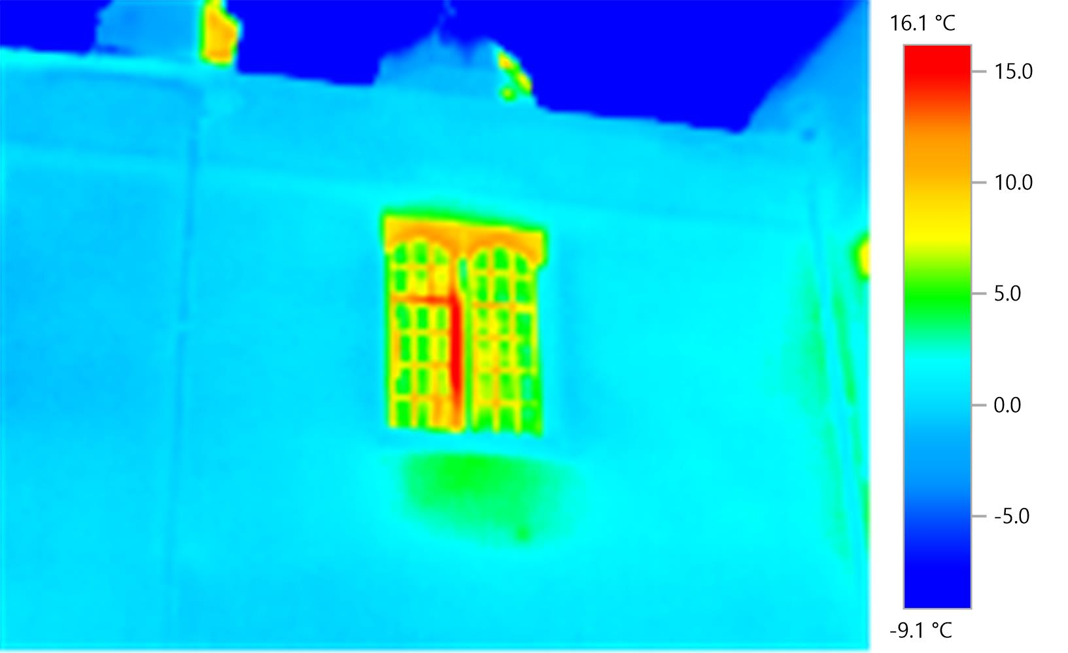
Fig. 12 - West façade level 1 window

5. Propose
The building's windows can be updated to improve the building's energy efficiency, reduce costs, provide a better interior environment and maintain greater security. The costs of the investment justify substantially the reduction of the costs of heating, energy use, noise reduction, and the cancellation of dust inflows. The use of internal blinds is also a positive option and to be considered for better window performance. Heavy and coated curtains are effective in reducing heat loss. Double glazing with double profile are effective only when the original frames allow their incorporation, but as in this case it is not possible to remove the existing windows to change them, the option that is proposed are secondary glazing, and the placement of an independent Upvc frame (fig. 13) with profile for double glazing capable of providing the desired function in sustainable terms. This double-glazed window inside the building with fixing the shoulders and window sill, provides the same insulation values, reducing energy losses, noise reduction and dust entry, guaranteeing the same existing light input through the old window. The design of this window should be discreet and projected with profiles that cannot be viewed from outside the old window so that the building can maintain its original design. Additional security measures can be incorporated in a sensible way in existing windows. The new secondary window for thermal performance also provides an extra safety measure.
Local: Windows Company at Lampeter - J & P Home Improvements
Double glazing installer in Lampeter, Wales
Address: Unit 1-5, Lampeter Industrial Estate, Tregaron Rd, Lampeter SA48 8LT

Appendix 2 – page 27 (existing window drawings, propose internal window propose, and detail drawing)

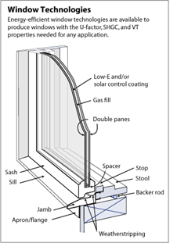
Fig. 13 simple frame system for secondary’s or internal window.

6. Conclusion
The key to preserving old buildings and listed buildings is regular maintenance. It will be easy to predict that historic buildings have a lifespan, when in fact, old buildings can last indefinitely. Repairing windows sometimes becomes difficult, simply because some recent materials are incompatible with the previous ones. In the case of wood and stone, its replacement is simple. In the type of studied window of iron with wooden frames, its repair must be careful because the iron windows have a tendency over time to have corrosion and besides the window is damaged, it also damages the surrounding woods and even the wall itself when they are fixed with iron spikes. Periodic inspections should be carried out to detect pathologies in their initial phase, thus avoiding their replacement. Typically, the damage is caused by the humidity or the consequence or symptom of other defects to which the building is subject. Most of the materials of old buildings can be recycled. The lead can be melted, while the glass is re-used. The tiles can be stored, retrieved and used later. The wooden beams provide a highly sustainable solution in the repair of damaged windows. The best contribution to sustainability is part of the education, awareness and training of professionals in preservation techniques and processes, as well as the pathological and holistic understanding of the research processes. The long-term performance of windows depends on their tightness. Improper choice and application of paint may provide water ingress and ultraviolet attacks. The windows facing south, due to their exposure, are the ones that present greater deterioration in the frames. Neglect, lack of maintenance, inadequate labor, and the use of improper materials are often the reason for early deterioration. There are several measures that can be considered to minimize thermal losses in old buildings, such as: installation of heat-insulated shutters; maintenance of wood and metal parts; application of secondary glasses to maintain the integrity of the original window; application on the thermal protection film glass; regular maintenance and moisture control in the window; discrete caulking; put insulation on the floor, and walls.
It has also been found that the south facing windows have a greater wear and deterioration because they have a greater exposure to the sun, which causes a significant difference in temperature from day to night and the material tends to break and crack. and the jugs of the inner courtyard and side facing west, have signs of deterioration and the need to be treated, but do not require so much conservation work, which significantly reduces costs. As for the method and restoration, it must be initiated by the current windows, and so that when the interior secondary windows are fixed on the existing materials are prepared for their fixation without additional costs or risks. All work must begin and be prepared in advance.

References
[1] https://www.ordnancesurvey.co.uk/support/understanding-gis/

[2] (1) TUTTON, Michael; HIRST, Elizabeth- Windows history, repair and conservation‖; Donhead, 2007; pp. 7 a 155.

[3] https://www.bsesc.energy.gov?images/windows-components

[4] https://www.britishlistedbuildings.co.uk

[5] https://www.historicengland.org.uk

[6] https://www.guardian.com – Preserving historical buildings 12.10.2016
[7] https://www.doble-glazers.co.uk registered in England company number 07575287
Local company at Lampeter

[8] https://www.easthants.gov.uk – windows in listed buildings and conservation areas guidance

[9] https://www.breeam.com – sustainable refurbishment of domestic buildings using bream

[10] https://www.scambs.moderngov.co.uk – chapter 14 – sustainability energy efficiency and listed buildings

[11] https://www.planningportal.gov.uk – building regulations and listed buildings

[12] https://www.planningni.gov.uk – building on tradition – sustainable design guide for listed buildings

[13] https://www.bathnes.gov.uk – planning policy – Energy Efficiency and renewable energy guidance for listed buildings

[14] https://www.transact.westminter.gov.uk>docstores – Retrofitting historic buildings-Westminster city council

[15] https://www.highland.gov.uk / meetings – Planning guidance for listed buildings

APPENDIX 1
1. Principles of Selection for Listing Buildings General principles applied by the Secretary of State when deciding whether a building is of special architectural or historic interest and should be added to the list of buildings compiled under the Planning (Listed Buildings and Conservation Areas) Act 1990.
2 Our aim is to improve the quality of life for all through cultural and sporting activities, support the pursuit of excellence, and champion the tourism, creative and leisure industries.

Principles of Selection for Listing Buildings
Introduction
1. This guidance sets out the general principles that the Secretary of State applies when deciding whether a building is of special architectural or historic interest and should be added to the list of buildings compiled under the Planning (Listed Buildings and Conservation Areas) Act 1990. The Secretary of State cannot take any other factors into account when considering his decision. Identifying and Recording the Historic Environment
2. In its broadest sense, the historic environment embraces all those aspects of the country that reflect the shaping hand of human history. Scarcely any part of England is untouched by the interaction between people and nature, which has taken place over thousands of years. Some of the most obvious features of this environment are historic buildings. England is exceptionally rich in these - great churches, houses, and civic buildings - but our understanding of the historic environment now encompasses a much wider range of features, and in particular stresses the relationship between individual buildings, and also the value of historic townscape and landscape as a whole.
3. There is growing appreciation not just of the architectural set pieces, but of many more structures, especially industrial, agricultural and other vernacular buildings that, although sometimes individually unassuming, collectively reflect some of the most distinctive and creative aspects of English history. More than this, our understanding and appreciation of the historic environment now stretches beyond buildings to the spaces and semi-natural features that people have also molded, and which are often inseparable from the buildings themselves. For example, the pattern of roads and open spaces and the views they create within historic townscapes may be as valuable as the buildings. In the countryside, the detailed patterns of fields and farms, of hedgerows and walls, and of hamlets and villages, are among the most highly valued aspects of our environment. England is particularly rich in the designed landscapes of parks and gardens, and the built and natural features they contain: the greatest of these are as important to national, and indeed international, culture, as are our greatest buildings.
4. Processes of classification are necessary for the practical purposes of identifying and protecting individual sites and areas. This is achieved through the statutory systems for scheduling ancient monuments, listing historic buildings and designating conservation areas. Scheduling and listing are undertaken by the Secretary of State; designation of conservation areas is the responsibility of local planning authorities. In addition, English Heritage compiles registers of parks and gardens of special historic interest, and of historic battlefields. Once identified in these ways, the historic environment may be protected through the planning system. Listing Buildings of Special Architectural and Historic Interest
5. Section 1 of the Planning (Listed Buildings and Conservation Areas) Act 1990 (the Act) imposes a duty on the Secretary of State to compile or approve a list or lists of buildings of special architectural or historic interest as a guide to the planning authorities when carrying out their planning functions. The planning system is designed to regulate the development and use of land in the public’s interest. The designation of historic sites enables the planning system to protect them, through the complementary systems of listed building consent and conservation area control, coupled with controls over scheduled monument consent.
6. The statutory criteria for listing are the special architectural or historic interest of a building. Many buildings are interesting architecturally or historically, but, in order to be listed, a building must have “special” interest.
7. Buildings on the list are graded to reflect their relative architectural and historic interest. Buildings of historic interest may justify a higher grading than would otherwise be appropriate.
• Grade I buildings are of exceptional interest;
• Grade II* buildings are particularly important buildings of more than special interest;
• Grade II buildings are of special interest, warranting every effort to preserve them.
8. In addition to the statutory criteria and the general principles contained in this guidance, Selection Guides for different building types are published on English Heritage’s website. The Selection Guides provide detailed technical information about each building type and are linked to the general principles contained in this guidance. They demonstrate what features are considered significant and likely to make a building of special architectural or historic interest when assessing buildings of a particular type from different periods, regions, or styles. It is recognized that some buildings are unique or will fall into more than one building type. Where a building is a composite of different types, then any relevant criteria from the Selection Guides applies. The general principles outlined below take precedence over the Selection Guides, which are published as supplementary information. The Guides are updated and revised when needed to reflect the growing understanding of the significance of particular types of building through further research. Statutory Criteria
9. The Secretary of State uses the following criteria when assessing whether a building is of special interest and therefore should be added to the statutory list: • Architectural Interest. To be of special architectural interest a building must be of importance in its architectural design, decoration or craftsmanship; special interest may also apply to nationally important examples of particular building types and techniques (e.g. buildings displaying technological innovation or virtuosity) and significant plan forms;
• Historic Interest. To be of special historic interest a building must illustrate important aspects of the nation’s social, economic, cultural, or military history and/or have close historical associations with nationally important people. There should normally be some quality of interest in the physical fabric of the building itself to justify the statutory protection afforded by listing.
10. When making a listing decision, the Secretary of State may take into account the extent to which the exterior contributes to the architectural or historic interest of any group of buildings of which it forms part. This is generally known as group value. The Secretary of State will take this into account particularly where buildings comprise an important architectural or historic unity or a fine example of planning (e.g. squares, terraces or model villages) or where there is a historical functional relationship between a group of buildings. If a building is designated because of its group value, protection applies to the whole of the property, not just the exterior.
11. When considering whether a building is of special architectural or historic interest the Secretary of State may take into account the desirability of preserving, on the grounds of its architectural or historic interest, any feature of the building containing a man-made object or structure fixed to the building or forming part of the land and comprised within the curtilage of the building. The desirability of preserving such a feature is a factor which would increase the likelihood of the building being listed. However, in the absence of any other aspects of special architectural or historic interest, such features will justify the listing of the building only if they are of themselves of sufficient interest to render the building of special interest. The provision can be used for a variety of features; examples could include a finely paneled sixteenth century room, a fireplace and over-mantel that has been introduced from another building, or an elaborate plaster ceiling. This provision cannot be used to preserve in situ anything that is not a fixture, such as furniture or paintings. General Principles
12. Age and rarity. The older a building is, and the fewer the surviving examples of its kind, the more likely it is to have special interest. The following chronology is meant as a guide to assessment; the dates are indications of likely periods of interest and are not absolute. The relevance of age and rarity will vary according to the particular type of building because for some types, dates other than those outlined below are of significance. However, the general principles used are that: • before 1700, all buildings that contain a significant proportion of their original fabric are listed; • from 1700 to 1840, most buildings are listed; • after 1840, because of the greatly increased number of buildings erected and the much larger numbers that have survived, progressively greater selection is necessary; • particularly careful selection is required for buildings from the period after 1945; • buildings of less than 30 years old are normally listed only if they are of outstanding quality and under threat.
13. Aesthetic merits. The appearance of a building – both its intrinsic architectural merit and any group value – is a key consideration in judging listing proposals, but the special interest of a building will not always be reflected in obvious external visual quality. Buildings that are important for reasons of technological innovation, or as illustrating particular aspects of social or economic history, may have little external visual quality.
14. Selectivity. Where a building qualifies for listing primarily on the strength of its special architectural interest, the fact that there are other buildings of similar quality elsewhere is not likely to be a major consideration. However, a building may be listed primarily because it represents a particular historical type in order to ensure that examples of such a type are preserved. Listing in these circumstances is largely a comparative exercise and needs to be selective where a substantial number of buildings of a similar type and quality survive. In such cases, the Secretary of State’s policy is to list only the most representative or most significant examples of the type.
15. National interest. The emphasis in these criteria is to establish consistency of selection to ensure that not only are all buildings of strong intrinsic architectural interest included on the list, but also the most significant or distinctive regional buildings that together make a major contribution to the national historic stock. For instance, the best examples of local vernacular buildings will normally be listed because together they illustrate the importance of distinctive local and regional traditions. Similarly, for example, some buildings will be listed because they represent a nationally important but localized industry, such as shoemaking in Northamptonshire or cotton production in Lancashire.
16. State of repair. The state of repair of a building is not a relevant consideration when deciding whether a building meets the test of special interest. The Secretary of State will list a building which has been assessed as meeting the statutory criteria, irrespective of its state of repair.

APPENDIX 2

