

Programme: Master of Business Administration
Module: Strategic Management
Module code: LCMB7003
Assignment Title: Assessment component:
Individual report
Title: International Market Expansion Strategy for Leather Industries of Bangladesh Limited (LIBL): A Strategic Management Analysis for Entry into the United Kingdom Market

Lecturer Name: Amare Desta
Student Name: Kazi Enamul
Student ID:2432479
Word Count: 5209
Date of Submission: 21/12/225

Table of Contents
1. Introduction 5
2. Section 1: Selection of Organisation and Target Market 5
2.1 Profile of Leather Industries of Bangladesh Limited (LIBL) 5
2.2 Justification for Selecting the United Kingdom Market 6
3. Section 2: Comprehensive Strategic Analysis 8
3.1 Macro-Environmental Analysis 8
3.2 Industry Analysis (Porter’s Five Forces) 12
4. Section 3: Strategy Development and Formulation 15
4.1 Evaluation of Strategic Options 15
4.2 Entry Mode Strategy 15
4.3 Competitive Advantage Strategy 17
4.4 Strategic Risk Analysis 17
4.5 Corporate Social Responsibility Integration 18
5. Section 4: Performance Evaluation Framework 18
5.1 Selection of Measurement System 18
5.2 Balanced Scorecard for LIBL’s UK Expansion 19
5.3 Success Metrics & Monitoring Approach 22
6. Conclusion 22
References 23

List of Figures
Figure 1: EU Leather Accessories Import Value 7
Figure 2: UK Leather Goods Market Size & Outlook, 2023-2030 8
Figure 3: Global Leather Goods Market 12
Figure 4: OLI Framework 16

List of Tables
Table 1: PESTLE Analysis of UK Market 11
Table 2: Balanced Scorecard for LIBL’s UK Expansion 21

1. Introduction
The global leather goods sector remains highly competitive, driven by rising consumer demand. Leather Industries of Bangladesh Ltd. (LIBL) is a diversified leather product producer of handbags, footwear, jackets, money bags, and small accessories, and has established itself in the fast-growing leather value chain in Bangladesh. The country is the second-largest exporter of leather footwear and leather goods in the world, which is favourable to the company, as it is supported by a well-developed tanning ecosystem concentrated in the districts of Savar and Chattogram (BIDA, 2022). In the last 10 years, some companies in Bangladesh's leather industry have expanded into other markets, including Japan and Italy, demonstrating the industry's potential to meet global demand for mid-range and high-end leather goods (The Financial Express, 2025). LIBL is thus in an industry that is export-facilitated but not exploited, compared to regional competitors such as Vietnam and India.
According to FMI 225, international growth is a calculated move, from 493.58 billion in 2025 to 904.41 billion in 2035, driven by increased demand for ethically sourced leather products worldwide and changing consumer purchasing habits in Europe and the Middle East (FMI, 2025).

The push factors are the growing domestic competition, environmental compliance demands, and capacity saturation, and the pull factor is the availability of a premium market and the rise in the demand for handcrafted and small-batch accessories in markets like the UAE and Germany (McKinsey & Company, 2025). The existence of competitive forces in the world takes the form of technologically advanced global brands, underscoring the need for strategic market diversification to ensure future competitiveness. This report discusses the strategic factors that inform Leather Industries of Bangladesh Ltd. (LIBL) as it seeks to pursue international expansion. It considers the pertinent analytical tools and models to provide a systematic approach for LIBL to enter an appropriate international market.(BIDA,2023).

2. Section 1: Selection of Organisation and Target Market

2.1 Profile of Leather Industries of Bangladesh Limited (LIBL)
Leather Industries of Bangladesh Limited (LIBL) has grown into a mid-sized yet strategically positioned producer of leather products, with a diversified product line that includes handbags, footwear, jackets, small accessories, travel wallets, and handcrafted personal leather products (LIBL, 2025). LIBL was founded during a period when the Bangladesh leather-processing industry was flourishing, which is why it benefited from both incorporation into global leather value chains and access to highly skilled artisanal labour concentrated around the Savar Tannery Industrial Estate (Reza, 2022). With over 200 workers and many years of supplier relationships with tanneries producing bovine and goat leather, LIBL has developed a production model that combines mechanised finishing and artisanal craftsmanship, enabling it to cater to mid-range consumer markets that require both quality and affordability (LIBL, 2025). This positions LIBL to leverage its operational maturity for strategic international expansion, especially in markets where demand for quality, ethically produced leather-based products is still growing rapidly.
Its existing regional exports and established supply relationships indicate operational readiness, making LIBL a strategically suitable candidate for international expansion into higher-value global markets. In FY2023, Bangladesh exported leather and leather goods worth USD 1.12 billion, and the broader industry trend suggests that firms such as LIBL can use competitive market entry into international markets (Fiber2Fashion, 2023). LIBL's supply chain is reliable, as vertically integrated supplier networks in Savar and Hemayetpur have standardised tanning, chemical treatment, and finishing plants that ensure consistent quality of inputs (LIBL, 2025). The firm also enjoys strong geographic proximity to Hazrat Shahjalal International Airport and Chattogram Port, which allows shorter transit times for small- and medium-sized export products (Ministry of Finance, 2024). OECD (2023) notes that medium-sized companies offering diversified products and a flexible production base are well-placed to develop market strategies, especially in high-end and semi-high market segments globally. The resource base of LIBL, cost-efficiency, and product breadth thus offer a strong basis for internationalisation, and the strategic challenge currently facing the firm is to match its capabilities with markets that offer growth opportunities as well as those that fit the firm's quality-cost value proposition.

2.2 Justification for Selecting the United Kingdom Market
The world leather goods market shows three potential markets: the European Union (EU), the United States, and the Middle East. The EU is the world's largest importer of leather products. In 2022, imports amounted to EUR 2.97 billion, driven by high demand for fashion accessories and products of ethical origin (CBI, 2024) [Refer to Figure 1]. Non-EU exporters, however, must navigate tough environmental compliance regulations and intense competition from Italy and Spain, which can be difficult for newcomers. The United States is a high-value retail sector with high-value brands. Yet, tariffs on imports of leather products from developing nations, as well as long shipping times, may increase operating risk for mid-sized exporters (TOI, 2025). Moreover, the fast-fashion trend is shaping American consumers' preferences and driving the need for intensive marketing budgets, which may be inconsistent with LIBL's existing resource pool (Palomo-Lovinski and Hahn, 2020).
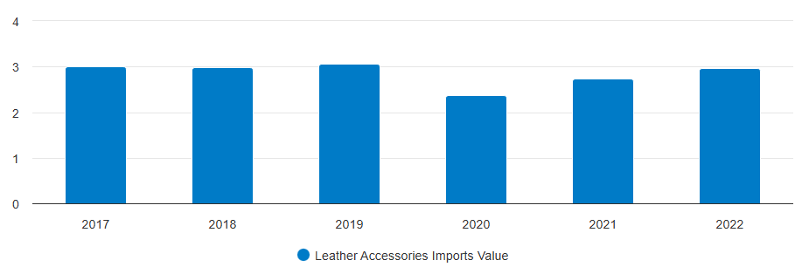

Figure 1: EU Leather Accessories Import Value
(Source: CBI, 2024)
The Middle East, and the UAE in particular, is still seeing increasing demand for luxury and handcrafted leather at a 10.78% CAGR, driven by growing retail centres and wealthy consumer segments (MI, 2024). Nonetheless, the market is typified by a powerful brand-conscious culture, with European labels occupying shelf space at the expense of new brands. Although each of the three areas offers the company considerable growth opportunities, they entail varying strategic trade-offs in tariffs, logistical viability and cultural fit, and the choice of LIBL should focus on markets where its value proposition based on craftsmanship can create a long-term competitive effect.
The United Kingdom is the most strategically appropriate market for LIBL to expand internationally, given its market size, consumer preferences, and trade conditions. The leather goods market in the UK was valued at about GBP 10.567 billion in 2023, driven by steady demand for handbags, footwear, and small leather goods, especially in major cities like London, Manchester, and Birmingham (GVR, 2024) [Refer to Figure 2]. Consumer behaviour in the UK is also shifting towards sustainably sourced, handmade, and ethically produced leather products, making LIBL well-positioned for artisanal, low-volume production (Butler, 2024). This aligns with Bangladesh's competitive advantage in producing quality leather products at reasonable price points, allowing LIBL to position itself against middle-tier brands rather than competing directly with luxury European brands.
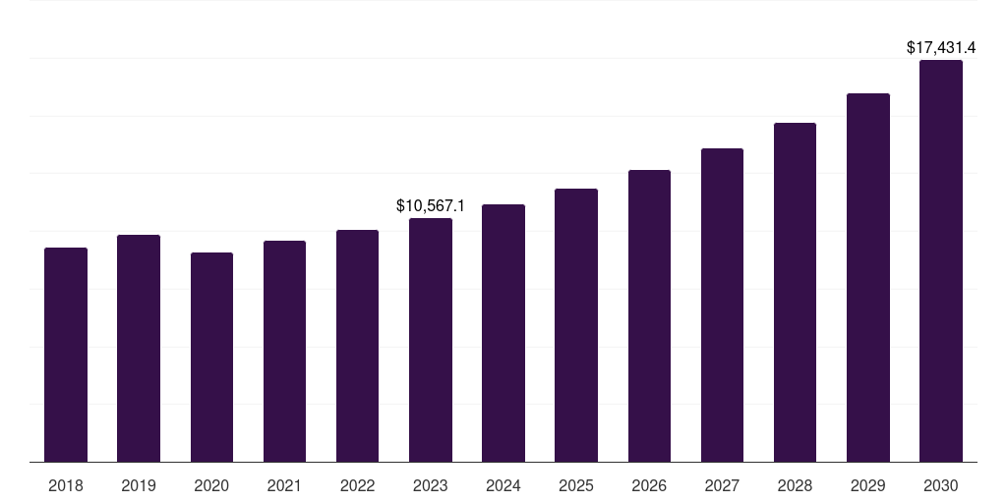

Figure 2: UK Leather Goods Market Size & Outlook, 2023-2030
(Source: GVR, 2024)
One of the key strengths is that the UK Generalised Scheme of Preferences (GSP) provides reduced tariffs on Bangladeshi leather products, and the presence of over 652,500 Bangladeshi people in the UK facilitates greater market familiarity. (The Financial Express, 2024; Chowdhury, 2025). This tariff situation is giving LIBL an advantage, making it more cost-competitive than most Asian competitors whose products are exported to the UK. Also, the logistical connectivity between Chattogram Port and the UK ports of Felixstowe and Southampton provides predictable freight schedules that would be preferred by mid-size exporters (OECD, 2020). The UK market has thus provided an ideal combination of stable demand, regulatory feasibility, and a competitive fit, offering a favourable strategic base for LIBL's international market development plan.

3. Section 2: Comprehensive Strategic Analysis

3.1 Macro-Environmental Analysis
Factors | Analysis | Impact
Political | In the UK, the government promotes FDI by providing incentives, simplifying the process, and supporting UK Trade and Investment programs. The GSP scheme is advantageous to Bangladesh's exporters, as it offers favourable tariffs on leather products (Trade EC, 2025). The​‍​‌‍​‍‌ UK GSP provides Bangladesh leather exports with 0–5% tariffs. For example, handbags 0%, footwear ​‍​‌‍​‍‌0–3% (Trade EC, 2025). However, it has strict import controls after Brexit, especially under the UK REACH framework, which is the main regulation governing the use of chemicals in imported products (Kubiak-Hardiman et al., 2022). Leather imports must undergo customs declarations, provide chemical-compliance documentation, and meet traceability standards. For LIBL, regulatory compliance will be a must to open the UK market and be retail-legal and risk-free under the law and image. | Negative
Economic | The​‍​‌‍​‍‌ leather goods market in the United Kingdom is large and expanding. The market was valued at about 10.6 billion U.S. dollars in 2023, and the projections indicate an increase to around 17.4 billion U.S. dollars by 2030, with a CAGR of 7.4% (PS Market Research, 2025). This indicates a strong demand for leather bags, shoes, and accessories, primarily in metropolitan areas where disposable income remains relatively high. For LIBL, this means lucrative market potential; however, to keep prices competitive, it needs to handle exchange-rate volatility (GBP/BDT), import duties, and logistics costs ​‍​‌‍​‍‌efficiently. | Positive
Social | Consumers​‍​‌‍​‍‌ in the UK, mainly Millennials and Gen Z, are going for more artisan, niche leather brand products rather than mass-produced ones. Around 45% of UK luxury buyers consider the most important factor to be the quality of the work and unique, small-batch ​‍​‌‍​‍‌products (Statista Research Department, 2024). The demand for one-of-a-kind, artisan-made products is increasing, in perfect harmony with Bangladesh's leather heritage (Zdonek et al., 2025). Nevertheless, the growing popularity of vegan and animal-free products means that LIBL must uphold the highest ethical and welfare standards to continue selling. | Positive
Technological | The UK market is more advanced in digital technologies: e-commerce, omnichannel retail, efficient logistics, and supply-chain traceability technologies (e.g., RFID, digital tracking) are being adopted rapidly (Khan et al., 2022). To remain competitive, LIBL must be ready to adopt high-tech production and logistics solutions and invest in digital marketing and retail infrastructure. | Positive
Legal / Regulatory | The UK has stringent product compliance requirements, including REACH-compliant chemical regulations, correct labelling, and recognised ethical sourcing (Vandenbroucke, 2023). Retailer approval requires importers to meet environmental audit requirements and labour certification standards. A high level of intellectual protection will require LIBL to register trademarks and protect its special product designs against copying. | Negative
Environmental | The​‍​‌‍​‍‌ UK values environmentally friendly leather production as a top priority. This includes the need for a lowered carbon footprint, a more chemical-free tanning process, and better wastewater management (Dantas et al., 2025). UK​‍​‌‍​‍‌ sustainable fashion market is growing rapidly and expected to reach $1.76B by 2033, up from $261M in 2024 (IMARC Group, 2025). It is a clear indication that both consumers and retailers are shifting their preferences towards circular fashion and recycled materials (IMARC Group, 2025). Therefore, sustainability innovation becomes indispensable for LIBL if it wants to meet expectations and gain market acceptance. | Positive

Table 1: PESTLE Analysis of UK Market
(Source: Author)
Analysis:
The​‍​‌‍​‍‌ UK market is highly demand-driven and offers significant growth opportunities. Nevertheless, it is necessary to be very rigorous in compliance. LIBL must deal with chemical regulations after Brexit, import controls, and sustainability requirements. Besides ethical sourcing, being digital-ready, conducting environmental audits, and protecting your IP are equally important. Winning in the market will be achieved through cost-effective production, state-of-the-art facilities, clear traceability, and evidently sustainable, low-impact leather production that aligns with consumers' constantly changing values.
Effectiveness and Limitations of PESTLE Analysis
The PESTLE analysis is a powerful tool for LIBL when deciding whether to enter the UK leather goods market. It shows them the external factors that are shaping their strategic decisions. This analysis helps LIBL examine trade policies, such as the UK's GSP preferences, which affect product pricing competitiveness, as well as economic indicators, such as consumer purchasing power and demand for luxury accessories (Retail Economics, 2025). The tool also highlights social trends in the UK, promoting the virtues of craftsmanship, ethical sourcing, and sustainability, which are necessary for LIBL to position their products. Technological features, such as the predominance of e-commerce and traceability systems, help LIBL coordinate its operations with market expectations. The PESTLE analysis also helps identify regulatory requirements, such as compliance with REACH and environmental standards, so LIBL can forecast legal obligations and avoid market-entry barriers. In addition, environmental issues led LIBL to implement cleaner tanning and waste-management methods to maintain its competitiveness.
However,​‍​‌‍​‍‌ PESTLE comes with its limitations. It offers a high-level view but does not indicate the extent of the impact, nor does it prioritise the most important factors. Moreover, the assessment depends on the timing; for instance, changes in political, economic, and regulatory conditions in the UK after Brexit can be rapid. Above all, PESTLE does not consider factors related to the competitiveness of the industry and the company's internal capabilities, which implies that LIBL needs to use additional instruments such as Porter's Five Forces to make sure that their strategic choices are thorough and ​‍​‌‍​‍‌insightful.

3.2 Industry Analysis (Porter’s Five Forces)
Competitive Rivalry — High
The​‍​‌‍​‍‌ market for leather goods in the UK is a crowded place full of different brands - local, European, and global ones, ranging from leather houses with a luxury heritage to fashion brands with a relatively accessible price level.
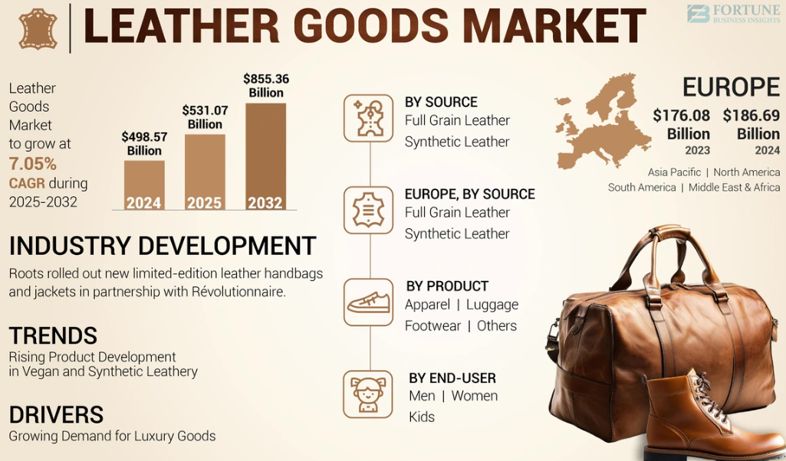

Figure 3: Global Leather Goods Market
(Source: Fortune Business Insights, 2025).
The figure above shows the market size of Global Leather Goods. The total UK leather-goods market was valued at USD 855.36 billion in 2023, with a CAGR of 7.05% from 2025–2032, genuine-leather products accounting for the largest share of revenue, according to a recent market report (Fortune Business Insights, 2025). Due to a large market size and brand diversity from luxury handbags to mid-range wallets and shoes, there is intense competition on price, design, quality, and brand identity. A company like LIBL will face the challenge of creating brand visibility and differentiating itself from the ​‍​‌‍​‍‌competition.
Threat of New Entrants — Moderate to High
The production of leather goods is a skill-intensive process and requires some capital investment, with the average spend for a small business ranging from £8312 to £103,906 (Bodhi, 2023). That is initial cost of opening a new venture However, with the advent of e-commerce, the traditional barriers to entry have been lowered. This is because foreign producers can now reach UK consumers directly without the need to establish a lengthy physical retail infrastructure. The UK retail sector is going online significantly more than online retail accounted for approximately 45.8% of total UK retail sales and 0.8% of retail sales in 2025 (Retail Economics, 2025). This situation creates many opportunities for new entrants. Nevertheless, to succeed, the new entrants will have to contend with compliance requirements (quality and chemical regulations), the complexity of logistics, and brand trust - hence, entry is feasible but still difficult.
Bargaining Power of Suppliers — Low to Moderate
Supplier power in the UK leather goods market is also not very strong, as it has many logistics, packaging, and distribution partners, making it less dependent on any one supplier. Leather sourcing is also a competitive business worldwide, which means companies can switch if pricing or quality is unfavourable (Govindan et al., 2021). Supplier power increases in the higher-end leather business, though, where only a limited number of tanneries can comply with stringent UK chemical and sustainability requirements, and so bargain more effectively. In the case of LIBL, long-lasting relationships with high-quality, certified suppliers will enhance the company's consistency, coupled with effective cost control.
Bargaining Power of Buyers — High
The bargaining power of UK buyers, including retailers and end consumers, is high because of the extensive access to leather goods of global luxury and middle-tier brands. Online platforms provide real-time price comparisons and product reviews, lowering switching costs and enabling customers to demand higher quality at competitive prices (Roberts-Islam, 2022). The retailers also exert pressure on the supply chain by imposing strict conditions on sustainability certifications, chemical safety compliance, and supply chain transparency before listing products. Customers' demands for high-quality workmanship and brand value are increasing. Hence, LIBL needs to focus on high-quality management and persuasive value propositions to gain buyers' acceptance in the UK market effectively.
Threat of Substitutes — High
Non-leather​‍​‌‍​‍‌ alternatives (such as synthetic leather, vegan leather, and recycled materials) are becoming increasingly popular worldwide. In the UK, growing concern for the environment and animal welfare is making vegan/leather-free substitutes more attractive, particularly to younger consumers (Choi and Lee, 2021). The total UK leather-goods market was worth USD 10,567.1 million in 2023, with "vegan leather" identified as the fastest-growing segment (Grand View Research, 2024). Due to the availability of substitutes and their lower prices, these products pose a real threat to the sale of genuine leather products. Hence, LIBL must remind the consumers of the benefits of real leather: long-lasting, made by skilled craftsmen, tradition and high quality -- together with morally sourced -- to resist the pressure of ​‍​‌‍​‍‌substitution.
Overall Analysis:
The UK leather goods sector is both large and expanding, but also very competitive, buyer-oriented and susceptible to replacement and regulatory pressures. The market is favourable, particularly for companies that can offer high-quality, ethical sourcing and differentiation. Foreign trade has been severely reduced, and export and import values have decreased by 14.4% and 20.7%, respectively, compared to 2022 (Leather UK, 2024). This decline in trade reflects a contraction of the market on a broad ​‍​‌‍​‍‌basis. In the case of LIBL, the winning strategy will be to leverage production, make substantial investments in compliance and branding, and pursue a niche (e.g., quality artisan leather goods) rather than the mass-market price.
Effectiveness and Limitations of Porter’s Five Forces
Porter’s Five Forces is a great means to analyse LIBL's UK market entry, as it clearly shows the competitive pressures it faces. It assists in identifying the main competitors affected by the dominant brands worldwide and the wide-ranging product offerings, thereby directing LIBL to set itself apart by focusing on the brand's skills and origin. Besides, the model shows that buyers have significant power and face a serious threat of substitution, which points to the need for environmental friendliness and a well-thought-out brand strategy. In evaluating the power of suppliers and the barriers to entry, it is helpful for LIBL to organise its costing, find supply chain partners, and comply with UK regulations. In brief, the system is a great tool for management to see and decide on the next steps regarding industry attractiveness and profitability.
However, this instrument imposes constraints and primarily focuses on rivalry and external factors, disregarding internal factors such as LIBL's top-notch production and highly skilled workers. Besides, it considers the market as somewhat static, whereas the retail sector in the UK is changing very rapidly due to rising sustainability requirements and e-commerce growth. In addition, Porter's framework lacks the elements of strong potential for working together, such as collaborations with local retailers or ethical fashion networks. Consequently, it must be supported by the PESTLE analyses to accomplish the strategy of being fully ​‍​‌‍​‍‌aware.

4. Section 3: Strategy Development and Formulation

4.1 Evaluation of Strategic Options
The market development offers LIBL a conditioned entry into the UK leather goods market, where the value-added prospects are much greater than those in regional markets. This strategy aligns with the Ansoff Matrix's aim of expanding into new geographical markets and utilising available product strengths (Peterdy, 2025). This strategy fits well for LIBL, as the UK leather goods market is projected to generate approximately £17.43 billion in revenue by 2024, indicating significant demand for high-quality, ethically sourced accessories (GVR, 2024). Market development would enable the company to take advantage of its existing product line without redesigning it at high cost, as product development would, whereas capabilities that are not yet as fully developed as those in LIBL would (WBG, 2023). Correspondingly, diversification is the riskiest, as it involves entering new markets and launching new products simultaneously, which is not an appropriate strategy for a Bangladeshi SME manufacturer (Hossain et al., 2022). Although market penetration is not a risky strategy, it is inappropriate considering that Bangladesh is a saturated leather industry with over 3,500 SMEs, competing mostly based on price (The Financial Express, 2025). In this regard, market development presents the best strategic fit, as it is the most effective way to balance risk and opportunity, and LIBL can consider expanding its artisanal, cost-effective products into a high-growth international market. This strengthens market growth as the most feasible strategic alternative for facilitating sustainable international growth.

4.2 Entry Mode Strategy
One of the most important steps in entering the UK market of leather goods is the choice of the entry mode that will both provide strategic control of the business and operational viability of LIBL entering the UK market. The Eclectic Paradigm of Dunning emphasises ownership, location, and internalisation benefits in the choice of the entry strategy, and LIBL operational capabilities are quite appropriate with the controlled and cost-efficient mode of entry (CFI, 2022). Direct exporting is also the most appealing because of its lower financial requirements and lower operational risk, as it allows the firm to deliver products to distributors or retailers in the UK without a physical presence (Amazon, 2022). This form is especially applicable, as in 2024, UK imports of leather exceeded 9.0 billion, indicating that the market is highly likely to absorb foreign suppliers (UK Trade, 2024). Licensing provides a low entry barrier and limited control over product quality, brand loyalty, and artisanal skills, which are features that make LIBL stand out in international markets (WIPO, 2020). Wholly owned subsidiaries or joint ventures would offer greater long-term control. Still, they would require a large capital outlay and face complex regulatory environments and long-term risks, which are inappropriate for an SME with little international experience.
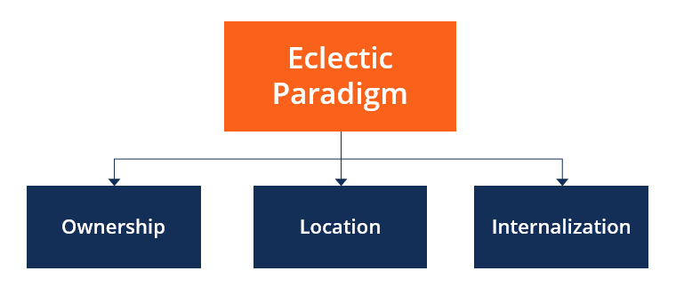

Figure 4: OLI Framework
(Source: CFI, 2022)
E-commerce platforms offer a high-potential supplement to direct exporting, as many international brands now sell their products through platforms like Amazon UK and Shopify. In the UK, in 2023, more than 70% of consumers of fashion accessories made purchases online, which demonstrates the convenience of online retail (Statista, 2024). Such a model of direct exporting and online retailing thus provides low entry costs, high market penetration, and high brand awareness, but at the cost of low efficiency and limited product control (Amazon, 2022). This ambivalent form also permits LIBL to acquire information about consumer reactions before making any visits, thereby enabling it to plunge further into the market, facilitating quality agility and risk avoidance as it grows in a competitive market environment. All these considerations render direct export via e-commerce the most appropriate mode of entry for LIBL into the UK market.

4.3 Competitive Advantage Strategy
The Generic Strategies framework by Porter provides a formal way to determine the competition LIBL can undertake in the UK leather goods market. Of the existing strategies, including cost leadership, differentiation, and focus, differentiation can be considered the most appropriate strategy to implement at LIBL because the increasing number of UK consumers demand ethically sourced and handcrafted leather products (Renub, 2025). According to recent market surveys, 62% of consumers in the UK are eager to buy accessories from brands with clear sustainability statements, which has driven a trend toward conscious consumption (Fiber2Fashion, 2024). Cost leadership will not work, since Bangladesh is currently competing with major low-cost manufacturers in Vietnam, China, and India, so LIBL will not be able to outmuscle the major competitors based on price alone (TOI, 2024). A focus strategy that appeals to niche consumer groups has potential, but is not scalable at low stages of international expansion (Palmié et al., 2023). Differentiation will enable LIBL to leverage its artisanal production model, high-quality sourcing of bovine and goat leather, and adherence to evolving environmental standards in Bangladesh, making it an ethical alternative to mass-produced leather brands.
The feasibility of this strategic direction in the UK is proven by the examples of real-life successful brands like the British brand Carl Friedrik, which has chosen a differentiation strategy in terms of craftsmanship and premium materials and has increased by an increase of more than tenfold annually (Carl Friedrik, 2024). This makes differentiation the most competitive strategy for enabling LIBL to penetrate the market in the long term.

4.4 Strategic Risk Analysis
The TOWS Matrix will help LIBL match its internal strengths to external market conditions, enabling the business to create strategic responses that leverage strengths and minimise weaknesses. The company has the following strengths to capitalise on the opportunities, namely high-quality craftsmanship, cost-effective production, and well-established supplier networks, which can be utilised to take the opportunities of the rising demand for sustainable leather products in the UK, which is now over 35% of total purchases of leather accessories (LinkedIn, 2025). When these strengths are matched with opportunities, they enable strategies such as premium product positioning and the launch of eco-certified collections. Nevertheless, other threats to LIBL include stringent environmental regulations in the UK and rivalry with other well-established European brands (CBI, 2023). The latter can be addressed by enhancing waste-management procedures and adopting internationally recognised standards, including the LWG (Leather Working Group) certification, which many suppliers of UK retailers much need (LWG, 2019).
The weaknesses, including the lack of international branding and understanding of UK consumer preferences, can be addressed through partnerships with local distributors and investment in digital marketing campaigns targeting ethically oriented consumers (Balatsas-Lekkas et al., 2024). Also, currency risks, shipping delays, and similar dynamics are potential operational risks, so LIBL needs flexible supplier contracts and logistics suppliers. Together, the TOWS analysis highlights strategic alignment and proactive risk mitigation as the strategies for successfully entering the UK.

4.5 Corporate Social Responsibility Integration
The integration of CSR is an essential element for the credibility and competitiveness of LIBL in the UK, where ethical buying is now an important purchasing choice. Compliance with international leather sustainability standards and enhanced traceability of its supply chain will enable the company to improve its ethical sourcing practices (Chen et al., 2022). The environmental expectations of UK retailers operating in sustainable production, including water recycling, reduced chemical use, and circular waste management, are also aligned with sustainable production (Dellyana and Aldianto, 2024). The strategy of implementing CSR also facilitates compliance with the UN Sustainable Development Goals, specifically SDGs 1 and 2 on responsible consumption and production (Shayan et al., 2022). By integrating CSR into the heart of LIBL's UK market strategy, it will build brand trust and strengthen its competitive positioning over time.

5. Section 4: Performance Evaluation Framework

5.1 Selection of Measurement System
To make sure that the UK expansion of LIBL is systematised in terms of its monitoring at both the financial and non-financial levels, a more organised performance measurement system is needed. The Balanced Scorecard (BSC) is the most appropriate framework because it integrates financial and customer, operational, and learning results, ensuring that strategic goals are linked to quantifiable performance drivers (Madsen, 2025). The BSC is a broader strategic monitoring tool, unlike the Triple Bottom Line, which focuses on sustainability, making it especially suitable for international entry situations when market responsiveness, capability development, and customer acquisition are key (Sedovs et al., 2024). Its applicability is evident in other companies, such as Clarks UK, which employed a system designed using a BSC to align production performance with targets for retail expansion. This makes the BSC the best tool to guide LIBL through the intricacies of UK market entry.

5.2 Balanced Scorecard for LIBL’s UK Expansion
A Balanced Scorecard is a strategic management instrument that tracks an organisation's performance from four perspectives: financial, customer, internal processes, and learning (Kumar et al., 2023). It used to monitor and control LIBL's entry into the UK market. It does this by connecting the goals to quantifiable Key Performance Indicators (KPIs) across the four areas: Financial, Customer, Internal Processes, and Learning & Growth.
Financial Perspective
Financial​‍​‌‍​‍‌ objectives largely revolve around the metrics of net profit, top-line growth, and cost control. Some key performance indicators would be sales revenue in the UK, targeting 5 million pounds in the first year, and a gross profit margin of 40% or more. The return on investment (ROI) for the expansion program is set at 15% or greater. Such financial metrics help ensure that LIBL's market entry in the UK is viable and that competitive pricing remains possible.
Customer Perspective
The customers' goals revolve around the company becoming better known, satisfying more customers, and increasing its market share in premium leather segments. Key performance indicators (KPIs) include a Net Promoter Score (NPS) of 60 or higher, a brand recognition index of 70% or higher among the target audience, and a market share of 2–3% in the UK leather goods premium segment during the first two years. Baquero (2022) notes that such measures reflect the weight UK consumers give to ethical sourcing, eco-friendliness, and impeccable artisanal production.
Internal Process Perspective.
Operational​‍​‌‍​‍‌ efficiency and regulatory compliance must be at the top of the company's agenda. Performance indicators should include a production defect rate of less than 2%, full compliance with UK REACH chemical regulations and environmental standards, and average order fulfilment time for online orders of 7 days or less. These indicators serve as the mainstays of quality assurance, on-time delivery, and regulatory compliance (HSE, 2021). It is the mainstay of trust and collaboration with retailers in the UK market.
Innovation and organisational capability
Organisational​‍​‌‍​‍‌ capability, together with innovation, is necessary for survival in the long run (Samadi et al., 2023). Among the key performance indicators are the following: >40 training hours per employee per year, the development of at least 5 new UK-market-specific designs annually, and full adoption of digital tools for marketing, e-commerce, and traceability. Achieving these goals revitalises employees' skills, the company's capacity for innovation, and its digital presence, thereby being instrumental in ecological growth.
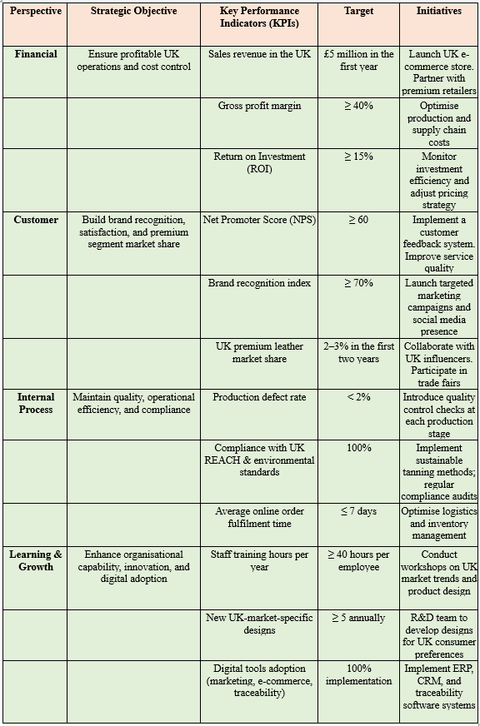

Table 2: Balanced Scorecard for LIBL’s UK Expansion
(Source: Author)

5.3 Success Metrics & Monitoring Approach
The performance and monitoring strategy should be integrated to ensure that LIBL's strategic goals are met within the first few years of its operation in the UK market. Real-time dashboards will be used to support quarterly performance reviews, after which leadership can track KPIs such as defect rates, fulfilment time, and sales conversion trends (Ajax et al., 2025). Implementing BSC indicators within the framework of ERP and CRM systems, in the footsteps of Bata, which optimised the European order cycle using SAP-based analytics, will improve data precision and strategic decision-making (Al-Assaf et al., 2024). The development of coordinated feedback mechanisms will enable LIBL to tailor marketing, pricing, and product design to UK consumer reactions, with performance measurement directly linked to strategy adjustments. This will ensure that the monitoring structure plays a significant role in the continued competitive development of the new market.

6. Conclusion
As indicated in the report, LIBL has the potential to effectively enter the UK leather goods market, given its operational competency, product quality, and a stable supply chain. The strategy options analysis demonstrated that market development through direct exporting and online retail, facilitated by the Internet, is the most viable and controllable avenue for seizing opportunities in a mature yet craft-oriented market. The case studies of successful brand entries into the UK by Roxy Leather and Hidesign were used to illustrate how firms with craftsmanship in the focus markets of emerging economies can find a niche by aligning product authenticity with changing consumer expectations. The new differentiation approach, supported by ethical sourcing and design innovation, will position LIBL to meet the demands of UK customers who will be increasingly concerned with sustainable and artisanal products. The Balanced Scorecard model also enhances the expansion plan by providing a systematic approach to tracking financial performance, customer acquisition, operational discipline, and capability development. Generally, the suggested plan offers LIBL a logical and feasible path towards long-term global expansion in line with building a well-established market share within the United Kingdom.

References
Ajax, R., Joseph, O. and Own, J. (2025) How Real-Time Dashboards Improve Business Performance, ResearchGate. Available at: https://www.researchgate.net/publication/388780068_How_Real-Time_Dashboards_Improve_Business_Performance (Accessed: 1 December 2025).
Al-Assaf, K., Alzahmi, W., Alshaikh, R., Bahroun, Z. and Ahmed, V. (2024) ‘The Relative Importance of Key Factors for Integrating Enterprise Resource Planning (ERP) Systems and Performance Management Practices in the UAE Healthcare Sector’, Big Data and Cognitive Computing, 8(9), pp. 122–122. Available at: https://doi.org/10.3390/bdcc8090122.
Amazon (2022) Direct vs. indirect exporting: What is best for your business?, https://sell.amazon.in/grow-your-business/amazon-global-selling. Available at: https://sell.amazon.in/grow-your-business/amazon-global-selling/blogs/direct-vs-indirect-exporting (Accessed: 1 December 2025).
Balatsas-Lekkas, A., Luomala, H. and Pennanen, K. (2024) ‘Factors associated with Finnish, German and UK consumers’ intentions to test, buy and recommend reusable fast-moving consumer goods packaging’, Sustainable Production and Consumption, 52, pp. 210–227. Available at: https://doi.org/10.1016/j.spc.2024.10.011.
Baquero, A. (2022). Net Promoter Score (NPS) and Customer Satisfaction: Relationship and Efficient Management. Sustainability, 14(4). DOI: https://doi.org/10.3390/su14042011.
BIDA (2022) Bangladesh: A Global Leather Leader, Investbangladesh.gov.bd. Available at: https://www.investbangladesh.gov.bd/investment-sector/leather-footwear (Accessed: 1 December 2025).
Bodhi, V. (2023). The Largest Business Costs In The UK Right Now in 2023. [online] www.servcorp.co.uk. Available at: https://www.servcorp.co.uk/en/blog/business-networking/largest-business-costs-in-the-uk-right-now/, [Accessed 1 Dec. 2025].
Butler, S. (2024) ‘Ethical shopping on the rise in UK despite cost of living crisis’, The Guardian, 2 April. Available at: https://www.theguardian.com/environment/2024/apr/02/ethical-shopping-on-the-rise-in-uk-despite-cost-of-living-crisis (Accessed: 1 December 2025).
Carl Friedrik (2024) Carl Friedrik, Carlfriedrik.com. Available at: https://www.carlfriedrik.com/int/pages/about-us?srsltid=AfmBOor6YmvGp0k2PVnuoi2JU8gCeyVb3fO_vPie4ljd4a6I-o78HyCJ (Accessed: 1 December 2025).
CBI (2023) The EU Green Deal – How will it impact my business? | CBI, www.cbi.eu. Available at: https://www.cbi.eu/market-information/eu-green-deal-how-will-it-impact-my-business (Accessed: 1 December 2025).
CBI (2024) The European market potential for leather accessories | CBI, Www.cbi.eu. Available at: https://www.cbi.eu/market-information/apparel/leather-fashion-accessories-0/market-potential (Accessed: 1 December 2025).
CFI (2022) Eclectic Paradigm, Corporate Finance Institute. Available at: https://corporatefinanceinstitute.com/resources/management/eclectic-paradigm/ (Accessed: 1 December 2025).
Chen, X., Xu, L., Ren, Z., Jia, F. and Yu, Y. (2022) ‘Sustainable supply chain management in the leather industry: a systematic literature review’, International Journal of Logistics Research and Applications, 26(12), pp. 1–41. Available at: https://doi.org/10.1080/13675567.2022.2104233.
Choi, Y.-H. and Lee, K.-H. (2021). Ethical Consumers’ Awareness of Vegan Materials: Focused on Fake Fur and Fake Leather. Sustainability, [online] 13(1), p.436. DOI: https://doi.org/10.3390/su13010436.
Chowdhury, M.A. (2025) 1 Million: UK’s Booming Bangladeshi Community Revealed, Dazzlingdawn.com. Available at: https://dazzlingdawn.com/public/2025/03/15/1-million-uks-booming-bangladeshi-community-revealed (Accessed: 1 December 2025).
Dantas, M.P., Rafael, C., Yamaguchi, N.U., Júnior, S., Peralta, R.M., Bracht, A. and Carvalho, R. (2025). Pathways in Agro-Industrial Waste Upcycling: A Review of Sustainable Textile Innovations and Economic Perspectives. Plants, [online] 14(23), pp.3574–3574. DOI: https://doi.org/10.3390/plants14233574.
Dellyana, D. and Aldianto, L. (2024) ‘Innovative Marketing Strategy for Green Products in Search of Better Customer Acquisition’, Core Values and Decision-Making for Sustainable Business, pp. 75–99. Available at: https://doi.org/10.1007/978-3-031-78361-6_4.
Fiber2Fashion (2023) Bangladesh’s exports of leather goods at $1,120 mn in June-May 2023, Fibre2fashion.com. Fibre2Fashion. Available at: https://www.fibre2fashion.com/news/apparel-news/bangladesh-s-exports-of-leather-goods-at-1-120-mn-in-june-may-2023--288130-newsdetails.htm (Accessed: 1 December 2025).
Fiber2Fashion (2024) Cost blocks sustainable lifestyle for 62% of UK’s consumers, Fibre2fashion.com. Fibre2Fashion. Available at: https://www.fibre2fashion.com/news/sustainability-news/cost-blocks-sustainable-lifestyle-for-62-of-uk-s-consumers-290967-newsdetails.htm (Accessed: 1 December 2025).
Fiber2Fashion (2025) Bangladesh faces hurdles in diversifying beyond garments, Fibre2fashion.com. Fibre2Fashion. Available at: https://www.fibre2fashion.com/news/textiles-policy-news/bangladesh-faces-hurdles-in-diversifying-beyond-garments-305917-newsdetails.htm (Accessed: 1 December 2025).
FMI (2025) Leather Goods Market, www.futuremarketinsights.com. Available at: https://www.futuremarketinsights.com/reports/leather-goods-market (Accessed: 1 December 2025).
Fortune Business Insights (2025). Leather Goods Market Size, Share, Industry Forecast 2029. [online] www.fortunebusinessinsights.com. Available at: https://www.fortunebusinessinsights.com/leather-goods-market-104405, [Accessed 1 Dec. 2025].
Govindan, K., Shaw, M. and Majumdar, A. (2021). Social Sustainability Tensions in Multi-tier Supply Chain: a Systematic Literature Review Towards Conceptual Framework Development. Journal of Cleaner Production, [online] 279(123075). doi:https://doi.org/10.1016/j.jclepro.2020.123075.
Grand View Research (2024). Leather Goods Market Size & Outlook, 2030. [online] Grandviewresearch.com. Available at: https://www.grandviewresearch.com/horizon/outlook/leather-goods-market-size/global, Accessed 1 Dec. 2025].
GVR (2024) UK Leather Goods Market Size & Outlook, 2030, Grandviewresearch.com. Available at: https://www.grandviewresearch.com/horizon/outlook/leather-goods-market/uk (Accessed: 1 December 2025).
Hossain, K., Soon Lee, K.C., Abdul Ghani Azmi, I.B., Idris, A.B., Alam, M.N., Rahman, Md.A. and Mohd Ali, N. (2022) ‘Impact of innovativeness, risk-taking, and proactiveness on export performance in a developing country: evidence of qualitative study’, RAUSP Management Journal, 57(2), pp. 165–181. Available at: https://doi.org/10.1108/rausp-01-2021-0002.
HSE (2021). UK REACH: UK REACH Explained. [online] www.hse.gov.uk. Available at: https://www.hse.gov.uk/reach/about.htm, [Accessed 1 Dec. 2025].
IMARC Group (2025). UK Sustainable Fashion Market Size, Share, Growth and Industry Report. [online] Imarcgroup.com. Available at: https://www.imarcgroup.com/uk-sustainable-fashion-market?utm, [Accessed 1 Dec. 2025].
ITA (2020) Direct Exporting | BETA - International Trade Administration, beta.trade.gov. Available at: https://beta.trade.gov/article?id=Direct-Exporting (Accessed: 1 December 2025).
Khan, Y., Su’ud, M.B.M., Alam, M.M., Ahmad, S.F., Ahmad (Ayassrah), A.Y.A.B. and Khan, N. (2022). Application of Internet of Things (IoT) in Sustainable Supply Chain Management. Sustainability, [online] 15(1), p.694. DOI: https://doi.org/10.3390/su15010694.
Kubiak-Hardiman, P., Haughey, S.A., Meneely, J., Miller, S., Banerjee, K. and Elliott, C.T. (2022). Identifying Gaps and Challenges in Global Pesticide Legislation that Impact the Protection of Consumer Health: Rice as a Case Study. Exposure and Health, 15, pp.597–618. doi:https://doi.org/10.1007/s12403-022-00508-x.
Kumar, S., Lim, W.M., Sureka, R., Chiappetta, J. and Bamel, U. (2023). Balanced scorecard: trends, developments, and future directions. Review of Managerial Science, 18(1), pp.2397–2439. doi:https://doi.org/10.1007/s11846-023-00700-6.
Leather UK (2024). UK Leather & Leather Goods Industry in 2023 Report. [online] Available at: https://leatheruk.org/wp-content/uploads/2024/05/LUK-2023-industry-report_web.pdf, [Accessed 1 Dec. 2025].
LIBL (2025) Leather Industries of Bangladesh Limited – Top Rated Bangladeshi Leather Industry, Libltd.net. Available at: https://libltd.net/ (Accessed: 1 December 2025).
LinkedIn (2025) 📥 Download Sample 💰 Get Special Discount United Kingdom Luxury Leather Goods Market Global Outlook, Country Deep-Dives & Strategic Opportunities (2024-2033) Market size (2024): USD 100 billion · Forecast (2033): USD 150 billion · CAGR: 4.5% Transformation in Industry Demand The United Kingdom luxu, Linkedin.com. Available at: https://www.linkedin.com/pulse/united-kingdom-luxury-leather-goods-market-szwdc/ (Accessed: 1 December 2025).
LWG (2019) Leather Working Group, Leatherworkinggroup.com. Available at: https://www.leatherworkinggroup.com/ (Accessed: 1 December 2025).
Madsen, D.O. (2025) ‘Balanced Scorecard: History, Implementation, and Impact’, Encyclopedia, 5(1), p. 39. Available at: https://doi.org/10.3390/encyclopedia5010039.
Mammen, J., Alessandri, T.M. and Weiss, M. (2019) ‘The Risk Implications of diversification: Integrating the Effects of Product and Geographic Diversification’, Long Range Planning, 54(1), p. 101942. Available at: https://doi.org/10.1016/j.lrp.2019.101942.
McKinsey & Company (2025) The State of Fashion 2025. Available at: https://www.mckinsey.com/~/media/mckinsey/industries/retail/our%20insights/state%20of%20fashion/2025/the-state-of-fashion-2025-v2.pdf (Accessed: 1 December 2025).
MI (2024) Middle East and Africa Luxury Goods Market | 2020-2027 | Industry Report | Covid Insights, www.mordorintelligence.com. Available at: https://www.mordorintelligence.com/industry-reports/middle-east-and-africa-luxury-goods-market (Accessed: 1 December 2025).
Ministry of Finance (2024) Support to Sustainable Graduation Project (SSGP) Economic Relation Division Ministry of Finance SUBMITTED BY: Dulal Krishna Saha, Former Executive Chairman (Secretary), NSDA Foundation for Socio-Economic Development Initiative (FSDI). Available at: https://erd.portal.gov.bd/sites/default/files/files/erd.portal.gov.bd/page/6fc21888_1122_4f28_b548_75c698b5b78e/Logistics_Final%20Report.pdf (Accessed: 1 December 2025).
OECD (2020) The Competitiveness of Global Port-Cities. Available at: https://www.oecd.org/content/dam/oecd/en/publications/reports/2014/12/the-competitiveness-of-global-port-cities_g1g37699/9789264205277-en.pdf (Accessed: 1 December 2025).
OECD (2023) BANGLADESH OECD Development Pathways Production Transformation Policy Review of Bangladesh INVESTING IN THE FUTURE OF A TRADING NATION. Available at: https://www.oecd.org/content/dam/oecd/en/publications/reports/2023/09/production-transformation-policy-review-of-bangladesh_a305bdac/8b925b06-en.pdf (Accessed: 1 December 2025).
Palmié, M., Parida, V., Mader, A. and Wincent, J. (2023) ‘Clarifying the scaling concept: A review, definition, and measure of scaling performance and an elaborate agenda for future research’, Journal of Business Research, 158, p. 113630. Available at: https://doi.org/10.1016/j.jbusres.2022.113630.
Palomo-Lovinski, N. and Hahn, K. (2020) American Consumer Perceptions of Sustainable Fashion, Fast Fashion, and Mass Fashion Practices, ResearchGate. unknown. Available at: https://www.researchgate.net/publication/339417516_American_Consumer_Perceptions_of_Sustainable_Fashion_Fast_Fashion_and_Mass_Fashion_Practices (Accessed: 1 December 2025).
Peterdy, K. (2025) Ansoff Matrix, Corporate Finance Institute. Available at: https://corporatefinanceinstitute.com/resources/management/ansoff-matrix/ (Accessed: 1 December 2025).
PS Market Research. (2025). Industry Reports. [online] Psmarketresearch.com. Available at: https://www.psmarketresearch.com/industry-report, [Accessed 1 Dec. 2025].
Renub (2025) United Kingdom Leather Goods Market Size & Trends 2025-2033, Renub.com. Available at: https://www.renub.com/united-kingdom-leather-goods-market-p.php (Accessed: 1 December 2025).
Retail Economics (2025). UK Online Retail Sales Report & Shopping Statistics | Retail Economics. [online] www.retaileconomics.co.uk. Available at: https://www.retaileconomics.co.uk/report-online-retail, [Accessed 1 Dec. 2025].
Reza, M.H. (2022) ‘The Ins and Outs of the Leather Industry in Bangladesh’, Journal La Bisecoman, 3(2), pp. 49–58. Available at: https://doi.org/10.37899/journallabisecoman.v3i2.564.
Roberts-Islam, B. (2022). Fashion’s Leather Misinformation Problem and Why ‘Vegan’ Doesn’t Mean ‘Sustainable’. [online] Forbes. Available at: https://www.forbes.com/sites/brookerobertsislam/2022/11/10/fashions-leather-misinformation-problem-and-why-vegan-doesnt-mean-sustainable/,[Accessed 1 Dec. 2025].
Samadi, M., Mirnezami, S.R. and Torabi Khargh, M. (2023). The impact of organizational capabilities on the international performance of knowledge-based firms. Journal of Open Innovation: Technology, Market, and Complexity, 9(4), p.100163. doi:https://doi.org/10.1016/j.joitmc.2023.100163.
Sedovs, E., Volkova, T. and Ludviga, I. (2024) ‘Sustainable development and strategic management - what is on the horizon in our non-ergodic world research?’, Sustainable Futures, 9, p. 100414. Available at: https://doi.org/10.1016/j.sftr.2024.100414.
Shayan, N.F., Kalejahi, N.M., Alavi, S. and Zahed, M.A. (2022) ‘Sustainable Development Goals (SDGs) as a Framework for Corporate Social Responsibility (CSR)’, Sustainability, 14(3). Available at: https://doi.org/10.3390/su14031222.
Statista (2024) Topic: Fashion e-commerce in the United Kingdom, Statista. Available at: https://www.statista.com/topics/8759/fashion-e-commerce-in-the-united-kingdom/?srsltid=AfmBOoqYQRe_C0bqFrYuKqiuZ3agRzclEeOfKyT4hXv3LezkoZUIZ6vQ (Accessed: 1 December 2025).
Statista Research Department (2024). Topic: Luxury goods, Gen Z, and millennials. [online] Statista. Available at: https://www.statista.com/topics/12825/luxury-goods-gen-z-and-millennials/?srsltid=AfmBOoqnhDmtTkZpyvnjUyZ7lQl93YmWvi3zlYtJHYzQO3zZBMEPcJMl#topicOverview, [Accessed 1 Dec. 2025].
TE Raja Simhan (2023). Increase in labour cost in Bangladesh could help Indian garment exporters, say experts. [online] BusinessLine. Available at: https://www.thehindubusinessline.com/economy/increase-in-labour-cost-in-bangladesh-could-help-indian-garment-exporters-say-experts/article67539968.ece, [Accessed 1 Dec. 2025].
The Financial Express (2024) The Financial Express, The Financial Express. Available at: https://thefinancialexpress.com.bd/trade/uk-export-may-widen-as-dcts-surrogates-gsp (Accessed: 1 December 2025).
The Financial Express (2025) The Financial Express, The Financial Express. Available at: https://thefinancialexpress.com.bd/views/views/bangladesh-needs-to-accelerate-green-transformation-of-the-leather-industry (Accessed: 1 December 2025).
TOI (2024) India’s textile boost: Ministry drafts plan to regain edge over Bangladesh, China; targets $100 bn exports by 2030, The Times of India. The Times Of India. Available at: https://timesofindia.indiatimes.com/business/india-business/indias-textile-boost-ministry-drafts-plan-to-regain-edge-over-bangladesh-china-targets-100-bn-exports-by-2030/articleshow/124889114.cms (Accessed: 1 December 2025).
TOI (2025) US-India trade: Tariffs to hit leather sector; Kolkata exporters pondering ‘Made in Europe’ question, The Times of India. The Times Of India. Available at: https://timesofindia.indiatimes.com/business/india-business/us-india-trade-tariffs-to-hit-leather-sector-kolkata-exporters-pondering-made-in-europe-question/articleshow/123475736.cms (Accessed: 1 December 2025).
Trade EC (2025). Generalised Scheme of Preferences (GSP) | Access2Markets. [online] trade.ec.europa.eu. Available at: https://trade.ec.europa.eu/access-to-markets/en/content/generalised-scheme-preferences-gsp, [Accessed 1 Dec. 2025].
UK Trade (2024) UK trade, Ons.gov.uk. Office for National Statistics. Available at: https://www.ons.gov.uk/economy/nationalaccounts/balanceofpayments/bulletins/uktrade/june2024 (Accessed: 1 December 2025).
Vandenbroucke, S. (2023). The portrayal of effectiveness of supplier codes of conduct in improving labor conditions in global supply chains: A systematic review of the literature. Regulation & Governance, 18(1), pp.307–327. doi:https://doi.org/10.1111/rego.12514.
WBG (2023) Suite 3 Advanced Incubator Management 10. Available at: https://documents1.worldbank.org/curated/en/617871562181584311/pdf/BIM-Module-10B-Technology-Commercialization-through-Incubation-Part-2.pdf (Accessed: 1 December 2025).
WIPO (2020) Marketing Crafts and Visual Arts: The Role of Intellectual Property A practical guide International Trade Centre. Available at: https://www.wipo.int/edocs/pubdocs/en/intproperty/itc_p159/wipo_pub_itc_p159.pdf (Accessed: 1 December 2025).
Zdonek, I., Podgórska, M. and Hysa, B. (2025). The Sustainable Fashion Value Proposition of Companies Identifying with the Zero Waste Movement. Sustainability, [online] 17(3), pp.887–887. doi:https://doi.org/10.3390/su17030887.

