Quantitative
Research
Essay

Name: Edward Clive Jones

Student number: 1801831

Programme of Study: BA Outdoor Adventure Education

Module: Business Inquiry and Research

Module code: BMSP5007

Tutor: Dr Alex Bell

Date: 29th April 2020

Introduction
This report presents the study of peoples preferred exercise routines, before and now during the current period of quarantine, as well as their enjoyment of three major physical activities. I have chosen this topic as it currently very relevant to people’s lives and this is enforced with the news and media seeming to put more emphasis on exercise. Furthermore when out I have noticed many people cycling and running that may not be in normal day to day life.
Procedure
I have collected the data through a survey with the goal being that I have quantitative answers to compare and analyse. This survey has been done through Microsoft forms (2020) as this allow me to send people a link and it requires minimal work on their end to answer. Another benefit of this method is I can make people anonymous and just use a number for each participant. Since the goal of the survey was to collect quantitative data I created questions that were either yes or no or on a numbers scale. While a qualitative approach may uncover deeper meaning and peoples reasons for their actions and exercise routines in their daily lives quantitative findings from my survey will show what the majority is actually doing which can then be used to determine reasons for their behaviour (Madrigal and McClain, 2012). A benefit of a quantitative approach is that if I can find any statistical significance I may not need to increase my sample size. Even a small sample size, while it may be more difficult to do so, can be used to determine facts about the data without the need to increase the population Madrigal and McClain, 2012).
I will use both excel and spss to try and analyse themes and correlations within the data and use graphs and charts to visualize them. By trying to gather data about two or more variables in as similar group or topic I can see if a correlation exists when one variable increases or decreases correspondingly with the other variable (Quantitative Research Methods, 2020). Hopefully within the topic area I can gain more understanding or highlight why people behave as they do in relation to exercising and quarantine.

Data Presentation and Findings
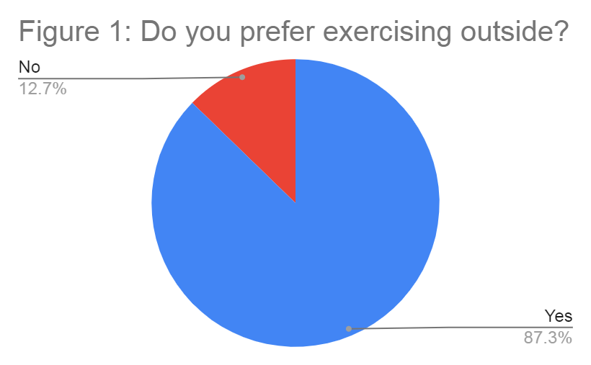
From the overall population it is clearly established that the majority prefer to exercise outside. Due to the ration between yes and no it can be assumed that the percentages would likely remain consistent with and increase to the survey population therefore it is likely not necessary to find out.
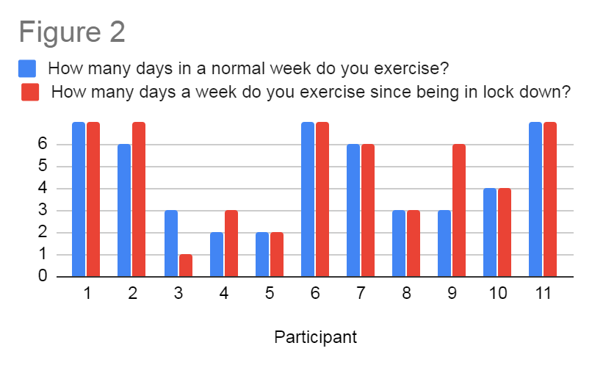
This data show that for the majority of participants there is little or no difference in the amount of days that they exercise during a normal week compared to now in quarantine. For a couple of participant the amount they exercise has changed dramatically with participant three exercising only a third of their regular amount during a regular week. In contrast participant nine has doubles the amount of days they exercise.
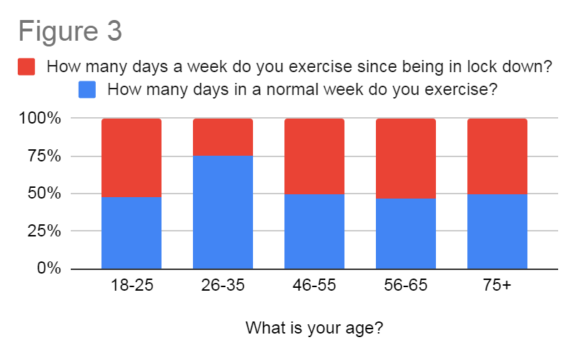
Continuing the analysis of the previous graph more can be revealed by looking at the ages of the participants and how this correlated to the amount of time they exercise between the different weeks. The age range of 26-35 seems to be the outlier however when looking at the raw data the reason becomes clear as only one participant falls within this age range leading to the answer being heavily skewed. When looking at figure 2 participant 9 also saw a large change between the weeks however this is less obvious in the overall balance in figure 3 as five participants fell within the 56-65 age range that participant nine was a part of. Because of the imbalance of the number of participants within each age range it could lead to the conclusion when looking at figure 3 that on average the entire population exercises fewer days in a week during quarantine. This observation comes down to the imbalance created by the one participant within age range 26-35. However by calculating the mean for each week when looking at the raw data a regular week comes out to 4.6 days whereas a week in quarantine comes to 4.8 days.
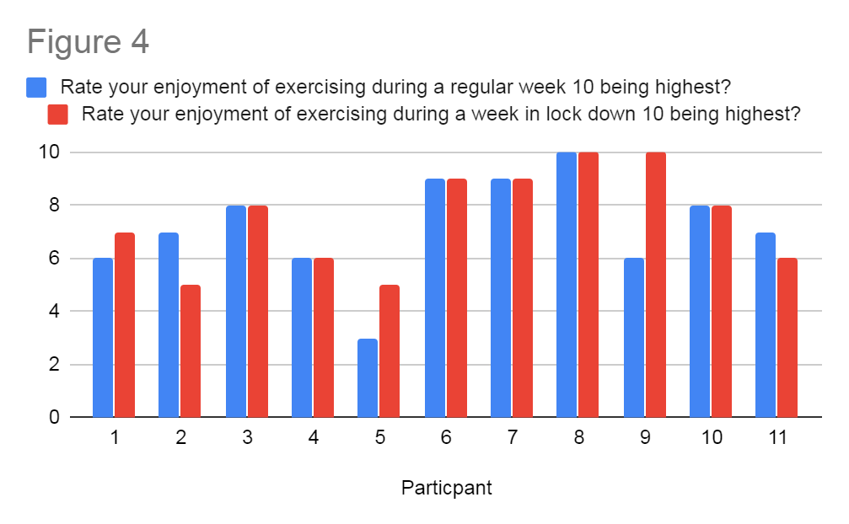
When comparing peoples enjoyment for each weekly scenario it is easier to see what the majority of the population prefers. Since figure 2 and 3 show that on average the overall population is excessing more during a week in quarantine it’s not a surprise that this also translates to a higher average level of enjoyment across the population.
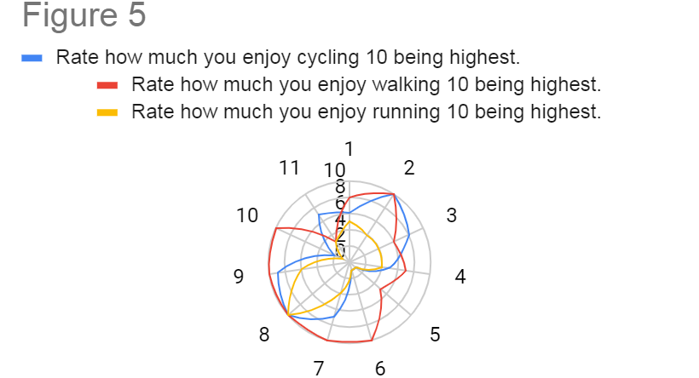
There are a few problems with my questions on peoples enjoyment of certain activities. Figure 5 shows peoples enjoyment of activities with the larger area visualizing greater enjoyment. This can also be used to say what activities may be peoples preference. Reviewing these questions within the survey now I can say that there are many limiting factors. The first being that the enjoyment doesn’t relate to the previous questions in that it fails to find a relationship between exercising in a regular week and during quarantine and what effect this has on the enjoyment of each activity. Another problem or improvement that could have been made is by asking about peoples enjoyment of activities that are possible during quarantine and activity’s that are not or at least not recommended. The results of this could have been used to expand on the previous analysis on whether people enjoy exercising more during a regular week or quarantine. A further problem with implementing these questions is the ten question limit that I has to use for my survey. For example if I were to compare even four activities, two that are permitted during quarantine and two that are not, I would have had to replace another question. Another relationship I could have analysed is peoples preference to exercising inside or out and how this related to the activity’s they enjoy however the current survey only includes activities which people must do outside unless they have an exercise bike or treadmill however with figure 1 its clear that the majority would still not prefer this as much as having access to going outside and enjoying nature.
Conclusion/Reflection
I conclusion on of the main problems with my questionnaire and data is the limited use of the findings. While I have highlighted some trend throughout the data such as people exercising more during the lockdown as well as enjoying it more at the same time. My biggest difficulty between making the survey and analysing the results was knowing what questions within the survey would allow me to use programs like spss to crosstab variables within the data. This comes down to both ends where initial I was unsure of formatting questions and what types of information to find out as well as how to get quantitative answers from this.

Additionally when it came to me analysing the data I was unable to harness the functions within spss mostly due to the data I had collected but also my limited knowledge of what I can or should be doing with the program. I was able to use excel to create some basic graphs to help me show some of the correlations within the data but none of these were that insightful and I would have liked for the majority of the questions answers to correlate in some way.

The quantitative approach used for this study had strengths and weaknesses. A strength was the ease at which I could create a questionnaire and give it a range of answers to each question. Another benefit of the Microsoft forms that I used to make my survey was that I could easily send the link to someone and it was made easy on their end to fill it out because it just updated for me and did not require any extra work on their end. Also they were able to send the link to others which could help more if the goal was to get as many responses as possible.

While I was able to find one strong ration in figure 1 that would likely not change much with an increase in populations size I wouldn’t say the same for the reliability of the rest of my trends. Like with most surveys there is almost no downside to having asked a larger population. This would have made any correlations I did find more reliable and representative of greater and more diverse population.
Word count: 1402

References
Madrigal, D., McClain, B. (2012) Strengths and Weaknesses of Quantitative and Qualitative Research. Available at: https://www.uxmatters.com/mt/archives/2012/09/strengths-and-weaknesses-of-quantitative-and-qualitative-research.php (Accessed: 25, April 2020).
Microsoft forms (2020) Available at: https://forms.office.com/Pages/DesignPage.aspx (Accessed: 25, April 2020).
Quantitative Research Methods (2020) Available at: https://moodle.uwtsd.ac.uk/pluginfile.php/192410/mod_resource/content/1/Quantitative%20Research.pdf (Accessed: 25, April 2020).

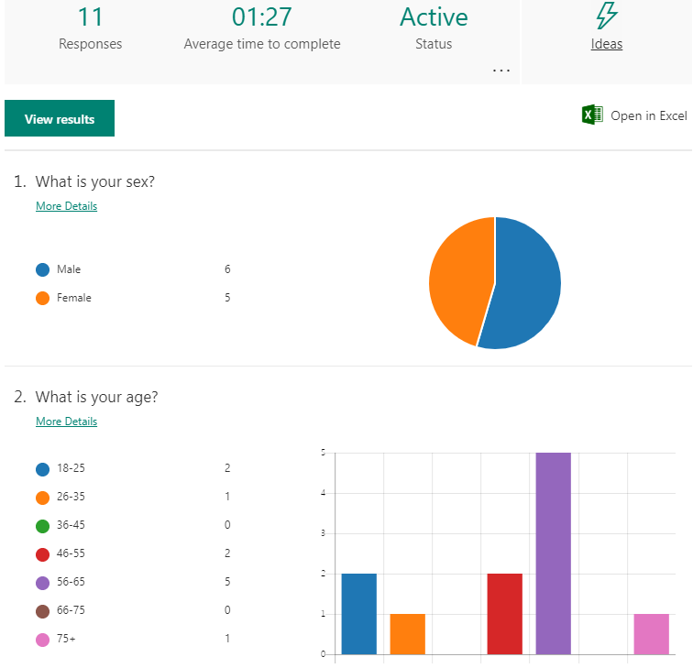
Appendices



