Training Program script

Manager: good morning, today I have brought you all here because I want to carry out a role play training session with you. I will present a scenario and I want you to act accordingly. Angelika will play the receptionist and Jack will play the guest. Jack, I want you to complain about your room, you may begin whenever your ready.

Receptionist: Good morning/ afternoon Mr Coates, how are you today?

Guest: Good morning I’m good thanks, how are you?

Receptionist: I’m good thank you sir, is everything up to your standards so far?

Guest: Well actually I had booked a room with a balcony and a sea view but I haven’t got either, which I’m not happy about. Can you just double check and see if you can do anything for me.

Receptionist: I apologize about this inconvenience, I will talk to my manager to see how we can solve this issue. Have you had any breakfast Mr Coats?

Guest: no actually I haven’t

Reception: could I interest you in a breakfast voucher on the hotel?

Guest: that sounds brilliant

Reception passes the voucher on: there you go sir enjoy your breakfast, while we solve this issue

Guest: thank you

Reception goes to manager: hi sir we have an issue where the customer hasn’t received the correct room they book, how can we accommodate this customer?

Manager: provide the customer with the room they booked free of change and a free voucher at the spa

Reception: Sir I looked in the system but there aren’t any room with the balcony only the view

Manager: ok no worries give the customer a free voucher to the spa and give them a free upgrade to the viewed room

Customer returns
Receptionist: I am so sorry but there is no more rooms with a balcony available but we can provide you with a sea view if you would like also with a free spa voucher once during your stay

Guest: Ok I am happy to change rooms to one with a sea view and I appreciate the spa voucher. Thank you. (walks off)

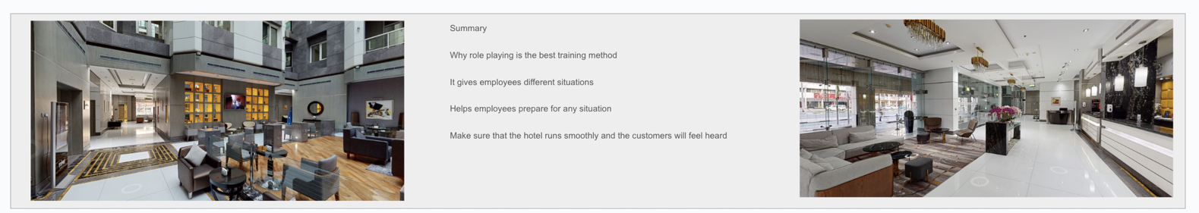
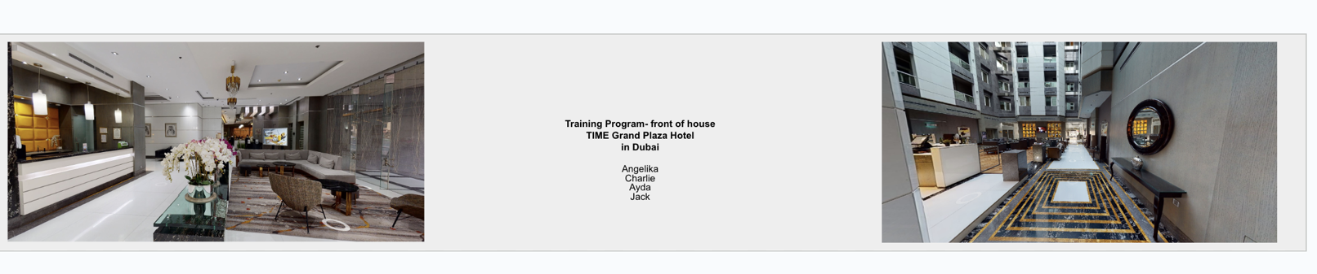
Manager: Well done for dealing with the problem and providing the customer with breakfast, it is clear that you have thought first about the customer rather than stressing to resolve the issue. Also, you don’t need to ask permission to upgrade a customer if you see there’s an issue on our part.

