

LOCATION: Graig | LLEOLIAD: Graig
LEVEL 6 | LEFEL 6
EXAMINATION PERIOD | CYFNOD ARHOLIADAU
January 2018 | IONAWR 2018

MODULE CODE: M6X01084
Advanced Routing
TIME: 2 HOURS

answer All quESTIONs in Section A
ANSWER ANY THREE QUESTIONS FROM SECTION B

Equipment or materials required – None
Adnoddau neu ddefnyddiau sydd eu hangen - Dim

Answer ALL questions in Section A

  - What are the three criteria, in order, that OSPF derives its router ID? (6 Marks)
- The router ID is explicitly configured using the OSPF router-id rid router configuration mode command. The rid value is any 32-bit value expressed as an IPv4 address. This is the recommended method to assign a router ID.
- If the router ID is not explicitly configured, the router chooses the highest IPv4 address of any of configured loopback interfaces. This is the next best alternative to assigning a router ID.
- If no loopback interfaces are configured, then the router chooses the highest active IPv4 address of any of its physical interfaces. This is the least recommended method because it makes it more difficult for administrators to distinguish between specific routers.

  - What is the benefit of route summarisation? (4 Marks)
Route summarisation allows a router to group networks together and advertises them as one large group using a single, summarised route. The ability to summarise routes is necessary due to the rapid growth of networks.

  - Discuss the advantages and disadvantages of both Static and Dynamic Routing.
(10 Marks)
Static routing provides some advantages over dynamic routing, including:
- Static routes are not advertised over the network, resulting in better security.
- Static routes use less bandwidth than dynamic routing protocols, no CPU cycles are used to calculate and communicate routes.
- The path a static route uses to send data is known.
Static routing has the following disadvantages:
- Initial configuration and maintenance is time-consuming.
- Configuration is error-prone, especially in large networks.
- Administrator intervention is required to maintain changing route information.
- Does not scale well with growing networks; maintenance becomes cumbersome.
- Requires complete knowledge of the whole network for proper implementation.
- If a link fails, a static route cannot reroute traffic.

Dynamic Routing Advantages include
- Suitable for all topologies where multiple routers are required
- Generally independent of network size
- Automatically adapts topology to reroute traffic if possible
Disadvantages include:
- Can be more complex to implement
- Less secure. Additional configuration settings are required to secure
- Route depends on current topology
- Requires additional CPU, RAM and link bandwidth

Answer THREE questions in Section B

  - Define the following EIGRP terms: - (16 Marks)
- Successor
A successor is a neighboring router that is used for packet forwarding and is the least-cost route to the destination network.

- Feasible Distance (FD)
This is the lowest calculated metric to reach the destination network. This is also known as the metric for the route.

- Feasible Successor (FS)
This is a neighbor that has a loop-free backup path to the same network as the successor, and it satisfies the Feasibility Condition

- Reported Distance (RD) or Advertised Distance (AD)
The reported distance is simply an EIGRP neighbor’s feasible distance to the same destination network.

- Feasible Condition or Feasibility Condition (FC)
FC is met when a neighbor’s Reported Distance (RD) to a network is less than the local router’s feasible distance to the same destination network. If the reported distance is less, it represents a loop-free path.

- What does the P indicate in the following: - (2 Marks)
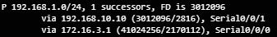
P - Route in the passive state. When DUAL is not performing its diffusing computations to determine a path for a network, the route is in a stable mode, known as the passive state. All routes in the topology table should be in the passive state for a stable routing domain.

- What would be indicated if the P was an A? (2 Marks)

If DUAL recalculates or searches for a new path, the route is in an active state and displays an A.

        - Define the following components of OSPF (15 Marks)
  - Data Structures
OSPF creates and maintains three databases: -
- Adjacency database - Creates the neighbor table.
- Link-state database (LSDB) - Creates the topology table.
- Forwarding database - Creates the routing table.
These tables contain a list of neighboring routers to exchange routing information with and are kept and maintained in RAM.

  - Routing Protocol Messages
OSPF creates and maintains three databases:-
- Adjacency database - Creates the neighbor table.
- Link-state database (LSDB) - Creates the topology table.
- Forwarding database - Creates the routing table.
These tables contain a list of neighboring routers to exchange routing information with and are kept and maintained in RAM.

  - Algorithm
The router builds the topology table using results of calculations based on the Dijkstra SPF algorithm. The SPF algorithm is based on the cumulative cost to reach a destination.
The SPF algorithm creates an SPF tree by placing each router at the root of the tree and calculating the shortest path to each node. The SPF tree is then used to calculate the best routes. OSPF places the best routes into the forwarding database, which is used to make the routing table.

- What is the difference between Single Area and Multiarea OSPF? 5 Marks)
- Single-Area OSPF - All routers are in one area called the backbone area (area 0).
- Multiarea OSPF - OSPF is implemented using multiple areas, in a hierarchal fashion. All areas must connect to the backbone area (area 0). Routers interconnecting the areas are referred to as Area Border Routers (ABRs).

        - Define Autonomous System (AS) (3 Marks)
An autonomous system (AS) is a collection of routers under a common administration such as a company or an organization. An AS is also known as a routing domain

        - Where would an Interior Gateway Protocol (IGP) be used? Give examples of IGPs. (4 Marks)
Used for routing within an AS. It is also referred to as intra-AS routing. Companies, organizations, and even service providers use an IGP on their internal networks. IGPs include RIP, EIGRP, OSPF, and IS-IS.

        - Where would an Exterior Gateway Protocol (EGP) be used? Give an example of an EGP. (4Marks)
Used for routing between ASes. It is also referred to as inter-AS routing. Service providers and large companies may interconnect using an EGP. The Border Gateway Protocol (BGP) is the only currently-viable EGP and is the official routing protocol used on the Internet

        - Define the following: (9 Marks)
  - Single Homed
The single homed design means you have a single connection to a single ISP. With this design, you don’t need BGP since there is only one exit path in your network. You might as well just use a static default route that points to the ISP.
  - Dual Homed
The dual homed connection adds some redundancy. You are still only connected to a single ISP, but you use two links instead of one. There are some variations for this design. Two connections between two routers, one router connecting to two router and two routers connecting to two routers.
  - Multi Homed
Multihomed means we are connected to at least two different ISPs.
Single multihomed
One router connecting to two different ISPs
Two routers connecting to two different ISPs.
Dual multihomed
One router connecting to two ISPs but with dual connections
Two routers connecting to two ISPs with dual connections
Two routers each connecting to two ISPs

        - With regard to OSPF define Backbone (Transit) are and Regular (Non-Backbone) area. (10 Marks)
Backbone (Transit) area - An OSPF area whose primary function is the fast and efficient movement of IP packets. Backbone areas interconnect with other OSPF area types. Generally, end users are not found within a backbone area. The backbone area is also called OSPF area 0. Hierarchical networking defines area 0 as the core to which all other areas directly connect .
OSPF enforces this rigid two-layer area hierarchy. The underlying physical connectivity of the network must map to the two-layer area structure, with all non-backbone areas attaching directly to area 0. All traffic moving from one area to another area must traverse the backbone area. This traffic is referred to as interarea traffic.
Regular (Non-backbone) area - Connects users and resources. Regular areas are usually set up along functional or geographical groupings. By default, a regular area does not allow traffic from another area to use its links to reach other areas. All traffic from other areas must cross a transit area.
        - Define the following (Illustrate your answer): (10 Marks)
- Internal router – This is a router that has all of its interfaces in the same area. All internal routers in an area have identical LSDBs .
- Backbone router – This is a router in the backbone area. The backbone area is set to area 0.
- Area Border Router (ABR) – This is a router that has interfaces attached to multiple areas. It must maintain separate LSDBs for each area it is connected to, and can route between areas. ABRs are exit points for the area, which means that routing information destined for another area can get there only via the ABR of the local area. ABRs can be configured to summarise the routing information from the LSDBs of their attached areas. ABRs distribute the routing information into the backbone. The backbone routers then forward the information to the other ABRs. In a multiarea network, an area can have one or more ABRs.
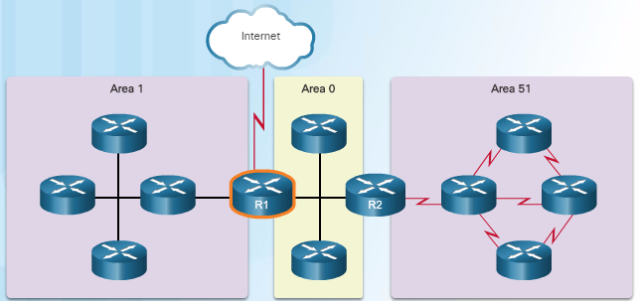
- Autonomous System Boundary Router (ASBR) – This is a router that has at least one interface attached to an external internetwork. An external network is a network that is not part of this OSPF routing domain. For example, a network connection to an ISP. An ASBR can import external network information to the OSPF network, and vice versa, using a process called route redistribution.

        - With regard to IPv4 and IPv6, discuss the following terms (Illustrate your answer): (12 Marks)
There is not a single date to move to IPv6. For the foreseeable future, both IPv4 and IPv6 will coexist. The transition is expected to take years. The IETF has created various protocols and tools to help network administrators migrate their networks to IPv6. The migration techniques can be divided into three categories:
- Dual Stack –dual stack allows IPv4 and IPv6 to coexist on the same network segment. Dual stack devices run both IPv4 and IPv6 protocol stacks simultaneously.
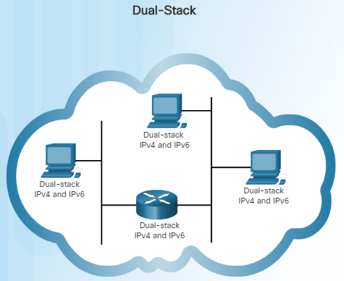
- Tunneling –tunneling is a method of transporting an IPv6 packet over an IPv4 network. The IPv6 packet is encapsulated inside an IPv4 packet, similar to other types of data.
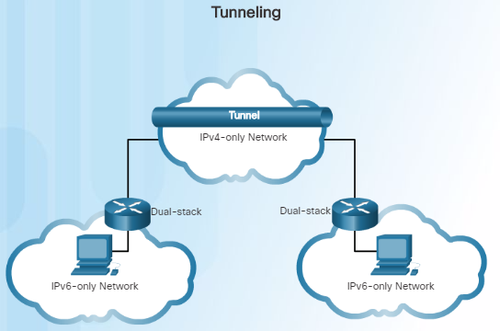
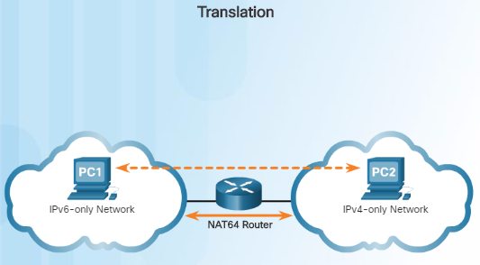
- Translation – As Network Address Translation 64 (NAT64) allows IPv6-enabled devices to communicate with IPv4-enabled devices using a translation technique similar to NAT for IPv4. An IPv6 packet is translated to an IPv4 packet and vice versa.

        - Describe how the Extended Unique Identifier - 64 (EUI-64) generates an interface ID. (8 Marks)
This process uses a client’s 48-bit Ethernet MAC address, and inserts another 16 bits in the middle of the 48-bit MAC address to create a 64-bit Interface ID.
An EUI-64 Interface ID is represented in binary and is made up of three parts:
- 24-bit OUI from the client MAC address, but the 7th bit (the Universally/Locally (U/L) bit) is reversed. This means that if the 7th bit is a 0, it becomes a 1, and vice versa.
- The inserted 16-bit value FFFE (in hexadecimal).
- 24-bit Device Identifier from the client MAC address.

