Module name:
BMIH5003
Foreign Languages and Cultural Awareness
Module Tutor: Giulia Chifari

Name: Ionelia Popoiu
Student ID Number: 2243056

Table of Contents
Component 1- Professional Reflection 4
Component 2 - Training plan 5
Component 3 – Student self-reflection 6
Component 4 – Training presentation 8
References 16

Component 1- Professional Reflection
Cultural awareness and sensitivity are a very important aspects in the hospitality industry as hotels and restaurants cater to people from all cultural backgrounds. Cultural sensitivity involves respecting customs, language, traditions and religious practices of customers (Christiansen, et al., 2020). This extends to dietary restrictions as per religion or tradition, language of expression and level of understanding. If the customer at a restaurant or bar speaks a different language and does not understand the local language, it becomes difficult for the server to cater to their needs and may create misunderstandings.
I witnessed such a cultural misunderstanding once when I was working as a cashier at a restaurant in a city in France, at a summer internship. It was lunch time, a very busy time of the day for the restaurant. Being a professional in the field of hospitality, I always observe keenly, especially when I am in a foreign land. A group of Asian tourists came to the restaurant, it looked like they got the restaurant name through some social media website. They could not speak French and were struggling to order, though it seems they could understand and read English a bit. However, the young woman who was serving them was equally struggling to make sense of their orders as she was a native worker and could speak only French. The process of ordering took forever, the guests were asking what kind of meat is there in a dish listed, but the server was just describing the whole dish, in French. The dish which finally got served had some seafood in it which the guests did not ask for. The guests also asked for some drinks without ice but were served drinks with ice. All this misunderstanding took place because of just one problem – language. It left the guests dissatisfied, not enjoying their meal and the server frustrated and disheartened due to unfavourable reactions from the guests.
I felt bad for both, I think all this could have been avoided if the management had paid attention to this important issue, as cultural values affect brand loyalty. The relationship between the global restaurant brand and customer’s cultural values dictates how comfortable customers feel (Han, et al., 2021). Thus, the management must make some additions and adjustments to cater to customers with different culture and language. The food menu should have been provided in English too, with food pictures and codes/stickers which can describe whether the dish is vegetarian/non vegetarian/vegan, what kind of meat it contains. The restaurant must also invest in hiring a few multilingual employees who may act as interpreters in such situations. All employees must have basic training of greeting in a few languages, understanding different language customers using sign languages and codes (Koc, 2020). In this particular restaurant, basic language training in English would have taken care of majority of tourists as most Asian, American, Australian continent people and many European country tourists can speak and/or read English. A supervisor also must be present, taking rounds and can intervene in such stressful situations.

Component 2 - Training plan
To address cultural sensitivity in the hotel business, it is important to train the hotel staff, ensuring that all employees are equipped in dealing cultural differences in the customers (Abramson & Moran, 2018). I have come up with a step-by-step plan for the whole staff. With diverse workforce, it becomes difficult to communicate, but the cultural differences and language barriers can be handled effectively if there is effective communication between different group of people involved in the process (Liu, et al., 2022). As the first step, hospitality industry must aim to employ people from diverse backgrounds, culturally different and bilingual or multi-lingual abilities. Hiring foreign nationals and immigrants is a good way to include diversity, however challenges in the form of communication barrier can rise when non-natives are hired. I have worked on three different scenarios of cultural and language barriers and made suggestions to overcome these barriers successfully.
1) Between restaurant staff: Good communication between restaurant staff plays important role in increasing productivity and forming trust. When employees speak different languages, some codes and abbreviations can be used to quickly convey orders etc. For example, “reso” can be used for reservations, “A’ la minute” a French term for dish to be made fresh to order, “in the window” is used for latest orders prepared and ready to be served. The common language shared by the staff reduces confusion, bring employees together and creates bonds (West & Turner, 2019).
2) Between managers and staff: Communication may suffer if the manager and staff speak different languages, this happens when staff consists of immigrant workers or non-natives. The managers must be given training in basic languages mostly used by the staff. The material regarding food and work place safety, feedback and appraisal etc must be prepared in translated version for the staff. The managers can use pictures, videos, animation etc to convey their standard instructions to staff more effectively.
3) Between customers and restaurant staff: Customers may be of any cultural background and may speak any language, the staff cannot be ready with all language options. However, a basic training in general greetings, description of dishes, asking preferences from customers must be given to all staff members in a few most spoken languages. Hiring staff from different cultural background is the first step towards embracing cultural differences (Abramson & Moran, 2018). This ensures cultural diversity and a respect towards different cultures and languages which in turn shows in the patience displayed by staff while serving the customers.
To make things easier for customers who do not speak native language, menu should contain descriptive pictures of the dishes, animations for showing level of spice/hot etc., type of meat used, whether it’s a vegan or vegetarian dish. The manager or supervisor should always be available if any issue arises due to problems with customers and servers, to respectfully understand and resolve.
The staff should be encouraged to use simple language and frequently used phrases, many customers may recognise these. Menu can be prepared in a couple of languages that the management thinks can be useful for majority of different culture customers. Finally, a sense of respect and patience towards customers’ needs is foremost. Even if the staff finds inconvenient to converse with customers, they must not show impatience and frustration. They can ask for help, they may use translation Apps, they may try to converse using hand gestures or pictures.

Component 3 – Student self-reflection
The self-reflection model given by David Kolb, called Kolb’s reflective cycle, focusses on four stages and different styles of learning. I am using this model here to reflect upon my own understanding of the importance of cultural awareness within the hospitality industry. The four stages of Kolb’s model and my reflection on those lines is as follows (Fried, 2023):
Stage 1 : Concrete experience: My experience in the hospitality industry, at different locations , in different countries has enhanced my understanding of the importance of cultural awareness. By embracing cultural diversity, hospitality organisations create a brand image for themselves which is inclusive, global and warmly welcome customers from all countries/regions all over the world (Maheshkar & Sharma, 2018).
Stage 2: Reflective observation: I initially assumed that knowing the local language and employing native as well as non-native staff is good enough to tackle cultural issues. But my experience made me realise that when a hospitality organisation sets up branches in other countries with different cultural backgrounds, a deep knowledge of the local culture is a must and all operations of the organisation must adjust accordingly (Hampde, et al., 2020). For example, in UK, people typically like light breakfast on weekdays and a heavy full English breakfast on weekends, accompanied by fine tea on all days. If the organisation opens up a restaurant in France or Hotel which offers breakfast, the same practice won’t work as French breakfasts consist of mostly sweet and baked delicacies followed by strong coffee. Thus, an understanding of the cultural difference is necessary.
Stage 3: Abstract Conceptualisation: The experience I had at different locations let me think what I could have done better in some situations. I was afraid to talk to customers who spoke different languages and would always start looking for someone who could understand the customer’s language. In retrospect, I should have instead tried to make use of simple sentences and use facial and sign gestures to convey my message to the customers. Mostly customers don’t ask complicated things if they are at foreign location. I could have learnt basics in different languages and used pictures or even translation apps.
Stage 4: Active experimentation: With this newly acquired knowledge about cultural sensitivity, I have come up with some strategies which can help me and my fellow workers in the hospitality industry.
Have patience and respect every culture. Things may not be right or wrong, they are different. For example, customers coming from Western countries like USA are more casual with their server, while customers from Asian countries hold stricter standards in server-customer interactions (Fam, et al., 2021). The restaurant/hotel staff must respond as per the customers’ preference.
Do not judge any customer on basis of language they speak, clothes they wear, the way they eat or the kind of requests they make. Some customers may have special requests which are unfamiliar. The staff must carry out service as per their request if its reasonable, if not then they must politely make guests understand the limitations and offer alternatives.
Every culture has its own rules regarding behaviour, which may be different at the place they are visiting. If the hospitality organisation expects certain behaviour from the guests, then it can display its house rules politely around the property, in multi-language posters with indicative pictures/drawings.

Component 4 – Training presentation
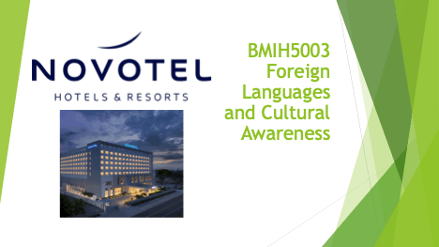
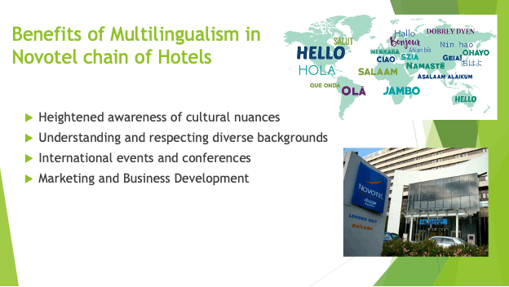
In the dynamic and diverse hospitality industry, multilingualism provides a competitive advantage. Hospitality professionals who have learnt different languages, know more about cultural nuances too which provides them heightened cultural sensitivity. This cultural sensitivity is crucial in understanding and respecting customers from diverse backgrounds (Deresky, 2017). Hotels also host international conferences where people from all over the world attend the events. Staff which is multilingual provides smooth communication and plays a pivotal role in coordinating and hosting these events, which enhances the guests’ experience. Also, multilingual professionals contribute to the formation of global marketing strategies by using their cultural awareness, creating content and advertising in different languages which attracts diverse audiences.
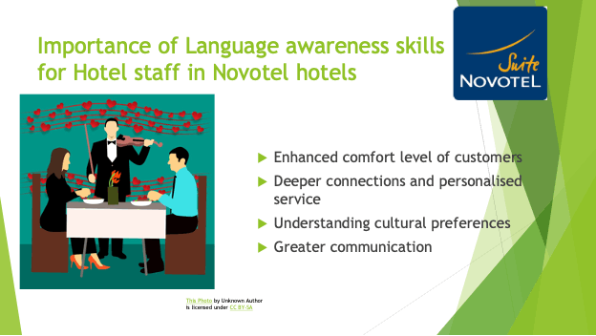
Hospitality staff with different language skills is very important in the era of globalization when hotels cater to guests from all cultural backgrounds. When the staff speaks in the guests’ language in the Novotel hotel establishments, they feel enhanced comfort level which helps them enjoy the hospitality and overall satisfaction level is high (Ford & Sturman, 2018). The staff can understand the cultural preferences of international clientele and their expectations can be fulfilled. Staff which can speak different languages has greater communication with the customers as well as native staff and immigrant workers, which leads to satisfied guests and deeper connect with colleagues.
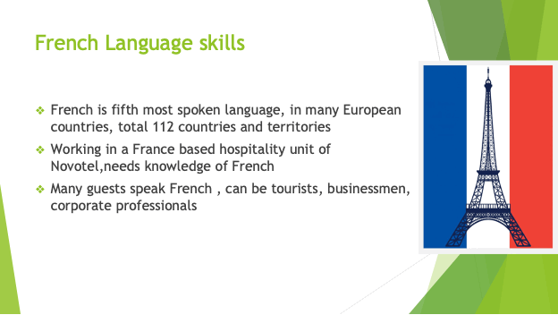
As an example of acquiring language skills, French language is discussed here for Novotel units in France. French is fifth most widely spoken language in the world. Many European countries like France, Belgium, Luxembourg, Switzerland, and many more speak French, total of 112 countries and territories speak French (BBC, 2024). Restaurants and hotels based in these countries, like Novotel hotel establishments, do require their staff to have good knowledge of French, it is expected by the natives, locals and by many visitors who can speak French. The hotels/restaurants of Novotel in other countries like UK, receive many French speaking guests from the above-mentioned countries as well as from countries like Congo, Mali, Canada, Haiti, Algeria and many more countries where French is the official or most spoken language. Hotels and restaurants around the world cater to many customers whose primary language is French, these may be tourists, businessmen or corporate professionals who travel to different countries.
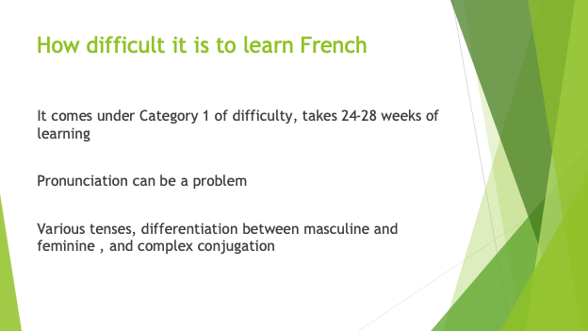
French language is one of the easiest to learn, with Category 1 of the language difficulty in learning. English language speakers easily write and read French. The problem area for most people is pronunciation, since people are not used to the different phonetics, sounds and intonation. It takes time and practice to master. The differentiation between masculine and feminine is another tough area to tackle (BBC, 2024). There are many tenses to be learnt and complex conjugations that may add problems for beginners. However, taking regular learning courses, specifically group courses, help learn faster as it allows interactions and knowledge sharing with others.
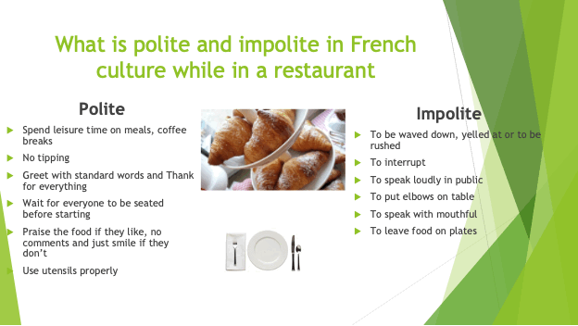
French people love to spend leisure time on their meals and coffee breaks. Their culture is a non-tipping one and they are being polite by giving the hotel/restaurant their time. It is considered polite to greet with ‘Bonjour’ and say goodbye with ‘Au revoir’. It is polite to wait for everyone to be seated before starting the meal (Glape, 2024).
It is impolite to interrupt someone while they are speaking and impolite to be loud in public. They do not like to be rushed, yelled at, or waved down. People use utensils properly, will not speak with their mouthful. It is considered impolite to leave food on the plate, and to put elbows on the table. It is impolite to comment on food in a negative way, they either praise the food or just smile if it wasn’t much satisfactory.
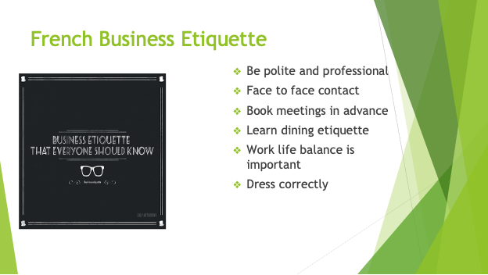
In French business culture, politeness and good manners are appreciated. Address people with appropriate titles like Madame and Monsieur. Face to face contact is preferred, especially for new business relationships or if an important deal is being closed (Chevant-Aksoy, 2022). French people do not prefer last minute things, thus booking meetings in advance is required. They prefer quality and don’t want to be rushed. Learning dining etiquettes like using utensils, not speaking with mouthful, not putting elbows on table and many more as discussed earlier, are important. French people like to keep their work life and private life separate. So, after office hours are mostly off time for people, though in this digital age it is becoming difficult to keep work at bay in off time. Finally, it is considered impolite to dress casually in short dresses, torn jeans etc. as it is seen disrespectful. People dress formally when meeting clients and for business meetings but may dress more informally otherwise. However, dressing correctly is most required, even if it’s not formal.
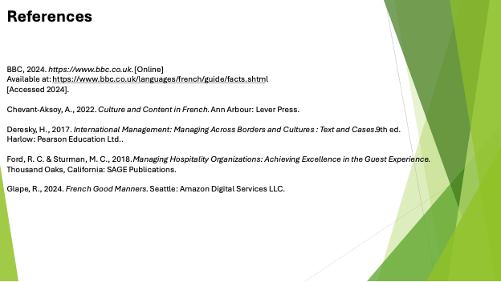

References
Abramson, N. R. & Moran, R. T., 2018. Managing Cultural Differences: Global Leadership for the 21st Century. Abingdon:: Routledge.
BBC, 2024. https://www.bbc.co.uk. [Online]
Available at: https://www.bbc.co.uk/languages/french/guide/facts.shtml
[Accessed 2024].
Chevant-Aksoy, A., 2022. Culture and Content in French. Ann Arbour: Lever Press.
Christiansen, B., Karmowska, J. & Branch, J. D., 2020. Cultural Factors and Performance in 21st Century Businesses. Hershey: IGI Global.
Deresky, H., 2017. International Management: Managing Across Borders and Cultures : Text and Cases. 9th ed. Harlow: Pearson Education Ltd..
Fam, K.-S.et al., 2021. The Role of Cultural Differences in Customer Retention: Evidence from the High-Contact Service Industry. Journal of Hospitality & Tourism Research, 47(1).
Ford, R. C. & Sturman, M. C., 2018. Managing Hospitality Organizations: Achieving Excellence in the Guest Experience. Thousand Oaks, California: SAGE Publications.
Fried, J., 2023. Transformative Learning Through Engagement. Oxfordshire: Taylor & Francis.
Glape, R., 2024. French Good Manners. Seattle: Amazon Digital Services LLC.
Hampde, C., Turner, F. T. & Hampden-Turner, C., 2020. Riding the Waves of Culture: Understanding Diversity in Global Business. London: John Murray Press.
Han, S. H., Chen, C.-H. S. & Lee, T. J., 2021. The interaction between individual cultural values and the cognitive and social processes of global restaurant brand equity. International Journal of Hospitality Management, 94(102847).
Koc, E., 2020. Cross-Cultural Aspects of Tourism and Hospitality. Oxfordshire: Taylor & Francis.
Liu, Y., Liu, J. & King, B., 2022. Intercultural communicative competence: Hospitality industry and education perspectives. Journal of Hospitality, Leisure, Sport & Tourism Education, 30(100371).
Maheshkar, C. & Sharma, V., 2018. Handbook of Research. Hershey: IGI Global.
West, R. & Turner, L. H., 2019. Interpersonal Communication. Thousand Oaks, California: SAGE Publications.

