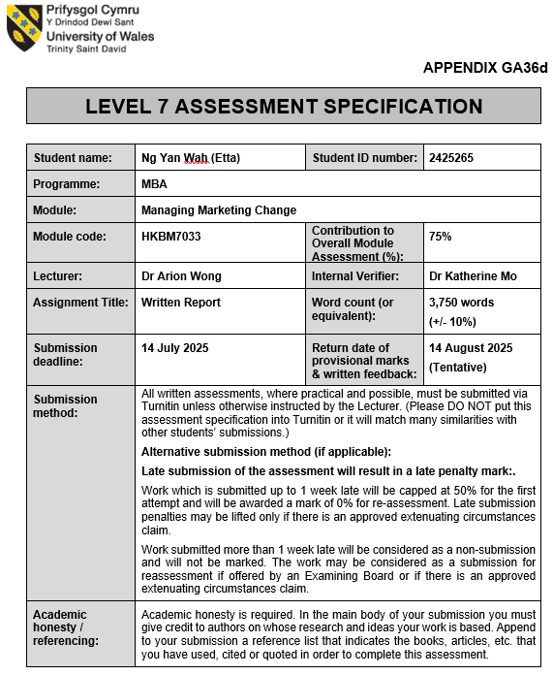

Contents
1. Introduction 3
2. Situation Analysis 4
2.1 Macro Environment 4
2.1.1 Political 4
2.2.2 Economic 4
2.2.3 Social 5
2.2.4 Technology 5
2.2 Micro Environment 6
3. Company’s Segmentation, Targeting and Positioning 7
3.1 Company’s Segmentation in Hong Kong 7
3.2 Company’s Target customers and Consumers 7
4. Market Mix of POP MART 10
4.1 Product 10
4.1.1 Product Lines 10
4.2 Price 11
4.3 Place 11
4.4 Promotion 11
5. SWOT Analysis 13
6. Conclusions and Recommendations 15
6.1 Feasible Strategies 15
6.1.1 Coupon Redemption 15
6.1.2 Timeline 15
6.1.3 Estimated outcomes 16
Reference 17

- Introduction
POP MART is a leading company of trendy toys in China, headquartered in China and listed in Hong Kong (Stock: 9992.HK). It focuses on design, production and sales on “blind box” toys, using Intellectual Property (IP) as core business model. It owns well-known original IPs such as Labubu, Molly and Dimoo, and also cooperates with international brands (such as Disney and Harry Potter) to launch declared joint products. (POP MART, 2023)

Key Trends:
POP MART successfully promoted the “blind Box” business model, consumers purchase the toys by random draw, increased collectability and rate of repurchase. According to Frost & Sullivan’s report, the scale of China's trendy toy market is expected to reach RMB 76.3 billion in 2024, with a compound annual growth rate (CAGR) of 29.8%.during 2020-2024. (Frost & Sullivan, 2021) Driven by young consumers and tourists, the Hong Kong market has seen strong performance in blind box sales in shopping hotspots (such as MongKok and Causeway Bay), and has expanded through a combination of online channels (official website, social e-commerce) and offline channels (vending machines, flagship stores).

Through limited edition and hidden edition strategies, POP MART created scarcity, and used social media (such as Xiaohongshu, Instagram) to strengthen fans’ interaction and increase sense of belonging to the brand. (Euromonitor, 2022)

Market Dynamics and Competitive factors:
According to Euromonitor (2023) Report, Asia’s trendy toys market reached USD 21.7 billion in 2022, predicted to increase to USD 35 billion in 2027. Factors of increment included Gen Z’s consumption power and social media exposure effect. Among Hong Kong’s 18-35 year olds, 68% are willing to pay for limited edition trendy toys with a premium price. (NielsenIQ, 2022) Social media platforms (such as Xiao Hong Shu and Instagram) driving the “unboxing video” upsurge, issues related to POP MART in 2022 cumulative playback volume exceeds 5 billion times. (CBNData, 2023)

- Situation Analysis

2.1 Macro Environment
PEST analysis is to help the company anticipate market shifts, identify potential threats and opportunities, and develop strategies to adapt effectively. It provides a broad overview of the external environment to support strategic planning and decision-making.

2.1.1 Political
Hong Kong’s political environment remains complex and sensitive due to the implementation of the national security law since 2020. his law has led to increased government oversight and occasional crackdowns on activities deemed politically sensitive, impacting the broader business climate and consumer sentiment. While the political tensions create a challenging environment, recent easing of some restrictions has temporarily improved market sentiment and investor confidence, as evidenced by a nearly 5% rise in POP MART’s share price and a turnover exceeding HKD 11 billion in Hong Kong trading in June 2025. (Ainvest, 2025) However, ongoing geopolitical tensions require the company to remain vigilant and adaptable to regulatory shifts to protect its operations and brand reputation in the city.

2.2.2 Economic
According to POP MART’s annual report in 2024, it highlights strong revenue growth driven by both mainland China and overseas markets, including Hong Kong. (POP MART, 2024) Hong Kong serves as a strategic international hub for POP MART’s expansion, benefiting from its robust retail infrastructure and affluent consumer base. Economic volatility and currency fluctuations remain risks, but Hong Kong’s stable economic fundamentals and status as a global financial center support POP MART’s international business model. Inflationary pressures and rising raw material costs globally may affect product pricing, but POP MART’s premium pricing strategy and diversified product range help mitigate these challenges. Hong Kong high disposable income levels among young consumers align well with POP MART’s target demographic of 15-35-year-olds, who have shown strong demand for collectible toys and lifestyle products. (Fangying.L., 2025)

2.2.3 Social
POP MART targets Millennials and Gen Z consumers, especially young women aged 15-30, who are attracted to trendy, collectible designer toys and the "blind box" purchasing experience. (Enyoung Liu, 2025) Hong Kong’s vibrant youth culture and trend-conscious population offer fertile ground for POP MART’s blind box collectibles and IP-driven products. The brand’s success is fueled by a predominantly young, urban customer base, with a slight female majority and significant engagement from students and young professionals. (Fangying.L., 2025) Celebrities and influencers created unboxing videos among their followers. POP MART leverages social media, influencer marketing and pop-up stores to foster a strong fan culture around its IP characters. POP MART encourages consumers to share unboxing videos on social media to share the surprised experience of unboxing the blind box. Once there were new series, POP MART published a variety of product introduction content on platforms such as Facebook, Instagram, TikTok and Youtube for influencer marketing.

One of the most striking examples of celebrity influence boosting POP MART’s brand is the global popularity surge of the character Labubu, largely attributed to Blackpink member Lisa’s endorsement. She further showcased Labubu by displaying its keychain charm hanging on her handbag during live streams and public appearances. This captured the attention of millions of her followers worldwide, sharing interest in Labubu collections.

However, social sensitivities related to political expression and cultural identity in Hong Kong require POP MART to carefully navigate marketing and product positioning to maintain broad appeal without controversy. (Ainvest, 2025)

2.2.4 Technology
POP MART invested in robotic vending machines (ROBOSHOPs) worldwide. Roboshops are advanced vending machine stores primarily located in high-traffic shopping malls and commercial districts. The Roboshops incorporate AI-powered robotic arms equipped with product location recognition technology, which can adjust for unevenly placed products, ensuring neat arrangement and smooth pickup operations. Revenue from Roboshops increased by 131.9% from RMB 57.4 million in 2023 to RMB 133.1 million in 2024.

POP MART leverages advanced omni-channel retail technologies in Hong Kong, combining physical flagship stores and pop-up experiences with digital platforms, including AR-enabled apps and online membership systems. The integration of offline and online channels enhances customer engagement and repeat purchase rates, critical in a competitive market. Hong Kong’s high internet penetration and tech-savvy consumers facilitate the adoption of these innovations. Additionally, POP MART’s use of data analytics and social media marketing, including influencer collaborations and viral campaigns, strengthens brand visibility and consumer loyalty. Continued investment in technology-driven retail experiences is essential for sustaining growth amid evolving consumer expectations. (Fangying,L., 2025)

2.2 Micro Environment
POP MART’s micro environment comprises key factors directly influencing its operations, including customers, suppliers, competitors, intermediaries, and internal resources. Its core customer base primarily consists of Millennials and Generation Z, especially young women aged 15-30, who are drawn to trendy, collectible designer toys and the excitement of the blind box experience. This digitally savvy demographic highly values unique artistic designs and limited-edition products. POP MART’s strategy of fostering a strong fan culture through influencer marketing, unboxing videos, and community platforms deepens customer loyalty and drives repeat purchases, essential for sustained growth (POP MART, 2024; Tingting F., 2025).

The company maintains close collaborations with a global network of pop artists and designers, including notable figures like Kenny Wong, and nurtures in-house creative teams. This ensures a steady flow of innovative IPs that set POP MART apart. Control over production and packaging safeguards quality and intellectual property, crucial in a market vulnerable to counterfeiting (POP MART, 2024).

Operating in a competitive landscape with players like Funko, Hot Toys, and 52TOYS, POP MART’s strength lies in its original IP portfolio, addictive blind box model, and integrated digital community. To sustain its edge amid market saturation and imitation, continuous innovation and international expansion are necessary (Tingting F., 2025).

POP MART’s omni-channel distribution includes over 200 physical stores, 1,800+ automated ROBOSHOPS vending machines, e-commerce platforms, and a proprietary social app that supports trading and community interaction. This extensive network enhances accessibility and engagement, enabling effective online and offline sales. The company’s IP incubation, design capabilities, and data-driven marketing drive rapid growth, though reliance on the blind box model requires ongoing diversification.

- Company’s Segmentation, Targeting and Positioning

3.1 Company’s Segmentation in Hong Kong
POP MART’s consumer segmentation in Hong Kong primarily revolves around young adults aged 15 to 35 years old. This age group represents the core demographic that drives demand for POP MART’s collectible designer toys, particularly the blind box format. Research indicates that approximately 65% of POP MART’s customers are young females within this age range, with the remaining 35% predominantly male but still within similar age brackets. This segmentation aligns with the broader trend across Greater China, where the brand resonates strongly with youthful consumers who seek affordable luxury and lifestyle products that double as collectibles and social currency.

The age segmentation reflects the lifestyle and consumption patterns of young urban professionals and students who appreciate POP MART’s products as a form of emotional relief from daily stress, a trendy desk accessory, or a unique gift option. The company’s IP-driven designs and surprise element in blind boxes cater well to this demographic’s appetite for novelty, exclusivity, and community belonging. (Tingting, F., 2025)

3.2 Company’s Target customers and Consumers
POP MART conducts mass marketing strategy, all consumers with different gender, age group, interests are POP MART’s target customers. For focus, POP MART targets mainly young consumers aged 15-30 years, with a significant proportion of female customers who have disposable income and an independent consumption mindset. This segment includes students, young professionals and office workers in Hong Kong. (POP MART, 2024) Gen Z’s spending power and emotional consumption patterns have propelled POP MART’s rapid growth, with its shares surging nearly 600% in Hong Kong over the past year, reflecting investor confidence in the brand’s appeal to this cohort. (Shidong.Z., 2025) POP MART focuses on consumers who seek emotional fulfillment through collectibles, including self-expression, companionship, and stress relief. These consumers are trend-sensitive, digitally savvy, and belong to communities that value pop culture and IP-driven products.

According to POP MART’s 2022 Annual Report, it shows that over 75% consumers are under 35. (POP MART, 2022) Young adults who’s’ age range between 18 to 35 years old are especially trendy, fashion-conscious and enjoy unique designs and limited-edition collectibles. 45% of consumers of POP MART was Gen Z (15-25 years olds) 40% of consumers was Millennials (26-35 years old) and 10% of consumers was Gen X (36-45 years old) who mostly purchase as gifts. (POP MART, 2023b) Alibaba’s 2023 Tmall Luxury & Collectibles report stated that women drive 68% of blind box purchase.

Gen Z’s affinity for pop culture, design, and interactive experiences makes them highly receptive to POP MART’s innovative IP collaborations and product launches, reinforcing the company’s positioning as a trendy lifestyle brand rather than just a toy manufacturer. The company’s focus on Gen Z in Hong Kong ensures it remains culturally relevant and responsive to evolving consumer preferences in this key international market.

3.3 Company’s Positioning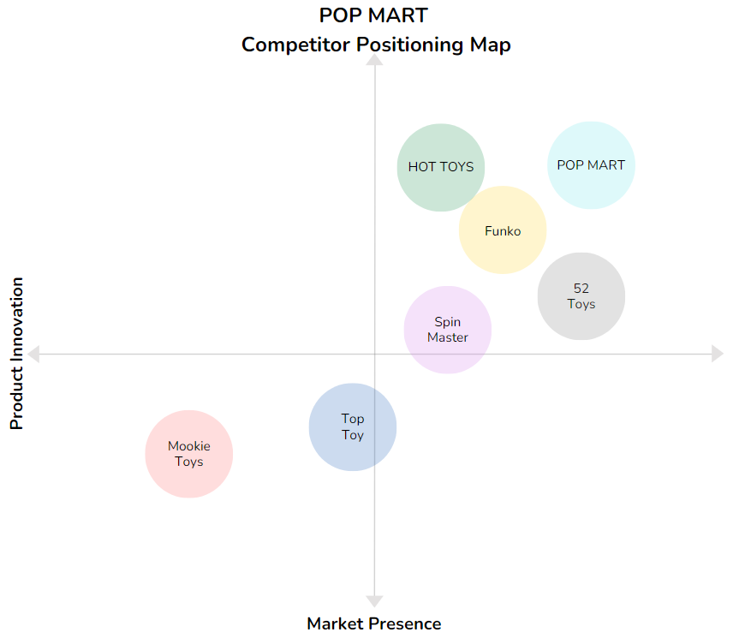
Source: Illustrate by writer

POP MART positions itself as a leading global innovator in the trendy collectible toy market, specializing in IP-based blind box products. The company owns exclusive intellectual properties like Labubu and Molly, which have cultivated strong global fan communities. POP MART operates an omni-channel retail network that includes physical stores, robotic vending machines, and digital platforms, ensuring wide accessibility and a seamless consumer experience. Leveraging data-driven marketing and continuous IP innovation, POP MART maintains its leadership in a fast-growing market, with a market value surpassing HKD 330 billion and overseas revenue increasing 475% year-on-year in Q1 2025 (Nasdaq, 2025; Xing Y, 2025)

POP MART differentiates itself through original, artist-designed characters such as Molly and Dimoo, appealing to art and design enthusiasts. Unlike competitors like Funko, which focus on licensed mainstream franchises with uniform “chibi”-style figures, POP MART offers unique, emotionally rich mini art sculptures that create distinct narrative worlds for collectors (Alts, 2025). Compared to Hot Toys, which targets high-end collectors with premium-priced licensed figures, POP MART operates with lower costs and higher margins, positioning itself as a luxury-like brand with mass appeal through its addictive blind box model. Spin Master competes mainly in traditional toy categories and lacks POP MART’s niche focus on designer blind boxes and original IP (Insider Monkey, 2023).

Among Chinese competitors, 52TOYS shares a similar strategy but is less internationally established and has a narrower product range. TOP TOY, affiliated with MINISO, emphasizes licensed collectibles, contrasting with POP MART’s original creations. Mookie Toys offers a broad range but lacks POP MART’s strong brand narrative and innovative marketing. POP MART’s competitive edge lies in its original IP development, artistic design, and blind box sales approach, enabling rapid domestic and international growth and a distinctive brand identity worldwide.

- Market Mix of POP MART

4.1 Product
POP MART’s product strategy in Hong Kong is centered on delivering a diverse and innovative range of designer collectible toys and lifestyle products that cater to the tastes and preferences of young, trend-conscious consumers. The company’s core product offering is built around its “blind box” model, which packages collectible figures in sealed boxes without revealing the specific character inside. This element of surprise creates a unique shopping experience that drives repeat purchases and fosters strong consumer engagement.

4.1.1 Product Lines
Blind Box Collectibles
POP MART’s flagship blind box figures feature a rich array of proprietary and licensed intellectual properties (IPs). In Hong Kong, popular IPs such as Molly, Labubu (from the “The Monsters” series), Skullpanda, and Crybaby have cultivated a strong fan base. These characters are developed by POP MART’s in-house team and renowned artists, blending pop culture, street art, and fine art influences. In 2024, four key IPs each generated over RMB 1 billion in revenue globally, with THE MONSTERS, MOLLY, SKULLPANDA, and CRYBABY among the most popular. (POP MART, 2024) 13 additional IPs contributing more than RMB 3 billion globally, reflecting strong market acceptance in Hong Kong and other East Asian markets. (POP MART, 2024)

Plush Toys and Lifestyle Accessories
POP MART has expanded its product offering beyond blind boxes to include plush toys, which experienced a remarkable 1,289% sales increase in 2024, reaching RMB 2.83 billion, accounting for 21.7% of total revenue. This surge is mirrored in Hong Kong, where plush toys and lifestyle accessories—such as jewelry under the Popop brand—have become increasingly popular among young consumers seeking collectible and wearable items inspired by POP MART’s Ips. (POP MART, 2024)

Limited editions and collaborations
To maintain exclusivity and appeal to collectors, POP MART regularly releases limited-edition figures and collaborates with renowned international brands (e.g., Disney, Warner Bros.) and local Hong Kong artists. These special editions enhance product desirability and reinforce the brand’s premium positioning in Hong Kong’s competitive retail environment. (POP MART, 2024)

ROBOSHOPS
A significant innovation in Hong Kong is the deployment of ROBOSHOPS which automated vending machines strategically placed in high-traffic locations such as shopping malls and transportation hubs. These machines provide convenient, round-the-clock access to blind box collectibles, complementing POP MART’s physical stores and online channels. By 2024, POP MART expanded its overseas ROBOSHOPS network to 192 units, including those in Hong Kong, supporting its omni-channel retail strategy and meeting the fast-paced lifestyle demands of urban consumers. (POP MART, 2024)

4.2 Price
POP MART employs a value-added pricing strategy, setting prices based on perceived consumer value and emotional engagement. The brand uses psychological “charm pricing”, with most products ending in the digit 9, such as RMB 59,69,79. It makes prices appear more attractive and affordable to consumers. (Enyong, L., 2025)

POP MART uses a cost-plus approach by adding a set profit margin to production costs. Consumers are willing to pay for the unique experience and collectible value. It prices are positioned between high-end designer toys like Bearbricks and mass-market like Miniso, which appealing to a broad customer base. (Enyong, L., 2025)

Prices are adjusted for overseas markets to account for tariffs and local costs. For example, a blind box priced at RMB 99 (US$ 13.50) in China, but sold for US$28 in the US, reflecting POP MART’s premium positioning aboard. (IndexBox, 2025)

4.3 Place
For the Omni-channel retail network, POP MART distributes its products through a mix of physical and digital channels to ensure wide accessibility and brand presence. (Giulia I., 2025)
POP MART operates over 200 flagship and physical stores globally, including in major cities like Hong Kong, Beijing, Shanghai, Los Angeles, London and Tokyo. The stores offer immersive brand experiences and exclusive product drops, driving foot traffic and community engagement. (TechNode F., 2025)

POP MART also operates more than 2,500 vending machines (Robo Shops) worldwide, which consumers could access to blind boxed and limited editions at anytime and everywhere. Robo shops are placed in shopping malls and transits hubs and entertainment districts, aimed to maximise visibility and impulse purchases. (Giulia, I., 2025)

For online channels, POP MART operates official e-commerce platforms and mini-programs on WeChat and other apps like Taobao. International e-commerce sites serve overseas customers by supporting global expansion and direct-to-consumer sales. (TechNode F., 2025)

4.4 Promotion
POP MART’s promotional strategy in Hong Kong employs an integrated marketing communications (IMC) approach that combines digital marketing, influencer partnerships, experiential retail, and public relations to build brand loyalty and awareness. The company actively engages its core Millennial and Gen Z audience through social media platforms such as Instagram, TikTok, Facebook, and WeChat. By encouraging user-generated content like unboxing videos, POP MART leverages authentic word-of-mouth and social sharing, which enhances brand credibility and emotional connection. (POP MART, 2024)

Celebrity endorsements play a significant role in POP MART’s promotion. Notably, Blackpink’s Lisa’s endorsement of the Labubu character has greatly increased brand visibility and appeal among young consumers in Hong Kong and beyond. The company’s proprietary mobile app and mini-programs offer personalized product recommendations and interactive features, driving customer engagement and repeat purchases.

Experiential marketing is another key element, with POP MART organizing pop-up events, large-scale exhibitions, and flagship stores in prime Hong Kong locations. These immersive brand experiences deepen emotional attachment and foster community among collectors. Additionally, POP MART’s AI-powered ROBOSHOPS vending machines provide convenient, 24/7 access to products in high-traffic areas, supporting impulse purchases and complementing the omni-channel retail strategy.

Public relations efforts focus on exclusive collaborations with global IPs and local artists, generating excitement and reinforcing POP MART’s image as a trendy lifestyle brand. Through this comprehensive promotional mix, POP MART effectively connects with Hong Kong’s young, trend-conscious consumers, driving sustained brand growth and market leadership.

- SWOT Analysis
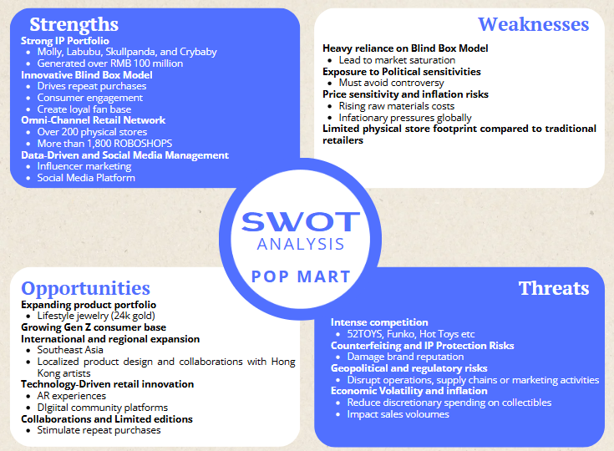
Source: Illustrate by writer

Strengths:
POP MART’s key strengths lie in its robust portfolio of original intellectual properties (IPs) such as Molly and Labubu, which have cultivated a loyal and engaged fan base in Hong Kong. The company’s innovative blind box model creates a unique and addictive consumer experience, driving high repeat purchase rates. Coupled with a strong omni-channel retail presence including flagship stores, automated ROBOSHOPS, and digital platforms. POP MART effectively reaches its core demographic of young, trend-conscious consumers. Its data-driven marketing and influential social media campaigns, boosted by celebrity endorsements like Blackpink’s Lisa, further enhance brand visibility and customer loyalty.

Weaknesses:
Despite its marketing successes, POP MART is heavily reliant on the blind box format, which may face challenges if consumer novelty wanes or if regulatory scrutiny over collectible products intensifies. The politically sensitive environment in Hong Kong also constrains marketing flexibility, requiring careful navigation to avoid controversy. Additionally, rising raw material and inflationary costs pose risks to pricing strategies and profit margins. While the company’s physical store footprint in Hong Kong is growing, it remains relatively limited compared to traditional retailers, potentially restricting impulse purchase opportunities beyond vending machines and online channels.

Opportunities:
POP MART has significant opportunities to expand its product portfolio, particularly in plush toys and lifestyle accessories, which have shown explosive growth in recent years. The rising purchasing power and cultural influence of Gen Z consumers in Hong Kong align well with POP MART’s trendy, affordable exclusivity positioning. The city’s role as a regional hub also offers a strategic platform for further international expansion and localized collaborations with Hong Kong artists. Continued investment in retail technology, such as expanding ROBOSHOPS and enhancing AR-enabled experiences, can deepen consumer engagement and differentiate the brand in a competitive market.

Threats:
POP MART faces intense competition from both domestic and international players, including Funko and Hot Toys, which may erode market share if they innovate aggressively or leverage stronger licensed IPs. Counterfeiting remains a persistent threat, potentially undermining brand reputation and consumer trust. Geopolitical tensions and evolving regulatory landscapes in Hong Kong and abroad add layers of operational risk. Moreover, shifting consumer preferences in the fast-moving youth culture market require constant innovation, and economic volatility or inflation could dampen discretionary spending on collectibles, impacting sales growth.

- Conclusions and Recommendations

6.1 Feasible Strategies

6.1.1 Coupon Redemption
Coupon redemption is widely recognized as an effective marketing tool to boost sales volume and enhance customer engagement. For POP MART, implementing coupon redemption programs can stimulate purchase acceleration by incentivizing consumers to buy more frequently or in larger quantities. Research shows that promo codes and digital coupons not only encourage immediate purchases but also increase overall profitability when targeted correctly. For instance, a large-scale study involving over 400,000 customers demonstrated that promo code coupons induce purchase acceleration and remain profitable even after accounting for this effect, highlighting their value in driving sales growth through timely incentives and price discrimination strategies. (Scott.N., 2021)

Moreover, coupon redemption fosters higher purchase frequency and customer retention by creating a sense of value and reward. POP MART’s existing marketing mix, which targets millennials and Gen Z consumers who appreciate novelty and collectability, aligns well with coupon strategies. Coupons can encourage these consumers to purchase multiple blind boxes or limited editions, increasing average transaction sizes and reinforcing emotional connections with the brand. The availability of coupons also appeals to price-sensitive segments without weakened brand equity, as POP MART’s pricing strategy already includes tiered offerings for different consumer groups.

6.1.2 Timeline
Promotion plan started in July 2025 (Q3 2025) targets back-to-school and pre-holiday consumer spending peaks, maximizing early coupon adoption. (Richard.L., 2025) July is part of the summer holiday period when consumers, especially young adults and families, have more leisure time and disposable income to spend on collectibles and entertainment products. This timing supports higher engagement and purchase frequency. (Futubull, 2025)

Alignment with new product launch end events benefits the new promotion plan. POP MART’s “THE MONSTERS Wacky Mart” pop-up store will run from June 27 to July 27, 2025 at Harbour City, Hong Kong, attracting significant foot traffic and consumer excitement. (Harbour City, 2025) Launching the coupon campaign in July leverages this high-visibility event, encouraging visitors to redeem coupons both at the pop-up and official stores. POP MART has multiple official stores in prime Hong Kong locations such as Langham Place (Mongkok), Times Square (Causeway Bay), K11 Musea (Tsim Sha Tsui), Festival Walk (Kowloon Tong), and New Town Plaza (Shatin). The coupon program can be seamlessly integrated across these physical stores and online platforms, maximizing reach. (POP MART, 2025) Starting in July allows sufficient time to pilot, optimize, and scale the coupon redemption program before major shopping events in Q4, such as Singles Day (Nov 11) and Christmas, when consumer spending peaks.

6.1.3 Estimated outcomes
Coupon redemption can effectively boost POP MART’s sales by driving purchase acceleration, increasing average transaction size, and enhancing customer loyalty. According to industry data, digital coupons typically achieve redemption rates of 7% or higher, which is considered a strong benchmark for successful e-commerce promotions. (Opensend, 2025) This means that when POP MART distributes coupons, a significant portion of recipients are likely to redeem them, directly translating into increased sales volume.

Moreover, redemption rates between 10% and 20% can lead to a 5% to 15% increase in revenue, with only minimal impact on profit margins if managed well. (Opensend, 2025) This suggests that a well-designed coupon campaign could realistically contribute to POP MART’s target of increasing sales by 10% or more. Coupons incentivize customers to buy more frequently or in larger quantities, especially when combined with POP MART’s addictive blind box model and limited edition releases.

Tracking coupon performance through metrics such as redemption rate, incremental sales lift, and average order value allows POP MART to optimize campaigns and maximize return on investment. Additionally, coupons can attract new customers and encourage repeat purchases, fostering long-term loyalty and community engagement—key drivers in POP MART’s marketing strategy. (Tim.K., 2024)

Given POP MART’s strong digital ecosystem, including its app and social platforms, it is well positioned to deliver targeted and seamless coupon experiences that boost conversion rates.
Source: Illustrate by writer

Reference
Aaron A (2025) POP MART: A new collectible phenomenon. Available from https://www.kickscrew.com/en-AE/blogs/sneakernews/pop-mart-a-new-collectible-phenomenon [Accessed on 6th July 2025]
Ada X (2024) Business Model and Marketing Strategy Analysis of POP MART. Available from: https://clausiuspress.com/conferences/LNEMSS/ICEMESS%202024/ES49.pdf [Accessed on 7th July 2025]
Ainvest (2025) Pop Mart shares rise nearly 5% in Hong Kong trading; turnover exceeds 11 billion HKD. Available from: https://www.ainvest.com/news/pop-mart-shares-rise-5-hong-kong-trading-turnover-exceeds-11-billion-hkd-2506/ [Accessed on 12th July 2025]
ALTS (2025) POP MART: The largest collectibles company nobody talks about [Youtube} Available from: https://www.youtube.com/watch?v=ugSSLN1Jrx0&t=11s [Accessed on 8th July 2025]
Daxureconsulting (2024) POP MART in China: How it became a brand that pops to mind. Available from: https://daxueconsulting.com/pop-mart-designer-toy-market-in-China/ [Accessed on 6th July 2025]
DCFmodeling (2025) An overview of POP MART International Group Limited. Available from: https://dcfmodeling.com/blogs/vision/9992hk-mission-vision [Accessed on 6th July 2025]
Enyoung Liu (2025) Analysis of Marketing Strategies of POP MART. Available at: https://www.ewadirect.com/proceedings/aemps/article/view/19257
Euromonitor (2022). Toys and Games in Hong Kong.
Fangying.L. (2025) Analysis of Influencing Factors in Blind Box Purchases and Optimization of Marketing Strategies—A Case Study of Pop Mart. Available from: https://www.ewadirect.com/proceedings/aemps/article/view/22492 [Accessed on 12th July 2025]
Frost & Sullivan (2021). China Trendy Toys Market Research Report.
Futubull (2025) POP MART International (9992.HK): Solid 2024 Results on outperforming overseas business. Available from: https://news.futunn.com/en/post/54785969/pop-mart-international-9992-hk-solid-2024-results-on-outperforming?level=1&data_ticket=1751882699781021 [Accessed on 7th July 2025]
Giulia I (2025) China’s collectible toys market: Key insights from POP MART’s Labubu
Han.Y., Zhenhe. S., Yingsa. Z., (2024) Marketing STrategy Behind the POP MART-Based on 4C and 4P. Available from: https://www.ewadirect.com/proceedings/aemps/article/view/12494 [Accessed on 7th July 2025]
Harbour City (2025) THE MONSTERS Wacky Mart Pop-Up Store. Available from: https://www.harbourcity.com.hk/en/article/the-monsters-wacky-mart-pop-up-store/ [Accessed on 8th July 2025]
IndexBox (2025) {LinkedIn} Available from: https://www.linkedin.com/posts/indexbox_pop-mart-increases-labubu-prices-and-shifts-activity-7321246654353883137-l8_s [Accessed on 6th July 2025]
Insider Monkey (2023) 20 Biggest Toy Companies in the World. Available from: https://finance.yahoo.com/news/20-biggest-toy-companies-world-153507474.html?guccounter=1&guce_referrer=aHR0cHM6Ly93d3cucGVycGxleGl0eS5haS8&guce_referrer_sig=AQAAAK4pON0GtmdovvpqEX_loG5FNujdXZEXZQYiH8b0hYDDeqmhfMMlJwnl2OfdtCWzUpj-n5TwF7kd4LikB6jsEmP3024r_3JMfWO8SopC7rlgMRE0iSkFz8RqXxf6SoTz94tUjgUQ3XVWMnT1HZ1BggOJ3idK39HOnVerc6JNs4VJ [Accessed on 8th July 2025]
Nasdaq (2025) POP MART’s Market Capitalization reaches all-time high amidst surge in popularity and consumer engagement. Available from: https://www.nasdaq.com/articles/pop-marts-market-capitalization-reaches-all-time-high-amidst-surge-popularity-and-consumer [Accessed on 6th July 2025]
Opensend (2025) 7 Promotional Redemption Rate Statistics For eCommerce Stores. Available from: https://www.opensend.com/post/promotional-redemption-rate-statistics-ecommerce [Accessed from 8th July 2025]
Phenomenon [Accessed on 6th July 2025]
POP MART (2023). Annual Report 2022.
POP MART (2023b) Investor Report 2023
POP MART (2024). Annual Report 2024
POP MART (2025) Official Website www.popmart.com
Richard L. (2025) Decoding POP MART's Growth Narrative: Opportunities, Overvaluation, and Insider Signals. Available from: https://volyard.com/blog/decoding-pop-mart-s-growth-narrative--opportunities--overvaluation--and-insider-signals [Accessed on 7th July 2025]
Ruichi L (2025) Research on POP MART consumer behavior and corporate marketing strategy. Available from: https://isccac.org/d/file/articles/2023-02-09/2f40f9dfadd80b6af2c68ac3b1159dd2.pdf [Accessed on 6th July 2025]
Scott.N. (2021) The Antecedents and Consequences of Promo Code Redemptions. Available from: https://papers.ssrn.com/sol3/papers.cfm?abstract_id=3930720 [Accessed on 8th July 2025]
Sekkei Digital Group (2025) Top Chinese social media platforms in 2025. Available from: https://sekkeidigitalgroup.com/top-chinese-social-media-platforms-2025/ [Accessed on 7th July 2025]
Shidong.Z. (2025) [South China Morning Post] Out with the old, in with Pop Mart: Gen Z’s ‘emotional consumption’ lifts consumer stocks. Available from: https://www.scmp.com/business/china-business/article/3314366/gen-zs-emotional-consumption-fuels-surge-consumer-stocks-investors-dump-old-names [Accessed on 12th July 2025]
TechNode F (2025) CHines toy maker POP MART sees explosive overseas growth, Q1 revenue up over 165%. Available from: https://technode.com/2025/04/24/chinese-toy-maker-pop-mart-sees-explosive-overseas-growth-q1-revenue-up-over-165/ [Accessed on 6th July 2025]
Tim.K. (2024) [Linkedin] Tracking effectiveness and ROI of digital coupon campaigns. Available from: https://www.linkedin.com/pulse/tracking-effectiveness-roi-digital-coupon-campaigns-tim-koopmans-buffe/ [Accessed on 8th July 2025]
Tingting F (2025) The IP Strategy behind Pop Mart’s Overnight Popularity. Available from: https://www.hkubs.hku.hk/research/thought-leadership/hkej-column/the-ip-strategy-behind-pop-marts-overnight-popularity/ [Accessed on 8th July 2025]
Valery T (2023) Unbox The Secret: POP MART’s MArketing Strategy in Singapore and Beyond. [Accessed on 7th July 2025]
Vertu (2025) Top 10 Brands Like POP MART for Collectible Toy Fans. Available from: https://vertu.com/lifestyle/what-brands-are-similar-to-pop-mart-top-10-collectible-toys/ [Accessed on 8th July 2025]
Will K., (2025) What Is PEST Analysis? Its Applications and Uses in Business Available at: https://www.investopedia.com/terms/p/pest-analysis.asp
Xing Y (2025) POP MART: Labubu drives stock price to new peaks, Market value surpassed HK 310 Bn. Available from https://equalocean.com/news/2025060521559 [Accessed on 6 July 2025]
Yuke X, 2025 China’s POP MART exercises pricing power as Labubu popularity surges abroad. Available at: https://www.scmp.com/business/companies/article/3307706/Chinas-pop-mart-exercises-pricing-power-labubu-popularity-surges-abroad

