A Strategic Change Plan
Toyota Motor Manufacturing (UK) Ltd



Student name: Mustafa Alsaady
Student ID number: 2326285
Module: LCLM6003 Leading and Implementing Change
Programme: BA (Hons) Leadership and Management Skills for the Workplace
Module leaders: Nadeem Mirza and Sujeewa Herath
Assignment title: A Strategic Change Plan

Contents
Executive Summary 2
1. Introduction 3
2. Recent History and the Need for Strategic Change 4
3. Strategic Environment Analysis 5
3.1 PESTEL analysis 5
3.2 Porter’s Five Forces 6
3.3 SWOT synthesis 7
4. Evaluation of Change Management and the 2017–2019 Case 8
5. Leadership and Organisational Culture 11
6. Proposed Smart Zero-Emission Manufacturing Transformation Programme 12
6.1 Scope, objectives and governance 12
6.2 Implementation approach 13
6.3 Financial plan and business case 14
6.4 Communication, workforce and suppliers 16
6.5 Risk and evaluation 18
7. Conclusion and Professional Reflection 19
Reference List 20

Figures and tables are integrated within the relevant analytical sections.

Executive Summary
Toyota Motor Manufacturing (UK) Ltd (TMUK) operates a vehicle plant in Burnaston, Derbyshire, and an engine plant in Deeside, North Wales. Its strengths in the Toyota Production System, hybrid expertise and a skilled workforce remain relevant, but regulation, battery electric rivals, software-defined cars, artificial intelligence and supply-chain volatility are reshaping how vehicles are designed, built and sold. Toyota’s financial strength means the main risk is not immediate decline but strategic: namely, whether TMUK can rapidly reconfigure proven hybrid and lean capacity for a zero-emission, data-rich market (Toyota Motor Corporation, 2024; International Energy Agency, 2025).
This report evaluates TMUK’s environment through PESTEL, Porter’s Five Forces and SWOT, and examines the 2017–2019 TNGA and Corolla transition as a previous change case. Pettigrew’s contextual model is used as the main framework because it links why change is needed, what needs to change and how change grows over time (Pettigrew, 1987). The suggested three-year Smart Zero-Emission Manufacturing Transformation Programme combines flexible production processes for EVs, AI-based quality support, predictive maintenance and digital twins, energy savings and supplier development. For an indicative £275 million investment, the base-case NPV is £59.1m with a simple payback of 5.1 years, subject to validation. Operational continuity and long-term capability are protected through stage gates, employee consultation, cyber controls and balanced evaluation.

1. Introduction
TMUK is both legally and operationally separate from Toyota (GB) plc, which is responsible for sales and marketing, and from Toyota Motor Corporation, the global parent company. Production started in 1992 and Toyota reports total investment of £2.82 billion across Burnaston and Deeside, which employed 2,929 people in 2024 (2,371 at Burnaston and 558 at Deeside) and support a wider supplier network (Toyota Manufacturing UK, 2025). At present, Burnaston makes Corolla hatchback and Touring Sports cars and Deeside makes engines. Strategic product, battery and software decisions are made at group and European level, with local impacts on jobs, skills, plant usage, suppliers and environmental results.
The concept of digital transformation needs to be carefully articulated. Digitisation refers to converting information into a digital format; digitalisation refers to the use of digital technologies to enhance activities, while transformation implies changes to capabilities, structures and value creation (Gong and Ribiere, 2021). Therefore, deploying robots or dashboards without reworking decision rights, skills and work design is automation, not strategic renewal. Research indicates that a successful digital transformation requires a blend of technology and dynamic capabilities and organisational learning (Hanelt et al., 2021; Warner and Wäger, 2019). This report looks at what has changed since 2017, assesses a documented TMUK change and suggests a financially and operationally managed plan for the future. The central argument is that Toyota should not abandon lean principles: kaizen can accelerate evidence-based digital learning, but excessive caution should be challenged and functional silos reduced.
Analytical figures use five-point ordinal scores to make priorities explicit. These are not statistical estimates but interpretative judgements drawn from cited evidence; they do not reflect Toyota’s own measurements.

2. Recent History and the Need for Strategic Change
The recent history of TMUK shows evidence of both resilience and exposure. In 2017, Toyota announced a £240 million upgrade of Burnaston as part of the Toyota New Global Architecture (TNGA). The investment enabled more flexible, standardised production and prepared the plant for the new Corolla hatchback and Touring Sports models, including hybrids, which entered production in January 2019 (Toyota Motor Europe, 2017; Toyota Motor Europe, 2019). Its significance was twofold: it secured new model allocation despite Brexit uncertainty, and it brought electrification experience to the UK plant. However, it did not create battery-electric vehicle or battery production capability in the UK. This sequence is summarised in Figure 1.
Supply-chain resilience was then tested by the pandemic, semiconductor shortages, energy-price rises and logistics disruption. Just-in-Time remains valuable where demand and supply are predictable, but when disruption persists, multi-tier supplier visibility, alternative sourcing and buffer stock become valuable. Ivanov and Dolgui (2020) suggest that ensuring performance under varying circumstances is more important for viable supply networks than recovery after shock. Batteries, power electronics, semiconductors and software create different supplier dependencies for TMUK compared with conventional engine components.
Toyota entered this period in a strong financial position. Its revenue in the fiscal year ending March 2024 was around ¥45.1 trillion and operating income was around ¥5.35 trillion, demonstrating its capacity to invest (Toyota Motor Corporation, 2024). However, battery-electric vehicles still represented only a small share of Toyota’s sales compared with hybrids. Toyota’s multi-pathway approach limits technology and infrastructure risk, but it may dilute urgency and learning in batteries and software. Although hybrid technology still reduces fuel use, it cannot meet zero-tailpipe-emission requirements (Isenstadt and Slowik, 2025). The strategic challenge is therefore whether TMUK can leverage its profitable hybrid capability while developing the ability to transition quickly to battery-electric production.
However, TMUK’s own performance has weakened. Burnaston produced 180,425 vehicles in 2016 (Toyota Manufacturing UK, 2017) but only 98,082 in 2024 (Toyota Manufacturing UK, 2025), a fall of almost half. This suggests that the group’s financial strength has not protected UK output, and that TMUK needs to change if it is to secure its future.
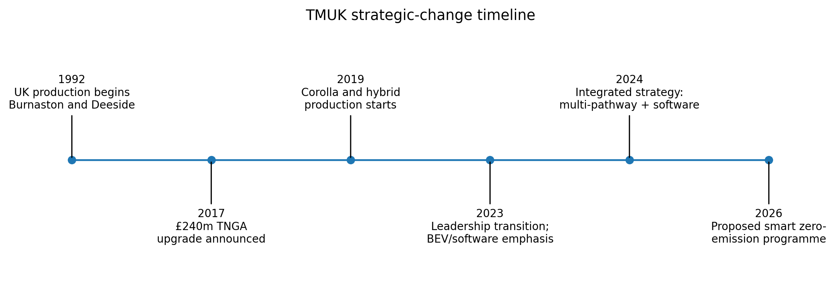
Figure 1. TMUK strategic-change timeline. Source: A synthesis from Toyota Motor Manufacturing UK (n.d.), Toyota Motor Europe (2017; 2019) and Toyota Motor Corporation (2024).

3. Strategic Environment Analysis

3.1 PESTEL analysis
The UK Vehicle Emissions Trading Scheme progressively requires manufacturers to sell a higher share of zero-emission cars, with penalties and trading flexibilities affecting portfolio economics; this creates political and legal exposure (UK Government, 2023). Battery sourcing is also a strategic issue because of post-Brexit rules of origin. Economic pressure arises from capital requirements, energy costs, interest rates and unpredictable residual value. Socially, customers value lower running costs and digital services, while charging, affordability and battery life remain concerns. These mixed preferences support Toyota’s multi-pathway logic but make communication more complex.
Technology is the strongest force. AI can help to enhance visual inspections, predictive maintenance and scheduling, and digital twins can simulate line changes without physically interrupting the system (Jones et al., 2020). However, AI relies on representative data, secure systems and human oversight. The environmental dimension extends beyond tailpipe emissions to battery materials, plant energy, logistics and end-of-life recovery. The International Energy Agency (2025) projects that electric-car uptake will continue to grow globally, indicating a long-term shift rather than a short-term trend. Figure 2 rates each factor using judgement based on the cited evidence rather than measured company data, and serves as a prioritisation tool.
Table 1. PESTEL evidence summary
Factor | Main TMUK implication | Assessment
Political/legal | ZEV mandate, trade rules and product-compliance exposure | High
Economic | Capital intensity, energy prices, finance costs and demand uncertainty | High
Social | Mixed charging, affordability and digital-service expectations | Medium-high
Technological | Batteries, AI, software, cyber and digital twins redefine capability | Very high
Environmental | Lifecycle emissions, energy, materials and circularity | Very high

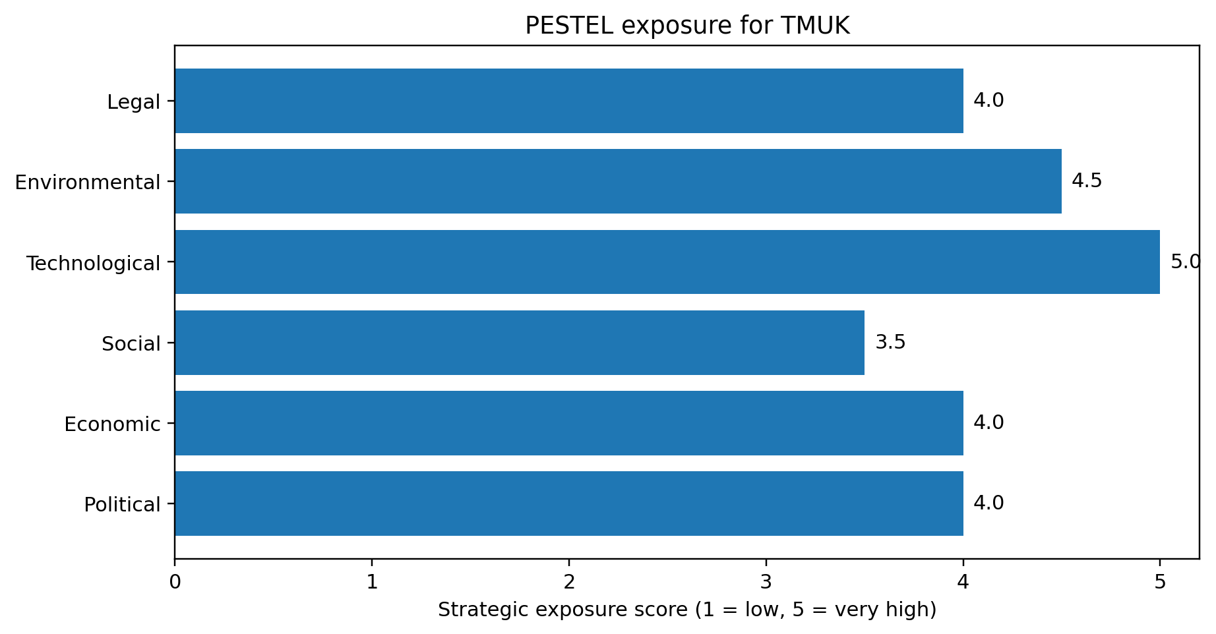
Figure 2. PESTEL exposure scores. Source: author’s judgement based on UK Government (2023), Toyota Motor Corporation (2024), SMMT (2024) and International Energy Agency (2025).

3.2 Porter’s Five Forces
Competition is intense, as Tesla and fast-growing Chinese manufacturers compete strongly on price, batteries, software features and model development speed. Supplier power is high for battery cells, critical minerals, semiconductors and specialist software, although Toyota’s scale gives it bargaining power. Buyer power is also strong because digital comparison and low switching costs in fleet purchasing and finance make it easy to change supplier. Although new entrants face major manufacturing and regulatory hurdles, some traditional barriers can be reduced through contract production, modular platforms and direct sales. Substitutes such as public transport, mobility services and used vehicles apply moderate pressure. Porter's framework explains industry structure, but it is relatively static and insufficiently considers the extent of collaboration with battery partners and governments, and so the scores in Figure 3 inform, rather than dictate, judgement (Porter, 2008).
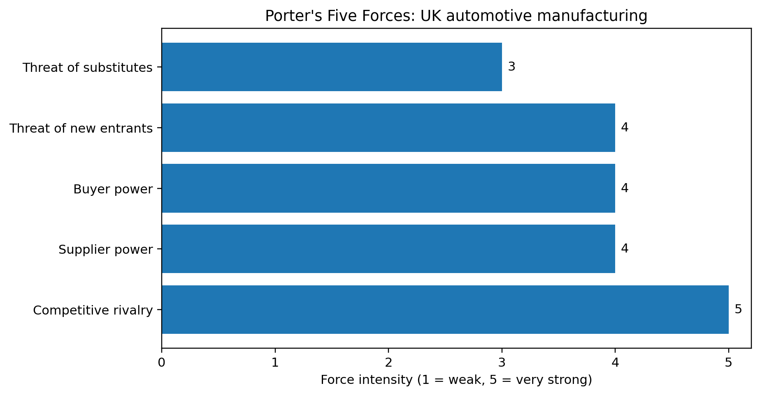
Figure 3. Porter force-intensity scores. Source: A judgement based on Porter (2008), SMMT (2024) and International Energy Agency (2025).

3.3 SWOT synthesis
Figure 4 combines internal and external evidence. Toyota's assets include the Toyota Production System, hybrid engineering, quality reputation and skills and resources all over the world. Weaknesses include limited UK battery-electric production, legacy data integration, slower software cycles and dependence on global product allocation. Opportunities include AI-driven operations, flexible zero-emission manufacturing, industry collaboration and circular battery models. Threats include aggressive EV pricing, battery supply exposure, cybersecurity threats and policy volatility. The synthesis shows a key strategic mismatch: TMUK has disciplined improvement routines, but future advantage depends on routines that span software, data and battery systems. Dynamic-capabilities theory proposes that sensing change is not enough; management must also seize opportunities and reconfigure the resource base (Teece, 2018).
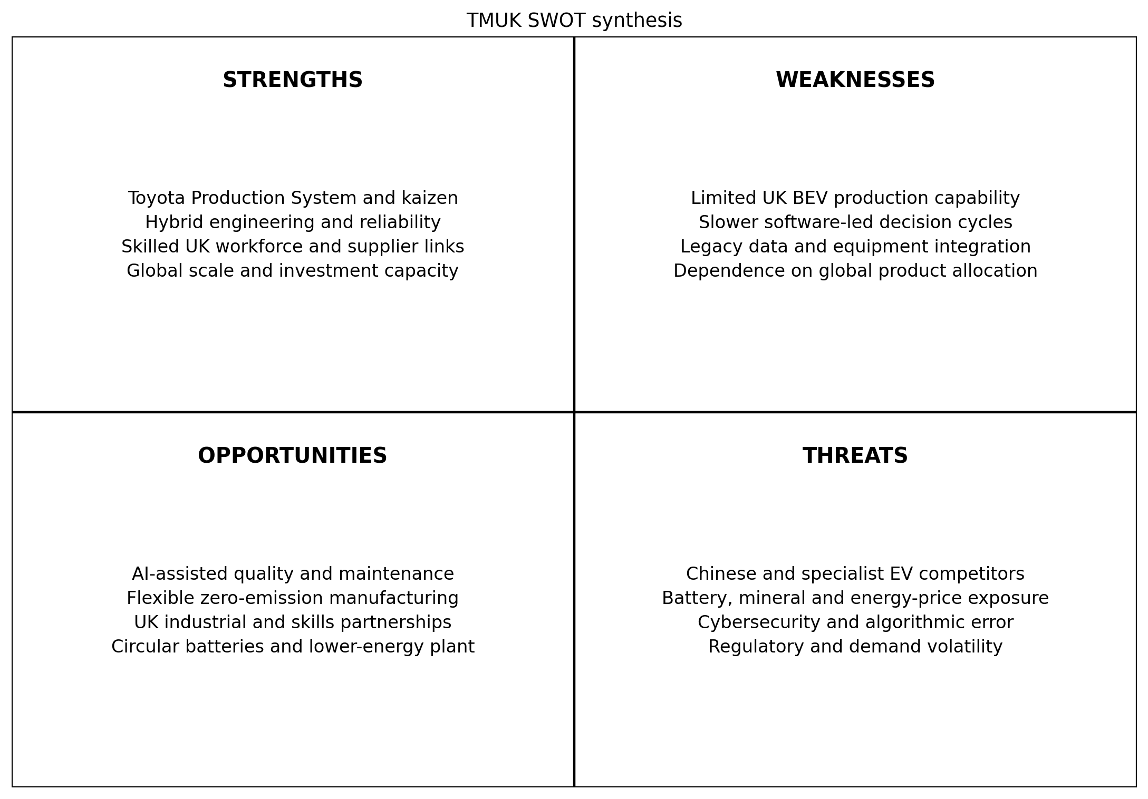
Figure 4. TMUK SWOT synthesis. Source: Personal analysis based on Toyota Motor Corporation (2024), Toyota Motor Manufacturing UK (n.d.) and International Energy Agency (2025).

4. Evaluation of Change Management and the 2017–2019 Case
The TNGA and Corolla transition provides a specific past change against which models can be tested. Applying Pettigrew’s model, the outer context comprised Brexit uncertainty, emissions regulation and global platform competition, and the inner context comprised Toyota's lean culture, UK skills and reliance on group product decisions. The content was the £240m plant conversion, TNGA capability, revised processes and hybrid Corolla allocation. The investment approval and engineering redesign took place in 2017, the training in 2018 and the commissioning and launch in 2019. Public evidence confirms a successful production start but says little about resistance, employee voice, disruption costs or benefit realisation. Distinguishing documented results from assumptions about internal experience is therefore a precondition for critical evaluation (Toyota Motor Europe, 2017; Toyota Motor Europe, 2019).
A major strength of Pettigrew’s model is its view that context, content and process interact rather than following a linear or universal sequence (Pettigrew, 1987). It explains why Toyota’s established culture can be both resource and constraint, and why the same technology may produce different outcomes in another plant. However, its main drawback is practical ambiguity: it identifies relationships but not tasks, ownership or employee readiness. It should therefore inform strategic sense-making and ongoing review in the proposed programme, supported by more structured implementation tools. This interaction is shown in Figure 5.
Lewin’s model would unfreeze existing assumptions using regulatory and competitor evidence, move through a pilot and reskilling phase, and finally refreeze successful practice into standard work. It is simple, which aids communication, and refreezing can mean the stabilisation of learning processes and not the permanent freezing of the organisation (Burnes, 2020b). However, a three-stage representation can hide politics and the overlapping releases typical of digital change. Kotter’s model would first establish urgency, then form a cross-functional guiding coalition, communicate a vision, break down obstacles, and deliver pilot successes and then the new behaviour (Kotter, 1995). It is powerful for mobilisation but can become top-down, which conflicts with Toyota’s employee-led problem-solving.
At the individual level, the ADKAR model assesses awareness, desire, knowledge, ability and reinforcement (Hiatt, 2006). For a Burnaston technician, Awareness concerns the business case, Desire concerns job security, Knowledge comes through data and high-voltage training, Ability is demonstrated safely on the line, and Reinforcement is through coaching and appraisal. This identifies sources of resistance more precisely than Kotter, but neglects market context and power. Accordingly, Pettigrew’s model is the most comprehensive for TMUK, with ADKAR for people, Kotter for coalition and communication, and a Plan-Do-Check-Act process for experiments. This hybrid avoids pretending that one model can address every level of change (Burnes, 2020a; Cameron and Green, 2020).
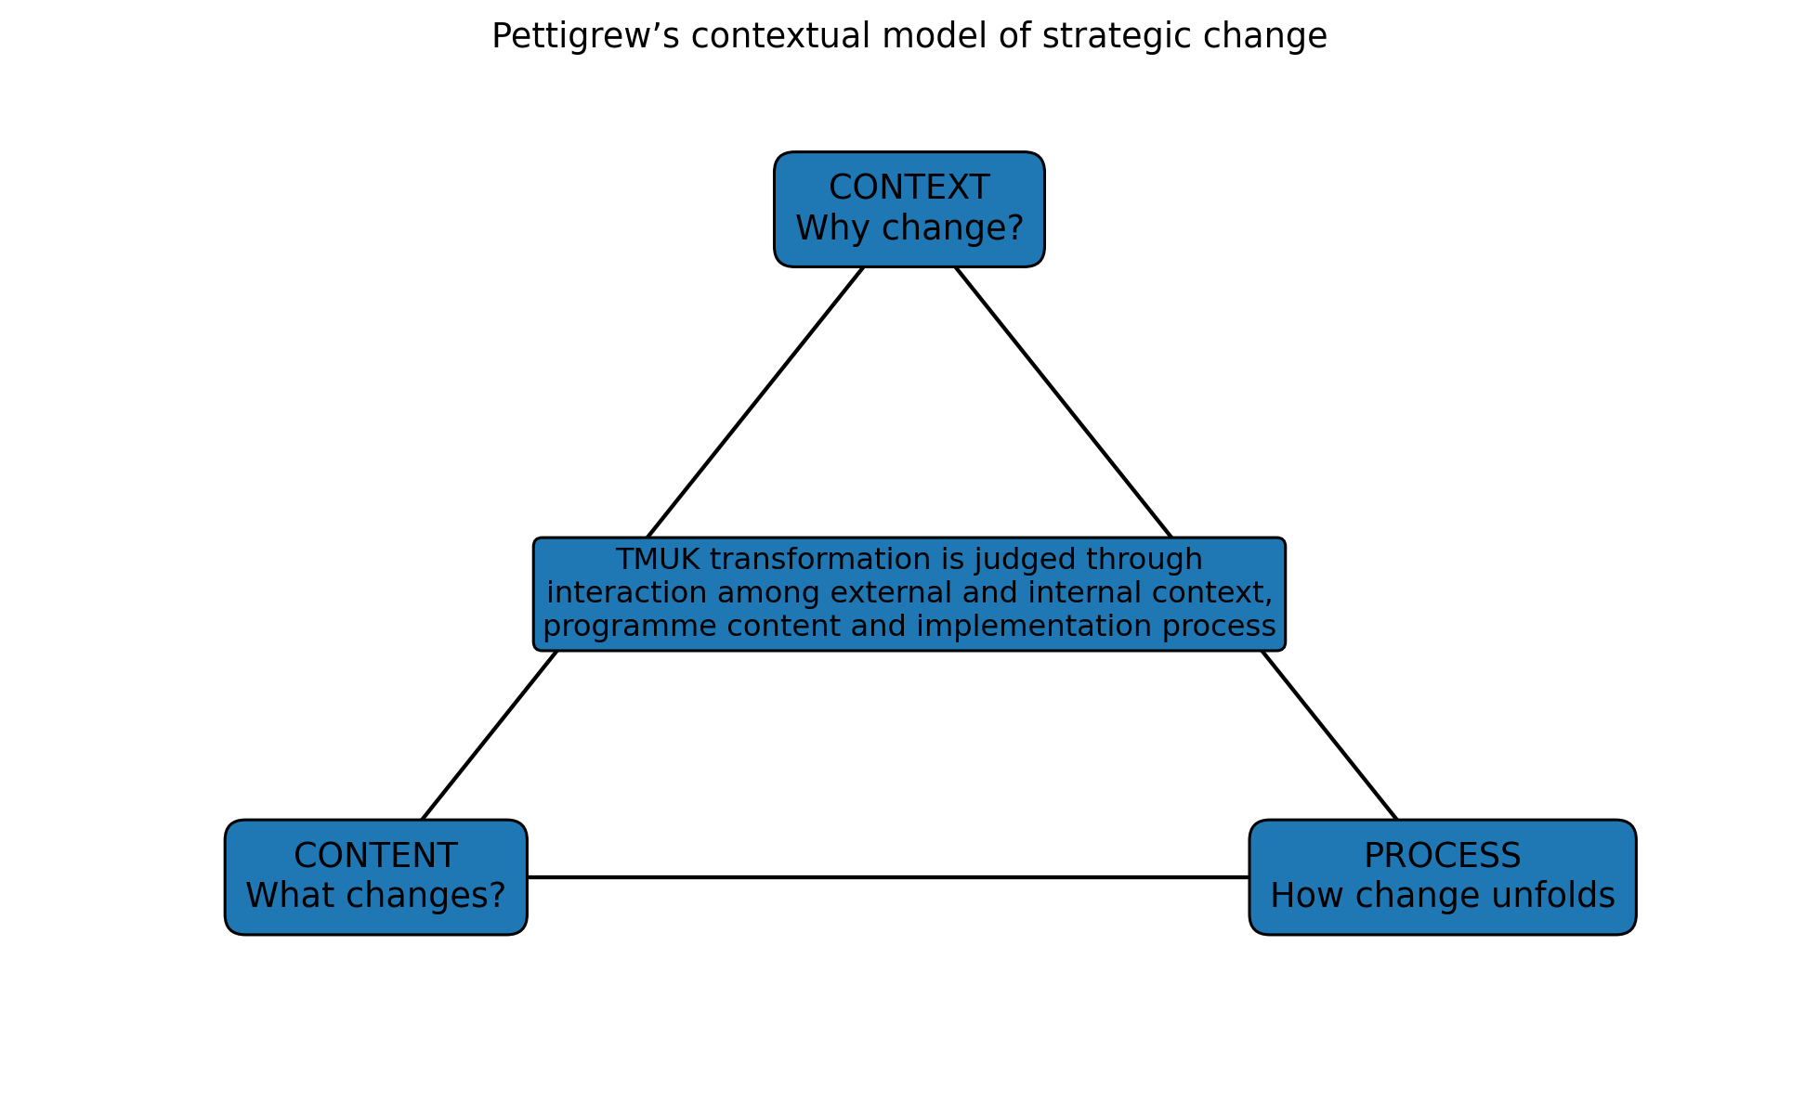
Figure 5. Pettigrew’s contextual model applied to TMUK. Source: adapted from Pettigrew (1987).
Table 2. Critical comparison of change models
Model | Direct TMUK application | Strength | Limitation
Pettigrew | Reassess regulatory and cultural context, programme content and implementation process at each gate | Explains interaction and historical path dependence | Diagnostic; offers no prescribed sequence
Lewin | Unfreeze assumptions, pilot new work, stabilise approved routines | Clear and compatible with standard work | Three stages can oversimplify continuous digital change
Kotter | Create urgency, coalition, vision, pilot wins and cultural embedding | Strong mobilisation and senior alignment | Can become linear and top-down
ADKAR | Test awareness, desire, knowledge, ability and reinforcement by role | Diagnoses individual readiness and resistance | Underplays market context, structure and power

5. Leadership and Organisational Culture
The leadership of the TNGA transition appears to have been mostly transformational. TMUK’s Managing Director, Marvin Cooke, described the new Corolla as “a real sign of confidence in the capabilities of our workforce” (Toyota UK, 2019), and £21.3m of the investment was directed towards training, research and environmental measures. Investing in employees’ skills in this way reflects the transformational focus on developing followers and building trust (Northouse, 2021; Busari et al., 2020).
However, the decision itself was made at group level in Japan and Europe, with TMUK responsible for implementation. This had advantages and disadvantages. On one hand, it secured new model production and investment for the UK plants. On the other, it suggests that UK employees and managers had limited influence over the direction of change, which is closer to a top-down approach.
Finally, the public evidence contains little about employees’ views, even though they were the people who had to deliver the change on the production line. This is a significant gap, because without their perspective it is difficult to judge how far the change was accepted rather than simply complied with.
Leadership should combine transformational direction with lean participation. Transformational leadership can explain why zero-emission and digital capability secure the long-term future of UK production, intellectually challenge assumptions and link individual learning to collective purpose (Northouse, 2021). Transformational leadership has been associated with positive employee responses to change, influenced by trust and followership (Busari et al., 2020). However, inspiration alone is not enough. Leaders need to practise genchi genbutsu (going to see the process), welcome challenge from operators and treat abnormal AI output as a problem to investigate rather than a reason to blame.
Ambidextrous leadership is also crucial. Current Corolla manufacturing requires reliability, standardisation and uncompromising safety, while digital pilots need fast feedback and tolerance of contained failure. Separate governance for pilots can protect production discipline. Toyota’s culture helps by supporting learning, problem visibility, kaizen, jidoka and respect for people (Liker, 2021). However, a successful history may create an underlying assumption that incremental improvement from within is always safer than partnership or fast reallocation from the outside.
This tension can be seen by applying Schein’s model in Figure 6. Andon boards, standard work, team huddles and visual controls are examples of artefacts. Espoused values include continuous improvement, customer-first quality and respect for people. Underlying assumptions include the beliefs that quality is the responsibility of everyone, problems need to be brought to the fore and long-term capability is important. These assumptions can support the programme if AI is framed as enhancing judgement and revealing problems. Culture becomes a barrier when standardisation is treated as a reason to reject experimentation, or when respect is expressed without involving the people whose jobs are being redesigned (Schein and Schein, 2017). Leaders should keep the principles but adapt how they are applied.
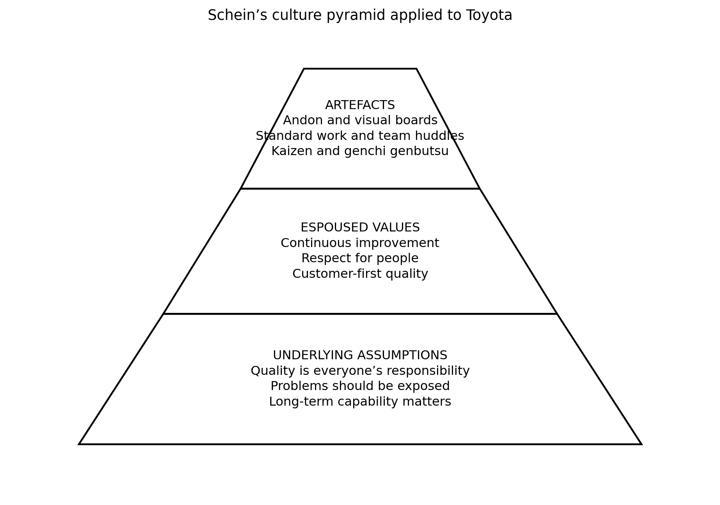
Figure 6. Schein’s culture pyramid applied to Toyota. Source: adapted from Schein and Schein (2017), with Toyota examples informed by Liker (2021).

6. Proposed Smart Zero-Emission Manufacturing Transformation Programme

6.1 Scope, objectives and governance
The programme aims to enhance existing operations and to strengthen TMUK’s ability to flex towards producing next-generation electrified vehicles. It encompasses modular production equipment, AI-driven visual inspection, predictive maintenance, digital twins, secure plant data, energy management, as well as high-voltage skills and supplier traceability. AI should make initial recommendations or flag decisions, while decision authority remains with accountable employees. This augmentation approach addresses the "automation–augmentation paradox" identified by Raisch and Krakowski (2021).
The steering committee should be chaired by the TMUK managing director, be accountable to the board, and include employee representatives, finance, HR, procurement, IT, engineering, cybersecurity and Toyota Motor Europe. A programme director is responsible for delivery; plant workstream leaders take responsibility for benefits; finance verifies savings independently; and safety or data concerns can halt deployment. The objectives in Table 3 are deliberately conditional because they depend on the baseline established in months 1–3. This prevents attractive percentages from being treated as evidence before they are measured.
Table 3. Programme objectives
Objective | Measure and target | Deadline
Reliability | Reduce pilot-process unplanned downtime by 20% from verified baseline | Month 24
Quality | Reduce selected repeat defects by 15% without weakening inspection | Month 24
Energy | Reduce energy per vehicle by 20% from baseline | Month 36
Capability | 90% of affected employees pass role-specific digital/high-voltage assessment | Month 30
Adoption | 85% competent regular use among approved-system users | 18 months after release
Resilience | Map critical tier-one and selected tier-two battery/electronics dependencies | Month 12
Governance | Complete safety, privacy, cyber and algorithmic assurance before go-live | Every release

6.2 Implementation approach
There are six overlapping stages of implementation as shown in Figure 7. Mobilisation sets up baseline levels, data ownership, skills and supplier loading. The design stage selects a pilot process where faults and downtime occur often enough to measure improvement, but where trials will not compromise vehicle safety. The pilot integrates two technologies: predictive maintenance and computer vision, with operators helping to label data and define escalation rules. Evaluation compares results with a similar untreated process where possible. Scaling takes place only when technical, safety, adoption and financial requirements are met. The final stage embeds approved methods into standard work, with training, audits and continued quarterly review. Digital twins can lower the cost of physical trials, but they need to be validated with the real process behaviour (Jones et al., 2020).
Deployment is incremental, but direction is strategic. A big-bang installation would expose production, cyber and employee risks simultaneously. Conversely, endless pilots would become ‘innovation theatre’ with no capability transfer. Stage gates therefore require a decision to STOP, ADAPT or SCALE. At the end of months 6, 18 and 30, Pettigrew-based reviews reassess context, content and process, making allowances for changes in regulation, products and battery partnerships that may occur during the programme.
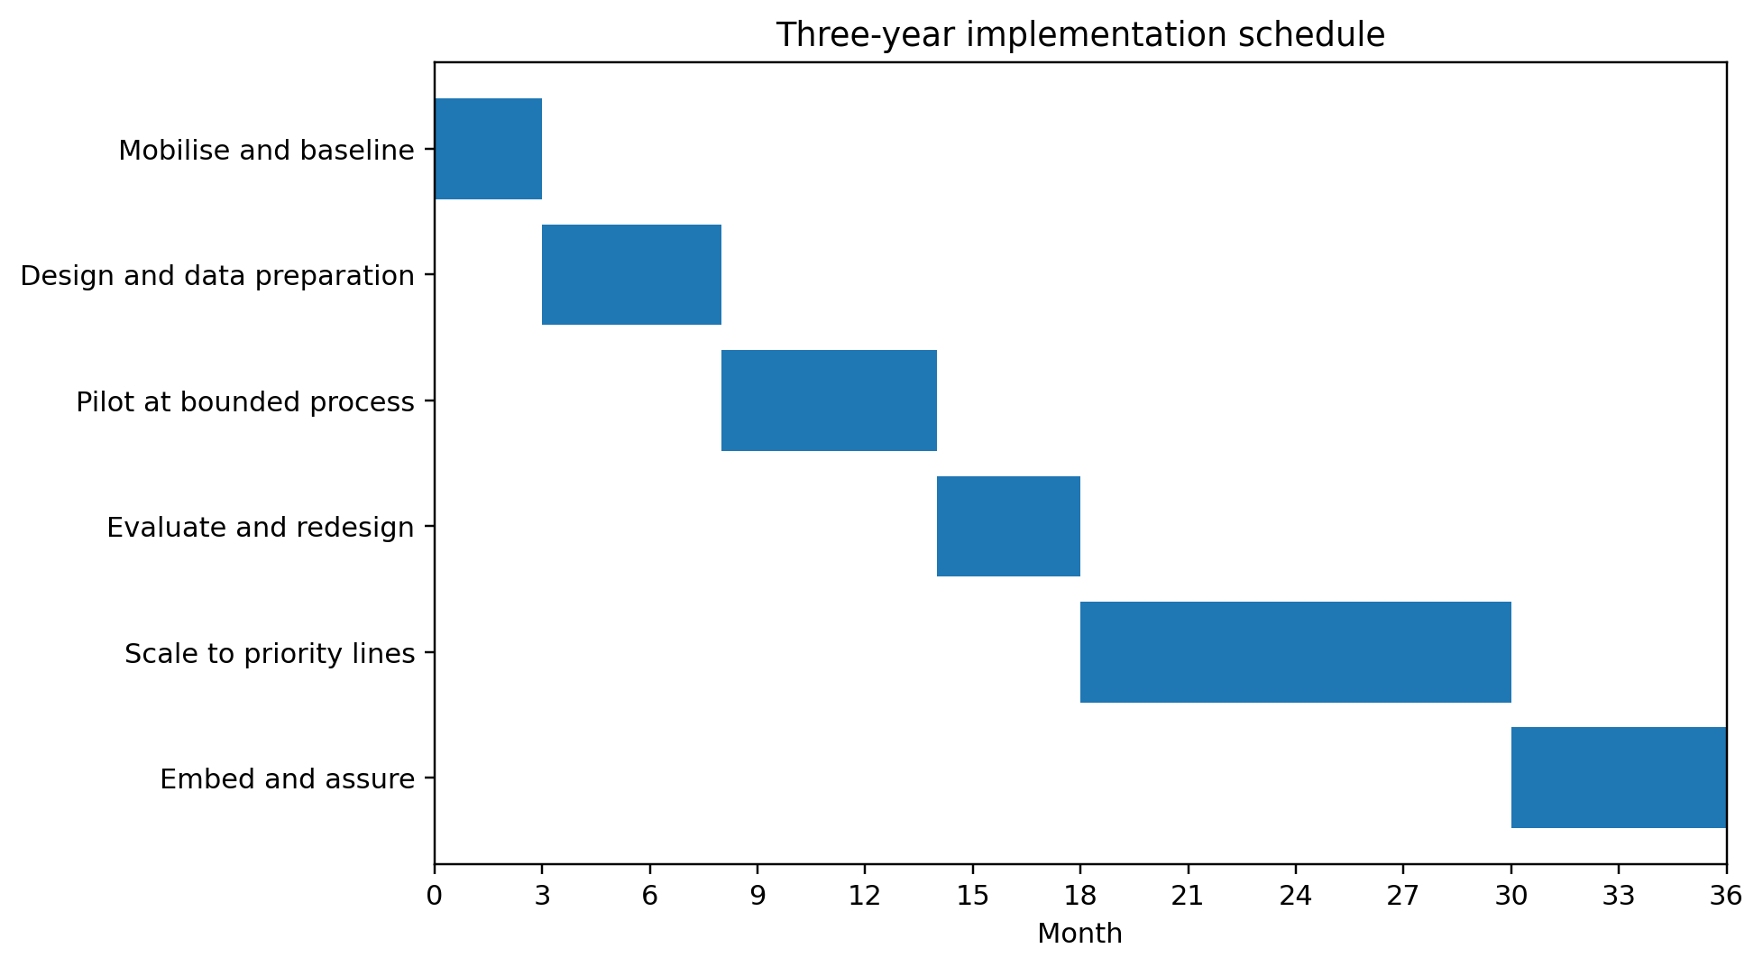
Figure 7. Proposed three-year implementation schedule.

6.3 Financial plan and business case
The indicative capital requirement is £275 million: £120m flexible production and EV equipment; £42m sensors, AI, digital twins and data architecture; £28m energy measures; £18m training; £14m cybersecurity and data governance; £18m supplier development; £10m programme assurance; and £25m contingency. Funding is proposed from Toyota capital expenditure, asset or green finance, competitive UK support schemes and supplier contributions, but none of these is assumed until approved.
Expenditure is shown separately from the resulting net cash flows, which are discounted at an assumed corporate hurdle rate of 8 per cent, as is common practice (Atrill and McLaney, 2022). Benefits from avoided downtime, fewer defects, energy savings, inventory optimisation and redeployed capacity rise from £10m in year one to £90m a year in years six and seven. The base case results in NPV of £59.1m and simple payback in 5.1 years. A conservative case (costs 10% higher, benefits 20% lower) gives an NPV of minus £27.7 million, while an optimistic case gives an NPV of £118.0 million. Figure 8 and Table 5 show that approval must be conditional, not automatic. The model should be updated at every gate using actual pilot data, and no employment savings should be counted as a benefit unless there is an agreement on a workforce plan.
Table 4. Indicative investment allocation
Category | £m
Flexible production and electrified-vehicle equipment | 120
AI, sensors, digital twins and data architecture | 42
Energy and environmental measures | 28
Training and change support | 18
Cybersecurity and data governance | 14
Supplier development and integration | 18
Programme management and assurance | 10
Contingency | 25
Total | 275

Table 5. Seven-year sensitivity analysis at 8% discount rate
Scenario | Cost/benefit assumption | NPV (£m) | Simple payback
Conservative | Costs +10%; benefits -20% | -27.7 | 6.3 years
Base | Planned costs and benefits | 59.1 | 5.1 years
Optimistic | Costs -5%; benefits +15% | 118.0 | 4.6 years

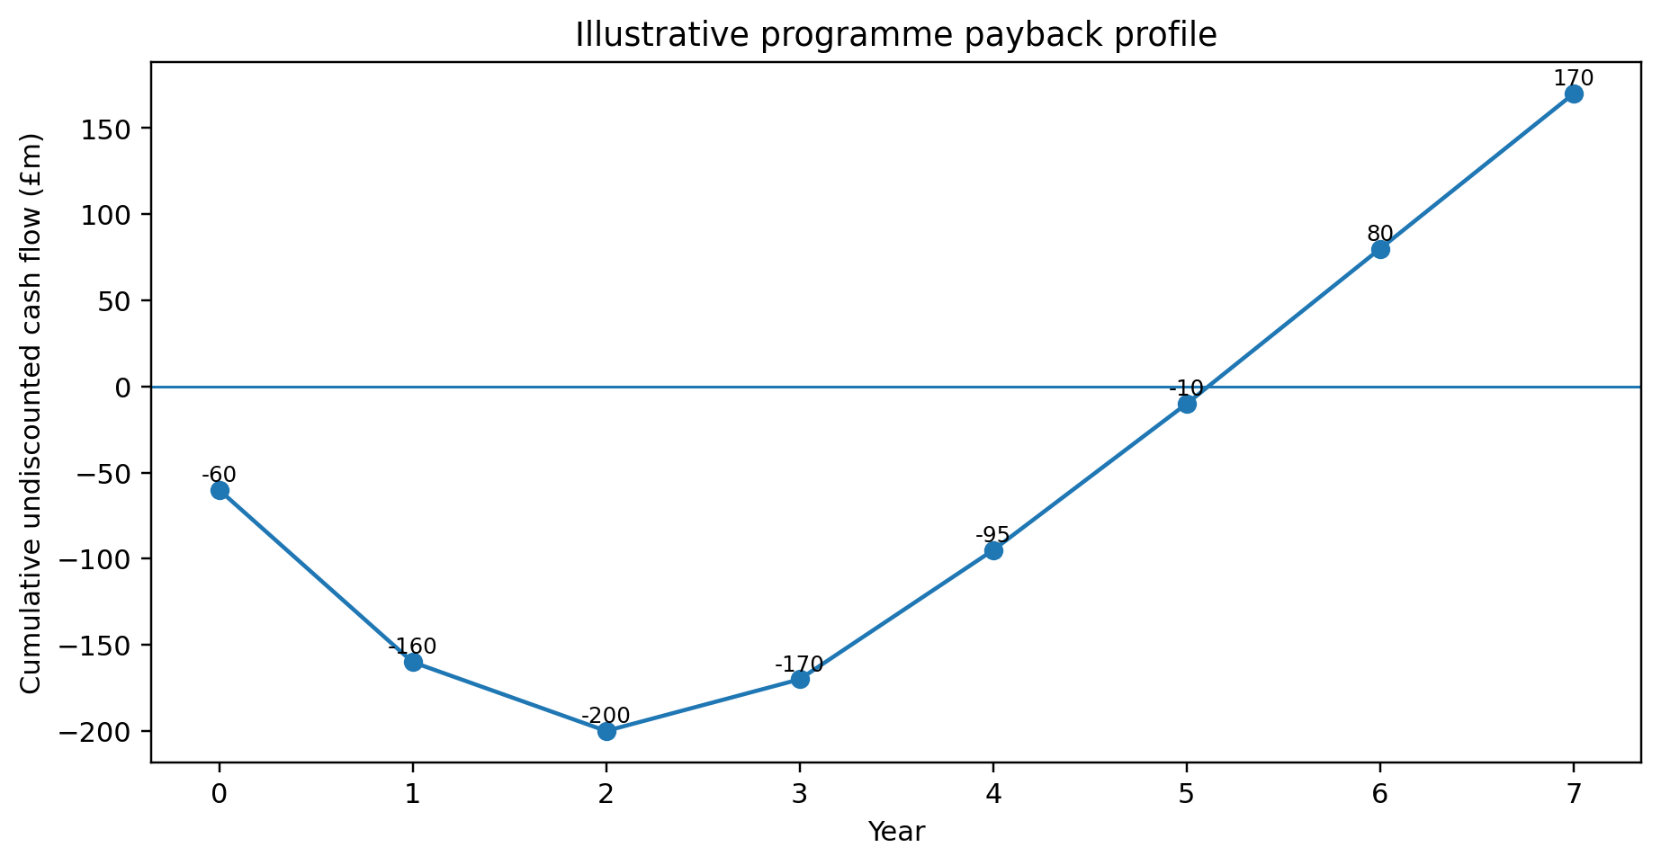
Figure 8. Illustrative cumulative cash-flow profile. Source: calculations using Table 5 assumptions and the NPV method described by Atrill and McLaney (2022).

6.4 Communication, workforce and suppliers
Communication should foster dialogue rather than announce pre-made decisions. Monthly plant forums, paid learning time, team demonstrations and anonymous pulse surveys are provided to employees and unions. Responses are owned by HR and the change lead: unresolved job-design issues are escalated to the steering committee within 10 working days, and safety or privacy concerns within 24 hours. Using ADKAR conversations, supervisors identify whether hesitation stems from a gap in Awareness, Desire, Knowledge, Ability or Reinforcement. Oreg et al. (2018) found that recipients respond not only to the change itself but also to how it is handled, highlighting the importance of procedural fairness for acceptance.
Suppliers receive quarterly readiness reviews, shared data and targeted technical support. Procurement must not push all transition costs downstream, because weak suppliers undermine Toyota’s own resilience (Ivanov and Dolgui, 2020). Six-monthly reports are sent to government and local stakeholders on investment, skills and environmental outcomes. Dealers and customers are briefed together, and only once claims about quality, emissions or digital services have been substantiated by third-party evidence. Table 6 identifies the accountable owner for each stakeholder group, together with feedback and escalation measures.
Table 6. Communication and escalation plan
Stakeholder | Responsible owner | Channel and frequency | Feedback/escalation
Employees/unions | HR and change lead | Monthly forum; team demonstrations; pulse survey | Reply within 10 days; safety/privacy within 24 hours
Board/TME | Programme director and CFO | Monthly dashboard; quarterly stage gate | Variance above tolerance triggers reforecast or stop
Suppliers | Procurement director | Quarterly readiness review and technical clinic | Critical failure escalates to resilience workstream
Government/community | Managing director | Six-monthly skills, investment and environment report | Material concern logged and answered publicly
Dealers/customers | Commercial lead | Evidence-based briefing before launch | Quality or privacy complaint enters formal incident process

6.5 Risk and evaluation
The main risks include production disruption, cost overruns, inaccurate data, algorithmic error, cybersecurity threats, skills gaps, vendor failure, technology obsolescence and employee mistrust. Examples of controls are isolated test beds, human approval for safety critical decisions, representative datasets for validation, access control, incident exercises and contractual supplier requirements. The NIST AI Risk Management Framework supports AI governance by mapping, measuring and managing risk throughout the system lifecycle (National Institute of Standards and Technology, 2023). A live risk register records each risk’s owner, probability, impact, early-warning indicator and residual exposure; any red-rated safety or cyber risk automatically pauses deployment.
Evaluation uses financial, operational, workforce, environmental and governance measures. Finance and internal audit (IA) analyse results against the verified baseline and, as far as possible, a control process, at 3, 6, 12 and 24 months after each release. The core indicators are unplanned downtime, first-time quality, repeat defects, energy per vehicle, training competence, employee trust, supplier traceability, model precision and recall, cyber incidents, realised cash benefit and forecast NPV. Benefits count only where a named owner, a measurement method and a counterfactual are documented. This prevents normal production variation from being attributed to the technology and frames evaluation as organisational learning rather than post hoc rationalisation of the programme (Cameron and Green, 2020).
Table 7. Evaluation scorecard
Dimension | Key indicators | Decision rule
Financial | Spend, realised benefit, NPV and payback forecast | Reforecast at every gate
Operational | Downtime, throughput, first-time quality, repeat defects | Scale only after sustained improvement
Workforce | Competence, adoption, engagement, safety and redeployment | No scale with unresolved critical capability gap
Environmental | Energy per vehicle, waste and operational emissions | Verify against metered baseline
Digital governance | Accuracy, drift, data quality, privacy and cyber incidents | Pause on red-rated residual risk

7. Conclusion and Professional Reflection
TMUK’s lean system, hybrid expertise and financial backing provide a solid platform, but strategic renewal is essential. As the PESTEL, Five Forces and SWOT analyses show, regulation, battery-electric competition, software, AI and supply dependency are shifting the economics of products and production. The TNGA/Corolla transition during 2017-2019 illustrates Toyota’s capacity to invest in and introduce complex change, but also shows the limits of public evidence of employee experience and real benefits. Pettigrew's model is most suitable as it maintains the linkage between context, content and process, while Kotter, ADKAR and PDCA add implementation discipline.
The programme should treat the £275m business case as an assumption to be tested. Lean participation, clear governance and protection of employee voice must go hand-in-hand with transformational direction.
Using Gibbs’ (1988) reflective cycle, the most challenging part of this module was researching the organisation and bringing the evidence together into one coherent plan. At first, I found it difficult to judge which sources were reliable, as much of the information about TMUK came from news articles and websites of varying quality. Relying on peer-reviewed journal articles and official company reports helped me build arguments on stronger evidence and to recognise where public information was incomplete. The clearest example was the lack of evidence about employees’ views of the 2017–2019 change. This taught me that the people who carry out change are often the least heard, even though its success depends on them. In my future workplace practice, I will therefore listen to the staff who do the work before proposing changes to how they work, and use their feedback to shape the plan rather than treating it as an afterthought.

Reference List
Atrill, P. and McLaney, E. (2022) Accounting and Finance for Non-Specialists. 12th edn. Harlow: Pearson.
Burnes, B. (2020a) Managing Change. 8th edn. Harlow: Pearson.
Burnes, B. (2020b) ‘The origins of Lewin’s three-step model of change’, The Journal of Applied Behavioral Science, 56(1), pp. 32–59. Available at: https://doi.org/10.1177/0021886319892685.
Busari, A.H., Khan, S.N., Abdullah, S.M. and Mughal, Y.H. (2020) ‘Transformational leadership style, followership, and factors of employees’ reactions towards organizational change’, Journal of Asia Business Studies, 14(2), pp. 181–209. Available at: https://doi.org/10.1108/JABS-03-2018-0083.
Cameron, E. and Green, M. (2020) Making Sense of Change Management. 5th edn. London: Kogan Page.
Gibbs, G. (1988) Learning by Doing: A Guide to Teaching and Learning Methods. Oxford: Further Education Unit, Oxford Polytechnic.
Gong, C. and Ribiere, V. (2021) ‘Developing a unified definition of digital transformation’, Technovation, 102, article 102217. Available at: https://doi.org/10.1016/j.technovation.2020.102217.
Hanelt, A., Bohnsack, R., Marz, D. and Antunes Marante, C. (2021) ‘A systematic review of the literature on digital transformation: insights and implications for strategy and organizational change’, Journal of Management Studies, 58(5), pp. 1159–1197. Available at: https://doi.org/10.1111/joms.12639.
Hiatt, J. (2006) ADKAR: A Model for Change in Business, Government and Our Community. Loveland, CO: Prosci Learning Center Publications.
International Energy Agency (2025) Global EV Outlook 2025. Paris: International Energy Agency. Available at: https://www.iea.org/reports/global-ev-outlook-2025 (Accessed: 4 August 2026).
Isenstadt, A. and Slowik, P. (2025) Hybrid Vehicle Technology Developments and Opportunities in the 2025–2035 Time Frame. Washington, DC: International Council on Clean Transportation. Available at: https://theicct.org/wp-content/uploads/2025/02/ID-292-%E2%80%93-Hybrid-techology_paper_final.pdf (Accessed: 4 August 2026).
Ivanov, D. and Dolgui, A. (2020) ‘Viability of intertwined supply networks: extending the supply chain resilience angles towards survivability’, International Journal of Production Research, 58(10), pp. 2904–2915. Available at: https://doi.org/10.1080/00207543.2020.1750727.
Jones, D., Snider, C., Nassehi, A., Yon, J. and Hicks, B. (2020) ‘Characterising the digital twin: a systematic literature review’, CIRP Journal of Manufacturing Science and Technology, 29, pp. 36–52. Available at: https://doi.org/10.1016/j.cirpj.2020.02.002.
Kotter, J.P. (1995) ‘Leading change: why transformation efforts fail’, Harvard Business Review, 73(2), pp. 59–67. Available at: https://hbr.org/1995/05/leading-change-why-transformation-efforts-fail-2 (Accessed: 4 August 2026).
Liker, J.K. (2021) The Toyota Way: 14 Management Principles from the World’s Greatest Manufacturer. 2nd edn. New York: McGraw Hill.
National Institute of Standards and Technology (2023) Artificial Intelligence Risk Management Framework (AI RMF 1.0). NIST AI 100-1. Gaithersburg, MD: National Institute of Standards and Technology. Available at: https://doi.org/10.6028/NIST.AI.100-1.
Northouse, P.G. (2021) Leadership: Theory and Practice. 9th edn. Thousand Oaks, CA: SAGE.
Oreg, S., Bartunek, J.M., Lee, G. and Do, B. (2018) ‘An affect-based model of recipients’ responses to organizational change events’, Academy of Management Review, 43(1), pp. 65–86. Available at: https://doi.org/10.5465/amr.2014.0335.
Pettigrew, A.M. (1987) ‘Context and action in the transformation of the firm’, Journal of Management Studies, 24(6), pp. 649–670. Available at: https://doi.org/10.1111/j.1467-6486.1987.tb00467.x.
Porter, M.E. (2008) ‘The five competitive forces that shape strategy’, Harvard Business Review, 86(1), pp. 78–93. Available at: https://hbr.org/2008/01/the-five-competitive-forces-that-shape-strategy (Accessed: 4 August 2026).
Raisch, S. and Krakowski, S. (2021) ‘Artificial intelligence and management: the automation–augmentation paradox’, Academy of Management Review, 46(1), pp. 192–210. Available at: https://doi.org/10.5465/amr.2018.0072.
Schein, E.H. and Schein, P.A. (2017) Organizational Culture and Leadership. 5th edn. Hoboken, NJ: Wiley.
Society of Motor Manufacturers and Traders (2024) Motor Industry Facts 2024. London: Society of Motor Manufacturers and Traders. Available at: https://www.smmt.co.uk/reports/smmt-motor-industry-facts-2024/ (Accessed: 4 August 2026).
Teece, D.J. (2018) ‘Business models and dynamic capabilities’, Long Range Planning, 51(1), pp. 40–49. Available at: https://doi.org/10.1016/j.lrp.2017.06.007.
Toyota Manufacturing UK (2017) Toyota Manufacturing UK celebrates 25th anniversary of manufacturing at Burnaston site. Available at: https://www.toyotauk.com/toyota-in-the-uk/news/toyota-manufacturing-uk-celebrates-25th-anniversary-of-manufacturing-at-burnaston-site (Accessed: 27 September 2026).
Toyota Manufacturing UK (2025) TMUK key figures summary 2025. Available at: https://www.derbyshire.gov.uk/site-elements/documents/pdf/community/twinning/toyota-city/external-key-figures-summary-slide-2025.pdf (Accessed: 27 September 2026).
Toyota Motor Corporation (2024) Integrated Report 2024. Toyota City: Toyota Motor Corporation. Available at: https://global.toyota/en/ir/library/annual/ (Accessed: 4 August 2026).
Toyota Motor Europe (2017) ‘Toyota invests GBP 240 million to upgrade its UK plant’, 16 March. Available at: https://newsroom.toyota.eu/toyota-invests-gbp240-million-to-upgrade-its-uk-plant/ (Accessed: 4 August 2026).
Toyota Motor Europe (2019) ‘Toyota starts production of all-new Corolla in UK’, 14 January. Available at: https://newsroom.toyota.eu/toyota-starts-production-of-all-new-corolla-in-uk/ (Accessed: 4 August 2026).
Toyota Motor Manufacturing UK (n.d.) Toyota Manufacturing UK. Available at: https://www.toyotauk.com/ (Accessed: 4 August 2026).
Toyota UK (2019) Toyota celebrates the start of new Corolla vehicle production at Toyota Manufacturing UK, 14 January. Available at: https://media.toyota.co.uk/toyota-celebrates-the-start-of-new-corolla-vehicle-production-at-toyota-manufacturing-uk/ (Accessed: 27 September 2026).
UK Government (2023) The Vehicle Emissions Trading Schemes Order 2023, SI 2023/1394. Available at: https://www.legislation.gov.uk/uksi/2023/1394/contents/made (Accessed: 4 August 2026).
Warner, K.S.R. and Wäger, M. (2019) ‘Building dynamic capabilities for digital transformation: an ongoing process of strategic renewal’, Long Range Planning, 52(3), pp. 326–349. Available at: https://doi.org/10.1016/j.lrp.2018.12.001.

