

School of Engineering
Motorsport Engineering BEng

Material Selection Report
Engineering Design and Materials ACHA4001

Catriona Burn
2203239
April 2024
Contents
1 Introduction 1
2 Component Design Specification 2
3 Material Selection 3
3.1 4340 Steel 3
3.2 Titanium 3
3.3 Aluminium 2024 T3 4
3.4 Oil tempered Chromium Silicone 4
4 Manufacturing Process Selection 5
4.1 Cold drawn 5
4.2 Oil tempering 5
4.3 CNC Spring Coiling Machine 5
5 Conclusion 6
6 References 7

[Figure 1] Different valve springs (Peterson Spring, 2024) 2
[Figure 2] Rocker arms from a V8 (Midwestern Garage, 2020) 2
[Table 1] Materials data (Hemanth, 2021) 3
[Figure 3] Engineering stress-strain curve of OT wire. 5
[Figure 4] AIM 4000 CNC Spring Coiling Machine. (Automated Industrial Motion, 2015) 5

Introduction
In the pursuit of efficiency, durability and high performance in internal combustion engines, the selection of materials and manufacturing processes of parts is a super critical part of automotive engineering. This technical report aims to explore these critical processes for valve springs, specifically in a V8, as they play such a pivotal role in the function of the engine. By delving into properties of materials such as steel alloys, titanium and aluminium and looking at Youngs modulus values, as well as manufacturing process evaluation and economic analysis of each step, the aim is to explore the most efficient and cost effective materials and ways of manufacturing.

Component Design Specification
Understanding of valve spring functionality is critical for the manufacturing process, which is why the first step is to create a design specification. This specification should state everything the part needs to do, what temperatures and forces the part will be under and any other design features necessary.
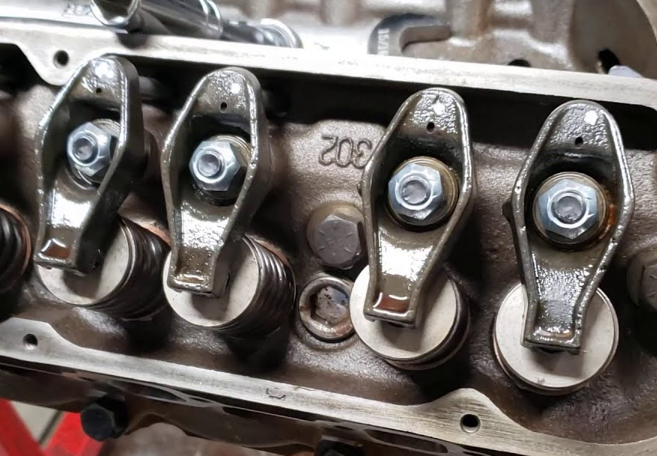
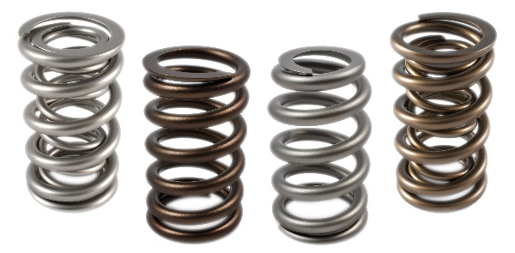
The job of the valve spring is to open and close the valve at the correct point, it does this when compressed directly through the camshaft, or by rocker arms that are pushed by the camshaft. Rocker arms (shown in Figure 2) have a push rod or lifter pushing on one end and the other end sits on the tip of the valve. On a V8 the camshaft is often situated below the push rod, parallel to the valve, and as the camshaft rotates, the push rod lifts up and down moving the rocker arm. The rocker arm compresses the spring which in turn moves the valve to open and close.
[Figure 1] Different valve springs (Peterson Spring, 2024)

The design of the valve spring should specify its ability to compress while also ensuring rapid return to original shape, effectively mitigating valve float at higher engine speeds. This implies the need for a higher spring rate, with the required rate increasing proportionally with the vehicles maximum rpm. On some high performance engines that rev up to 15 or 18 thousand rpm, double or even triple valve springs are used. This elevates the spring rate to a level higher than that on a single spring configuration. On a V8 engine at max rpm of around 7500, the springs must hold sufficient strength to endure forces in the vicinity of 140psi when the valves are closed, and approximately 400psi when open. Therefore the spring rate needed would be higher than on a daily use road car than only revs to 5 or 6 thousand rpm because a small 2.0L or less engine would not reach those pressures. As most engines are expected to last for at least 100,000 miles, these springs also need to be durable enough to last and to be compressed and decompressed constantly for long periods of time.
[Figure 2] Rocker arms from a V8 (Midwestern Garage, 2020)

Material Selection
When deciding which material is best, the material properties need to be considered. The table below shows different properties that are important for a valve spring.
[Table 1] Materials data (Hemanth, 2021)

Material | Density (kg/m³) | Youngs modulus  (Pa) | Ultimate Tensile Strength (Pa)
4340 Steel | 7850 | 2.0x10¹¹ | 1100x10⁶
Ti-6Al-4V Titanium | 4428 | 11.9x10¹⁰ | 950x10⁶
Aluminium 2024 T3 | 2770 | 7.31x10¹⁰ | 4.30x10⁸
Silicone Chrome alloy | 7944 | 2.07x10¹¹ | 3.20x10⁸

4340 Steel
4340 Steel is a medium carbon steel. It has 0.37-0.43% carbon content as well as 1.8% nickel and 0.7-0.9% chromium (MatWebInc, 2019). Carbon content in steel gives it properties of strength and hardness and makes it more resistant to wear and makes it better at holding shape. This is ideal for a valve spring as it needs to return to shape quickly. Chromium helps protect from corrosion, although in this case it isn’t a necessity for the part as the spring is not likely to corrode as it is oil coated.
This material is a very good option for valve springs. It has a high density which will keep the strength when the spring is compressed, and the carbon content adds stronger properties that other metals have.

Titanium
Ti-6Al-4V is a grade 5 titanium alloy containing 6% aluminium and 4% Vanadium (MatWebInc, 2019b). Aluminium strengthens and increases the melting point of the alloy to over 300℃, while also reducing the density. Vanadium forms a layer on the material which protects against oxidation. Ti-6Al-4V is one of the most widely used high strength titanium alloys because of its high strength to density ratio. It is ideal for some automotive parts such as fuel tanks, exhaust pipes, connecting rods, and even valves or collets, but valve springs are better with higher density and stronger material, such as steel. This is because although titanium has a high strength, it is very expensive for a part that would need to be mass manufactured, and it has a high mass, adding unnecessary weight to the engine when a lighter and cheaper option is available.

Aluminium 2024 T3
Aluminium 2024 T3 contains small amounts of chromium, copper and magnesium. Copper adds an increase in strength and hardening, but can also reduce corrosion resistance. Magnesium also gives properties of strength and increased corrosion resistance, counteracting the copper. The best property of aluminium is its super low density. It is most commonly used for crank cases, or cylinder blocks, as well as pistons and engine heads. This is because it is not as strong as steel or iron so performs better under low stress.
Aluminium is not the ideal material for a valve spring because it is not strong enough to withstand the forces it would experience. It is also a very soft material, easy to bend and distort, this is not a good property for a valve spring as it would not keep its shape. As well as this, aluminium is more expensive than materials such as steel or iron and would not be a cost effective way of manufacturing valve springs.

Oil tempered Chromium Silicone
Oil tempered Chromium Silicone is a steel alloy. It has a carbon content of 0.50-0.59%, but is mostly Steel. It has high strength, high heat resistance and high fatigue resistance and is used for shock loads (IZUMIDA, MATSUMOTO and MURAI, 2016). Chromium Silicone is either cold drawn or oil-tempered, but oil tempered wire has better durability and is easier to bend without damage or fatigue. Oil tempered wire is also better at absorbing impact and vibrations as well as being cheaper than other wires.

Manufacturing Process Selection

Cold drawn
Cold drawn steel is processed at room temperature (around 20℃) and produces thin shapes such as wire or a rod (Rothstein, 2019). The metal is hot rolled and hammered down so that it fits in the machine. This machine stretches it into its final shape, in this case a wire, which can then be coiled into springs.

Oil tempering
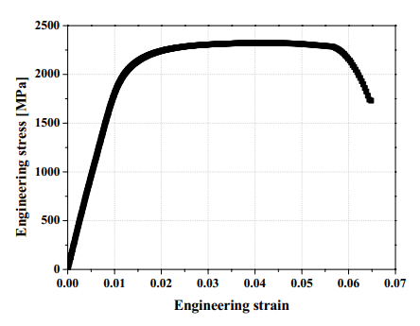
Oil tempering is a process of heating the wire to super high temperatures, 800-900℃, and then cooled in oil. Cooling steel in oil helps with quick cooling without any damage or distortion. By heating the metal, this process eliminates any surface flaws that can be caused by tools or handling during cold coiling processes.
“common practice to make valve springs from oil-tempered spring-wire” (Donkin, 1928)
Oil tempered steel wire has high heat, fatigue and sag resistance. It is ideal for valve springs because it keeps its shape well under high pressures and temperatures. It also has a high tensile strength and can improve fuel efficiency by reducing friction with surrounding parts (Ko, Ahn and Lee, 2022). To the right (figure 1) is a stress-strain graph of oil tempered (OT) wire. It shows maximum stress of around 2250MPa up to a strain of around 0.055 before dropping down after reaching maximum tensile strength.
[Figure 3] Engineering stress-strain curve of OT wire.
This manufacturing method is very effective for small projects, but it is time consuming. With the equipment that exists now, there are better, more efficient ways of producing springs. Especially when mass production is necessary for big companies like Ford and Volkswagen etc that produce millions a day.
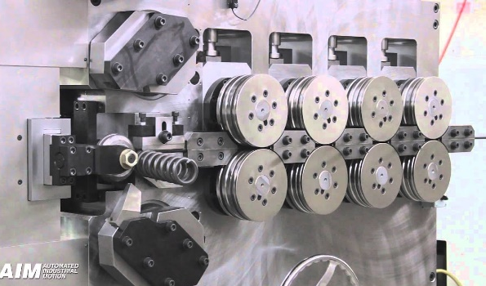

CNC Spring Coiling Machine
Using a CNC Coiling Machine gives each spring consistent accuracy that would not be made manually. These machines program wire feed speed, pitch, diameter and number of coils, in seconds (Auto Link, n.d.). They are time efficient, as it is a constant process, and have a wide range of different tools and settings to accommodate for different spring designs. The picture to the right (figure 2) shows the spring coiling machine. It feeds the wire towards a rotating circle, which pushes the wire inwards in a curved shape, producing a coil.
[Figure 4] AIM 4000 CNC Spring Coiling Machine. (Automated Industrial Motion, 2015)
This method is ideal for mass production of valve springs, but also for high performance springs that need to be accurate and exactly the same as each other to get the most power out of the engine.

Conclusion
After a lot of research and comparison of materials, the conclusion is that a type of steel is the best material for valve springs. This is because of the low cost and high durability and strength. Although 4340 steel is a good option, oil tempered Chromium Silicone is a better option because of the added strength and heat resistant properties from the higher carbon content. Oil tempering is the most effective way of producing the wire from steel, but hand coiling the springs before cooling them is too time consuming and will produce too many inaccuracies. Using the CNC spring coiling machine is the best option for manufacturing the springs, it is accurate and with use of its computer programs, can correct any distortions in the wire.

References
Airedale Springs (2024). Spring Materials Information. [online] Airedale Springs. Available at: https://www.airedalesprings.co.uk/spring-materials/#:~:text=Chrome%20Vanadium%20and%20Chrome%20Silicone [Accessed 10 Apr. 2024].
Auto Link (n.d.). What is a Spring Coiling Machine? [online] www.autolinkcnc.com. Available at: https://www.autolinkcnc.com/en/blog/what-is-a-cnc-spring-coiling-machine/ [Accessed 20 Apr. 2024].
Automated Industrial Motion (2015). AIM 4000 CNC Spring Coiling Machine. [online] www.youtube.com. Available at: https://www.youtube.com/watch?app=desktop&v=yYTgiAMSTNA [Accessed 20 Apr. 2024].
Donkin, W.T. (1928). Notes on Valve-Spring Design. SAE Transactions, [online] 23, pp.404–408. Available at: https://www.jstor.org/stable/44437148 [Accessed 15 Apr. 2024].
Hemanth (2021). COMPARATIVE ANALYSIS OF ENGINE VALVE SPRING WITH VARIOUS ALLOYS. [online] Available at: https://www.irjmets.com/uploadedfiles/paper/volume3/issue_6_june_2021/13919/1628083541.pdf [Accessed 18 Apr. 2024].
IZUMIDA, H., MATSUMOTO, S. and MURAI, T.M. (2016). History and Future of High-Fatigue-Strength Steel Wire for Automotive Engine Valve Spring. 82.
Ko, D., Ahn, N. and Lee, K. (2022). Infuence of the surface faws in oil-tempered wires on the fatigue life of automotive engine valve springs. Scientific Reports, [online] 12(1). Available at: https://www.proquest.com/docview/2747549476?accountid=130472&parentSessionId=RE5Q2QzVjf%2BVY4ay9CTLoj7YK1DVBQHpV%2Fbd2spa2i4%3D&pq-origsite=primo&sourcetype=Scholarly%20Journals [Accessed 18 Apr. 2024].
MatWebInc (2019a). ASM Material Data Sheet. [online] Matweb.com. Available at: http://asm.matweb.com/search/SpecificMaterial.asp?bassnum=M434AE. [Accessed 16 Apr. 2024].
MatWebInc (2019b). MatWeb - The Online Materials Information Resource. [online] www.matweb.com. Available at: https://www.matweb.com/search/DataSheet.aspx?MatGUID=b350a789eda946c6b86a3e4d3c577b39&ckck=1. [Accessed 16 Apr. 2024].
Midwestern Garage (2020). 221, 260, 289, 302 & 351W windsor small block Ford sbf rocker arm install 3/8 stud with 5/8 nut. [online] www.youtube.com. Available at: https://www.youtube.com/watch?app=desktop&v=c_i8IHgrCc4 [Accessed 21 Apr. 2024].
Peterson Spring (2024). Engine Valve Springs - Peterson Spring. [online] Peterson Spring. Available at: https://www.pspring.com/products/engine-valve-springs/ [Accessed 21 Apr. 2024].
Rothstein, B. (2019). All About Steel: Cold Rolled vs. Cold Drawn vs. Hot Rolled. [online] Mead Metals, Inc. Available at: https://www.meadmetals.com/blog/cold-drawn-vs-cold-rolled. [Accessed 12 Apr. 2024].

