MA (Ed) ECGE7001 Sharon Stace-Smith
Philosophy and Practice of Social Research
Part 1

This assignment will seek to consider, identify and critically evaluate a research paradigm and methodology for a research proposal for my educational establishment. It will identify the choice of focus and seek to identify potential impact on the students. I will attempt to rationalise the methodology I propose using and will consider the myriad of ethical considerations. An appendix is attached to this assignment after the Bibliography giving examples of key documents relating the research proposal.

A key component of current Welsh Assembly thinking is the Professional Working Model, an initiative which looks to place teachers at the heart of research. The sharing of good practice amongst educational practitioners at all levels is the new ‘buzz-word’ and sees schools as active teaching and learnings hubs. This increase in enquiry amongst practitioners naturally leads to some necessary questions, not least of which are, ‘What is the purpose of this research?’ and ‘How is it going to enhance the learning or understanding of its subject?’ These give rise to the operational definitions, Matthew and Ross (2010), and the consideration that any question must be both valid and context specific.

Research Proposal
Against this background, and being part of a research active primary school, a prime area for practitioner action research has presented itself. As Literacy, Language and Communications Coordinator, I have been analysing reading data at both school/child level and authority/national level. We are already undertaking a ‘home/school reading project’, but analysis of data and teacher assessments reveal a worrying trend. Like many other schools, reading comprehension can be difficult to teach effectively to all learners. Statistics published by Stats Wales for the Welsh Assembly Government show that in 2017, our county was 3.6% above the Wales average at L4 Reading, but 3.5% below at L5 and 1.1% below at L6+. This would suggest the majority of students across the county achieving expected levels only. The discrepancy across authorities is even greater. At L4, Vale of Glamorgan’s percentage is just 37.1% whereas Neath Port Talbot’s is 53.4%. These percentages soon reverse when analysing higher levels with 53.0% of Monmouthshire children attaining L5 compared to 34.6% of Neath Port Talbot, and 4.1% of Anglesey and Gwynedd children attaining L6+ to Neath Port Talbot’s 0.1%. Socio-economic and other differences between authorities will no doubt underly some of these discrepancies, however they indicate that there are clear factors influencing children’s attainment in reading and reading comprehension.
Much research and literature has been devoted to reading comprehension strategies and all practitioners have preferred methods. Most, like myself, used a mixed method approach. To discontinue this in favour of a single new approach would introduce too many variables and may disadvantage some children by the omission of a preferred strategy. Therefore, it is proposed that intervention / pedagogy-specific strategies be introduced in addition to existing practice to allow for greater validity in any change in results. Consequently, after a detailed book and journal literature review of differing approaches including metacognition, reciprocal reading, active reading, drama-based learning and philosophy-based learning, and after in-depth discussions with colleagues, both in school and in the wider teaching community, I have chosen three strategies that each present themselves as having the potential for greatest positive impact on learning within our context. The reasoning of three different strategies follows on from the empirical evidence that no one reading comprehension strategy will have a positive impact on all learners. The proposed time-span for the research is one academic year of three terms. In this way, the hypothesis is that one intervention strategy can be introduced per term and analysis made of both its immediate and ongoing impact. A term would be a minimum amount of time to allow for an in-depth immersion and have any measurable effect and any more than one academic year would necessitate a different variable of a new cohort of participants. The subsequent collational of results and analysis at the end of the project will need to reflect both individual impacts and the combined impact of all three strategies.
Therefore, I propose the following research question:
‘Can the specific teaching strategies, introduced through tailored intervention programmes, of metacognition, philosophy-based learning and promoting active reading as a means to comprehension, improve children’s reading comprehension attainment?’
In brief, my proposed research design paradigm will include the mixed methodologies of:
- Initial analysis of secondary quantitative statistical data to provide a baseline for later comparison
- Initial paper questionnaire followed by sensitive online survey assessing respondent attitudes to the subject matter
- Small scale focus-group interviews (one per half term to indicate trends in attitude / behaviours and to record, assess and reflect on the intervention procedures)
- Initial modelling of strategies through role play
- Event-contingent journal entries
- Observations (three per term as this would allow for sustainability given any change of circumstance in the current financial environment)
- Repetition of initial questionnaire and survey
- Repetition of initial analysis of secondary quantitative statistical data to provide a comparison from the baseline.
The proposed subject group is quite small, a Year 5 group of, potentially, eleven children. The considerations in the choice of this group over another, are that they are a mixed year of roughly equal boys/girls, they represent differing abilities, attitudes to reading and education and are a from a varied socio-economic background. In short, they represent a microcosm of our school at any given time. I am their class-teacher so am in a good position to observe and carry out the research following the ethical parameters outlined later. The potential number would make provision for transience away from school, non-participation and withdrawal of participation whilst still leaving enough to continue with the research. It also allows for greater flexibility in using mixed methods qualitative and quantitative approaches. As such, this will give a triangulation of results and afford a greater degree of reliability to my data collection and analysis, and validity to my conclusions.
In the following sections I will outline further the rationale behind the choice of subjects, the timescale, the implications of the research on the participants, the proposed methodologies, ethical implications and intended audience and implications for teaching practice of the research.

Methodology
For my proposed research, in addition to the initial data analysis and quantitative data collection, I intend to use a mixed methods qualitative approach. This would allow for a mixed methodology of ethnography, epistemology and ontology. For all three proposed interventions, there will be an element of ethnography through teaching but with the philosophy-based learning and the active reading this will be more involved as they require a greater degree of initial modelling to ensure efficacy.
The methodologies of any research depend on its research parameters. Epistemological factors such as positivism, investigation through objective methodologies, and social constructionism, which sees reality as a construct by people and society, could lead to the use of different research methods and different interpretations of results. The methodology used therefore, needs to be fit for purpose and context specific. The proposed research question does not seek to prove or disprove a theory and is not seeking to promote a universal theory. The research will be, longitudinal rather than cross-sectional, and follow a time linear construct. The time-scale of three terms will allow for sufficient learner development in order to be able to ensure validity and reliability of results.
Quantitative research is suitable for most large-scale research projects but can provide base-line data for smaller-scale studies as well. Questionnaires through online surveys, paper-based, postal or oral researcher to respondent questionnaires are common, however ensuring informed consent is one pitfall as is the reliability of answers. The researcher is wholly dependent on the respondent’s state of mind at the moment of filling in the questionnaire which may vary widely from a repeat questionnaire at a later date. In this project, it is hoped that by actively engaging the interest of the small number of respondents, this will not happen.
The collation of questionnaire data needs to be based along mathematical principles. I will code responses into mathematical formulae ensuring that the coding takes account of the equal weighting of answers i.e. quantifying the difference between groups of data to ensure the effect size is equally comparable in terms of significance, Hattie (2012). Mathematical models of variation theory can help disentangle divergent results and I will be using standard deviation to add another dimension to analysis of the mean, median and mode of data sets. I will be presenting the data in appropriate graphical formats to help clarify findings.
Other forms of qualitative data include surveys, observations and secondary data. Graphic analysis, cluster analysis and hypothesis testing models are all useful for identifying relationships and trends, and for having a mathematical model to add weight to a particular conclusion. Within the school setting, the Welsh National Test Results, All Wales Core Data Sets, School Categorisation and Stats Wales would all be useful sources as well as school specific data measures such as INCERTS, All Wales Reading Tests and RAPID & LASS cognitive assessment testing results.
In terms of quantitative data, I propose using these last three school specific data results in conjunction with the Welsh Assembly Government education statistics. I will initially identify trends from all data sources over the last three years using both graphic and cluster analysis in order to accurately identify trends. Following this will be two questionnaires to be administered both at the beginning of the research project and again at the end. The first will be a paper questionnaire focussing on the actualities and frequency of reading; the second will be a short online ‘user-friendly’ survey that will focus on attitudes to reading and reading comprehension. Both questionnaires will include a child-friendly age-appropriate mixture of dichotomous questions, open questions with room for additional comments (affording a degree of additional qualitative data), multiple-choice ranking and rating questions to ensure that respondents are engaged and able to give true answers. I will avoid the use of an odd number of questions to encourage respondents to commit to a viewpoint. The rationale behind the use of two different questionnaires/surveys is that, given the focus group for the proposed research, they would be more likely to answer sensitive questions in an online anonymous survey but much less likely to answer truthfully if they had to put pen / pencil to paper, where they would think that handwriting could be recognised and they might be able to be identified. However, with straightforward answers, they would probably welcome the chance to ‘tick the boxes’ and have their say. Two shorter surveys would also be more accessible to ALN and short-attention-span children and it is hoped that using these formats will ensure respondent engagement and reliability. The two different forms would also have the added benefit of affording a degree of triangulation of data where data sets overlap, thus adding validity to the results.
Qualitative data such as interviews, focus groups, direct observations including video and audio, and secondary data including diaries or journals, self-reporting and written accounts are often suitable and more revealing for small scale research projects such as action research and case studies. Interviews with individuals or focus groups can be instrumental in providing ‘rich’ data but need to be approached with care. First, should they be structured, semi-structured or unstructured? The former ensures that responses are all pertinent but may not allow for any divergence which could be interesting to the research question; the latter addresses this point and allows for ‘free-flow’ of ideas but has the added risk that much information, superfluous to the research, is given and pertinent data may be neglected. The semi-structured approach is therefore the most plausible approach for my proposed action research as it will allow for a greater amount of detailed ‘rich’ data. Questions will need to be open-ended rather than dichotomous to allow for discussion and inconsistencies in answers can be gently probed to elicit clarification of meaning. A variety of question structures, using language appropriate to the interviewees will be used and leading questions will be avoided at all times. As interviewer, I will need to, not only act as impartial chairperson to ensure conversation stays within a range of pre-agreed parameters, but will also need to take the interviewees to a present or back to a past experience rather than asking them to postulate on future events as, by dint of their age, they have limited life experiences on which to draw suppositions. The environment of any interview will be agreed on by all parties to ensure the interviewees feel safe and comfortable to talk. I will need to be aware at all stages, both during and afterwards during transcription, of any bias and partiality. Data will be transcribed within a 24-hour period as this would ensure a faithful transcription and validity of subsequent collected data.
Observations can be a very useful tool as they follow an ethnomethodological approach rather than an ethnographic one. Observations are a good source of dramaturgy and narrative research, as the researcher is outside the events and can record them faithfully. The use of video in such situations can be useful to ensure that the observer does not omit any pertinent data however this in itself can influence participant behaviour and affect the reliability of any data collected as per the Hawthorne Effect. For this reason, I do not propose using video or audio as a method of data collection. Observations have the drawback of being difficult logistically to organise as the researcher needs to be completely divorced from the activity. There is always the added risk of the researcher being a catalyst for divergent behaviours in the children. As the subject of this proposed research form half of my own class, these considerations are lessened by my daily presence, and, given their upper junior age range, they are far more likely to be able to stay on task with another practitioner, allowing me free to observe unhindered.
Studying a situation from an immersive viewpoint such as role play research, can also be very effective with younger children and children experiencing deep trauma, however for this project, the only role play will take the form of modelling at the start of each intervention.
In small scale action research and case studies, researcher diaries or journals can be an effective way of noting interesting and pertinent observations for later collation. There can be three different catalysts for entering data and it is important to decide which is most appropriate before commencement. Interval-contingent - recordings made at a specific predetermined time interval, signal-contingent – recording events from a given signal, or event-contingent – recordings undertaken during a specific event setting. They can be time-heavy and care should be taken to note down observations immediately as human fallibility could evidence itself in subject matter being wrongly remembered or attributed and misinterpreted in the light of later developments. Managed properly however, they can be an extremely useful and ‘thick’ source of qualitative data, Cohen et al (2011) and it is for this reason that I proposed keeping an event-specific journal.
The debate over qualitative versus quantitative research is a long one. Qualitative will give the researcher more data and data of a greater variety but is more prone to researcher bias and is more suited to smaller-scale studies due to the ensuing large amount of data to be collated per participant. Quantitative data scores highly in this context, and with the advent of a myriad of online survey programmes, is widely accessible and easily shared via social media. It is, therefore, well-suited to large scale research projects and has the advantage of being able to be repeated to have measurable comparison data. One major bonus for qualitative over quantitative research is the ability for it to act as catalyst for models of reflective practice. Kolb (1984) and Gibbs (1988) both postulate that given models can allow the researcher to reflect on events and data with greater depth. Schon (1978) advocates reflection during an event whereas Brookfield (2005) escalates this theory to different viewpoints and perceptions of reflection from the different parties involved. This is redolent of immersive approaches to data collection but with the adage that the data has already been collated and needs only interpretation and representation. It is at this point the Brookfield’s theory has the most potential for ethical compromise as, in an attempt to see the situation from the different viewpoints of all those concerned, the researcher will bring their own experiences and preconceptions to the research. Social science and educational research are concerned with human beings and human beings are products of the sum of their experiences and are therefore unable to be truly impartial in any reflective exercise.
Despite this, or perhaps because of it, the collation and analysis of data will need to be administered with clear impartially. To this end, students will be coded with the coding known only to me as researcher. Every effort will be made to ensure that no individual can be traced or identified in any way and all data records will be destroyed on completion of the project. During the research, the coding system will be adopted and kept on password protected file. I do not propose using any additional media such as video or audio, thereby eliminating the need for additional multi-media security measures. The online survey will be constructed using ‘SurveyMonkey’ so that individual responses will be anonymous. Empirical evidence suggests that any intervention into reading comprehension has some effect with some pupils and not with others, therefore I have no preconceptions that any one of the three proposed intervention pedagogies will have a particular effect over and above the others. I have no financial or educational interest in any one proposal and therefore feel that I can be impartial when analysing results. My only driving concern is to find out if one particular method is more effective than another so that it can be repeated to the benefit of other children.

Data Analysis
In brief, the analysis of data will be as follows:
- Secondary quantitative statistical data analysis collated in a spreadsheet for easy conversion to graphs and differential analysis - providing a baseline for later comparison.
- Questionnaire and online survey – quantitative analysis using variation theory to code answers into quantifiable data. Qualitative collation of open-ended comments.
- Small scale focus-group interviews – initial transcription of notes followed by qualitative analysis, identifying trending comments, viewpoints etc and noting divergent opinions for later analysis.
- Role-play strategies modelling – journal entries of pertinent occurrences.
- Event-contingent journal – identification and grouping of comments into linear narrative. Also, quantitative analysis of student participation to be made using the Leuven Scale.
- Observations – initial transcription of notes, then repeat of systems used for journal and interviews.
- Repetition of initial questionnaire analysis and secondary statistical data – comparison graphs used to compare data.
The proposed use of mixed methodologies of quantitative secondary statistical data and questionnaires, along with a triangulation of mixed methodology qualitative research will, it is hoped, provide balance to the data collection and afford validity to the research. The proposed methods of data analysis will require extensive collation of qualitative results into identifiable groups for further qualitative and quantitative analysis, which would then provide a basis for a linear narrative and concluding summary. This type of analysis is time-heavy but manageable, given the small number of participants in the research group.

Ethical Considerations
Educational research necessarily deals with human beings; humans of all ages, shapes and sizes, of differing abilities, life experiences and life expectations. As early as 1979, Burrell and Morgan identified four paradigms for the social researcher. Ontological awareness is one cornerstone. The researcher should be aware of social realities; the social phenomena of not only those being researched, but also those of the researcher themselves must be addressed, acknowledged and considered. With regards to epistemology, the researcher must be wary of preconceptions and biased interpretations of results. The relationship between humans and their environment as well as that of human nature itself, should not be underestimated. Skewed research results can be common when the researcher has predetermined if the subjects are either merely responding to their social environment or actively controlling it.
The ethical considerations of research cannot be understated. In today’s world of instant internet publication and access, the security of data collected, and the integrity of the researcher take on a heightened significance. General Data Protection Regulation (GDPR) coming into force in 2018 has served to try and afford some protection to the UK population during a time, when advances in ICT, automatic data collection processing and selling are outstripping the average citizen’s ability to comprehend this new norm. When working with adults, this climate can make them wary of any research participation; with younger children, this is lessened, however informed parental consent is a lawful prerequisite of participation in any research, therefore, I propose to see the parents/guardians of the eleven children concerned to explain briefly, in person, the proposed research, to then give them a letter of explanation/introduction, a consent form and to allow a suitable period of time for any questions to arise and be answered fully. As it is envisaged that the research will begin in September, this process will take place during the second half of the preceding summer term.
While the full informed consent of parents/guardians and carers is required, for children under 16 and adults lacking mental capacity, informed assent is also necessary. This involves the researcher telling the child about the research and its parameters, its possible implications and potential outcomes as well as the methodology to be used. All of this must be child-friendly, backed up with suitable picture card cues and should be undertaken in a place and at a time when the child can engage fully with the researcher i.e., not at breaktime, just before lunch or when they are tired etc. The child must be able to ask and have questions answered in a way suitable to them and it must be clear that the child has understood and is happy to participate, i.e. to give assent, before the research begins. Researchers need to also be mindful of the target parents/guardians, particularly those from socio-disadvantaged groups, as some may be non-readers, have EAL considerations and may be unduly biased against education by their own earlier experiences of it. These people would be unlikely to engage with overly verbose, academic statements and it would be entirely reasonable to therefore argue that ‘informed’ consent had not be given. It is for this reason that I wish to see each parent in person. It is hoped that the ‘personal touch’ will help parents, particularly those who are either busy or have educational issues themselves, to engage fully with the proposed research in an informed way. My introductory letter has been written in a straight-forward / school language, which the parents will be familiar with. The target group is 9-10 year olds and, as readers, picture cues can be kept to a minimum but I will need to take care and allow time for children to think of questions, process the answers and come back with more questions before I deem assent has been given. The same process is also true for parents/guardians. Additionally, it will be stressed to parents/guardians and the children that they can withdraw consent/assent at any time with no adverse effects to themselves and stop their participation in the research project. Their participation in an intervention that may help them will continue, but their data will not be used in the research in any way.
The ethical researcher must face issues of responsibility – to the research participants, to themselves and to their subject matter. They must afford the rights, permissions and protection to participants through diligent duty of care with no maleficence or discrimination. Confidentiality and the need for participant anonymity regarding both non-identification and non-traceability are key concerns, as is the safe storage and limited access to data and its subsequent archiving. The researcher must be continually aware of their own position as researcher and must ensure that they themselves exert no influence over participants. This can be more problematic when working with young or vulnerable children. Ethical decisions must be made on a case by case basis, with regard to context and to codes of practice such as BERA (British Education Research Association), the ethical committees and review boards of any associated academic institutions, regulatory frameworks and relevant legislation. The researcher has a responsibility to all parties and must ensure that they uphold that responsibility at all times
As the class teacher of the proposed subject group, I am in a unique position to understand and appreciate the social realities and experiences as well as the behaviours and context of each of the subjects concerned. Ontologically, as observer, I am unlikely to have any distracting effects on the children, as they expect my presence in most lessons. This forestalls the need for covert observations to prevent unpredictable behaviours and instead means that I can engage in overt observations. I would, however, have to guard against observer bias in terms of how I expect them to behave versus the behaviour and responses presenting themselves at that moment.
This is part of the rationale behind using the Year 5 cohort only and beginning the research in the September that they move into the class. I will, necessarily from transition work, know of the children and have an indication of their learning needs, and they will know me as a teacher, but first-hand preconceptions on my part will be less and can be minimised. I plan to use event-contingent journal entries with specific reading and reading comprehension lessons and activities as the event marker. In this way, I can be sure that I will be able to ensure consistency of recording to build a linear model for later analysis. I also intend using the Leuven Involvement Scale during observations as a means of ensuring consistency and to provide further quantitative data for analysis as this is a recognised system to ensure consistency of recording data over a longer period of time.
The use of, potentially, all eleven of one year group negates any potential for discrimination along socio-economic, colour, ethnicity or gender lines however, given the small number of participants, the resulting data may well produce interesting results, particularly in relation to potential improvements along gender and academic achievement lines such as a measurable improvement in boys engagement / performance or an above average improvement for ALN, MAT, FSM, PDG or BESD children. It would be foolish to ignore any such improvement, and indeed unethical to deny future year groups similar progress, therefore, I propose a system of coding participants according to both gender and the above classifications. In this way, I hope to identify if any particular intervention has an additional effect on any particular group. This research is not seeking to analyse attainment differences between one group and another, but instead is looking for any markers of individual progression / enhanced understanding. However, should it become apparent from analysis of results, that a particular intervention appears to have a greater impact on a given group, then it could be the precursor of further additional research.

Other Considerations
The proposed target audience for this research is other education practitioners and KS2 teachers. If the interventions trialled have no significant effect then the children will be unaffected as ‘normal’ teaching methods would have continued to take place. However, implications for future practice within our own educational establishment could include an improved pedagogy for reading comprehension, sharing of good practice amongst the wider educational environment and an improvement in standards of attainment amongst pupils. Successful interventions would be rolled out across the school to encompass all classes and school policies would be rewritten to take account of the new pedagogy and its potential influence on other curriculum areas / AoLEs.
Empirical evidence suggests that various interventions will always have some positive impact on a large enough cohort of children. However, the final report will have to clearly address and reflect the three-intervention approach outlined and ensure that readers understand the timescales concerned for each individual intervention and that overall results will probably be as a result of the systematic exposure to different interventions.
In conclusion, I am proposing a mixed methodology research project undertaken within the strict parameters of BERA, Education Workforce Council (EWC), UWTSD institutional Ethical Guidelines and GDPR General Data Protection Regulation. The project will run for one academic year to allow for detailed collection of linear data and will encompass potentially, all eleven Year 5 students once informed parental consent and pupil assent has been given. The research parameters allow for a safe, considered ethical approach in which no child will be disadvantaged in any way. Any findings will be collated using coding to ensure anonymity and the subsequent report will be available to participants and their families as well as KS2 teachers and associated professionals. All data will be securely kept during the course of the project and will be destroyed upon completion.
The research hopes to find empirical evidence that certain pedagogical interventions can have a positive impact on learner participation and outcomes in the field of reading comprehension. It is hoped that this research proposal can continue to ethical approval so that it can actioned.

Bibliography

Alderson, P. & Morrow, V. (2011) The ethics of research with children and young people : a practical handbook (2nd ed). London: SAGE.

Burrell and Morgan (1979) Sociological paradigms and organizational analysis London: Heinemann

Cohen, L. and Manion, L. (2011) Research Methods in Education (7th ed). London: Routledge
Dawson, C. (2009) Introduction to Research Methods: a practical guide for anyone undertaking a research project (4th Edition) Oxford

Dawson, C. (2009) Introduction to Research Methods Glasgow: Bell and Ban Ltd

Hattie, J. (2012) Visible learning for teachers: maximising impact on learning London: Routledge

Kumar, R. (2014) Research Methodology London: Sage Publications Ltd

Laevers, F. (2008) The Leuven involvement scale for young children Leuven: CEGO

Matthew, B. and Ross, L. (2010) Research Methods: a practical guide for the social science Harlow: Pearson

Mauthner, M. L., Birch, M., Jessop, J. & Miller, T. (eds) (2012) Ethics in Qualitative Research. London: Sage Publications Ltd

Thomas, G. (2017) How to do your research project: a guide for students (3rd Edition) London: Sage Publications Ltd

Government Official Documents

Edinburgh Literacy Hub Teachers’ Guide to Reading Comprehension Strategies P5-S3 Available at: https://education.gov.scot/improvement/documents/literacy/lit13_teachingreadingcomprehensionfinaldraft.pdf

Welsh Government. (2015) Effective Use of Data and Research Evidence. Cardiff: Welsh Government.
http://learning.gov.wales/docs/learningwales/publications/150814-effective-use-of-data-en.pdf

Welsh Assembly Government Education Statistics. Available at: https://statswales.gov.wales/Catalogue/Education-and-Skills/Schools-and-Teachers/Examinations-and-Assessments/Key-Stage-2/results-by-localauthority-level

Journals and Papers

Adair, J. (1984) Journal of Applied Psychology The Hawthorne Effect: A Reconsideration of the Methodological Artefict (Vol.69(2)), p.334

Duke, N.K. & Pearson, P.D. (2008) Journal of Education Effective Practices for Developing Reading Comprehension (Vol. 189, No. 1/2) pp107-123 Sage Publications Inc

Garcia-Madruga, J.A. & Elosua, M.R. (2013) Reading Research Quarterly Reading Comprehension and Working Memory’s Executive Processes: An Intervention Study in Primary School Students (Vol. 8, Issue 2) pp155-175

Groen, M.A., Veenendaal, N.J., Verhoeven L. (2018) Journal of Research in Reading The role of prosody in reading comprehension: evidence from poor comprehenders (Vol. 42, Issue 1) pp37-57

Kelly, A.E. (2003) Educational Researcher The Role of Design in Educational Research - Design-Based Research: An Emerging Paradigm for Educational Inquiry (Vol. 32, No.1, pp5-8)

Regulatory Frameworks Documentation
British Educational Research Association (2018) Ethical Guidelines for Educational Research 4th Edition Available at: https://www.bera.ac.uk/researchers-resources/publications/ethicalguidelines-for-educational-research-2018

Education Workforce Council, Research Ethic. available at: https://www.ewc.wales/site/index.php/en/policy-hub/practitioner-research/research-ethics.html

ICO, Information Commissioners Office, Guide to the General Data Protection Regulation 2018 Available at: https://ico.org.uk/for-organisations/guide-to-data-protection/guide-to-the-general-data-protection-regulation-gdpr/

UWTSD (2017) Research Ethics & Integrity Code of Practice 2017-20 Available at:
https://www.uwtsd.ac.uk/media/uwtsd-website/content-assets/documents/research/research-ethics-integrity-code-practice.pdf

Websites / online Articles and Journals
Baker S.E. & Edwards R. National Centre for Research Methods How many qualitative interviews is enough? http://eprints.ncrm.ac.uk/2273/4/how_many_interviews.pdf

British Educational Research Association https://www.bera.ac.uk/

Duke N.K. & Pearson P.D. (2017) Effective Practices for Developing Reading Comprehension. Available at: https://journals.sagepub.com/doi/abs/10.1177/0022057409189001-208

Edwards R. & Holland J. ‘What is?’ Research Methods series What is qualitative interviewing? http://eprints.ncrm.ac.uk/3276/1/complete_proofs.pdf

Jerrim, J. (2013) The Sutton Trust: Improving Social Mobility The Reading Gap Available at https://www.suttontrust.com/wp-content/uploads/2013/07/READINGGAP.pdf

Lexia reading programme Available online at: https://www.lexialearning.com

Quigley, Muijs and Stringer (updated 2019) Metacognition and self-regulated learning: Guidance Report Education Endowment Foundation. Available at: https://educationendowmentfoundation.org.uk/evidence-summaries/teaching-learning-toolkit/meta-cognition-and-self-regulation/
Wiles R., Crow G, Heath S. & Charles V. (2006) ESRC National Centre for Research Methods NCRM Working Paper Series, Anonymity and Confidentiality. Available at: http://eprints.ncrm.ac.uk/423/1/0206_anonymity%2520and%2520confidentiality.pdf

Jones, G. (2016) Is it time to call time on Hattie and the significance of the 0.4 effect size? Evidence Based Educational Leadership. Blog Available at: https://evidencebasededucationalleadership.blogspot.com/2016/04/is-it-time-to-call-time-on-hattie-and.html

Appendix 1:

Example of graphic and cluster analysis of data to be used for secondary data.

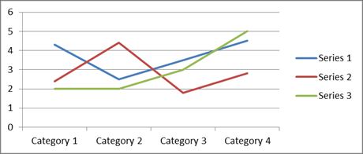

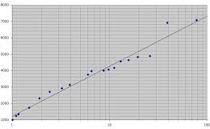

Appendix 2: Proposed questionnaire

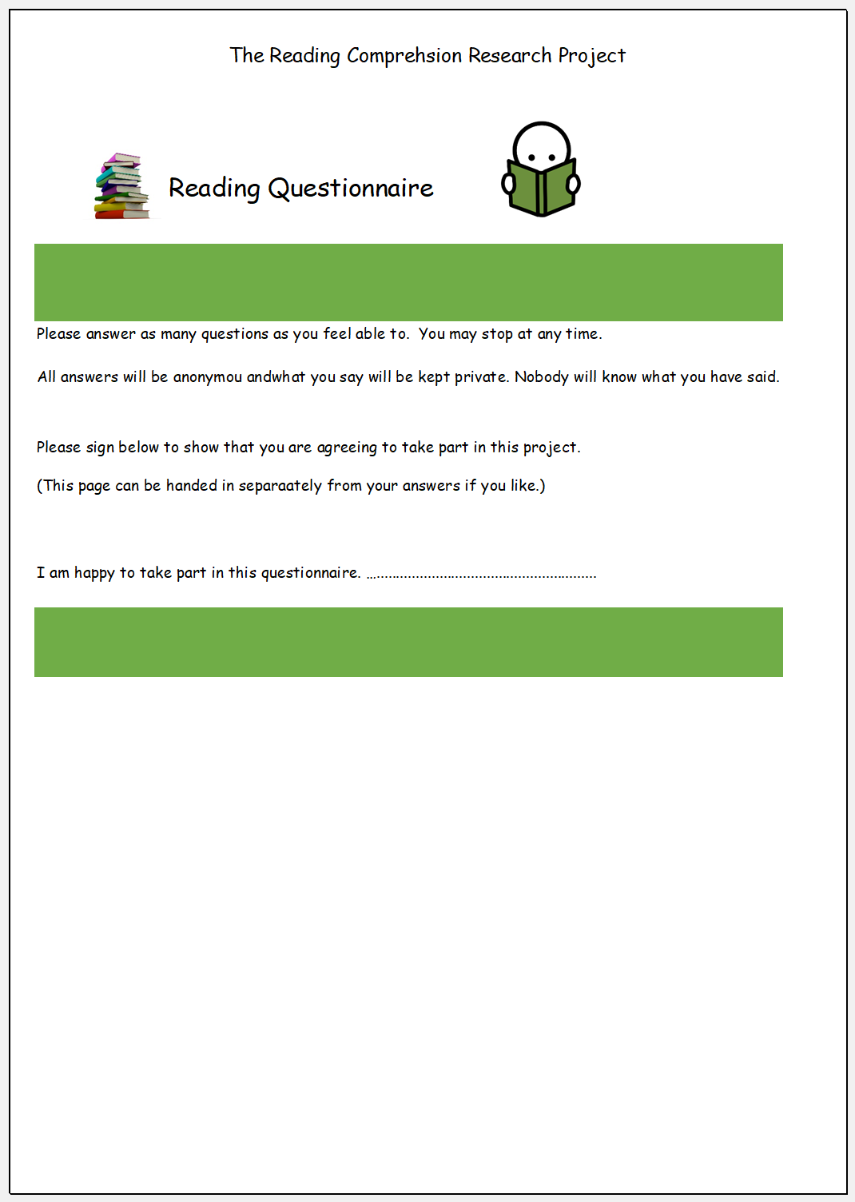
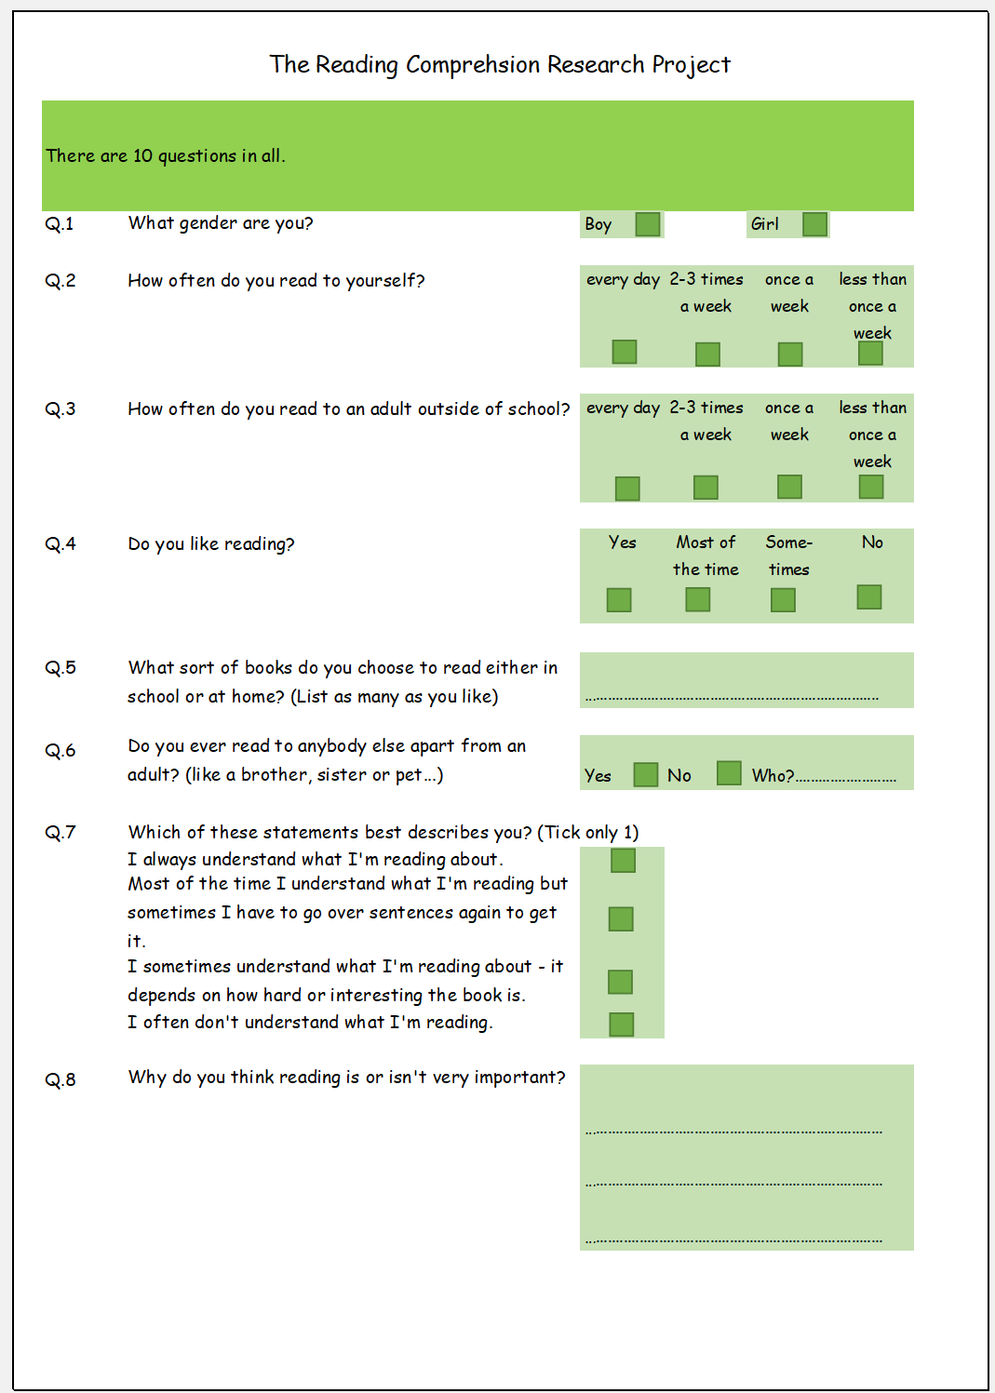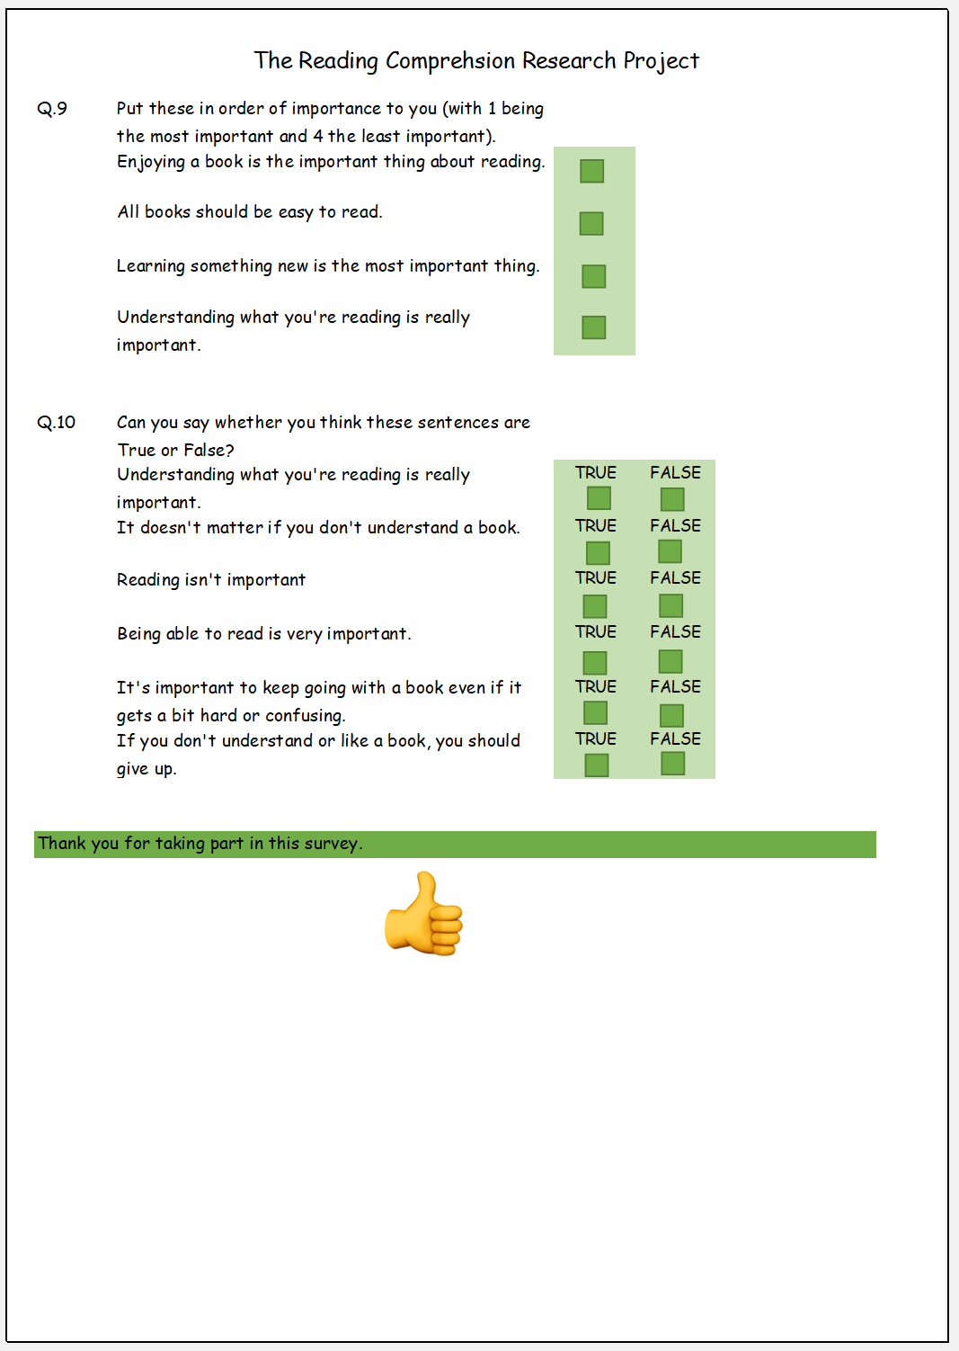

Appendix 3: Proposed Letter of Introduction

Address withheld at present

Date to be confirmed once ethical approval has been granted

Reading Comprehension Research Project 

Dear (names to be added individually),

I am carrying out a small scale research project to try and find the best ways of helping children do well in understanding what they are reading and reading comprehension.
As you know, we are always looking for innovative and new ways to engage and help the children at ***(name withheld for now)** School with some good results. Pupil voice is strong and the children are very good at giving us feedback about what is working and what isn’t. However, many of them have said that they would like us to find an easier way through reading comprehension. The statistic nationwide throughout Wales show a huge difference between authorities as well as between boys and girls.

It is my firmly-held belief that all children are individuals and cannot be pigeon-holed into a little box and as such, you can be sure that we are helping your child to achieve their very best at all times. To this end, I want to trial three new ways of teaching and helping with reading comprehension.

The first is metacognition where the children will be taught and encouraged to analyse how they are learning and completing tasks so that they can improve which ever area they need to.

The second is philosophy-based-learning. You will be aware that we are a philosophy school and that this underpins our very ethos. As such the children are adept at thinking and debating and I hope, will take well to sessions where we will use debates, 20 questions games and dilemma role-play to explore the higher order reading skills of inference and deduction. To them it will seem like play, but the skills that they will develop and sharpen will be very real indeed.

The final approach will be to promote active reading. This is based around research that shows that when children are actively engaged in and are enjoying their reading, they have a deeper understanding of the contexts and sub-contexts of the text. To do this, we will be exploring for example, different genres of reading as well as different styles and places to read. Your child may well want to experiment reading to the dog or to a sibling, in the garden, on the toilet – nowhere will be out of bounds! For a time, your child may well come home with different types of books and texts of different reading levels.
Please do not be alarmed if this includes picture books. They are an incredibly rich source of material for comprehension activities. They will be reading additional texts of varying complexity in school as well. It is very important that children see themselves and readers and enjoy what they are reading. Without this, they will not develop the reading skills they need for later life.

The research study will take place over the whole academic year and will involve questionnaires at the beginning and end for your child and some interviews and observations by myself during the year. I will be looking at and analysing test data from your child but this and all other data collected will be anonymised and, should you agree for your child to take part, nobody will be able to identify you or your child in any way from the research findings. All data will be kept securely and will be destroyed once the project is complete. You or your child will be able to withdraw at any point during the research if they/you want to with no ‘hard feelings’ at all. All participation is entirely voluntary and all the children in the class will be taking part in all the activities so if you or your child decide not to take part, they won’t miss out on anything; it is just that their data won’t go forward to be included in the research findings.

At the end of the research, I will be inviting all parents and children to a choice of either 1:1 meeting with me or a group/class meeting where I will share all the results with you. If conclusive, I will be sharing the resulting report with other primary teachers in our cluster, local authority and **Name of consortia**.

I will be explaining everything to your children and asking them for their assent to take part as both you and your child need to feel happy and relaxed about taking part. If you are happy to go ahead, please fill in the attached form and return it to me at school.
If you have any other questions about any part of this project, please do not hesitate to contact me, either at school or on ****Hwb email address***.

I really hope that you and your child will be happy to take part in this research. This is a very exciting time for all of us and I am really hoping that the next year will see the class flourish in new ways.

Many thanks,

***my name***

Appendix 4: Proposed Consent Form
Reading Comprehension Research Project
Consent Form to take part in the Reading Comprehension Research Project at *****Name*** School

Name of investigator: ***my name*** Please initial
or tick to show your agreement.

I have read the accompanying letter about the Reading Comprehension Research Project and have been given an opportunity to ask questions and have them answered fully.

I understand that my child’s participation in this project is entirely voluntary and that they or I/we can withdraw at any time without giving a reason and that they will not be unfairly treated as a result.

I understand that my child will take part in questionnaires and surveys and that observations will be made by ***name of researcher***. Test data may be used for the purposes of the research but I understand that all data will be anonymised and that my child will be untraceable in any subsequent report.

I understand that I and my child will be invited to a meeting of our choice at the end of the project to discuss the findings.

I understand and am happy to have the subsequent report shared with other teachers in the school, local authority and **name of consortia**.

Signed: ……………………………………………………… Date:…………………………

Name:………………………………………………………..

Relationship to child:………………………………….

MA (Ed) ECGE7001 Sharon Stace-Smith
Philosophy and Practice of Social Research
Part 2

The video link for the presentation for this component can be found at: https://youtu.be/5dZt2KFxEnQ

Bibliography

Alderson, P. & Morrow, V. (2011) The ethics of research with children and young people : a practical handbook (2nd ed). London: SAGE.

Burrell and Morgan (1979) Sociological paradigms and organizational analysis London: Heinemann

Cohen, L. and Manion, L. (2011) Research Methods in Education (7th ed). London: Routledge
Dawson, C. (2009) Introduction to Research Methods: a practical guide for anyone undertaking a research project (4th Edition) Oxford

Dawson, C. (2009) Introduction to Research Methods Glasgow: Bell and Ban Ltd

Hattie, J. (2012) Visible learning for teachers: maximising impact on learning London: Routledge

Kumar, R. (2014) Research Methodology London: Sage Publications Ltd

Laevers, F. (2008) The Leuven involvement scale for young children Leuven: CEGO

Matthew, B. and Ross, L. (2010) Research Methods: a practical guide for the social science Harlow: Pearson

Mauthner, M. L., Birch, M., Jessop, J. & Miller, T. (eds) (2012) Ethics in Qualitative Research. London: Sage Publications Ltd

Thomas, G. (2017) How to do your research project: a guide for students (3rd Edition) London: Sage Publications Ltd

Government Official Documents

Welsh Government. (2015) Effective Use of Data and Research Evidence. Cardiff: Welsh Government.
http://learning.gov.wales/docs/learningwales/publications/150814-effective-use-of-data-en.pdf

Journals and Papers

Adair, J. (1984) Journal of Applied Psychology The Hawthorne Effect: A Reconsideration of the Methodological Artefict (Vol.69(2)), p.334

Kelly, A.E. (2003) Educational Researcher The Role of Design in Educational Research - Design-Based Research: An Emerging Paradigm for Educational Inquiry (Vol. 32, No.1, pp5-8)

Regulatory Frameworks Documentation
British Educational Research Association (2018) Ethical Guidelines for Educational Research 4th Edition Available at: https://www.bera.ac.uk/researchers-resources/publications/ethicalguidelines-for-educational-research-2018

Education Workforce Council, Research Ethic. available at: https://www.ewc.wales/site/index.php/en/policy-hub/practitioner-research/research-ethics.html

ICO, Information Commissioners Office, Guide to the General Data Protection Regulation 2018 Available at: https://ico.org.uk/for-organisations/guide-to-data-protection/guide-to-the-general-data-protection-regulation-gdpr/

UWTSD (2017) Research Ethics & Integrity Code of Practice 2017-20 Available at:
https://www.uwtsd.ac.uk/media/uwtsd-website/content-assets/documents/research/research-ethics-integrity-code-practice.pdf

Websites / online Articles and Journals
Baker S.E. & Edwards R. National Centre for Research Methods How many qualitative interviews is enough? http://eprints.ncrm.ac.uk/2273/4/how_many_interviews.pdf

British Educational Research Association https://www.bera.ac.uk/

Edwards R. & Holland J. ‘What is?’ Research Methods series What is qualitative interviewing? http://eprints.ncrm.ac.uk/3276/1/complete_proofs.pdf

Wiles R., Crow G, Heath S. & Charles V. (2006) ESRC National Centre for Research Methods NCRM Working Paper Series, Anonymity and Confidentiality. Available at: http://eprints.ncrm.ac.uk/423/1/0206_anonymity%2520and%2520confidentiality.pdf

Jones, G. (2016) Is it time to call time on Hattie and the significance of the 0.4 effect size? Evidence Based Educational Leadership. Blog Available at: https://evidencebasededucationalleadership.blogspot.com/2016/04/is-it-time-to-call-time-on-hattie-and.html

APPLICATION FOR ETHICAL APPROVAL

In order for research to result in benefit and minimise risk of harm, it must be conducted ethically. A researcher may not be covered by the University’s insurance if ethical approval has not been obtained prior to commencement.

The University follows the OECD Frascati manual definition of research activity: “creative work undertaken on a systematic basis in order to increase the stock of knowledge, including knowledge of man, culture and society, and the use of this stock of knowledge to devise new applications”. As such this covers activities undertaken by members of staff, postgraduate research students, and both taught postgraduate and undergraduate students working on dissertations/projects.

The individual undertaking the research activity is known as the “principal researcher”.

Ethical approval is not required for routine audits, performance reviews, quality assurance studies, testing within normal educational requirements, and literary or artistic criticism.

Please read the notes for guidance before completing ALL sections of the form.

This form must be completed and approved prior to undertaking any research activity. Please see Checklist for details of process for different categories of application.

SECTION A: About You (Principal Researcher)

Full Name: |  |  | Sharon Julia Anne Stace-Smith
Tick all boxes which apply:
Member of staff: | ☐ | Student: |  | ☒ | Honorary research fellow: | ☐

Faculty/School/Centre: | Faculty of Education and Communities Universal
Campus: | Swansea
E-mail address:
Contact Telephone Number: | 07775 607552
For students:
Student Number: | P152424 | Undergraduate | ☐
Programme of Study: | MA Education Leadership | Taught Postgraduate | ☒
Director of Studies/Supervisor: | Catherine Morgan | Research | ☐

SECTION B: Approval for Research Activity

Has the research activity received approval in principle?  (please check the Guidance Notes as to the appropriate approval process for different levels of research by different categories of individual) |  | YES | ☒ | NO | ☐
 |  |  |  | Date
If Yes, please indicate source of approval (and date where known): | Research Degrees Committee |  | ☐
 | Faculty Research Committee |  | ☐
 | Other (write in) |  | ☒
Approval in principle must be obtained from the relevant source prior to seeking ethical approval.

SECTION C: External Ethical Guidance Materials

Please list the core ethical guidance documents that have been referred to during the completion of this form (including any discipline-specific codes of research ethics, and also any specific ethical guidance relating to the proposed methodology). Please tick to confirm that your research proposal adheres to these codes and guidelines.
BERA Ethical Guidelines for Educational Research 2018 | ☒
Research Ethics & Integrity Code of Practice (USTSD) 2017-20 | ☒
General Data Protection Regulation 2018 | ☒

SECTION D: External Collaborative Research Activity

Does the research activity involve collaborators outside of the University? |  | YES | ☐ | NO | ☒
If Yes, please provide the name of the external organisation and name and contact details for the main contact person:
Institution
Contact person name
Contact person e-mail address

Where research activity is carried out in collaboration with an external organisation
Does this organisation have its own ethics approval system? | YES | ☐ | NO | ☐
If Yes, please attach a copy of any final approval (or interim approval) from the organisation

SECTION E: Details of Research Activity

Indicative title: | Can the specific teaching strategies, introduced through tailored intervention programmes, of metacognition, philosophy-based learning and promoting active reading as a means to comprehension, improve children’s reading comprehension attainment?
Proposed start date: | 01/09/2019 | Proposed end date: | 31/07/2020
Purpose of research activity (including aims and objectives)
Outline the purpose, aims and objectives of the research activity, including key research questions. Show briefly how existing research has informed the proposed activity and explain what the research activity will add and how it addresses an area of importance. (Maximum 300 words)
This research aims to investigate if targeted pedagogical interventions can have a positive impact on learner participation and outcomes in the field of reading comprehension. It aims to introduce one targeted intervention per term over the course of an academic year, evaluating each in turn and as a cumulative whole at the end of the project.

This is following on from an analysis of data which shows that children in the proposed study group are potentially underperforming in reading comprehension. A further analysis of national data has revealed that this could be a current trend, possibly arising from the current prevailing teaching pedagogies. Empirical evidence shows that a mixed pedagogical approach to reading comprehension can produce better results. After a careful review of literature and current trends in teaching, the three pedagogies of metacognition, philosophy-based-learning and promoting active reading as a means to comprehension were deemed most suitable for our educational context as all three would work well with the learning styles of the children concerned.

The target group is a year-group of Year 5 pupils, 5 boys and 6 girls with a mixture of learner needs such as ALN (Additional Learning Needs), MAT (More Able and Talented) and BESD (Behaviour, Emotional or Social Difficulties). By having a wide variety of children with differing learning needs and styles, any results findings will be more pertinent and more easily transferable to a general generic classroom situation.
The aim of this research therefore is to ascertain if three given teaching interventions and styles of learning can have a significant impact on one year group of children regarding reading comprehension.

(this box should expand as you type)
Proposed methods
Provide a brief summary of all the methods that may be used in the research activity, making it clear what specific techniques may be used. If methods other than those listed in this section are deemed appropriate later, additional ethical approval for those methods will be needed. (Maximum 600 words)
The proposed research will use a mixed methodology approach using both quantitative and qualitative analysis. In the first instance, there will be an analysis of secondary quantitative statistical data, including Welsh National Test results, All Wales Reading test scores, LASS & RAPID cognitive test results, PM assessments, INCERTS and teacher assessments. These would all be carried out by the school regardless of the research, so mean no additional testing for the subject group. This analysis will provide a baseline for later comparison to the results of the same tests at the end of the academic year.

The proposal is to then use two questionnaires, one will be a paper questionnaire using a mixture of closed dichotomous multiple choice and open questions with room for additional comment as well as the use of ranking and rating. This questionnaire will focus on the actualities of reading with questions such as ‘how often do you read?’ and ‘what types of books do you like?’. There will be no ‘personal’ or sensitive questions in this questionnaire as, on reflection of the proposed group, the participants could feel uncomfortable answering sensitive question in this format and, as such, would be likely to not want to answer them or not take part in the questionnaire. However, it is my considered opinion that they may well feel more comfortable answering such questions in an anonymous online survey. This will form the second questionnaire and will examine attitudes to reading and their own perceptions of themselves as readers and comprehenders.
Once per half term, giving a total of six times during the course of the project, there will be small focus-group interviews. They will aim to use three or four of the participants, depending on participant preferences, personalities and group dynamics. During these, I, as researcher, will ask questions but will also take notes for transcription afterwards. This will be overt note-taking. Care will be taken to ensure that all voices and opinions are heard whilst those who wish to remain quiet may do so. It will be made clear to all participants that everyone’s opinion is valid and that any comments made during the focus group remain confidential. It is envisaged that this will be a rich source of data regarding attitudes, behaviour and will lead to trend analysis.
As the pedagogies will be new and involve student participation, there will be a need for initial modelling of strategies through role play. This could give a valuable insight into how quickly learners adopt a new style of learning and could give useful attitudinal behaviour indicators for later comparison.
Event-contingent journals will also be kept, recording pertinent events and comments through the use of coded entries. It is hoped that these will give detailed data and will mark any systematic but slow changes in attitudes and/or attainment. Along with these, and focussing on the same ideas, will be observations. These will take place less often at three per term, giving nine observations in total but the equal spacing of them will give an indication of any changes in behaviour and application. The Leuven Scale for Involvement will be used to ensure that consistency is maintained between observations and again, all data will be coded. After discussion with my Headteacher, it has been decided that three observations per term is practicable given our current working arrangements so consistency of intervals can be maintained throughout the research project.
At the end of the research period there will be a repetition of the same analysis of secondary quantitative statistical data to provide a comparison from the baseline. This will be analysed and presented using comparative graphs and analysis.

(this box should expand as you type)

Location of research activity
Identify all locations where research activity will take place.
Pembrokeshire
(this box should expand as you type)
Research activity outside of the UK
If research activity will take place overseas, you are responsible for ensuring that local ethical considerations are complied with and that the relevant permissions are sought. Specify any local guidelines (e.g. from local professional associations/learned societies/universities) that exist and whether these involve any ethical stipulations beyond those usual in the UK (provide details of any licenses or permissions required). Also specify whether there are any specific ethical issues raised by the local context in which the research activity is taking place, for example, particular cultural sensitivities or vulnerabilities of participants.
(this box should expand as you type)

SECTION F: Scope of Research Activity

Will the research activity include: | YES | NO
Use of a questionnaire or similar research instrument? | ☒ | ☐
Use of interviews? | ☒ | ☐
Use of diaries? | ☒ | ☐
Participant observation with their knowledge? | ☒ | ☐
Participant observation without their knowledge? | ☐ | ☒
Use of video or audio recording? | ☐ | ☒
Access to personal or confidential information without the participants’ specific consent? | ☐ | ☒
Administration of any questions, test stimuli, presentation that may be experienced as physically, mentally or emotionally harmful / offensive? | ☐ | ☒
Performance of any acts which may cause embarrassment or affect self-esteem? | ☐ | ☒
Investigation of participants involved in illegal activities? | ☐ | ☒
Use of procedures that involve deception? | ☐ | ☒
Administration of any substance, agent or placebo? | ☐ | ☒
Working with live vertebrate animals? | ☐ | ☒
Other primary data collection methods, please explain in this box | ☐ | ☒

If NO to every question, then the research activity is (ethically) low risk and may be exempt from some of the following sections (please refer to Guidance Notes).

If YES to any question, then no research activity should be undertaken until full ethical approval has been obtained.

SECTION G: Intended Participants

Who are the intended participants: | YES | NO
Students or staff at the University? | ☐ | ☒
Adults (over the age of 18 and competent to give consent)? | ☐ | ☒
Vulnerable adults? | ☐ | ☒
Children under 18? | ☒ | ☐
Prisoners? | ☐ | ☒
Young offenders? | ☐ | ☒
Those who could be considered to have a particularly dependent relationship with the investigator or a gatekeeper? | ☐ | ☒
People engaged in illegal activities? | ☐ | ☒
Others (please identify): | ☐ | ☒

Participant numbers and source
Provide an estimate of the expected number of participants. How will you identify participants and how will they be recruited?
11 Year 5 children aged 9-10 years old. They are the entire Year 5 cohort of 11 with 6 girls, 5 boys with mixed educational and emotional needs. They have been identified by virtue of their similarity of age / school year.

this box should expand as you type)

Information for participants: | YES | NO | N/A
Will you describe the main research procedures to participants in advance, so that they are informed about what to expect? | ☒ | ☐ | ☐
Will you tell participants that their participation is voluntary? | ☒ | ☐ | ☐
Will you obtain written consent for participation? | ☒ | ☐ | ☐
Will you explain to participants that refusal to participate in the research will not affect their treatment or education (if relevant)? | ☒ | ☐ | ☐
If the research is observational, will you ask participants for their consent to being observed? | ☒ | ☐ | ☐
Will you tell participants that they may withdraw from the research at any time and for any reason? | ☒ | ☐ | ☐
With questionnaires, will you give participants the option of omitting questions they do not want to answer? | ☒ | ☐ | ☐
Will you tell participants that their data will be treated with full confidentiality and that, if published, it will not be identifiable as theirs? | ☒ | ☐ | ☐
Will you debrief participants at the end of their participation, in a way appropriate to the type of research undertaken? | ☒ | ☐ | ☐
If NO to any of above questions, please give an explanation
(this box should expand as you type)

Information for participants: | YES | NO | N/A
Will participants be paid? | ☐ | ☒ | ☐
Is specialist electrical or other equipment to be used with participants? | ☐ | ☒ | ☐
Are there any financial or other interests to the investigator or University arising from this study? | ☐ | ☒ | ☐
Will the research activity involve deliberately misleading participants in any way, or the partial or full concealment of the specific study aims? | ☐ | ☒ | ☐
If YES to any question, please provide full details
(this box should expand as you type)

SECTION H: Anticipated Risks

Outline any anticipated risks that may adversely affect any of the participants, the researchers and/or the University, and the steps that will be taken to address them.
Risks to participants
For example: emotional distress, financial disclosure, physical harm, transfer of personal data, sensitive organisational information
Given the nature of the research, any emotional distress should be reduced to a minimum and no more than would experienced in a normal school day. I have, however, considered the following
- I have considered the need to put participants at their ease and to fulfil my duty of care to them. Every effort will be made to conduct interviews at suitable times and in suitable locations, agreed on by the participants in advance.
- Should the participants wish to stop or withdraw from the research ar activity at any time, they will be free to do so.
- Should participants not wish to take part in a focus group interview they will be allowed to opt out with no bias.
- When filling in questionnaires, respondents will be allowed to skip questions and to stop at any point should they wish to.
- Participants will be reassured that all information given during the research will remain confidential, however if a child protection disclosure is made, it will be reported to the proper authorities and dealt with in line with the school’s policy and procedures.

There is minimal risk of participants being embarrassed or upset in some way by various activities during this research and will be no more or less than are encountered on an average school day during lessons. I, as teacher, will be present at all times during the research and will be able to monitor such situations and intervene where necessary. There is always a risk of a child becoming uncomfortable about their own academic attainment but, again, this will be monitored carefully and remedial action taken.

Concerns about anonymity, confidentiality and data protection are often prevalent with participants and their parents / guardians. The procedures outlined above will be explained in detail to all participants to allay fears. There will be regular ‘drop-in’ session throughout the project should any parent/guardian or child wish to ask questions or discuss anything relating to the research.

Some participants may be caused stress by worrying over questions in questionnaires and any perceived time constraints. These will be allayed by reassuring all respondents that they can answer only those questions they wish to and have as much time as they need.

All interviews will be carried out with sensitivity ensuring that all those who wish to speak are able to, that sufficient time is given for answers and that when in focus groups, everyone’s opinion is of equal value. It will be an agreed prerequisite of all interviews that everything discussed remains confidential.

The school where the research will be carried out has its own risk assessments regarding health and safety issues and these will be adhered to, as will all school policies and procedures. Measures will be taken by the researcher to ensure that the integrity and good name of the school will not be jeopardised in any way by this research, either before-hand, during or afterwards. The school will not be named in any report and all identifying information will be omitted to ensure confidentiality of the school, its staff and pupils. All correspondence with parents will be presented to the Head Teacher and Governing Body Chairperson for approval before being sent out.

All participants will have the right to withdraw at any time without fear of bias or prejudice. Should this happen, then I would ask sensitively if the withdrawee were willing to share why they wished to leave the project. In this way I would hope to amend procedures in the light of anything done or said by myself to cause such an event.

(this box should expand as you type)
If research activity may include sensitive, embarrassing or upsetting topics (e.g. sexual activity, drug use) or issues likely to disclose information requiring further action (e.g. criminal activity), give details of the procedures to deal with these issues, including any support/advice (e.g. helpline numbers) to be offered to participants. Note that where applicable, consent procedures should make it clear that if something potentially or actually illegal is discovered in the course of a project, it may need to be disclosed to the proper authorities
n/a
(this box should expand as you type)
Risks to investigator
For example: personal safety, physical harm, emotional distress, risk of accusation of harm/impropriety, conflict of interest
Given the research parameters and venue, I do not foresee any risk to myself as researcher as all activity will take place during the confines of the school and the school day. I do not anticipate any emotional distress to be caused to myself other than an accusation of impropriety. To safeguard myself, I will be following school policy and procedures to ensure that the pupils, staff and myself are properly safeguarded.

To mitigate against stress arising from the logistical management of the project, I will endeavour to space out activities so that transcription of events can be spaced equally to allow time for completion. I have studied the ethical codes as laid out by the University and BERA and am satisfied that my research will be conducted in a safe and way with minimum risk to myself.

(this box should expand as you type)
University/institutional risks
For example: adverse publicity, financial loss, data protection
There should be no risks to the University from this research. All University guidelines will be adhered to at all times and the research carried out with honesty and integrity. I will avoid any conduct which could lead to claims of negligence or allegations of misconduct. All participants will be given contact information for the faculty and school Headteacher should they have any concerns regarding my conduct during this research.

(this box should expand as you type)
Adverse outcomes
List measures put in place to limit any adverse effects or outcomes of research activity where appropriate. Include any emergency protocols.
I do not anticipate any adverse outcomes given the ethical considerations and safeguards outlined in this form.

In all cases of adverse events occurring during this research, they will immediately be reported to the Ethics Committee. In such case, I, the researcher will withdraw for the research process with immediate effect until notified by the Ethics Committee that the University is satisfied that the research design has been modified in such a way that further harm cannot be caused.

(this box should expand as you type)

Disclosure and Barring Service
If the research activity involves children or vulnerable adults, a Disclosure and Barring Service (DBS) certificate must be obtained before any contact with such participants. | YES | NO | N/A
Has a DBS certificate been obtained? | ☐ | ☐ | ☒

SECTION I: Feedback, Consent and Confidentiality

Feedback
What feedback will be provided to participants, how will this be done and when?
Feedback will be offered via one to one meetings or group meetings with parents/guardians and bygroup meetings or one to one meetings with participants. This will allow for confidentiality and give a choice to those who do like group sessions. The findings from the research will be outlined to them using appropriate language and visual data and a copy of the written report will be available for those who wish it.
No information will be disseminated online and confidentiality, non-traceability and anonymity will be maintained at all times during the feedback sessions.
There will be additional opportunities for ‘drop-in’ sessions during the research should parents/guardian and children wish to ask any questions, raise any concerns or enquire about processes and methodologies of the research.

(this box should expand as you type)
Informed consent
Describe the arrangements to inform potential participants, before providing consent, of what is involved in participating. Describe the arrangements for participants to provide full consent before data collection begins. If gaining consent in this way is inappropriate, explain how consent will be obtained and recorded.
All information regarding the project and all questionnaires, letters and consent forms will be discussed with the university and Headteacher in advance of seeking consent from individuals.

All potential participants will be seen in person and given an information letter and consent form in the term prior to the proposed start of the research project. In addition to this, they will be invited to a meeting and given further information if wanted. The information outlined will include:
- What the research is about, why it is happening, who is conducting it, where and when.
- What will happen to the results and who will be able to see any subsequent report.
- How the findings of the report will be fed back to the participants and their families including alternative arrangements where wished.
- What will be expected of them if they choose to take part and how long it will take.
- Detailed information about maintaining anonymity and confidentiality, what this means and how it will happen.
- Information about their right to withdraw at any time.
- Information on the consent form.
- The timescale for asking questions, seeking answers and completing the consent form (half a term) allowing for time to consider all aspects of the research
- Details of ‘check-in’ times during the research if they have any questions.
- Information about the safe storage of data in line with GDPR, school and University policies.
- Details of how to raise any concerns during the research and contact details of the both the Headteacher and University Faculty should they wish to raise a concern or make a complaint.
- Understanding that all participation is voluntary and that the researcher has no financial interest or otherwise in the research or its outcome.
- An understanding that any disclosures regarding child protection will be reported to the relevant persons as per safeguarding policies.
- The aim of this process to to gain informed voluntary consent / assent given that the researcher will be following all of the above.

(this box should expand as you type)
Confidentiality / Anonymity
Set out how anonymity of participants and confidentiality will be ensured in any outputs. If anonymity is not being offered, explain why this is the case.
Anonymity will be promised to all participants in the study. All participant names will be coded in such a way as to make identification impossible; this code will be known only to the researcher. All identifying aspects /events / features will be eradicated from the report ensuring non-traceability of the participants. This code will be used in all data collection, journals, observations and focus group meetings and paper copies of data will be kept in a secure locked cupboard in school.

All participants will have the right to withdraw at any time and their data will removed from the data sets for collation and analysis. This will not to possible to do for the questionnaires should the participant wish to fill them in anonymously as the researcher would not be able to identify the particular responses. However all other data would be retrieved and destroyed.

All participants will sign to say that they will keep confidential any opinions voiced during the focus group interviews.

Only the researcher will have access to all data records and they will be destroyed once the research project is completed.
Confidentiality will be maintained during the feedback sessions to parents and participants.

The final report will be assessed by both the Headteacher of the school and the University and will have no identifying features. In the case of any pertinent quotes, written permission will be sought and given before publication.

(this box should expand as you type)

SECTION J: Data Protection and Storage

In completing this section refer to the University’s Research Data Management Policy and the extensive resources on the University’s Research Data Management web pages (http://uwtsd.ac.uk/library/research-data-management/).
 | YES | NO
Does the research activity involve personal data (as defined by the Data Protection Act)? | ☒ | ☐
If YES, provide a description of the data and explain why this data needs to be collected:
Existing school data from assessments and tests will be used for comparative purposes before and after the project time.
Questionnaires, transcripts of interviews, observation notes and journals will all be used to record data. These will be kept securely in a locked cupboard within the school. All data submitted online and kept electronically will be password protected on a computer that has up--to-date antivirus software. Data analysis will also be kept on this computer and will be password protected to which only the researcher has access.
All names will be coded from the start with non-traceability being central to the coding.
These documents will be saved for the lifetime of the project and will be destroyed upon completion of the project.

(this box should expand as you type)
Does it involve sensitive personal data (as defined by the Data Protection Act)? | ☐ | ☒
If YES, provide a description of the data and explain why this data needs to be collected:
(this box should expand as you type)

Will the research activity involve any of the following activities: | YES | NO
Electronic transfer of data in any form? | ☐ | ☒
Sharing of data with others at the University? | ☐ | ☒
Sharing of data with other organisations? | ☐ | ☒
Export of data outside the European Union or importing of data from outside the UK? | ☐ | ☒
Use of personal addresses, postcodes, faxes, emails or telephone numbers? | ☐ | ☒
Publication of data that might allow identification of individuals? | ☐ | ☒
Use of data management system? | ☐ | ☒
Data archiving? | ☐ | ☒
If YES to any question, please provide full details, explaining how this will be conducted in accordance with the Data Protection Act (and/or any international equivalent):
(this box should expand as you type)

Will the research activity involve storing personal data on one of the following: | YES | NO
Manual files (i.e. in paper form)? | ☒ | ☐
University computers? | ☐ | ☒
Private company computers? | ☐ | ☒
Home or other personal computers? | ☐ | ☒
Laptop computers/ CDs/ Portable disk-drives/ memory sticks? | ☒ | ☐
“Cloud” storage or websites? | ☐ | ☒
Other – specify: | ☐ | ☒
For all stored data, explain the measures in place to ensure data confidentiality, including details of password protection, encryption and anonymisation:
Data protection as outlined above. An encrypted password protected laptop will be used for data collation and report writing. Only the researcher has access and will know the password. The laptop is set to automatically lock after 2 minutes of inactivity.

(this box should expand as you type)

List all who will have access to the data generated by the research activity:
The researcher only.
(this box should expand as you type)
List who will have control of, and act as custodian(s) for, data generated by the research activity:
The researcher

(this box should expand as you type)
Give details of data storage arrangements, including where data will be stored, how long for, and in what form. Will data be archived – if so how and if not why not.
Paper data will be stored in a locked cupboard in school, electronic data will be on a password protected computer with the password known only to the researcher.

(this box should expand as you type)

SECTION K: Declaration

The information which I have provided is correct and complete to the best of my knowledge. I have attempted to identify any risks and issues related to the research activity and acknowledge my obligations and the rights of the participants.

In submitting this application I hereby confirm that I undertake to ensure that the above named research activity will meet the University’s Research Ethics and Integrity Code of Practice
Signature of applicant: | S.J.A. Stace-Smith | Date: | 8/4/19

For students:
Director of Studies/Supervisor:
Signature:
Date:

For staff:
Head of School/Assistant Dean:
Signature:
Date:

Checklist: Please complete the checklist below to ensure that you have completed the form according to the guidelines and attached any required documentation:
☒ | I have read the guidance notes supplied before completing the form.
☒ | I have completed ALL RELEVANT sections of the form in full.
☒ | I confirm that the research activity has received approval in principle
☐ | I have attached a copy of final/interim approval from external organisation (where appropriate)
☒ | I understand that it is my responsibility to ensure that the above named research activity will meet the University’s Research Ethics and Integrity Code of Practice.
☒ | I understand that before commencing data collection all documents aimed at respondents (including information sheets, consent forms, questionnaires, interview schedules etc.) must be confirmed by the DoS/Supervisor, module tutor or Head of School.

RESEARCH STUDENTS AND STAFF ONLY
All communications relating to this application during its processing must be in writing and emailed to pgresearch@uwtsd.ac.uk , with the title ‘Ethical Approval’ followed by your name.
You will be informed of the outcome of your claim by email; therefore it is important that you check your University and personal email accounts regularly.

STUDENTS ON UNDERGRADUATE OR TAUGHT MASTERS PROGRAMMES should submit this form (and receive the outcome) via systems explained to you by the supervisor/module leader.

This form is available electronically from the Academic Office web pages: http://www.uwtsd.ac.uk/academic-office/

Welsh Government. (2015) Effective Use of Data and Research Evidence. Cardiff: Welsh Government.
Welsh National Test Results, All Wales Reading Test, PM Testing, teacher assessment, Stats Wales - Welsh Assembly Government Education Statistics
Stats Wales
See Appendix 1 for examples of graphic and cluster analysis to be used
See Appendix 2 for example of the proposed paper questionnaire
Adair, J. (1984) Journal of Applied Psychology The Hawthorne Effect: A Reconsideration of the Methodological Artefict (Vol.69(2))
See Appendix 3 for example of proposed Letter of introduction/explanation
See Appendix 4 for example of proposed Consent Form (to be approved by SMT and governors beforehand)
Laevers, F. (2008) The Leuven involvement scale for young children Leuven: CEGO
ALN – Additional Learning Needs, MAT – More Able and Talented, FSM – families in receipt of Free School Meals, PDG – Poverty and Deprivation Grant – families who are above the level of FSM but who maybe on in work credit and who may be experiencing real poverty, BESD – Behavioural, Emotional or Social Difficulties
British Educational Research Association (2018) Ethical Guidelines for Educational Research 4th Edition
Education Workforce Council, Research Ethic
UWTSD (2017) Research Ethics & Integrity Code of Practice 2017-20
ICO, Information Commissioners Office, Guide to the General Data Protection Regulation 2018

