prevailing Dominance
Strategic Management Evaluation

University Of Wales Trinity Saint David
Ba International Business Management
Mukul Bakkolla
2220398

Executive summary

Tata Motors is dominant player in Indian electric vehicle sector holding significant market share. Despite increasing competition. The Indian government policies have played a crucial role in accelerating EV adoption. However, challenges such as poor infrastructure inadequate charging stations, Reduced range. Are difficult to tackle.

Tata Motors benefits from government incentives and shifting consumer preferences towards sustainable mobility. However reliance on infrastructure gaps and the evolving competitive landscape pose strategic risks. Internally Tata’s strong brand presence, Market leadership and synergy with its other business sectors provide solid foundation for growth

Tata Motors employees the hybrid strategy of cost leadership and differentiation. leveraging its market segmentation approach to meet its diverse consumer needs. Sustainability remains as its vision with commitments to carbon neutrality and renewable energy integration. To maintain leadership Tata must address infrastructure barriers by charging stations, advanced battery technologies and expanding its presence in tier one and Tier two cities. By overcoming these challenges and capitalising on these opportunities.
Tata can sustain its dominance in the Indian market and enter into global markets
Table of Contents
Executive summary 1
INTRODUCTION 3
External Analysis of TATA 5
PESTEL 5
Porters 5 forces 7
Internal Analysis 8
S.W.O.T 8
TOWS 9
Strategy Formulation and competitive positioning 9
Sustainability and strategic recommendations 10
Strategic recommendation 10
Conclusion 11

INTRODUCTION
Driven by government incentives, growing environmental sustainability, and technological developments, India's Electric Vehicle industry is experiencing rapid growth. By introducing initiatives such as the Faster Adoption and Manufacturing of Hybrid and Electric Vehicles (FAME) plan,. By 2030, India intends to have 30% of private automobiles, 70% of commercial vehicles, 40% of buses, and 80% of two-wheelers and three-wheelers sold as EV’s. This means an impressive target of 80 million electric vehicles on Indian roadways by 2030. Through the 'Make in India' campaign, India also strives for complete EV manufacturing locally. IBEF (2024). According to (Garg et al., 2023) The rise of electric vehicles has difficulties, especially with regard to the development of Electric Vehicle Charging Stations (EVCS). The Indian government is actively promoting the use of EVs to support sustainable means of transportation. However, problems like predicting load, grid overloading, and the need for standardised charging methods make it hard, for EV infrastructure to grow. Manufacturers of electric cars also find it complicated, by the variations in commercial setups and charging technologies. In this battlefield is the market leader TATA Motors. According to (Agarwal, 2025) Although it's only the third quarter of fiscal year 2025, Tata Motors already have the large part of Indian EV market, with about 61% share. This shows that the company is dedicated to the EV market, it has been an industry leader, especially in the passenger car category, where it makes up more than two-thirds of the market share in sales. (Naskar, 2024)
However the current situation in the economy could cause problems for Tata Motors. The company's income has gone up and down across all of its business, which could effect on its overall financial condition. In particular, Jaguar, Land Rover have record positive sales, but Tata's passenger car segment saw a 4.3% drop over the past year. Said (Agarwal, 2025). Tata needs to deal with economic uncertainty and changes in the market that could hurt its future growth and profits.

External Analysis of TATA

PESTEL
Political Factors
The Indian EV sector is heavily influenced by government regulations and policies to promote EV adoption. FAME-I and FAME-II, the Vehicle Scrappage Policy, and the National Electric Mobility Mission Plan (NEMMP) 2020 are among the Indian government's policies. These programs give incentives, infrastructure, research and development, Subsidies to innovate the Indian EV sector. (Das, Bhat, 2022)

Economic Factors
Government measures to promote electric vehicles have reduced upfront costs for consumers, which encourages EV adoption. These measures have helped reduce the price gap between electric and combustion engine vehicles, making EVs more affordable. (Rajmal, Gupta, 2025)

Social Factors
social aspects influencing customer impressions and decisions making about electric vehicles is the availability of charging stations. Insufficient charging stations is causing discourage in consumers, better infrastructure is need to enable the shift to EV’s. (Bhattacharyya, Thakre, 2021)

Technological Factors
Advancement in battery technology, Such as lithium-ion systems, Improvements in charging infrastructure, are critical for the development of India's EV Industry. Lithium-ion battery energy storage systems (BESS) are gaining popularity. These technologies are becoming commercially feasible for various purposes, which will help improve India's EV ecosystem's efficiency and sustainability. (Gandhok, Manthri, 2023)

Environmental Factors
Urban pollution, climate change are the major drivers, In terms of environmental factor. These factors are influencing consumers attitude towards sustainability, Giving rise to sustainable transportation.
(Gautam, Bolia, 2024)

Legal Factors
Government initiatives and regulations. Interconnected with the political aspect which is to encourage EVs. Scheme’s such as (NEMMP) and (FAME) initiatives encourage EV development. These schemes encourage EV adoption by facilitating infrastructure construction, finance allocation, and research and development.

Porters 5 forces
Tata EV dominance fell to 61% in 2024 from 73% a year earlier as JSW MG Motor's new vehicles have the gained share. Mahindra & Mahindra, Hyundai Motor, and market leader Maruti Suzuki will make an appearance with their EVs in India this year. Tesla has long eyed India. Threat of new entrants is a key aspect that has to be addressed by Tata, and make changes to lead its dominance. Reuters (2025). Analysing the Bargaining power of buyers, the lack of infrastructure, will cause disadvantage for TATA, also the replaceability, by combustion vehicles available at an even lower price point indicates as a threat of substitute for TATA. (Business world, 2024). India is experiencing EV development at its highest pace it had ever been in before, with government policies and plans such as the FAME 1 and FAME 2, NEMMP 2020, the vehicle scrappage policy all helping India to grow its EV infrastructure. Despite these efforts lack of charging stations remain to be one of the major setback for EV industry, discouraging potential customers. Tata relying heavily on government initiatives may prevent them from early adoption of market trends. While the government initiatives and policies remain an important aspect for Eclectic Vehicle development in India. Addressing the potential barriers in infrastructure is important. If Tata can overcome these infrastructure barriers on its own it will have a sustainable competitive advantage in the EV industry.

Internal Analysis

S.W.O.T
strength
One of the notable strength of Tata Motors is its market share in India, the strongest player in the country having the most market share, the leadership position is now even more boosted after the company's rebranding efforts. This rebranding effort is to enhance its identity in the EV sector which will help Tata Motors further gain its market share (Qureshi, 2023)

Weakness
Inadequate infrastructure for EV sector in India Possess to be the biggest weakness for Tata, acting as a barrier for new customers, limited range on the vehicles, this performance metrics for EVs in India is a challengeable weakness. (Serohi, 2022)

Opportunities
Tata Motors are well positioned to offer their EV models to international markets, driven by declining price of lithium ion batteries, using strategic pricing, the evolving landscape of EV industry. Provides Tata Motors a solid foundation for expansion. The reduction in prices of lithium ion batteries which were $1400 per kilowatt hour in 2010 to $130 per kilowatt hour in 2023 further enhances the feasibility for global expansion (Oriel, 2024) . Additionally Tata’s presence in various other sectors such as infrastructure and energy, can be used as a foundation to grow India's EV infrastructure. With the help of these other sectors Tata can grow EV infrastructure to its advantage and have a synergy which will give Tata a long term sustainable competitive edge.( Srivastava,2023)

Threat
The threat of new entrance in the market has never been this high for Tata, with players like Hyundai, Maruti Suzuki, Mahindra and Mahindra, JSW MG. Which caused Tata to lose its market share from 75% to 61%. This increased competition pressurises Tata Motors to innovate rapidly and reduces prices to maintain its market leadership. (Morris, 2023)

TOWS
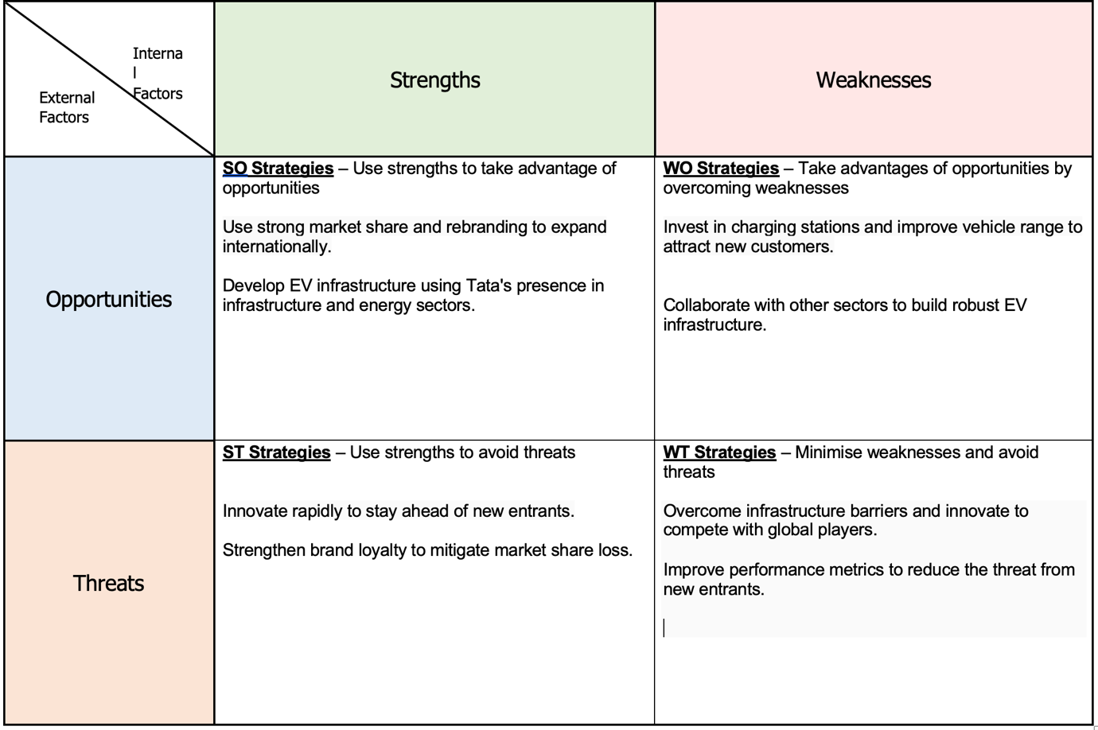

Tata Motors hold a strong leadership position in India, boosted even more by rebranding it's EV image. However developing infrastructure in India along with the limited vehicle range act as a significant weakness. The company's leadership position, strategic pricing, the decline in prices of lithium batteries, act as a solid foundation for expansion domestically and globally. Fuelling this even further with the presence of Tata in other sector. Despite these strengths the threat of new entrants can cause Tata to pressurise and reduce its prices To maintain its leadership, but this could mean imbalance in their financial plans. Addressing these challenges and staying ahead of competition through innovation and pricing Tata can sustainably maintain its long term leadership position.

Strategy Formulation and competitive positioning

Tata Motors positioning itself internationally and domestically. emphasising on following the differentiation and cost leadership Strategies of Porter's generic strategies. Rising its international sales from 9% in 2016 to 79.8% in 2018. This change implies that Tata is using its skills to its best for providing distinctive goods at competitive price globally (Sushil, Garg, 2019)
Furthermore the company's use of market segmentation strategies, has enabled it to produce models, And marketing plans, to meet the specific needs of Various customer segments, thereby improving marketing success and optimising return on investment. Tata Motors appears to be having a hybrid strategy of Differentiation and cost leadership. Allowing it to compete in a global scale and on a domestic scale. (Kumar, Sowmya, 2024).

Sustainability and strategic recommendations
According to Tata Motors corporate Responsibility (Tata Motors,N.D) They want to be Driven by a clear vision, to commit themselves to achieve complete carbon reductions across the company covering Scope 1, Scope 2, and Scope 3 emissions. By 2040 and 2045 respectively, the target is to reach Net Zero greenhouse gas emissions for their passenger and commercial vehicle operations. By 2030, they want to have 100% renewable electricity in running their operations. They also set interim science-based targets to ensure a low-carbon future. According to Chandra (2024) Shailesh Chandra Managing Director for Tata Motors said that This year, They focused on achieving Their sustainability goal of net zero emissions by 2040. They successfully reduced emissions for Scope 1, Scope 2, and Scope 3 in accordance with the SBTi glidepath. Plant operations have become more environmentally friendly by using renewable energy and implementing a sustainable waste management system.
While electric vehicle seems to be a sustainable option in India and is contributing towards sustainable India, This truly depends on the amount of renewable energy that is present in the electricity mix . India's electricity mix is heavily dependent on fossil fuels especially coal which accounts to almost 89.57% off electricity mix in India contributing to 68% of greenhouse gases (Chauhan, Anjum, 2024). In the recent years with the help of government incentives and policies, India has seen a rise of renewable electricity sources such as solar and wind in its electricity mix (Singh, Idrisi, 2020).Although the reliance on fossil fuels is heavy in India at this moment, the progression towards clean and renewable energy is growing at its rapid pace.

Strategic recommendation
- Infrastructure Development- Following a strategy used previously by Tesla, where Tesla had its own supercharging stations, which helped potential buyers overcome the fear of charging the vehicles on the go, this charging infrastructure has helped Tesla gain dominance in the US. (Chandler, 2016). Tata with the help of its subsidiary companies can setup infrastructure like Tesla, also making the stations charge themselves with solar. This way Tata will not only overcome the barrier of infrastructure but also work towards sustainability.

- Embedding solar panels- with the use of Solar photovoltaic panels embedded in the body of the vehicle. EV’s can generate its own electricity. There by overcoming the fear of range in potential customers.

- Investment in R&D- Constant research and development, will give rise to innovative solutions in order for Tata to have its leadership in market share, it is important for Tata to develop its own technology.

- Targeting Tier 2,3 cities- Targeting sub-urbanised and rural cities in India, can be a potentially big market for Tata Motors as the demand for 3 Wheeler electric vehicles is at its highest, and will help the growth of sustainability, in developing India. (Sankar Das et al., 2024)

Conclusion
Tata Motors driven by its cost leadership style and differentiation strategy, has achieved domestic dominance and Global presence also leveraging market segmentation to meet its diverse customer needs. The company aims for sustainability accompanied by carbon reductions goals. With Tata’s rebranding efforts, strong market share. Strategic plans are important for it to prevail dominance. Despite various strengths, Tata faces critical challenges in India such as the infrastructure development, increased competition has led to pressurised Tata to innovate rapidly, & to reduce its prices to meet the competition, this can lead to long term financial trouble and the power grid of India heavily dependent on fossil fuels. which makes Tata’s sustainable plans even more difficult. However Tata Motors are well positioned with their hybrid strategies and sustainable goals . With addressing the challenges of infrastructure investing in R&D and leveraging market segmentation. They have to be key essentials for maintaining their domestic dominance, followed by leading global dominance and achieving long-term success sustainably.

References

Agarwal, U. 2025, "Tata Motors Q3 FY25 Revenue Rises To Rs 113.6K Cr", Business world (India), .
Bhattacharyya, S.S. & Thakre, S. 2021, "Exploring the factors influencing electric vehicle adoption: an empirical investigation in the emerging economy context of India", Foresight (Cambridge), vol. 23, no. 3, pp. 311–326.
Chandler, D. 2016, "Electric Vehicle Adoption Showing Strength, Driving Charger Network Installations", Electrical Marketing, .
Chauhan, J. & Anjum, A. 2024, "Role of electricity generation technology in the long-term energy sustainability of India", Holistic approach to environment, vol. 14, no. 2, pp. 71–77.
Chandra, S. (2024). Business segments. [online] Available at: https://www.tatamotors.com/financials/79-ar-html/pdf/tata-motor-IAR-2023-24-Shailesh-Chandra.pdf [Accessed 21 Mar. 2025].
Das, P.K. & Bhat, M.Y. 2022, "Global electric vehicle adoption: implementation and policy implications for India", Environmental science and pollution research international, vol. 29, no. 27, pp. 40612–40622.
Gandhok, T. & Manthri, P. 2023, "Public policy and strategic business recommendations to accelerate adoption of stationary battery energy storage systems (BESS) in India", Management of environmental quality, vol. 34, no. 6, pp. 1516–1533.
Garg, A., Pattnaik, T., Verma, S.R., Ballal, M.S., Wath, M.G. & Wakode, S.A. 2023, "Addressing Challenges and Promoting Standardization in EVCS: A Review", IEEE, , pp. 1.
Gautam, D. & Bolia, N. 2024, "Understanding consumer choices and attitudes toward electric vehicles: A study of purchasing behavior and policy implications", Sustainable development (Bradford, West Yorkshire, England), vol. 32, no. 5, pp. 4895–4915.
IBEF (2024). Electric Vehicles: Electric Vehicle Industry in India and its Growth. [online] India Brand Equity Foundation. Available at: https://www.ibef.org/industry/electric-vehicle# [Accessed 18 Mar. 2025].
Kumar, M.P. & Sowmya, R. 2024, "FINANCIAL INVESTMENT IN TATA GROUP", International journal of management research and reviews, vol. 14, no. 4, pp. 262–271.
Morris, K. 2023, "Interview - Shailesh Chandra: ‘We Currently Command 85 Percent Of The Market Share in EV Industry’", Car India, .
Naskar, A. 2024, "Feature: Vanishing Vroom Vroom", Impact, .
Oriel, A. 2024, "Indian EV market heats up: M&M, Maruti, and Hyundai gear up to challenge Tata and MG in 2024 showdown: The growing Indian EV market is poised for fierce competition as M&M, Maruti Suzuki, and Hyundai prepare to launch a clutch of new EVs next year, challenging leaders Tata Motors and JSW MG Motor India. It's game on", Business today (New Delhi, India), .
Qureshi, N. 2023, "TATA.ev takes charge as the new face of Tata Motors' EV business", afaqs, .
Rajmal & Gupta, K. 2025, "Fuelling Electric Vehicles Growth: Factors that Matter in India’s Electric Vehicles Growth Story", Studies in microeconomics, vol. 13, no. 1, pp. 76–105.
Reuters (2025). Tata Motors looks to local battery play as EV competition rises. [online] The Economic Times. Available at: https://economictimes.indiatimes.com/industry/renewables/tata-motors-looks-to-local-battery-play-as-ev-competition-rises/articleshow/117462253.cms?from=mdr [Accessed 18 Mar. 2025].

Sankar Das, S., Debadatta Behera, D., Bijeta Nayak, B., Kumar Patjoshi, P. & Chandra Mohanty, R. 2024, "Towards Sustainable Mobility: A Framework and Strategies for Rural Transportation Sustainability", Journal of physics.Conference series, vol. 2818, no. 1, pp. 12019.
Shantanu, S. (2023). Tata Power: Pioneering India’s sustainable energy future. [online] ieefa.org. Available at: https://ieefa.org/resources/tata-power-pioneering-indias-sustainable-energy-future [Accessed 19 Mar. 2025].

Serohi, A. 2022, "E-mobility ecosystem innovation – impact on downstream supply chain management processes. Is India ready for inevitable change in auto sector?", Supply chain management, vol. 27, no. 2, pp. 232–249.
Singh, A.K. & Idrisi, A.H. 2020, "Evolution of Renewable Energy in India: Wind and Solar", Journal of the Institution of Engineers (India) Series C, vol. 101, no. 2, pp. 415–427.
Sushil & Garg, S. 2019, "Internationalization of Tata Motors: Strategic Analysis Using Flowing Stream Strategy Process", International journal of global business and competitiveness, vol. 14, no. 1, pp. 54–70.
"Tata Motors Enters Mid-Sized SUV Segment With Curvv.EV, Starting At Rs 17.49 Lakhs", 2024, Business world (India), .
Tata Motors (2023). Tata Motors | Agile, new-age & future-ready. [online] Tata Motors - Largest Automobile Manufacturer, Biggest Automobile Company in India. Available at: https://www.tatamotors.com/corporate-responsibility/planet-resilience/ [Accessed 20 Mar. 2025].

