5/10/2018
A Critical Analysis on the Effectiveness of Celebrity Endorsements within the Sports Industry.

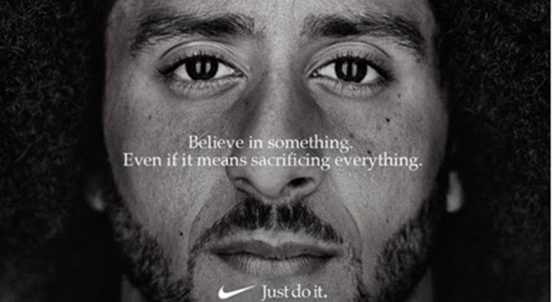
Josh Lewis (P134269)
Mba (Masters of business administration) University of Wales Trinity Saint David

Acknowledgements
On the completion of this study, I would firstly like to thank Beth Cummings for her continuous support throughout the academic year. On reflection, the support Beth provided was imperative to the successful completion of this study. Beth’s guidance throughout the study allowed me to meet deadlines successfully and satisfactory. Beth’s support not only made for a successful completion of the study but also a thoroughly enjoyable experience.
I would also like to extend my thank you to those who completed the questionnaire survey and especially to those who participated in both focus groups which was a significantly important addition to this study.

Abstract
This study examined the effectiveness of celebrity endorsements within the sports industry whilst also taking in to account the wider environment and marketing landscape. To achieve this there were two set objectives that were analysed to support the aim of this study which included an analysis on paid versus unpaid endorsements and also the influence celebrity endorsements can have on consumer behaviour.
The research within this study followed an inductive approach where conclusions were not pre-determined and derived from the research findings and analysis of data both primary and secondary. This allowed for a more thorough analysis free of judgment, where the author investigated the topic with an open mind. The literature review consisted of two main focus areas in line with the studies objectives. The area of consumer behaviour and how it may be influenced by endorsements is a significantly large area to research, for this particular reason the author narrowed the research to two key areas. This disciplined approach allowed for a deeper analysis and investigation in to the key important areas without getting distracted by unnecessary data and information.
The first main scope of research was the analysis on the effectiveness of celebrity endorsements and the impact they can have on consumer behaviour. The research analyses key areas that celebrity endorsements can impact which included brand equity and brand image. This section of the study also acknowledged and discussed key limitations of celebrity endorsements which included the financial cost and behaviour of celebrities in question.
The second key area within the literature review was the analysis of paid versus unpaid endorsements. This chapter identified how the introduction of social media has created alternative endorsement opportunities away from the traditional approach and strategy. The effectiveness of social media influencers was discussed and compared against celebrity endorsements; findings included how social media influencers have higher engagement rates but with a limited reach.
The research methods utilised allowed the author to gain both primary and secondary data to strengthen the study. The study commenced with the research of literature via sources such as books, online journals and websites. This allowed the author to gain a greater understanding of the area before tailoring the research specifically to this study via a more exploratory research approach. Primary data derived from an online survey and two focus groups that the author conducted. The questionnaire survey was completed by 102 respondents. The findings from the survey and focus groups complemented and supported the findings that derived from the secondary research and literature review. The number of respondents within the survey and the participants within the focus group may have only been of a small sample size in comparison to the sports industry it provided a small insight in to the influence celebrity endorsements can have on consumer behaviour.
The findings suggested that celebrity endorsements can be significantly effective, however unpaid social media influencers can provide a far more economical and effective approach on a lower scale. The type of organisation, industry and endorsement will determine the most effective approach to endorsements.

Table of Contents
- Introduction ………………………………………………………………………………………………………5
  - Endorsements ……………………………………………………………………………………..6
  - Celebrity Endorsements ………………………………………………………………………6
  - Athlete Endorsements …………………………………………………………………………7
  - Influencers …………………………………………………………………………………………..8
  - Importance of Study …………………………………………………………………………….8
- Paid V Unpaid Endorsements …………………………………………………………………………..10
  - Paid Endorsements …………………………………………………………………………….10
  - Brand Image ……………………………………………………………………………………….11
  - Brand Equity ……………………………………………………………………………………….12
- Limitations of Paid Endorsements ……………………………………………………………………14
  - Financial Cost ……………………………………………………………………………………..14
  - Intended Target Market ……………………………………………………………………..14
  - Celebrity/Athlete Risks ……………………………………………………………………….15
- Paid Endorsement Discussion Points ………………………………………………………………..16
- Unpaid Endorsements ………………………………………………………………………………………17
  - Influence of Social Media …………………………………………………………………...17
  - Social Media Influencers ……………………………………………………………………..18
  - Unpaid Micro-Influencers …………………………………………………………………...19
  - Paid v Unpaid Analysis …………………………………………………………………………20
- Consumer Behaviour …………………………………………………………………………………………22
  - The Source Credibility Model ……………………………………………………………….22
  - The Source Attractiveness Model …………………………………………………………24
- Research Methodology ………………………………………………………………………………………25
  - Research Approaches …………………………………………………………………………...25
  - Research Methods ………………………………………………………………………………..25
    - Secondary Research …………………………………………………………..25
    - Primary Research ……………………………………………………………...26
  - Qualitative/Quantitative Data ……………………………………………………………….26
  - Methods Used ……………………………………………………………………………………….27
    - Alternative Methods ………………………………………………………….28
  - Limitations of Research ………………………………………………………………………….29
- Findings ……………………………………………………………………………………………………………….30
  - Questionnaire Charts …………………………………………………………………………………….30
- Focus Groups 1 & 2 Analysis ……………………………………………………………………………………….44
- Conclusion ………………………………………………………………………………………………………………….47
- Appendix …………………………………………………………………………………………………………………….50
  - Questionnaire Survey ………………………………………………………………………..50
  - Focus Group 1 ……………………………………………………………………………………53
  - Focus Group 2 ……………………………………………………………………………………56
- Reference List ……………………………………………………………………………………………………………..60
- Bibliography ………………………………………………………………………………………………………………..65

- Introduction
Aim
A critical analysis on the effectiveness of celebrity endorsement within the sports industry.
Objectives
- A critical analysis of paid for endorsement v unpaid endorsement within the sports industry.
- An evaluation of the influence of celebrity endorsement on consumer behaviour within the sports industry.

1.1 Endorsements
This research seeks to explore the effectiveness of celebrity endorsement within the sports industry. The term ‘endorsement ‘will first be defined and analysed to allow a deeper understanding of the concept. Endorsements are common practice within advertisements and the effectiveness can sometimes be difficult to measure (Knoll, 2017). Walker (2018) argued that since the introduction of social media, the method of endorsements has continued to grow and this research will seek to understand just how effective endorsements really are.
Cromwell (2018) defined the term endorsement as an advertising practice commonly used within the marketing environment to promote a product or service through utilising recognisable people such as celebrities or athletes with the aim of influencing consumer behaviour and brand awareness.
The influence that celebrities have on celebrity endorsements will be evaluated to help achieve the aim of this dissertation that was to evaluate the effectiveness of celebrity endorsements. The objectives include the topic of consumer behaviour and how it could be influenced by celebrity endorsements. Shi (2013) defined consumer behaviour as a study on consumers to understand the processes they undertake, consumer behaviour identifies how a consumers emotions and attitudes can influence their purchasing decisions. This dissertation will seek to explore the endorsement environment; taking into consideration the advantages and limitations of paid for and unpaid endorsements whilst also acknowledging the power of social media influencers and how they can disrupt the market.
Griffin (2014) argued that the two industries that have appeared to significantly exploit the idea of endorsements is the fashion and sports industries that both include high profile and recognisable endorsement within their advertisement campaigns. Griffin (2014) continued to state that it seems difficult to foresee a future where celebrities are not involved in product marketing and that endorsements will more than likely escalate due to new social media platforms being introduced on the already powerful and accessible platform of social media. The rise in social media has led to the introduction of ‘social media influencers’ that have gained market share within the endorsement environment and will be defined further in this introduction and discussed throughout this dissertation.
1.2 Celebrity Endorsements
Khan (2017) defined the term ‘celebrity endorser’ as a person with a degree of fame willingly supporting a product or service in a way that is visible and clearly communicated to the public. Khan continued to argue that there are five dimensions associated with celebrity endorsement that are:
- Celebrity Attractiveness
- Celebrity Trustworthiness
- Celebrity Meaningfulness
- Celebrity Likeability
- Celebrity Expertise
Khan (2017) argued that the more dimensions the celebrity has then the greater benefits for the organisation and the more effective the endorsement has been. The five dimensions highlighted are of paramount importance when an organisation selects a celebrity to endorse their products; the organisation will likely seek celebrities who have a clean image and a trustworthy reputation to represent their brand in the best possible manner. An organisation will ideally utilise role models who may have a large following or fan base in the hope of achieving greater brand equity and awareness whilst also promoting sales for a particular product or service (Haroon, 2015). Utilising ‘role models’ to endorse a brand appears to be the traditional method of endorsements and still commonly used today such as David Beckham endorsing H&M, Tiger Woods endorsing Nike and Jennifer Anniston endorsing Smart Water.
Vemuri (2004) believes that the first celebrity endorsement occurred in the late 1700’s where organisations would use royal endorsements as a tool to develop their brand; royal endorsements are still used today and are defined as the Royal Warrant Holders Association. A royal warrant is the recognition for a brand that has supplied products or services to the queen or other members of the royal family for at least five years and who currently still have a trading agreement. This highly respected award can also be perceived as an endorsement that allows a brand to develop their brand image and potentially raise brand equity, both considered important benefits of celebrity endorsements (Baker, 2001).
The first notable celebrity endorsement within the sports industry was in 1894 where baseball player Honus Wagner endorsed baseball bats manufactured at a local Louisville company (Forn, 2014).
1.3 Athlete Endorsements
Athletes are a common marketing tool within sporting advertisements and athlete endorsements have become a major financial injection into the industry; there are a number of benefits of utilising athletes for marketing purposes but most notably because of the impact, they can provide on brand equity and scope of communication. In relation to Khans five dimensions it is clear to see how athletes can be an effective strategic marketing tool with their fanatical followers and constant media and social media attention, however not all athlete endorsements have been effective and their limitations and considerations will be evaluated further within this dissertation.
Andrews (2004) argued that the development of marketing activities within the sports industry has been a direct effect of commercialisation within the industry leading to more opportunities for both organisations and athletes. Nissan Vice President, Jean Pierre Diernaz stated that sport has the power to cohere marketing messages on a major international level and is significantly more effective in comparison to other industries (Diernaz, 2017) . This belief has appeared to increase the level of commercialisation within the industry by the involvement of organisations who may not reside within the sports industry but identify the industry as an opportunity for growth and development.
The popularity of endorsement deals has increased allowing not just the top athletes to earn revenue streams outside of their particular sport. The obvious benefits include the financial compensation that athletes can expect to receive. Nike are an organisation that clearly value the strategic tool of celebrity endorsements and have offered ‘lifelong’ contracts to athletes which continue even after the athlete retires, the three athletes include NBA stars Michael Jordan and Lebron James with the third and most recent being football player Cristiano Ronaldo (Garcia, 2016). These lifelong contracts that Nike have developed displays how the attractiveness and popularity of the celebrity appears to be more important than their sporting ability, it has been reported by CNN (2016) that Nike have paid Michael Jordan over four-hundred million since 1993 even though he retired in 2003. These lifelong contracts may also be used to achieve sustainable competitive advantage over other big brands such as Adidas; the longevity of the contracts appears to display how an athlete’s value does not decrease after retirement due to their name becoming a brand within themselves leading to further marketing opportunities. Rovell (2010) argued that George Foreman’s grill deal has become the best endorsement in sports marketing history and has significantly altered the legacy that the former sports star will leave behind by stating that George Foreman is significantly more recognised due to the grill endorsement than his boxing career. Foreman also reported earning significantly higher than what he made during his sports career.
1.4 Influencers
Freberg (2010) defined social media influencers as “third party endorsers” who use their social media platform and presence to shape their audiences’ attitudes and can be either paid or unpaid. Smith (2017) argued that influencers can be paid but some will work for free if they are passionate about a particular brand and these customers then become brand advocates and may receive free products or services in return for their work.
Since the invention of social media and its rapid rise in networks such as Twitter and Facebook a new strategy of ‘influencers’ as opposed to celebrities appears to be commonly used. This involves a person with a large following on their social media platform with the ability to communicate to a large quantity of other users and could potentially influence purchasing intentions (Young, 2017). Social media influencers may not be household names such as David Beckham at H&M but still have the platform to connect and communicate with a wide target audience, the benefits of the ‘influencers’ will be evaluated within this study to determine its effectiveness in comparison to the traditional endorsements. This study will identify and state recommendation’s that will derive from the research undertaken.
Looking at the numbers of followers an influencer has may display their potential reach however, there has been some complications with this that brands will need to consider. Since the popularity of receiving mass followers and the opportunities it can provide an influencer there has been reports of people utilising bots and paying for fake accounts to follow their social media page in order to give the impression that they have the ability to reach a wide target market. A recent New York Times investigation into Twitter followers released that there has been an American company called Devumi who actively sells Twitter followers to actors, models and businesses. According to the New York Times, the company has sold over 200 million fake followers to approximately 39,000 customers including the sale of 600,000 twitter followers to Paul Hollywood, the judge on UK television show the Great British Bake Off (Palmer, 2018).
1.5 Importance of Study
When evaluating the aims and objectives both primary and secondary research will be used to support the conclusions and findings within each chapter. Primary research will include the use of questionnaires and focus groups and secondary research will derive from books, journals and online sources. The research undertaken will include both qualitative and quantitative data in order to achieve greater results from a wider target audience.
The importance of this dissertation is to understand the effectiveness of celebrity endorsements within the sports industry; the sports industry has become a highly lucrative and heavily commercialised industry that attracts marketing activities from a wide range of other industries including club sponsorship to individual endorsement deals (Whiteside, 2011). This dissertation will evaluate the effectiveness of celebrity endorsements to identify to what extent they may influence consumer decisions. Since the rise in social media, the new method used to communicate to consumers that includes the social media influencers as previously mentioned. Influencers have appeared to disrupt the traditional celebrity endorsement model and could potentially provide a more effective alternative to the traditional concept of celebrity endorsements that brands will need to be aware of.

2.0 Paid v Unpaid Review of Literature
The marketing landscape within the sports industry has been undergoing transformation since the rise in social media. Harris (2018) argued that there has been a significant transformation in how celebrities communicate and engage with the public and labelled the relationship between social media and the sports industry as a ‘match made in heaven’ due to the engagement of fans transforming from just watching a sport to also watching the celebrities or athletes throughout their everyday life. Salmi (2016) argued that the most important factors that lead to the success of sports teams and their brand is commercialisation, branding and also customer relationship management that can be significantly enhanced via social media platforms due to the athletes having direct communication to fans as opposed to going through other media networks that may act as a middle man. The level of involvement of an athlete and the relationships they can develop with fans can also significantly develop consumer buyer behaviour; Housman (2000) defined buyer behaviour as the contributing factors to a consumer’s decision to engage with a brand; factors include attitudes, emotions and intentions. Athletes with higher levels of involvement or brands with greater CRM (customer relationship management) process may significantly influence consumer behaviour.
Along with the change in the relationship between athlete and fans within the sports industry, this has had a direct impact on the concept of celebrity endorsement within the industry. With the greater communication tools now available to athletes and the general public, endorsement deals have entered a new market of social media influencing where celebrities and ‘influencers’ can share their favourite products or brands with their social media followers even though they may be being paid to do so (Hosanager, 2017). Berthon (2012) argued that the power of social media must be understood by brands across the world; social media can bring many opportunities and benefits for a brand but can also bring implications and negative public attention. Berthon (2012) used the example of Dave Carrol who wrote the song ‘United Breaks Guitars’ and uploaded it to Facebook and YouTube where the video then became viral; the song was in relation to the poor customer service Mr Carrol received when his guitar was broken by baggage handlers whilst on a United airways flight. Mr Carrol spent over 12 months in a legal battle with the airline to be compensated for the damages however United refused and rejected his compensatory claim which led to the disgruntled consumer writing the song ‘United Breaks Guitars’. The video was viewed millions of times and was then shown on TV networks such as CNN; the result of this video was an apparent loss of 20% market capitalisation for the company with an estimated financial cost of $180 million dollars. A recent sporting example of the power of social media is the video of ex-footballer and TV pundit Jamie Carragher appearing to spit at a 14-year-old girl from his car window that was filmed on camera. The video has received over a million views on YouTube, has also been shared widely on all social media platforms leading to the pundit having to pay compensation to the victim, and was suspended from Sky Sports (Moyes, 2018).
2.1 Paid Endorsements
The most popular method of celebrity endorsements is the method of ‘paid endorsement’ that we see throughout our everyday lives from our favourite celebrity’s social media content to TV commercials with celebrities such as Jamie Redknapp wearing suits from high street retail brand, Burtons where these celebrities are then financially compensated (Elberse, 2012) . This method of endorsement is also the most traditional approach where brands can specifically target a celebrity or somebody with a degree of fame to publicly promote their brand or products in a positive manner. The use of celebrities appears to be a strategic marketing tool to influence consumer-purchasing decisions. Whitbourne (2011) describe paid endorsement deals as an act of manipulation; a strategy with the aim of utilising or building emotional connections that the public may hold with the celebrity hoping that these connections will then be transferred to the brand they are representing. As stated in the introduction the celebrity endorsement strategy is not new and has been around for a very long time, there has appeared to be a rise in the number of endorsement deals and their financial value that they can create for both celebrity and brand. Within the contemporary marketing environment, on average in 1970 a person would see 500 advertisements a day to now being exposed to an apparent staggering 5,000 advertisements (Johnson C. , 2016). The sports industry in particular has seen significant growth not just in its financial value but also the shear amounts of endorsement deals affiliated to an individual athlete, David Beckham at this present time is reported to be endorsing a range of brands including Adidas, H&M, Gillette and Haig Club Whiskey. These endorsements are believed to be accumulating a collective annual worth of around £20 million pounds even though the ex-football star retired over five years ago (Platt, 2018). This year Rory Mcilroy signed a ten-year deal with Nike to wear the brand for a figure of $300 million dollars (Reid, 2018). The significant growth in the value of endorsement deals would appear to suggest that there must be some form of return on investment for the major brands who are willing to pay individuals extraordinary amounts of money. There are a range of benefits associated with paid endorsement deals that may include the development of brand image and an increase in brand equity (Johnson, 2017). Along with the benefits there are also some limitations that should be understood when discussing paid for endorsements that include the misconduct of the enduring athlete, lack of honesty and the risk of celebrities becoming ‘over endorsed’ and losing credibility. However if the company selects an appropriate endorser to promote their brand then there appears to be strong evidence that a return on their investment is possible. An advantage of using paid endorsements is that a company can selectively chose who they believe can have the most positive impact on their brand image, which could potentially influence consumer-purchasing decisions and increase brand equity.
2.2 Brand image
Martenson (2016) defined brand image as the effect of how a brand is perceived by the public including potential consumers. As previously stated a paid endorsement can be the most effective method to obtain an endorser who can effectively promote the brand; Bergkvist (2016) argued that there must be a ‘celebrity-brand fit’ in order to achieve a greater positive impact on the brand image. Bergkvist (2016) continued to define the concept of ‘celebrity-brand fit’ as the similarity or consistently between the celebrity and brand. For the endorsement to have the greatest impact on the brand, it appears that the endorsement must firstly be believable; for example, the Rory Mcilroy and Nike endorsement appears to be effective and genuine due to Nike being associated with manufacturing golf attire and products with Mcilroy wearing the golf attire whilst playing golf. The celebrity-brand fit however doesn’t always appear to be essential as previous successful and lucrative endorsement deals have had a weak celebrity-brand fit but were still successful such as the David Beckham and Pepsi endorsement that lasted ten years and cost the company over £20 million pounds over the ten year period (Klayman, 2008). Even though Pepsi position themselves within the sports market via their marketing activities in extreme sports, similar to Red Bull It appears hard to believe that a sporting icon such as David Beckham indulges in high sugar content fizzy drinks. With his endorsement earnings gaining media attention, it appears clear that consumers were aware that the celebrity in question was being paid to promote the brand. This did not seem to affect the effectiveness and longevity of the endorsement. Chan (2017) investigated the effect a paid endorsement has on brand image and brand awareness; the authors findings suggested that using celebrities could increase both brand image and awareness and continued to suggest that utilising a celebrity can increase purchase confidence, encourage the trial of a product or service and can increase brand retention. The study by, Chan (2017) also suggested that participants within her study were most likely to recall celebrity endorsers if they considered them either attractive or funny and not what their background appeared to be.; this may suggest how the Pepsi and Beckham endorsement was successful even with a weak celebrity-brand fit. A benefit of paid endorsement is that a brand can carefully select an athlete or celebrity that they may consider attractive or funny in the hope of influencing consumer purchasing decisions.

2.3 Brand equity
Johnson (2017) defined brand equity as the added value a brand brings to a product or service beyond its functional benefits and proceeded to argue that celebrity endorsements are the most popular and effective marketing tool utilised to raise brand equity whilst also having a direct impact on consumer behaviour. Murugananthan (2009) argued that a large number of consumers believe that the endorsers do not use the product themselves and are aware of the financial rewards the celebrity can receive; the author continued to argue that this does not affect the effectiveness of the endorsement. This argument appears to disagree with (Khan 2017) belief of the five dimensions associated with celebrity endorsements within the introduction. One of the key concepts being ‘trustworthiness’ where Khan (2017) stated the importance of making an endorsement believable; however this argument is not supported throughout this literature review in relation to the David Beckham case study where consumers appeared to be aware that Beckham would not be indulging in Pepsi, however the endorsement was still considered a success.
Johnson (2017) argued that there are five areas that an athlete or celebrity endorsement can develop in order to influence consumer behaviour, the five areas are stated below;
- Brand Recognition
- Brand Insistence
- Brand Loyalty
- Brand Preference
- Brand Recall
Johnson (2017) argued that within the sports industry these key areas could all be developed via the utilisation of athletes within their advertising campaigns.
Rath (2013) defined brand recognition as the extent to which a person can identify a brand or product based on variables such as logo or advertising campaign. This definition appears to support the argument that even if an endorsement has a low brand-celebrity fit it may still be effective if the endorsement is remembered resulting in an increase in brand recognition. By utilising high profile celebrities or athletes it is more likely that the endorsement will be remembered, especially by the fans or followers of the endorser. Pugazhanthi A et al (2011) argued that celebrity endorsed products are more recognisable than without the use of celebrities and stated that an endorsement can increase both brand recognition and recall, the authors then concluded that the consumers purchasing attitudes can be significantly influenced by a celebrity endorsement.
Although there appears to be an abundance of benefits to celebrities or influencers wearing a specific brand there may also be dis-advantages for brands that may not want to be associated with a particular celebrity or organisation. Retailer, Abercrombie & Fitch reportedly paid the cast of Jersey Shore to not wear or endorse their products on the show due to fear of the significant damage it may have on its brand image (Sweney, 2011).
According to Johnson (2017) the second area that a celebrity endorsement can impact to influence consumer behaviour is the idea of ‘brand insistence’. Pleshko (2006) defined brand insistence as a deep sense of customer loyalty where a consumer will not be happy with any other brand or alternative product/service. Within the sports industry children who identify Cristiano Ronaldo as a role model may only want to wear Nike boots and would not accept the idea of an Adidas pair as those are not endorsed by their favourite athlete.
There appears to be strong evidence to suggest that celebrity endorsements can increase brand equity, which can in turn influence consumer-purchasing intentions resulting from an effective endorsement.

3.0 Limitations of Paid Endorsements
The research undertaken within this chapter appears to suggest that celebrity endorsements are in fact significantly effective; however, there appears to be some limitations to organisations paying a celebrity to promote their brand. There are a range of limitations that organisations will need to be aware of which includes the financial cost of an endorsement, their intended target market and the image/reputation of the endorser they pay to represent their brand along with some other considerations that will need to be identified. Soni (2011) argued that although a celebrity endorsement can develop the attractiveness of an advertisement or product there will always be risks that will need to be monitored to avoid the endorsement tarnishing the brand of the endorsed product. The following are a number of limitations and potential risks that will need to be evaluated.
3.1 Financial Cost
The research has indicated that endorsements can generate income for celebrities however from the companies’ perspective they can come at a significant financial cost. Within the sports industry, Ronaldo’s lifetime contract with Nike is reported to cost the organisation around one billion euro, by attaining a high profile athlete to promote a brand the organisation may achieve competitive advantage but it can be difficult to conclude whether the endorsement has provided a return on investment at such a large cost (Khoury, 2017). Khoury (2017) continued to argue that using lower profile or local celebrities that can still have an influence on consumers may be an effective investment for organisations with a limited financial budget as high profile figures such as David Beckham and Michael Jordan may not be realistically affordable. When identifying celebrity endorsement as an effective strategy, organisations will need to be aware of the financial implications that may affect the business.
A study conducted within the Madrid Business School by, Ana Rumschisky concluded that celebrity endorsements do in fact have a measurable impact on a brand that can allow for the increase in product price. According to the study, consumers are prepared to pay 20% more for the same products because of who is endorsing the brand in question; the study also argued that consumers can be influenced to purchase celebrity endorsed products through their imaginative aspirations (Devale, 2009).
3.2 Intended Target Market
Before identifying celebrity endorsement, as an appropriate method to influence consumer behaviour the organisation will firstly need to gain a deeper understanding of their target market, this can derive from an effective market research analysis to determine its effectiveness. Fotinelli (2010) argued that children and young adults purchasing intentions are most likely to be influenced by a celebrity endorsement. Looking at the sports industry it is reported that Nike sell approximately slightly over 120 million pairs of football boots per year around the globe, with the sport predominantly played competitively by children and young adults it appears that the Ronaldo endorsement deal may be appropriate and also effective (Weiss, 2018). Fotinelli (2010) released a study on behalf of the Mountain Equipment Cooperative who are a Canadian consumer cooperative; the analysis stated that 35% of study respondents between the ages of 18-34 would trial a product that was endorsed by a celebrity where only 14% of adults aged 35-54 and 11% of respondents aged 55+. This study appears to suggest that celebrity endorsements may be more effective if targeting a younger generation, this research study appears to identify why celebrity endorsements are popular within the sports industry where participants are likely to be of a younger age. The research findings provided appear to demonstrate how celebrity endorsements can influence the consumer behaviour decision making process, and the activities associated with the purchase and usage of a product when a consumer decides to engage with a brand; this can be significantly encouraged by a celebrity endorser and different generations may be more influenced by an endorsement (Sokolovska, 2016).
3.3 Celebrity/ Athlete Risks
Another important consideration to understand is the risks associated by the selected celebrity to endorse a brand. Soni (2011) highlighted four key factors that are, negative publicity, multiple product endorsements with other brands, tarnished brand image and misleading advertisement that can also all lead to high financial risk due to the implications these factors may provide. White (2016) stated that an athlete being associated with other brands is at risk of being “over-endorsed” which can lead to an ineffective endorsement due to variables such as a lack of trust with the brand and celebrity in question. Celebrities who endorse a number of brands can put themselves at risk of legal action if there is a cross over. In 1999 Nike were sued by the Acushnet Company because they used Tiger Woods in a golf ball and golf attire commercial even though at the time Woods was being sponsored by the Acushnet company that manufactured the golf brand Titleist (Bloomberg, 1999). The Behaviour of a celebrity can also provide risks as negative media attention surrounding the celebrity may have implications on the brands they represent. Within the sports industry there are many endorsement deals that were terminated early due to the behaviour of the endorser such as in 2016 where Nike terminated the endorsement deal with boxer Manny Pacquiao due to the athlete making homophobic remarks in a Filipino TV interview (Rovell, Nike cuts ties with Manny Pacquiao after derogatory comments, 2016).

4.0 Paid endorsement Key discussion Points
It appears that celebrity endorsements can be highly effective and can be used as an effective marketing strategy, however, there are limitations highlighted that can affect the profitability and effectiveness of the strategy. Khan (2017) and Jayapalan (2017) undertook a study on the influence that celebrity endorsements can have on consumer purchasing intentions and their findings were as followed below,
- Purchasing decisions can be significantly influenced by products endorsed by a celebrity.
- A celebrity endorsement can develop positive consumer attitudes and perception towards an endorsed product.
- Negative brand publicity can have negative effects on the celebrity endorser and vice versa; this may indicate why brands are quick to end relationships with endorser during times of controversy.
- The study implies that there is a strong correlation between brand acceptance and celebrity advertisements.
There appears to be strong evidence to suggest that celebrity endorsements are incredibly effective however as mentioned there are limitations such as financial costs. Since the rise in social media, it has changed the landscape of endorsement as social network platforms such as Facebook, Twitter and Instagram have provided a new platform for organisations to utilise to their advantage. These platforms can also offer a more cost effective strategy by selecting un-paid influencers that could potentially have the same impact as paid celebrity endorsements. The Following chapter evaluate un-paid endorsements and their effectiveness.

5.0 Unpaid Endorsements
Unpaid endorsements also known as covert endorsements are when a celebrity or high profile figure wears a brand because they want to wear it and are not influenced by the organisation to do so, they also receive no financial payments unlike paid endorsements that have previously been discussed (Hackley, 2011). A common type of covert endorsements are unpaid testimonials where a celebrity or high profile figure such as an athlete, YouTube blogger , or Instagram influencer can say or report something positive about a brand without being paid or influenced to do so (Duncan, 2018). A high profile figure wearing a particular brand or reporting positive feedback about a brand without being paid will likely influence consumer purchasing intentions just like a paid endorsement would, perhaps even more (Duncan,2018). Duncan then continued to use the example of Chef Delia Smith who used a particular cooking utensil on her cooking show, the brand then saw a significant increase in sales following the show. A recent example includes Megan Markle being photographed wearing a Strathberry handbag; following these images the specific hand bag apparently sold out within 10 minutes; the company’s website traffic reportedly increased by almost 5000% (Lo, 2018).
Rotfeld (2008) argued that covert marketing is an organisation marketing actions where consumers believe that the actions are not influenced by an organisation, i.e. a celebrity wearing a Nike shirt without being paid or sponsored by Nike or Delia Smith using a certain utensil without being paid to do so. Rotfeld (2008) continued to argue that unpaid endorsements can be extremely effective and can significantly influence consumer behaviour; he supported his argument by suggesting that the public are generally sceptical when it comes to paid advertisements so random unpaid publicity or even random endorsements by members of the public in the street can provide a more persuasive sales message. Rotfeld (2008) concluded by suggesting that the public are wary of paid endorsements because of their deceptive influence on consumers. Murugananthan (2009) argued that there was no evidence to suggest that paid endorsements are less effective if consumers are aware of payments the endorser will receive or not. Within the sports industry the ‘old model of paid endorsements’ are still extremely popular and some may argue effective, however; Davies (2015) believes that the ‘new model of endorsements’ using social media platforms for celebrity endorsements and communications can offer free advertisements that can be greatly enhance the endorsement potential and can significantly influence consumer decisions. The change in the marketing landscape has be highlighted throughout this study and, Davies (2015) appears to be referring to that concept when she compares the old versus new model of celebrity endorsements. The old model appears to be the traditional paid advertisements through TV networks and newspapers where the new model targets social media platforms and can be paid or unpaid. There appears to be strong evidence to suggest that social media has become a revelation within the marketing industry.
5.1 The Influence of Social media
The invention of social media has affected not only the business landscape but also the consumers everyday lives, the recently published ‘Global Digital Report 2018’ stated that there are over 3.1 billion social media users which equates to 42% of the entire global population (Chaffey, 2018). Social media appears to be a highly attractive avenue for endorsements due to it being convenient to use and having the ability to target billions of people, this can also be a cost effective strategy as opposed to the old model of endorsements (Chaffey, 2018). The celebrity endorsements on the social media platform can still be paid endorsements via a celebrity or athletes social media page such as Gareth Bale endorsing the new ‘Wish app’ which is a free shopping app that can be downloaded on androids and tablets. The campaign also targeted Paul Pogba and Neymar Jnr with the advertisements being published on Twitter, Facebook and Instagram (Beer, 2018). Sam Jones, the managing director of the shopping app stated that as a young brand their aim of the campaign was to build trust and legitimacy and argued that by using the sports stars it allowed them to start telling their story to the world (Jones S. , 2018). The campaign using sports starts on a social media platform was hugely effective with the Neymar video being viewed over 2 million times in just 2 hours demonstrating just how powerful social media can be (Beer, 2018). Being able to reach a large target audience in a short amount of time appears to be the ideal scenario for brands seeking publicity, however to do this there appears to be more cost effective options as opposed to using leading sports stars. The rise in social media has introduced the role of ‘social media influencers’ that brands can use to their advantage.
5.2 Social Media Influencers
Glucksman (2017) defined the term ‘social media influencer’ as a third party endorser who has the ability to shape audiences attitudes via the use of social media channels such as Facebook or Twitter. Social media influencers can be a more cost effective tool as opposed to using celebrities or athletes, social media influencers can be unpaid and they may do it as a hobby however the more effective influencers with the ability to target a wide target audience may be paid or expect to be paid (Fastenau, 2017). The effectiveness and cost of utilising social media influencers will range from using micro-influencers that can be everyday people but with a large social media following of around 10,000 up to celebrity influencers such as Kim Kardashian who reportedly earns $500,000 for every post (Fastenau, 2017).
Berger (2018) defined a micro-influencer as a person with the ability to achieve a greater than average communications reach or influence via word of mouth within the marketplace; these influencers are not celebrities but may work in their category or can simply be knowledgeable and authentic with their reccommendations. Berger (2018) continued to argue that influencers are more prominent within the sporting good, fashion and fitness industry; even though they communicate to a limited target audience, their engagement rates are much higher than macro-influencers and are more likely to be unpaid. Although micro-influencers have a limited target audience this can often be expanded due to growth in their public image. A successful micro-influencer within the sports industry who seen a significant growth in his potential target audience is fitness guru Joe Wicks however; his success may have transformed him from a micro-influencer to a more macro-influencer. A recent study by the Keller Fay group (market research Company) on the effectiveness of micro-influencers concluded their findings in to the three key findings below:
- 82% of consumers are ‘highly likely’ to act upon an influencers recommendation as opposed to 73% who would act upon a recommendation by an average person.
- Micro-influencers tend to have a wider range of influence on different groups of people from different socio-ethnic and socio-economic backgrounds
- 94% of study participants believed that influencers are more believable and credible.
- Micro-influencers have between 25-50% engagements per post.
Nolk (2017) defined a macro-influencer as a person with the ability to reach an audience of between 10,000 – 1 million people; Nolk argues that even though Macro influencers can communicate with a far greater audience the engagement rate per post is between 5-25%, significantly lower than micro-influencers. The greater exposure that macro-influencers can have may compensate for the lack of engagement per post; the exposure itself may still have a significant impact on consumer behaviour (Berger, 2018). As well as the greater exposure, a macro-influencer can provide for a brand there are other benefits that may make macro-influencers more attractive for brands to take advantage. Hatton (2018) argued that a key benefit of using macro-influencers is that the brand may have more control of the content as there is a stronger chance that macro-influencers will be paid which is unlikely in the case of micro-influencers. Hatton (2018) continued to argue that an important advantage from a financial perspective is that the ROI (return on investment) on macro-influencer posts are easier to calculate as the post will usually contain a special promotional code that consumers can use and brands can track. Tracking promotional codes can also lead to the brand gaining a greater insight in to consumer behaviour whilst shopping online.
Celebrities that promote products on a social media platform can also be identified as a social media influencer and they are labelled as ‘mega-influencers’. These however can also be defined as a form of paid celebrity endorsements and are highly unlikely to be unpaid; however, speculative advertisements are common on social media where celebrities tend to publicise themselves wearing luxury brands to develop their own personal image without being sponsored (Glucksman, 2018). All forms of influencers appear to be effective in different ways however, Pierucci (2018) believes that micro-influencers with accounts of less than 30,000 followers are far more beneficial and add value far greater than the other forms of influencers.
5.3 Un-paid Micro-influencers
Continuing from the evaluation on the different forms of social media influencers there appears to be strong evidence suggesting that micro-influencers are the most desirable. As mentioned micro-influencers can be either paid or unpaid, paid influencers are likely to be paid around $150 dollars per post according to (Lee, 2017). There appears to be a number of reasons why micro-influencers can be more valuable and not just, because they can be unpaid or with little costs, Pierucci (2018) identified six benefits of utilising micro-influencers that are numbered below.
- Trusted
- Brand Relevant
- High In Volume (Can have a number of micro-influencers promoting a brand)
- Loyal
- Brand Advocate
- Power to Influence
Lee (2017) argued that turning fans in to brand advocates could be a very effective approach to building brand engagement; followers of the influencer may already know his views on the brand and may provide a more trustworthy endorsement. Lee (2018) stated that developing loyalty with influencers who are already fans of a particular brand would be easy as there is already a brand-relationship built from previous purchasing history and brand affinity.
Although there appears to be a number of benefits associated with micro-influencers such as the potential of, unpaid endorsement or high levels of engagement but there are also some limitations that brands will need to be aware.
Davies (2017) argued that relevant micro-influencers can be hard to find, by using relevant influencers as opposed to a random social media influencer will add greater value from higher levels of credibility and a more trustworthy endorsement. Davies (2017) also identified that it may be more difficult to work with micro-influencers because you will need to spend valuable time finding a relevant person; for greater reach a brand may decide to use multiple micro-influencers across different backgrounds and geographical locations, which may be a time-consuming process. Davies (2017) also argued that the return on investment can be difficult to determine, there may not be financial investment but there would certainly be the investment of valuable hours researching and selecting the appropriate influencer.

5.4 Paid V Unpaid Analysis
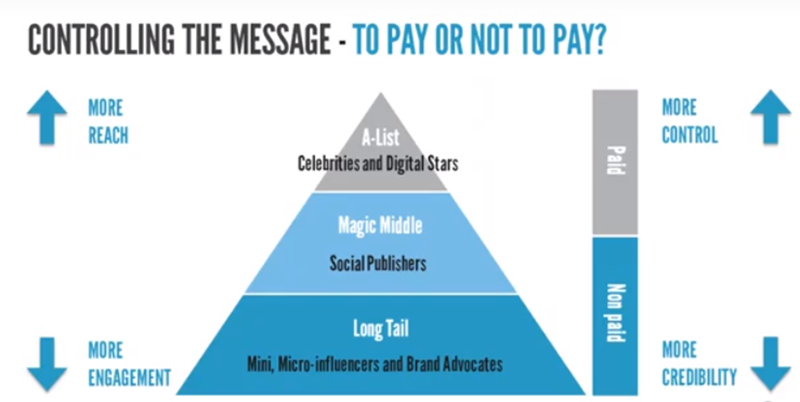
(Johnson, 2017)
The above image identifies the benefits and limitations of paid versus un-paid. Within this chapter there has been a number of benefits that have been identified and limitations that have also been discussed, this image appears to suggest that the four key areas involved in paid versus unpaid endorsements are reach, control, credibility and customer engagement. Johnson (2017) suggests that unpaid micro-influencers or brand advocates have a greater impact on customer engagement as opposed to paid celebrity endorsements. It would appear that although the unpaid micro-influencers have greater engagement they do not possess the ability to reach as many potential consumers as the paid celebrity endorsements and maybe even the macro-influencers. Within this chapter is was stated that micro-influencers tend to have around 10,000 or less social media followers which means their potential reach is 10,000 people, celebrities and macro-influencers can have far more providing a greater reach. Another key area discussed when comparing paid versus unpaid is the concept of, credibility. There have been arguments suggesting that paid endorsements are more trustworthy and credible whereas other arguments have suggested that there is no impact on consumer behaviour if the endorsement is paid or unpaid. This image suggests that un-paid endorsements have greater credibility whereas paid endorsements have less credibility but do have greater control. Paid endorsements may have greater control due to contractual agreements and they are simply providing a service that the brand is paying for; the brand paying the endorser may have full control over the message they would like to be communicated.
Recent changes in the social media advertising market may have impacted paid endorsements as a new legislation being introduced makes it illegal if a paid advertisement does not clearly state that the endorsement is paid. The new rule states that endorsers such as celebrities must clearly disclose a material connection within the advertisement, abbreviations within adverts include ‘adv.’ (advertisement) and ‘spo’ short for sponsored (Rath J. , 2017). Making consumers aware that an endorsement is paid could potentially lead to less credibility according to the above image; the new legislation will make it more difficult for endorsers to hide their true relationship with the brand e.g. financial payments. Un-paid endorsements may now become more effective as they will not have to disclose any information; this may have greater influence on consumer behaviour. The new legislation appears to be great for unpaid endorsements but may be a cause for concern when considering paid endorsements. Marsh (2017) stated that it is now an obligation to disclose payments and anyone that doesn’t clearly disclose of paid ads are in breach of the consumer protection legislation and may face legal action; a recent example within the sports industry includes, Michael Phelps endorsing Kellogg’s cornflakes on Instagram but not stating that the endorsements was paid. This new legislation can be perceived as a limitation to its effectiveness as there are arguments suggesting that paid endorsements lack trust and credibility. Berger (2018) stated that word of mouth is significantly more effective than advertisements because people trust it more; knowing that someone is paid to talk about something enforcers a weaker sales message because people may struggle to trust the person in question. Unpaid endorsements can be perceived to be more genuine and may build emotional connections to consumer via the trust that can be developed; this may have a significant influence on consumer behaviour.

  - Consumer Behaviour
Dootson (2017) stated that consumer behaviour is the decision-making process when engaging with the brand; consumers will make decisions based on if they want to buy, want or need when engaged with the product or service. Celebrity endorsements are commonly used as a strategic method to influence consumer behaviour, adding celebrities to an advertisement can enhance audience attentiveness, increase desirability and make the product more credible and memorable (Wei, 2013).
So far, research has identified the effectiveness of celebrity endorsements and how they can influence consumer behaviour; a common argument within this dissertation is that celebrity endorsements are effective because they can increase credibility, in particular unpaid micro-influencers. McCracken (2016) described brand credibility as the believability of the information communicated via a brand. It would appear so far from the secondary research provided that, unpaid may be more effective than paid endorsements when it comes to influencing consumer behaviour; however there are arguments provided to suggest that paid endorsements can still be just as effective and can reach a greater audience. There are two models that can be used in relation to celebrity endorsements and their influence on consumer behaviour and they are the Source Credibility model and the Source Attractiveness model.
6.1 The Source Credibility Model

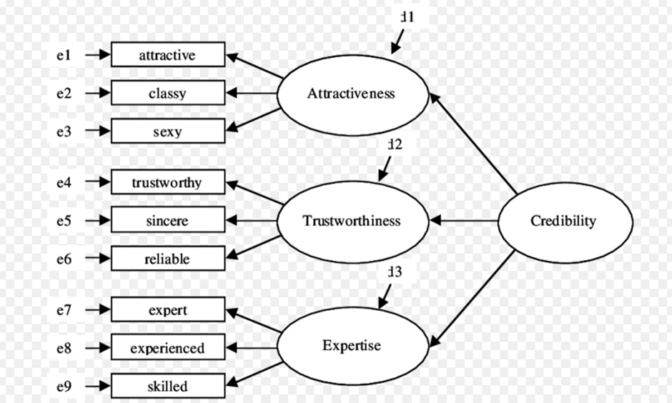
(Bozan, 2017)
Johansson (2017) stated that this model argues that the effectiveness of a celebrity endorsement and its influence on consumer behaviour will derive from three key areas of the celebrity endorser that are attractiveness, trustworthiness and expertise of the endorser in question. The model above clearly flows from left to right but can also be interpreted in reverse and argues that the effectiveness of an endorsement depends on the credibility associated with the endorser (Johansson, 2017). Edrogan (1999) argued that a celebrity or endorser with a level of credibility can significantly influence consumer behaviour and purchasing intentions; Edrogan continued to argue that a credible celebrity can develop the process of ‘internalisation’ within consumers; beliefs, values and behaviours can all be developed within this process leading to a positive influence on consumer behaviour. The trustworthiness of an endorser has been discussed within this dissertation and has appeared as a key area within the, source credibility model. The area of trustworthiness can be influenced by three key sub-areas that can be seen within the model, these are trust, sincere and reliability all influencing the trustworthiness of a celebrity and endorsement from a consumers perspective. Baker (2001) argues that the area of ‘trustworthiness’ within the source credibility model refers to the honesty, integrity and believability of the celebrity endorser; if an endorser has all three then the more trustworthy and effective that celebrity could potentially be. The secondary research within this dissertation appears to state that unpaid endorsements have a greater degree of trust therefore increasing their credibility.
Another key area within the ‘source credibility model’ is the area of expertise that is broken up in to three sub-categories of expert, experienced and skilled. Cristiano Ronaldo endorsing Adidas football boots may be seen as effective because he is an expert within the field and wears those boots. Edrogan (1999) defined this area of the model as the extent to which an endorser is perceived to be valid in the eyes of a consumer. The endorser being an expert in the field my increase its credibility influencing consumer behaviour however as previously discussed there are many other examples where celebrity endorsements have been successful without the previously discussed celebrity-brand fit, for example David Beckhams Pepsi endorsement. Paid celebrity endorsement may be more effective within the sports industry as athletes may be recognised as being experts within their field; the consumer may be more inclined to listen to someone that has achieved greater success within their filed as opposed to an unknown social media micro-influencer for example.
The third and final key area within the model is the area of ‘attractiveness’, the attractiveness of an endorsement has also appeared previously within this study. The three sub-categories of this are; sexy, classy and attractive; apparently all resulting in a more attractive endorser leading to a more effective endorsement. An example of this strategic approach appears to be the beauty products industry which appears to target young women who may be considered attractive in order to influence consumers, these can be considered as micro-influencers and usually operate on Instagram or Twitter. it has also been reported that leading international marketing services organisation St.Ives , utilise an advertising strategy that relies heavily on influencer marketing and have aided the marketing activities for major organisations such as Neutrogena; the strategy appears to include the use of young females who have a large social media following such as Joelle Fletcher who has over two million followers on her Instagram account with a reported engagement rate of 3.7% (Seymour, 2017).
The above models highlight the key areas where the research suggests, consumer behaviour can be influenced by a celebrity endorsement. Successful endorsers within the sports industry such as Michael Jordan and David Beckham appear to have what the above models appear to highlight as effective characteristics, characteristics such as familiarity, expertise and attractiveness.

  - The Source Attractiveness Model
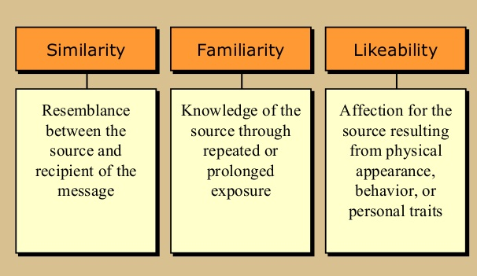
(Maguire, 2001)
Following on from the credibility model and the area of ‘attractiveness’ within it, there has also been a published model called the ‘source attractiveness model’ that discusses the importance of using attractive endorsers. (Edrogan, 2008) argued that consumers tend to have more positive stereotypes about physically attractive people. McGuire (2001) stated that there has been research to prove that attractive endorsers have a greater influence on consumer behaviour than unattractive endorsers do. The three areas of this model as displayed in the above image is the similarity between the source and communicated message, the familiarity of the endorser and the likeability of the endorser that includes physical appearance. The model suggests that these core areas can have a significant impact on consumer behaviour (Edrogan, 1999).
The model appears to suggest that the familiarity of an endorser can have greater benefits for the brand; this may suggest that paid endorsements have the potential to be more effective because it is likely that the celebrity will already have a large network of fans/followers both domestically and internationally unlike social media influencers. Paid endorsements may also have more control over the selection process when targeting ‘attractive’ endorsers to represent their brand.
Johansson (2017) argued that the physical attractiveness of an endorser can impact the effectives of the persuasiveness communicated message through a process called ‘identification’ where a consumer accepts the information because they simply want to identify with the celebrity/endorser in question.

7.0 Research Methodology
The aim of this dissertation is to analyse the effectiveness of celebrity endorsement within the sports industry. In order to achieve this goal the aim was broken down in to two objectives that were:
- A critical analysis of paid for endorsement v unpaid endorsement within the sports industry.
- An evaluation of the influence of celebrity endorsement on consumer behaviour within the sports industry.
This chapter will now identify the research approaches undertaken and the research methods used in order to attain accurate and relevant data to successfully achieve the aim of this dissertation.
7.1 Research Approaches
A research approach is the process of identifying a specific approach to study a particular topic and can be broken down in to two distinct categories that are inductive and deductive (Dudovskiy, 2018). Thomas (2010) argued that inductive research approach is broken down in to two parts with the first being to condense textual data into a summarised format and then secondly to establish relevant links between the summary findings and the research objectives in order to support any conclusions made. The inductive approach appears to give the researcher a sense of freedom as there may not be any predetermined conclusions or findings; the researcher uses the data provided to form opinions and feelings surrounding the topic and any conclusions made will derive from the research and data collected.
Jones (2009) described a deductive research approach as the analysis and evaluation of pre-determined theory or hypothesis and argued that this method can be an effective tool to keep a researcher focused on a particular area; this however can lead to lack of freedom when conducting research.
The research approach utilised within this dissertation appears to follow the inductive approach as conclusions derived from the secondary research of books and journals, conclusions made were constructed from the data provided and were not pre-determined. There was freedom within the research and the questionnaire was used post-literature review in order to attain a more in-depth analysis leading on from the research of secondary data.
7.2 Research Methods
In order to gain a deeper understanding of the research topic both secondary and primary research were used within this dissertation, both forms of research having their advantages and limitations that will now be discussed in relation to this project.
7.2.1 Secondary Research
Widaman (2011) defined secondary research as existing data collected by other researchers to pursue their goals. Secondary research can come in many forms ranging from books, journals, websites many other online sources easily accessible to the researcher. Secondary research was used widely throughout this dissertation and the research data used within was pre-dominantly from secondary sources in particular online journals and books. Secondary research was used to gain an understanding of the bigger picture in terms of celebrity endorsement; the research collected from a variety of sources provided a strong framework to build a bigger picture and to help achieve the dissertation objectives. Secondary research can be effective early on within a project as it can enhance the researchers understanding of the project and help determine the most appropriate method of primary research if necessary. There is a range of advantages when using secondary data such as recently mentioned the increased exposure to an industry or area of research. Other benefits includes the accessibility of secondary research and the vast sources available to the researcher. Secondary research can also be more cost effective as opposed to primary research because many online sources offer free access to a variety of literature that can be relevant to the research being undertaken. Secondary Research was most commonly used within this study to gain a deeper understanding of the area and because it can be effective when working within time constraints as researching secondary data can be undertaken whenever the author wishes too as opposed to primary research that may involve the reliance on others. Secondary was also used as it is a cost-effective approach and length of time needed is the responsibility of the author. Secondary research within this dissertation allowed the author to gain an in-depth understanding within a relatively short period.
7.2.2 Primary Research
O'Connor (2010) defined primary research as a collection of data that has not been collected before; the author initiates his own investigation to achieve results. There are a range of methods that can be utilised in order to retrieve primary data this includes questionnaire/surveys, interviews, focus groups and many other observational assessment strategies. Primary data can be effective when wanting to get specific information or data in relation to a project. Primary data has a range of benefits that include the relevancy of the research, as the author will have scope to tailor the research to suit the project where as opposed to secondary research that may provide general information and data not specific to a project. Primary research can also provide more reliable data that has not been already published by another author or organisation with a specific agenda causing research bias. Primary data was used within the dissertation to enhance the credibility of the research and to support the findings and data that derived from the secondary research. The secondary research helped build a strong framework and understanding of the topic where the primary research then allowed the author to attain information that is more specific and allowed the author to explore areas that may not have been discussed within the secondary research. Primary research can also eliminate the risk of unreliable information that can be easily found when conducting secondary research.

7.3 Qualitative/Quantitative Data
The two forms of data that can be retrieved from a research method can be classified as either quantitative or qualitative data; this dissertation involves both classifications to achieve accurate and more in-depth knowledge and understanding of the topic and this can be described as a mixed method research. Driscoll (2007) defined the mixed method approach as a hybrid approach used to expand the scope of research and to minimise the limitations of the approach alone. Using both forms of data appears to strengthen the findings and can allow for statistical and more personal findings when analysing both forms. Salib (2007) defined quantitative data as data that displays a quantity or range; Salib continued to argue that this form of data may reach a wider target audience but is likely to be less personal and less in-depth than other forms of data. An example could be a simple survey with yes and no answers where the participant’s response is limited but there may be a greater range of participants.
Rupert (2007) argued that qualitative data involves the understanding of human behaviour where the data collected is from the language of the participant and the data is generally not in the form of numbers. Qualitative data can usually be secreted from methods such as interviews or observations; questionnaire surveys allowing the participant freedom to expand on their answers may also generate more qualitative findings. Both approaches have their advantages and limitations where quantitative data can be effective to get a general idea of an area of research within a quick time frame where qualitative data appears to be able to generate more detailed and personal data; however, this may also rely on the availability and motivation of others.
7.4 Methods Used
A questionnaire survey and focus groups were used within this dissertation as a primary research method used to gain a deeper understanding of the topic. The questionnaire was chosen because the author believed it to be the most appropriate form of action and it can generate findings within a short time period. DeFranzo (2012) argued that questionnaire surveys could be the most effective research method available when aiming to target a wider range of participants within a time-constricted environment. According to DeFranzo, other benefits includes its cost effectiveness, may not rely on geographical location and can generate a broad range of data. Another important reason why the questionnaire survey was selected is due to the nature of the project; this project required findings from a wide audience to attain accurate findings. The questionnaire was designed both online and hard copy which allowed the author to disperse it using online social media platforms and also physically handing out the questionnaire survey to be completed. This method allowed for a greater response range from a wider target market within a realistic time frame. Before the questionnaire was distributed, the author decided to undertake a ‘questionnaire pilot’ to determine whether there were areas of the survey that may require amendments to ensure that the final results collected were as accurate as possible.
Although there many advantages of using the questionnaire as a research method there were some limitations that the author was aware that included the lack of personal thoughts or opinions such as feeling and emotions in relation to the topic. To combat this limitation the questionnaire survey utilised rating scales and added areas for comment to encourage participants to expand on their selected answer; this allowed further information to be analysed. Another limitation that the author was made aware of was the range of participants; when posting the questionnaire on an online social media platform it is likely that participant’s would be friends of the author and may be within the same age range and could potentially have the same interests and opinions leading to biased findings. This was the primary reason why the questionnaire was also dispersed via a hard paper copy format to randomly selected individuals from a range of backgrounds to achieve more general findings from a wider audience; this was done by handing out the questionnaires within the author’s workplace setting.
Focus groups were used to compliment the questionnaire survey by enabling the author to probe further in to the questionnaire findings and allowed the author to attain more qualitative data. Focus groups are an effective survey method depending on the nature of the project and can significantly develop the scope and depth of research depending on the participants within the focus group and their engagement. The focus groups within this study consisted of predominantly male participants; the first focus group consisted of five males and the second consisted of four males and one female; this is something that will be taken in to consideration during the data analysis and limitations of research section.
Focus groups can generate discussions relevant to a research topic and results can be achieved quickly depending on the participants, questioning can also be tailored to the research to ensure discussion points are relevant to the research. Focus groups can also be an effective method to allow for deeper discussion leading on from the initial questioning. There are limitations to focus groups that the author was fully aware of which included managing the dominant speakers within the group; this was combated by encouraging all participants to engage and by directing questions specifically at the quite participants. Limitations also include the limited range of participants; a focus group will likely have around 5-8 participants whereas the questionnaire had the ability to reach over 100 participants. Although the findings may have been in depth and detailed the limited range of responses may not be beneficial for the nature of the project by itself where the analysis of findings may take a statistical approach. For this reason, the author decided to utilise both questionnaire survey and a focus group to complement each other and to attain a deeper level of understanding and research through analysing both the quantitative and qualitative data from these chosen methods. The data from the questionnaires will be analysed using pie charts and findings will be compared with the secondary data within the research along with the data secreted from the focus groups. Pie charts can be an effective method to aid visual representation of the findings that will derive from the question. Data from the focus groups will be analysed by seeking patterns throughout the discussions that may or may not relate to the findings from the questionnaire and literature review.
7.4.1 Alternative methods
Although the questionnaire was selected as the most appropriate course of action, other methods were considered. There was a range of alternative methods that could have been used that includes interviews, case studies or scientific experiments.
Interviews were considered within this dissertation to understand the role of celebrity endorsements within the sporting environment and may have been beneficial, however there were some limitations; therefore, they were considered unnecessary for this particular project. Interviews can be an effective method to gain inside knowledge and information whilst also having the scope to ask secondary questionnaires in order to probe for deeper information. When interviewing participants the researcher will also have the ability to ask questions that are more open-ended to encourage further discussion and analysis of the topic in question. Interviews appear to be a more personal approach that can provide qualitative data specifically tailored to the research (Johnson, 2017). However there are limitations in relation to interviews that include the reactive effect; this is where a researchers presence may influence a participants answers leading to biased results being received; another important limitation was that interviews may only be able to reach a low research sample that may not represent the wider environment (Johnson, 2017). Interviews can also be time consuming and results may be difficult to analyse due to its limited sample.
Observational experiments can be an effective method of research however, this approach did not seem necessary for this dissertation. Observational experiments can be effective as they can take place within a natural environment where participants may not feel influenced or encouraged to answer in a particular way, this can lead to more pure and honest results. Observational experiments can also generate quantitative data that can be easily analysed. The disadvantages of observational experiments is that they may not always be relevant to the research objectives and can be difficult to effectively observe large groups. Observational experiments can also influence the ‘Hawthorne Effect’ where participant’s behaviour is influenced if they are aware they are being observed (Thompson, 2016).
7.5 Limitations of Research
Attaining reliable and unbiased data is of paramount importance within this research project and it is important that all limitations must be recorded accurately and taken in to consideration when analysing the findings to form accurate conclusions. As previously mentioned within this chapter the focus groups conducted are heavily dominated by male participants, only one female participated in the second group and the first focus group consisted of only male participants; the author will need to be aware of the risk of gender bias within the findings and data retrieved from these focus groups. The questionnaire survey consisted of 60% male and 40% female; although this split is less significant than in the focus groups the author will still need to understand that the results came from predominantly male participants. Other limitations within this research is the distributed method that the author used to disperse the questionnaire to potential participants. The author used social media and his work place to attract participants and encourage them to take part, this results in a large percentage of participants falling in the same bracket as the author. 56% of respondents were aged 18-25 and 37% were between 26-33; this means that 92 of the 102 participants were under the age of 33. The author in future may wish to disperse the questionnaire survey more equally across wider age groups. Other limitations may also include the time scale in which the author conducted the research; the project was undertaken within 5 months in order to meet deadlines; given more time the author may have had freedom to conduct more primary research to strengthen the credibility and reliability of the data.

- Findings

This chapter will now explore the findings that were taken from the primary research that included a questionnaire and two focus groups. Please refer to the appendix throughout this chapter.
In total there were 102 participants that took part in the questionnaire survey and their responses have been analysed below.

  - – Questionnaire Charts

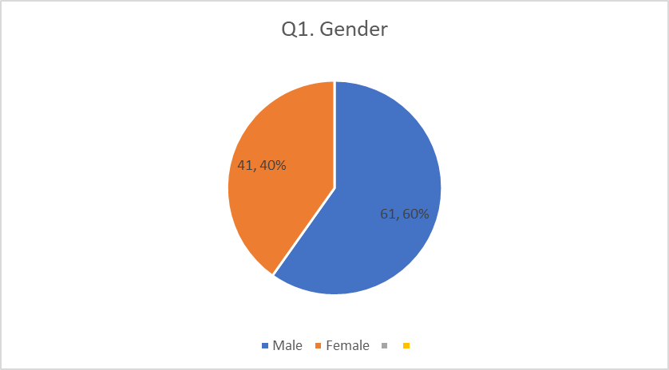

This chart clearly displays that the respondents were predominantly male, however with the range of respondents there is still a respectable female presence with 41 females accumulating to 40% completing the survey. There may be a number of reasons why more males have completed the survey which may include, the author sending out the survey within his social group that consists of mainly males. This question was asked in order for the author to gain a gender representation and to analyse any patterns that may occur. Getting a picture of the demographics allows the author to make accurate assumptions based on the findings provided by the line of questioning; such as the influence online endorsements promoting beauty products may significantly influence younger women more perhaps than other non-gender endorsements can influence male consumers. Younger women in general appear to be more susceptible to being influenced by online adverts displaying ‘attractive’ women; a strategy commonly used by retailors and previously discussed within the study.

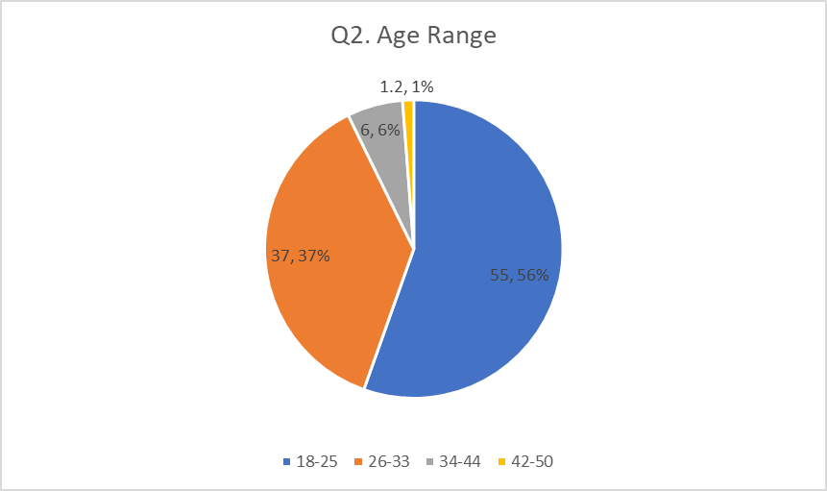

This chart displays the spread of age groups who completed the survey. It’s clear to see that the vast majority of respondents were aged between 18-33, 93% in total (56% 18-25, 37% 26-33). According to the data included within this study this age bracket is also the most active across social media. The age of participants can be an important finding as in the research there was a discussion surrounding the effectiveness of endorsements on younger people; this question has allowed the author to compare the findings with the arguments provided within the research. The research appeared to indicate that younger people may be more influenced by celebrity endorsements.

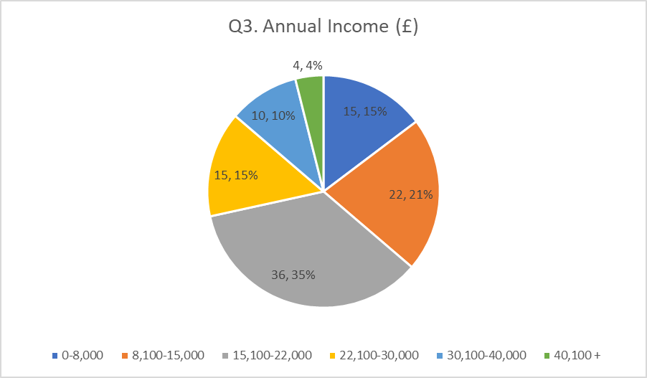

This chart displays the demographic income levels of the participants; its clear to see that the majority (36%) had an annual income of £15,000 – 22,000 with the second highest response being (21%) £ 8,100 – 15,000. These figures reflect the respondents age bracket where the majority were young adults; some are likely to be full time students working part time jobs and others may only be starting off in their respective careers with low annual income due to their inexperience. This question was used to identify a potential link between disposable income and celebrity endorsed products as opposed to more affordable alternatives. The data displays how age bracket and annual income are closely related; although the majority of participants in this survey have less disposable income they may also be most influenced by celebrity endorsements according to Pleshko (2006); who populated this to a term labelled ‘brand insistence’ where there is a strong demand regardless of cost.

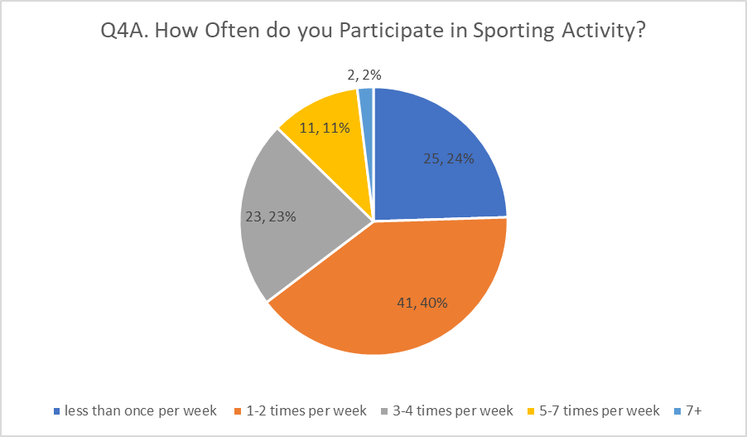

This question was used to identify how many respondents physically participate in sporting activities to assess any potential links between participation and the likelihood of being influenced by a celebrity endorser. The large majority (40%) of respondents stated that they participate in a sporting activity approximately 1-2 times per week with 24 % stating that they participate less than once per week. These figures demonstrate that the respondents within this survey are not the most active in term of sporting participation; participation levels can be used to analyse whether people who participate in sports or not are more or less likely to be influenced by an endorser. The importance of this question was to also gain an understanding of how sports brands may not be simply purchased or admired for their functional capabilities but also for their appearance and fashion. Wearing brands such as Nike and Adidas can simply be a lifestyle and fashion choice as opposed to wearing them simply for sporting activities; this concept allows both sporting and not sporting consumers to be influenced by sporting endorsements such as the Swayne Johnson and Under Armour example. Consumers may be influenced by the design and image as opposed to the supposed sporting benefits that brand and its products can provide.

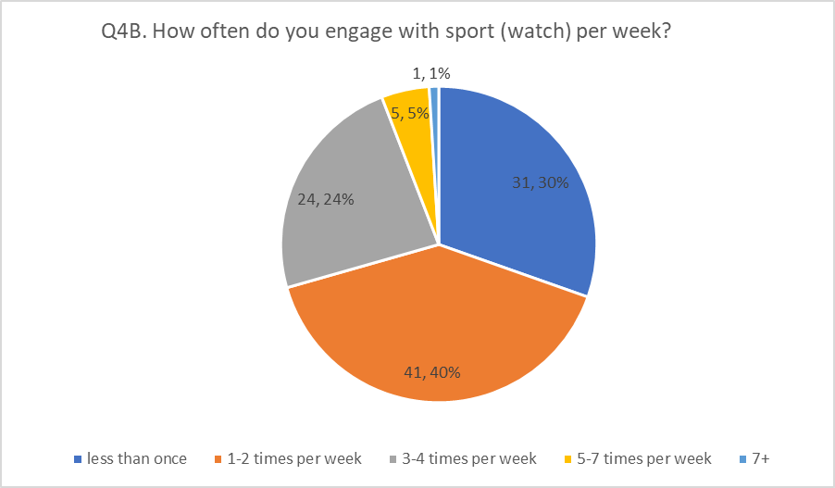

This question again aimed to gain an understanding on engagement levels with the sports industry. This question was used to identify how many respondents engage with sport on a weekly basis which can include being a spectator. The chart displays that only 1% of respondents watch sport less than once per week. The majority watch sport 1-2 times per week (40%) and 24 % stated they watch sport 3-4 times per week. The previous questions (Q4A) demonstrated how physical participation levels were relatively low, this question displays that even though participation levels can be considered low the engagement levels are relatively high with 99% of respondents engaging with sport at least once per week. This question can determine whether watching sport can increase the likelihood of being influenced by celebrity endorsements that are common practice within the industry.

This chart clearly illustrates that Nike and Adidas hold significant market share; within this survey, 86% of participants said that they would most likely purchase Nike (46%) or Adidas (40%). These figures are not surprising as it appears inconceivable that another brand could compete with these brands within the sports industry. These figures also coincide with the young age of the participants who could potentially be influenced by top athletes and sports teams that are sponsored by these brands e.g. Adidas sponsoring Manchester United and Nike sponsoring Cristiano Ronaldo. Although the brand “Gym Shark” can often be seen being endorsed by influencers across social media platforms it doesn’t appear to be associated with top athletes or celebrities; this may have influenced the participants to opt for brands that they have a deeper connection with through the sports industry. The Gym shark approach may involve significantly less costs than others whilst still capturing market share, albeit very minimal in comparison to Nike and Adidas.

Following on from Q5, this question sought to gain an understanding on ‘why’ the participants opted for a particular brand. The analysis on Q5 identified brands being linked with celebrity endorsers as a possible influencer; these celebrity endorsers and sports teams could also increase brand awareness. The findings within this chart however states that, 0% of participants believe that they purchase a specific brand because of a celebrity endorser or advertisements; it appears difficult to measure whether participants can be subconsciously influenced by endorsements and other marketing activities. 50% of participants stated that they would pick a particular brand due to the quality and 27% stated that it’s the design that influences them. 17% were influenced by price; due to this survey being predominantly completed by young people under the age of 33, they may wear more expensive brands for social status and perceived acceptance. Young people who may not own their own home may also have more disposable income to select products for a variety of reasons, without a serious consideration of the price (Pleshko, 2006).

The term ‘celebrity endorsement’ appears to be open to interpretation; these findings suggest that participants perceptions on the term can vary significantly. Interestingly only 9% of participants opted for the ‘celebrity/influencer believes in the brand’ statement which appears to indicate that consumers aren’t convinced by the brand-endorser relationship; 58% of people stated that ‘the celebrity is paid to wear the brand’ which shows that the majority of consumers are aware of potential financial gains that endorsers can receive to promote a particular brand. 23% however stated that ‘the celebrity likes the brand’ which contradicts the recently made conclusion that consumers aren’t convinced by the endorser-brand relationship as almost a quarter of participants believe that endorsers/influences genuinely like the brand that they are promoting which could build intangible values such as trust within the brand. The difficulty with analysing this question is that although it gives an insight in to what the participants believe regarding the term ‘celebrity endorsement’, it could also be argued that the term can include all of the above which makes it difficult to get a conclusive answer.

This chart illustrates how likely a participant is to purchase an endorsed product. Surprisingly, 51% of participants said that they would ‘likely’ purchase an endorsed product; however, referring back to Q6, 0% of participants said they chose a specific brand because of a celebrity endorser which appears to contradict each other. These results may again appear to display how the term ‘celebrity endorsement’ can be open to interpretation. Over half of the participants stated they would likely purchase an endorsed product which signals that celebrity endorsements are in fact significantly effective. There are an abundance of other reasons why consumers may purchase that endorsed brand that can include quality, value and accessibility. Purchasing an endorsed brand may not signal a strong endorsement, however according to the data within this study, celebrity endorsements can increase awareness of a product and brand retention which could potentially lead to an increase in sales.

Data within this study suggested that celebrity endorsements are effective when the celebrity in question is attractive, familiar and likeable; data also included that endorsements can influence consumers who have an affiliation with a certain celebrity through a process called ‘identification’. This question asked participants which celebrity they would most likely affiliate themselves with, with 38% of participants selecting ‘David Beckham’; this could be due to his popularity, attractiveness and his perceived ‘coolness’ or likeability factor which were all discussed within this study. 23% stated that they were most likely to affiliate themselves with a celebrity related to their hobbies or past time, this signals that a strong celebrity-brand fit may influence a number of consumers. Third most selected response was ‘Megan Markle’; this could be due to her constant media attention, widespread positive publicity and her attention to fashion; similarly, to David Beckham, Megan Markle may also be perceived as ‘attractive’ which appears to influence an effective endorser. 16% of people stated that they did not affiliate themselves with celebrities or influencers; this however does not mean they are not influenced by celebrity endorsements as data suggests endorsements can influence brand retention and brand image which all may be in the subconscious mind of a consumer. Joe Wicks a popular social media influencer, was only selected by 2% of the participants; this may be due to a number of reasons such as lack of influence, popularity and limited reach as opposed to other celebrities such as Beckham and Megan Markle. Another perceived social media influencer, Kayla Itsines had a selected response of 4% of participants. This does not appear to conclude that celebrity endorsements are more effective but appears to display the power of the more notable individuals such as David Beckham. This comparison appears slightly unfair on Joe Wicks and Kayla Itsines who gained popularity via social media and have a significantly lower celebrity status than the likes of David Beckham, but it does highlight their limitation to influence a wider range of consumers.

This question seeks to understand the impact on a brand when the endorser receives negative media attention for behaving irresponsibly; for example, Tiger woods having an affair. It can be argued that there is a responsibility on both parts of an endorsement from the company’s side and most definitely the athletes’ side. An athlete may not want to be associated with a company that for example, operates unethically whereas a company may not want a celebrity to promote their brand whose behaviour has been deemed inappropriate. Sports brands however appear to maintain relationships with celebrities that have behaved ‘irresponsibly’; Novan-Williams( 2018) stated that Nike have traditioanlly backed controversial athletes since their existence, including Tiger Woods and currently Colin Kaeprnick, the NFL star who knelt for the US anthem in protest of police brutality against ethnic minorities across the united states. The country dividing controversy surroinding Colin Kaepernick has been going on since September 2016 when the incident happened; Nike recently partnered with Kaepernick to release an advertisement with the powerful message stating, “Believe in Something, even if it means sacrificing everything” (Novan-Williams, 2018). Senior financial analyst Brian Nagel, argued that even with the outrage on Twitter the advert has generated $43 million in “buzz” for the retailor, which equates to $43 million in media exposure (Nagel, 2018). This example appears to demonstrate the power of celebrity endorsement and its effectiveness, where a brand, builds a relationship with a controversial athlete has made front page news across the world generating millions of dollars for the brand whilst sending out a powerful message. Almost half of participants stated that they were unlikely to boycott a brand due to an endorser behaving irresponsibly. The limitation within this question appears to be the term, behaving “irresponsibly”; more serious crimes may result in more severe consequences for the brand.

The data within this study suggested that unpaid influencers were effective due to their ability to build trust with consumers whilst having higher engagement rates in comparison to celebrity endorsements; this question examined whether consumers would be more influenced if an endorser was unpaid. 60% of participants stated that they would be significantly more influenced by a celebrity endorsement if the celebrity was unpaid; this appears to suggest that the effectiveness of influencers and the significant influence they may hold over consumers can significantly impact purchasing decisions. Just 5% of participants stated that they would not be more influenced if an endorsement was unpaid; this appears to display how the financial rewards for endorsers can seemingly impact its effectiveness. Although unpaid influencers appear to be more effective on a personal basis they seem to lack the reachability factor that paid celebrities have where they may promote a brand to consumers worldwide. This chart demonstrates how unpaid endorsements are effective but it still appears difficult to compare against paid celebrity endorsements with a far wider reach.

Throughout this study there has not only been discussions on what makes the most effective endorsement, e.g. Celebrity v Influencer but discussions have also included what makes a certain celebrity or influencer more effective as opposed to others. An example within the data included the beauty industry using, young and attractive females within their marketing strategies; the attractiveness of an endorser appears to have an influence on its effectiveness. This chart however, displays that only 16% of participants believe that the attractiveness of an endorser has the most significant influence on themselves. The data stated that it may be difficult to measure as the attractiveness of a celebrity could potentially influence brand retention and product familiarity without being conscious of the reason behind it. Another area that has been discussed is the effectives of having a strong ‘celebrity-brand’ fit, 43% of participants within this study stated that this was the strongest influence on them. There appears to be a range of benefits of having a relevant endorser sponsor a product or brand such as Ronaldo endorsing Nike whilst wearing their boots, however this doesn’t appear to be an essential characteristic of an effective celebrity endorsement, for example, George Foreman the retired boxer, endorsing a cooking appliance; now commonly known as the ‘George Foreman grill’. 40% of participants within this study stated that the successfulness of an endorser has the strongest influence on them; this could potentially build trust between the product and consumer; for example, ranked number one US golf player Dustin Johnson uses the brand ‘TaylorMade’, his successfulness may portray that these branded clubs are likely to be of a high quality as they are being used by a successful person within that field. 0% of participants answered with ‘none of the above’ signalling that every participant are in fact strongly influenced by one or more of the characteristics stated for selection.

The power of social media and its influence on consumers and society as a whole has been a regular theme within this study, 38% of participants stated that they considered social media to be their strongest influence when making purchasing decisions; social media is a platform that people can share with the world whatever they feel necessary, online retailors also utilise social media platforms to communicate and engage with potential consumers and may utilise a social media strategy to influence consumer purchasing decisions. ‘Friends’ or ‘followers’ may also post pictures on social media outlets wearing new clothing etc, this can also be a form of unpaid endorsement and could potentially influence other consumers. 54% of participants stated that ‘word of mouth’ has the strongest influence on them when making purchasing decisions; word of mouth can be a more personal endorsement for a brand and can be significantly effective; taking recommendations from friends or family where there is a degree of trust may be more effective than listening to a celebrity that the participant is likely to have never met. ‘word of mouth’ and ‘social media’ dominated the participants responses, accumulating to 92% between them which displays their effectiveness. third most selected response at just 7% was TV advertisements. TV advertisements can be a very expensive investment for brands and this study appears to suggest that in the contemporary marketing environment there may be more effective options as opposed to paying high fees and using up resources for TV commercials with a relatively low engagement rate. On the other hand TV commercials according to the data, can increase brand retention and can have a significantly wider reach than other methods.

- Focus Group 1 & 2 Analysis
The quantitative research conducted drew comparisons with the findings within the literature review. There were also a wide range of similarities between the survey responses and the findings within the focus groups; these comparisons will be highlighted further within this chapter. The focus groups aimed to gain a deeper understudying of the key topics drawn from the review of literature and quantitative primary research. The author undertook a thematic approach to analysing the findings from the focus groups to ensure that all key data was captured and recorded with any apparent themes or consistencies being noted.
The first focus group appeared to focus more on the wider environment and the broader term of ‘celebrity endorsement’; just like with the questionnaire the term ‘celebrity endorsement’ was up for debate with contrasting answers from participants and questionnaire participants. The participants within focus group one appeared to agree that the term ‘celebrity endorsement’ usually meant that a celebrity would be paid or there would be some form of contractual obligation; within the questionnaire findings, 58% stated that celebrities are paid to endorse a brand. The research within this study displays how not all celebrity endorsements are paid, however the large majority appear to be and this can be something that consumers may not be fully aware of. New legislations for paid advertisements discussed within this study make it a legal requirement for endorsers to disclose whether an advertisement is paid or not in order to make consumers fully aware. This appears to have the potential ability to lead to a paid endorsement becoming less effective as the consensus within the focus group 1 was that they would be more influenced by an endorsement that is unpaid, this was also the same with the questionnaire findings.
Focus group one also discussed the characteristics of an effective endorser, this is an area that has been covered throughout this study. The questionnaire findings suggested that the most significant influence on a consumer was a, strong celebrity-brand fit. This was discussed within the first focus group and appeared to cause disagreements within the group; characters of an effective endorser discussed were, Familiarity, popularity, attractiveness and believability which can be defined as having a strong celebrity-brand fit. Participants within the focus group discussed how ‘attractiveness’ can make an effective endorser; within the questionnaire findings only 16% of participants stated that they were strongly influenced by ‘attractiveness’. Participant C, within the focus group (1) highlighted the financial limitations of celebrity endorsements and made the argument that it would be extremely difficult to find a mainstream celebrity to promote a brand or product without expecting payment in return, and suggested that unpaid social media influencers can offer a much more economical solution to product promotion for smaller companies with less resource. The survey findings stated that 38% of participants were most likely to be influenced by social media when making purchasing decisions and 60% of participants stated that they would be more influenced by an endorsement if it was unpaid; these figures appear to complement participants C’s argument that unpaid social media influencers can be an extremely powerful and a cost effective solution to product or brand promotion without having to spend the levels of capital that celebrity endorsements may require or expect. The focus group (1) ending by the participants discussing the effectiveness of a social media strategy; the consensus was that because of the influence social media has on people’s lives and the dependability factor it influences then it is an extremely effective strategy as opposed to the traditional television adverts where ‘people tend to zone out’ according to participant B; this may also increase brand retention that was described as a key factor within a successful endorsement according to the literature review within this study. The discussion also involved the limitations of social media influencers and the limited reach they provide a brand; this was a factor that, Johnson (2017) illustrated as engagement versus reach and credibility against control. A brand may have more control over a paid endorsement due to contractual agreements and payments for a service but unpaid influencers may provide a more credible endorsement with higher engagement rates as opposed to celebrity endorsements, albeit with less control over the message portrayed.
Focus group (2) appeared to discuss the benefit of ‘brand retention’ and whether or not celebrity endorsements can influence this suggested factor to an effective endorsement. The literature review argued that a benefit to celebrity endorsements as opposed to social media influencers is that celebrity endorsements have more influence and can strongly encourage brand retention due to the popularity and familiarity of the celebrity involved within the endorsement; although the survey findings illustrate that 0% of participants would purchase a product because of a celebrity endorsement; the data would suggest that they are significantly more likely to remember the product as opposed to a product endorsed by a social media influencer who may only be familiar to consumers with in a niche market or specific social media platform. Brand retention was a common theme throughout the study and it would appear that the most successful endorsements are in fact remembered; participants within the focus group (2) discussed the endorsements they remember due to the celebrity involved. Participants appeared to disagree on what had the strongest influence on brand retention, celebrities or influencers; participant A commented that celebrities can influencer people from outside of their field whereas as social media influencers may be limited to their market or industry. Participant A supported his argument by using the Gerard Butler, Hugo Boss advert and the David Beckham whiskey example. A-list celebrities may be familiar not just within their profession or industry and have the potential and ability to cross in to other industries. Participant B however argued that he would be more likely to remember a social media influencer who he follows as opposed to a random celebrity he may have no affiliation with. The study argued that attractiveness and familiarity all influence a successful endorsement.
Participant A argued that brand retention can be significantly influenced if the celebrity or influencer perhaps wears the brand themselves; this can include the celebrity-brand fit that often arises throughout this study. 43% of survey participants stated that they would be most influenced by an endorsement that included a strong celebrity-brand fit; the study suggests that this can also increase credibility within the endorsement. Although the data and survey highlight’s the effectiveness of having a celebrity brand fit, participant B within focus group two suggests that popularity and familiarity may be more important and reverted back to the David Beckham example of successfully endorsing products that may reside outside of the sports industry. This argument displays how characteristics such as attractiveness and popularity can be just as, or more important than relevancy.
David Beckham was a common theme throughout the study and focus group discussion, the researcher sought to gain an understanding of what the participants feel has aided to the successfulness of Beckham within the marketing landscape; unsurprisingly and mirroring the data participant E commented that it is the attractiveness and perceived lifestyle of Beckham that makes him a ‘desirable person’. Participant D stated that it is his (Beckham) popularity across both genders and age groups that makes him a successful endorser; a characteristic that was highlighted within the literature review. Participant A commented that the cross over from sports to fashion may have significantly raised his profile and creating a more marketable celebrity.
Focus group two concluded by the researcher leading an activity that tested the brand retention of celebrities and the products, the researcher would say the name of a brand and participants would note down celebrities they affiliate with that brand. A popular answer for Under Armour was Dwayne Johnson who is regularly seen wearing Under Armour across social media platforms; this indicates again that popularity, familiarity and attractiveness may increase the effectiveness’ of an endorsement. Another test the researcher conducted was the affiliation of products to a celebrity, in reverse order to the previous test. When the researcher announced retired boxer George Foreman, all five participants noted down the ‘grill’ that he has become renowned for. Michael Jordan was also used and generated the same responses with three participants stating Nike and two stating ‘Air Jordan’; when the researcher stated the brand ‘Gym Shark’ a brand heavily promoted via social media only one participant answered with a person they affiliate with that brand. This simple activity displayed how celebrity endorsements can be extremely effective compared to unpaid influencer endorsements that may be forgotten over a period of time. George Foreman first endorsed the grill in 1994 and is clearly still recognised today, 24 years later.

- Conclusion
The aim of this study was to conduct a critical analysis on the effectiveness of celebrity endorsement within the sports industry. To achieve this aim two objectives were set which were;
- A critical analysis of paid for endorsement v unpaid endorsement within the sports industry.
- An evaluation of the influence of celebrity endorsement on consumer behaviour within the sports industry.
These set objectives provided a thorough investigation into the effectiveness of celebrity endorsements within the sports industry; from achieving these objectives it became very clear just how effective celebrity endorsements can be and the significant influence they can hold in the conscious and unconscious mind of the consumers. There appears to be no doubt that celebrity endorsements can significantly influence consumer behaviour; this study however, also analysed the effectiveness of unpaid social media influencers and how they have appeared to disrupt the traditional market and landscape of celebrity endorsements. To achieve the two objectives within this study, in-depth research was undertaken which included both primary and secondary data to compare and contrast findings with the authors personal research in to the field of endorsements. Secondary data included a review of literature surrounding celebrity endorsements to determine its effectiveness, where the primary research included a questionnaire survey that had over one hundred responses which was complimented by two focus groups.
From analysing the data its clear to see not just how celebrities can influence consumer purchasing intentions, but also how endorsements can influence and alter a brands perception. A Key finding from within the questionnaire survey in relation to objective (2), the evaluation of the influence of celebrity endorsement on consumer behaviour, was that the term ‘celebrity endorsement’ can be open for interpretation. This finding suggests that not all consumers are aware of financial payments or legal binding contracts within the relationship between the brand and celebrity which can impact its effectiveness, over 60% of survey participants said they would be more influenced by an endorsement if it was unpaid; however not all consumers are aware of any potential payments which can be of benefit to the endorsement.
The introduction to this study included five key characteristics of an effective endorsement by Khan (2017) that included; Celebrity Attractiveness, trustworthiness, meaningfulness, likeability and expertise. These characteristics were supported throughout the literature and research both secondary and primary. 16% of survey participants stated that they were influenced by ‘attractive’ endorsers. The secondary research also concluded that attractive people tend to make a more effective endorsement; the study frequently used examples of successful endorsers who may be perceives as attractive to support the findings; these included David Beckham on numerous occasions and also Megan Markle. The study included examples of endorsers/influencers outside of a sporting context as there has been evidence included to suggest a clear link between sport and the rise in general leisure wear whilst also indicating a link between sports and general lifestyle brands. Sporting brands are not solely purchased by sporting enthusiasts as the evidence has suggested.
Characteristics such as ‘meaningfulness’ and ‘expertise’ can be easily cross examined with the term ‘celebrity-brand’ fit that was frequently analysed throughout the study. Although the evidence suggests that the relevancy of an endorsement can increase consumer trust and brand retention there is an abundance of evidence also suggesting that the attractiveness and popularity of an endorser can make up for a weak celebrity-brand fit and still significantly influence consumer behaviour. Within both focus groups and throughout the literature review the term ‘celebrity-brand fit’ was discussed and appears evident that it can in fact increase the effectiveness of an endorsement.
Another area that was discussed within the literature review and supported in the questionnaire survey findings was how brands can associate themselves with celebrities who may have been deemed to have behaved irresponsibly without negative consequences on their brand image. The current example of this as analysed within the literature review is the new Nike advertisement featuring Colin Kaepernick; the video has been watched around the world with Nike seeing significant increases in sales. Nike used the media attention surrounding the controversial athlete to their advantage and capitalised on an opportunity overlooked by other brands potentially wary of receiving negative media attention resulting in a tarnished brand. The Nike advert featuring the athlete appears to be far more than just a regular brand promotion, the message of ‘believing in yourself’ and the idea of sacrificing to achieve your dreams is a motivational message that consumers are likely to align themselves with; this appears to concentrate on the message it portrays and the cause of the message as well as the brand it is promoting. Building these emotional touchpoints and connections with consumers can significantly increase brand identity, reputation and customer loyalty by building deeper and more meaningful relationships with consumers globally.
The questionnaire survey displayed that 19% of participants were ‘extremely unlikely’ to boycott a brand associated with a celebrity deemed to have behaved irresponsibly and 49% stating that they were ‘unlikely’; these figures display how being associated with miss behaving celebrities does not impact the effectiveness of an endorsement and as Nike have displayed, this can actually be an area of opportunity as opposed to an area to avoid.
The review of literature, commenced by the discussion of how the sporting environment is becoming more commercialised and described the relationship between the sports industry and endorsements as a “match made in heaven”, this appears to be a traditional approach where celebrities such as David Beckham and LeBron James are often linked with different brands on TV commercials and billboards etc. but since the invention of social media there has been an opportunity for online advertisements which has led to the introduction of social media influencers. The traditional approach to celebrity endorsements are evidently extremely effective according to the data within this study; however, depending on the circumstances the concept of social media influencers can prove to be a more effective strategy to create an effective endorsement. The data highlighted how social media influencers in general have higher engagement rates as opposed to the traditional celebrity endorsement activity with significant lower costs; this can be perceived as a major benefit for smaller companies with limited capital for marketing activities. The lower costs and high engagement rates appear attractive however the study discussed the disadvantages of this approach which included, limited scope and minimal brand retention if the consumer isn’t interested. Referring back to objective (1) the critical analysis of paid v unpaid endorsements the data collected closely correlates with objective (2) which focused on the influence endorsements have on consumer behaviour; both types of endorsements appear to influence consumer behaviour in different ways with the questions being, to what greater extent? The study suggests that unpaid social media influencers are the most effective strategy for smaller organisations with limited funds etc, but it also highlights the importance for major companies to also have a social media marketing strategy in place due to its popularity and reliance within society.
When comparing paid v unpaid, the data provided evidence to support the findings that celebrity endorsements are still in fact extremely effective regardless of the new social media influencer approach. Celebrity endorsements appear to target the subconscious minds of consumers, where the consumers may not realise just how they have been influenced by an endorsement. Celebrity endorsements can have a significant reach advantage over social media influencers and even though they have a lower engagement rate they can still communicate the brand and product to potential consumers.
The granularity within this study allowed the author to create supportive conclusions based on the evidence and data that derived from the research both primary and secondary. In conclusion, from the analysis of the data provided it is evident that celebrity endorsements are in fact the most effective strategy, however unpaid or low cost social media influencers can be effective to a certain extent but may find it difficult to achieve the desired scope and effectiveness that celebrity endorsements can produce. Social media influencers however can be perceived as an effective alternative for smaller organisation with limited capital.

- Appendix

  - Questionnaire Survey

Celebrity Endorsement Questionnaire
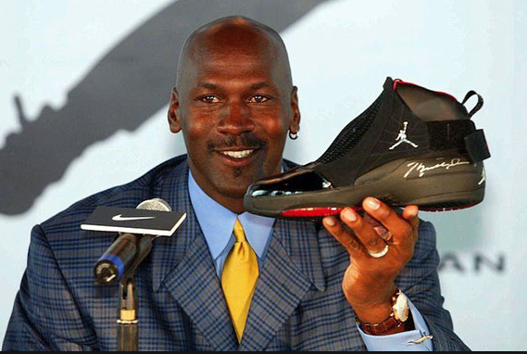
This questionnaire is in regards to the effectiveness of celebrity endorsements and its influence on consumer behaviour. This questionnaire will also examine the effectiveness between paid or unpaid endorsements.
Your participation is voluntary and much appreciated, all questions are optional so if you feel uncomfortable with any of the questions feel free to move on to the next.
Certain questions have a comment line underneath should you wish to add anything.
- Please select your gender. (optional)
- Male
- Female

- Please select the age range you reside within. (optional)
- Under 18
- 18-25
- 26-33
- 34-41
- 42-50
- 50 +

- Which bracket does your annual income reside within ?(optional)
- 0 – 8,000 pound
- 8,100 – 15,000 pound
- 15,100 – 22,000 pound
- 22,100- 30,000 pound
- 30,100 – 40,000 pound
- 40,100 +

4a) How often do you participate in sporting activity?
- Less than once per week
- 1-2 times per week
- 3-4 times per week
- 5-7 times per week
- 7+ per week
4b) How often do you engage with sport (watch) per week?
- Less than once per week
- 1-2 times per week
- 3-4 times per week
- 5-7 times per week
- 7+ per week

- Which sporting brand are you most likely to purchase?
- Adidas
- Nike
- Puma
- Under Armour
- Gym Shark
- Other (Please State) ………………………………………………………………………………………………….

- What makes you pick that particular brand?
- Design
- Quality
- Connection with a particular sport
- Celebrity endorser
- Advertisements
- Price
- Other (Please state) ………………………………………………………………………………………………….

- What does celebrity endorsement mean to you?
- The celebrity is paid to wear the brand
- Celebrity just likes the brand
- A company gives the celebrity free products
- Celebrity/influencer believes in the brand
- Other (please comment) , …………………………………………………………………………………………………………………….

- How likely are you to purchase a celebrity endorsed product?
- Extremely Unlikely
- unlikely
- Neutral
- Likely
- Extremely Likely

- Which celebrities/influencers are you most likely affiliate yourself with?
- David Beckham
- Kayla Itsines
- Joe Wicks
- Megan Markle
- Celebrity related to my hobbies/past time
- None of the above (Please Comment) ………………………………………………………………………………..

- How likely are you to boycott a brand that is associated with a celebrity that has behaved irresponsibly? For example, Tiger woods extramarital affair whilst endorsing Nike.

- Extremely Unlikely
- unlikely
- Neutral
- Likely
- Extremely Likely

- Do you believe that you would be more influenced by a celebrity endorsement if the celebrity was unpaid? Please circle your answer below, 1 = Not at all 4 = significantly

1 2 3 4

- What type of Celebrity would you consider to have the strongest influence on you?
- Attractive
- Successful
- Popular
- Strong celebrity-brand fit (celebrity relevant to the brand/product)
- None of the above
Any Comments …………………………………………………………………………………………………….

- What communications outlet/platform would you consider to influence you the most when purchasing brands/products?
- Social media (Instagram, Snapchat, Facebook etc.)
- TV commercials
- Radio
- Word of mouth from friends/family or a member of the general public
- Other, Please State: ……………………………………………………………………….
- None of the above

Thank you for your Participation.

11.2 Focus Group 1
Date conducted – Friday August 3rd 2018 at 9:30am.
Duration: 41 minutes and 51 seconds recorded via an iPad device.
P = Participant e.g., PD (Participant D) agreed with.
Conductors questions or inputs will be in bold to separate himself from the participants within this document.

This focus group was made up of 4 participants who will be labelled as participant A, B, C and D. Participants were all Male within an age range of 23-27. The aim of this focus group was to gather qualitative data to support the questionnaire findings and to contribute to the dissertation titled “A Critical Analysis on the Effectiveness of Celebrity Endorsement Within the Sports Industry”.
The conductor, Josh Lewis introduced the purpose of the research to the participants involved and commenced the focus group discussion by asking the question of, what exactly does the term ‘endorsement’ mean to you?
A: Paying someone famous to wear your clothing or to represent a company.
D: having a celebrity or famous person speaking on behalf of a company.
B: Paying someone to wear your clothing, like Ronaldo wearing Nike boots and probably getting paid.
D: A company can also sponsor athletes or celebrities and I think that can also probably constitute as an endorsement.
C: (agreed with participant B) Paying for someone to represent and vouch for a product or a business in general.

The general consensus within the early minutes of the discussion was that the term ‘endorsement’ usually involves a contract or payment. Participant D stated that Endorsements do not have to be paid and argued that celebrities can represent or promote a company without being paid and used the example of ‘Sport Relief’ as an example where athletes can represent numerous charity’s in the hope of encouraging the public to donate money; the athletes in question may not receive any payment for doing so.

Participant A agreed with PD but argued that although the athletes seemingly promoting charities may not receive monetary payments they may still be doing it for personal gain such as an improved public image.
Participant B disagreed with PA and argued that “not all celebrities or athletes crave media attention” and used David Beckham as an example stating; “David Beckham is constantly involved in charity work and his public image doesn’t need to be improved upon”.

As the discussion started drifting away from the topic in question the Conductor asked another question to engage the participants in a more relative topic to gather more important data.

What would make an effective endorser?
After this question was asked there appeared to be a moment of silence as the participants gathered their thoughts; Participant A was first to answer again.

A: Somebody popular and well known; you can put Beckham on anything and it will probably sell and….
Before Participant A finished stating his opinion he was interrupted by PD who argued that an effective endorser will need to know what exactly he was endorsing and argued that; David Beckham wouldn’t be able to endorse women’s make up because he doesn’t wear it and probably doesn’t know a lot about it

Participant D appears here to be referring to the relevance of the celebrity in question; this is something that was highlighted within the literature review and was described as a celebrity-brand fit.
B: I don’t think a celebrity would always have to understand what he’s endorsing for it to be effective; it depends on the situation. I think that if the purpose was to raise awareness then David Beckham will always be an effective endorser because of the millions of fans he has worldwide even if he may not be relevant to the product or company.
Participant C appeared to agree with this and mentioned that there an abundance of celebrities promoting companies via social media and they may not have an in-depth understanding of what exactly they are promoting.

Participant D replied by stating that a more effective endorsement needs to be believable and argued that if David Beckham endorsed Primark it may not be successful because it is extremely unlikely that David Beckham shops or wears clothing from Primark.

Participant C disagreed and stated that successful endorsements don’t need to be believable to be successful and argued that a celebrity creating attention for a company can be successful from a company’s point of view; regardless if the endorsement is believable or not. Participant C continued to argue that if David Beckham was to endorse Primark it would certainly be a success for the company because it would raise their profile and perhaps create positive media attention which is something that Primark seldomly receives.

Participant D appeared to agree with the recent argument but still believes that the most effective endorsements are believable; but acknowledged that not all endorsements have to be believable, but to achieve greater success, being believable is important.
Participant C then changed the direction of the discussion by asking the other participants whether they feel like unpaid endorsements are more effective because they are more authentic and a celebrity isn’t getting paid to speak on behalf of a brand or product.

A: I think being genuine probably helps and would definitely be a positive but I don’t think that it is always necessary.
B: I agree; I think that the majority of endorsements are not genuine but are still an effective tool to influence consumers and to develop a company.
A: I think that customers probably know that the celebrities are getting paid and I don’t think it would be that significant in terms of the effectiveness of an endorsement.
Participants A, B and C appeared to have formed an agreement on the topic however, participant D believes that endorsements are more likely to influence customers if they believe in the athlete. Participant D continued to state that even though a paid endorsement can still be successful; unpaid endorsements may provide a unique selling point and can perhaps significantly influence the levels of consumer trust.
Participant B then appeared to be influenced by the recent comments of PD and stated that even though paid endorsements are effective; unpaid endorsements may be able to build a stronger connection with Customer.
C: The probably would be finding unpaid endorsers to represent a brand because most celebrities would probably expect payment for their time and influence. I think that people on Social media can maybe be an effective method of unpaid endorsements are at least a lot cheaper than celebrities like Beckham.

This statement appeared to cause disagreements with the group and the participants started to talk over each other making it difficult to record what was being said, to gain control of the group the conductor asked the question of;
Are social media endorsements an effective strategy?
The group consensus to this question was that because of the popularity and the dependence of social media in people’s lives and daily routines it’s a very effective strategy as opposed to just using TV adverts.
C: I think that if a company can find a low-key celebrity on social media to represent their brand, they can target a wide audience and would be cheaper than paying other more well-known celebrities to appear on television adverts. Finding someone with a lot of followers on social media and who happens to be a fan of a certain brand may potentially endorse products unintentionally; just like James Corden who wears a lot of Ralph Lauren Polo t-shirts on his American show. He may not be endorsing the company intentionally but him constantly wearing them will influence people.
D: even though social media is effective I think that the biggest celebrities like David Beckham and Ronaldo will always be more effective but extremely unlikely that they will endorse a brand for free; so, I think that unpaid endorsements can be effective but the bigger deals will require the presence of a popular figure.
From this point on the group discussed the relevance of social media in today’s society and came to the consensus that Social media advertisements are now more effective than other marketing strategies.

11.3 Focus Group 2
Date - Wednesday 29th August
Duration – 48 Minutes and 12 seconds
This focus group discussion was made up of 5 participants that will be labelled as Participant A, B, C, D and E. The demographics of the group were made up of both genders but predominantly male; there was one female that participated. Participants aged between 24-28. The aim of this focus group was once again to retrieve qualitative data and to support the findings within the literature review and also the questionnaire survey. The structure of this focus group differed from the previous focus group (focus group 1) where participants freely discussed the topic of celebrity endorsement; this focus group included some activities to increase the engagement of the participants and to generate more in-depth data.
The conductor, Josh Lewis once again commenced the focus group by introducing the aim of this focus group and the purpose of the research. The participants were briefed prior to the discussion about the line of questions and the participants informally discussed the concept of ‘celebrity endorsement’ and how social media has perhaps created another platform for marketing activities. The conductor used the findings from the questionnaire survey to engage the participants and to develop the findings that derived from the questionnaire survey.
Are you more likely to remember a brand or product that uses a celebrity within its advertisement? A common argument within the literature review was that a benefit of celebrity endorsement is ‘brand retention’; this question allowed the author to identify the participants memory of recent adverts.
E – Yes! especially if you follow the celebrity on Instagram etc then it is hard not to remember what they advertised as they would usually promote it on all social media platforms.
A – I think it depends on what celebrity they use and also what product or company it is; I would probably only remember an advert if I knew who the celebrity was. If it’s a celebrity that I don’t know then I would probably forget about the product they were endorsing.
Participants B and C verbally agreed with participant A above response.
D – I think the type of advert also helps people to remember a product; I think using a celebrity is quite common and I don’t think many people consciously pay attention to TV adverts in general but on social media they seem more difficult to ignore.
E – I could probably state all the products that Jessica Ennis endorses because she’s always pretty active on social media and I follow her on Instagram etc; even though I remember the products I’m not sure if I could name the brand,
What products or brands can you recall her endorsing?
E – Adidas and the bank, but I can’t remember which one.
(It would appear that the bank in question is in fact Santander)

Would you say you were more likely to remember a product endorsed by a more high-profile celebrity?
B- Not really, I don’t really follow any high-profile celebrities as such but I do follow Joe Wicks who’s pretty well known.
A – I think people would generally remember advertisements including more popular celebrities; Joe Wicks is big on social media but other than that I doubt he would be that recognisable; especially if you are not interested in what he talks about like healthy living and fitness tips etc.
E – I think it helps
C – I agree with what he said (participant A) I think people like Joe Wicks can only really influence people within that filed, somebody like Beckham or Gerard Butler could endorse anything and it would probably work.
Can you name something that Gerard Butler has Endorsed?
C – Hugo Boss aftershave
E – I definitely think that the more popular celebrities are more effective in terms of an advert being remembered unless it is directly associated with something you have an interest in; like if Joe Wicks promoted a new smoothie brand I would not remember it because I don’t really know Joe Wicks where as Participant B would probably recall it.
A – I think its more memorable if the person actively wears the brand also as opposed to just wearing it in an advert or tweeting about it.
Do you think that celebrity endorsers are more effective if they are connected to the product or brand in question then? for example David Beckham being endorsed by Adidas and wearing their boots. (This question explores the concept of celebrity-brand fit)
B – I think it definitely helps but I also don’t think its imperative for it to be classed as successful, like what participant C said earlier; if somebody like Beckham endorses something it will probably be memorable and effective because of how popular and admired he is regardless of whether he actively wears the brand in question.
What do you think makes David Beckham so successful?
E - Probably his looks and his lifestyle, I think he’s a desirable person
D – he is admired by both genders and by people of all ages which I think is important
A – His crossover from sports in to fashion probably helped also
B – Definitely his popularity, he’s portrayed to be a genuine down to earth person
C – I think it’s a combination of what you all mentioned and marrying a spice girl probably helped his image
E – Absolutely, I think he has been quite clever in how he conducts and markets himself away from the sports industry in to other areas such as his clothing line
What do you think Is the most important attribute for a successful celebrity endorser?
A – Popularity, I think having a large fan base or following from whatever your background probably helps
E – I think that being attractive in general is important, although this sounds shallow but all the more notable celebrity endorsers and the ones mentioned today such as Butler, Beckham and Jessica Ennis are all attractive people.
C – I would agree with that (Participant A), I think looks are important but I think other characteristics can also help, like being funny or just providing something different in general. Something that can help people remember you.
B – I think personality and character helps also; I think to build trust with consumers it is more effective for a brand to associate themselves with celebrities who can be considered as trustworthy and respectable; but having said that other celebrities such as Tiger Woods would probably still be an effective endorser even with his tarnished image
E – I think celebrity scandals are usually forgotten fairly quickly by consumers and don’t think it would impact future sponsorships or endorsements
For the next part the conductor gave each participant a pen and paper and explained the aim of the next task. The participants answered individually without conferring with the other participants. The first questions involved the conductor saying a brand name such as ‘Adidas’; the participants would then have to individually make a note of a celebrity or company they associate with that brand.
H & M
4 out of 5 participants answered David Beckham, participant E did not respond.
Under Armour
Two participants answered the Rock (Dwayne Johnson)
2 answered the Welsh rugby team
1 answered Tottenham Hotspur Football club
Gym Shark
Only 1 participant responded to this question. Participant B answered Steve Cook (Gym Shark Ambassador)
The next questions ran with the same structure but in reverse, the conductor would say a name of a celebrity and the group would make a note of a brand or product that would spring to mind.
George Foreman
All 5 participants answered grill
Jamie Redknapp
2 participants responded with Burton menswear and 1 responded with Thomas Cook. 2 did not respond.
Conor McGregor
3 answered Monster energy and 2 identified the UFC brand
Michael Jordan
2 responded air Jordan and 3 responded with Nike

That exercise concluded the focus group.

Reference List
Andrews, D. (2004). The Commercialisation of Sport. Abingdon: Routledge. Retrieved 06 2018
Baker, J. (2001). Celebrity Endsorsement. Journal of Marketing Management, 241. Retrieved 07 2018
Beer, J. (2018). Here's How Wish Got Gareth Bale. Retrieved 07 2018, from FastCompany: https://www.fastcompany.com/40584849/heres-how-wish-got-gareth-bale-to-joke-about-missing-the-world-cup
Berger, J. (2018). RESEARCH SHOWS MICRO-INFLUENCERS HAVE MORE IMPACT THAN AVERAGE CONSUMERS. Experticity. Retrieved 07 2018
Bergkvist, L. (2016). A new model of how celebrity endorsements work: attitude toward the endorsement as a mediator of celebrity source and endorsement effects. International Journal of Advertsiing, 171-184. Retrieved 06 2018
Berthon, P. (2012). Marketing meets Web 2.0, social media, and creative consumers: Implications for international marketing strategy. Buisness Horizons. Retrieved 06 2018
Bloomberg. (1999). Nike is Sued Over Tiger Woods Gold ADs. Bloomberg Business. Retrieved 06 2018, from https://www.nytimes.com/1999/07/09/business/nike-is-sued-over-tiger-woods-golf-ads.html
Chaffey, D. (2018, March). Global social media research summary 2018. Retrieved 07 2018, from www.smartinsights.com: https://www.smartinsights.com/social-media-marketing/social-media-strategy/new-global-social-media-research/
Chan, K. (2017). Impact of celebrity endorsement in advertising on brand image among Chinese adolescents. (emaraldinsight, Ed.) Young Consumers, 14(02). Retrieved 06 2018
Cromwell, L. (2018, July). Definition of Endorsements. Retrieved July 31, 2018, from The Economic Times: https://economictimes.indiatimes.com/definition/endorsements
Davies, D. F. (2015). Unpacking Celebrity Brands Through Unpaid Market Communications. Journal of Marketing Management, 5(6), 665-680. Retrieved 06 2018
DeFranzo, S. (2012, 07). Advantages and Disadvantages of Surveys. Retrieved 07 24, 2018, from snapsurveys.com: https://www.snapsurveys.com/blog/advantages-disadvantages-surveys/
Devale, K. (2009). Celebrity Advertising: What Is the ROI? (W. U. Pennsylvania, Ed.) Knowledge@Wharton. Retrieved 08 2018
Diernaz, J. P. (2017, March). What you need to know about sports marketing in 2017 and beyond. Retrieved 07 2018, from Campaign: https://www.campaignlive.co.uk/article/need-know-sports-marketing-2017-beyond/1424873
Dootson, P. (2017). Deterring deviant consumer behaviour: when 'it's wrong, don't do it' doesn't work. Journal of Marketing Management, 33(15), 1355-1384. Retrieved 07 2018
Driscoll, D. (2007). Merging Qualitative and Quantitative Data in Mixed Methods Research: How To and Why Not. Ecological and Environmental Anthropology, 3(1), 19. Retrieved 07 24, 2018
Dudovskiy, J. (2018). Research Approach. Retrieved 07 2018, from research-methodology.net: https://research-methodology.net/research-methodology/research-approach/
Duncan, A. (2018). What Is an Endorsement in Advertising. The Ups and Downs of Testimonials and Celebrity Endorsements. Retrieved 07 2018
Edrogan, Z. (1999). Celebrity Endorsement. Journal of Marketing Management, 291-314. Retrieved 07 2018
Elberse, A. (2012). The Economic Value of Celebrity endorsements. Journal of Advertising Research, 149-151. Retrieved 06 26, 2018
Fastenau, J. (2017). Under the Influence: The Power of Social Media Influencers. 15. Retrieved 07 2018
Flores, L. (2018). How open data may be leveraged to help develop a new “research paradigm". International Journal of Market Research, 342. Retrieved 07 2018
Forn, J. (2014). The Dawn of Athlete Endorsements. Our Game. Retrieved 06 2018
Fotinelli, C. (2010). Celebrity endorsers have more impact on younger consumers. New Study From MEC Shows 18-34 Year-Old Shoppers Trust Their Idols. Retrieved 06 2018
Freberg, K. (2010). Who are the social media influencers? A study of public perceptions of personality. Public Relations Review, 90. Retrieved 06 2018
Garcia, A. (2016). Cristiano Ronaldo is the third athlete to sign Nike 'lifetime' deal. Washington: CNN. Retrieved 06 2018
Glucksman, M. (2017). The Rise of Social Media Influencer Marketing on Lifestyle Branding. Elon Journal of Undergraduate Research in Communications, 78. Retrieved 07 2018
Griffin, N. (2014, August). How important is celebrity endorsement to a brand? Retrieved 07 2018, from Linkedin: https://www.linkedin.com/pulse/20140831165959-1263978-how-important-is-celebrity-endorsement-to-a-brand
Hackley, C. (2011). Unpaid product placement The elephant in the room in UK TV’s new paid-for product placement market. International Journal of Advertising, 703-720. Retrieved 07 2018
Haroon, M. (2015). Impact of Role Models on Purchasing Intentions Among Youngsters. Journal of Management Sciences, 2, 243-255. Retrieved 06 2018
Harris, N. (2018). The impact of social and digital media on sport. LA Trobe University, Nest. Retrieved 06 21, 2018
Hatton, G. (2018, February). Micro Influencers vs Macro Influencers. Retrieved 07 2018, from www.socialmediatoday.com: https://www.socialmediatoday.com/news/micro-influencers-vs-macro-influencers/516896/
Hosanager, K. (2017). Social Media Endorsements: Where Will Marketers Draw the Line? Strategic Management . Retrieved 06 2018
Housman, A. (2000). A multi‐method investigation of consumer motivations in impulse buying behavior. Journal of Consumer Marketing, 17(5), 403. Retrieved 08 2018
Johansson, M. (2017). How does celebrity endorsement affect consumers' perception on brand image and Purchase Intention ? Lulue University of Technology, 7. Retrieved 07 2018
Johnson, C. (2016). cutting through Advertisng clutter. CBS News. Retrieved 06 2018
Johnson, D. B. (2017). Does Celebrity Endorsement Influence Brand Equity. International Journal of Management Studies, 93-100. Retrieved 06 28, 2018
Jones, M. (2009). Difference Between Inductive and Deductive Approaches to Research. Research Methods for Business Students. Retrieved 07 18, 2018
Jones, S. (2018, 06). Here's How Wish Got Gareth Bale. Retrieved 07 2018, from FastCompany: https://www.fastcompany.com/40584849/heres-how-wish-got-gareth-bale-to-joke-about-missing-the-world-cup
Khan. (2017). Does Celebrity Endorsements Influence Brand Equity. International Journal of Management Studies, 95. Retrieved 07 02, 2018
Khan, A. (2017). Does Celebrity Endorsement Affect Customers Purchase Intentions ? Analysis of Findings from Delhi. Pranjana: The Journal of Management Awereness, 15. Retrieved 06 07, 2018
Khoury, G. (2017). Are Celebrity Endorsements Worth it For Your Company ? Find Law. Retrieved 06 2018
Klayman, B. (2008). Pepsi and Beckham end endorsement relationship. Reuters. Retrieved 06 2018
Knoll, J. (2017). The Effectiveness of Celebrity Endorsement: A Meta-Analysis. Journal of the Academy of Marketing Science, 45(1), 55-75. Retrieved 09 2018
Lee, k. (2017, May). How Much Does Micro-Influencer Marketing Cost? Retrieved 07 2018, from Marketing Technology Insights: https://martechseries.com/social/influencer-marketing/much-micro-influencer-marketing-cost/
Lo, A. (2018, April). How Meghan Markle put this brand's bags on the map. Retrieved 08 2018, from Money.CNN: https://money.cnn.com/2018/04/11/smallbusiness/strathberry-meghan-markle/index.html
Marsh, S. (2017, Oct). Social media stars breaching rules on promoting brands, watchdog says. Retrieved 07 2018, from www.theguardian.com: https://www.theguardian.com/media/2017/oct/05/social-media-stars-breaching-rules-on-promoting-brands-watchdog-says-instagram-twitter
Martenson, R. (2016). Corporate brand image, satisfaction and store loyalty. (E. Insight, Ed.) International Journal of Retail and Distribution Management, 35(7). Retrieved 06 2018
McCracken, R. (2016). Enhancing Brand Credibility Via Celebrity Endorsement Trustworthiness Trumps Attractiveness and Expertise. Journal of Advertising Research, 20. Retrieved 07 2018
McGuire, J. (2001). How Does Celebrity Endorsement Affect Consumers Perception on Brand Image and Purchase Intentions. Journal of Marketing Management, 234. Retrieved 07 2018
Moyes, S. (2018, March). Jamie Carragher: Ex-England player apologises for 'awful' behaviour. Retrieved 08 2018, from BBC.co.uk: https://www.bbc.co.uk/sport/football/43376262
Murugananthan. (2009). Does Celebrity Endorsement Influnece Brand Equity. International Journal of Management Studies, 93-97. Retrieved 06 2018
Nolk, T. V. (2017). The Difference Between Micro, Macro and Mega Influencers. Retrieved 07 2018
Novan-Williams, E. (2018, September). Kaepernick Campaign Created $43 Million in Buzz for Nike. Retrieved 09 2018, from www.bloomberg.com: https://www.bloomberg.com/news/articles/2018-09-04/kaepernick-campaign-created-43-million-in-buzz-for-nike-so-far
O'Connor, A. (2010). Reporting guidelines for primary research: Saying what you did. Preventive Veterinary Medicine, 144-150. Retrieved 07 2018
Palmer, A. (2018, 02). Twitter followers are vanishing by the MILLIONS from celebrity and influencer accounts as feds open probe into social media 'black market' for bots. Retrieved 07 2018, from Mail Online: http://www.dailymail.co.uk/sciencetech/article-5341637/Celebrities-lose-followers-Twitter-rids-fake-accounts.html
Pierucci, S. (2018, January). Why MICRO-INFLUENCER Marketing is ‘The Game’ in 2018. Retrieved 07 2018, from The Startup: https://medium.com/swlh/why-micro-influencer-marketing-is-the-game-in-2018-fdeda0993c36
Platt, O. (2018). David Beckhams Endorsement Deals. Goal. Retrieved 06 2018
Pleshko, L. (2006). An Exploratory Investigation of Brand Insistence in Retailing. Review of Business Research, 6(5), 60-69. Retrieved 06 2018
Pugazhanthi. (2011). Does Celebrity Endorsement Influence Brand Equity. International Journal of Management Studies, 93. Retrieved 06 2018
Rath, J. (2017). The FTC wants social media stars to stop sneaking in ads on Instagram. Business Insider. Retrieved 07 2018
Rath, S. (2013). Brand Recognition and Advertising Effectiveness. The Journal of Contemporary Management Research, 2(8), 82-88. Retrieved 06 2018
Reid, P. (2018). Rory McIlroy signs $100m deal with TaylorMade. The Irish Times. Retrieved 06 2018
Rotfeld, H. J. (2008). The Stealth Influence of Covert Marketing and Much Ado About What May Be Nothing. Journal of Public Policy and Marketing, 21(1), 63-70. Retrieved 07 2018
Rovell, D. (2010, August). Foreman's Grill Deal: Best In Sports Marketing History? Retrieved 07 2018, from CNBC: https://www.cnbc.com/id/38657945
Rovell, D. (2016). Nike cuts ties with Manny Pacquiao after derogatory comments. Retrieved 06 2018, from ESPN: http://www.espn.co.uk/boxing/story/_/id/14793389/nike-ends-endorsement-contract-manny-pacquiao
Rupert, D. (2007). Merging Qualitative and Quantitative Data in Mixed Methods Research: How To and Why Not. Ecological and Environmental Anthropology, 21. Retrieved 07 24, 2018
Salib, P. (2007). Merging Qualitative and Quantitative Data in Mixed Methods Research: How To and Why Not. Ecological and Environmental Anthropology, 3, 20. Retrieved 07 24, 2018
Salmi, M. (2016). How do Brand Personality, Identification, and Relationship Length Drive Loyalty in Sports ? Journal of Service Theory and Practice, 50-71. Retrieved 08 01, 2018
Seymour, K. (2017). CASE STUDY: SKINCARE ADVERTISING WITH SOCIAL MEDIA INFLUENCERS. MediaKix. Retrieved 07 2018
Shi, S. (2013). A Study of Consumer Behaviour Under Flash Sales. International Journal of Market Research, 57(6), 929-934. Retrieved 06 2018
Smith, R. (2017). The Truth About Influencer Comms, From Those in The Know. PR Week. Retrieved 06 2018
Sokolovska, A. (2016). Impact of Celebrity Endorsement on Consumer Buying Behavior. Retrieved 08 2018, from www.guided-selling.org: https://www.guided-selling.org/impact-of-celebrity-endorsement-on-consumer-buying-behavior/
Soni, P. (2011). Risks Associated With Celebrity Endorsements - An Empirical Analysis. Indian Journal of Marketing, 41(5), 10-19. Retrieved 06 2018
Sweney, M. (2011). ersey Shore's The Situation offered cash not to wear Abercrombie & Fitch. Retrieved 08 2018, from The Guardian: https://www.theguardian.com/media/2011/aug/17/jersey-shore-situation-abercrombie-fitch
Thomas, D. (2010). A General Inductive Approach for Analyzing Qualitative Evaluation Data. Retrieved 07 2018, from researchgate: https://www.researchgate.net/publication/224029397_A_General_Inductive_Approach_for_Analyzing_Qualitative_Evaluation_Data
Vemuri, K. (2004). Celebrity Endorsement: Through The Ages. Case Development Centre. Retrieved 06 2018
Walker, O. (2018, August). The rise of celebrity financial endorsements. (T. F. Times, Ed.) Financial Times. Retrieved 09 2018, from https://www.ft.com/content/ca7005fb-e901-3600-9cfc-e464873fadcf
Wei, P.-S. (2013). An examination of the celebrity endorsements and online customer reviews influence female consumers’ shopping behavior. Computers in Human Behaviour, 33(1), 193-201. Retrieved 07 2018
Weiss, R. (2018, January). Nike Gains a Step on Adidas in Competition for Top Soccer Stars. Retrieved 06 2018, from Bloomberg: https://www.bloomberg.com/news/articles/2018-01-26/nike-gains-a-step-on-adidas-in-competition-for-top-soccer-stars
Whitbourne, S. (2011). The Lure of Celebrity endorsements. Psychology Today. Retrieved 06 2018
White, D. (2016). The effects of negative information transference in the celebrity endorsement relationship. International Journal of Retail and Distribution Management. Retrieved 06 2018
Whiteside, E. (2011). Good for Society or Good for Business? Division I Sports Information Directors' Attitudes Toward the Commerciaiization of sports. International Journal of Sports Communication, 473-480. Retrieved 06 2018
Widaman, K. (2011). creating and using short forms of scales in secondary research. Secondary data analysis: An introduction for psychologists, 40-60. Retrieved 07 2018
Young, B. (2017). How Valuable Are Social Media Influencers For Brands. (F. News, Ed.) Business Source Complete, 73(16).
Yu, C.-C. (2005). Athlete endorsement in the international sports industry. International Journal of Sports Marketing and Sponsorship, 6(3). Retrieved 06 15, 2018

Bibliography
Agrawal, J. (1995). The Economic Worth of Celebrity Endorsers: An Event Study Analysis (Vol. 59). Journal of Marketing. Retrieved 09 2018
Amos, C. (2015). Exploring the relationship between celebrity endorser effects and advertising effectiveness. International Journal of Advertising, 27(2), 209-234. Retrieved 09 2018
Chung-Kue, H. (2002). An examination on multiple celebrity endorsers in advertising. Journal of Product & Brand Management, 11(1). Retrieved 2018
Clifton, R. (2003). Brands and Branding. Profile Books. Retrieved 09 2018
Cromwell, L. (2018, July). Definition of Endorsements. Retrieved July 31, 2018, from The Economic Times: https://economictimes.indiatimes.com/definition/endorsements

Djafarova, E. (2017). Exploring the credibility of online celebrities' Instagram profiles in influencing the purchase decisions of young female users. Computers in Human Behaviour, 68, 1-7. Retrieved 09 2018
Dootson, P. (2017). Deterring Deviant Consumer Behaviour: when its wrong; dont do it, it doesnt work. Journal of Marketing Management, 1355-1854. Retrieved 10 2018
Elberse, A. (2012). The Economic Value of Celebrity Endorsements. Journal of Advertising Research, 52(2), 149-165. Retrieved 08 2018
Hearn, A. (2015). From Celebrity to Influencer. In D. Marshall, A Compnaion to Celebrity. John Wiley & Sons inc . Retrieved 10 2018
Johansson, M. (2017). How does celebrity endorsement affect consumers' perception on brand image and Purchase Intention ? Lulue University of Technology, 7. Retrieved 07 2018
Keel, A. (2012, August). Celebrity Endorsements and Beyond: New Avenues for Celebrity Branding. Psychology & Marketing. Retrieved 10 2018
Khamis, S. (2016, February). Self-branding, ‘micro-celebrity’ and the rise of Social Media Influencers. Celebrity Studies, 8(2), 191-208. Retrieved 10 2018
Meenaghan, T. (1998). The impact of celebrity endorsements on consumers. Irish Marketing Review, 10(2), 15-24. Retrieved 08 2018
Vierman, M. D. (2016). Marketing through Instagram influencers: the impact of number of followers and product divergence on brand attitude. International Journal of Advertsing, 36(5), 798-828. Retrieved 09 2018
Wells, V. (2014). Behavioural Psychology, Marketing and Consumer Behaviour: a literature review and future research agenda. Journal of Marketing Management, 1119-1159. Retrieved 10 2018

