

University of Wales Trinity Saint David

DATA HANDLING & BUSINESS INTELLIGENCE
Lecturer: Amitave Banik
Student Name: Cerasela Lavinia Stoica
Student id : 2125057

Submission date: 06/08/2023

Table of Contents
Introduction 3
Current Five Business Intelligence Trend 3
Current Data Warehousing Trend 4
Current Data Mining Trend 5
Conclusion 6
References 7

Introduction
Nowadays the revolution of business intelligence and data exploration has started on a large scale. This report will check out the current trends of business intelligence, data warehousing and data mining as well and the implementation of business intelligence trends. Moreover, it will also describe how from the year 2021 BI industry started evolving and BI strategies and tools started increasing customisation in the year of 2022.

Current Five Business Intelligence Trend
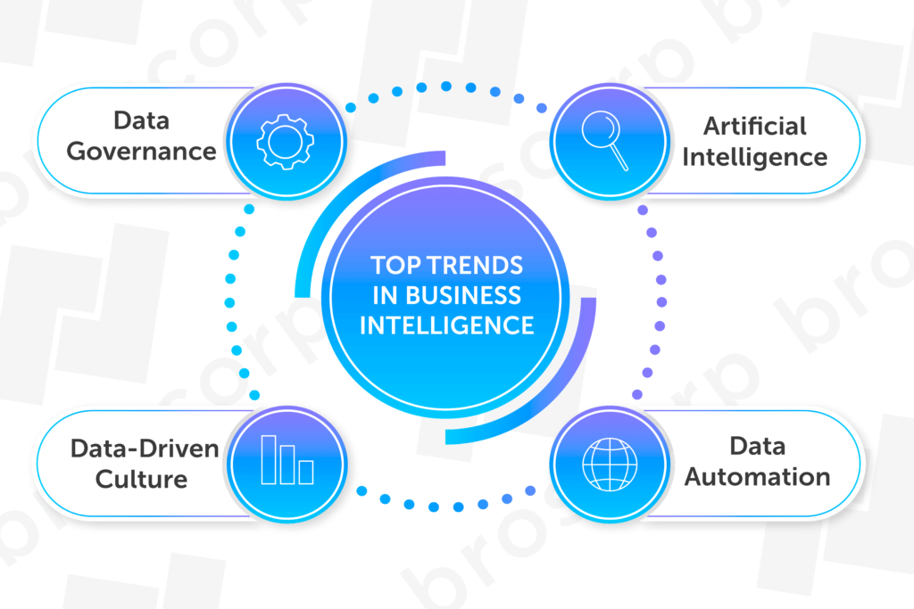
Figure 1: Current Business Intelligence trend
(Source: Enholm et al., 2022)
Business intelligence is a software that consumes business data and introduces it in user-friendly views like graphs, charts, dashboards and reports. Business intelligence merges data tools, data visualisation, data mining, business analytics, best practices and infrastructure to help the organisations make more data-managed decisions. Data decentralisation, market analysis, maintaining data records, and resource planning are a few examples of business intelligence. Currently used major five trends of Business Intelligence are as discussed below:
Artificial Intelligence
According to Enholm et al., (2022), artificial intelligence can make machines perform the hard tasks on their own which can be executed only by human intelligence. According to the report of strategic technology, it will mix engineering and hyper-automation with artificial intelligence with the help of high focus on possible security risk and vulnerable attack points. Introducing This trend in BI will serve in automatic and comprehensive analysis of the total set of data from any source of data without the effort of humans. Artificial intelligence can also be used in the process of online verification such as CAPTCHA technology by the help of GANs or Generative Adversarial Networks.
Data Security
Having updated and accurate data is critical for the success of business intelligence. However, there have been such cases like data breaches, data piracy, cyber-attacks even in large tech companies (Riaz et al., 2020). Results the company to lost the data of their customers, so they need the help of data security. One of the latest trends used in business intelligence to stay safe from these problems is data security or cyber security. Data security is a scalable and composable security control, which protects digital assets that reside in the cloud, in applications, IoT and many others. It tries to build a defined security perimeter around a specific point, with a more standard approach such as enabling users to control data from their own smartphones in a secure way.
Data Discovery
Discovering patterns and discrepancies in data is known as Data discovery. This is a method of using foster visualisations and logic to explain all collected data from different internal and external sources. It has great advantage in keeping apt stakeholders involved with the data from when it allows them to intuitively analyse and manipulate the data and extract actionable insights (Benevento et al., 2022). The demand for data discovery tools within all businesses has defamed due to the increasing need for data insights and data usage. Nowadays for depth data analysis through augmented and interactivity data discovery will be replaced with simple KPI monitoring.
Data Governance
The process which provides the steps for architecture, operational infrastructure, and managing data assets is known as data governance. All companies can successfully use the power of technology, people and processes to deliver understandable, secure and trustworthy data with the help of data governance (Jimenez et al., 2019). In the past years because of compact regulations like GDPR, companies were forced to ensure a secure environment for sensitive data, which increased the need for data governance processes. Modern business intelligence tools support this trend to maximise company’s analytics value. As the amount of data being collected keeps growing every second in today's highly competitive business environment, data governance becomes a compulsory practice.

Collaborative Business Intelligence
Nowadays, businesses are getting more competitive thus the need for collaborative business intelligence has increased. It mixed collaboration tools such as online BI tools which includes social media and other 2.0 technologies. Facilitated businesses where reports are edited and analysis is done create unique challenges which can only be solved by collaborative business intelligence (Ahmad et al., 2020). These online BI tools make automated reports which can be scheduled at particular times for particular person. Research assumes that collaborative business intelligence will become accessible by a large number of users and will be connected to larger systems in the future.

Current Data Warehousing Trend
In this time, data warehousing is trending within the marketing agencies. Some of the major data warehousing are as follows:
Green Data Warehousing
Green data warehousing has become trending in the sense of energy decreasing operations for businesses. It is great to see this trend making its own path onto the scene while all are tackling climate change.
Custom Data Warehousing
Custom data warehousing is also trending among the market agencies as it is built with user-friendly interfaces.
Outsourcing Data Management
It is trending within marketing agencies looking to estimate their plans. It enables businesses to decrease their in-house IT staffing costs (Edvardsson et al., 2020).
Virtual Data Warehousing
It is becoming in trend as it can be utilised faster than physical solutions and is cost-effective.

Current Data Mining Trend
Visual Data Mining
Visual data mining is becoming important as it allows users to easily interpret relationships and difficult data patterns. It involves using interactive visualisation tools to enable users to analyse and explore data.

Research Analysis
Research analysis is being used in fields such as drug discovery, proteomics and genomics to help researchers gain insights into difficult biological processes.
Web Mining
This trend is important as it analyses the web data to identify the web content, social media sentiment and trends and patterns in user behaviour.
Real-time Data Mining
It is important in industries like e-commerce, healthcare and finance. This helps to analyse data as it is generated to improve decision-making and give real-time insights (Massaro et al., 2019).
Implementation of Business Intelligence trends
Artificial Intelligence based business applications can use modelling and algorithms to turn data into actionable insights by which organisations can optimise a range of business processes and functions from employees’ schedules to make product pricing. Artificial intelligence can be applied in a business by the process of Natural Language Processing (NLP), data analytics and Automation, which are the top applications.
As mentioned by Kristoffersen et al., (2021), data security can be used in a wide range of technologies and techniques, including physical security, organisational standards, logical controls, administrative control and other safeguarding methods which decrease unauthorised access. Data security can be applied to a business by three main processes, which are legal security, software security and hardware security.
Data discovery is enabling companies to grab a 360-degree view of their customers by assessing and compiling customer sentimental, transactional and behavioural data within the many channels, where customers use to interact with companies. The major three data discoveries are preparation, visualisation and analysis, by which these methods can be applied in business.
Data governance governs who can access what kinds of data. It provides a framework to help the companies not only to avoid liability and risks but also provides a set of tools to mine data for maximising its value. There are mainly four phases in data governance, which are grow, build, plan and initiate, which can be applied to a business for its expansion.
Collaborative Business Intelligence is the collaboration software like Microsoft Teams combined with business intelligence tools or use of social media tools to help improve the decision-making of the business of an organisation (Richards et al., 2019). Collaborative business intelligence can be applied to a business by gathering data and organising it with the help of reporting.

Conclusion
This report has revolved around the trends and implementations of business intelligence as well as the trend of data warehousing and data mining. From this report it was concluded that BI connects people with information where and when they need it and gives capabilities far beyond spreadsheets to bring a true picture of the business. However, it has been understood from this report that finding a BI strategy that matches a company's budgets, expertise and resources can be challenging.

References
Enholm, I.M., Papagiannidis, E., Mikalef, P. and Krogstie, J., (2022). Artificial intelligence and business value: A literature review. Information Systems Frontiers, 24(5), pp.1709-1734.
Riaz, S., Khan, A.H., Haroon, M., Latif, S. and Bhatti, S., (2020), August. Big data security and privacy: Current challenges and future research perspective in cloud environment. In 2020 International Conference on Information Management and Technology (ICIMTech) (pp. 977-982). IEEE.
Benevento, E., Aloini, D. and van der Aalst, W.M., (2022). How can interactive process discovery address data quality issues in real business settings? Evidence from a case study in healthcare. Journal of Biomedical Informatics, 130, p.104083.
Jimenez, L.M., Polo, J.A. and Duarte, N.A., (2019), May. Overview of data governance in business contexts. In IOP Conference Series: Materials Science and Engineering (Vol. 519, No. 1, p. 012023). IOP Publishing.
Ahmad, S., Miskon, S., Alabdan, R. and Tlili, I., (2020). Towards sustainable textile and apparel industry: Exploring the role of business intelligence systems in the era of industry 4.0. Sustainability, 12(7), p.2632.
Edvardsson, I.R., Durst, S. and Oskarsson, G.K., (2020). Strategic outsourcing in SMEs. Journal of small business and enterprise development, 27(1), pp.73-84.
Massaro, A., Vitti, V., Galiano, A. and Morelli, A., (2019). Business intelligence improved by data mining algorithms and big data systems: an overview of different tools applied in industrial research. Computer Science and Information Technology, 7(1), pp.1-21.
Kristoffersen, E., Mikalef, P., Blomsma, F. and Li, J., (2021). The effects of business analytics capability on circular economy implementation, resource orchestration capability, and firm performance. International Journal of Production Economics, 239, p.108205.
Richards, G., Yeoh, W., Chong, A.Y.L. and Popovič, A., (2019). Business intelligence effectiveness and corporate performance management: an empirical analysis. Journal of Computer Information Systems, 59(2), pp.188-196.

